Annual Pricing Review for 2026–27 prices

Version: | 1
Date: | June 2026

Acknowledgement
The National Disability Insurance Agency acknowledges the Aboriginal and Torres Strait Islander peoples of this nation and the Traditional Custodians of the lands across which our Agency conducts our business. We pay our respects to the custodians of the land on which we work as well as their ancestors and Elders, past, present and emerging.
The National Disability Insurance Agency is committed to honouring Aboriginal and Torres Strait Islander peoples’ unique cultural and spiritual relationships to the land, waters, and seas and their rich contribution to society.

Copyright and use of the material in this document
Copyright in the material in this document, with the exception of third-party material, is owned and protected by the National Disability Insurance Agency.
The material in this document, with the exception of logos, trademarks, third party material and other content as specified is licensed under Creative Commons Attribution Non-Commercial No Derivatives (CC BY NC ND) licence, version 4.0 International. You may share, copy and redistribute the document in any format. You must acknowledge the National Disability Insurance Agency as the owner of all intellectual property rights in the reproduced material by using ‘© National Disability Insurance Agency 2026’ and you must not use the material for commercial purposes.
Reproduction of any material contained in this document is subject to the CC BY NC ND licence conditions available on the Creative Commons Australia site, as is the full legal code for this material.
The National Disability Insurance Agency expects that you will only use the information in this document to benefit people with disability.

Terms we use
Acronym | Meaning
ABS | Australian Bureau of Statistics
APR | Annual Pricing Review
CPI | Consumer Price Index
DHDA | Department of Health, Disability and Ageing
DSW | Disability Support Worker
EBA | Enterprise Bargaining Agreement
FWC | Fair Work Commission
GDP | Gross Domestic Product
HCSA | Health Care and Social Assistance
HPSS Award | Health Professionals and Support Services Award 2020
ITM | Isolated Towns Modification
MBS | Medicare Benefits Schedule
MMM | Modified Monash Model
MM | Modified Monash category
MTA | Medium Term Accommodation
NDIA or Agency | National Disability Insurance Agency
NDIS or Scheme | National Disability Insurance Scheme
NDIS Commission | National Disability Insurance Scheme Quality and Safeguards Commission
OMS | Orientation and Mobility Specialists
PHI | Private health insurance
RBA | Reserve Bank of Australia
SA2 | Statistical Area Level 2
SAL | Suburbs and Localities
SCHADS Award | Social, Community, Home Care and Disability Services Industry Award 2010
SCCP | Social, Community and Civic Participation
SEIFA | Socio-Economic Indexes for Areas
SIL | Supported Independent Living
STA | Short Term Accommodation
WPI | Wage Price Index

Contents
1. Executive summary 6
2. Introduction 17
3. Domestic economic conditions 21
4. Participant considerations for pricing improvement 28
5. Differentiated pricing 32
6. Pricing context for this APR 36
7. Disability Support Worker-related supports 37
8. Therapy supports 60
9. Support Coordination 99
10. Plan Management 117
11. Social, Community and Civic Participation 136
12. Isolated towns 156
Appendix A: DSW Cost Model 177
Appendix B: Details of MBS and PHI implied hourly price rate conversions 180

- Executive summary
The Annual Pricing Review (APR) is the primary mechanism through which the National Disability Insurance Agency (NDIA) considers whether National Disability Insurance Scheme (NDIS) prices are appropriate. Detailed analysis is undertaken to assess NDIS prices and what, if any, changes the NDIA considers are appropriate. It considers how markets are functioning, how providers are responding to existing settings, and whether pricing continues to support participant outcomes and access to quality supports. Prices shape provider behaviour, workforce investment and the range of service models available to participants. Pricing complements regulatory and policy settings managed through other agencies, all within the shared market stewardship framework led by the Department of Health, Disability and Ageing (DHDA).
This year’s APR is published against the backdrop of the National Disability Insurance Scheme Amendment (Securing the NDIS for Future Generations) Bill 2026 (Bill), which was introduced into Parliament on 14 May 2026. Amongst other things, the Bill proposes to amend the National Disability Insurance Scheme Act 2013 (NDIS Act) to provide the Minister for the National Disability Insurance Scheme with the power to make a pricing determination. It would also confer the NDIA with a specific function to provide advice to the Minister for the purposes of making a pricing determination.
Consistent with the NDIA’s existing functions, this year’s APR sets out guidance and views regarding appropriate NDIS prices. If the Bill is subsequently passed, it is anticipated the APR will then be used to inform advice provided by the NDIA to the Minister for the purposes of making a pricing determination.
Evidence informing this year’s APR includes administrative and claiming data, expanded benchmarking against broader health and social services markets, and insights from the NDIA’s Quality Supports Program pilots.
  - Disability Support Worker-related supports
From 1 July to 31 December 2025, more than 325,000 participants – 43% of all active participants – claimed DSW-related supports, delivered by more than 144,750 providers. Both registered and unregistered provider segments had an increase in total payments. Registered provider numbers grew by 20% to 12,555, with total payments increasing by 15% to $12.3 billion. Unregistered provider numbers grew by 5% to 133,348, with payments up by 12% to $4.7 billion. While average claims per registered provider decreased, average claims per unregistered provider increased, indicating the 2 market segments are diverging in scale and structure.
Most claims are submitted at the maximum price published on the NDIS website. In the 6 months to 31 December 2025, 69% of claims were made at this published price, up from 66% in the previous year. Registered providers claimed at the published price 73% of the time, while unregistered providers did so 61% of the time. These trends indicate the published price functions as the prevailing rate for most providers. The implications for pricing design are examined in Chapters 5 and 7.

DSW Cost Model indexation
The DSW Cost Model links prices to wage rates under the Social, Community, Home Care and Disability Services Industry Award 2010 (SCHADS Award) and is adjusted annually for minimum wage decisions. The NDIA’s guidance on 2026-27 adjustments reflect these inputs and maintain consistency with the model’s established methodology.

Recommendation 1:
Prices for supports determined by the NDIS Disability Support Worker Cost Model should be adjusted to reflect changes in the minimum wage specified in the Social, Community, Home Care and Disability Services Industry Award 2010 (SCHADS Award), as determined by the Fair Work Commission’s Annual Wage Review determination on 2 June 2026.

DSW Cost Model Review
The DSW Cost Model has not been comprehensively reviewed since its benchmarking data was established using 2020–21 market conditions. The market has changed materially since then, with significant growth in provider numbers, changes in market structure, and developments in industrial relations environments including the Fair Work Commission’s (FWC) Gender-based undervaluation – priority awards review (including SCHADS Award). A review of the model’s assumptions, structure and inputs is scheduled for 2026–27 and will provide the vehicle for incorporating structural changes arising from the FWC proceedings.

Recommendation 2:
The NDIA should undertake a review of the Disability Support Worker Cost Model, including consideration of whether the model’s structure and the way workforce and wage-setting inputs are incorporated continue to appropriately reflect contemporary employment and labour market conditions.
  - Short Term Accommodation
The current bundled price guidance for Short Term Accommodation (STA) is not consistent with Section 10 of the National Disability Insurance Scheme Act 2013, which limits NDIS funding to disability-related supports. The existing pricing guidance bundles accommodation, food, utilities and DSW costs into a single daily claim, without distinguishing between disability-related supports and non-disability living costs, such as food and utilities.
Unbundling STA into separate pricing components for accommodation, DSW costs and applicable loadings would align claiming with service delivery and bring pricing into closer alignment with comparable supports such as Supported Independent Living (SIL) and Medium Term Accommodation (MTA). The unbundled structure would enable claims to reflect actual hours of support delivered, the timing of support, and the intensity of support provision.

Recommendation 3:
The current daily price for Short Term Accommodation should be unbundled so that:
    - The accommodation component reflects only the capital cost of a temporary stay away from a participant’s usual place of residence. The price of Short Term Accommodation should be aligned with the existing price for Medium Term Accommodation ($158.66).
    - New 'Short Term Accommodation – Assistance with self care or community access activities’ support items apply. These support items should be structured by day of the week and time of day and aligned with the Disability Support Worker Cost Model. This will allow for accurate claiming based on:
  - The actual hours of support delivered,
  - The times of the day and week supports are delivered, and
  - The intensity of supports delivered.
    - Providers supporting participants funded for High Intensity Supports and/or behaviours of concern will be able to claim these loadings when appropriate.
  - Nursing and other supports
For nursing and other supports not covered by the Disability Support Worker (DSW) Cost Model, the NDIA recommends a weighted combination of the Australian Bureau of Statistics (ABS) Wage Price Index (WPI) and Consumer Price Index (CPI) to maintain alignment with broader labour cost movements. The 80/20 WPI/CPI weighting reflects that labour costs are the dominant cost component for these supports, with non-wage costs accounting for the remainder.

Recommendation 4:
Prices should increase for nursing and other supports not covered by Disability Support Worker-related supports, Capital supports or otherwise covered in the Annual Pricing Review. This adjustment should reflect the weighted movement in the ABS WPI (Australia, total hourly rates of pay excluding bonuses) and the ABS CPI (All Groups, weighted average of 8 capital cities) over the 12 months to the end of Quarter 3 (31 March 2026) immediately preceding the indexation data (with an 80/20 weighting).
  - Therapy supports
Therapy supports were accessed by more than 465,600 participants between July and December 2025, with total payments of $2.7 billion. Therapy supports operate within professional labour markets that span private practice, health, aged care and other government-funded programs. External benchmarking against the Medicare Benefits Schedule (MBS), private health insurance (PHI) sources (PHI 1 and PHI 2) and other comparable government schemes provides the primary reference point for assessing whether NDIS therapy prices are appropriate.
Where benchmarking indicates prices should better align with prevailing market rates, NDIS prices should be adjusted accordingly. This approach reflects the principle that NDIS pricing should be informed by the broader markets in which therapy professionals operate.

Psychologist price
Benchmarking results support a recommendation that the NDIS price for Psychologists should align with PHI 1 ($250.00), PHI 2 ($252.00) and MBS ($260.00) data for a 60-minute session. A national maximum price of $252.99 per hour would align NDIS prices with typical market rates, support access to qualified Psychologists and help maintain timely, high-quality care for participants.

Recommendation 5:
The national price for supports delivered by a Psychologist should be a maximum of $252.99 per hour. This should apply uniformly across all jurisdictions.

Dietitian price
Benchmarking results support a reduction of the NDIS price for Dietitian supports to a maximum of $178.99 per hour. This takes into account the PHI 2 75th percentile ($155.00 per hour) and the MBS 75th percentile ($152.00 per hour), based on large-scale billing data and adjusted for session duration. Given the size and consistency of the divergence that remains between the NDIS price and PHI 2 and MBS figures, the NDIS price should be reduced to minimise disruption within markets while moving toward a more appropriate price.

Recommendation 6:
The national price for supports delivered by a Dietitian should be a maximum of $178.99 per hour.

Exercise Physiologist price
Benchmarking results support a recommendation that the NDIS price for supports provided by an Exercise Physiologist should be a maximum of $161.99 per hour. This takes into account the MBS 75th percentile ($152.00) and the PHI 1 75th percentile ($132.00), based on large-scale data and adjusted for session duration. This would improve alignment with prevailing market rates, while allowing for transition and minimising disruption within markets.

Recommendation 7:
The national price for supports delivered by an Exercise Physiologist should be a maximum of $161.99 per hour.

Orientation and Mobility Specialist price
Registration of Orientation and Mobility Specialists (OMS) was recognised by the NDIS Quality and Safeguards Commission in March 2025. Introducing dedicated OMS support line items would improve claiming accuracy and reduce reliance on a category that aggregates multiple unidentified disciplines.
The NDIA considers that a national hourly price of $156.16 is appropriate, with applicable remote loadings and access to standard ancillary activities.

Recommendation 8:
The national price for supports delivered by an Orientation and Mobility Specialist should be a maximum of $156.16 per hour.

Other Professionals price
The ‘Other Professionals’ claiming category presents a material challenge for pricing and stewardship because claims are not linked to a specified profession or registration status. This means the NDIA cannot clearly determine what supports are being claimed, and prices cannot be reliably benchmarked against the MBS, PHI or recognised allied health professions. This lack of visibility weakens transparency, value for money and assurance that funding aligns with Section 10 of the National Disability Insurance Scheme Act 2013. In the absence of more robust information, a higher price for this category would not be supported by available evidence.

Recommendation 9:
The national price for supports delivered by ‘Other Professionals’ (not including Early Childhood supports) should be a maximum of $156.16 per hour.

Claiming for non-face-to-face time
Currently, in the therapy context, direct service delivery, provider travel and report writing are bundled as non-face-to-face activities. Unbundling these operationally distinct components would improve transparency and accuracy in claiming, and support more consistent claiming practices across providers.

Recommendation 10:
A separate line item should be introduced for claiming provider travel associated with therapy supports, distinct from the therapy line item. This provider travel line item would enable provider travel to be claimed and recorded separately from direct service delivery, improving transparency and accuracy in claiming.

Recommendation 11:
Separate line items should be introduced for claiming non-face-to-face therapy support provision, including activities such as preparation, documentation, and NDIS-requested reporting. These line items would enable non-face-to-face activities to be claimed and recorded separately from direct service delivery, improving transparency and accuracy in claiming.
  - Support Coordination
Support Coordination supports were accessed by more than 291,800 participants in the 6 months to December 2025, representing around 38% of active participants. The provider market continues to grow through small-scale entrants rather than the expansion of existing providers. Approximately 3,000 providers supported only one participant with average claims of $2,000, while more than 5,000 providers supported 5 or fewer participants with an average of approximately $4,000 each. By contrast, the largest 201 providers (supporting more than 250 participants) accounted for approximately 35% of total claims, with average claims of $1.1 million per provider.
Registered providers accounted for 79% of total payments, though unregistered provider numbers and participant reach continued to grow. Support Coordination is a market generated by the NDIS, with demand and supply shaped primarily by plan design, eligibility settings and prices, rather than external market benchmarks.

Support Coordination: Level 1: Support Connection, Level 2: Coordination of Supports and Level 3: Specialist Support Coordination
Analysis indicates that, while the Support Coordination market continues to evolve, the current maximum price remains appropriate.

Recommendation 12:
The maximum prices for Support Coordination should be:
- $80.06 for Level 1: Support Connection
- $100.14 for Level 2: Coordination of Supports
- $190.54 for Level 3: Specialist Support Coordination

Psychosocial Recovery Coach
The price for Psychosocial Recovery Coach supports should be determined using the DSW Cost Model, and that price should be indexed in line with the model.

Recommendation 13:
Prices for Psychosocial Recovery Coaches should align with the indexation of supports determined by the Disability Support Worker Cost Model in Recommendation 1.
  - Plan Management
In the 6 months to December 2025, approximately 65% of all active participants used plan managers to process NDIS payments, with $13.4 billion in participant payments processed. This included $292 million in monthly fees. The provider base remains stable and concentrated, with the largest providers processing most payments. The market shows signs of diversification, with two-thirds of Plan Managers also claiming fees for other supports.
Consultation feedback indicates Plan Management costs are driven primarily by transaction volumes and system-related administrative requirements, rather than labour cost movements. This supports a recommendation that prices should better reflect the administrative and transactional nature of the support.

Recommendation 14:
The monthly fee for Plan Management should be $104.45 per month.

Recommendation 15:
The NDIS should undertake a review of the Plan Management pricing approach to ensure price guidance and recommendations align with the administrative and transactional nature of the support and reflect how Plan Management is delivered in practice.
  - Social, Community and Civic Participation
The Social, Community and Civic Participation (SCCP) market comprises 2 distinct provider markets. Most of the SCCP providers are unregistered and are predominantly sole traders or small businesses. There are fewer registered providers, but they operate under higher governance, workforce and compliance obligations.
Current pricing does not distinguish between these markets, despite their different operating models. Claims data shows price clustering close to the maximum price across the market. This means the existing price is doing little to distinguish between materially different forms of service delivery. A targeted differential for unregistered providers would align pricing with market structure while maintaining participant access to support.

Price differentiation for unregistered SCCP providers
The price for unregistered SCCP providers should be reduced by 10% from 1 January 2027. The price for registered SCCP providers should be maintained. These prices would provide a clear distinction between provider segments with different operating models and regulatory obligations, while limiting disruption for participants and preserving access to support.
The recommended price reduction applies only to unregistered providers delivering SCCP supports, including associated high-intensity variants. The price for registered providers should be maintained.

Recommendation 16:
The prices for Social, Community and Civic Participation supports delivered by unregistered providers, including high intensity supports should be reduced by 10% from 1 January 2027. Indexation of these supports should be ceased.
The prices and indexation for Social, Community and Civic Participation supports delivered by registered providers should be maintained.
  - Isolated Towns
Access to NDIS supports in Isolated Towns continues to be constrained by geographic remoteness, extended travel requirements and thin provider markets that are not fully reflected in the standard Modified Monash Model classification. NDIA administrative data shows that, while the plan utilisation trend for locations subject to the Isolated Towns Modification (ITM) has been positive over the past 3 years, these locations have consistently lower plan use and slower first plan activation than
non-isolated locations within the same Modified Monash category (MM). In 2024–25, average plan use in Isolated Towns was approximately 10% lower than non-isolated locations in MM 3 and MM 4, and around 17% lower in MM 5, despite the application of existing price loadings and travel arrangements.
Data also shows that these locations have higher provider travel costs than
non-isolated locations with the same MM category, indicating a continued need for additional price loadings.
Evidence supports the continued application of the ITM for towns that are surrounded by, or require travel through, remote or very remote areas. These locations continue to exhibit characteristics like MM 6 areas, including lower plan use and higher travel costs, supporting ongoing reclassification to MM 6.
Analysis also identifies a subset of MM 4 and MM 5 locations where plan use remains materially below the national average of 76%, with limited improvement over time, extended travel requirements and higher levels of socio‑economic disadvantage. For these locations, modifying the MM category is not considered proportionate and may increase the risk of market distortion.
A more targeted and transparent approach is therefore required. A 2-tiered framework, which retains the existing ITM as Type 1 Isolated Towns and introduces a new Type 2 ITM that applies defined market levers based on objective, data driven criteria, would support improved access to supports in thin markets while limiting unintended impacts across the broader care economy.

Recommendation 17:
The NDIA should continue publishing the current locations on the Isolated Towns Modification list, with an updated definition to reflect inclusion of ‘surrounded by OR travel through remote areas’. These towns should be referred to as Type 1 Isolated Towns and will continue to have their Modified Monash category modified to MM 6, resulting in the application of the relevant loading and travel arrangements. The NDIA should also publish the guidelines for managing the Type 1 Isolated Towns Modification, including the process for transitioning locations that no longer meet the policy definition.

Recommendation 18:
The NDIA should publish a Type 2 Isolated Towns Modification on the NDIS website, including the policy definition, guidelines for management and locations that meet the criteria. Providers in a Type 2 Isolated Towns location should be eligible to negotiate travel costs as part of their service agreements with participants, but no additional loading applies.
For a location to be listed on the Type 2 Isolated Towns Modification, it must have been identified as needing additional support based on low plan utilisation, travel time and socio-economic disadvantage, specifically meeting the following criteria:
- The location must be classified as a MM 4 and/or MM 5; and
- The average Statistical Area 2 plan utilisation over 3 years is 60% or less (calculated using only MM 4/5 locations); and
- Travel time from a MM 4/5 Statistical Area 2 to the nearest MM 1/2/3 is 70 minutes or more (calculated using the Statistical Area 2 location with most participants); and
- The Socio-Economic Indexes for Areas – Index of Relative Socio-Economic Disadvantage decile score at the Statistical Area 2 level is 5 or below.

Recommendation 19:
The NDIA should monitor and evaluate market levers implemented for locations in the Type 2 Isolated Towns Modification for the duration of the adjustment. This will allow further investigation to understand the impact of changes made and any unintended consequences of the market intervention to inform future guidance and advice.

- Introduction
  - Context
The NDIS was established in 2013 to support people with disability to pursue their goals, help them to realise their full potential, assist them to participate in and contribute to society, and empower them to exercise choice and control over their lives and futures. The NDIS provides funding to eligible individuals (participants) so they can purchase the disability-related goods and services (supports) they need in the open market.
In carrying out its functions, the NDIA considers whether the prices and market settings that apply in this market remain appropriate and reflect current market conditions.
On 14 May 2026, the National Disability Insurance Scheme Amendment (Securing the NDIS for Future Generations) Bill 2026 was introduced into Parliament. Amongst other things, the Bill proposes to amend the National Disability Insurance Scheme Act 2013 (NDIS Act) to provide the Minister with the power to make a pricing determination. It would also confer the NDIA with a specific function to provide advice to the Minister for the NDIS for the purposes of making a pricing determination.
Consistent with the NDIA’s existing functions, this year’s APR sets out guidance and views regarding appropriate NDIS prices. If the Bill is subsequently passed, it is anticipated the APR will then be used to inform advice provided by the NDIA to the Minister for the NDIS for the purposes of making a pricing determination.
  - The NDIA’s market stewardship role
The Australian Government’s stewardship of disability support markets is a shared responsibility. The Department of Health, Disability and Ageing (DHDA) leads the overall market stewardship framework, with the NDIA, the NDIS Quality and Safeguards Commission (NDIS Commission), and state and territory governments each contributing within their areas of responsibility. DHDA’s leadership role encompasses the broader policy settings that shape market conditions. The NDIA exercises its functions in this regard primarily through providing guidance regarding appropriate NDIS pricing, possibilities for targeted intervention where markets are not functioning effectively, and market monitoring.
Within this shared framework, the NDIA’s stewardship role is exercised principally through making recommendations concerning prices. Prices influence provider behaviour, shape market entry and exit, and affect the quality and range of supports available to participants. Providing guidance on pricing requires coordination with regulatory, quality assurance and workforce policy settings managed by other agencies. The Pricing Interdepartmental Committee (IDC), established in November 2022, provides the primary mechanism for this coordination, bringing together senior representatives from DHDA, as well as the Department of Finance, the Treasury, and the Department of the Prime Minister and Cabinet. This cross-government governance ensures pricing decisions are informed by whole of government fiscal, policy and market considerations, and aligned across agencies.
  - Scope and limitations of this review
The APR assesses whether current NDIS prices remain appropriate and makes recommendations for the forthcoming financial year. It focuses on prices that can be considered based on current evidence, including market data, benchmarking, consultation and insights from the NDIA’s broader reform work.
The APR does not make recommendations for the redesign of the full pricing architecture of the Scheme or seek to resolve longer-term structural questions at once. Recommendations for broader pricing reform are being progressed through the NDIA’s 3-Year Pricing Workplan, including targeted reviews, pilot activity and more detailed design work in priority markets.
This APR makes recommendations where the evidence supports action now and identifies areas where further work is being undertaken through the scheduled reform program. This reflects a staged approach to reform with annual recommendations operating alongside deeper market and design reform over time.
  - 3-Year Pricing Workplan
This APR is delivered within the NDIA’s 3-Year Pricing Workplan, which provides a sequenced approach to pricing reform. The first year focuses on building evidence through targeted market analysis, pilots and the APR. The second year focuses on formal pricing reviews guided by terms of reference informed by earlier APRs, pilot findings and consultation. The third year focuses on implementation and consolidation. Through this approach, the APR enables the NDIA to recommended responses to emerging market pressures where evidence supports early action, while supporting the development and implementation of more substantial changes in a measured way. The Workplan can be found on the NDIS website: https://www.ndis.gov.au/providers/pricing-arrangements/making-pricing-decisions/pricing-work-plan .The Workplan may be subject to updates if the amendments to the National Disability Insurance Scheme Act 2023 proposed by the National Disability Insurance Scheme Amendment (Securing the NDIS for Future Generations) Bill 2026, introduced into Parliament on 14 May 2026, are made.
  - Quality Supports Program
The Quality Supports Program was established to identify the features of quality service provision, understand the cost associated with delivering quality supports, and assess the relationship between service characteristics and participant outcomes. It includes three 12-month pilots:
- Supported Independent Living (SIL) pilot (44 registered providers), which started in August 2025.
- Support Coordination pilot (3 registered providers), which started in August 2025.
- Therapy pilot (27 registered providers), which started in March 2026.
Collectively, SIL and Therapy providers participating in the pilots represent approximately 30% of participants receiving these supports and provide national coverage including regional, remote and very remote locations. Total grant funding of up to $45 million has been provided. It supports the participating providers to work collaboratively with the Agency to provide insights, evidence and data through financial reports, case studies and engagement activities. Findings will inform future pricing reviews as part of the 3-Year Pricing Workplan. More information can be found on the NDIS website https://www.ndis.gov.au/grants/quality-supports-program
  - APR consultation process
This APR included a formal consultation process with participants, providers, peak bodies, professional associations and other stakeholders.
The consultation received 3,243 responses, the highest response rate in APR history. This provides a broad evidence base on how current prices are affecting market conditions, service delivery and participant experience.

Consultation with other government insurance and funding schemes
The NDIA collaborated with 16 Commonwealth, state and territory schemes to establish comparable therapy pricing. The schemes include:
- Catastrophic Injuries Support (CIS) Scheme
- Comcare
- Department of Veterans’ Affairs
- ReturnToWorkSA
- State Insurance Regulatory Authority
- Victorian Transport Accident Commission
- WorkCover Queensland
- WorkCover WA
- WorkSafe Victoria.

Pricing Interdepartmental Committee
The Pricing Interdepartmental Committee (IDC), established in November 2022, supports a strategic, joint approach to NDIS pricing. It serves as a key mechanism for aligning pricing policy with broader government, economic, regulatory, and social objectives.
The IDC includes senior representatives from the:
- Department of Health, Disability and Ageing
- Department of Finance
- Department of the Prime Minister and Cabinet
- NDIS Quality and Safeguards Commission
- The Treasury

Pricing Arrangement Reference Group
The APR was informed by advice and peer review from the NDIA’s Pricing Arrangement Reference Group, which provides expert advice on pricing arrangements to the NDIA Board via the Chief Executive Officer of the NDIA. This advisory process helps ensure pricing guidance is transparent, evidence-based, and aligned with the NDIA’s objectives to support participant outcomes and strengthen market stewardship. More information can be found on the NDIS website at https://www.ndis.gov.au/reference-group-updates/pricing-arrangement-reference-group

- Domestic economic conditions
  - Economic outlook
Australia’s economic growth recovered in 2025, following very weak growth in 2024, to reach its fastest annual pace in nearly 3 years in the December quarter 2025. This rebound was driven by a recovery in private demand, led by strong household spending and investment, as well as ongoing growth in public demand.
While the labour market has remained resilient over the past year, inflationary pressures picked up strongly in the second half of 2025, leading to the Reserve Bank of Australia (RBA) increasing the cash rate target in February and March 2026. In addition, the conflict in the Middle East has introduced significant uncertainty into the Australian economy and resulted in sharply higher fuel prices, which, if sustained, will add to inflation.
Prior to the conflict in the Middle East, the Australian economy was expected to gain further momentum over 2026, with real Gross Domestic Product (GDP) forecast to grow by 2.1% by mid-2026, before easing from late-2026 and growing by 1.6% over 2027. However, since the conflict in the Middle East, the outlook for the Australian economy has continued to shift rapidly, with GDP growth expected to be lower than previously forecasted as higher inflation and tighter-than-expected monetary policy slow GDP growth over 2026 and 2027.
  - Inflation
Inflation increased in the Australian economy over the second half of 2025, rising above the RBA’s inflation target band and reaching a 19-month high in January 2026. This represents a return of inflationary pressures following a period in which inflation had been gradually easing from its peak in late-2022. The increase affected a wide range of goods and services. This may lead to higher cost pressures for providers delivering supports to NDIS participants, including higher energy, logistics, interest rate and property costs, resulting in pressure to raise prices for their services.
Headline inflation rose 3.8% in the year to January 2026, unchanged from December 2025. This is the third time annual headline inflation has reached 3.8% between late 2025 and early 2026. The increase in inflation was higher than expected and is forecast to remain above the RBA target band of 2–3% for some time.
The RBA expects headline inflation to increase to around 5% over the year to the June quarter 2026. This is around three-quarters of a percentage point higher than had been expected in February 2026. While uncertainties about the outlook for inflation remain, there is a risk inflation will remain above target for longer than previously anticipated given the rise in oil prices.
In contrast, health inflation eased over the past year and is back below the headline inflation rate for the second consecutive month since 2023 (Figure 1). Annual inflation for health goods and services rose 3.2% in January 2026, driven by a 4.2% increase in the cost of medical and hospital services. While health inflation has outpaced headline inflation for the past few years, the gap closed over 2025. This suggests that since the end of 2025, cost pressures in the Health Care and Social Assistance (HCSA) industry are slightly below the overall economy.
Figure 1: Headline and health inflation (CPI) growth, 2016 to 2026
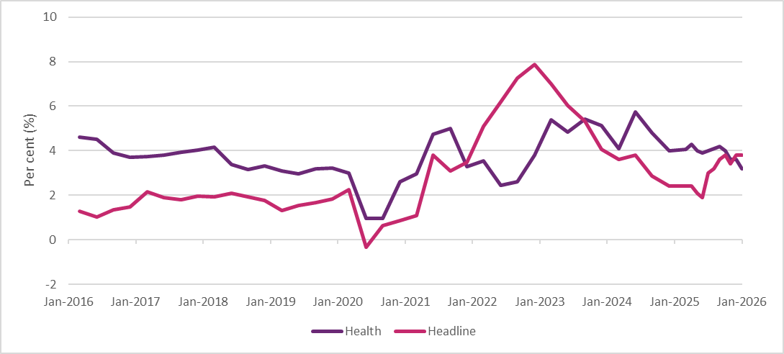
Source: ABS Consumer Price Index, Australia, January 2026
  - Labour market conditions
Australia’s labour market has remained resilient over the past year with employment continuing to grow, the participation rate nearing record highs, and the unemployment rate remaining close to historical lows.
Employment increased by approximately 264,700 people over the year to February 2026. The participation rate rose to 66.9% in February 2026 and the unemployment rate increased to 4.3% in February.
Prior to the conflict in the Middle East, conditions in the labour market were expected to remain resilient, with the unemployment rate forecast to remain low by historic standards, at 4.3% over 2026, before gradually increasing over 2027. The participation rate is also expected to remain close to recent record highs at around 67%. Employment is forecast to grow at a slower rate, reflecting easing labour demand in the non‑market sector. However, depending on how long the conflict in the Middle East persists, labour market conditions could weaken as economic growth slows, with some forecasts predicting the unemployment rate to peak between 4.5% and 5% by the end of 2026.
The HCSA sector is the largest industry employer in the Australian economy. Employment in this industry increased by 18,100 people (or 0.7%) over the year to the December quarter 2025 to 2.5 million people. This represents 16.5% of total employment. While employment in the HCSA industry increased over 2025, the sector experienced a significant slowdown in employment growth compared to the very strong rates of the past few years (Figure 2). Despite slowing down, employment in the HCSA industry has still grown at a higher average rate over the past 10 years compared to all industries.
Figure 2: Employment growth in all industries and HCSA industry, 2015 to 2025
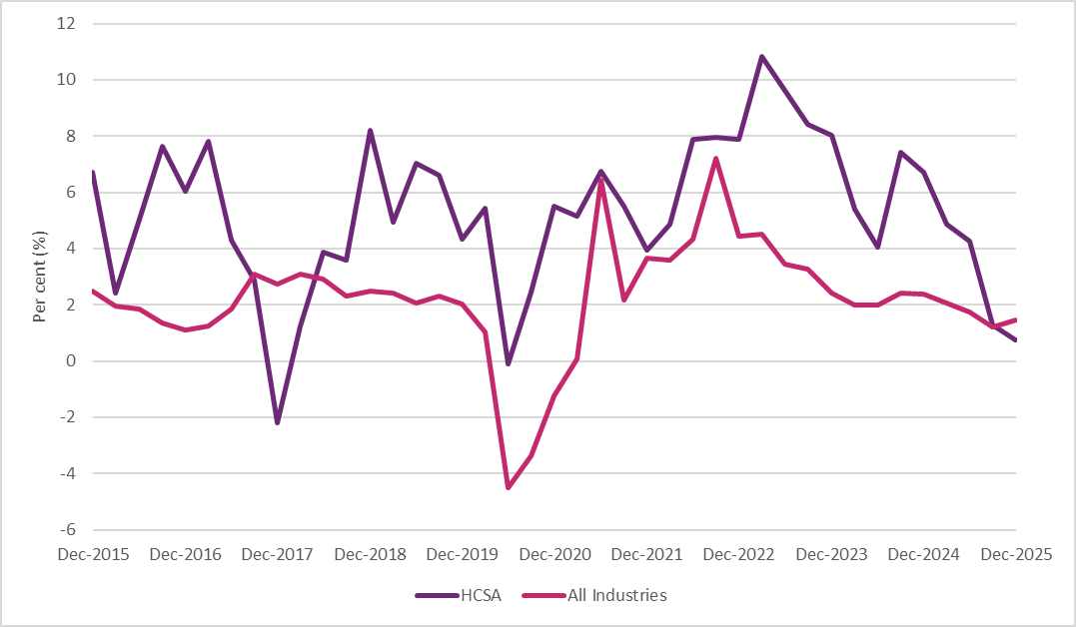
Source: ABS Labour Account Australia, December 2025
Within the care and support workforce, the largest NDIS-related occupation by employment in November 2025 was aged and disability carers, with 347,500 workers. This was followed by nursing support and personal care workers, and welfare support workers. Together, these occupations represent more than 77% of workers in NDIS-related occupations.
Demand for workers in the HCSA industry remains strong. There were 59,600 job vacancies in the HCSA sector in November 2025. This is double the pre-pandemic level of job vacancies for that industry. Aged and disability carers recorded the highest number of vacancies, representing nearly a third of NDIS-related vacancies, followed by nursing support and personal care workers and occupational therapists. This highlights the increasing demand for health care and support services in the Australian economy.
Alongside the high number of job vacancies in the HCSA industry, Jobs and Skills Australia considered several NDIS-related occupations to be in shortage in 2025. These include aged and disability carers, physiotherapists, speech therapists and audiologists, occupational therapists, and psychologists. Workforce retention was reported as the cause of the shortage for aged and disability carers. This is not unique to the NDIS sector, as shortages are experienced by the broader HCSA industry, particularly considering an ageing population and an increased prevalence of chronic conditions.
The disability workforce is expected to continue to increase significantly to support the forecast growth in the NDIS and the HCSA industry. Jobs and Skills Australia projects employment in the HCSA industry to grow by 290,300 people (or 12.3%) over the 5 years to May 2030 (Figure 3). This is the strongest projected employment growth of all industries and more than double the projected increase in the level of employment for the ‘professional, scientific, and technical services’ industry (second largest industry by level of employment in the economy). The occupations projected to have the strongest employment growth over the 5 years to May 2030 are predominately in the health therapy area, with both physiotherapists and occupational therapists expected to grow by nearly 20%. Employment for aged and disability carers is expected to grow by 39,800 people (or 10.7%) over the
5 years to May 2030.
Figure 3: Projected employment growth for the 5 largest industries, May 2025 to May 2035
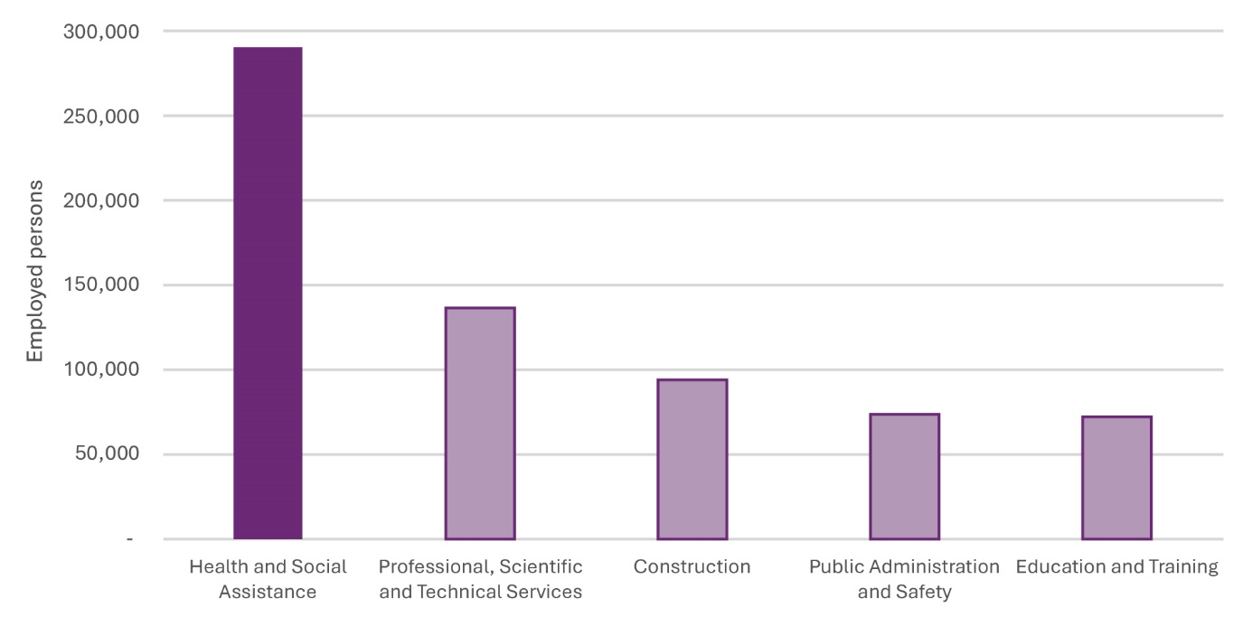
Source: Jobs and Skills Australia Employment Projections, May 2025 to May 2035
  - Wage growth
Wage growth remained broadly steady in 2025 and remains below the highs in recent years. Wage growth was 3.4% over the year to the December quarter 2025, up from 3.2% in the December quarter 2024. Despite the slight increase, annual wage growth is now at its third lowest level since peaking in the December quarter 2023.
Prior to the conflict in the Middle East, wages were forecast to ease slightly over the year ahead as labour market conditions gradually soften. Wages were expected to grow by 3.1% in both 2026 and 2027. This remains well above the 5-year pre-pandemic average rate of 2.1%. However, given the conflict, wages growth may be limited as the economic outlook changes and the labour market weakens.
The HCSA industry also recorded steady but strong wage growth in 2025, driven by significant award rate increases and high labour demand, though the pace of annual growth has slightly moderated from 2024 levels. Wage growth in the HCSA industry was 4.4% over the year to the December quarter 2025, up from 2.8% in the December quarter 2024. Wage growth in the HCSA industry remains above the
all-industries wage growth rate, suggesting some continued upward pressure on wages for care and support sector workers.
  - What this means for pricing and market recommendations
Current economic conditions are relevant to this APR because disability support providers are exposed to both wage and non-wage cost pressures. Above target inflation increases the cost of inputs such as transport, energy, insurance and premises, while continued wage growth in the HCSA sector increases the cost of labour, which remains the primary input for most supports.
These pressures affect appropriate NDIS pricing differently across support types. For supports with recommended prices which are assessed through cost-based or indexation methods, the question is how current wage and non-wage movements should flow through the pricing framework. For supports with recommended prices which are assessed by reference to external markets, the question is whether those market benchmarks have already incorporated current cost pressures and whether NDIS prices remain appropriately positioned relative to them.
In this context, the macroeconomic environment supports the use of different approaches for pricing recommendations made in the APR. For DSW-related supports, the DSW Cost Model and related indexation settings provide the primary mechanism for reflecting labour cost movements. For nursing and other general supports, the blended Wage Price Index (WPI)/Consumer Price Index (CPI) approach recognises both wage and broader input cost changes. Benchmarking remains the relevant reference point for therapy supports, while recognising that adjustments in benchmark prices may lag behind changes in provider cost conditions.
The persistence of above target inflation into 2026 means the cost environment remains higher than the settings under which many current prices were originally calibrated. This context is relevant to both upward and downward price decisions and reinforces the need for pricing that is responsive to current market conditions.
- Participant considerations for pricing improvement
  - Context
Participant perspectives provide important contextual insight for recommendations made in the APR. While participant views are not the sole factor considered by the NDIA in its analysis of efficient prices or provider cost structures, they inform implementation design recommendations, identify transition risks, and highlight areas where price changes may interact with market access and choice and control. This chapter draws on the participant consultation undertaken for the APR to identify considerations relevant to differentiated pricing.
  - Market functioning, participant behaviour and trade-offs
Participant choices reflect broader market conditions, including availability of services, perceived provider capability and the potential trade-offs created by differentiated pricing. Consultation feedback indicated participants’ provider choices are shaped primarily by trust and rapport, availability and reliability of services, and provider qualifications or experience. Registration status was not identified as a primary driver of choice. Participants reported that both registered and unregistered providers can deliver high-quality supports. Many participants using registered providers identified training, supervision and oversight as important indicators of quality.
This was reflected in participants’ responses to registration-based differentiated pricing. When asked whether this change would influence provider choice, many respondents (43%) said it would not alter their choices, largely due to established relationships and the perceived quality of their current providers. Approximately
two-thirds of respondents reported a preference for unregistered providers, citing greater service flexibility, continuity through consistent staffing, more personalised support, and simpler administrative processes. Around one-third of respondents preferred registered providers, citing perceptions of higher service quality, stronger safeguarding mechanisms and greater accountability.
These responses suggest provider choice is driven more by existing relationships and service experience than by pricing signals alone. They also indicate that differentiated pricing could still affect participants indirectly by changing the quantity of support they can purchase or the providers available to them. Around 27% of respondents expressed concern that reductions to prices for unregistered providers could decrease available support hours. Participants consistently identified the preferred outcome as one in which they are not required to trade quality against quantity. Consistent minimum standards across all providers were identified as the most effective mechanism for achieving this, rather than price differentiation alone.
Reported behavioural responses reinforce this interpretation. Around one-third of respondents preferred registered providers and would maintain that preference under differentiated pricing. Another group indicated they would switch to registered providers if pricing signalled a meaningful quality difference. However, the largest group indicated their choices would remain unchanged, reflecting the dominance of relationship-based and availability-based decision-making. Around 7% of respondents indicated that provider choice depends on support type, with preferences for registered providers for higher-risk or higher-intensity supports.

Limits of pricing as a quality signal
These behavioural patterns point to a fundamental constraint: pricing, in isolation, has limited effectiveness as an indicator of provider quality. Consultation revealed a clear distinction between support for differentiation in principle and confidence that price differences would signal quality differences in practice.
A substantial proportion of participants supported differentiated pricing as a fairer reflection of regulatory obligations between registered and unregistered providers. Participants noted that differentiation could incentivise investment in governance and quality systems, including encouraging some unregistered providers to pursue registration. However, an equally substantial proportion of respondents reported no observable difference in service quality between registered and unregistered providers. For these participants, a recommendation of higher prices for registered providers would represent a cost increase without corresponding benefit. Participants consistently indicated that they assess provider quality through experience, trust, relationships and professional credentials rather than price signals.
This finding underscores a core limitation: when participants lived experiences do not align with the assumed quality distinction implied by price, pricing cannot function effectively as a proxy for quality. Registration status was seen as playing a limited role for therapy supports, where professional regulation through bodies such as the Australian Health Practitioner Regulation Agency provides an independent quality assurance mechanism. These insights reinforce the importance of anchoring price differentiation in verifiable structural characteristics, such as the cost of registration obligations, rather than assumed quality differences.

Alternative basis for differentiation
Given these constraints, participants identified alternative bases for differentiated pricing that better reflect their experience. Provider capability was the most supported basis. Participants emphasised that pricing should reflect skills, experience and the complexity of supports delivered. While existing differentiation for high-intensity supports is recognised, some participants considered further detail is required to distinguish activities involving different levels of risk and expertise.
Seven per cent of respondents indicated provider choice under differentiated pricing depends on support type, preferring registered providers for high-risk supports while opting for unregistered providers for lower skill supports to maximise hours. Some participants also supported differentiation based on legal entity type, noting sole traders and larger organisations face structurally different cost environments.
Collectively, these insights indicate participants support fair and targeted recommendations as to pricing differentiation but do not view pricing as a trusted quality signal. Price recommendations must operate alongside regulatory and quality assurance mechanisms designed to protect participant safety rather than substituting for them.
  - Continuity of supports
Continuity of support is a central factor shaping risks associated with differentiated pricing. Participants place a high value on maintaining stable access to, and relationships with, their current providers. Losing access to current providers was raised by 22% of respondents as a key concern, reflecting the possibility some unregistered providers may exit the market or reduce service availability if prices are reduced.
Provider-switching patterns offer important context for assessing the likelihood of disruption. Analysis compared provider retention between November 2023 to October 2024 and November 2024 to October 2025, for participants with an active plan at the end of October 2025. It showed complete provider switching is relatively uncommon across all support categories. Table 1 summarises retention and switching patterns across key categories.
Table 1: Provider retention and switching, between November 2023 to October 2024 and November 2024 to October 2025
 | Support coordination | Therapy supports | DSW-related supports | Plan management
Same providers | 62.60% | 26.60% | 34.90% | 78.80%
All new providers | 5.90% | 6.00% | 4.40% | 3.50%
Kept some providers, removed others | 16.40% | 24.50% | 22.80% | 10.60%
Kept some providers,  added others | 10.90% | 16.00% | 14.50% | 5.30%
Kept some providers, removed and added others | 4.20% | 26.90% | 23.40% | 1.80%
Source: NDIS internal administrative data
Complete switching rates ranged from 3.5% (Plan Management) to 6.7% (Social, Community and Civic Participation – not listed above). Therapy supports showed a similar low complete switch rate of 6.0%, with changes likely reflecting shifts between therapy modalities rather than disengagement. DSW-related supports recorded the lowest rate at 4.4%, with higher rates of partial change reflecting the diverse ways participants allocate DSW funding across multiple providers. These patterns suggest moderate adjustments to recommended pricing are unlikely to cause widespread provider churn, though maintaining continuity requires particular attention in thin markets and for participants with specialised support needs.
  - Implementation considerations
Participants identified measures to support informed decision making under differentiated pricing, including clearer information about the practical benefits of engaging registered versus unregistered providers (24% of respondents), improved tools for comparing providers on quality and price, and clear examples showing how changes would affect individual plan budgets. More broadly, participants emphasised that pricing adjustments should be accompanied by accessible information about what protections apply when transitioning provider types.

- Differentiated pricing
  - Context and purpose
The participant consultation examined in Chapter 4 establishes that participants support fair pricing differentiation but do not rely on price as a quality signal. This chapter addresses the structural question: where materially different obligations, cost structures or regulatory requirements exist across providers delivering the same support, should a single price recommendation apply.
Prices play a central role in shaping NDIS markets. They influence how supports are delivered, which delivery models are viable and how risk is shared between the NDIS, providers and participants. Where providers operate under broadly similar conditions, a uniform maximum price can function as a reasonable market signal. However, where materially different conditions and cost structures exist across providers delivering the same support, a single maximum price may not adequately reflect the diversity of delivery conditions.
The Independent Pricing Committee has recommended that NDIS prices move beyond the assumption that uniform hourly pricing is always appropriate and move towards differentiated approaches that better reflect the diversity of supports, delivery contexts and provider obligations. Submissions to this APR indicated broad agreement that some form of differentiation is warranted but cautioned against excessive fragmentation of prices which could increase administrative complexity, reduce market transparency and create unintended incentives for providers to restructure operations to charge higher rates. The NDIA’s approach is to recommend differentiation selectively, where structural differences between providers are clear, enduring, consistently applicable and verifiable, not as a generalised response to variations in cost pressures.
  - How differentiation already operates
Differentiated pricing is not new within the NDIS. The NDIA’s pricing framework already applies differentiation in targeted ways where service delivery conditions differ predictably. Geographic adjustments using the Modified Monash Model recognise the higher costs of delivering services in rural and remote areas. Time-of-day loadings reflect the penalty rates applicable to work performed outside standard business hours and on weekends and public holidays. Higher rates exist for supports involving greater intensity or complexity. These share common characteristics: each is anchored in objective, verifiable characteristics; each reflects structural rather than discretionary cost differences; and each can be administered consistently without subjective assessment. The extensions recommended in this APR are designed to meet the same criteria.
  - Registration status as a basis for differentiation
Provider registration is a meaningful structural distinction within the NDIS. Registration determines a provider’s ability to deliver supports to Agency-managed participants, underpins NDIS Quality and Safeguards Commission (NDIS Commission) oversight, and signals a provider has met the applicable NDIS Practice Standards, passed audit requirements and established internal systems necessary for ongoing compliance. These obligations are enduring, verifiable and at provider-level. They do not depend on individual participant characteristics or the nature of specific support episodes.
The regulatory and governance obligations associated with registration impose costs unregistered providers do not incur. These include costs associated with initial and ongoing audit and certification; compliance with Practice Standards including those relating to governance, risk management and human resources; maintaining worker screening and training records to the standard required by the NDIS Commission; and administrative systems for quality reporting and complaints handling. While these costs vary by provider size and operating model, their existence is a structural feature of the registration requirement, not a discretionary business decision.
The current approach to prices does not reflect these differences. Making identical price recommendations concerning providers operating under materially different regulatory and governance settings treats the obligations of registration as commercially irrelevant to pricing. This weakens the alignment between the NDIS regulatory framework and its pricing framework and may reduce the incentive for providers to register or maintain registration where the cost of compliance is not reflected in the prices they charge.
Participant consultation provided nuanced insights on this question. While 43% of respondents indicated differentiated pricing would not change their provider choices, about two-thirds expressed a preference for unregistered providers. Participants consistently acknowledged that registration-based differentiation reflects real differences in provider obligations. However, participants also indicated that pricing has limited effectiveness as a quality signal, and they assess provider quality through experience, trust and professional credentials rather than price. Registration-based pricing differentiation would reflect the NDIA’s verifiable basis for confidence that minimum standards have been met — it would not mean registered providers deliver higher quality supports.
  - Application in this APR
This APR applies differentiated pricing in its recommendations relating to one support category: Social, Community and Civic Participation (SCCP) supports.
Under the recommendation, unregistered providers face a 10% price reduction and ceasing of indexation, while registered providers continue at the existing rate. This recommendation reflects the distinctive market structure of SCCP supports, where unregistered providers are predominantly sole traders and many already claim below the maximum price published by the NDIA. The existing uniform rate does not reflect the materially different cost structures and operating conditions across the 2 market segments.
The recommended 10% reduction is a policy judgment anchored in multiple evidence sources: consultation feedback, analysis of claiming behaviour showing significant headroom between typical unregistered provider claims and the existing NDIS price, the structural characteristics of the unregistered SCCP provider market, and the need for a differential meaningful enough to shape market behaviour while not so large as to create unacceptable disruption. The detailed evidence and rationale are set out in the SCCP chapter of this report.
For other support categories, differentiation based on registration status is established as a pricing principle but not yet applied to specific price recommendations. For therapy supports, external benchmarking against observed market rates is the primary mechanism for determining recommended prices, and the benchmarking methodology already captures differences in delivery context. For DSW-related supports, the scheduled DSW Cost Model Review in 2026–27 is the appropriate vehicle for considering how registration-based differences should be reflected in model assumptions.

Provider-side versus participant-side differentiation
The NDIA has given greater weight to provider-side differentiation than participant-side differentiation. Provider characteristics such as registration status are stable, transparent and administratively straightforward to verify. They are known to the NDIA through existing registration and claiming systems and can be applied consistently across all participants and support episodes without requiring subjective assessment.
Participant-level characteristics such as age, disability type, cultural background, communication needs and geographic location are relevant to the cost and complexity of support delivery. However, they are multidimensional, context-specific and change over time. Incorporating these characteristics into pricing recommendations raises questions of administrative feasibility, equity between participants, and the risk of creating incentives for providers to favour participants with less complex needs. Other parts of the Scheme including plan design, service commissioning and the forthcoming Therapy Pricing Review are better suited to addressing participant-level variation in the cost and complexity of support delivery than this APR.

Limits of differentiated pricing
Differentiated pricing has clear limits. Recommended prices cannot capture every source of cost variation, respond to all competitive pressures, or substitute for broader reforms to service design, workforce development and market structure. Differentiated pricing does not address funding levels or plan adequacy. Where cost pressures are widespread across providers operating within a support category, the appropriate response would be to adjust the base price rather than introduce targeted differentiation.
Differentiation is most effective where cost differences are structural, concentrated in identifiable provider groups and clearly linked to obligations or characteristics the Scheme can verify. It is less effective where cost differences arise from individual business decisions, competitive dynamics or other external factors.
Differentiated pricing would also involve implementation risks. If applied too broadly or on weakly specified grounds, it may reduce transparency, increase administrative complexity and create incentives for providers to reorganise around pricing categories rather than service need. Differentiated pricing should therefore remain targeted and proportionate, with clear criteria for where it is and is not warranted.
  - Policy direction
The NDIA will continue to recommend differentiated pricing selectively and with restraint where it would improve the targeting of prices, align pricing with the obligations providers actually bear, and meets the criteria of being objective, verifiable and transparent. The NDIS operates in a mixed market where different provider models coexist. Price recommendations do not remove the need for commercial decisions by providers, nor do they guarantee the financial viability of any individual provider. What differentiation can do is ensure that where the NDIS requires providers to meet additional obligations, the pricing framework recognises those obligations in a targeted and evidence-based way.
The next APR will assess the impact of the SCCP differentiation on provider behaviour, participant access, claiming patterns and registration rates, and adjust the approach if warranted. Differentiation for other support categories will be progressed as evidence matures and the results of the Quality Supports Program pilots become available.

- Pricing context for this APR
The participant chapter (Chapter 4) showed pricing does not operate as a reliable signal of quality on its own, and continuity of support remains a central consideration for participants. The differentiated pricing chapter (Chapter 5) sets out the circumstances in which pricing could be used as a targeted response to structural differences between providers. The following support-specific chapters apply that broader framework across the major NDIS support markets.
Taken together, the Scheme-wide data points to a small number of recurring patterns:
- Provider-count growth does not always translate into stable effective supply.
- Registered and unregistered provider markets often operate under materially different delivery models and obligations.
- Some pricing issues arise from market specific features, including workforce dynamics, claiming design and service intensity, rather than from a common Scheme-wide cause.
These patterns do not justify a single pricing response across all supports. They indicate the need for an approach that is responsive to differences in market structures and delivery conditions.
This chapter does not seek to restate the detailed evidence for each market; its purpose is to signal that the pricing problem does not present in the same way across the Scheme so the appropriate response must be assessed support by support.

- Disability Support Worker-related supports
  - Context
Disability Support Workers (DSW) are the largest workforce within the NDIS and deliver supports that account for the majority of NDIS expenditure. DSW-related supports span a broad range of activities, from assistance with daily living and
self-care to Supported Independent Living (SIL), community participation, Short Term Accommodation and high-intensity support for participants with complex needs. In the 6 months to December 2025 more than 325,000 participants accessed DSW-related supports through approximately 145,000 providers, with total payments of $17.1 billion. This represents approximately 66% of total NDIS expenditure over the period.

Approach to determining recommended DSW-related prices
The NDIA uses the DSW Cost Model to estimate the cost a provider would likely incur to deliver a billable hour of support. The model informs the NDIA’s price guidance for a range of DSW-related supports and is based on a set of assumptions aligned with minimum wage and employment conditions under the Social, Community, Home Care and Disability Services Industry Award 2010 (SCHADS Award).
Following refinements in 2022, the DSW Cost Model groups provider expenses into 3 broad categories:
- Direct worker employment costs, including wages (based on SCHADS Award levels 2.3–4.4), superannuation (12% from 1 July 2025), leave entitlements and allowances.
- Operational overheads, covering supervision, rostering, training and quality assurance, including assumptions around utilisation rates and workforce mix.
- Corporate overheads, such as accounting, human resources, information technology and other business functions.
A margin is also applied to reflect working capital needs. All elements are calculated as a percentage of direct costs, using a multiplicative model structure.
While the NDIA acknowledges some providers use Enterprise Bargaining Agreements (EBAs) or classify workers differently under the SCHADS Award (for example, Home Care versus Social and Community Services streams), the DSW Cost Model benchmarks are based on Award minimums and remain the most appropriate foundation for setting national prices.
The DSW Cost Model does not function in isolation. It is applied alongside consideration of market conditions, industrial relations changes, regulatory requirements, and workforce dynamics when determining final price settings for DSW-related supports.
This chapter serves 2 related but distinct purposes with the APR for 2026-27 prices. First, it assesses whether the current approach to developing guidance on pricing remains sufficient to support annual maintenance of DSW-related prices through the established SCHADS Award-linked indexation approach. Second, it examines emerging market signals to see whether they indicate that broader assumptions underpinning the DSW Cost Model no longer reflect contemporary delivery conditions.
This chapter informs the near-term pricing recommendations in this APR, while also identifying the structural questions to be tested through the scheduled DSW Cost Model Review in 2026–27. This includes whether a common pricing framework continues to operate appropriately across increasingly different provider models and support types.
More detailed costs and model assumptions are available in Appendix A and on https://www.ndis.gov.au/providers/pricing-arrangements#disability-support-worker-cost-model.
  - Supported Independent Living pilot
The SIL pilot started in August 2025 as part of the NDIA’s Quality Supports Program. It is the first time the NDIA has collected financial and operational data this specific to SIL. Forty-four registered SIL providers across Australia are participating in the 12-month pilot, providing detailed information, insights and data on service models, cost structures and operating practices.
Participating providers are playing a key role in working collaboratively with the NDIA to understand the features of quality SIL provision, including staffing models, governance arrangements and the operational requirements associated with supporting participants with high and complex needs.
Findings from the pilot will inform future market stewardship and pricing advice for SIL, including the scope of the DSW Cost Model Review scheduled for 2026–27. Pilot learnings will help the NDIA assess whether the current approach to developing price guidance appropriately reflects the distinctive cost and delivery features of SIL.
  - Scheme statistics

DSW market
In the 6 months to December 2025 more than 325,000 NDIS participants claimed at least one DSW-related support. This is a 7.6% increase from the previous period. The number of providers rose by 5.8% to 144,754 over the same period (Table 2). The longer-term growth trend in both participant and provider numbers from January 2023 to December 2025 is illustrated in Figure 4.
A key trend in the 6 months to December 2025 is the divergence between provider growth and average claim value between the 2 sectors. The number of active registered providers grew by 20.3% compared to the 6 months to December 2024. Despite a 14.6% rise in total payments to this group, the average claim per active registered provider declined by 4.7% to $977,900 (Table 3). This decline suggests registered providers are, on average, operating at a smaller scale compared to a year ago.
The unregistered market shows different dynamics. The number of active unregistered providers increased by a modest 4.8%, while the number of participants using unregistered providers grew by 6.6%. Total payments to unregistered providers rose by 12.1% to $4.7 billion (Table 4). Unlike the registered provider sector, the average claim per unregistered provider increased by 6.9% to $35,500.
Table 2: DSW-related supports Scheme statistics – all providers, July 2024 to December 2025
Statistics | July – December 2024 | July – December 2025 | Percentage change
Number of NDIS participants | 301,964 | 325,011 | +7.6%
Number of active providers | 136,859 | 144,754 | +5.8%
Total amount claimed by active providers of DSW-related supports | $15.0 billion | $17.1 billion | +13.9%
Average amount claimed by all active providers of DSW-related supports | $109,400 | $117,800 | +7.7%
Table 3: DSW-related supports Scheme statistics – registered providers, July 2024 to December 2025
Statistics | July – December 2024 | July – December 2025 | Percentage change
Number of NDIS participants | 202,684 | 219,612 | +8.4%
Number of active providers | 10,439 | 12,555 | +20.3%
Total amount claimed by active providers of DSW-related supports | $10.7 billion | $12.3 billion | +14.6%
Average amount claimed by all active providers of DSW-related supports | $1.03 million | $0.98 million | -4.7%
Table 4: DSW-related supports Scheme statistics – unregistered providers, July 2024 to December 2025
Statistics | July – December 2024 | July – December 2025 | Percentage change
Number of NDIS participants | 179,165 | 190,984 | +6.6%
Number of active providers | 127,217 | 133,348 | +4.8%
Total amount claimed by active providers of DSW-related supports | $4.2 billion | $4.7 billion | +12.1%
Average amount claimed by all active providers of DSW-related supports | $33,200 | $35,500 | +6.9%
Source: NDIS internal administrative data
Average revenue is rounded up to the nearest hundred.
Note: The totals for registered and unregistered DSW-related providers may not match the overall active provider count due to 2 factors: 1) Some providers offer both registered and unregistered supports within the same period, 2) A small fraction of providers with unspecified registration status are included in the total count but not detailed in the table.
Figure 4 illustrates the long-term growth in DSW-related supports from the
6 months to June 2023 to the 6 months to December 2025. While total expenditure on DSW-related supports has remained stable as a proportion of total scheme expenditure, the absolute cost has grown by 44% to $17.1 billion in the 6 months to December 2025.
Figure 4: NDIS expenditure on DSW-related supports relative to total NDIS expenditure, January 2023 to December 2025
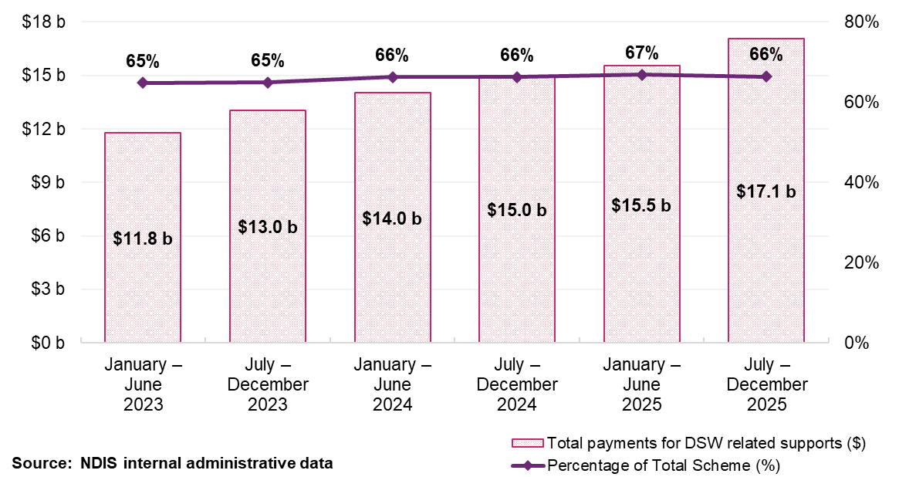

Supported Independent Living market
SIL is the largest support category within the NDIS by expenditure. In the
6 months to December 2025 SIL supports accounted for $5.8 billion in total payments across approximately 39,400 participants and 8,500 active providers.
SIL is structurally distinct from other DSW-related supports. Registered providers account for 47% of providers but 96% of SIL payments ($5.6 billion), reflecting their role in delivering high-volume, high-cost shared living supports. Unregistered providers account for 53% of providers but only 4% of payments ($258 million) and typically support small numbers of participants. Among registered SIL providers, companies make up 89% of the market, with sole traders accounting for 3%. Among unregistered SIL providers this is inverted: sole traders represent 70% of the market and companies 25%. While there are some larger providers in the market, it is characterised by a large number of small to medium-sized providers. The top
3 providers represent just over 10% of the market in terms of the number of participants (Figure 5).
Figure 5: Top 10 registered providers by participant, July to December 2025
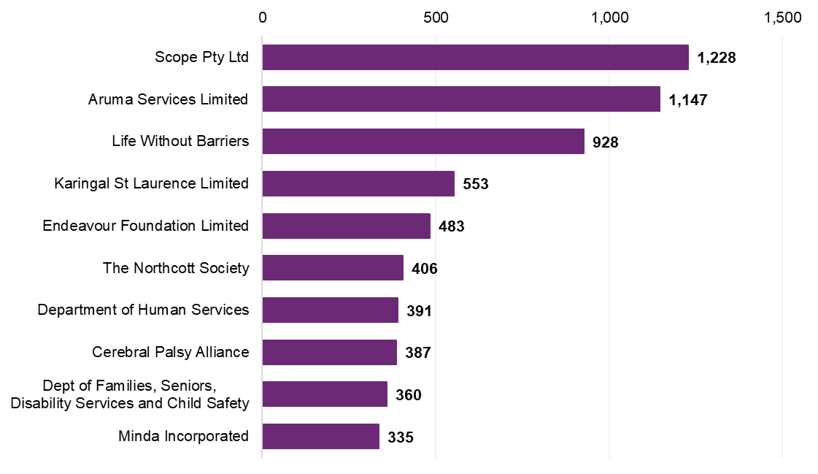
Source: NDIS internal administrative data
The structural features of SIL have direct implications for pricing. SIL supports are delivered continuously, often 24 hours a day, in shared living arrangements where rostering, staffing ratios and vacancy management creates cost management challenges that differ materially from episodic or session-based DSW supports. Participants also have limited practical ability to switch providers without changing residence. These features distinguish SIL from the broader DSW market and support the need for specific attention to SIL cost structures through the DSW Cost Model Review.
Table 5 shows participant numbers for SIL‑related supports delivered between July 2024 and December 2025 increased by 4.5% while provider numbers rose by 20.7%. Total payments to registered SIL providers rose by 10.4%, but average claims per provider declined from $1.55 million to $1.42 million.
Table 6 shows unregistered SIL providers operate at smaller scale. While participant numbers declined by 12.4% between July 2024 and December 2025, provider numbers remained relatively stable, declining by 0.6%. Despite declining participant numbers, total payments rose by nearly 9% to $257.9 million, and average claims per provider increased from $51,900 to $56,800.
Table 5: SIL-related supports Scheme statistics – registered providers, July 2024 to December 2025
Statistics | July – December 2024 | July – December 2025 | Percentage change
Number of NDIS participants | 34,831 | 36,410 | +4.5%
Number of active providers | 3,276 | 3,953 | +20.7%
Total amount claimed by active providers of SIL-related supports | $5.1 billion | $5.6 billion | +10.4%
Average amount claimed by all active providers of SIL-related supports | $1.55 million | $1.42 million | -8.5%
Source: NDIS internal administrative data
Table 6: SIL-related supports Scheme statistics – unregistered providers, July 2024 to December 2025
Statistics | July – December 2024 | July – December 2025 | Percentage change
Number of NDIS participants | 3,440 | 3,014 | -12.4%
Number of active providers | 4,569 | 4,541 | -0.6%
Total amount claimed by active providers of SIL-related supports | $237.1 million | $257.9 million | +8.8%
Average amount claimed by all active providers of SIL-related supports | $51,900 | $56,800 | +9.4%
Source: NDIS internal administrative data

Mandatory registration for SIL providers
From 1 July 2026 the NDIS Commission will implement mandatory registration for all SIL providers. This regulatory shift signifies that SIL, previously accessible through a mix of registered and unregistered entities, will be reclassified as a high-risk support. For providers, this means continuing to deliver SIL services after the deadline will be strictly contingent upon achieving formal registration. This represents a fundamental shift from elective compliance to a fixed, non-negotiable operational cost, placing pressure on administrative overheads and service delivery models.
The analysis applied to recommended pricing for SIL supports in this chapter reflects the current market distribution between registered and unregistered SIL providers; however, it is important to note this profile will shift significantly in future reviews as the sector transitions toward a fully registered environment from July 2026.

Participants
The top 10 DSW-related support items with the highest total payments in the
6 months to December 2025 are shown in Table 7. Assistance in Supported Independent Living – Standard is the largest support category based on total payments, accounting for $5.4 billion. While this support has the highest expenditure, other standard supports continue to increase in volume. The Assistance with Self-Care Activities – Standard ($4.4 billion) and Community, Social and Recreational Activities – Standard ($4.2 billion) support categories had the highest participant volumes and were delivered by 93,467 and 96,593 providers respectively.
By contrast, high-intensity supports such as Supported Independent Living – High Intensity ($404 million) and Assistance with Self-Care Activities – High Intensity ($477 million) were accessed by fewer participants and delivered by a small cohort of providers, 1,435 and 5,640 respectively (Table 7).
The distribution of support types across provider categories reflects the structural features of the market. Higher intensity supports, which carry greater regulatory, workforce and governance requirements, are predominantly delivered by registered organisations. Standard supports are more consistently delivered across registered and unregistered providers, including through sole traders and small-scale delivery models.

Table 7: Top 10 largest DSW-related supports (based on payments), July to December 2025
Support delivered | Total payments (million) | Number of participants | Number of providers
Assistance in Supported Independent Living - Standard | $5,432 | 37,096 | 8,052
Assistance With Self-Care Activities -Standard | $4,442 | 169,590 | 93,467
Access Community Social and Recreational Activities - Standard | $4,241 | 257,528 | 96,593
Group Activities - Standard | $658 | 63,422 | 7,682
Assistance With Self-Care Activities - High Intensity | $477 | 6,323 | 5,640
Assistance in Supported Independent Living (SIL) - High Intensity | $404 | 3,310 | 1,435
Short Term Accommodation (STA) and Assistance | $271 | 19,333 | 8,601
Activity Based Transport | $257 | 177,480 | 42,546
Capacity Building and Training | $206 | 57,068 | 25,716
Supports in Employment | $200 | 22,956 | 3,824
Source: NDIS internal administrative data
Note: Payment is on a cash basis.

Providers
The share of total DSW-related payments received by the top 10 providers fell from 8.9% in the 6 months from January to June 2023 to 6.9% in the 6 months from July to December 2025 (Figure 6). This decline coincides with the broader 6% growth in the active provider pool over the last year, indicating a gradual dilution of market concentration. The market share of the largest 10 providers has been falling continuously since the 6 months to June 2023.
This trend is more pronounced in thin markets where new entrants are reshaping market composition. In remote areas the top 10 providers’ market share dropped from 36% in the 6 months to June 2023 to 26% in the 6 months to December 2025. In very remote areas their share fell from 34% to 29% over the same 3-year period (Figure 7).
Figure 6: Top 10 providers’ market share against overall provider growth on
DSW-related supports, January 2023 to December 2025
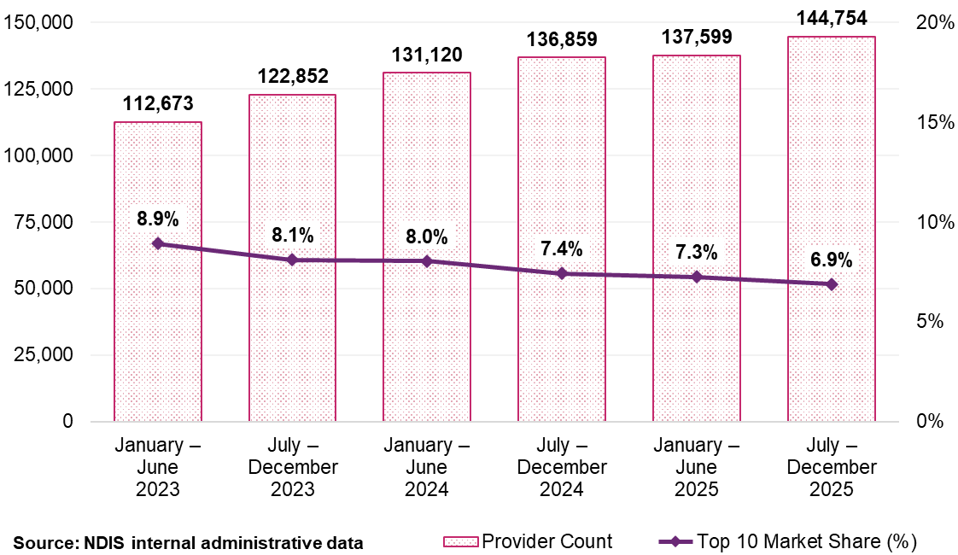
Figure 7: Top 10 providers’ market share by remoteness for DSW-related supports, January 2023 to December 2025
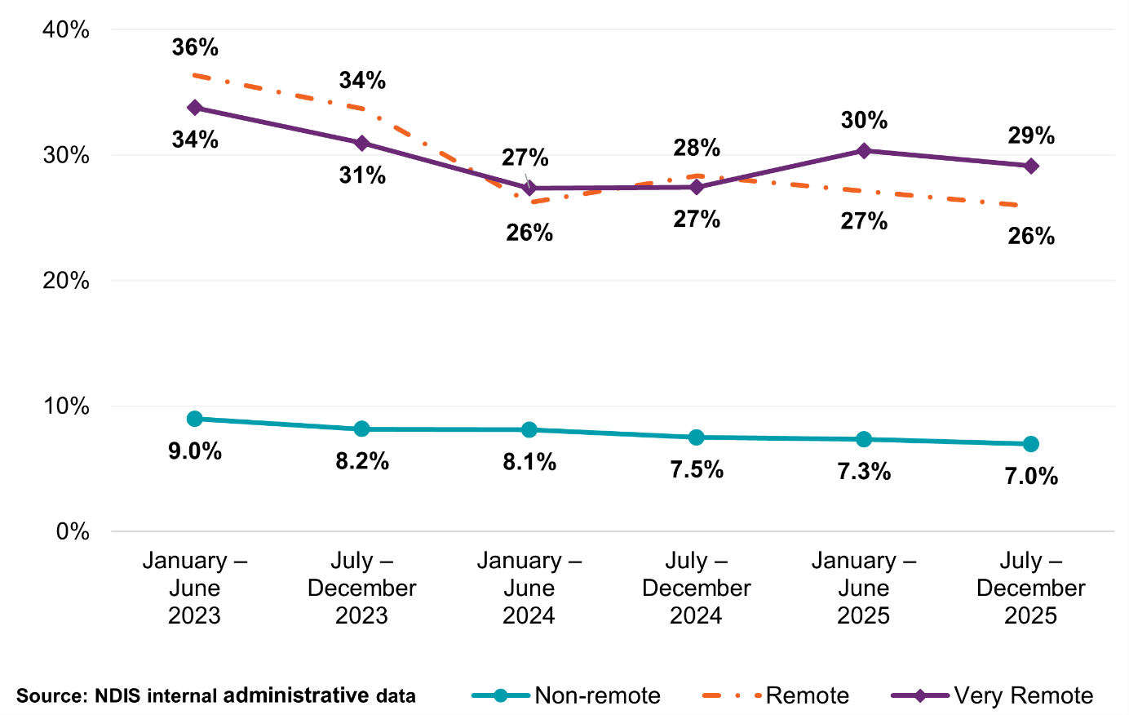

Legal entity
Companies and sole traders represent opposite ends of the provider spectrum for DSW-related supports. Companies comprise 17% of active providers but deliver the most supports, claiming $13.3 billion (78% of total payments) at an average of $525,600 per provider (Table 8). Sole traders account for 78% of active providers but operate at a much smaller scale, claiming $2.6 billion (15% of total payments) with an average claim of $22,800.
Table 8: DSW-related supports Scheme statistics by legal entity type, July to December 2025
Statistics | Company | Government entity | Partnership (other) | Trust / super | Sole trader
Number of NDIS participants | 262,990 | 2,306 | 10,140 | 31,736 | 118,724
Number of active providers | 25,238 | 205 | 2,435 | 4,451 | 112,421
Total amount claimed by active providers of DSW-related supports (billion) | $13.3 | $0.2 | $0.2 | $0.8 | $2.6
Average amount claimed  by all active providers of DSW-related supports | $525,600 | $761,500 | $77,400 | $187,700 | $22,800
Source: NDIS internal administrative data
Note: Providers with a missing legal entity type are excluded.

Claiming patterns
Claiming patterns for DSW-related supports have remained relatively stable over the past 3 years, with most claims made at or near the maximum price. In the 6 months to December 2025, 69 per cent of all claims were made at the maximum price. Registered providers have claimed at that price more consistently than unregistered providers, with the gap remaining relatively stable across the observation period (Table 9).
Table 9: Claiming patterns at the maximum price analysis for DSW-related supports, January 2023 to December 2025
Claiming patterns – at published price | January – June  2023 | July – December 2023 | January – June  2024 | July – December 2024 | January – June  2025 | July – December 2025
Registered | 74% | 73% | 71% | 71% | 74% | 73%
Unregistered | 60% | 56% | 61% | 57% | 64% | 61%
All providers | 70% | 67% | 67% | 66% | 70% | 69%
Source: NDIS internal administrative data

Provider scale and share of payments
The market remains highly diverse in terms of size of providers. Providers supporting 5 or fewer participants account for 89% of all DSW providers but claim only 17% of total payments. More than half of all active providers, 81,819 providers, support a single participant. At the other end of the distribution, providers supporting more than 100 participants account for less than 0.5% of providers but 34% of total payments (Table 10). The diversity in the scale of providers means care is required when analysing the health of the market as growth in the number of providers cannot be extrapolated to imply an expansion of sustained delivery capacity.
Table 10: Statistics on the size of providers for DSW-related supports, July to December 2025
Size of provider (number of participants supported) | Number of providers | Total payments to providers (billion) | Average payments to providers | Share of total payments
1 | 81,819 | $1.2 | $14,800 | 7.1%
2 | 24,170 | $0.7 | $27,500 | 3.9%
3 | 11,412 | $0.5 | $39,600 | 2.7%
4 | 6,611 | $0.4 | $54,800 | 2.1%
5 | 4,162 | $0.3 | $69,800 | 1.7%
6–10 | 7,739 | $1.0 | $133,700 | 6.1%
11–50 | 7,070 | $4.7 | $663,000 | 27.5%
51–100 | 1,113 | $2.6 | $2.3m | 15.0%
101–250 | 498 | $2.3 | $4.6m | 13.3%
251–1000 | 146 | $2.2 | $15.3m | 13.1%
1000+ | 14 | $1.3 | $91.9m | 7.5%
Overall | 144,754 | $17.1 | $117,800 | 100%
Source: NDIS internal administrative data
Note: Average revenue is rounded up to the nearest hundred.

Payment consistency
Long-term provider retention varies significantly by registration status, with 41% of registered providers active across all 6 half-year periods from January 2023 to December 2025, claiming 92% of total registered payments (Figure 8). In contrast amongst unregistered providers, consistent activity is significantly lower, with 17% delivering supports across all 6 periods. However, this stable base still captures the majority of value, claiming 69% of total unregistered payments, while a larger portion of the unregistered market is transient (Figure 8).
Figure 8: Provider continuity for DSW-related supports by registration status and percentage of total payments, January 2023 to December 2025
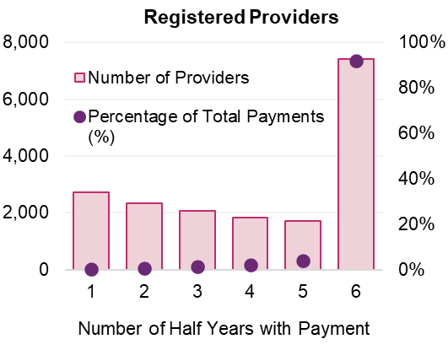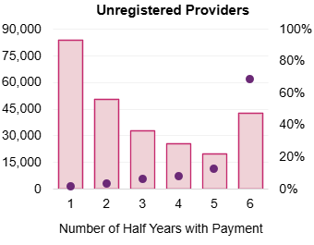
Source: NDIS internal administrative data

Payment activity for registered providers
Market turnover analysis shows provider entries and exits have a minimal financial impact relative to the total market size. Inactive registered providers accounted for 0.2% of total payments in the 6 months to December 2025, and similarly, newly active registered providers contributed 1.0% of total payments in the same period (Figure 9).
Figure 9: DSW-related registered provider activity movements, January 2023 to December 2025
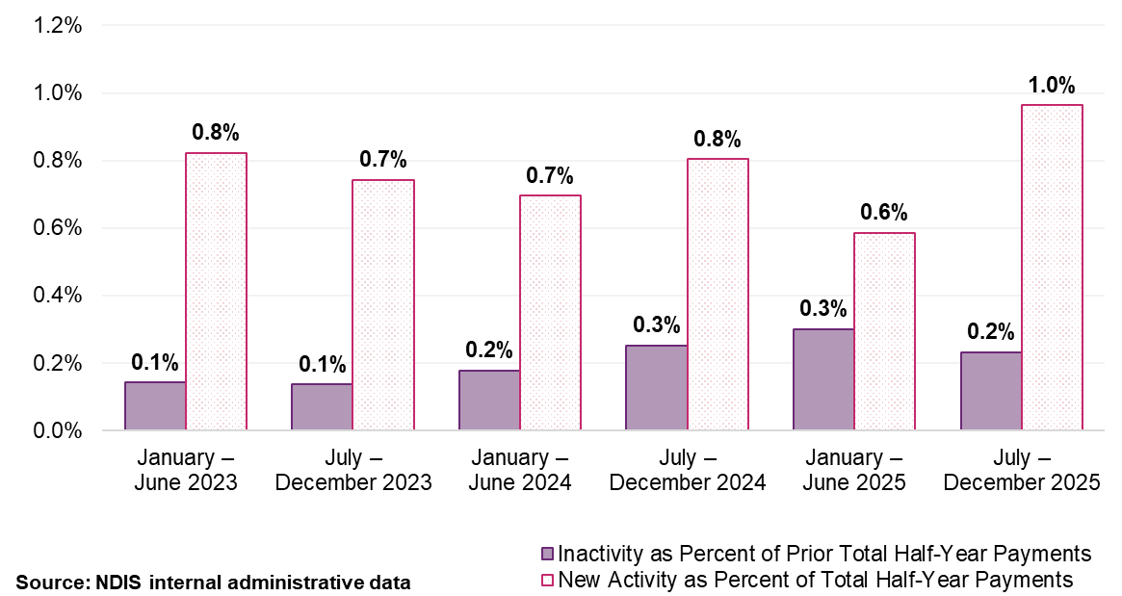
Note: ‘New Activity’ within a half-year period is identified when providers who were inactive in the previous half-year begin to receive payments. Conversely, ‘Inactivity’ is noted when providers that received payments in one half-year do not in the subsequent one. These fluctuations are measured as a percentage of the total payments made within that half-year, or the previous one, in the case of inactivity.
  - Consultation
Consultation evidence in this chapter plays a different role from consultation in the benchmarked therapy market and Scheme-created markets like plan management and support coordination. In the absence of external price comparators, provider feedback on cost pressures is the primary source of evidence for identifying which DSW Cost Model assumptions may no longer reflect contemporary service delivery conditions. This makes consultation more analytically important here than in chapters where benchmarking data is available. At the same time, provider reports of cost pressures do not by themselves establish that current prices are inadequate. They identify where the model warrants scrutiny, not what the price level should be. Participant feedback identifying access and quality concerns are relevant to monitoring and stewardship; they do not determine pricing recommendations.

Participants
Participant responses indicate that in the DSW market, quality and access are closely linked. Around 74% of respondents rated quality as very or somewhat important. This suggests participants place substantial weight on the suitability and reliability of support rather than on price alone. At the same time access constraints were prominent. Half of respondents who expressed a view on complex supports said they often or sometimes had difficulty finding providers able to deliver to them, while 52% said many providers, or at least a few providers, would not travel to them. These responses were more common in regional and remote areas and among respondents supporting participants with more complex needs. This indicates that practical access remains uneven, even where overall provider supply appears sufficient.
This does not mean participants are indifferent to price. Concerns increased when pricing was perceived to affect the amount of support that could be purchased or the ability to retain existing providers. When asked about their strongest concerns with differentiated pricing, 70% cited getting fewer hours in their plan, 59% cited providers charging more than needed and 55% cited losing access to their current provider. Only 7% reported no concerns. This suggests participants experience price most directly through its effect on continuity and purchasing power, rather than as a simple signal of provider quality.
Responses on provider choice reinforce this pattern. When asked how they would respond to differentiated pricing, 45% said it would not change their provider choice, indicating that existing relationships and service fit remain the dominant considerations. However, 27% said they would choose unregistered providers to access more hours from their budget, while 15% said they would choose registered providers for quality or safety. A further 7% said their choice would depend on support type and 7% said they would need help understanding their options. Taken together, the consultation suggests participants value quality and continuity but often make choices within constrained local markets where provider availability, willingness to travel and the effective purchasing power of plan budgets shape the options available to them.

Providers
Provider feedback indicates the DSW market remains heavily anchored to award-based employment settings. Around 89% of DSW consultation respondents identified the SCHADS Award as part of their primary employment model, with a further 10% identifying an EBA in some form. This suggests that, for most providers responding on DSW supports, pricing concerns are being considered through an award-linked cost structure rather than through purely discretionary labour arrangements. In that context, the key question is not whether SCHADS wage rates are adequate, but rather which elements of the broader cost structure providers are unable to recover under current prices.
On the question of cost structures that are difficult for providers to absorb, provider feedback points more strongly to the broader delivery requirements surrounding direct care than to wage rates alone. Qualifications and training were identified in 75% of DSW consultation records, while 69% referred to supervision, administration or other indirect-time burdens and 55% raised safeguarding or oversight considerations. This suggests that while SCHADS remains the core wage-setting framework, providers see cost pressures arising from the wider operating requirements attached to employing and supporting that workforce. The implication for pricing is that the issue may lie less in annual recognition of SCHADS wage movements and more in whether the broader DSW Cost Model continues to reflect the non-direct costs associated with delivering supports under contemporary workforce, compliance and safeguarding settings.
Responses on pricing differentiation reinforce this pattern. Registration status was the most nominated basis for differentiation in DSW supports, followed by participant complexity and workforce qualifications. In qualitative responses, providers frequently linked these issues back to the cost of employing and supervising staff under more formal service models, and to concerns that providers investing in compliance, workforce capability and governance face the same prices as models with materially lower overheads. The consultation suggests SCHADS-linked indexation remains accepted as the appropriate mechanism for annual wage adjustments, but providers are less confident that the current DSW Cost Model fully captures the broader cost structures associated with delivering workforce-intensive supports under contemporary award, regulatory and safeguarding settings.
  - Discussion
This chapter addresses 3 distinct questions. First, whether the current indexation approach remains appropriate for 2026–27. Second, whether the DSW Cost Model continues to provide an adequate basis for pricing DSW-related supports, or whether its structural assumptions require updating, a model-adequacy question. Third, what the pathway to structural reform should be, including the scope and sequencing of the DSW Cost Model Review and the SIL Pricing Review. These 3 questions are related but distinct: the first can be answered affirmatively on current evidence without resolving the second, and the second can be diagnosed without fully resolving the third.
The persistence of claiming at the 60-minute maximum price (69% across all providers and 73% for registered providers), remains stable over the past 3 years. This pattern establishes that the prices published by the NDIA continue to function as an active market-setting mechanism rather than a passive ceiling. This indicates that the NDIA’s approach to indexation has real consequences: providers are pricing at or near the maximum price and annual wage adjustments flow through directly to provider economics. It also means that any structural understatement of costs in the model is not offset by providers charging below the recommended maximum price. These signals together confirm that annual SCHADS-linked indexation remains the appropriate near-term pricing response, while also pointing to why the model’s structural assumptions warrant a more comprehensive review.

Cost model adequacy
The DSW Cost Model provides a transparent and consistently applied basis for developing pricing recommendations for workforce-intensive supports. Its link to SCHADS Award wage rates ensures annual price adjustments track the primary cost driver for most providers. For the purpose of developing recommendations for 2026-2027 prices, the model remains fit for use.
The question of whether the model’s structural assumptions remain adequate is separate from the indexation question and requires its own assessment. The model’s overhead parameters were last calibrated based on benchmarking survey results from 2020–21. Three developments indicate the model assumptions may no longer reflect contemporary delivery conditions.
First, the operational overhead assumptions, covering supervision, training, utilisation and quality assurance, were all calibrated against a provider mix that predates significant market fragmentation. Since then, the number of micro-providers and sole traders has grown and accounts for 78% of active providers. This means the model’s utilisation assumptions, designed around organisational delivery at scale, are increasingly applied to delivery models with structurally different cost profiles. Second, consultation evidence indicates providers see cost pressures primarily arising from broader workforce requirements, qualifications and training, supervision and administration, and safeguarding, rather than from award wage rates alone. These are the components of operational overhead most likely to have shifted since 2020–21, and the direction of risk is that the model understates them for registered organisational providers delivering complex supports. Third, SIL delivery conditions have diverged materially from the common model assumptions, a point addressed in the SIL subsection below.

Industrial relations context
The Fair Work Commission’s (FWC) Expert Panel for pay equity in the care and community sector is conducting a Gender-based undervaluation – priority awards review. Initiated in June 2024, it includes the SCHADS Award as one of
5 priority awards. In its initial decision in April 2025, the Expert Panel found that increases to minimum award wages for social and community services employees and home care employees in disability care covered by the SCHADS Award are necessary, finding that existing rates do not properly reflect the value of the work performed in part due to historical gender-based undervaluation.
The Expert Panel’s provisional view is the 5 separate SCHADS classification structures should be abolished and replaced with a single, simplified classification structure based on alignment with the Caring Skills benchmark rate. This would also involve revoking the existing Equal Remuneration Order as it would be redundant once new rates are in place. Submissions from interested parties reflected broad support for addressing gender-based undervaluation and a simplified classification structure but raised significant concerns that the proposed structure fails to capture the nuance of work in the social services sector and that some workers could face reduced pay under the transition.
The NDIA will continue to monitor the progression of the Award case and consider any final determination in its guidance through the DSW Cost Model Review scheduled for 2026–27.

Market structure and dynamics
The DSW market continues to grow and diversify, with provider numbers reaching nearly 145,000 in the 6 months to December 2025. Growth has occurred across all geographic areas and both registration categories. However, the composition of this growth matters for pricing. Most new entrants are operating at very small scale, with 89% of providers supporting 5 or fewer participants, and 81,819 providers (57%) supporting a single participant. The core of economically significant providers, those delivering most payments, is a relatively stable cohort, with 41% of registered providers active across all 6 half-year periods accounting for 92% of registered provider payments. Growth in provider numbers should not be read as a material expansion of sustained delivery capacity.

Supported Independent Living
SIL warrants specific attention within the DSW pricing framework. It is the largest support category by expenditure, is dominated by registered providers, and supports a cohort that is generally more established and higher intensity than the broader DSW market. SIL participants are concentrated in longer-duration support arrangements and higher-support streams, indicating a market shaped less by episodic service use and new entrant growth than by sustained, continuous care. This distinguishes SIL from other DSW-related supports where delivery is more episodic, participant-provider relationships are more contestable, and provider entry is a more meaningful indicator of effective supply.
The provider market is also structurally distinct. While registered providers account for less than half of all SIL providers they receive almost all SIL payments. This indicates the economically material segment of the market is overwhelmingly registered and large in scale. Unregistered providers are numerically present but financially peripheral. Participant choice is also materially weaker than in other DSW markets, as changing SIL providers often requires changing living arrangements rather than simply changing service providers. Taken together, these features suggest the current general DSW pricing framework may not fully capture the cost structure, fixed operating requirements and weaker competitive dynamics of SIL. The SIL pilot is therefore a central part of the NDIA’s evidence-building for future reform. Its findings will help determine whether SIL requires price settings that better reflect its distinctive delivery model and cost structure. Until that evidence is available, current SIL prices should continue to be maintained through the standard DSW Cost Model.
Participants currently using unregistered providers may be forced to switch if their preferred provider chooses not to register. In regional, rural and remote areas, choice in providers is often limited. Mandatory registration may push smaller, boutique or local providers out of the market. However, participants will have the assurance that every worker in their home has passed mandatory worker screening checks, and the provider meets national SIL Practice Standards (also set to be introduced from 1 July 2026).
The implementation of mandatory registration is expected to trigger a period of market consolidation as providers evaluate the long-term viability of their current operating models. The significant capital investment required for Certification Audits, coupled with the increased administrative overhead of high-risk compliance, creates a substantial barrier to entry. Consequently, providers unable or unwilling to absorb these additional regulatory costs may choose to exit the SIL market. This potential reduction in the number of active providers poses a direct risk to participant choice, as the market may shift toward a more concentrated landscape dominated by larger, integrated organisations, potentially limiting the diversity of service models available to participants.
  - Recommendations

DSW Cost Model indexation and review
Supports priced under the DSW Cost Model are directly linked to wage decisions under the FWC’s SCHADS Award and to the National Employment Standards. While structured indexation gives providers certainty to meet minimum legal entitlements for their employees, the NDIA should retain flexibility to respond to changes that affect the NDIS and the disability sector.
When making pricing decisions for DSW-related supports, the NDIA considers:
- Movements in adjacent sectors, such as Aged Care Award decisions
- Changes to applicable awards, including the current Gender-based undervaluation – priority awards review
- Any changes to the National Employment Standards.
Where appropriate, the NDIA may undertake further review of pricing decisions to assess implications for provider sustainability and NDIS outcomes. Any final outcomes from the gender undervaluation proceedings will be incorporated into the DSW Cost Model.

Recommendation 1:
Prices for supports determined by the NDIS Disability Support Worker Cost Model should be adjusted to reflect changes in the minimum wage specified in the Social, Community, Home Care and Disability Services Industry Award 2010 (SCHADS Award), as determined by the Fair Work Commission’s Annual Wage Review determination on 2 June 2026.

Recommendation 2:
The NDIA should undertake a review of the Disability Support Worker Cost Model, including consideration of whether the model’s structure and the way workforce and wage-setting inputs are incorporated continue to appropriately reflect contemporary employment and labour market conditions.

Short Term Accommodation
The Short Term Accommodation (STA) recommendation addresses a specific structural issue. The current approach bundles accommodation and support worker costs into a single rate. This does not reflect the distinct cost components of temporary accommodation and the actual hours and intensity of support delivered. It also embeds cost elements not specified within the NDIS Supports for Participants Rules, reducing transparency about what the price is intended to fund. Unbundling STA prices, aligning the accommodation component with the existing Medium-Term Accommodation (MTA) rate and the support worker component with SIL pricing under the DSW Cost Model, would improve transparency and enable more accurate claiming based on actual support delivered, in alignment with comparable supports.

Recommendation 3:
The current daily price for Short Term Accommodation should be unbundled so that:
    - The accommodation component reflects only the capital cost of a temporary stay away from a participant’s usual place of residence. The price of Short Term Accommodation should be aligned with the existing price for Medium Term Accommodation ($158.66).
    - New 'Short Term Accommodation – Assistance with self‑care or community access activities’ support items apply. These support items should be structured by day of the week and time of day and aligned with the Disability Support Worker Cost Model. This will allow for accurate claiming based on:
- The actual hours of support delivered,
- The times of the day and week that supports are delivered, and
- The intensity of supports delivered.
    - Providers supporting participants funded for High Intensity Supports and/or behaviours of concern will be able to claim these loadings when appropriate.
  - Indexation of nurses and other general supports
In December 2024, the FWC issued its decision in the Aged Care Work Value Case, introducing staged wage increases for nurses employed in aged care settings. However, these increases did not apply to nurses classified as ‘other than aged care employees. In response, nurses in other sectors have pursued comparable wage outcomes through separate industrial processes.
NDIS nursing prices were established in 2019 using higher award wage benchmarks across jurisdictions and are differentiated by nursing level and service context. These prices have been indexed annually. Having regard to the Aged Care determination, the NDIA considers current nursing prices remain appropriate. Award wages for a mid‑level Registered Nurse are materially lower than the applicable NDIS prices once non‑wage costs are accounted for in the Nursing Cost Model. At this stage, there is limited evidence of sector‑wide access issues or coordinated claims for higher NDIS rates. The NDIA will continue to monitor access and labour market conditions, including the potential flow‑on effects of future aged care wage decisions.
For nurses and selected community‑based supports not covered by the DSW Cost Model (which applies to workers employed under the SCHADS Award) and are not otherwise subject to specific adjustments in this APR, price movements should be applied through indexation. Indexation will reflect a weighted combination of movements in the Australian Bureau of Statistics (ABS) Wage Price Index (WPI) and Consumer Price Index (CPI). This ensures price adjustments remain proportionate, evidence‑based and aligned with broader provider cost pressures, without pre‑empting the outcomes of sector‑specific wage processes.

Recommendation 4:
Prices should increase for nursing and other supports not covered by Disability Support Worker-related supports, Capital supports or otherwise covered in the Annual Pricing Review. This adjustment should reflect the weighted movement in the ABS WPI (Australia, total hourly rates of pay excluding bonuses) and the ABS CPI (All Groups, weighted average of 8 capital cities) over the 12 months to the end of Quarter 3 (31 March 2026) immediately preceding the indexation data (with an 80/20 weighting).

- Therapy supports
  - Context
Therapy supports are delivered within professional labour markets of the care economy that extend beyond the NDIS. Psychologists, Physiotherapists, Occupational Therapists, Speech Pathologists, Dietitians and Exercise Physiologists work in various settings across Medicare, private health insurance (PHI), aged care, worker’s compensation and motor accident schemes, and private practice. The NDIS is one source of funding in these markets, rather than the sole or dominant source of demand, with participants the purchasers of therapy services.
The structure of the therapy market creates a distinct pricing context. Unlike most other NDIS support categories, therapy services have observable market prices established through millions of transactions that can be captured through other funding systems. Medicare Benefits Scheme (MBS) data, PHI claims data and pricing information from government injury and compensation schemes provide an external reference for assessing prevailing market rates. The sources are used for comparison, not because they are identical to the NDIS, but because they share the same therapist workforce. The professionals who deliver NDIS therapy also deliver services under MBS, PHI and other compensation schemes, and their allocation decisions are shaped by the relative return across those systems.
The existence of these external markets creates a specific pricing challenge. Where NDIS prices sit consistently and materially above prevailing rates in comparable markets, the NDIA risks systematically paying higher rates for professional services available at lower rates elsewhere. This may not represent value for participants or the NDIS. On the other hand, if prices sit materially below prevailing rates, qualified professionals may direct their capacity toward better-compensated settings, reducing participant access to timely and appropriate therapy. The NDIA’s objective is to position recommended NDIS prices within the range of observed market rates at a level that supports access to quality services that promote positive participant outcomes and sustains provider services, while avoiding systematic overpayment relative to the broader care economy.
The previous APR established the benchmarking methodology that informs this assessment, drawing on MBS and PHI billing data alongside other government schemes’ pricing. Following that initial review, price adjustments were made to several therapy types, jurisdictional pricing premiums were removed for Psychologists and Physiotherapists, and the potential for longer-term structural adjustments to therapy pricing was considered. This APR applies updated and additional data to the same methodology, recommends continued refinement of pricing to align with broader markets and progresses the foundational work for broader pricing reform.
  - Scheme statistics

Market overview
In the 6 months to December 2025, therapy supports were accessed by 465,602 participants. This is an increase of 12.8% compared to the same period in 2024. Total payments reached $2.7 billion, an increase of 10.3% compared with the same period in 2024, and accounts for approximately 10% of total NDIS expenditure. Despite growing participant demand, the number of active therapy providers declined by 3.9% to just over 53,200 (Table 11, Figure 10). This divergence, rising demand alongside declining provider numbers, is a distinctive market signal for therapy and not observed in DSW, Support Coordination, Plan Management or Social, Community and Civic Participation markets. It shapes how pricing risk should be assessed. Provider numbers are already contracting so reductions that widen the gap between NDIS and comparator rates carry a higher probability of further exits, than increases carry of overshooting the market.
Table 11: Therapy supports Scheme statistics – all providers, July 2024 to December 2025
Statistics | July – December 2024 | July – December 2025 | Percentage change
Number of NDIS participants | 412,945 | 465,602 | +12.8%
Number of active providers | 55,366 | 53,205 | -3.9%
Total amount claimed by active providers of therapy supports | $2.4 billion | $2.7 billion | +10.3%
Average amount claimed by all active providers of therapy supports | $43,700 | $50,100 | +14.6%
Source: NDIS internal administrative data
Figure 10: NDIS expenditure on therapy supports since January 2023 relative to total NDIS expenditure
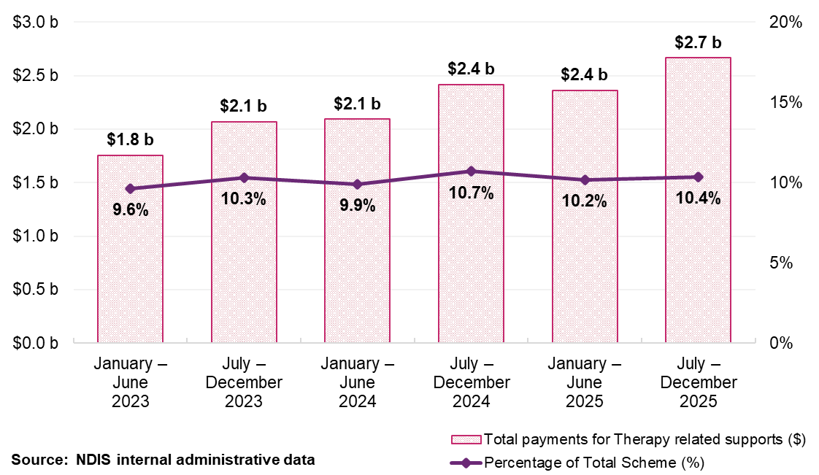

Participants, payments and providers
In the 6 months to December 2025, 5 therapies accounted for more than 75% of all therapy payments: Early Childhood Intervention therapists ($592 million), Occupational Therapists ($554 million), Behaviour Support Professionals ($497 million), Speech Pathologists ($234 million) and Physiotherapists ($211 million) (Table 12). Together, these 5 categories represented $2.1 billion in claims. This is just over three-quarters of the NDIA’s $2.7 billion therapy expenditure during the reporting period.
In the 6 months to December 2025, 337,008 participants used registered providers, representing a 10% increase compared with the same period in the previous year. Over the same period, 290,644 participants used unregistered providers, a 14% increase from the previous year.
Figure 11 illustrates the high degree of concentration in therapy expenditure, showing that a small number of therapy types have consistently accounted for most NDIS therapy payments over time. This concentration has remained stable despite growth in overall expenditure.

Table 12: Scheme expenditure by type of therapist, July to December 2025
Type of therapist | Total payments (million) | Number of participants | Number of providers
Early Childhood | $592 | 141,068 | 17,758
Occupational Therapist | $554 | 267,211 | 9,222
Behavioural Therapist | $497 | 76,888 | 1,955
Speech Pathologist | $234 | 133,587 | 6,169
Physiotherapist | $211 | 99,986 | 8,968
Psychologist | $205 | 111,413 | 13,312
Exercise Physiologist | $86 | 42,604 | 3,997
Other Professional | $77 | 54,899 | 13,663
Therapy Assistant | $43 | 42,008 | 4,385
Social Worker | $28 | 16,312 | 2,667
Counsellor | $27 | 18,745 | 4,235
Dietitian | $20 | 23,429 | 1,833
Podiatrist | $14 | 34,165 | 2,671
Miscellaneous | $9 | 3,708 | 2,281
Development Educator | $8 | 4,057 | 435
Music Therapist | $7 | 4,303 | 735
Art Therapist | $5 | 3,146 | 828
Rehabilitation Counsellor | $0.8 | 714 | 285
Orthoptist | $0.7 | 1,142 | 230
Audiologist | $0.5 | 1,314 | 159
Total | $2,666 | 465,602 | 53,205
Source: NDIS internal administrative data
Note: The total for both the number of participants and providers represents unique counts within the July to December 2025 period. ‘Other Professional’ refers to a diverse group of therapy providers offering services such as assessments, recommendations, and group therapies, which may encompass a variety of therapy disciplines not individually listed. Total payments also include therapy-related travel payments, which amounted to $49 million and claimed by 14,977 providers from 226,966 participants.
Figure 11: Largest 10 therapy types based on total NDIS payments, January 2023 to December 2025
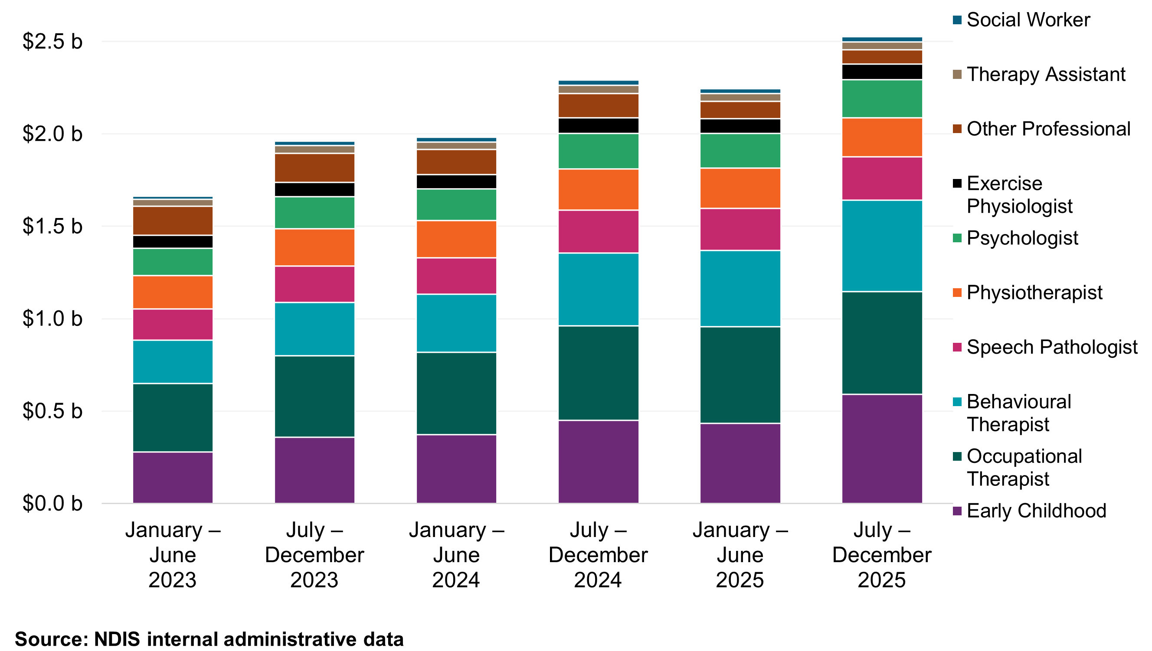

Provider growth and registration trends
The therapy provider market continues to be dominated by unregistered providers. In the 6 months to December 2025, unregistered providers represented approximately 87% of all therapy providers. This percentage has remained broadly stable since 2023 (Figure 12). Unregistered providers accounted for approximately 40% of total therapy payments, while registered providers, at 13% of provider count, delivered approximately 60% of total payments (Table 13, Table 14 and Figure 12).
While the number of therapy providers declined over the period, trends are different amongst registered and unregistered providers. The number of registered providers increased slightly by 0.5%, from 7,237 to 7,274, while the number of unregistered providers declined by 4.9%, from 48,709 to 46,330 (Table 13 and Table 14). These movements reinforce the dominance of registered providers in the market that continue to deliver a disproportionate share of total therapy payments relative to their share of provider numbers.
This gap between provider numbers and payment share reflects the different scale at which registered and unregistered therapy providers operate. In the 6 months to December 2025, the average claim per registered therapy provider was $225,100 compared to $22,000 for unregistered providers (Table 13 and Table 14), a ratio of more than 10:1.
Table 13: Therapy supports Scheme statistics – registered providers, July 2024 to December 2025
Registered providers | July – December 2024 | July – December 2025 | Percentage change
Number of NDIS participants | 307,193 | 337,008 | +9.7%
Number of active providers | 7,237 | 7,274 | +0.5%
Total amount claimed by active providers of Therapy supports | $1.5 billion | $1.6 billion | +9.5%
Average amount claimed by all active providers of Therapy supports | $206,700 | $225,100 | +8.9%
Source: NDIS internal administrative data
Table 14: Therapy supports Scheme statistics – unregistered providers, July 2024 to December 2025
Unregistered providers | July – December 2024 | July – December 2025 | Percentage change
Number of NDIS participants | 255,389 | 290,644 | +13.8%
Number of active providers | 48,709 | 46,330 | -4.9%
Total amount claimed by active providers of Therapy supports | $0.9 billion | $1.0 billion | +12.0%
Average amount claimed by all active providers of Therapy supports | $18,600 | $22,000 | +18.3%
Source: NDIS internal administrative data
Note: The totals for registered and unregistered providers may not match the overall provider count due to 2 factors: 1) Provider registration status may change during the period and are counted towards both categories, 2) A small fraction of providers with unspecified registration status are included in the total count but not detailed in the table.
Figure 12: Total payments for therapy support items by provider registration status, January 2023 to December 2025
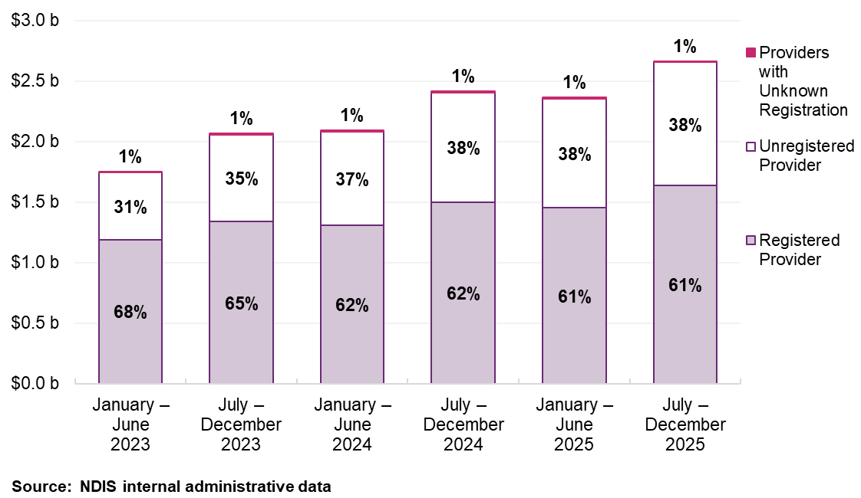
Note: Numbers may not add to 100% due to rounding.
From January 2023 to mid-2024, both provider numbers and participant demand grew, though participant growth outpaced provider growth throughout this period. From mid-2024, the pattern shifted: active provider numbers peaked at 55,366 in the July-December 2024 period and declined to 53,205 by December 2025, a fall of 3.9%, while participant numbers continued to rise, reaching 465,602 by December 2025, up 12.8% on the same period in 2024 (Figure 13).
The decline in active providers is driven entirely by the unregistered segment, where provider numbers fell 4.9% (from 48,709 to 46,330), while registered provider numbers were broadly stable (up 0.5% from 7,237 to 7,247). This suggests the overall contraction reflects churn and exit among smaller, unregistered providers, rather than a broad market withdrawal.
Taken together, growing participant demand and a contracting unregistered provider base means an increasing share of therapy demand is being absorbed by a stable registered provider cohort. This is a trend with implications for both access and the distribution of pricing pressure across the market.
Figure 13: Number of participants and providers claiming therapy supports, January 2023 to December 2025
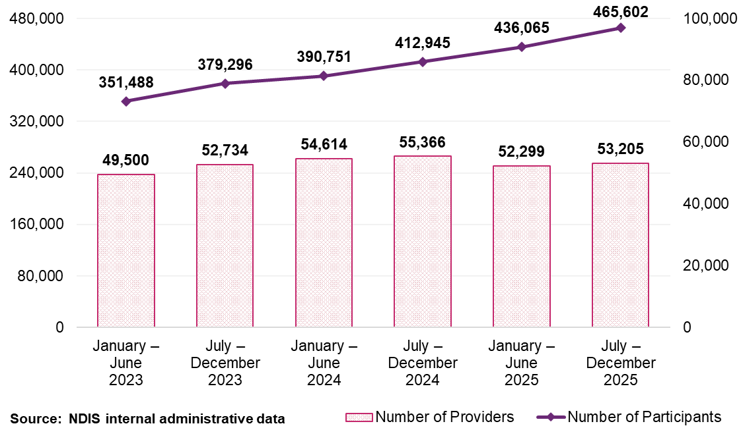

Business structure – most supports are provided by companies
The therapy market has produced a diversity of provider types that reflect the range of participant needs across the Scheme. As at December 2025, companies accounted for approximately 33% of therapy providers and delivered more than 70% of total therapy payments, while also supporting the largest number of participants (Table 15, Table 16 and Table 17). Sole traders represented approximately 56% of providers but accounted for a substantially smaller share of total payments ($421 million) (Table 15, Table 16 and Table 17). This distribution reflects the range of service delivery models present in the therapy market. Larger providers tend to operate at scale across broader participant cohorts, while sole traders typically deliver therapy to smaller numbers of participants, often alongside private or Medicare caseloads.
Table 15: Therapy supports Scheme statistics by legal entity type, July to December 2025
Statistics | Company | Government entity | Partnership (other) | Trust / super | Sole trader
Number of NDIS participants | 391,655 | 4,506 | 13,094 | 104,979 | 157,004
Number of active providers | 17,535 | 115 | 969 | 4,791 | 29,796
Total amount claimed by active providers of Therapy supports ($ million) | $1,912.6 | $9.8 | $30.1 | $281.2 | $421.1
Average amount claimed by all active providers of Therapy supports | $109,100 | $85,100 | $31,000 | $58,700 | $14,100
Source: NDIS internal administrative data
Note: Providers with a missing legal entity type are excluded. Average revenue is rounded up to the nearest hundred.
Table 16: Number of providers of therapy supports by legal entity type, January 2023 to December 2025
Legal entity type | January – June 2023 | July – December 2023 | January – June 2024 | July – December 2024 | January – June 2025 | July – December 2025
Company | 14,668 | 15,977 | 16,700 | 17,427 | 16,792 | 17,535
Government entity | 169 | 174 | 164 | 134 | 122 | 115
Partnership (other) | 1,288 | 1,258 | 1,229 | 1,200 | 1,040 | 969
Trust / super | 4,967 | 5,101 | 5,109 | 5,084 | 4,795 | 4,791
Sole trader | 28,398 | 30,204 | 31,398 | 31,515 | 29,541 | 29,796
Total | 49,500 | 52,734 | 54,614 | 55,366 | 52,299 | 53,205
Source: NDIS internal administrative data
Note: Providers with a missing legal entity type are excluded and some entities may have changed their legal entity type during the year.
Table 17: Payment amount ($ million) for therapy supports by legal entity type, January 2023 to December 2025
Legal entity type | January – June 2023 | July – December 2023 | January – June 2024 | July – December 2024 | January – June 2025 | July – December 2025
Company | $1,198.3 | $1,427.5 | $1,455.3 | $1,702.0 | $1,680.6 | $1,912.6
Government entity | $7.0 | $8.2 | $7.4 | $10.0 | $8.7 | $9.8
Partnership (other) | $27.4 | $28.4 | $25.9 | $28.3 | $26.8 | $30.1
Trust / super | $205.7 | $242.6 | $241.9 | $268.8 | $254.0 | $281.2
Sole trader | $304.0 | $349.9 | $349.2 | $395.1 | $382.4 | $421.1
Total | $1,753.6 | $2,070.3 | $2,092.8 | $2,417.2 | $2,363.3 | $2,666.4
Source: NDIS internal administrative data
Note: All payments are included here regardless of missing details. Payments from missing legal entity type are excluded from the breakdown but included in the total.

Geographic distribution
Provider distribution varied by region. In non-remote areas, the number of registered providers was 7,224 in the 6 months to December 2025, while unregistered providers numbered 46,012 (Table 18 and Table 19). In remote areas there were 600 registered providers compared to 1,135 unregistered providers. For very remote areas there were 354 registered providers and 567 unregistered providers (Table 18 and Table 19).
Between January 2023 and December 2025, the number of registered providers declined by 12% in non-remote areas but grew in both remote and very remote areas by 15% and 19% respectively (Table 18).
Unregistered providers have grown across all areas (increased by 10% in non-remote areas, 46% in remote areas and 64% in very remote areas (Table 19). These trends indicate continued growth in provider availability across remote regions, supported by steadily increasing numbers of both registered and unregistered providers.

Table 18: Registered providers by remoteness for therapy supports, January 2023 to December 2025.
Remoteness | January – June  2023 | July – December  2023 | January – June  2024 | July – December  2024 | January – June  2025 | July – December  2025
Non-remote | 8,250 | 7,325 | 7,081 | 7,192 | 6,918 | 7,224
Remote | 522 | 519 | 616 | 609 | 546 | 600
Very remote | 298 | 324 | 315 | 348 | 354 | 354
Total for registered | 8,300 | 7,391 | 7,125 | 7,237 | 6,977 | 7,274
Source: NDIS internal administrative data
Table 19: Unregistered providers by remoteness for therapy supports, January 2023 to December 2025.
Remoteness | January – June  2023 | July – December  2023 | January – June  2024 | July – December  2024 | January – June  2025 | July – December  2025
Non-remote | 41,938 | 45,543 | 47,465 | 48,299 | 45,347 | 46,012
Remote | 775 | 944 | 1,368 | 1,343 | 1,139 | 1,135
Very remote | 346 | 427 | 515 | 561 | 535 | 567
Total for unregistered | 42,260 | 45,961 | 47,941 | 48,709 | 45,690 | 46,330
Source: NDIS internal administrative data
Note: The totals for registered and unregistered providers may not match the overall provider count due to 3 factors: 1) Provider registration status may change during the period and be counted towards both categories. 2) A small fraction of providers with unspecified registration status are included in the total count but not detailed in the table. 3) Unavailability of participant location data at the time of transactions, which affects the determination of provider remoteness.

Market share and consolidation
The distribution of therapy payments continues to reflect a highly decentralised provider market. This indicates that market growth has been distributed across the provider base rather than concentrated among a small number of large operators. Between January 2023 to December 2025 the top 10 providers’ share of total therapy payments remained broadly stable, declining only slightly from 10.8% to 10.6% (Figure 14).
Market share differs by remoteness. In non-remote areas the top 10 providers’ share remained steady at around 10.7% (Figure 15). In contrast, remote and very remote regions showed an overall decline in concentration, with the top 10 providers’ share decreasing over the January 2023 to December 2025 period. These trends indicate a gradual redistribution of service delivery toward a broader base of providers, particularly in remote and very remote areas.
Figure 14: Top 10 providers’ market share against overall provider growth on therapy supports, January 2023 to December 2025
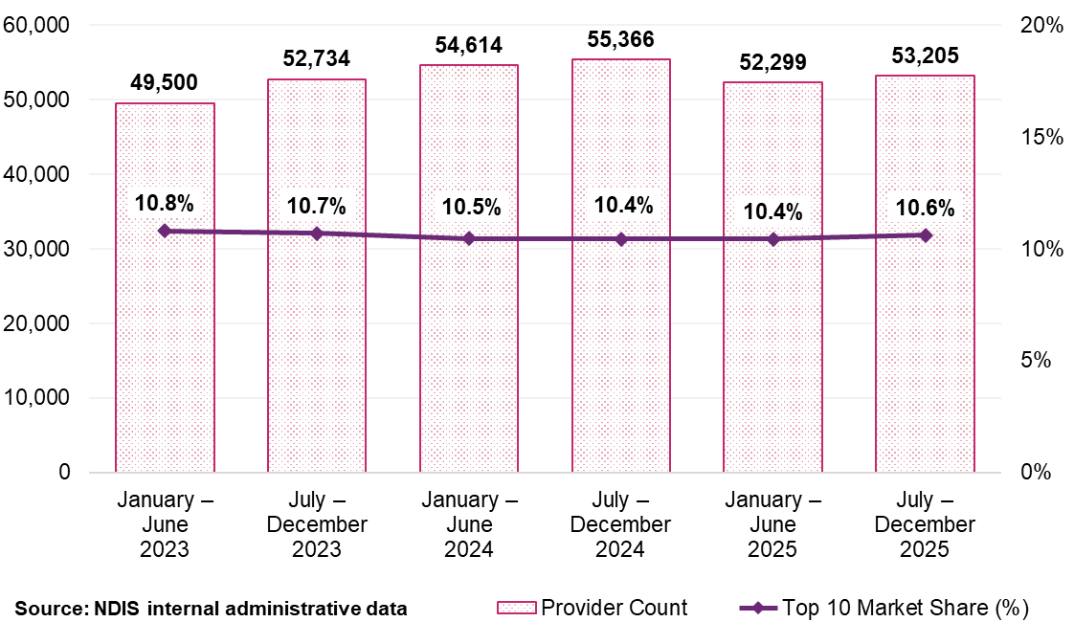
Figure 15: Top 10 providers’ market share by remoteness for therapy supports, January 2023 to December 2025
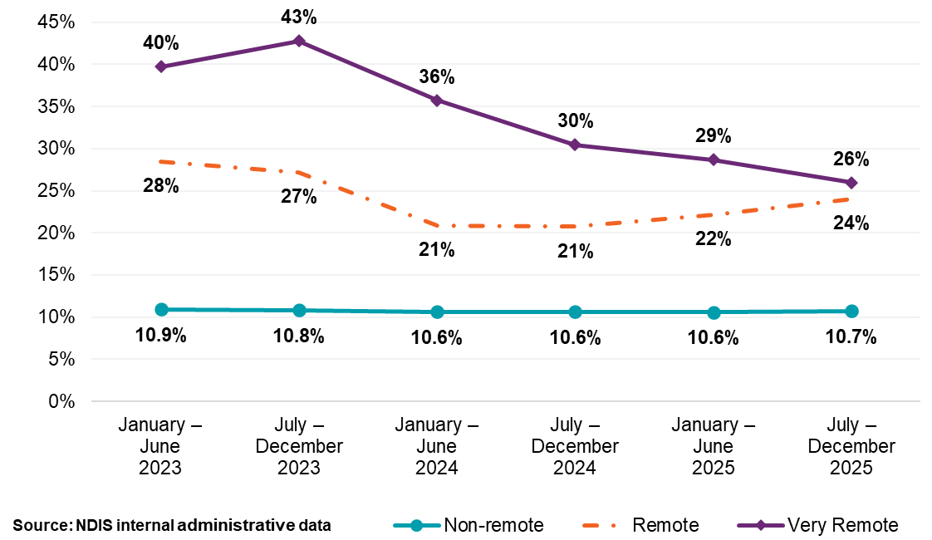

Provider scale and share of payments
The therapy provider market is characterised by a broad distribution of provider scale alongside a high concentration of payments among a small number of large providers. In the 6 months to December 2025, providers supporting 5 or fewer participants accounted for approximately 61% of all therapy providers yet together received only a small share of total payments (Table 20). Many of these were sole practitioners for whom NDIS-funded therapy sits alongside PHI, Medicare or other caseloads (Table 21 and Table 22).
At the other end of the scale, providers supporting more than 250 participants represented less than 1% of all providers but accounted for approximately 41% of total therapy payments (Table 20). The largest provider cohort, supporting 1,000 or more participants, averaged more than $10 million in payments during the July to December 2025 period (Table 20).
This pattern differs by registration status. Among registered providers, those supporting more than 250 participants accounted for a small share of provider numbers but delivered more than 60% of registered‑provider payments, with the largest providers (1,000+ participants) alone accounting for 31% of total registered payments (Table 21). In contrast, unregistered providers were heavily concentrated at the smaller end of the scale, with providers supporting 50 or fewer participants comprising the majority of unregistered providers and accounting for most unregistered‑provider payments (Table 22).
Table 20: Statistics on provider payments for therapy supports – all providers, July to December 2025
Size of provider (number of participants supported) | Number of providers | Total payments to providers (million) | Average payments to providers | Share of total payments
1 | 17,604 | $29.9 | $1,700 | 1%
2 | 6,361 | $24.0 | $3,800 | 1%
3 | 3,835 | $22.6 | $5,900 | 1%
4 | 2,765 | $21.5 | $7,800 | 1%
5 | 2,127 | $20.4 | $9,600 | 1%
6–10 | 6,348 | $99.6 | $15,700 | 4%
11–50 | 10,673 | $536.0 | $50,200 | 20%
51–100 | 1,799 | $319.0 | $177,300 | 12%
101–250 | 1,179 | $493.1 | $418,300 | 18%
251–1000 | 461 | $570.6 | $1.2m | 21%
1000+ | 53 | $529.6 | $10.0m | 20%
Overall | 53,205 | $2,666.4 | $50,100 | 100%
Source: NDIS internal administrative data
Average revenue is rounded up to the nearest hundred.
Table 21: Statistics on the size of providers for therapy supports – registered providers only, July to December 2025
Size of provider (number of participants supported) | Registered provider count | Total payment to registered provider  (million) | Average payment per registered provider | Share of total registered payment
1 | 1,431 | $2 | $1,700 | 0%
2 | 562 | $3 | $4,600 | 0%
3 | 340 | $2 | $7,300 | 0%
4 | 283 | $3 | $10,100 | 0%
5 | 219 | $2 | $10,900 | 0%
6–10 | 721 | $14 | $20,100 | 1%
11–50 | 1,948 | $139 | $71,300 | 8%
51–100 | 701 | $153 | $0.22m | 9%
101–250 | 645 | $310 | $0.48m | 19%
251–1000 | 372 | $494 | $1.33m | 30%
1000+ | 52 | $515 | $9.90m | 31%
Overall | 7,274 | $1,638 | $225,100 | 100%
Source: NDIS internal administrative data
Note: Numbers may not add to 100% due to rounding. Average revenue is rounded up to the nearest hundred.
Table 22: Statistics on the size of providers for therapy supports – unregistered providers only, July to December 2025
Size of provider (number of participants supported) | Unregistered provider count | Total payment to registered provider  (million) | Average payment per unregistered provider | Share of total unregistered payment
1 | 16,275 | $27 | $1,700 | 3%
2 | 5,847 | $22 | $3,700 | 2%
3 | 3,533 | $20 | $5,700 | 2%
4 | 2,497 | $19 | $7,500 | 2%
5 | 1,930 | $18 | $9,400 | 2%
6–10 | 5,671 | $85 | $15,000 | 8%
11–50 | 8,822 | $398 | $45,100 | 39%
51–100 | 1,116 | $166 | $0.15m | 16%
101–250 | 547 | $183 | $0.33m | 18%
251–1000 | 91 | $76 | $0.83m | 7%
1000+ | 1 | $3 | $3.21m | 0%
Overall | 46,330 | $1,017 | 22,000 | 100%
Source: NDIS internal administrative data
Note: Numbers may not add to 100% due to rounding. Average revenue is rounded up to the nearest hundred.

Claiming patterns
Claims at the maximum price published by the NDIA remain the dominant pattern across the therapy market. In the 6 months to December 2025, 62% of therapy claims were made at the maximum price for a full hour, down from 69% in July to December 2024. Registered providers claim at the full-hour maximum price more frequently than unregistered providers, 65% compared with 59% in the most recent period, though both groups have declined from earlier peaks and the gap between them has remained relatively consistent. (Table 23 and Figure 16).
The decline in full-hour maximum price claiming warrants a note. It is consistent with changes set out in the NDIS price guidance, which clarified that the hourly rate is not a session rate and claims should reflect the actual length of time delivered, with pro-rata charging applying. It is also possible the shift reflects changes in how providers structure claims in response to travel claiming rules, where a provider may claim a shorter direct service time and separately claim travel, rather than absorbing both within a full hour claim. Under this interpretation, the decline in full hour maximum price claiming would not represent a reduction in revenue per client interaction. The NDIA will continue to monitor claiming patterns, including the relationship between direct service claims and ancillary claims, to better distinguish between these explanations before drawing conclusions about provider behaviour or market pricing dynamics.
Table 23: Claiming patterns at maximum price analysis for therapy supports, January 2023 to December 2025
Claiming patterns – at published price | January – June  2023 | July – December 2023 | January – June  2024 | July – December 2024 | January – June  2025 | July – December 2025
Registered | 70% | 69% | 70% | 69% | 73% | 65%
Unregistered | 57% | 58% | 61% | 60% | 63% | 59%
All providers | 66% | 65% | 66% | 66% | 69% | 62%
Source: NDIS internal administrative data
Note: All providers above are inclusive of providers with the unknown registration status at the time of the transaction.
Figure 16: Percentage of NDIS claims billed at various time durations across therapy support type, July to October 2025
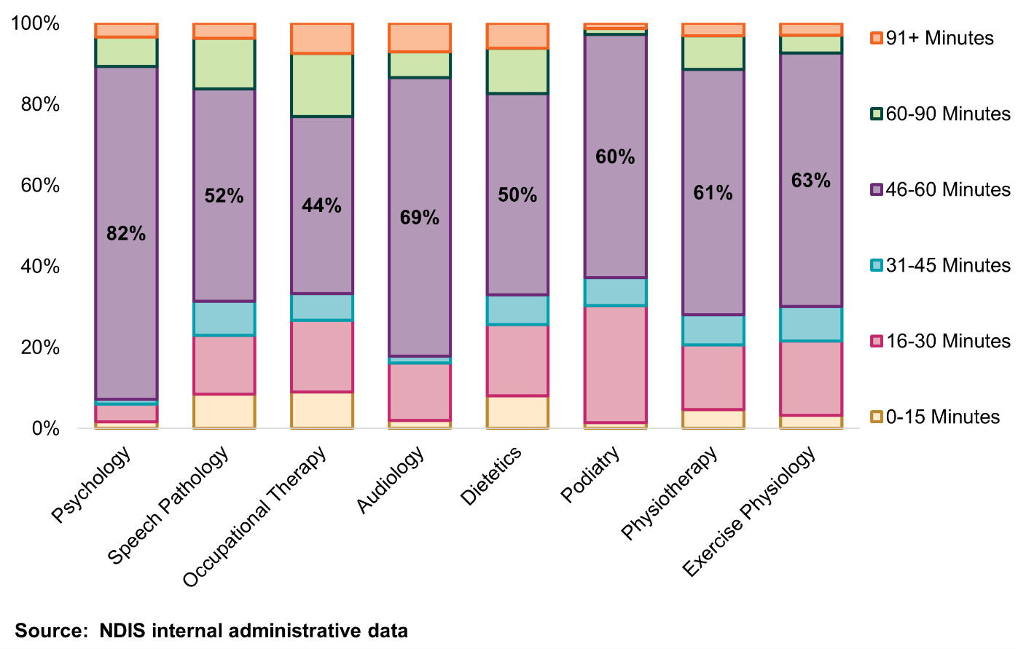
Source: NDIS internal administrative data
Note: Data is on an accrual basis.

  - Business dynamism

Payment consistency
As shown in Figure 17, there is a clear distinction between registered and unregistered providers and payment consistencies, measured by the number of half‑year periods in which providers recorded at least one claim between January 2023 and December 2025. Amongst registered providers, 45% were active across all 6 half-year periods from January 2023 to December 2025, accounting for 91% of total payments, representing a relatively stable base.
Amongst unregistered providers, the largest group was active for only one half-year period, although a stable base of 23% delivered therapy over all 6 periods and claimed over 75% of payments to unregistered providers.
Figure 17: Provider continuity for therapy supports by registration status and percentage of total payments, January 2023 to December 2025
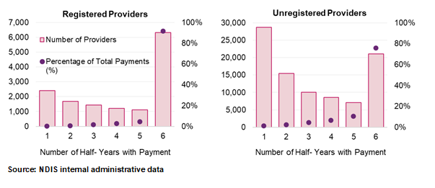

Comparison of provider payments for ‘new activity’ and ‘inactivity’
Figure 18 shows new activity among registered providers has consistently exceeded inactivity across all periods. Newly active registered providers accounted for between 0.7–1.4% of total payments in each half‑year period, while inactive registered providers represented only 0.3–0.4% of payments. This pattern indicates a steady entry of providers into the therapy market, with new activity consistently outweighing exits.
Figure 18: Registered therapy provider activity movements, January 2023 to December 2025
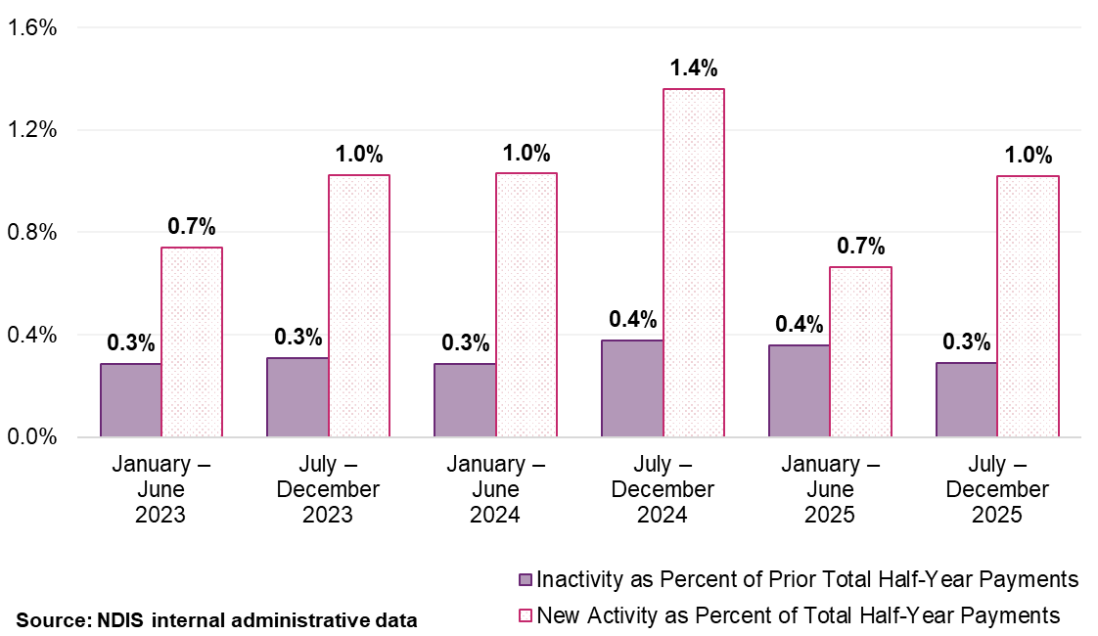
Note: ‘New activity’ is characterised by providers receiving payments in the half-year who did not receive payments in the preceding half-year. ‘Inactivity’ refers to providers not receiving payments in a half-year after having received payments in the previous one. Each provider’s activity is quantified as a percentage of the total payments within that half-year for new activity, of the prior half-year for inactivity.

Workforce constraints and price setting
Market capacity is shaped by underlying labour market conditions that affect the availability of supports. These markets operate within the broader health and care economy, where workforce supply is influenced by training pipelines, competition across funding systems and structural constraints that limit short term responsiveness to price signals.
Workforce shortages continue to constrain market responsiveness. Key therapy professions face persistent national shortages with projected strong future demand for services, as identified by Jobs and Skills Australia. While the number of practitioners has increased across most therapy professions, this growth has not translated into a commensurate expansion of effective supply. Between 2023–24 and 2025, the number of therapy professionals increased from around 156,500 to approximately 198,100, with particularly large increases in Psychologists, Physiotherapists, Counsellors and Occupational Therapists (Table 24). Despite this growth, shortages persist, reflecting long training pathways, competition across the broader health system and the concentration of practitioners in non-NDIS markets or lower complexity service settings. These factors limit the ability of the workforce to scale in response to price changes alone.
Table 24: Number of therapy professionals, 2025
Type of therapist | Number of practitioners
Physiotherapists | 45,900
Psychologists | 48,900
Counsellors | 43,400
Occupational Therapists | 34,200
Dietitians | 5,400
Audiologists | 2,600
Speech Pathologists | 11,000
Podiatrists | 6,700
Total | 198,100
Source: Jobs and Skills Australia; Psychology Board of Australia
These constraints operate within a labour market that is not primarily governed by award-based wage setting. While the Health Professionals and Support Services Award 2020 (HPSS Award) establishes a minimum wage framework, it applies to only a minority of the therapy workforce. Most therapists are engaged under enterprise bargaining agreements or individual arrangements, with remuneration typically around 36% higher than award rates. Pay levels are therefore shaped by pricing and demand across multiple funding systems, including Medicare, PHI and state-based schemes, rather than by award conditions alone.
In this environment, earnings function as contextual information rather than a pricing input. They illustrate the structural gap between wages and market fees and help explain why NDIS therapy prices do not map directly to pay rates. Earnings do not capture the full cost structure of service provision, including administration, supervision, insurance, compliance obligations, business systems and non-face-to-face activities. Therefore, they are an inappropriate basis for recommending prices.
Taken together, these workforce characteristics support recommending prices which are anchored to observable market prices rather than workforce composition or wage structures. Price recommendations should also account for broader stewardship considerations, including sustainability, access and alignment with comparable markets, recognising the limited role of price as a lever for addressing structural supply constraints. In this context, changes to pricing would be more likely to support provider viability and workforce retention than to generate additional supply in the short term.

Health Professionals and Support Services Award
The Fair Work Commission (FWC) work includes considering gender-based undervaluation in the HPSS Award, which is relevant to allied health professions, including several therapy disciplines funded by the NDIS. Unlike DSW-related supports, however, NDIS therapy recommended prices are not directly linked to award wage rates through a cost model.
The NDIA’s approach to therapy price recommendations uses benchmarking against observed market rates in Medicare, PHI and comparable government schemes. For this reason, the appropriate response would not be to pass through potential HPSS Award outcomes directly into the recommended price of NDIS therapy. Rather, any sustained effect of HPSS Award changes on therapy labour markets should emerge over time through broader market rates and be captured through the established benchmarking approach in future pricing reviews.
  - Benchmarking methodology
Therapy supports are priced in the context of broader professional labour markets. Psychologists, Physiotherapists, Occupational Therapists, Speech Pathologists and other therapy professionals work across multiple funding systems, including Medicare, PHI, and selected government compensation schemes. For that reason, the NDIA assess therapy prices against observed prices in those comparator systems, rather than against provider-reported costs or workforce earnings alone.
Benchmarking is one input into price recommendations. It is used alongside Scheme data, consultation evidence and broader market stewardship considerations. For this APR, the NDIA assessed more than 16 million therapy transactions across Medicare, PHI and other government schemes. Data coverage, inclusion rules and source specific limitations are set out in Appendix B.
Because recommendations for NDIS therapy prices are expressed as hourly rates, while many comparator systems use session-based pricing, comparator fees were converted to hourly equivalents using estimated session durations for each therapy type. The purpose of this conversion is not to treat different systems as identical, but to place observed prices on a common basis for comparison. Modality specific session duration assumptions, source coverage and sensitivity testing are provided in Appendix B.
Benchmark results are interpreted against a reference range from the median to the 75th percentile of observed comparator-market prices. In broad terms, where NDIS prices sit within or close to that range, the benchmark evidence does not support a recommendation for a price change. Where a recommended price sits materially above or below that range, the benchmark evidence may support movement in the relevant direction. Where evidence is mixed, limited or materially uncertain, the recommendation is that current prices are maintained pending further analysis.
Comparator systems are not identical to the NDIS, and benchmark results must be interpreted with that in mind. Claimant mix differs across funding systems, private and publicly funded billing patterns are not the same, and some NDIS claiming arrangements differ structurally from those used in Medicare and PHI. These differences do not make benchmarking inappropriate, but they do mean the benchmark should be read as a reference point for the core therapy rate rather than a complete equivalence of reimbursement structures across systems. The main interpretative caveats, including bulk billing, claimant mix and ancillary claiming differences, are summarised in Appendix B.
This benchmarking framework provides the basis for assessing whether therapy prices are broadly aligned with observed market rates. It informs the direction of any recommended price movement. Separate judgement is then required on the pace and scale of the recommended change, taking account of workforce constraints, provider participation, transition risk and broader market stewardship considerations.
  - Interpreting benchmarking results
Benchmarking is used in this chapter as a reference point for price adjustment, not as a mechanical rule. Its purpose is to assess whether the recommended prices for NDIS therapy are broadly aligned with, materially above, or materially below observed rates in comparator systems that draw on the same professional workforce. This provides an external anchor for pricing recommendations, while still requiring judgement about data limitation, market conditions and the appropriate pace of change.

Benchmarking reference range
For therapy supports, the Agency uses a reference range bounded by the median and 75th percentile of observed comparator-market rates, converted to hourly equivalents. This price range represents the upper half of the observed interquartile market distribution and operates as the policy reference point for calibration.
Positioning in the upper half of the distribution, rather than at the median, reflects 2 considerations. First, NDIS participants often present with a broader range of clinical needs than the general population represented in lower-priced benchmark transactions, including bulk-billed MBS services. Second, the MBS dataset includes lower-priced transactions that sit toward the bottom of observed market rates and pull down the median relative to the rates at which most privately billed therapy is delivered.
A range, rather than a point target, better reflects the nature of the underlying data. Market distributions move between review periods, billing patterns vary across sources, and no single comparator price can be treated as the correct therapy rate for the NDIS. Prices within or close to the reference range are therefore treated as broadly aligned. Prices materially below the range may indicate risk to participant access. Prices materially above the upper bound indicate the NDIS rate sits above the upper end of observed comparator-market pricing and therefore would require stronger justification.

Applying the benchmark to price recommendations
The Agency does not respond mechanically when an NDIS price sits outside the reference range. The benchmark result is considered together with the direction and magnitude of the misalignment, the robustness of the underlying data, and other decision-relevant evidence, including provider participation, access indicators and market conditions. In this way, the reference range anchors the pricing recommendation but does not displace judgement about how that recommended price might be applied.
This matters particularly in therapy markets, where comparator evidence is strong enough to inform the direction of price adjustment, but not sufficient on its own to determine the scale and timing of change in every case. Benchmarking therefore carries substantial policy weight in this chapter, but it is not used as a catch-all justification for broader market or transparency decisions. Those questions are addressed separately.
  - Summary results
Applied on that basis, the benchmark results fall into 3 groups. For psychology, the current NDIS price sits below the reference range and supports an increase. For dietetics and exercise physiology, current prices sit above the reference range and support downward adjustment. For occupational therapy, speech pathology, podiatry and audiology, current prices fall within or close to the reference range, or the comparator evidence is not sufficiently strong to support a change. The modality sections below set out how that benchmark signal is interpreted for each profession. Figure 19 presents the summary results.
Figure 19: MBS and PHI converted hourly rates for therapy professionals compared to the applicable NDIS prices for 2025–26
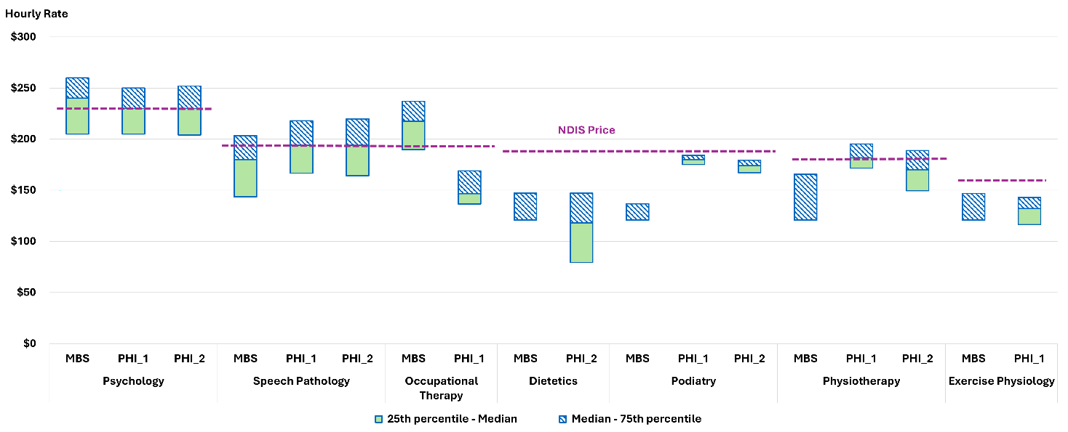

Psychologists
The current NDIS price of $232.99 per hour sits below the median of observed market rates. The 75th percentile implied hourly rates are $260.00 (MBS), $250.00 (PHI 1) and $252.00 (PHI 2) for a 60-minute session (Figure 20). The previous APR recommended an increase to the NDIS price by $10 and removed state differentials to consolidate the recommended price into a single national rate. Updated data in this APR indicates the NDIS price is below the reference range.
Figure 20: MBS and PHI converted hourly rates for Psychologists compared to the applicable NDIS prices
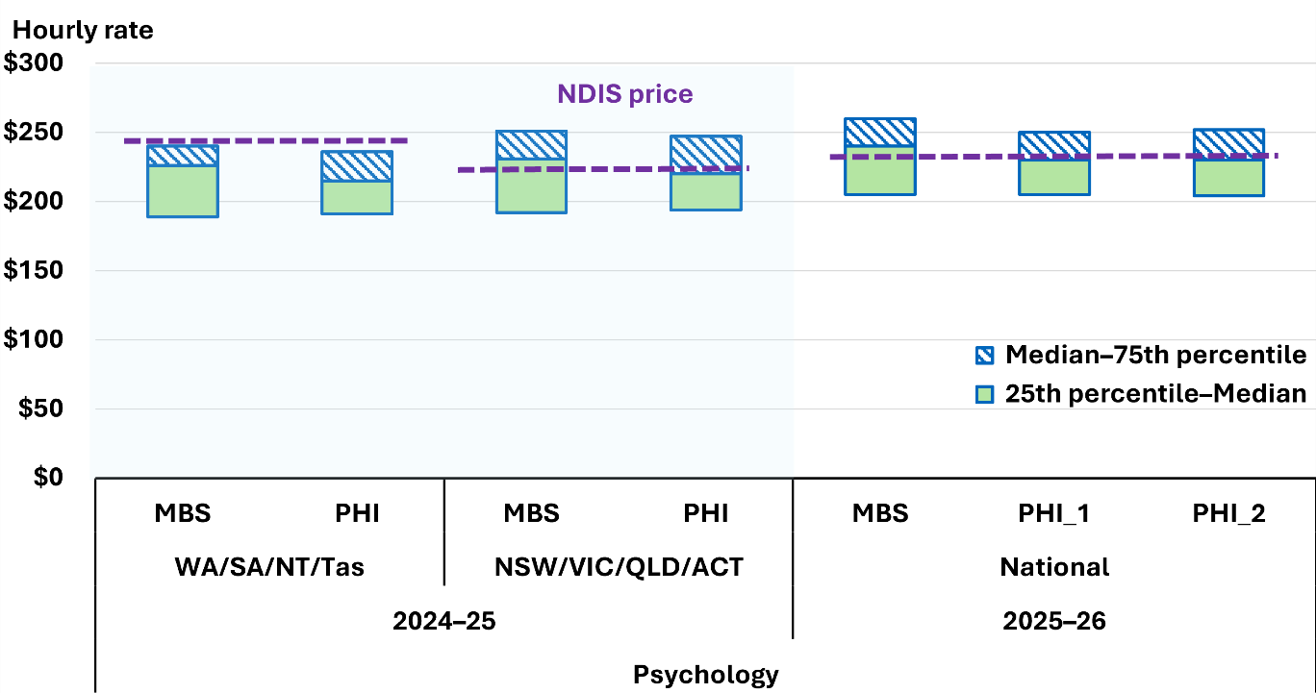
Source: MBS and PHI

Physiotherapists
The previous APR resulted in a reduction of the maximum physiotherapy price by $10 per hour and the consolidation of state-based differentials into a single national rate. Monitoring to 31 December 2025 does not indicate that this change disrupted participant access or accelerated provider exit. Participant numbers remained consistent with pre-change trends across states and remoteness categories, average participant per provider remained broadly stable, and provider numbers continued the gradual decline that predated the pricing change. Payment levels in previously higher-rate jurisdictions converged toward the national rate as intended. (Figure 21 and Figure 22).
Figure 21: Average number of participants per provider of Physiotherapists, January 2023 to December 2025
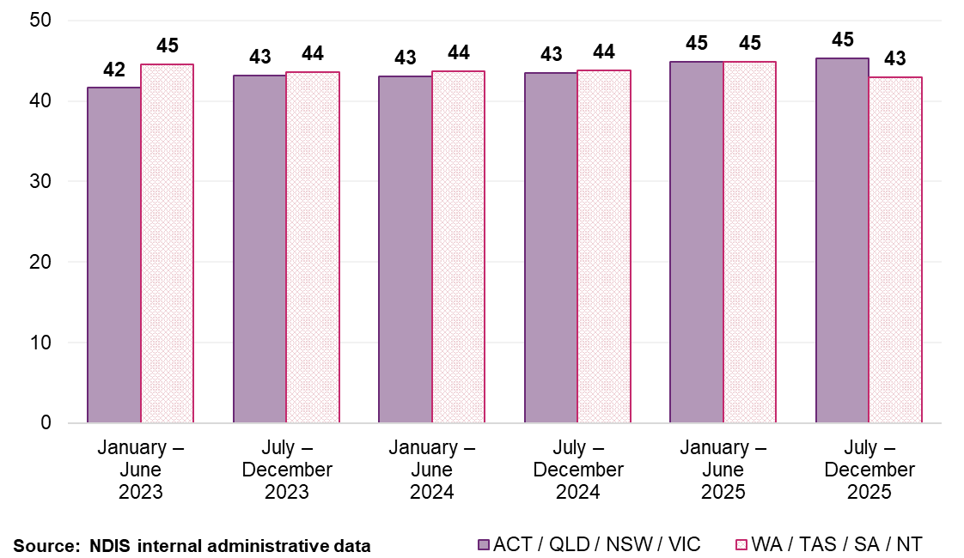
Figure 22: Average total payments per participant for supports delivered by Physiotherapists, January 2023 to December 2025
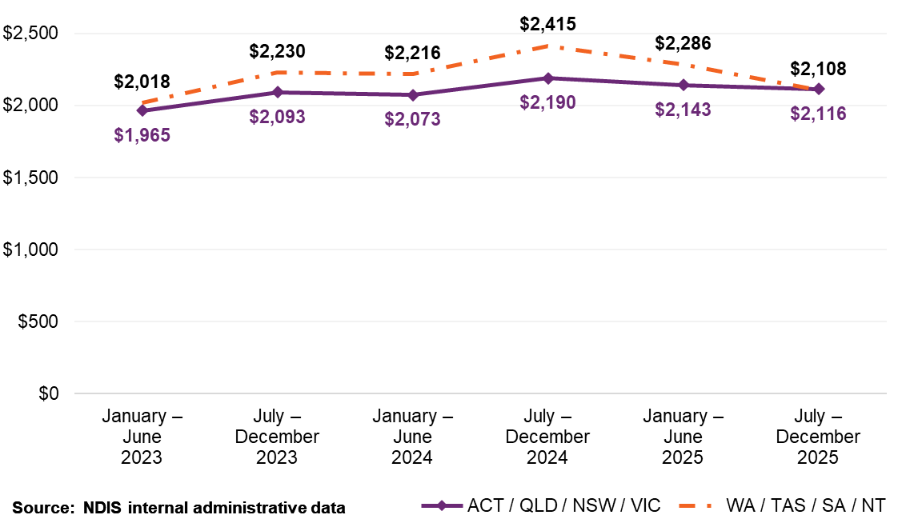
Benchmarking for physiotherapy remains materially sensitive to the session-length assumption used to convert comparator fees into hourly equivalents. Relatively small changes in the assumed median session length produce materially different benchmark positions. Using plausible assumptions of 32.5-, 35-and 37.5-minute results in a benchmark range that spans outcomes both above and below the current NDIS price. This means the comparator evidence does not support a sufficiently robust case for a recommendation of further price adjustment on benchmarking grounds alone.
The NDIA has adopted 35 minutes as the central conversion assumption for this review. This reflects the midpoint of the conservative range tested. On that basis, the current physiotherapy price sits broadly within the plausible benchmark range. Taken together, the monitoring evidence and the sensitivity of the comparator analysis do not support a recommendation of a further adjustment in this APR. The recommended maximum physiotherapy price will therefore remain unchanged at $183.99 per hour. Appendix B sets out the derivation of the 35-minute assumption and the full sensitivity analysis using 32.5-, 35- and 37.5-minute assumptions (Figure 23).
Figure 23: MBS and PHI converted hourly rates for Physiotherapists compared to the applicable NDIS price (sensitivity analysis) for 2025–26
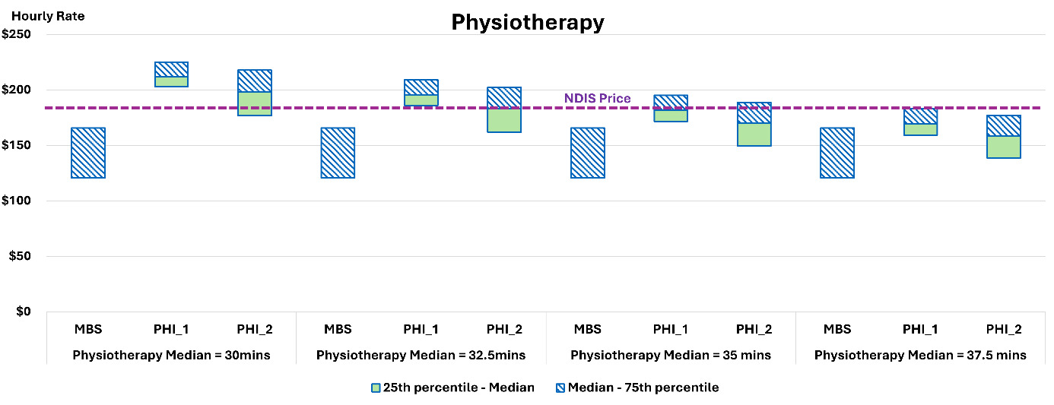
Source: MBS and PHI data

Dietitian
The current NDIS price of $188.99 per hour sits above the reference range. The NDIS hourly rate is 21.9% above the PHI 2 75th percentile ($155.00) and 24.3% above the MBS 75th percentile ($152.00) (Figure 24). The previous APR resulted in a reduction in the price for Dieticians by $5 per hour. Updated data indicates the gap has narrowed only marginally.
Figure 24: MBS and PHI converted hourly rates for Dietitians compared to the applicable NDIS prices
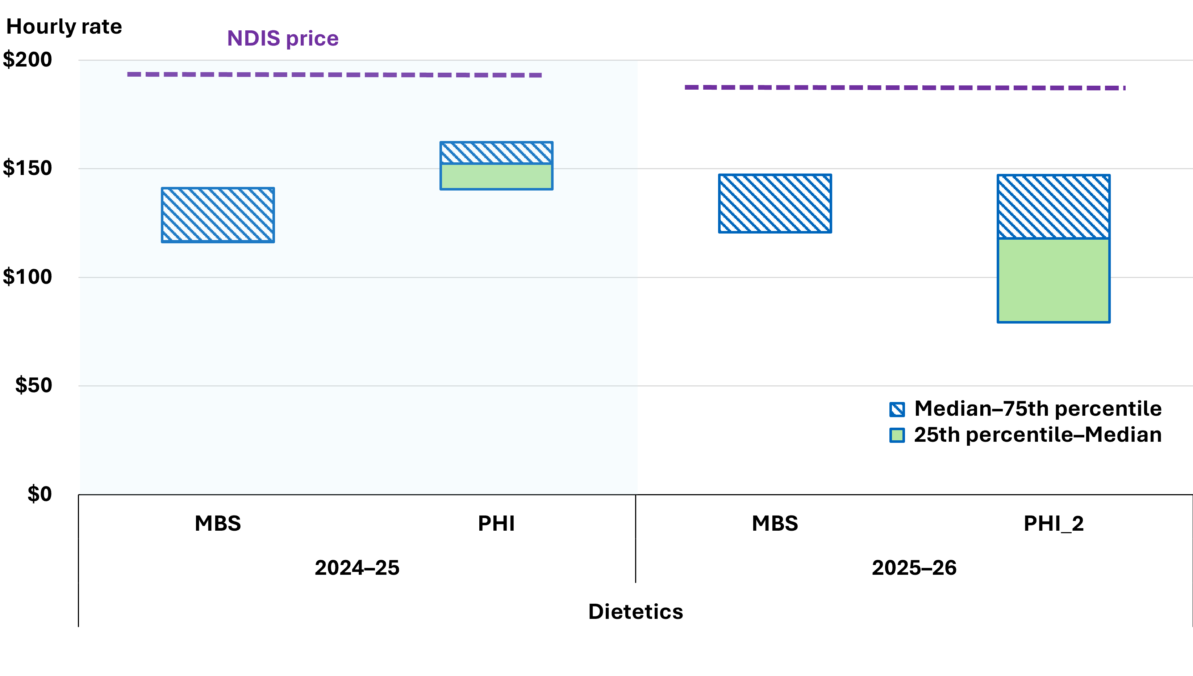
Source: MBS and PHI data

Exercise Physiologists
The current NDIS price of $166.99 per hour sits above the reference range. The NDIS hourly rate is 9.9% above the MBS 75th percentile ($152.00) and 26.5% above PHI 1 ($132.00) (Figure 25). The NDIA’s finding is based on improved data coverage, including PHI transactions data not previously available.
Figure 25: MBS and PHI converted hourly rates for Exercise Physiologists compared to the applicable NDIS prices
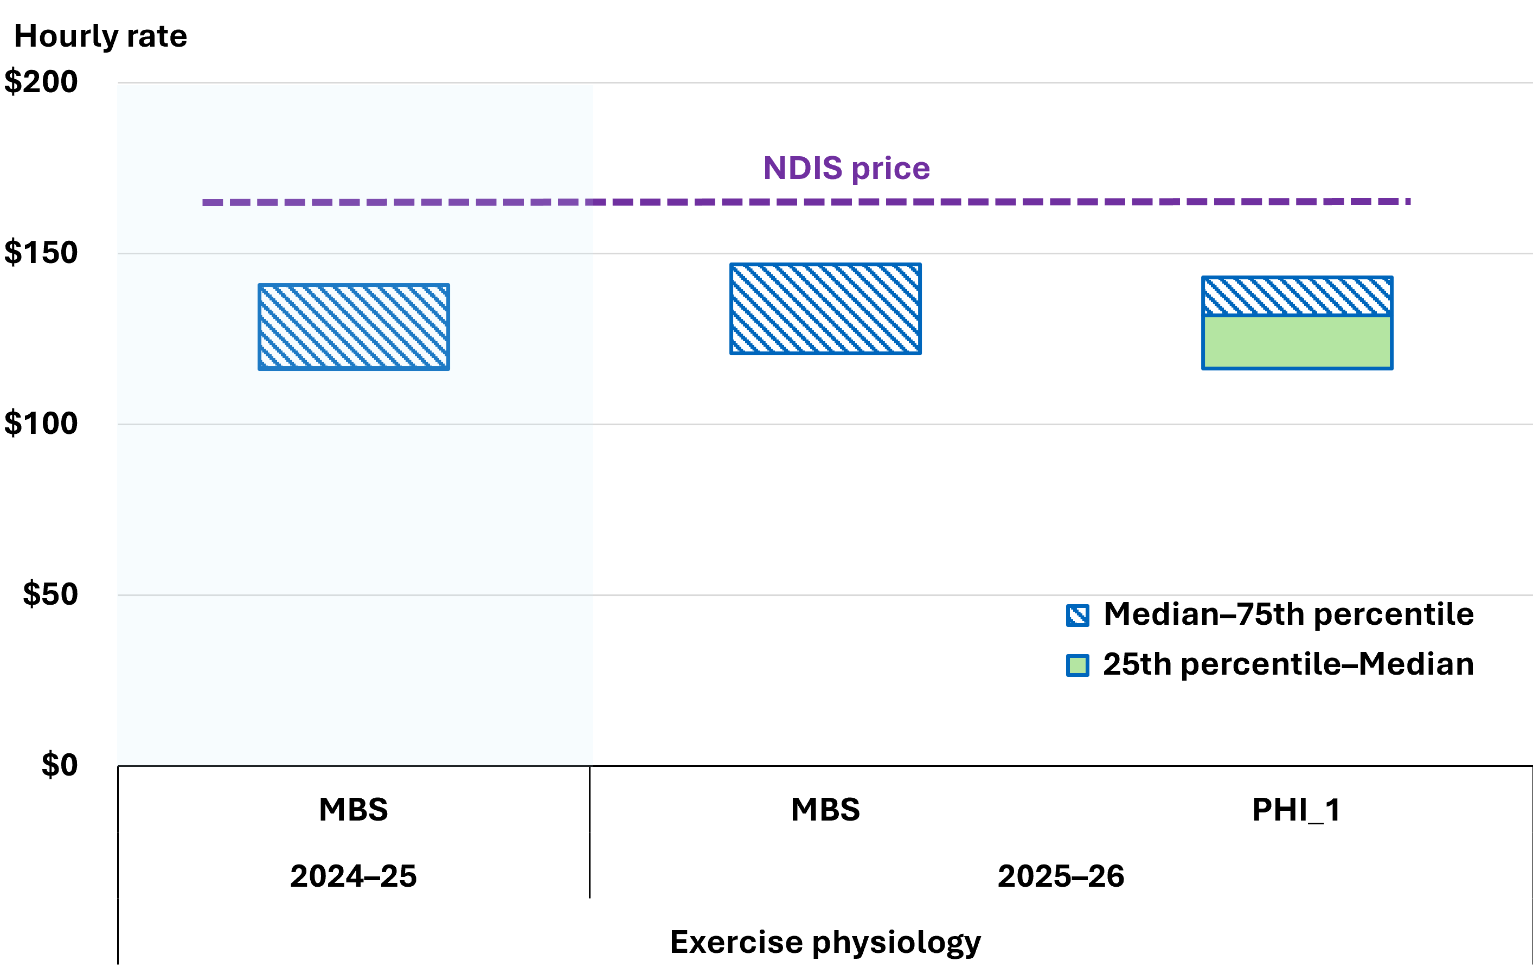
Source: MBS and PHI

Orientation and Mobility Specialists
The registration of Orientation and Mobility Specialists (OMS) was recognised by the NDIS Commission in March 2025, but NDIS services have continued to be claimed under the residual ‘Other Professionals’ category. The introduction of dedicated OMS support line items would improve claiming accuracy. Evidence to support alignment with higher‑priced allied health disciplines is limited, with only a small number of comparable government schemes providing relevant pricing information. The available evidence from these schemes indicates materially lower pricing.
The NDIA recommends aligning OMS prices with counselling supports, reflecting comparable scope and market positioning. The evidence supports a recommended national hourly maximum price of $156.16 with applicable remote loadings to be implemented from 1 July 2026.

Other therapists
Occupational Therapists, Speech Pathologists, Podiatrists and Audiologists were included in the benchmarking analysis. It found NDIS prices for these professionals fall within or close to the reference range and no adjustments are recommended. Speech Pathologists ($193.99 per hour) shows close alignment with observed market rates. Occupational Therapists ($193.99 per hour) presents mixed signals: above the PHI 75th percentile, below the MBS 75th percentile, but falls within a reasonable range given the robust sample size. Audiologists ($193.99) produced mixed results with limited observations and does not support an adjustment. Podiatrists ($188.99) exceed the 75th percentile but sit closer to PHI rates. The current NDIS price remains within an acceptable range.
Figure 26 presents the professionals where no price adjustments are recommended.
Figure 26: Professionals with no recommended changes to prices for 2025–26
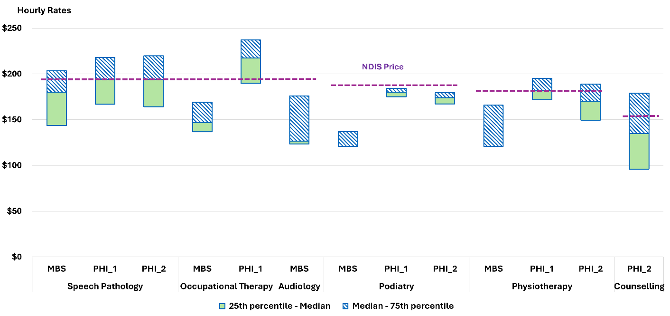
Source: MBS and PHI data

Other Professionals
The ‘Other Professionals’ category aggregates a wide range of professional services under a single price structure without identifying the practitioner’s discipline at the point of claim. Robust benchmarking is not possible because the underlying discipline is unknown.
The Agency recommends aligning the ‘Other Professionals’ price with comparable, lower-priced therapy supports where practitioner scope and market positioning are broadly similar, specifically counselling and creative therapies. A maximum price of $156.16 per hour is recommended. This will not apply to Early Childhood supports, which should remain at $193.99 per hour. The Agency also proposes introducing practitioner identification at the claim level to enable future benchmarking.
  - Geographic patterns in market rates
The NDIA continues to support standardised national prices for therapy supports following the removal of state‑based price differentials as set out in the previous APR.
Updated MBS evidence indicates average therapy prices remain broadly consistent across states and territories, indicating no underlying geographic price variation that would justify differentiated NDIS prices (Figure 27). Post‑implementation monitoring confirms payment levels in previously higher-rate jurisdictions have converged towards the national rate without disruption to participant access. Remote and very remote loadings of 40% and 50% respectively continue to be supported by the evidence and no changes are proposed.
Figure 27: Average price for Medicare-subsided services by state and territory
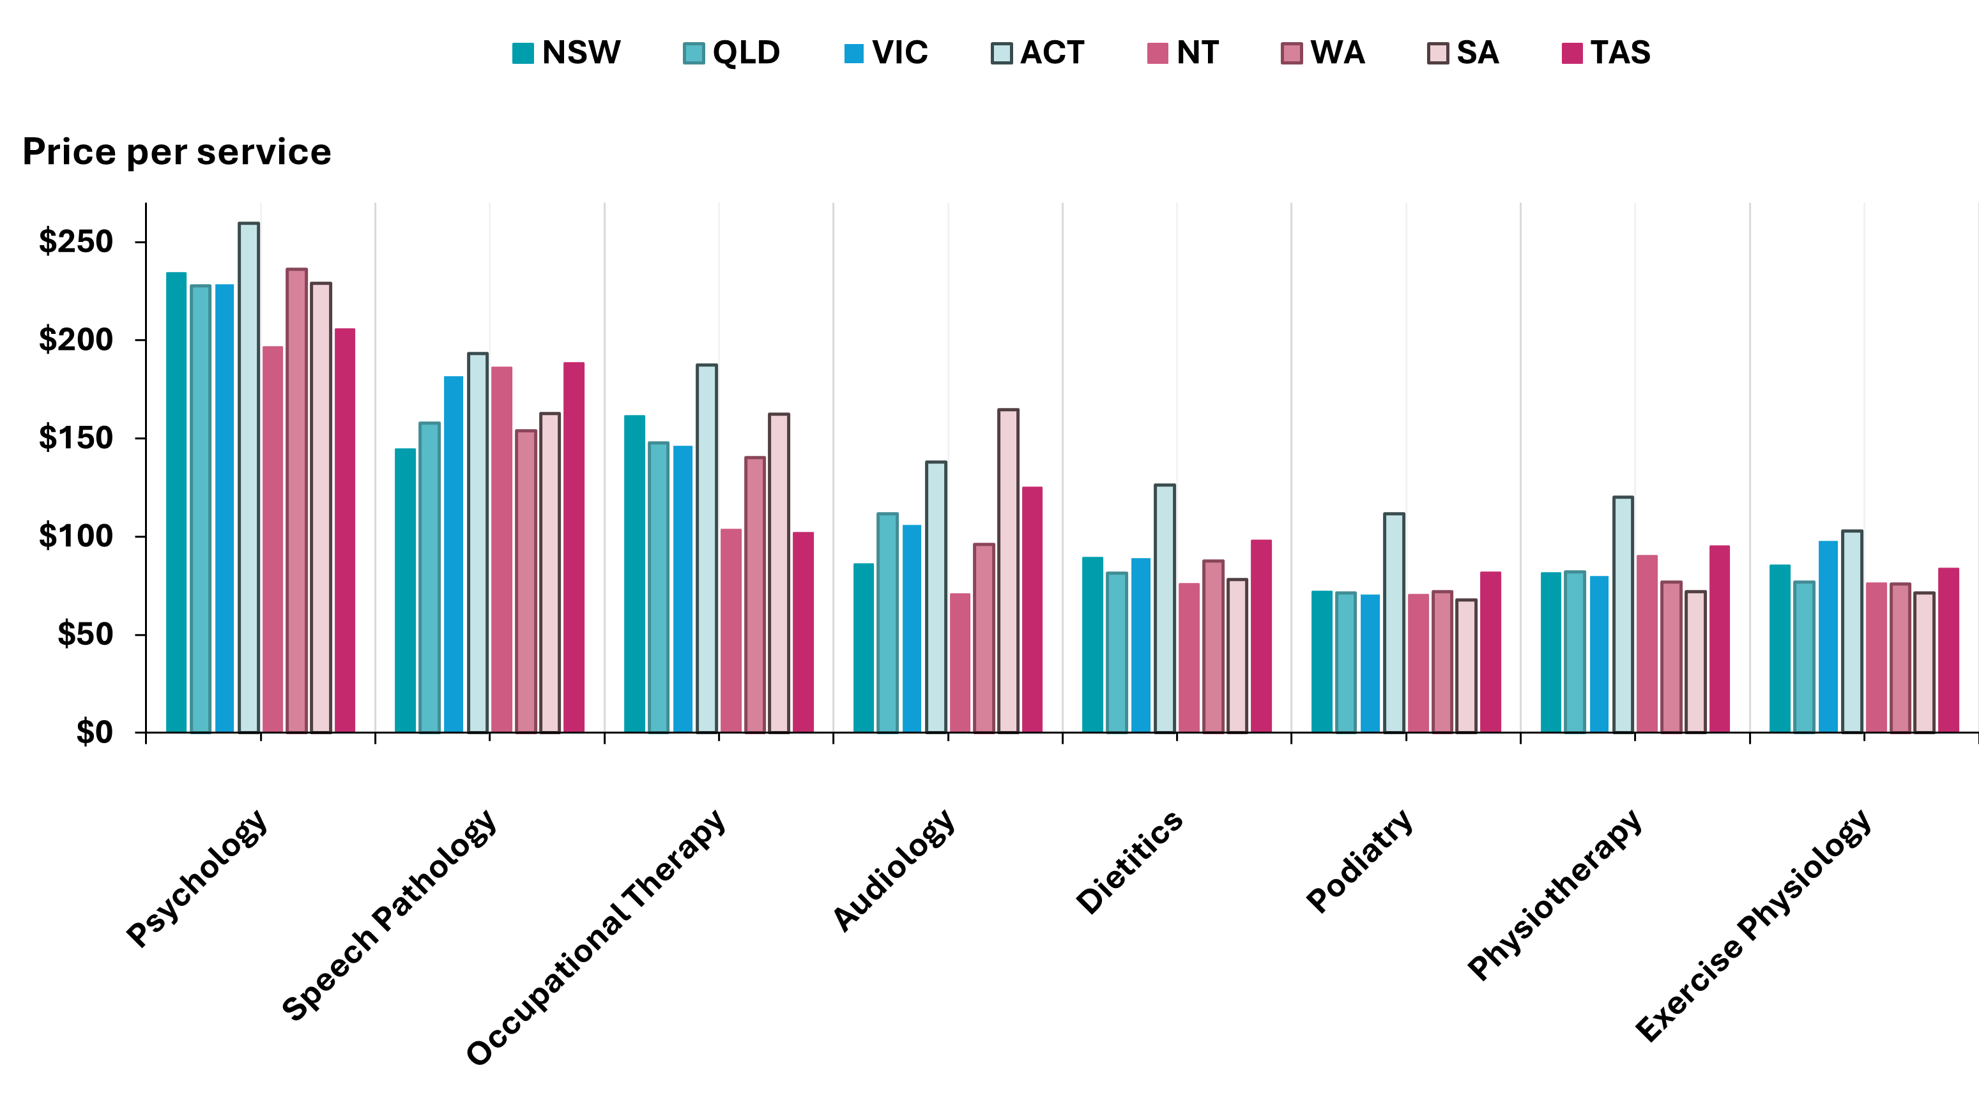
Source: NDIA calculations of MBS dataset.
Note: This figure represents the average price charged per session from MBS data. It is different from the hourly rates as it has not been adjusted for time.
  - Other government schemes
This section presents benchmarking data from selected Commonwealth- and state-funded schemes, including:
- ComCare
- Department of Veterans’ Affairs (DVA)
- Home and Community Care Program for Younger People (HACC PYP)
- Lifetime Support Authority (LSA)
- Motor Accidents Insurance Board (MAIB)
- National Injury Insurance Scheme Queensland (NIISQ)
- ReturnToWorkSA
- State Insurance Regulatory Authority (S I R A)
- Transport Accident Commission (T A C)
- WorkCover Queensland
- WorkCover WA
- WorkSafe Victoria.
Seven provided transaction-level data meeting the NDIA’s benchmarking criteria. The remainder provided published rate schedules.
These schemes fund allied health services for specific populations (for example, injured workers, veterans, motor accident claimants). Unlike MBS or PHI, many set explicit time-based rates and some include allowances for indirect service delivery.
Figure 28 presents NDIS prices compared to other government-funded schemes’ pricing for therapy supports. This has been calculated at a comparable hourly rate and presented in a similar way to previous APRs for consistency.
Figure 28: Comparison of NDIS prices to other government schemes
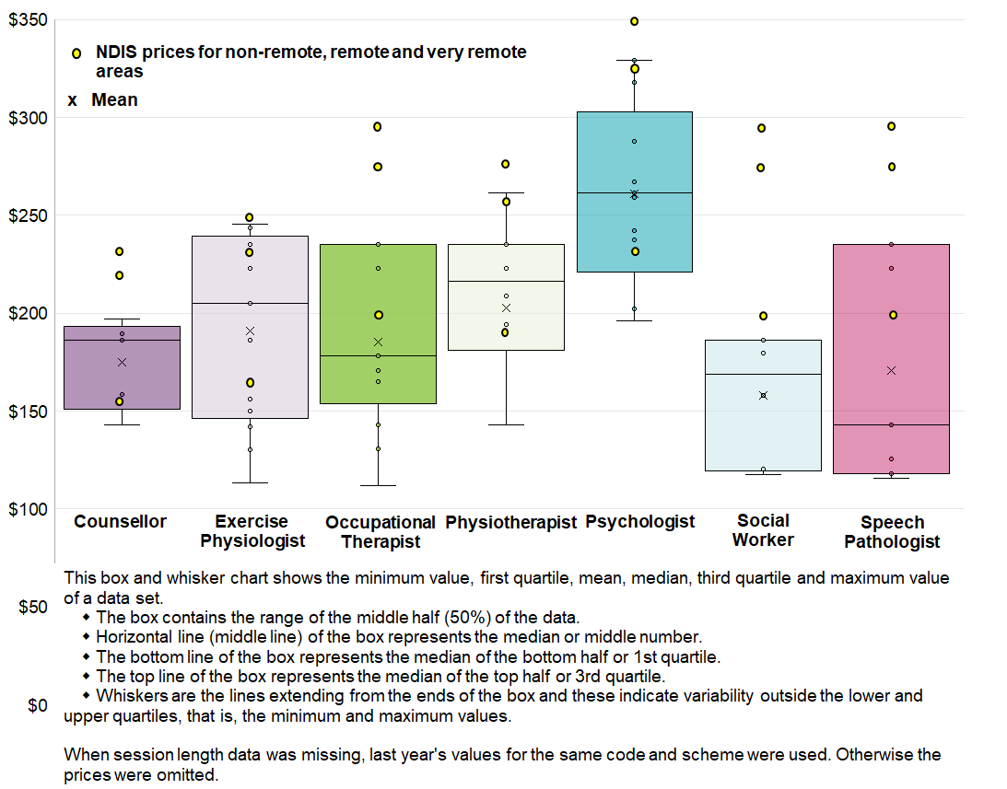
Source: NDIA calculations using prices received from other government funding schemes
Note: The multiple NDIS data points per therapy type indicates prices for non-remote, remote and very remote areas.
NDIS prices are generally comparable with these schemes, with broad overall alignment. Psychology pricing sits below the median across comparative schemes, supporting the case for an increase. Occupational therapy and speech pathology are priced consistently lower under these schemes. These schemes often incorporate defined billing rules and tighter controls on indirect activity.

Transaction-level price benchmarking
Transaction-level data from 7 Commonwealth and relevant state-funded government schemes were analysed using the NDIA’s benchmarking method. Only 7 of the 13 schemes provided data with visibility of the providers full charge per visit including gap payments. Aggregate expenditures of claim amounts without visit-level breakdown were excluded.
When grouped by scheme type, CTP (motor accident) schemes pay systematically higher rates than workers’ compensation schemes across all therapy types except speech pathology (Figure 29 and Figure 30). This is consistent with the higher complexity and severity of motor accident claimants.
Figure 29: Individual state and Commonwealth schemes converted hourly rates
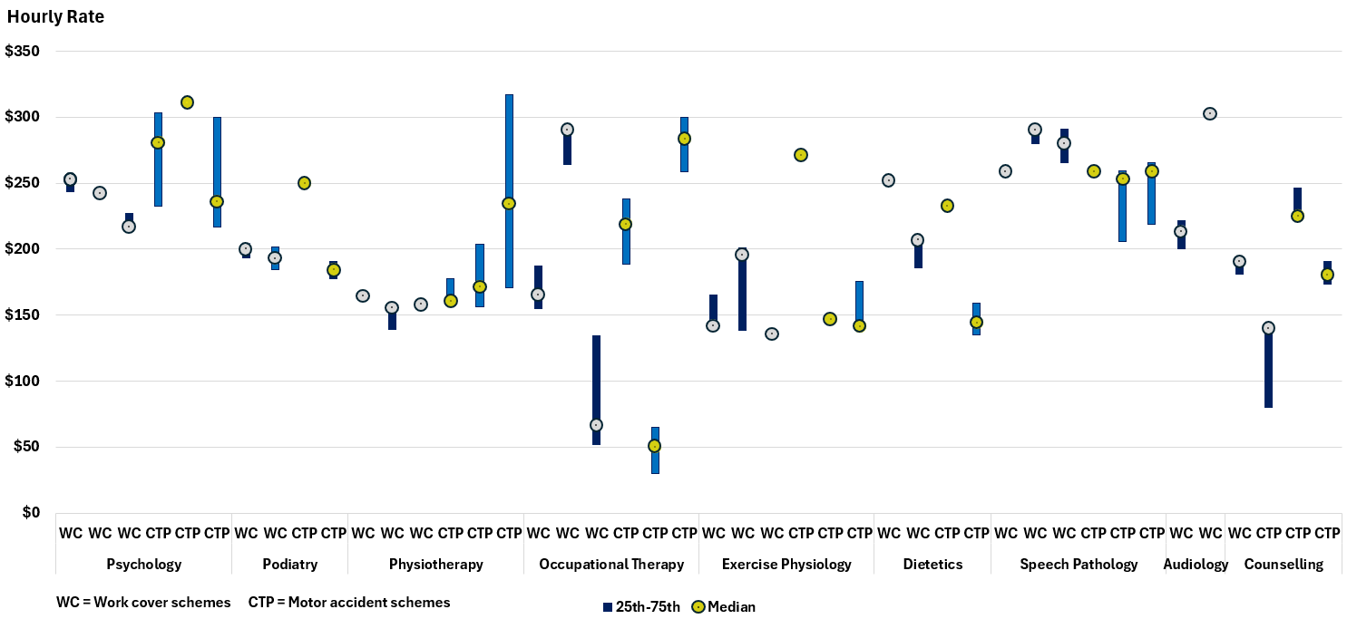
Source: State and Commonwealth schemes
Figure 30: State and Commonwealth schemes aggregated by work cover and motor accident converted hourly rates
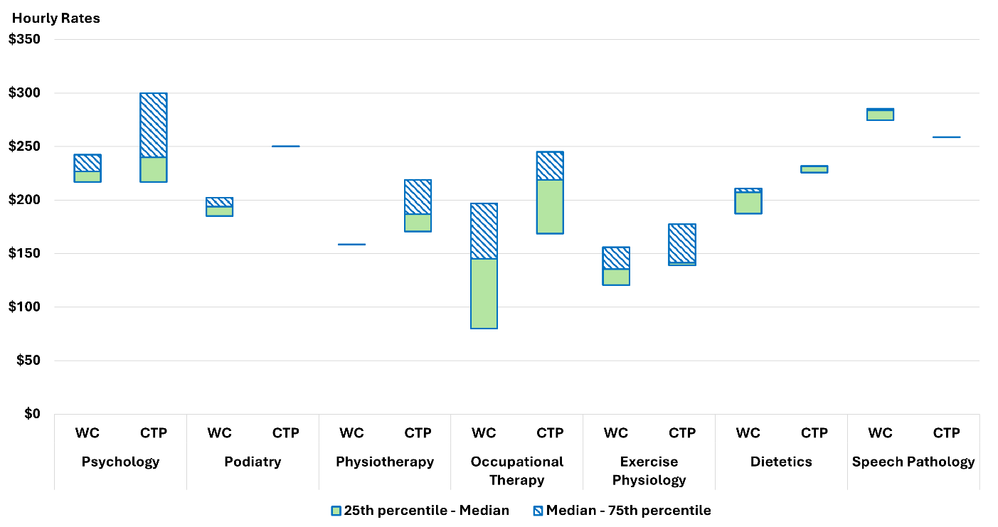
Source: State and Commonwealth schemes
  - Consultation

Participant consultation
Participant consultation provides useful insight into how therapy supports are experienced and valued, but it is not treated in this chapter as a substitute for empirical pricing evidence. Participants reported that therapist capability, disability-specific experience, rapport and convenience matter more than price when selecting a provider. At the same time, respondents were clear that prices matter where they affect how many therapy hours a plan can purchase or whether providers are willing to travel. Concerns about losing hours, losing an existing provider, or having more plan funds absorbed by travel were prominent, particularly for plan-managed participants, rural and remote participants, and families with younger children.
These responses indicate participant choice in therapy is real but constrained by budget effects. They also reinforce that practical consequences of pricing reform are experienced less through headline price levels than through purchasing power, continuity and access to home-based delivery. Consultation therefore helps identify participant risks that should be considered when recommending changes and when designing claiming reforms.

Provider consultation
Provider consultation similarly informs interpretation rather than determining conclusions. Therapy providers reported delivering services under the NDIS requires more effort than under comparator systems, particularly in documentation, assessment, family consultation and compliance. Providers also reported that a typical claimed session includes a material non-direct component, with average time allocations across all respondents of approximately 73% direct therapy, 16% documentation, 8% coordination and 5% other activities. Responses were broadly consistent across provider size and registration status.
Provider views are useful in 2 ways. First, they provide context for interpreting comparator evidence in a market where the NDIS operates with different administrative and claiming arrangements. Second, they help explain why session structure and transparency have become a policy issue in their own right. Provider consultation should be interpreted with this context in mind, because it reflects experience and incentives within the current framework. It is better read as informing the calibration of pricing recommendations than as an independent measure of the appropriate price level. That distinction is worth preserving when drawing conclusions from the consultation evidence.

How consultation informs interpretation
Participant responses are consistent with this chapter’s market data in showing that therapy is a support category where access, continuity and home-based delivery matter materially to participants. Provider responses are consistent with the claim structure evidence in showing that therapy sessions often include a mix of direct and non-direct activity that is not clearly visible in current claims. Both sets of consultation therefore support the need for careful calibration of recommended price changes and for improvements to claiming transparency.
At the same time, consultation should not be used to do more than it can reasonably support. Participant concerns about access do not establish that a given recommended price is correct. Provider reports of greater effort under the NDIS do not, by themselves demonstrate that benchmarks are inappropriate. The role of consultation in this chapter is to identify implementation risks, explain stakeholder experience, and help prioritise structural reform where existing data visibility is poor.
  - Discussion
This chapter applies a comparator-based pricing approach to a support category that operates in broader professional labour markets. The benchmarking results indicate most therapy prices remain broadly aligned with the Agency’s reference data, with targeted movement supported only for a smaller number of modalities. The Agency recommendation is therefore selective adjustments where comparator evidence is clearest, rather than broad repricing across the therapy market.
The chapter also finds how the Agency responds to the benchmarking results matters. Therapy markets remain capacity-constrained, provider numbers have recently declined in the unregistered market while demand has grown, and billing continues to cluster strongly at the 60-minute maximum price promulgated by the NDIA. These conditions do not displace the benchmark signal but support a measured approach to implementation rather than mechanical movement to any particular point within the comparator range.

Therapy activity composition
APR consultation gives the Agency its clearest indication to date of what is commonly included within a claimed therapy session. Across 1,930 valid responses, providers reported that a typical claimed session comprised, on average, 73% direct therapy, 15% documentation, 8% coordination and 5% other activity. This indicates that a material share of claimed therapy time is commonly allocated to activities other than direct clinical contact.
This has an important transparency implication. A participant, planner or reviewer may reasonably read a one-hour therapy claim as broadly equivalent to one hour of direct therapy. The survey results suggest this is often not the case. On the reported mean composition, a 60-minute claimed session equates to approximately 45 minutes of direct therapy, with the remaining time typically allocated across documentation, coordination and other related activity. Longer claimed sessions also appear to have a progressively larger non-direct component (Table 25).
Table 25: Reported therapy activity composition and session length
Session length (minutes) | Number of respondents | Direct therapy | Documentation | Coordination | Other activities
30–45 | 57 | 77.4% | 14% | 6.4% | 2.7%
45–60 | 753 | 78.2% | 13.6% | 5.6% | 3.1%
60–90 | 946 | 72% | 15.8% | 8.5% | 4.8%
More than 90 | 182 | 59.9% | 20% | 11.5% | 10.4%
All durations | 1,983 | 73.4% | 15.3% | 7.6% | 4.6%
Note: Values are means. Medians are not used because they are calculated independently for each activity category and do not sum to 100% across a row.
This does not mean non-direct activity is inappropriate or should not be claimable. Documentation, coordination and related work can be necessary parts of delivering quality therapy supports. The issue is the current claiming structure does not make these components visible. A 60-minute session comprising mostly of direct therapy and a 60-minute session containing a materially different mix of direct and non-direct activity appear the same in the claiming data. This limits the Agency’s ability to interpret billing behaviour, reduces transparency for participants about how plan funds are being used, and weakens the evidence base for future pricing recommendations.

Incremental refinement and reform
A related issue identified in this chapter is the limited visibility of current claims more broadly. Claiming data continues to show concentration at standard session lengths, while recent changes in claiming patterns are not yet interpretable with confidence as a change in underlying therapy durations or provider revenue. Current administrative data does not clearly distinguish between direct therapy, non-face-to-face activity and travel-related components.
The proposed reforms to non-face-to-face claiming, travel claiming and practitioner identification are therefore important in their own right. Their purpose is to improve transparency, strengthen pricing governance and provide a better evidence base for future reviews.
Taken together, this chapter supports a sequenced therapy pricing approach. Comparator evidence provides the reference point for calibration. Market conditions inform how that evidence should be applied. Session composition and claiming evidence identifies a separate transparency problem that should be addressed to improve future pricing recommendations. This combination supports a pricing approach that is evidence-based, proportionate and better aligned to the structure of the therapy market.
  - Recommendations

Psychologist price
The current price sits below the reference range. The 75th percentile implied hourly rates are $260.00 (MBS), $250.00 (PHI 1) and $252.00 (PHI 2). This follows the $10 increase and consolidation of state-based differentials in the previous APR.

Recommendation 5:
The national price for supports delivered by a Psychologist should be a maximum of $252.99 per hour. This should apply uniformly across all jurisdictions.

Dietitian price
The current price sits above the reference range by the largest margin of any therapy type with robust benchmarking data. The NDIS hourly rate is 21.9% above the PHI2 75th percentile and 24.3% above the MBS 75th percentile. The reduction of $5 for the 2025-26 financial year narrowed this gap only marginally.

Recommendation 6:
The national price for supports delivered by a Dietitian should be a maximum of $178.99 per hour.

Exercise Physiologist price
The current price of $166.99 sits above the reference range. The previous APR did not recommend an adjustment for exercise physiology due to limited PHI data at that time. Improved data coverage this year, including PHI transaction data not previously available, would support a reduction.

Recommendation 7:
The national price for supports delivered by an Exercise Physiologist should be a maximum of $161.99 per hour.

Orientation and Mobility Specialist price
The Agency recommends introducing dedicated support line items for OMS to improve claiming transparency and enable more accurate monitoring of service use and pricing. Given the limited availability of benchmarking evidence and materially lower pricing observed in comparable government schemes, the Agency recommends aligning OMS prices with counselling supports. A national hourly price of $156.16 is recommended, with applicable remote loadings and access to standard ancillary activities.

Recommendation 8:
The national price for supports delivered by an Orientation and Mobility Specialist should be a maximum of $156.16 per hour.

Other Professionals price
The ‘Other Professionals’ category does not identify practitioner discipline at the point of claim, limiting the ability to benchmark prices against observable market rates. The Agency therefore recommends setting the price at $156.16 per hour, aligned with lower‑priced comparable therapies such as counselling and creative therapies. This change excludes Early Childhood supports, which should remain at $193.99 per hour, and will be complemented by practitioner identification at the claim level to support more precise pricing over time.

Recommendation 9:
The national price for supports delivered by ‘Other Professionals’ (not including Early Childhood supports) should be a maximum of $156.16 per hour.

Claiming for non-face-to-face time

Recommendation 10:
A separate line item should be introduced for claiming provider travel associated with therapy supports, distinct from the therapy line item. This provider travel line item would enable provider travel to be claimed and recorded separately from direct service delivery, improving transparency and accuracy in claiming.

Recommendation 11:
Separate line items should be introduced for claiming non-face-to-face therapy support provision, including activities such as preparation, documentation, and NDIS-requested reporting. These line items would enable non-face-to-face activities to be claimed and recorded separately from direct service delivery, improving transparency and accuracy in claiming.
- Support Coordination
  - Context
Support coordination enables participants to make effective and informed use of their NDIS plans. Support coordinators work with participants to identify, engage and coordinate both funded supports and mainstream services. They ensure supports are appropriately tailored to individual needs and aligned with participants’ goals and their allocated budget. The intent of this role is to build participant capability, strengthen decision making and support participants to exercise choice and control.
To perform these functions, support coordinators require a comprehensive understanding of the service market, including the range, suitability and availability of services in relation to participants’ needs, goals and circumstances. This includes the capacity to identify alternative providers when required, maintain continuity of supports, and ensure timely access to appropriate services.
The NDIS pricing framework for support coordination is structured to reflect varying levels of participant need and case complexity. Supports are delivered under 3 categories:
- Level 1: Support Connection
- Level 2: Coordination of Supports
- Level 3: Specialist Support Coordination.
Unlike therapy supports, where external benchmarks against MBS and PHI provides observable market rates, support coordination is a market created by the NDIS. There is no comparable external market against which to benchmark price recommendations. Demand is driven by plan design, and eligibility supply is shaped by existing maximum prices and registration conditions. The scope of the support coordinator role is defined by what the Scheme funds rather than by an independent professional market. This means the question is not whether NDIS prices are aligned with external market rates, they cannot be, but whether current prices support a market that delivers quality support coordination at a sustainable scale. That assessment relies on Scheme data, provider behaviour and, increasingly, the Quality Supports Program pilot evidence.

Support Coordination pilot
The Support Coordination pilot was established through the Quality Supports Program to help the NDIA develop a broader evidence base on which to develop a deeper understanding of practices that lead to better outcomes for participants and implications for pricing recommendations.
The Support Coordination pilot has started and will run for 12 months, with the Agency working with selected providers to identify features of quality service provision and cost models associated with providing quality support coordination services.
  - Scheme statistics

Market overview
The support coordination market continued to expand in the 6 months to December 2025. Total participants accessing support coordination reached 291,832, an increase of 11% from the previous year (Table 26). Registered providers supported 237,655 participants, a 9.1% increase, while participants using unregistered providers grew more strongly to 69,189, a 19.6% increase (Table 27 and Table 28).
Total payments reached $618.1 million for the 6 months from July to December 2025, a 9% increase from the previous corresponding period (Table 26). Registered providers retained the majority of market share at $487 million. However, revenues for unregistered providers are growing at a faster rate of 11% compared with 9% for registered providers (Table 27 and Table 28). Payments for support coordination relative to total NDIS expenditure remained relatively stable at 2.4% during this period (Figure 31).
Table 26: Support coordination Scheme statistics – all providers, July 2024 to December 2025
Statistics | July – December 2024 | July – December 2025 | Percentage change
Number of NDIS participants | 262,994 | 291,832 | +11.0%
Number of active providers | 10,182 | 11,129 | +9.3%
Total amount claimed by active providers of support coordination-related supports | $564.8 million | $618.1 million | +9.4%
Average amount claimed by all active providers of support coordination-related supports | $55,500 | $55,500 | 0.0%
Source: NDIS internal administrative data
Table 27: Support coordination Scheme statistics – registered providers, July 2024 to December 2025
Statistics | July – December 2024 | July – December 2025 | Percentage change
Number of NDIS participants | 217,822 | 237,655 | +9.1%
Number of active providers | 4,152 | 4,973 | +19.8%
Total amount claimed by active providers of support coordination-related supports | $446.8 million | $486.7 million | +8.9%
Average amount claimed by all active providers of support coordination-related supports | $107,600 | $97,900 | -9.0%
Source: NDIS internal administrative data
Table 28: Support coordination Scheme statistics – unregistered providers, July 2024 to December 2025
Statistics | July – December 2024 | July – December 2025 | Percentage change
Number of NDIS participants | 57,874 | 69,189 | +19.6%
Number of active providers | 6,207 | 6,428 | +3.6%
Total amount claimed by active providers of support coordination-related supports | $117.4 million | $130.8 million | +11.4%
Average amount claimed by all active providers of support coordination-related supports | $18,900 | $20,300 | +7.4%
Source: NDIS internal administrative data
Figure 31: Number of participants and providers claiming support coordination supports, January 2023 to December 2025
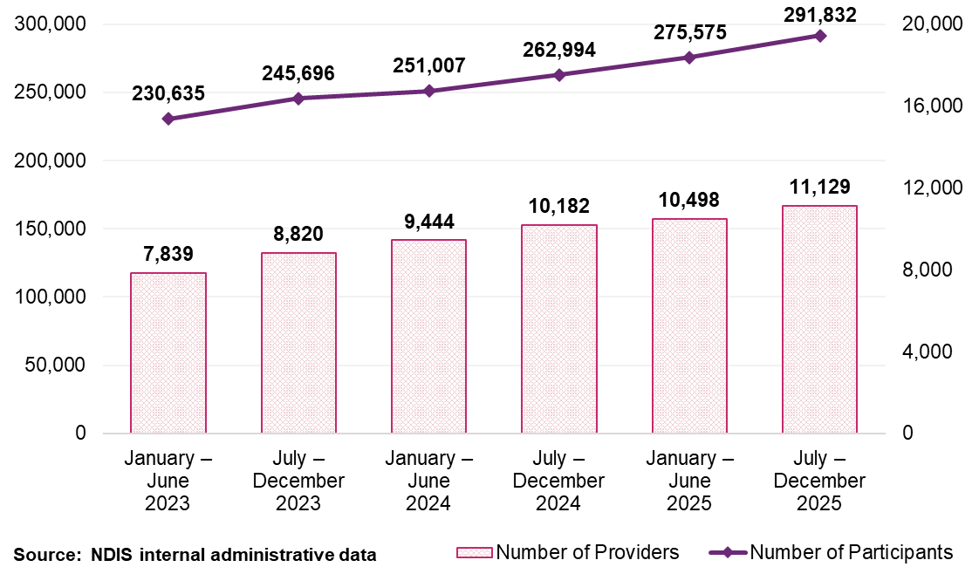

Participants
Three specific support types accounted for most of all payments in the 6 months to December 2025. Level 2: Coordination of Supports was the most claimed category. It was used by 275,167 participants and generated $506 million in payments. This represented approximately 82% of total support coordination payments (Figure 32). Level 1: Support Connection and Psychosocial Recovery Coaching was accessed by 39,397 participants, followed by Level 3: Specialist Support Coordination, accessed by 12,683 participants. Figure 32 shows the distribution of participants using different levels of support coordination. The estimates suggest the use of support coordination related services continues to show steady increases over time.
Figure 32: Participants using different levels of support coordination supports, between July 2024 to December 2025 and July 2025 to December 2025
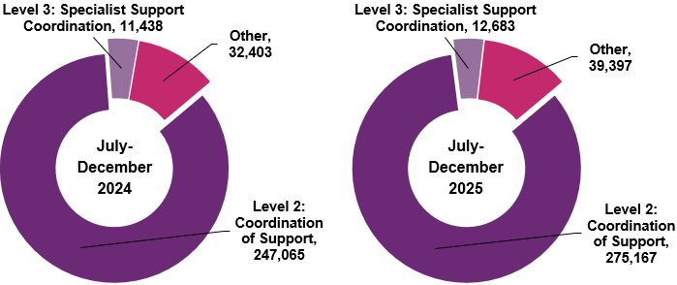
Source: NDIS internal administrative data
Note: The “Other” category includes Psychosocial Recovery Coaching and Level 1: Support Connection supports.

Providers

Provider growth
The total number of active support coordination providers reached 11,129 in the
6 months to December 2025, reflecting a 9% increase from the previous year (Table 26).
A divergence in growth trends was observed based on registration status, with the number of registered providers growing by to 20% from the previous year to 4,973. The number of unregistered providers increased by 4% to 6,428. This growth in providers has occurred alongside significant participant growth, particularly in the unregistered segment where demand continues to rise (Figure 33).
Figure 33: Number of providers by support coordination level, January 2023 to December 2025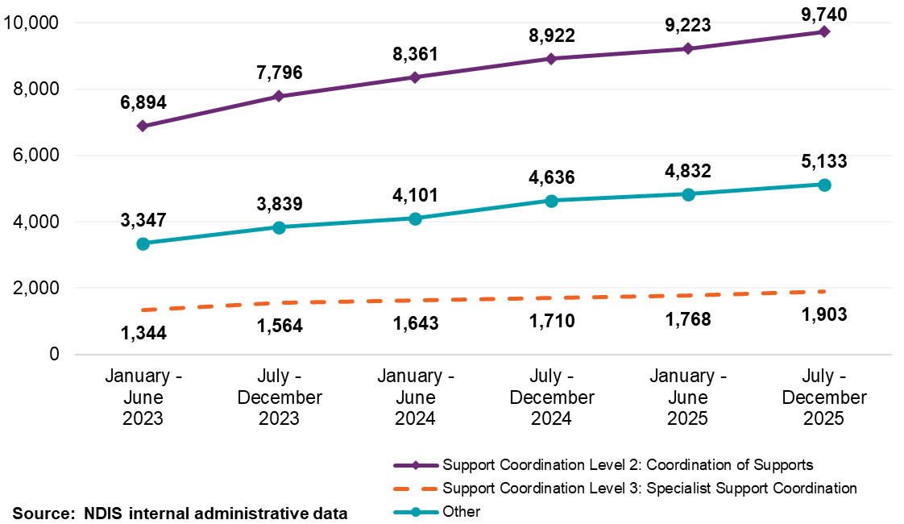
Note: The “Other” category includes Psychosocial Recovery Coaching and Level 1: Support Connection supports.

Provider concentration
Market concentration is low and has declined across the past 3 years. The combined market share of the top 10 providers fell from 7.9% in the 6 months to July 2023 to 7.2% in the 6 months to December 2025 (Figure 34). This decline occurred as overall provider numbers grew by 9%, indicating new entrants are diluting market concentration.
Figure 34: Top 10 providers’ market share against overall provider growth on support coordination supports, January 2023 to December 2025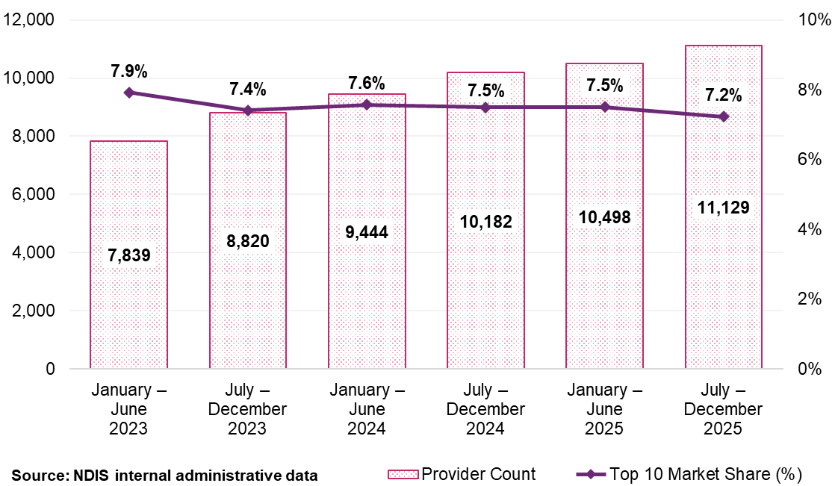
Note: The figure shows market share for both registered and unregistered providers.

Geographic spread of providers
Provider numbers grew across all remoteness categories between January 2023 and December 2025, with the overall market growing by 42% in non-remote areas (to 11,023 providers), 46% in remote areas to (708 providers) and 45% in very remote areas to (402 providers). Growth in thinner markets outpaced non-remote area growth in absolute percentage terms, indicating geographic availability has improved across the period. Despite this expansion, market concentration among the largest providers remained relatively stable. Figure 35 shows that, for support coordination supports, the top 10 providers’ market share in non‑remote areas declined modestly from around 7.9% in early 2023 to around 7.1% in December 2025, while in remote areas it remained broadly stable, decreasing slightly from around 40% to around 36%. In very remote areas, the top 10 providers’ market share remained unchanged at around 44% over the same period.
The registered and unregistered market contributed differently to this growth by remoteness. In non-remote areas, registered providers grew by 42% and unregistered providers by 46% (Table 29 and Table 30). In remote and very remote areas, unregistered provider growth was substantially greater. Unregistered providers grew by 69% in remote areas and 94% in very remote areas, compared with 40% and 28% for registered providers respectively.
Figure 35: Top 10 provider market share by remoteness for support coordination supports, January 2023 to December 2025
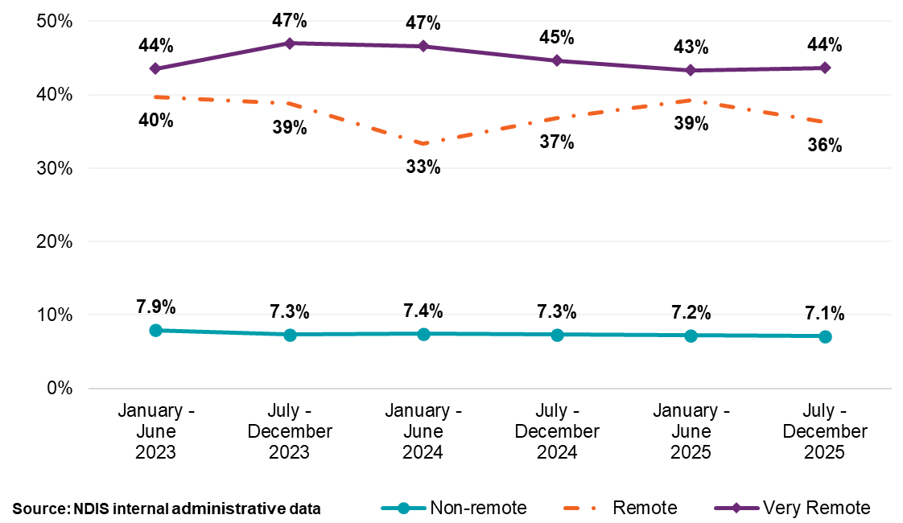
Table 29: Registered providers by remoteness for support coordination supports, January 2023 to December 2025
Remoteness | January – June  2023 | July – December  2023 | January – June  2024 | July – December  2024 | January – June  2025 | July – December  2025
Non-remote | 3,467 | 3,645 | 3,838 | 4,111 | 4,381 | 4,924
Remote | 324 | 362 | 425 | 427 | 396 | 453
Very remote | 199 | 212 | 215 | 227 | 244 | 255
Total for registered | 3,501 | 3,684 | 3,876 | 4,152 | 4,425 | 4,973
Source: NDIS internal administrative data
Table 30: Unregistered providers by remoteness for support coordination supports, January 2023 to December 2025
Remoteness | January – June  2023 | July – December  2023 | January – June  2024 | July – December  2024 | January – June  2025 | July – December  2025
Non-remote | 4,366 | 5,242 | 5,709 | 6,128 | 6,191 | 6,367
Remote | 160 | 197 | 298 | 329 | 253 | 271
Very remote | 80 | 98 | 114 | 143 | 158 | 155
Total for unregistered | 4,420 | 5,300 | 5,771 | 6,207 | 6,258 | 6,428
Source: NDIS internal administrative data
Note: The totals for registered and unregistered support coordination providers across different remoteness may not match the overall active provider count due to 2 factors: 1) Some providers offer both registered and unregistered supports within the same period, 2) A small fraction of providers with unspecified registration status are included in the total count but not detailed in the table.

Market composition
Companies claimed $489 million in payments in the 6 months to December 2025, with an average claim of $79,100 per provider, continuing to account for the largest share of market value (Table 31). While sole traders represented the largest cohort by provider count, with 4,147 active providers, they claimed $82 million, representing 13% of total payments. Companies claimed approximately 6 times the total value of payments compared to sole traders, with their average claim 4 times higher than the $19,800 average for sole traders (Table 31). This structural difference in entity type is further highlighted by the breakdown of registered providers, which is dominated by corporate entities (Figure 36). Unregistered providers are dominated by other entity types (Figure 37).
Table 31: Support coordination supports Scheme statistics by legal entity type, July to December 2025
Statistics | Company | Government entity | Partnership (other) | Trust / super | Sole trader
Number of NDIS participants | 237,344 | 989 | 5,024 | 18,079 | 44,474
Number of active providers | 6,184 | 18 | 223 | 557 | 4,147
Total amount claimed by active providers of support coordination supports (million) | $489.1 | $2.0 | $8.6 | $35.4 | $82.3
Average amount claimed by all active providers of support coordination supports | $79,100 | $111,100 | $38,800 | $63,600 | $19,800
Source: NDIS internal administrative data
Note: Providers with a missing legal entity type are excluded.
Average revenue is rounded up to the nearest hundred.
Figure 36: The counts of registered providers of support coordination supports by entity type and total payments, July to December 2025
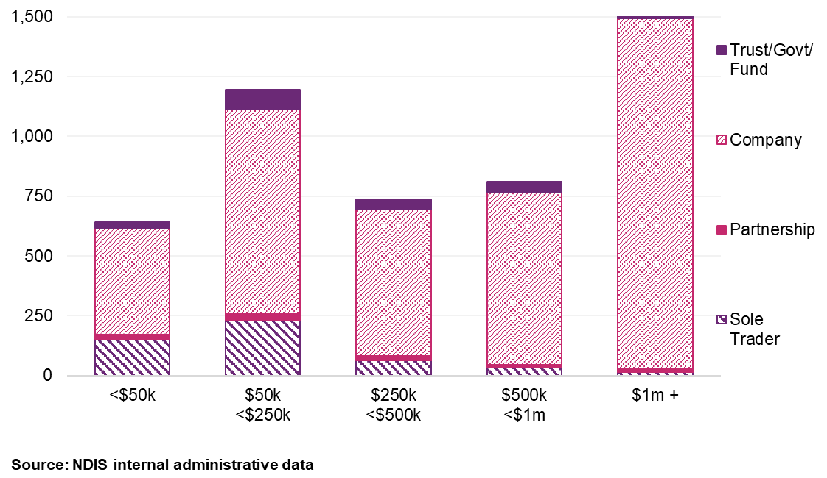
Figure 37: The counts of unregistered providers of support coordination supports by entity type and total payments, July to December 2025
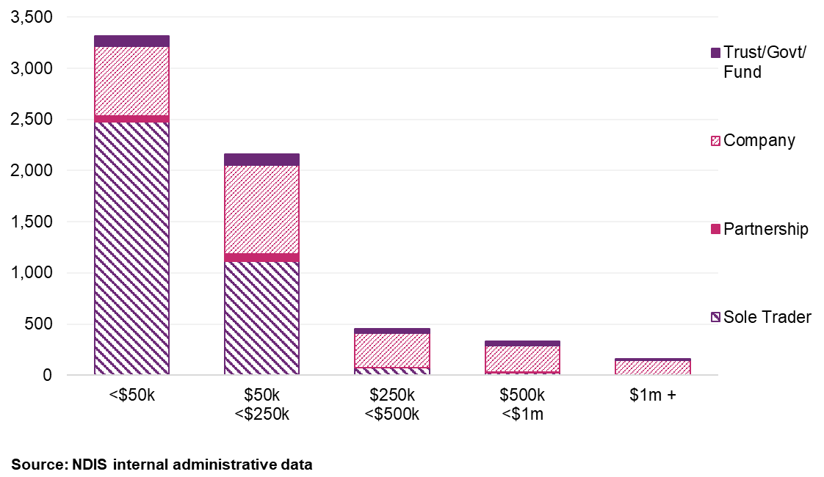

Provider scale and revenue distribution
The support coordination market is characterised by a large number of smaller providers, with the larger providers dominating revenues. The 201 providers supporting 251 or more participants, 1.8% of all active providers, received $214.2 million in payments, representing 34.7% of total support coordination payments in the 6 months to December 2025. At the other end, the 5,666 providers supporting 5 or fewer participants, 50.9% of all providers, received a combined $22.8 million, or 3.7% of total payments (Table 32).
The number of smaller providers warrants closer attention. Of the 3,180 providers supporting a single participant, average revenue was $2,000 for the half-year, consistent with a small number of hours of coordination delivered to one person over 6 months. These providers are, in aggregate, barely present in the payment volume (1.1% of total expenditure) despite representing 28.6% of all active providers. This changes at the 11-50 participant cohort, where 2,804 providers averaged $47,100 per provider and collectively accounting for 21.4% of payments. Above 101 participants, 708 providers (6.4% of the total) received 57.7% of all support coordination payments (Table 32).
Table 32: Statistics on the size of providers for support coordination supports, July to December 2025
Size of provider (number of participants supported) | Number of providers | Total payments to providers (million) | Average payments to providers | Share of total payments
1 | 3,180 | $6.5 | $2,000 | 1.1%
2 | 974 | $4.0 | $4,200 | 0.7%
3 | 639 | $4.1 | $6,500 | 0.7%
4 | 487 | $4.2 | $8,600 | 0.7%
5 | 386 | $4.0 | $10,300 | 0.6%
6-10 | 1,269 | $20.0 | $15,800 | 3.2%
11-50 | 2,804 | $132.1 | $47,100 | 21.4%
51-100 | 682 | $86.2 | $126,400 | 13.9%
101-250 | 507 | $142.7 | $281,400 | 23.1%
251-1000 | 184 | $152.7 | $830,100 | 24.7%
1000+ | 17 | $61.5 | $3.6m | 9.9%
Overall | 11,129 | $618.1 | $55,500 | 100%
Source: NDIS internal administrative data
Note: Average revenue is rounded up to the nearest hundred.
  - Business dynamism

Market entry and exit
Market entry remained high across both segments in the 6 months to December 2025, with 1,579 newly active unregistered providers and 619 newly active registered providers (Figure 38). However, the net effect of this entry differed markedly by segment when provider exits are also considered. The unregistered market recorded net growth of 221 active providers, indicating that departures nearly matched entries. The registered market achieved net growth of 821 active providers, indicating substantially stronger retention.
Figure 38: Newly active support coordination provider counts, January 2023 to December 2025
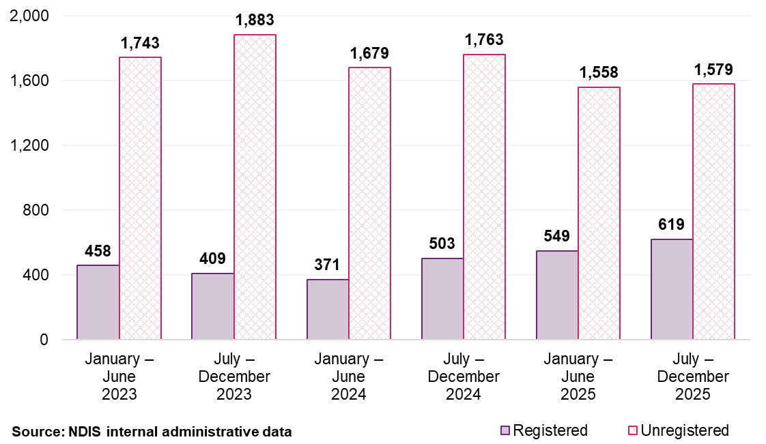

Comparison of provider payments for ‘new activity’ and ‘inactivity’
Payments attributable to new activity accounted for 1.7% of total payments in the 6 months to December 2025, compared with 0.8% reduction for inactivity (Figure 39). Entry continues to exceed exit in value terms, and this pattern has been consistent across the 3-year review period. The registered segment drives this dynamic: registered providers contributed the majority of new payments, consistent with the stronger net provider growth recorded in the registered market (821 net providers, compared with 221 for unregistered). Overall, the market continues to grow to meet demand, with registered providers showing greatest stability in service provision.
Figure 39: Support coordination registered provider activity movements, January 2023 to December 2025
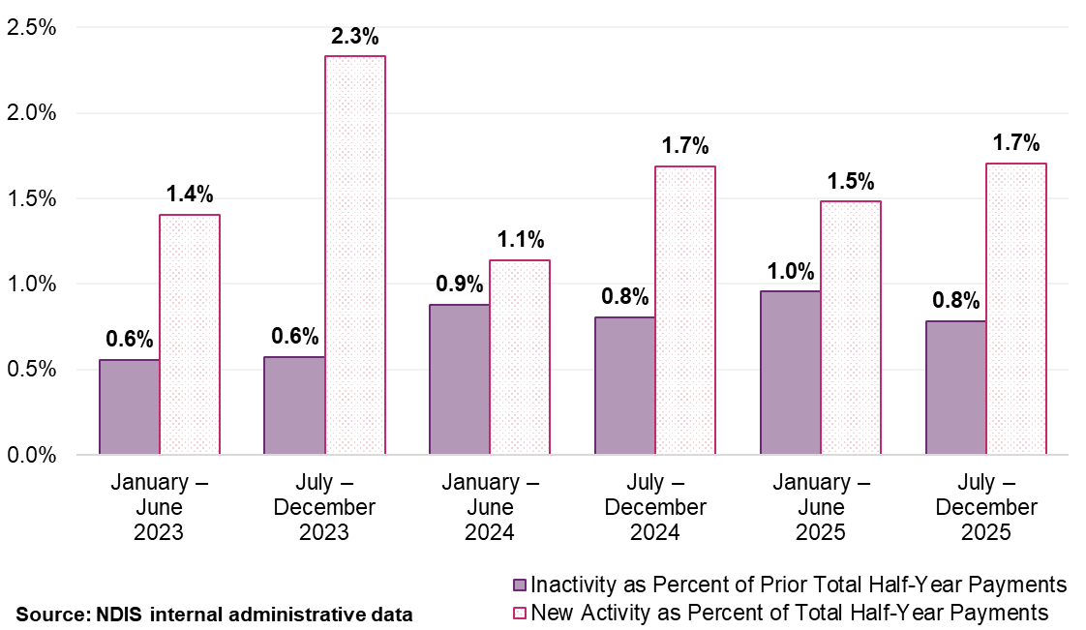
Note: ‘New Activity’ within a half-year period is identified when providers who were inactive in the previous half-year begin to receive payments. Conversely, ‘Inactivity’ is noted when providers that received payments in one half-year do not in the subsequent one. These fluctuations are measured as a percentage of the total payments made within that half-year, or the previous one, in the case of inactivity.

Payment consistency
Provider continuity data shows a meaningful difference in stability between the 2 segments. Among registered providers, 37% were active across all 6 half-year periods from January 2023 to December 2025, accounting for 85% of total registered payments (Figure 40). Among unregistered providers, only 15% were active across all 6-year periods, with a large share active for only one half-year period. That 15% stable cohort claimed 63% of unregistered payments (Figure 40).
Figure 40: Provider continuity for support coordination supports by registration status and percentage of total payments, January 2023 to December 2025
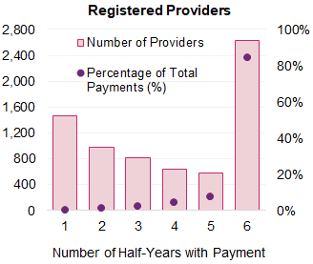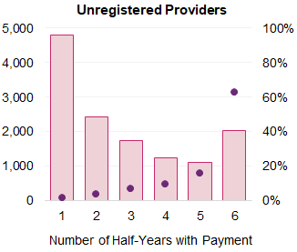
Source: NDIS internal administrative data
  - Consultation
Consultation evidence in this chapter informs interpretation of the market data but does not determine pricing conclusions. Because the support coordination market is created by the Scheme and has no external price comparisons, there is no independent market rate to validate against. Participant and provider feedback therefore serves a different analytical function here than in the benchmarked therapy market. It identifies what participants value in support coordination, flags where the scope of the role may have shifted relative to its pricing basis and shows access risks that market data may not fully capture. While these are important inputs, they do not establish on their own that current maximum prices are inadequate.

Participant consultation
Consistent with the participant choice findings reported in Chapter 4, trust and relationship quality, qualifications and training and availability were the most cited factors in choosing a support coordinator. Registration status was identified by 13% as a factor influencing choice of provider. Participants in regional areas placed greater emphasis on availability than those in major cities, reflecting thinner provider presence.
Provider continuity was a prominent concern: 54% identified losing their current provider as a risk with any pricing changes, and 65% were concerned about receiving fewer hours. These concerns were more pronounced among plan-managed respondents (56% and 69% respectively). Participants described their support coordinator as essential to understanding plan budgets, identifying providers and maintaining continuity across plan periods.

Provider consultation
Among provider respondents, 16% delivered support coordination services. Registered support coordination providers favoured registration as the basis for pricing differentiation (56%); unregistered providers preferred participant complexity (48%) and workforce qualifications (21%). This divergence mirrors the patterns observed across all support types.
Provider responses consistently identified a gap between the scope of the role as currently practised and the scope assumed by pricing. The most frequently raised issues were expanded cross-system navigation (housing, health, justice and education); crisis intervention including after-hours response, non-billable administrative work (reporting, service liaison, plan review preparation); and intensive capacity building with participants and families. These structural observations were about the evolving scope of the support coordination role, not the specific price. The Quality Supports Program Support Coordination pilot will provide the first evidence base for assessing whether the current pricing remains aligned with how the role is delivered in practice.
  - Discussion
The support coordination market is a Scheme-created market. Its size, structure and conduct are shaped directly by NDIS plan design, eligibility settings and prices rather than by independent supply and demand dynamics. Assessing whether prices remain appropriate therefore requires a different framework from the benchmarked therapy market and the DSW market, priced through the DSW Cost Model. The issue is not whether prices are aligned with external benchmarks, there are none, but whether current prices would support a market that delivers quality support coordination, and whether the scope of what providers are delivering has moved materially relative to what pricing assumes. This chapter addresses both of those questions.
On the first question, the market data supports maintaining current maximum prices. The core case is the stability and scale of the continuously active registered provider cohort. Thirty-seven per cent of registered providers were active across all 6 half-year periods from January 2023 to December 2025 and accounts for 85% of total registered provider payments. This segment delivers the most support coordination at scale and it is not showing signs of distress. Entry consistently exceeds exit in value terms. Average revenue for the stable cohort is consistent with a viable business model at the scale these providers operate. The decline in average registered provider revenue reflects dilution across a rapidly expanding provider base, 20% growth in provider numbers in the most recent period, rather than a deterioration among established operators. These signals collectively support the conclusion that current prices are not preventing the core provider base from sustaining delivery.
The high churn in the unregistered market segment warrants a separate interpretation. Unregistered providers are a single category. They include sole traders building small businesses and a much larger group of providers that cycle in and out of the market within a single reporting period. The latter group is not responding to pricing signals. Providers entering to support a specific participant and then exiting when that relationship ends are participating in a different type of market dynamic. Treating unregistered churn as a pricing concern would misread the data. The relevant question is whether the stable unregistered cohort is viable, and the evidence is consistent with it being so.
On the second question, consultation evidence identifies a material gap between the scope of the support coordination role as currently practiced and the scope the pricing approach was designed around. Providers consistently described activities, including cross-system navigation, crisis response, intensive capacity building and non-billable administrative work, that extends beyond the support coordination function implicit in current pricing. This is not a new observation, but it has not previously been supported by cost and service data at the provider level. The Support Coordination pilot will, for the first time, generate direct evidence on cost structures and service characteristics associated with quality support coordination. That evidence will provide the appropriate basis for assessing whether the framework for recommending NDIS pricing needs to be updated, rather than consultation data alone. Maintaining current price maximums while the pilot generates evidence is a deliberate sequencing decision rather than an absence of policy position.
  - Recommendations

Support Coordination
On balance, analysis indicates that while the Support Coordination market structure and dynamics have been evolving in recent years, there is no evidence to suggest supply is unable to meet participant demand.

Recommendation 12:
The maximum prices for Support Coordination should be:
- $80.06 for Level 1: Support Connection
- $100.14 for Level 2: Coordination of Supports
- $190.54 for Level 3: Specialist Support Coordination.

Psychosocial Recovery Coaching
Aligning Psychosocial Recovery Coaching with the DSW Cost Model would ensure prices appropriately reflected movements in the SCHADS Award, including minimum wage increases, superannuation changes and other employment‑related on‑costs considered through the APR. This approach would support workforce viability, promote consistency across DSW‑related supports, and help safeguard participant access to clinically appropriate, recovery‑oriented services.

Recommendation 13:
Prices for Psychosocial Recovery Coaches should align with the indexation of supports determined by the Disability Support Worker Cost Model in Recommendation 1.

- Plan Management
  - Context
There are 3 options available for managing participant funding: self-management, plan management, and Agency-management, which can be used in combination.
Under plan management, participants engage a registered plan manager to pay invoices, monitor budgets, and maintain financial records on their behalf. Plan-managed participants can access both registered and unregistered providers, an option that is not available under Agency-managed arrangements alone. Plan managers can claim for 2 distinct services: a fixed monthly fee for ongoing financial administration and a separate capacity‑building support when assisting participants to develop the skills needed to manage their funding independently.
The previous APR led to the introduction of a single national rate and the removal of the one-off establishment fee. Following the removal of remote and very remote loadings, plan management is now priced at a flat national rate with no geographical variation.
As use of plan management has increased, the provider market has consolidated around larger and more specialised organisations with the systems and scale required to process high volumes of transactions efficiently. Plan management is a fee-based, administrative service. Its cost drivers, transaction volume, processing systems, and operational scale are structurally different from those of hourly clinical or support services.
The question of appropriate prices is therefore not whether fees align with external labour market rates, but whether the current fee structure reflects how services are delivered and creates appropriate incentives for the role plan managers play in the Scheme’s payment architecture. This chapter addresses both the near-term pricing recommendations and the case for why the fee structure should be reviewed.
  - Scheme statistics

Market overview
Between July and December 2025, 1,616 registered plan managers submitted at least one claim (Table 33), processing just under $16 billion in payments from participant plans. Of this, $320 million was claimed directly as plan management fees, while the remaining $15.6 billion reflects payments made to other providers on behalf of participants.
Participant numbers grew by 15.5% to 518,548 participants, while plan management payments grew by 3.7% to $320 million in the 6 months to December 2025. This divergence reflects the removal of the establishment fee and remote loadings that took effect from 1 July 2025.
Table 33: Plan management Scheme statistics, July 2024 to December 2025
Statistics | July – December 2024 | July – December 2025 | Percentage change
Total number of NDIS participants | 448,951 | 518,548 | +15.5%
Total number of active providers | 1,624 | 1,616 | -0.5%
Total amount claimed for plan management fees | $309 million | $320 million | +3.7%
Total number of active providers claiming fees | 1,376 | 1,335 | -3.0%
Average amount claimed for plan management fees per provider | $224,500 | $240,000 | +6.9%
Source: NDIS internal administrative data
Note: Figures reflect payments made for plan management supports and may differ from the number of providers registered with the NDIS Quality and Safeguards Commission or participants with plan-management funding.
Figure 41 shows plan‑managed payments now account for approximately 60% of total Scheme payments, exceeding the share of participants using plan management (50%).
Figure 41: Distribution of payments (by payments made) by plan management type, January 2023 to December 2025
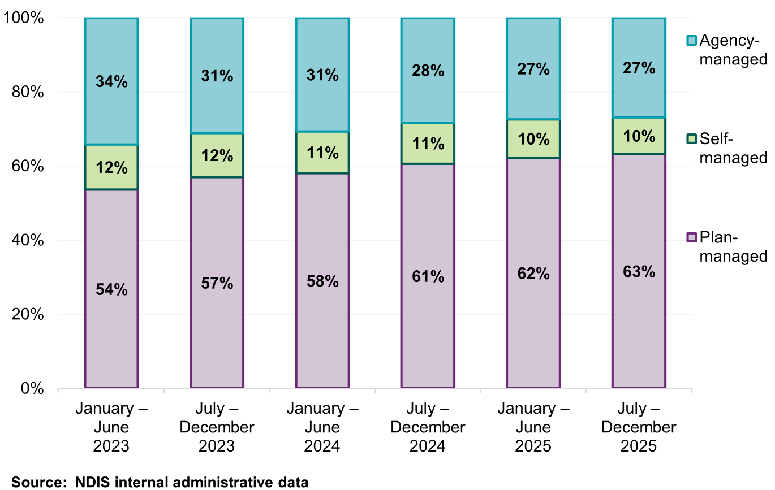
Note: Management type is determined by the payment management type. Payment type can only either be Agency-managed, plan-managed or self-managed. Therefore, there is no mixed payment type, in contrast to participants in Figure 42.
Plan management payments grew 18.6% from $13.5 billion to $16 billion, driven primarily by Core – Daily Activities (up 21%) and Core – Community (up 18%). Growth was broad-based across support categories (Table 34).
Table 34: Total payment via active registered plan managers (including plan management fee), July 2024 to December 2025
Support category | July – December 2024  (million) | July – December 2025  (million) | Percentage change
Core - Daily Activities | $6,012.4 | $7,276.6 | +21.0%
Core - Community | $4,147.2 | $4,894.2 | +18.0%
Capacity Building - Daily Activities | $1,925.2 | $2,125.9 | +10.4%
Capacity Building - Support Coordination | $316.2 | $397.2 | +25.6%
Capacity Building - Choice and Control | $308.9 | $320.5 | +3.7%
Capital - Assistive Technology | $237.0 | $300.6 | +26.8%
Core - Consumables | $226.8 | $224.2 | -1.1%
Capacity Building - Relationships | $78.2 | $140.5 | +79.5%
Capacity Building - Social and Civic | $75.5 | $95.7 | +26.7%
Capital - Home Modifications | $48.6 | $82.5 | +69.6%
Capacity Building - Employment | $51.4 | $70.0 | +36.2%
Core - Transport | $15.2 | $16.8 | +10.6%
Capacity Building - Health and Wellbeing | $8.8 | $7.6 | -13.4%
Capacity Building - Home Living | $0.4 | $0.6 | +41.8%
Capacity Building - Lifelong Learning | $0.1 | $0.2 | +38.8%
Total payments via Plan Managers (including plan management fee) | $13.5 billion | $16.0 billion | +18.6%
Source: NDIS internal administrative data.
Note: Some support categories have experienced large percentage growth, reflecting increases from small bases. These categories and line items should be interpreted with caution.

Participants
The proportion of participants using plan management continued to increase and reached 50% of all Scheme participants in the second half of 2025 (Figure 42).
Figure 42: Distribution of participants (by payments made) by plan management type, January 2023 to December 2025
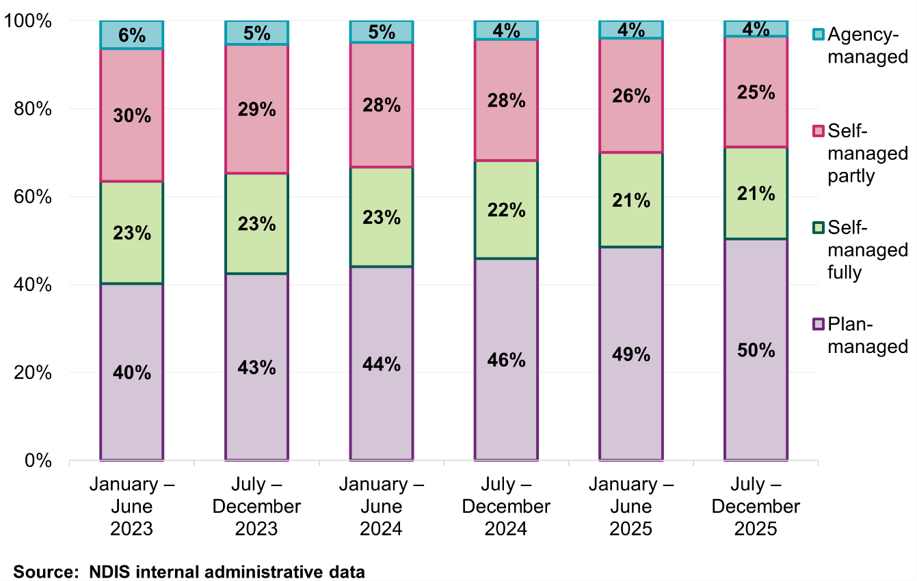
Note: Management type of the participants is determined by the payment management type and is consistent with the Quarterly Report to Disability Ministers.
“Agency-managed” participants refer to participants with only Agency-managed payments during the period. “Self-managed partly” participants refer to participants with self-managed payments as well as either Agency-managed and/or plan-managed payments during the period. “Self-managed fully” participants refer to participants with only self-managed payments during the period. “Plan-managed” participants refer to participants with only plan-managed payments and those with Agency-managed payments during the period.

Participants by remoteness
The use of plan managers among participants in remote and very remote areas continued to grow across the 3-year period to December 2025. In very remote areas, participant numbers increased from 2,972 in the first half of 2023, and to 4,293 in the second half of 2025. Remote areas showed growth from 4,307 to 6,256 over the same period, despite some variation between half-year periods (Table 35).
Table 35: Participants by remoteness for plan management supports, January 2023 to December 2025
Remoteness | January – June  2023 | July – December 2023 | January – June  2024 | July – December 2024 | January – June  2025 | July – December 2025
Non-remote | 357,743 | 392,657 | 409,758 | 440,190 | 475,023 | 508,660
Remote | 4,307 | 4,707 | 7,886 | 8,098 | 5,858 | 6,256
Very remote | 2,972 | 3,203 | 3,518 | 3,767 | 3,974 | 4,293
Overall | 365,053 | 400,403 | 418,009 | 448,951 | 484,278 | 518,548
Source: NDIS internal administrative data.
Note: Participants can be counted more than once if they have moved locations. Participants with missing remoteness are not shown in the table above but are included in the overall results.

Providers
While participant numbers have grown substantially, the number of active registered plan managers has remained broadly stable over the period. Between January 2023 and December 2025, the number of registered plan managers fluctuated within a narrow range, indicating little net change over time (Figure 43).
This stability is consistent with the market structure described in the previous APR. The fixed monthly fee favours providers that operate at scale, and the market is consolidated in that direction. The reduction in smaller provider numbers has been offset by larger providers absorbing additional participants.
Figure 43: Distribution of participants and providers with a plan manager, January 2023 to December 2025
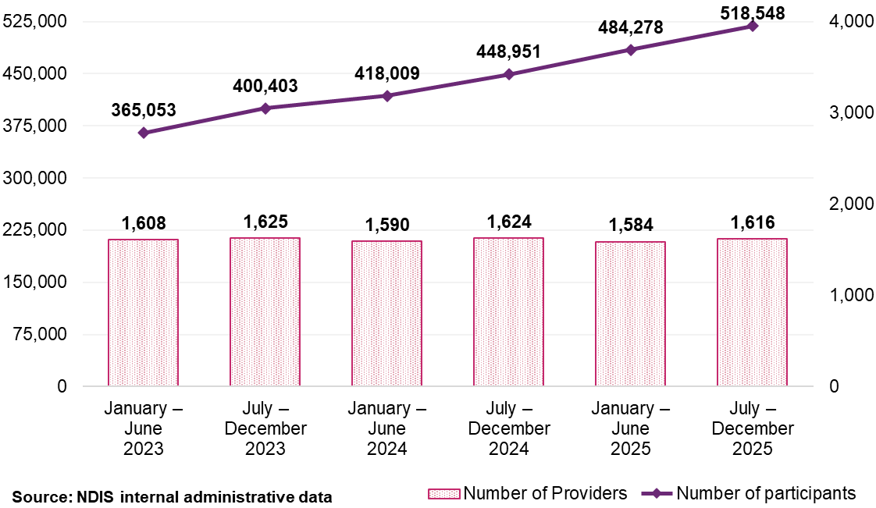
The 5 largest plan managers processed a significant and stable portion of total payments throughout the 3-year period. The composition of this group has remained unchanged since the first half of 2023, indicating a mature market where the largest providers have established durable positions (Figure 44).
Figure 44: Scheme expenditure for largest 5 plan managers (based on total payments processed), January 2023 to December 2025
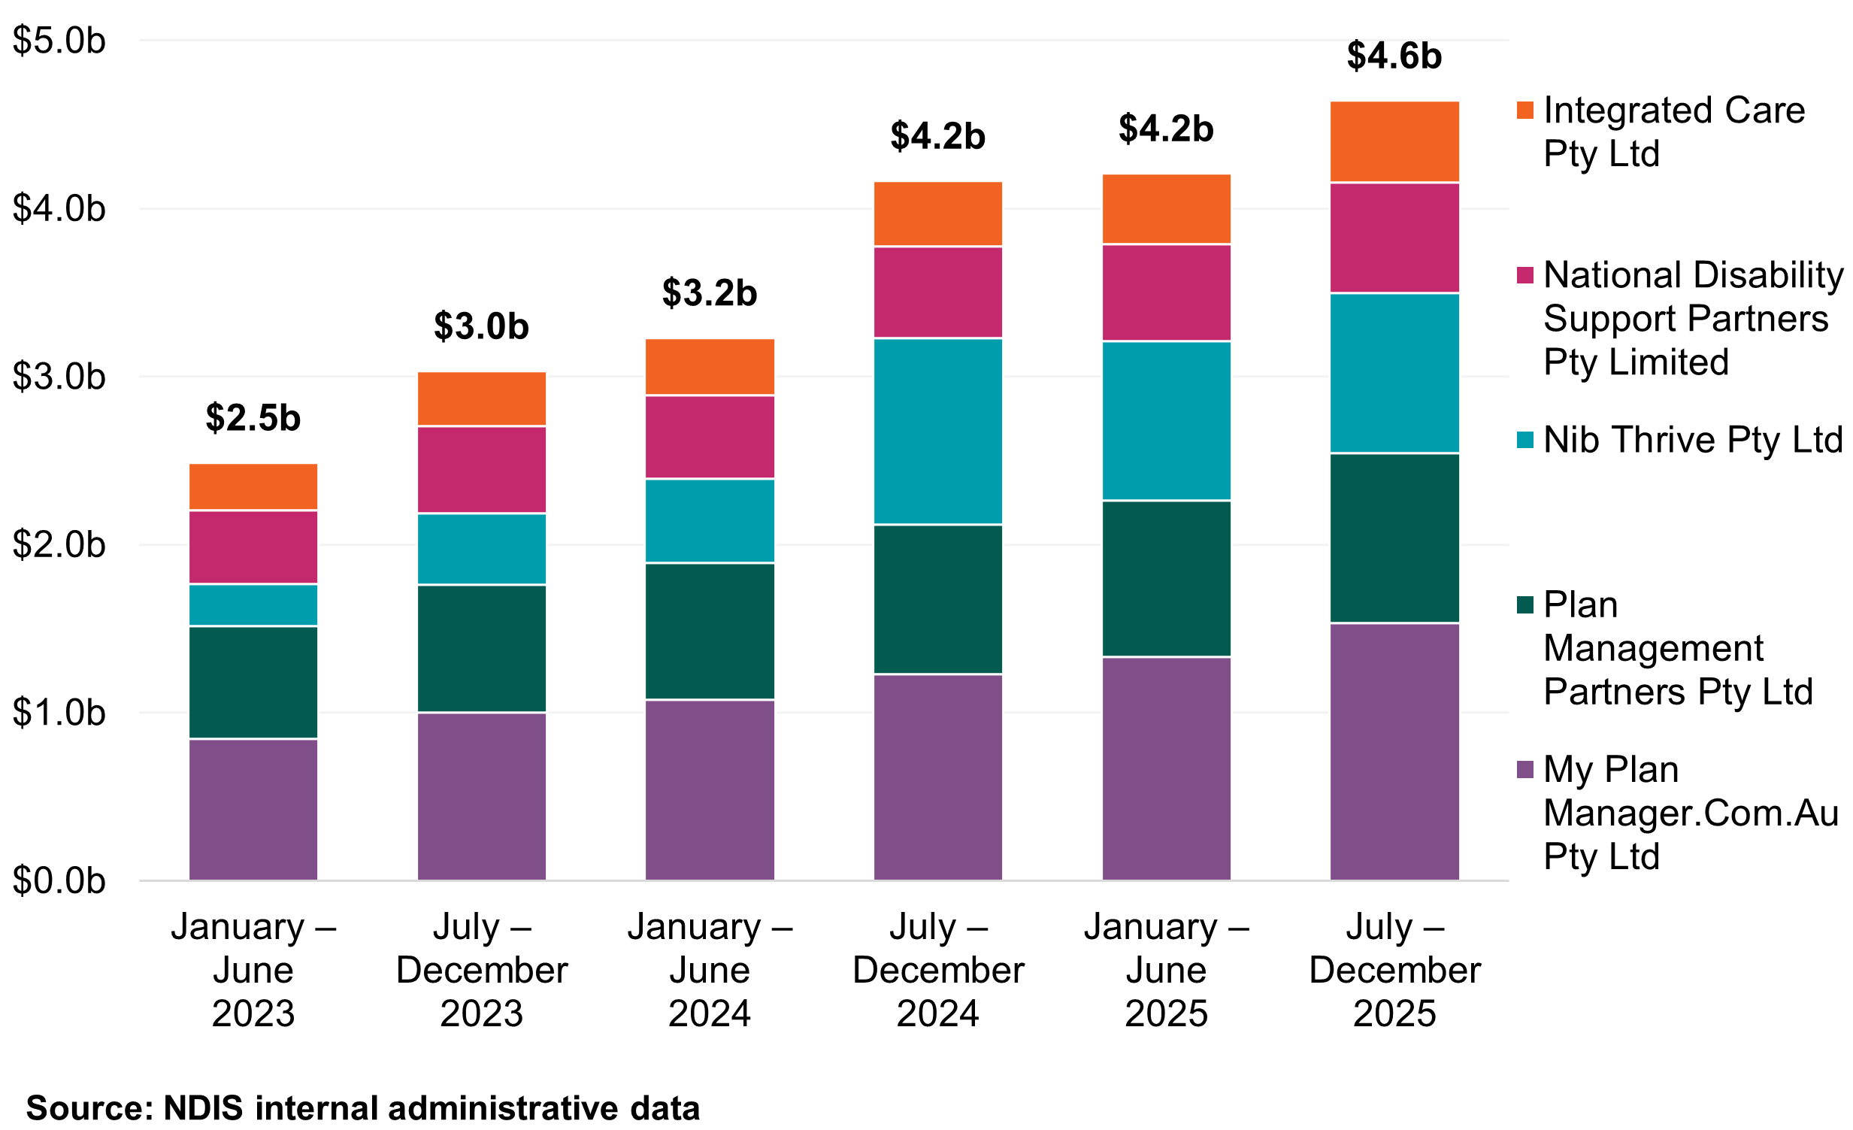
Note: The largest 5 plan managers are based on total payments from January 2023 to December 2025. This group has remained unchanged since January to June 2023.

Top 10 providers market share by remoteness
The top 10 providers maintained consistent market share across all remoteness categories. In remote and very remote areas these providers managed more than half of all plan-managed payments, a share that has grown over the 3-year period. The same 10 providers held their position throughout. This indicates large providers are successfully servicing these markets through virtual delivery models that do not depend on physical presence (Figure 45).
This pattern reinforces the recommendation in the previous APR to remove remote and very remote loadings (see Section 9.4).
Figure 45: Top 10 providers’ market share by remoteness, January 2023 to December 2025
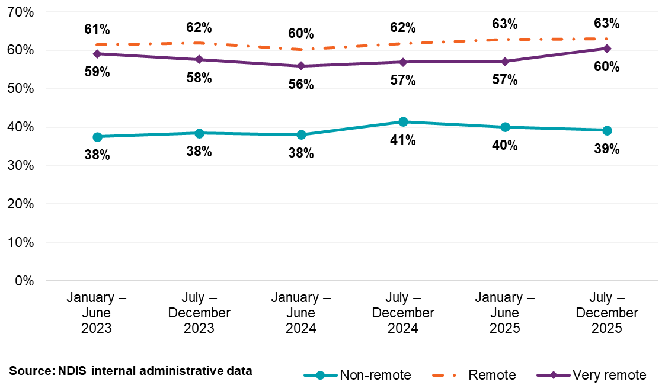
Note: Top 10 providers are determined by total payment processed by plan managers.

Providers by remoteness
The number of active plan managers showed slight variations across remoteness areas between January 2023 and December 2025. Among participants in non‑remote areas, the number of plan managers servicing these participants increased slightly by 4% (from 1,278 to 1,334). Remote areas saw a larger increase of 24% (from 242 to 300), while very remote areas experienced the largest growth at 32% (from 150 to 198) (Table 36).
Table 36: Active plan managers by remoteness, January 2023 to December 2025
Remoteness | January – June  2023 | July – December 2023 | January – June  2024 | July – December 2024 | January – June  2025 | July – December 2025
Non-remote | 1,278 | 1,323 | 1,354 | 1,372 | 1,352 | 1,334
Remote | 242 | 259 | 320 | 317 | 296 | 300
Very remote | 150 | 167 | 172 | 179 | 194 | 198
Overall | 1,284 | 1,331 | 1,360 | 1,376 | 1,356 | 1,335
Source: NDIS internal administrative data.
Note: Remoteness of plan managers uses participants’ address as a proxy. Plan managers may be counted more than once if they provide support to participants located in multiple remoteness locations. This means the rows will not add up to the totals. Plan managers with missing remoteness are not shown in the table above but included in the overall results.

Providers by entity types
Most plan management providers are companies. They represent 75% of active providers and handle most plan‑managed payments. In the 6 months to December 2025, 998 companies processed just under $14 billion in total payments, with average claims of $14 million per provider. Sole traders (205 providers) claimed $15.5 million in plan management fees, averaging $75,700 per provider (Table 37).
Table 37: Plan managers Scheme statistics by legal entity type, July to December 2025
Statistics | Company | Government entity | Partnership (other) | Trust / super | Sole trader
Number of NDIS participants | 458,197 | 206 | 10,885 | 27,545 | 26,712
Number of active providers | 998 | 5 | 33 | 94 | 205
Total amount claimed by active providers (including management fee) (million) | $13,968.0 | $3.7 | $329.8 | $936.4 | $715.1
Average amount claimed (million) | $14.0 | $0.7 | $10.0 | $10.0 | $3.5
Total amount claimed by active providers as plan management fee (million) | $281.3 | $0.1 | $6.4 | $17.2 | $15.5
Average amount claimed as plan management fee | $281,800 | $24,500 | $192,500 | $182,900 | $75,700
Source: NDIS internal administrative data.
The average plan management fee per company provider ($281,800) is 3.7 times that of the average sole trader ($75,700), reflecting the same structural dynamic seen across the market, the flat monthly fee generates returns proportional to participant volume, and companies dominate that volume. This pattern is examined further in the Provider revenue and processing section below.
  - Business dynamism
The following subsections examine provider turnover, scale and specialisation,
3 characteristics that, taken together, indicate whether the market is stable, whether pricing is binding, and whether the current fee structure is producing appropriate incentives.

Provider continuity by provider size
The plan management market is characterised by high continuity and low turnover. Approximately 94% of all plan-managed payments between January 2023 and December 2025 were processed by providers who were active across all 6
half-year periods. Providers active for only one or 2 periods accounted for less than 1% of total payments (Figure 46).
Figure 46: Plan managers continuity by percentage of total payments, January 2023 to December 2025
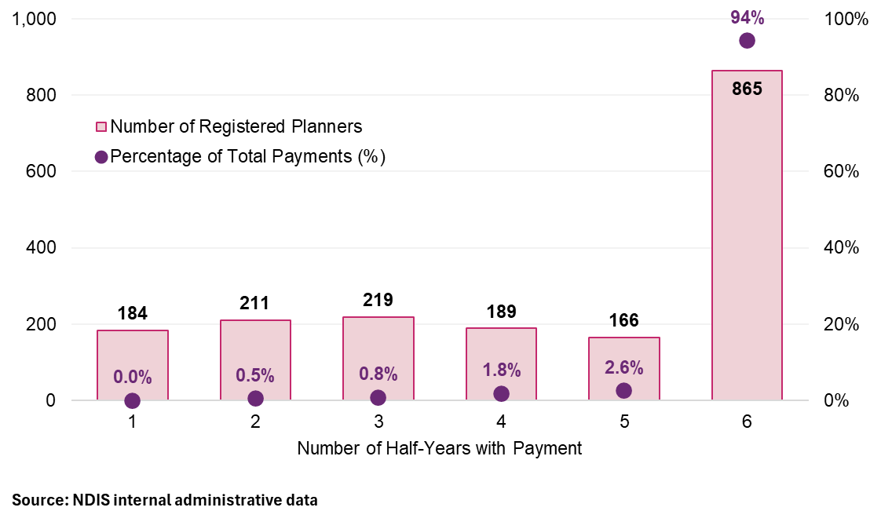
Provider turnover in the plan management market remains low. Across the 3-year period newly active providers accounted for 0.2–0.8% of total plan-managed payments in any given half-year period. Similarly, inactive providers (those potentially exiting the market or claiming episodically) consistently represented less than 1% of payments from the prior period (Figure 47).
Figure 47: Registered plan manager activity movements, January 2023 to December 2025
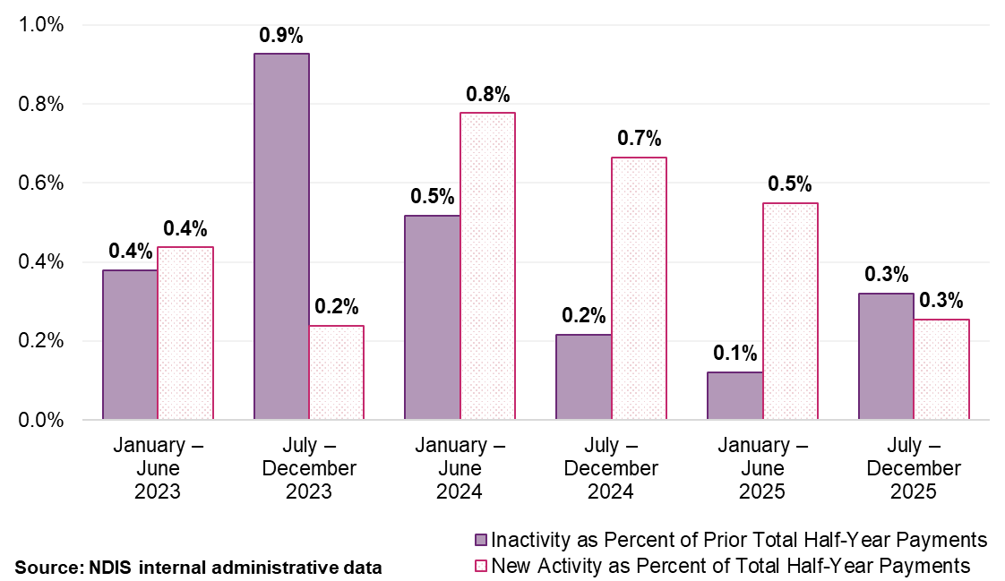
Note: ‘New activity’ is characterised by providers receiving payments in the half-year who did not receive payments in the preceding half-year. ‘Inactivity’ refers to providers not receiving payments in a half-year after having received payments in the previous one. Each provider’s activity is quantified as a percentage of the total payments within that half-year for new activity, of the prior half-year for inactivity.

Provider scale
Plan managers overwhelmingly operate at some scale. In the second half of 2025, 99.5% of all plan-managed payments were processed by providers supporting more than 20 participants. Very small-scale providers (10 or fewer participants) account for a significant share of provider numbers but less than 0.5% of total payments. This pattern has been stable since 2023 (Figure 48).
Figure 48: Plan management providers and number of participants that claimed, January 2023 to December 2025
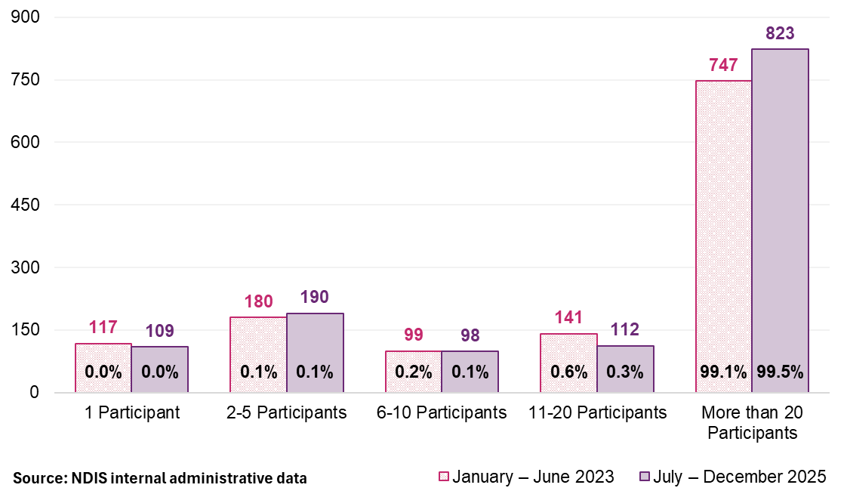

Plan managers providing other services
Sixty-four per cent of plan managers delivered other supports to their plan-managed participants in the second half of 2025, though these services accounted for only 3% of total plan-managed payments (Figure 49 and Figure 50). The share of providers delivering only plan management services increased from 29% to 36% over the 3-year period, indicating a gradual shift toward specialisation (Figure 49).
The delivery of both financial oversight and funded supports by the same provider creates a potential conflict of interest, which the NDIS Commission has identified as a regulatory priority.
Figure 49: Number of plan managers claiming other services for their plan-managed participants for the period, January 2023 to December 2025
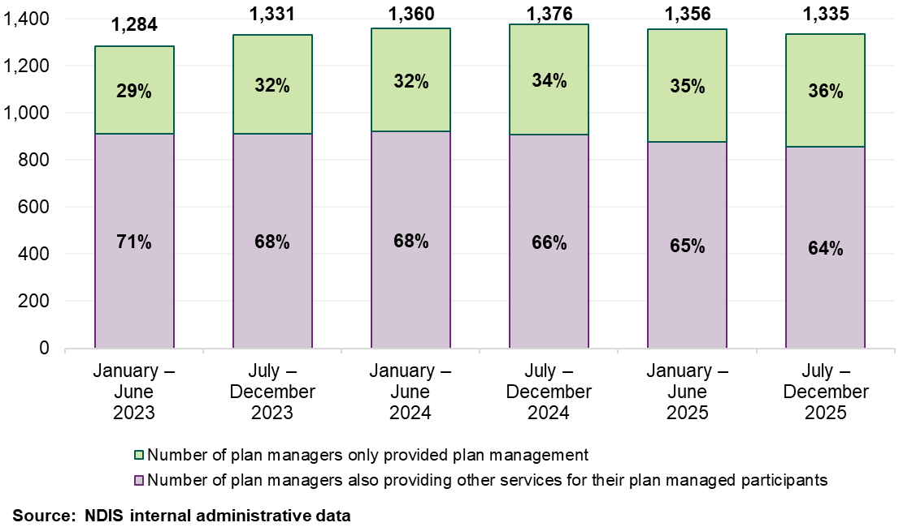
Figure 50: Payment of plan managers claiming other services for their plan-managed participants for the period, January 2023 to December 2025
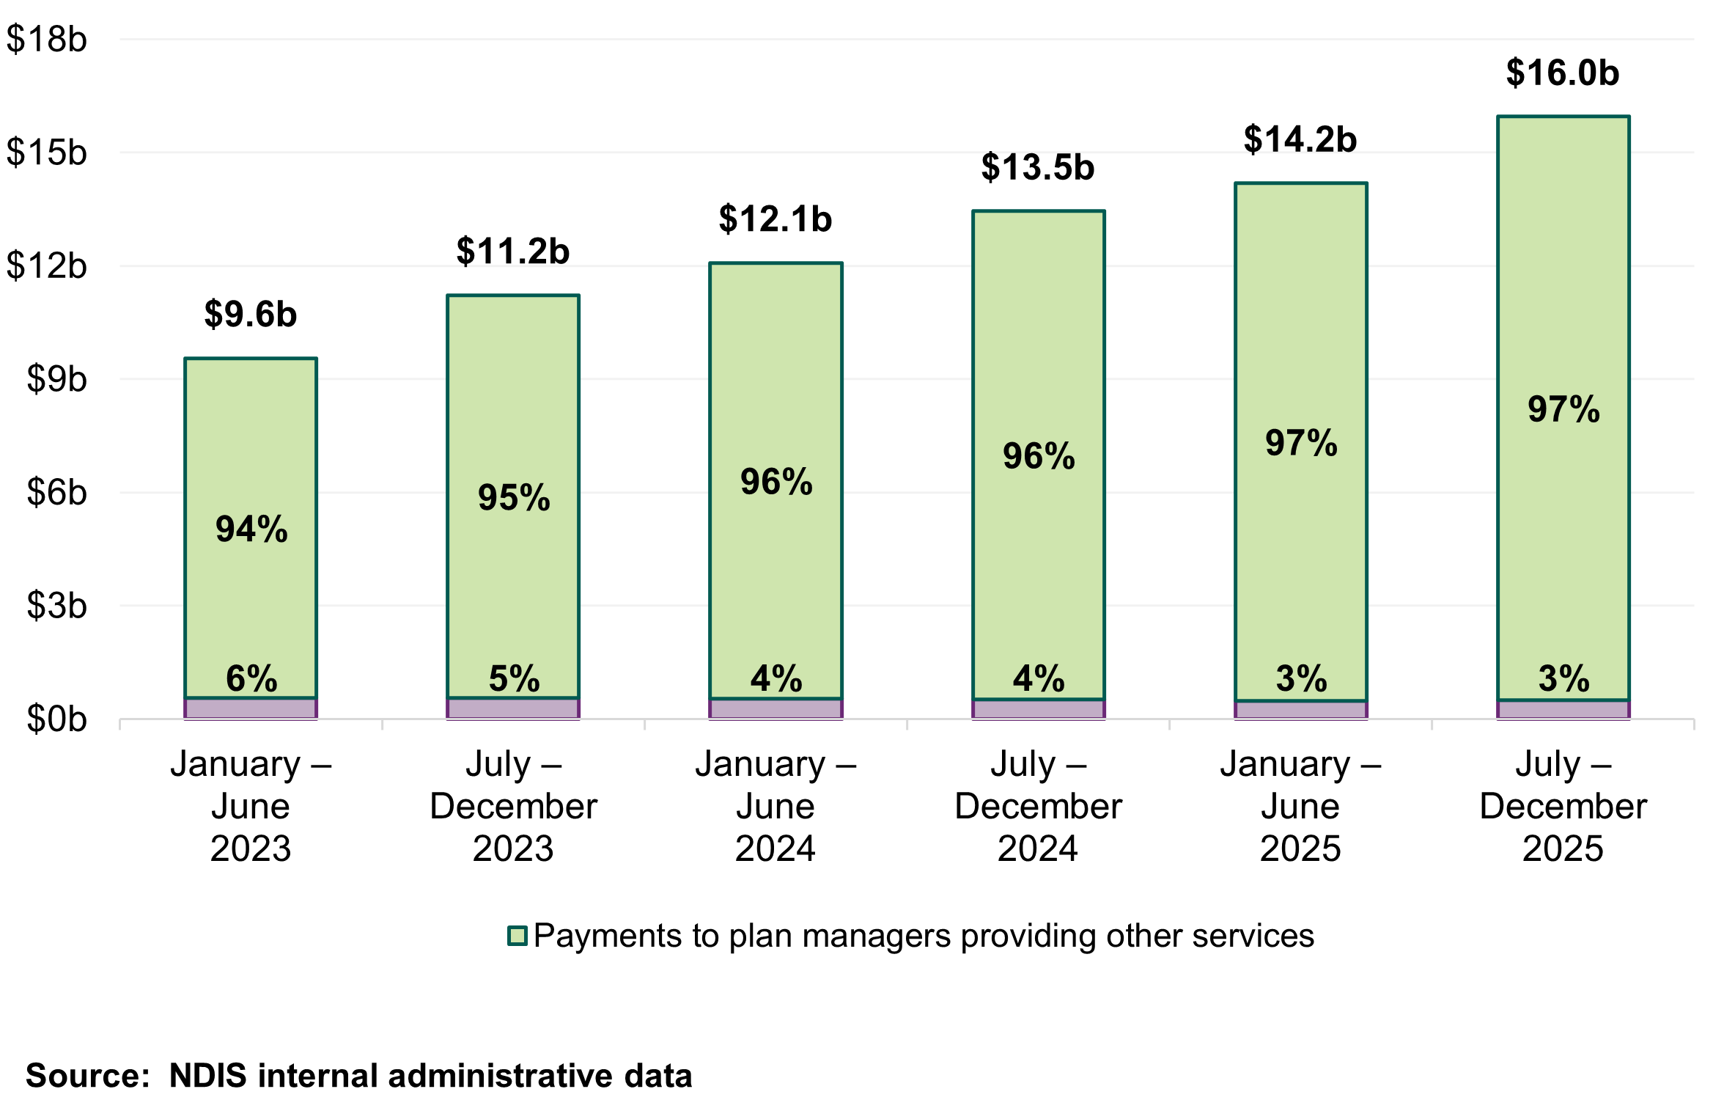
Taken together, business dynamism data indicates a settled and concentrated market with near-zero turnover, operation at large scale as the norm, and a clear trend toward specialisation. These characteristics confirm the current pricing structure is not causing market instability. They also indicate the structure of the flat fee, which rewards volume and does not differentiate by service complexity, has shaped how the market operates. This is the context for the revenue and processing analysis below.
  - Impact of the 2024–25 APR
The 2024–25 APR recommended removing the establishment fee and monthly fee loadings for remote and very remote areas, from 1 July 2025. Monitoring data over the 6 months to December 2025 indicates no disruption to participant access or provider viability.
Participant numbers using plan management in remote and very remote areas continued to grow in line with pre-change trends. Active plan manager numbers in these areas were similarly stable, with no evidence of market exits. Provider caseloads held steady at approximately 19 participants per provider. Total and average payments dropped immediately on 1 July 2025 and stabilised at the lower level, consistent with the expected impact of removing the loading. In previously higher-rate areas, payments converged toward the national rate as intended.
Removal of the establishment fee had no observable effect on provider entry, participant uptake or market stability. The evidence confirms the pricing changes for 2025-26 did not destabilise the market, consistent with large providers servicing remote areas through virtual delivery models that do not depend on location-based cost structures.
  - Provider revenue and processing
The revenue plan managers receive per transaction varies materially with provider scale. In the 6 months to December 2025, 66 million plan-managed transactions were processed. Based on total plan management fees paid, this implies an average of $4.86 per transaction from the Scheme's perspective. Larger plan managers received $4.40 per transaction; smaller providers received $5.40, a 23% differential in implied revenue per transaction (Table 38 and Table 39).
Table 38: Plan management fees and transactions by entity size, July to December 2025
Entity size  (plan managers fees) | Total plan management fees | Transactions count | Fee per transaction
More than $2.5 million | $157 million | 36 million | $4.40
Less than $2.5 million | $163 million | 30 million | $5.40
Total | $320 million | 66 million | $4.86
Source: NDIS internal administrative data.
Table 39: Plan management bulk versus non-bulk payments by entity size, July to December 2025
Entity size  (transaction fees) | Bulk payment processing | Non-bulk payment processing | Proportion of total
More than $2.5 million | 100% | 0% | 50%
Less than $2.5 million | 80% | 20% | 50%
Total | 90% | 10% | 100%
Source: NDIS internal administrative data.
Note: Refunds payments are all processed individually and are excluded from the table above to focus on payments.
This differential is driven by processing method. Larger plan managers process effectively 100% of payments via bulk file upload. Smaller providers process more than 20% as individual payment requests, which involves higher per-transaction administrative effort (Table 40).
Table 40: Plan management bulk versus non-bulk payments by entity type, July to December 2025
Entity type | Bulk payment processing | Non-bulk payment processing | Proportion of total
Company | 91% | 9% | 87%
Trusts / super | 83% | 17% | 6%
Sole trader | 83% | 17% | 5%
Partnerships (other) | 87% | 13% | 2%
Government entity | 89% | 11% | 0%
Total | 90% | 10% | 100%
Source: NDIS internal administrative data.
These patterns indicate providers processing most of the plan-managed activity are operating comfortably within the existing flat monthly fee, and there is no evidence of system-wide cost pressures to warrant an increase. The current pricing structure implicitly favours processing volume and creates incentives for consolidation, as providers operating at scale can process more transactions within the same fixed fee. Whether this consolidation is entirely desirable depends on whether smaller plan managers deliver a qualitatively different service, such as more intensive participant engagement, that the flat fee does not distinguish from automated processing. The revenue and processing analysis, alongside the consultation evidence below, informs that question.
  - Consultation
Consultation evidence in this chapter serves a specific analytical purpose. Market data establishes the plan management market as stable, mature and operating at scale. What market data cannot establish is whether the flat monthly fee adequately compensates for qualitative differences in service delivery, particularly whether more intensive, relational engagement with participants represents a distinct cost that the current fee structure does not distinguish from high-volume automated processing. Provider and participant responses are the primary evidence base for the differing quality aspects of plan management delivery. They do not determine the appropriate fee level but rather identify whether the current structure is creating the right incentives and whether a structural review is needed.

Provider survey
There were 135 provider survey respondents who identified as plan managers. When asked about pricing structures and plan management service delivery, the largest group (43 respondents, 31.9%) preferred a hybrid model combining a flat fee with tiered levels for complex plans. Additionally, 40 respondents (29.6%) preferred a flat monthly fee, 17 preferred a transaction-based model and 9 (6.7%) preferred volume-based tiers.
Provider feedback on the current fee level was consistent. Most respondents considered the monthly fee insufficient, particularly for smaller plan managers and for participants with complex plans requiring more intensive financial administration and participant engagement. Many respondents raised the need for a monthly fee increase and/or specifically called for reinstatement of the establishment fee, noting the initial set-up of a new plan involves substantial administrative effort that is not reflected in the ongoing monthly payment. Several respondents noted the fee has not increased for 7 years despite rising wages, insurance, rent and registration costs over the same period.
Smaller plan managers reported being disproportionately affected by the current fee structure. Respondents described difficulty competing with larger providers that have invested in automated systems, while still managing participants who require hands on support including phone contact, budget explanations and provider coordination beyond invoice processing.

Participant survey
Of the 557 participant survey respondents, 296 (53%) identified as plan-managed, with a further 45 reporting more than one plan management arrangement. Plan management pricing was not the primary focus of the participant survey, and the survey did not include dedicated questions on plan management fee levels or service quality.
In free-text responses, participants raised plan management directly. The most common themes related to the financial viability of their plan manager, particularly smaller operators, and the value participants place on the relational and advisory role plan managers play beyond invoice processing. Several participants said their plan manager helped them understand their plan, navigate provider options and manage budgets – functions that go beyond financial administration. A smaller number of respondents observed that pricing pressures risk reducing the quality and availability of plan management supports, particularly for participants in regional areas or with complex support arrangements.
  - Discussion
This chapter addresses 2 distinct problems. The first is whether it should be recommended that the current monthly fee should be maintained at its present level. The second is whether the flat monthly fee structure creates appropriate incentives for the role plan managers play in the Scheme’s payment architecture, a structural design question. These questions have different evidential bases and different implications. The first can be answered affirmatively on current market data. The second cannot be fully resolved without a review of the pricing approach, and the evidence supports progressing that review.
The plan management market is the most consolidated in the Scheme. The same 5 providers have held dominant positions for 3 years. Provider turnover is near zero. Providers who have been continuously active since January 2023 process 94% of all plan-managed payments. This is a mature oligopoly, not a competitive market, and the pricing structure has produced this outcome by design. The flat monthly fee rewards processing scale and automation, and the market has consolidated accordingly.
The 25% revenue-per-transaction differential between large and small providers ($4.40 versus $5.40 per transaction) is driven by processing automation. The market has optimised for the incentive the pricing structure creates: minimise per-transaction cost, maximise participant volume and invest in bulk processing systems. This may be an efficient outcome where the primary objective is standardised financial processing. It may be less desirable if plan management should also encompass budget advice, provider navigation and participant support, functions that smaller plan managers report delivering, but the flat fee does not distinguish from automated processing.

Recommended pricing approach
The revenue per-transaction data and provider consultation responses point to a tension that will sharpen over time. The flat fee does not distinguish between high-automation, large scale processing and more intensive, relational participant engagement. As processing automation improves, the cost advantage for large providers will continue to grow, and the gap between what the flat fee compensates and what smaller plan managers deliver will widen.
Provider survey respondents were divided on alternatives: 32% preferred a hybrid model (flat fee plus tiered levels for complexity), 30% preferred the current flat fee, 13% preferred a transaction-based model. The distribution suggests broad support for moving beyond a single flat fee, though there is no consensus on a replacement structure. A review should examine whether alternative approaches — such as volume-based discounting, tiered pricing, a per-transaction fee, or a hybrid model — would better reflect observed cost structures and provide appropriate signals. The review should also consider the interaction between plan management pricing and the broader reforms to plan management governance.

Conflict of interest
The trend toward provider specialisation is positive. The proportion of plan managers delivering only plan management services has increased from 29% to 36%, and other services delivered by plan managers represent a declining share of total plan-managed payments (3%, down from 7% in 2023). The Agency will continue to monitor these indicators alongside the NDIS Commission's regulatory work on conflicts of interest.
  - Recommendations
The plan management market is mature, stable and operating at scale. Continuously active providers process 94% of payments and no disruption to market stability followed the 2024–25 pricing changes. The evidence does not support recommending an upward adjustment to the current monthly fee at this time.

Recommendation 14:
The monthly fee for Plan Management should be $104.45 per month.
It is recommended that as the NDIS transitions from rapid growth to market stewardship, prices should reflect the role plan management plays within the broader system architecture. While current evidence supports maintaining the price, the structure of pricing should be reviewed to ensure it aligns with long-term market design objectives. This approach recognises that mature markets require periodic structural review even in the absence of instability.

Recommendation 15:
The NDIA should undertake a review of the Plan Management pricing approach to ensure price guidance and recommendations remain aligned with the administrative and transactional nature of the support, and reflect how Plan Management is delivered in practice.
- Social, Community and Civic Participation
  - Context
Social, Community and Civic Participation (SCCP) supports enable participants to engage in community, social and recreational activities where assistance is required due to the functional impacts of their disability. Supports are delivered as individual or group-based services across community settings, centres and participants’ homes. The category includes standard community access, high-intensity supports for participants with complex behavioural or health needs, and group and centre-based transport. Supports are delivered predominantly by disability support workers and do not require professional qualifications.
SCCP supports are delivered through 2 structurally distinct provider models that the current pricing approach treats as equivalent. The first is an organisational model: predominantly registered providers operating as companies with employed workforces, formal governance and compliance systems. The second is a relational model: predominantly unregistered sole traders working directly with one or 2 participants through personal, ongoing relationships.
As set out in Chapter 4, participants value both models — trust, rapport and flexibility are the primary drivers of provider choice, with registration ranking lowest among selection factors. The 2 models carry different regulatory obligations, different cost structures, and deliver different forms of assurance to the Scheme. There is currently a national maximum price across both models. Whether this uniform pricing approach remains appropriate is the central question of this chapter.
  - Market overview
SCCP is a large and growing market. In the 6 months to December 2025, payments reached $5.5 billion, which is 21% of total Scheme payments, and services were delivered by 99,365 providers to 276,333 participants (Table 41, Figure 51). Payments grew by 57% in absolute terms between January 2023 and December 2025, though it has remained stable as a share of Scheme payments. As a result any pricing change in this category applies to a significant share of overall Scheme expenditure.
The SCCP market grew substantially between January 2023 and December 2025, with provider numbers increasing by 41–45% and total expenditure rising by 57%. (Table 41, Figure 51).
Table 41: SCCP supports Scheme statistics – all providers, July 2024 to December 2025
Statistics | July – December 2024 | July – December 2025 | Percentage change
Number of NDIS participants | 253,154 | 276,333 | +9.2%
Number of active providers | 90,045 | 99,365 | +10.4%
Total amount claimed by active providers of SCCP-related supports | $4.7 billion | $5.5 billion | +16.2%
Average amount claimed by all active providers of SCCP-related supports | $52,400 | $55,200 | +5.3%
Source: NDIS internal administrative data
Averages are rounded to the nearest hundred.
Figure 51: NDIS expenditure on SCCP supports relative to total NDIS expenditure, January 2023 to December 2025
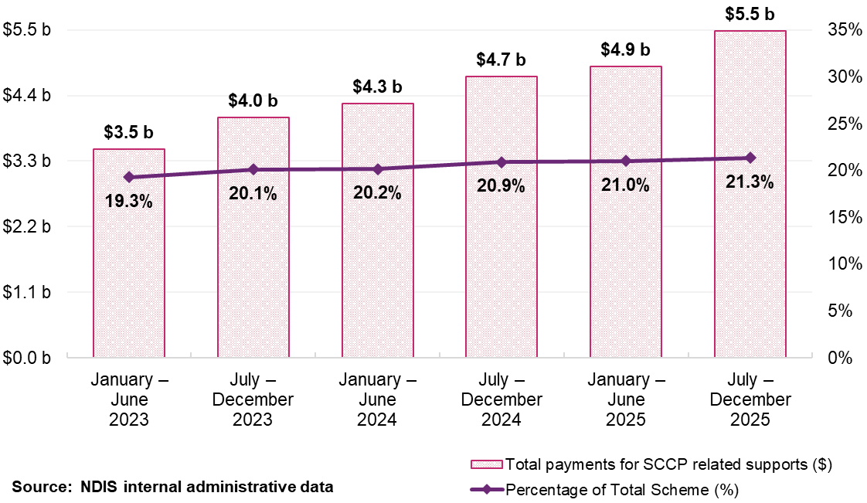
Registered providers account for 10% of providers (10,393) but receive 62% of total payments ($3.4 billion), at an average of $328,900 per provider. Unregistered providers account for 90% (89,907) but receive 38% of payments ($2.1 billion), at an average of $22,900 per provider. This 15-fold difference in average revenue is consistent with the fundamentally different operating models, not simply different scales (Table 42, Table 43).
Table 42: SCCP supports Scheme statistics – all registered providers, July 2024 to December 2025
Statistics | July – December 2024 | July – December 2025 | Percentage change
Number of NDIS participants | 166,953 | 182,839 | +9.5%
Number of active providers | 8,345 | 10,393 | +24.5%
Total amount claimed by active providers of SCCP-related supports | $2.9 billion | $3.4 billion | +16.8%
Average amount claimed by all active providers of SCCP-related supports | $350,700 | $328,900 | -6.2%
Source: NDIS internal administrative data
Averages are rounded to the nearest hundred.
Table 43: SCCP supports Scheme statistics – all unregistered providers, July 2024 to December 2025
Statistics | July – December 2024 | July – December 2025 | Percentage change
Number of NDIS participants | 137,957 | 150,942 | +9.4%
Number of active providers | 82,303 | 89,907 | +9.2%
Total amount claimed by active providers of SCCP-related supports | $1.8 billion | $2.1 billion | +15.2%
Average amount claimed by all active providers of SCCP-related supports | $21,700 | $22,900 | +5.5%
Source: NDIS internal administrative data
Averages are rounded to the nearest hundred.
Note: The totals for registered and unregistered providers may not match the total provider count due to 2 factors: 1) Some providers offer both registered and unregistered supports within the same period, 2) A small fraction of providers with unspecified registration status are included in the total count but excluded from the detailed tabulation in the table.
SCCP supports, covering both standard and high intensity individual and group delivery across community settings, accounted for approximately $4.2 billion in payments in the 6 months to December 2025, delivered by 95,395 providers to 256,093 participants, representing around 76% of total SCCP expenditure (Table 44).
Table 44: Top 10 largest SCCP supports (based on payments), July to December 2025
Support delivered | Total payments (million) | Number of participants | Number of providers
Access Community Social and Recreational Activities Standard | $4,230 | 256,093 | 95,395
Group Activities Standard | $658 | 63,422 | 7,682
Activity Based Transport | $253 | 173,901 | 41,949
Access Community Social and Recreational Activities High Intensity | $144 | 6,594 | 3,757
Provider Travel | $80 | 91,128 | 26,993
Group Activities High Intensity | $65 | 2,886 | 865
Centre Capital Cost | $48 | 53,344 | 1,756
Establishment Fee for Personal Care/Participation | $3.6 | 4,997 | 1,595
Access Community Social and Recreational Activities Standard - TTP | $1.3 | 897 | 174
Group Activities Standard - TTP | $0.5 | 468 | 85
Source: NDIS internal administrative data
  - Market analysis

Two delivery models, one maximum price
Registration status and legal entity data together confirm SCCP is not a single market differentiated only by provider size. It comprises 2 structurally distinct delivery models operating under the same price.
The first is an organisational delivery model, associated predominantly with larger registered providers operating as companies. Companies account for around 19% of active providers but claim 74% of total SCCP payments (approximately $4 billion), at an average of $211,100 per provider (Table 45). These providers operate with formal governance structures, employed workforces, enterprise agreements and compliance systems.
The second is a relational delivery model, associated predominantly with unregistered sole traders. Sole traders account for 76% of providers (75,504) and claim 20% of payments (approximately $1.1 billion), at an average of $14,400 per provider (Table 45). These providers typically work directly with a small number of participants without the overhead structures that organisational delivery requires. Fifty-six per cent of all SCCP providers (55,862) support a single participant and 88% support 5 or fewer participants.
Table 45: SCCP supports NDIS statistics by legal entity type, July to December 2025
Statistics | Company | Government entity | Partnership (other) | Trust / super | Sole trader
Number of NDIS participants | 220,373 | 1,216 | 7,192 | 22,592 | 89,483
Number of active providers | 19,151 | 140 | 1,671 | 2,901 | 75,504
Total amount claimed by active providers of SCCP-related supports ($ million) | $4,043.3 | $6.3 | $66.5 | $272.4 | $1,087.9
Average amount claimed by all active providers of SCCP-related supports | $211,100 | $45,200 | $39,800 | $93,900 | $14,400
Source: NDIS internal administrative data
Average revenue is rounded up to the nearest hundred.
Note: Providers with a missing legal entity type are excluded.
The unregistered market is mostly sole traders. Of the 89,909 unregistered providers with a known entity type, 74,762 are sole traders and only 15,147 are organisations. This is in contrast to the registered market where, the number of organisations (9,566) are significantly more than sole traders (829) and registered organisations claim substantially more in payments ($3,368 million compared with $50 million respectively) (Table 46 and Table 47).
The distribution of providers by legal entity type and number of participants supported shows a clear and notable pattern. Among unregistered sole traders, 47,795 (64%) support a single participant, and a further 13,307 support 2 (Table 46 and Table 47). More than 4 in 5 unregistered sole traders work with one or 2 people. By contrast, registered organisations span the full range of provider scale, from individual participant relationships to providers supporting hundreds of participants. This reflects an organisational delivery model designed to operate at scale.
Table 46: Number of providers and total payments by legal entity type and number of participants – registered providers, July to December 2025
Size of provider (number of participants supported) | Organisation count | Total organisation payment  (million) | Sole trader count | Total sole trader payment  (million)
1 | 1,811 | $21 | 307 | $3
2 | 962 | $25 | 122 | $2
3 | 682 | $28 | 91 | $3
4 | 522 | $33 | 58 | $2
5 | 424 | $29 | 42 | $2
6–10 | 1342 | $155 | 108 | $10
11–50 | 2278 | $1,004 | 96 | $24
51–100 | 623 | $650 | 5 | $4
101–250 | 311 | $634 | - | -
251–1000 | 101 | $554 | - | -
1000+ | 10 | $234 | - | -
Overall | 9,566 | $3,368 | 829 | $50
Source: NDIS internal administrative data
Table 47: Number of providers and total payments by legal entity type and number of participants – unregistered providers, July to December 2025
Size of provider (number of participants supported) | Organisation count | Total organisation payment  (million) | Sole trader count | Total sole trader payment  (million)
1 | 6,246 | $51 | 47,795 | $379
2 | 2,213 | $43 | 13,307 | $204
3 | 1,202 | $32 | 5,846 | $133
4 | 847 | $35 | 3,031 | $87
5 | 631 | $30 | 1,699 | $58
6–10 | 1,720 | $126 | 2,447 | $111
11–50 | 2,022 | $426 | 635 | $65
51–100 | 204 | $123 | 2 | $1
101–250 | 53 | $61 | - | -
251–1000 | 7 | $18 | - | -
1000+ | 2 | $74 | - | -
Overall | 15,147 | $158 | 74,762 | $1,038
Source: NDIS internal administrative data

Claiming behaviour
Claiming behaviour evidence indicates the current maximum prices bears differently on registered and unregistered providers. Registered providers claim at the maximum price in approximately 73–79% of transactions; unregistered providers do so in around 61–67% of transactions. This 10–15% gap has been stable over 3 years (Table 48).
Table 48: Claiming patterns at published price analysis for SCCP supports, January 2023 to December 2025
Claiming patterns – at published price | January – June  2023 | July – December 2023 | January – June  2024 | July – December 2024 | January – June  2025 | July – December 2025
Registered | 79% | 78% | 73% | 74% | 77% | 77%
Unregistered | 64% | 62% | 63% | 61% | 67% | 64%
All Providers | 75% | 73% | 70% | 70% | 74% | 73%
Source: NDIS internal administrative data
Note: All providers above are inclusive of providers with the unknown registration status at the time of the transaction.
Among unregistered providers supporting one participant, 25% claim at less than 80% of the current maximum price, 16% between 80–90% of the maximum price, and 26% at the maximum price. Under the proposed recommended 10% reduction, the new unregistered maximum price would sit at approximately 80% of the current level. This means 25% of this group would be already operating within or below the proposed rate, and a further 16% would be within 10% of it. The rest of the market, comprising registered providers and unregistered providers supporting more than one participant, shows a different distribution: 18% below 80%, 25% between 95–99%, and 29% at the price (Table 49).
Table 49: Distribution of SCCP provider claims relative to the published price, by provider type and participant count, July to December 2025
Published price | Unregistered providers with only one participant | Registered providers and unregistered providers with more than one participant | All providers who provided SCCP supports
Less than 50% of published price | 2,296 (4%) | 2,232 (5%) | 4,516 (5%)
50%–70% of published price | 4,598 (9%) | 2,863 (6%) | 7,433 (7%)
70%–80% of published price | 6,603 (12%) | 3,288 (7%) | 9,880 (10%)
80%–90% of published price | 8,820 (16%) | 6,190 (13%) | 14,963 (15%)
90%–95% of published price | 6,889 (13%) | 6,177 (13%) | 13,012 (13%)
95%–99% of published price | 10,334 (19%) | 11,621 (25%) | 21,825 (22%)
At published price | 14,147 (26%) | 13,110 (29%) | 26,993 (27%)
Over published price | 153 (0%) | 296 (1%) | 447 (0%)
Total | 54,039 (100%) | 45,871 (100%) | 99,365 (100%)
Source: NDIS internal administrative data
Note: Claims for supports not subject to a published price are not shown separately in the table but are included in the total for each column. The sum of the first and second columns may not equal the total for all providers column, as registration status of the provider can change during the reporting period. Providers are grouped according to the price applicable to their claims.
The 54,039 unregistered providers supporting a single participant represent a segment of the SCCP market with distinct claiming and scale characteristics. They are predominantly sole traders (47,795 of 54,039) and their largest support item is Access Community and Social Recreational Activities. This accounts for $413 million of the $430 million in total SCCP payments received by this group.

Market capacity and stability
Market concentration is low and declining. The top 10 providers' share of total SCCP payments fell from 5.8% to 5.4% over the 3-year period; in remote areas the decline was sharper, from 24% to 18% (Figure 52). This pattern indicates new provider entry has dispersed market share rather than increased concentration.
Figure 52: Top 10 providers’ market share against overall provider growth on SCCP supports, January 2023 to December 2025
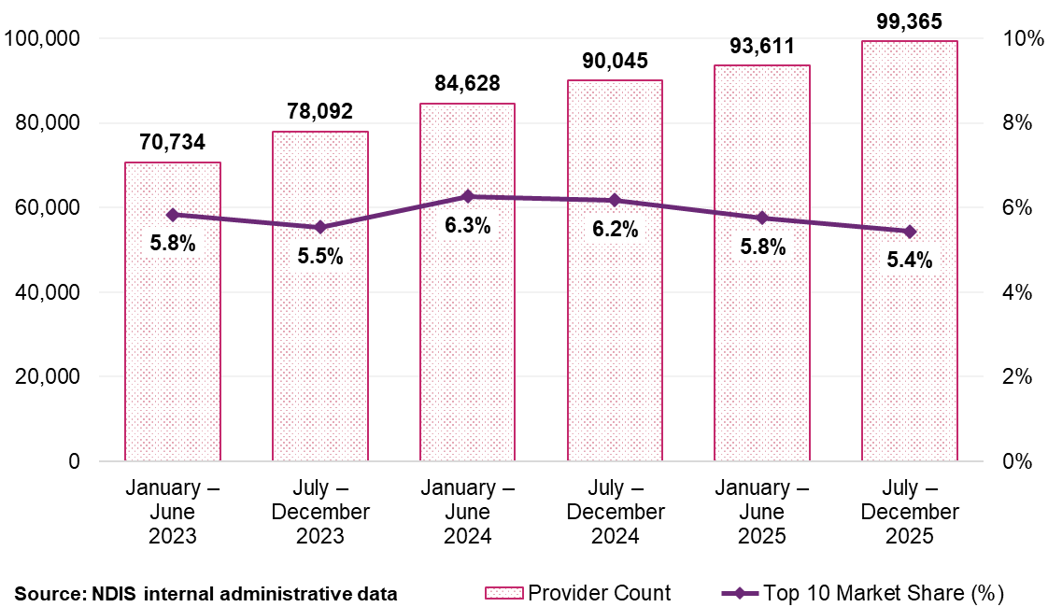
Provider numbers increased across all remoteness categories between January 2023 and December 2025. In non-remote and very remote areas registered provider growth outpaced unregistered provider growth (Table 50, Table 51, Table 52 and Figure 53). In remote areas the pattern was more even. The SCCP market is expanding in all geographic settings with no evidence of supply contraction in thin markets.
Table 50: SCCP supports Scheme statistics – non-remote locations, January 2023 to December 2025
Remoteness | January – June  2023 | July – December 2023 | January – June  2024 | July – December 2024 | January – June  2025 | July – December 2025
Registered | 6,468 | 6,541 | 7,286 | 8,260 | 8,923 | 10,284
Unregistered | 63,713 | 71,000 | 76,914 | 81,204 | 84,216 | 88,810
All providers | 69,851 | 77,120 | 83,472 | 88,875 | 92,481 | 98,169
Source: NDIS internal administrative data
Table 51: SCCP supports Scheme statistics – remote locations, January 2023 to December 2025
Remoteness | January – June  2023 | July – December 2023 | January – June  2024 | July – December 2024 | January – June  2025 | July – December 2025
Registered | 271 | 269 | 356 | 374 | 329 | 388
Unregistered | 763 | 891 | 1,354 | 1,334 | 1,019 | 1,122
All providers | 1,026 | 1,153 | 1,694 | 1,689 | 1,342 | 1,490
Source: NDIS internal administrative data
Table 52: SCCP supports Scheme statistics – very remote locations, January 2023 to December 2025
Remoteness | January – June  2023 | July – December 2023 | January – June  2024 | July – December 2024 | January – June  2025 | July – December 2025
Registered | 152 | 173 | 192 | 191 | 204 | 240
Unregistered | 369 | 409 | 446 | 508 | 455 | 514
All providers | 517 | 576 | 634 | 692 | 650 | 743
Source: NDIS internal administrative data
Note: The totals for registered and unregistered providers may not match the overall active provider count due to 2 factors: 1) Some providers offer both registered and unregistered supports within the same period, 2) A small fraction of providers with unspecified registration status are included in the total count but excluded from the detailed tabulation in the table.
Figure 53: Top 10 providers’ market share by remoteness for SCCP supports, January 2023 to December 2025
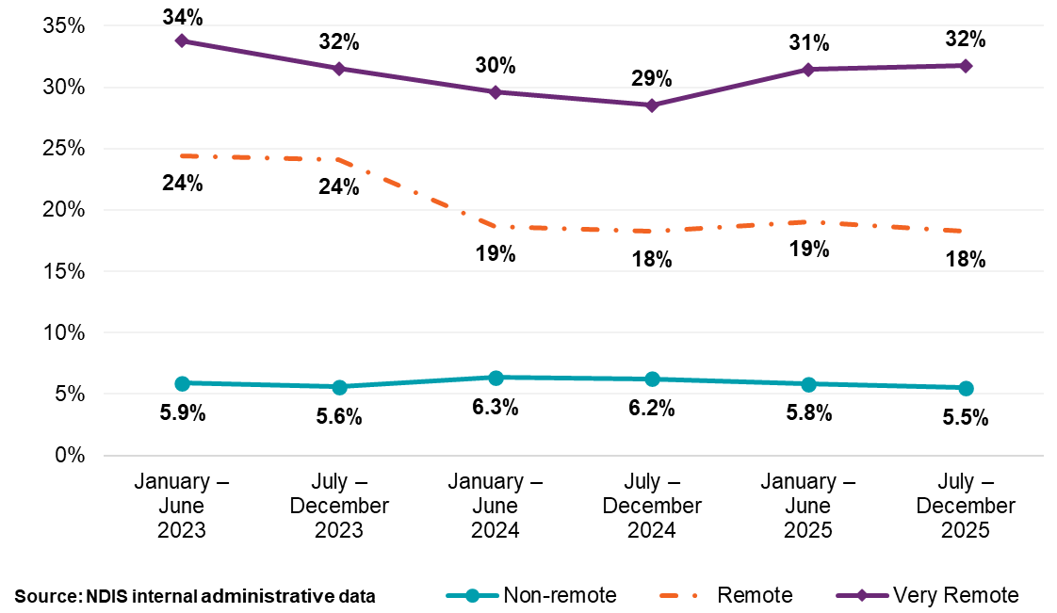
Provider continuity data highlights different patterns of stability between registered and unregistered providers. Forty-one per cent of registered providers were active across all 6 half year periods from January 2023 to December 2025, accounting for 91% of payments to registered providers. Among unregistered providers, only 15% were active across all 6 periods, with 34% active for just a single period (Figure 54). The unregistered market has substantially higher provider turnover than the registered provider market, consistent with a delivery model where individuals move in and out of the market rather than operating as sustained businesses.
Despite this turnover provider entry consistently exceeds exit. Inactive registered providers accounted for 0.3% of total payments across the period, while new active registered providers contributed 1.2% (Figure 55).
Figure 54: Provider continuity for SCCP supports by registration status and percentage of total payments, January 2023 to December 2025
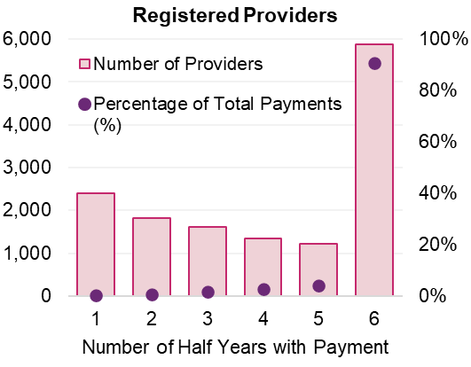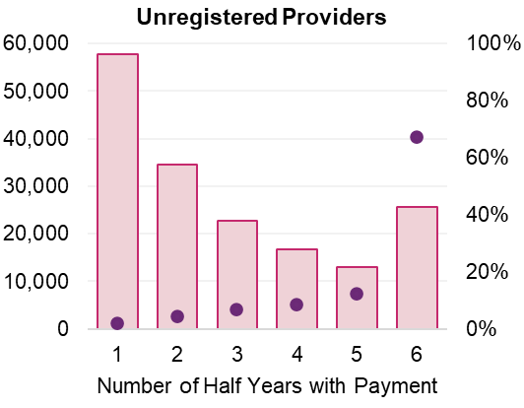
Source: NDIS internal administrative data
Figure 55: SCCP registered provider activity movements, January 2023 to December 2025
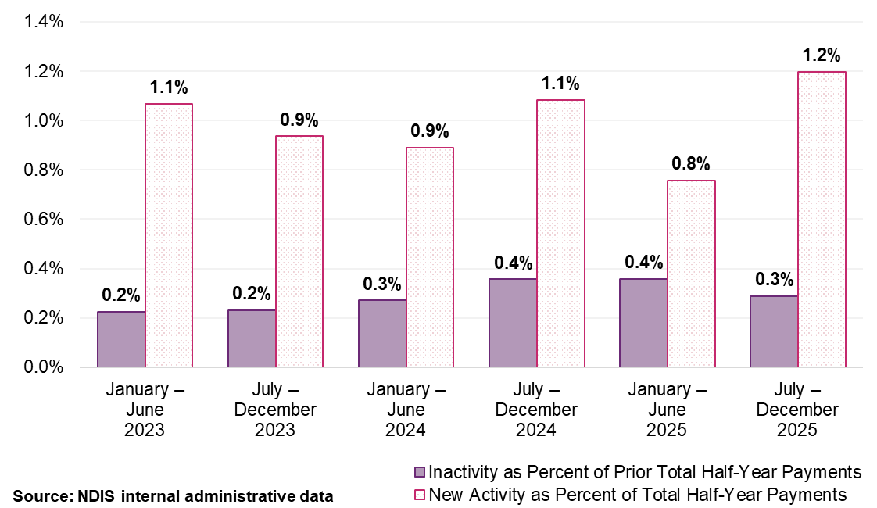
Note: ‘New Activity’ within a half-year period is identified when providers who were inactive in the previous half-year begin to receive payments. ‘Inactivity’ is noted when providers received payments in one half-year but not in the subsequent one. These fluctuations are measured as a percentage of the total payments made within that half-year, or the previous one, in the case of inactivity.

Consultation

Provider survey
The provider survey included questions focused specifically on SCCP supports. Responses reveal 2 distinct approaches to quality assurance corresponding to the
2 delivery models described above.
Organisational providers predominantly assure quality through formal systems. Among registered and larger providers, 92% reported structured induction and training arrangements, 81% reported formal supervision, 99% maintained written safety policies and 96% conducted regular practice reviews. Sole traders more commonly assure quality through personal capability and direct participant relationships: 77% reported holding formal qualifications and 80% monitored participant feedback. Only 18% reported supervision arrangements and 77% reported written policies. The distinction matters for pricing because formal systems impose verifiable, ongoing costs that relational delivery models do not.
Sixty-nine per cent of SCCP provider respondents supported registration-based pricing differentiation. Support was strongest among large and medium-sized providers (90%) compared with 20% among sole traders. This distribution reflects commercial interests and policy views. However, among smaller registered providers (those with 1–19 staff), 52% supported differentiation. This suggests registration-related costs rather than size alone drive views on pricing.
Support for differentiation was stronger among providers servicing remote and very remote areas (79%) than non-remote areas (67%). This is the inverse of what would be expected if providers in thin markets were concerned about supply disruption.
Among respondents who expressed a view, 50% indicated the differential should be greater than 15%, and a further 32% indicated 10–15%. Written submissions from registered organisations estimated registration-related costs at more than 10% of operating expenses before accounting for broader organisational costs such as supervision, human resources, rostering and premises.
Providers expressed a general preference for complexity-based differentiation, with participant complexity the most frequently cited basis across all support types (745 respondents), ahead of registration (426 respondents). The discussion section below addresses why registration is nonetheless the preferred mechanism at this time.
On provider exits, 58% indicated they would maintain their current registration status, 12% reported they would seek registration, 1% indicated they would deregister, and 28% said their response would depend on the size of the differential. Among sole traders, 52% indicated their response would depend on the differential, and 9% reported they would seek registration. These responses are consistent with a
price-sensitive group that would assess viability and adjust, not one that would exit the market at scale.

Participant survey
Trust, personal connection and flexibility were the most frequently cited factors that influence provider choice for participants. Registration ranked lowest among factors affecting initial provider selection. Many participants using unregistered providers described those relationships as more personalised or responsive than their experience with registered organisations.
Participants are not indifferent to quality. Forty per cent indicated formal quality systems were very important to them, with a further 37% indicating they were somewhat important. But participants assess quality primarily through direct experience and ongoing relationships, not through the regulatory signal registration is designed to convey. Participants using registered providers most commonly cited safety standards, qualifications and supervision as reasons for their choice; participants using unregistered providers most commonly cited flexibility, familiarity and ease of booking.
When asked whether they would pay more for stronger quality systems, 61% said it would depend on the amount, 20% said yes, and 19% said no. These responses indicate conditional willingness to pay, not resistance to differentiation.
Critically, the pricing change is more likely to affect provider economics than participant choice. Among the 217 respondents using unregistered providers, 53% indicated a pricing differential would not change their provider choice, and only 4% said they would switch to a registered provider for quality reasons. These responses were consistent across locations.
  - Discussion
The SCCP market contains 2 structurally distinct delivery models operating under materially different regulatory and governance conditions, served by a single price. The 15-fold difference in average revenue between registered ($328,900) and unregistered ($22,900) providers reflects the structural reality, an organisational model with formal governance, employed workforces and compliance systems operating alongside a relational model of predominantly sole traders with minimal overheads and no registration obligations. A price calibrated to the cost structure of one model and applied uniformly to both creates a persistent misalignment between the pricing architecture and the regulatory framework it is designed to support.
This discussion addresses 3 analytically distinct questions that should be kept separate. First, whether the evidence supports differentiating prices based on provider registration. Second, what amount of differential is appropriate given available data. Third, what the appropriate pricing trajectory is given the proposal to cease indexation for unregistered providers. The consultation and market data inform all 3 questions.

Why differentiate
The case for differentiation does not rest on a precise quantification of the cost difference, as the Agency does not have cost data sufficient for that calculation. It rests on the structural observation that the Scheme imposes different regulatory obligations on different providers, that these obligations give rise to ongoing costs, and a pricing framework which does not recognise this distinction is misaligned with the regulatory framework it is designed to support. The differential is a policy judgment, not a cost-recovery calculation.
The claiming-behaviour data provides the most direct evidence consistent with a structural cost difference. The 10-15 percentage point gap between registered (73-79% at the published price) and unregistered (61-67%) provider claiming has been stable across 3 years, all geographic areas and all time periods. This stability indicates the gap reflects persistent structural differences rather than short-term behavioural variations. Among unregistered providers supporting a single participant, 25% already claim at less than 80% of the current price. This headroom is consistent with a price on the basis of registered provider cost structures being applied to providers with a structurally lower cost base. Claiming behaviour does not prove a specific cost differential, but it is the best available signal in the absence of direct cost data, and it consistently points in the same direction.
Consultation evidence is consistent with this structural reading but should not be treated as determining the appropriate price level. Provider survey responses confirm registered providers operate formal quality systems, supervision arrangements and compliance infrastructure that impose ongoing costs. Participant survey responses confirm participants distinguish between delivery models in practice, even if they do not select providers based on registration status as such. These responses identify the nature of the cost and quality difference; they do not specify the price at which it should be recognised. That remains a policy judgement informed by, but not delivered from, consultation.
Provider consultation indicated a preference for complexity-based differentiation (745 respondents) ahead of registration (426 respondents). The Agency is of the view that registration would be the more appropriate mechanism for SCCP, for 3 reasons. First, registration is observable at the point of claim, a binary attribute already recorded for every transaction. Second, complexity-based differentiation is already embedded in SCCP pricing through high-intensity, group delivery and centre-based prices. Third, registration reflects enduring provider-level obligations that apply regardless of participant mix, providing a clearer pricing signal than participant-level complexity assessment. Complexity-based pricing may be considered in future reviews as outcomes data improves.
The rationale for applying differentiation to SCCP specifically, and the framework for its potential extension to other support categories, is set out in Chapter 5. That chapter also addresses the question of whether and how registration-based pricing should operate across the Scheme. The SCCP-specific analysis in this chapter provides the market evidence and proposed implementation detail for this category. Chapter 5 provides the policy framework within which that sits.

The size of the differential
A 10% reduction in the price for unregistered providers is recommended to maintain the integrity of registered provider operating requirements. Prices for registered providers should continue to be indexed through the DSW Cost Model.

Cost structure analysis
The DSW Cost Model builds the recommended maximum price from base pay through direct on-costs (leave, superannuation, allowances), then operational overheads (21.65%), then corporate overheads (12%), Direct on-costs apply equally to both delivery models, with sole traders funding their own entitlements on the same basis as employed workers. The structural cost difference arises in the overhead layers.
Operational overheads cover supervision, quality and safeguarding infrastructure, workforce rostering and human resources (HR) management, workers’ compensation, and utilisation. The first three are registration specific: registered providers must maintain supervisory and governance infrastructure that sole traders do not need because they are the worker. Corporate overheads cover HR, legal, marketing and enterprise technology, functions that are largely absent from the sole trader model. In addition, registered providers bear NDIS Commission audit fees, registration levies and worker screening administration costs that do not appear in the model at all.
Taken together, the registration-specific components are conservatively estimated at 17-25% of the current DSW Level 1 weekday daytime price. The proposed 10% differential sits at the lower end of this range. It is a conservative first step, not an upper bound on the structural difference.
The cost components identified above are not unique to SCCP. They arise wherever registered providers deliver DSW-related supports through an employed workforce. What is specific to SCCP at this point is the readiness to act, the structural split between delivery models is clearest here, the market data is most mature, and provider numbers are growing with no supply contraction signals. These conditions are not equally present in other DSW-related support markets. Chapter 5 sets out the framework for extending differentiation as those conditions develop.

Participant access and choice
As established in Chapter 4, participants assess providers through experience, trust and relationships, not registration status. Registration-based pricing reflects the cost of the institutional assurance model, not a judgment about the relative quality of registered and unregistered supports. The primary risk to participant access is provider exit, not participants switching providers on the basis of registration. Among the 217 survey respondents using unregistered providers, 53% indicated a pricing differential would not change their provider choice and only 4% said they would switch to a registered provider.
On provider exit intent, 58% of unregistered providers indicated they would maintain their current registration status, 12% would seek registration and 1% would deregister. The most analytically significant response was the 28% who said their response would depend on the size of the differential. Among sole traders, the dominant form of unregistered providers, this uncertainty was higher at 52%. At present, this group cannot be characterised as likely to exit or likely to continue, their response is genuinely uncertain at the proposed 10% reduction. The Agency does not treat this uncertainty as a reason to defer the policy decision, but it does treat it as the primary reason for the monitoring obligations set out below. The stable unregistered cohort, providers who have delivered continuously across all 6 periods (Figure 54) and account for 67% of unregistered provider payments, is the group where continuity matters. Exits concentrated among the less active, single-period providers would have no materially different impact on participant access than exit among this core cohort. Monitoring indicators are therefore calibrated to distinguish between these groups.

Pricing trajectory and indexation
The proposal to cease indexation for unregistered providers is a separate and distinct policy recommendation to the 10% initial differential. It should be assessed on its own terms. Ceasing indexation would mean that every year the maximum recommended registered price increases through the DSW Cost Model, the effective differential would widen by the value of that year’s indexation increase, compounding indefinitely unless the Agency intervenes.
The rationale for the compounding mechanism is that it would progressively strengthen the pricing signal associated with registration without requiring active review at each APR. This is a legitimate policy design choice. However, it would be necessary to ensure the upper price of the differential remains appropriate. A trajectory that is appropriate at 16-19% (projected by 2028–29) may not remain appropriate at 25% to 30%. The differential and trajectory would be assessed at each subsequent APR, with the 2026–27 review providing the first monitoring of data against which the compounding approach could be evaluated.

Expected effects and monitoring framework
A pricing adjustment carries risk when the market is fragile, supply is constrained or concentration is high. The market data set out in this chapter does not indicate the presence of these characteristics at the aggregate level. Provider numbers are growing, market concentration is low and declining, and entry consistently exceeds exit. This does not eliminate localised risk, particularly in remote and very remote areas, but it means the aggregate market conditions support implementation of a first-generation differential.
The Agency will monitor the impact through the following indicators, with particular attention to the first 12 months and to remote and very remote areas. Monitoring will distinguish between exits among continuously active providers (the stable core cohort) and exits among less active, single-period providers, as the access implications of these two patterns differ materially.
- Change in active unregistered SCCP provider numbers, overall and by remoteness.
- Change in active registered SCCP provider numbers.
- Change in participant access, measured by participant numbers, plan utilisation and plan management type.
- Claiming behaviour, including convergence at the new unregistered price.
- Provider exit and entry rates, with attention to concentration among single-participant sole traders.
The Agency will reassess the differential if monitoring data indicates a decline in unregistered provider numbers exceeding 10% over 12 months in any remoteness category; a decline in SCCP plan utilisation in thin markets; or evidence that participant access has been materially reduced.

Interaction with broader reforms
The SCCP market provides an appropriate starting point for registration-based pricing. It has the largest volume of unregistered providers, the clearest structural split between delivery models, and the most detailed market data for monitoring. This approach is consistent with the broader registration reform agenda and is intended to reinforce the incentive structure that a graduated, risk-proportionate framework creates.
  - Recommendations
Differentiated prices should apply based on provider registration status for SCCP supports.
Current prices for registered providers should continue to apply. The price for unregistered providers should be reduced by 10% on 1 January 2027. The differential should apply across the relevant standard and high-intensity support items, including associated claiming for non-face-to-face support provision, provider travel, short notice cancellations and activity-based transport.
The NDIA should monitor the impact through the 2026–27 APR, including effects on provider participation, participant access, claiming behaviour and registration rates, and adjust settings if evidence warrants.

Recommendation 16:
The prices for Social, Community and Civic Participation supports delivered by unregistered providers, including high intensity supports should be reduced by 10% from 1 January 2027. Indexation of these supports should be ceased.
The prices and indexation for Social, Community and Civic Participation supports delivered by registered providers should be maintained.

- Isolated towns
  - Context
The NDIA, in its analysis and recommendations, applies different pricing arrangements depending on whether support is delivered in a regional, remote or very remote area. Remoteness is determined using the Modified Monash Model (MMM), which classifies areas from major cities (Modified Monash category (MM) 1) through to very remote (MM 7). The MMM classification directly affects applicable prices, provider travel claiming arrangements, and the level of funding available to participants within their plans. Remote (MM 6) and very remote (MM 7) locations receive a 40% and 50% price loading respectively, with the ability to negotiate travel claims.
Following the release of the Western Australia Market Review in 2019, the NDIA implemented recommendations to modify the MM categories of some locations for planning and pricing purposes. These changes were formalised NDIS pricing guidance as the Isolated Towns Modification (ITM). The primary purpose of the ITM was to improve consistency and equity in pricing outcomes for locations that experience service delivery conditions similar to remote or very remote areas, despite not meeting the standard MM thresholds.
Under the initial ITM framework, an isolated town was defined as a location surrounded by remote or very remote areas. The NDIA deemed such locations 'enclaves' and reclassified them as either remote (MM 6) or very remote (MM 7). This enabled providers delivering services to participants in these areas to negotiate travel and receive the respective loading.
The ITM was extended in 2021 to include locations (Geraldton, Western Australia, and Cardwell, Far North Queensland) where travel to a major city (MM 1) or other city of more than 50,000 people (MM 2) required crossing a remote area.
In 2025, the NDIA released the 3-Year Pricing Workplan outlining the NDIA’s pricing improvement program. The first year focuses on immediate actions and evidence building, including a review of the application of the MMM, the ITM and related exception provisions. This APR examined whether current classifications remain appropriate and whether they continue to reflect contemporary service delivery conditions.
This review included:
- Data analysis of provider availability, participant plan utilisation and market depth across rural and remote communities.
- Review of the ITM Policy to assess whether the current list and criteria remain appropriate and identify areas where the policy may need updating to reflect contemporary service conditions.
- Engagement and consultation with jurisdictions, Peak and Disability Representative and Carer Organisations and participant representatives to test whether current classifications and pricing arrangements adequately reflect access challenges in rural and remote areas.
- Comparative analysis of how similar regional frameworks operate in health and aged care systems to identify alignment opportunities.
- Recommendations for refining the ITM, updating exceptions and ensuring transparent criteria for any future adjustments.
  - Stakeholder consultation
Consultation was undertaken with a broad range of stakeholders including state and territory governments, and the Agency’s Rural and Remote Advisory Group. The consultation sought to test the feasibility of existing and proposed approaches to the ITM, identify risks and unintended consequences, and inform the development of a nationally consistent and transparent policy framework.
The consultation process highlighted several recurring key themes across regions and stakeholder groups. While some themes were specific to geographic or cultural contexts, there was strong consistency around the need for a more transparent, data-driven and nationally consistent approach to addressing challenges in rural and remote areas beyond the remit of the existing ITM.
Key themes from consultation are outlined below.

Local context
Stakeholders emphasised that MMM classification and ITM play a critical role in sustaining service delivery for towns with fragile markets or markets that acted like MM 6 and MM 7 locations. However, concerns were raised that the current criteria for inclusion on the ITM does not adequately capture the operational challenges faced by very small towns or dispersed population clusters.
Feedback suggested the MMM classification and ITM criteria do not sufficiently account for local context, dynamics and population across metropolitan and regional, rural and remote areas.
Stakeholders suggested the Socio-Economic Indexes for Areas (SEIFA) be investigated as a new ITM criteria, particularly the Index of Relative Socio-Economic Disadvantage (IRSD) (https://www.abs.gov.au/methodologies/socio-economic-indexes-areas-seifa-australia-methodology/2021#index-of-relative-socio-economic-disadvantage-irsd-) that examines indicators of disadvantage in a community such as low income, low education, unemployment, and percentage of people with disability.

Distance from a major centre
Travel requirements were consistently identified as a key driver of access challenges. The availability of public transport or a reliance on fly-in-fly-out services were important factors, as was the rate at which providers can claim for travel based on the MM category of a town. Other aspects of travel such as availability of infrastructure, sealed roads, accommodation options for providers, and telecommunications and internet availability impact on service delivery were also reported.
Travel claiming caps (for example, 30 minutes for MM 1–3, 60 minutes for MM 4–5) were consistently cited as a constraint in thin markets, particularly in MM 5 locations, where travel to the nearest MM 1–3 centre may exceed 60 minutes.

Provider numbers
A consistent concern raised across consultation activities was the challenge to attract and retain workforce based in rural and remote areas.
Stakeholders indicated data showing the number of providers in a specific region as a proportion of participant numbers is not a meaningful metric of market capacity. It was reported that providers may be travelling into these communities rather than based locally and the frequency of support may be misaligned with true demand. Stakeholders suggested low plan utilisation rates would be a more appropriate metric as an indicator of thin markets.
This insight directly informs the analytical approach taken in this chapter. Plan utilisation, not provider count, is used as the primary metric for identifying market stress.

Market distortion
Some stakeholders warned against the ‘over-classification’ of towns as part of the ITM, as this can potentially create oversupply of providers in certain markets while leaving other towns underserviced.
The Department of Health, Disability and Ageing (DHDA) recently undertook a review of the remoteness classification system for aged care. That review examined the application of the MMM in aged care settings. Feedback received through both NDIA and DHDA consultations identified the need for greater pricing and policy alignment across the care-economy, with concerns expressed about market distortion.
Feedback suggested additional criteria could be added to the existing ITM Policy to reduce the ‘bluntness’ of the current approach and provide a more sensitive understanding of communities where thin markets are likely to exist.
  - Scheme statistics
This section analyses NDIA administrative data to assess market outcomes across MM categories and to evaluate the effectiveness of the current ITM.
The analysis is organised in 2 parts. The first examines market conditions across all MM categories to establish a national baseline. The second focusses specifically on existing ITM locations to assess whether current policy settings continue to reflect actual service delivery conditions.

Statistical areas for analysis
The Australian Bureau of Statistics (ABS) classifies Australia into a hierarchy of statistical areas for the publication and analysis of statistics and data, as defined by the Australian Statistical Geography Standard.
The MMM is a health-focused classification system that uses ABS Statistical Area Level 1 as its primary building block. Because Statistical Areas Level 1 are too small for most data analysis, Statistical Areas Level 2 (SA2s) is the standard level for viewing and reporting this data. SA2s are medium-sized, general-purpose areas built to represent communities that interact together socially and economically. Most SA2s have a population range of 3,000 to 25,000 people.
Local Government Areas’ populations vary more widely than SA2 with boundaries set by state and territory governments. Populations can vary from under 100 people to more than 1.2 million people.
Suburbs and Localities (SALs) are statistical approximations of the official gazetted suburbs. The ABS designs SA2s to align as closely as possible to SALs. For this review, analysis has been undertaken at either the MMM classification or SA2 level. Specific to the NDIS context, using the SA2 allows for greater participant numbers of an area, contributing to more reliable utilisation data. Similarly, other indexes are more reliably calculated at SA2 levels rather than smaller SAL level.

NDIA data analysed across MMM
To understand the landscape of the market across different areas of remoteness, the NDIA examined data over 3 financial years, from 1 July 2022 to 30 June 2025.
The majority of active participants (78%) live in New South Wales (29%), Queensland (22%) and Victoria (27%), followed by 9% each in South Australia and Western Australia, as shown in Figure 56. Figure 57 shows that overall, 69% of participants live in MM 1, with 11% living in regional areas (MM 4–5) and under 2% in remote and very remote areas (MM 6–7).
Figure 56: Percentage of active participants by state and territory, 1 July 2024 to 30 June 2025
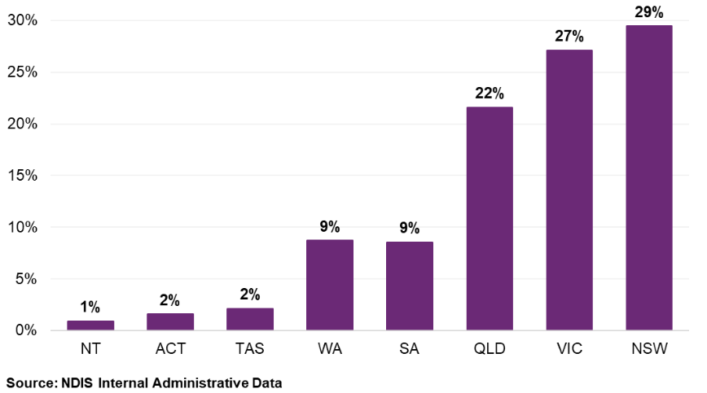
Figure 57: Percentage of participants by MM category, 1 July 2024 to 30 June 2025
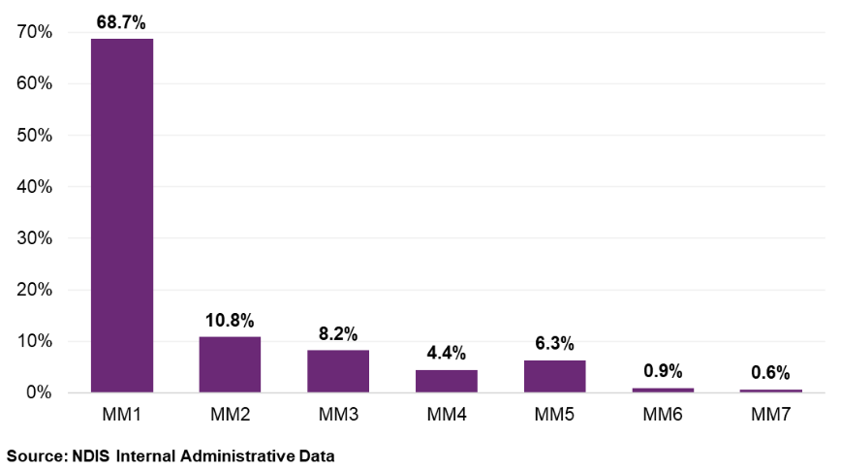
The share of active participants living across MMM areas varies significantly by state and territory. Most active participants in the Northern Territory and Tasmania live in a regional centre (MM 2), 56% and 66% respectively, with the Northern Territory having the largest number of participants living in a remote or very remote area (42% in MM 6–7). Aside from the Australian Capital Territory, where 100% of active participants live in a major city, all other states have the highest percentages of participants living in MM 1, ranging from 62% in Queensland to 79% in Western Australia (Table 53).
Table 53: Percentage of participant numbers in each state and territory by MM category, 1 July 2024 to 30 June 2025
MM category | ACT | NSW | NT | QLD | SA | TAS | VIC | WA
MM 1 | 99.9% | 70.2% | N/A | 62.0% | 75.2% | N/A | 72.8% | 79.1%
MM 2 | 0.1% | 3.1% | 55.0% | 22.1% | 2.0% | 66.0% | 9.7% | 5.1%
MM 3 | N/A | 13.4% | N/A | 3.7% | 9.2% | 17.8% | 6.6% | 6.0%
MM 4 | N/A | 5.9% | N/A | 4.0% | 3.4% | 0.4% | 5.3% | 1.1%
MM 5 | N/A | 7.0% | 1.2% | 6.4% | 7.7% | 14.6% | 5.7% | 4.2%
MM 6 | N/A | 0.4% | 23.0% | 0.9% | 1.8% | 1.0% | 0.0% | 2.8%
MM 7 | N/A | 0.0% | 20.8% | 0.9% | 0.7% | 0.2% | N/A | 1.7%
Total | 100% | 100% | 100% | 100% | 100% | 100% | 100% | 100%
Source: NDIS internal administrative data
Plan use (how much of their plan a participant spends) is a useful partial indicator of the extent to which the market is functioning and able to meet the needs of participants. This indicator was widely supported by stakeholders as an indicator of thin markets.
Table 54 compares total plan use across MM categories from 2019 to 2025, with increases noted across all areas since 2019. The most significant increase in plan use since 2021 was in very remote areas (21.6%), with remote areas also experiencing a 5.7% increase. It is likely this is the effect of both the remote and very remote areas loadings (40% and 50% respectively) applied for pricing and planning purposes, along with non-pricing interventions, such as coordinated funding proposals, that NDIA has facilitated in these areas.
Whilst plan use in MM 5 has increased since 2019, it has only marginally increased since 2021 (0.7%) and as of June 2025, is lower than remote areas (67% compared to 71%). This trend has been confirmed through stakeholder consultation, with MM 4 and MM 5 locations identified as key areas of concern.
The overall national plan use rate is 76%.
Table 54: Comparison of total plan use by MM category, 2019 to 2025
MM category | Utilisation June  2019 | Utilisation December 2021 | Utilisation June  2025 | Increase in utilisation (%) since 2019 | Increase in utilisation (%) since 2021
MM 1 | 69% | 75% | 78% | 12.5% | 3.5%
MM 2 | 69% | 76% | 74% | 8.0% | -2.0%
MM 3 | 67% | 73% | 74% | 10.9% | 1.8%
MM 4 | 65% | 70% | 72% | 10.4% | 2.5%
MM 5 | 58% | 67% | 67% | 16.3% | 0.7%
MM 6 | 63% | 67% | 71% | 12.4% | 5.7%
MM 7 | 39% | 50% | 61% | 55.8% | 21.6%
Source: NDIS internal administrative data
Plan activation, which is the length of time that elapses between when a first NDIS plan is approved, to the time the first service or support is claimed, is another partial indicator of the health of markets. Table 55 compares first plan activation percentages across MM categories from 1 July 2024 to 30 June 2025. On average, 74% of all first plans are activated within the first month with this figure ranging from 71% in MM 5 locations to 75% in MM 1 locations. (Table 55). Subsequent plan activation has been excluded from this data as on average, 95% of subsequent plans are activated within the first month.
Table 55: Comparison of first plan activation percentages across MM category from month 1 to month 6+, 1 July 2024 to 30 June 2025
First plan activation | MM 1 | MM 2 | MM 3 | MM 4 | MM 5 | MM 6 | MM 7
Month 1 | 75% | 73% | 73% | 72% | 71% | 73% | 74%
Month 2 | 12% | 13% | 13% | 13% | 13% | 12% | 11%
Month 3 | 5% | 5% | 5% | 5% | 6% | 6% | 5%
Month 4 | 2% | 3% | 3% | 3% | 3% | 2% | 3%
Month 5 | 1% | 2% | 2% | 2% | 2% | 1% | 1%
Month 6 | 1% | 1% | 1% | 1% | 1% | 1% | 1%
Over 6 months | 3% | 3% | 3% | 4% | 4% | 3% | 4%
Source: NDIS internal administrative data
Provider claiming data was used to determine the median number of providers per participant within localities and regions. Whilst medians vary considerably across locations, when reviewing these at the MM category level, numbers vary between 4.5 and 5 providers per participant (Figure 58). It is noted that the provider ratio is high in MM 5, despite total plan use and plan activation being lower. This may indicate that whilst providers are providing services to participants in MM 5 locations, the frequency of support may be misaligned with true demand.
Figure 58: Comparison of the median number of providers per participant across MM category, 1 July 2024 to 30 June 2025
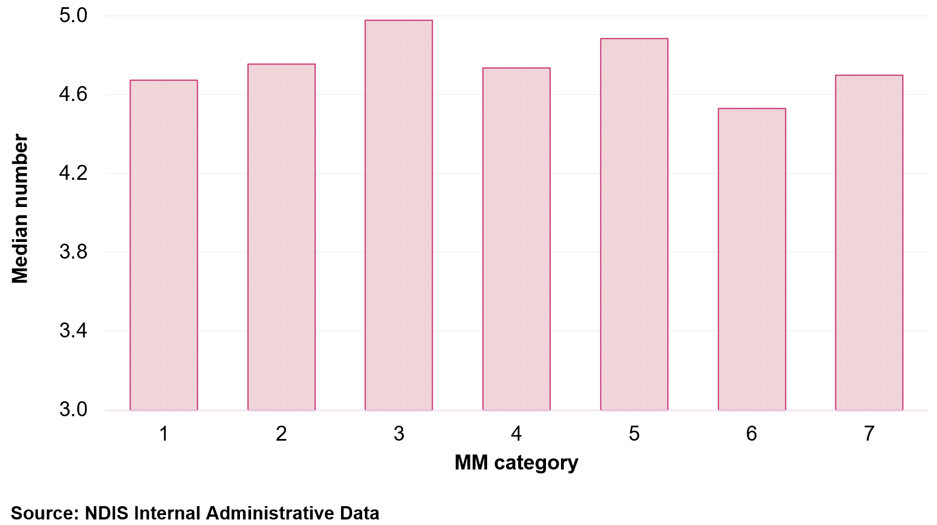
Provider travel data demonstrates higher travel claims as population density decreases. Travel claims are highest in remote and very remote locations reflecting that providers servicing these areas aren’t restricted by travel caps and may enter specific arrangements with participants to cover travel costs. Data indicates higher claims in MM 4 and 5 locations compared to MM 1–3 with this broadly reflecting the travel time limits that can be claimed as specified in NDIS guidance (Figure 59).
Figure 59: Median provider travel costs across MM category – labour versus non-labour travel, 1 July 2024 to 30 June 2025
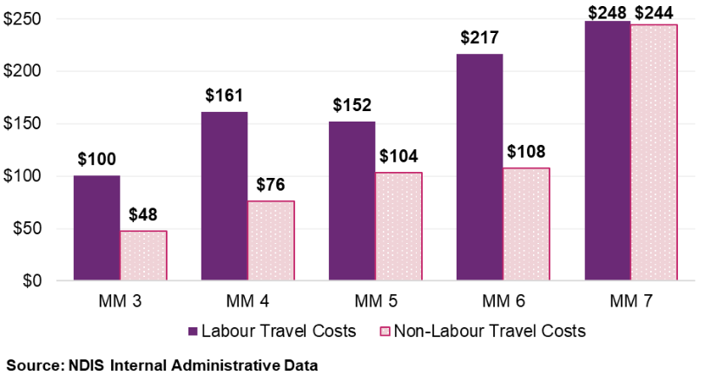

Review of the current ITM
There are 133 locations listed in the existing ITM table in the PAPL.
As at 30 June 2025, there were 4,040 participants living in an ITM location across 4 states and territories, with most participants living in Western Australia and Queensland (Figure 60).
Figure 60: Number of participants living in an ITM location by state, 1 July 2024 to 30 June 2025
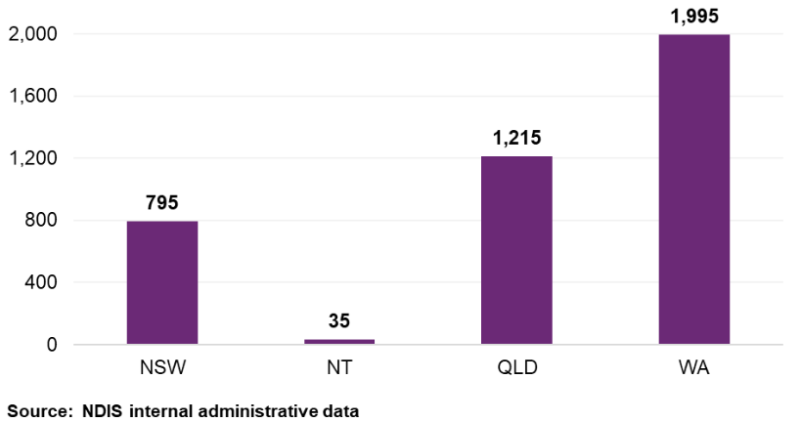
These ITM locations all fall within MM 3–6, with the majority (59%) participants living in a MM 3 area (Figure 61).
Figure 61: Percentage of participants living in ITM locations by MM category, 1 July 2024 to 30 June 2025
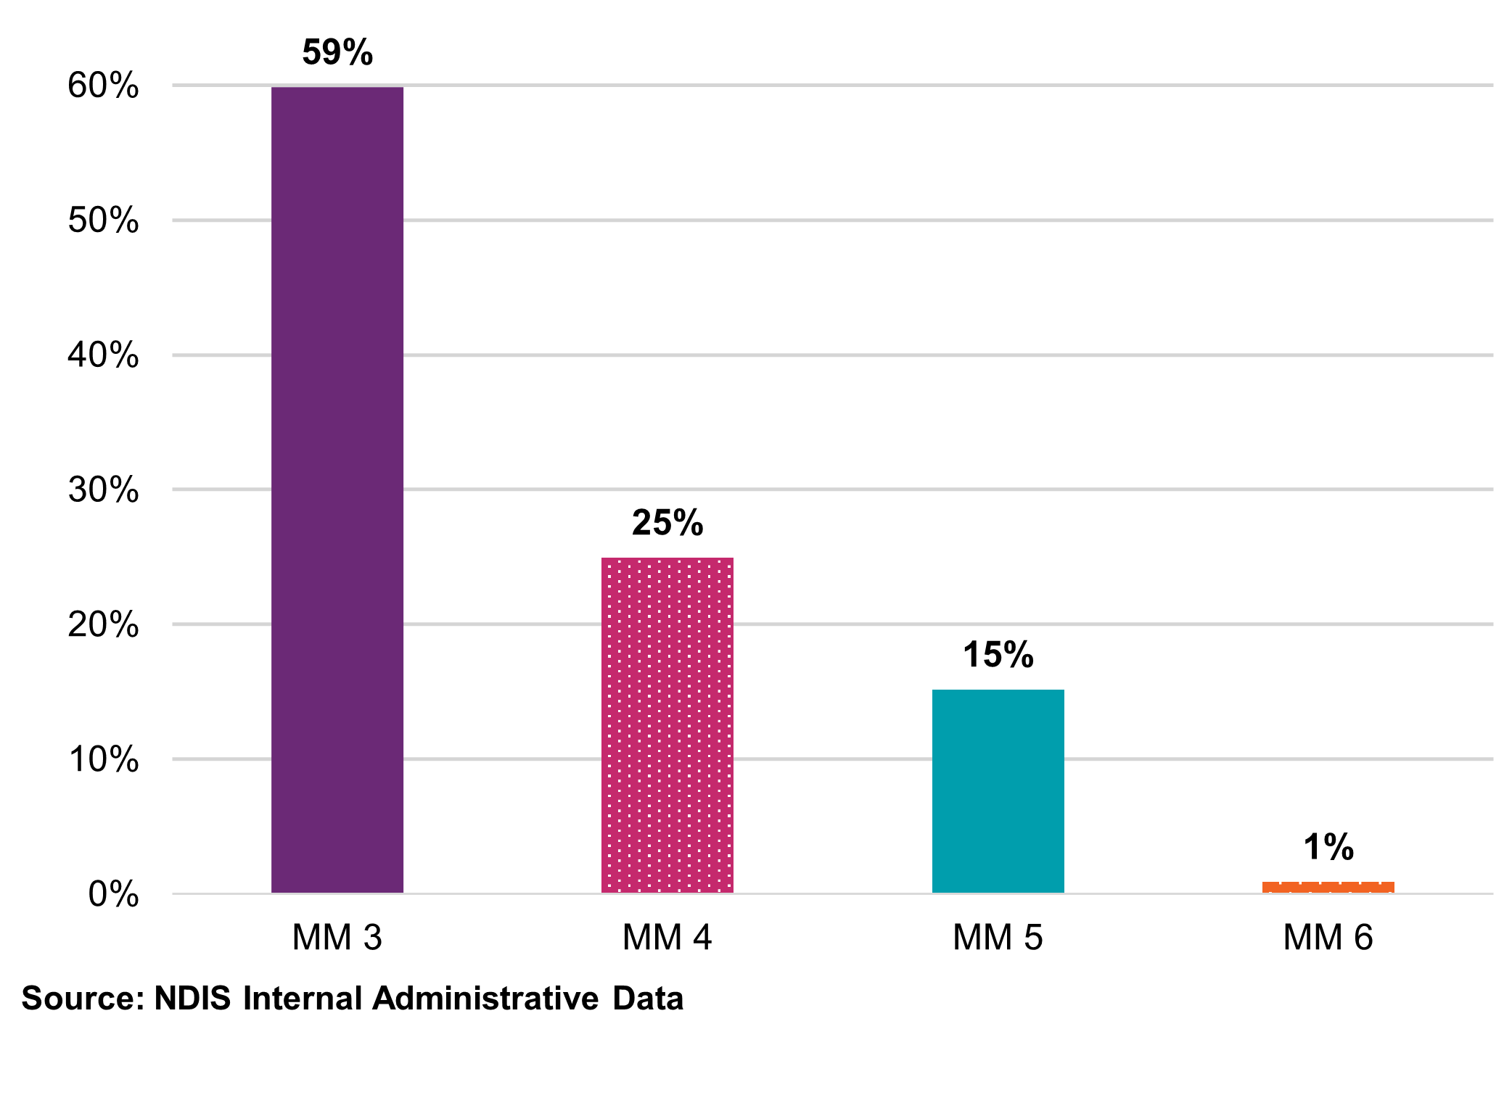
Note: Numbers may not add to 100% due to rounding.
The MM 6 location is Gunbalanya, Northern Territory, a remote area that has been reclassified as a very remote area (MM 7) to reflect exceptional seasonal challenges. Due to the low participant numbers in this location, the remaining analysis will be centred on MM 3–5 locations.
Plan use in ITM locations have been reviewed and compared to utilisation rates in the previous 2 years. Figure 62 demonstrates that most towns have remained relatively steady (in MM 3 and MM 4) with MM 5 use increasing from 55% to 58%.
Figure 62: Comparison of ITM plan utilisation, between 1 July 2022 to 30 June 2023 and 1 July 2024 to 30 June 2025
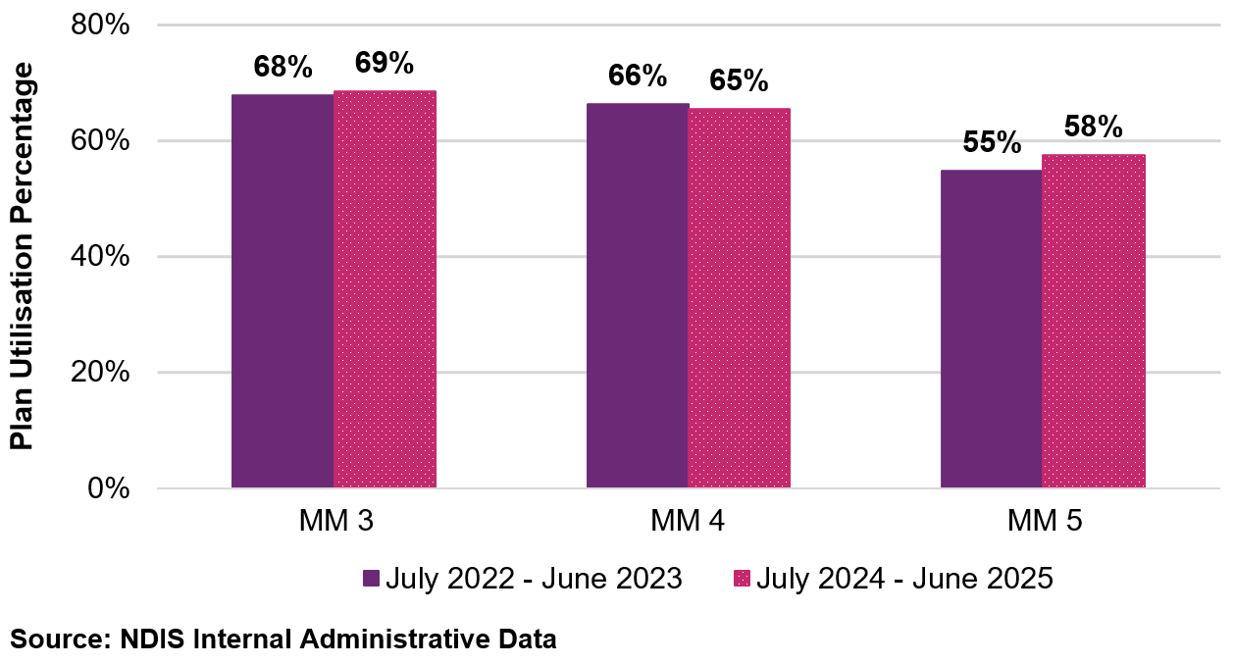
Although plan use has increased, it continues to remain lower in ITM locations than other locations across Australia with the same MM category (Figure 63), with MM 3–4 areas approximately 10% lower and MM 5 areas 17% lower.
The current policy reclassifies ITM locations to MM 6 to reflect the geographical nature of the locations. When comparing plan use of ITM locations to the national MM 6 plan use, ITM locations continue to have lower plan use across MM 3–5 compared to 71% across remote areas (MM 6).
Figure 63: Comparison of average total plan utilisation by MM category of ITM locations versus non-ITM locations, 1 July 2024 to 30 June 2025
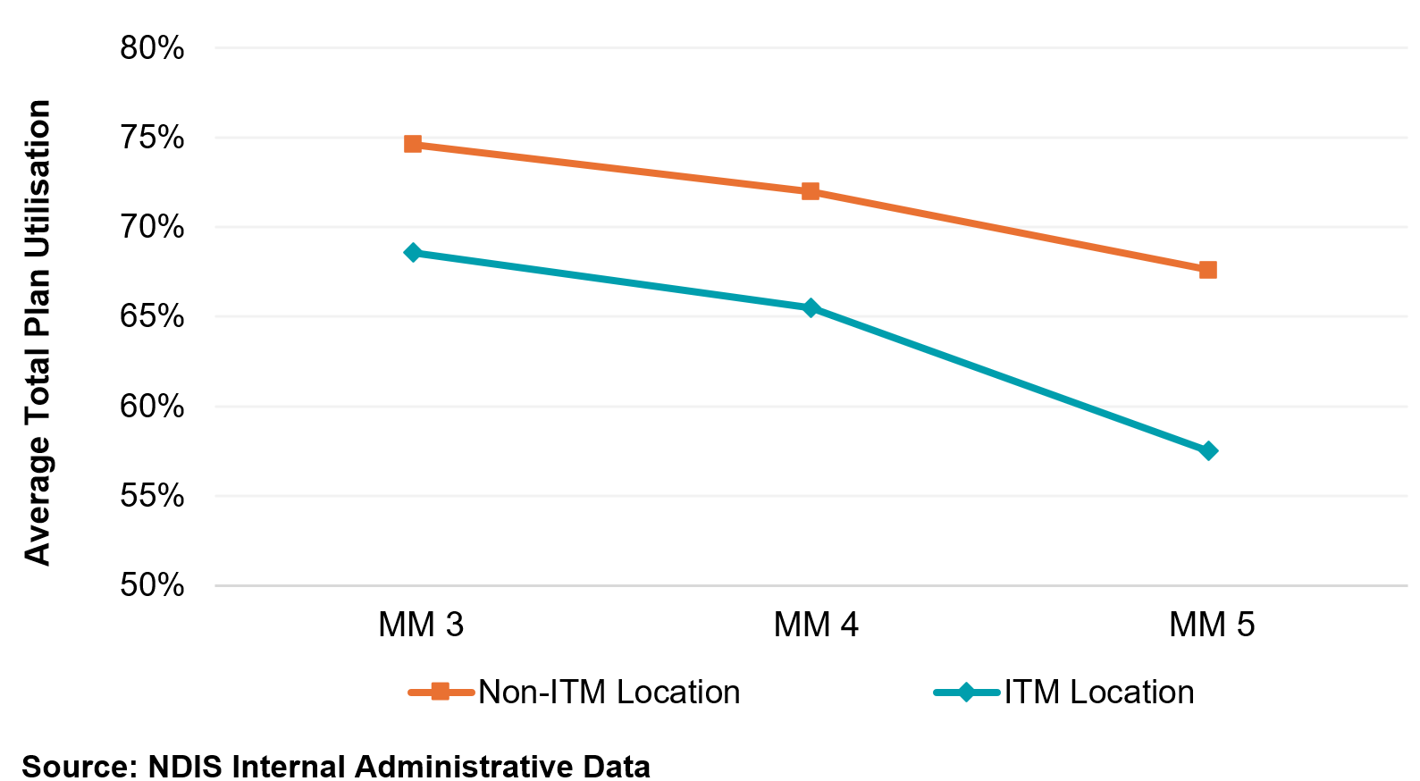
First plan activations in ITM locations were on average slower than non-ITM locations, with 69% first plans activated in the first month, compared to 74% in
non-ITM locations as shown in Table 56. Broken Hill and Hay were outliers with 89% and 88% first plan activations in the first month respectively. In comparison to this, first plan activation in the Greater Geraldton area was substantially longer with only 57% of plans activated in the first month.
Table 56: Comparison of first plan activation percentages across ITM and non-ITM locations from month 1 to month 6+, 1 July 2024 to 30 June 2025
 | Month 1 | Month 2 | Month 3 | Month 4 | Month 5 | Month 6 | Over 6 months
Non-ITM | 74.2% | 12.6% | 5.2% | 2.6% | 1.5% | 1.0% | 2.9%
ITM | 69.2% | 13.3% | 4.4% | 2.5% | 2.6% | 1.8% | 6.2%
Source: NDIS Internal Administrative Data
Analysis of travel data indicates increased costs in ITM locations compared to other locations at the same classification, with higher costs observed in regional areas (MM 4–5) (Figure 64). This reflects the nature of these towns where participants are located in a hub, surrounded by remote areas, requiring providers to travel from larger regional areas or centres.
Figure 64: Comparison of travel data (non-labour and labour costs combined) in ITM location within different MM categories, 1 July 2024 to 30 June 2025
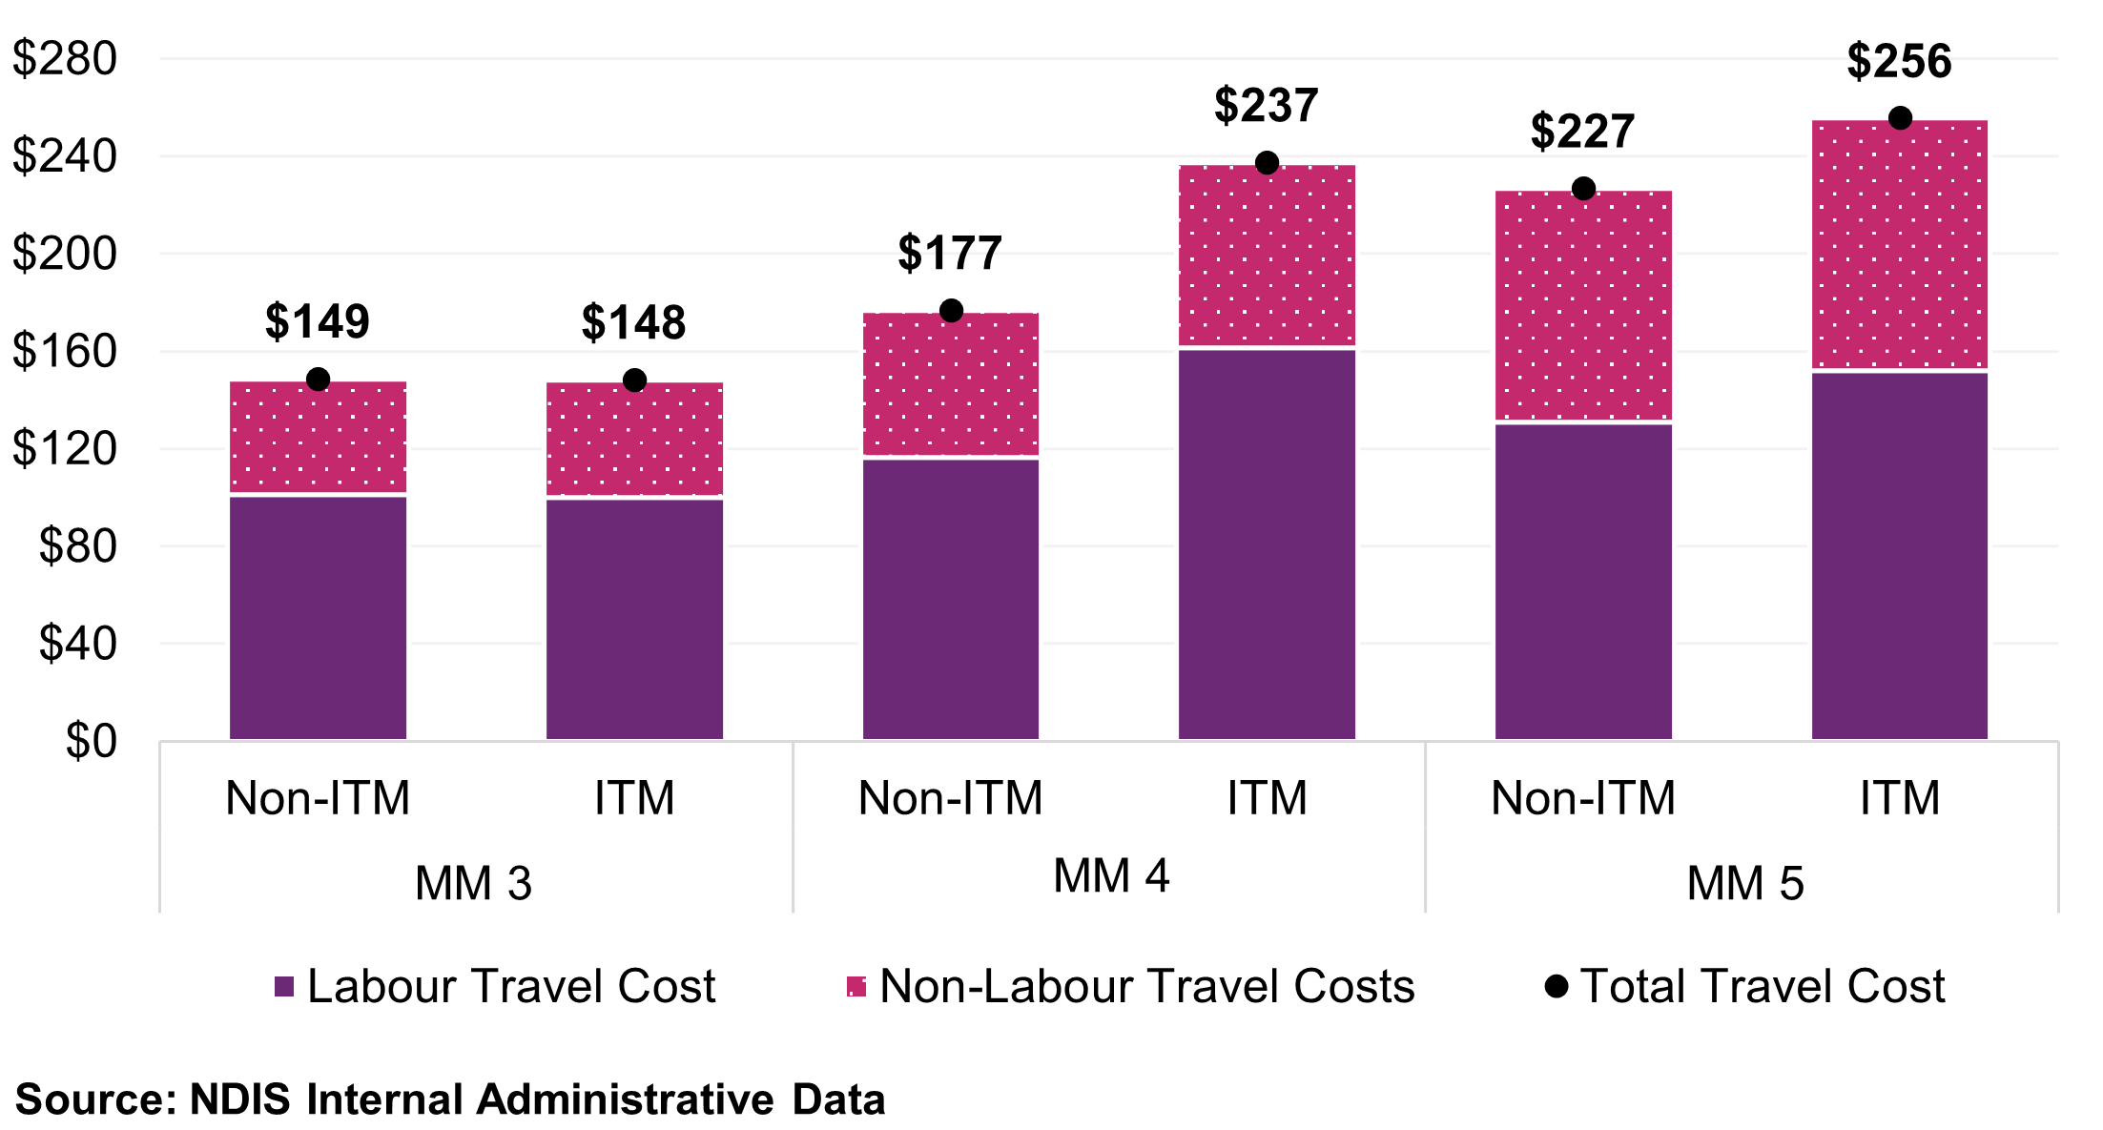

Further market analysis
To address stakeholder concerns that the MMM classification system does not adequately take into consideration socio-economic disadvantage, the use of SEIFA within government was explored, with the IRSD being the recommended index. The SEIFA measures underlying indicators of socio-economic disadvantage at a population level (including education, unemployment, income levels) which is used for understanding the operating environment of service markets. This may correlate with lower service availability, reduced market attraction and poorer access to supports. Figure 65 is a map of Australia, ranked by IRSD, representing how vast the landscape is with majority of Australia’s landmass ranked 1–3 or 3–5, which indicates higher disadvantage.
Figure 65: SEIFA-IRSD decile rankings mapped across Australia, 2021
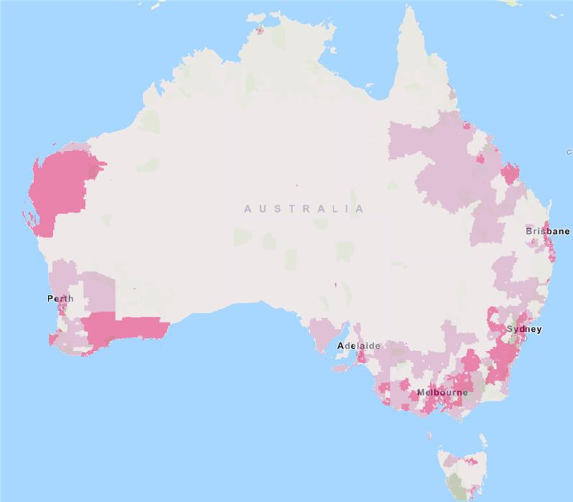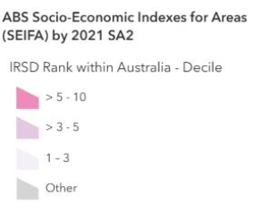
Source: Socio-Economic Indexes for Areas, Australian Bureau of Statistics
  - What this means for pricing and market decisions
This chapter’s analysis supports 2 policy recommendations, first, the current ITM list (referred to below as Type 1 locations) remains appropriate and should be retained with an updated definition; second, a new category of locations (Type 2) should be identified using a multi-criteria framework where additional market intervention is warranted. The following paragraphs set out the evidence for each conclusion.
Plan use, the share of plan budgets participants spend, is the most revealing indicator of thin market stress. Plan use in MM 5 locations (67%) is lower than in MM 6 locations (71%) despite MM 5 having substantially more participants and a larger geographic footprint. This inversion, regional areas performing worse than remote areas on the access metric, indicates the current pricing architecture, which applies 40% and 50% loadings to MM 6 and MM 7 respectively but not to MM 4–5, may have created a discontinuity in market conditions at the boundary between regional and remote classifications.
A multi-criteria framework could be considered to identify Type 2 locations where market stress is concentrated driven by a combination of distance, disadvantage and low service density.
A pricing lever available for the newly identified Type 2 Isolated Town locations, that avoids the over classification risk identified by stakeholders where loadings are applied too broadly, would be to allow travel-time negotiations without a loading.
This would address one of the 3 constraints (travel-cost recovery) but not the other 2 (workforce absence and socio-economic disadvantage). In locations where plan use is low, primarily because providers are not present, enabling travel negotiation may attract fly-in-fly-out services but is unlikely to generate locally based supply. The pricing adjustment may be necessary but not sufficient for the most constrained locations.
The distinction between Type 1 Isolated Towns (reclassified to MM 6 with full loading) and Type 2 Isolated Towns (travel negotiation only) locations would create a graduated response that is proportionate to the evidence. However, Type 2 areas should be monitored specifically for whether the travel-negotiation lever produces measurable improvement in plan use. If plan use in these areas does not respond to the pricing adjustment within 12–24 months, the evidence would support considering whether complementary non-pricing levers, coordinated funding proposals, direct commissioning or workforce incentives, should be implemented to address the supply-side constraints pricing alone cannot resolve.
  - Discussion

Assessment: existing ITM locations
The ITM was implemented to modify the MM categories of some locations for planning and pricing purposes, reflecting the geographic nature of locations surrounded by remote or very remote areas.
The ITM policy was subsequently extended to include locations where it is not possible to travel to a major city or regional centre (MM 1–2) without crossing a remote area (MM 6). Whilst the locations affected by this change were listed NDIS pricing guidance, the policy definition of the ITM was not explicitly reflected, with stakeholder feedback indicating the policy needs to be more clearly defined.
Plan use, plan activation and travel data for existing ITM locations indicate these towns continue to act like remote regions with reduced plan use, longer plan activation and increased travel costs as compared to non-ITM locations with the same MM category.

In addition to this, stakeholders supported the existing policy for these towns, noting the geographic isolation and remoteness of these locations, and indicated a risk of provider withdrawal and reduced access to services if isolated status or loadings are removed.
It is noted that whilst the existing policy is beneficial to NDIS participants and providers, the loadings and travel arrangements associated with the reclassification may result in market distortion within the broader care sector, with Broken Hill, New South Wales, or Kalgoorlie, Western Australia, as prime examples of such locations.
The existing ITM remains appropriate as service delivery and market metrics continue to reflect the geographic isolation of localities. It is recommended that these towns continue to be reclassified to MM 6 and with the updated definition published.

Example one – Broken Hill, New South Wales
Based on the MMM classification 2023, Broken Hill, New South Wales, is classified as MM 3. However, due to its isolation under the current ITM it has been reclassified to MM 6. As at 30 September 2025, there were 671 NDIS participants living in Broken Hill with 36% aged 0–14 years (243 participants). The most prevalent primary diagnoses being autism, followed by intellectual disability and developmental delay.
Plan use data for the first quarter of 2025–26 (1 July 2025 to 30 September 2025) for participants aged 0–8 years shows 93% use of Core supports and 45% for Capacity Building supports. For participants aged 9–14 years in the same quarter, Core support use was 72% and Capacity Building was 42%.
The NDIS Provider Finder (https://www.ndis.gov.au/participants/working-providers/finding-providers/provider-finder) indicates there are 24 providers registered for early childhood therapy services in Broken Hill. Of these, only 2 providers are based in Broken Hill, with the remaining providers based across New South Wales, Victoria and South Australia, with some providers specialising in fly-in-fly-out service delivery.
For participants to access providers outside Broken Hill, the closest MM 1–2 location is Adelaide, South Australia, approximately a 5 to 6-hour drive or Mildura, Victoria, which is a MM 3 and approximately a 3-hour drive. Early childhood service providers travelling from Adelaide or Mildura would only be able to claim up to 30 minutes travel for their services if the location wasn’t reclassified through the ITM policy.
The SEIFA-IRSD decile score at the SA2 level for Broken Hill is 2, indicating high relative disadvantage.
By acknowledging the service delivery challenges faced by locations such as Broken Hill, which are unlikely to change as they are reflective of the geographic location, broader workforce, market and socio-economic influences, the ITM continues to address the original policy intent.

Refining the ITM
Stakeholders identified that the current ITM policy is limited to a focus on geographic constraints and lacks the sensitivity to capture local market dynamics or thin market issues, with several localities identified as experiencing ongoing market challenges. There was strong consensus regarding the need for a more transparent, data-driven and nationally consistent approach to addressing challenges in rural and remote areas beyond the remit of the existing ITM.

Locations by MMM classification
MM 4 and MM 5 locations have been highlighted through both consultation and data analysis as areas where markets may require further intervention.
Stakeholders identified MM 4 and MM 5 locations near MM 6–7 locations, but also locations that were not adjacent to remote areas. Stakeholders advised that travel distances to regional centres was a major factor driving thin markets even when the location was within a cluster of MM 4 and 5 localities. For example, Kojonup (MM 5) in Western Australia, which is 183 km or approximately 130 minutes' drive from Bunbury (MM 2) in Western Australia.
Data analysis as per Section 12.3.2 supports focusing on MM 4–5, with MM 5 locations in particular, identified as having lower scores or ratings in numerous metrics, including plan utilisation and plan activation.

Provider data and plan use
Throughout the consultation, plan use was consistently identified as a more meaningful indicator of market functioning than counts of providers servicing a location. Analysis of utilisation data indicates that, on average, plan use is lower in MM 5 locations than MM 6 locations, despite there being no evidence of materially lower provider numbers in MM 5 locations. This suggests that provider presence alone is not a reliable proxy for effective access to supports.
Lower plan use in MM 5 locations is likely driven by a combination of factors, including misalignment between the frequency of services delivered and underlying participant demand. Notably, there are substantially more participants living in MM 5 locations than in MM 6 locations, approximately 44,540 compared to 6,492 respectively, while the geographic area covered by MM 5 locations is also marginally larger. These factors increase service delivery complexity and may contribute to reduced utilisation outcomes.
While plan use outcomes in MM 4 locations are higher than in MM 5 locations, performance remains below that observed in MM 1 to MM 3 locations. This indicates that market challenges are not confined to the most remote settings and may persist in some regional areas.
Plan use is therefore considered a robust primary metric for identifying market stress and for informing consideration of locations that may require additional policy or market interventions.
Analysis of plan utilisation data over consecutive years has indicated that using average utilisation at the SA2 level, provides more reliable utilisation data rather than at a SAL level, due to participant population numbers. With fluctuations in plan use evident across years, using a 3-year rolling average helps to counteract yearly fluctuations which may occur due to participant priorities, numbers of first plans or other factors, and identifies areas with trends of lower utilisation.
Based on analysis covering the period from 1 July 2022 to 30 June 2025, a utilisation threshold of 60% has been identified as an appropriate indicator of potential market stress. This threshold is materially below the national average plan usage rate of 76%, while remaining broadly consistent with utilisation levels observed in existing MM 5 ITM locations.
Analysis of provider‑to‑participant ratios at the SAL level was also undertaken, however, no consistent relationship was observed between provider ratios and utilisation outcomes at this level. This further supports the use of utilisation as the preferred metric for assessing market performance.

Travel factors
The PAPL sets out the conditions under which providers may claim travel costs when delivering supports. Providers can claim for labour (time) and non-labour (such as road tolls, parking fees and the running costs of the vehicle). In MM 1–3 areas providers can claim up to 30 minutes of travel (labour time) to and from each participant. In MM 4–5 locations providers can claim up to 60 minutes of travel (labour time). Provider travel in remote (MM 6) and very remote (MM 7) areas allows providers to enter specific arrangements for labour costs (time) incurred. In all locations the price for therapy supports labour travel (time) is 50% of the relevant hourly rate.
Travel times exceeding 60 minutes between MM 4 or MM 5 locations and the nearest MM 1–3 centre were identified as a key contributor to service access challenges. Data analysis also suggests there are increased costs associated with travel to MM 4–7 locations.
A travel time threshold of more than 70 minutes between an MM 4 or MM 5 location and the nearest MM 1–3 centre is proposed as an indicator of potential market stress. Potential locations were identified through a mapping of the MM 4 and 5 SA2 localities with the most participants, to the nearest MM 1–3 location.
As part of the analysis, a number of geospatial tools and methods were explored, however Google Maps was deemed the most appropriate and reliable option available. It is also available for public use and is likely to be the tool used by participants and providers travelling to receive or deliver services.

Socio-economic considerations
Stakeholders consistently mentioned the need to factor in socio-economic data into decisions around isolated towns or towns that are likely to be experiencing market challenges. As identified in Section 12.3.4, the use of SEIFA within government was explored, with the IRSD being the recommended index. The IRSD avoids distortion caused by pockets of advantage and aligns most closely with the ITM regarding market under supply, low workforce capability and poorer social outcomes. A lower score measures underlying indicators of socio-economic disadvantage at a population level (for example, education, unemployment, income levels) which is used for understanding the operating environment of service markets. As the IRSD is a decile score of 1 = most disadvantaged to 10 = least disadvantaged, a score of 5 or below is considered likely to capture more disadvantaged locations than those above 6.

Combining factors to identify locations experiencing market stress
A multi-criteria framework is recommended to identify locations which are likely to be experiencing thin market challenges.
Comprehensive analysis of data, from 1 July 2022 to 30 June 2025, has been completed based on the factors identified above, namely:
- Location classified as a MM 4 and/or MM 5
- Average SA2 plan utilisation over 3 years is 60% or less (calculated using only MM 4/5 locations)
- Travel time from a MM 4 or 5 SA2 to the nearest MM 1–3 is 70 minutes or over (calculated using the SA2 location with most participants)
- SEIFA-IRSD decile score at the SA2 level is 5 or below.
As a result, 21 SA2 areas have been identified as locations that may benefit from further market intervention based on low plan use, travel time and socio-economic disadvantage. As at 30 June 2025, there are 1,728 participants living in these locations.
These 21 areas would form the basis of the proposed Type 2 Isolated Town category, which is the subject of Recommendation 18 below. The criteria developed in this chapter, plan use below 60%, travel time exceeding 70 minutes to the nearest MM 1–3 centre, and SEIFA-IRSD score of 5 or below, represents a material improvement over the binary ITM and non-ITM classification and create a graduated response that is proportionate to the evidence.

Example two – St Helens-Scamander, Tasmania
St Helens-Scamander (SA2) in Tasmania is a proposed new Isolated Town and was identified by stakeholders for consideration. Most of this SA2 is considered rural (MM 5) with some remote parts (MM 6). The number of participants residing in the rural area of this SA2 as at 30 June 2025 is 169.
Currently the maximum amount of travel time providers can claim is 60 minutes to and from this location. The nearest large regional centre to St Helens-Scamander is Launceston (MM 2) which is approximately 2 hours’ drive or 151 km from St Helens-Scamander.
The 3-year combined total plan utilisation average for the 169 participants (1 July 2022 to 30 June 2025) sits just under 60%, with minimal change observed over the past 3 years, indicating a trend of lower plan use in this SA2.
This location has a SEIFA-IRSD score of 2 (where 1 = most disadvantaged and 10= least disadvantaged) indicating high levels of relative disadvantage.
The combination of these metrics and stakeholder feedback suggests a market lever should be applied in the MM 5 areas of St Helens-Scamander.
  - Recommendations

Recommendation 17:
The NDIA should continue publishing the current locations on the isolated Towns Modification list, with an updated definition to reflect inclusion of ‘surrounded by OR travel through remote areas’. These towns will be referred to as Type 1 Isolated Towns and will continue to have their MM category modified to MM 6, resulting in the application of the relevant loading and travel arrangements. The NDIA should also publish the guidelines for managing the Type 1 Isolated Towns Modification, including the process for transitioning locations that no longer meet the policy definition.

Updated policy definition Type 1 Isolated Towns Modification
The town must be classified as MM 3, MM 4 and/or MM 5 AND either fully surrounded by or require travel through a remote (MM 6) or very remote (MM 7) area to the nearest town classified as MM 1 or MM 2.
Note: Gunbalanya in the Northern Territory should be included as an existing ITM.

Recommendation 18:
The NDIA should publish a Type 2 Isolated Towns Modification on the NDIS website, including the policy definition, guidelines for management and locations that meet the criteria. Providers in a Type 2 Isolated Towns location should be eligible to negotiate travel costs as part of their service agreements with participants, but no additional loading applies.
For a location to be listed on the Type 2 Isolated Towns Modification, it must have been identified as needing additional support based on low utilisation, travel time and socio-economic disadvantage, specifically meeting the following criteria:
- The location must be classified as a MM 4 and/or MM 5; and
- The average Statistical Area 2 plan utilisation over 3 years is 60% or less (calculated using only MM 4/5 locations); and
- Travel time from a MM 4/5 Statistical Area 2 to the nearest MM 1/2/3 is 70 minutes or more (calculated using the Statistical Area 2 location with most participants); and
- The Socio-Economic Indexes for Areas – Index of Relative Socio-Economic Disadvantage decile score at the Statistical Area 2 level is 5 or below.

Recommendation 19:
The NDIA should monitor and evaluate market levers implemented for locations in the Type 2 Isolated Towns Modification for the duration of the adjustment. This will allow further investigation to understand the impact of changes made and any unintended consequences of the market intervention to inform future guidance and advice

Appendix A: DSW Cost Model

DSW Cost Model detailed breakdown
The NDIA uses the DSW Cost Model to estimate the cost that a reasonably efficient provider would incur in delivering a billable hour of support. Its primary aim is to ensure that pricing recommendations reflect the cost-of-service delivery.

Parameters of the DSW Cost Model
In 2022, the NDIA simplified the DSW Cost Model. The simplification was prompted by a recognition that the model’s specificity could inadvertently encourage rigid adherence to its parameters as de facto targets, potentially restricting innovation and adaptability of providers. By consolidating the cost categories into direct worker employment costs, operational overheads and corporate overheads, the NDIA aimed to reflect the nuanced ways providers manage their resources. The current parameters of the DSW Cost Model are outlined below:
- Base salary and shift loadings: The cost model is based on permanent worker costs. These are linked to the Social, Community, Home Care and Disability Services Industry Award 2010 (SCHADS Award) wage levels 2.3, 2.4/3.1, 3.2 and 4.4.
- Direct on-costs: Includes superannuation entitlements (12% from 1 July 2025), annual leave entitlements (20 days), personal leave entitlements including domestic and family violence leave (10.3 days), long service leave entitlements (4.3 days), and employee allowances.
- Operational overheads: Covers supervision, quality and safeguarding, training, and workforce rostering costs, alongside provisions for utilisation rates and the mix of permanent versus casual staff, and the extent to which overtime is utilised.
- Corporate overheads: Accounts for essential business functions such as accounting, human resources, information technology, legal and marketing.
- Margin: Represents the return the provider makes because of the provision of working capital to the business.
The DSW Cost Model is driven by the relevant SCHADS Award wage movements, operating on a multiplicative basis where operational and corporate overheads, as well as profit margins, are determined as a percentage of the direct costs, including wages and on-costs. Any changes in the wage rates directly affects the entire model’s cost structures.
The model is an important approximation, considered alongside market dynamics, award conditions and regulatory requirements such as minimum wages and superannuation contributions, used to developing pricing guidance.

Applicable industrial award
The NDIA recognises that some DSWs are classified as Home Care Employees and others are classified as Social and Community Services Employees under the SCHADS Award. The DSW Cost Model takes its parameters from the Social and Community Services Employees section for the SCHADS Award, which has the more generous provisions. The NDIA also recognises that some DSWs are employed under Enterprise Bargaining Agreements (EBAs). However, these EBAs must leave the worker no worse off overall than they would be under the relevant Award. Any additional benefits offered by EBAs over the Award have been agreed to by providers and are often offset by productivity gains. The NDIA therefore considers the conditions set out in the Social and Community Services Employees section of the SCHADS Award to be the most appropriate foundation for the DSW Cost Model.
The NDIA recognises that providers must employ DSWs with different skill levels and levels of experience to meet the different needs of participants. The DSW Cost Model therefore has different sets of cost assumptions for 4 types of workers that will be referred to as DSW Level 1, DSW Level 2, DSW Level 3 and DSW Level 4.

DSW provider data

Provider distribution by geographic areas
Patterns in provider growth across geographic areas reflect broader market expansion and the emergence of new service delivery models. As shown in Table 57 and Table 58, provider numbers increased across all geographic areas between January 2023 and December 2025. Growth was strongest in remote and very remote areas, where provider numbers rose most rapidly in proportional terms, driven primarily by unregistered providers.
In remote areas the number of unregistered providers has grown by 32% over the observation period, while growth in very remote areas grew by 26%. This coincided with a sharp decline in market share of the top 10 providers in those areas, suggesting the entry of new providers is reshaping market composition, even in thin markets.
While the entry of new providers may enhance access and flexibility, it also raises considerations for service quality and continuity, particularly for participants with complex needs. Many of the newer providers operate at small scale, and the viability of these delivery models under current price settings, especially in areas where workforce supply is constrained, warrants monitoring through the NDIA’s market stewardship function.
Table 57: Number of registered providers by remoteness for DSW-related supports, January 2023 to December 2025
Remoteness | January – June  2023 | July – December  2023 | January – June  2024 | July – December  2024 | January – June  2025 | July – December  2025
Non-remote | 8,802 | 8,608 | 9,469 | 10,340 | 10,879 | 12,430
Remote | 380 | 388 | 517 | 516 | 443 | 482
Very remote | 227 | 236 | 266 | 260 | 273 | 299
Total for registered | 8,888 | 8,693 | 9,568 | 10,439 | 10,993 | 12,555
Source: NDIS internal administrative data
Table 58: Number of unregistered providers by remoteness for DSW-related supports, January 2023 to December 2025
Remoteness | January – June  2023 | July – December  2023 | January – June  2024 | July – December  2024 | January – June  2025 | July – December  2025
Non-remote | 103,028 | 113,419 | 120,924 | 125,628 | 125,959 | 131,802
Remote | 1,199 | 1,374 | 2,117 | 1,991 | 1,477 | 1,579
Very remote | 582 | 622 | 689 | 757 | 678 | 728
Total for unregistered | 104,263 | 114,777 | 122,518 | 127,217 | 127,434 | 133,348
Source: NDIS internal administrative data
Note: The total of registered and unregistered providers and the total across remoteness may not match the overall provider counts due to 3 main reasons: 1) Remoteness of providers uses participants’ address as a proxy. Providers may be counted more than once if providers provide support to participants located across varying remoteness levels. 2) Registered status of provider may change during the period. 3) Small portion of providers and participants with indeterminate registration status or missing remoteness are included in the overall total.

Appendix B: Details of MBS and PHI implied hourly price rate conversions

Benchmarking approach

Overview
Benchmarking is a core input into the NDIA’s assessment of whether NDIS therapy prices are appropriately positioned relative to prices observed in the non-NDIS system that share the therapy workforce with the NDIS. The NDIA’s benchmarking analysis compares NDIS prices to prices charged for similar services in other funding systems, including the Medicare Benefits Schedule (MBS), private health insurance (PHI) and selected government injury and compensation schemes. Where used as comparators in this analysis, the full provider charge comprising the Scheme subsidy and co-payment is applied.
Benchmarking is one input into pricing decisions, alongside Scheme statistics, consultation feedback and broader market stewardship considerations. For this APR, the NDIA reviewed more than 16 million therapy transactions across multiple funding systems, building on the expanded methodology introduced in the previous APR. Chapter 8 provides detail on the specific datasets used, coverage by therapy type and the criteria applied to include or exclude data sources. In this APR, benchmarking contributes to the evidence base for developing recommendations about whether therapy prices should be maintained, revised, or restructured for the 2026–27 financial year.

Estimating hourly rates from session-based pricing
NDIS therapy prices are set on an hourly basis, whereas many comparator systems use session‑based pricing. To enable meaningful comparison, the NDIA’s benchmarking framework converts session‑based prices into implied hourly rates using estimated session durations.
The NDIA estimates typical session lengths at the 25th percentile, median and 75th percentile for each therapy type across data sources, drawing on transaction data and consultation with allied health peak bodies. These estimates are then used to convert observed MBS and PHI session prices into hourly equivalents with PHI_1 and PHI_2 representing 2 anonymised PHI entities.
Estimated session length assumptions affect the level of implied hourly rates. For example, a median MBS price of $58 for supports delivered by a Dietician with an estimated session duration of 30 minutes equates to an hourly rate of $116. At the 75th percentile, a price of $88 with an estimated 38‑minute session equates to an hourly rate of $139.
Table 59 outlines the reference range for the conversion of MBS and PHI session fees to an hourly rate.
Table 59: MBS and PHI session fees with corresponding reference times for conversion to an hourly rate
Therapist | Source | Session fee:  25th | Session fee:  Median | Session fee:  75th | Session length estimate:  25th | Session length estimate:  Median | Session length estimate:  75th | Hourly rate:  25th | Hourly rate:  Median | Hourly rate:  75th | NDIS Published Price
Psychologists  Blank  Blank | PHI_1 | $205.0 | $230.0 | $250.0 | 60.0 | 60.0 | 60.0 | $205.00 | $230.00 | $250.00 | $232.99
Psychologists  Blank  Blank | PHI_2 | $204.1 | $230.0 | $252.0 | 60.0 | 60.0 | 60.0 | $204.10 | $230.00 | $252.00 | $232.99
Psychologists  Blank  Blank | MBS | $205.0 | $240.0 | $260.0 | 60.0 | 60.0 | 60.0 | $205.00 | $240.00 | $260.00 | $232.99
Speech Pathologists  Blank  Blank | PHI_1 | $108.0 | $145.5 | $190.0 | 38.9 | 45.0 | 52.3 | $166.80 | $194.00 | $217.98 | $193.99
Speech Pathologists  Blank  Blank | PHI_2 | $105.0 | $145.5 | $194.0 | 38.4 | 45.0 | 53.0 | $164.24 | $194.00 | $219.81 | $193.99
Speech Pathologists  Blank  Blank | MBS | $100.0 | $150.0 | $194.0 | 41.8 | 50.0 | 57.2 | $143.54 | $180.00 | $203.44 | $193.99
Occupational Therapists  Blank | PHI_1 | $97.0 | $110.0 | $145.0 | 42.6 | 45.0 | 51.5 | $136.68 | $146.67 | $168.90 | $193.99
Occupational Therapists  Blank | MBS | $100.0 | $145.0 | $194.0 | 31.6 | 40.0 | 49.1 | $189.69 | $217.50 | $237.00 | $193.99
Dieticians  Blank | PHI_2 | $30.0 | $59.0 | $97.0 | 22.7 | 30.0 | 39.6 | $79.32 | $118.00 | $147.06 | $188.99
Dieticians  Blank | MBS | $60.4 | $60.4 | $95.0 | 30.0 | 30.0 | 38.7 | $120.80 | $120.80 | $147.21 | $188.99
Podiatrists  Blank  Blank | PHI_1 | $80.0 | $90.0 | $100.0 | 27.4 | 30.0 | 32.6 | $175.12 | $180.00 | $184.11 | $188.99
Podiatrists  Blank  Blank | PHI_2 | $75.0 | $87.0 | $99.0 | 26.9 | 30.0 | 33.1 | $167.34 | $174.00 | $179.41 | $188.99
Podiatrists  Blank  Blank | MBS | $60.4 | $60.4 | $80.0 | 30.0 | 30.0 | 35.1 | $120.80 | $120.80 | $136.84 | $188.99
Physiotherapists  Blank  Blank | PHI_1 | $93.0 | $106.0 | $122.0 | 32.5 | 35.0 | 37.5 | $171.69 | $181.71 | $195.20 | $183.99
Physiotherapists  Blank  Blank | PHI_2 | $81.0 | $99.2 | $118.0 | 32.5 | 35.0 | 37.5 | $149.54 | $170.06 | $188.80 | $183.99
Physiotherapists  Blank  Blank | MBS | $60.4 | $60.4 | $95.0 | 30.0 | 30.0 | 34.4 | $120.80 | $120.80 | $165.73 | $183.99
Exercise Physiologists  Blank | PHI_1 | $76.0 | $99.0 | $120.0 | 39.2 | 45.0 | 50.3 | $116.45 | $132.00 | $143.04 | $166.99
Exercise Physiologists  Blank | MBS | $60.4 | $60.4 | $95.0 | 30.0 | 30.0 | 38.8 | $120.80 | $120.80 | $146.95 | $166.99
Social Workers | PHI_2 | $180.0 | $200.0 | $220.0 | 60.0 | 60.0 | 60.0 | $180.00 | $200.00 | $220.00 | $193.99
Counsellors | PHI_2 | $96.0 | $135.0 | $178.8 | 60.0 | 60.0 | 60.0 | $96.00 | $135.00 | $178.80 | $156.16
Audiologists | MBS | $60.4 | $63.3 | $145.0 | 29.3 | 30.0 | 49.4 | $123.64 | $126.60 | $175.95 | $193.99
Source: NDIA calculations from MBS and PHI data

Data preparation and processing
Comparability across datasets was ensured through concordance and data-cleaning measures. Where data sources applied different therapy modality naming conventions, the primary modality was aligned with the corresponding NDIS therapy type, using secondary descriptors where necessary. Where remoteness classifications differed from the Australian Statistical Geography Standard or the Modified Monash Model, locations were converted to the NDIS remoteness categories.
Outliers were removed using a standard statistical rule (the Tukey interquartile range method). Where national datasets were disproportionately concentrated in a single state, observations were re‑weighted to improve national representativeness.

Interpretation and application
Benchmarking results are interpreted using the reference range bounded by the median and 75th percentile of observed market prices. This recognises variation in participant complexity and service mix, while positioning the recommended maximum price in the upper half of the observed interquartile price range.
Price recommendations are made where robust and consistent evidence indicates NDIS prices are materially misaligned with prevailing market rates, considering the broader funding context. Where the evidence is mixed, limited or subject to material uncertainty, current price recommendations have been maintained.
Differences in claimant profiles across data sources are considered when interpreting the results. PHI data generally reflects higher-income clients; motor vehicle accident schemes tend to involve more severe injuries and higher support intensity; and workers’ compensation and MBS support a more mixed range of needs. These differences influence service mix and pricing patterns and are considered.

Structural differences between NDIS and comparator systems
The comparator systems used in the NDIA’s benchmarking analysis differ from the NDIS in ways that affect how observed prices should be interpreted.
Under the NDIS, providers may be able to claim separately for non-face-to-face support provision, NDIS-requested reports, provider travel, provider travel non-labour costs and short-notice cancellations. Remote and very remote loadings also apply. By contrast, MBS and PHI session fees are all-inclusive, covering the direct contact time as well as associated activities such as preparation, documentation and routine administration.
These structural differences do not make benchmarking inappropriate, but they do affect how the results should be interpreted. Benchmarking provides a reference point for the core therapy rate rather than a full equivalence of reimbursement structures across systems.
The existence of separately claimable ancillary items under the NDIS means simple hourly-rate comparison should not be read as a complete comparison of total reimbursement per participant encounter. However, the current evidence base does not quantify that difference with sufficient precision to use it as a standalone basis for current price settings. Accordingly, the benchmarking analysis is used to assess whether recommended core therapy prices are broadly aligned with observed market rates in comparable systems, while structural differences in claiming arrangements are treated as an interpretive caveat rather than a separate decision rule.

Benchmarking data coverage
Table 60 shows the number of observations available by modality across the data sources. MBS remains the largest source, contributing more than 10 million transactions. PHI data adds more than 4.5 million transactions. Coverage varies by therapy type, with most modalities demonstrating strong representation. Where sample sizes are small, multiple data sources are used to strengthen analysis where possible.
Table 60: Number of observations from each source of comparative therapy dataset
Therapist | MBS* (transactions) | PHI_1 (transactions) | PHI_2 (transactions) | Other government schemes (transactions)
Psychologists | 2,054,273 | 70,979 | 132,196 | 202,206
Speech Pathologists | 96,003 | 27,237 | 42,103 | 2,663
Occupational Therapists | 92,045 | 34,819 | - | 102,366
Audiologists | 5,519 | - | - | 8,205
Dietitians | 376,848 | - | 50,680 | 422
Podiatrists | 3,636,151 | 162,483 | 569,844 | 5,261
Physiotherapists | 3,453,741 | 690,657 | 2,674,365 | 759,326
Social Workers | - | - | 611 | 686
Counsellors | - | - | 46,243 | 11,297
Exercise Physiologists | 378,399 | 12,801 | - | 184,860
Total | 10,092,979 | 998,976 | 3,516,042 | 1,277,292
Source: NDIS internal administrative data and NDIA calculations from MBS and PHI
Note: Number of transactions are after removal of outliers.
* MBS item codes used in analysis: Psychology 80010, Speech Pathology 10970, Occupational Therapy 10958, Audiology 10952, Dietetics 10954, Podiatry 10962, Physiotherapy 10960, Exercise Physiology 10953
Therapy types, such as Audiology in MBS, with sparse data or single-price observations are subject to greater data sensitivity. The NDIA uses triangulation across sources to mitigate data gaps where possible.

Benchmarking results and implications for prices

Converting session fees to hourly rates
Session length estimates are derived from a regression analysis of 1,738 published website listings collected in 2024 across 8 therapy types. The model examined the relationship between listed price and session length and was validated against MBS and PHI item descriptors and through consultation with allied health peak bodies. The estimated durations were then paired with MBS and PHI quartiles to derive hourly equivalents.
Figure 66: Average number of participants per provider of Physiotherapists, January 2023 to December 2025
Figure 67: Average total payments per participant for supports delivered by Physiotherapists, January 2023 to December 2025

Application to physiotherapy
The 2024–25 APR applied a 45-minute median session length in converting MBS and PHI physiotherapy session costs into hourly rates. Consultation for this APR revealed a degree of uncertainty that was sufficient for this assumption to be reconsidered.
In undertaking the benchmarking analysis for this APR, the NDIA determined that a 35-minute reference time to estimate the standard session length for physiotherapy is a plausible alternative to the reference time applied in the previous APR. It represents the midpoint of the conservative range tested in the sensitivity analysis.
In this APR, the NDIA applies a 35-minute session length assumption pending further analysis through the Quality Supports Program Therapy pilot and the scheduled Therapy Pricing Review, which will undertake more detailed work on session structure, conversion methodology and benchmarking translation.
Taken together, the monitoring evidence, consultation findings and sensitivity analysis do not support a sufficiently robust case for a further adjustment to the physiotherapy prices in this APR. The observed provider response to the reduction in the previous APR does not indicate access disruption or provider withdrawal, and within the plausible range of session length assumptions, the current price sits broadly within the benchmark range. On that basis, the physiotherapy price will remain unchanged at $183.99 per hour.

Addressing known methodological questions

Bulk billing in MBS data
The MBS dataset includes bulk-billed services. The NDIA’s benchmarking reference range uses the full fee charged, government rebate plus any patient co-payment, not the rebate alone. Bulk-billed services sit toward the lower end of the price distribution and do not materially affect the upper half of the distribution, where the reference range sits and where privately billed transactions dominate.

Patient mix and comparability
Claimant profiles differ across data sources. The NDIA’s benchmarking approach is a price comparison, not a clinical equivalence assessment. There is a question as to whether the recommended NDIS prices are positioned appropriately within the observed range at which qualified professionals deliver therapy in broader markets. The benchmarking approach seeks to ensure that the NDIS rate is within or higher than the reference range, which places it in the upper half of the interquartile price range.

Billing differences between NDIS and other schemes
In response to the APR, Allied Health Professionals Australia (AHPA) submitted that direct comparison with MBS and PHI pricing does not adequately account for the higher administrative burden, coordination and reporting requirements under the NDIS, and the differences in clinical models and client cohorts. The Agency acknowledges these differences. They are addressed structurally by: (a) positioning the reference range at the upper half of the interquartile range rather than the median; (b) the NDIS’s separately claimable ancillary items (non-face-to-face time, travel, report writing) which are additional to the session rate benchmarked; and (c) the phased approach to adjustments, which avoids large or abrupt changes in markets where provider supply is constrained. Benchmarking does not assert that NDIS and MBS service delivery are identical. It uses observable funded-system rates as the most defensible reference for pricing decisions in a professional labour market where providers operate across multiple systems.

Why publicly advertised provider rates are not the primary comparator
The benchmarking analysis uses MBS and PHI data rather than private provider advertised rates as its primary comparator. Private advertised rates do not necessarily equate to actual transacted prices and the volume of services delivered at these rates is unknown. Additionally, actual prices may vary by practitioner, scheme coverage and negotiation, and are not captured in any national dataset with the coverage or consistency of MBS or PHI claims data.

National Disability Insurance Agency
ndis.gov.au
Telephone 1800 800 110
Webchat ndis.gov.au
Follow us on our social channels
Facebook, Twitter, Instagram, YouTube, LinkedIn
For people who need help with English
TIS: 131 450
For people who are deaf or hard of hearing
TTY: 1800 555 677
Voice relay: 1800 555 727
National Relay Service: relayservice.gov.au

Australian Bureau of Statistics (2026). Australian National Accounts: National Income, Expenditure and Product, December 2025. https://www.abs.gov.au/statistics/economy/national-accounts/australian-national-accounts-national-income-expenditure-and-product/dec-2025
ibid
Reserve Bank of Australia (2026). Statement on Monetary Policy – February 2026. https://www.rba.gov.au/publications/smp/2026/feb/
Reserve Bank of Australia (2026). Statement by the Monetary Policy Board: Monetary Policy Decision – 17 March 2026. https://www.rba.gov.au/media-releases/2026/mr-26-08.html
ibid
Australian Bureau of Statistics (2026). Consumer Price Index, Australia, January 2026. https://www.abs.gov.au/statistics/economy/price-indexes-and-inflation/consumer-price-index-australia/jan-2026
ibid
Reserve Bank of Australia (2026). Statement on Monetary Policy – February 2026. https://www.rba.gov.au/publications/smp/2026/feb/
Reserve Bank of Australia (2026). Minutes of the Monetary Policy Board Meeting – 16 and 17 March 2026. https://www.rba.gov.au/monetary-policy/rba-board-minutes/2026/2026-03-17.html
Reserve Bank of Australia (2026). Statement by the Monetary Policy Board: Monetary Policy Decision – 17 March 2026. https://www.rba.gov.au/media-releases/2026/mr-26-08.html
Australian Bureau of Statistics (2026). Consumer Price Index, Australia, January 2026. https://www.abs.gov.au/statistics/economy/price-indexes-and-inflation/consumer-price-index-australia/jan-2026
ibid
ibid
Australian Bureau of Statistics (2026). Labour Force, Australia, February 2026. https://www.abs.gov.au/statistics/labour/employment-and-unemployment/labour-force-australia/feb-2026
ibid
Reserve Bank of Australia (2026). Statement on Monetary Policy – February 2026. https://www.rba.gov.au/publications/smp/2026/feb/
Department of the Treasury (2025). Mid-Year Economic and Fiscal Outlook 2025–26. https://budget.gov.au/content/myefo/download/myefo-2025-26.pdf
ibid
Australian Bureau of Statistics (2026). Labour Account Australia, December 2025. https://www.abs.gov.au/statistics/labour/labour-accounts/labour-account-australia/dec-2025
ibid
Australian Bureau of Statistics (2025). Labour Force, Australia, Detailed, November 2025. https://www.abs.gov.au/statistics/labour/employment-and-unemployment/labour-force-australia-detailed/nov-2025
ibid
Australian Bureau of Statistics (2025). Job Vacancies, Australia, November 2025. https://www.abs.gov.au/statistics/labour/jobs/job-vacancies-australia/nov-2025
Jobs and Skills Australia (2025). Internet Vacancy Index, December 2025. https://www.jobsandskills.gov.au/data/internet-vacancy-index#downloads
Jobs and Skills Australia (2026). Jobs and Skills Atlas accessed January 2026. https://www.jobsandskills.gov.au/jobs-and-skills-atlas
Jobs and Skills Australia (2025). Occupation Shortage Drivers Report, October 2025. https://www.jobsandskills.gov.au/data/occupation-shortage#occupationshortage-1
Jobs and Skills Australia (2025). Employment Projections – May 2025 to May 2035. https://www.jobsandskills.gov.au/data/employment-projections#downloads
ibid
ibid
ibid
Australian Bureau of Statistics (2026). Wage Price Index, Australia, December 2025. https://www.abs.gov.au/statistics/economy/price-indexes-and-inflation/wage-price-index-australia/dec-2025
Reserve Bank of Australia (2026). Statement on Monetary Policy – February 2026. https://www.rba.gov.au/publications/smp/2026/feb/
Australian Bureau of Statistics (2026). Wage Price Index, Australia, December 2025. https://www.abs.gov.au/statistics/economy/price-indexes-and-inflation/wage-price-index-australia/dec-2025
Australian Bureau of Statistics (2026). Wage Price Index, Australia, December 2025. https://www.abs.gov.au/statistics/economy/price-indexes-and-inflation/wage-price-index-australia/dec-2025
ibid
See Occupation and Industry Profiles, Jobs and Skills Australia (https://www.jobsandskills.gov.au/data/occupation-and-industry-profiles)
See Statistics, Psychology Board of Australia (https://www.psychologyboard.gov.au/About/Statistics.aspx)
See Socio-Economic Indexes for Areas (SEIFA), Australia 2021, Australian Bureau of Statistics (https://experience.arcgis.com/experience/32dcbb18c1d24f4aa89caf680413c741/page/IRSD)

