NDIA Statement of Commitment to Closing the Gap

Contents
NDIA Statement of Commitment to Closing the Gap 5
The NDIA operating environment 6
Our commitments 6
Embedding the Priority Reforms 7
Supporting transformation 10
Monitoring and accountability 11
The artwork 12

Acknowledgement of Country
The NDIA acknowledges the Traditional Custodians of Country throughout Australia and their continuing connection to land, sea and community. We pay our respects to them and their cultures, and to Elders past, present and emerging.
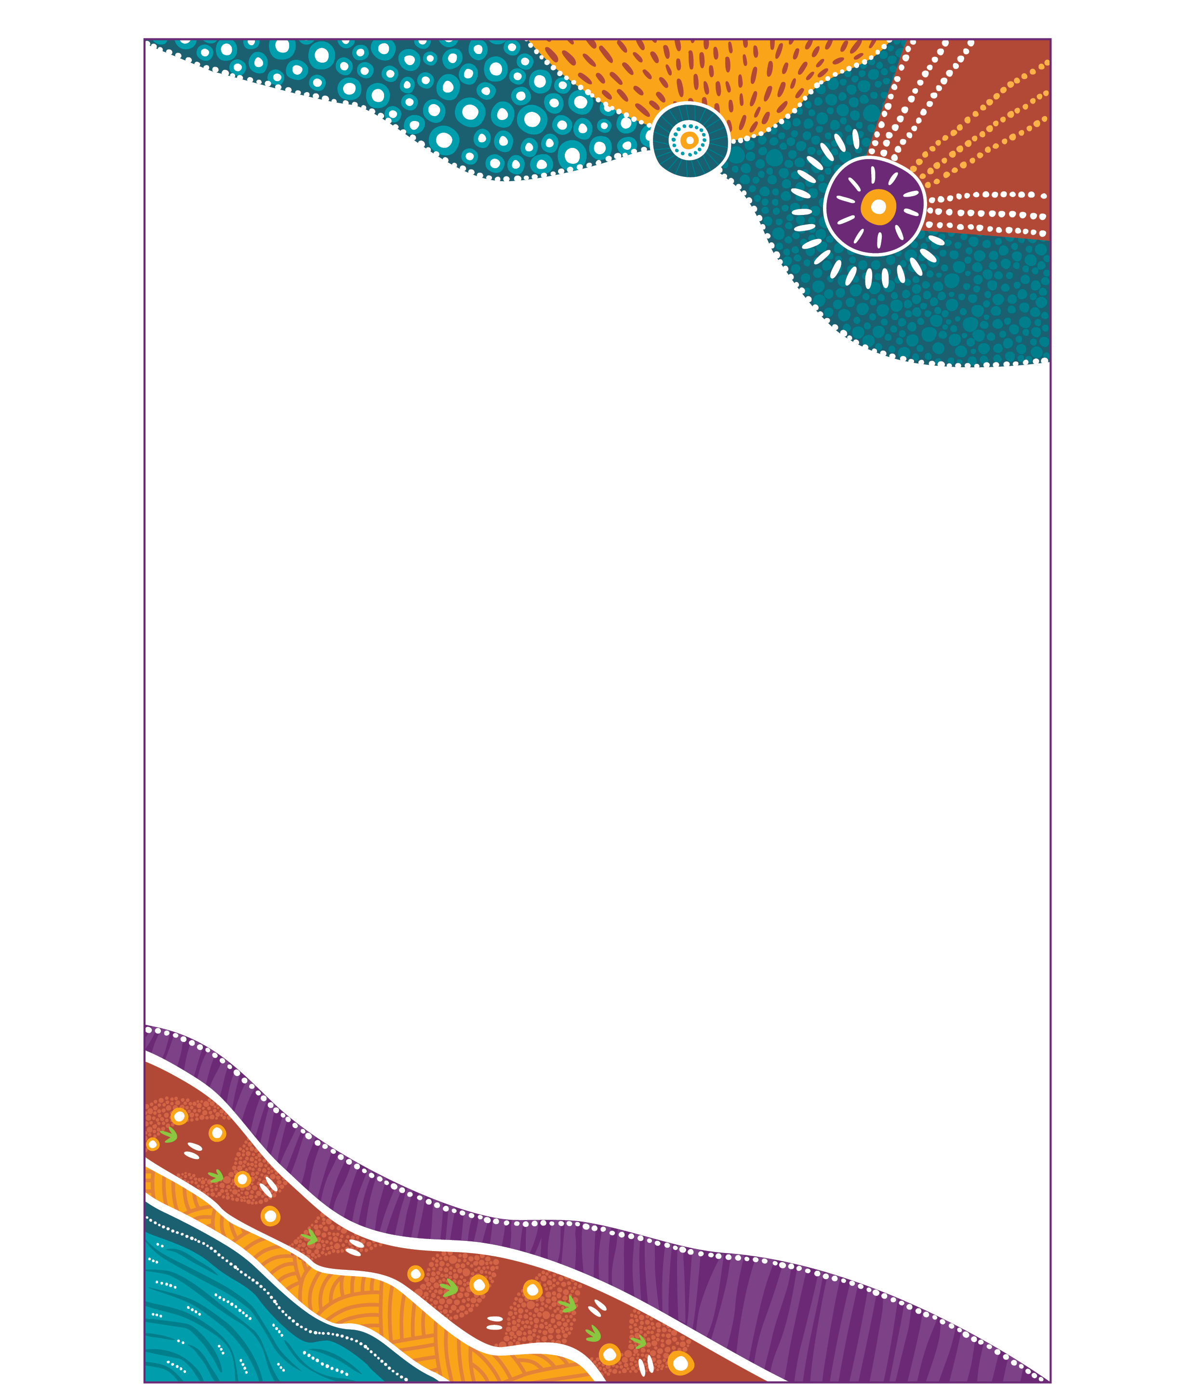
Artwork ‘Belonging’ by Charmaine Mumbulla.

NDIA Statement of Commitment to Closing the Gap
The National Disability Insurance Agency (NDIA) makes this enduring statement of commitment (SoC) to the National Agreement on Closing the Gap to First Nations peoples with disability, their families, carers and service delivery partners.
We acknowledge the patience and resilience of First Nations people, particularly those living with disabilities. We recognise so many have engaged in a relentless and tiring struggle for the recognition of historical truth in the pursuit of equity. We also understand this struggle has resulted in both disappointments and successes. A recent success is the 2020 National Agreement on Closing the Gap (National Agreement).
The NDIA will work alongside First Nations peoples and communities to deliver on our responsibilities under the National Agreement Priority Reforms and socioeconomic targets. We recognise and value First Nations excellence and the knowledges held over millennia. We will transform how we work to achieve equitable outcomes for First Nations participants and their families.

The NDIA operating environment
The NDIA is a government agency as well as a corporate entity, with a Board that reflects independent leadership. The NDIS is framed by legislation and the NDIA is a Health, Disability and Ageing Portfolio Agency.
The NDIA operates in alignment with the United Nations Declaration on the Rights of Indigenous Peoples and the United Nations Convention on the Rights of Persons with Disabilities, as well as the Australian Racial Discrimination Act 1975
and the Public Service Act 1999 which require government to represent and
serve the diversity of people in Australia. The NDIA Board and Executive Leadership Team fully support the National Agreement. We will transform the way we work to embed the Closing the Gap (CTG) Priority Reforms in all our business. It is the responsibility of all staff to understand the ambition of the Priority Reforms, enact change and report our progress.

Our commitments
- We will be an exemplar and steward of CTG practice across the Commonwealth.
- We will acknowledge and address the intersection between disability, race, gender and the social cultural and structural determinants of health and wellbeing.
- We will acknowledge that First Nations people across Australia are not homogenous – we will work locally to understand needs, aspirations and solutions, and respond respectfully and appropriately to the rich diversity, ingenuity and unique circumstances of First Nations peoples.
- We will practice critical reflection at individual and system levels to improve equity in the NDIS and create a culturally safe, respectful and trauma-informed Agency.
- We will recognise that reducing inequality for First Nations participants requires a holistic approach where participants, their families and carers, and service delivery partners are involved in shaping the policies and procedures that impact their lives.
- We will do business in a way that embeds the Priority Reforms.
The SoC complements the NDIS First Nations Strategy 2025-2030 and the Commonwealth Closing the Gap Implementation Plans and Annual Reports.

Embedding the Priority Reforms
Four Priority Reforms underpin the National Agreement on Closing the Gap, which shape our commitments as an Agency.
- Priority Reform 1: Formal partnership and shared decision-making.
- Priority Reform 2: Building the community controlled sector.
- Priority Reform 3: Transforming government organisations.
- Priority Reform 4: Shared access to data and information at a regional level.

Priority Reform 1: Formal partnership and shared decision-making
The NDIA shares power in decision-making with First Nations peoples in the
spirit of ‘nothing about us without us’ and the aspiration for self-determination and
sovereignty. In sharing power, we will:
- work in formal and genuine partnerships based on shared decision-making at national and local levels
- monitor the health of these relationships to ensure we are accountable.

Priority Reform 2: Building the community controlled sector
The NDIA recognises the strength of the First Nations community-controlled sector as a key service partner in delivering improved outcomes for First Nations peoples with disability. We will:
- provide long-term and sustainable investment in the community controlled sector to deliver local services that meet the needs of First Nations participants
- support and invest in the integration of the Aboriginal Community Controlled Sectors delivering disability supports
- support whole-of-government efforts that expand the Aboriginal Community Controlled Sector and First Nations businesses and their workforces, specifically their role in NDIS service delivery.

Priority Reform 3: Transforming government organisations
The NDIA will identify and eliminate racism and strengthen and embed cultural safety through system transformation. We will:
- elevate First Nations’ voices in governance structures across the Agency
- engage meaningfully with First Nations people with disability, their families, carers and service delivery partners with appropriate timeframes to reflect participant-first views consistent with communities’ ways of working
- raise the understanding and ability of our workforce to recognise, respond, prevent and eliminate racism in policy and practice
- work with First Nations participants, their families, carers and representative organisations, to make the NDIS and the Agency culturally safe
- ensure equity in all aspects of the Agency’s work, from communication to Scheme access, assessment, planning, delivery, review and reporting
- champion anti-racism and cultural safety as part of whole-of-government system transformation
- increase First Nations employment within the Agency and support the career development of First Nations staff, valuing the strength, understanding and ability to provide culturally safe services.

Priority Reform 4: Shared access to data and information at a regional level
The NDIA will integrate Indigenous Data Sovereignty principles throughout the Agency. We will:
- raise our understanding of what Indigenous Data Sovereignty is, what it means for the Agency and how we will enact it
- apply the ‘Framework for Governance of Indigenous Data’, specifically the CARE principles of collective benefit, authority to control, responsibility to engage respectfully and ethical practice
- develop a data plan that addresses the Closing the Gap socioeconomic targets that intersect with disability.

Supporting transformation
As NDIA staff members we will work as allies to support transformation by:
- taking responsibility to educate ourselves on the Priority Reforms to understand what they mean for First Nations people, the Agency and our individual roles and actively embed them in our day-to-day work
- privileging and responding to First Nations voices, valuing and learning from lived experience, reflecting participant-first views in the development of Agency policies, procedures and programs
- completing cultural awareness training and cultural safety training as part of mandatory training and recognising this is a life-long learning that we must activate
- stepping out of the comfort of being a bystander and become an active ally by recognising and challenging our unconscious biases, ingrained behaviours, and engagement practices that may harm First Nations Peoples - and committing to transforming these behaviours in meaningful and respectful ways
- calling out racism and embedding cultural safety in work and always demonstrating culturally safe behaviour
- using First Nations-led concepts of evidence and research to inform our decision-making and influence our colleagues and external stakeholders
- fostering collaborative partnerships with individuals, organisations, and across agencies and governments, drawing on our collective strengths to create equitable, connected and culturally safe experiences for First Nations participants.

Monitoring and accountability
In our reporting we will:
- design reporting and evaluation with First Nations voices so it reflects First Nations experiences and aspirations
- be open and transparent about how we deliver on these commitments to both First Nations peoples and governments
- use the knowledge that First Nations people have agreed for us to use with respect
- minimise the number of times we ask First Nations people to tell their story, learn from what we already know and act on this
- communicate reporting in culturally meaningful ways, including First Nations Languages, storytelling and yarning.

The artwork
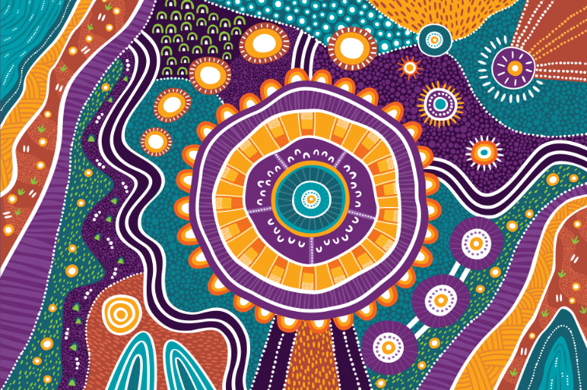
Figure 1: Artwork ‘Belonging’ by Charmaine Mumbulla
The vision of the National Disability Insurance Scheme (NDIS) is to create an inclusive Australia for people with disability. This artwork features themes of inclusivity and belonging.
Belonging is represented by the large circle at the centre of the artwork. This is significant because the core intention of the NDIS is to facilitate and enhance a sense of belonging within the community for those who require assistance.
The small u-symbols within this circle represent the diversity of people and communities coming together within the safety of the larger circle. This symbolises an inclusive Australia where everyone belongs and is able to gather together equally.
Three interconnected circles to the side represent the three core functions of the NDIS. These include individually tailored supports for eligible people with a disability, information and referrals for all people with a disability and their carers and to create community awareness of the issues that affect people with disability and encourage community capacity building.
The weaving parallel lines that run throughout the artwork signify the journey that people with a disability embark on by engaging with the core functions of the NDIS. As such, it represents the connections between individuals and services within the community.
A stylised shooting star at the top symbolises the NDIS vision for an inclusive Australia for people with disability.
The expansive and diverse countries where the NDIS deliver its services across Australia are represented in the artwork and include the red dust desert, temperate rainforest, saltwater coastal countries and inland freshwater regions.

About the artist

Charmaine Mumbulla is a Kaurna and Narungga woman from the Yorke Peninsula, with family ties to the Gumbaynggirr people of the NSW Mid-North Coast. Together with her partner she runs an Aboriginal creative agency called Mumbulla Creative. Charmaine is passionate about working on projects that support social justice. She works closely with organisations to tell their stories through her art.

Symbolism in artwork

Fair and equitable access and support

This artwork element represents ‘Fair and equitable access and support’. It depicts an organic shape at the centre with small white dots. The shape is surrounded by u-symbols. The shape indicates the importance of place-based approaches in the provision of services. The u-symbols represent people working together to improve access and participation in the NDIS for First Nations people.

NDIS ‘our way’ – transformation for power-sharing
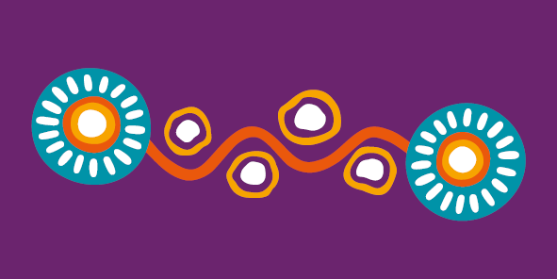
This artwork element represents ‘Transformation for power-sharing’. The two circles represent a co-design approach between Aboriginal and Torres Strait Islander communities and government. They are connected by a pathway which shows strengthening of ties. The smaller circles along the pathway represent independence of choice, cultural safety, kinship mapping and communication.

Working together well within and across sectors

This artwork element represents ‘Working together well within and across sectors’. It depicts a circular shape at the centre surrounded by u-symbols and radiating dots. The u-symbols are symbolic of cross-sector collaboration. The radiating dots show the positive benefits of working together for improved outcomes through accountability and evidence.

Gathering, sharing and revisiting knowledge about meaningful change

This artwork element represents ‘Gathering, sharing and revisiting knowledge about meaningful change’. It depicts a circular shape at the centre encased by two sets of parallel lines. The parallel lines, distinct yet unified, are symbolic of accountability and evidence, which are used to measure tangible outcomes. The shape at the centre is representative of cultural knowledge.

Contact us
National Disability Insurance Scheme (NDIS):
- Website: ndis.gov.au (external)
- Telephone: 1800 800 110
- Webchat: ndis.gov.au (external)
Follow us on our social channels:
- Facebook (external)
- Instagram (external)
- YouTube (external)
- LinkedIn (external)
- X (external)
For people who need help with English:
- Translating and Interpreting Service (TIS): 131 450
For people who are deaf or hard of hearing:
- Type and Listen (TYY): 1800 555 677
- Voice relay: 1800 555 727
- National Relay Service: accesshub.gov.au (external)

