


School leaver employment
Provider reported services & outcomes
July 2024 to June 2025

Report produced March 2026
Market Strategy Branch

ndis.gov.au

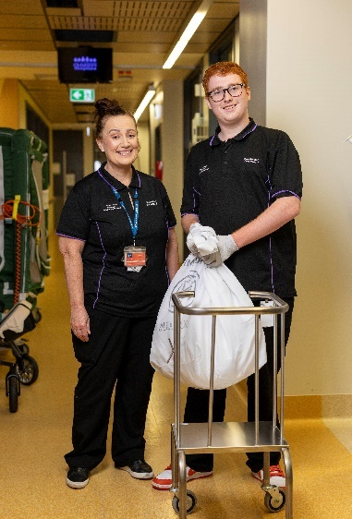
William’s story

For Queensland National Disability Insurance Scheme (NDIS) participant William, finishing school came with a clear goal – he wanted to find work.
What he wasn’t sure about was what job would suit him.
With employment assistance funding included in his plan, William was able to build the confidence and practical skills he needed to find and secure a job – one he enjoyed.
Today, William is a patient support officer at a Queensland hospital. He’s supporting staff and helping keep the hospital running.
‘It’s great working there. I get to do multiple jobs,’ he said. ‘I do a lot of recycling. I collect all the hospital’s general waste and take it down to the compactor.
‘I also collect all the clean linen and take it up to the wards and then collect all the dirty linen to take down to be washed.’
William has worked as an orderly, transporting patients for scans and tests. He enjoys this type of work, being part of a team and supporting those around him.
‘I like helping people and I don’t mind a chat either,’ he smiled. ‘For me, it’s not just about earning money – it’s about giving back.’
Growing up, William spent “quite a bit of time” at the same hospital as a patient.
‘In my interview I said I wanted to give back to the community that helped me,’ he said.
After leaving school, William used his employment assistance funding to connect with a local NDIS registered employment provider who assisted him to build the skills and confidence he needed to transition from school to work.
William was introduced to Nick, a disability employment consultant. Nick sat down with William to learn his strengths, interests and career goals and they mapped out a plan.
Nick supported William to update his resume, write cover letters and look for jobs online. He also spent several hours with William helping him prepare for potential job interviews.
When William saw a role come up at the local hospital, he liked the sound of it. He showed Nick, who encouraged and supported him to apply.
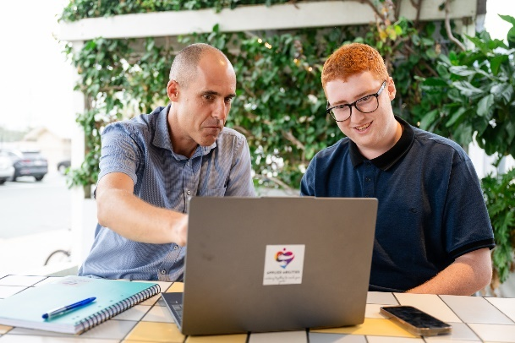
‘Nick helped me update my resume and practice interviews,’ William said. ‘He also taught me the STAR (Situation, Task, Action, Result) method. It really helped.’
The preparation paid off. William was offered an interview.
‘I went in feeling confident and ready and when I left, I felt like I did really well,’ he said.
When William got the call to offer him the job, he happened to be with Nick.
‘I was stoked,’ William said. ‘Nick congratulated me. He was really happy for me too.’
Nick helped William prepare for his first day. They planned how he would travel to work. Together they did a “dry run” walking to the nearest bus route to make sure William felt comfortable travelling to work and could manage on his own.
‘William did really well,’ Nick said. ‘He got to work on time and handled the trip with ease. I’m really proud of him – all the effort and commitment he showed.’
In William’s new role, he also spent time shadowing experienced hospital staff. Over time, it’s helped him learn all the important tasks that keep the hospital running smoothly.
Michael, William’s line manager, said the 18-year-old is a much-loved member of staff.
‘If you ask William to do a job he’s always happy to do it and he gets it done,’ he said.
‘Doing all these different roles also exposes him to a lot of different areas around the hospital, so he gets to meet a lot of people. He’s always friendly, so everyone enjoys seeing him around.’
William’s family were “really proud” when he shared he’d secured a role at the hospital.
‘Mum was really happy for me,’ he said. ‘I love my mum. She’s been a great support. My dad and grandma were proud too.’
For other young people leaving school, William has simple advice.
‘Keep searching and don’t give up,’ he said. ‘Try new things you’ve never tried before. Just keep going and you’ll eventually find your way.’
With employment assistance funding and a strong will to succeed, William’s taken an important step into the workforce. He’s building new skills, gaining more confidence, enjoying greater independence – he’s opening up a world full of future possibilities.

Contents
School leaver employment 1
Contents 4
1. Executive summary 6
1.1 Introduction 6
1.2 Employment support provider reporting 6
1.3 Report enhancements 6
1.4 Key findings 7
2. Provider and participant count 9
2.1 Provider count 9
2.2 Participant count 9
3. Participant demographics 10
3.1 Employment support recipients 10
3.2 Location 11
3.3 Primary disability 11
3.4 Age 12
3.5 Gender 12
3.6 Aboriginal and Torres Strait Islanders status 13
3.7 Culturally and Linguistically Diverse status 13
4. Supports & milestones 14
4.1 Support type hours 14
4.2 Support delivery method 15
4.3 Progress towards milestones – snapshot at each reporting period 15
4.4 Progress towards milestones – cumulative for the year 17
5. Final outcomes 19
6. Final employment outcomes 22
6.1 Employment type 22
6.2 Hours worked 23
6.3 Industry of employment 24
6.4 NDIS supports in employment 25
6.5 Supported wages 25
7. Intermediate employment outcomes 26
7.1 Employment outcomes (July 2024 to June 2025) 26
7.2 Employment type 26
7.3 Hours worked 27
7.4 Industry of employment 28
7.5 NDIS supports in employment 29
7.6 Supported wages 29
8. Model summary 30
8.1 Modelling approach 30
8.2 What helps (or hinders) finding paid employment 31
8.3 Comparisons in modelled predictors between reporting period ending December 2024 versus the period ending June 2025 32
9. Appendix 33
9.1 Appendix 1 – Methodology for the section titled “Progress towards milestones – cumulative for the year” 33
9.2 Appendix 2 – Model accuracy 35

Executive summary

Introduction

The Agency is committed to ensuring participants have the same opportunities to work as other Australians and the confidence, support, and skills to achieve their work goals.

The NDIS can make a significant difference for young participants by supporting them early to aspire to work, develop skills and connect to the right job role and employer.
Employment assistance is individualised support intended to build a participant’s skills, confidence, and capacity for work.

This eighth edition of the School Leaver Provider Quarterly Report analyses the early intervention employment support provided to participants of school leaving age, their progress and the outcomes they’ve achieved, allowing us to share insights on best practice and the factors that lead to successful employment outcomes.

Employment support provider reporting

Employment support providers submit data through the provider reporting tool (the tool) to the NDIA each quarter. The data submitted includes participants’ demographic details, activities, progress towards milestones, the method of delivery, outcomes achieved, and employment details. The provider confirms the details they are including, particularly the outcomes achieved, with the participant prior to submitting the report to the NDIA.

This report provides insights on the data submitted through the tool, aggregated across all providers’ that contributed from July 2024 to June 2025.

Report enhancements

Some providers reported additional participants who were active in Q1 and Q2 2025. The additional number of participants are now included in those quarters' totals. This might result in Q3 and Q4 2024 numbers being slightly different to the same periods published in the seventh edition of the report for calendar year 2024.

We encourage participants to discuss the available information with providers when considering selecting or changing providers. Additional questions that participants can ask providers about their service are available here.

The report will feature a participant story, like William’s, in each release to showcase a positive employment outcome. Participants, or providers with the consent of the participant, are invited to forward stories to participant.employment@ndis.gov.au.

If you have general feedback or questions about this report, please email participant.employment@ndis.gov.au.

Key findings

The information contained in this report represents data submitted to the Agency by providers of employment assistance to school leavers delivered from July 2024 to June 2025.

For the 12 months ending June 2025, 9,117 young participants aged 15 to 24 had claimed payments for support items “school leaver employment supports” or “employment assistance” for the school leaving age group. This report includes only participants whose providers submitted data to the Agency.

In the previous report covering the 12 months ending December 2024, the figure reported was 9,234 participants; however, this has since been corrected to 8,158 participants.

For the period July 2024 to June 2025, providers reported:

Demographics
- 8,531 participants received employment assistance to help them transition from school to work of which 3,048 commenced during the year.
- Commencement varies across quarters with the highest number starting in the January to March quarter after leaving school. 757 participants commenced receiving employment supports in July to September 2024, 739 commenced in October to December 2024, 999 commenced in January to March 2025, and 553 commenced in April to June 2025.
- School leaving participants receiving employment supports in the quarter to June 2025 predominantly have autism (63%) or intellectual disability (27%), with 67% being male.
- The majority of employment support recipients are in N S W (33%), followed by V I C (23%), and Q L D (18%).
- 6% of employment support recipients identified as Aboriginal or Torres Strait Islander people. While this is slightly lower than the 9% of all NDIS participants aged 15-24 who identify as Aboriginal or Torres Strait Islander, this gap has been consistent for the last few iterations of the report.
- 7% of employment support recipients identified as being from a Culturally and Linguistically Diverse community. This is slightly higher than the 6% of all NDIS participants aged 15 to 24 who identified as being from these communities. This gap has also been consistent for the last few iterations of the report.
Time spent in training
- 47% of the training time was spent building participant’s social, presentation, communication and work skills.
- Participants receive supports via group-based activities (50% of support time), one to one support (49% of support time) and via distance or online methods (2%) in the latest quarter.

Exits from employment support
- 2,633 participants were reported as exiting employment supports during the four quarters.
- Of the 2,633 participants who exited:
  - 64% (1,691 out of 2,633) exited without an employment outcome compared to 64% (1,437 out of 2,262) in the previous report (1 year to 31 December 2024).
  - 12% (328 out of 2,633) went on to further study or volunteer work.
  - 20% (521 out of 2,633) achieved open employment outcomes compared to 21% (478 out of 2,262) in the previous report (1 year to 31 December 2024).
  - 4% (93 out of 2,633) achieved supported employment outcomes (in supported employment services (previously Australian Disability Enterprises ADEs), and this proportion is slightly higher than the 3% (70 out of 2,262) figure from the report of December 2024.
  - Less than 1% (4 out of 2,633) did not have an outcome reported.
- Despite the number of open employment outcomes increasing to 521, total exits increased substantially from 2,262 to 2,633, resulting in a reduction in the open employment outcome proportion from 21% to 20%.
  - The main reason for this change was a shift in provider participation during the reporting period. One large provider ceased delivering services, with 268 affected participants subsequently referred to other providers. For reporting purposes, participants recorded as ‘referred to another provider’ are classified as non-employment outcomes, temporarily increasing the proportion of non-employment outcomes.
- Of the participants who finished employment support with open and supported employment outcomes over the four quarters, 44% were employed on a part time basis while 36% were employed casually, 11% were employed full time.
- Of participants who finished employment support with paid employment:
  - 71% worked up to 21 hours per week.
  - 69% worked in retail, hospitality, tourism, trades, manufacturing or operations.
  - 23% said they will be using NDIS supports in employment to maintain their employment. Of participants who finished employment support with paid employment, 18% receive a wage determined under the Supported Wage System (S W S).
Interventions compared to outcomes
- Increased time receiving skill specific training was associated with a higher chance of making significant progress towards or fully gaining specific skills.
- Participants who made significant progress or fully achieved the following milestones were more likely to gain paid employment:
  - Employer engagement and job customisation
  - Work skills
  - Work experience.
  - Building social, presentation and communication skills

Note: Figures in this report have been rounded to the nearest whole percentage.

Provider and participant count

Provider count

Figure 1. Providers claiming and reporting – April to June 2025
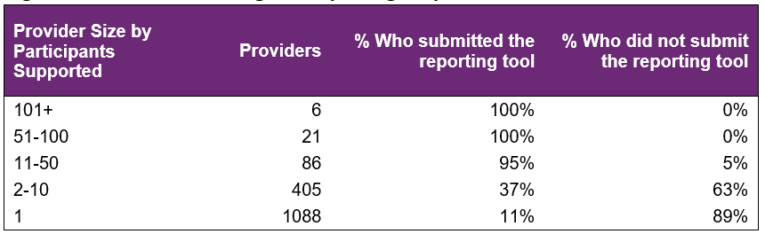

From April to June 2025 (Figure 1), NDIA recorded 1,606 providers claiming for employment support delivered to school leavers across the country, with 27 providers delivering to 51 or more participants. 86 providers delivered services to 11 to 50 participants and 1,493 providers delivered supports to 10 or fewer participants. The largest 24 providers delivered support to 36% of participants and reported on them all during the year. Across all of these providers, data was submitted for 73% of participants through the provider tool.

In the current reporting period, (Figure 2), providers who have 10 or fewer participants have lower submission rates. The proportion of providers submitting data over the 4 quarters has been fairly stable.

Figure 2. Percentage of providers who submitted the reporting tool – January to December 2024
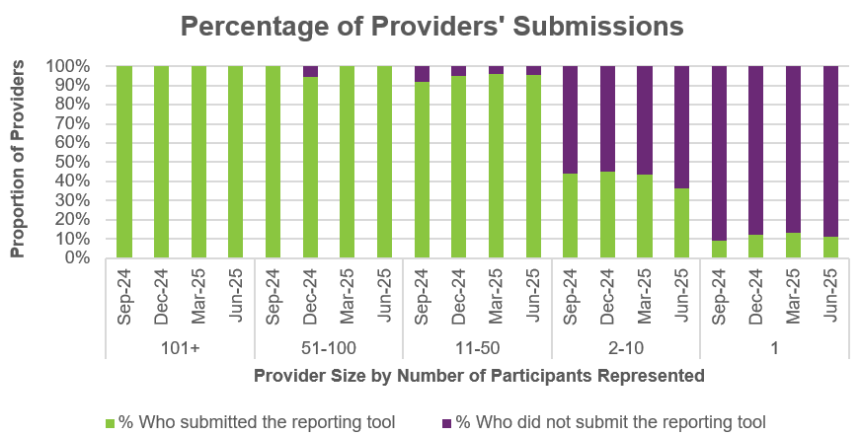

Participant count

Figure 3. Participants represented in reporting – April to June 2025
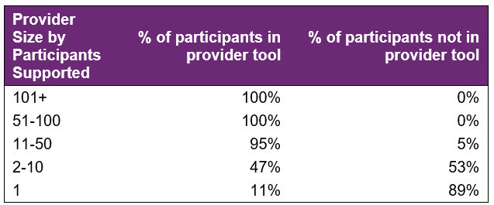
Overall, 27% of school leaving participants who received employment supports in the last quarter were not represented in the reporting submitted by providers. This slight increase from 25% in the previous report to 31 December is due to the expansion of data collection to all providers claiming capacity building employment supports for the school leaving cohort (not just those who claim the school leaver employment support item).

Participant demographics

Employment support recipients

The Provider Reporting Tool data provides information on participants receiving employment during the year. Participants that started employment support during a previous period and continue to be recipients in the current period are included in the ‘Existing’ numbers, and those that started receiving employment during the current period are included in the ‘New’ numbers. While participants that exited employment support during the current period are included in the ‘Exited’ numbers.

Note, if the participant exits employment support in a quarter, they will be counted in the "Exit" numbers for that quarter. If that same participant re-enters employment support a few quarters later, they will be counted in the "New" numbers again.

Figure 4. Number of participants
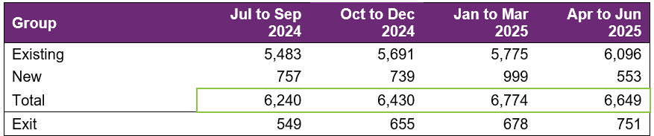

The number of participants receiving employment assistance reported in the Provider Reporting Tool (the Tool) has steadily increased over the first 3 quarters, with a slight decrease in the fourth quarter.

Many young people transition out of school between October to December (after Year 12), which creates a surge in commencements (999 in the Jan to Mar 2025 quarter) as they look for assistance to pursue their work goals.

Conversely, the end of the year often aligns with support completion (typically after 2 years for school leavers). However, exits have grown consistently over the 4 quarters, in-line with the growing number of participants receiving employment supports during the financial year.

Please note that the numbers of participants reported in this report for the July to September 2024 quarter and the October to December 2024 quarter differ from the numbers for those same periods in the previous edition report due to late reporting. That is, the participants had not been reported when the previous edition report was compiled but have now been reported for this report.

Location

Figure 5. State or Territory of residence – number of participants
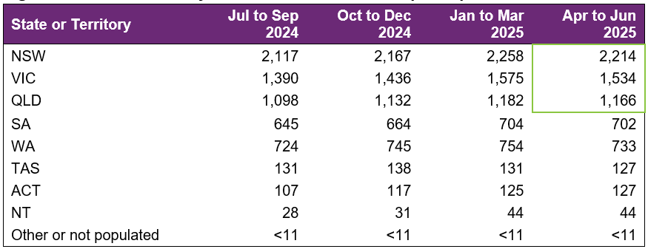
The majority of employment support recipients were in NSW (33%), followed by VIC (23%), and QLD (18%). For comparison, the top 3 states for all NDIS participants aged 15-24 are NSW (29%), VIC (27%) and QLD (22%). The over-representation in NSW is partly due to the earlier roll out to full scheme in that state and the influence of the legacy NSW Transition to Work program and the role of NSW Education transition teachers helping students to consider post school options and connecting many with employment providers.

Primary disability

Figure 6. Primary disability – number of participants
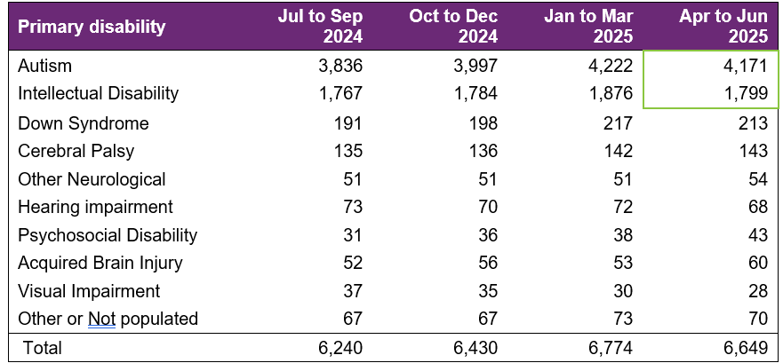

The most common primary disabilities experienced by participants utilising these supports in the latest quarter were autism (63%), followed by intellectual disability (27%). For comparison, 67% and 18% of all NDIS participants aged 15-24 report having autism and intellectual disability, respectively.

Age

Figure 7. Age – percentage of participants
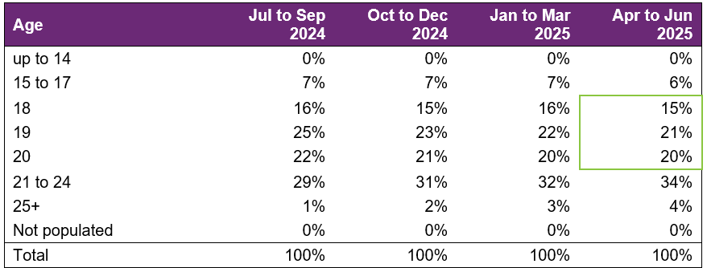
Participants aged 18 to 20 accounted for 56% of employment support recipients. Recipients aged 21 to 24 has steadily grown in proportion over the 4 quarters, while the proportion of recipients aged 15 to 19 has reduced. This is likely a mix of natural ageing of the cohort as well as providers continuing to report on the participants they are supporting regardless of the line item they are using to claim.

Gender

Figure 8. Gender – percentage of participants
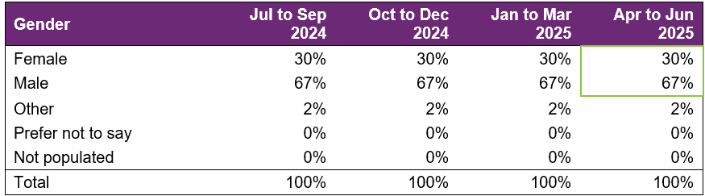
In the most recent quarter, employment support recipients were 30% female and 67% male. In comparison to all NDIS participants aged 15 to 24, 35% were female and 63% were male. This is in line with the high proportion of employment supports recipients reporting autism as the primary disability, as the majority of participants who report autism are males.

Aboriginal and Torres Strait Islanders status

Figure 9. Aboriginal and Torres Strait Islanders – percentage of participants
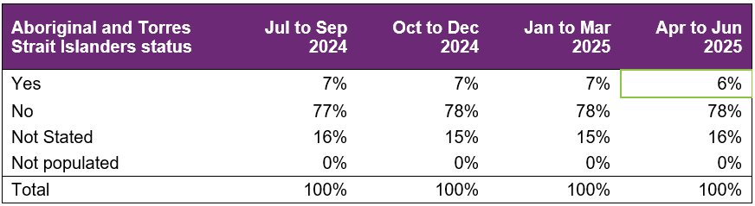

In the most recent period, 6% of employment support recipients identified as Aboriginal and / or Torres Strait Islander. This is slightly lower than the 9% of all NDIS participants aged 15-24 who identified as Aboriginal and / or Torres Strait Islander. This gap has been consistent for the last few iterations of the report.

Culturally and Linguistically Diverse status

Figure 10. Culturally and linguistically diverse – percentage of participants
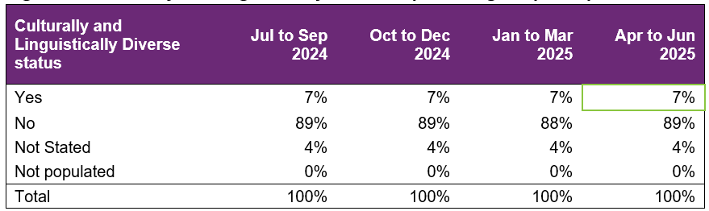

In the most recent period, around 7% of employment support recipients identified as being from a Culturally and Linguistically Diverse community. This is slightly higher than the 6% of all NDIS participants aged 15 to 24 who identified as being from a Culturally and Linguistically Diverse community. This gap has been consistent for the last few iterations of the report.

Supports & milestones

Support type hours

Figure 11. Support type provided – percentage of average hours per participant
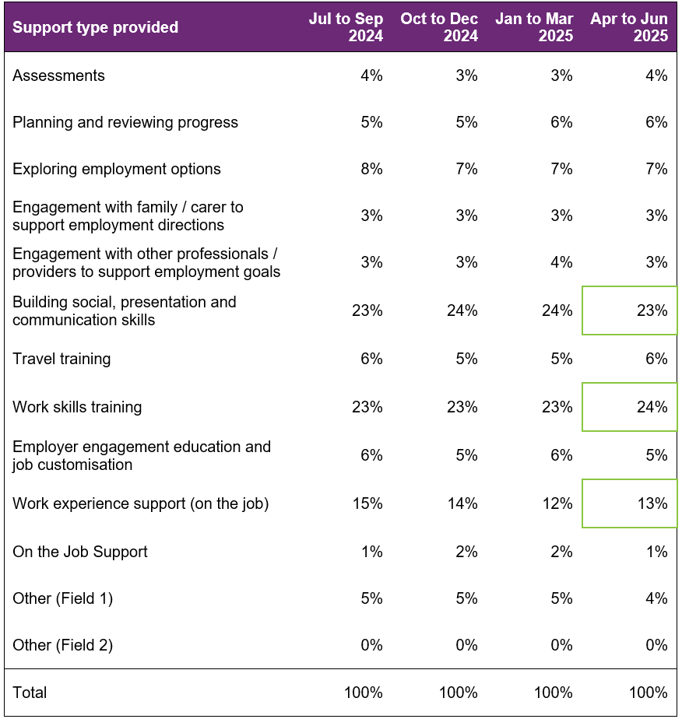

Almost half (47%) of the training time was spent building participants’ social, presentation, communication, and work skills. The amount of time dedicated to work experience support (on the job) has accounted for 13% of the total training time. Percentages across the board have remained steady over the four quarters.

Support delivery method

Figure 12. Delivery method – percentage of hours
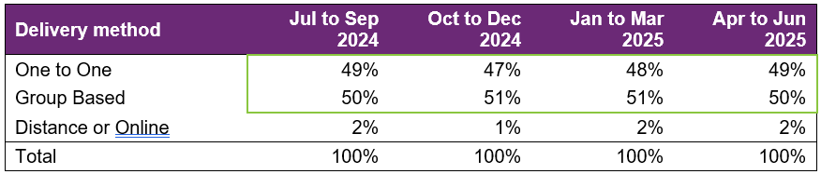

Participants have been excluded from this section where the sum of One to One, Group based, Distance or Online percentages did not equal 100%.
The percentage of one-to-one support vs group-based has remained steady over the 4 quarters.

Progress towards milestones – snapshot at each reporting period
This section looks at the distribution of progress for participants who worked on a particular milestone (where there are training hours reported for that specific skill), for each reporting period in isolation (non-cumulative).

Social, presentation and communication skill

Figure 13. Social, presentation and communication skill milestone – percentage of participant progress
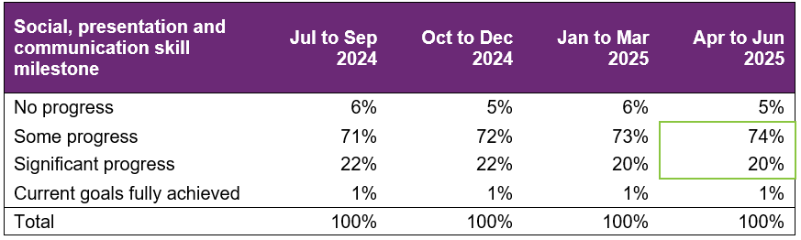

For participants who worked on this specific milestone, 74% reported some progress and 22% reported significant progress in the latest reporting period. Percentages have remained relatively consistent over the 4 quarters.

Travel skill

Figure 14. Travel skill milestone – percentage of participant progress
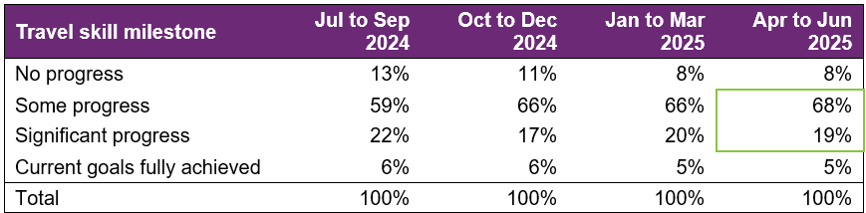

For participants who worked on this specific milestone, 68% reported some progress and 19% reported significant progress in the last quarter, which were an increase and decrease respectively compared to the previous quarter.

Work skill

Figure 15. Work skill milestone – percentage of participant progress
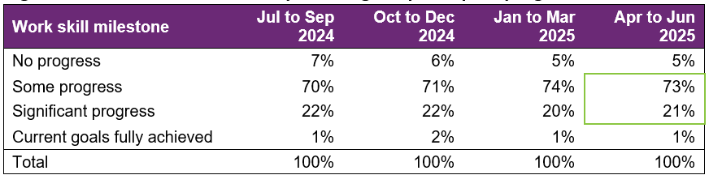

For participants who worked on this specific milestone, 73% reported some progress and 21% reported significant progress. The percentages have remained relatively consistent over the 4 quarters.

Employer engagement, education, and job customization

Figure 16. Employer engagement, education, and job customisation milestone – percentage of participant progress
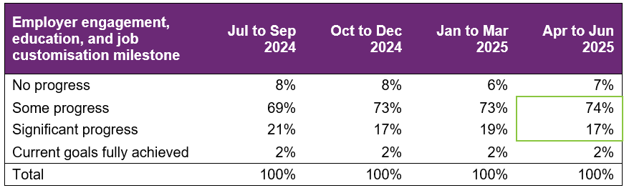

Providers who reported activities as “engaging with employers, educating and customising jobs” for participants reported that 74% made some progress and 17% made significant progress. There was a slight decrease in those making significant progress in the last quarter and a slight increase in those making some progress.

Work experience

Figure 17. Work experience milestone – percentage of participant progress
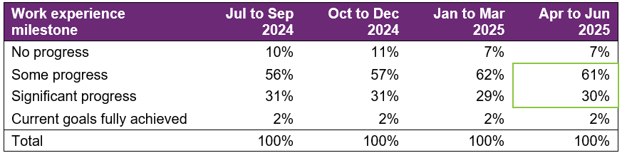

For participants with a work experience milestone, 61% were reported to be making some progress and 30% making significant progress in the most recent quarter. Percentages for making some progress have increased over the 4 quarters.

Progress towards milestones – cumulative for the year

The following sections show that more time receiving supports or training is associated with better progress towards mastering specific skills. For each participant, the best progress (across 4 quarters) towards mastering the specific skills is used for this analysis, and compared against the cumulative time receiving employment supports, and training for the specific skills.
Appendix 1 includes more detail on the methodology used in this section.

Social, presentation and communication skill

Figure 18. Social, presentation and communication skill milestone – percentage of participant progress
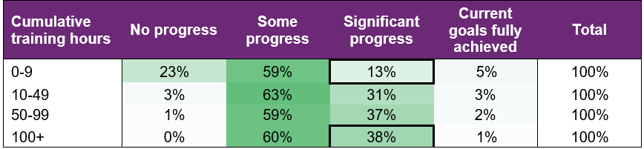
Of the participants who received up to 9 hours of training on social, presentation, and communication skills, around 13% were able to make significant progress towards mastering these skills. This proportion increased to 38% for those who received 100+ hours of the skill-specific training.

Travel skill

Figure 19. Travel skill milestone – percentage of participant progress
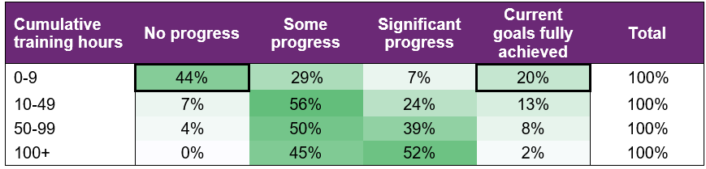

While 20% participants were able to fully achieve their goal within 0-9 hours of training, about half (44%) did not make any progress. This suggests that for some participants, travel skills may be a primary area of focus and that they need only a few hours of personalised support to fully achieve their goals, while others need more than 10 hours of training to start making progress towards their goals.
Note that the unusually decreasing percentage of participants with current goals fully achieved as cumulative training hours increase is due to small counts (hence percentage volatility) in this category.

Work skill

Figure 20. Work skill milestone – percentage of participant progress
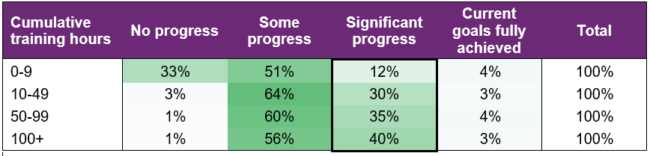

Attaining significant progress in work skills was achieved through more cumulative hours of training demonstrating the need for tailoring this support for the individual.

Employer engagement, education, and job customisation

Figure 21. Employer engagement, education, and job customisation milestone – percentage of participant progress
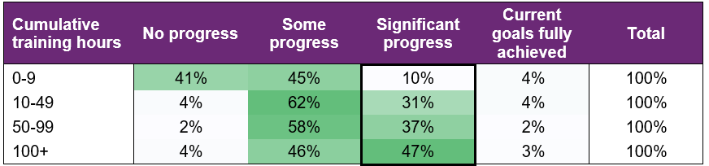

Making significant progress towards employer engagement, education, and job customisation milestones increased markedly with more hours spent on these activities.

Work experience

Figure 22. Work experience milestone – percentage of participant progress
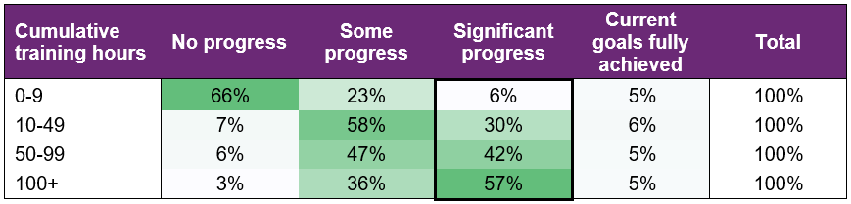

Similarly, making significant progress towards work experience milestones increased consistently with more hours of training.

Final outcomes

This section shows the distribution of outcomes upon exiting employment support (based on the employment support reported end/exit date).

Figure 23. Final outcomes (upon exiting employment support) – number of participants
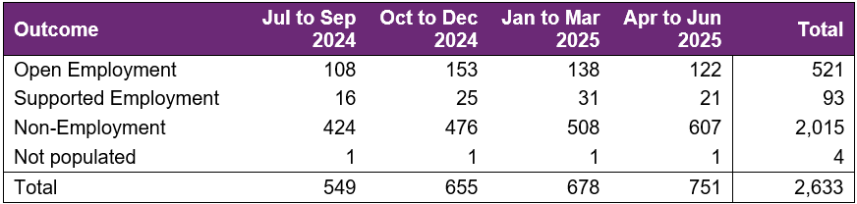

The number of participants finishing employment supports with open or supported employment was highest in the October to December quarter. This tends to be a seasonally high quarter, as seen in previous versions of this report.

From July 2024 to June 2025, 614 participants finished employment support with open or supported employment.

Figure 24. Final outcomes (upon exiting employment support) – percentage of participants
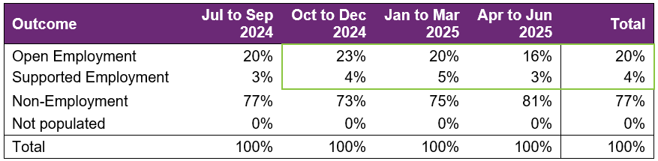

Non-employment outcomes rose in the April to June 2025 quarter, leading to the drop in the proportion of open employment outcomes. As outlined in the key findings section (section 1.4), the main reason for this is one large provider ceased delivering services in that quarter, with 268 affected participants subsequently referred to other providers. For reporting purposes, participants recorded as ‘referred to another provider’ are classified as non-employment outcomes, temporarily increasing the proportion of non-employment outcomes.

If this one-off impact to employment outcomes were excluded, the open employment percentage would have been roughly 21%, in-line with the 21% figure from the previous report.

The following table provides a more granular breakdown of outcomes for participants who exited employment supports from July 2024 to June 2025.

Figure 25. Final outcomes breakdown – percentage and total number of participants:
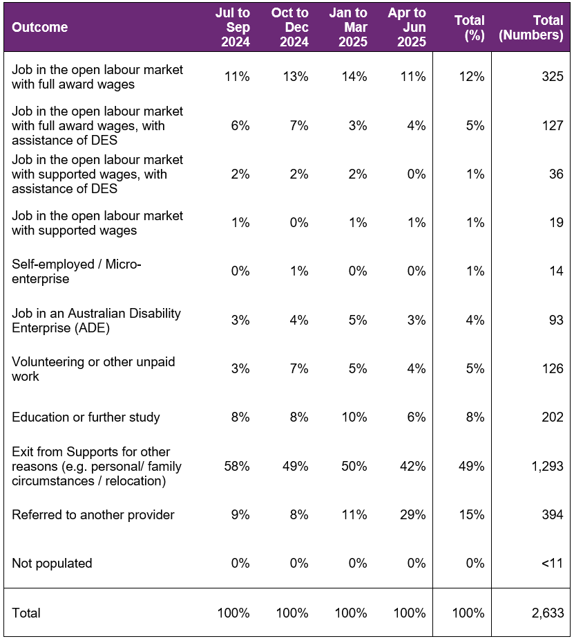

The absolute numbers (non-percentages) have been shown as a total only in the above table (not broken down into individual quarters) due to low volumes in the individual quarter. Individual quarter absolute numbers will be shown once there is sufficient volume.

For participants whose final outcome is Exit from Supports for other reasons, the common reasons reported were:
- personal or family circumstances
- relocated
- not engaging or contactable
- school leaver employment supports funding ended
- transferred to D E S or another provider
- not a good fit or ready for employment preparation.

Open employment outcomes comprise of:
- jobs in the open labour market, with full award or supported wages, with or without the assistance of Disability Employment Services (D E S)
- or Self-employment/Micro-enterprise.

A job in a supported employment service (previously known as Australian Disability Enterprise (A D E)) is classified as Supported Employment. The other categories in the chart above are classified as non-employment outcomes.

Figure 26. Final outcomes breakdown – participants in open and supported employment, by primary disability – percentage:
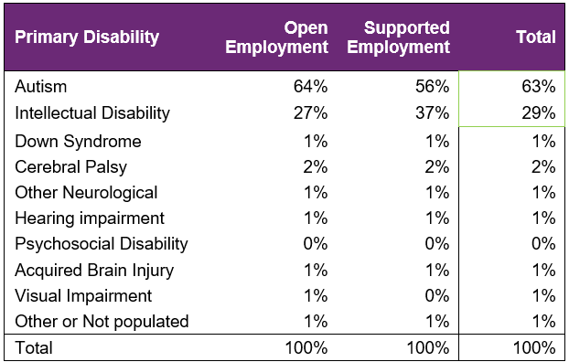

There is a fair representation of participants with a primary disability of autism who finished in employment - 63% finished in employment versus 63% who received support (from section 3.3).

On the other hand, primary disability of intellectual disability seems to be slightly over-represented - 29% finished in employment versus 27% who received support (from section 3.3).

Final employment outcomes

Employment type

Figure 27. Employment type – number of participants

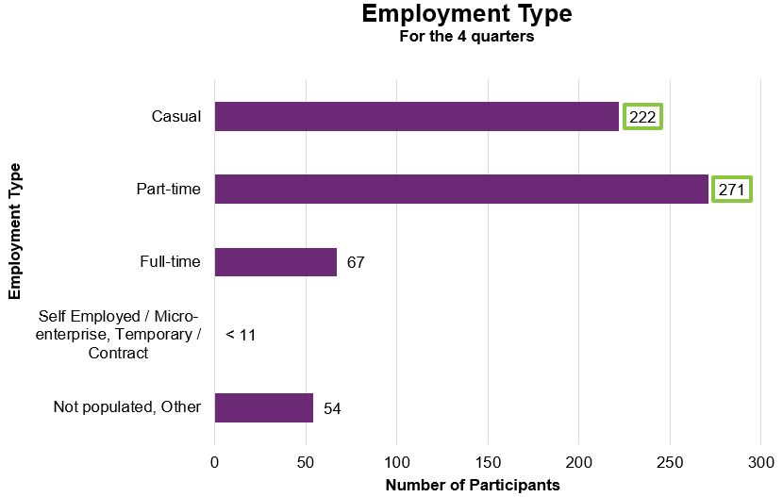

From July 2024 to June 2025, of participants who finished employment support with paid employment, 222 gained casual work while 271 gained part-time work.

Figure 28. Employment type – percentage of participants
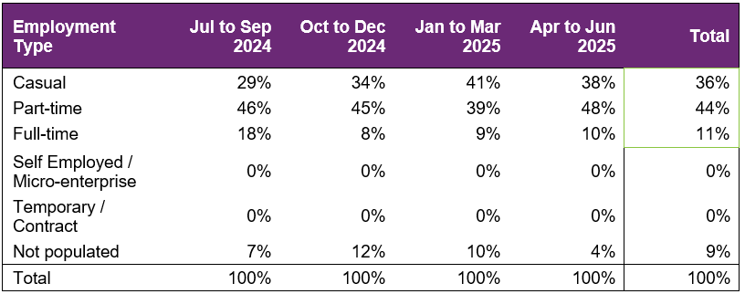

From July 2024 to June 2025, of participants who finished employment support with paid employment, 36% gained casual work while 44% gained part-time work and 11% gained full-time work.

These numbers tend to be somewhat volatile from quarter to quarter due to small counts.

Hours worked

Figure 29. Hours worked per week – percentage of participants

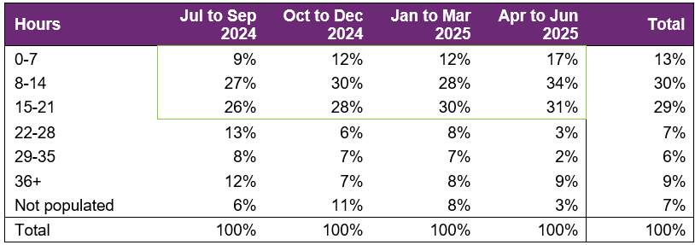

From July 2024 to June 2025, of participants who finished employment support with paid employment, there has been an increase in those who worked up to 21 hours per week over the four quarters. However, as mentioned previously, these numbers tend to be quite volatile between quarters due to small counts.

71% of participants who finished employment support with paid employment worked up to 21 hours per week.

Industry of employment

Figure 30. Industry of employment – percentage of participants
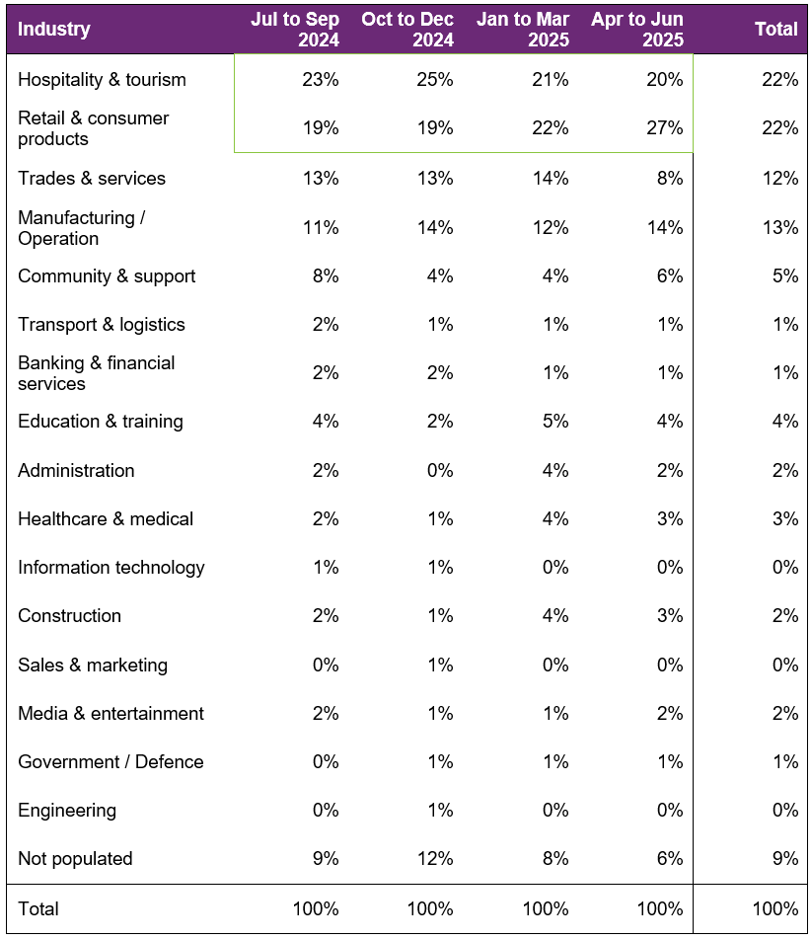

The percentage of participants who worked in hospitality and tourism as well as Retail and consumer products fluctuated over the four quarters, with a small decrease overall for the former and a noteworthy increase for the latter. Both are still the top two industries for participants to be employed in over the last four quarters.

From July 2024 to June 2025, of participants who finished employment support with paid employment, 69% work in Hospitality, Tourism, Retail, Trades, Manufacturing, or Operation.

NDIS supports in employment

Figure 31. Will the participant be utilising NDIS supports in employment? – percentage of participants
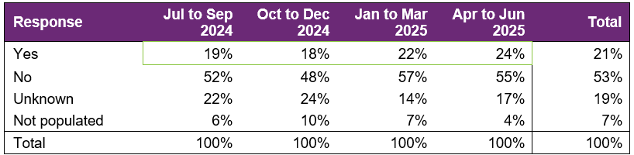

The percentage of participants that will be utilising NDIS supports in employment to maintain their employment has increased over the four quarters.

For the 2025 financial year, providers reported 21% of participants who finished employment support with paid employment will be using NDIS supports in employment to maintain their employment. This is a decrease from the 23% figure in the seventh version of this report for calendar year 2024. However, the trend over the past 3 quarters has been positive.

Supported wages

Figure 32. Will the participant receive a wage determined under the supported wage system? - Percentage of participants
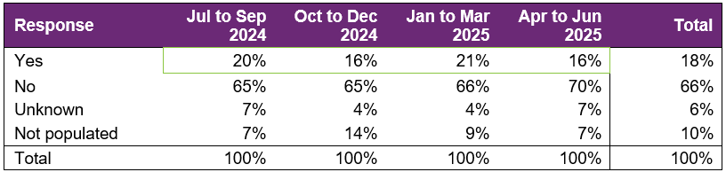

Of participants who finished employment support with paid employment, the percentage who were reported to receive a wage determined under the Supported Wage System (S W S) has fluctuated over the four quarters and seen a slight decrease overall. These numbers are in line with the changing mix of open employment vs supported employment outcomes reported in each quarter.
Over the 12 months, 18% of participants who commenced paid employment receive a wage determined under the S W S.

Intermediate employment outcomes

This section contains the employment features for all the participants who commenced employment from July 2024 to June 2025. The participants may or may not have exited employment support during this period. Participants with Employment Type "Work Experience" are excluded.

Employment outcomes (July 2024 to June 2025)

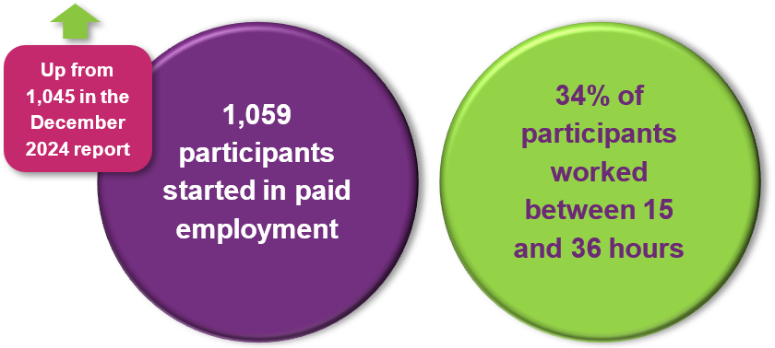

The top 4 industries in which participants started employment were Retail, Hospitality/Tourism, Trades/Services and Manufacturing/Operations.

Employment type

Figure 33. Employment type – number of participants
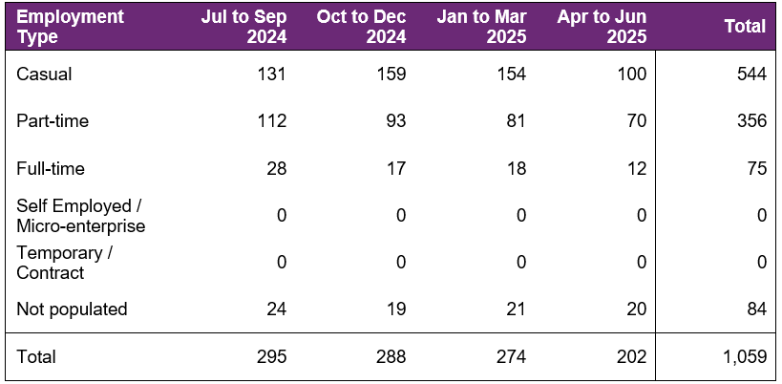

The number of participants commencing casual and part-time employment fluctuated across the four quarters, with a drop in the April to June 2025 quarter.

A total of 1,059 participants were reported to have commenced employment from July 2024 to June 2025. During this period, 544 started casual work while 356 started part-time work.

Figure 34. Employment type – percentage of participants
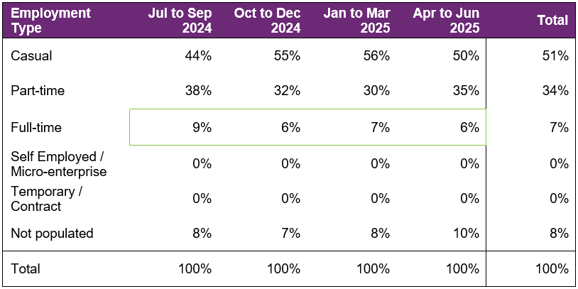

The percentage of participants who started full-time work fluctuated during the period, totalling 7% for the 4 quarters (slight decrease overall versus the December 2024 report).

From July 2024 to June 2025, of participants who started employment, 51% started casual work, while 34% started part-time work.

Hours worked

Figure 35. Hours worked per week – percentage of participants
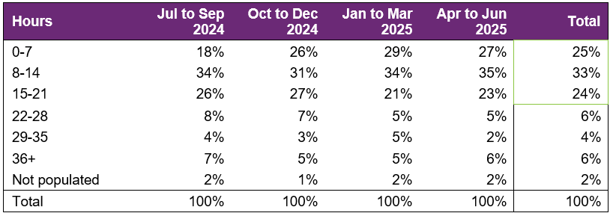

From July 2024 to June 2025, of participants who started employment, 82% worked up to 21 hours per week.

Percentages fluctuated between quarters, with most categories of employment hours fluctuating except for the proportion of participants working 22 – 28 hours which saw a decrease over the 4 quarters.

Industry of employment

Figure 36. Industry of employment – percentage of participants
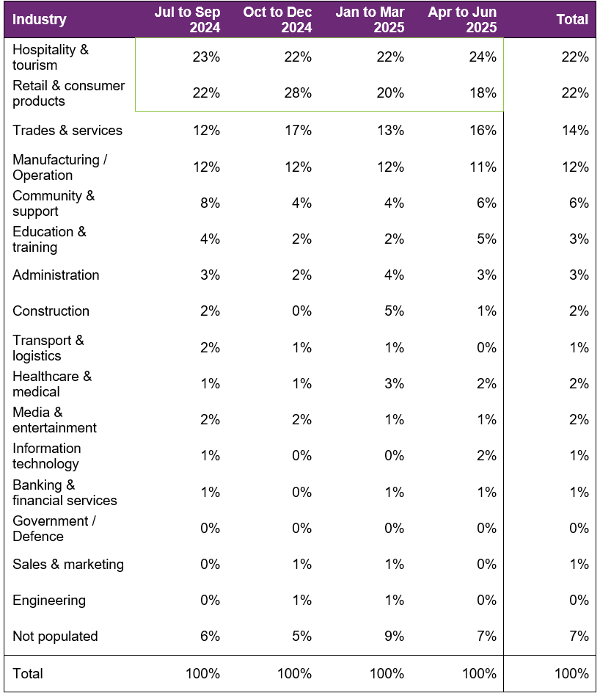

The percentage who worked in hospitality and tourism remained fairly stable over the 4 quarters while the percentage who worked in retail and consumer products fluctuated.
From July 2024 to June 2025, of participants who started employment, 71% worked in Hospitality and tourism, Retail and consumer products, Trades and services, Manufacturing or Operation.

NDIS supports in employment

Figure 37. Will the participant be utilising NDIS supports in employment? – percentage of participants
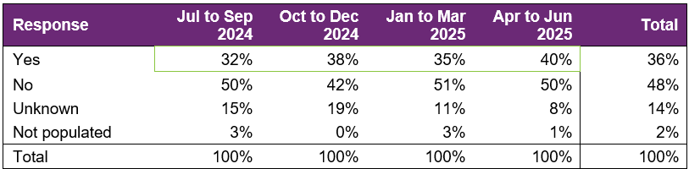

From January to December 2024, of participants who started employment, providers report 36% will be using NDIS supports in employment to maintain their employment.

This is a slight decrease versus the 38% figure in the December 2024 report and is a trend that has continued from previous reports.

Supported wages

Figure 38. Will the participant receive a wage determined under the supported wage system? - Percentage of participants
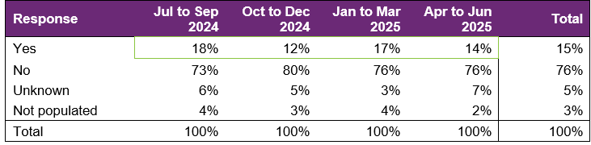

This percentage has fluctuated over the four quarters with no clear trend.

For the year, providers report 15% of the participants who started employment will receive a wage determined under the Supported Wage System (S W S).

Model summary

Modelling approach
A model was built to predict successful employment outcomes, defined as any of the following:
- Job in the open labour market, with full award or supported wages, with or without the assistance of Disability Employment Services (D E S)
- Self-employed / Micro-enterprise
- Supported employment.
The modelling dataset is sourced from the Provider Reporting Tool and NDIA’s own participant data, with the former containing outcomes and support hours and the latter containing characteristics such as Culturally and Linguistically Diverse Status and education activities.
In addition, Socio-Economic Indexes for Areas (S E I F A) data was attached to the modelling dataset, mapping to the 2021 LGA. Note that some LGA names in the Provider Tool were updated to the 2021 LGA due to changes in LGA boundaries between 2016-2021.
The analysis employed an XGBoost machine learning model, an advanced implementation of the Gradient Boosting Machine, to model the relationship between finding paid employment and its key drivers.
The top drivers of finding paid employment, that providers have most direct influence on (ranked in order from most to least important), are:
- Progress made towards achieving employer engagement and job customisation milestones.
- Progress made towards achieving work experience support milestones.
- Progress made towards achieving work skills milestones.
- Hours spent in work experience support.
- Progress towards building social, presentation and communication skills
Appendix 2 has more details on the accuracy of the model.

What helps (or hinders) finding paid employment
Figure 39. Variables that help or hinder finding paid employment – for the model covering period ending in June 2025.
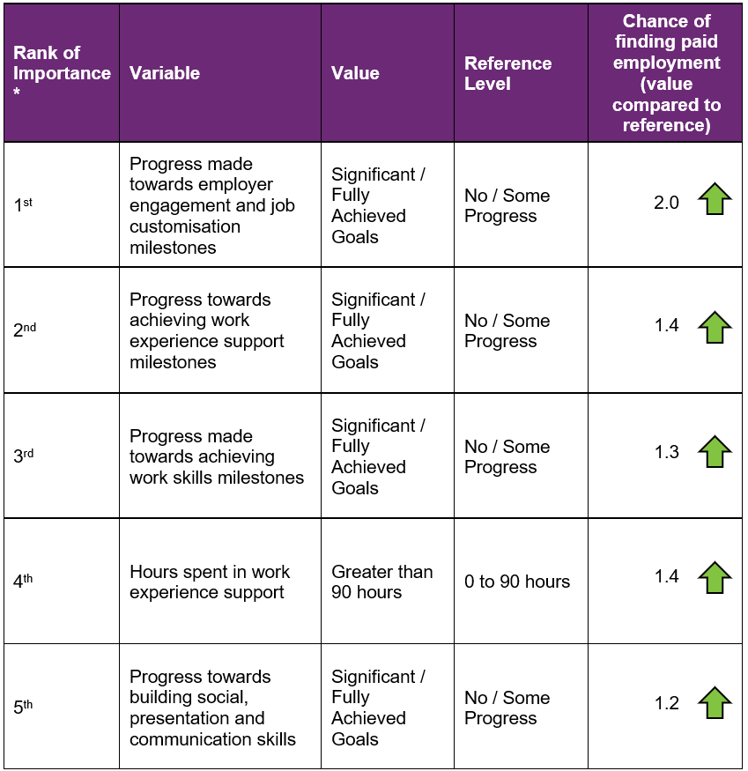
How to interpret the above table:
- Participants who made significant progress towards or fully achieved their employer engagement, education, and job customisation milestones were 2 times as likely to find employment compared to participants who made no or some progress towards similar milestones.
- Participants who were spent 90+ hours in work experience support are 1.4 times as likely to find employment compared to participants who spent up to 90 hours in work experience support.

Comparisons in modelled predictors between reporting period ending December 2024 versus the period ending June 2025
The following table provides a comparison of the top five most significant predictors in the model covering the period ending in December 2024, versus the model covering the period ending in June 2025.

Figure 41. Comparison of the top five most significant predictors
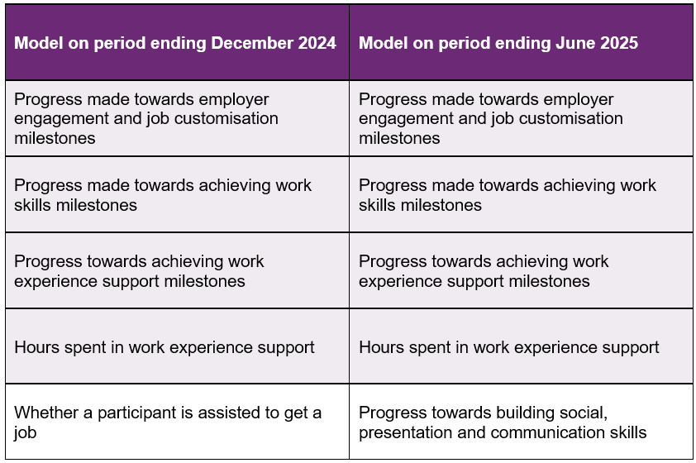

As shown above, the predictor “Whether a participant is assisted to get a job” was significant in the model covering the period ending December 2024 but no longer in the top 5 for the model covering the period ending June 2025. This predictor has been replaced by “Progress towards building social, presentation and communication skills” in the top 5.

The modelling insights from the period ending June 2025 data are based on 3,845 observations, which is more than the 3,186 observations used to model the period ending December 2024. These additional observations have led to a slight change in significant predictors although most have stayed the same.

Appendix

Appendix 1 – Methodology for the section titled “Progress towards milestones – cumulative for the year”
This Appendix provides more details on how to interpret the section titled “Progress towards milestones – cumulative for the year,” and the methodology used.
How to interpret the table below

Work experience milestone – percentage of participant progress
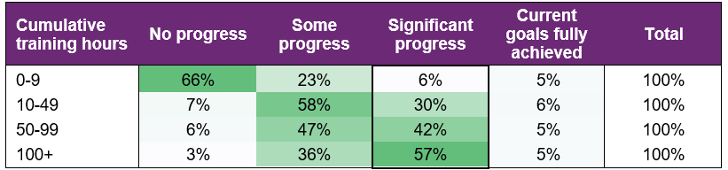

Out of all participants who have received 100+ hours of on-the-job work experience support (cumulative for the year)
- 3% have "No progress" as the best result for the year.
- 36% have "Some progress" as the best result for the year.
- 57% have "Significant progress" as the best result for the year.
- 5% have "Current goals fully achieved" as the best result for the year.
The sum of each row in the above table equals 100%.

Methodology (for cumulative training hours)
The starting universe is all participants reported in the Provider Reporting Tool across the 4 quarters. For each participant, the "cumulative training hours" is then calculated as the total of the milestone-specific training hours reported in the Provider Tool for the 4 quarters. The best progress for the specific milestone is used (of all progress entries reported in the Provider Reporting Tool across the 4 quarters).
For example, if for participant John Smith, below are the progresses and hours reported across the 4 quarters.
Work experience support (on the job)
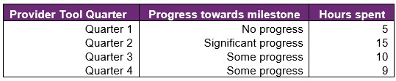
then "cumulative training hours" = 39 = 5 + 15 + 10 + 9 and the progress selected for John is "Significant progress" (the best progress of the 4 quarters). The "cumulative training hours" is then rounded down to the nearest whole number (e.g., 6.75 is rounded down to 6), and grouped into bands. Then for each cumulative training hours group (e.g., 0-9), the percentage of participants in each (best) progress category is calculated so that the sum of the row is 100%.

Appendix 2 – Model accuracy

The generalised linear model presented in Section 8 has the following accuracy:
Figure 42. Model accuracy – Gini and AUC
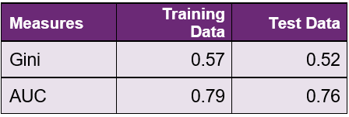
The closer the test set AUC and Gini is to 1, the better the model performance.
The Test Data AUC (and Gini) is typically lower than the Training Data AUC (and Gini). This is because the model was built on the Training Data, hence predicts more accurately on it. The Test Data Gini and AUC however, give an indication of the model prediction accuracy when the model predicts on unseen data (on which it was not built).
Figure 43. Model accuracy – receiver operating curve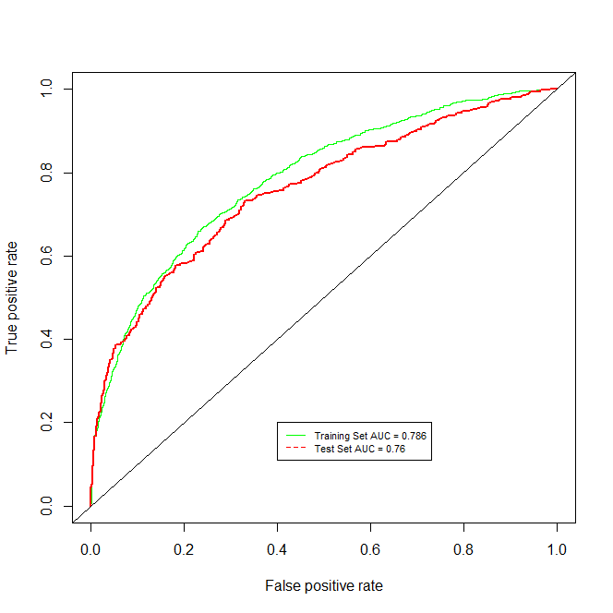

Figure 44. Model accuracy – actual versus predicted
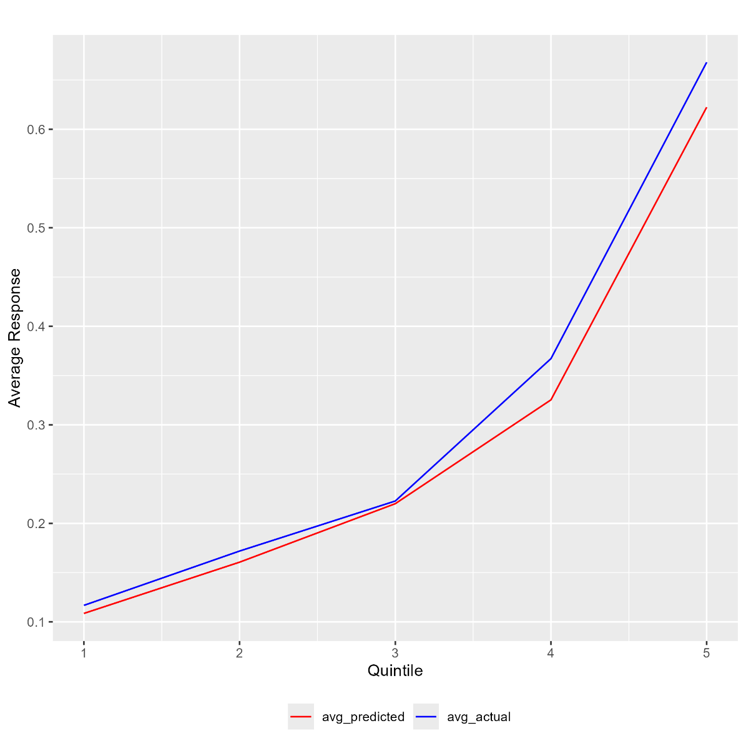

The model predicted probability (red) curve is close to the actual outcome (blue) curve, indicating that the model is able to accurately predict the probability of recipients finding paid employment.

Source: Australian Bureau of Statistics. For further information: Socio-Economic Indexes for Areas (SEIFA): Technical Paper, 2021 | Australian Bureau of Statistics (abs.gov.au) Link to the data: Socio-Economic Indexes for Areas (SEIFA), Australia, 2021 | Australian Bureau of Statistics (abs.gov.au) - Local Government Area, SA1 Distributions, SEIFA 2021.xlsx

