20 October 2025
Mr Kurt Fearnley AO
Chairman
National Disability Insurance Agency
GPO Box 700
CANBERRA ACT 2601

Dear Kurt,
JUNE 2025 FINANCIAL SUSTAINABILITY REPORT
I am writing as the Reviewing Actuary of the NDIS to summarise my review of the final draft of the 30 June 2025 Financial Sustainability Report (2025 FSR) provided on 17 October 2025. Subsection 180E(2) of the National Disability Insurance Scheme (NDIS) Act 2013 (the Act) requires that I review each FSR and report my findings to the Board. Subsection 180E(4) of the Act requires that I report any significant concerns about the sustainability of the NDIS to the Board as soon as is practical.

Review of the Financial Sustainability Report
Subsection 180B(1) of the Act requires the Scheme Actuary to prepare a FSR, at least annually. The FSR provides a projection of the Scheme expenses (the total amount spent by participants). Part 3 of the NDIS Rules for the Scheme Actuary sets out the required content of the FSR.
The Agency has provided me with the material required to undertake a review of the 2025 FSR. I have been provided with: [1] papers to the Sustainability Committee from the Scheme Actuary, setting out draft and final projection results; [2] the Original Cohort Model (OCM) used to derive the June 2025 projection, with the final version supplied on 26 August 2025; [3] a final draft of the 2025 FSR, supplied on 17 October 2025; [4] summarised Scheme experience that enables me to examine the reasonableness of some assumptions underpinning the June 2025 projection; [5] presentations prepared by the NDIA’s actuarial team, setting out key features of the experience and assumptions adopted; [6] the Plan Reassessment Model (PRM); and [7] the microsimulation model (MSM) and supporting spreadsheets. I have discussed these materials with members of the Agency’s actuarial team.
The projections included in this FSR allow for experience to moderate over time, largely a result of the expected impact of Scheme Reforms. This review considers whether the adjustments made to past experience are proportionate to the expected impacts of these reforms.
For this review, commentary on the short term refers to the four-year Budget period; the medium term refers to the balance of the ten-year projection presented in the FSR; the long term refers to the period beyond ten years. Graphs are constructed on a financial year basis, with, for example, 2025 representing the 2024-25 financial year.
My letter reviews the main judgments taken by the Scheme Actuary in the projections. I have not undertaken a full technical review of all of the models used. Spot checks have been carried out.

Context
The Scheme is undertaking a significant program of Scheme Reforms, aimed at improving the sustainability of the Scheme. These include:
- Reforms that impact the profile of new entrants. This includes improving evidence for children with developmental delay (from 1 October 2024) and an allowance for Foundational Supports (effective from 1 July 2026), which we understand will be updated to allow for the Thriving Kids program (announced in August 2025) when the design of that program is available;
- Operational measures and reforms aimed at reducing plan growth. This includes increasing planning consistency on reassessments, strengthening evidentiary standards for plan change requests, building staff capability to ensure a greater focus on Scheme sustainability, and the introduction from 1 July 2026 of New Framework Planning;
- Resourcing that will impact the numbers of people leaving the Scheme by processing the backlog of eligibility reassessments; and
- Reforms that will impact the rate at which participants utilise their plans. This includes the list of approved supports implemented in October 2024, the roll out of Funding Periods from May 2025, and the Scheme Integrity measures (of which Crack Down on Fraud (CDoF) is a part).
The reforms are in various stages of planning, design and implementation. The Scheme Actuary has allowed for these reforms based on the current understanding of the reform design. We note that design of the Thriving Kids program has not yet been completed and the scenario assumed for Foundational Supports does not reflect the expected design. Therefore, projections related to Foundational Supports are subject to a higher degree of uncertainty than other reforms and should be updated when the design of the Thriving Kids program is sufficiently certain.
The Agency implemented a new computer system (PACE) in late 2023. This resulted in lower numbers of new entrants in the second half 2023-24 and the first half of 2024-25. This is an outcome of changes to processes and operational disruption associated with the rollout of the new system rather than a real feature of the experience. In addition, as the Agency manages resources across a range of processes according to demand, the resources applied to process new entrants have not been consistent over time. The combined impacts of the new computer system and constraints on processing capacity have distorted the underlying experience of the Scheme and make interpretation of trends more difficult. The Scheme Actuary has adjusted new entrant data to inform new entrant assumptions; this is discussed later in this letter.

Models Used

Original Cohort Model
The 2025 FSR presents a ten-year projection of expected Scheme expenses. The projection has been developed in the Original Cohort Model (OCM). The OCM comprises an assumptions spreadsheet that is used by a SAS model to project the Scheme population and cash flows. These results are then formatted in spreadsheets. In reviewing earlier projections, we have verified the accuracy of the SAS model, relative to the original spreadsheet models. We have performed spot checks for consistency during this review.
The OCM projection methodology is broadly the same as that which was used for the 2024 FSR. Three key differences are:
- The FSR presents a single projection allowing for the expected impact of Scheme Reforms. The 2024 FSR provided projections both before (“initial June 2024”) and after (“final June 2024”) allowance for part of these reforms. Commentary in this letter on changes to projections generally refers to changes since the “final” 2024 FSR projection. Whilst it is not required, I believe that presenting a projection of the current trajectory of the Scheme and a projection after the effect of Scheme Reforms can assist understanding of the sustainability pressures faced by the Scheme;
- The age bands modelled for children have changed slightly, with the Scheme Actuary now modelling ages 0-8 years and 9-14 years (previously 0-6 years and 7-14 years). This change was made to align the modelled age bands more closely with operational changes for children. Aligning modelling with operational requirements in the Scheme can help monitor actual and expected experience in a more meaningful manner; and
- The approach taken in this review was to model average committed supports (i.e. participant plans) and utilisation rates (i.e. payments as a percentage of committed supports) separately, with the combination of these two metrics result in average payments per participant (previously the Scheme Actuary modelled average payments per participant directly). This change was made to enable more explicit modelling of the impacts of plan inflation and utilisation, and a better understanding of the projected committed supports and utilisation separately. I support this change.

Plan Reassessment Model
The Plan Reassessment Model (PRM) is a new model developed by the Agency in 2024-25. It is being used in the FSR for the first time this year.
The PRM projects resourcing levels for Agency activities, in particular plan reassessment processes (i.e. volume and inflation outcomes by type of plan reassessment, including new entrants), by month, for two years. The PRM provides some additional detail compared to the OCM. However, it does not model participant demographics; participants are modelled as a single group rather than by disability type, level of function, age, etc.
The PRM is not yet mature. As such, I have not been able to fully review this model in the time available. Whilst I have not checked the detail of this model, I note that the participant numbers (including assumed numbers of new entrants and exits) are consistent with those in the OCM.

Interaction between the OCM and PRM
There are complex interdependencies between the OCM and the PRM:
- New entrants and exits are modelled in the OCM, and the PRM is calibrated to achieve the same numbers of participant movements;
- Average committed supports for new entrants and exits in the PRM are based on the starting average committed supports in the OCM;
- Plan inflation and utilisation are modelled in the PRM, including the expected impacts of Scheme Reforms.
For the 2025 FSR, the Scheme Actuary has adopted the projected payments from the PRM for the 2025-26 and 2026-27 projection years. This is based on the view that the resourcing levels and plan reassessment processes that are modelled in the PRM are more important drivers of cost than demographics in these years. This is achieved by calibrating the OCM model such that it produces the same total payments as the PRM for these two projection years.
For 2027-28 and later years, the Scheme Actuary has adopted projected payments from the OCM, as demographic changes become increasingly important drivers of cost. Importantly, the plan growth assumptions used in the OCM for these projection years are based on the plan growth assumption implied by the PRM model.
While I commend the development of the PRM, the immaturity of the model combined with the interdependencies and calibrations with the OCM add complexity to the projections. Model proliferation, whilst necessary at this time due to limitations of the OCM, raises risks in the actuarial process that will need to be addressed at some point. More flexible models, perhaps projecting participants individually, may need to be considered as a way of consolidating projection tools.

Microsimulation Model
The Scheme Actuary has been developing the microsimulation model (MSM) over the last two years. This model simulates the pathways of current and future NDIS participants at an individual level, modelling the evolution of participant attributes and payments. The MSM provides a complimentary forecast. It has not been relied on for the 2025 FSR.
I am reviewing the MSM and will provide this advice to the Scheme Actuary. I regard the ongoing enhancement and use of the MSM as a healthy development to the actuarial management of the Scheme. I encourage the Scheme Actuary to continue the development of the MSM as it can provide contrasting insights into the Scheme experience compared with the OCM.

Projection of Scheme expenses

Comment on key population assumptions

Starting population
The starting population is the actual Scheme population on 30 June 2025. The starting population of 739,414 is 2.5% (17,830) higher than the population that was expected in the June 2024 FSR.

Impacts of PACE/Processing Capacity
For this FSR, the Scheme Actuary has taken into account the numbers of participants at various touchpoints in the process of being either admitted to the Scheme or leaving the Scheme. Virtual “queues” of participants have formed over the last two years due to the impacts of the new PACE system and processing constraints:
- After an applicant to the Scheme has submitted their application, their access request needs to be validated. At June 2024, there were around 22,000 access requests awaiting validation, much higher than the usual level. This large queue was cleared over the latter half of 2024 and on 31 May 2025 there were 1,600 people in this queue.
- Once an access request has been validated, a decision as to whether the person is eligible for the Scheme needs to be made. Over the latter half of 2024, the number of requests awaiting an access decision grew to around 23,000 people (as the access request validation queue was processed). Over the first half of 2025, this large queue was cleared and on 31 May 2025 there were around 2,000 people in this queue.
- In 2024-25, 83% of non-mortality exits (participants leaving the Scheme) were due to Agency-initiated eligibility reassessments. There have also been processing capacity constraints around the number of eligibility reassessments that have been able to be undertaken (as resources have been diverted to processing access requests). At the end of June 2025, there were 43,500 participants due for an eligibility reassessment.
These processing impacts have resulted in distortions in the natural flow of new entrants into the Scheme and of participants leaving the Scheme.
The Scheme Actuary has considered the impact on historical new entrant numbers by adjusting the period in which new entrants would have joined, had processing constraints not existed, and using these adjusted numbers to inform assumptions for future new entrants. These adjusted numbers are termed ‘remediated’ new entrants and estimate the underlying trend in new entrants if not for the new computer system and processing capacity constraints. The remediated figures shift new entrants from the 2024-25 year to the 2023-24 year, with the shift linked to the timing of when new access requests were made. I regard these data adjustments as appropriate.

New entrants
Figure 1 shows the actual number of new entrants, and remediated numbers for the two most recent financial years. Attachment A shows the same information broken down by age and by disability type.
Given the disruptions to the usual pattern of new entrants joining the Scheme, combined with expected future changes in experience due to NDIS initiatives, setting new entrant assumptions is more uncertain than in previous projections.
Figure 1: Actual & projected total number of new entrants
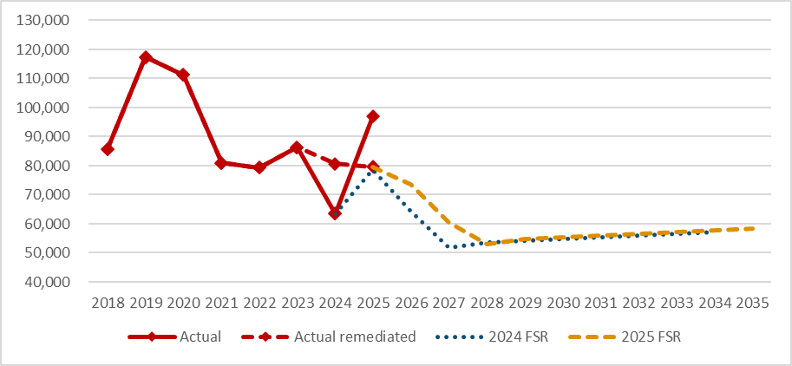
End of Figure
New entrant assumptions have primarily been set having regard to the remediated data over the period November 2023 to October 2024, by disability type. The exceptions to this are for applicants with developmental delay and autism where:
- Short term adjustments have been made to allow for declining numbers of new entrants with a previously unmet need (PUN). These are participants who would have entered the Scheme earlier had they been able to request access and provide evidence about their disability. The assumed reduction is the same as was used in the 2024 FSR. By contrast, the number of new entrants with autism has increased in each of the last four years (based on adjusted data from the Scheme Actuary). Considerable uncertainty remains around the long-term level of autism in the population requiring support.
- Tighter evidence requirements for access to the Scheme for developmental delay were introduced in October 2024. It has been assumed that this will result a 10% reduction in the rate of new entrants with developmental delay. This is lower than the reduction assumed in the 2024 FSR, which was 15%. This assumption is supported by the limited experience so far.
- Reductions were also made to allow for diversions away from the Scheme after the establishment of Foundational Supports, changing the way supports are provided to children, commencing 1 July 2026 (noting this commencement date is one year later than assumed in the 2024 FSR). This change is expected to reduce the number of children with developmental delay entering the Scheme. Diversions away from the Scheme are assumed to be 50% effective in the first year of operation. Allowance is also made for delayed entry into the Scheme. Participants who (if not for Foundational Supports) would have joined the Scheme and been expected to transition to a higher cost cohort later, are assumed have a delayed entry into the Scheme into these higher cost cohorts at their expected point of transition.
These three factors are the reasons why new entrants are assumed to decline over 2025-26, 2026-27 and 2027-28, before increasing with population growth.
The 2024 FSR incorporated a PUN allowance for all disability types. This has been removed in this FSR (other than for applicants with developmental delay and autism) as the remediated new entrant numbers suggest that new entrant rates may have reached the assumed long-term level. Assumptions that the number of new entrants with previously unmet needs will reduce have exhibited material levels of uncertainty in the past. I support of the removal of this assumption.
Given that the design of the Thriving Kids program is still in its early stages, the assumptions around the reduction in children entering the Scheme are the same as those adopted in the 2024 FSR for Foundational Supports, delayed one year to reflect the delayed start date.
Uncertainty in this year’s new entrant assumptions is primarily in the assumed numbers of participants with developmental delay and autism, particularly the moderation in the number of new entrants with a PUN and the impact of the Thriving Kids program.

Leaving the Scheme
The projection assumes a proportion of participants will leave the Scheme to live independently. Attachment B compares recent and projected experience.
Processing capacity has impacted on the ability to undertake eligibility reassessments in a timely manner. For this FSR, the Scheme Actuary has again modelled the number of exits arising from eligibility reassessments in line with the expected resourcing of this activity, noting that allowance has been made for less than maximum capacity on the expectation that some resources may be diverted to processing access requests.
It is assumed that 45% of eligibility reassessments will result in access revocation, based on recent experience. While this is appropriate, we note that recent experience includes a large backlog component. As a result, the profile of plans undertaking eligibility reassessment may change as the backlog is cleared. Whether adopting 45% after the backlog has been cleared (2028-29 and later years) is appropriate will need to be monitored.
Figure 2 shows the actual and projected number of non-mortality exits.
Figure 2: Actual & projected total number of exits
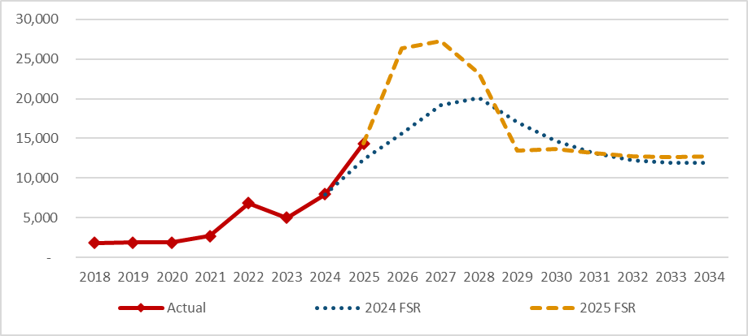
End of Figure
In the 2025 FSR, exits are assumed to increase substantially from 2024-25 levels (14,600 exits) in each of the next three years (between 23,200 and 27,300 exits per year) as the backlog of eligibility reassessments are processed. The backlog is assumed to be cleared by the end of 2027-28, after which exits are assumed to revert to long term levels.
Uncertainty in this year’s exit assumptions is primarily related to the availability of resources to process eligibility reassessments and the assumed proportion that will leave the Scheme. With the large number of projected exits in the next three years, continued monitoring of progress against these assumptions is important, with either resources adjusted to meet expectations, or assumptions adjusted, as appropriate.

Deaths
The projection assumes that a proportion of participants that will die. Attachment B compares recent and projected experience. This shows that, overall, the rate of exits due to mortality was close to that which was expected in the 2024 FSR (6,131 actual deaths compared with 6,005 expected). However, the number of deaths for participants with higher support needs was considerably higher than expected. This is a feature we have observed for a few years now. The 2025 FSR has increased the mortality assumptions for participants with higher support needs. I agree with this change.

Supported Independent Living population projection
Participants receiving SIL account for around one third of Scheme outlays, despite comprising only 5% of participants. Small changes in the SIL population can have a material impact on costs.
The number of participants with SIL supports grew by 5.2% in the year to 30 June 2025. This was 2.3% below what was expected in the 2024 FSR and is a result of both:

- Fewer participants transitioning into SIL than expected. While fewer participants transitioned to SIL than expected in 2024-25, the expected number was a sizeable reduction on the 2023-24 actual transitions, and the overall trend in SIL transitions was broadly in line with expectations. As a result, the rate of SIL transitions is unchanged from the 2024 FSR assumptions. I concur with this approach but note the dependency on uncertain future moderation in the net intake (discussed further below).
- Higher than expected numbers of participants with SIL supports leaving the Scheme. Mortality is the main cause of exit for participants with SIL supports. SIL mortality rates have been increased. This has been discussed above.
Figure 3 shows that the net intake to SIL has moderated over the last three years and is expected to further moderate in 2026-27. The higher mortality rates assumed for participants with higher support needs results in a lower projected SIL net intake, compared to the 2024 FSR.
Figure 3: Projected SIL net intake
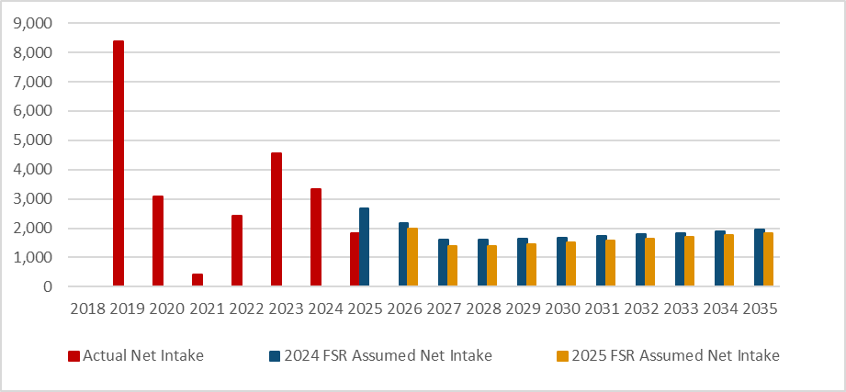
End of Figure
As the projected SIL net intake is lower than in the 2024 FSR, the projected SIL population is also lower in the 2025 FSR compared with the 2024 FSR. This is shown in Figure 4.

Figure 4: Projected SIL population
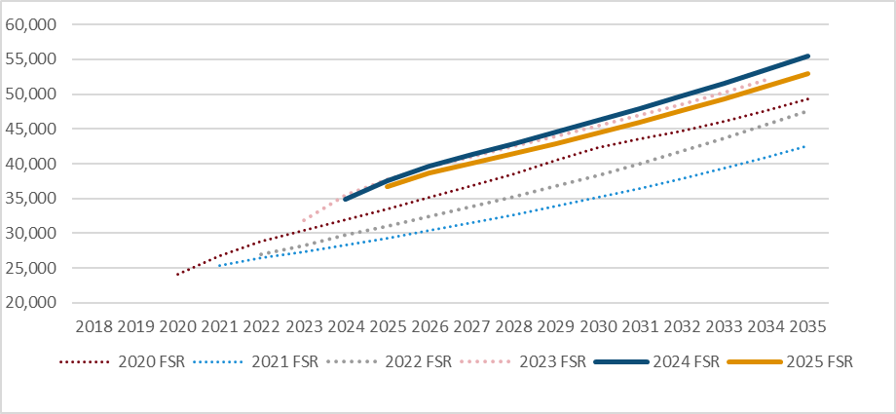
End of Figure

Comment on the total NDIS population projection
Figure 5 shows the projected number of participants in successive FSR projections. The 2025 FSR is projecting 2.1% higher numbers of participants on 30 June 2026 than the 2024 FSR. Participant numbers are projected to be 1.8% higher on 30 June 2029.
Figure 5: Actual & projected number of participants at 30 June
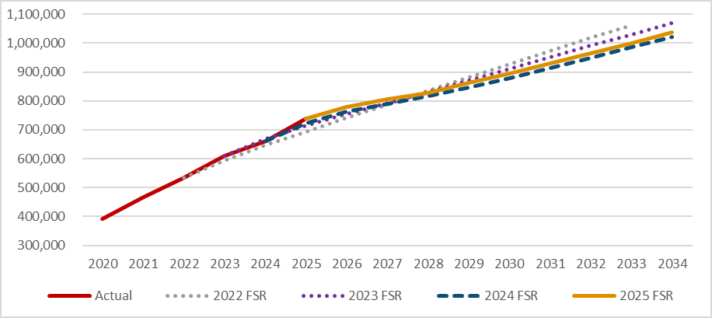
End of Figure
Figure 6 shows the recent and projected participation rates.
Figure 6: Projected participation rate
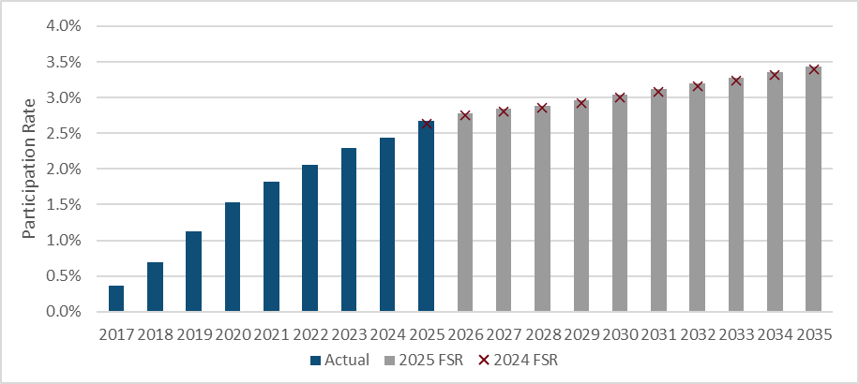
Note: Participation rate = NDIS participants expressed as a percentage of the Australian population
End of Figure
I have previously pointed to greater uncertainty where projection assumptions were assumed to moderate over time as the Scheme matured and that moderation was not supported by any change in the Scheme. For this FSR, the assumed moderation in experience is supported by numerous Scheme Reforms that are either in place already or are expected to be in place in the short term. While these Scheme Reforms increase the level of confidence that the experience will moderate, the quantum of this moderation is highly uncertain given the limited experience on which assumptions can be based.
The modelling and monitoring of each Scheme Reform is at a different level of maturity, depending on when the reform commenced. It is recommended the modelling and monitoring continue to be developed and extended across all reforms at the appropriate time. Monitoring should be used to check progress and either adjust the resourcing, or adjust the projection assumptions, accordingly. This will help to manage uncertainty.
Key areas of uncertainty in the population projection are:
- Assumptions regarding the rate at which new entrants with developmental delay and autism will moderate, including, but not limited to, the timing and impact of diversions from the Scheme to Foundational Supports/Thriving Kids program.
- Assumptions regarding participants leaving the Scheme, which are dependent on resourcing to undertake eligibility reassessments; and
- Assuming the net increase in SIL participants will moderate over the next two years.
Noting the above uncertainty, my view is that this projection provides a reasonable scenario of the projected population. To reach this conclusion it is critical that the scope, timing and effectiveness of the program of Scheme Reforms occurs as has been assumed. This underlines the importance of extending the modelling and monitoring of each reform, particularly in areas where experience is assumed to moderate.

Comment on key participant spend assumptions

Committed supports
The starting committed supports used in the 2025 FSR projection are, in aggregate, the 2024-25 projected ultimate committed supports (taken from the Participant Plan Provision valuation). The assumed “shape” of committed supports by participant cohort is the same as the actual committed supports in April 2025. Committed supports are then increased in each future year and spent at the assumed rate of utilisation. These two factors are discussed below, with additional discussion in Attachment C.

Future Growth in Committed Supports
Future committed supports are increased to allow for normal plan inflation, modelled transitions (including ageing), additional growth in plans beyond these factors, and the impact of Scheme Reforms. Modelled transitions and ageing are examined as part of the population projection and are not considered further in this section. Normal inflation plus additional growth is termed Growth in Committed Supports. As Growth in Committed Supports compound year-on-year, projection results are increasingly sensitive to these assumptions with each projection year.
As noted above, Growth in Committed Supports is modelled in two parts. The first is normal plan inflation, which reflects increases in prices and wages. The projection includes normal inflation assumptions that vary by payment type; the overall Scheme-wide assumptions adopted are shown in Attachment C. The second component is additional Scheme-specific plan growth. The projection assumes additional plan growth that is uniform across all payment types. Assumptions quoted in this letter are averages and are provided to assist the reader understand the trends in the projection.
Figure 7 shows historical and assumed future Growth in Committed Supports for the Scheme as a whole and for SIL and non-SIL participants. Growth in Committed Supports has exceeded 10% for each of the last three years. Growth in Committed Supports for SIL participants has been consistently lower than for non-SIL participants. Growth in Committed Supports is assumed to moderate in 2025-26 to 5.6%. This is attributable to the Agency’s Sustainability Initiative (see Attachment C). It is assumed to further moderate in 2026-27 to 3.3% and to be 3.6% per annum thereafter, attributable to New Framework Planning, expected to commence on 1 July 2026. We note that Growth in Committed Supports for 2026-27 is assumed to be lower than normal inflation (3.5% per annum), implying negative additional plan growth for this year.
There is no experience upon which to base the assumptions regarding the impact of these reforms. Further, New Framework Planning is still subject to co-design. The reasonableness of this projection will depend on these reforms being implemented in the time frame, and with the effect, that is assumed. In this situation, the Board should seek to enhance the monitoring of the progress towards the key assumptions that underpin the expected outcomes in each reform. I note that monitoring of some Scheme Reforms has commenced, and reporting is expected to mature.
Figure 7: Growth in Committed Supports (normal inflation and additional plan growth)
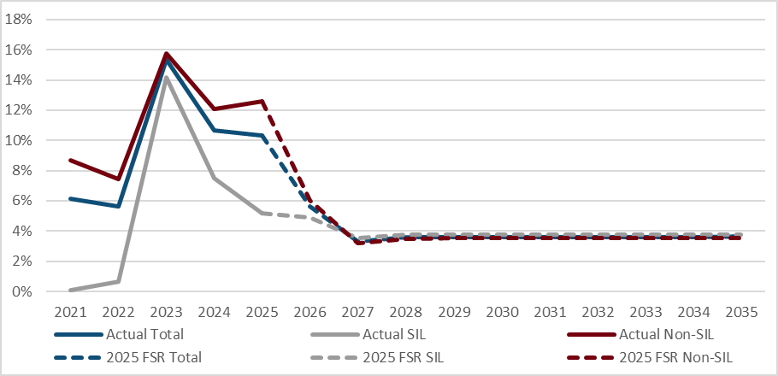
End of Figure
The projected average committed supports for the Scheme as a whole, for SIL and for non-SIL participants are shown in Figure 8. SIL average committed supports are shown against the right axis.
Figure 8: Average Committed Supports
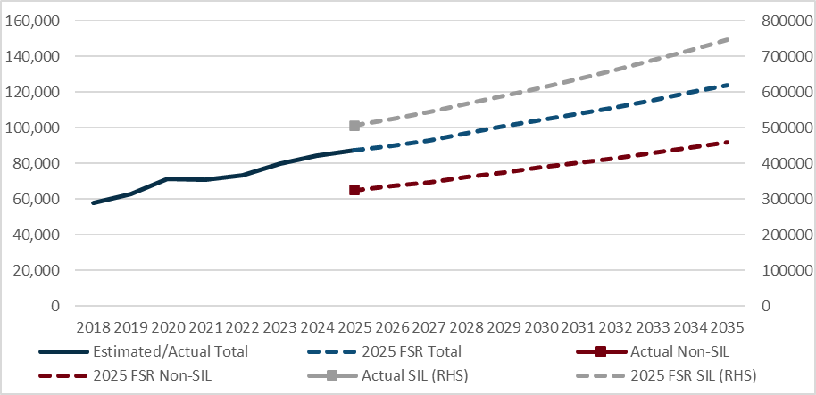
End of Figure

Utilisation
Utilisation is defined as payments (on an accrual basis) divided by committed supports. The starting utilisation used in the 2025 FSR projection is the 2024-25 utilisation, with the 2024-25 utilisation rate adopted for each cohort.
Future utilisation rates are assumed to moderate because of integrity measures that reduce fraudulent and unauthorised payments. The introduction of funding periods is assumed to further reduce utilisation, by reducing the capacity of participants to over-spend. These moderating impacts are assumed to be partially offset in the medium term (in a small manner) by behavioural factors arising from lower plan inflation and flexible budgets (i.e. participants can more easily switch budgets from one support to another if one budget is exhausted).
As for the assumptions regarding changes in plan growth, the reasonableness of this projection will depend on these reforms being implemented in the time frame, and with the effect that is assumed. They will also depend on behavioural change remaining negligible. Enhancing the monitoring of progress towards key assumptions is also recommended for these initiatives and reforms.
Actual and projected utilisation for the Scheme as a whole, and for SIL and non-SIL participants, is shown in Figure 9.
Figure 9: Utilisation
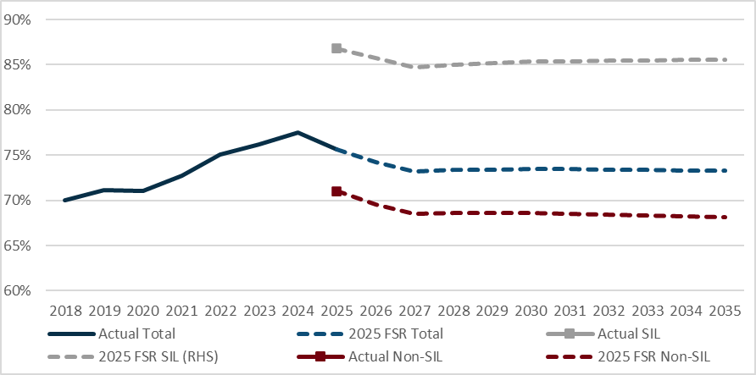
End of Figure
Utilisation for SIL participants is projected to be 16.3% higher than for non-SIL participants in 2025-26. This differential is projected to increase slightly over the projection to 17.4% in 2034-35.
In the medium term, utilisation is assumed to remain reasonably flat after 2028.

Summary of participant spend assumptions
Figure 10 summarises the trend in committed supports and utilisation (both historical and projected).
Growth in average committed supports is projected to reduce from 10.3% in 2024-25 to 5.6% in 2025-26, with additional growth in plans reducing from 8.3% to 2.5% over the same timeframe. The main mechanism for achieving this significant reduction in additional growth is through the Sustainability Initiative, particularly a slower growth in committed supports for unscheduled reassessments.
The average growth in committed supports is expected to be 3.6% per annum over the medium term. This is only marginally higher than the assumed level of normal inflation of 3.5% per annum i.e. close to nil additional plan growth. I understand that the Scheme Actuary is relying on the ongoing effectiveness of New Framework Planning to achieve this low level of additional growth. There is a risk that will not be achievable in the medium term.
Figure 10: Actual and projected committed supports, utilisation and average spend
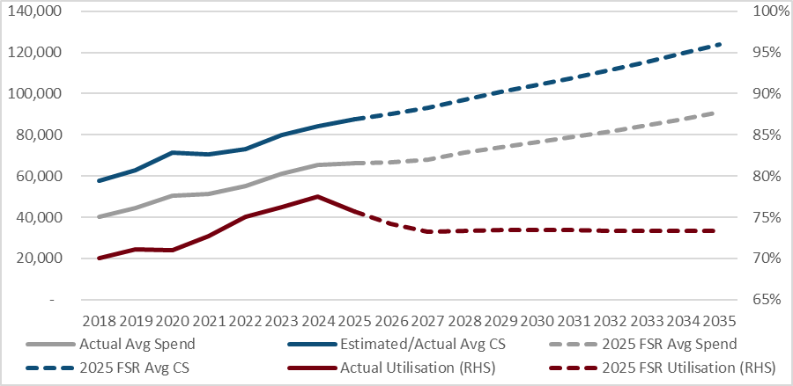
End of Figure
Average utilisation steadily increased from 2017-18 until 2023-24 and then fell a little in 2024-25. I have been advised that the drop in 2024-25 is attributable to the introduction of the list of approved supports (Section 10) and the CrackDown on Fraud initiative. This projection expects that utilisation will reduce by 1.4% and 1.0% over the next two years, from 75.7% in 2024-25 to 73.2% in 2026-27. Average utilisation is then expected to remain flat over the medium term. There is a risk that this does not happen as it contrasts with the experience of the Scheme.

2025 FSR projection
Figure 11 shows that the resulting 2025 FSR projection (solid black line) is marginally lower than the 2024 FSR.
Figure 11: Actual & projected total participant spend
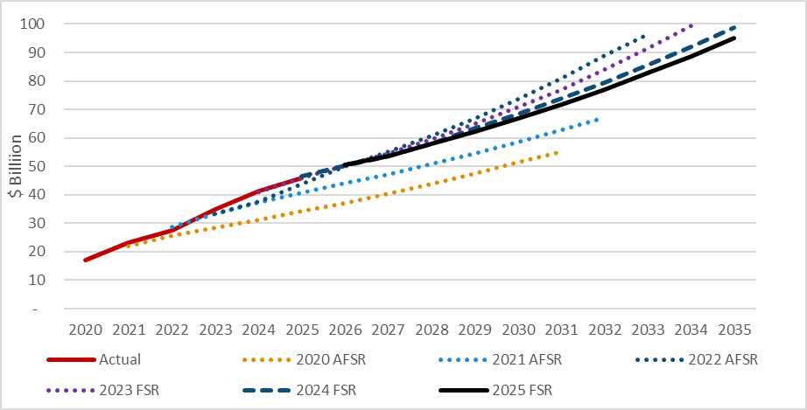
End of Figure

Sustainability
The 2025 FSR projection allows for the recent experience of the Scheme, adjusted for the expected impact of Scheme Reforms. The Scheme Reforms assume that plan growth will reduce from 2025-26, plan utilisation will reduce over the next two years, the number of new children joining the Scheme with developmental delay or autism will reduce from 2025-26, and the number of participants exiting the Scheme will increase over the next three years as eligibility reassessments are resourced.
Planning and design of most of the reforms is still progressing. It is therefore best to interpret the 2025 FSR projection as one scenario by which the Scheme’s rate of growth may slow.
The impact on projected Scheme expenditure is set out in Figure 11 above.
- In the short-term, the growth rate is expected to slow to levels that are below 8% per annum. For this to occur, the reforms must be implemented within the time frame, and have the effect, that is assumed. This is a complex reform program and detailed analysis of the impact of all initiatives has not been completed. Assumptions relating to the timing of Foundational Supports and New Framework Planning have been updated, but there is insufficient additional information available to further inform the expected impact of these reforms since the last FSR. Considerable uncertainty in the projection remains.
- In the medium-term, growth is assumed to be around 7.4% per annum. This requires a sustained reduction in the number of children entering the Scheme, sustained low growth in committed supports (excluding growth due to transitions and ageing) of around 3.5% per annum (i.e. negligible additional growth in plans), and plan utilisation to remain flat at around 73%. There is a risk that a combination of low plan increases, greater flexibility in how participants may spend their plan, and associated behavioural change, may see utilisation increase in the medium term.
Subject to resourcing and effective implementation, the planned reforms are expected to reduce the Scheme’s rate of growth in the short term and the modelling has focussed on that timeframe. Given the demographic momentum in a relatively young scheme, it is recommended the Scheme Actuary continue to enhance the modelling of these reforms to consider the longer-term implications for the Scheme. Medium term sustainability pressures may remain on the Scheme as the population ages.
Given the higher level of uncertainty associated with any reform, it is recommended the Scheme Actuary continue to develop the models that estimate the impacts of the reforms and regularly monitor progress against experience.
Focusing on the annual growth target for NDIS participant expenses of no more than 8% by 1 July 2026 risks focusing too heavily on the short term. As I have noted in previous letters, a growth rate that persists above the rate of nominal growth in GDP creates an increasing call on the Budget, which itself can bring risks to the sustainability of the Scheme. I note the Minister for Disability and the NDIS has indicated that growth of 5% to 6% is preferable. Growth at this level would be closer to expected long term GDP growth and is therefore less likely to present sustainability pressure. Further reforms to the Scheme would be needed to achieve a growth rate of 5% to 6%.
Discussion of Scheme sustainability in the context of Scheme Reforms and targeted growth rates may be interpreted as focussing solely on aggregate Scheme expenditure. While Scheme expenditure is clearly a key element to ensuring sustainability, it is timely to remind ourselves that the NDIS Rules requires that the FSR also report on participant outcomes. This means that the sustainability of the Scheme is supported by both the quantity and quality of the Scheme expenditure. A maturing microsimulation model (MSM), implementation of the National Disability Data Asset and further development of the Investment Effectiveness Program may all increase the Scheme’s capacity to identify and encourage a growing proportion of Scheme expenditure that delivers improved outcomes. Utilising these tools, I believe the FSR will be able to increase its focus on participant outcomes over time.
This projection does not include the costs of the Foundational Supports/Thriving Kids program that will be provided in future. It is envisaged that these costs are separate to the NDIS. Whilst this is appropriate for this FSR, broader financial sustainability pressures may arise from the costs of all supports that are provided. Further, the use of linked data sets to better inform future participation in the Scheme (transitions from the Foundational Supports/Thriving Kids program) are likely to be required.

Operating Expenses
The FSR discusses the Scheme’s operating expenses. As there is no projection of expenses, I have not undertaken a review of any operating expense models.
The Scheme Actuary draws attention to the reduction in operating expenses embedded in the 2025-26 Budget. As I have noted earlier in this letter, for the projected Scheme expenses to occur, the operational activity expected by the assumptions, including the implementation of Scheme Reforms, needs to occur with the effect that is assumed. This activity includes eligibility assessments, re-assessments, and plan reviews. If the activity does not occur at the level assumed, then it is reasonable to expect that the projected Scheme expenses will also differ and will likely be higher than shown. The Scheme Actuary has made the same point in the FSR.

Uncertainty
Future experience will differ from, and may exceed, that which has been projected. Uncertainty in the projection is, in part, demonstrated by variations in successive projections in recent years.
Key areas of risk in this projection include assumptions of low rates of additional plan growth, the design of Foundational Supports/Thriving Kids and its impact on new entrants, whether utilisation will remain flat throughout the medium term, and the resourcing of eligibility reassessments that result in the assumed increased rates of exit. As the impacts of many of the Scheme Reforms are yet to emerge in the data, and in line with recommendations in the 2024 FSR, a report to monitor the implementation of these initiatives has commenced.
I believe there is additional uncertainty in the projection of participants aged 65 and over. This group is modelled as a single cohort. This cohort has exhibited on of the highest rates of growth in average spend per participant (10.8% increase in the 6 months to June 25 over the 6 months to June 24). Equivalent rates in the prior three years were all higher. The growth in the average spend is projected to reduce to below 4% in each of the projection years. It is not clear that modelling this group as a single cohort enables the Scheme Actuary to capture all the effects of ageing in the Scheme.
The effect of uncertainty is illustrated in sensitivity tests in Section 6 of the FSR.

Conclusion
The Scheme Actuary has selected assumptions based on the Scheme’s experience. These are then modified to allow for Scheme Reforms. The modifications are not trivial. The June 2025 FSR assumes that new entrants, additional plan growth and utilisation will moderate and that exits will increase. These assumptions are supported by a program of Scheme Reforms.
Modelling of the Scheme Reforms brings additional uncertainty to this projection. This is because:
- most of the reforms have either only just commenced or are yet to commence. Further, some reforms are still being designed. This means there is little to no Scheme experience to support the expected impact of the reforms at this time;
- little allowance has been made in the projections for potential behavioural change of Scheme participants, with the most likely possibility being that downward pressure on plans results in higher plan utilisation than what is assumed in the projections. This could mean that the reforms do not have the effect that is assumed.
To manage this, the Scheme Actuary has commenced a process of monitoring the drivers of the emerging experience against that which is expected. Enhancing the monitoring of resources and productivity against the projection assumptions is an increasingly important addition to the actuarial management of the Scheme. This should be extended across all reforms.
If the Reforms are implemented in the timeframe and with the effect that is assumed (noting the uncertainties surrounding any projection), I would be satisfied that the projection, taken as a whole, provides a reasonable scenario of projected expenditure. However, the scenario assumed for Foundational Supports no longer reflects the expected design and the projection should be updated when the design of the Thriving Kids program is sufficiently certain.
Sustainability pressures are expected to persist in the Scheme whilst growth remains materially above the GDP growth rate. The Scheme Actuary has noted that further reforms will be required to meet this level of growth. I encourage the Scheme Actuary to extend the projections beyond the medium term to help stakeholders understand the impact of longer-term demographic forces within the population.
A proliferation of models is occurring over time. I encourage the Scheme Actuary to review the role of, and functionality required from, each model. He could then develop a program to optimise the number of models, and in turn manage risk in the actuarial process. This is consistent with Recommendation Two in the 2025 FSR.
Yours sincerely

Guy Thorburn
Australian Government Actuary

Attachment A: Distribution of new entrants

Distribution by age
With the change made to the age band groupings for this Projection, we do not have an historical time series of the new 0 to 8 years and 9 to 14 years age bands. As such, we have shown the experience for ages 0 to 14 years combined.

Actual and expected experience
Figure 12 sets out the actual number of new entrants by age (remediated figures for 2023-24 and 2024-25), and those projected in both the 2024 FSR and the 2025 FSR projections.
Figure 12: Actual and projected new entrants by age
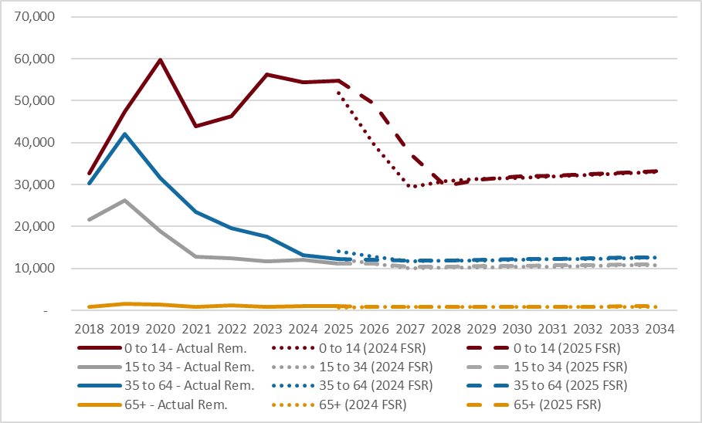
End of Figure

New entrants, ages 0-14
The remediated number of new entrants aged 0-14 in 2024-25 was a little higher (6%) than the number projected in the 2024 FSR. The 2024 FSR expected new entrants aged 0-14 to then reduce over the next two years before increasing gradually with population growth. The sharp decline was attributed to clearing the backlog of access requests (i.e. a timing effect), an expected reduced incidence of children on the Scheme because of tightened evidence requirements, and diversions from the Scheme due to the implementation of Foundational Supports.
In the 2025 FSR, new entrant numbers are assumed to be higher in 2025-26 and 2026-27 than in the 2024 FSR, before returning to levels comparable with the 2024 FSR from 2027-28. The higher assumed numbers of new entrants in 2025-26 and 2026-27 reflects the delayed implementation of Foundational Supports.
The projection has not been updated for any changes in scope that may arise in the design of the Thriving Kids program. Given the Thriving Kids program is still being designed, this is not unreasonable. I expect that the modelling (and monitoring) of the impact of the Thriving Kids program will develop throughout the design phase. The projection in this report should then be updated.
Uncertainty in the underlying rate of child new entrants is currently elevated due to the uncertain impact and timing of the Scheme Reforms that effect children joining the Scheme.

New entrants, ages 15-34 and 35-64
The remediated number of new entrants in 2024-25 in each of these age groups was lower than assumed in the 2024 FSR (9% lower for those aged 15-34 and 12% lower for those aged 35-64). Numbers are assumed to decline further over the next two years, before increasing with population growth. The decline in the projection over 2025-26 and 2026-27 is attributed to declining numbers of new entrants with a PUN, specifically new entrants with autism.

New entrants, age 65+
The projected number of new entrants aged 65 and over is small and is similar to the previous projection.

Distribution by disability
Figure 13 sets out actual number of new entrants by disability (remediated figures for 2023-24 and 2024-25), and those projected in both the 2024 FSR and the 2025 FSR projections.
Figure 13: Actual and projected number of new entrants for major disability types
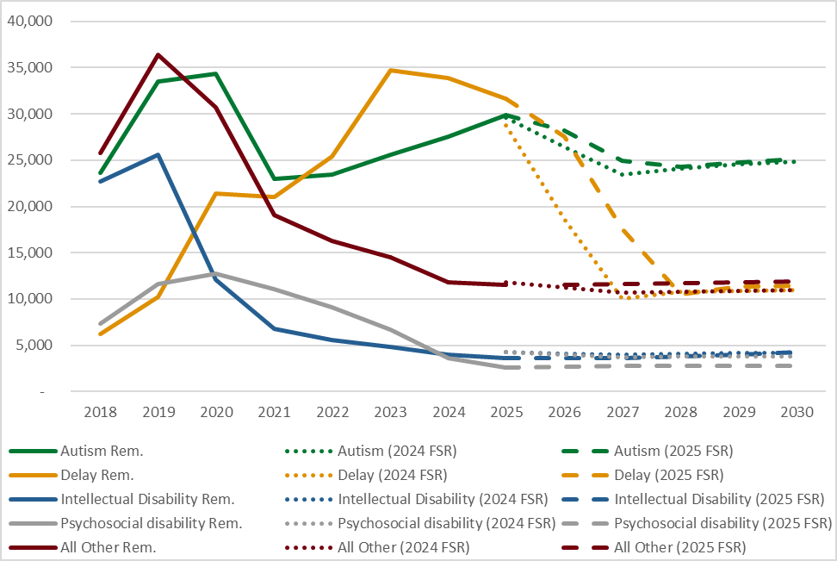
End of Figure

Figure 13 shows that the remediated number of new entrants in 2024-25 were higher than expected for those with developmental delay (+10%), but considerably lower than expected for those with intellectual and psychosocial disability (-15% and -41% respectively). The Scheme Actuary has reflected this experience in the assumed new entrant rates in the 2025 FSR, as well as allowing for the delayed implementation of Foundational Supports (impacting new entrants with autism and developmental delay).

Attachment B: Mode of departure

Leaving the Scheme
Participants can leave the Scheme for reasons other than mortality. Figure 14 compares recent rates of leaving the Scheme with recent projections.
Figure 14: Actual and projected crude rate of leaving (for reasons other than death)
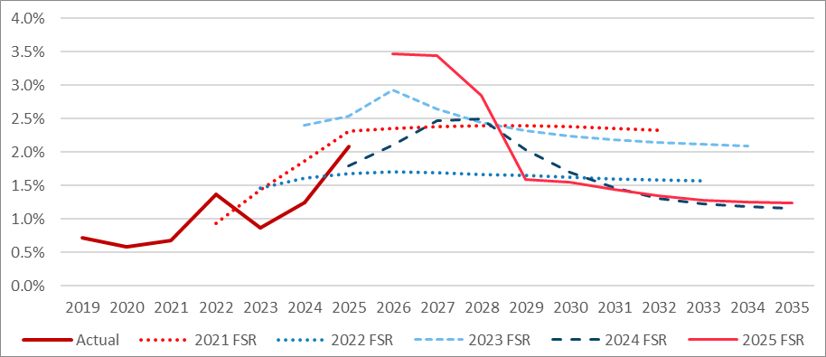
End of Figure
The rate of exit increased between 2023 and 2025. The expected increase in the rate of exit is supported by the Scheme Actuary’s assessment of the Agency’s planned resourcing and a significant backlog of plans due for an eligibility reassessment. This provides a basis against which progress can be tracked.

Mortality
Participants may also cease to participate in the Scheme due to their death. The actual number of deaths in 2024-25 was 6,131. This is close to the expected number of 6,005 projected in the 2024 FSR.
Figure 15 compares the recent crude mortality rate for the Scheme to recent projections. Historical experience will exhibit significant volatility in a population of this size. I also note that the COVID-19 pandemic has resulted in higher than usual levels of mortality in Australia in 2021-22 and 2022-23 in particular.
Mortality assumptions are set by age, disability type, level of function and SIL status. Assumptions for non-SIL participants have not changed from those adopted in the 2024 FSR.
Figure 15: Actual and projected crude mortality exit rate
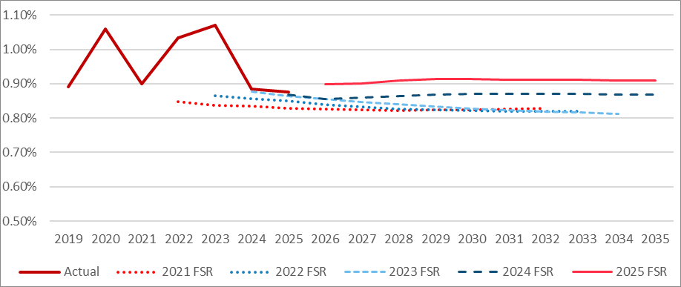
End of Figure
Whilst the total number of deaths in the Scheme is relatively small, the distribution of deaths is important. For example, very few participants with the highest support needs leave the Scheme for reasons other than mortality. As a result, the mortality rates of participants with higher support needs have a material impact on projected expenses. This can be seen by examining the experience of Scheme Participants receiving SIL as this cohort naturally includes a higher proportion of participants with higher support needs. Figure 16 shows that expected mortality rates for SIL (as represented by the 2024 FSR) have been below the recent experience of the Scheme. The Scheme Actuary has increased the mortality assumptions for participants with higher support needs in the 2025 FSR. I support this change.
Figure 16: Actual and projected crude mortality rate for SIL participants
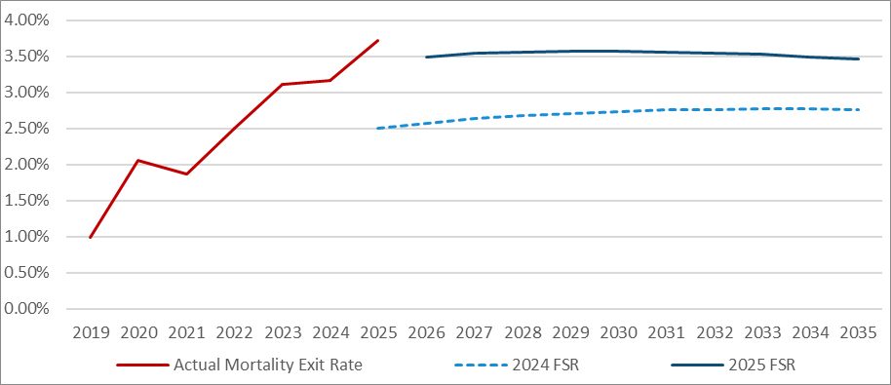
End of Figure

Attachment C: Participant spend
This year, the process for determining the participant spend commences with the current committed supports. Future committed supports are increased to allow for normal economic inflation, modelled transitions and ageing in the Scheme, additional growth in plans beyond these factors and the impact of Scheme Reforms. Committed supports are then multiplied by utilisation rates to determine the participant spend on an accrual basis.
Modelled transitions and ageing in the Scheme are examined as part of the population projection and are not considered further in this attachment. Normal inflation plus additional growth is termed Growth in Committed Supports. Projected utilisation factors are based on recent utilisation, adjusted for Scheme Reforms. These assumptions are discussed below.

Plan inflation

Normal inflation
Normal inflation is that which is occurring in the broader economy and impacts prices and wages. Normal inflation is one factor that informs price movements in the Scheme. In turn, price movements inform plan increases. Normal inflation experienced by the Scheme is therefore an important factor that underpins assumptions about total plan growth. Reflecting this importance, plan growth is modelled by way of an assumption relating to normal inflation, plus an allowance for additional plan growth. This section relates to the component referred to as normal inflation.
The projection assumes that normal inflation reflects the Scheme’s price increases and then follows broader economic forecasts. This is set out in Table 1.
Table 1: Comparison of normal inflation assumptions
 | 2025-26 | 2026-27 | 2027-28 | 2028-29
2024 FSR | 3.9% | 3.7% | 3.7% | 3.5%
2025 FSR | 3.0% | 3.7% | 3.5% | 3.5%
Difference | -0.9% | 0.0% | -0.2% | 0.0%
End of Table
Assumptions in this projection are lower than in the 2024 FSR for the 2025-26 year but are then close to the 2024 FSR assumptions for future years. The reduction in assumed inflation for 2025-26 is due to the impact of both the Agency’s annual pricing review and a lower-than-expected Social, Community, Home Care and Disability Services Industry (SCHADS) Award wage decision compared with the assumption in the 2024 FSR. The Scheme Actuary has explained the rationale for the normal inflation assumptions. I regard them as reasonable.

Total plan growth
Total plan growth includes both normal inflation and additional growth in plan sizes. Table 2 shows total plan growth, normal inflation (as per Table 1) and the implied additional growth in plans.
Table 2: Adopted plan inflation assumptions
 | 2025-26 |  | 2026-27 |  | 2027-28 |  | 2028-29 |  | 2029-30
Growth in Committed Supports | 5.6% |  | 3.3% |  | 3.6% |  | 3.6% |  | 3.6%
Comprising
Normal inflation | 3.0% |  | 3.7% |  | 3.5% |  | 3.5% |  | 3.5%
Additional growth | 2.5% |  | -0.3% |  | 0.1% |  | 0.1% |  | 0.1%
End of Table
We saw in Figure 7 of the main letter that plan inflation has been very high in the recent past; this has mostly been driven by additional growth, rather than normal inflation. The projections assume that additional growth will be substantially lower in 2025-26, negative in 2026-27, and then very low in 2027-28 and later years. These reductions in assumed additional growth in plans are due to the assumed impacts of Scheme Reforms as discussed below.

The moderating effect of Scheme Reforms
The Agency has commenced, or is planning, several reforms that are expected to deliver the moderating effect on assumed plan inflation shown in the previous section.
- Sustainability Initiative – the Agency is in the process of implementing 18 “actions” under four pillars (building capability of staff, quality first plans and reassessments, supporting participants to spend in accordance with their plans, practice and process improvement) to address sustainability. The actions are expected to impact both the number of requests for plan changes and the level of plan inflation. Some of these actions are likely to have a direct impact on inflation (such as introducing quality checks on plans with high increases), while others are supporting actions that encourage “cultural change” to maintain sustainability (such as targeted sustainability awareness campaigns for frontline staff).
The 2025 FSR assumes that the Sustainability Initiative will result in 20% fewer unscheduled plan reassessments per month in 2025-26 (compared with the experience in the 6 months to April 2025) and that plan inflation on those unscheduled reassessments will be lower at 15% for Old Framework Plans (compared with 22.6% in the 6 months to April 2025). Whether these assumptions bear out in practice will need close monitoring.
- New Framework Planning – As part of the Scheme Reforms announced in the 2024-25 Budget, the Agency is in the process of implementing New Framework Planning informed by a support needs assessment. Under New Framework Planning, participant budgets will be determined based on a new process to establish funding based on assessed support needs. The new process is expected to achieve greater consistency across the Scheme.
New Framework Planning is now expected to commence on 1 July 2026, with a 4.5-year implementation period (for the 2024 FSR, it was assumed to have a start date of 1 September 2025 and a 3-year implementation period).
Plan inflation is assumed to be 6.5% lower with New Framework Planning compared with the Old Framework. Although significant work has been undertaken over the last twelve months, the Agency is yet to finalise the support needs assessment or budget model rule sets for New Framework Planning hence the savings assumed are the same as used in the 2024 FSR (but with the revised implementation start date and transition period). The Sustainability Initiative is assumed the mitigate the cost of the delay in New Framework Planning. In the absence of the final design and modelling of this reform I am unable to comment further on the reasonableness of these assumptions.

Summary
Significant reductions in the rate of Growth in Committed Supports are required for these projections to occur in practice. The projection assumes that the rate of Growth in Committed Supports will be very close to normal inflation through the medium term. Whilst the rate of Growth in Committed Supports has been slowing in recent times, consistently maintaining the rate of Growth in Committed Supports within 0.1% of normal inflation has not yet occurred in the life of the Scheme.

Utilisation
Utilisation assumptions are based on recent experience, adjusted for the expected impact of initiatives and reforms. Considerations that help assess the reasonableness of plan utilisation assumptions are discussed below.

The moderating effect of initiatives and reforms
The NDIA has planned initiatives that are expected to have a moderating effect on future utilisation. These include the Crack Down on Fraud and related integrity measures and the introduction of funding periods.
- Integrity measures – The Crack Down on Fraud initiative commenced in February 2024, focused on developing new IT platforms and systems to enhance the Agency’s prevention and detection capabilities.
Estimated savings are based on four components: savings from providers that are banned or subject to payment reviews; manual payment reviews by the Payment Integrity Team; system enhancements, in particular the implementation of invoice matching; and automated cancellations and system prompts expected to influence behaviour. Allowances are also made for re-utilisation – i.e. that a proportion of payments avoided or cancelled will subsequently be spent on legitimate supports.
While the Agency has plans for further integrity measures, allowance in the projections has only been made for programs that are already underway and resourced. Further savings that may arise from future programs that are not yet resourced have not been included. This is appropriate.
Estimates of additional savings due to addressing integrity losses are 0.1% of Scheme expenditure for 2025-26 increasing to 0.4% for 2027-28, noting that the impact of integrity measures effective by June 2025 are incorporated into the starting position.
- Section 33 funding periods – The Scheme Actuary estimates that the total cost of plan overutilisation in the Scheme is between $2.2 and $2.4 billion per annum. The introduction of funding periods is expected to help participants to spend in line with their plan and reduce the risk of funds being exhausted early in the plan. As such, overutilisation of plans is expected to reduce.
Funding periods are expected to be phased in over time as participant plans are reassessed (either scheduled or unscheduled). The plans funds are released progressively for periods of either 1, 3, 6 or 12 months. It is assumed that 76% of participants (representing 91% of Scheme payments) will have funding periods in their plans by June 2027.
Funding periods are not expected to fully eliminate overutilisation. It is assumed that 60% of over-utilised payments are removed for plans with funding periods attached.
Historically, utilisation has steadily increased over time. If plan growth slows in the manner that is assumed, then it is also reasonable to assume that this will further contribute to increases in utilisation. Further, supports being able to be used more flexibly in New Framework Planning is also likely to contribute to higher utilisation. Reflecting this, the Scheme Actuary has assumed an increase in plan utilisation by a factor of 1.005, 1.0075 and 1.01 in 2027-28, 2028-29 and from 2029-30 respectively. These factors result in modest increases in three specific years. Utilisation is projected to remain flat thereafter.

Summary
Utilisation assumptions reflect recent experience, reduced for the expected effect of initiatives that are underway. These initiatives have only recently commenced and there is limited experience upon which to set assumptions.
There is also the potential for the Scheme to experience behavioural change that results in plans being utilised differently in the future in ways that diminish the assumed reduction in utilisation. The Scheme Actuary has allowed for a small increase in utilisation in the short term.
Historically, utilisation rates have increased steadily over time. Some of this is increase is thought to reflect participants maturing in the Scheme. Some of it may have been attributable to factors related to the Crack Down on Fraud initiative and overspending in plans. Beyond 2030, utilisation is now assumed to remain flat. The degree to which this occurs is uncertain.

In this letter, references to Scheme Reforms also include the Sustainability Initiative that the Agency launched in May 2025.
Namely, the National Disability Insurance Scheme Amendment (Getting the NDIS Back on Track No. 1) Act 2024
A common reason for the remaining 10% of participants leaving the Scheme is because they move into a community/aged care facility
Committed supports for 2018 to 2024 are estimated using actual average spend and actual utilisation, noting that these actual figures are taken from different sources; 2025 is an actual figure
Committed supports for 2018 to 2024 are estimated using actual average spend and actual utilisation, noting that these actual figures are taken from different sources; 2025 is an actual figure
National Disability Insurance Scheme—Rules for the Scheme Actuary 2013, rule 9, 25 June 2103

