

Annual

Financial

Sustainability

Report

2024 –25
David Gifford
Scheme Actuary
BEc MBA FIAA
Cover page

Charlotte Straume

Family express gratitude for life-changing NDIS supports

Bundaberg father, Nathan Straume, said the National Disability Insurance Scheme (NDIS) has changed his family’s lives and opened up a world of possibilities for his 15-year-old daughter.
An only child, Charlotte, is nonspeaking with Cerebral Palsy. Not in a financial position to buy equipment, let alone build a new house to meet his daughter’s needs, Nathan has welcomed the incredible support his family has received from the NDIS.
Since joining the Scheme in April 2018, Nathan said they’ve be so grateful for a raft of supports, some of which include ramps around their home, car modifications, power assist fastening wheelchair wheels and a surround bed, so Charlotte is safe and secure at night.
“Charlotte also has funding for regular physio, speech and occupational therapies, and support workers to come to the house, between 5pm and 8pm, to assist her. Then it’s our time,” he said.
“I’m into cycling so it means I can go and train or go to the gym because I don’t have to be at home caring for Charlotte. We can have a life now, and we are less dependent on family and friends.
“It also means I can spend quality time with my daughter in a range of social settings rather than being her full-time carer. I can be her dad, and we can do fun stuff together.”
Nathan said prior to the NDIS it was tough for him, and partner Carolyn, financially, physically and emotionally, without adequate supports.
“We would get to the end of the day, and we were just exhausted after feeding, changing, dressing and bathing Charlotte… we just didn’t have the energy for spending quality time with her,” he said.
“That’s where the NDIS has been life changing. It has given us back quality time to spend with Charlotte and time for ourselves.
“Supports like the car modifications have opened up a world of possibilities for us and now Charlotte is exposed more to the outside world,” Nathan said.
“We can drive to the shops as a family, we can go to the movies, take Charlotte to all her medical appointments and do a lot of other social activities we just haven’t been able to do before.”
Nathan said his parents also help take care of Charlotte but prior to NDIS supports they felt they didn’t have the ability to take their granddaughter out.
“Now, if I have to go away for work or they feel like taking Charlotte out, they can come and get the car. They can take her to medical appointments for me or just take her out for a treat to the local donut shop. She loves donuts!” Nathan said with a laugh.
Now ramps are installed around the family home, and Charlotte has power assist wheels, which fasten to her wheelchair, so she doesn’t have to exert herself as much. Nathan says she’s a lot more independent.
“Now she wheels herself out the front door and onto the school bus. She doesn’t need us anymore. It means I can get ready for work and not have to rush around to get her out the door,” he said.
My parents also live four doors down, so we say why don’t you go and visit nanny and granddad, and she’s off, out the door. Now she has the ability to visit them without us.
“We’ve also just got Charlotte a surround single bed. One of her goals in her NDIS plan was to feel safe in the home, and she loves this bed. She gets in and falls asleep within minutes”.
“The NDIS has created all of this, so I want to thank everyone who supported us to make it happen from the bottom of my heart for what they’ve done and continue to do,” Nathan said.
The NDIS provides Australians under the age of 65 who have a permanent and significant disability with the supports they need to live more independently and to increase their social and economic participation.

End of story


Acknowledgement of Country
The NDIA acknowledges the Aboriginal and Torres Strait Islander peoples of this nation and the Traditional Custodians of the lands across which our Agency conducts our business. We pay our respects to the custodians of the land on which we work as well as their ancestor and Elders, past and present.
The NDIS is committed to honouring Aboriginal and Torres Strait Islander peoples’ unique cultural and spiritual relationships to the land, waters, seas and their rich contribution to society.

Copyright in the material in this document, with the exception of third party material, is owned and protected by the National Disability Insurance Agency.
The material in this document, with the exception of logos, trademarks, third party material and other content as specified is licensed under Creative Commons Attribution Non-Commercial No Derivatives (CC BY NC ND) licence, version 4.0 International. You may share, copy and redistribute the document in any format. You must acknowledge the National Disability Insurance Agency as the owner of all intellectual property rights in the reproduced material by using ‘© National Disability Insurance Agency’ and you must not use the material for commercial purposes.
Reproduction of any material contained in this document is subject to the CC BY NC ND licence conditions available on the Creative Commons Australia site, as is the full legal code for this material.
The National Disability Insurance Agency expects that you will only use the information in this document to benefit people with disability.

Contents

Contents ………………………………………………………………………………………….. 6
Accessibility outline 9
Executive summary 10
Foundational financial sustainability 10
The impacts of Scheme reforms 10
Impact of Scheme reforms on June 2025 projections 11
June 2025 projection of Scheme expenses 12
Information and data used for analysis 16
Projection models 18
Number of participants 20
Participants leaving the Scheme for reasons other than mortality 22
Participants leaving the Scheme for mortality reasons 23
Participant payments, and average payments per participant experience 26
Components of growth in payments 29
Future growth in committed supports and changes to utilisation 30
Scheme expenses 33
Risks and uncertainty inherent in Scheme projections 34
Judgement and materiality regarding main assumptions 36
Operating expenses 37
Outcomes 37
Investment Effectiveness Program 38
Section 1 Introduction 39
1.1 Purpose of the NDIS 39
1.2 Definition of financial sustainability 40
1.3 Scheme reforms update since previous review 40
1.4 Impact of Scheme reforms on June 2025 projections 42
1.5 Reliance and limitations 42
Section 2 Information and data integrity 43
2.1 Information and data used for analysis 43
2.2 Information systems overview 45

Section 3 Modelling approach 47
3.1 Introduction 47
3.2 The inputs which are varied are the assumptions participant numbers 48
3.3 Scheme expenses relating to participant supports 49
3.4 Stochastic model 50
3.5 Microsimulation model 50
Section 4 Scheme experience 54
4.1 Participant numbers 54
4.2 Actual versus expected participant numbers 55
4.3 Plan budgets and committed supports 65
4.4 Utilisation 71
Section 5 Projections 83
5.1 Total Scheme expense projections 83
5.2 Comparison with the previous AFSR 87
5.3 Participant projections 90
5.4 Committed supports projections 99
5.5 Utilisation projections 104
5.6 Average annual payments per participant model results 108
5.7 Pricing and normal inflation assumptions 110
5.8 Lifetime expense for care and support 112
5.9 Operating expenses 115
Section 6 Uncertainty and comparisons to previous projections 117
6.1 Scenario analysis 117
6.2 Stochastic modelling 125
6.3 Judgement and materiality of assumptions 130
6.4 Historic Scheme projections 131
Section 7 Participant outcomes and investment effectiveness 138
7.1 Outcomes and financial sustainability 138
7.2 The NDIS Outcomes Framework 139
7.3 Reporting on outcomes 142
7.4 Participant outcomes – economic and social participation 142
7.5 “Has the NDIS helped?” – participants 146
7.6 Family and carer outcomes 153
7.7 “Has the NDIS helped?” – families and carers 155
7.8 Investment Effectiveness Program – IEP 157
Section 8 Risk management 163
8.2 Risk management arrangements and responsibilities 163
8.3 Responsibilities of the Scheme Actuary 164
8.4 Corporate Plan strategic risks 166
8.5 Modelling risks 172
8.6 Business continuity and risk management system 172
8.7 Assessment of the risk management framework 172
Section 9 Recommendations 174
9.1 Progress since previous review 174
9.2 Recommendations from this review 176
Glossary – Acronyms and Definitions 2024-25 AFSR 178
Acronyms 178
Definitions 180
Appendix table of contents 187
Appendix A Comparison to previous review (detailed tables) 188
Appendix B Reconciliation to previous review 194
Appendix C State and territory breakdown 196
Appendix D Participation rates 198
Appendix E Scheme experience – payments 201
Appendix F Scheme experience – plan budgets 204
Appendix G Scheme experience – mortality experience 206
Appendix H New entrants assumption setting details 213
Appendix I Average committed supports and utilisation assumption settings details 218
Appendix J Scenario analysis from previous AFSRs 222
Appendix K Scenario analysis of participant numbers 231
Appendix L Microsimulation model 233

Accessibility outline
To assist our readers using assisted technology throughout the report, the following listed information is to advise the styles that have been used within the report with explanations and where they can be found. The styles are:
- Title This style is found on the front cover of the report only. The style’s font is Aptos and size is 28pt.
- Heading 1 This style is found at the beginning of each new section. Heading 1 starts with the word Section. This style is also found in the navigation pane. The style’s font is Aptos and size is 18pt.
- Heading 2 This style is a subheading and is found throughout the section at the start of each new subheading that relates to heading 1. This style is found in the navigation pane. The style’s font is Aptos and size is 14.5pt.
- Heading 3 This style is a minor subheading and is found throughout the document supporting heading 2. This style is found in the navigation pane. The style’s font is Aptos and size is 12pt.
- Heading 4 This style is the heading used for the title of the appendix. This style is not found in the navigation pane. The style’s font is Aptos and size is 16pt.
- Heading 5 This style is the heading used for the alpha headings in the appendix section. The style is found at the start of each new appendix section. This style is not found in the navigation pane. The style’s font is Aptos and size is 12pt.
There are other styles used throughout the document; they are dot point, numeric point, alpha point, arrow point, bold text, the figure and table header and end of figure/table. These styles are not found in the navigation pane.
All headings and styles are based on the normal style, font Aptos,11.5pt.
End of Accessibility outline

Executive summary

An annual financial sustainability report (AFSR) is required under section 180B of the NDIS Act and provides an assessment of the financial sustainability of the National Disability Insurance Scheme (“the Scheme”, or NDIS). The AFSR is produced using data at 30 June each year and a summary included in the NDIA annual report.
The 2024-25 AFSR uses data to 30 June 2025 to project future Scheme expenses. The results in this report are referred to as the “June 2025 projections”.
The 2023-24 AFSR (referred to as the “previous review”) was based on data to 30 June 2024. The results in the previous review are referred to as the “June 2024 projections”.

Foundational financial sustainability
The NDIS Insurance Principles and Financial Sustainability Manual outlines the NDIS insurance model in detail and defines financial sustainability as the state where:
- The Scheme is successful on the balance of objective measures and projections of economic and social participation and independence, and on participants’ views that they are getting enough money to buy enough goods and services to allow them reasonable access to life opportunities - that is, reasonable and necessary support.
- Contributors think that the cost is and will continue to be affordable, under control, represents value for money and, therefore, remain willing to contribute.

The impacts of Scheme reforms
In April 2023, the National Cabinet set a target to reduce annual growth in Scheme expenses to 8% from financial year 2026-27, moderating thereafter. The Minister for Disability and the NDIS announced, in August 2025, the Commonwealth’s intention to further reduce the Scheme growth within the medium term to 5-6% per annum.
In the past two financial years, the Government invested significantly in the NDIA’s workforce and introduced changes to legislation (Parliament of Australia 2024) to improve outcomes for people with disability and help ensure the sustainability of the NDIS.
The NDIA engages extensively with people with disability to co-design the NDIS reforms. Recent activities have focused on improving early intervention pathways, participant planning processes and participant safety, as well as improving the approach to assessments and budgeting.

The NDIA’s integrity and anti-fraud activities are also contributing to the sustainability of the NDIS.
The June 2024 projections included estimated future savings related to anticipated future Scheme reform activities, covering:
- Legislation changes enabling measures to reduce intra-plan inflation by establishing total funding amounts, funding components and funding periods; and introducing assessment and budgeting reforms that establish New Framework Planning (NFP) informed by a support needs assessment.
- Integrity and fraud improvements through the Crack Down on Fraud program (CDoF) that will see technology enhancements made to prevent and reduce fraud and non-compliant behaviour.
- Foundational Supports a National Cabinet commitment to develop and implement Foundational Supports provided outside the NDIS. The aim is to improve support for individuals who are not NDIS participants, including children with early intervention needs.
Since the previous review, amendments to the NDIS Act took effect from 3 October 2024. As a result of these changes, the following Scheme reform activities have occurred or are in progress:
- Introduced a list of NDIS supports to clarify what supports participants can spend their funds on (October 2024).
- Introduced funding periods to help participants spend within their plan budgets (May 2025).
- Commenced development of NFP that will introduce a supports needs assessment and flexible budgets.
The CDoF program has increased its workforce to enhance fraud detection and ensure the integrity of payments. The CDoF program complements the work of the Fraud Fusion Taskforce.
In August 2025, the Minister for Disability and the NDIS announced plans to establish a new program called ‘Thriving Kids’ to be introduced in 2026-27. Thriving Kids is an important aspect of Scheme reforms, with a key focus to provide supports outside the NDIS for children aged 8 or under with mild to moderate developmental delay and autism.

Impact of Scheme reforms on June 2025 projections
Reforms are at various stages of implementation. Some reform activities have partially or fully emerged in Scheme experience over 2024-25 and are implicitly incorporated in the June 2025 projections.
Other reform activities, or programs, are either in the process of being implemented, or under development and expected to impact Scheme experience in future years. These are explicitly allowed for in assumptions regarding future Scheme experience.
As the design of the Thriving Kids program is not yet finalised, assumptions regarding Foundational Supports in the June 2025 projections are consistent with those in the June 2024 projections, but with commencement from 1 July 2026 rather than 1 July 2025. Future projections will reflect assumptions regarding Thriving Kids at the point agreement is reached in relation to policy settings.

June 2025 projection of Scheme expenses
Table 1 shows projected Scheme expenses on an accrual basis are $50.7 billion in 2025-26, increasing to $95.8 billion in 2034-35. For the four years to June 2029, total projected Scheme expenses are $225.3 billion. The June 2025 projection of Scheme expenses incorporate revisions to assumptions and changes in future expectations since the previous review. This includes updates to the estimated savings due to Scheme reforms and impacts of changes to operational processes and measures.
It is important to recognise that the projected Scheme expenses are shown in nominal terms, i.e., future dollars of estimated Scheme expenses include the effects of inflation over time. This impact of inflation increases over the longer term and is particularly significant for the result in 2034-35. Scheme expenses are estimated to be 1.8% of Gross Domestic Product (GDP) in 2025-26, increasing to 2.1% in 2034-35. In considering longer-term projections it is recommended users refer to expenses as a percentage of GDP rather than nominal dollar figures as these provide a more meaningful measure of Scheme expenses.

Table 1. June 2025 projection of Scheme expenses
Scheme expenses ($m) | 2025-26 | 2026-27 | 2027-28 | 2028-29 | 2034-35 | Total 2025-29
Participants (0-64)  (cash basis) | 44,839 | 47,227 | 50,439 | 53,847 | 81,550 | 196,353
Participants (65+)  (cash basis) | 5,555 | 6,400 | 7,330 | 8,229 | 13,609 | 27,514
Total Scheme expenses (cash basis) | 50,394 | 53,627 | 57,769 | 62,076 | 95,159 | 223,866
Participants (0-64) (accrual basis) | 45,114 | 47,517 | 50,749 | 54,179 | 82.058 | 197,559
Participants (65+)  (accrual basis) | 5,591 | 6,441 | 7,377 | 8,282 | 13,697 | 27,692
Total Scheme expenses (accrual basis) | 50,705 | 53,958 | 58,126 | 62,461 | 95,755 | 225,250
Total Scheme expenses (% of GDP) | 1.8% | 1.8% | 1.8% | 1.9% | 2.1% | 1.8%
End of table
Table 2 shows the projected Scheme expenses are $1.2 billion lower in the four years to June 2029 and $4.3 billion lower in 2034-35, compared to the June 2024 projections.
Table 2. Comparison with June 2024 projections
Scheme expenses ($m accrual basis) | 2025-26 | 2026-27 | 2027-28 | 2028-29 | 2034-35 | Total 2025-29
June 2025 projections (a) | 50,705 | 53,958 | 58,126 | 62,461 | 95,755 | 225,250
June 2024 projections (b) | 50,789 | 54,215 | 58,390 | 63,062 | 100,071 | 226,455
Difference ($m) (a - b) | -84 | -256 | -264 | -601 | -4,316 | -1,205
Difference (%) (a/b - 1) | -0.2% | -0.5% | -0.5% | -1.0% | -4.3% | -0.5%
End of table
Table 3 shows the changes in projected Scheme expenses relative to the June 2024 projections. Changes result from updates for actual experience to 30 June 2025 and revisions to assumptions about future experience, including allowance for impacts of operational measures and Scheme reforms.
Updates for actual experience, for the 12 months ending 30 June 2025, have reduced projected Scheme expenses by $1.1 billion (0.5%) for the four years to 30 June 2029. Participant experience (higher numbers of participants and mix of participants at 30 June 2025) increased Scheme projections over the four-year forward estimate period by $2.1 billion. Lower average payments per participant over the 12 months ending 30 June 2025 reduced Scheme projections by $3.2 billion.
Compared to the June 2024 projections, key assumptions in the June 2025 projection include:
- Higher rates of participants leaving the Scheme, mostly children aged 0-8 who entered via the early intervention pathway.
- Lower rates of new entrants for some disability types.
- A decrease in future assumed prices for supports, reflecting the outcome of the 2024-25 Annual Pricing Review as well as lower future changes to prices.
- Revised assumptions regarding growth in participant plans and rates of utilisation due to operational measures and Scheme reforms.
Revisions made to assumptions about future experience, including estimated impacts of operational measures and Scheme reforms (before allowing for changes in assumed timelines for implementation), have reduced projected Scheme expenses by $7.8 billion (3.4%) for the four years to 30 June 2029. Of this total:
- Participant-related assumptions account for a reduction of $2.5 billion.
- Reductions in future assumed prices for supports account for a reduction of $2.0 billion.
- Other factors related to additional growth in Scheme payments, account for a further reduction of $3.2 billion.
Changes to the assumed commencement dates for the Foundational Supports and New Framework Planning, and changes to the period of transition to New Framework Planning have increased Scheme projections by $7.7 billion over the four years forward estimate period:
- Foundational Supports are expected to commence from 1 July 2026 rather than 1 July 2025 as was assumed in the June 2024 projections.
- New Framework Planning is expected to commence from 1 July 2026 rather than 1 July 2025 as was assumed in the June 2024 projections. Also, it will be phased in over 4.5 years rather than three years as was assumed in the June 2024 projections.

Table 3. Movements in projected Scheme expenses relative to June 2024 projections
Scheme expenses  ($m accrual basis) | 2025-26 | 2026-27 | 2027-28 | 2028-29 | Total 2025-29
June 2024 projections | 50,789 | 54,215 | 58,390 | 63,062 | 226,455
Participant experience to June 2025 | 437 | 525 | 543 | 567 | 2,072
Payment per participant experience to June 2025 | -717 | -765 | -824 | -890 | -3,197
Updates for experience | -280 | -240 | -281 | -323 | -1,125
Participant assumption updates | -204 | -536 | -812 | -992 | -2,543
Pricing assumption updates | -413 | -432 | -566 | -606 | -2,017
Assumptions regarding implementation of future reforms | 1,115 | 2,656 | 2,035 | 1,922 | 7,728
Other changes | -302 | -1,704 | -639 | -603 | -3,248
Updates for assumptions | 196 | -16 | 18 | -278 | -80
June 2025 projections | 50,705 | 53,958 | 58,126 | 62,461 | 225,250
End of table
Table 4 shows year-on-year growth in projected Scheme expenses over the four years to 30 June 2029. Growth is expected to reduce from 9.4% in 2025-26 to rates below 8% from 2026-27 onwards, consistent with the commitment made by National Cabinet in April 2023.
Total growth in projected Scheme expenses is split into three key components: participant impacts (new entrants to, and participants leaving the Scheme), pricing impacts (resulting from the Scheme’s Annual Pricing Review and driven by consumer and wage inflation over time) and the real growth in payments above pricing impacts. In 2025-26, the growth in Scheme expenses due to the participant impact is 2.0%, the pricing impact is 3.0% and the real growth in payments is 4.4%. By 2028-29 these are projected to be 1.4% for participant impacts, 3.5% for pricing impacts and 2.6% for real growth in payments.
The participant impact is expected to reduce from 2026-27 onwards, reflecting the estimated impact of the introduction of Foundational Supports, with lower numbers of children expected to join the Scheme, and higher numbers of children forecast to leave the Scheme as the current queue of eligibility reassessments are completed. The reduction in the real growth in payments is driven by the impact of the Scheme reforms and operational measures focused on moderating additional growth in plan budgets.
In 2034-35, growth in Scheme expenses is projected to be 7.2%, including 2.1% from real growth in payments.
Table 4. Projected annual growth in Scheme expenses
Growth Component (%) | 2025–26 | 2026–27 | 2027–28 | 2028–29 | 2034-35
Participant impacts | 2.0% | 1.7% | 1.4% | 1.4% | 1.6%
Pricing impacts | 3.0% | 3.7% | 3.5% | 3.5% | 3.5%
Real growth in payments | 4.4% | 1.0% | 2.8% | 2.6% | 2.1%
Total growth | 9.4% | 6.4% | 7.7% | 7.5% | 7.2%
End of table
The June 2025 projections assume higher rates of growth in Scheme expenditure than the medium-term target announced by the Minister of 5-6% per annum. To achieve this target further reforms will be needed beyond those assumed in this report. Growth in Scheme expenditure of 6% per annum from 1 July 2030 onwards would reduce Scheme expenses by $6 billion in 2034-35 relative to the June 2025 projections.

Information and data used for analysis
Table 5 summarises the sources of data used for the actuarial analyses underpinning this AFSR, which relies upon the Agency’s case management system, finance system and data warehouse, as well as external sources. The analysis in this report is based on data at 30 June 2025, unless stated otherwise.

Table 5. Summary of data utilised for actuarial analysis
Data | Description
Participant characteristics | - Demographic information (age, gender, disability and other participant profile information).  - Eligibility reassessment status.  - Outcome of eligibility reassessment and decision date.
Access requests to the NDIS | - Demographic information (age, gender, and other participant profile information).  - Access request date and status.  - Outcome of request and decision date.
NDIA Workforce | - Headcount and FTE of staff from Service Delivery.  - Finance new policy proposal modelled future workforce FTE.
Payments to service providers | - Service provider submitting the claim for payment.  - Participant for whom the support was provided.  - The support item and cost of support provided.  - Dates of when the support was provided.  - Method of plan management used.
Payments to participants | - Participant submitting the claim for payment.  - The support category provided.  - Total amount spent by support category.  - Period of reimbursement.
NDIS participant plans | - Plan approval date.  - Length of plan.  - All plan budgets included in the plan.  - Level of function.  - Number of plan change requests.
In-kind supports data | - Unit record in-kind support details from state/territory programs including details on support type, level and duration of coverage.
Data on outcomes | - Information collected from surveys of participants and their families and carers about how they are doing in different areas of their lives and how they are progressing over their time in the NDIS.
Financial information | - Data from the PACE and SAP CRM systems was reconciled with financial information in SAP.
ABS Survey of Disability, Ageing and Carers | - Prevalence of disability in Australia, including demographic and socioeconomic profile of people with disabilities.
Economic information | - Government economic forecasts for Gross Domestic Product (GDP).  - Inflation indicators.
Demographic information | - Australian Life Tables 2018-2020 – published in November 2021.  - Budget 2025-26: population projections, Australia, 2024-25 to 2035-36 from the Centre for Population Projections.  - Population forecasts beyond 2035-36 - 2023 Intergenerational Report.  - Estimated Resident Population data up to 30 June 2024 – published by the Australian Bureau of Statistics (ABS).
Fraud and Integrity data | - Crack Down on Fraud data.  - Tested and cancelled payment requests.  - Intervened and cancelled integrity loss payments.  - Payment assurance error rate.  - Details of integrity initiatives funded within the Crack down on Fraud program.
End of table

Projection models
Original cohort model
An experience-based projection model, the Original Cohort Model (OCM), is used to project total Scheme expenses. Modelling enhancements are made from time to time to reflect the ongoing maturing of the Scheme, as well as developments in Scheme experience, including impacts of changes to operational processes, and improved model governance.
Since the previous AFSR, the methodology used to project average payments per participant has been updated, to be explicitly calculated based on a separate projection of the average committed supports per participant, and projection of average proportion of committed supports used per participant (referred to as utilisation). Projected average payments per participant are now calculated as the projected committed supports per participant, multiplied by the projected utilisation per participant.
Previously, average payments per participant were projected directly, based on assumptions about future growth in average payments per participant. The change in methodology enables more explicit modelling of the impacts of growth in participant plan budgets and of participant spending behaviour, reflected in the usage of participant plan budgets.
Changes were also made to the childhood age-bands, to better understand and model the impacts of operational measures in the early childhood approach and Scheme reforms related to children.
Plan reassessment model
To better estimate the expected impact of operational measures and Scheme reforms aimed at moderating growth in participant plan budgets and help participants more effectively manage spending of their budgets, a new Plan Reassessment Model (PRM) has been developed to complement the OCM.
The PRM is a short-term projection model which projects Scheme expenditure for two years (2025-27) and is used to forecast the monthly numbers of plan reassessments, allowing for expected resource capacity and productivity. Assumptions are then made about expected growth in participant plan budgets on reassessment and expected change in participant spending behaviour, to estimate expected impacts of operational measures and Scheme reforms.
Microsimulation model
The Microsimulation Model (MSM) is an alternative forecasting model, first introduced for the 2023-24 AFSR. The MSM is an independent model used as a reasonableness check against the OCM for the June 2025 projections. The MSM simulates the pathways of current and future NDIS participants at an individual level, modelling the evolution of participant attributes: age, primary disability type, and level of function over time. Over the last year several enhancements have been made to the MSM. Consistent with the OCM, the MSM has been updated to project committed supports per participant and the proportion of committed supports utilised. Previously the MSM projected average payments per participant, without explicitly modelling committed supports or utilisation.
Stochastic model and scenarios
Uncertainty exists in any projection, and the level of uncertainty generally increases in the longer term. As the Scheme matures, and becomes more complex in nature, the expected trajectory of Scheme experience and projected expenses can change materially. This could be the result of decisions and actions of the Government or the Agency as well as changes to the Australian and global economic climate. Two approaches continue to be used to illustrate the drivers of uncertainty and their estimated impacts on the projection results:
- Testing the sensitivity of projected Scheme expenses to changes in specific key assumptions via construction of a number of scenarios, included in Section 6.1.
- Projecting Scheme expenses using a stochastic model providing a quantification of the interaction between material risks facing the Scheme and the variability in these risk factors. The approach and results of this model are included in
Section 6.2.

Number of participants
Figure 1 shows the number of actual participants in the Scheme each year, and the projected number of future participants at this review (June 2025 projections) compared to those from the previous review (June 2024 projections). At 30 June 2029 it is estimated there will be 861,526 participants in the Scheme, increasing to 1,072,099 by 30 June 2035. This is 1.8% more participants at 30 June 2029 and 1.3% more by 30 June 2035, compared to the previous review.
Figure 1. Comparison of participant numbers to previous review at 30 June
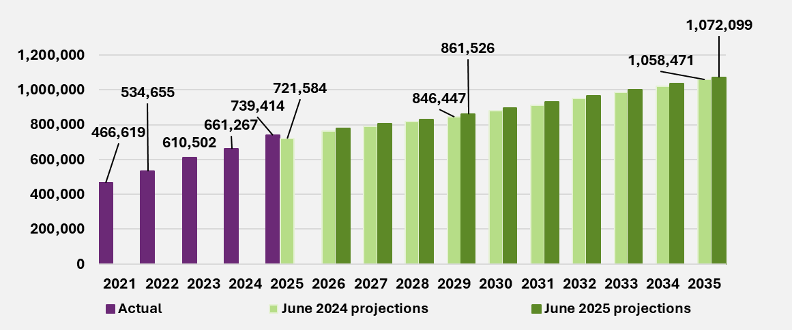
End of figure
Projections of future expected participant numbers are impacted by the starting population of participants at 30 June 2025 and assumptions about future expected numbers of new entrants and participants leaving the Scheme. The updated June 2025 projections forecast total participant numbers to be slightly higher for all future years compared to the June 2024 projections. There were 17,830 (or 2.5%) more participants active in the Scheme at 30 June 2025 than expected in the June 2024 projections, mainly due to the 18,159 more new entrants joining the Scheme in 2024-25. This is a key contributing factor to the higher future expected participant numbers in the June 2025 projections.
New entrants
The total number of new entrants to the Scheme in the twelve months to 30 June 2025 was 96,866. This is 23% (18,159) higher than the 78,707 new entrants expected to join the Scheme in 2024-25 from the previous review, and 53% higher compared to the total number of new entrants of 63,424 that joined the Scheme in 2023-24.
When a person with a disability requests access to the Scheme, their request is first validated, and then a decision is made on the person’s eligibility to access the Scheme. The higher-than-expected number of new entrants in the 12 months to June 2025 was due to the clearing of the backlog of access requests awaiting validation and decision. These backlogs had built following the Agency moving to a new computer system in November 2023. The Agency hired additional frontline staff and improved their capability to process access requests, enabling the backlogs to be cleared.
Higher-than-expected numbers of new entrants joining the Scheme in 2024-25 were mainly driven by 8,227 (28%) and 8,613 (30%) more new entrants with autism and developmental delay respectively. This was partially offset by 1,276 (30%) fewer new entrants with psychosocial disability compared to expected. There were 14,125 (27%) more children aged 0 to 14 and 4,035 (15%) more participants aged 15 and above than expected. New entrants with developmental delay or autism accounted for around 78% of all new entrants to the Scheme.
For the June 2025 projections, new entrant rate assumptions were updated based on Scheme experience for the 12 months to 31 October 2024. The Scheme experience was adjusted to allow for the number of new entrants during this period removing the effect of backlogs.
New entrant rate assumptions were revised upward for participants aged 15 and over with autism, which considered the continued increase in prevalence of autism. They were also revised upward as a result of a lower-than-expected moderation in the number of new entrants with developmental delay. This was partially offset by a continuing decline in new entrants with psychosocial disability. Small revisions to new entrant rate assumptions were also made for other disabilities, in line with experience. Consistent with the previous review, an allowance was made for estimated impacts on projected numbers of new entrants related to Foundational Supports to be provided outside the Scheme.
Table 6 shows the updated long-term new entrant rates assumed for the June 2025 projections compared to those assumed for the previous review. The table shows the aggregated new entrant rate of 234.0 (per 100,000 population aged 0 to 64) is 0.7% higher than the new entrant rate assumed in the previous review.
Table 6. Current and previous long-term new entrant rate assumptions (per 100,000 population aged 0 to 64)
 | June 2025 projections | June 2024 projections | Difference | Difference (%)
All disabilities | 234.0 | 232.3 | 1.7 | 0.7%
End of table
Figure 2 shows the updated June 2025 projections of future expected numbers of new entrants, compared to the previous review. The numbers of new entrants to the Scheme are projected to be higher in 2025-26 and 2026-27 compared to the previous review, mainly due to the delayed introduction of Foundational Supports from mid-2026.
Figure 2. Comparison to previous review of new entrant numbers
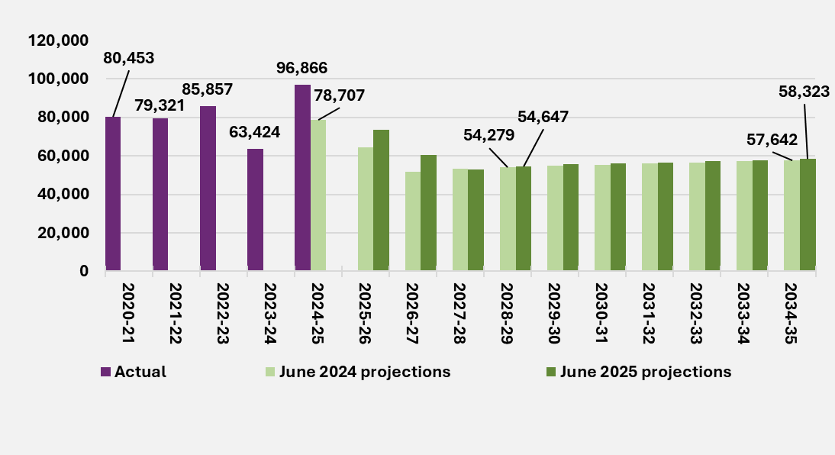
End of figure

Participants leaving the Scheme for reasons other than mortality
One of the Scheme’s objectives is early investment and intervention which should lead to capacity building and greater social and economic participation where support from the NDIS is no longer required. This is the primary driver for participants leaving the Scheme, with higher rates observed for children leaving the Scheme than adults (for reasons other than mortality).
The observed experience is directly related to operational capacity and resource allocation towards eligibility reassessments. The eligibility reassessment criteria used to decide if a participant has an outcome of “access maintained” or “revoked” is unchanged.
In 2024-25, the number of participants leaving the Scheme for reasons other than mortality was 14,123, 14% higher than the expected number of 12,384 in the June 2024 projections, and 92% higher than the observed number in 2023-24 of 7,353. The higher number of participants leaving the Scheme in 2024-25, compared to 2023-24. is due to the Agency’s continued efforts to address the backlog of eligibility reassessments (ERs).
Since the previous review, there has been focussed efforts to recruit and on-board operational staff dedicated to processing eligibility reassessments, increasing operational capacity during 2024-25. However, some of this additional capacity was used to assist in clearing of the backlog of new access requests in 2024-25. More resources are expected to be allocated to processing of eligibility reassessments in 2025-26 onwards.
Rates of participants leaving the Scheme from 2025-26 onwards have been revised to reflect the expected increase in workforce capacity to process eligibility reassessments. No future change to eligibility criteria has been assumed.
The expected rates of participants leaving the Scheme are higher in the short-term (2025-27) compared with the previous review.
Figure 3 shows the overall rate of participants leaving the Scheme, across all disability types and ages. This increases from an observed rate of 2.0% in 2024-25 to around 3.5% in 2025-26 and 2026-27, before steadily reducing over the medium-term from 2028-29 onwards.
Figure 3. Comparison to previous review of rates of participants leaving the Scheme
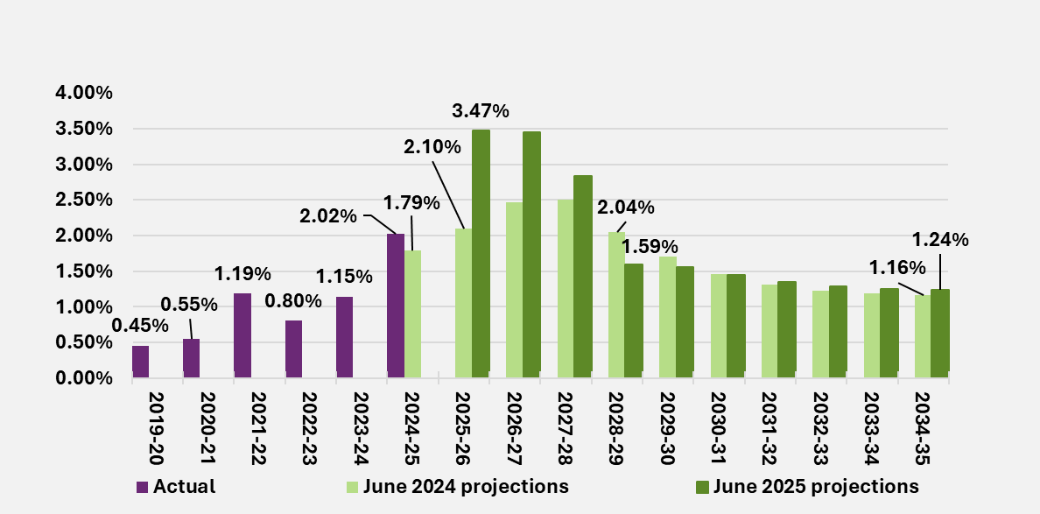
End of figure

Participants leaving the Scheme for mortality reasons
The second key driver for participants leaving the Scheme is mortality.
Figure 4 shows that the overall rate of participants leaving the Scheme for mortality reasons in 2024-25 was 0.88%, broadly in line with the expected rate of 0.87% in the previous review. However, projected mortality rates for specific participant cohorts have been revised compared to the previous review to align with recent trends in experience.
Figure 4. Comparison to previous review of rates of participants leaving the Scheme for mortality reasons
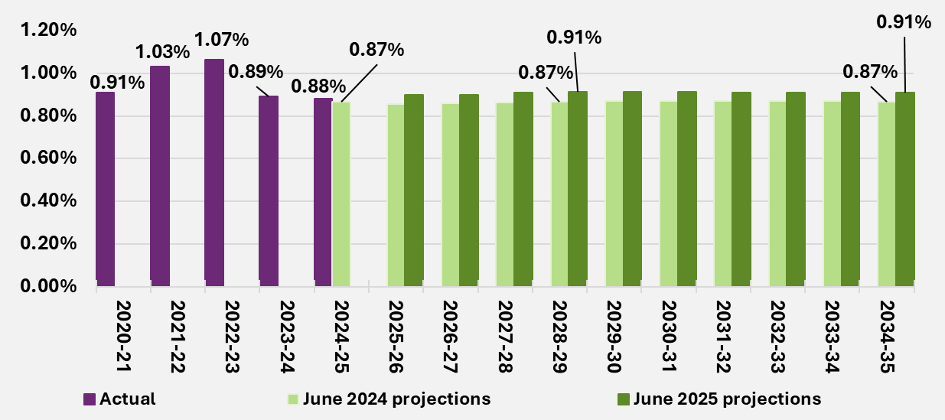
End of figure

Participant transitions within the Scheme
Participants with Supported Independent Living arrangements
The number of active participants at 30 June 2025 with Supported Independent Living (SIL) arrangements was 36,691, or 2.2% (838) lower than expected in the previous review, driven by greater number of participants leaving for mortality reasons and fewer participants transitioning into SIL in 2024-25.
Figure 5 shows that the rate of participants transitioning into SIL of 0.88% in 2024-25 was lower than the expected rate of 1.01% from the previous review. However, this is still higher than the expected rate of 0.82% in 2025-26.
The Agency continues to implement the independent living initiative as part of the 2023–24 Budget’s Scheme reforms initiatives. The number of home and living applications has been relatively stable during 2024-25 and is expected to continue into 2025-26 for each disability type and age group. This is unchanged since the previous review. There is a small increase in assumed transition rates overall due to a change in the mix of projected participants.

Figure 5. Comparison to previous review of rates of participants without SIL supports aged 15 years and above transitioning into SIL
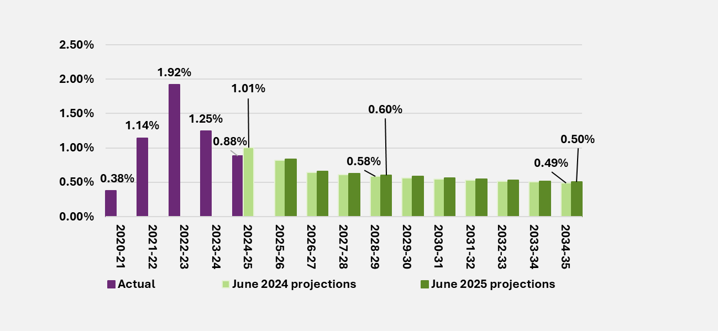
End of figure
Changes of primary disability of children with developmental delay
Some children with developmental delay may change their reported primary disability, most commonly to autism or intellectual disability, due to receiving a formal diagnosis when their eligibility for the Scheme is reassessed. As average plan budgets and payments for participants with autism and intellectual disability are typically higher than those with developmental delay, this results in higher Scheme expenses.
Figure 6 shows the historical and projected rates of children with developmental delay transitioning to autism and intellectual disability. The increase in transition rates observed in 2024-25 compared to 2023-24 is related to the increased activity to process eligibility reassessments. Where the outcome of an eligibility reassessment is a change to access, a participant’s primary disability may be updated to reflect the latest information.
Projected transition rates have increased in 2025-26 and 2026-27 compared to the previous review, to reflect the anticipated increase in activity in clearing the backlog of ERs. In the medium to long-term, transition rates are broadly in line with the previous review.

Figure 6. Comparison to previous review of rates of participants transitioning from developmental delay to autism and intellectual disability
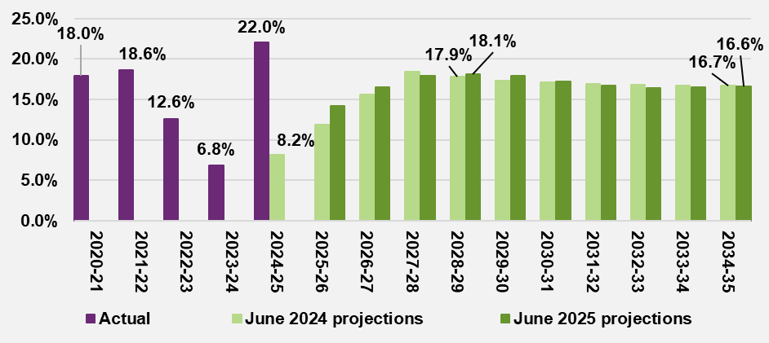
End of figure

Participant payments, and average payments per participant experience
Scheme expense measures
Scheme expenses for 2024-25 is the total of all payments incurred for supports provided to participants during the 12 months ending 30 June 2025. The cash basis of Scheme expenses reflects payments made within the period under consideration while the accrual basis allows for payments incurred but not yet paid at the end of the period (in this case 30 June 2025).
Scheme expense experience
For 2024-25, Scheme expenses on an accrual basis were $46.3 billion, $0.5 billion (1.1%) lower than the 2024-25 estimate of $46.9 billion in the June 2024 projections. This can be expressed as a total of $61.3 billion of committed supports across all participant plan budgets of which 75.6% of this total was utilised by participants..
Table 7. 2024-25 Accrual payments and committed supports
 | Accrual payments ($b) | Committed supports ($b) | Utilisation (%)
Total | 46.3 | 61.3 | 75.6%
End of table

Over 2024-25, Scheme expenses on a cash basis were $45.9 billion. This was $0.6 billion (1.3%) lower than the 2024-25 estimate of $46.4 billion in the June 2024 projections.
Variance in payments over the twelve months ending 30 June 2025, was driven by a lower-than-expected average payments for participants with SIL arrangements.
Table 8 shows the variance in payments over 2024-25 on a cash basis for participants with SIL arrangements and those not in SIL arrangements. The payment variance for participants with SIL arrangements was $0.6 billion (3.7%) lower than expected and in line with expected for participants not in SIL arrangements.
Table 8. 2024-25 Participants payments experience by SIL status ($b)
Cash payments | Actual | Expected | Difference | Difference %
SIL | 15.5 | 16.1 | -0.6 | -3.7%
Non SIL | 30.3 | 30.3 | 0 | 0.0%
Total | 45.9 | 46.4 | -0.6 | -1.3%
End of figure
Average payments per participant experience
The average payment per participant, for the twelve months ending 30 June 2025 was $65,800, (1.2%) lower than the expected payment of $66,600 from the previous review, after adjusting for the actual mix of participants in 2024-25.
Table 9 shows the variance in average payments per participant over the twelve months to 30 June 2025, for participants with SIL arrangements and those not in SIL arrangements. The 2024-25 annual average payment per participant was $10,300 (2.3%) lower than expected for participants with SIL arrangements, and $300 (0.6%) lower than expected for participants not in SIL arrangements.
Table 9. 2024-25 annual average payments experience, by SIL status of
participants ($)
Average payments per participant | Actual | Expected | Difference | Difference %
SIL | 433,300 | 443,500 | -10,300 | -2.3%
Non SIL | 45,900 | 46,200 | -300 | -0.6%
Total | 65,800 | 66,600 | -800 | -1.2%
End of figure

The lower payments experience in 2024-25 compared with expected, was partially driven by a combination of:
- Lower total plan inflation in the second half of 2023-24 with plan inflation experience observed to have a delayed impact on the level of payments.
- Lower observed utilisation in 2024-25 likely due to the introduction of Section 10 list of included and excluded supports, integrity and Crack Down on Fraud activities.
Growth in average payments per participant moderated in 2024-25
The average payments per participant in 2024-25 increased by 2.2% relative to 2023-24 payment levels. The observed growth in 2024-25 average payments has moderated compared to the average growth of 6.1% per annum over the past three years. This is shown in Figure 7 below.
Figure 7. Average payments for all participants from 2021-22 to 2024-25
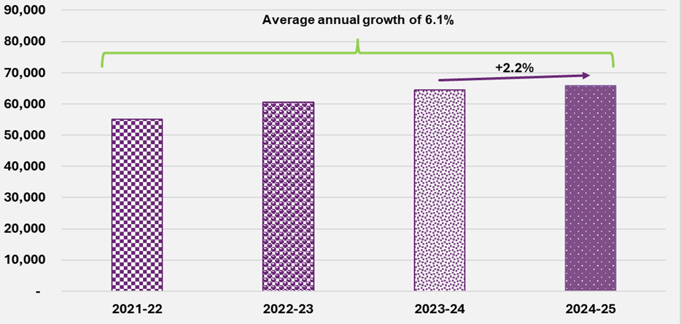
End of figure
Figure 8 shows that the growth in average payments both for participants with SIL arrangements and for those not in SIL arrangements has moderated in 2024-25. The annual growth rate has moderated to 3.8% for participants with SIL arrangements and 2.1% for participants not in SIL arrangements.

Figure 8. Average payments for participants, by SIL status for participants from 2021-22 to 2024-25
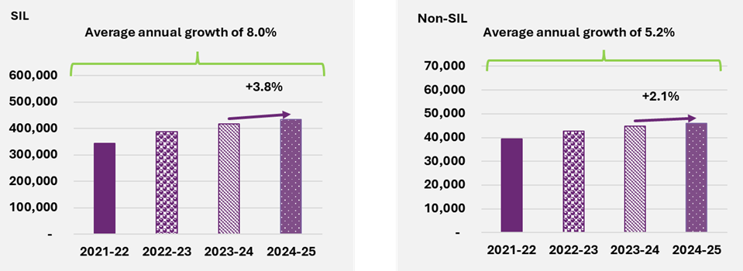
End of figure

Components of growth in payments
Scheme expenses increase over time due to many factors, such as participant related impacts, including the net increase in numbers of participants in the Scheme, normal inflationary sources (such as general increases in wages and consumer prices), as well as real growth in payments over and above the normal inflationary sources.
There are a number of factors contributing to the real growth in payments, including:
- Some participants will access SIL supports over time – participant SIL needs are assessed, and higher support needs are reflected as an increase in their plan budget.” as this is what we have written in section 4.6.4 and 5.4.2.
- When children transition from development delay to other disabilities, such as autism – support needs generally increase.
- The increased need for supports as the participants age over time – with a change in support needs reflected in the participants plan budget.
- Other growth in payments as participant circumstances and support needs change, referred to as additional growth in payments – participant plan budgets are re-assessed, or participants change their spending behaviour resulting in increases to participant plan budgets or increased utilisation of their plan budget.
Each of these factors are allowed via separate assumptions and/or transition modelling in the projection of Scheme expenses.
Table 10 shows a breakdown of the observed annual growth in average payments per participant from 2021-22 to 2024-25. After allowing for pricing impacts and changes in participant mix, the additional growth in average payments per participant in 2024-25 was 3.9%, a reduction of 0.9% compared to 2023-24.
Table 10. Breakdown of growth in payments per participant
Average payments per participant | 2021-22 | 2022-23 | 2023-24 | 2024-25 | Average 2021-25
Observed growth | 1.8% | 9.9% | 6.2% | 2.2% | 5.0%
Pricing impact | 2.4% | 6.8% | 4.1% | 2.8% | 4.0%
Participant mix impact | -6.2% | -4.3% | -2.8% | -4.4% | -4.4%
Additional growth | 5.6% | 7.4% | 4.8% | 3.9% | 5.4%
End of table
The pricing impact reflects growth in average payments due to higher prices being paid for support, in line with the outcome of the NDIS Annual Price Review (APR) effective at the beginning of the financial year (1 July). The outcomes of the 2023-24 NDIS APR were effective from 1 July 2024 and reflected in the 2024-25 participant payments, contributing 2.8% to the overall growth in average payments for 2024-25.
The participant mix impact reflects growth in average payments due to changes in total participant plan budgets and overall percentage utilisation at the Scheme level, arising from changes in mix of participant characteristics, by age, primary disability type, SIL status of participants and maturing of new entrants. Changes in mix of participants contributed -4.4% to the overall growth in average payments for 2024-25. This means average payments per participant, after adjusting for participant mix, are 4.4% lower compared to 2023-24.
Additional growth in payments, over and above pricing impacts and changes in participant mix, contributed 3.9% to the overall growth in average payments for 2024-25. This additional growth in payments is linked to observed plan inflation over and above normal inflationary sources, and over-utilisation of participant plan budgets.

Future growth in committed supports and changes to utilisation
For the June 2025 projections, the total scheme expenses in the future years are determined by applying committed supports assumptions to the projected participant population to arrive at projected committed supports (plan budgets). Assumed utilisation rates are then applied to the projected committed supports at a cohort level to produce projected Scheme expenses.
Starting committed supports and utilisation rates
Starting average committed supports amounts and utilisation rates were fitted at the detailed cohort level and calibrated to reflect the 2024-25 experience.
When the fitted starting committed supports and utilisation rates were applied to average active participants for 2024-25, reasonableness checks were undertaken to ensure they align closely to experience in aggregate, and broadly at the cohort level. Table 11 shows the product of the starting assumptions applied to the participant population by SIL status.
Table 11. Starting committed supports and utilisation rates by SIL status of participants
 | Accrual payments  ($b) | Committed supports ($b) | Utilisation (%)
SIL | 15.7 | 18.1 | 86.8%
Non SIL | 30.7 | 43.2 | 71.0%
Total | 46.3 | 61.3 | 75.6%
End of table
Pricing and normal inflation
Committed supports are assumed to grow with future price changes and economic inflation. For 2025-26, the normal inflation rate assumptions reflect the changes to price limits detailed in the 2024-25 Annual Pricing Review.
Key changes to the price limits include an increase for disability support worker related supports, reflecting the Fair Work Commission’s (FWC) decisions regarding the minimum wage and changes to the superannuation guarantee. Changes have also been made to therapy pricing, to reflect the maturity of the market and align pricing nationally.
From 2026-27 onwards, the normal inflation rate assumptions are based on the recent Treasury forecasts of the Wage Price Index (WPI) and Consumer Price Index (CPI), used to estimate the minimum wage increase for disability support workers, and increases to therapy supports, consumables and capital items.
Table 12 shows the normal inflation rate assumptions used for the June 2025 projections, compared to those assumed for the previous review. The rate of normal inflation assumed for 2025-26 reflects the 2024-25 change in NDIS price limits which resulted from the FWC decision to increase minimum award wages by 3.5% from 1 July 2025. This led to a decrease in the normal inflation rate assumed for 2025-26. The assumptions for 2026-27 onwards are largely unchanged.

Table 12. Comparison of current and previous normal inflation assumptions
Projection years | 2025-26 | 2026-27 | 2027-28 | 2028-29 | 2034-35
June 2025 Projections | 3.0% | 3.7% | 3.5% | 3.5% | 3.5%
June 2024 Projections | 3.9% | 3.7% | 3.7% | 3.5% | 3.5%
Difference | -0.9% | 0.0% | -0.2% | 0.0% | 0.0%
End of table
Allowance for Scheme reforms and operational measures
Projected committed supports and utilisation at the Scheme level are then adjusted for the impact of the following Scheme reforms and operational measures:
- NFP.
- The inclusion of funding periods in participant plans.
- Integrity and fraud measures.
- Operational measures focused on the quality of the Agency’s planning progress.
These measures are expected to lead to lower growth in committed supports. This is primarily driven by stronger and more consistent reassessment processes in the short-term, followed by the introduction of new support needs assessment and flexible budgets, in the medium term, as the New Framework Planning is rolled out.
Scheme reforms are also assumed to lead to reductions in utilisation – by around 1% in 2025-26, and a further 1% in 2026-27. This is primarily driven by:
- Funding periods reform, which is expected to reduce the proportion of participants who over-utilise their plan.
- Implementation of integrity and fraud measures, which are expected to reduce unauthorised use of NDIS funds.
Growth in committed supports
Table 13 shows the resultant projected annual growth in average committed supports after allowing for all participant related assumptions, future expected price and normal inflation, and the estimated impacts of Scheme reforms and operational measures discussed above. Growth in committed supports is expected to increase from 3.4% in 2025-26 to a high of 4.3% in 2027-28 before reducing to 3.9% in 2028-29.

Table 13. Projected annual growth in average committed supports by SIL status of participants
Yearly growth rate in average committed supports | 2025-26 | 2026-27 | 2027-28 | 2028-29 | 2034-35
SIL | 4.5% | 3.8% | 3.9% | 4.0% | 4.0%
Non SIL | 4.0% | 3.2% | 4.3% | 3.8% | 3.4%
Total | 3.4% | 3.4% | 4.3% | 3.9% | 3.6%
End of table
Changes in utilisation
Table 14 shows the projected utilisation rates which reflect an expected reduction of 1.4% in 2025-26, followed by a further 1.0% reduction in 2026-27 related to Scheme reforms. Total utilisation of participant plan budgets is expected to reduce from 75.6% in 2024-25 to 73.4% in 2027-28 remaining at that level over the medium to long-term.
Table 14. Projected utilisation rates by SIL status of participants
Projected utilisation rates | 2025-26 | 2026-27 | 2027-28 | 2028-29 | 2034-35
SIL | 85.8% | 84.7% | 85.0% | 85.1% | 85.6%
Non SIL | 69.5% | 68.5% | 68.6% | 68.6% | 68.1%
Total | 74.2% | 73.2% | 73.4% | 73.4% | 73.3%
End of table

Scheme expenses
Table 15 shows the projections of total committed supports, utilisation and total Scheme expenses on an accrual basis.
Table 15. Projected total committed supports, utilisation (%) and Scheme expense projections ($m)
June 2025 projections | 2025-26 | 2026-27 | 2027-28 | 2028-29 | 2034-35
Total committed supports | 68,331 | 73,713 | 79,212 | 85,101 | 130,612
Utilisation | 74.2% | 73.2% | 73.4% | 73.4% | 73.3%
Total Scheme expenses | 50,705 | 53,958 | 58,126 | 62,461 | 95,755
End of table
Table 16 shows the total growth in projected Scheme expenses, split into the three key components as per Table 4, but with a further breakdown of the real growth in payments above pricing impacts. The breakdown includes SIL entry and exit, transitions of children from developmental delay to other disability types, ageing, and additional growth.
This demonstrates that there are several factors which lead to increases in payment levels over time. Pricing impacts and real growth in payments are the key drivers of growth in projected Scheme expenses.
Table 16. Projected annual growth in Scheme expenses – further breakdown
Scheme expenses | 2025-26 | 2026-27 | 2027-28 | 2028-29 | 2034-35
Participant impacts | 2.0% | 1.7% | 1.4% | 1.4% | 1.6%
Pricing impacts | 3.0% | 3.7% | 3.5% | 3.5% | 3.5%
Real growth in payments | 4.4% | 1.0% | 2.8% | 2.6% | 2.1%
Additional growth | 1.4% | -1.5% | 0.4% | 0.2% | 0.1%
Transitions from developmental delay | 0.2% | 0.3% | 0.3% | 0.3% | 0.2%
SIL entry and exit | 2.5% | 2.2% | 1.8% | 1.8% | 1.3%
Ageing | 0.1% | 0.2% | 0.2% | 0.3% | 0.5%
Other | 0.1% | -0.1% | 0.0% | 0.0% | 0.1%
Total growth | 9.4% | 6.4% | 7.7% | 7.5% | 7.2%
End of table

Risks and uncertainty inherent in Scheme projections
The estimation of future expenditure based on experience is inherently challenging and there is significant uncertainty in the projection. Given the long-term nature of the Scheme, experience continues to mature, and many aspects remain difficult to interpret. Specifically, estimation of future expenditure based on experience is inherently challenging given the relative size, complexity, and evolving nature of the Scheme. The Scheme is undergoing a period of significant reform following the NDIS Review and subsequent legislative changes. There is, therefore, significant uncertainty in the projection and this level of uncertainty increases over the longer term.
As for the previous review, a Stochastic Model has been used as a tool to measure the level of uncertainty in relation to Scheme expenses. The stochastic model varies the assumptions of the June 2025 projections relating to the key risks to determine the probability distribution of expected future Scheme expense outcomes.
The material risks identified are additional growth in payments, model specification risk, the number of new entrants to the Scheme, normal inflation and the number of participants transitioning to SIL arrangements. These risks have been identified and quantified using historical experience. It is difficult to make objective adjustments to the stochastic model for changes to the Scheme which have not yet occurred. Therefore, the results presented below exclude the impact of the Scheme reforms or the impacts of any future legislative or major policy interventions not considered in this report. However, Scheme reforms are another key source of uncertainty.
Figure 9 illustrates the stochastic simulation of Scheme expense outcomes expressed as a percentage of the June 2025 projections (before Scheme reforms), with varying confidence intervals. Scheme expenses are expected to increase over time and the uncertainty associated with the Scheme expenses is also expected to increase over time.
The 5th percentile and 95th percentile results form a 90% confidence interval for the range of expected outcomes for projected Scheme expenses. There is an equal 5% likelihood that the Scheme expense would be:
- At least 4.2% below, or at least 6.1% above the June 2025 projection in 2025-26.
- At least 7.4% below, or at least 8.7% above the June 2025 projection for the four years to 30 June 2029.
- At least 20.8% below, or at least 26.3% above the June 2025 projection in 2034-35.
Figure 9. Ranges of uncertainty in June 2025 projected Scheme expenses as a proportion of baseline projection (%)
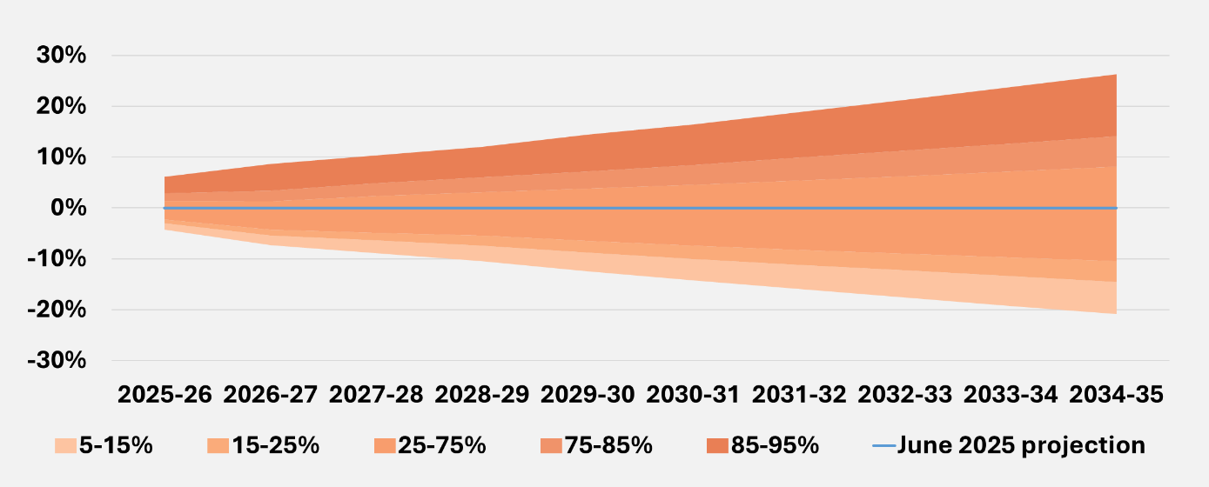
End of figure
The impact of the Scheme reforms on the uncertainty relating to each of the key risks above is difficult to quantify. Reforms are aimed at improving the financial sustainability of the Scheme, including achieving the 8% growth target in the NDIS Financial Sustainability Framework by 2026-27, with further moderation thereafter. This goal aims to substantially reduce the overall uncertainty associated with Scheme expenses in the medium to longer term.
In particular, the introduction of NFP is expected to give people with disability a flexible budget where they can decide how to best spend their budget in accordance with the NDIS Act. This is anticipated to deliver a level of consistency in funding for participants who have similar needs and situations, and lead to an outcome longer term that will moderate growth in line with government objectives.
However, the design and implementation of the Scheme reforms is ongoing and thus, at least in the short term the Scheme is faced with additional uncertainty as a result.
These opposing factors, coupled with the still emerging policy detail relating to the Scheme reforms, means that they have been excluded from the stochastic modelling in this report.

Judgement and materiality regarding main assumptions
Table 17 sets out the relative level of judgement involved and materiality associated with each of the main assumptions underlying the Scheme projections, both in the short-term (four years 2025-26 to 2028-29) and the medium to long term (years 2029-30 and beyond). The level of judgment reflects the extent to which there is supporting evidence, based on credible and reliable data (lower degree of judgement), or other factors where there is less certainty (higher degree of judgement). The materiality of the respective assumptions is informed by the scenario analysis results (Section 6.1).
In both the short and medium to long-term, a high degree of judgment is involved in setting the additional growth in committed supports assumptions, which are influenced by a number of factors. By contrast, mortality rate assumptions, which are derived from experience and not impacted by changes to decisions and actions of the government and Agency involve little judgement. New entrant assumptions are split between children (aged 0 to 14) and older children and adults (aged 15 and above), as different factors influence each group of new entrants.
Whilst the relative level of judgement associated in setting each of the various assumptions remains consistent over the long-term, compared to the short-term, the level of materiality increases over the long-term. As the Scheme continues to grow from year to year, the cumulative impact on the projected Scheme expenses becomes greater in the medium to long-term.
The level of judgement and materiality associated with each of the main assumptions, is consistent with the material risks, and variability in these risk factors is included in the Stochastic Model used to assess the uncertainty inherent in the projection of Scheme expenses (Section 6.2).
Table 17. Relative level of judgement and impact on Scheme projections of main assumptions
Level of judgement/materiality | Short term  2025-29 | Long term  2029-30 and beyond | Difference in  Long term
Participant related assumptions
Mortality rates | Low/Medium | Low/High | Higher materiality
Leaving and delay transition | Medium/Low | Medium/Medium | Higher materiality
SIL transition rates | Medium/Medium | Medium/Medium | No difference
New entrant (ages 0 to 14) | Medium/Low | Medium/High | Higher materiality
New entrants (ages 15 and above) | Medium/Medium | Medium/High | Higher materiality
Payment related assumptions
Future price increase | Medium/Medium | Medium/Medium | No difference
Utilisation | Medium/Medium | High/Medium | Higher level of judgement
Additional growth in Committed supports | High/High | High/High | No difference
End of table

Operating expenses
Actual operating expenses in 2024-25 of $2,541 million or 5.5% of Scheme expenses, were $247 million lower than the estimate of $2,788 million in the 2025-26 Budget.
The June 2025 projections assume NDIA resourcing remains sufficient to continue administering the Scheme at the same time as effectively implementing reforms. At the time of writing, work is being undertaken to ensure that the funding of Scheme reforms, as well as business-as-usual activities, is secured. If this does not eventuate, Scheme expenses would be expected to be higher than those shown in this report. In the 2025-26 Budget, NDIA operating expenses reduce by 38% in 2026-27.

Outcomes
A holistic assessment of Scheme financial sustainability requires consideration of both the costs of participant funding and the associated benefit the funding provides for participants in enabling them to achieve their desired goals and outcomes.
In the NDIS Corporate Plan 2024-25, key activity 1 is “Improve participant experience and outcomes with a financially sustainable Scheme”, which sits under Program 1.1 “Reasonable and necessary supports for participants”. Aligned to key activity 1 are specific performance metrics, such as the proportion of participants in work and the proportion of participants involved in community and social activities. The NDIA had a target of 26% of working-age participants in paid employment by June 2025, with the achieved result of 23% slightly below this target. For participants aged 15 and over, the percentage of participants actively involved in the community was 41% compared to the 2024-25 target of 46%.
The NDIS Outcomes Framework also measures outcomes for the families and carers of participants, recognising that the outcomes for people with a disability and the people who support them are likely to be closely linked. The percentage of parents/carers of participants in a paid job is 53%.
On the whole, perceptions of the Scheme have been positive, with participants and their families/carers more likely to report that the Scheme had helped them in various areas of their lives, the longer the participant was in the Scheme. Participant outcomes and family and carer outcomes are further discussed in Section 7.

Investment Effectiveness Program
In 2024–25, the Investment Effectiveness Program (IEP) transitioned from technical validation to building the core capabilities needed for policy-relevant analysis. The program focused on two strategic priorities: developing tailored outcome measures for specific supports and establishing a secure data linkage between NDIS administrative data and the ABS Person-Level Integrated Data Asset (PLIDA).
New capability was developed to integrate policy consultation and qualitative insight into the design of outcome metrics, ensuring they reflect the intent of specific supports and are suitable for modelling. This was supported by significant data engineering work, including the alignment of participant data to calendar quarters, the use of Census and transactional data to infer context and control for confounding factors, and the creation of synthetic indicators of service access and availability.
These foundations enabled longitudinal modelling of over one million NDIS plans and supported the development of outcome measures tailored to specific supports. Examples include modelling the impact of Support Coordination on plan utilisation, provider stability, and participant self-management. The program also further developed the Participant Outcomes Knowledge Graph (POKG), a research framework that maps relationships between supports and outcomes.
This work contributes to a more evidence-based understanding of Scheme benefits and supports the implementation of NDIS Review recommendations focused on participant decision-making and long-term sustainability. It lays the groundwork for future analysis and evaluation, helping to translate complex data into actionable insights for policy and practice.
End of Executive Summary

Introduction

An annual financial sustainability report (AFSR) is required under section 180B of the NDIS Act and provides an assessment of the financial sustainability of the National Disability Insurance Scheme (“the Scheme”, or NDIS). The AFSR is produced using data at 30 June each year and a summary included in the NDIA annual report.
The 2024-25 AFSR uses data to 30 June 2025 to project future Scheme expenses. The results in this report are referred to as the “June 2025 projections”.
The 2023-24 AFSR (referred to as the “previous review”) was based on data to 30 June 2024. The results in the previous review are referred to as the “June 2024 projections”.

Purpose of the NDIS
The purpose of the NDIS is to provide reasonable and necessary funding to people with a permanent and significant disability allowing them to have choices and control over the supports and services they need to pursue an ordinary life.
A key cornerstone underlying the operation of the Scheme is strong insurance principles, where evidence-based decisions on access and planning are made by drawing on objective information on individuals and the longitudinal data that is collected on participants in the Scheme. Experience is closely and regularly monitored to allow emerging risks and issues to be identified and, where required, remediation strategies to be implemented.
The Scheme has a lifetime, person-centric approach to its model of support for people with disability, where early investment in core, capacity building and capital supports are anticipated to drive better outcomes for participants and their families/carers over their lifetime.
Since inception, the National Disability Insurance Agency (“the Agency”, or NDIA) has had an increasing focus on improving participant experience. The Participant Service Charter sets out the level of service participants can expect from the NDIA and partners in the community. It is being actioned under the Participant Service Improvement Plan 2022-23 which sets out how the Agency works towards increased consistency and transparency of decision making with better operational procedures, guidelines and controls. In late 2023, the Agency commenced the national roll out of a new Customer Relationship Management system, as well as associated changes to operational processes, to improve experience people have with the Scheme. The transition to the new computer system and nationally consistent ways of working continues and provides an important foundation for the Agency before greater transformation changes for the Scheme.

Definition of financial sustainability
The NDIS Insurance Principles and Financial Sustainability Manual outlines the insurance model in detail and defines financial sustainability as the state where:
- The Scheme is successful on the balance of objective measures and projections of economic and social participation and independence, and on participants’ views that they are getting enough money to buy enough goods and services to allow them reasonable access to life opportunities - that is, reasonable and necessary support.
- Contributors think the cost is and will continue to be affordable, under control, represents value for money and, therefore, remain willing to contribute.
The current government expectation of Scheme expenses is included in the annual Portfolio Budget Statements (the Budget), noting it is not only the financial cost of the Scheme that is important within the context of financial sustainability, but also the outcomes for participants achieved by the Scheme.
Outcomes for participants and their families/carers are reported regularly in the NDIA’s Quarterly Reports to Disability Ministers, and more detailed analysis and data is available on the NDIA Data and Insights website. Section 7 of this report contains key information relating to outcomes measurement and recent results of the outcomes being achieved by Scheme participants, their families and carers.
The NDIS has operated since 1 July 2013. The first three years of the Scheme were a trial period, and this was followed by the transition period which commenced on 1 July 2016, with the Scheme progressively rolled out across the country over four years. While the Scheme has now operated in all regions of Australia for five years, it remains relatively immature. The numbers of participants entering the Scheme each year have not stabilised, and growth in expenses for participant supports continue to grow at a rate higher than general inflation.
Pressures on the financial sustainability of the Scheme remain, reflected in the generally upward revision of projected Scheme expenses in previous AFSRs and Budget estimates until 2023. Design and implementation of Scheme reforms has commenced, seeking to bring the NDIS back to its original intent and resulting in the stabilisation of projected Scheme expenses. Collectively, the reforms, which include legislative amendments, Agency operational measures and a more cohesive ecosystem of support inside and outside of the NDIS, are all focused on improving the financial sustainability of Scheme.

Scheme reforms update since previous review
In April 2023, the National Cabinet set a target to reduce annual growth in Scheme expenses to 8% from financial year 2026-27, moderating thereafter. The Minister for Disability and the NDIS announced, in August 2025, the Commonwealth’s intention to further reduce Scheme growth within the medium term to 5-6% per annum.
In the past two financial years the Government has invested significantly in the NDIA’s workforce and introduced changes to legislation to improve outcomes for people with disability and help ensure the sustainability of the NDIS.
The NDIA engages extensively with people with disability to co-design Scheme reforms. Recent activities have focused on improving early intervention pathways, participant planning processes and participant safety, as well as improving the approach to assessments and budgeting.
The NDIA’s integrity and anti-fraud activities are also contributing to the sustainability of the NDIS.
The June 2024 projections included estimated future savings related to anticipated future Scheme reform activities, covering:
- Legislation changes enabling measures to reduce intra-plan inflation by establishing total funding amounts, funding components and funding periods; and introducing assessment and budgeting reforms that establish New Framework Planning (NFP) informed by a support needs assessment.
- Integrity and fraud improvements through the Crack Down on Fraud program (CDoF) that will see technology enhancements to prevent and reduce fraud and non-compliant behaviour.
- Foundational Supports, a National Cabinet commitment to develop and implement Foundational Supports provided outside the NDIS. The aim is to improve support for individuals who are not NDIS participants, including children with early intervention needs.
Since the previous review, amendments to the NDIS Act took effect from 3 October 2024. As a result of these changes, the following Scheme reform activities have occurred or are in progress:
- Introduced a list of NDIS supports to clarify what supports participants can spend their funds on (October 2024).
- Introduced funding periods to help participants spend within their plan budgets (May 2025).
- Commenced development of NFP that will introduce a supports needs assessment and flexible budgets.
The CDoF program has increased its workforce to enhance fraud detection and ensure the integrity of payments. The CDoF program complements the work of the Fraud Fusion Taskforce.
In August 2025, the Minister for Disability and the NDIS announced plans to establish a new program called ‘Thriving Kids’ to be introduced in 2026-27. Thriving Kids is an important aspect of Scheme reforms, with a key focus to provide supports outside the NDIS for children aged 8 or under with mild to moderate developmental delay and autism.

Impact of Scheme reforms on June 2025 projections
Reforms are at various stages of implementation. Some reform activities have partially or fully emerged in Scheme experience over 2024-25 and are implicitly incorporated in the June 2025 projections.
Other reform activities, or programs, are either in the process of being implemented, or under development and expected to impact Scheme experience in future years. These are explicitly allowed for in assumptions regarding future Scheme experience.
As the design of the Thriving Kids program is not yet finalised, assumptions regarding Foundational Supports in the June 2025 projections are consistent with those in the June 2024 projections, with commencement from 1 July 2026 rather than 1 July 2025 as was assumed in the June 2024 projections. Future projections will reflect assumptions regarding Thriving Kids at the point agreement is reached in relation to policy settings.

Reliance and limitations
It is the responsibility of the Agency and other parties to ensure recipients of copies of, or extracts from, this report understand the reliance on which any conclusions in it are based.
Given the long-term nature of the Scheme, experience continues to be relatively immature, and many aspects remain difficult to interpret. Specifically, estimation of future expenditure based on experience is inherently challenging given the relative size, complexity, and evolving nature of the Scheme, meaning there is significant uncertainty in the projection. As the Scheme continues to mature, as staff, operational and governance capabilities improve, and as the reforms take effect, there is an expectation the Scheme experience will change, perhaps materially, and this would affect the eventual trajectory of Scheme expense.
Future events cannot be predicted, and they may lead to unexpected impacts on Scheme experience which differ from the projections in this report. Examples of events with the potential to have a significant impact on future Scheme experience include reform implementation leading to outcomes which are different from currently expected, another pandemic, and changes to economic conditions which cause further workforce shortages in the disability sector.
More data on Scheme experience is available in NDIA quarterly reports and on the NDIA Data and Insights website.
Note that many of the figures in this report have been rounded, whereas differences are generally calculated from unrounded metrics.
End of Section 1

Information and data integrity

An integral part of an insurance model is the collection of accurate data in a timely manner. This is because quality data drives the ability of the Agency to monitor emerging experience, perform meaningful analyses, project the financial position of the Scheme and, hence make consistent evidence-based decisions to support Scheme objectives. The success of the Scheme is dependent on the availability and quality of the data and information collected.
The data collected by the Agency is varied and broad-reaching and covers information across each step of the participant pathway, from Scheme access and eligibility to participant plan approval, plan implementation and plan reassessment. Payments for disability supports and the outcomes for participants and their families/carers are also collected regularly to track progress of participants and the Scheme. The information being collected enables the Agency to continually build one of the most comprehensive, longitudinal data sources on disability in the world.

Information and data used for analysis
Table 2.1 summarises the sources of data used for the actuarial analysis underpinning this AFSR, which relies upon the Agency’s case management system, finance system and data warehouse, as well as external sources. The analysis in this report is based on data at 30 June 2025, unless stated otherwise.
The Agency’s workforce continues to manage workflow across two computer systems as the transition to PACE, the new Customer Relationship Management (CRM) system, is still in progress, having commenced in November 2023. The impacted workflow relates to access eligibility decisions, approval of first plans, eligibility and plan reassessments.
Where data is used to conduct actuarial analyses, it is important to acknowledge any limitations associated with the data that could give rise to uncertainty in the results. One particular area relates to participants with Supported Independent Living (SIL) arrangements, where there is no single flag of SIL usage available to accurately identify participants with SIL supports.
A combination of participants’ prior access to SIL supports, and their recent payments experience, is used to estimate numbers of participants with SIL supports. Imperfections exist with this solution, introducing systemic variability in the number of participants with SIL arrangements in a given month, and the analyses used to inform the transition of participants to SIL arrangements. Despite this variability, the numbers of participants with SIL and associated experience analyses, used to inform setting of assumptions for Scheme projections are robust.

Table 2.1. Summary of data utilised for actuarial analysis
Data | Description
Participant characteristics | - Demographic information (age, gender, disability and other participant profile information).  - Eligibility reassessment status.  - Outcome of eligibility reassessment and decision date.
Access requests to the NDIS | - Demographic information (age, gender, and other participant profile information).  - Access request date and status.  - Outcome of request and decision date.
NDIA Workforce | - Headcount and FTE of staff from Service Delivery.  - Finance new policy proposal modelled future workforce FTE.
Payments to service providers | - Service provider submitting the claim for payment.  - Participant for whom the support was provided.  - The support item and cost of support provided.  - Dates of when the support was provided.  - Method of plan management used.
Payments to participants | - Participant submitting the claim for payment.  - The support category provided.  - Total amount spent by support category.  - Period of reimbursement.
NDIS participant plans | - Plan approval date.  - Length of plan.  - All plan budgets included in the plan.  - Level of function.  - Number of plan change requests.
In-kind supports data | - Unit record in-kind support details from state/territory programs including details on support type, level and duration of coverage.
Data on outcomes | - Information collected from surveys of participants and their families and carers about how they are doing in different areas of their lives and how they are progressing over their time in the NDIS.
Financial information | - Data from the PACE and SAP CRM systems was reconciled with financial information in SAP.
ABS Survey of Disability, Ageing and Carers | - Prevalence of disability in Australia, including demographic and socioeconomic profile of people with disabilities.
Economic information | - Government economic forecasts for Gross Domestic Product (GDP).  - Inflation indicators.
Demographic information | - Australian Life Tables 2018-2020 – published in November 2021.  - Budget 2025-26: population projections, Australia, 2024-25 to 2035-36 from the Centre for Population Projections.  - Population forecasts beyond 2035-36 - 2023 Intergenerational Report.  - Estimated Resident Population data up to 30 June 2024 – published by the Australian Bureau of Statistics (ABS).
Fraud and Integrity data | - Crack Down on Fraud data.  - Tested and cancelled payment requests.  - Intervened and cancelled integrity loss payments.  - Payment assurance error rate.  - Details of integrity initiatives funded within the Crackdown on Fraud program.
End of table

Information systems overview
The Agency’s Information systems (comprising case management, finance and data warehouse) are important infrastructure in the ongoing financial sustainability of the Scheme.
Case management systems
From 1 July 2016, the Agency used SAP Customer Relationship Management (CRM) as its case management system. The CRM system is hosted and maintained by Services Australia. The primary objective of this delivery was to enable critical operational activities, such as plan approvals and payments.
The Agency launched a new CRM system, PACE, to replace the existing SAP CRM system over time. PACE supports community connections, scheme access, planning, participant check-in, claims and payments validation as well as other services.
PACE was launched in Tasmania in November of 2022. The expansion of PACE to service all Australians commenced in November 2023. PACE continues to be updated and improved based on the experiences of participants, their families and carers, providers, NDIA and Partners in The Community staff.
Finance systems
SAP Finance is the Agency’s finance system and was introduced on 1 July 2016. All payments to and from the Agency are made using SAP Finance. In line with Services Australia’s practice, the Agency uses the SAP Public Sector Collection and Disbursement (SAP PSCD) system as an intermediary between the SAP CRM and SAP Finance (operated by Services Australia as a shared service).
Data warehouse
The Enterprise Data Warehouse (EDW) integrates and presents Scheme and Agency data to business analytics and reporting teams. Data is sourced from operational Business systems, include CRM and financial systems, and integrated in a single data model. The EDW contains integrated data on participants, scheme access and planning, budget and payments and other domains. The EDW supports legislated reporting, business operational reporting, analytics services, and ad hoc reporting.
End of Section 2.

Modelling approach

Introduction
An experience-based projection model, the Original Cohort Model (OCM) is used to project Scheme participant numbers and Scheme expenses. To reflect the ongoing maturing of the Scheme, the latest developments in Scheme experience, refinements to operational processes and enhancements to modelling techniques, updates to the model are undertaken each year. An alternative model, the Microsimulation model, has been used to produce Scheme projection results for comparison with the existing model results (see Section 3.5).
As with previous AFSRs, the model used to produce the June 2025 projections documented in this 2024-25 AFSR is based on projecting average payments made for supports for 2,280 participant cohorts. The average payments for each cohort are then multiplied by projected participant numbers and summed across all cohorts to arrive at the total Scheme expense.
Since the previous AFSR, the methodology used to project average payments per participant has been updated, to be explicitly calculated based on a separate projection of average committed supports per participant, and projection of average proportion of committed supports used per participant (referred to as utilisation). Projected average payments per participant are now calculated as the projected committed supports per participant, multiplied by the projected utilisation per participant.
Previously, average payments per participant were projected directly, based on assumptions about future growth in average payments per participant. The change in methodology enables more explicit modelling of the impacts of growth in participant plan budgets and of participant spending behaviour, reflected in the usage of participant plan budgets.
Changes have also been made to the childhood age-bands, increasing the number of participant cohorts modelled, to better understand and model the impacts of operational measures in the early childhood approach and Scheme reforms related to children.
Assumptions have been set considering factors both internal and external to the Scheme. External factors include broader macroeconomic factors, to the extent they impact the Scheme. Internal factors include trends in past numbers of participants and payments per participant as well as the estimated impacts of the Scheme reforms on the Scheme.
To better estimate the expected impact of operational measures and Scheme reforms, aimed at moderating growth in participant plan budgets and help participants more effectively manage spending of their budgets, a new Plan Reassessment Model (PRM) has been developed to complement the OCM.
The PRM is a short-term projection model which projects Scheme expenditure for two years. It is used to forecast the monthly numbers of plan reassessments, allowing for expected resource capacity and productivity. Assumptions are then made about expected growth in participant plan budgets on reassessment and expected change in participant spending behaviour, to estimate expected impacts of operational measures and Scheme reforms.
As with any projection, there is uncertainty in the results. This is particularly relevant given the systemic risk arising from the factors mentioned above. As the Scheme continues to mature, the expected trajectory of Scheme experience and projected expenses may change, possibly materially, resulting from the decisions and actions of the Government and Agency and the Australian and global economic climate. Two approaches have been used to illustrate the drivers of uncertainty and their estimated impacts on the projection results:
- Testing the sensitivity of projected Scheme expenses to changes in specific key assumptions via construction of a number of scenarios, included in Section 6.1.
- Projecting Scheme expenses using a stochastic model which provides a quantification of the interaction between material risks facing the Scheme and the variability in these risk factors. The approach and results of this model are included in Sections 3.4 and 6.2 respectively.
Figure 3.1. on page 53 summarises the modelling approach in graphical format.

The inputs which are varied are the assumptions participant numbers
- Annual population projections are calculated by exact age and cohort by adding future new entrants to the starting population at 30 June 2025, reducing the population due to mortality and participants leaving the Scheme, and ageing the remaining participants by one year.
- Each cohort is differentiated by age band (summarised into ten groups), primary disability and level of function (57 groups), gender (two groups) and whether a participant is accessing SIL supports (two groups). This leads to 2,280 unique cohorts.
- The number and profile of participants expected to enter the Scheme in each projection year is based on the historic profile of new entrants, split between:
- New incidence to disability, and an ongoing level of previously unmet need for disability supports.
- Loadings for short term trends in specific cohorts, including previously unmet need at higher levels than are expected in the medium to long term.
- There is a transition model to explicitly allow for participants who enter the Scheme with developmental delay but are later determined to have autism or an intellectual disability. Some participants with developmental delay will transition to another disability once a diagnosis has been made. These transfers typically happen between the ages of 5 to 8.
- There is also a transition model to explicitly allow for participants transitioning into SIL arrangements. It is assumed participants do not leave SIL other than through death, apart from those aged 65 and over as they may leave the Scheme by entering Residential Aged Care. Although participants with SIL only represent about 5% of Scheme participants they are modelled explicitly, as they contribute about a third of the expenses.

Scheme expenses relating to participant supports
- The projection of Scheme expenses is now based on projecting average committed supports per participant (instead of average payment per participant) and how much participants use their committed supports i.e. utilisation.
- Both committed supports and utilisation are modelled on an ultimate basis. That is, allowing for delays in payments for supports of up to several months after they are provided, and also allowing for retrospective changes to the amount of committed supports during a period (this mainly occurs due to overspending on plans or intra-plan inflation).
- Explicit allowance is made in the committed supports projection for the variance in average committed supports for future new entrants, relative to the broader Scheme population.
- Growth in committed supports per participant is added in future years from both normal inflationary sources and other sources of additional growth.
- Scheme expenses (projected committed supports multiplied by projected utilisation) are projected on an accrual basis, representing the estimated rate of supports provided by the Scheme.
- Projected committed supports and projected Scheme expenses are split between 15 support categories.
- Factors are derived for each of the 15 different support categories and applied to the accrual Scheme expenses to determine results on a cash basis.

Stochastic model
In addition to the deterministic projections in this report, a stochastic projection model (‘Stochastic Model’) was developed to quantify the level of overall uncertainty inherent in the Scheme projections by allowing for random variation in key risks over time. The Stochastic Model was run based on the scenario before allowances for Scheme reforms.
The risks underlying the projected expenses of the Scheme are regularly monitored and analysed and the Stochastic Model is used as a tool to measure the level of uncertainty relating to Scheme expenses. The Stochastic Model generated 20,000 randomly varied assumptions of the June 2025 projection model relating to the key risks (before Scheme reforms). These simulations were then combined to determine the probability distribution of expected future Scheme expense outcomes.
The methodology underlying the Stochastic Model can be described as follows:
- The projection methodology underlying the Stochastic Model is a replication of the projection methodology in the June 2025 projection model.
- Stochastic variation has then been applied to assumptions related to the key risks. The mean for each key assumption (before Scheme reforms) is calibrated to its future expectation in the June 2025 projections. The assumptions have been allowed to vary stochastically around the mean, based on a level of variation for each future projection year, which is set based on a combination of analysis of historical levels of volatility in Scheme experience, comparable historical indices, and actuarial judgement.
- The addition of incremental volatility each year increases the overall uncertainty of Scheme expenses over time.
- The Stochastic Model does not assume any explicit correlation between the stochastically modelled risks, noting any such correlations are likely to be relatively immaterial.

Microsimulation model
In conjunction with the existing projection model, a Microsimulation Model (‘MSM’) has been developed. This is the second year that the MSM has been used to project Scheme expenses. The development of the MSM aligns with recommendations from the NDIS Review, that “...the Scheme Actuary should also develop different forecasting models, including for specific cohorts, to improve the accuracy of NDIS projections…”. This emphasises the importance of diversifying forecasting methods to support the financial sustainability of the Scheme.
The MSM serves several key purposes, this includes:
- Enhancing stakeholder confidence: The MSM aims to provide stakeholders with greater confidence in the accuracy and reliability of the Agency's forecasts of Scheme expenses.
- Reducing model specification risk : The existence of an additional projection model assists in reducing the risks associated with relying on a single model. An additional projection model also helps to ensure estimates of future Scheme expenses remain robust.
- Introducing innovation: The MSM introduces innovative approaches to forecasting Scheme expenses. The MSM methodology incorporates advanced statistical techniques and demographic modelling to enhance accuracy and flexibility in forecasting.
The MSM serves as an alternative projection scenario in this review, verifying the baseline results from the existing model. The results from the MSM are shown as a scenario in Section 6.1.5.
Going forward, the MSM is planned to continue to be part of the AFSR. The use of the MSM will be determined as part of the Projections Model Roadmap discussed in Section 9.

Microsimulation model methodology
A Microsimulation Model generates detailed projections by simulating the attributes of individuals over time. Each individual is represented as a discrete unit, with specific characteristics and behavioural rules that are applied to model their progression over time. The individual level results are then aggregated to analyse the trajectory of participants and their characteristics overtime. The MSM is designed to simulate the pathways of current and future participants, considering the evolution of their attributes over time.
In similar vein to the OCM, the MSM forecasts Scheme expenses by multiplying projected participant numbers by the estimated utilised committed supports per participant.
- Participant numbers are projected by modifying the existing participant numbers each quarter to account for the intake of new entrants into the Scheme, and the reduction due to mortality and other reasons for participants leaving the Scheme. An explicit allowance is made for changes in participants’ primary disability group (i.e. changing from developmental delay to autism or intellectual disability) and for participants transitioning into SIL arrangements. Additionally, the MSM also explicitly models changes in participants’ level of function over time (the OCM implicitly models this as part of the additional growth assumption).
- Estimated committed supports per participant is updated quarterly to reflect both normal inflation and additional plan growth assumptions.
- Estimated payments are derived by applying utilisation assumptions to the committed supports.
The attributes used in participant and payments projections of the MSM remain broadly consistent with those used in the OCM. Furthermore, the key judgements when setting the assumptions that underpin the MSM are largely consistent with those used in the OCM.
The MSM differs from the OCM in several key areas:
- Individual-level projections: In the MSM, the expected pathway of each
de-identified individual is modelled over time. This facilitates the reporting of projections for different cohorts of participants.
- Modelling changes in participant level of function: The MSM includes the ability to account for changes in participants’ level of function over time. This approach acknowledges that participant level of function can evolve over time due to factors such as ageing, rehabilitation and changes in the participants’ health.
- Flexibility: The MSM is designed to be flexible. This means that in comparison with the OCM, it is easier to incorporate additional characteristics in the future such as secondary disability type or socio-economic factors.
- Quarterly projections: The MSM generates projections on a quarterly basis. This higher frequency is designed to allow more timely insights into the Scheme’s projections.

Key MSM developments over 2024-25
To support the ongoing refinement of Scheme projections and enhance robustness in forecasting, several developments have been made to the MSM since the previous review. Consistent with the OCM, the MSM has been updated to project committed supports per participant and the proportion of committed supports utilised. Previously the MSM projected average payments per participant, without explicitly modelling committed supports or utilisation.
Additionally, Generalised Linear Models (GLMs) are now used to set most assumptions, projections of the Australian population and new entrants have been enhanced, and improvements have been made to the reporting of results from the simulation engine.
These developments collectively enhance the flexibility, accuracy, and transparency of the MSM, supporting its continued use as a complementary projection tool alongside the OCM.

Figure 3.1. Schematic of modelling approach
End of figure
End of section 3

Scheme experience

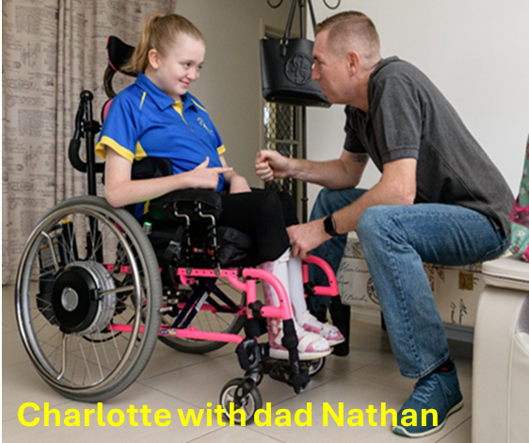
This section includes trends in Scheme experience to 30 June 2025. Comparisons of actual experience are made to projections from the previous review relating to key drivers of Scheme expenses including participant numbers, average payments, plan budgets, inflation experience and utilisation rates.

Participant numbers
At 30 June 2025 there were 739,414 active participants with an approved NDIS plan. The Scheme population continued to grow at a rate over and above population growth. Active participant numbers increased by 11.8% compared to the Scheme population at 30 June 2024, lower than the rate of growth in the 2022-23 financial year, but higher than in the 2023-24 financial year as shown in Figure 4.1. The increase reflected the net effect of new entrants and participants that have been leaving the Scheme over the past 12 months.
Figure 4.1. Active participants in the Scheme over the past three years at 30 June
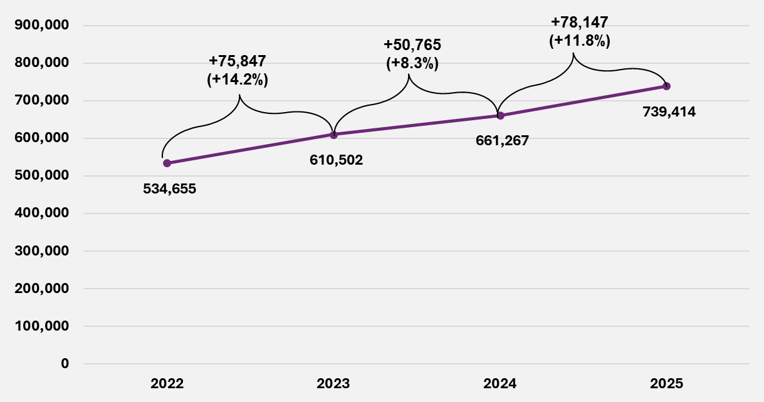
End of figure

Actual versus expected participant numbers

The net movement in Scheme participants was higher than expected
As shown in Table 4.1 the Scheme population of 739,414 active participants at 30 June 2025 was 17,830 (2.5%) was higher than expected from the previous review. The net movement in participants over the 12 months to 30 June 2025 was 78,147, 29.6% higher than expected, driven by a higher number of new entrants to the Scheme and partially offset by a higher number of participants leaving the Scheme.
Table 4.1. Actual versus expected total participant numbers and net increase at
30 June 2025
At 30 June 2025 | Actual | Expected | Difference | % Difference
Participant numbers | 739,414 | 721,584 | 17,830 | 2.5%
Net Increase over this financial year | 78,147 | 60,317 | 17,830 | 29.6%
End of table
The comparison of actual net movement in participants expected from the previous review is shown in Table 4.2, Table 4.3, Table 4.4 and Table 4.5 by key participant characteristics (participants with SIL and without SIL supports, age group, primary disability type and reported level of function respectively).
Table 4.2 compares the net movement in participants over 2024-25 against expectations from the previous review by SIL status and shows that:
- The net movement of participants without SIL supports was 18,668 (32.4%) more than expected. This was driven by clearing the backlogs of access requests that waited for validation and decision, leading to a higher number of new entrants, partially offset by a higher number of participants leaving the Scheme as a result of efforts to clear the backlog of eligibility reassessments (ERs).
- The net movement of participants with SIL supports was 838 (31.3%) less than expected from the previous review, reflecting more participant deaths and fewer participants transitioning to SIL.
Table 4.2. Actual versus expected net movement in participant numbers in 2024-25
by SIL status
SIL status | Actual | Expected | Difference | % Difference
SIL | 1,841 | 2,679 | -838 | -31.3%
Non SIL | 76,306 | 57,638 | 18,668 | 32.4%
Total | 78,147 | 60,317 | 17,830 | 29.6%
End of table
Table 4.3 compares the net movement of participants over 2024-25 against expectations from the previous review by age group and shows that:
- The net movement of participants was higher than expected across all age groups.
- The largest variation was related to children aged 0 to 14, reflecting a significant proportion of new entrants to the Scheme and participants leaving at these ages.
Table 4.3. Actual versus expected net movement in participants in 2024-25
by age group
Age Group | Actual | Expected | Difference | % Difference
0 to 14 | 36,340 | 23,018 | 13,322 | 57.9%
15 to 24 | 20,115 | 18,252 | 1,863 | 10.2%
25 to 64 | 15,960 | 13,876 | 2,084 | 15.0%
65+ | 5,732 | 5,171 | 561 | 10.9%
Total | 78,147 | 60,317 | 17,830 | 29.6%
End of table
Table 4.4 shows the primary disability groups where the net movement in participants in 2024-25 differed significantly from that expected in the previous review. There are:
- 20,202 more participants with autism at the end of June 2025 than expected, due to higher numbers of participants with autism joining the Scheme in 2024-25 and more children with developmental delay transitioning to autism than expected.
- 5,340 fewer participants with developmental delay at the end of June 2025, due to more children with developmental delay either leaving the Scheme, as they no longer required supports, or transitioning into other disability types as their support needs changed. This was partially offset by the higher than expected number of children with developmental delay entering the Scheme in 2024-25.
- 1,572 fewer participants with psychosocial disability, due to lower numbers of participants with psychosocial disability entering the Scheme in 2024-25 than expected.
Table 4.4. Actual versus expected net movement in participant numbers in 2024-25
by primary disability
Age Group | Actual | Expected | Difference | % Difference
Autism | 56,016 | 35,814 | 20,202 | 56.4%
Developmental delay | 5,553 | 10,893 | -5,340 | -49.0%
Intellectual disability | 4,489 | 4,222 | 267 | 6.3%
Psychosocial disability | 1,435 | 3,007 | -1,572 | -52.3%
Other disability types | 10,654 | 6,381 | 4,273 | 67.0%
Total | 78,147 | 60,317 | 17,830 | 29.6%
End of table
Table 4.5 compares the net movement in participants over 2024-25 against expectations from the previous review by reported level of function and shows that:
- Actual net movement in participants by reported levels of function was significantly different from expected. Most of the variation arose from participants aged 0 to 14 years.
- The net movement in participants with high reported levels of function was higher than expected, driven by more children entering the Scheme than expected, partially offset by more participants than expected leaving the Scheme.
- The net movement in participants at medium and low reported levels of function were lower than expected, partially driven by lower numbers of new entrants to the Scheme.
- A significant number of participant records do not have the participant’s level of function. These participants are reported as “missing” level of function. This contributes to the large variation observed across different reported levels of function.
Table 4.5. Actual versus expected net increase in participants in 2024-25 by reported level of function
Reported level of function | Actual | Expected | Difference | % Difference
High | 33,740 | 8,987 | 24,753 | 275.4%
Medium | 29,044 | 37,794 | -8,750 | -23.2%
Low | 4,798 | 23,281 | -18,483 | -79.4%
Missing | 10,565 | -9,745 | 20,310 | -208.4%
Total | 78,147 | 60,317 | 17,830 | 29.6%
End of table

Scheme participants as a proportion of the general population continues to increase
The participation rate refers to the proportion of the Australian population who are NDIS participants. The rate varies by age and gender, reflecting the prevalence of different disability types.
Figure 4.2 shows participation rates for all ages increased since the previous review. Participation rates were high for children and peaked at 11.6% at age 6 for 30 June 2025. This reflected the large numbers of children that entered the Scheme with autism and developmental delay. The rate then declined steadily to 1.3% by age 35, before rising gradually to 2.2% by age 60. The increase in participation rates for children continued to be higher than other ages.
Appendix D presents a further breakdown of participation rates by gender.

Figure 4.2. Proportion of Australian population in the Scheme by age at 30 June
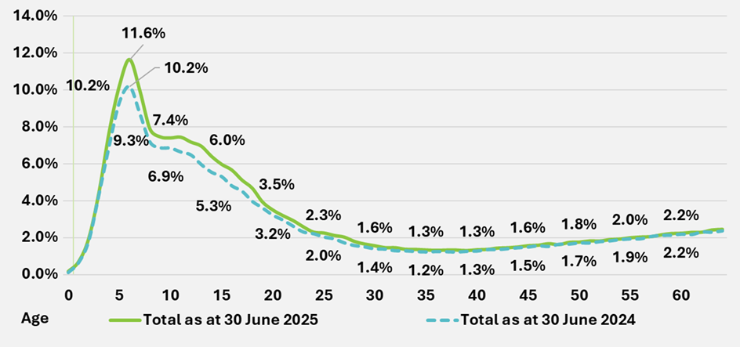
End of figure
Figure 4.3 shows the participation rate over time, with the year-on-year increase between June 2024 and June 2025 higher than the preceding year. This was driven by high numbers of new entrants over 2024-25, particularly participants with autism, who comprise approximately 40% of total participants in the Scheme. General population growth continued to increase above general population growth.
Figure 4.3. Participants aged 0 to 64 years as a proportion of Australian population
at 30 June
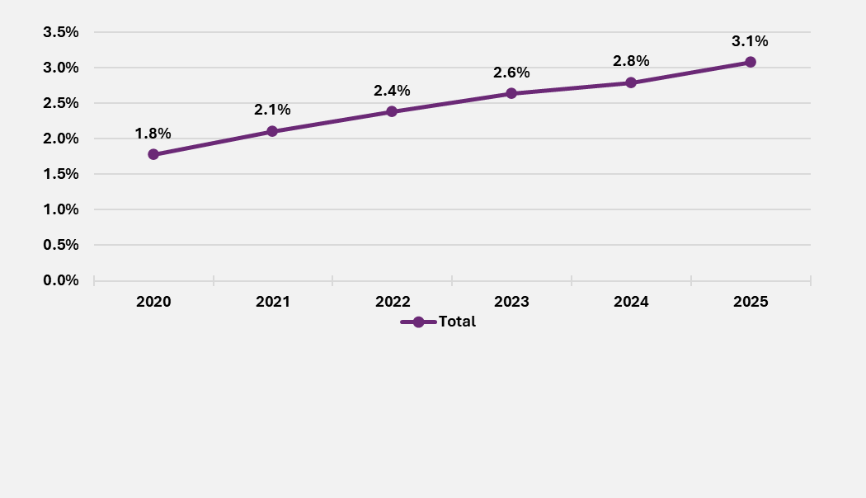
End of figure
Figure 4.4 compares the trend in participation rates over time for participants with a primary disability of autism, developmental delay and all other disability types. Participation rates of those with autism showed a steady growth over time with a larger increase between June 2024 and June 2025, reflecting higher-than-expected numbers of new entrants to the Scheme with autism. In contrast, participation rates of those with developmental delay and all other disability types showed signs of the curve flattening between 30 June 2023 and 30 June 2025.
Figure 4.4. Participants aged 0 to 64 years as a proportion of Australian population by primary disability at 30 June
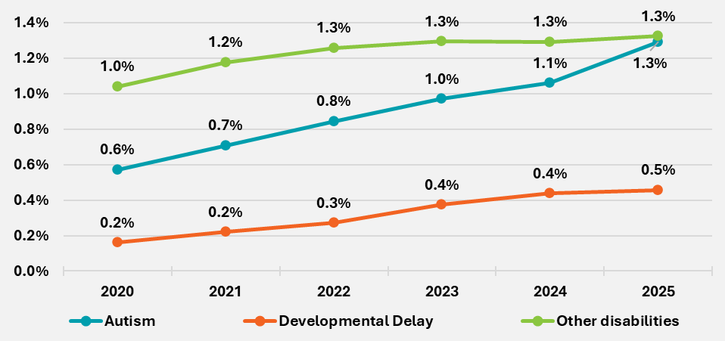
End of figure

The number of new entrants to the Scheme increased in 2024-25
The two drivers of growth in participant numbers are the rate of new entrants to the Scheme, and the rate at which participants leave the Scheme or pass away.
Figure 4.5 shows the total number of new entrants to the Scheme in 2024-25 was 96,866, which was 23% higher than the expected number of 78,707 from the previous review, and 53% higher compared to the total number of new entrants of 63,424 in 2023-24.
Figure 4.5. Number of new entrants to the Scheme by financial year
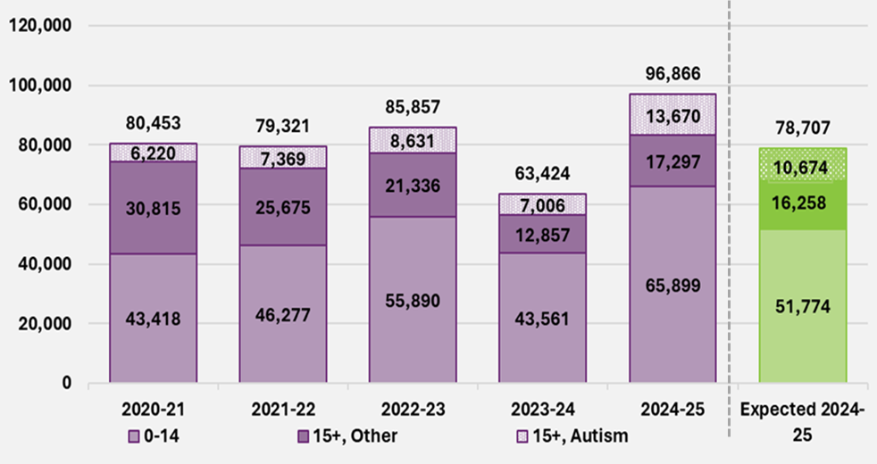
End of figure
When a person with a disability requests access to the Scheme, their request is first validated, and then a decision is made on the person’s eligibility to the Scheme. For those who meet the eligibility requirements, a process is undertaken to determine and approve a first plan.
The higher-than-expected number of new entrants in the 12 months to June 2025 was due to the clearing of the backlog of access requests awaiting validation and a decision. These backlogs had built up as a result of changes to processes following the Agency moving to a new computer system in November 2023. The Agency hired additional frontline staff and improved their capability to process access requests, enabling the backlogs to be cleared. Approving first plans was also prioritised. As a result, the Agency’s performance against the Participant Service Guarantee (PSG) related to access decisions and first plan timeframes had improved significantly by June 2025.
Figure 4.6 shows the number of access requests waiting for validation decreased from a high of 22,497 in July 2024 to 1,857 in January 2025 and remained relatively stable for the remainder of 2024-25. This had a flow on impact to the number of access requests waiting for a decision. Queues of access requests waiting for a decision increased from 6,098 in July 2024 up to a high of 22,715 in December 2024 before reducing sharply to levels of 2,000 or lower from May 2025 onwards.
Figure 4.6 Number of access requests awaiting validation and a decision over 2024-25
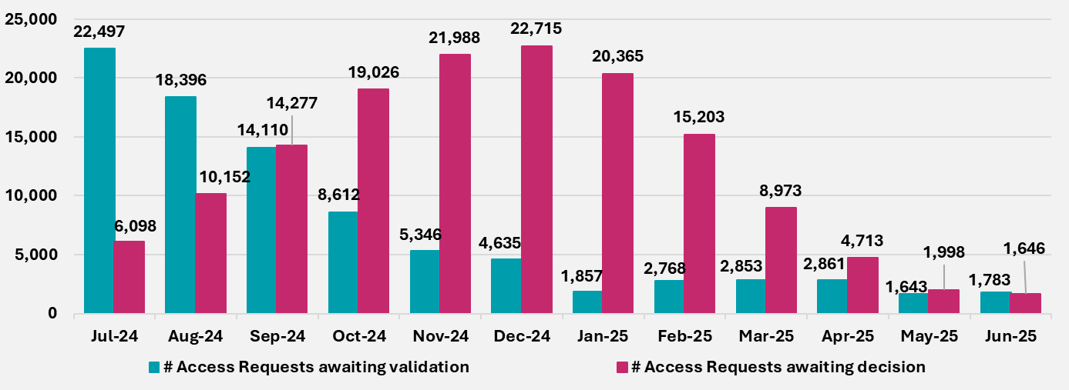
End of table
Table 4.6 shows higher-than-expected numbers of new entrants in 2024-25 were observed across most major disability types, but were mainly driven by:
- The number of new entrants with a primary disability of autism being 8,227 (27.8%) higher than expected.
- The number of new entrants with developmental delay being 8,613 (29.9%) higher than expected.
This was partially offset by 1,276 (29.8%) fewer new entrants with psychosocial disability than expected. The number of new entrants with a primary disability of developmental delay or autism accounted for approximately 78% of all new entrants to the Scheme, compared to the expected proportion of 74%. Reasons for the high proportions of new entrants with developmental delay included the waiting times to obtain an autism diagnosis for children, increased awareness of developmental delay, and a lack of capacity within mainstream services to support children with developmental delay.
Primary disability | Actual | Expected | Difference | % Difference
Autism | 37,868 | 29,641 | 8,227 | 27.8%
Developmental delay | 37,393 | 28,780 | 8,613 | 29.9%
Intellectual disability | 4,428 | 4,235 | 193 | 4.5%
Psychosocial disability | 3,012 | 4,288 | -1,276 | -29.8%
All other disability types | 14,165 | 11,763 | 2,402 | 20.4%
Total | 96,866 | 78,707 | 18,159 | 23.1%
Table 4.6. Actual versus expected number of new entrants by primary disability
End of figure
Table 4.7 shows there was a total of 18,159 (23.1%) more new entrants that joined the Scheme in 2024-25 compared to expected: 14,125 (27.3%) more new entrants aged 0 to 14 and 4,035 (15.0%) more aged 15 and above.
Age band | Actual | Expected | Difference | % Difference
0 to 14 | 65,899 | 51,774 | 14,125 | 27.3%
15+ | 30,967 | 26,932 | 4,035 | 15.0%
Total | 96,866 | 78,707 | 18,159 | 23.1%
Table 4.7. Actual versus expected number of new entrants by age group
End of table

The number of participants leaving the Scheme for reasons other than mortality was higher than expected
Within the context of financial sustainability, it is important to understand the emerging experience of participants leaving the Scheme. Participants may leave the Scheme for various reasons and are analysed in two categories for projection purposes:
- Mortality:
- Participants who have passed away.
- Participants leaving the Scheme for other reasons, including where they:
- No longer met the Scheme’s eligibility criteria.
- Chose to leave the Scheme of their own accord.
- Chose to move into residential aged care if over the age of 65.
A proportion of participants leaving the Scheme was always expected within the original Scheme design, with one of the Scheme’s objectives being early investment and intervention to build capacity and engender greater social and economic participation where support from the NDIS is no longer required.
Figure 4.7 shows the total number of participants leaving the Scheme for reasons other than mortality in 2024-25 was 14,123, 14% higher than the expected number of 12,384 from the previous review, and 92% higher than the 7,353 participants leaving the Scheme in 2023-24. The higher number was due to the Agency’s continued efforts to clear the backlog of eligibility reassessments. Total numbers of ERs completed increased by over 150% in 2024-25 compared to 2023-24, contributing to a higher number of revocations of Scheme access and participants leaving the Scheme.
This was driven by:
- Recruitment and on-boarding of operational staff dedicated to the processing of ERs.
- The productivity of the dedicated team being higher than expected in the previous review.
Figure 4.7. Actual versus expected number and proportion of participants leaving the Scheme for reasons other than mortality by age group
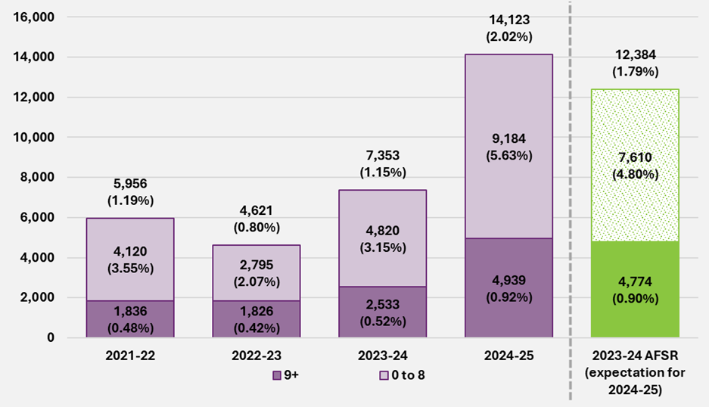
End of figure
Since 30 January 2025, participants who are notified about an eligibility reassessment were given 90 days to provide additional information, extended from 28 days. This information helps understand if participants’ support needs have changed and whether they still meet the eligibility criteria for the Scheme.
The number of participants leaving the Scheme was lower for the 6 months to June 2025, compared to the 6 months to December 2024 because of this change.

The number of participants leaving the Scheme for mortality reasons was in line with expected
The second key driver of participants leaving the Scheme is mortality.
Figure 4.8 shows over the 12 months to June 2025; the total number of participant deaths was 6,158 and was broadly in line with the expected number of 6,005 from the previous review (a rate of 0.88% compared to the expected rate of 0.87%).
Although overall the mortality experience was relatively stable over the last four years, variations were observed at the cohort level. For example, the mortality rate for participants aged 45-64 years has been higher than expected while the rate for those aged 65 and over has been lower than expected for the most recent two years. Experience varies further by characteristics such as disability type and level of support need.
Figure 4.8. Actual vs expected number and proportion of participants leaving the Scheme for mortality reasons by age group
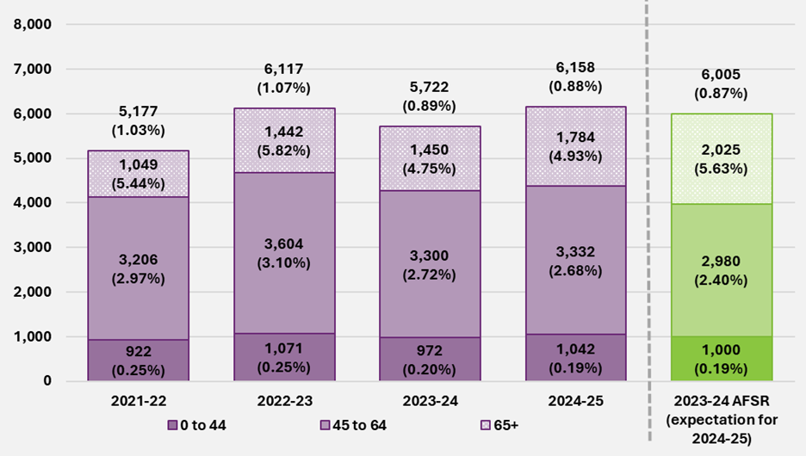
End of figure

The growth in number of participants with Supported Independent Living has moderated
Participants with SIL supports are modelled explicitly in forecasting Scheme expenses because payments on plans with SIL are higher, averaging over $400,000 per year per participant compared with the Scheme average of around $65,800. While the proportion of participants with SIL account for 5% of total participants, payments for participants with SIL make up around a third of total payments. A small change to the expected number of participants with SIL can have a material impact on the expected future expense of the Scheme.
The distribution of participants with SIL supports by age group and level of support need have changed over time.
Figure 4.9 shows that more than half of participants with SIL supports are aged 45 years and over. The proportion of participants with SIL supports aged 65 years and over has continued to increase over the past four years, from 8% at 30 June 2022 to 14% at 30 June 2025.
Figure 4.9. Distribution of participants with SIL supports by age group, at 30 June
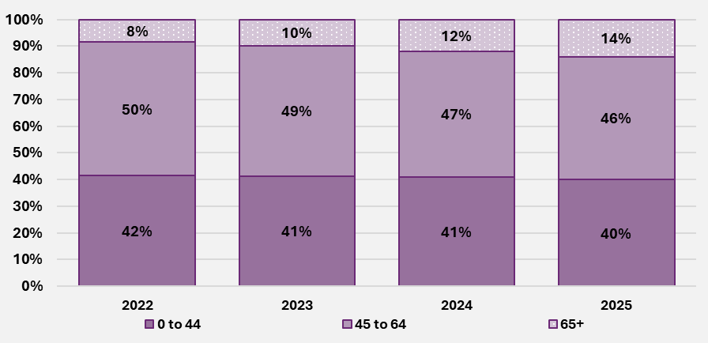
End of figure
As at 30 June 2025, almost 1 in 5 participants with SIL supports are funded for supports on a participant-to-support worker ratio of 1:1 (or greater). Almost all participants with SIL supports (98%) have high support needs, increasing from 95% at 30 June 2023.
The number of Scheme participants with SIL supports increased in 2024-25 due to existing participants moving into SIL arrangements, and, to a lesser extent, new entrants requiring SIL supports. Although the number of Scheme participants with SIL supports has increased, the number of 36,691 was 2.2% (838) lower than the expected number of 37,529 in the previous review, as shown in Table 4.8, driven by more participants leaving for mortality reasons and fewer participants transitioned to SIL supports in 2024-25.
The Agency continues to implement the independent living initiative as part of the 2023–24 Budget’s Scheme reforms initiatives. During 2024-25, the number of home and living applications have been relatively stable.

Table 4.8. Actual versus expected total participants with SIL at 30 June 2025 and net increase in 2024-25
At 30 June 2025 | Actual | Expected | Difference | % Difference
Participant numbers with SIL | 36,691 | 37,529 | -838 | -2.2%
Net increase with SIL | 1,841 | 2,679 | -838 | -31.3%
End of table

Plan budgets and committed supports
To understand the Scheme experience, it is important to differentiate plan budgets from committed supports.
Plan budgets
Plan budgets refer to the amount of funds that participants may access for their needs before the plan expiry date, according to their plan at a specific point in time. Total plan budgets represent the total funds available to all Scheme participants at a point in time.
Plan durations vary from plan to plan and can be a few days to a few years in length. Average annualised plan budgets are used to measure plan budgets available to a single participant on average, assuming the plan duration is a single year, at a point in time. This is an effective way to compare changes in plans over time or to compare plans across different participant cohorts. Plan budgets and plan duration may change over time to reflect annual price increases, or a participant’s changing support needs over time.
Plan budgets is a snapshot at a point of time, so there is no retrospective change to this measure.
Committed supports
Committed supports refer to the amount of funds available to the participants over a period, considering all the changes in plan budgets during that period. They reflect the actual commitment of the Agency over that period, for either a single participant or the whole Scheme.
However, there can be retrospective changes to the amount of committed supports during a period. This is mainly due to:
- Overspending on plans, or intra-plan inflation.
- Annual pricing increase on the unspent portion of plan budgets being spread across the entire duration of the respective plans.
For this reason, the final or ultimate committed supports for a period may not be known until many months after the period has ended.

In this report, reference to committed supports allows for these retrospective changes.
Committed supports is an important measure to calculate utilisation rates, which is defined as the proportion of committed supports over a period used by participants to purchase supports.

Total annualised plan budgets increased by 16% over 2024-25
Total annualised plan budgets at 30 June 2025 were $61.0 billion, 16% higher than those at 30 June 2024. The overall growth in plan budgets over 2024-25 is comparable to that in 2023-24 (15%).
The committed supports estimate for 2024-25 was $61.3 billion, 13% higher than those for 2023-24. The overall growth in committed supports was lower than in 2023-24 (17%).
Figure 4.10. Total annualised plan budgets and committed supports at 30 June
over time ($billion)
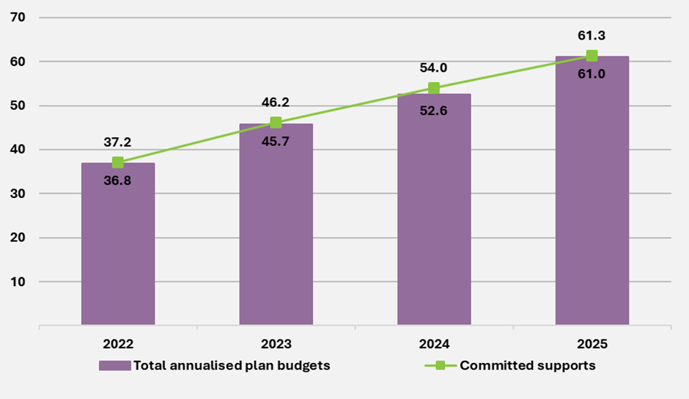
End of figure

Average annualised plan budgets increased by 4% in 2024-25
Figure 4.11 shows the overall average annualised plan budget increased by 3.8% in the last 12 months ending 30 June 2025. This compares with an average annual growth rate of 6.2% from 30 June 2022 to 30 June 2025.

Figure 4.11. Average annualised plan budget at 30 June over time ($)
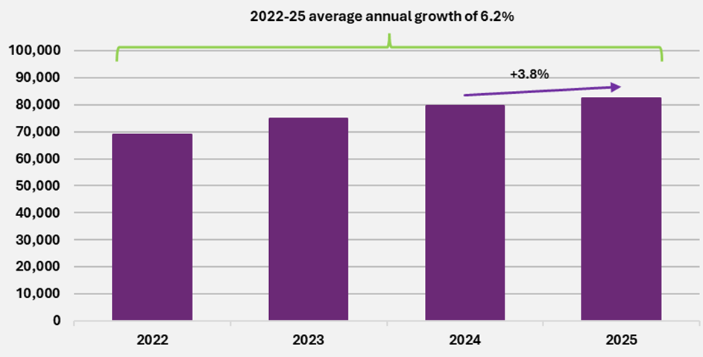
End of figure

Average annualised plan budget growth moderated more for participants with SIL supports
Figure 4.12 shows for participants in SIL arrangements, average annualised plan budgets increased at a slower rate of 5.1% in 2024-25, compared to the average annual growth of 9.8% over the three years to 30 June 2025. For participants not in SIL arrangements the growth in 2024-25 of 5.5% was slightly higher than the average annual growth of 5.1% over the three years to 30 June 2025.
Figure 4.12. Average annualised plan budget by SIL status at 30 June over time ($)
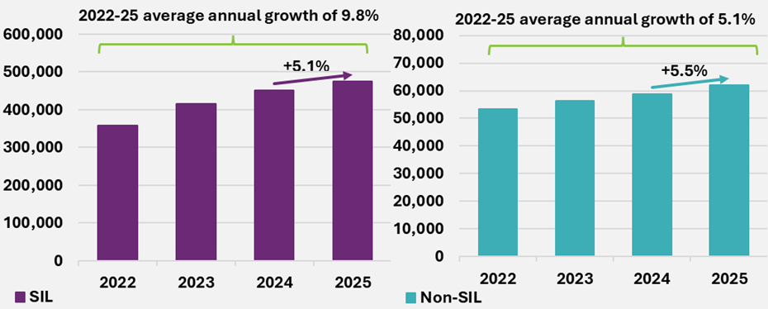
End of figure

Annual growth in plan budgets is higher for older age groups with moderation observed in 2024-25
Figure 4.13 shows for all age groups, other than children aged 0 to 14 years, average annualised plan budgets grew at a slower rate in 2024-25, compared to the annual growth over the three years to 30 June 2025. Growth in 2024-25 was 0.5% for participants aged 15 to 24 years, 5.7% for ages 25 to 64 and 9.0% for ages 65 and above.
Average annualised plan budgets for children aged 0 to 14 years increased by 5.0%, in line with the average annual growth of 5.1% over the three years to 30 June 2025.
Figure 4.13. Average annualised plan budget by age group at 30 June over time ($)
(all participants)
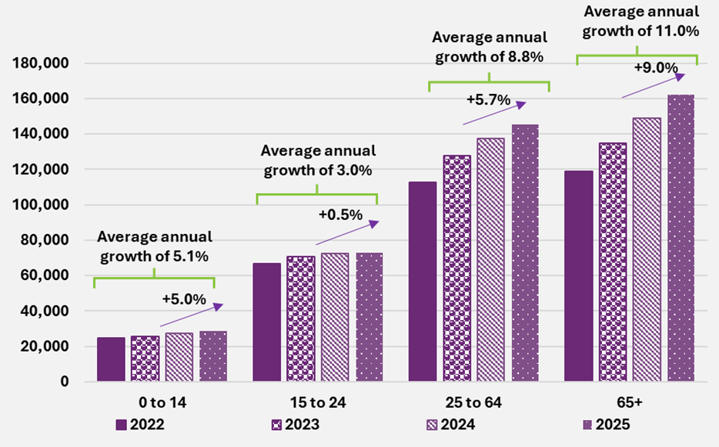
End of figure

Figure 4.14 shows for participants with SIL arrangements the average annual growth in plan budgets for the three years ending 30 June 2025 is higher for older age groups. Average annual growth increases from 8.8% for ages 0 to 24, up to 10.9% at ages 65 and above. Growth in 2024-25 moderated to between 4.4% for ages 0 to 24, up to 6.3% at ages 65 and above.
Figure 4.14. Average annualised plan budget by age group at 30 June over time ($) (participants with SIL supports)
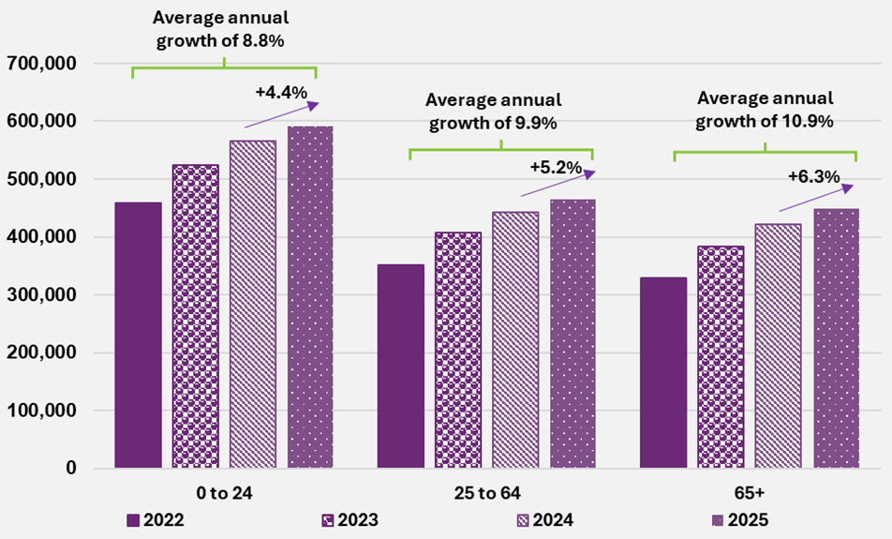
End of figure

Figure 4.15 shows for participants not in SIL arrangements the growth in average plan budgets in 2024-25 was close to the average annual growth for the three years to 30 June 2025. Growth in 2024-25 was 5.0% for children aged 0 to 14 years, 3.0% for ages 15 to 24 and 7.9% for ages 25 and above.
Figure 4.15. Average annualised plan budget by age group at 30 June overtime ($) (participants without SIL supports)
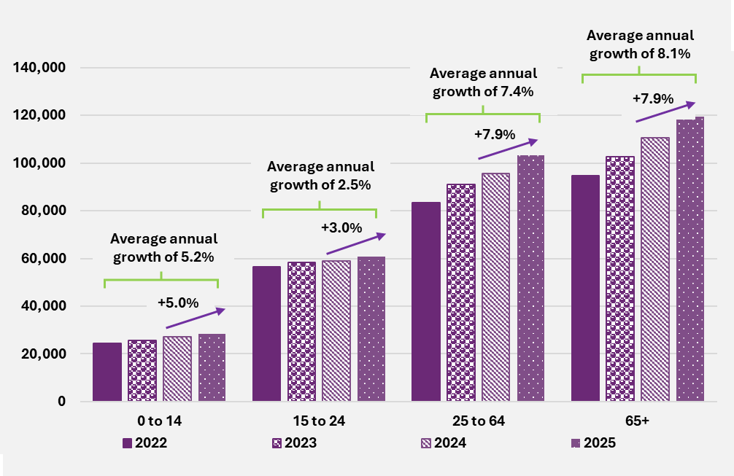
End of figure

Plan budgets do not show signs of stabilising over a participant’s time in the Scheme
Increases in average plan budgets by participant entry years and number of years in the Scheme are shown in Figure 4.16. Across all entry years, average plan budget increases with the number of years in the Scheme. However, the average plan budgets (for any number of years in the Scheme) after 30 June 2019 were at a lower level compared to those in prior years. This reflects a changing mix of participants over time, with the earlier years prioritising the transition of participants from existing federal, state and territory government Schemes into NDIS. Conversely, in recent years there has been a growing proportion of younger participants entering the NDIS with disabilities such as developmental delay. Children, on average, have lower plan budgets than adults.

Figure 4.16. Average budgets by years of entry ending 30 June and years in Scheme
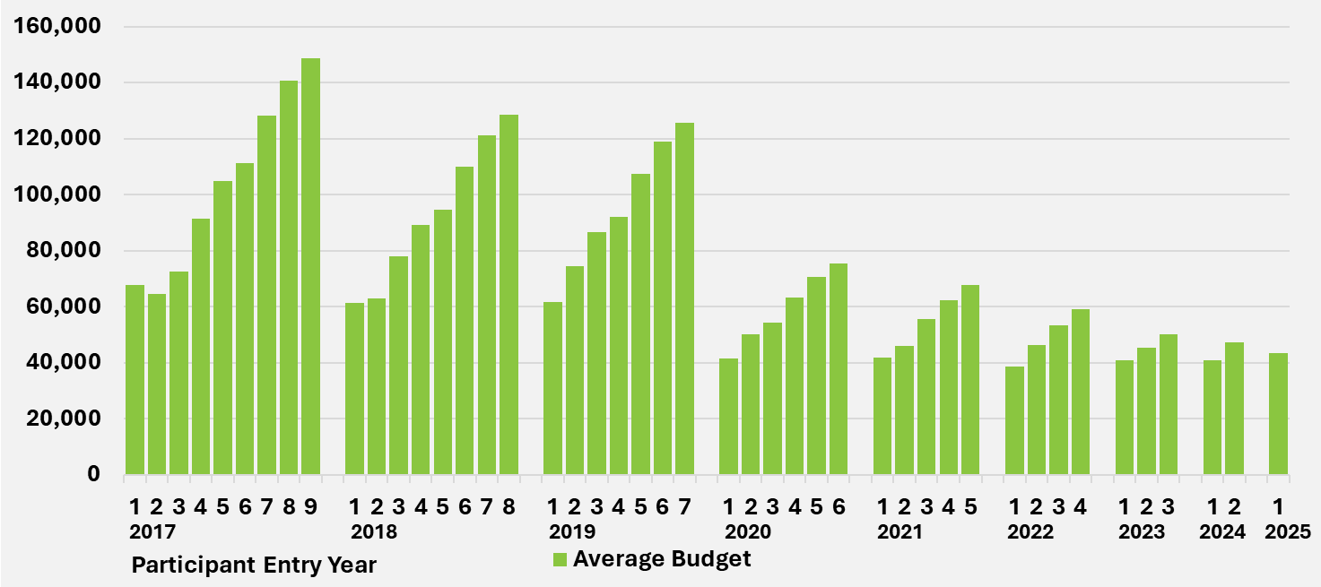
End of figure

Utilisation
The proportion of committed supports over a period used by participants to purchase supports is referred to as the utilisation rate.
Utilisation rates are calculated based on the total payments for all supports supplied in the period, regardless of when the payment is made (i.e. on an ‘accrual’ basis). Ultimate utilisation rates for a given period, may not be known until several months after the period has ended, due to payment delays and retrospective changes to committed supports.
To monitor utilisation experience in a timely manner, a consistent measure is often used that allows for a lag (3 months) in the payments and committed supports experience. This enables a comparison of utilisation rates and trends over time.
There are various reasons that the utilisation rate is not 100% depending on individual participant behaviours and preferences, including:
- Change of circumstance leading to supports included in plan no longer being required.
- Lack of availability of suitable disability supports.
- Choice of the participant not to access supports included in their plan.
- Purchase of supports at a price which is lower than that on which a participant’s plan is based.
- Overspending on plans (which leads to overutilisation).
- Inclusion of contingency type supports in plans, e.g. respite care.

Scheme utilisation was 76% for the 2024-25 financial year
Table 4.9 provides an overview of Scheme utilisation rates by support years on 30 June 2025. Utilisation at the Scheme level has increased from a rate of 71.5% in 2020-21 and prior years, to a high of 77.5% in 2023-24, reducing to 75.6% in 2024-25.
Table 4.9. Estimated utilisation rate by support year at 30 June 2025
Utilisation component | 2020-21 and prior | 2022-23 | 2023-24 | 2023-24 | 2024-25 | Total
Committed supports ($m) | 83,882 | 37,188 | 46,192 | 54,046 | 61,269 | 282,577
Accrual payments ($m) | 59,986 | 27,931 | 35,184 | 41,907 | 46,321 | 211,329
Utilisation rate (%) | 71.5% | 75.1% | 76.2% | 77.5% | 75.6% | 74.8%
End of table

Utilisation rates are higher the longer a participant has been in the Scheme
Figure 4.17 shows that utilisation rates increase with the number of years participants remain active in the Scheme, especially for the first five years.
The greatest increase in utilisation occurs between the first and second years, as participants learn what supports and services can be accessed and how to use their plans when they first join the Scheme. Utilisation of plan budgets for participants with up to 12 months in the Scheme is 56%, increasing to 68% in the second year, 72% in the third year and continuing to increase up to 80% for participants in their eighth year in the Scheme. It takes time for participants to understand how to best access the supports in their plans, and to find the most suitable providers of support for their needs.
Utilisation experience for participants active in the Scheme for more than five years on 30 June 2025, is heavily influenced by participants who transitioned from state and territory disability programs. Observed utilisation rates for this cohort are very different on average compared to participants who joined the Scheme in the last five years (2020-25), after the national rollout of NDIS. The utilisation experience beyond five years could change over time as the mix of participants in the Scheme changes.

Figure 4.17. Utilisation rates are higher the longer a participant has been
in the Scheme
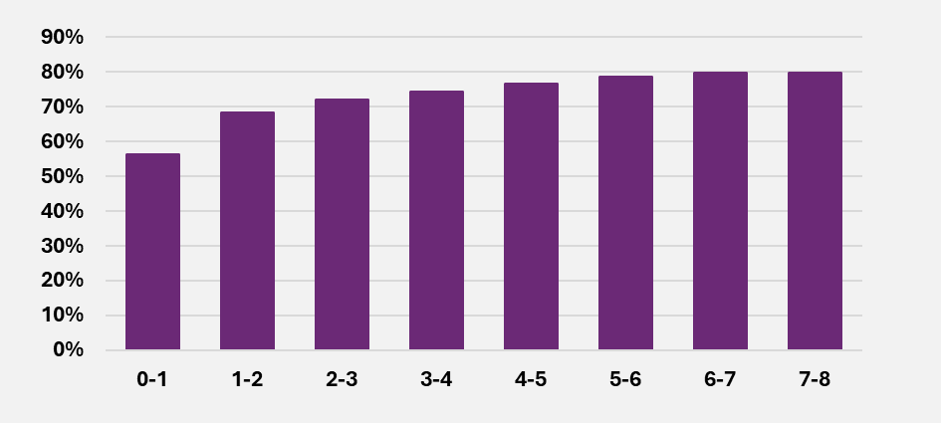
End of figure

Utilisation rates by participant SIL status
Figure 4.18 shows participants in SIL arrangements, on average, have a relatively higher rate of utilisation (87.2%) compared with participants not in SIL arrangements (69.5%).
Figure 4.18. Utilisation of committed supports from 1 October 2024 to 31 March 2025
by SIL status
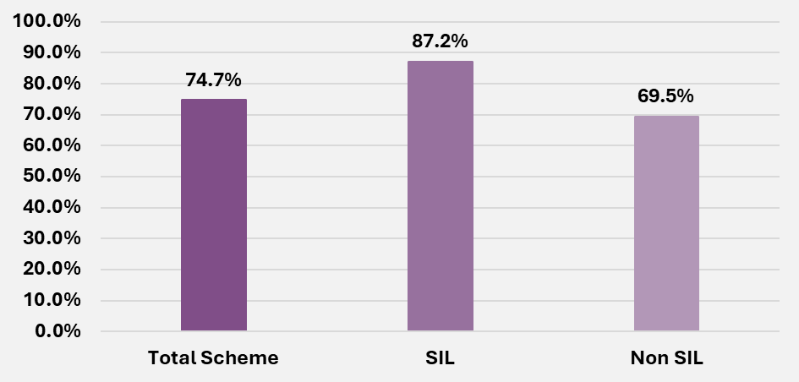
End of figure

  - Total Scheme expenses

Scheme expenses for the year were lower than expected
Scheme expenses for 2024-25 is the total of all payments incurred for supports provided to participants during the 12 months ending 30 June 2025. The cash basis of Scheme expenses reflects payments made within the period under consideration while the accrual basis allows for payments incurred but not yet paid at the end of the period (in this case 30 June 2025.
For 2024-25, Scheme expenses on an accrual basis were $46.3 billion, $0.5 billion (1.1%) lower than the 2024-25 estimate of $46.9 billion in the June 2024 projections. This can be expressed as a total of $61.3 billion of committed supports across all participant plan budgets of which 75.6% of this total was utilised by participants.
Table 4.10. 2024-25 Accrual payments and committed supports
 | Accrual payments ($b) | Committed supports ($b) | Utilisation (%)
Total | 46.3 | 61.3 | 75.6%
End of table
Over 2024-25, Scheme expenses on a cash basis were $45.9 billion. This was $0.6 billion (1.3%) lower than the estimate of $46.4 billion in the June 2024 projections.

Lower Scheme expenses mostly related to participants with SIL arrangements
Table 4.11 compares the Scheme expense experience in 2024-25 on a cash basis against the expectations in the June 2024 projections by SIL status. Scheme expenses related to participants with SIL supports were $602 million (3.7%) lower than expected. Scheme expenses related to participant without SIL supports were in line with expected.
Table 4.11. 2024-25 Scheme expense experience, by SIL status of participants ($m).
Cash payments | Actual | Expected | Difference | Difference %
SIL | 15,537 | 16,140 | -602 | -3.7%
Non SIL | 30,307 | 30,302 | 4 | 0.0%
Missing | 9 | 0 | 9 | No Value
Total | 45,853 | 46,442 | -588 | -1.3%
End of table
Table 4.12 shows a breakdown of Scheme expenses related to participants with SIL arrangements by major primary disability groups. The difference compared to expectations was mainly driven by participants with intellectual disability, autism or psychosocial disabilities. Scheme expenses for these participants were around $421 million lower than expected in total. This represents 70% of the total variance in Scheme expenses for participants with SIL arrangements.
Table 4.12. Scheme expense experience, participants with SIL by primary
disability ($m)
Primary disability | Actual | Expected | Difference | Difference %
ABI | 1,475 | 1,538 | -63 | -4.1%
Autism | 2,162 | 2,277 | -115 | -5.1%
Intellectual disability | 5,981 | 6,177 | -196 | -3.2%
Other neurological | 1,352 | 1,402 | -51 | -3.6%
Psychosocial disability | 1,614 | 1,724 | -110 | -6.4%
All other disability types | 2,953 | 3,021 | -68 | -2.2%
Total | 15,537 | 16,140 | -602 | -3.7%
End of table
Table 4.13 shows a breakdown of Scheme expenses related to participants not in SIL arrangements by major primary disability groups. The difference between actual and expected varies by the primary disability groups, but the difference is very minimal at the total level.
Table 4.13. Scheme expense experience, participants without SIL by primary
disability ($m)
Primary disability | Actual | Expected | Difference | Difference %
ABI | 1,708 | 1,675 | 33 | 2.0%
Autism | 7,291 | 7,587 | -296 | -3.9%
Intellectual disability | 6,018 | 6,047 | -29 | -0.5%
Other neurological | 2,382 | 2,260 | 122 | 5.4%
Psychosocial disability | 4,110 | 4,177 | -68 | -1.6%
All other disability types | 8,798 | 8,555 | 242 | 2.8%
Total | 30,307 | 30,302 | 4 | 0.0%
End of table

Reduction in average plan growth in second half of 2023-24 drove lower 2024-25 payments
The recent lower payment experience compared with expected, was partially driven by lower plan inflation in the second half of 2023-24. Figure 4.19 shows the quarterly plan inflation (annualised) from Q1 2023-24 to Q4 2024-25.
Total plan inflation (annualised and net of indexation) decreased over the 2023-24 year from 12.7% in Q1 to 7.5% in Q3, before gradually increasing again to a peak of 12.1% in Q2 2024-25. The plan inflation decreased again to 9.7% in Q4 2024-25.
There is usually some lag before plan inflation experience impacts payment levels, therefore, the lower level of plan inflation in 2023-24 from Q2 likely contributed to lower-than expected payments in 2024-25.
Figure 4.19. Quarterly plan inflation rate net of indexation for 2024-25
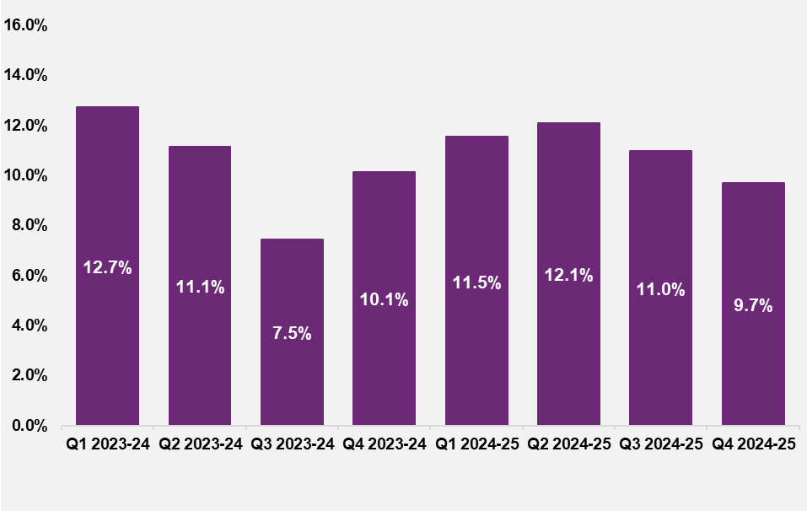
End of figure

Monthly utilisation rates reduced in 2024-25 compared to last year
Figure 4.20 shows monthly utilisation in the 12 months leading up to June 2025. Monthly utilisation has been consistently lower since October 2024 compared to the same period a year earlier.
This is another reason for the lower-than-expected payment experience in the 12 months to 30 June 2025.
The lower utilisation in 2024-25 is likely driven by the introduction of Section 10 lists of included and excluded supports, and integrity and Crack Down on Fraud activities, including changes made to claims process for self-managed plans, banning of providers and manual review of claims of some providers prior to payment.
Figure 4.20. Monthly utilisation (year on year comparison) for 2024-25
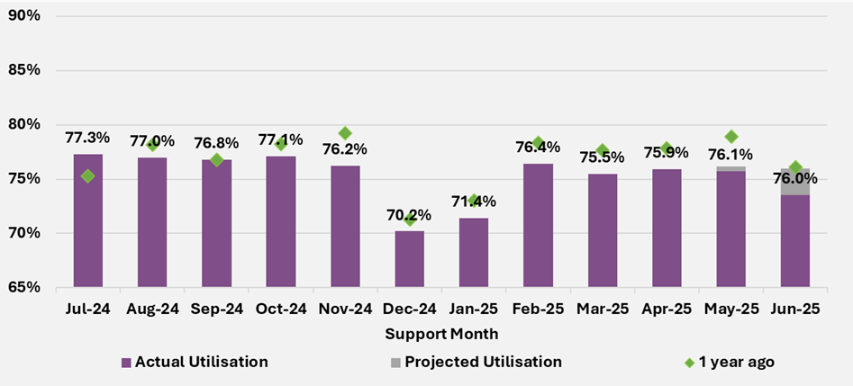
End of figure

  - Average payments per participant
Table 4.14 shows for the participants with SIL arrangements, average payments per participant in 2024-25 were 2.3% lower than the estimate in the June 2024 projections, and 0.6% lower for participants not in SIL arrangements.
Table 4.14. 2024-25 average payments experience, by SIL status of participants ($).
Average payment per participant⁴² | Actual | Expected⁴³ | Difference | Difference %
SIL | 433,300 | 443,500 | -10,300 | -2.3%
Non SIL | 45,900 | 46,200 | -300 | -0.6%
Total | 65,800 | 66,600 | -800 | -1.2%
End of table

Average payment growth continued to moderate in 2024-25
Figure 4.21a shows that the average payments per participant in 2024-25 increased by 2.2% relative to 2023-24 payment levels. The observed growth in 2024-25 payments has moderated compared to the average growth of 6.1% per annum over the past three years.
Figure 4.21a. Average payments for all participants from 2021-22 to 2024-25
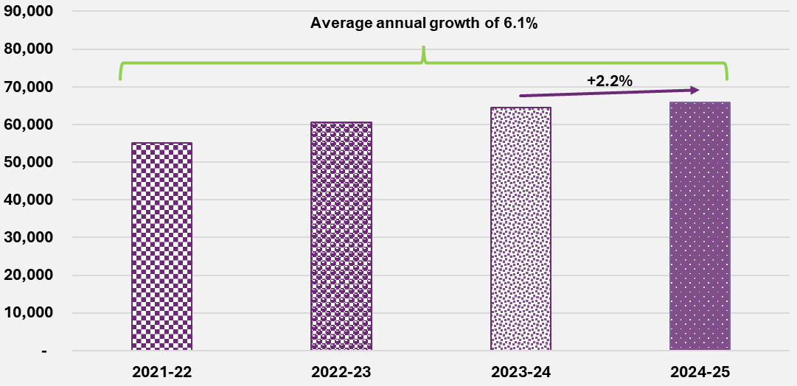
End of figure

Figure 4.21b shows that the average payments for participants with SIL supports grew at an average rate of 8.0% respectively, moderated to 3.8% in the last 12 months.
Figure 4.21b. Average payments for participants with SIL supports from 2021-22 to 2024-25
Figure 4.21c shows that the average
payments for participants Non SIL supports grew at an average rate of 5.2% respectively, moderated to 2.1% in the last 12 months.
Figure 4.21c. Average payments for participants without SIL supports from 2021-22 to 2024-25

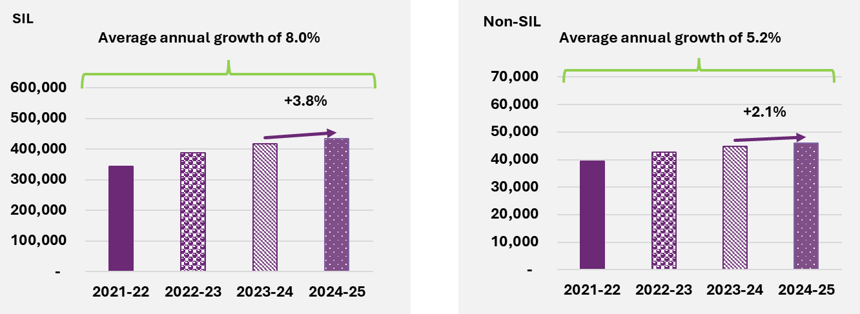

End of table End of table

Lower average payment growth in 2024-25 observed across all age groups
Average payments for adults and older adults are relatively higher and grow faster than those for children and young adults. Despite these differences, the growth rates moderated over time for participants at all age groups.
Figure 4.22 shows the change in average payments in 2024-25, compared to 2023-24 payments levels, for all age groups were lower than their corresponding average annual growth rate from 2021-22 to 2024-25.
Figure 4.22. Average payments for all participants by age group from
2021-22 to 2024-25
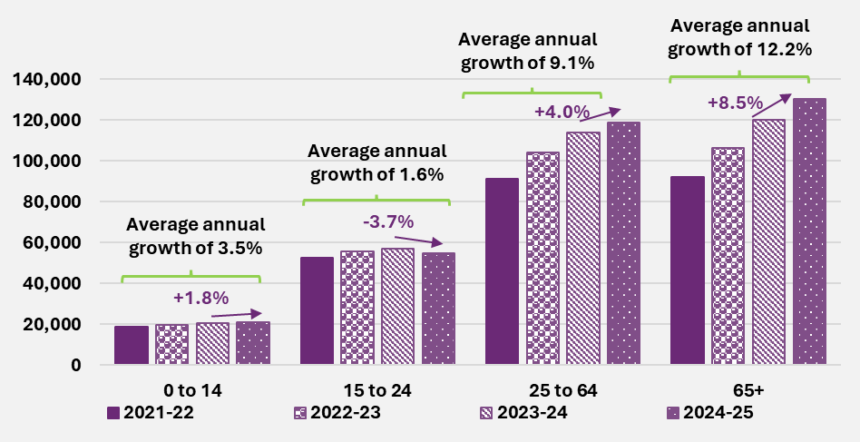
End of figure
Average payment growth for all participants increased with age in general, with rates of growth within each age group moderating over the last three financial years. The moderation for young adults was particularly noticeable, the average payment reduced by 3.7% in 2024-25, where all other age groups continue to experience growth in average payments.

Relatively higher average payment growth in 2024-25 observed for participants aged 65+ not in SIL arrangements
Figures 4.23a and 4.23b similarly show that the growth in average payments for moderated across all age groups in 2024-25 for both participants with SIL arrangements and those not in SIL arrangements. Growth in average payments in 2024-25, relative to 2023-24 payment levels, is lower than the average annual growth rate over the 2021-22 to 2024-25 financial years.

Figure 4.23a. Average payments for participants with SIL supports by age group
from 2021-22 to 2024-25
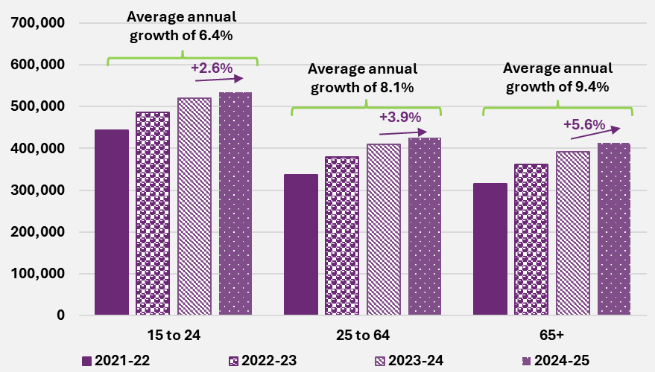
End of figure
Figure 4.23b also shows that for participants not in SIL arrangements, the average payment growth for adults and older adults were much higher than those of children and young adults.
The growth in average payments of 7.0% in 2024-25 for participants not in SIL arrangements and aged 65+ is relatively higher than that for participants aged 65+ with SIL arrangements of 5.6% in 2024-25.

Figure 4.23b. Average payments for participants without SIL supports by age group from 2021-22 to 2024-25
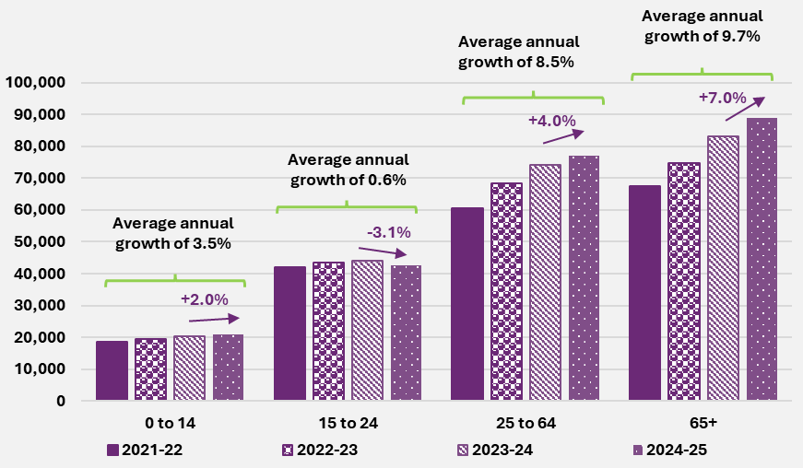
End of figure

Components of growth in average payments
Scheme expenses increase over time due to many factors, such as the participant related impacts, including the net increase in numbers of participants in the Scheme, normal inflationary sources (such as general increases in wages and consumer prices), as well as real growth in payments over and above the normal inflationary sources.
There are a number of factors contributing to the real growth in payments, including:
- Some participants will access SIL supports over time – participant SIL needs are assessed, and higher support needs are reflected as an increase in their plan budget.
- When children transition from development delay to other disabilities, such as autism – support needs generally increase.
- The increased need for supports as the participants age over time – with a change in support needs reflected in the participants plan budget.
- Other growth in payments as participant circumstances and support needs change, referred to as additional growth in payments - participant plan budgets are re-assessed, or participants change their spending behaviour resulting in increases to participant plan budgets or increased utilisation of their plan budget.
Each of these factors are allowed via separate assumptions and/or transition modelling in the projection of Scheme expenses.
Table 4.15 shows a breakdown of the observed annual growth in average payments per participant from 2021-22 to 2024-25.
The growth in average payments per participant was 2.2% over 2024-25. This consists of an increase of 2.8% related to pricing impacts, a decrease of 4.4% due to changes in participant mix mostly related to a higher proportion of participants at younger ages and an increase of 3.9% due to additional growth impacts.
The additional growth in payments of 3.9% in 2024-25 is 0.9% lower compared to 2023-24.
Table 4.15. Breakdown of growth in payments per participant
Item of growth | 2021-22 | 2022-23 | 2023-24 | 2024-25 | Average 2021-25
Observed growth | 1.8% | 9.9% | 6.2% | 2.2% | 5.0%
Pricing impact | 2.4% | 6.8% | 4.1% | 2.8% | 4.0%
Participant mix impact | -6.2% | -4.3% | -2.8% | -4.4% | -4.4%
Additional growth | 5.6% | 7.4% | 4.8% | 3.9% | 5.4%
End of table
The pricing impact reflects growth in average payments due to higher prices being paid for supports, in line with the outcome of the NDIS Annual Price Review (APR) effective at the beginning of the financial year (1 July). The outcomes of the 2023-24 NDIS APR were effective from 1 July 2024 and reflected in the 2024-25 participant payments, contributing 2.8% to the overall growth in average payments for 2024-25.
The participant mix impact reflects growth in average payments due to changes in total participant plan budgets and overall percentage utilisation at the Scheme level, arising from changes in mix of participant characteristics, by age, primary disability group, SIL status of participants and maturing of new entrants. Changes in mix of participants contributed -4.4% to the overall growth in average payments for 2024-25. This means average payments per participant, after adjusting for participant mix, are 4.4% lower compared to 2023-24.
Additional growth in payments, over and above pricing impacts and changes in participant mix, contributed 3.9% to the overall growth in average payments for 2024-25. This additional growth in payments is linked to observed plan inflation over and above normal inflationary sources, and over-utilisation of participant plan budgets.
End of Section 4

Projections

Total Scheme expense projections
This section shows the total Scheme expense projections for each financial year on a cash basis and accrual basis.
The accrual basis results relate to support provided in a financial year but not yet paid by the end of that financial year, e.g. 2025-26 accrual basis results will include all supports provided prior to 30 June 2026 but not yet paid by 30 June 2026.
In the June 2025 projections, committed supports are projected for each future period, and utilisation rates are applied to the committed supports to arrive at estimated Scheme expenditure on accrual basis (i.e. payments for supports).
This is a change in methodology compared with previous Scheme projections where payments were modelled directly. The new methodology enables more explicit modelling of the impacts of plan inflation and utilisation and a better understanding of the projected committed supports and utilisation separately.
The cash basis results are expected cash payments in each financial year, which is derived from the accrual basis projections above, with adjustment to allow appropriately for the expected delay in payments.

Participant number projections
Table 5.1 shows that the Scheme is projected to have a population of 861,526 participants at 30 June 2029 of whom 802,724 are expected to be aged 0 to 64. This is equivalent to a participation rate of 3.4% of the Australian general population aged 0 to 64.
Table 5.1. June 2025 projection of participant numbers at 30 June
Participant numbers | 2025 | 2026 | 2027 | 2028 | 2029 | 2035
0-64 years | 700,306 | 735,221 | 756,078 | 773,723 | 802,724 | 991,800
65+ years | 39,108 | 44,484 | 49,657 | 54,331 | 58,802 | 80,300
Total | 739,414 | 779,705 | 805,735 | 828,054 | 861,526 | 1,072,099
Participation rate (0-64) | 3.1% | 3.2% | 3.3% | 3.3% | 3.4% | 4.0%
End of figure
Table 5.2 and Table 5.3 show the split in the projection between existing participants and future participants (i.e., new entrants post 30 June 2025). At 30 June 2035, 52% of projected participants are estimated to be existing Scheme participants, with 48% being future new entrants to the Scheme.
Table 5.2. Split of participant numbers between existing and future participants
at 30 June
Number of participants | 2025 | 2026 | 2027 | 2028 | 2029 | 2035
Existing Scheme participants | 739,414 | 706,214 | 672,874 | 648,206 | 632,649 | 557,963
Future participants | 0 | 73,492 | 132,861 | 179,848 | 228,876 | 514,137
Total | 739,414 | 779,705 | 805,735 | 828,058 | 861,526 | 1,072,099
End of table
Table 5.3. Proportional split of participants between existing and future participants
at 30 June
Number of participants | 2025 | 2026 | 2027 | 2028 | 2029 | 2035
Existing Scheme participants | 100% | 91% | 84% | 78% | 73% | 52%
Future participants | 0% | 9% | 16% | 22% | 27% | 48%
Total | 100% | 100% | 100% | 100% | 100% | 100%
End of table

Committed supports and utilisation projections
Combining projections of the number of participants with average committed supports assumptions results in the Scheme committed supports projections for each financial year. Utilisation rates are applied to projected committed supports to determine projected Scheme expenses. The results at total Scheme level are shown in Table 5.4 below.
Committed supports are projected to rise each year of the projection. Utilisation is projected to fall in 2025-26 and 2026-27, primarily due to the implementation of the funding periods reform and scheme integrity measures. From 2027-28, utilisation remains relatively stable.
Table 5.4. Total committed supports, utilisation and Scheme expense projections
Scheme expenses | 2024-25 | 2025-26 | 2026-27 | 2027-28 | 2028-29 | 2034-35
Total Committed Supports ($m) | 61,269 | 68,331 | 73,713 | 79,212 | 85,101 | 130,612
Utilisation (%) | 75.6% | 74.2% | 73.2% | 73.4% | 73.4% | 73.3%
Total Scheme expenses (accrual basis) ($m) | 46,347 | 50,705 | 53,958 | 58,126 | 62,461 | 95,755
End of table

Scheme expense projection
Table 5.5 shows the June 2025 projection of Scheme expenses, incorporating revisions to assumptions and changes in future expectations since the June 2024 projections. The projection implicitly allows for the expected impact of reform activities that have partially or fully emerged in Scheme experience over 2024-25. It explicitly allows for the impact of other reform activities, or programs that are either in the process of being implemented, or under development and expected to impact Scheme experience in future years.
As the design of the Thriving Kids program is not yet finalised, assumptions regarding Foundational Supports in the June 2025 projections are consistent with those in the June 2024 projections, but with commencement from 1 July 2026.
The projected total Scheme expenses on an accrual basis are $50.7 billion in 2025-26, increasing to $95.8 billion in 2034-35. Total projected Scheme expenses are $225.3 billion for the four years to 30 June 2029.
It is important to recognise that the projected Scheme expenses are shown in nominal terms, i.e., that future dollars of estimated Scheme expenses include the effects of inflation over time. This impact of inflation increases over the longer term and so is particularly significant for the result in 2034-35. Scheme expenses are estimated to be 1.8% of Gross Domestic Product (GDP) in 2025-26, increasing to 2.1% in 2034-35. In considering longer-term projections it is recommended that users refer to expenses as a percentage of GDP rather than nominal dollar figures as these provide a more meaningful measure of Scheme expenses.
Table 5.5. June 2025 projection of Scheme expenses ($m)
Scheme expenses | 2025-26 | 2026-27 | 2027-28 | 2028-29 | 2034-35 | Total 2025-29
Scheme expenses (cash basis) (0-64) | 44,839 | 47,227 | 50,439 | 53,847 | 81,550 | 196,353
Scheme expenses (cash basis) (65+) | 5,555 | 6,400 | 7,330 | 8,229 | 13,609 | 27,514
Total Scheme expenses (cash basis) | 50,394 | 53,627 | 57,769 | 62,076 | 95,159 | 223,866
Scheme expenses (accrual basis) (0-64) | 45,114 | 47,517 | 50,749 | 54,179 | 82,058 | 197,559
Scheme expenses (accrual basis) (65+) | 5,591 | 6,441 | 7,377 | 8,282 | 13,697 | 27,692
Total Scheme expenses (accrual basis) | 50,705 | 53,958 | 58,126 | 62,461 | 95,755 | 225,250
Total Scheme expenses (% of GDP) | 1.8% | 1.8% | 1.8% | 1.9% | 2.1% | 1.8%
Total Scheme expenses (accrual basis) today's dollars | 46,229 | 48,460 | 49,437 | 50,588 | 59,309 | 194,714
End of table
Table 5.6 shows projected Scheme expenses on an accrual basis, split between existing Scheme participants and participants expected to join the Scheme after 30 June 2025. By 2034-35, 68% of projected expenses relate to existing Scheme participants, with 32% relating to new entrants.
Table 5.6. Split of Scheme expenses ($m accrual basis) by existing and new participants
Scheme expenses | 2025-26 | 2026-27 | 2027-28 | 2028-29 | 2034-35
Existing Scheme participants | 49,652 | 50,552 | 52,030 | 53,555 | 65,147
Future participants | 1,053 | 3,407 | 6,097 | 8,905 | 30,608
Total Scheme expenses | 50,705 | 53,958 | 58,126 | 62,461 | 95,755
Scheme expenses (%)
Existing Scheme participants | 97.9% | 93.7% | 89.5% | 85.7% | 68.0%
Future participants | 2.1% | 6.3% | 10.5% | 14.3% | 32.0%
Total Scheme expenses | 100% | 100% | 100% | 100% | 100%
End of table

Projected annual growth in Scheme expenses
Table 5.7 shows year-on-year growth in projected Scheme expenses over the four years to 30 June 2029. Growth is expected to reduce from 9.4% in 2025-26 to rates below 8% from 2026-27 onwards, consistent with the commitment made by National Cabinet in April 2023.
Total growth in projected Scheme expenses is split into three key components: participant impacts (new entrants to, and participants leaving the Scheme), pricing impacts (resulting from the Scheme’s Annual Pricing Review and driven by consumer and wage inflation over time) and the real growth in payments above pricing impacts.
In 2025-26, the growth in Scheme expenses due to the participant impact is 2.0%, the pricing impact is 3.0% and the real growth in payments is 4.4%. By 2028-29 these are projected to be 1.4% for participant impacts, 3.5% for pricing impacts and 2.6% for real growth in payments.
The participant impact is expected to reduce from 2026-27 onwards, reflecting the estimated impact of the introduction of Foundational Supports, with lower numbers of children expected to join the Scheme, and higher numbers of children forecast to leave the Scheme as the current queue of eligibility reassessments are completed. The reduction in the real growth in payments is driven by the impact of the Scheme reforms and operational measures focused on moderating additional growth in plan budgets.
In 2034-35, growth in Scheme expenses is projected to be 7.2%, including 2.1% from real growth in payments.
Real growth in payments above pricing impacts is further split into impacts arising due to SIL entry and exit, transitions of children from developmental delay to other disability types, ageing, and additional growth.
This demonstrates that there are several factors which lead to increases in payment levels over time. Pricing impacts and real growth in payments are the key drivers of growth in projected Scheme expenses.
Table 5.7. Projected annual growth in Scheme expenses
Scheme expenses | 2025-26 | 2026-27 | 2027-28 | 2028-29 | 2034-35
Participant impacts | 2.0% | 1.7% | 1.4% | 1.4% | 1.6%
Pricing impacts | 3.0% | 3.7% | 3.5% | 3.5% | 3.5%
Real growth in payments | 4.4% | 1.0% | 2.8% | 2.6% | 2.1%
Additional growth | 1.4% | -1.5% | 0.4% | 0.2% | 0.1%
Transitions from developmental delay | 0.2% | 0.3% | 0.3% | 0.3% | 0.2%
SIL entry and exit | 2.5% | 2.2% | 1.8% | 1.8% | 1.3%
Ageing | 0.1% | 0.2% | 0.2% | 0.3% | 0.5%
Other | 0.1% | -0.1% | 0.0% | 0.0% | 0.1%
Total growth | 9.4% | 6.4% | 7.7% | 7.5% | 7.2%
End of table
The June 2025 projections assume higher rates of growth in Scheme expenditure than the medium-term target announced by the Minister of 5-6% per annum. To achieve this target further reforms will be needed beyond those assumed in this report. Growth in Scheme expenditure of 6% per annum from 1 July 2030 onwards would reduce Scheme expenses by $6 billion in 2034-35 relative to the June 2025 projections.

Comparison with the previous AFSR
Table 5.7 shows projected Scheme expenses are $1.2 billion lower in the four years to 30 June 2029 and $4.3 billion lower in 2034-35, compared to the June 2024 projections.

Table 5.7. Comparison of June 2024 projections ($m accrual basis)
Scheme expenses | 2025-26 | 2026-27 | 2027-28 | 2028-29 | 2034-35 | Total 2025-29
June 2025 projections (a) | 50,705 | 53,958 | 58,126 | 62,461 | 95,755 | 225,250
June 2024 projections (b) | 50,789 | 54,215 | 58,390 | 63,062 | 100,071 | 226,455
Difference ($) (a – b) | -84 | -256 | -264 | -601 | -4,316 | -1,205
Difference (%) (a/b -1) | -0.2% | -0.5% | -0.5% | -1.0% | -4.3% | -0.5%
End of table
The changes that have resulted in this movement from the June 2024 projections are presented in Table 5.8.
Updates to experience resulted in a $1.1 billion decrease to projected Scheme expenses over the four-year period. This includes:
- A $2.1 billion increase due to a higher-than-expected number of active participants at 30 June 2025. The key driver is a higher number of new entrants to the Scheme than expected, related to the clearing of the backlogs of access requests that awaited validation and decision.
- A $3.2 billion decrease due to lower-than-expected average payments per participant in 2024-25, resulting in lower average payments assumptions (which are now a combination of average committed supports assumptions and utilisation assumptions as discussed in Section 3) used in the June 2025 projections, before allowing for inflation impacts. This is driven by continued moderation of plan growth experience in 2024-25. Average committed supports and utilisation projections are shown in Sections 5.4 and 5.5 respectively.
Updates to assumptions accounted for a $0.1 billion decrease over the four-year period, comprising:
- A $0.1 billion increase due to slightly higher new entrant assumptions, which reflects the latest experience observed in the Scheme to 31 October 2024. Rates of new entrants with autism (aged 15 years and over), developmental delay and all other disability types were increased in line with experience. This was partially offset by the removal of short-term new entrant loadings for all other disability types, apart from autism and developmental delay, and a reduction in rates of new entrants with psychosocial disability.
- A $2.7 billion decrease due to higher expected rates of participants leaving the Scheme in the short term, compared with the June 2024 projections. The assumptions for the rate of participants leaving the Scheme were updated to reflect that the current backlog of eligibility reassessments is forecast to be cleared earlier than anticipated and an increasing trend of mortality rates for those with high support needs and relatively high plan budgets.
- A $0.1 billion increase due to a short term increase in the estimated future number of children with developmental delay transitioning to autism and intellectual disability. This is the result of the anticipated increase in activity in clearing the backlog of eligibility reassessments, noting children with developmental delay will sometimes receive a formal diagnosis when their eligibility for the Scheme is reassessed.
- A $2.0 billion decrease due to the 2024-25 Annual Price Review, and changes in assumptions about future normal inflation compared to normal inflation assumed in the June 2024 projections. Further details are shown in Section 5.7.
- A $7.7 billion increase due to the delay in implementation of future scheme reforms (New Framework Planning – NFP and Foundational Supports).
- A $3.2 billion decrease due to other changes in assumptions about future additional growth in average plan budgets and utilisation per participant. This includes assumption changes relating to Scheme reforms and operational measures (other than the delay in implementation of NFP and Foundational Supports).

Table 5.8. Movements in projected Scheme expenses ($m accrual basis) since previous review
Scheme expenses ($m accrual basis) | 2025-26 | 2026-27 | 2027-28 | 2028-29 | Total 2025-29
June 2024 projections | 50,789 | 54,215 | 58,390 | 63,062 | 226,455
Participant experience to June 2025 | 437 | 525 | 543 | 567 | 2,072
Payment per participant experience to June 2025 | -717 | -765 | -824 | -890 | -3,197
Updates for experience | -280 | -240 | -281 | -323 | -1,125
New entrants | -15 | 4 | 36 | 67 | 92
Participants leaving the scheme | -191 | -560 | -880 | -1,087 | -2,718
Transitions of children from developmental delay to other disabilities | 2 | 20 | 32 | 29 | 83
Pricing assumption updates | -413 | -432 | -566 | -606 | -2,017
Assumptions regarding implementation of future reforms | 1,115 | 2,656 | 2,035 | 1,922 | 7,728
Other changes | -302 | -1,704 | -639 | -603 | -3,248
Updates for assumptions | 196 | -16 | 18 | -278 | -80
June 2025 projections | 50,705 | 53,958 | 58,126 | 62,461 | 225,250
End of table

Participant projections
The number of participants expected in the Scheme at the end of each projection year is determined as a function of:
- The number of participants currently in the Scheme.
- The number of new participants expected to enter the Scheme each year.
- The rate at which participants are expected to leave the Scheme due to mortality.
- The rate at which participants are expected to leave the Scheme due to other reasons, such as no longer meeting eligibility requirements or no longer requiring disability supports.
Other dynamics related to the number of participants in the Scheme, which are known to influence Scheme expenses, are also considered:
- The rate at which children that joined the Scheme with developmental delay receive a diagnosis, which typically results in a change in reported primary disability to autism or intellectual disability.
- Participants transitioning to SIL supports.
Projections of future expected participant numbers are impacted by the starting population of participants at 30 June 2025 and assumptions about future expected numbers of new entrants and participants leaving the Scheme. The updated June 2025 projections forecast total participant numbers to be slightly higher for all future years compared to the June 2024 projections. There were 17,830 (or 2.5%) more participants active in the Scheme at 30 June 2025 than expected in the June 2024 projections, mainly due to the 18,159 more new entrants joining the Scheme in 2024-25. This is a key contributing factor to the higher future expected participant numbers in the June 2025 projections.
Further, an assumed 12 month delay in the introduction of Foundational Supports to be provided outside the Scheme, for children with early intervention needs, means more children are expected to join the Scheme in the short-term (compared to the June 2024 projections). Over the short-term, the higher expected numbers of children joining the Scheme are expected to be partially offset by higher expected numbers of children leaving the Scheme due to non-mortality reasons. This is linked to the Agency focus to clear the current backlog of eligibility reassessments for children who enter the Scheme via the early intervention pathway.
Figure 5.1. Comparison to previous review of participant numbers at 30 June
End of figure

New entrants
The number of new participants expected to enter the Scheme each year is modelled based on assumed rates of new entrants. Expected new entrant rates are comprised of two components:
- Short-term new entrant loadings which apply until the assumed steady-intake date of 30 June 2026. These loadings allow for participants with previously unmet needs (PUN) at higher levels than are expected in the medium to long term and for other trends in experience which are not expected to continue. In this review, short-term loadings were removed for all other disability types apart from autism and developmental delay. This is because the experience suggests that new entrant rates for these cohorts may have already approached a long-term steady state.
- Long-term new entrant rates, which apply beyond the steady-intake date.
The long-term rates have been updated based on 12 months of Scheme experience to 31 October 2024. For the purpose of setting assumptions, the Scheme experience was adjusted to allow for the number of new entrants during this period, removing the effect of backlogs. The following changes were made to long-term new entrant rates, compared to the previous review:
- An increase in autism rates by 5%, for participants aged 15 years and over. This considered the increasing number of new entrants in this cohort in recent years, rising participation rates, and uncertainty around the level of autism in the population requiring support through the Scheme.
- An increase in developmental delay rates by 3%. This considered the recent moderation in new access requests for children aged 0 to 8, which was less than that assumed in the previous review.
- A decrease in psychosocial disability rates by 27% and an increase in overall rates for all other disabilities by 6%, in line with the experience.
In addition, there is an allowance for the impacts of Foundational Supports; a National Cabinet commitment to support individuals who are not NDIS participants, including children with early intervention needs. Foundational Supports results in a reduction compared with observed experience in the number of children aged 0 to 8 entering the Scheme with developmental delay or autism. This is because children with early intervention needs, who are relatively higher functioning and have lower support needs, will have improved access to supports outside the NDIS. However, the commencement date has been revised to 1 July 2026 rather than 1 July 2025 as was assumed in the June 2024 projections. This results in a higher number of new entrants joining the Scheme in the 2025-26 and 2026-27 years compared to the previous review.
The Thriving Kids program announced in August 2025 is intended to provide children with mild to moderate autism and developmental delay with necessary supports outside of the NDIS. As the details of this program are not yet finalised, the assumptions regarding Foundational Supports in the June 2025 projections are consistent with those in the June 2024 projections. New entrant assumptions regarding Thriving Kids will be updated in future projections when agreement is reached in relation to policy settings.
Table 5.9 shows the aggregated new entrant rate of 234.0 (per 100,000 population aged 0 to 64) is 0.7% higher than the new entrant rate assumed in the previous review.
Table 5.9. Current and previous long-term new entrant rate assumptions
(per 100,000 population aged 0 to 64)
 | June 2025 projections | June 2024 projections | Difference | Difference (%)
All disabilities | 234.0 | 232.3 | 1.7 | 0.7%
End of table
Figure 5.2 shows the impact of these assumption changes on the annual number of new entrants to the Scheme.
The overall number of new entrants in the June 2025 projections in the long term are higher by 1% compared to the June 2024 projections, driven by a higher number of new entrants with developmental delay and autism before the impact of Foundational Supports. This is offset by a decrease in the number of new entrants with psychosocial disability, with a small increase in all other disabilities.
In the short-term, the projected number of new entrants in 2025-26 is 9,229 (14%) higher than the previous review, and in 2026-27 is 8,612 (17%) higher than the previous review. This is due to the revised commencement date of Foundational Supports.
Figure 5.2. Comparison to previous review of new entrant numbers
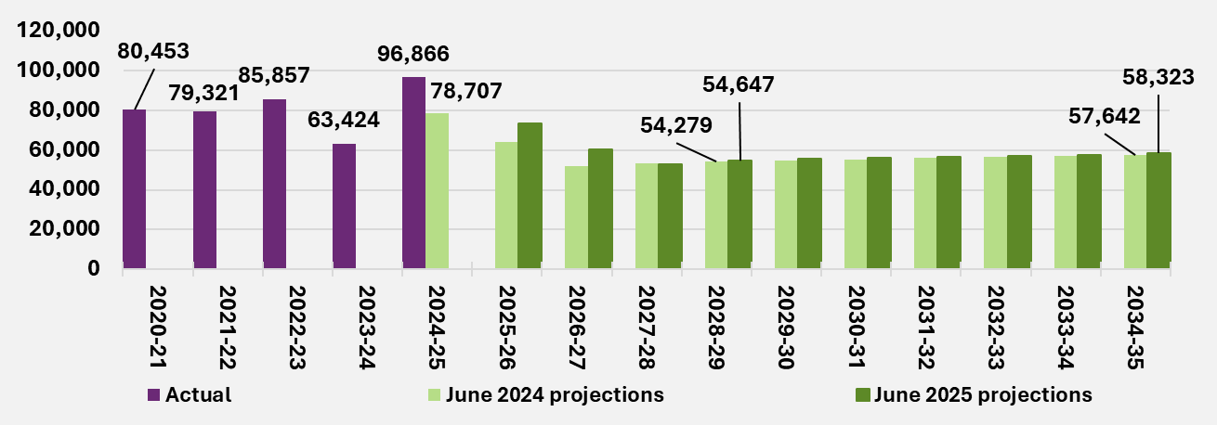
End of figure

Participants leaving the Scheme
Figure 5.3 shows actual and projected rates of participants leaving the Scheme for reasons other than mortality, compared with the June 2024 projections.
Rates of participants leaving the Scheme are directly related to operational capacity and resource allocation towards eligibility reassessments. The eligibility reassessment criteria used to decide if a participant has an outcome of “access maintained” or “revoked” is assumed to remain unchanged.
Since the previous review, there has been focussed efforts to recruit and on-board operational staff dedicated to processing eligibility reassessments, increasing operational capacity during 2024-25. However, some of this additional capacity was used to assist in clearing of the backlog of new access requests in 2024-25. More resources are expected to be allocated to processing of eligibility reassessments in 2025-26 onwards.
The assumed rates of participants leaving the Scheme from 2025-26 onwards have been revised to reflect the expected increase in workforce capacity to process eligibility reassessments. No future change to eligibility criteria has been assumed.
The projected rates of participants leaving the Scheme shown in Figure 5.3 are expected to be higher in the first three projection years, compared with the previous review. With increased Agency focus and resources dedicated to processing eligibility reassessments, the current backlog is expected to be cleared earlier than previously expected. Rates of participants leaving the Scheme are expected to reduce towards stable long-term levels from 2028-29 onwards.
The rate of participants leaving is projected to increase to 3.47% in 2025-26, compared with 2.10% in the previous review, and remains at about 3.5% in 2026-27 before reducing to a long-term level from 2028-29 onwards. The rate of participants leaving is projected to reduce to 1.24% by 2034-35, compared with 1.16% in the previous review.
Figure 5.3. Comparison to previous review of rates of participants leaving the Scheme
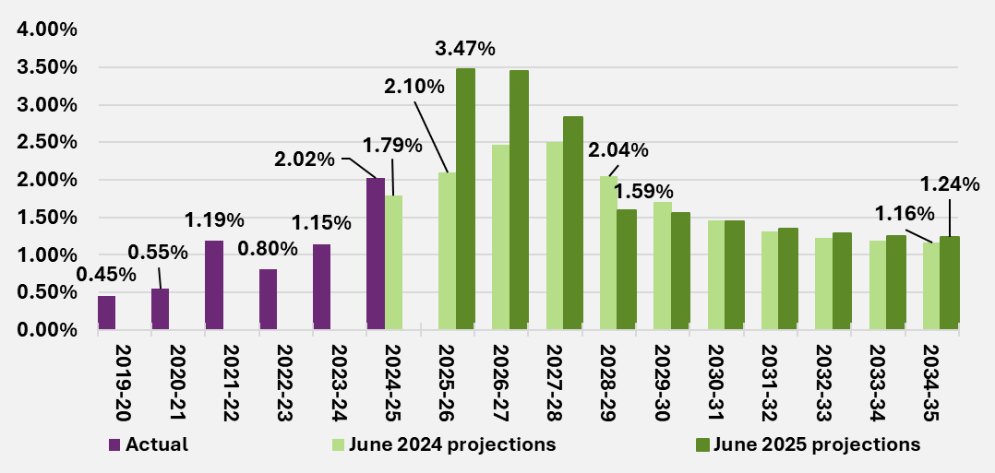
End of figure
Figure 5.4 presents the equivalent comparison of rates for participants aged 0 to 8 years leaving the Scheme. The trend in rates at this cohort over time are similar to the rates for overall participants shown in Figure 5.3. This is because most participants leaving the Scheme are children on the early childhood pathway that have seen the benefits of early intervention.
The rate of participants aged 0 to 8 leaving is projected to increase to 10.81% in 2025-26, compared with 5.64% in the previous review, and further increase to about 12% in 2026-27. This is expected to reduce to 5.66% by 2028-29 and gradually decrease to 3.33% by 2034-35, compared with 3.08% in the previous review.
Figure 5.4. Comparison to previous review of rates of participants aged 0 to 8 leaving the Scheme
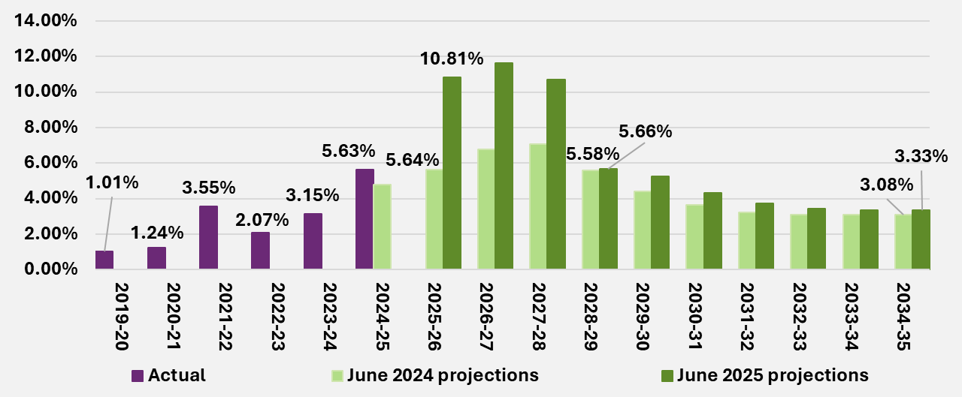
End of figure
Figure 5.5 similarly shows the rates of participants aged 9 and above leaving the Scheme. This cohort makes up a smaller proportion of participants expected to leave and mainly consist of participants that have opted to leave the Scheme or older participants that have moved into community or aged care settings permanently.
The rate of participants aged 9 years and above is projected to increase to 1.35% in 2025-26 and stay at around 1.4% in 2026-27, driven by clearing of the backlog of eligibility reassessments. This is expected to reduce to 0.91% by 2028-29 before gradually increasing to 1.05% by 2034-35, compared to 0.98% in the previous review.
Figure 5.5. Comparison to previous review of rates of participants aged 9 years and above leaving the Scheme
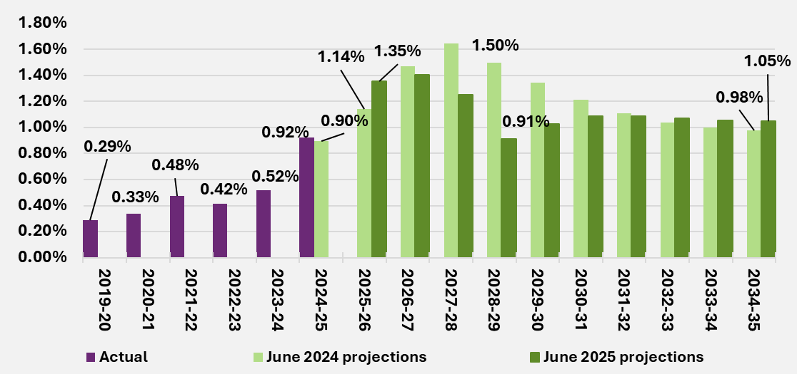
End of figure

Changes to primary disability of children with developmental delay
Children who joined the Scheme with developmental delay will sometimes receive a formal diagnosis when their eligibility for the Scheme is reassessed, resulting in a change to their reported primary disability. The most common transition observed is from developmental delay to a diagnosis of autism or intellectual disability. All else being equal, average plan budgets and payments for participants with autism and intellectual disability are typically higher than those with developmental delay. This then results in higher Scheme expenses.
Figure 5.6 and Figure 5.7 show the historical and projected rates of children with developmental delay transitioning to autism and intellectual disability respectively. The increase in transition rates observed in 2024-25 compared to 2023-24 is related to the increased activity to process eligibility reassessments. Where the outcome of an eligibility reassessment is a change to access, a participant’s primary disability may be updated to reflect the latest information.
Projected transition rates from developmental delay to autism have increased in the short to medium term from 2025-26 to 2027-28 compared to the previous review, to reflect the anticipated increase in activity in clearing the backlog of eligibility reassessments. The projected transition rates in the long term from 2028-29 are broadly in line with the previous review.

The transition rate assumption from developmental delay into intellectual disability is unchanged compared to the previous review. However, the projected transition rates have decreased, due to a change in the age composition of children with developmental delay.
Figure 5.6. Comparison to previous review of rates of participants transitioning from developmental delay to autism
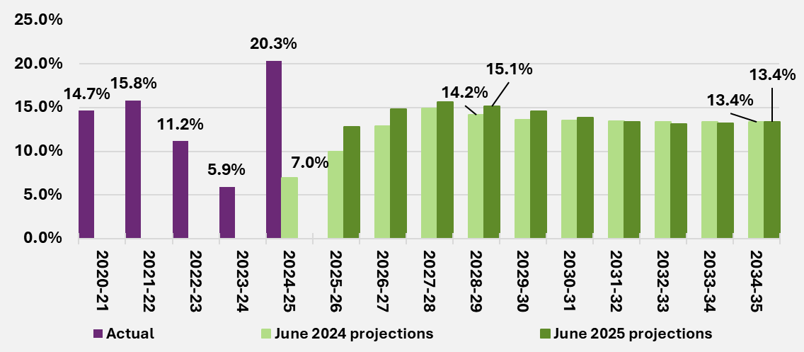
End of figure
Figure 5.7. Comparison to previous review of rates of participants transitioning from developmental delay to intellectual disability
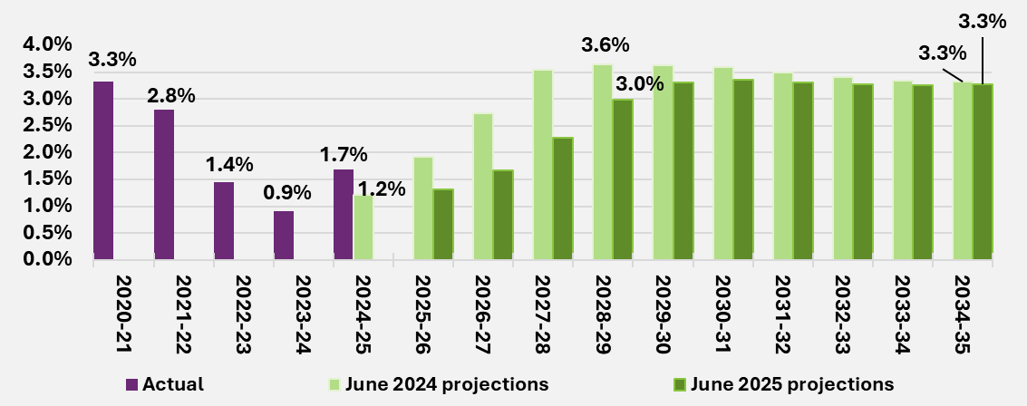
End of figure

Mortality
Figure 5.8 shows overall mortality rates are projected to be higher than those in the previous review. Mortality rates for participants with high support needs have been increased, to reflect the observed experience. Another key driver of the increase in projected rates is a higher projected proportion of older participants, which is associated with increased mortality.
Figure 5.8. Comparison to previous review of rates of participants leaving the Scheme for mortality reasons
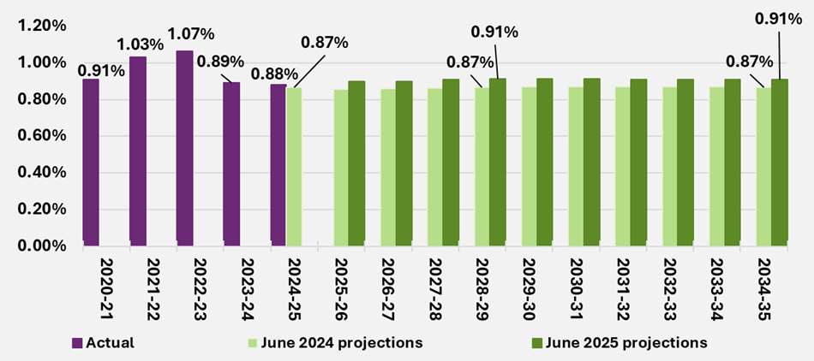
End of figure

Participants transitioning to SIL supports
The number of participants in SIL are projected using an assumed rate of participants transitioning to newly accessing SIL supports.
Figure 5.9 shows the historical and projected rates of participants aged 15 and above transitioning into SIL. The rate of participants transitioning into SIL of 0.9% in 2024-25 was lower than the expected rate of 1.0% from the previous review. However, this is still higher than the expected rate of 0.8% in 2025-26 from the previous review. The stable number of home and living applications in 2024-25 is expected to continue into 2025-26, and hence the rates of participants transitioning into SIL are in line with the previous review.
Figure 5.9. Comparison to previous review of rates of participants without SIL supports aged 15 and above transitioning into SIL
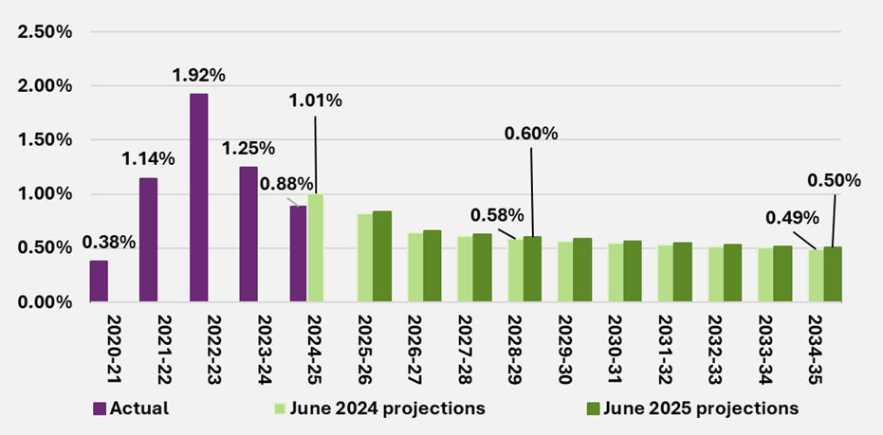
End of figure

Committed supports projections

Starting average committed supports assumptions
Starting average committed supports assumptions are set with reference to committed supports for participants who have been in the Scheme for at least 12 months (with a separate allowance being made for lower expected committed supports for participants in the first year).
Committed supports data as at April 2025 was used as the basis to derive the starting average committed supports assumptions, with adjustment for annualisation and future development of committed supports.
These assumptions were set at the detailed cohort level: by support category, primary disability type, SIL status, level of function and age group. The resultant average committed supports assumptions were calibrated to the 2024-25 committed supports experience at the Scheme level.
Table 5.10 shows the starting average committed supports assumptions for the June 2025 projections for the main primary disability types, by participant SIL status.
- The starting average committed supports for all participants as at 30 June 2025 is $87,000.
- Participants with SIL supports have relatively higher average committed supports compared to participants without SIL supports, across all main primary disability types. Participants with SIL supports have relatively higher needs for daily activity supports.
- For participants without SIL supports, those with developmental delay have the lowest average committed supports. Participants with developmental delay are mainly young children who have relatively lower support needs compared to participants with other primary disability types.
- Participants with other neurological disabilities have relatively higher average committed supports, reflecting their higher support needs.

Table 5.10. 2024-25 average committed supports ($) by SIL status and
primary disability type
Primary disability | With SIL supports | Without SIL supports | Total
Autism | 620,400 | 40,700 | 50,100
Developmental delay | 0 | 23,900 | 23,900
Intellectual disability | 434,100 | 93,900 | 143,900
Other neurological | 608,600 | 156,300 | 206,100
Psychosocial disability | 494,200 | 92,100 | 118,400
All other disability types | 536,000 | 97,000 | 125,900
Total | 502,500 | 64,700 | 87,000
End of table
Table 5.11 shows the starting average committed supports by disability and age groups.
- Average committed supports increase as participants age, reflecting higher support needs on average over time due to deterioration of functionality and other changes in circumstances.
- As noted previously, participants with other neurological disabilities have higher average committed supports which reflects their relatively higher support needs. By contrast, participants with developmental delay are primarily children requiring early intervention supports with lower average committed supports.
Table 5.11. 2024-25 average committed supports ($) by age band and
primary disability type⁵⁷
Primary disability | 0 to 8 | 9 to 14 | 15 to 24 | 25 to 64 | 65+ | Total
Autism | 31,500 | 29,300 | 61,400 | 115,400 | 187,400 | 50,100
Developmental delay | 24,100 | 18,500 | 0 | 0 | 0 | 23,900
Intellectual disability | 54,800 | 48,900 | 114,500 | 185,900 | 245,800 | 143,900
Other neurological | 84,900 | 91,100 | 159,200 | 227,000 | 216,300 | 206,100
Psychosocial disability | 0 | 56,300 | 143,000 | 116,900 | 126,600 | 118,400
All other disability types | 38,600 | 41,900 | 83,800 | 151,900 | 151,300 | 125,900
Total | 28,500 | 33,100 | 77,800 | 150,800 | 169,300 | 87,000
End of table

Future growth in committed supports
Projections of total committed supports for years 2025-26 onwards are determined by applying average committed supports assumptions to the projected participant population.
Average committed supports are assumed to increase over time, due to normal inflationary sources (such as general increases in wages and consumer prices), as well as real growth in average committed supports over time.
Regarding the growth due to normal inflationary sources, average committed supports are assumed to grow year-on-year with future price changes and economic inflation. For 2025-26, the normal inflation rate assumptions reflect the changes to price limits detailed in the 2024-25 Annual Pricing Review. Details of these assumptions are provided in Section 5.7.
There are a number of factors contributing to the real growth in committed supports, including:
- Some participants will access SIL supports over time – participant SIL needs are assessed, and higher support needs are reflected as an increase in their plan budget.
- When children transition from development delay to other disabilities, such as autism – support needs generally increase.
- The increased need for supports as participants age over time – with a change in support needs reflected in the participants plan budget.
- Other additional growth in committed supports as participant circumstances and support needs changes – participant plan budgets are re-assessed resulting in increases to participant plan budgets.
Each of these factors are allowed via separate assumptions and/or transition modelling in the projection of total committed supports.
The impact of the following Scheme reforms and operational measures were allowed for in the setting of additional growth assumptions for committed supports:
- NFP.
- Operational measures focused on the quality of the Agency’s planning process.
These measures are expected to lead to lower growth in committed supports, primarily driven by stronger and more consistent plan reassessment processes. Overall, growth in committed supports is expected to reduce to between 7-8% p.a. by 2026-27 and remain in this range over the projection period.

Total committed supports projections
Table 5.12 shows the June 2025 projection of total committed supports at the Scheme level, including proportions estimated for participants with and without SIL supports.
Total committed supports are projected to grow by 11.5% from $61.3 billion in 2024-25 to $68.3 billion in 2025-26, however from 2026-27 to 2028-29, the annual growth rate is projected to reduce to 7-8%, resulting a total committed supports of $85.1 billion in 2028-29.
Approximately 30% of projected Scheme committed supports in 2024-25 relates to participants with SIL supports, and 70% relates to participants without SIL supports. This is relatively unchanged over the 10-year projection period.
Table 5.12. June 2025 projection of total committed supports and proportion
by SIL status ($m)
 | 2024-25 | 2025-26 | 2026-27 | 2027-28 | 2028-29 | 2034-35
Committed supports | 61,269 | 68,331 | 73,713 | 79,212 | 85,101 | 130,612
Growth (%) | 0 | 11.5% | 7.9% | 7.5% | 7.4% | 7.2%
Proportion with SIL supports | 29.5% | 29.0% | 29.1% | 29.1% | 29.2% | 29.7%
Proportion without SIL supports | 70.5% | 71.0% | 70.9% | 70.9% | 70.8% | 70.3%
End of table

Average committed supports projection
Average committed supports were selected for each participant cohort and support category based on recent experience in 2024-25, with assumptions applied to allow for future normal inflation, additional growth and the changing mix of participants over time.
Table 5.13 shows that the projected average committed supports are expected to increase by 3.4% from $87,000 in 2024-25 to $90,000 in 2025-26. This increase is driven by price limit changes from the 2024-25 Annual Pricing Review and anticipated real growth in average committed supports, partially offset by changes in participant mix.
By 2028-29, average committed supports are projected to be $100,700. The pattern of annual growth also reflects the allowance made for the estimated impact of the Scheme reforms and operational measures.
Table 5.13. Projected average committed supports
Average committed supports June 2025 projections | 2024-25 | 2025-26 | 2026-27 | 2027-28 | 2028-29 | 2034-35
SIL | 502,500 | 525,000 | 544,900 | 566,300 | 588,600 | 745,300
Non SIL | 64,700 | 67,200 | 69,400 | 72,300 | 75,100 | 91,600
Total | 87,000 | 90,000 | 93,000 | 97,000 | 100,700 | 123,900
Yearly growth rates - SIL | 0 | 4.5% | 3.8% | 3.9% | 4.0% | 4.0%
Yearly growth rates – Non SIL | 0 | 4.0% | 3.2% | 4.3% | 3.8% | 3.4%
Total Growth | 0 | 3.4% | 3.4% | 4.3% | 3.9% | 3.6%
End of table
Table 5.14 and Table 5.15 show the projected average committed supports for all participants, broken down by age band and disability respectively:
- Children have relatively lower average committed supports than adults, reflecting a higher proportion of early intervention participants and more informal supports, primarily provided by parents.
- Participants with spinal cord injury, other neurological, acquired brain injury, stroke, cerebral palsy or multiple sclerosis have higher average committed supports that reflects their higher support needs, while participants with hearing impairment, other sensory/speech, or developmental delay had lower average committed supports.
Table 5.14. Average committed supports ($) by age group and projection year
Age group | 2024-25 | 2025-26 | 2026-27 | 2027-28 | 2028-29 | 2034-35
Young Children (0 to 8) | 28,500 | 29,500 | 31,100 | 34,000 | 36,800 | 47,300
Children (9 to 14) | 33,100 | 34,000 | 34,200 | 34,400 | 34,500 | 39,300
Young adults (15 to 24) | 77,800 | 78,000 | 77,400 | 77,100 | 77,500 | 88,400
Adults (25 to 64) | 150,800 | 156,500 | 159,400 | 162,500 | 165,600 | 182,300
Older adults (65+) | 169,300 | 179,700 | 185,700 | 191,600 | 197,300 | 233,100
Total | 87,000 | 90,000 | 93,000 | 97,000 | 100,700 | 123,900
End of table
Table 5.15. Average committed supports ($) by primary disability type⁵⁹
Primary disability | 2024-25 | 2025-26 | 2026-27 | 2027-28 | 2028-29 | 2034-35
Autism | 50,100 | 52,000 | 54,100 | 56,700 | 59,700 | 83,600
Developmental delay | 23,900 | 25,200 | 26,800 | 29,900 | 32,800 | 39,100
Intellectual disability | 143,900 | 149,800 | 153,300 | 156,900 | 160,300 | 184,300
Other neurological | 206,100 | 216,600 | 220,800 | 224,500 | 228,300 | 258,500
Psychosocial disability | 118,400 | 126,300 | 131,500 | 136,800 | 142,300 | 179,000
All other disability types | 125,900 | 133,400 | 138,300 | 143,200 | 148,200 | 181,500
Total | 87,000 | 90,000 | 93,000 | 97,000 | 100,700 | 123,900
End of table
Table 5.16 shows the 2028-29 projected average committed supports for participants, broken down by disability and age group. Similar to Table 5.31, average committed supports are lower at younger ages, and for participants with development delay, whilst average committed supports are higher for participants with other neurological disabilities.

Table 5.16. Average committed supports ($) for participants by age band and primary disability type in 2028-29
Primary disability | 0 to 8 | 9 to 14 | 15 to 24 | 25 to 64 | 65+ | Total
Autism | 34,900 | 31,600 | 66,700 | 121,600 | 187,000 | 59,700
Developmental delay | 33,200 | 23,000 | 0 | 0 | 0 | 32,800
Intellectual disability | 66,400 | 51,900 | 118,400 | 202,600 | 275,300 | 160,300
Other neurological | 136,400 | 105,200 | 161,700 | 242,300 | 242,600 | 228,300
Psychosocial disability | 0 | 75,200 | 147,900 | 140,900 | 149,300 | 142,300
All other disability types | 43,000 | 43,800 | 89,400 | 174,400 | 185,400 | 148,200
Total | 36,800 | 34,500 | 77,500 | 165,600 | 197,300 | 100,700
End of table

Utilisation projections

Starting utilisation assumptions
To reflect the latest Scheme experience, utilisation from 1 October 2024 to 31 March 2025 was used and adjusted to reflect the ultimate utilisation for the full year of 2024-25.
These assumptions were set by support category, primary disability type, SIL status, level of function and age group, consistent with the average committed supports assumptions. However, utilisation assumptions also vary by duration, i.e. how many years a participant has been with the Scheme. As shown in Section 4.4.2, utilisation tends to increase over time as participants get more experienced with the Scheme.
2024-25 Starting utilisation details
Table 5.17 shows the utilisation rates by primary disability type and SIL status in 2024-25:
- Participants with SIL supports have relatively higher utilisation rates, compared to those without SIL supports, across all primary disability types.
- Participants with developmental delay have relatively lower utilisation rates.
- Utilisation rates vary by disability, and the variation is greater for participants with SIL supports compared to those without SIL supports.

Table 5.17. 2024-25 utilisation rates by primary disability type and SIL status
Primary disability | SIL | Non SIL | Total
Autism | 80.4% | 68.6% | 70.9%
Developmental delay | 0 | 63.3% | 63.3%
Intellectual disability | 89.3% | 70.8% | 79.0%
Other neurological | 84.5% | 71.5% | 75.7%
Psychosocial disability | 78.1% | 73.7% | 74.9%
All other disability types | 91.9% | 71.3% | 77.1%
Total | 87.0% | 70.4% | 75.3%
End of table
Table 5.18 shows the utilisation of participants in 2024-25 by disability and age group:
- Utilisation tends to increase with age, reflecting increasing support needs, as well as participants learning how to use their plan more effectively over time (noting older participants have been participants in the Scheme for longer, on average, than younger participants). There are also exceptions, e.g. for participants with autism, delay and intellectual disability, utilisation for younger children is higher than for older children.
- Participants with developmental delay had the lowest utilisation rates, and participants with intellectual disabilities had the highest utilisation rates.
Table 5.18. 2024-25 utilisations rates by age group and primary disability type⁶² ⁶³
Primary disability | 0 to 8 | 9 to 14 | 15 to 24 | 25 to 64 | 65+ | Total
Autism | 70.6% | 67.8% | 68.4% | 77.1% | 79.7% | 70.9%
Developmental delay | 63.5% | 52.1% | 0 | 0 | 0 | 63.3%
Intellectual disability | 73.1% | 69.9% | 70.7% | 81.7% | 85.9% | 79.0%
Other neurological | 65.9% | 71.7% | 73.4% | 77.2% | 73.6% | 75.7%
Psychosocial disability | 0 | 83.1% | 66.1% | 75.0% | 76.7% | 74.9%
All other disability types | 61.9% | 67.9% | 73.0% | 78.4% | 77.0% | 77.1%
Total | 66.3% | 68.1% | 69.8% | 78.5% | 77.8% | 75.3%
End of table

Future change in utilisation
Utilisation is projected to reflect future changes in the Scheme, as well as change in participant mix over time.
Scheme reforms and operational measures are expected to reduce utilisation in the short term – by around 1% in 2025-26, and a further 1% in 2026-27. This is primarily driven by:
- The funding periods reform, which is expected to reduce the proportion of participants who over-utilise their plan.
- Implementation of integrity and fraud measures, which are expected to reduce unauthorised use of NDIS funds.
Changes in participant mix over time will also drive changes in the overall utilisation projection. For example, from 2020-21 onwards, most new entrants have been children and/ or have lower support needs than existing participants, and therefore new entrants have tended to lower the average rate of utilisation in the Scheme over time. However, as the Scheme matures, the average duration per participant in the Scheme also increases, which tends to increase the average rate of utilisation. Hence the future utilisation rate will be impacted by the proportion of new entrants vs mature participants, as well as how the average support needs change over time.

Total utilisation projections
Figure 5.19 shows the projected utilisation rates for participants with and without SIL supports.
Table 5.19. Utilisation projections by SIL status
Utilisation June 2025 projections | 2024-25 | 2025-26 | 2026-27 | 2027-28 | 2028-29 | 2034-35
SIL | 87.0% | 85.8% | 84.7% | 85.0% | 85.1% | 85.6%
Non SIL | 70.4% | 69.5% | 68.5% | 68.6% | 68.6% | 68.1%
Total | 75.3% | 74.2% | 73.2% | 73.4% | 73.4% | 73.3%
End of table
Table 5.20 and 5.21 and show projected utilisation rates by primary disability type for participants with and without SIL supports respectively.

Table 5.20. Utilisation for participant with SIL by primary disability type
Primary disability | 2024-25 | 2025-26 | 2026-27 | 2027-28 | 2028-29 | 2034-35
Autism | 80.4% | 86.9% | 85.8% | 86.1% | 86.2% | 86.6%
Intellectual disability | 89.3% | 86.0% | 85.0% | 85.4% | 85.5% | 85.9%
Other neurological | 84.5% | 84.2% | 83.2% | 83.5% | 83.6% | 83.8%
Psychosocial disability | 78.1% | 83.7% | 82.8% | 83.1% | 83.3% | 83.9%
All other disability types | 91.9% | 86.1% | 85.0% | 85.2% | 85.3% | 85.3%
Total | 87.0% | 85.8% | 84.7% | 85.0% | 85.1% | 85.6%
End of table
Table 5.21. Utilisation for participants without SIL by primary disability type
Primary disability | 2024-25⁶⁶ | 2025-26 | 2026-27 | 2027-28 | 2028-29 | 2034-35
Autism | 68.6% | 66.0% | 64.9% | 65.0% | 64.9% | 64.7%
Developmental Delay | 63.3% | 62.3% | 61.5% | 61.3% | 61.1% | 61.8%
Intellectual Disability | 70.8% | 71.6% | 70.6% | 70.8% | 70.7% | 70.7%
Other Neurological | 71.5% | 70.6% | 69.7% | 69.9% | 70.0% | 69.7%
Psychosocial disability | 73.7% | 71.0% | 70.1% | 70.4% | 70.5% | 70.8%
All other disability types | 71.3% | 71.8% | 70.9% | 71.1% | 71.3% | 71.4%
Total | 70.4% | 69.5% | 68.5% | 68.6% | 68.6% | 68.1%
End of table
Table 5.22 shows the utilisation of participants in 2028-29 by disability and age group. Similar trends to those in 2024-25 were observed. Utilisation rates increase in general with age. Participants with developmental delay have the lowest utilisation rates, and participants with intellectual disability have the highest utilisation rates.

Table 5.22. Utilisation for participants in 2028–29 by age band and
primary disability type
Primary disability type | 0 to 8 | 9 to 14 | 15 to 24 | 25 to 64 | 65+ | Total
Autism | 69.3% | 64.7% | 65.7% | 75.5% | 80.8% | 68.9%
Developmental delay | 61.4% | 51.8% | 0 | 0 | 0 | 61.1%
Intellectual disability | 67.5% | 73.1% | 71.3% | 78.7% | 79.9% | 77.0%
Other neurological | 71.3% | 74.3% | 73.9% | 76.3% | 71.8% | 74.5%
Psychosocial disability | 0 | 59.5% | 69.3% | 74.7% | 73.6% | 74.4%
All other disability types | 64.2% | 67.8% | 72.8% | 77.1% | 73.4% | 75.5%
Total | 65.5% | 66.1% | 67.8% | 76.8% | 74.2% | 73.4%
End of table

Average annual payments per participant model results
This section shows the average annual payment projections after reforms, by combining starting and projected committed supports, as well as starting and projected utilisation.
Table 5.23 shows the projected average payments and yearly growth rates by SIL status. Average payments are projected to grow by around 2% in the short term, increasing to 4.5% in 2027-28, reflecting the change in participants’ mix with the introduction of Foundational Supports. Growth gradually reduces from 2028-29 onwards.
Participants with SIL supports have higher average annual payments, reflecting their higher support needs than participants without SIL supports.
Table 5.23. Average annual payments ($) and yearly growth rates by SIL status⁶⁷
Average payments June 2025 projections | 2025-26 | 2026-27 | 2027-28 | 2028-29 | 2034-35
SIL | 450,200 | 461,500 | 481,400 | 501,200 | 637,700
Non SIL | 46,700 | 47,500 | 49,600 | 51,500 | 62,500
Total | 66,800 | 68,100 | 71,200 | 73,900 | 90,800
Yearly growth rates SIL | 3.0% | 2.5% | 4.3% | 4.1% | 4.1%
Yearly growth rates Non SIL | 2.6% | 1.6% | 4.4% | 3.8% | 3.3%
Total | 1.9% | 2.0% | 4.5% | 3.9% | 3.6%
End of table
Table 5.24 shows the projection of average annual payments for participants with SIL supports by primary disability type:
- Average annual payments for participants with SIL supports in 2025-26 are projected to be $450,200, increasing to around $501,200 by 2028-29.
- Average annual payments for participants with SIL supports vary by disability, and autism and other neurological have higher average payments relative to other disabilities.
Table 5.24. Average annual payments ($) for participant with SIL by
primary disability type
Primary disability | 2025-26 | 2026-27 | 2027-28 | 2028-29 | 2034-35
Autism | 560,300 | 571,200 | 592,700 | 613,800 | 758,800
Intellectual disability | 388,600 | 397,100 | 413,100 | 428,700 | 533,800
Other neurological | 532,700 | 543,700 | 564,900 | 585,500 | 721,600
Psychosocial disability | 430,000 | 438,600 | 455,200 | 471,500 | 581,300
All other disability types | 480,900 | 491,700 | 511,800 | 531,700 | 666,900
Total | 450,200 | 461,500 | 481,400 | 501,200 | 637,700
End of table
Table 5.25 shows the projection of average annual payments for participants without SIL supports by primary disability type:
- Average annual payments for participants without SIL supports in 2025-26 are projected to be $46,700, increasing to around $51,500 in 2028-29.
- Participants with other neurological disabilities had the highest average annual payments in both 2024-25 and 2028-29.
Table 5.25. Average annual payments ($) for participants without SIL supports by primary disability type⁶⁸
Primary disability | 2025-26 | 2026-27 | 2027-28 | 2028-29 | 2034-35
Autism | 28,300 | 29,000 | 30,500 | 31,900 | 43,100
Developmental delay | 15,700 | 16,500 | 18,300 | 20,100 | 24,200
Intellectual disability | 70,800 | 71,700 | 73,800 | 75,600 | 88,500
Other neurological | 115,400 | 115,300 | 117,200 | 119,200 | 135,100
Psychosocial disability | 69,300 | 70,500 | 73,100 | 75,500 | 92,000
All other disability types | 73,800 | 74,800 | 77,200 | 79,600 | 95,000
Total | 46,700 | 47,500 | 49,600 | 51,500 | 62,500
End of table
Table 5.26 shows the projected average annual payments in 2028-29 by age group and disability.
Average annual payments increases with age in general. The exception to this is for young children – children aged 0 to 8 have slightly higher average payments than children
aged 9 to 14.
Average annual payments for participants with developmental delay and autism are much lower compared to other disabilities, reflecting the younger age profile and lower support needs on average for these cohorts.
Table 5.26. Average annual payments ($) for participants by age band and primary disability type in 2028-29
Primary disability | 0 to 8 | 9 to 14 | 15 to 24 | 25 to 64 | 65+ | Total
Autism | 24,200 | 20,400 | 43,800 | 91,800 | 151,100 | 41,100
Developmental delay | 20,400 | 11,900 | 0 | 0 | 0 | 20,100
Intellectual disability | 44,800 | 38,000 | 84,400 | 159,500 | 220,100 | 123,400
Other neurological | 97,200 | 78,200 | 119,600 | 184,700 | 174,200 | 170,200
Psychosocial disability | 0 | 44,800 | 102,400 | 105,200 | 109,800 | 105,900
All other disability types | 27,600 | 29,600 | 65,100 | 134,500 | 136,000 | 111,800
Total | 24,100 | 22,800 | 52,600 | 127,100 | 146,400 | 73,900
End of table

Pricing and normal inflation assumptions
Scheme expenses are assumed to increase over time with inflation, both from normal inflationary sources (such as general increases in wages and consumer prices) and from additional cost pressures (referred to as additional growth).
For 2025-26, the normal inflation rate assumptions are primarily based on the pricing decisions made by the Agency in the 2024-25 Annual Pricing Review. From 2026-27 onwards, the normal inflation rate assumptions are based on the recent Treasury forecasts of the Wage Price Index (WPI) and Consumer Price Index (CPI), used to estimate the minimum wage increase for the disability support workers, and increases to therapy supports, consumables and capital items.

Annual pricing review (APR)
The normal inflation rate assumptions for the 2025-26 financial year reflect the changes to price limits detailed in the 2024-25 Annual Pricing Review (2024-25 APR).

The 2024-25 APR took effect from 1 July 2025 and includes the following changes:
- Price limits for supports delivered by disability support workers and Level 1 support co-ordinators have increased by 4.02%, reflecting:
- The Fair Work Commission’s (FWC) National Minimum Wage decision to increase minimum award wages by 3.5%.
- The adjustment to price limits to reflect the increase in superannuation guarantee charge (SGC) of 0.5% in full.
- Adjustments made to therapy pricing, including:
- Removal of state and territory special pricing arrangement.
- Reduction in psychologist, physiotherapist, dietitian and podiatrist price limits.
- Reduction in amounts that can be claimed for travel costs for therapists.
- Removal of plan management set up fee and remote loadings.
- For non-disability support workers, a 3.2% per annum increase. The rate is calculated based on the weighted movement in the ABS WPI and CPI indices.
- No increase to price limits for support coordination levels 2 and 3 price limits.

SCHADS Award forecast
Increases in NDIS price limits for disability support workers are typically based on the changes to the Social, Community, Home Care and Disability Services Industry Award (SCHADS Award) pay rates as determined annually by the Fair Work Commission (FWC). Therefore, the normal inflation assumption for attendant care support beyond 2025-26 is set with reference to expectations of future increases in the SCHADS award.
Table 5.27 shows the SCHADS Award rate forecast in the June 2025 projections.
Table 5.27. Comparison of SCHADS Award forecast
 | 2025-26 | 2026-27 | 2027-28 | 2028-29
June 2025 assumptions | 3.50% | 4.00% | 3.75% | 3.75%
June 2024 assumptions | 3.75% | 4.00% | 4.00% | 3.75%
Difference | -0.25% | 0.00% | -0.25% | 0.00%
End of table
Over the last decade, growth in the relevant SCHADS pay rate has been higher than the Wage Price Index (WPI) on average, and in recent periods has consistently been at around 70% of average weekly earnings (AWE). Assumptions about future increases in SCHADS have been set in order to maintain this relativity.
For the June 2025 projection, the SCHADS award rate is projected to grow at a rate of 4.0% which is 0.75% above the Treasury WPI forecast for 2026-27 and at 3.75% in 2027-28 which is 0.25% above the Treasury WPI forecast of 3.5%. From 2028-29 onwards, it is assumed the SCHADS growth rate will converge to a long-term forecast of 3.75%, aligning with the long-term WPI forecast.

Normal inflation projection
Table 5.28 compares the overall normal inflation rate assumptions in the June 2024 projections to the rates assumed in the June 2025 projections. The rates shown are the weighted average of rates assumed across different support categories. The level of normal inflation assumed for 2025-26 has reduced by 0.9% since the June 2024 projections, mainly driven by the reduction in therapy supports price limit and removal of management fee stated in the 2024-25 APR. The long-term normal inflation assumed is materially unchanged.
 | 2025-26 | 2026-27 | 2027-28 | 2028-29
June 2025 Projections | 3.0% | 3.7% | 3.5% | 3.5%
June 2024 Projections | 3.9% | 3.7% | 3.7% | 3.5%
Difference (%) | -0.9% | 0.0% | -0.2% | 0.0%
Table 5.28. Comparison of normal inflation assumptions to historic assumptions
End of table
These assumptions are subject to uncertainty due to:
- The review of gender-based undervaluation - Since the issue of gender undervaluation was raised last year, the FWC has undertaken a review to determine whether gender-based undervaluation requiring remedy exists. It was found that several classifications under these Awards have been subject to gender-based undervaluation and the FWC has recommended changing the classification structure of awards, including a proposed single rate for a qualified disability care worker. The decision remains provisional at the time of writing, and the overall cost implications for the Scheme remain highly uncertain.
- Instability in economic conditions both globally and in Australia - This increases the risks to economic forecasts and therefore to estimating future normal inflation of disability support costs.

Lifetime expense for care and support
In addition to annual projections, the AFSR is required to include estimates of the lifetime expense for care and support (lifetime expense) for participants. This refers to Scheme expenses for care and support provided over the participant’s entire lifetime. This estimate provides a useful benchmark to monitor the financial sustainability of the Scheme, as better outcomes for participants should generally result in lower long-term payments for disability support in the future. Therefore, as more experience emerges, the lifetime expense estimates for participants may be expected to reduce, on average.
Average participant lifetime expenses have been projected based on the assumptions underlying the June 2025 projections (including allowance for Scheme reforms) and then discounted to a present value at 30 June 2025 assuming a long-term discount rate of 5.0% per annum for all future years.
The lifetime expense is projected separately for both the expected cohort of new entrants to the Scheme during 2025-26 as well as existing participants at 30 June 2025.

Lifetime expense for new entrants
The lifetime expense projection for new entrants is intended to reflect the underlying profile, and associated expense, of new entrants to the Scheme each year going forward once the Scheme reaches a steady-intake state. This means no short-term allowances are made, and that the new entrant cohort reflects a longer-term view based on new incidence of disability and an immaterial level of participants entering with a previously unmet need.
Table 5.28 shows the lifetime expenses for the estimated annual population of new entrants in 2025-26.
The average lifetime expenses are calculated by primary disability type, defined by the primary disability of the participant when they enter the Scheme, and then applied to the estimated annual population of new entrants in 2025-26 to get the total lifetime expenses. In particular, for participants who enter with developmental delay, lifetime expenses include the cost of supports for those who are later diagnosed with autism, intellectual disability or other permanent disability type and remain in the Scheme into adulthood.
The total lifetime expenses for the estimated annual population of new entrants in 2025-26 is projected to be $113.6 billion based on the current long-term assumptions, representing 3.9% of projected GDP for 2025-26. This doesn’t mean the government is required to set aside 3.9% of GDP to cover the lifetime expenses for these participants, as the Scheme is funded on an ongoing basis by the government. Table 5.28 also shows about 79% of the total lifetime expenses for New Entrants in 2025-26 are for participants with autism, developmental delay and intellectual disability.

Primary disability | New entrant population (2025-26) | Average lifetime expense per participant  ($m) | Total lifetime expenses ($m) | Total lifetime expenses (%)
ABI | 1,156 | 2.61 | 3,015 | 3%
Autism | 25,908 | 2.11 | 54,618 | 48%
Cerebral palsy | 435 | 3.88 | 1,686 | 1%
Hearing impairment | 1,582 | 0.25 | 391 | 0%
Intellectual disability | 3,604 | 2.93 | 10,569 | 9%
Multiple sclerosis | 943 | 1.49 | 1,402 | 1%
Developmental delay | 25,214 | 0.96 | 24,300 | 21%
All other disability types | 2,248 | 1.92 | 4,324 | 4%
Other neurological | 2,332 | 1.51 | 3,514 | 3%
Other physical | 794 | 1.04 | 827 | 1%
Other sensory speech | 39 | 0.09 | 3 | 0%
Psychosocial disability | 2,705 | 1.82 | 4,920 | 4%
Spinal cord injury | 364 | 3.76 | 1,369 | 1%
Stroke | 1,061 | 2.02 | 2,138 | 2%
Visual impairment | 534 | 0.96 | 512 | 0%
Total | 68,918 | 1.65 | 113,588 | 100%
Table 5.28. Average payments & total lifetime expenses for new entrants in 2025-26

Projected GDP $m (2025-26) | 2,876,800
% of GDP | 3.9%
End of table

Total lifetime expense
The total lifetime expenses for the 739,414 current participants in the Scheme are estimated to be $1.76 trillion, representing 61.1% of the projected GDP for 2025-26.
The estimated average lifetime expense of these participants is $2.4 million per participant which is significantly higher than the average of $1.6 million for new entrants due to the different disability and age distributions of the two populations. In particular, the profile of current participants is skewed towards those with lower functional levels compared with new entrants. The new entrants’ cohort has a greater number of higher functioning children, many of whom enter the Scheme through the early intervention requirement (Section 25 of the NDIA Act), and who are expected to leave the Scheme and hence have a lower average lifetime expense.

Operating expenses
Agency costs, referred to as “operating expenses”, are costs associated with the operation of the NDIS, including resourcing costs related to participant eligibility assessments and planning, monitoring and reporting of Scheme performance, and governance activities. These costs are separate to Scheme expenses, which represent the total cost of supports and services provided to all participants in the Scheme, before allowance for Agency costs.
Table 5.29 shows actual operating expenses in 2024-25 of $2,541 million, or 5.5% of Scheme expenses, were $247 million lower than the 2025-26 Budget for 2024-25 of $2,788 million.
Table 5.29. Actual operating expenses compared to expectations
Operating expenses ($m) | 12 months ending 30 June 2025
Actual | 2,541
(2025-26 Budget) | 2,788
Difference (Actual – Budget) | 247
End of table
The 2025-26 Budget included $175.4 million over four years from 2025–26 (and $43.8 million per year ongoing) to further safeguard the integrity of the National Disability Insurance Scheme (NDIS) and support people with disability. This funding includes:
- $151.0 million over four years from 2025–26 (and $43.8 million per year ongoing) to continue enhancements to the National Disability Insurance Agency’s (NDIA’s) fraud detecting information technology systems, with this funding to be held in the Contingency Reserve until the fraud and compliance system enhancements funded in previous economic updates are complete.
- $17.1 million in 2025–26 to continue to invest in the NDIA’s ability to detect and respond to fraud and non‑compliant payments.
- $7.3 million in 2025–26 to extend supplementary funding for the NDIS Appeals Program.
This measure builds on the 2022–23 October Budget measure titled Plan for the National Disability Insurance Scheme, the 2023–24 Budget measure titled Improving the Effectiveness and Sustainability of the National Disability Insurance Scheme, the 2024–25 Budget measure titled National Disability Insurance Scheme – getting the NDIS back on track, and the 2024–25 MYEFO measure titled National Disability Insurance Scheme Reform.
The June 2025 projections assume NDIA resourcing remains sufficient to continue administering the Scheme at the same time as effectively implementing reforms. At the time of writing, work is being undertaken to ensure that the funding of Scheme reforms, as well as business-as-usual activities, is secured. If this does not eventuate, Scheme expenses would be expected to be higher than those shown in this report. In the 2025-26 Budget, NDIA operating expenses reduce by 38% in 2026-27.
End of Section 5

Uncertainty and comparisons to previous projections

This section includes scenario analyses where individual assumptions are varied compared with the assumptions used to arrive at the projected Scheme expenses presented in this report. The scenarios demonstrate the sensitivity of results to changes in future expectations.
Charlotte going to school
The scenario analysis section also contains the results from an alternative projection model known as the microsimulation model (MSM), which is described in Section 3.5. The MSM is designed to simulate individual pathways of current and future participants based on demographic characteristics and their evolution over time.
This section also contains the results of a stochastic projection model. This model allows for the uncertainty of the most significant key risks to the estimation of Scheme expenses, and the results provide a confidence interval for the range of expected projection outcomes.
Also discussed is the level of judgment required in assumption setting, and the materiality of the different assumptions made in the Scheme projections.
Finally, the section shows a comparison of the June 2025 projection results with historical projection results and Productivity Commission estimates, to illustrate how expectations of Scheme expenses have changed over time.

Scenario analysis
As noted throughout this report, there is considerable uncertainty in relation to these projections, and actual Scheme expenses may vary, possibly significantly. To quantify the inherent uncertainty, an alternative set of projections have been calculated for several scenarios. These consider a range of plausible outcomes in relation to some of the key uncertainties. Specifically:
- Growth in average payments per participant.
- Number of new entrants to the Scheme.
- Rate of participants leaving the Scheme.
- Number of participants with Supported Independent Living arrangements.
- Projection model approach.

Growth in average payments per participant
Average payment growth per participant comprises the average committed supports growth per participant, arising from normal inflation and addition growth, as well as the change in the level of utilisation of these committed supports.
Average committed supports have grown at rates exceeding normal inflation for several years. Utilisation rates have also been increasing gradually over time.
Normal inflation growth uncertainty
As noted in Section 5.7 the normal inflation rate assumptions beyond 2025-26 are primarily driven by projected future increases in the Social, Community, Home Care and Disability Services (SCHADS) Industry Award. Adjustments related to addressing the gender-based undervaluation issue within the sector may also contribute to future changes in SCHADS rates, noting this decision and its timing have not been finalised at time of writing.
The scenarios outlined in Table 6.1 below illustrate the impact of higher or lower than the baseline SCHADS rates on the overall Scheme projections.
- A one percentage point increase to SCHADS rates assumptions across all projection years. This increases Scheme expenses by $1.4 billion in 2028-29 and $7.0 billion in 2034-35.
- A one percentage point reduction to SCHADS rates assumptions across all projection years. This decreases Scheme expenses by $1.4 billion in 2028-29 and $6.5 billion in 2034-35.

Scheme expenses ($m) | 2025-26 | 2026-27 | 2027-28 | 2028-29 | 2034-35 | Total 2025-29
Baseline: June 2025 projections ($m) | 50,705 | 53,958 | 58,126 | 62,461 | 95,755 | 225,250
Table 6.1. Scenarios with higher and lower SCHADS rates - projected Scheme expenses and variance to June 2025 projections
Scenario 1: SCHADS rates increase by 1% in the projection years
Scheme expenses ($m) | 50,705 | 54,361 | 59,004 | 63,890 | 102,731 | 227,960
Variance to baseline ($m) | 0 | 402 | 877 | 1,430 | 6,975 | 2,709
Variance to baseline (%) | 0.0% | 0.8% | 1.5% | 2.3% | 7.3% | 1.2%
Scenario 2: SCHADS rates decrease by 1% in the projection years
Scheme expenses ($m) | 50,705 | 53,556 | 57,258 | 61,058 | 89,297 | 222,576
Variance to baseline ($m) | 0 | -402 | -869 | -1,403 | -6,458 | -2,674
Variance to baseline (%) | 0.0% | -0.8% | -1.5% | -2.3% | -6.7% | -1.2%
End of table
Committed supports additional growth uncertainty
Other than the impact of normal inflation, average committed supports levels increase over time due to factors such as participants changing primary disability (e.g. from delay to autism), participants starting to have SIL arrangements and participants using more of their funded supports after an initial period in the Scheme. The additional growth in average committed supports, after allowing for these factors which are modelled separately, is a projection assumption that is based on a high level of judgement. This acknowledges that historic rates of growth provide only limited evidence regarding future rates of growth. The average committed supports growth assumptions have a material effect on Scheme projections.
Committed supports utilisation rates uncertainty
Utilisation rates can be influenced by a range of factors, including changes in participant spending behaviours and changes in individual circumstances. Current and future Scheme reforms such as the introduction of the New Framework Planning (NFP) and sustainability initiatives may also impact participants’ usage of committed supports in future. The future utilisation rates of the Scheme remain highly uncertain.
Table 6.2 contains scenarios to gauge the impact of changes in average committed supports growth driven by the current and future Scheme reforms, noting that average committed supports growth rates have decreased since the previous review. There remains uncertainty about future growth rates of Scheme costs. Please note that these scenarios also correspond to the impact of changes in future utilisation rates in the Scheme.

This is illustrated in Table 6.2 which presents the following scenarios:
- A one percentage point increase to average committed supports growth rates or one percentage point increase in utilisation rates in the short-term, for the four years from 2025-26 to 2028-29. This adds $2.5 billion to Scheme expenses in 2028-29 and $3.9 billion in 2034-35.
- A one percentage point increase to average committed supports growth rates or one percentage point increase in utilisation rates across all projection years. This adds $2.5 billion to Scheme expenses in 2028-29 and $10.0 billion in 2034-35.
- A one percentage point reduction to average committed supports growth rates or one percentage point decrease in utilisation rates in the short-term, for the four years from 2025-26 to 2028-29. This reduces Scheme expenses in 2028-29 by $2.5 billion and in 2034-35 by $3.8 billion.
- A one percentage point reduction to average committed supports growth rates or one percentage point decrease in utilisation across all projection years. This reduces Scheme expenses in 2028-29 by $2.5 billion and in 2034-35 by $9.2 billion.

Table 6.2. Scenarios with higher and lower average committed supports growth
rates / utilisation rates – projected Scheme expenses and variance to
June 2025 projections
Scheme expenses ($m) | 2025-26 | 2026-27 | 2027-28 | 2028-29 | 2034-35 | Total 2025-29
Baseline: June 2025 projections ($m) | 50,705 | 53,958 | 58,126 | 62,461 | 95,755 | 225,250
Scenario 1: Higher growth or utilisation rates in the short-term (+1%)
Scheme expenses ($m) | 51,212 | 55,043 | 59,888 | 64,997 | 99,643 | 231,139
Variance to baseline ($m) | 507 | 1,085 | 1,761 | 2,536 | 3,888 | 5,889
Variance to baseline (%) | 1.0% | 2.0% | 3.0% | 4.1% | 4.1% | 2.6%
Scenario 2: Higher growth or utilisation rates in the short and long term (+1%)
Scheme expenses ($m) | 51,212 | 55,043 | 59,888 | 64,997 | 105,773 | 231,139
Variance to baseline ($m) | 507 | 1,085 | 1,761 | 2,536 | 10,018 | 5,889
Variance to baseline (%) | 1.0% | 2.0% | 3.0% | 4.1% | 10.5% | 2.6%
Scenario 3: Lower growth or utilisation rates in the short-term (-1%)
Scheme expenses ($m) | 50,198 | 52,885 | 56,400 | 59,999 | 91,982 | 219,482
Variance to baseline ($m) | -507 | -1,074 | -1,726 | -2,461 | -3,773 | -5,768
Variance to baseline (%) | -1.0% | -2.0% | -3.0% | -3.9% | -3.9% | -2.6%
Scenario 4: Lover growth or utilisation rates in the short and long term (-1%)
Scheme expenses ($m) | 50,198 | 52,885 | 56,400 | 59,999 | 86,599 | 219,482
Variance to baseline ($m) | -507 | -1,074 | -1,726 | -2,461 | -9,156 | -5,768
Variance to baseline (%) | -1.0% | -2.0% | -3.0% | -3.9% | -9.6% | -2.6%
End of table

Number of new entrants to the Scheme
Short-term uncertainty
The number of new entrants to the Scheme in 2024-25 has increased compared to the previous year and is above expectations in the previous review. The higher-than-expected number of new entrants was due to the clearing of the backlog of access requests that awaited validation and decision, as well as prioritisation in approving first plans. As a result of the clearing of the backlog, the material driver of variability of new entrants in 2025-26 is new access requests.
Based on analysis of the monthly number of new access requests over 2024-25, the following two scenarios are shown in Table 6.3 to reflect a reasonable range of new entrants in 2025-26:
- Higher number of new entrants in 2025-26, increased by 15%. This increases Scheme expenses by $0.4 billion in 2028-29 and by $0.5 billion in 2034-35.
- Lower number of new entrants in 2025-26, reduced by 10%. This decreases Scheme expenses by $0.3 billion in 2028-29 and by $0.3 billion in 2034-35.
Table 6.3. Scenarios with higher and lower new entrants in 2025-26 – projected Scheme expenses and variance to the June 2025 projections
Scheme expenses ($m) | 2025-26 | 2026-27 | 2027-28 | 2028-29 | 2034-35 | Total 2025-29
Baseline: June 2025 projections ($m) | 50,705 | 53,958 | 58,126 | 62,461 | 95,755 | 225,250
Scenario 1: Higher number of new entrants in 2025-26
Scheme expenses ($m) | 50,848 | 54,320 | 58,544 | 62,893 | 96,273 | 226,606
Variance to baseline ($m) | 143 | 362 | 418 | 433 | 517 | 1,356
Variance to baseline (%) | 0.3% | 0.7% | 0.7% | 0.7% | 0.5% | 0.6%
Scenario 2: Lower number of new entrants in 2025-26
Scheme expenses ($m) | 50,611 | 53,717 | 57,852 | 62,171 | 95,410 | 224,351
Variance to baseline ($m) | -94 | -241 | -275 | -290 | -345 | -899
Variance to baseline (%) | -0.2% | -0.4% | -0.5% | -0.5% | -0.4% | -0.4%
End of table
Short and long-term uncertainty
In the future, new entrant rates will be dependent on the general prevalence of autism and other disabilities, operational measures and Scheme reforms. The following two scenarios, shown in Table 6.4, illustrate the sensitivity of the long-term new entrant rate assumptions on future Scheme expenses.
- Greater rate of new entrants, increased by 20% for all years. This increases Scheme expenses by $1.7 billion in 2028-29 and by $6.1 billion in 2034-35.
- Lower rate of new entrants, reduced by 20% for all years. This decreases Scheme expenses by $1.8 billion in 2028-29 and by $6.1 billion in 2034-35.

Table 6.4. Scenarios with higher and lower new entrant rates– projected Scheme expenses and variance to the June 2025 projections
Scheme expenses ($m) | 2025-26 | 2026-27 | 2027-28 | 2028-29 | 2034-35 | Total 2025-29
Baseline: June 2025 projections ($m) | 50,705 | 53,958 | 58,126 | 62,461 | 95,755 | 225,250
Scenario 3: Higher new entrant rates
Scheme expenses ($m) | 50,891 | 54,605 | 59,309 | 64,195 | 101,843 | 229,001
Variance to baseline ($m) | 186 | 647 | 1,183 | 1,735 | 6,087 | 3,751
Variance to baseline (%) | 0.4% | 1.2% | 2.0% | 2.8% | 6.4% | 1.7%
Scenario 4: Lower new entrant rates
Scheme expenses ($m) | 50,515 | 53,305 | 56,953 | 60,696 | 89,665 | 221,469
Variance to baseline ($m) | -189 | -654 | -1,173 | -1,764 | -6,090 | -3,781
Variance to baseline (%) | -0.4% | -1.2% | -2.0% | -2.8% | -6.4% | -1.7%
End of table

Rate of participants leaving the Scheme
Rate of participants leaving the Scheme, for reasons other than death, are forecasted to be higher than projected in previous reports in the short-term, driven by the Agency’s current focus on clearing the backlog of eligibility reassessments and dedicated resources towards this initiative.
Table 6.5 presents a scenario where more Agency resources are diverted from processing eligibility reassessments than assumed in the June 2025 projections, and as a result the backlog of ERs is cleared a year later than forecasted. This increases Scheme expenses by an additional $0.2 billion over the four years to 2028-29.
Table 6.5. Scenarios with a lower rate of participants leaving the Scheme – projected Scheme expenses and variance to the June 2025 projections
Scheme expenses ($m) | 2025-26 | 2026-27 | 2027-28 | 2028-29 | 2034-35 | Total 2025-29
Baseline: June 2025 projections ($m) | 50,705 | 53,958 | 58,126 | 62,461 | 95,755 | 225,250
Scenario: Lower rate of participants leaving the Scheme
Scheme expenses ($m) | 50,726 | 54,036 | 58,218 | 62,495 | 97,792 | 225,476
Variance to baseline ($m) | 22 | 77 | 92 | 35 | 37 | 225
Variance to baseline (%) | 0.04% | 0.14% | 0.16% | 0.06% | 0.04% | 0.10%
End of table

Number of participants with Supported Independent Living arrangements
The number of participants with SIL arrangements at 30 June 2025 was lower than expected in the previous review. Most participants with SIL arrangements are those that entered the Scheme and then subsequently transitioned to a plan with SIL via a home and living application. The number of home and living applications were stable in 2024-25. However, anticipating the number of participants likely to require SIL arrangements, and when this demand will reach a long-term steady state, remains a challenge. The number of participants with SIL arrangements is an area of significant uncertainty that also has a material impact on projected Scheme expenses.
To illustrate the impact of varying the number of participants in SIL on Scheme expenses, the following scenarios are presented in Table 6.6:
- Higher number of participants with SIL, with 200 net increase in participants with SIL each year. This scenario increases Scheme expenses by $0.3 billion in 2028-29 and by $1.0 billion in 2034-35.
- Lower number of participants without SIL, with 200 net decrease in participants with SIL each year. This scenario decreases Scheme expenses by $0.3 billion in 2028-29 and by 1.0 billion in 2034-35.
Table 6.6. Scenarios with higher and lower number of participants with SIL – projected
Scheme expenses and variance to the June 2025 projections
Scheme expenses ($m) | 2025-26 | 2026-27 | 2027-28 | 2028-29 | 2034-35 | Total 2025-29
Baseline: June 2025 projections ($m) | 50,705 | 53,958 | 58,126 | 62,461 | 95,755 | 225,250
Scenario 1: Higher number of participants with SIL
Scheme expenses ($m) | 50,742 | 54,071 | 58,323 | 62,748 | 96,747 | 225,884
Variance to baseline ($m) | 37 | 113 | 197 | 287 | 992 | 634
Variance to baseline (%) | 0.1% | 0.2% | 0.3% | 0.5% | 1.0% | 0.3%
Scenario 2: Lower number of participants with SIL
Scheme expenses ($m) | 50,668 | 53,845 | 57,930 | 62,174 | 94,762 | 224,617
Variance to baseline ($m) | -37 | -113 | -197 | -287 | -993 | -633
Variance to baseline (%) | -0.1% | -0.2% | -0.3% | -0.5% | -1.0% | -0.3%
End of table

MSM alternative projection model
As discussed earlier in Section 3.5, an alternative projection model known as the microsimulation model (MSM) has been further developed. This is the second year that the MSM has been used to project Scheme expenses.
The key judgements when setting the assumptions that underpin the MSM are largely consistent with those used in the existing model. Appendix L contains further details on the June 2025 MSM projections (e.g. projected new entrants, mortality, etc) including comparisons to the existing projection model.
Table 6.7 presents the results of the MSM. The MSM result is $410 million lower than the baseline June 2025 projection over 2025-29.
Table 6.7. Scenario showing the results from the 30 June 2025 MSM projections - projected Scheme expenses and variance to the June 2025 projections
Scheme expenses ($m) | 2025-26 | 2026-27 | 2027-28 | 2028-29 | 2034-35 | Total 2025-29
Baseline: June 2025 projections ($m) | 50,705 | 53,958 | 58,126 | 62,461 | 95,755 | 225,250
Scenario: Results from the 30 June 2025 MSM projections
Scheme expenses ($m) | 50,705 | 53,958 | 57,984 | 62,192 | No value | 224,840
Variance to baseline ($m) | 0 | 0 | -142 | -268 | No value | -410
Variance to baseline (%) | 0.00% | 0.00% | -0.24% | -0.43% | No value | -0.18%
End of table

Stochastic modelling

Approach
The risks underlying the projected expenses of the Scheme are continually monitored and analysed and the stochastic model is used as a tool to measure the level of uncertainty in relation to Scheme expenses. The stochastic model varies the assumptions of the June 2025 projections relating to the key risks to determine the probability distribution of expected future Scheme expense outcomes.
The material risks identified are additional growth in payments, model specification risk, the number of new entrants to the Scheme, normal inflation and the number of participants transitioning to SIL arrangements. These risks have been identified and quantified using historical experience, and it is difficult to make objective adjustments to the stochastic model for changes to the Scheme which have not yet occurred. Therefore, the results presented below exclude the impact of the Scheme reforms or the impacts of any future legislative or major policy interventions not considered in this report. However, Scheme reforms are another key source of uncertainty. This is discussed further at the end of this section.

Summary of the key risks modelled stochastically
The following section provides an overview of the uncertainty relating to each of the key risks varied stochastically.
Additional growth in payments
The historic escalation in average payments has remained above normal inflation, even after allowing for other factors such as ageing and transitions to SIL arrangements which are modelled explicitly in projections of the Scheme. Sustained high levels of additional growth in payments remains one of the most critical sustainability pressures for the Scheme given the material impact on projected Scheme expenses. Given the evolving nature of the Scheme, assumptions relating to additional growth in payments involve considerable judgement and thus, remain highly uncertain.
Model specification risk
The deterministic projection model is an imperfect representation of the future payment process, leading to potential biases in the projection of Scheme expenses. The risk that actual outcomes vary from the projections remains high, given NDIS processes are still evolving. There are also some limitations in the data available for analysis. This risk remained relatively stable compared to last year. While there has been a methodology change in how payments are projected (now determined as committed supports times utilisation as set out in Section 3), there have been minimal changes in the underlying processes used in the model's construction and execution.
New entrants
The Scheme continues to experience high levels of new entrants, particularly for participants with autism and developmental delay. There remains a high level of uncertainty in the new entrant assumptions.
Normal inflation
Future increases in wages and consumer prices are key sources of uncertainty. The uncertainty reflects increased economic uncertainties both globally and in Australia, the residual impacts of previous monetary policy initiatives and the impact of Fair Work Commission decisions.
Transitions into Supported Independent Living (SIL)
There are a number of drivers of uncertainty relating to expenses for participants with SIL arrangements, one of which is the number of transitions of participants into SIL each year. Rates of transition into SIL are set based on an experience analysis of participants gaining access to SIL supports and allow for the ongoing changes in operational processes that may affect such transitions into the future. The number of participants with SIL supports has stabilised over the last year but the level of transitions into SIL in the future remains uncertain.

Summary of results
Figure 6.1 illustrates the stochastic simulation of Scheme expense outcomes expressed as a percentage of the June 2025 projections (before Scheme reforms), with varying confidence intervals. Scheme expenses are expected to increase over time and the uncertainty associated with the Scheme expenses is also expected to increase over time as demonstrated by the increasing coefficient of variation (CV) in Table 6.8. The compounding uncertainty over time reflects the challenges in projecting future outcomes in the long term.
Figure 6.1. Ranges of uncertainty in June 2025 projected Scheme expenses as a proportion of baseline projection (%)
End of figure
Figure 6.1 shows that the range of outcomes for the Scheme is greater above the baseline than below the baseline, primarily driven by the skewed nature of uncertainty in additional growth in payments. The average of all 20,000 simulations (which is equivalent to the baseline projection) is greater than the median result (50th percentile) as the more extreme high values increase the average.
The 5th percentile and 95th percentile results form a 90% confidence interval for the range of expected outcomes for projected Scheme expenses.

As shown in Table 6.8 there is an equal 5% likelihood that the Scheme expense would be:
- At least 4.3% below, or at least 6.1% above the June 2025 projection in 2025-26.
- At least 7.4% below, or at least 8.7% above the June 2025 projection for the four years to 30 June 2029.
- At least 20.8% below, or at least 26.3% above the June 2025 projection in 2034-35.
Table 6.8. Difference in Scheme expense percentiles as a proportion of the
June 2025 projections (%)
Percentiles | 2025-26 | 2026-27 | 2027-28 | 2028-29 | 2034-35 | 2025-29
5.0% | -4.3% | -7.3% | -8.8% | -10.5% | -20.8% | -7.4%
25.0% | -2.2% | -4.3% | -4.8% | -5.4% | -10.4% | -4.0%
50.0% | -0.6% | -1.8% | -1.5% | -1.4% | -2.0% | -1.3%
75.0% | 1.4% | 1.3% | 2.3% | 3.1% | 8.1% | 1.9%
95.0% | 6.1% | 8.6% | 10.4% | 12.0% | 26.3% | 8.7%
End of table

Quantification of key risks
Table 6.9 shows the CV of the Scheme expense associated with each risk if it were modelled separately and independently of the other key risks. The largest contributor to risk is additional growth in payments, however, in the longer term, other risks can become more significant.
Table 6.9. CV assessment of each individual component of risk
Percentiles | 2025-26 | 2026-27 | 2027-28 | 2028-29 | 2034-35 | 2025-29
Additional growth in payments | 2.9% | 7.1% | 7.3% | 7.3% | 9.4% | 5.9%
Model specification risk | 1.6% | 2.2% | 2.9% | 3.5% | 6.2% | 2.3%
New entrants | 0.2% | 0.6% | 1.3% | 2.1% | 7.1% | 1.1%
Normal inflation | 0.0% | 0.8% | 1.7% | 2.5% | 7.7% | 1.3%
Supported Independent Living | 0.4% | 0.8% | 0.8% | 0.8% | 1.0% | 0.7%
All Risk Types | 3.4% | 6.3% | 7.1% | 7.8% | 15.1% | 5.8%
End of table
The key observations for each risk are as follows:
- Additional growth in payments has the highest CV compared to the other risks for each projection year. Assumptions relating to additional growth in payments remain highly uncertain, given the evolving nature of the Scheme, and the level of judgement involved in determining the additional growth in payments assumption.
- Model specification risk has a high CV, increasing over time, reflecting the inherent complexity in modelling and projecting Scheme expenses.
- New entrant risk increases over time due to the number of new entrants in earlier years impacting the Scheme expense in future years, and the uncertainty in estimating the incremental number of new entrants in future years.
- Normal inflation risk is zero in the first projection year. Assumptions relating to normal inflation are deterministic in the first projection year as they are based on the 2024-25 Annual Pricing Review. Normal inflation risk has lower CV compared to most of the other risks during the period from 2025-29. However, it becomes more significant during 2034-35 projection year. The CV in later years reflects increasing uncertainty in the level of wage and consumer prices over time.
- SIL transitions risk is lower in the first projection year since a proportion of the participants who are expected to transition into SIL in that year already have a finalised Home and Living decision. In later years, the level of uncertainty relating to SIL transitions, as measured by its impact on total Scheme expenses, is expected to increase only slightly. This is because the uncertainty in total Scheme expenses will increasingly be driven by younger new entrants, who are less likely to require SIL supports compared to existing, older, participants.

Estimated Impact of Scheme reforms on uncertainty
The impact of Scheme reforms on the uncertainty relating to each of the key risks above is difficult to quantify.
Reforms are aimed at improving the financial sustainability of the Scheme, including achieving the 8% growth target in the NDIS Financial Sustainability Framework by 2026-27, with further moderation thereafter. This goal aims to substantially reduce the overall uncertainty associated with Scheme expenses in the medium to longer term, primarily through reductions in the coefficient of variation for the additional growth in payments and new entrant risks.
In particular, the introduction of NFP is expected to give people with disability a flexible budget where they can decide how to best spend their budget in accordance with the NDIS Act. This is anticipated to deliver a level of consistency in funding for participants who have similar needs and situations, and lead to an outcome longer term that will moderate growth in line with government objectives.
However, the design and implementation of the Scheme reforms is ongoing and thus, at least in the short term the Scheme is faced with additional uncertainty as a result.
These opposing factors, coupled with the still emerging policy detail relating to the Scheme reforms, means that they have been excluded from the stochastic modelling in this report. This is consistent with the approach taken in the 2023-24 AFSR.

Judgement and materiality of assumptions
A level of judgement is required in setting assumptions about future experience of the Scheme. The level of judgment varies depending on the extent to which there is supporting evidence, based on credible and reliable data (lower degree of judgement), or other factors where there is less certainty (higher degree of judgement). In terms of reforms, the level of judgment required is also dependent on the degree to which there is an existing Government commitment, as well as whether co-design has been conducted and implementation of the reform has commenced. Further, different assumptions impact Scheme projections to a greater or lesser degree, referred to as the materiality of the respective assumptions, which is informed by the scenario analysis results (Section 6.1).
Table 6.10 sets out the relative level of judgement involved and materiality associated with each of the main assumptions underlying the Scheme projections, both in the short-term (four years 2025-26 to 2028-29) and the medium to long term (years 2029-30 and beyond).
In both the short and medium to long-term, a high degree of judgment is involved in setting the additional growth in committed supports assumptions, which are influenced by a number of factors. By contrast, mortality rate assumptions, which are derived from experience and not impacted by changes to decisions and actions of the government and Agency involve little judgement. New entrant assumptions are split between children (aged 0 to 14) and older children and adults (aged 15 and above), as different factors influence each group of new entrants.
Whilst the relative level of judgement associated in setting each of the various assumptions remains consistent over the long-term, compared to the short-term, the level of materiality increases over the long-term. As the Scheme continues to grow from year to year, the cumulative impact on the projected Scheme expenses becomes greater in the medium to long-term.
The additional growth in committed supports assumption involves significant judgment, demonstrating a much higher level of variability than all other assumptions, and resulting in the greatest impact on the projected future Scheme expense. Whilst more data and information are available to assess new entrant experience, the significant variability in number of new entrants from year to year, as well as the impact of Scheme reforms and improvements to the process, makes it more challenging to set assumptions with confidence.
The level of judgement and materiality associated with each of the main assumptions, is consistent with the material risks, and variability in these risk factors is included in the Stochastic Model used to assess the uncertainty inherent in the projection of Scheme expenses (Section 6.2).
Table 6.10. Relative level of judgement and impact on Scheme projections of main assumptions
Level of judgement/materiality | Short term  2025-29 | Long term  2029-30 and beyond | Difference in  Long term
Participant related assumptions
Mortality rates | Low/Medium | Low/High | Higher materiality
Leaving and delay transition | Medium/Low | Medium/Medium | Higher materiality
SIL transition rates | Medium/Medium | Medium/Medium | No difference
New entrant (ages 0 to 14) | Medium/Low | Medium/High | Higher materiality
New entrants (ages 15 and above) | Medium/Medium | Medium/High | Higher materiality
Payment related assumptions
Future price increase | Medium/Medium | Medium/Medium | No difference
Utilisation | Medium/Medium | High/Medium | Higher level of judgement
Additional growth in Committed supports | High/High | High/High | No difference
End of table

Historic Scheme projections
With each update of Scheme projections, assumptions balance both the emerging experience (considering the significance and duration of the trends), and future expectations which continue to change over time. Updates to assumptions consider the significant growth in the Scheme since its commencement, the relative immaturity of the Scheme and, in the most recent projections, the estimated impact of Scheme reforms and operational initiatives. As more data becomes available and as the Scheme continues to evolve, so too does the projection of Scheme expenses.
The changes in estimates of Scheme expenses as well as participant numbers and average payments per participants are set out below. The Scheme expense estimates by the Productivity Commission in 2017 (PC estimates) are also included for comparison.
Figure 6.2 shows the change in projected future Scheme expenses, for the four-year forward estimates at the specified projection date. Forward estimates of Scheme expenses have been revised at each projection date, demonstrating the variability in actual experience, compared to expected, and the inherent uncertainty in setting assumptions about future expected experience. However, the change in projected Scheme expenses has reduced significantly since June 2021, reflecting a gradual stabilising of future expectations, particularly through reforms which aim to improve the financial sustainability of the Scheme.
Figure 6.2 Change in forward estimates of Scheme expenses, by projection date
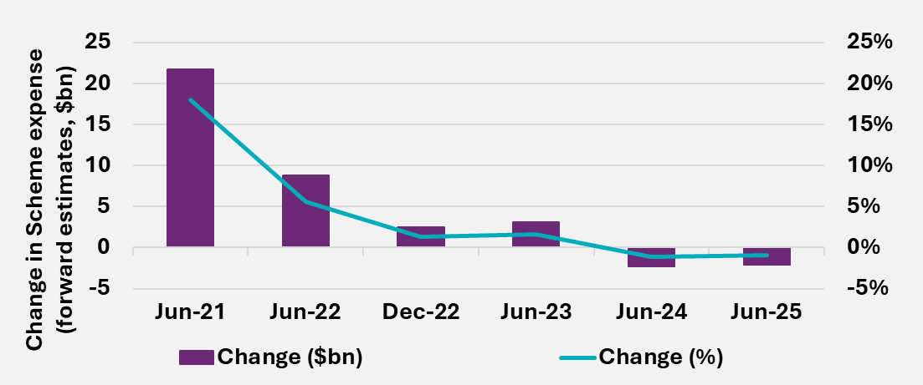
End of figure
Table 6.11 shows that up until the June 2023 projections, projected Scheme expenses were generally revised upwards for each successive AFSR. Since the June 23 projections, Scheme expenses have been more stable in 2024-25 and 2025-26 but in the medium term, projected Scheme expenses have declined in recent projections, where savings are expected from Scheme reforms.
Actual Scheme expenses of $46.3 billion in 2024-25 were $0.5bn below the forecast in the June 2024 projections. This shows that while the revised estimate narrowed the difference, there remains a challenge in accurately projecting participant payments, even in the short term.
While a component of the increases in the total expense projection over time is from a greater number of participants than previously expected, the main driver is the sustained growth in average payments per participants. The 30 June 2025 projection reflects both the emerging experience in new participants entering the Scheme, average committed supports and utilisation rates per participant, as well as the successful delivery of the Scheme reforms. This further adds to the complexity in projecting participant payments.
Table 6.11. Scheme expenses – Scheme projections and 2017 PC estimates found on page 134.
Table 6.12. shows the total projected participants for successive AFSRs. The PC estimates assumed participants would initially enter the Scheme more rapidly than occurred prior to June 2019. Participant projections for each successive AFSR projection have been revised to reflect the pace at which participants have entered the Scheme. The projections have been generally revised upwards at successive AFSRs.
For the 30 June 2025 projection, participant assumptions have been revised upwards to reflect the recent higher participant numbers experience relative to the expectations at the 30 June 2024 projection.
Table 6.12. Participant numbers - Scheme projections and 2017 PC estimates found on page 135.
Table 6.13. shows that, historically, the assumptions for average payments per participant have generally been revised upwards at successive reviews. This reflects the emerging experience of sustained significant growth in actual average payments over an extended period. Despite these substantial increases, Scheme projections have historically typically under-projected average payments in each year. Projections have assumed operational initiatives and Scheme reforms would lead to reduced growth in average payments over time.
Average payments per participant in the 2024-25 financial year were lower than projected from the 30 June 2024 projections as discussed in Section 4. This experience has been considered in the decreases made to the starting average committed supports and utilisation assumptions during this review as discussed in Section 5.
Table 6.13. Average payments per participant ($) - Scheme projections and 2017 PC estimates found on page 136.
Table 6.14. shows the actual growth and assumed growth assumptions for successive AFSRs. Compared to the 30 June 2024 projections, the 30 June 2025 AFSR projects a growth rate which is slightly higher in 2025-26, the same in 2026-27, higher in 2027-28 and then lower in 2028-29. Overall, the growth rate of 12.3% over these four projection years for the
30 June 2025 projections is lower than the growth rate of 13.5% for the 30 June 2024 projections, reflecting how growth assumptions have generally been revised downward each year.
Table 6.14. Actual and assumed rates of growth in average payments per participant found page 137.

Total participant costs ($b) | 2018-19 | 2019-20 | 2020-21 | 2021-22 | 2022-23 | 2023-24 | 2024-25 | 2025-26 | 2026-27 | 2027-28 | 2028-29
PC estimates
2017 PC Estimates |  | 21.9 | 23.8 | 25.5 | 27.2 | 29.0 | 30.8 | 32.7 | 34.8 | 36.8 | 38.9
Scheme projection
30 June 2025 AFSR | 0 | 0 | 0 | 0 | 0 | 0 | 0 | 50.7 | 54.0 | 58.1 | 62.5
30 June 2024 AFSR | 0 | 0 | 0 | 0 | 0 | 0 | 46.9 | 50.8 | 54.2 | 58.4 | 64.0
30 June 2023 AFSR | 0 | 0 | 0 | 0 | 0 | 41.4 | 46.4 | 50.8 | 55.2 | 60.2 | 65.6
31 December 2022 | 0 | 0 | 0 | 0 | 35.1 | 40.0 | 45.3 | 50.3 | 55.0 | 60.3 | 66.0
30 June 2022 AFSR | 0 | 0 | 0 | 0 | 34.0 | 38.1 | 44.1 | 50.3 | 55.5 | 61.2 | 67.3
30 June 2021 AFSR | 0 | 0 | 0 | 29.2 | 33.9 | 38.0 | 41.4 | 44.6 | 47.9 | 51.5 | 55.3
31 December 2020 | 0 | 0 | 0 | 28.1 | 32.9 | 36.9 | 40.7 | 44.1 | 47.8 | 51.8 | 55.9
30 June 2020 AFSR | 0 | 0 | 22.3 | 26.1 | 28.9 | 31.4 | 34.3 | 37.4 | 40.7 | 44.1 | 47.8
31 December 2019 | 0 | 0 | 21.8 | 25.4 | 28.5 | 31.4 | 34.2 | 37.1 | 40.2 | 43.4 | 46.9
30 June 2019 AFSR | 0 | 16.7 | 21.1 | 24.2 | 26.9 | 28.9 | 30.8 | 33.3 | 35.8 | 38.4 | 41.2
30 June 2018 AFSR | 9.5 | 16.0 | 20.3 | 23.6 | 26.6 | 29.5 | 31.7 | 34.0 | 36.4 | 38.9 | 0
Comparison with actuals
Actual participant costs (accrual) | 10.5 | 17.6 | 23.3 | 28.6 | 35.1 | 41.8 | 46.3 | 0 | 0 | 0 | 0
Actual participant costs compared with June AFSR ($) | 0.9 | 0.8 | 1.0 | -0.6 | 1.1 | 0.5 | 0.5 | 0 | 0 | 0 | 0
Actual participant costs compared with June AFSR (%) | 8.9% | 4.8% | 4.5% | -2.1% | 3.1% | 1.1% | -1.1% | 0 | 0 | 0 | 0
Table 6.11. Scheme expenses – Scheme projections and 2017 PC Estimates
End of figure

Table 6.12. Participant numbers – AFSR projections and 2017 PC estimates
Total participant costs ($b) | 2018-19 | 2019-20 | 2020-21 | 2021-22 | 2022-23 | 2023-24 | 2024-25 | 2025-26 | 2026-27 | 2027-28 | 2028-29
PC estimates
2017 PC Estimates | 447,300 | 473,700 | 485,900 | 497,700 | 509,300 | 520,800 | 532,000 | 542,900 | 553,200 | 563,100 | 573,000
Scheme projection
30 June 2025 AFSR |  |  |  |  |  |  |  | 779,700 | 805,700 | 828,100 | 861,500
30 June 2024 AFSR | 0 | 0 | 0 | 0 | 0 | 0 | 721,600 | 763,900 | 789,900 | 816,400 | 846,400
30 June 2023 AFSR | 0 | 0 | 0 | 0 | 0 | 668,900 | 714,800 | 754,000 | 792,200 | 831,400 | 871,100
31 December 2022 | 0 | 0 | 0 | 0 | 0 | 673,700 | 728,500 | 780,300 | 829,800 | 879,200 | 928,500
30 June 2022 AFSR | 0 | 0 | 0 | 0 | 592,300 | 646,000 | 693,900 | 741,100 | 787,800 | 834,200 | 880,400
30 June 2021 AFSR | 0 | 0 | 0 | 530,500 | 586,400 | 630,300 | 670,400 | 709,600 | 748,000 | 785,600 | 822,700
31 December 2020 | 0 | 0 | 0 | 537,900 | 596,600 | 643,200 | 682,800 | 721,600 | 759,700 | 797,200 | 834,100
30 June 2020 AFSR | 0 | 0 | 456,300 | 500,200 | 532,300 | 558,100 | 583,500 | 608,500 | 633,100 | 657,500 | 681,600
31 December 2019 | 0 | 0 | 443,200 | 485,200 | 518,400 | 544,000 | 568,500 | 592,500 | 616,300 | 639,900 | 663,000
30 June 2019 AFSR | 0 | 369,100 | 423,900 | 470,600 | 501,500 | 523,700 | 544,600 | 564,300 | 583,200 | 601,500 | 619,300
30 June 2018 AFSR** | 306,200 | 380,500 | 426,600 | 465,100 | 499,300 | 521,000 | 541,700 | 561,700 | 581,100 | 600,100 | 0
Comparison with actuals
Actual participant numbers | 286,000 | 392,000 | 466,600 | 534,700 | 610,500 | 661,300 | 739,400 | 0 | 0 | 0
Actual participant numbers compared with June AFSR ($) | -20,200 | 22,900 | 10,300 | 4,200 | 18,200 | -7,600 | 17,800 |  | 0 | 0
Actual participant numbers compared with June AFSR (%) | -7.1% | 5.8% | 2.2% | 0.8% | 3.0% | -1.2% | 2.4% | 0 | 0 | 0
End of table

Table 6.13. Average payments per participant ($) – AFSR projections and 2017 PC estimates
Total participant costs ($b) | 2018-19 | 2019-20 | 2020-21 | 2021-22 | 2022-23 | 2023-24 | 2024-25 | 2025-26 | 2026-27 | 2027-28 | 2028-29
PC estimates
2017 PC Estimates |  | 47,500 | 49,500 | 51,900 | 54,100 | 56,300 | 58,500 | 60,900 | 63,400 | 65,900 | 68,500
AFSR
30 June 2025 AFSR |  |  |  |  |  |  |  | 66,800 | 68,100 | 71,200 | 73,900
30 June 2024 AFSR | 0 | 0 | 0 | 0 | 0 | 0 | 67,200 | 67,800 | 69,100 | 72,000 | 76,300
30 June 2023 AFSR | 0 | 0 | 0 | 0 | 0 | 64,000 | 66,300 | 68,400 | 70,600 | 73,300 | 76,200
31 December 2022 | 0 | 0 | 0 | 0 | 0 | 61,300 | 63,700 | 65,800 | 67,300 | 69,500 | 72,000
30 June 2022 AFSR | 0 | 0 | 0 | 0 | 59,400 | 60,700 | 64,900 | 69,100 | 71,500 | 74,300 | 77,400
30 June 2021 AFSR | 0 | 0 | 0 | 57,800 | 59,900 | 61,600 | 62,800 | 63,700 | 64,800 | 66,200 | 67,800
31 December 2020 | 0 | 0 | 0 | 55,000 | 57,200 | 59,100 | 60,900 | 62,400 | 64,100 | 66,100 | 68,100
30 June 2020 AFSR | 0 | 0 | 51,800 | 53,800 | 55,300 | 57,200 | 59,800 | 62,400 | 65,000 | 67,900 | 70,800
31 December 2019 | 0 | 0 | 51,800 | 53,900 | 56,200 | 58,700 | 61,100 | 63,500 | 66,000 | 68,600 | 71,400
30 June 2019 AFSR | 0 | 49,800 | 52,000 | 53,400 | 54,800 | 56,200 | 57,700 | 59,700 | 61,900 | 64,400 | 67,000
30 June 2018 AFSR | 38,800 | 45,500 | 49,500 | 52,400 | 55,100 | 57,900 | 59,700 | 61,600 | 63,600 | 65,800 | 0
Comparison with actuals
Actual participant costs (accrual) | 42,500 | 50,800 | 54,300 | 55,200 | 60,600 | 64,400 | 65,800 | 0 | 0 | 0 | 0
Actual participant costs compared with June AFSR ($) | 3,600 | 1,000 | 2,600 | -2,600 | 1,200 | 400 | -1,300 | 0 | 0 | 0 | 0
Actual participant costs compared with June AFSR (%) | 8.5% | 1.9% | 4.7% | -4.8% | 2.0% | 0.7% | -2.0% | 0 | 0 | 0 | 0
End of table

Table 6.14. Actual and assumed rates of growth in average payments per participant
30 June 2025 AFSR | 2018-19 | 2019-20 | 2020-21 | 2021-22 | 2022-23 | 2023-24 | 2024-25 | 2025-26 | 2026-27 | 2027-28 | 2028-29
30 June 2025 AFSR | 0 | 0 | 0 | 0 | 0 | 0 | 0 | 1.4% | 2.0% | 4.5% | 3.9%
30 June 2024 AFSR | 0 | 0 | 0 | 0 | 0 | 0 | 4.3% | 0.9% | 2.0% | 4.2% | 5.9%
30 June 2023 AFSR | 0 | 0 | 0 | 0 | 0 | 5.5% | 3.7% | 3.2% | 3.3% | 3.8% | 3.9%
31 December 2022 | 0 | 0 | 0 | 0 | 0 | 1.0% | 3.9% | 3.3% | 2.4% | 3.2% | 3.5%
30 June 2022 AFSR | 0 | 0 | 0 | 0 | 7.7% | 2.1% | 6.9% | 6.6% | 3.5% | 3.9% | 4.2%
30 June 2021 AFSR | 0 | 0 | 0 | 6.5% | 3.5% | 2.9% | 1.9% | 1.5% | 1.8% | 2.1% | 2.4%
31 December 2020 | 0 | 0 | 0 | 1.3% | 3.9% | 3.3% | 3.1% | 2.5% | 2.7% | 3.0% | 3.1%
30 June 2020 AFSR | 0 | 0 | 1.9% | 3.8% | 2.9% | 3.6% | 4.4% | 4.4% | 4.3% | 4.3% | 4.4%
31 December 2019 | 0 | 0 | 2.0% | 3.9% | 4.4% | 4.5% | 4.0% | 3.8% | 3.9% | 4.0% | 4.1%
30 June 2019 AFSR | 0 | 17.4% | 4.2% | 2.8% | 2.5% | 2.7% | 2.6% | 3.5% | 3.8% | 3.9% | 4.1%
30 June 2018 AFSR | -0.1% | 17.3% | 8.8% | 5.8% | 5.2% | 5.0% | 3.1% | 3.2% | 3.3% | 3.5% | 0
Actual experience at 30 June | 9.2% | 19.7% | 6.9% | 1.6% | 9.9% | 6.2% | 2.2% | 0 | 0 | 0 | 0
End of table
End of Section 6

Participant outcomes and investment effectiveness

Outcomes and financial sustainability
Any assessment of Scheme financial sustainability needs to consider not only the costs of participant funding but also the extent to which this funding enables participants to achieve their goals and outcomes.
Underscoring the insurance-based principles upon which the Scheme rests, the National Disability Insurance Scheme Act 2013 (the NDIS Act) specifies that reasonable and necessary supports for people with disability should:
- Support people with disability to pursue their goals and maximise their independence.
- Support people with disability to live independently and to be included in the community as fully participating citizens.
- Develop and support the capacity of people with disability to undertake activities that enable them to participate in the community and in employment.
Hence, the NDIA has a responsibility to measure how participant funding impacts the achievement of outcomes related to maximising independence and inclusion in the community, including employment. This includes consideration of both the amount and type of funding, for example, the types of supports that lead to good outcomes for participants.
In turn, analysis of how funded supports change in response to outcomes contributes to effective monitoring of Scheme financial sustainability. For example, achieving increased independence should lead to a decrease in funded core supports over time.
As the cost of the Scheme increases, it becomes increasingly important for the Agency to demonstrate how the Scheme is successfully building the capacity of participants to increase their independence and economic and social participation. A positive perception of the Scheme by the general public, who contribute through taxation, needs to be maintained to ensure their ongoing support. A positive benefit-cost analysis, where there is evidence of marginal gains being achieved with the funding, will help to demonstrate the success of, and engender trust in, the Scheme.
Ideally, this benefit-cost analysis should have wider scope than just the NDIS. The NDIS is expected to benefit the broader Australian economy, for example through increased participation in work for people with disability and their families and carers (with consequent reduction in government income support), reduced hospitalisations through improved support in the community, and reduced involvement with the justice system through improved community connections and health and wellbeing outcomes.
Hence, measurement of outcomes and costs, both to the NDIS and other mainstream service systems, is critical in understanding the success of the NDIS and is a legislative requirement.
Outcomes and the IEP
As discussed in Section 7.8 of this report, the Investment Effectiveness Program (IEP) examines the relationship between government-funded support services and the attainment of participant outcomes under the Scheme. It forms part of a broader research agenda the NDIA is currently progressing that is designed to improve outcomes for participants and support building a robust evidence base that improves Scheme effectiveness and sustainability. A key input to this analysis is the longitudinal data collected on outcomes for participants of the NDIS.
Families and carers
Families and carers play an important role in supporting NDIS participants. Improved outcomes for participants under the NDIS can be expected to facilitate this role, leading to improved outcomes for families and carers also, such as increased employment.
The NDIS Act also acknowledges the role of families and carers in participants’ lives:
- The role of families, carers and other significant persons in the lives of people with disability is to be acknowledged and respected.
- The relationship between people with disability and their families and carers is to be recognised and respected.

The NDIS Outcomes Framework
The NDIS Outcomes Framework comprises a series of questionnaires to collect information on how participants and their families and carers are progressing in different areas of their lives.
The framework was developed to monitor individual and Scheme progress over time, and to benchmark (for example, to Australians without disability, and to other OECD countries). Longitudinal modelling of the data collected has also been used to investigate the link between outcomes and key drivers, including participant characteristics, socio-demographic factors, as well as the supports received by participants.
Development of the framework involved:
- A review of existing national and international frameworks.
- A review of available population data against which to benchmark performance, including Australian Bureau of Statistics (ABS) surveys as well as other sources.
- Consultation with a wide range of stakeholders, including the NDIA Independent Advisory Council (IAC), key stakeholder groups, disability researchers, participants and families/carers.
- A pilot of the questionnaires conducted in 2014.
Work is currently underway to review and refresh the NDIS Outcomes Framework, with changes to the existing framework expected from 2027.

Age groups and outcome domains
Leveraging research conducted by the Independent Advisory Council (IAC), the NDIS Outcomes Framework takes a lifespan approach to the measurement of outcomes, recognising that different milestones are important for different age groups. Hence different versions of the questionnaires are used, for both participants and families/carers, depending on the age of the participant.
There are four versions of the participant questionnaires (as per Figure 7.1) and three versions of the family/carer questionnaires by participant age group
(as shown in Figure 7.2).
Participant domains vary for children and adults. While most domains overlap, goals and outcomes may differ depending on the age group.
Figure 7.1. Participant domains by age group
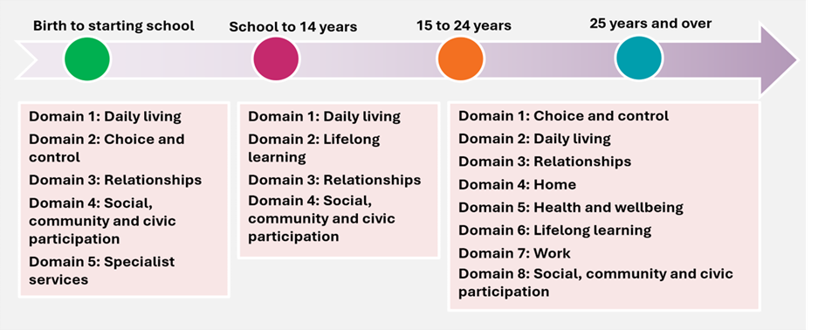
End of figure

Figure 7.2. Family/carer domains by participant age
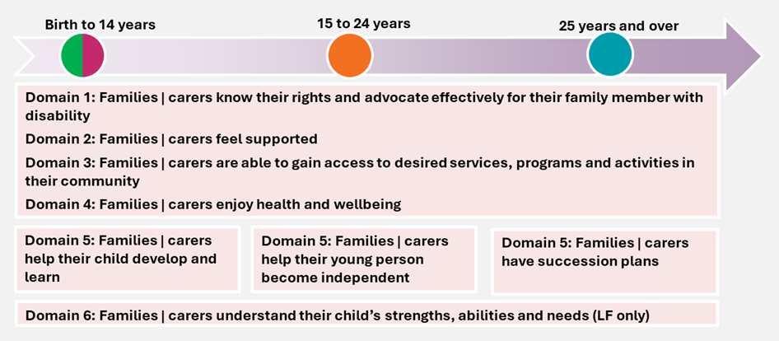
End of figure
Overall, families and carers share many similar goals and challenges, regardless of participant age. As such, a number of the domains do indeed overlap.

Short form (SF) versus long form (LF)
The 2014 pilot was used to refine the questionnaires, including removing redundant questions and revising wording for clarity. It also led to the development of two versions of the questionnaires – a long form (LF) (similar to the versions piloted), and a short form (SF).
The SF is intended to be completed by all participants and a family member or carer (where possible) and contains questions useful for planning, as well as key indicators to monitor and benchmark over time.
The LF is completed for a subset of participants and includes all of the SF questions plus some additional questions allowing more detailed investigation of participant and family/carer experience and enabling additional benchmarking.

Baseline versus longitudinal
Participants and their families and carers are interviewed at around Scheme entry (i.e. baseline measure), and approximately annually thereafter.
It is important to recognise that, with respect to how they are going in different areas of their lives, participants do not enter the Scheme on an equal footing. A range of individual and external factors will impact on the experiences of participants at baseline, including the extent to which their disability affects their life, where they live, and the extent of support they receive from family and friends.
Consequently, the success of the Scheme should be judged not on baseline outcomes, but on how far participants have come since they entered the Scheme, acknowledging their different starting points.
The longitudinal history built up from responses to the Outcomes’ Framework questionnaires is used to analyse progress at an individual and Scheme level, provide insight into how the Scheme is making a difference, and point to areas where improvements may be required.

Reporting on outcomes
Information collected from the questionnaires is used to contribute to a range of publicly available reports, including:
- Quarterly reports to disability ministers (Quarterly Reports | NDIS).
- Annual outcomes reports and dashboards (Participant, families and carer outcomes reports | NDIS).
- Deep dives focusing on specific outcome areas, such as:
- Employment outcomes – participants, their families and carers | NDIS
- Health and wellbeing of NDIS participants and their families and carers | NDIS.
- the impact of the COVID-19 pandemic on participant and family/carer outcomes.
- The NDIA Annual Report and the Annual Performance Statement (APS).

Participant outcomes – economic and social participation
Analysing changes in participants’ economic and social participation is important for understanding whether the reasonable and necessary supports funded by the Scheme are resulting in better participant outcomes. In the NDIS Corporate Plan 2025-26, key activity 1 is “Improve participant experience and outcomes with a financially sustainable Scheme”, which sits under Program 1.1 “Reasonable and necessary supports”. Aligned to key activity 1 are specific performance metrics, such as the proportion of participants in work and the proportion of participants involved in community and social activities. Changes in outcomes have been measured for participants who have been in the Scheme for at least two years, to allow sufficient time for the reasonable and necessary supports provided by the Scheme to have an influence on participant outcomes.
This section shows analyses of participant outcomes as at 30 June 2025, for participants entering the Scheme from 1 July 2016.

Employment
The NDIA recognises the critical role of employment in boosting the well-being, economic security and social inclusion of people with disability. From a sustainability perspective, when a NDIS participant works, they contribute to the economy, use less support for other activities to fill their days, and family members and carers can also return to work and contribute to the economy. The NDIA had a target of 26 per cent of working-age participants in paid employment by June 2025, with the achieved result of 23 per cent slightly below this target.
The NDIS Participant Employment Strategy 2024-26 (the Strategy), announced by the Minister on 15 March 2024, sets out the NDIA’s vision, commitment, and plan for supporting participants to find and keep meaningful employment.
The current low unemployment rate in Australia offers increased opportunities for employment of people with disability, including NDIS participants. The Employment Action Plan 2024-26 adapted the Strategy action plans to the current environment and contains 16 targeted actions that sit under four priority areas.
The updated Strategy focuses on:
- Quality planning.
- Efficient and effective employment supports.
- Supporting more employers to employ NDIS participants.
- An integrated eco-system of employment support.
Results – percentage in a paid job
The Corporate Plan employment metric for participants aged 15 and over is based on the SF question “Are you currently working in a paid job?” with response options “Yes”, “No, but I would like one”, and “No and I don’t want one”. The indicator “percentage in a paid job” is the number answering “Yes” as a percentage of the total number answering the question, and hence the denominator includes people who are not interested in employment. From a benchmarking perspective, this is similar to the “employment to population ratio” reported in the ABS Labour Force statistics.
The percentage in a paid job for those in the Scheme for at least two years continues to be relatively stable overall. However, results differ by age group. While employment has increased for those in the 15–24-year age group, it has remained stable or declined for all other age bands. Specifically, comparing responses at the most recent SF reassessment (between two and seven years after entry) with responses at Scheme entry (i.e. baseline measure), there has been a:
- Thirteen percentage point increase from 10% to 23% for participants aged 15-24 years.
- Three percentage point increase from 26% to 29% for participants aged 25-34 years.
- One percentage point decrease from 28% to 27% for participants aged 35-44 years.
- Two percentage point decrease from 25% to 23% for participants aged 45-54 years.
- Four percentage point decrease from 20% to 16% for participants aged 55-64 years.
- Six percentage point decrease from 14% to 8% for participants aged 65 years and older.
Overall, for participants of working age (15-64 years) there has been a two-percentage point increase, from 21% to 23%. This compares to a 2024-25 target of 26%.
Figure 7.3 provides more detail on these results, showing trends over time in the Scheme by age band for different duration cohorts (participants who have been in the Scheme for approximately eight, seven, six, five, four, three or two years at 30 June 2025).
Figure 7.3 shows a strong increasing trend in the percentage with a paid job for the 15 to 24 age group for all duration cohorts, in part reflecting the transition from school to work. For those aged 25 and over, the trend over time is similar amongst each of the age- based subgroups.
In general, participants aged 25 to 44 have a higher percentage of those in a paid job, compared to other age groups, and this is more pronounced for those in the Scheme for two to four years. For all duration cohorts, the level of employment is lower for participants aged 55 to 64, and lowest for those aged 65 and over, and both of these age groups show a decreasing trend. Part of this decreasing trend is likely to be due to participants retiring from the workforce.
Figure 7.3. Percentage of participants in a paid job – longitudinal trends for participants in the Scheme for two to eight years, participants aged 15 to 64
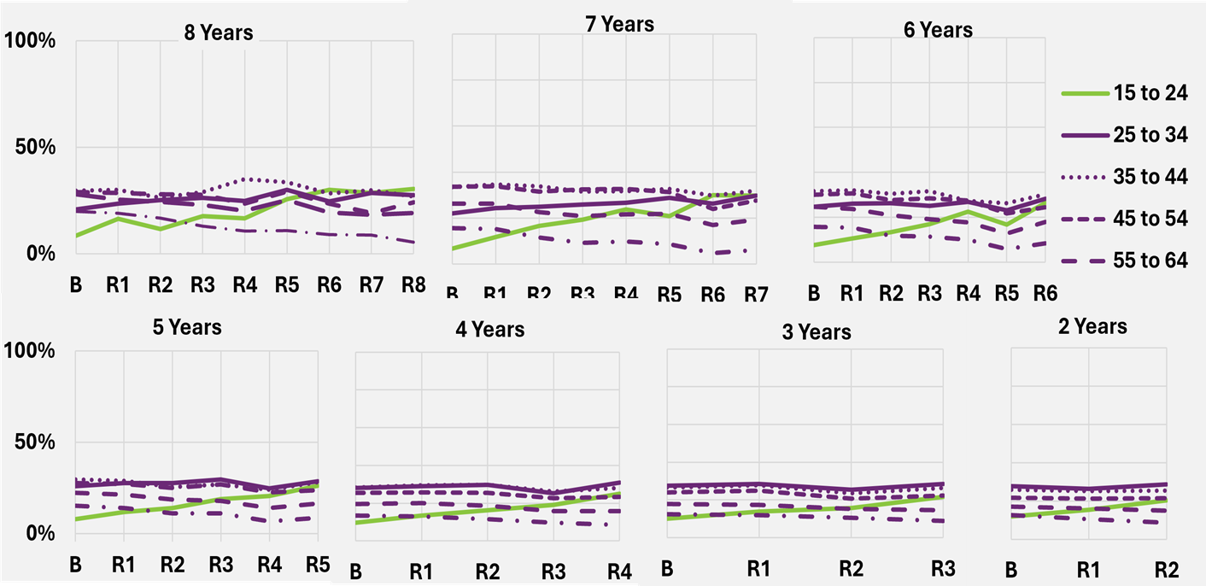
End of figure

Further details about the employment outcomes for NDIS participants can be found in the publicly available report titled “Employment outcomes for NDIS participants as at 31 December 2022”. High level insights on employment outcomes are also published in the NDIA’s Quarterly Reports to Disability Ministers.

Social and community participation
Participation in the community has many benefits for participants, including fostering a sense of belonging and connection, developing social networks and reducing isolation, and increasing confidence and feelings of safety. It can also be a way to increase opportunities for social inclusion and community access research. Participation in the community can lead to increased independence and reduced reliance on Scheme supports.
Results – percentage actively involved in the community
The Corporate Plan social and community engagement metric for participants aged 15 and over is based on the SF question “Have you been actively involved in a community, cultural or religious group in the last 12 months?” with response options “Yes, a general community group”, “Yes, a group for people with disability”, “No, but I would like to be” and “No and I don’t want to be”. The indicator for social and community engagement is the number answering “Yes” (regardless of setting) as a percentage of the total number answering the question.
Results for this metric tend to be more similar by age group than for employment. Specifically, the percentage actively involved in a community, cultural or religious group in the last 12 months showed a:
- Six percentage point increase from 33% to 39% for participants aged 15–24 years.
- Ten percentage point increase from 34% to 44% for participants aged 25-34 years.
- Eight percentage point increase from 34% to 42% for participants aged 35-44 years.
- Seven percentage point increase from 34% to 41% for participants aged 45-54 years.
- Six percentage point increase from 34% to 40% for participants aged 55-64 years.
- Six percentage point increase from 36% to 43% for participants aged 65 years and older.
Overall, for participants aged 15 and over, there has been a seven-percentage point increase, from 34% to 41%. This compares to a 2024-25 target of 46%.
Figure 7.4 provides more detail on these results, showing trends over time in the Scheme by age band for different duration cohorts (participants who have been in the Scheme for approximately eight, seven, six, five, four, three or two years at 30 June 2025). Due to improvements persisting over time, the change from baseline is usually greater the longer participants have been in the Scheme, for all age groups.
Figure 7.4 shows that increases in social and community participation generally tend to level off slightly after approximately three years in the Scheme. Whilst differences by age are smaller than for employment, participants aged 25 to 34 tend to be slightly above other age groups, whereas participants aged 15 to 24 tend to be slightly below. The extent of improvement is slightly higher for those aged 25 to 54.
Figure 7.4. Percentage of participants actively involved in the community – longitudinal
trends for participants in the Scheme for two to eight years, participants aged 15 and over
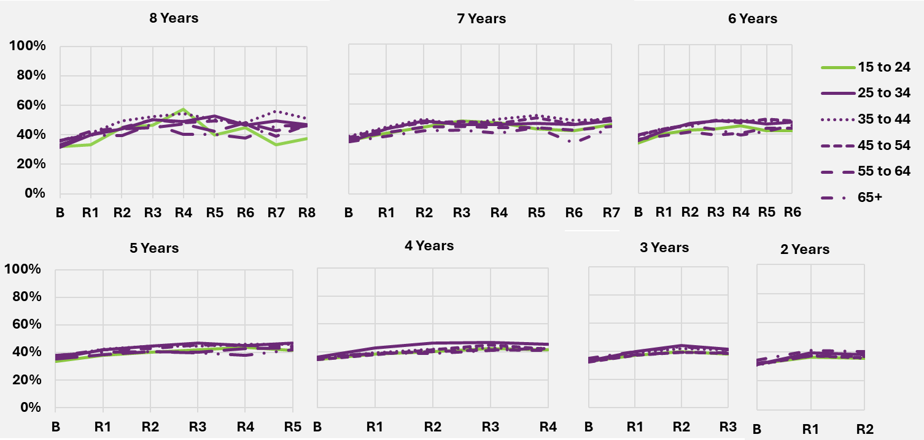
End of figure

“Has the NDIS helped?” – participants
Participants who have entered the Scheme since 1 July 2016 have been asked whether the NDIS has helped with areas related to each domain. Participants are asked at approximately annual intervals, allowing the Agency to gain valuable longitudinal insights. Results for selected domains are shown in this section, and compare responses provided at the first SF reassessment with those from later SF reassessments, for participants who have been in the Scheme for at least two years. This section shows analyses of participant outcomes as at 30 June 2025, for participants entering the Scheme from 1 July 2016.
On the whole, perceptions of the Scheme have been positive, with participants and their families/carers more likely to report that the Scheme had helped them in various areas of their lives, the longer the participant was in the Scheme. These results suggest a growing level of support for the Scheme by its participants and the family members and carers of participants. These positive perceptions are another indication of Scheme effectiveness and in the long-term assist in strengthening the ongoing financial sustainability of the Scheme.
On 30 October 2023, the NDIA rolled out PACE nationwide (refer to pages 43 and 45 for definition). Under this new system, the answer options for perceptions on whether the NDIS has helped have been updated, with “Yes” expanded to include “Yes, a lot” and “Yes, a bit”. A positive response is the total of these two options.
Therefore, in this section, the percentages responding positively to “Has the NDIS helped” questions are a mix of those responding “Yes” in the previous data system, as well as “Yes, a lot” and “Yes, a bit” in PACE.
It is hypothesised that some participants who answered “Yes, a bit” or “Did not need help in the area” using the new answer options may have answered “No” under the previous system answer options. This likely explains the larger-than-usual increase in the percentage responding positively at the latest reassessment, which contains a large proportion of responses from the new data system.

Results – Corporate Plan choice and control metric
The Corporate Plan choice and control metric for participants aged 15 and over is based on the SF question “Has the NDIS helped you have more choices and more control over your life?”
Positive perceptions of whether the NDIS has helped with choice and control have increased for the latest reassessment compared to the first reassessment across all age bands. Older participants tend to have higher levels of satisfaction. Specifically, the percentage who think that the NDIS has helped them have more choices and more control over their life showed a:
- Thirteen percentage point increase from 61% to 74% for participants aged 15-24 years.
- Fourteen percentage point increase from 67% to 81% for participants aged 25-34 years.
- Twelve percentage point increase from 70% to 82% for participants aged 35-44 years.
- Thirteen percentage point increase from 70% to 83% for participants aged 45-54 years.
- Thirteen percentage point increase from 72% to 85% for participants aged 55-64 years.
- Sixteen percentage point increase from 72% to 88% for participants aged 65 years and older.
Overall, for participants aged 15 and over, there has been a thirteen-percentage point increase, from 67% to 81%.
Figure 7.5 provides more detail on these results, showing trends over time in the Scheme by age band for different duration cohorts (participants who have been in the Scheme for approximately eight, seven, six, five, four, three or two years at 30 June 2025).
Figure 7.5 shows the generally lower levels of satisfaction for participants aged 15 to 24 compared to the older age groups.
Figure 7.5. Percentage who think the NDIS has helped them have more choices and more control over their life – longitudinal trends for participants in the Scheme for two to eight years, participants aged 15 and over
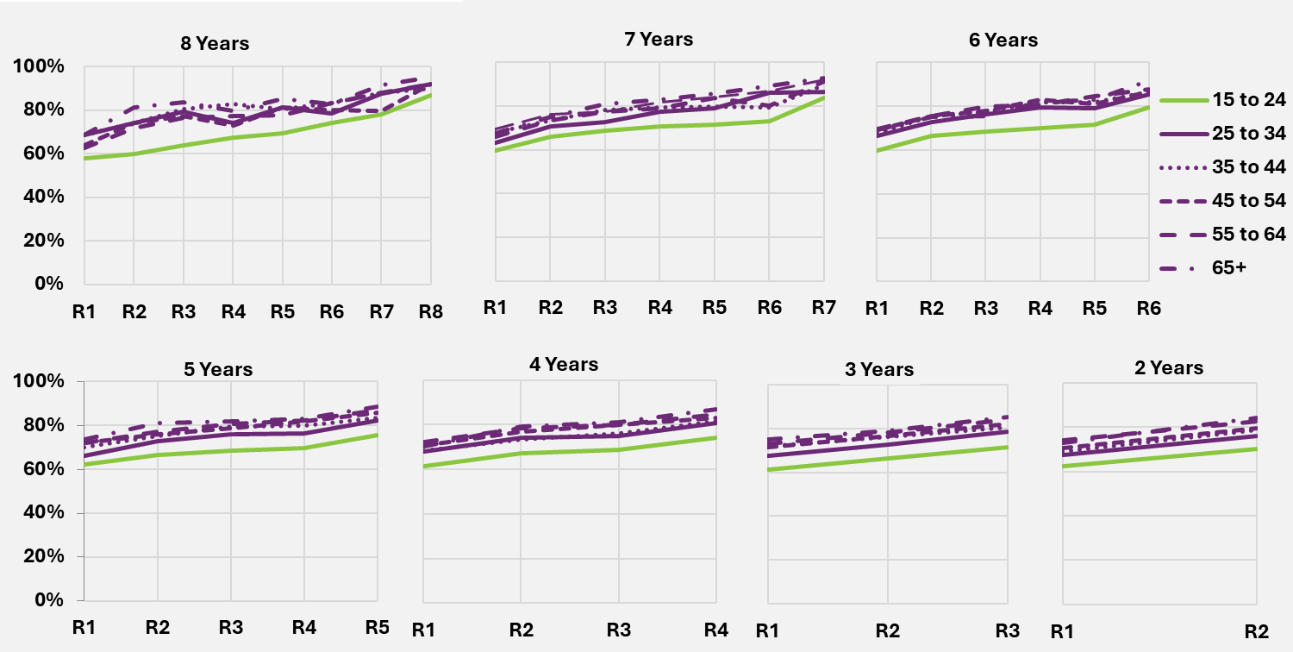
End of table

Other results – “Has the NDIS helped?”
For children aged from birth to before starting school, results have improved across all domains.
Table 7.1 shows the percentages responding positively at first reassessment and at latest reassessment, as well as the change between the two time points, for the birth to before starting school age group.

Table 7.1. “Has the NDIS helped?” – participants aged from birth to before starting school
Domain | First reassessment% | Latest reassessment% | Percentage point change
Daily living: child’s development | 91 | 95 | +4
Daily living: access to specialist services | 92 | 96 | +4
Choice and control (child’s ability to communicate what they want) | 82 | 89 | +6
Relationships (fitting into family life) | 78 | 85 | +8
Social, community and civic participation (fitting into community life) | 64 | 72 | +9
End of table
Improvements were slightly stronger for fitting into family and community life (although results for these domains started off at a lower level and hence had more scope to improve).
Figure 7.6 provides more detail for two areas (development and access to specialist services), showing trends over time in the Scheme for different duration cohorts (participants who have been in the Scheme for approximately eight, seven, six, five, four, three or two years at 30 June 2025).
Figure 7.6. Percentage who think the NDIS has helped – longitudinal trends for participants in the Scheme for two to eight years, age 0 to before starting school
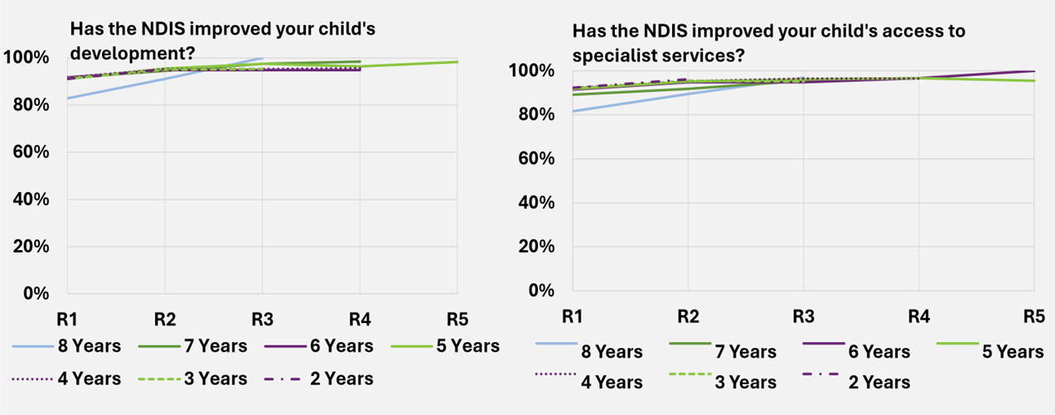
End of figure
Figure 7.6 shows very high levels of satisfaction for these two areas throughout. Nevertheless, an improving trend over time in the Scheme has been observed. Results for the different duration cohorts are generally similar.
For children aged from starting school to age 14, results are generally less positive than for the younger age group but show stronger improvement over time.
Table 7.2 shows the percentages responding positively at first reassessment and at latest reassessment, as well as the change between the two time points, for the starting school to age 14 age group.
Table 7.2. “Has the NDIS helped?” – participants from starting school to age 14
Domain | First reassessment % | Latest reassessment % | Percentage point change
Daily living (independence) | 62 | 77 | +15
Lifelong learning (access to education) | 42 | 55 | +13
Relationships (with family and friends) | 51 | 64 | +14
Social, community and civic participation (social and recreational life) | 46 | 57 | +12
End of table
Figure 7.7 provides more detail for two domains (gaining independence and relationships with family and friends), showing trends over time in the Scheme for different duration cohorts (participants who have been in the Scheme for approximately eight, seven, six, five, four, three or two years at 30 June 2025).
Figure 7.7 shows an increasing trend for these two indicators over time in the Scheme, apart from some volatility for those in the Scheme for six, seven and eight years (where numbers are smaller). Participants entering more recently show higher levels of satisfaction than those entering earlier.

Figure 7.7. Percentage who think the NDIS has helped – longitudinal trends for participants in the Scheme for two to eight years, age starting school to 14
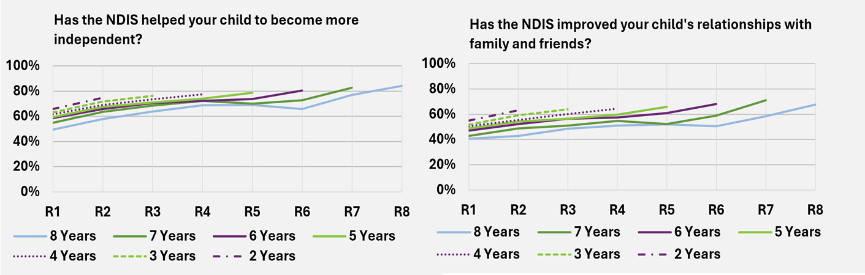
End of figure
For young adults aged 15 to 24 years, Table 7.3 shows the percentages responding positively at first reassessment and at latest reassessment, as well as the change between the two time points.
From Table 7.3, the largest improvement over time in the Scheme has been observed for the daily living domain (+14 percentage points). Strong improvements have also been observed for choice and control (+13 percentage points), health and wellbeing (+13), social, community and civic participation (+11), and relationships (+9). There was a 6-percentage point increase for lifelong learning, while home and work each showed a marginal increase (+2 and +3 percentage points, respectively).
Table 7.3. “Has the NDIS helped?” – participants aged 15 to 24
Domain | First reassessment % | Latest reassessment % | Percentage point change
Choice and control | 61 | 74 | +13
Daily living | 61 | 76 | +14
Relationships | 50 | 59 | +9
Home | 23 | 25 | +2
Health and wellbeing | 44 | 57 | +13
Lifelong learning | 36 | 42 | +6
Work | 18 | 22 | +3
Social, community and civic participation | 55 | 66 | +11
End of table
Figure 7.8 provides more detail for two domains (daily living and health and wellbeing), showing trends over time in the Scheme for different duration cohorts (participants who have been in the Scheme for approximately eight, seven, six, five, four, three or two years at 30 June 2025).
Figure 7.8 shows that improvements continue to occur over eight years for both domains shown.
Figure 7.8. Percentage who think the NDIS has helped – longitudinal trends for participants in the Scheme for two to eight years, age 15 to 24
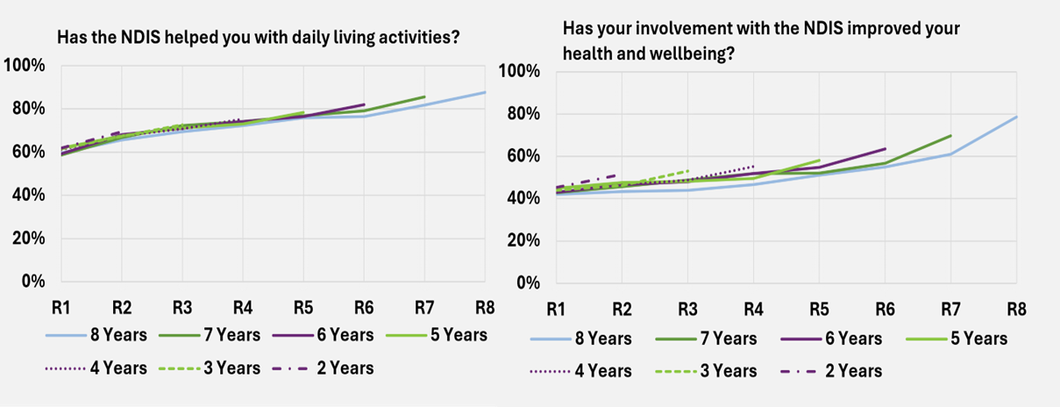
End of table
For participants aged 25 years and over, perceptions tend to be more positive than for those aged 15 to 24, and the older adult group also shows a stronger improvement over time. Table 7.4 shows the percentages responding positively at first reassessment and at latest reassessment, as well as the change between the two time points.
From Table 7.4, the largest improvements over time in the Scheme have been observed for health and wellbeing and social, community and civic participation (+15 percentage points). Strong improvements have also been observed for choice and control and daily living, (+13 percentage points), and relationships (+14 percentage points). By contrast with the younger adult group, there was a larger improvement for the home domain (+9 percentage points), and a similar increase for lifelong learning (+7 percentage points). Similar to the younger adult group, the work domain showed a lower increase
(+4 percentage points).

Table 7.4. “Has the NDIS helped?” – participants aged 25 and over
Domain | First reassessment % | Latest reassessment % | Percentage point change
Choice and control | 70 | 83 | +13
Daily living | 73 | 86 | +13
Relationships | 53 | 67 | +14
Home | 31 | 39 | +9
Health and wellbeing | 53 | 67 | +15
Lifelong learning | 30 | 37 | +7
Work | 19 | 23 | +4
Social, community and civic participation | 60 | 74 | +15
End of table
Figure 7.9 provides more detail for two domains (daily living and health and wellbeing), showing trends over time in the Scheme for different duration cohorts (participants who have been in the Scheme for approximately eight, seven, six, five, four, three or two years at 30 June 2025).
Figure 7.9. shows that improvements have continued to occur for these two domains, even after eight years in the Scheme
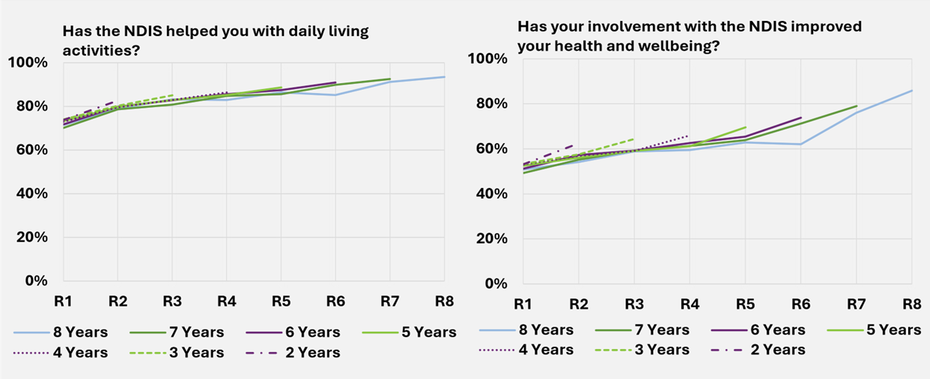
End of figure

Family and carer outcomes
The NDIS Outcomes Framework measures outcomes for the families and carers of participants as well as participants, recognising that the outcomes for people with a disability and the people who support them are likely to be closely linked. Families and carers of those participants who are well supported under the Scheme and who are achieving greater independence and social and economic participation, are likely to find the caring role easier and to experience increased wellbeing and greater opportunities for social and economic participation themselves. This improved situation for families and carers should in turn translate into further improved outcomes for participants (Volume 1 – Inquiry report – Disability care and Support pages 54-55, 131).

Results – percentage of parents/carers in a paid job
The metric for parent and carer employment is based on the SF question “Are you currently working in a paid job?” with response options “Yes” and “No”.
The percentage of parents/carers in a paid job for participants who have been in the Scheme for at least two years has improved over time. Specifically, comparing responses at the most recent SF reassessment (between two and eight years after entry) with responses at Scheme entry (i.e. baseline measure), there has been:
- An Eight percentage point increase from 46% to 54% for parents/carers of participants aged 0-14 years.
- A Two percentage point increase from 48% to 50% for participants aged 15 years and over.
Overall, for parents/carers of participants across all ages combined, there has been a six-percentage point increase, from 47% to 53%.
Figure 7.10. provides more detail on these results, showing trends over time in the Scheme for different duration cohorts (families/carers of participants who have been in the Scheme for approximately eight, seven, six, five, four, three or two years at 30 June 2025).
Figure 7.10 shows that across most cohorts, there appears to be a lower percentage of families and carers of participants aged 0 to 14 in a paid job across most earlier time points, compared to the 15 and over age group. However, families and carers of the 0 to 14 participant age group tend to show greater improvement over time, with a higher percentage in a paid job at the most recent reassessment, compared to the 15 and over age group. For families and carers of participants aged 15 and over, improvements seem to have levelled off over the latest year or two.

Figure 7.10. Percentage of parents/carers of participants in a paid job – longitudinal trends for participants in the Scheme for two to eight years
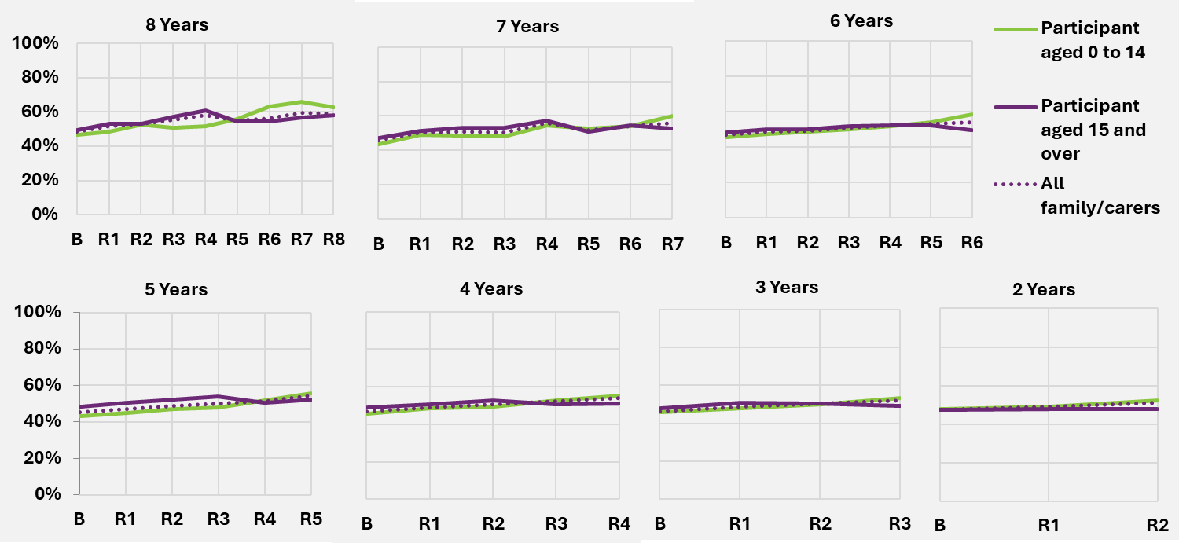
End of figure

“Has the NDIS helped?” – families and carers
Table 7.5 shows the percentages of families and carers responding positively at first reassessment and at latest reassessment, as well as the change between the two time points. Results are shown separately for participants aged 0 to 14 and those aged 15 and over.
From Table 7.5, perceptions tend to be more positive for families/carers of participants aged 0 to 14 than for those of older participants. The largest improvements over time in the Scheme have been observed for “rights and advocacy” and “families feel supported” (+10 percentage points for families/carers of participants aged 0 to 14, and +15 and +14 percentage points for families/carers of participants aged 15 and over, respectively).
Strong improvements have also been observed for access to services (+8 and +12 for families/carers of participants aged 0 to 14 and those aged 15 and over, respectively), and to a lesser extent health and wellbeing (+7 and +9 percentage points, respectively) and child’s development for families and carers of participants aged 0 to 14 (+7 percentage points).

Table 7.5. “Has the NDIS helped?” – families and carers
Domain | Participant aged 0 to 14  First reassessment % | Participant aged 0 to 14  Latest reassessment % | Participant aged 0 to 14  Percentage point change
Rights and advocacy | 65 | 75 | +10
Families feel supported | 70 | 79 | +10
Access to services, programs and activities | 72 | 80 | +8
Health and wellbeing | 45 | 52 | +7
Child’s development | 76 | 83 | +7
Domain | Participant aged 15 and over  First reassessment % | Participant aged 15 and over  Latest reassessment % | Participant aged 15 and over  Percentage point change
Rights and advocacy | 52 | 68 | +15
Families feel supported | 64 | 78 | +14
Access to services, programs and activities | 61 | 73 | +12
Health and wellbeing | 37 | 46 | +9
Child’s development | 0 | 0 | 0
End of table
Figure 7.11 provides more detail for the question “Has the NDIS improved the level of support for your family?”, showing trends over time in the Scheme for different duration cohorts (i.e. participants who have been in the Scheme for approximately eight, seven, six, five, four, three or two years at 30 June 2025).
Figure 7.11 shows that families and carers increasingly feel that the NDIS has improved the level of support for their family, the longer the participant has been in the Scheme. Families and carers of participants entering more recently tend to have higher levels of satisfaction.

Figure 7.11. Percentage of families/carers who think that the NDIS has improved the level of support for their family – longitudinal trends for participants in the Scheme for two to eight years, age 0 to 14 and 15 and over
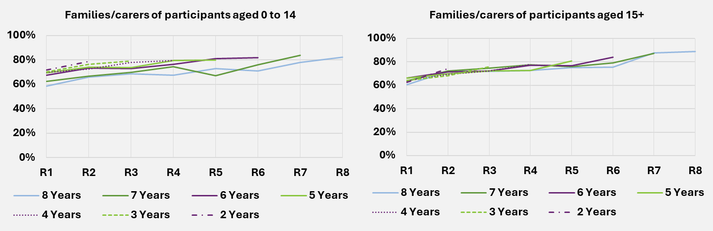
End of figure

Investment Effectiveness Program – IEP

Program progress in 2024-25
The Investment Effectiveness Program (IEP), first introduced in the 2021–22 AFSR and expanded in subsequent reports, continues its work to investigate the relationship between NDIS supports and participant outcomes. The IEP uses advanced analytics and qualitative methods to investigate participant outcomes, understand the effectiveness of NDIS supports, quantify the benefits of investment and build an evidence-based view of scheme value. Following the successful technical validation of analytical models last year, the program’s focus in 2024-25 shifted from broad exploration to establishing the foundational capabilities required for policy-relevant analysis.
This year’s progress was built on two strategic pillars. The first was a shift to more targeted analysis, focused on developing and modelling outcome measures tailored to specific supports. This reflects the Agency’s evolving approach to outcomes, moving from broad reporting to using measures that indicate the effectiveness of individual supports to assess impact and inform policy. This work has focused on areas of policy priority rather than whole-of-scheme analysis. The second pillar was the establishment of a secure data linkage between NDIS administrative data and the ABS Person-Level Integrated Data Asset (PLIDA), enabling a more comprehensive view of participant circumstances and supporting more robust analysis of support effectiveness. The following sections outline progress in building these capabilities.

Capability development
The IEP’s progress is underpinned by new capability to integrate policy and qualitative insight into the modelling process, particularly in the selection and refinement of outcome measures. This has been supported by data engineering work that enables linkage across non-scheme datasets and significantly expands the modelling capacity of the IEP’s machine learning methods. This section outlines three core components of that capability, using recent work on modelling Support Coordination effectiveness as an example.
Outcome selection
The IEP has focused on building capability to develop objective outcome measures derived from linked and administrative data, designed to reflect the intent of specific supports and better isolate their impact. While these measures do not directly capture wellbeing, they offer a structured way to assess whether supports are functioning as intended, with an implied link to participant outcomes downstream. This section outlines the IEP’s process for outcome measure development, using Support Coordination funding as a worked example.
The process begins with consultation alongside policy teams to clarify the objectives of a support and identify outcomes that reflect its intended impact. For Support Coordination, a key objective was effective plan implementation with well-matched providers aligned to participant goals. One way to assess this is by modelling the marginal impact of Support Coordination on the utilisation rate of budgeted supports. Significant underutilisation may suggest that additional coordination was needed to implement the plan more fully.
A related domain identified through consultation involves the connection, utilisation, and stability of mainstream services such as healthcare, education, and housing. These factors are closely tied to plan implementation: where broader needs are unmet, utilisation of NDIS supports may be diminished, and vice versa. To explore this, the IEP draws on subject matter expertise to define relevant cohorts and scenarios and uses linked data to model interactions between scheme and non-scheme supports. For example, outcomes scoped using ABS Person-Level Integrated Data Asset (PLIDA) linkage include stable utilisation of primary healthcare services over time; use of relevant medications for participants with psychosocial disability; and engagement with crisis or Centrelink payments for participants in defined life transition scenarios. Additional examples scoped with linked data are outlined in section 7.8.3.
Potential measures are refined through literature review examining contemporary evidence around plan utilisation, its limitations, systemic drivers, and prior modelling approaches. Qualitative and analytics teams use this to define parameters, including thresholds that indicate poor outcomes across different cohorts and the realistic influence of supports. For example, lower utilisation thresholds may be appropriate for participants with their first NDIS plan due to expected volatility.
The final stage involves identifying relevant drivers of each outcome and selecting linked data from PLIDA to control for confounding factors such as geography, income support status, and education. These variables are refined using the same qualitative lens applied to outcome measures, and decisions are validated with policy and subject matter experts.
The measures developed to assess Support Coordination effectiveness include:
- A measure to assess the impact of Support Coordination on the utilisation of other supports within a participant’s plan.
- A measure of provider stability, using a low rate of support provider ‘churn’ or switching as proxy for the continuity of a participant’s support network.
- A measure to understand the time taken for a participant to first access their NDIS supports following plan approval and first engagement with a Support Coordinator.
- A measure that uses successive plan data to assess a participant’s growing capacity to self-manage their supports.
Establishing the Participant Outcomes Knowledge Graph (POKG)
The POKG is the IEP’s overarching research framework. It maps relationships between participant characteristics, supports, and outcomes, and is used to structure inputs, assess data relevance, and evaluate confidence in results.
Over the past year, its qualitative evidence base has significantly expanded. This evidence informs the cohort definitions, outcome measures, and causal diagrams used in model development and consultation, including the work outlined in the outcome selection section above. Further detail on the POKG is available in the IEP section of the 2023–24 AFSR.
Data linkage
The integration of NDIS data with the ABS Person-Level Integrated Data Asset (PLIDA) represents a significant data engineering milestone for the IEP. This work has established a structured longitudinal data environment capable of supporting analysis of change over time, while accounting for complexities such as irregular plan lengths, variable data collection points, and the need to measure outcomes quarter by quarter.
To support this, the IEP has undertaken a range of data engineering activities that enhance reliability and enable longitudinal analysis. These include aligning participant data to calendar quarters to standardise trajectories across the population and incorporating point-in-time Census data to infer stable household composition and socioeconomic context over time. High-frequency transactional data, such as Pharmaceutical Benefits Scheme (PBS) claims, are linked to provide insight into co-morbidities and medication dependencies, improving the ability to control for health-related confounders. Synthetic indicators of local service availability have also been developed to account for market constraints that may influence support effectiveness.
The IEP also has access to a range of state and territory health data assets through the National Health Data Hub (NHDH) managed by the Australian Institute of Health and Welfare (AIHW). Although important datasets from these jurisdictions are not yet available to IEP (e.g. Justice and Education outcomes from the school system) the IEP environment serves as a proving ground for the future National Disability Data Asset (NDDA). It demonstrates how secure, de-identified, cross-portfolio data can be engineered for longitudinal analysis, supporting more accurate and policy-relevant insights. Lessons from this work will directly inform the design and governance of the NDDA and accelerate its application to Agency reporting and evidence products.

Future applications of IEP capability
New capability developed in 2024–25 enables the Agency to explore previously difficult questions about the relationship between NDIS supports and participant outcomes. Using the same process outlined in the capability development section, which combines linked data, policy consultation, qualitative insight and advanced analytics, the IEP has scoped outcome measures across three domains of analysis: A) the participant, B) the provider, and C) the system. The following section outlines the potential scope of analysis within each domain and signals directions for further development in 2025–26.
A. Participant-level analysis
This analytical stream is well established albeit has only been applied to NDIS SF outcomes (refer to Section 7.2) and administrative outcome measures (e.g. those outlined in section 7.8.2). It focuses on understanding the individual participant journey and how NDIS support payments influence this. For example, outcomes scoped for future application include:
- The relationship between NDIS supports and health and welfare system utilisation. This would involve using de-identified Medicare Benefits Schedule (MBS) and Pharmaceutical Benefits Scheme (PBS) data to understand how NDIS supports for capacity building and system navigation may influence engagement with primary care and potentially reduce the need for acute care services.
- Stability through life transitions and crisis situations. Modelling the role of NDIS supports in maintaining stability during critical life transitions, such as leaving school or changing housing. This can be achieved by creating measures to indicate ‘stability’ based on e.g. longitudinal patterns in MBS utilisation, employment and education records, or access to crisis payments made available through Centrelink for people in these circumstances.
- A range of economic and employment outcomes. This would use Australian Taxation Office (ATO) Single Touch Payroll data to model the relationship between NDIS supports and factor such as income level, quality and stability of work, and hours worked.
- Educational and vocational pathways. This would analyse National Centre for Vocational Education Research (NCVER) data on total Educational and Vocational activity to assess how NDIS supports may influence course completions and subsequent employment in specific industries.

B. Provider-Level analysis
This stream of analysis focuses on understanding the role of the provider in mediating participant outcomes. The capability creates a potential pathway to link to business-level data assets, such as the Business Longitudinal Analysis Data Environment (BLADE), which would provide a new evidence base for the Agency’s market stewardship role. For example, analysis could investigate:
- The association between participant outcomes and provider-level factors. This would involve exploring correlations between outcomes and provider characteristics such as business size, age, financial turnover, and degree of service specialisation, derived from Australian Business Register and business tax data.
- Workforce characteristics as a proxy for provider characteristics. This would use linked business employee data to infer things like workforce stability, mode of service delivery, participant-provider ratios. These can serve as indicators of service quality and continuity for participants.
C. System-level analysis
This stream focuses on understanding contextual and cohort-based variations in outcomes by synthesising data from participant and provider analyses. This work is critical for ensuring equitable access and outcomes across the Scheme. For example, this allows for analysis of:
- The influence of geography and market density on the outcomes participants achieve, providing a more sophisticated evidence base to understand and address challenges in thin markets.
- How the relationship between supports and outcomes differs for specific participant cohorts, such as for Culturally and Linguistically Diverse (CALD) participants or those in regional and remote areas.
Application of evidence
The evidence generated across all analytical domains can be applied in a structured and responsible way. The program’s analysis identifies sophisticated associations between supports and outcomes, accounting for a wide range of influencing factors. These insights help generate evidence-based hypotheses and can guide the prioritisation of more resource-intensive evaluation and causal research. By providing this diagnostic function, the program's analysis serves as a critical input to policy development. Ultimately, a core objective is to translate validated insights into accessible information, which will help build the evidence base required to support participants, their families, and carers in making more informed decisions about their supports.

Contribution to Scheme effectiveness and sustainability
The work undertaken in 2024-25 has established the core methodological and data foundations for a richer, quantifiable understanding of scheme benefits, a central component of sustainability. IEP's enhanced capabilities directly support the implementation of NDIS Review recommendations, particularly those focused on building a stronger evidence base to support participant decision-making.
This investment provides the tools for a more mature understanding of Scheme sustainability. It moves the discussion beyond nominal cost towards a holistic and evidence-backed view of the value and benefits generated for participants, their families, and the Australian community.
End of Section 7

Risk management

  - Introduction
The National Disability Insurance Scheme (NDIS) has been available to all Australians for five years. Given the long-term nature of the Scheme, experience continues to mature, and many aspects remain difficult to interpret. Specifically, estimation of future expenditure based on experience is inherently challenging given the relative size, complexity, and evolving nature of the Scheme. The Scheme is undergoing a period of significant reform following the NDIS Review and subsequent legislative changes. There is, therefore, significant uncertainty in the projections.
As the Scheme continues to mature, and staff, operational and governance capabilities improve, there is a continued expectation that Scheme operations and experience will change, perhaps materially, and this would affect the eventual trajectory of Scheme expenses. Decisions and actions of the Government and Agency and the Australian and global economic climate will also continue to impact the Scheme.
Future events cannot be predicted with certainty, and they may lead to unexpected impacts on Scheme experience which differ from the projections in this report. Examples of events with the potential to have a significant impact on future Scheme experience include another pandemic, unexpected changes in global inflationary pressures and changes to economic conditions which cause further workforce shortages in the disability sector.
With each update of the AFSR, projection assumptions balance both the emerging experience (considering the significance and duration of the trends), and future expectation which continue to change over time. Updates to assumptions consider the significant growth in the Scheme in the past, the relative immaturity of the Scheme and the reforms and operational measures as more data becomes available, as the Scheme continues to evolve, so too does the projection of Scheme costs.
Significant pressures on the financial sustainability of the Scheme remain and have become more significant. This is reflected in the upward revision of projected Scheme expenses in previous AFSRs and the more recent development and implementation of a number of reforms and operational measures.
There are a number of risks that impact on the financial sustainability of the Scheme. This chapter discusses these risks, and the mitigation factors in place or being developed to reduce their likelihood and impact.

Risk management arrangements and responsibilities
As set out in the NDIS Corporate Plan 25-26, the NDIA Risk Management Framework aims to ensure that risks are identified, assessed, mitigated, monitored and reported. This approach is designed to protects the NDIA’s purpose and fosters stability, accountability and public trust.
The NDIA’s risk governance and framework is underpinned by the:
- National Disability Insurance Scheme Act 2013.
- National Disability Insurance Scheme Risk Management Rules 2013.
- Public Governance, Performance and Accountability Act 2013.
- Related Commonwealth risk management policies and frameworks.
The NDIA Board oversees this approach through the Audit and Risk Committee, to ensure effective risk management, performance management and governance frameworks are in place.
Senior executives are responsible for identifying and managing Agency risks through regular monitoring and reviewing of risks, controls and treatment plans and consideration of emerging risks.
Risk management roles and responsibilities are defined for staff at all levels and supported by guidance materials, training modules, and via unrestricted access to risk advisory services and risk management tools.
The proactive use of risk management enables the Agency to effectively manage its operational and strategic risks in accordance with the risk appetite set by the Board.
The Agency has a structured approach to identifying, managing, escalating, and communicating risks. Together, the NDIA Board, the Audit and Risk Committee, the Strategic Leadership Team (SLT), and the Chief Risk Officer (CRO), oversee the efficacy of risk management performance of the NDIA and the effective implementation of a contemporary risk management framework.
The CRO assists the NDIA Board and SLT by providing independent and objective advice on risk management framework design and the prevailing risk and control environment, The Scheme Actuary has defined risk management responsibilities as part of their role, with the primary focus relating to the financial sustainability of the Scheme, as outlined below.

Responsibilities of the Scheme Actuary
The responsibilities of the Scheme Actuary in relation to the risk management of the Scheme are broadly defined in legislation and more explicitly detailed in the documents which comprise the Scheme’s and Agency’s risk management framework. These responsibilities are as follows:
NDIS Act
- If the scheme actuary has significant concerns about the financial sustainability of the National Disability Insurance Scheme, or the risk management processes of the Agency, he or she must report those concerns to the Board as soon as reasonably practicable.

NDIS risk management rules
- The Board must also ensure that the scheme actuary is involved in decisions made by the Agency and the Board in relation to risk, to the extent that that involvement is appropriate and consistent with the scheme actuary’s duties and the National Disability Insurance Scheme—Rules for the Scheme Actuary 2013.
NDIS - Rules for the Scheme Actuary
- The scheme actuary must include the following matters in an annual financial sustainability report:
(a) an overall assessment of the financial sustainability of the NDIS that identifies the key risks and issues impacting on the financial sustainability of the NDIS.
(b) a discussion of the key risks and issues identified and, where these have an adverse impact on financial sustainability, recommendations designed to manage the risks or address the issues.
- The scheme actuary must advise the Agency on how processes, systems and tools of the NDIS relating to the NDIS risk management framework can best be developed and implemented to enable the scheme actuary to perform his or her duties under section 180B of the Act effectively, and in particular to allow the scheme actuary to be satisfied that the NDIS is financially sustainable.
- The scheme actuary must include the following matters in an annual financial sustainability report:
(a) a discussion of the Agency's administrative infrastructure, its administrative processes and risk management arrangements.
- Risk management arrangements, of the Agency, means all of the systems, structures, cultures, processes, policies and people that identify, assess, mitigate and monitor all sources of risk, both internal and external, to financial sustainability.
NDIS Insurance Principles and Financial Sustainability Manual (page 18)
The NDIS Insurance Principles and Financial Sustainability Manual outlines the NDIS’ insurance model in detail and defines financial sustainability as the state where:
- The Scheme is successful on the balance of objective measures and projections of economic and social participation and independence, and on participants’ views that they are getting enough money to buy enough goods and services to allow them reasonable access to life opportunities - that is, reasonable and necessary support.
- Contributors think that the cost is and will continue to be affordable, under control, represents value for money and, therefore, remain willing to contribute.
To comprehensively consider the risks to financial sustainability faced by the Scheme, the two-fold definition above can be linked to the Strategic Risks identified in the most recent Corporate Plan and this analysis is provided in the next section.

Corporate Plan strategic risks
On an annual basis, the NDIA Board determines the strategic risks for the Agency, which are directly aligned to the Corporate Plan. The Board determined eight strategic risks for 2025-26 in the areas of:
- Participant experience and outcomes.
- Providers and markets.
- NDIS Sustainability.
- Workforce and culture.
- Integrity.
- Safeguarding our information.
- NDIA and NDIS transformation.
- Empowering First Nations Peoples.
The strategic risks are monitored against risk-aligned mitigation strategies, corporate plan performance measures and key risk indicators, with performance reported to the NDIA Board on a quarterly basis.
A number of key risks to the financial sustainability of the Scheme have been identified by the Scheme Actuary:
- Capability of disability provider market to respond to demand.
- Agency capacity.
- Fraud and non-compliance.
- Reforms and operational measures implementation.
- New entrants.
- Pricing/ Normal inflation.
- Additional growth in committed supports.
- Utilisation.
- Transitions into SIL.
- Participants leaving.
- Participant outcomes.
These key risks are expanded on in the commentary below, linking each of them to the strategic risks in the Corporate Plan.
Strategic risk 1 – Participant experience and outcomes
Our ability to provide a quality participant experience and fund reasonable and necessary NDIS supports (including general and early intervention) to eligible people with disability to ensure improved independence and social and economic participation.
Strategic Risk 1 closely mirrors the first component in the definition of financial sustainability in Section 8.3 above, with focus on participants’ views as to whether they are receiving reasonable and necessary support.
The NDIS Outcomes Framework measures outcomes for the families and carers of participants, recognising that the outcomes for people with a disability and the people who support them are likely to be linked. Participant outcomes and family and carer outcomes are discussed in Section 7.
The Investment Effectiveness Program (IEP) is being undertaken by the NDIA to better understand the link between Government funded supports and the attainment of participant outcomes. It is discussed in Section 7.
The NDIA has a responsibility to measure how participant funding impacts the achievement of outcomes related to maximising independence and inclusion in the community, including employment. This includes consideration of both amount and type of funding, for example, the types of supports that lead to good outcomes for participants. In turn, analysis of how funded supports change in response to outcomes contributes to effective monitoring of Scheme financial sustainability.
Sections 7.1-7.7 of this report discusses activities and results relating to the outcomes framework.
Strategic risk 2 – Providers and markets
Our ability to inform, engage and enable providers to deliver evidence-based, accessible and innovative supports to people with disability.
Strategic Risk 2 relates to both aspects of the Scheme’s financial sustainability, that is, participants’ views that they are receiving reasonable and necessary support and contributors’ views on the cost effectiveness of the Scheme.
A specific challenge in relation to this strategic risk is the capability of the disability provider market to respond to demand.
As the cost of the Scheme increases, it becomes increasingly important to measure how successful the Scheme is at building the capacity of participants to increase their independence and economic and social participation. A positive perception of the Scheme by the public, who contribute through taxation, needs to be maintained to ensure their ongoing support and continued development of a robust provider market.
Ideally, this cost-benefit analysis should have wider scope than just the NDIS. The NDIS is expected to benefit the broader Australian economy, for example through reduced hospitalisations via improved support in the community.
Hence, measurement of outcomes and costs, both to the NDIS and other mainstream service systems, is critical in understanding the success of the NDIS and is a legislative requirement.
Further, the NDIS forms part of the broader Australia’s Disability Strategy 2021-2031. The strategy is a commitment from all governments to a shared vision of an inclusive Australian society that enables people with disability to fulfil their potential as equal citizens. In particular, the strategy emphasises the need for improved performance of mainstream services in delivering outcomes for people with disability.
Strategic risk 3 - NDIS sustainability
Our ability to manage the sustainability of the NDIS.
Strategic Risk 3 relates directly to the ongoing costs of the Scheme as referred to in the second component of the financial sustainability definition.
Monitoring experience
A key tool for managing the sustainability of the NDIS is monitoring of emerging experience and importantly responding to adverse movements in the emerging experience. Section 4 provides detail of the trends in recent experience with comparisons of actual experience to the projections from the previous review. Key areas of focus for the experience monitoring relates to the key drivers of Scheme expenses including participant numbers, average payments, plan budgets, inflation experience and utilisation rates. These key areas are expanded on further below.
The experience is monitored closely and regularly reported to a number of stakeholders. The reporting on Scheme experience in recent years has led to legislative change and the co-design and implementation of various reforms and operational measures in response to this experience. This ties in with Strategy risk 7 – NDIA and NDIS transformation.
Inflationary effects and utilisation
Sections 5.4 and 5.7 sets out the inflation assumptions used for the June 2025 projections. This includes normal inflation and the additional growth in committed supports. Sustained elevated levels of additional growth in committed supports remains one of the most critical sustainability pressures for the Scheme given the material impact on projected Scheme expenses.
Given the evolving nature of the Scheme, assumptions relating to additional growth in committed supports involve considerable judgement and thus, remain highly uncertain.
The scenario analysis in Section 6.1 can be used to gauge the impact of higher normal inflation and additional growth in committed supports assumptions compared with the baseline projection.
The uncertainty around the additional growth assumption is also demonstrated in the stochastic modelling presented in Section 6.2 which includes a quantification of the substantial impact of this uncertainty on Scheme expenses.
Section 5.5 sets out the utilisation assumptions. Utilisation is projected to reflect future changes in the Scheme, as well as change in participants’ mix over time. Scheme reforms and operational measures are expected to reduce utilisation in the short term - by around 1% in 2025-26, and a further 1% in 2026-27.
Utilisation rates can be influenced by a range of factors, including changes in participant spending behaviours and changes in individual circumstances. Current and future Scheme reforms such as the introduction of the New Framework Planning (NFP) and sustainability initiatives may also impact participants’ usage of committed supports in future. The future utilisation rates of the Scheme remain highly uncertain.
Projected committed supports and utilisation at the Scheme level are adjusted in the June 25 projections for the impact of the Scheme reforms and operational measures.
New incidence of disability
Section 5.3 sets out the new entrant rate assumptions and details the revisions made to these to reflect the latest expectations of future Scheme experience. The overall number of new entrant projections in the long term are higher by 1% in the June 2025 compared to the June 2024 projections. This is driven by a higher number of new entrants with developmental delay and autism before the impact of Foundational Supports.
However, the overall participation rate (the proportion of the Australian population that are NDIS participants) has continued to grow since the previous review, albeit at a slowly decreasing rate. It is uncertain as to when new entrant rates will stabilise. This trend is driven predominantly by children with developmental delay joining the Scheme and new participants with autism.
Greater than expected new entrants will result in additional growth of Scheme expenses beyond those projected in this report. To illustrate the impact of current trajectories continuing scenario analysis is presented in Section 6.1, and uncertainty around these assumptions is included in the stochastic modelling presented in Section 6.2.
Participants leaving the Scheme
Section 5.3 also discusses the rate of participants leaving the Scheme for reasons other than death and are higher in the first few projection years relative to the previous review to align more closely with revised expectations.
Rates are expected to gradually increase in subsequent years towards longer term rates of participants leaving the scheme, reflecting the progressive impact of operational measures, which are themselves dependent on continued resource allocation towards eligibility reassessment and therefore remain uncertain.
To quantify this inherent uncertainty, the scenario analysis in Section 6.1 presents a scenario where more Agency resources are diverted from processing eligibility reassessments than assumed in the June 2025 projections, and as a result the backlog of Eligibility Reassessments is cleared a year later than forecasted.
Mortality
Section 5.3 also discusses the mortality rates noting that these are projected to be higher than those in the previous review. Mortality rates for participants with high support needs have been increased, to reflect the observed experience.
Transitions into SIL
Section 5.3 also discusses the assumptions related to SIL participants used for the June 2025 projections.
While the SIL transition assumptions are derived based on recent experience combined with long term expectations, there remains a degree of uncertainty around the emerging experience relating to the net increase in participants with SIL supports and when the number of participants with SIL will reach ‘maturity’ (grow in line with the overall growth in the adult population of the Scheme). There is also uncertainty about which alternative, more flexible and more efficient Home and Living option may be used in the Scheme in the future.
Estimation of the number of participants likely to require SIL supports is a challenge that also has a material impact on projected Scheme expenses. Scenarios are presented in Section 6.1 that illustrate the impact of higher or lower numbers of participants in SIL compared with the baseline projection and the stochastic modelling of transitions into SIL is presented in Section 6.2.
Strategic risk 4 – Workforce and culture
Our ability to build and maintain a safe, capable and high-performing workforce
Strategic Risk 4 relates, directly and indirectly, to both aspects of the Scheme’s financial sustainability, because the ability of the Scheme to maintain a high-performing workforce across all areas of its operations will impact participants’ access to reasonable and necessary supports and the cost of the Scheme.
The Scheme projections presented in this report implicitly assume that the Agency and disability sector more broadly will continue to be adequately resourced. The projections assume Agency resourcing remains relatively constant in real terms, and specifically that the funding of operational expenses is sufficient to implement and operationalise the Recent and Proposed Reforms. At the time of writing, work is being undertaken to ensure that the funding of reforms, as well as business-as-usual activities, is secured. If this does not eventuate, there is a risk that Scheme expenses are higher than those shown in this report.
Strategic risk 5 – Integrity
Our ability to protect the NDIS and participants against fraud and noncompliance, through a pro-integrity culture and in accordance with integrity frameworks and guidelines.
Strategic Risk 5 relates directly to the ongoing costs of the Scheme as referred to in the second component of the financial sustainability definition.
Fraud and non-compliance within the Scheme erode participant outcomes and inflate Scheme expenses, so maintaining the Scheme’s integrity by addressing Strategic Risk 6 is critical to its financial sustainability.
Strategic risk 6 – Safeguarding our information
Our ability to enhance the integrity of NDIA, NDIS and participant information, including preventing, detecting and responding to cyber security threats.
Strategic Risk 6 closely mirrors the first component in the definition of financial sustainability as this directly impacts on participants.
Important mitigation strategies to address this risk include maintaining appropriate cyber security measures and continuing to prioritise robust cybersecurity governance and operations to safeguard the Agency’s critical data and systems from evolving threats, including third party cyber risk.
Strategic risk 7 – NDIA and NDIS transformation
Our ability to transform the NDIA and NDIS in accordance with Government policy, reform recommendations and stakeholder expectations.
The June 2025 projections of Scheme expenses allow for the expected impact of the reforms and operational measures. Effective implementation of these and mitigating risks to these initiatives is key to ensuring the Scheme’s financial sustainability.
The projections presented in this report make several assumptions about how the reforms and operational measures will impact the underlying drivers of Scheme expenses. If the implementation of reforms and/or operational measures are delayed, or if the reforms do not have the effects assumed, then Scheme expenses are likely to be higher than the June 2025 projections, possibly materially.
Strategic risk 8 – Empowering First Nations Peoples
Our ability to build trust, promote equity and increase participation of First Nations Peoples by embedding the National Agreement on Closing the Gap Priority Reforms (genuine partnerships, shared decision-making and cultural safety) into the design and delivery of NDIS services.
Strategic Risk 8 closely mirrors the first component in the definition of financial sustainability as this directly impacts on participants.

Modelling risks
The decisions made in relation to the Scheme’s ongoing operations and financial sustainability partially rely on the modelling results provided to decision makers. NDIS payment processes are still evolving and there is a limited history available for setting assumptions, as well as some limitations in the data available for analysis.
Modelling imperfections exist, where certain factors impacting the Scheme are not reflected or are only indirectly captured in the projections. These factors are not explicitly allowed for in the structure of the modelling or the assumptions used. Examples include increases in plan utilisation with increased duration in the Scheme, the level of fraud and/or non-compliance within the Scheme, and the impacts of government policy or legislative changes to the Scheme’s operations.
These limitations give rise to model specification risk, which is the risk that the model is not an accurate representation of reality. The dynamically changing nature of the NDIS means that the actual outcomes of the Scheme may vary from the projections. Model specification risk is discussed in Section 6.2 and is explicitly included in the stochastic analysis presented in that section.

Business continuity and risk management system
The Agency is committed to ensuring that participant supports, and other critical business functions are maintained or quickly restored in the event of a significant outage, incident or crisis event. The Agency has established business continuity management plans, maintained through regular review and scenario analysis, to ensure the rapid resumption of Agency services and critical business activities in business disruptions.
The NDIA’s integrated risk management system provides a single platform for capturing and managing operational, strategic and regulatory risks, audit recommendations, incidents and business continuity plans. The system gives accountable executives a consolidated view of the risks and controls within their business and the broader NDIA and underpins quarterly risk reporting to the NDIA Board.

Assessment of the risk management framework
While the Agency’s tools, processes and procedures are commensurate with an entity of this size and level of maturity, they will continue to evolve with the Scheme. Future advancement in risk maturity will focus on further embedding positive risk behaviours and culture within the Agency, continuing to improve the integration and digitisation of its risk ecosystem to enhance risk-based decision making and consistency, better governance and implementation of policy changes, and proactive management of financial sustainability risks.
Managing strategic, regulatory and operational risks to remain at an acceptable level is fundamental to the success and longevity of the Scheme. While strategies to mitigate these risks are articulated in current risk reporting, the Agency monitors the effectiveness of these strategies to ensure that they are having the desired impact and to make the necessary adjustments to ensure they remain within acceptable tolerances.
The risk management processes of the Agency and the Scheme have been considered and, based on the information available, it is assessed that they are operating effectively to support the financial sustainability of the Scheme.
End of Section 8

Recommendations

Progress since previous review
There were two recommendations provided by the Scheme Actuary in the 2023-24 AFSR. This section provides an update on the progress that the Agency has made during the last twelve months with respect to each of the recommendations.
Recommendation 1 - Data quality
The success of the Scheme is dependent on the availability and quality of the data and information collected. Further investments should be made in the Agency’s data assets and the quality of data collected including continued development of the Enterprise Data Warehouse (EDW) as PACE (new Customer Relationship Management system) continues to roll-out and become embedded. This will enable more effective tracking of operational processes, and monitoring of Scheme experience (across participants, providers, and the Agency) leading to consistency of decision-making to address the effectiveness of processes and longer-term sustainability of the Scheme.
The Agency should continue to examine available data to understand the key risks to the financial sustainability of the Scheme and improve the quality and type of participant data collected. This will enable a deeper analysis and understanding of the drivers of participant needs over their lifetime, leading to improved insights and decision making, and reduce uncertainty in setting assumptions for the Scheme projections.
Progress update
The NDIA Data & Analytics Strategy 2025-2028 was developed and is being implemented. The key recommendations of the Strategy are:
- All Groups in the Agency should adopt and leverage the data and analytics platform being implemented by the Crack Down on Fraud (CDoF) program, and the timing of planned CDoF acquisition of data governance and end-user visualisation and reporting (EUVR) tools is to be brought forward.
- Formally defined analytics and reporting teams, including an uplift to the capabilities of Data & Analytics (and the Office of the Chief Information Officer) to provide critical centralised services, a controlled environment and the data, tools, and support to allow federated teams to operate effectively.
- Strengthen data governance across the data lifecycle, with particular focus on how we capture data in core business systems.
Improvements resulting from the implementation of the strategy include a new cloud-based data lake and data warehouse, a fully NDIA controlled environment, PowerBI (as well as SAS Viya) for reporting, choice of Posit or SAS Viya for advanced analytics, Machine Learning Operations for direct, real-time production interface to digital platforms, increased data availability including external data sources and more Agency corporate data and a data governance tool providing data definitions, quality standards and data lineage.
Enhancement work in relation to Reporting Platforms and Federated Analytics & Reporting is underway and work in relation to the Data Platform is in the re-design phase. Procurement of the new enterprise data warehouse is in progress.
With respect to deeper analysis and understanding of drivers of participant needs, specific examples of the sort of that data considered to be collected include change in circumstance, change in level of function, secondary disability, informal supports, and living arrangements.
Recommendation 2 - Projections Model Roadmap
Consistent with the recommendations from the NDIS Review, the Agency should develop a Projections Model Roadmap to define the different forecasting models used to project Scheme participants and expenses, including for specific cohorts. This will improve the reliability, robustness and usefulness of the Scheme projections.
Progress update
Over the last twelve months, development has continued on the Microsimulation Model (MSM) which was first introduced in the 2023-24 AFSR. This has included using generalised linear models to set most assumptions, leading to more robust projections that consider a larger number of factors when projecting scheme costs. The MSM will be a key component of the Agency's suite of forecasting models over the coming years and complements the Original Cohort Model (OCM) that currently produces our Scheme forecasts.
A new Plan Reassessment Model (PRM) has also been recently developed to complement the OCM and MSM. The PRM is a short-term projection model covering the next two years (2025-27), used to forecast the monthly numbers of plan reassessments, allowing for expected resource capacity and productivity. Assumptions are then made about expected growth in participant plan budgets on reassessment and expected change in participant spending behaviour, to estimate expected impacts of operational measures and Scheme reforms.
The functionality of the OCM and MSM have also been enhanced to produce projected Scheme payments using a committed supports x utilisation modelling approach which will better align to the New Framework Planning (NFP).

Recommendations from this review
Both of last year's recommendations are still highly relevant and ongoing so these will feed into the recommendations in this year’s report. The two specific recommendations in this year’s report set out below.
Data quality and availability
As improvements continue to be made from the implementation of the Data Strategy, the Agency will be able to conduct deeper investigations to better understand participant support needs over their lifecycle (i.e. - the type of supports and how support needs change over time, as well as the volume and frequency of supports) and help the NDIA better manage Scheme expenses. Reporting on Scheme expenses, participants and outcomes, is imperative to the operation and sustainability of the Scheme.
The EDW environment, including the integrity and quality of data, governance processes and data ownership, and efficiency of the platform for end-users, needs to continually evolve and improve over time. With increased focus on the effectiveness and sustainability of the Scheme, the accuracy and integrity of data used to make decisions and undertake analyses for the Agency to respond to requests for information in a timely manner, needs to uphold this higher level of scrutiny.
The type and quality of participant data collected is vital to building a robust evidence base, to monitor and track participant experience as it emerges, to analyse any emerging trends and outliers, and to conduct deep dives to investigate causes/reasons to explain patterns seen in the data. Such an evidence base is central to the management of the NDIS, providing an objective basis for the Agency to make informed decisions about policy design, and how best to support participants and ultimately drive optimal outcomes for participants, whilst managing the sustainability of the Scheme.
There is an opportunity to identify new participant data items and build a case for capturing new data, implementing/ enabling capture of participant data, and ultimately using new data to deepen analysis and understanding of key drivers of participant pathways across their lifecycle in the Scheme.
Recommendation 1 - Data quality and availability
The success of the Scheme is dependent on the availability and quality of the data and information collected. Further investments should be made in the Agency’s data assets and the quality of data collected including continued development of the EDW. This will enable more effective tracking of operational processes and monitoring of Scheme experience (across participants, providers, and the Agency), leading to consistency of decision-making to address the effectiveness of processes, and hence longer-term sustainability of the Scheme.
The Agency should continue to examine available data to understand the key risks to the financial sustainability of the Scheme and improve the quality and type of participant data collected. This will enable a deeper analysis and understanding of the drivers of participant needs over their lifetime, leading to improved insights and decision making, and reduce uncertainty in setting assumptions for the Scheme projections.
Projections Model Roadmap
The NDIS Review recommended that “...the Scheme Actuary should also develop different forecasting models, including for specific cohorts to improve the accuracy of the NDIS projections”. The continual development of projection models allows for the integration of innovative techniques, such as statistical and demographic modelling to enhance the accuracy and flexibility of the projections.
The development over the last 12 months of the PRM, and the ongoing development of the OCM and MSM is consistent with the recommendation of the NDIS Review.
A focus area for the next 12 months is the continued development of strategic plans for each of these three models. This will cover aspects such as the role and use of each model, model development, and consideration of model consolidation.
Recommendation 2 - Projections Model Roadmap
Consistent with the recommendations from the NDIS Review, the Agency should continue its development of a Projections Model Roadmap to define the different forecasting models used to project Scheme participants and expenses, including the role and use of each model. This will improve the reliability, robustness and usefulness of the Scheme projections.
End of Section 9

Glossary – Acronyms and Definitions 2024-25 AFSR

Acronyms
 | Acronyms
ABI | Acquired Brain Injury
ABS | Australian Bureau of Statistics
ACT | Australian Capital Territory
AFSR | Annual Financial Sustainability Report
AIHW | Australian Institute of Health and Welfare
APR | Annual Pricing Review
APS | Annual Performance Statement
ART | Administrative Review Tribunal
ATO | Australian Taxation Office
BLADE | Business Longitudinal Analysis Data Environment
CALD | Culturally and Linguistically Diverse
CB | Capacity Building
CDoF | Crack Down on Fraud
CPI | Consumer Price Index
CRM | Customer Relationship Management
CRO | Chief Risk Officer
EDW | Enterprise Data Warehouse
ER | Eligibility reassessment
EUVR | End-User Visualisation and Reporting
FTE | Full Time Equivalent
FWC | Fair Work Commission
GDP | Gross Domestic Product
GI/MM | General Injuries and Medical Misadventure
GLM | Generalised Linear Models
IAC | Independent Advisory Council
IEP | Investment Effectiveness Program
IGR | Intergenerational Report
LF | Long Form
LoF | Level of function
MBS | Medicare Benefits Schedule
MSM | Microsimulation Model
NCVER | National Centre for Vocational Education Research
NDDA | National Disability Data Asset
NDIA | National Disability Insurance Agency
NDIS | National Disability Insurance Scheme
NHDH | National Health Data Hub
NIIS | National Injury Insurance Scheme
NFP | New Framework Planning
NSW | New South Wales
NT | Northern Territory
OCM | Original Cohort Model
OECD | Organisation for Economic Cooperation and Development
PBS | Pharmaceutical Benefits Scheme
PC | Productivity Commission
PCI | Participant Critical Incident
PLIDA | Person Level Integrated Data Asset
POKG | Participant Outcomes Knowledge Graph
QLD | Queensland
QRDM | Quarterly Report to Disability Ministers
PRM | Plan Reassessment Model
RAC | Residential Aged Care
SA | South Australia
SAS | Statistical Analysis System
SCHADS | Social, Community, Home Care and Disability Services
SF | Short Form
SIL | Supported Independent Living
SLT | Strategic Leadership Team
TAS | Tasmania
VIC | Victoria
WA | Western Australia
WPI | Wage Price Index
End of table

Definitions
 | Definitions
2023-24 AFSR | Annual Financial Sustainability Report 2023-24.
Access request | A formal request by an individual for a determination of eligibility to access the Scheme.
Accrual basis | Payments are allocated to time periods based on when the service was provided to the participant, rather than when the cash is paid out by the NDIS.
Active participants | Those who have been determined eligible and have an approved plan (including cases where a participant's plan has expired and a new plan has not formally commenced, but they have not exited the Scheme).
Annual Performance Statement | Reporting on non-financial performance against planned results and targets set in the NDIS Corporate Plan.
Assistance with daily living | A type of core support that entails assistance with self-care activities.
Additional growth | A component of real growth in committed supports or payments. It is growth arising due to unscheduled plan reassessments or changes in utilisation of plan budgets. Previously has been referred to as superimposed inflation or additional inflation.
The Agency | National Disability Insurance Agency.
Assistive Technology | The full range of technological solutions that allow people with disability to be more independent and more connected. The primary purpose of assistive technology is to maintain or improve an individual’s functioning and independence to make participation possible (at home, school, workplace and/or community) and to enhance overall well-being.
Average annualised committed supports | Annualised committed supports divided by the average number of participants that are active in the year.
Average annualised payments | Annualised payments divided by the average number of participants that are active in the year.
Average payments | Historical periods: Average payments are calculated as total payments over a period, divided by the average number of active participants over the same period.  Projected periods: Average payments are calculated as projected average committed supports multiplied by projected utilisation rates.
Annualised plan budget | Plan budget at a specific point in time (on the current plan) scaled to a 12 month period. Annualised plan budgets may not reflect the actual amount of funds available to the participant over the year, since plan budgets may change over time.
Capacity-building support | Support that assists participants to increase their ability to live their life independently and achieve their goals.
Capital support | Support to purchase assistive technology or install home modifications to assist participants in day-to-day function and living.
Carer | Someone who provides personal care, support and assistance to a person with a disability and who is not contracted as a paid or voluntary worker.
Cash basis | Payments are allocated to time periods based on when the cash is paid out by the NDIS, regardless of when the support was provided.
Co-design | Co-design is people working together to solve problems. It is about developing ideas, products and systems together that work for everyone – especially for the people who use them. Co-design is different from consultation and collaboration because everyone has a say about the decisions that get made.
Committed supports | The amount of funds available to the participants over a period, considering all the changes in plan budgets during that period. They reflect the potential commitment of the Agency over that period.
Core support | Support that assists participants in day-to-day function and self-care.
COVID-19 pandemic | Global pandemic of coronavirus disease 2019.
Culturally and Linguistically Diverse | Country of birth is not Australia, New Zealand, the United Kingdom, Ireland, the United States of America, Canada or South Africa, or primary language spoken at home is not English. From September 2021, it excludes participants identifying as being part of First Nations Peoples.
Developmental delay | Delays in a child’s development that mean they find it much harder to do everyday things that other children their age can do, such as dressing themselves, walking, or talking.
Discount rate | An estimated interest rate for future time periods, which is used to calculate the current value of future payments.
Early childhood pathway | The nationally consistent early childhood pathway is for children younger than 6 with developmental delay or younger than 9 with a disability. Children younger than 6 who do not fully meet the definition of developmental delay and have developmental concerns will also be supported through the early childhood pathway.
Eligibility reassessment | A review of whether an active participant of the Scheme continues to meet the eligibility criteria to receive support from the Scheme.
First Nations People | Identified as Aboriginal and/or Torres Strait Islander.
Foundational Supports | A joint government commitment focused on developing and implementing supports outside the NDIS for children with early intervention needs.
Funding period | The time that a part of a participant’s funding becomes available and how long it needs to last. A participant can spend up to the amount of funding that is available in that time. Funding periods can be for either the total funding amount of a plan or for each funding component amount in a plan.
Getting the NDIS Back on Track | NDIS Amendment (Getting the NDIS Back on Track) Bill 2024 No.1, an amendment to the NDIS Act 2013 that implements recommendations from the NDIS Review aimed at improving participant experience and long-term sustainability of the Scheme.
Independent Advisory Council | Under the NDIS Act 2013, the IAC has a statutory function to advise the NDIA Board on key issues affecting participants, carers and families. Their advice aims to improve the Scheme, participant experience and outcomes.
In-kind | Existing Commonwealth or State/Territory government programs delivered under existing block grant funding arrangements.
Informal support | Supports for people with disability provided in a non-formal setting, primarily provided by parents.
Intra-plan inflation | Growth in a plan budget within a plan’s duration, between reassessments.
June 2024 projections | Projection of participant numbers and Scheme expenses reported in the previous review (2023-24 AFSR), using Scheme data to 30 June 2024.
June 2025 projections | Projection of participant numbers and Scheme expenses reported in this review (2024-25 AFSR), using Scheme data to 30 June 2025.
Level of function | A participant’s functional ability, measured using a range of widely accepted and validated tools which were selected based on expert advice from professionals with specialist disability knowledge.
Long form | Refers to the longer survey version, which contains more questions than the short form survey. It is conducted on a sample of NDIS participants each year.
Mainstream services | The government systems providing services to the Australian public e.g. health, mental health, education, justice, housing, child protection and employment services.
Market | Under the NDIS, the market is the place where participants and providers interact to trade for disability supports.
Mature participants | Participants who have been in the Scheme for at least one year.
National Disability Insurance Agency | The Commonwealth government organisation administering the NDIS.
National Disability Insurance Scheme | A national scheme for people with a disability caused by a permanent impairment, administered by the National Disability Insurance Agency (NDIA). The Scheme provides funding to eligible Australians with disability to purchase reasonable and necessary supports related to their disability. These supports help participants in their everyday life, and to pursue their goals.
NDIS Act | National Disability Insurance Scheme Act 2013, as amended.
NDIS Corporate Plan | Details the Agency’s strategic direction for the next four years, the key activities it plans to carry out, and the measures it will use to assess its performance.
NDIS Outcomes framework | The basis for measuring participant and family/ carer outcomes within the NDIS. It includes a number of surveys to collect information from participants and their families /carers and measure change across key life areas.
NDIS Quality and Safeguards Commission | An independent agency established to improve the quality and safety of NDIS supports and services.
New entrants | All participants entering the Scheme, having met the access eligibility requirements, with a first plan approved within a given financial year. Also known as participant intake.
New Framework Planning | Assessment and budgeting reform that is informed by a support needs assessment.
New incidence | People with a newly acquired disability accessing the Scheme for the first time.
Normal inflation | Growth in committed supports or payments, that is driven by increases in wages and consumer prices, and changes in price limits detailed in the 2024-25 Annual Pricing Review.
OECD countries | The Organisation for Economic Co-operation and Development (OECD) has 38 member countries, most of which are developed countries with high-income economies committed to market economies and democracy
Off-system payments | Off-system payments for participant supports are made to other government programs where they provide services covered by the Scheme, such as attendant care supports for participants in Residential Aged Care and Taxi Subsidy Schemes.
Outcomes framework questionnaires | One way in which the NDIA is measuring success for people with disability across 8 different life domains.
PACE | PACE is the Customer Relationship Management system used by the NDIA, replacing the old system SAP. National roll-out of PACE commenced from November 2023.
Participant | An individual whose access request has been determined ‘eligible’. A participant can be made eligible under the permanent disability criteria of the NDIS Act (s.24) or the early intervention criteria of the NDIS Act (s.25).
Participant cohort | A group of participants with similar characteristics. Participant cohorts have been determined by age, primary disability, recorded level of function, gender, whether they are in Supported Independent Living arrangements, and duration in the Scheme.
Participant intake | See ‘new entrants’.
Participant mix | The composition of the participant population in terms of key demographics such as age, gender, primary disability, level of function, and SIL status.
Participants new to SIL | Participants accessing Supported Independent Living arrangements for the first time.
Participation rate | The proportion of the Australian population who are NDIS participants.
Payment | Made to participants or their nominees for supports received as part of a participant’s plan, and to providers on behalf of participants as part of a participant’s plan.
PC estimates | Productivity Commission 2017, National Disability Insurance Scheme (NDIS) Costs, Study Report, Canberra.
Plan | A written agreement worked out with each participant, stating their goals and needs and the reasonable and necessary supports the NDIS will fund for them.
Plan budget | The amount of funds contained within a participant’s plan, approved to be provided to support a participant’s needs, at a specific point in time within the plan duration.
Plan duration | The length of time that a participant’s plan is active.
Plan inflation | Growth in a participant’s committed supports over time, which is due to a combination of economic inflation and a participant’s changing circumstances or support needs.
Plan reassessment | A review of a participant’s current plan. A plan reassessment may be requested by the participant or initiated by the Agency.
Previous review | The results of the annual review of the financial sustainability of the NDIS, for the period 1 July 2023 to 30 June 2024, reported in the 2023-24 AFSR.
Previously unmet need | People who had acquired a disability some years prior to accessing the Scheme for the first time.
Pricing | Guidance on the price to be paid for each support item. For some items, such as personal care and community access, the amount indicates the maximum price the NDIA will pay for that support.
Provider of support / Service provider | The provider responsible for the provision of disability supports for a NDIS participant. With respect to a payment request, the support provider is the provider paid by the NDIA for Agency-managed payments (paid provider). For self and plan-managed payments the support provider is the provider paid by the participant or plan manager respectively (on paid provider).
Real growth | Growth in committed supports or payments, over and above participant-related impacts and pricing impacts.
SAP | SAP is a software company that makes enterprise software. Also known as Systems, Applications and Products in Data Processing.
the Scheme | National Disability Insurance Scheme.
Scheme reforms | The combined impact of reforms enabled by legislation changes, the Crack Down on Fraud program, and Foundational Supports on projected Scheme expenses.
Short form | Refers to the shorter version of the outcomes’ questionnaire, which is intended to be collected for all participants at Scheme entry and approximately annually thereafter.
Steady Intake Date | The point in time where participant intake primarily represents participants with new incidence of disability. For this report 30 June 2026 has been assumed.
Stochastic model | A model which is used to estimate a range of potential outcomes by allowing for random variation in one or more inputs over time. In this case, the inputs which are varied are the material assumptions and risks which are most uncertain in the projection of Scheme expenses.
Support category | One of 15 categories in which the NDIS can provide support to participants. These include four core support categories (Transport, Consumables, Daily Activities and Social Community Civic), two capital support categories (Assistive Technology and Home Modifications) and nine capacity building (CB) support categories (Support Coordination, CB Relationships, CB Lifelong Learning, CB Home Living, CB Health and Wellbeing, CB Employment, CB Daily Activities, CB Choice and Control and CB Social Community Civic).
Supported Independent Living | Help with and/or supervision of daily tasks to develop the skills of an individual to live as independently as possible. Assistance provided to a participant will be included as part of their plan depending on the level of support they require to live independently in the housing option of their choice.
Thriving Kids | A program outside the NDIS intended to provide supports for children aged 8 or under with mild to moderate developmental delay and autism.
Trial period | From 1 July 2013 to 30 June 2016
Transition period | From 1 July 2016 to 30 June 2020.
Ultimate committed supports | The “final” estimate of committed supports over a period of time, allowing for retrospective changes. These changes are mainly due to intra-plan inflation on historical plans and annual pricing increases on unspent portions of plan budgets.
Utilisation rate | The proportion of committed supports over a period, used by participants to purchase support services.
Ultimate utilisation rate | A utilisation rate that allows for delays in payments for support services and retrospective changes in committed supports.
End of table
End of Glossary

Appendix table of contents

Appendix table of contents 187
Appendix A Comparison to previous review (detailed tables) 188
Appendix B Reconciliation to previous review 194
Appendix C State and territory breakdown 196
Appendix D Participation rates 198
Appendix E Scheme experience – payments 201
Appendix F Scheme experience – plan budgets 204
Appendix G Scheme experience – mortality experience 206
Appendix H New entrants assumption setting details 213
Appendix I Average committed supports and utilisation assumption settings details 218
Appendix J Scenario analysis from previous AFSRs 222
Appendix K Scenario analysis of participant numbers 231
Appendix L Microsimulation model 233

Comparison to previous review
(detailed tables)

Scheme expenses
Table A.1. Projection of Scheme expenses ($m accrual basis) – compared to the previous review

Projected Scheme expenses | 2025-26 | 2026-27 | 2027-28 | 2028-29 | 2034-35 | Total 2025-29
June 2025 projections
0-64 years | 45,114 | 47,517 | 50,749 | 54,179 | 82,058 | 197,559
65+ years | 5,591 | 6,441 | 7,377 | 8,282 | 13,697 | 27,692
Total | 50,705 | 53,958 | 58,126 | 62,461 | 95,755 | 225,250
June 2024 projections
0-64 years | 45,057 | 47,597 | 50,799 | 55,276 | 84,769 | 198,729
65+ years | 5,732 | 6,617 | 7,592 | 8,713 | 14,879 | 28,654
Total | 50,789 | 54,215 | 58,390 | 63,989 | 99,648 | 227,383
Difference
Difference 0-64 years | 57 | -80 | -49 | -1,098 | -2,711 | -1,170
Difference 65+ years | -141 | -176 | -215 | -431 | -1,182 | -962
Total | -84 | -256 | -264 | -1,529 | -3,893 | -2,132
% Difference
% Difference 0-64 years | 0.1% | -0.2% | -0.1% | -2.0% | -3.2% | -0.6%
% Difference 65+ years | -2.5% | -2.7% | -2.8% | -4.9% | -7.9% | -3.4%
Total | -0.2% | -0.5% | -0.5% | -2.4% | -3.9% | -0.9%
End of table

Table A.2. Projection of Scheme expenses ($m cash basis) – compared to the previous review
Projected Scheme expenses | 2025-26 | 2026-27 | 2027-28 | 2028-29 | 2034-35 | Total 2025-29
June 2025 projections
0-64 years | 44,839 | 47,227 | 50,439 | 53,847 | 81,550 | 196,353
65+ years | 5,555 | 6,400 | 7,330 | 8,229 | 13,609 | 27,514
Total | 50,394 | 53,627 | 57,769 | 62,076 | 95,159 | 223,866
June 2024 projections
0-64 years | 44,649 | 47,166 | 50,338 | 54,774 | 83,992 | 196,926
65+ years | 5,677 | 6,554 | 7,519 | 8,629 | 14,736 | 28,378
Total | 50,326 | 53,720 | 57,856 | 63,403 | 98,728 | 225,305
Difference
Difference 0-64 years | 190 | 62 | 102 | -927 | -2,442 | -574
Difference 65+ years | -122 | -154 | -189 | -400 | -1,127 | -865
Total | 68 | -92 | -87 | -1,327 | -3,569 | -1,438
% Difference
% Difference 0-64 years | 0.4% | 0.1% | 0.2% | -1.7% | -2.9% | -0.3%
% Difference 65+ years | -2.1% | -2.3% | -2.5% | -4.6% | -7.6% | -3.0%
Total | 0.1% | -0.2% | -0.2% | -2.1% | -3.6% | -0.6%
End of table

Scheme expenses by participants with SIL and without SIL
Table A.3. Projection of Scheme expenses by SIL status ($m accrual basis) – compared to previous review
Projected Scheme expenses | 2025-26 | 2026-27 | 2027-28 | 2028-29 | 2034-35 | Total 2025-29
June 2025 projections
Current SIL | 16,966 | 18,170 | 19,625 | 21,141 | 33,159 | 75,902
Current Non SIL | 33,739 | 35,788 | 38,501 | 41,320 | 62,596 | 149,348
Total | 50,705 | 53,958 | 58,126 | 62,461 | 95,755 | 225,250
June 2024 projections
Previous SIL | 17,968 | 19,200 | 20,658 | 22,580 | 34,758 | 80,406
Previous Non SIL | 32,820 | 35,015 | 37,732 | 41,410 | 64,890 | 146,977
Total | 50,789 | 54,215 | 58,390 | 63,989 | 99,648 | 227,383
Difference
Difference SIL | -1,002 | -1,030 | -1,033 | -1,439 | -1,599 | -4,503
Difference Non SIL | 918 | 774 | 769 | -90 | -2,294 | 2,371
Total | -84 | -256 | -264 | -1,529 | -3,893 | -2,132
% Difference
% Difference SIL | -5.6% | -5.4% | -5.0% | -6.4% | -4.6% | -5.6%
% Difference Non SIL | 2.8% | 2.2% | 2.0% | -0.2% | -3.5% | 1.6%
Total | -0.2% | -0.5% | -0.5% | -2.4% | -3.9% | -0.9%
End of table

Scheme expenses by primary disability type
Table A.4. Projection of Scheme expenses by primary disability type ($m accrual basis)
compared to previous review
Projected Scheme expenses | 2025-26 | 2026-27 | 2027-28 | 2028-29 | 2034-35 | Total 2025-29
June 2025 projections
Autism | 11,426 | 13,067 | 15,010 | 17,068 | 34,014 | 56,570
Development delay | 1,576 | 1,443 | 1,273 | 1,139 | 1,027 | 5,432
Intellectual disability | 12,752 | 13,250 | 13,991 | 14,740 | 20,108 | 54,732
Other neurological | 4,130 | 4,272 | 4,465 | 4,656 | 5,949 | 17,524
Psychosocial disability | 6,207 | 6,521 | 6,940 | 7,354 | 10,080 | 27,022
All other disability types | 14,614 | 15,406 | 16,448 | 17,503 | 24,578 | 63,970
Total | 50,705 | 53,958 | 58,126 | 62,461 | 95,755 | 225,250
June 2024 projections
Autism | 11,555 | 13,247 | 15,269 | 17,802 | 36,340 | 57,873
Development delay | 1,547 | 1,396 | 1,165 | 987 | 828 | 5,096
Intellectual disability | 13,040 | 13,627 | 14,428 | 15,530 | 21,481 | 56,626
Other neurological | 3,888 | 4,003 | 4,149 | 4,370 | 5,378 | 16,411
Psychosocial disability | 6,383 | 6,794 | 7,286 | 7,932 | 11,526 | 28,395
All other disability types | 14,375 | 15,147 | 16,092 | 17,368 | 24,095 | 62,983
Total | 50,789 | 54,215 | 58,390 | 63,989 | 99,648 | 227,383
Difference
Autism | -129 | -180 | -260 | -734 | -2,326 | -1,303
Development delay | 29 | 47 | 108 | 152 | 199 | 336
Intellectual disability | -288 | -377 | -438 | -790 | -1,373 | -1,893
Other neurological | 242 | 269 | 316 | 287 | 570 | 1,113
Psychosocial disability | -176 | -273 | -346 | -578 | -1,447 | -1,373
All other disability types | 239 | 259 | 355 | 135 | 483 | 988
Total | -84 | -256 | -264 | -1,529 | -3,893 | -2,132
% Difference
Autism | -1.1% | -1.4% | -1.7% | -4.1% | -6.4% | -2.3%
Development delay | 1.9% | 3.4% | 9.3% | 15.4% | 24.1% | 6.6%
Intellectual disability | -2.2% | -2.8% | -3.0% | -5.1% | -6.4% | -3.3%
Other neurological | 6.2% | 6.7% | 7.6% | 6.6% | 10.6% | 6.8%
Psychosocial disability | -2.8% | -4.0% | -4.8% | -7.3% | -12.6% | -4.8%
All other disability types | 1.7% | 1.7% | 2.2% | 0.8% | 2.0% | 1.6%
Total | -0.2% | -0.5% | -0.5% | -2.4% | -3.9% | -0.9%
End of table
Scheme expenses by support categories
Table A.5. Projection of Scheme expenses by support category ($m accrual basis) compared to previous review
Projected Scheme expenses | 2025-26 | 2026-27 | 2027-28 | 2028-29 | 2034-35 | Total 2025-29
June 2025 projections
Daily Activities | 26,639 | 28,388 | 30,605 | 32,922 | 50,584 | 118,554
Social Community Civic | 12,135 | 13,098 | 14,358 | 15,675 | 26,110 | 55,265
Transport | 1,001 | 1,059 | 1,135 | 1,212 | 1,747 | 4,407
Consumables | 701 | 724 | 759 | 793 | 1,028 | 2,977
Capital | 1,128 | 1,163 | 1,218 | 1,270 | 1,649 | 4,779
Capacity Building | 9,099 | 9,527 | 10,052 | 10,590 | 14,637 | 39,268
Total | 50,705 | 53,958 | 58,126 | 62,461 | 95,755 | 225,250
June 2024 projections
Daily Activities | 27,263 | 29,179 | 31,439 | 34,462 | 53,514 | 122,342
Social Community Civic | 12,406 | 13,532 | 14,860 | 16,573 | 28,360 | 57,371
Transport | 1,062 | 1,126 | 1,214 | 1,327 | 1,901 | 4,729
Consumables | 763 | 782 | 816 | 867 | 1,130 | 3,228
Capital | 1,061 | 1,078 | 1,118 | 1,182 | 1,490 | 4,439
Capacity Building | 8,235 | 8,517 | 8,944 | 9,579 | 13,253 | 35,275
Total | 50,789 | 54,215 | 58,390 | 63,989 | 99,648 | 227,383
Difference
Daily Activities | -623 | -791 | -834 | -1,539 | -2,930 | -3,788
Social Community Civic | -271 | -435 | -502 | -898 | -2,250 | -2,105
Transport | -61 | -68 | -79 | -115 | -154 | -322
Consumables | -61 | -58 | -57 | -75 | -102 | -251
Capital | 68 | 85 | 99 | 88 | 159 | 340
Capacity Building | 865 | 1,011 | 1,108 | 1,010 | 1,384 | 3,994
Total | -84 | -256 | -264 | -1,529 | -3,893 | -2,132
% Difference
Daily Activities | -2.3% | -2.7% | -2.7% | -4.5% | -5.5% | -3.1%
Social Community Civic | -2.2% | -3.2% | -3.4% | -5.4% | -7.9% | -3.7%
Transport | -5.7% | -6.0% | -6.5% | -8.6% | -8.1% | -6.8%
Consumables | -8.1% | -7.4% | -7.0% | -8.6% | -9.0% | -7.8%
Capital | 6.4% | 7.9% | 8.9% | 7.4% | 10.7% | 7.7%
Capacity Building | 10.5% | 11.9% | 12.4% | 10.5% | 10.4% | 11.3%
Total | -0.2% | -0.5% | -0.5% | -2.4% | -3.9% | -0.9%
End of table
Scheme expenses as proportion of Gross Domestic Product (GDP)
Total Scheme expenses (accrual basis) are estimated to represent 1.76% of GDP in 2025-26, increasing to 1.88% in 2028-29 and 2.13% in 2034-35. For ages 0 to 64, this is 1.57% of GDP in 2025-26, 1.63% of GDP in 2028-29 and 1.83% of GDP in 2034-35. Scheme expenses as a proportion of GDP are projected to be about the same or slightly lower than the previous review (Figure A.1 and A.2).
Figure A.1. Comparison of Scheme expenses (accrual basis) as a proportion of
GDP – all ages
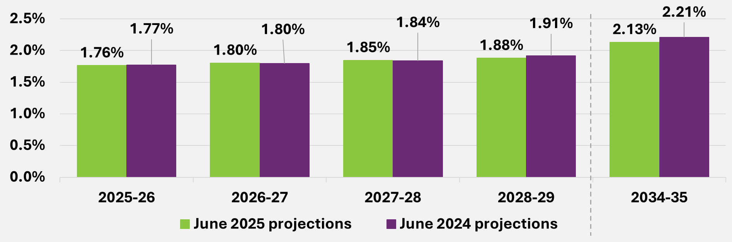
End of figure
Figure A.2. Comparison of Scheme expenses (accrual basis) as a proportion of
GDP ages 0 to 64
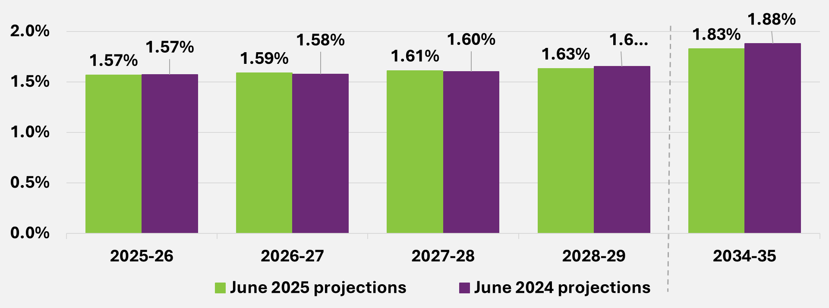
End of figure
End of Appendix A

Reconciliation to previous review

Projected participant numbers at 30 June 2026 are estimated to be around 15,800 higher than at the previous review. This is mainly driven by the higher number of new entrants than expected in 2024-25 and the expectation of a higher number of new entrants joining the Scheme in 2025-26. This is partially offset by an increase in the expected number of participants leaving the Scheme.
At 30 June 2029, projected participant numbers are expected to be around 15,000 higher than at the previous review. This is due to the same reasons as above and, in addition, an increase in the expected number of participants transitioning from developmental delay to other disabilities.
Table B.1. Change in projected participant numbers compared to previous review
at 30 June
Change in projected participant numbers | 2026 | 2027 | 2028 | 2029
June 2024 projections | 763,858 | 789,922 | 816,389 | 846,447
a) Experience between June 2024 and  June 2025 | 21,064 | 22,203 | 22,358 | 22,087
b) Change in assumptions relating to participants leaving the Scheme for reasons other than mortality | -14,128 | -25,937 | -29,813 | -25,183
c) Change in mortality assumptions | -317 | -634 | -941 | -1,237
d) Change in new entrant assumptions | 9,229 | 17,599 | 15,212 | 13,918
e) Change in assumptions related to participants transitioning from developmental delay to other primary disabilities | 0 | 2,580 | 4,850 | 5,495
June 2025 projections | 779,705 | 805,735 | 828,054 | 861,526
Total movement from June 2024 projections to June 2025 projections | +15,847 (+2.1%) | +15,812 (+2.0%) | +11,665 (+1.4%) | +15,079 (+1.8%)
End of table
For 2025-26, Scheme expenses are projected to be 0.2% lower than the previous review and Scheme expenses are projected to be lower than the previous review for all periods
Table B.2. Change in projected Scheme expenses ($m accrual basis) compared to previous review
Change in projected Scheme expenses | 2025-26 | 2026-27 | 2027-28 | 2028-29 | 2025-29
June 2024 projections | 50,789 | 54,215 | 58,390 | 63,062 | 226,455
a) Update to participant population at June 2025 | +437 | +525 | +543 | +567 | +2,072
b) Change in assumptions relating to participants leaving the Scheme for reasons other than mortality | -25 | -240 | -397 | -433 | -1,095
c) Change in mortality assumptions | -166 | -320 | -483 | -655 | -1,624
d) Change in new entrant assumptions | -15 | +4 | +36 | +67 | +92
e) Change in assumptions related to participants transitioning from developmental delay to other primary disabilities | +2 | +20 | +32 | +29 | +83
f) Change in assumptions relating to participants transitioning into SIL arrangements | +0 | +0 | +0 | +0 | +0
g) Update to average payments per participant at June 2025 | -717 | -765 | -824 | -890 | -3,197
h) Annual Price Review and Normal Inflation | -413 | -432 | -566 | -606 | -2,017
i) Assumptions regarding implementation of future reform | +1,115 | +2,656 | +2,035 | +1,922 | +7,728
j) Other Changes | -302 | -1,704 | -639 | -603 | -3,248
June 2025 projections | 50,705 | 53,958 | 58,126 | 62,461 | 225,250
Total movement from June 2024 projections to June 2025 projections | -84  (-0.2%) | -256  (-0.5%) | -264  (-0.5%) | -601  (-1.0%) | -1,205  (-0.5%)
End of table
End of Appendix B

State and territory breakdown

The projection model projects participant numbers and support costs at a Scheme level. A separate model is used to allocate projected Scheme participant numbers and Scheme expenses by State and Territory. The resulting Scheme participant numbers and Scheme expenses by jurisdiction are shown in Tables C.1 and C.2.
Scheme participant numbers by jurisdiction
Table C.1. Projected participant numbers by jurisdiction 30 June
Participant numbers | 2026 | 2027 | 2028 | 2029 | 2035
NSW | 229,182 | 235,494 | 238,926 | 244,645 | 304,623
VIC | 211,264 | 218,598 | 225,440 | 236,212 | 298,110
QLD | 168,624 | 175,058 | 181,806 | 191,291 | 236,969
WA | 68,677 | 71,539 | 74,676 | 79,275 | 99,573
SA | 65,914 | 68,102 | 69,738 | 71,614 | 85,742
TAS | 16,636 | 17,257 | 17,803 | 18,399 | 21,633
ACT | 12,427 | 12,492 | 12,317 | 12,498 | 15,825
NT | 6,898 | 7,112 | 7,266 | 7,512 | 9,538
OT | 84 | 83 | 82 | 81 | 86
Total | 779,705 | 805,735 | 828,054 | 861,526 | 1,072,099
End of table
Scheme expenses by jurisdiction
Table C.2. Projected Scheme expenses by jurisdiction ($m)
Scheme expenses (accrual basis) | 2026 | 2027 | 2028 | 2029 | 2035
NSW | 15,583 | 16,496 | 17,582 | 18,606 | 28,326
VIC | 12,731 | 13,622 | 14,778 | 16,021 | 25,027
QLD | 10,902 | 11,655 | 12,675 | 13,794 | 21,309
WA | 4,546 | 4,849 | 5,261 | 5,737 | 8,805
SA | 4,257 | 4,501 | 4,812 | 5,105 | 7,509
TAS | 1,205 | 1,281 | 1,380 | 1,475 | 2,107
ACT | 730 | 757 | 786 | 815 | 1,235
NT | 747 | 793 | 848 | 902 | 1,432
OT | 5 | 5 | 5 | 5 | 5
Total | 50,705 | 53,958 | 58,126 | 62,461 | 95,755
End of table

Participation rates by jurisdiction
Participation rates refer to the proportion of the Australian population that have a disability and are accessing Scheme supports. Table C.3 shows the projected participation rates by jurisdiction for people aged 0 to 64 years. Participation rates are projected to increase significantly over the short and medium to long term, across all states and territories. Participation rates are comparatively lower in WA, NT and the ACT and highest in SA.
Table C.3. Projected participation rates by jurisdiction at 30 June
Participation rate (%) | 2026 | 2027 | 2028 | 2029 | 2035
NSW | 3.0% | 3.1% | 3.1% | 3.1% | 3.6%
VIC | 3.3% | 3.4% | 3.4% | 3.6% | 4.1%
QLD | 3.4% | 3.5% | 3.5% | 3.7% | 4.3%
WA | 2.6% | 2.6% | 2.7% | 2.9% | 3.3%
SA | 4.1% | 4.2% | 4.3% | 4.4% | 5.2%
TAS | 3.4% | 3.6% | 3.7% | 3.8% | 4.5%
ACT | 2.7% | 2.7% | 2.6% | 2.6% | 3.1%
NT | 2.9% | 2.9% | 2.9% | 3.0% | 3.4%
OT | 0.0% | 0.0% | 0.0% | 0.0% | 0.0%
Total | 3.2% | 3.3% | 3.3% | 3.4% | 4.0%
End of table
End of Appendix C

Participation rates

Participation rates refer to the proportion of the general population that are participants of the NDIS.
Participation rates by gender
Scheme participation rates for males and females differ considerably at younger ages. At the peak, at age 6, the participation rate for males (15.6%) is more than double that of females (7.2%), noting that for participants aged below 18, the largest cohorts of Scheme participants are those with primary disability types of autism and developmental delay.
Figure D.1. Proportion of Australian male population in the Scheme
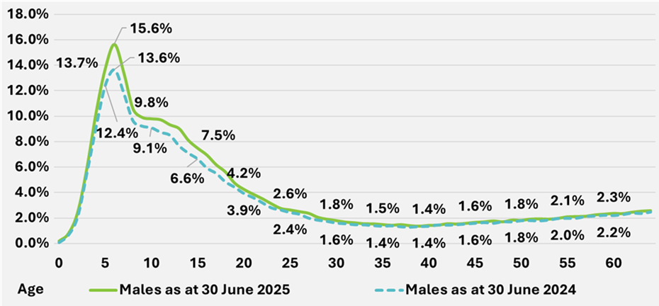
End of figure
Figure D.2. Proportion of Australian female population in the Scheme
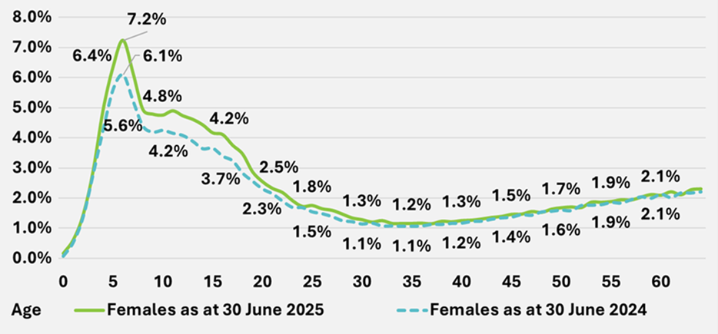
End of figure
Projected participation rates
Figure D.3 shows the projected participation rates for people aged 0 to 64 years. The chart shows that the participation rate is projected to increase over the next few years, with a 14% increase in the participation rate expected over the 5-year period between 30 June 2025 (3.1% participation rate) and 30 June 2030 (3.5% participation rate). Over the 5-year period between 30 June 2030 and 30 June 2035, the participation rate is expected to increase by a further 13% to 4.0% These participation rates imply that about 1 in 33 people in Australia aged between 0 and 64 years was a participant in the NDIS at 30 June 2025, and by 30 June 2035 this will increase to about 1 in 25 people.
Figure D.3. Projected participation rates for people aged 0 to 64 years at 30 June
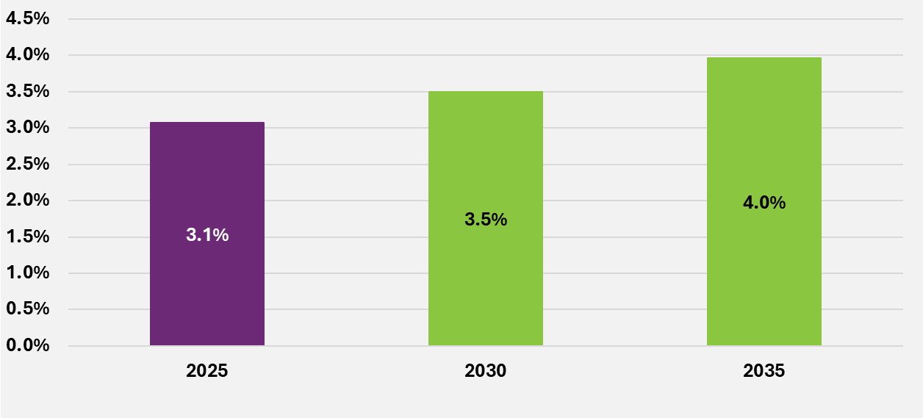
End of figure
Figure D.4 shows the projected participation rates for major primary disability types at this review, for people aged 0 to 64 years. This chart highlights that the main driver of the increase in participation rates is autism, partially offset by the decrease in developmental delay.
For participants with autism, participation rates increase from 1.3% at 30 June 2025 to 1.9% at 30 June 2030 (a 49% increase over this 5-year period), and to 2.4% at 30 June 2035 (a 24% increase over this 5-year period). These participation rates imply that about 1 in 77 people in Australia aged between 0 and 64 years was a participant of the NDIS with a primary disability of autism at 30 June 2025, and by 30 June 2035 this will increase to about 1 in 42 people.
For participants with developmental delay, participation rates decrease from 0.5% at 30 June 2025 to 0.20% at 30 June 2030 (a 56% decrease over this 5-year period), and to 0.17% at 30 June 2035 (a 16% decrease over this 5-year period).
For participants with disabilities other than autism or developmental delay, participation rates are projected to remain stable over the next ten years.

Figure D.4. Projected participation rates for major primary disability types for people aged 0 to 64 years, at 30 June
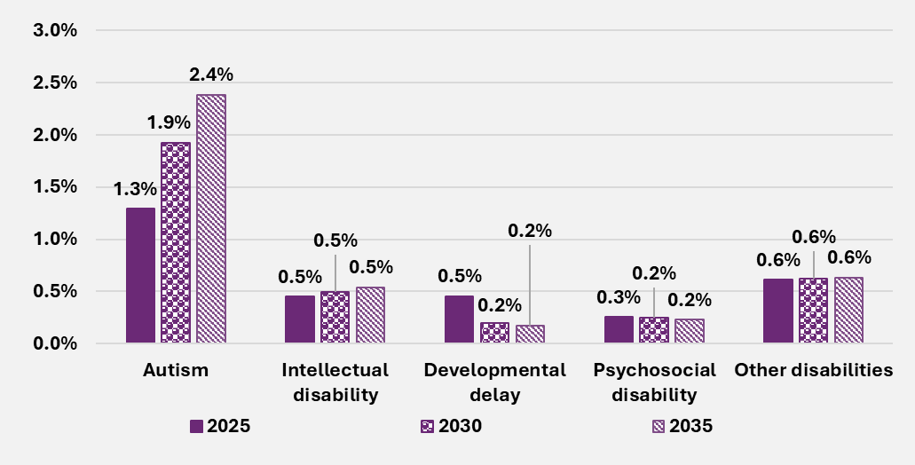End of figure
Figure D.5 shows the projected participation rates by age band at this review, for people aged 9 to 64 years. This chart highlights the main driver of the increase in participation rate between 30 June 2025, and 30 June 2035 are participants between the ages of 15 and 24. These participation rates imply 1 in 34 people in Australia aged between 19 and 24 years was a participant of the NDIS at 30 June 2025. By 30 June 2035 this is projected to become approximately 1 in 13 people, a 165% increase over the 10-year period.
Figure D.5. Projected participation rates for all disability types by age band, at 30 June
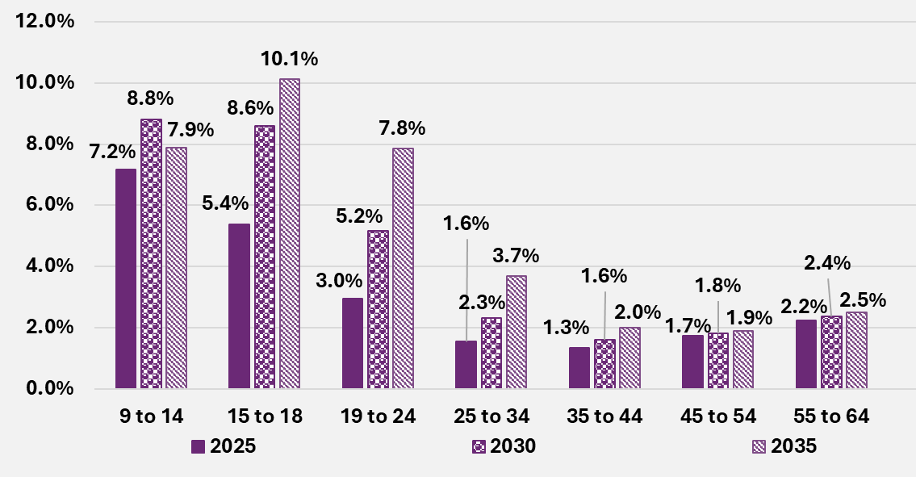
End of figure
End of Appendix D

Scheme experience – payments

Further breakdowns of payments by other characteristics
Average annualised payments by other characteristics show a broadly consistent trend.
Average annualised payments by level of function
Figure E.1 shows that average annualised payments in 2024-25 have increased by 2.4% for participants with a high level of function, 3.2% for participants with a medium level of function, and 4.6% for participants with a low level of function. This is comparatively lower than the average annual growth rate over the past three years of 9.5%, 8.2% and 9.4% per annum for participants with high, medium and low level of function respectively.
Figure E.1. Average annualised payments ($) for participants with high, medium, and low level of function
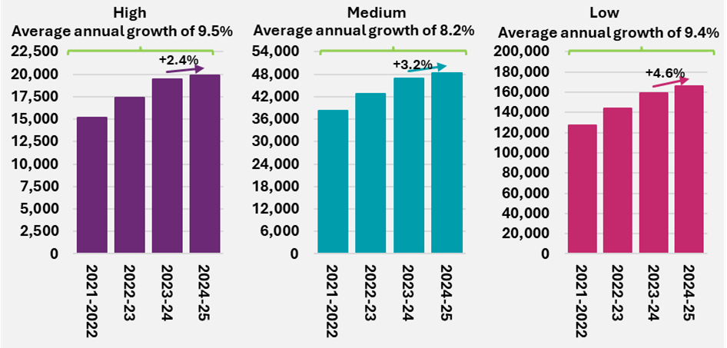
End of figure
Average annualised payments by primary disability groups
Figure E.2 shows average annual growth in payments, over the past three years, was highest for participants with a primary disability categorised as other neurological (13.8%), and lowest for participants with a primary disability of autism (3.9%). Average annual growth in payments since the previous review was 6.8% and -2.2% for participants with a primary disability categorised as other neurological and autism respectively.
This is consistent with the trends observed by age groups, where higher average payment growth was observed at older ages. Participants with a primary disability of autism tend to be younger on average, compared with participants with a primary disability categorised as other neurological.

Figure E.2. Average annualised payments ($) by primary disability type
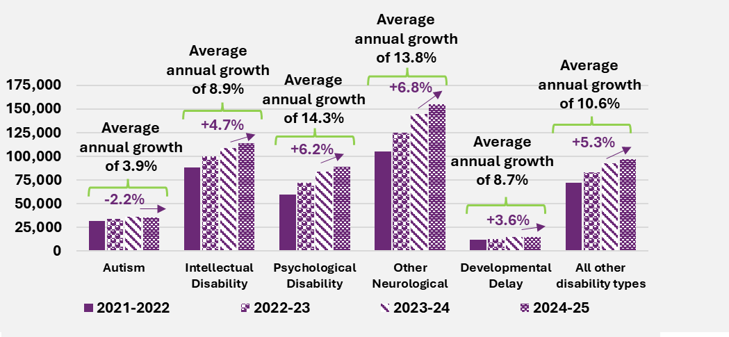
End of figure
Average annualised payments by participants’ remoteness
Figure E.3 shows average annualised payments of $67,500 in 2024-25 for participants in the Scheme living in major cities. Comparatively, average annualised payments for participants identifying as living in remote communities was $80,400. Average annualised payments in 2024-25 for participants remote areas were 19% to 75% higher than average payments for participants living in other remoteness categories.
Figure E.3. Average annualised payments ($) for participants by remoteness in 2024-25
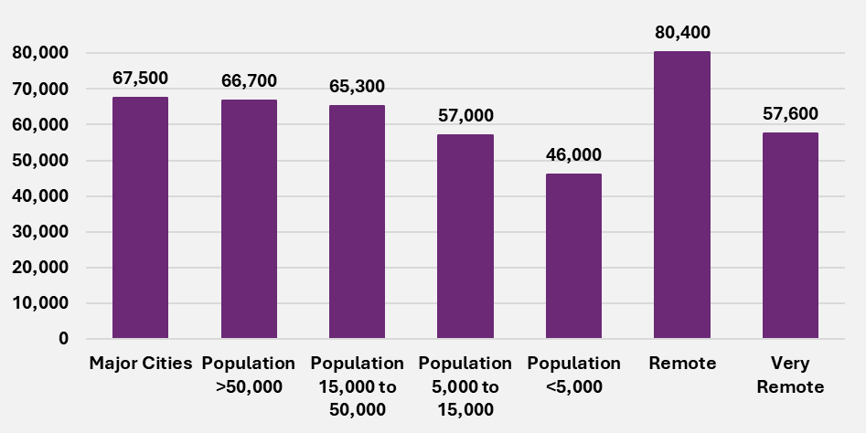
End of figure
Average annualised payments for First Nations people
8% of participants in the Scheme identify as First Nations people. Figure E.4 shows average annualised payments of $63,600, for both participants in the Scheme identifying as First Nations and non-First Nations people. The average annual growth in payments since the previous review, of 0.9% and 0.2% for First Nations and non-First Nations people respectively, is lower than the average growth of 6.9% and 5.3% per annum over the past three years.
Figure E.4. Average annualised payments ($) of participants identifying as First Nations people
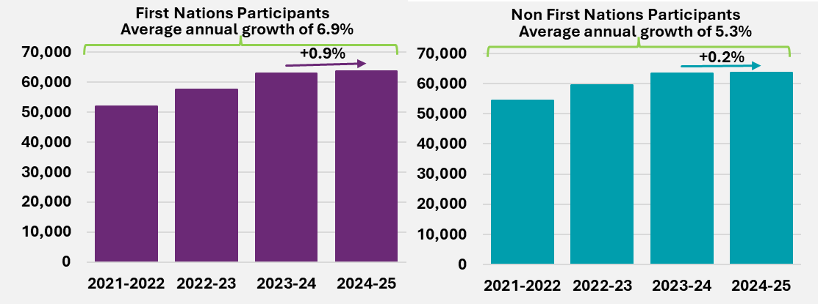
End of figure
Average annualised payments for participants identified as Culturally and Linguistically Diverse (CALD)
9% of participants in the Scheme identify as Culturally and Linguistically Diverse (CALD) people. Figure E.5 shows average annualised payments of $75,000 and $64,000 in 2024-25, for participants in the Scheme identifying as CALD and non-CALD respectively. The average annual growth in payments since the previous review, of 2.0% and 1.7% for CALD and non-CALD participants respectively, is lower than the average rate of growth per annum of 10.5% and 5.3% over the past three years.
Figure E.5. Average annualised payments ($) of participants identifying as Culturally and Linguistically Diverse (CALD) people
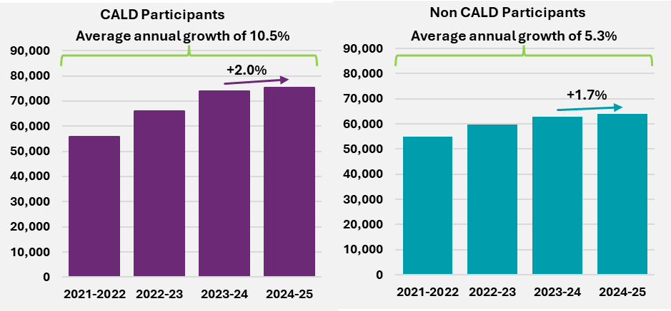
End of figure
End of Appendix E

Scheme experience – plan budgets

Further breakdowns of plan budgets by other characteristics
Average annualised plan budgets by other characteristics show a broadly consistent trend.
Average annualised plan budgets by level of function
Figure F.1 shows that average annualised plan budgets in 2024-25 have increased by 5.1% for participants with a high level of function, 7.5% for participants with a medium level of function, and 7.2% for participants with a low level of function. This is comparatively lower than the average annual growth rate over the past three years of 7.6%, 8.7% and 9.6% for participants with high, medium and low level of functioning respectively.
Figure F.1. Average annualised plan budgets ($) at 30 June over time for participants with high, medium, and low levels of function
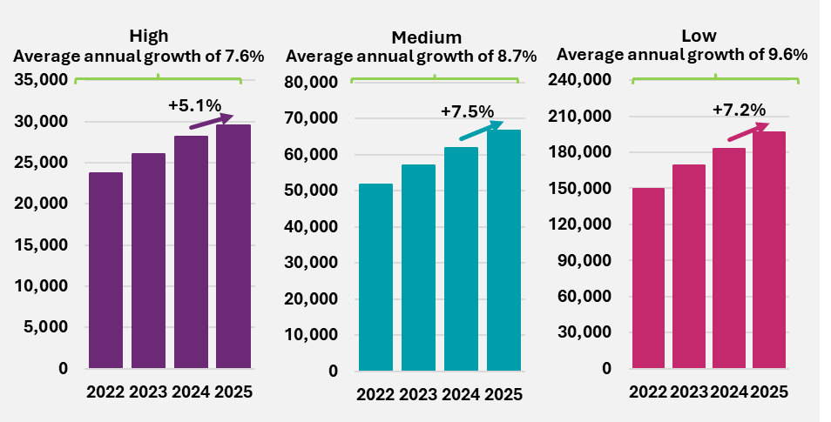
End of figure
Average annualised plan budgets by primary disability groups
Figure F.2 shows average annual growth in plan budgets, over the past three years, was highest for participants with a primary disability categorised as other neurological (12.8%), and lowest for participants with a primary disability of developmental delay (3.1%). Average annual growth in plan budgets since the previous review was 10.3% and 0.7% for participants with a primary disability categorised as other neurological and developmental delay respectively.
This is consistent with the trends observed by age groups, where higher average payment growth was observed at older ages. Participants with a primary disability of developmental delay tend to be younger on average, compared with participants with a primary disability categorised as other neurological.

Figure F.2. Average annualised plan budgets ($) at 30 June over time by primary disability type
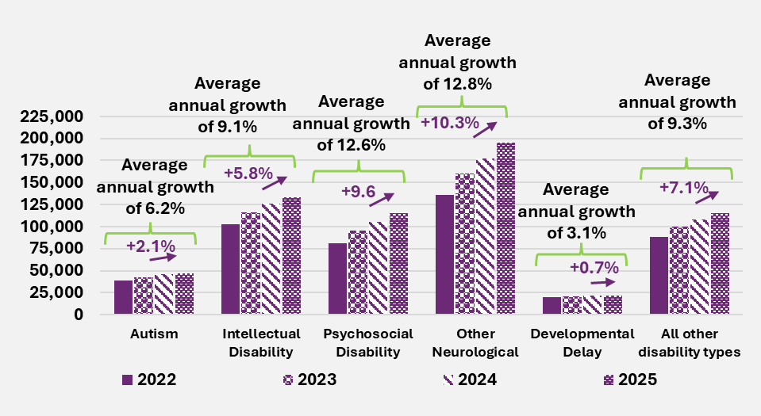
End of figure
End of Appendix F

Scheme experience – mortality experience

Scheme mortality experience over time
Figure G.1 shows the annualised rate (and number) of participants leaving the Scheme due to mortality in the calendar years 2020 to 2025. This is compared to the expected mortality rates based on assumptions from the June 2024 projections and the participant mix in each period.
Scheme mortality experience has been volatile and averages at around 0.96% annually over the calendar years 2020 to 2025¹⁰⁶. Mortality rates increased to a peak in 2022 and decreased until 2024, where they have remained in 2025.
The expected mortality rates decrease over time due to changes in participant mix. This is largely driven by new entrants to the Scheme who are predominantly children and/or participants with lower support needs and lower mortality rates than existing cohorts.
Mortality experience in the 6 months to June 2025 was in line with expectations, with 47 fewer deaths than expected and the actual mortality rate being 0.02 percentage points lower than expected.
Figure G.1. Actual vs expected mortality rates and number of participant deaths
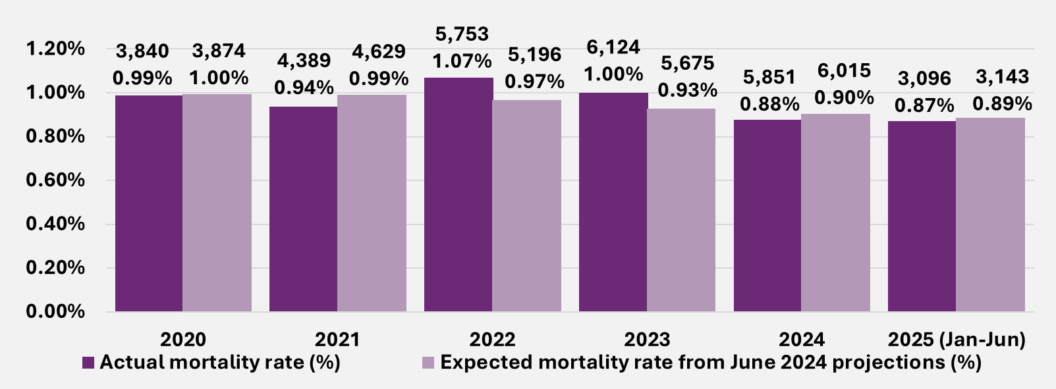
End of figure
Scheme mortality by primary disability group
Mortality experience varies widely by disability group, noting that different disabilities have different participant mixes in terms of age, gender and level of function.
Actual mortality rates for most primary disability groups increased to a peak in 2022 or 2023 and then decreased in 2024. This trend is particularly evident for participants with intellectual disability, psychosocial disability, other neurological disability, cerebral palsy or visual impairment. For acquired brain injury, multiple sclerosis, stroke, visual impairment, other neurological disability and other disabilities, mortality rates increased in 2025 compared to 2024, while decreases were observed for most of the remaining disability groups.
Mortality experience in 2025 varied by primary disability group:
- Participants with visual impairment, other neurological disability or other physical disability had lower rates of mortality than expected.
- Participants with acquired brain injury, spinal cord injury, stroke or other disability had higher rates of mortality than expected, which offset lower-than-expected experience for other disabilities.
- Mortality rates for participants with the remaining disability types were broadly in line with expectations.
- There have continued to be significantly more participants missing a primary disability in the system compared to previous years. Mortality rates for participants with a missing primary disability were higher than expected.
Table G.1. Actual mortality rates by primary disability group
Disability group | 2020 | 2021 | 2022 | 2023 | 2024 | 2025  Jan to Jun | Overall 2020 to Jun 2025
Acquired brain injury | 2.40% | 2.56% | 3.41% | 3.66% | 3.11% | 3.42% | 3.11%
Autism | 0.05% | 0.04% | 0.05% | 0.05% | 0.05% | 0.05% | 0.05%
Cerebral palsy | 0.56% | 0.80% | 0.98% | 1.05% | 0.95% | 0.81% | 0.87%
Developmental delay | 0.24% | 0.12% | 0.15% | 0.08% | 0.04% | 0.04% | 0.08%
Hearing impairment | 0.26% | 0.28% | 0.28% | 0.24% | 0.24% | 0.20% | 0.25%
Intellectual disability | 0.76% | 0.76% | 0.80% | 0.77% | 0.76% | 0.76% | 0.77%
Multiple Sclerosis | 1.07% | 1.18% | 1.32% | 1.56% | 1.32% | 1.53% | 1.33%
Psychosocial disability | 1.46% | 1.24% | 1.68% | 1.60% | 1.53% | 1.54% | 1.52%
Spinal cord injury | 1.98% | 2.11% | 2.80% | 2.70% | 2.54% | 2.15% | 2.42%
Stroke | 3.15% | 3.02% | 3.88% | 4.30% | 3.74% | 4.18% | 3.74%
Visual impairment | 1.23% | 1.15% | 1.06% | 1.24% | 1.09% | 1.13% | 1.15%
Other neurological | 5.06% | 4.76% | 5.48% | 5.33% | 4.85% | 5.06% | 5.10%
Other physical | 4.27% | 3.79% | 3.94% | 3.38% | 3.19% | 2.99% | 3.62%
Other sensory/speech | 0.26% | 0.22% | 0.19% | 0.30% | 0.25% | 0.21% | 0.24%
Other | 2.12% | 4.09% | 5.01% | 5.59% | 4.88% | 5.38% | 4.81%
Missing | 0.00% | 0.00% | 0.00% | 0.00% | 0.96% | 4.21% | 0.92%
Total | 0.99% | 0.94% | 1.07% | 1.00% | 0.88% | 0.87% | 0.96%
End of table

Table G.2. Expected mortality rates by primary disability group
Disability group | 2020 | 2021 | 2022 | 2023 | 2024 | 2025  Jan to Jun | Overall 2020 to Jun 2025
Acquired brain injury | 2.70% | 2.74% | 2.78% | 2.82% | 2.88% | 2.93% | 2.80%
Autism | 0.05% | 0.05% | 0.06% | 0.06% | 0.06% | 0.06% | 0.06%
Cerebral palsy | 0.79% | 0.79% | 0.79% | 0.80% | 0.81% | 0.82% | 0.80%
Developmental delay | 0.14% | 0.14% | 0.13% | 0.13% | 0.12% | 0.12% | 0.12%
Hearing impairment | 0.24% | 0.25% | 0.26% | 0.27% | 0.28% | 0.29% | 0.26%
Intellectual disability | 0.78% | 0.78% | 0.79% | 0.80% | 0.82% | 0.83% | 0.80%
Multiple sclerosis | 1.39% | 1.40% | 1.41% | 1.43% | 1.47% | 1.50% | 1.43%
Psychosocial disability | 1.30% | 1.33% | 1.35% | 1.38% | 1.43% | 1.47% | 1.38%
Spinal cord injury | 1.87% | 1.90% | 1.93% | 1.96% | 1.99% | 2.03% | 1.94%
Stroke | 2.96% | 3.02% | 3.06% | 3.11% | 3.18% | 3.23% | 3.09%
Visual impairment | 1.10% | 1.17% | 1.24% | 1.32% | 1.40% | 1.47% | 1.28%
Other neurological | 5.28% | 5.31% | 5.29% | 5.25% | 5.23% | 5.23% | 5.27%
Other physical | 3.88% | 3.95% | 3.97% | 3.99% | 4.00% | 4.03% | 3.97%
Other sensory/speech | 0.10% | 0.12% | 0.13% | 0.15% | 0.16% | 0.18% | 0.13%
Other | 3.35% | 3.75% | 3.97% | 4.12% | 4.28% | 4.44% | 4.06%
Missing | 0.06% | 0.05% | 0.05% | 0.06% | 0.06% | 0.07% | 0.06%
Total | 1.00% | 0.99% | 0.97% | 0.93% | 0.90% | 0.89% | 0.94%
End of table

Table G.3. Difference between actual and expected mortality rates by primary disability group
Disability group | 2020 | 2021 | 2022 | 2023 | 2024 | 2025  Jan to Jun | Overall 2020 to Jun 2025
Acquired brain injury | -0.30% | -0.18% | +0.63% | +0.84% | +0.23% | +0.49% | +0.31%
Autism | -0.01% | -0.02% | -0.00% | -0.01% | -0.01% | -0.01% | -0.01%
Cerebral palsy | -0.24% | +0.01% | +0.19% | +0.25% | +0.14% | -0.02% | +0.07%
Developmental delay | +0.10% | -0.01% | +0.01% | -0.05% | -0.08% | -0.08% | -0.04%
Hearing impairment | +0.02% | +0.03% | +0.02% | -0.03% | -0.04% | -0.09% | -0.01%
Intellectual disability | -0.01% | -0.02% | +0.02% | -0.02% | -0.05% | -0.08% | -0.03%
Multiple sclerosis | -0.33% | -0.22% | -0.09% | +0.13% | -0.16% | +0.03% | -0.10%
Psychosocial disability | +0.15% | -0.09% | +0.33% | +0.21% | +0.10% | +0.07% | +0.14%
Spinal cord injury | +0.11% | +0.20% | +0.87% | +0.75% | +0.55% | +0.13% | +0.48%
Stroke | +0.20% | -0.00% | +0.82% | +1.19% | +0.56% | +0.95% | +0.64%
Visual impairment | +0.13% | -0.02% | -0.18% | -0.08% | -0.31% | -0.34% | -0.13%
Other neurological | -0.21% | -0.55% | +0.18% | +0.08% | -0.38% | -0.18% | -0.17%
Other physical | +0.39% | -0.15% | -0.03% | -0.61% | -0.82% | -1.04% | -0.35%
Other sensory/speech | +0.16% | +0.10% | +0.06% | +0.15% | +0.09% | +0.03% | +0.11%
Other | -1.23% | +0.35% | +1.04% | +1.47% | +0.60% | +0.95% | +0.74%
Missing | -0.06% | -0.05% | -0.05% | -0.06% | +0.90% | +4.13% | +0.86%
Total | -0.01% | -0.05% | +0.10% | +0.07% | -0.02% | -0.01% | +0.02%
End of table
Scheme mortality by age group
Table G.4, Table G.5, and Table G.6 suggest that:
- Mortality rates generally increase after age 8. In 2024, actual mortality rates were 0.03% for participants aged 9 to 14, increasing to 4.88% for participants over 65.
- Overall, mortality rates decreased from 2022 to 2024, with larger percentage point decreases observed for participants aged 45 and over.
- Between 2024 and 2025, mortality rates remained stable across all age bands.
Actual mortality experience for the 6 months to 30 June 2025 was close to expectations for all age bands, except for ages 65 and over, noting it is the age band with the least number of participants and therefore subject to volatility.

Table G.4. Actual mortality rates by calendar year and age group
Age group | 2020 | 2021 | 2022 | 2023 | 2024 | 2025  Jan to Jun | Overall 2020 to Jun 2025
0 to 8 | 0.08% | 0.08% | 0.10% | 0.08% | 0.05% | 0.07% | 0.07%
9 to 14 | 0.06% | 0.06% | 0.06% | 0.07% | 0.03% | 0.04% | 0.05%
15 to 18 | 0.18% | 0.14% | 0.15% | 0.11% | 0.11% | 0.08% | 0.12%
19 to 24 | 0.21% | 0.19% | 0.23% | 0.19% | 0.17% | 0.15% | 0.19%
25 to 34 | 0.46% | 0.47% | 0.52% | 0.45% | 0.41% | 0.43% | 0.46%
35 to 44 | 0.94% | 0.87% | 1.06% | 1.01% | 0.94% | 0.86% | 0.96%
45 to 54 | 1.98% | 1.80% | 2.12% | 2.00% | 1.75% | 1.77% | 1.91%
55 to 64 | 3.82% | 3.48% | 3.90% | 3.85% | 3.41% | 3.45% | 3.66%
65+ | 4.45% | 4.91% | 5.58% | 5.33% | 4.88% | 4.87% | 5.06%
Total | 0.99% | 0.94% | 1.07% | 1.00% | 0.88% | 0.87% | 0.96%
End of table
Table G.5. Expected mortality rates by calendar year and age group
Age group | 2020 | 2021 | 2022 | 2023 | 2024 | 2025  Jan to Jun | Overall 2020 to Jun 2025
0 to 8 | 0.08% | 0.08% | 0.08% | 0.09% | 0.09% | 0.09% | 0.09%
9 to 14 | 0.08% | 0.08% | 0.07% | 0.07% | 0.07% | 0.06% | 0.07%
15 to 18 | 0.16% | 0.15% | 0.13% | 0.12% | 0.11% | 0.10% | 0.12%
19 to 24 | 0.26% | 0.24% | 0.23% | 0.21% | 0.19% | 0.18% | 0.22%
25 to 34 | 0.48% | 0.46% | 0.44% | 0.42% | 0.40% | 0.38% | 0.43%
35 to 44 | 0.97% | 0.95% | 0.92% | 0.89% | 0.86% | 0.84% | 0.90%
45 to 54 | 1.93% | 1.90% | 1.85% | 1.81% | 1.77% | 1.74% | 1.83%
55 to 64 | 3.70% | 3.65% | 3.57% | 3.48% | 3.40% | 3.36% | 3.53%
65+ | 5.05% | 5.10% | 5.11% | 5.13% | 5.16% | 5.19% | 5.13%
Total | 1.00% | 0.99% | 0.97% | 0.93% | 0.90% | 0.89% | 0.94%
End of table

Table G.6. Difference between actual and expected mortality rates by calendar year and age group
Age group | 2020 | 2021 | 2022 | 2023 | 2024 | 2025  (Jan to Jun) | Overall (2020 to Jun 2025)
0 to 8 | +0.00% | -0.01% | +0.01% | -0.01% | -0.04% | -0.02% | -0.01%
9 to 14 | -0.03% | -0.01% | -0.01% | -0.00% | -0.03% | -0.02% | -0.02%
15 to 18 | +0.01% | -0.01% | +0.02% | -0.01% | +0.01% | -0.02% | -0.00%
19 to 24 | -0.05% | -0.05% | +0.01% | -0.02% | -0.02% | -0.03% | -0.03%
25 to 34 | -0.02% | +0.00% | +0.07% | +0.03% | +0.02% | +0.05% | +0.03%
35 to 44 | -0.03% | -0.08% | +0.14% | +0.12% | +0.07% | +0.02% | +0.05%
45 to 54 | +0.05% | -0.10% | +0.27% | +0.20% | -0.02% | +0.03% | +0.08%
55 to 64 | +0.13% | -0.17% | +0.33% | +0.37% | +0.01% | +0.09% | +0.14%
65+ | -0.59% | -0.19% | +0.47% | +0.20% | -0.28% | -0.32% | -0.07%
Total | -0.01% | -0.05% | +0.10% | +0.07% | -0.02% | -0.01% | +0.02%
End of table
Scheme mortality by gender
Contrary to experience in the general Australian population, the actual mortality rates of female participants are higher than those of male participants (0.94% compared to 0.83% in both 2024 and 2025). This has historically been driven by a larger proportion of female participants in cohorts associated with higher mortality (and often with higher level of support need), such as other physical disabilities and multiple sclerosis. However, over the last few years the difference in mortality rates between male and female participants has reduced.
Mortality rates in 2025 were in line with expected for both female and male participants. Note that the comparison of actual and expected experience also includes participants whose gender is neither male nor female, however this is a relatively small group.
Table G.7. Actual mortality rates by calendar year and gender
Gender | 2020 | 2021 | 2022 | 2023 | 2024 | 2025  (Jan to Jun) | Overall (2020 to Jun 2025)
Female | 1.07% | 1.05% | 1.18% | 1.10% | 0.94% | 0.94% | 1.05%
Male | 0.93% | 0.87% | 1.00% | 0.94% | 0.83% | 0.83% | 0.90%
Other | 1.47% | 0.89% | 1.16% | 1.00% | 1.45% | 0.61% | 1.12%
Total | 0.99% | 0.94% | 1.07% | 1.00% | 0.88% | 0.87% | 0.96%
End of table

Table G.8. Expected mortality rates by calendar year and gender
Gender | 2020 | 2021 | 2022 | 2023 | 2024 | 2025  (Jan to Jun) | Overall (2020 to Jun 2025)
Female | 1.09% | 1.09% | 1.06% | 1.01% | 0.98% | 0.96% | 1.03%
Male | 0.94% | 0.93% | 0.91% | 0.88% | 0.86% | 0.85% | 0.89%
Other | 0.79% | 0.80% | 0.73% | 0.65% | 0.62% | 0.58% | 0.68%
Total | 1.00% | 0.99% | 0.97% | 0.93% | 0.90% | 0.89% | 0.94%
End of table
Table G.9. Difference between actual and expected mortality rates by calendar year and gender
Gender | 2020 | 2021 | 2022 | 2023 | 2024 | 2025  (Jan to Jun) | Overall (2020 to Jun 2025)
Female | -0.02% | -0.03% | +0.13% | +0.09% | -0.04% | -0.01% | +0.02%
Male | -0.01% | -0.07% | +0.09% | +0.06% | -0.03% | -0.01% | +0.01%
Other | +0.68% | +0.09% | +0.43% | +0.35% | +0.83% | +0.03% | +0.43%
Total | -0.01% | -0.05% | +0.10% | +0.07% | -0.02% | -0.01% | +0.02%
End of table
End of Appendix G

New entrants assumption setting details

Background
New entrants to the Scheme, both numbers and characteristics, are an important aspect of the overall Scheme experience and trajectory of Scheme expenses over the short and medium to long-term. New entrant rate assumptions, reflecting the expected new entrant numbers expressed as a proportion of the general population, are integral to the projection of total participants in the Scheme and estimates of Scheme expenses from 2025-26 onwards.
Experience of participants entering the Scheme, has been analysed by primary disability group, level of function, age group and gender, to derive the new entrant rate assumptions to use in the June 2025 projections. This is consistent with the approach used in the previous review.
Consistent with the previous review, an allowance was made for estimated impacts on projected numbers of new entrants related to Foundational Supports to be provided outside the Scheme. The assumptions in this review reflect a plausible scenario and are likely to be revised in future projections.
Review of new entrant rates
The long-term rates have been updated based on 12 months of Scheme experience to 31 October 2024. The Scheme experience was adjusted to allow for the number of new entrants during this period if the backlogs in access requests awaiting validation and decision had not built up.
The data were adjusted using:
- The month of creation of the access request for each participant who had entered the Scheme from July 2023 to April 2025 inclusive.
- The median length of time it took for a newly created access request to progress to the participant’s first approved plan, which was 2 months.
The adjusted estimate for the number of new entrants in 2024-25 is 79,612 or 1% above expected from the June 2024 projections.
Figure H.1 compares the actual and adjusted number of new entrants each month. The period of analysis used for setting assumptions for the June 2025 projections was from November 2023 to October 2024, as access requests received after October 2024 had not fully progressed into plans at the time of analysis.

Figure H.1. Actual vs adjusted number of new entrants
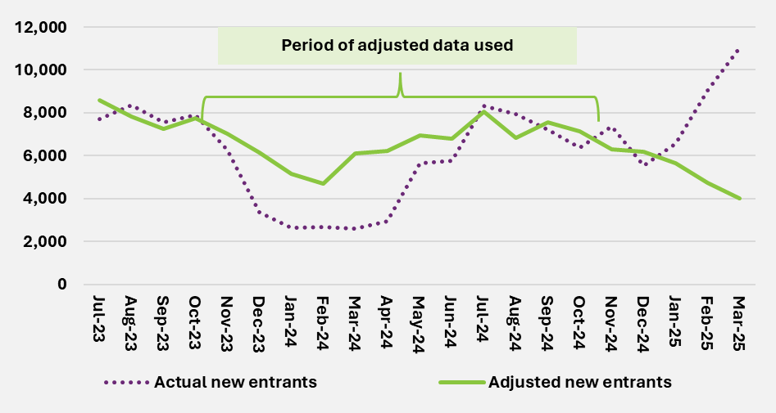
End of figure
Figure H.2 shows the actual and adjusted number of new entrants aged 15 years and over with autism. New entrant numbers for this cohort are higher on average over the 12 months to October 2024 compared to the previous 12-month period. This rising number of new entrants, as well as increasing participation rates for people with autism, may indicate higher new entrant rates in the long term.
Figure H.2. Actual vs adjusted number of new entrants aged 15 years and over
with autism
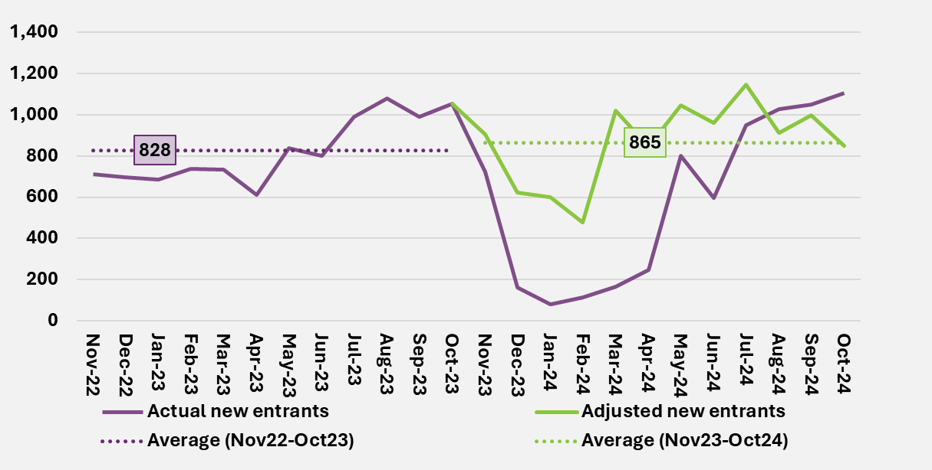
End of figure
Figure H.3 shows the actual and adjusted number of new entrants with developmental delay. While new entrant numbers with developmental delay have moderated over the 12 months to October 2024 compared to the previous 12-month period, experience was still higher than expected from the June 2024 projections.
Figure H.3. Actual vs adjusted number of new entrants with developmental delay
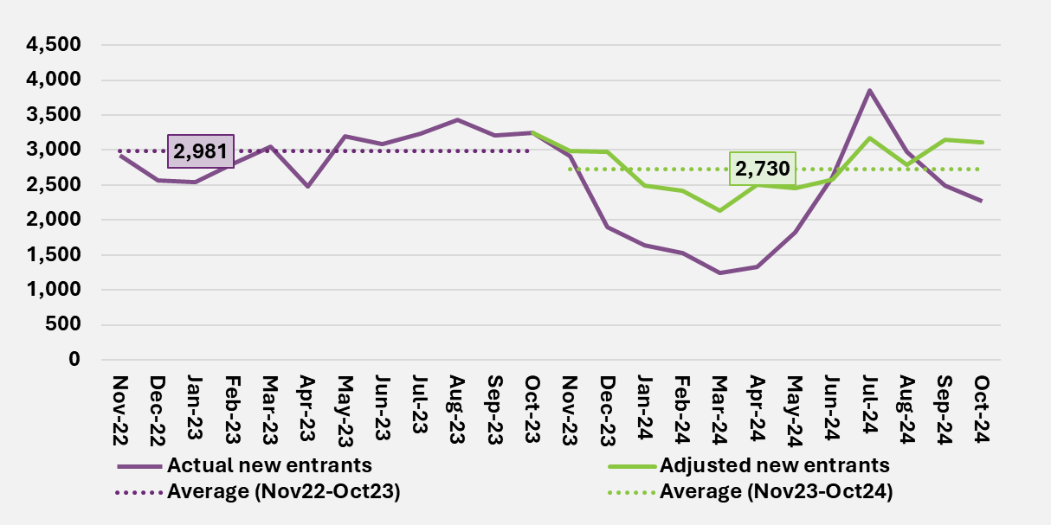
End of figure
Figure H.4 shows the actual and adjusted number of new entrants for disabilities other than autism and developmental delay. New entrant numbers have stabilised at a lower level in the 12 months to October 2024 compared to the previous 12-month period.
Figure H.4. Actual vs adjusted number of new entrants with disabilities other than autism and developmental delay
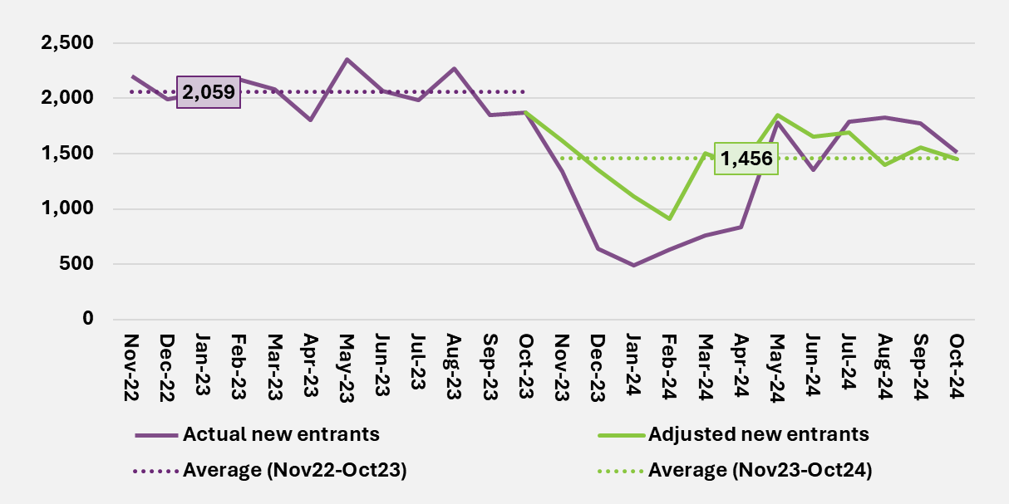
End of figure
New entrant rate assumptions by disability type
Table H.1 shows the long-term new entrant rates assumed for the June 2025 projections, compared to those assumed from the previous review by primary disability group.
- New entrant rates for autism were increased by 1% overall, however for participants aged 15 years and over the new entrant rates were increased by 5%. This considered the increasing number of new entrants in this cohort in recent years, rising participation rates, and uncertainty around the level of autism in the population requiring supports in the Scheme.
- New entrant rates for developmental delay were increased by 3%. This considered the recent moderation in new access requests for children aged 0 to 8, which was less than that assumed in the previous review.
- New entrant rates for psychosocial disability were decreased by 27% and increased by 6% for all other disabilities overall. This reflects the view that experience for these disabilities represent long-term levels of new entrant rates.
Table H.1. Comparison of assumed long-term new entrant rates (per 100,000 population aged 0 to 64) by disability group
Disability group | June 2025 projections | June 2024 projections | Difference | Difference (%)
Acquired Brain Injury | 5.0 | 5.7 | -0.6 | -10.7%
Autism | 106.1 | 105.1 | 1.0 | 1.0%
Cerebral Palsy | 1.9 | 1.9 | 0.0 | 0.1%
Developmental Delay | 48.2 | 46.6 | 1.6 | 3.4%
Hearing Impairment | 6.9 | 8.6 | -1.7 | -19.7%
Intellectual Disability | 17.8 | 17.8 | 0.0 | -0.3%
Multiple Sclerosis | 4.1 | 3.5 | 0.6 | 17.9%
Psychosocial Disability | 11.8 | 16.3 | -4.5 | -27.4%
Spinal Cord Injury | 1.6 | 1.4 | 0.2 | 11.7%
Stroke | 4.6 | 3.6 | 1.0 | 28.9%
Visual Impairment | 2.3 | 2.4 | -0.1 | -4.8%
Other Neurological | 10.2 | 8.2 | 2.0 | 24.7%
Other Physical | 3.5 | 4.8 | -1.3 | -27.9%
Other Sensory/Speech | 0.2 | 0.2 | 0.0 | -1.9%
Other | 9.8 | 6.3 | 3.5 | 55.6%
Total | 234.0 | 232.3 | 1.7 | 0.7%
End of table

New entrant rates by age group
Table H.2 shows the updated long-term new entrant rates (across all disability groups), compared to those assumed from the previous review by age group.
- New entrant rates for 0 to 14 year olds were increased by 4%, reflecting higher new entrant rates for developmental delay.
- New entrant rates for 15+ year olds were broadly in line with the previous review, due to offsetting movements in new entrant rates by disability. Higher new entrant rates for autism were offset by lower new entrant rates for psychosocial disability.
Table H.2. Comparison of assumed long-term new entrant rate (per 100,000 population aged 0 to 64) by age group
Age group | June 2025 projections | June 2024 projections | Difference | Difference (%)
0 to 14 | 661.7 | 637.1 | 24.6 | 3.9%
15+ | 120.4 | 120.2 | 0.2 | 0.2%
End of table
End of Appendix H

Average committed supports and utilisation assumption settings details

Starting assumptions for 2024-25 are fitted to reflect actual experience
To ensure the OCM model starts its projection from the actual 2024-25 experience and can project future Scheme expenses at the detailed cohort level, a fitting exercise was carried out to produce the starting average committed supports and starting utilisation assumptions for the model.
Both committed supports and utilisation are modelled on an ultimate basis. That is, allowing for delays in payments for supports of up to several months after they are provided, and also allowing for retrospective changes to the amount of committed supports during a period (this mainly occurs due to overspending on plans or intra-plan inflation).
These assumptions were fitted at the detailed cohort level and calibrated to match the total committed supports and utilisation in 2024-25, as shown in Table I.1.
Table I.1. 2024-25 Accrual payments and committed supports for 2024-25
 | Accrual payments ($b) = | Committed supports ($b) x | Utilisation (%)
Total | 46.3 | 61.3 | 75.6%
End of table
When the fitted starting average committed supports and utilisation assumptions are combined with the 2024-25 active participants in the OCM model, they produce committed supports, utilisation rates and accrual payments at cohort level, for example by SIL status, as shown in Table I.2.
Table I.2. Model results for 2024-25
 | Accrual payments ($b) | Committed supports ($b) | Utilisation (%)
With SIL arrangements | 15.6 | 18.1 | 86.6%
Without SIL arrangements | 30.7 | 43.2 | 71.1%
Total | 46.3 | 61.3 | 75.6%
End of table
For 2024-25, the total committed supports, utilisation and accrual payments from the OCM model match the 2024-25 total committed supports, utilisation and accrual payments results at the Scheme level. This demonstrates the fitted starting average committed supports and utilisation assumptions reflect the actual 2024-25 experience. More details on the fitted average committed supports and utilisation assumptions for 2024-25 are shown in the section below.
2024-25 average committed supports assumptions
To reflect the latest Scheme experience at cohort level, committed supports in the month of April 2025 were used. Using the average committed supports for the latest month best reflects the latest Scheme experience. Unlike average payments, no adjustment to allow for seasonality impacts is needed. The monthly committed supports value only changes if there is any change to participant plan budgets.
The fitted average committed supports are then annualised and further adjusted so that, when combined with the actual participant numbers in 2024-25, they reflect the ultimate committed supports for 2024-25 from the Participant Plan Provision (PPP) estimates at 30 June 2025. This ensures the fitted average committed supports reflects the 2024-25 experience, even though only April data is used for the fitting.
Mature participants vs first year participants
Starting average committed supports assumptions for 2024-25 were derived with reference to committed supports for participants who had been in the Scheme for at least 12 months (Mature participants).
For participants who had been in the Scheme for less than 12 months (First Year participants), the model assumes lower committed supports compared to the Mature participants, reflecting the experience observed.
Table I.3 shows the starting average committed supports in 2024-25 by SIL status. Participants with SIL arrangements have on average significant higher average committed supports than those without SIL arrangements, reflecting their higher support needs.
 | Average committed supports ($)
SIL | 502,500
Non SIL | 64,700
All participants | 87,000
Table I.3. Starting average committed supports for 2024-25

End of table
2024-25 utilisation rate assumptions
To reflect the latest Scheme experience, the utilisation from 1 October 2024 to 31 March 2025 was used. There is usually a time lag between provision of services and the payments made for those services, therefore the utilisation experience for supports provided in the latest few support months will not be final at 30 June 2025. The data selected for fitting the 2024-25 utilisation rate assumptions contains the latest 6 months of credible utilisation experience and reflects the latest scheme experience at cohort level.
The fitted utilisation rate assumptions are then adjusted to reflect the actual 2024-25 accrual basis payment results, when applied to the committed supports for 2024-25. This ensures the fitted utilisation rate assumptions are reflective of the 2024-25 experience, even though only 6 months of data is used for the fitting.
Utilisation rate assumptions are set by duration; the number of year’s participants are in the Scheme. As shown in Section 4.4 of this report, utilisation generally increases over time, as participants become more experienced with the Scheme.
Off-system payments
Off-system payments for participant supports are made to other government programs where they provide services covered by the Scheme, such as attendant care supports for participants in Residential Aged Care and Taxi Subsidy Schemes.
Average committed supports and utilisation assumptions in 2024-25 were fitted using on-system data only. Off-system payments were not included in the fitting process, since they are treated separately in payment datasets and noting they now account for less than 1% of Scheme expenditure. Adjustments for off-system payments were added back to the fitted results to show the total model results at Scheme level.
Table I.4 shows the starting utilisation rates with and without off-system payments.
Table I.4. Starting utilisation for 2024-25
Utilisation | Off-system payments included | Off-system payments excluded
SIL | 86.6% | 87.0%
Non SIL | 71.1% | 70.4%
All participants | 75.6% | 75.3%
End of table
The distribution of committed supports per participant is highly skewed
The Scheme supports participants with a diverse range of needs. Figure I.1 shows that of the total committed supports available to mature participants over the 12 months to 30 June 2025, 48% of committed supports related to the top 10% of participants when ranked by average committed supports over the period. Conversely, the bottom 40% of participants represent only 7% of committed supports.
Figure I.1. Cumulative percentage of total committed supports by ventiles (5% band), ranked by average committed supports
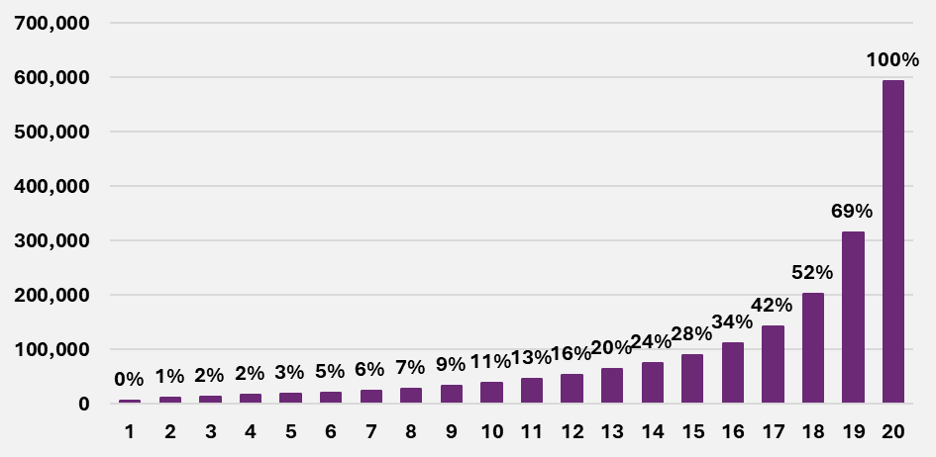
End of figure
Figure I.2 shows the distribution for participants without SIL arrangements only, removing the impact of participants with SIL arrangements who have higher committed supports on average. The distribution is relatively unchanged with 41% and 9% of committed supports in respect of the top 10% and bottom 40% of participants without SIL arrangements respectively.
Figure I.2. Average committed supports and cumulative percentage of Scheme expenses by ventiles (5% band) – participants without SIL arrangements only
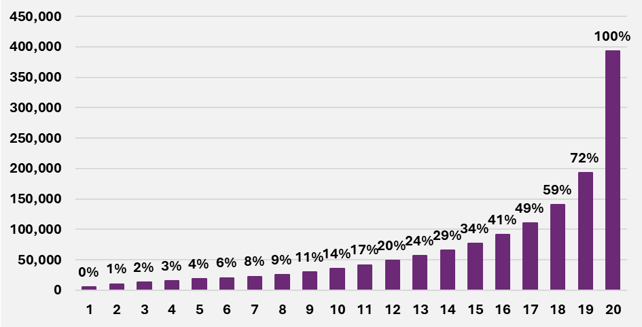
End of figure
End of Appendix I

Scenario analysis from previous AFSRs

This section summarises the results of projection scenarios considered in historic Annual Financial Sustainability Report projections since 2016-17. These scenarios assist in understanding the range of plausible projections based on reasonable alternative assumptions.
Note on terminology and term of projection
There have been several changes in terminology in recent AFSR compared with previous AFSRs. In this appendix, the original terminology has been used. In particular:
- Scheme expenses were previously referred to as ‘Total participant costs’.
- Participants leaving the Scheme were previously referred to as ‘non-mortality exits’.
- Supported Independent Living (SIL) was previously referred to as Shared Supported Accommodation (SSA).
- Additional growth has previously been referred to as ‘Additional inflation’ or ‘Superimposed inflation’.
It is also important to recognise that the scenarios set out in this appendix include results for 2029-30. In this AFSR, however, results are generally shown for 2028-29 and 2034-35 and so are not directly comparable with the scenario results presented here.

Table J.1. 2016-17 AFSR scenarios
Total participant costs $m | 2019-20 | 2024-25 | 2029-30
2016-17 Baseline | 21,240 | 30,492 | 41,783
Scenario 1a. Committed supports + utilisation of 85% | 20,436 | 28,943 | 38,863
Scenario 1b. Committed supports + utilisation of 90% | 21,638 | 30,645 | 41,149
Scenario 1c. Committed supports + utilisation of 100% | 24,042 | 34,050 | 45,721
Scenario 2a. 1% p.a. superimposed inflation | 21,756 | 32,762 | 47,095
Scenario 2b. 2% p.a. superimposed inflation | 22,279 | 35,179 | 53,022
Scenario 2c. 10% p.a. superimposed inflation for 2 years | 25,509 | 36,619 | 50,179
Scenario 2d. 5% p.a. superimposed inflation for 5 years | 23,897 | 38,551 | 52,826
Scenario 3a. Increase incidence 0 to 18 by 15% | 22,345 | 32,201 | 44,258
Scenario 3b. Reduce incidence 25+ by 5% | 20,662 | 29,676 | 40,695
Scenario 3c. Combination of 3a. and 3b. | 21,766 | 31,385 | 43,171
Scenario 4a. Halve non-mortality exits ages 0 to 64 | 21,240 | 31,315 | 44,041
Scenario 4b. Double non-mortality exits for ages 65+ | 21,237 | 30,434 | 41,532
Scenario 4c. Increase excess mortality by 50% | 21,168 | 30,017 | 40,583
Scenario 4d. Reduce excess mortality by 50% | 21,252 | 30,899 | 42,984
Scenario 5a. 5% of new incidence to highest LoF | 21,240 | 31,154 | 43,486
Scenario 5b. 5% of starting population to highest LoF | 25,216 | 35,449 | 47,576
Scenario 5c. Combination of 5a. and 5b. | 25,216 | 36,112 | 49,279
Scenario 6a. Increase SSA Numbers by 10% | 20,970 | 29,684 | 39,818
Scenario 6b. Increase SSA average cost by 25% | 21,822 | 30,939 | 41,570
Scenario 6c. Combination of 6a. and 6b. | 22,495 | 31,880 | 42,796
Scenario 7a. Remove age-based loadings for 65+ | 21,176 | 30,068 | 40,729
Scenario 10a. Exclude GI/MM from NIIS | 21,240 | 30,492 | 41,783
End of table

Table J.2. 2017-18 AFSR scenarios
Total participant costs $m | 2019-20 | 2024-25 | 2029-30
2017-18 Baseline | 15,638 | 31,715 | 44,395
1a Higher autism exits | 15,453 | 30,171 | 40,485
1b Lower autism exits | 15,676 | 32,099 | 45,579
2 Intellectual disability new incidence hump 17-22 yrs | 15,638 | 32,008 | 46,518
3a Higher proportion of participants in SSA (SIL) | 17,636 | 35,769 | 50,034
3b Lower proportion of participants in SSA (SIL) | 15,405 | 31,197 | 43,556
3c SSA cost innovation | 12,489 | 29,261 | 41,178
4a Increased number of adults | 16,276 | 38,193 | 53,883
4b Decreased number of children | 14,213 | 30,962 | 43,463
4c Increased new entrants | 15,887 | 36,377 | 50,143
5a Committed supports and 100% utilisation | 18,957 | 38,064 | 53,473
5b Committed supports and 75% utilisation | 13,839 | 28,548 | 40,105
7a AAT and mainstream | 18,123 | 37,118 | 51,450
7b AAT, mainstream and level of function movement | 18,400 | 37,686 | 52,236
7c AAT access decisions | 16,670 | 34,352 | 47,592
8a 3% pa superimposed inflation for 10 years | 15,676 | 35,882 | 55,465
8b 0% superimposed inflation | 14,810 | 29,407 | 41,164
End of table

Table J.3. 2018-19 AFSR scenarios
Total participant costs $m | 2019-20 | 2024-25 | 2029-30
2018-19 Baseline | 16,327 | 30,820 | 43,723
1a Additional cost of chronic health low range | 19,333 | 34,760 | 48,886
1b Additional cost of chronic health mid-range | 20,770 | 36,644 | 51,356
1c Additional cost of chronic health high range | 22,404 | 38,785 | 54,162
2 Lower autism and higher psychosocial disability numbers | 16,347 | 31,077 | 43,893
3 Intellectual disability new entrants hump for 17-22yrs | 16,327 | 31,209 | 46,322
4a Higher proportion of participants in SIL over long-term | 16,434 | 32,930 | 48,951
4b Long-term SIL reached over 20 years innovation | 16,302 | 30,331 | 42,573
4c SIL cost | 14,874 | 27,978 | 39,510
5 85%/100% utilisation rate for Non SIL/SIL respectively | 19,380 | 34,844 | 49,343
6a Transport policy: strict tightened eligibility | 16,125 | 30,469 | 43,215
6b Transport policy: tightened eligibility &increased budget | 16,454 | 31,041 | 44,043
6c Transport policy: tightened eligibility & bottom-up approach | 18,800 | 35,115 | 49,941
7 Steady intake date at 30 June 2020 | 16,425 | 28,286 | 41,344
8a Additional 3% pa superimposed inflation from 2021 | 16,327 | 35,152 | 56,030
8b Additional 1% pa superimposed inflation from 2021 | 16,327 | 32,264 | 47,825
End of tables

Table J.4. 2019-20 AFSR scenarios
Total participant costs $m | 2019-20 | 2024-25 | 2029-30
2019-20 Baseline | 0 | 34,109 | 51,304
Scenario 1a. => continuation of historical superimposed inflation | 0 | 45,399 | 68,282
Scenario 1b. => removal of 1% p.a. additional superimposed inflation | 0 | 32,364 | 48,447
Scenario 1c. => alternative normal inflation | 0 | 33,332 | 46,735
Scenario 2a. => higher proportion of participants in SIL over long-term | 0 | 37,230 | 60,805
Scenario 2b. => continuation of increasing SIL cost for 2 years | 0 | 37,909 | 57,276
Scenario 2c. => SIL cost innovation | 0 | 31,119 | 46,600
Scenario 3a. => 44,000 additional participants | 0 | 37,955 | 56,268
Scenario 3b. => 60,000 additional participants | 0 | 38,430 | 56,879
Scenario 3c. => 99,000 additional participants | 0 | 39,287 | 57,982
Scenario 5a. => steady Intake Date at 30 June 2021 | 0 | 33,207 | 50,180
Scenario 5b. => higher intake levels sustained for 3 years | 0 | 36,821 | 54,774
End of table

Table J.5. 2020-21 AFSR scenarios
Total participant costs $m | 2019-20 | 2024-25 | 2029-30
2020-21 Baseline | 0 | 41,373 | 59,284
Cost increase scenarios
Two additional years of high inflation | 0 | 46,613 | 69,464
Higher long term new incidence assumptions | 0 | 42,625 | 65,556
Lower non-mortality exit rates | 0 | 41,861 | 61,939
Higher cost of new entrants | 0 | 42,166 | 61,213
Higher SIL numbers (+500 p.a.) | 0 | 41,955 | 60,978
Three extra years to reach steady state | 0 | 42,091 | 60,865
Total of cost increase scenarios | 0 | 50,448 | 83,596
Plausible high case (variance) | 0 | 47,843 | 74,156
Cost reduction scenarios | 0 | 41,373 | 59,284
One year less of high inflation | 0 | 39,358 | 54,497
Lower long term new incidence assumptions | 0 | 41,373 | 57,496
Lower general population growth | 0 | 41,338 | 59,113
Lower SIL numbers (-200 p.a.) | 0 | 41,140 | 58,607
Lower cost of new entrants | 0 | 40,579 | 57,355
Total of cost decrease scenarios | 0 | 38,296 | 49,931
Plausible low case (variance) | 0 | 38,970 | 53,159
End of table
Table J.6. June 2022 projections scenarios
Scheme Expenses $m | 2019-20 | 2024-25 | 2029-30
2021-22 Baseline | 0 | 44,116 | 74,058
1a Higher numbers of participants with SIL (+500 per annum) | 0 | 44,595 | 75,952
1b Lower numbers of participants with SIL (-200 per annum) | 0 | 43,924 | 73,301
2 Lower rate of participants leaving the Scheme | 0 | 44,289 | 74,909
3a Higher assumptions regarding the number of new participants | 0 | 44,968 | 77,627
3b Lower assumptions regarding the number of new participants | 0 | 43,264 | 70,490
3c Higher assumptions regarding the number of new entrants with autism aged between 15 and 54 | 0 | 44,201 | 74,473
3d Three extra years to reach steady state | 0 | 44,460 | 75,866
4a Lower payments for new entrants | 0 | 43,503 | 71,902
4b Higher payments for new entrants | 0 | 44,728 | 76,215
5a Lower additional inflation | 0 | 42,962 | 69,054
5b Higher additional inflation | 0 | 46,689 | 83,836
End of table

Table J.7. June 2023 projections scenarios
Scheme Expenses $m | 2019-20 | 2024-25 | 2029-30
2022-23 Baseline | 0 | 46,376 | 71,482
1 Without the impact of Budget initiatives | 0 | 49,062 | 81,487
2a Higher growth in the short-term (+1%) | 0 | 47,264 | 74,333
2b Higher growth in the short and long term (+1%) | 0 | 47,264 | 76,347
2c Lower growth in the short-term (-1%) | 0 | 45,494 | 68,708
2d Lower growth in the short and long term (-1%) | 0 | 45,494 | 66,901
3a Higher average payments for new entrants | 0 | 46,626 | 72,975
3b Lower average payments for new entrants | 0 | 46,221 | 70,561
4a Higher rate of new entrants aged 0 to 14 with developmental delay or autism | 0 | 46,460 | 72,546
4b Higher rate of new entrants aged 15 and over with autism | 0 | 46,416 | 72,776
4c Higher rate of new entrants aged 15 and over, excluding those with autism | 0 | 46,617 | 73,159
4d Lower rate of new entrants aged 15 and over, excluding those with autism | 0 | 46,141 | 69,857
5a Higher number of participants in SIL | 0 | 46,540 | 72,442
5b Lower number of participants in SIL | 0 | 46,310 | 71,097
6 Lower rate of participants leaving the Scheme | 0 | 46,477 | 72,153
End of table

Table J.8. June 2024 projections scenarios
Scheme Expenses $m | 2019-20 | 2024-25 | 2029-30
2023-24 Baseline | 0 | 46,865 | 69,044
1a Higher growth in the short-term (+1%) | 0 | 47,333 | 71,848
1b Higher growth in the short and long term (+1%) | 0 | 47,333 | 73,292
1c Lower growth in the short-term (-1%) | 0 | 46,396 | 66,324
1d Lower growth in the short and long term (-1%) | 0 | 46,396 | 65,004
2a Greater number of new entrants in 2024-25 | 0 | 47,003 | 69,539
2b Lower number of new entrants in 2024-25 | 0 | 46,772 | 68,715
2c Higher new entrant rates | 0 | 47,022 | 71,785
2b Lower new entrant rates | 0 | 46,708 | 66,304
3 Lower rate of participants leaving the Scheme | 0 | 46,901 | 69,135
4a Higher number of participants with SIL | 0 | 46,901 | 69,515
4b Lower number of participants with SIL | 0 | 46,829 | 68,574
5 Results from the 30 June 2024 MSM Projections | 0 | 46,111 | No value
End of table
End of Appendix J

Scenario analysis of participant numbers

The projections presented in Section 5 of this report represent the projection of the Scheme population for the June 2025 projections. This appendix shows the impact on participant numbers for the scenarios detailed in Section 6.1.
Number of new entrants to the Scheme
To reflect a reasonable range of new entrants in 2025-26, the following scenarios are presented:
- Greater number of new entrants in 2025-26, increased by 15%.
- Lower number of new entrants in 2025-26, reduced by 10%.
Table K.1. Scenarios with higher and lower new entrants in 2025-26 – Projected participant numbers and variance to the June 2025 projections at 30 June
Participant numbers | 2026 | 2027 | 2028 | 2029 | 2035
Baseline June 2025 projections | 779,705 | 805,735 | 828,054 | 861,526 | 1,072,099
Scenario 1: Greater number of new entrants in 2025-26
Total participants | 790,729 | 816,590 | 838,136 | 871,174 | 1,080,121
Variance to baseline | 11,024 | 10,855 | 10,083 | 9,648 | 8,021
Variance to baseline (%) | 1.4% | 1.3% | 1.2% | 1.1% | 0.7%
Scenario 2: Lower number of new entrants in 2025-26
Total participants | 772,356 | 798,498 | 821,332 | 855,094 | 1,066,752
Variance to baseline | -7,349 | -7,237 | -6,722 | -6,432 | -5,348
Variance to baseline (%) | -0.9% | -0.9% | -0.8% | -0.7% | -0.5%
End of table
The following two scenarios illustrate the sensitivity of the long-term new entrant rate assumptions on future Scheme expenses:
- Greater rate of new entrants, for all years, increased by 20%.
- Lower rate of new entrants, for all years, reduced by 20%.
Table K.2. Scenarios with higher and lower new entrant rates – Projected participant numbers and variance to the June 2025 projections at 30 June
Participant numbers | 2026 | 2027 | 2028 | 2029 | 2035
Baseline June 2025 projections | 779,705 | 805,735 | 828,054 | 861,526 | 1,072,099
Scenario 3: Higher new entrant rates
Total participants | 793,489 | 831,406 | 863,206 | 906,527 | 1,174,287
Variance to baseline | 13,784 | 25,671 | 35,152 | 45,001 | 102,188
Variance to baseline (%) | 1.8% | 3.2% | 4.2% | 5.2% | 9.5%
Scenario 4: Lower new entrant rates
Total participants | 765,922 | 780,064 | 792,902 | 816,524 | 969,912
Variance to baseline | -13,784 | -25,671 | -35,152 | -45,001 | -102,188
Variance to baseline (%) | -1.8% | -3.2% | -4.2% | -5.2% | -9.5%
End of table
The following table presents a scenario where more Agency resources are diverted from processing eligibility reassessments than assumed in the June 2025 projections, and as a result the backlog of ERs is cleared a year later than forecasted.
Table K.3. Scenarios with a lower rate of participants leaving the Scheme – Projected participant numbers and variance to the June 2025 projections at 30 June
Participant Numbers | 2026 | 2027 | 2028 | 2029 | 2035
Baseline: June 2025 projections | 779,705 | 805,735 | 828,054 | 861,526 | 1,072,099
Scenario: Lower rate of participants leaving the Scheme
Total participant | 782,217 | 811,758 | 831,356 | 861,517 | 1,073,120
Variance to baseline | 2,512 | 6,023 | 3,302 | -9 | 1,021
Variance to baseline (%) | 0.32% | 0.75% | 0.40% | 0.00% | 0.10%
End of table
Scenarios with no change to projected participant numbers by comparison to the baseline projections have been excluded from this appendix. These scenarios are as follows:
- A one percentage point increase to SCHADS rates assumptions across all projection years.
- A one percentage point reduction to SCHADS rates assumptions across all projection years.
- A one percentage point increase to average committed supports growth rates or one percentage point increase in utilisation rates in the short-term, for the four years from 2025-26 to 2028-29.
- A one percentage point increase to average committed supports growth rates or one percentage point increase in utilisation rates across all projection years.
- A one percentage point reduction to average committed supports growth rates or one percentage point decrease in utilisation rates in the short-term, for the four years from 2025-26 to 2028-29.
- A one percentage point reduction to average committed supports growth rates or one percentage point decrease in utilisation across all projection years.
- Higher number of participants with SIL arrangements.
- Lower number of participants with SIL arrangements.
Participant numbers projected using the MSM alternative projection model are included in Appendix L.
End of Appendix K

Microsimulation model

Comparison of results and impact of key assumptions between existing projection model and microsimulation model
Similar to the existing projection model, the microsimulation model (MSM) estimates Scheme expenses by multiplying projected participant numbers by the estimated committed supports per participant and the expected utilisation rate. Details of participant numbers, committed supports per participant and utilisation projection components are provided below:
- Participant numbers are projected by modifying the existing participant numbers each quarter to account for ageing, the intake of new entrants into the Scheme, and the reduction due to mortality and participants leaving the Scheme. An explicit allowance is made for changes in participants primary disability type, and for participants transitioning into SIL arrangements. Additionally, the MSM also models change in participant level of function over time.
- Estimated committed supports per participant are adjusted each quarter for both normal inflation and additional growth.
The attributes used in the participant and committed supports projections of the MSM remain broadly consistent with those used in the existing projection model. Furthermore, the assumptions and key judgements that underpin the MSM are broadly consistent with those used in the existing projection model.
As discussed earlier in Section 3.5, the MSM differs from the existing projection model in several key areas. As a result of these differences between the MSM compared to the existing projection model, as well as differences in the assumption setting process (although noting that the judgements when setting the assumptions that underpin the MSM are largely consistent with those used in the existing projection model), the Scheme expenses generated by the MSM differ to those generated by the existing projection model.
Table L.1 compares the projected Scheme expenses from the June 2025 MSM projections to the baseline June 2025 projections. Over the four years to 30 June 2029, the Scheme expenses estimated by the June 2025 MSM projections are $410 million (or 0.18%) lower than those projected by the baseline June 2025 projections.
Table L.1. Comparison of projected Scheme expenses from the June 2025 MSM projections against the baseline June 2025 projections
Scheme expenses ($m) | 2025-26 | 2026-27 | 2027-28 | 2028-29 | 2034-35 | Total 2025-29
Baseline: June 2025 projections | 50,705 | 53,958 | 58,126 | 62,461 | 95,755 | 225,250
June 2025 MSM projections | 50,705 | 53,958 | 57,984 | 62,192 | No value | 224,840
Variance to baseline | 0 | 0 | -142 | -268 | No value | -410
Variance to baseline (%) | 0.00% | 0.00% | -0.24% | -0.43% | No value | -0.18%
End of table
Table L.2 compares the projected number of participants from the June 2025 MSM projections to the baseline June 2025 projections. The number of participants in the Scheme estimated by the June 2025 MSM projections is slightly lower than those estimated by the baseline June 2025 projections for 30 June 2026, 30 June 2028 and 30 June 2029. MSM projections are slightly higher than baseline projections for 30 June 2027.
Table L.2. Comparison of projected participants in the Scheme from the June 2025 MSM projections against the baseline June 2025 projections at 30 June
Number of participants | 2025-26 | 2026-27 | 2027-28 | 2028-29 | 2034-35
Baseline: June 2025 projections | 779,705 | 805,735 | 828,054 | 861,526 | 1,072,099
June 2025 MSM projections | 779,627 | 806,057 | 827,637 | 860,779 | No value
Variance to baseline | -78 | 322 | -417 | -747 | No value
Variance to baseline (%) | -0.01% | 0.04% | -0.05% | -0.09% | No value
End of table
Table L.3 compares the projected number of new entrants into the Scheme from the June 2025 MSM projections to the baseline June 2025 projections. The number of new entrants into the Scheme estimated by the June 2025 MSM projections is higher than those estimated by the baseline June 2025 projections from 2025-26 to 2026-27 and lower from 2027-28 to 2028-29.
Table L.3. Comparison of projected new entrants into the Scheme from the June 2025 MSM projections against the baseline June 2025 projections
Projected number of new entrants | 2025-26 | 2026-27 | 2027-28 | 2028-29 | 2034-35
Baseline: June 2025 projections | 73,492 | 60,495 | 52,964 | 54,647 | 58,323
June 2025 MSM projections | 73,766 | 60,914 | 52,646 | 54,497 | No value
Variance to baseline | 274 | 419 | -318 | -150 | No value
Variance to baseline (%) | 0.37% | 0.69% | -0.60% | -0.27% | No value
End of table
Table L.4 compares the projected number of participants leaving the Scheme for non-mortality reasons from the June 2025 MSM projections to the baseline June 2025 projections June 2025 MSM projections estimate slightly higher participants leaving the Scheme than baseline projections in 2025–26 and 2026–27 and lower exits in 2027–28 and 2028-29.
Table L.4. Comparison of projected number of participants leaving the Scheme from the June 2025 MSM projections against the baseline June 2025 projections
Projected number of participants leaving the Scheme | 2025-26 | 2026-27 | 2027-28 | 2028-29 | 2034-35
Baseline: June 2025 projections | 26,371 | 27,327 | 23,218 | 13,460 | 13,100
June 2025 MSM projections | 26,381 | 27,347 | 23,199 | 13,339 | No value
Variance to baseline | 10 | 20 | -19 | -121 | No value
Variance to baseline (%) | 0.04% | 0.07% | -0.08% | -0.90% | No value
End of table
Table L.5 compares the projected participants leaving for mortality reasons from the June 2025 MSM projections to the baseline June 2025 projections. June 2025 MSM projections estimate higher mortality than baseline projections in 2025-26, 2027-28 and 2028-29. MSM projections estimate slightly less mortality than baseline projections in 2026-27.
Table L.5. Comparison of projected participants leaving for mortality reasons from the June 2025 MSM projections against the baseline June 2025 projections
Projected number of participants deaths | 2025-26 | 2026-27 | 2027-28 | 2028-29 | 2034-35
Baseline: June 2025 projections | 6,829 | 7,138 | 7,428 | 7,714 | 9,588
June 2025 MSM projections | 7,172 | 7,137 | 7,867 | 8,016 | No value
Variance to baseline | 343 | -1 | 439 | 302 | No value
Variance to baseline (%) | 5.02% | -0.01% | 5.92% | 3.91% | No value
End of table
Table L.6 compares the projected number of participants transitioning to SIL arrangements from the June 2025 MSM projections to the baseline June 2025 projections. The number of transitioning participants estimated by the June 2025 MSM projections is lower than those estimated by the baseline June 2025 projections for all projection years.
Table L.6. Comparison of participants transitioning to SIL arrangements from the June 2025 MSM projections against the baseline June 2025 projections
Projected transitions to SIL | 2025-26 | 2026-27 | 2027-28 | 2028-29 | 2034-35
Baseline: June 2025 projections | 3,370 | 2,881 | 2,965 | 3,083 | 3,796
June 2025 MSM projections | 3,356 | 2,867 | 2,937 | 3,075 | No value
Variance to baseline | -14 | -14 | -28 | -8 | No value
Variance to baseline (%) | -0.42% | -0.48% | -0.96% | -0.24% | No value
End of table
Table L.7 compares the projected average committed supports amounts from the June 2025 MSM projections to the baseline June 2025 projections. The projected average committed supports amounts estimated by the June 2025 MSM projections are slightly lower than those estimated by the baseline June 2025 projections for all projection years.
Table L.7. Comparison of average committed supports amounts from the June 2025 MSM projections against the baseline June 2025 projections
Projected average plan budget amount ($) | 2025-26 | 2026-27 | 2027-28 | 2028-29 | 2034-35
Baseline: June 2025 projections | 90,000 | 93,000 | 97,000 | 100,700 | 123,900
June 2025 MSM projections | 89,500 | 92,300 | 96,200 | 99,800 | No value
Variance to baseline | -500 | -600 | -800 | -900 | No value
Variance to baseline (%) | -0.51% | -0.70% | -0.83% | -0.93% | No value
End of table
Table L.8 compares the projected utilisation from the June 2025 MSM projections to the baseline June 2025 projections. The projected utilisation estimated by the June 2025 MSM projections is slightly higher than those estimated by the baseline June 2025 projections for all projection years.
Table L.8. Comparison of Total Utilisation from the June 2025 MSM projections against the baseline June 2025 projections
Projected utilisation | 2025-26 | 2026-27 | 2027-28 | 2028-29 | 2034-35
Baseline: June 2025 projections | 74.2% | 73.2% | 73.4% | 73.4% | 73.3%
June 2025 MSM projections | 74.6% | 73.7% | 73.8% | 73.8% | No value
Variance to baseline | 0.39% | 0.50% | 0.44% | 0.43% | No value
End of table
Table L.9 compares the average payment amounts from the June 2025 MSM projections to the baseline June 2025 projections. The projected average payment amounts estimated by the June 2025 MSM projections are slightly higher than those estimated by the baseline June 2025 projections for 2025-26 and slightly lower 2026-27, 2027-28 and 2028-29.
Table L.9. Comparison of Average Payment amounts from the June 2025 MSM projections against the baseline June 2025 projections
Projected average payment ($) | 2025-26 | 2026-27 | 2027-28 | 2028-29 | 2034-35
Baseline: June 2025 projections | 66,800 | 68,100 | 71,200 | 73,900 | 90,800
June 2025 MSM projections | 66,800 | 68,100 | 71,000 | 73,700 | No value
Variance to baseline | 0 | 0 | -200 | -300 | No value
Variance to baseline (%) | 0.01% | -0.02% | -0.24% | -0.36% | No value
End of table
End of Appendix L
End of the 2024-25 Annual Financial Sustainability Report
We extend our warm thanks to Charlotte and her family for appearing in the
NDIS Annual Financial Sustainability Report 2024-2025.



National Disability Insurance Scheme
ndis.gov.au
Telephone 1800 800 110
Webchat ndis.gov.au
Follow us on our social channels
Facebook, Instagram, YouTube, LinkedIn
For people who need help with English
TIS: 131 450
For people who are deaf or hard of hearing
TTY: 1800 555 677
Voice relay: 1800 555 727
National Relay S

Scheme expenses relate to the payments made for participant supports and do not include operating expenses. Expenses on an accrual basis are based on when the service was provided to the participant recognising some services are paid for after the end of the period.
Movements in Scheme expenditure have not been itemised beyond 2028-29.
Includes delay in commencement of Foundational Supports (FS) to 2026-27, a shift from 3 to 4.5 years phasing of implementation of NFP, and delay in commencement to 1 July 2026.
Other changes includes the impact on updates to plan growth and utilisation assumptions of Scheme reforms and operational measures (other than FS and NFP).
There has been a change to the methodology in arriving at the Scheme growth results since the 2023-24 AFSR. The component of growth due to the average payments for new entrants increasing after their initial year in the Scheme was previously allocated to real growth in payments. In this report, it is allocated to participant impacts. This change is to ensure that real growth in payments reflects the increases in ongoing cost per participant over time and is independent of new entrants to the Scheme.
Committed supports refer to the amount of funds available to the participants over a period, considering all the changes in plan budgets during that period.
A stochastic model is used to estimate probability distributions of potential outcomes by allowing for random variation in one or more inputs over time. In this case, the inputs which are varied are the material assumptions and risks which are most uncertain in the projection of Scheme expenses.
Development delay includes both developmental delay (DD) and global developmental delay (GDD); GDD involves a formal diagnosis, whilst DD does not have such a requirements and access to the Scheme may be based on parental observation or identification of delay in a child’s development in an early childhood setting.
A change in access refers to a participant with early intervention needs providing evidence that they now meet the disability requirements of the NDIS, that is, that they have an impairment that results in a permanent disability that is likely to require lifetime support.
Both committed supports and utilisation rates are measured on an ultimate basis, with adjustments included to estimate changes which will occur after the end of the period. This is because payments will continue to be made for supports already provided, and the value of committed supports can also change retrospectively.
The expected average payments are mix adjusted using actual participant numbers.
‘Additional Growth’ in payments was referred to as ‘Additional Inflation’ and ‘Superimposed Inflation’ at previous reviews, prior to the 2022-23 AFSR.
Participant mix excludes the impact from change in participants’ level of function over time. This is because the model does not explicitly allow participants to change their level of function over time. It is allowed for in the additional growth in payments assumption. For this reason, when breaking down the observed growth, the impact of level of function change is removed from the participant mix impact and reflected in additional growth in payments item.
The annual growth in total average committed supports in 2025-26 is relatively lower, compared to the annual growth in average committed supports for participants by SIL status separately. This is due to a projected increase in the proportion of participants without SIL supports (Non SIL) during 2025-26, with relatively lower average committed supports.
A confidence interval, here, represents the simulated probability that the Scheme expense as a percentage of the baseline projection will fall between the specified range of outcomes of the stochastic model.
The 5th (95th) percentile, here, is the simulated Scheme expense at or below which 5 (95) percent of the simulated Scheme expenses lie.
Before Scheme reforms.
Level of judgement: Low = assumptions influenced by experience and/or data that is known, Medium = assumptions influenced by experience and operational processes, introducing some variability, High = assumptions influenced by experience, operational process, economic conditions etc., with higher variability.
The impact on total Scheme expenses for each level of materiality: Low: ≤1%, Medium: 1-5%, High: >5%.
Levels for the long term are highlighted in bold where they are different from the corresponding short term level.
This target is from the 2022-26 Corporate Plan. Note that the NDIS Corporate Plans for 2023-27 and 2024-25 no longer include a target for family/carer employment.
Participant cohorts are based on age, primary disability type, recorded level of function, gender, whether a participant is in Supported Independent Living arrangements, and duration in the Scheme.
Committed supports refer to the amount of funds available to the participants over a period, considering all the changes in plan budgets during that period.
A stochastic model is used to estimate probability distributions of potential outcomes by allowing for random variation in one or more inputs over time. In this case, the inputs which are varied are the material assumptions and risks which are most uncertain in the projection of Scheme expenses.
The 15 support categories include four core support categories (Transport, Consumables, Daily Activities and Social Community Civic), two capital support categories (Assistive Technology and Home Modifications) and nine capacity building (CB) support categories (Support Coordination, CB Relationships, CB Lifelong Learning, CB Home Living, CB Health and Wellbeing, CB Employment, CB Daily Activities, CB Choice and Control and CB Social Community Civic).
A deterministic projection model is a projection model which does not allow for uncertainty in its outputs.
The risk that a model is an imperfect representation of a complex real-life process, introducing unknown bias into the model.
The MSM is stochastic in nature, in that each individual’s projection is a simulation, reflecting the inherent uncertainty and variability in each individual’s trajectory. Aggregating these individual projections across cohorts help ensure the overall results remain relatively stable, despite the inherent variability at an individual level.
Attributes modelled include age, gender, primary disability group, level of function, whether a participant is in Supported Independent Living arrangements, and duration in the Scheme.
Although the MSM operates at an individual person level, all participants are de-identified, and the results used are always for cohorts of participants, never for individual participants.
The use of GLMs allows for more granular modelling, including duration effects and individual age-based assumptions.
It was expected that the 9,745 participants with missing level of function at 30 June 2024 would have correct level of function information recorded by 30 June 2025 resulting in a net reduction.
Australia’s population growth rate is around 1.4% per year on average over the past 3 decades, based on reports by the Australian Institute of Health and Welfare.
The numbers shown represent the number of participants in each queue who have never had an access decision or first plan before. That is, participants who have previously applied for access and had a decision are excluded from these counts.
Historical total numbers of participants leaving the Scheme may be different from the 2023-24 AFSR. This is due to participants re-entering the Scheme after previously leaving. When this occurs, participants’ records are adjusted, and they are no longer treated as having left in analyses.
Ultimate committed supports are estimated until all retrospective changes to all plans in a period are processed. It may change retrospectively in future AFSR publications as more experience emerges, especially for the last couple of years.
SIL supports for participants aged under 18 are rare. With so few participants, the growth rate of average annualised plan budget for this group were not shown given its stability.
Utilisation rates are based on the dollar weighted experience of all participants who have entered the Scheme since 1 July 2016. Experience from 1 April 2025 and beyond is still emerging and is not included.
Scheme expenses are before allowance for Agency operating expenses.
The missing category are payments recorded from participants with missing SIL status in the system.
The annual growth in total average committed supports in 2025-26 is relatively lower, compared to the annual growth in average committed supports for participants by SIL status separately. This is due to a projected increase in the proportion of participants without SIL supports (Non SIL) during 2025-26, with relatively lower average committed supports.
Average payments experience presented in this section is cash basis only, and therefore not directly comparable to average plan budgets and utilisation metrics that are outlined in the earlier sections due to timing differences in the cash payments results. This footnote also applies to Table 4.14 – column heading Average payment per participant.
The expected average payments are mix adjusted using actual participant numbers. This footnote also applies to Table 4.14 – column heading Expected.
Children aged 0-14 with SIL supports are very small in number, and their average payment growth is very volatile. Therefore, it is not shown in the chart.
Additional Growth was referred to as ‘Additional Inflation’ and ‘Superimposed Inflation’ at previous reviews, prior to the 2022-23 AFSR.
Scheme expenses relate to the payments made for participant supports and does not include operating expenses.
Total Scheme expenses shown in today’s dollars is calculated by discounting the nominal total Scheme expenses in each financial year, using the expected nominal GDP growth rate, back to the monetary value at 30 June 2025. The expected nominal GDP growth rate is lower for financial years 2025-26 and 2026-27 year, increasing in 2027-28 onwards to the long-term nominal GDP growth projection of c.5%. The amount is increasing over time reflecting the increase as a percentage of GDP.
There has been a change to the methodology in arriving at the Scheme growth results since the 2023-24 AFSR. The component of growth due to the average payments for new entrants increasing after their initial year in the Scheme was previously allocated to real growth in payments. In this report, it is allocated to participant impacts. This change is to ensure that real growth in payments reflects the increases in ongoing cost per participant over time and is independent of new entrants to the Scheme.
Movements in Scheme expenditure have not been itemised beyond 2028-29.
Includes delay in commencement of Foundational Supports (FS) to 2026-27, a shift from 3 to 4.5 years phasing of implementation of New Framework Planning (NFP), and delay in commencement to 1 July 2026.
Other changes includes the impact on updates to plan growth and utilisation assumptions of Scheme reforms and operational measures (other than FS and NFP).
Steady-intake date refers to the point in time where participant intake primarily represents participants with new incidence of disability.
These participants had acquired their disability some years prior and only accessed the Scheme recently.
While a significant proportion of eligibility reassessments are for children on the early childhood pathway, there is also a small proportion of older children and adults accessing early intervention supports through the NDIS with eligibility reassessments currently awaiting review.
A change in access refers to a participant with early intervention needs providing evidence that they now meet the disability requirements of the NDIS, that is, that they have an impairment that results in a permanent disability that is likely to require lifetime support.
There is a higher proportion of children with developmental delay aged 2 to 5 who are less likely to transition into intellectual disability, and a lower proportion aged 6 to 18 who are more likely to transition as the Agency initiates the eligibility reassessment process at age 6.
Figures are shown to the nearest hundred dollars. Blanks or zero means there are no or few participants in that age/disability cohort.
Real growth in average committed supports can arise due to a participant’s change in circumstance, ageing, or other reasons for an increased/varied need for supports. For example, participants may need more hours of care from disability support workers and/or greater proportion of hours in higher intensity supports.
Figures are shown to the nearest hundred dollars. Blanks or zero means there are no or few participants in that age/disability cohort.
Figures are shown to the nearest hundred dollars. Blanks or zero means there are no or few participants in that age/disability cohort.
Utilisation rate here refers to payments made to date on 30 June 2025 related to services provided from 1 October 2024 to 31 March 2025, expressed as a percentage of the committed supports from 1 October 2024 to 31 March 2025.
Blanks or zero means there are no or few participants in that age/disability cohort.
Off system adjustments were not included in the derivation of utilisation assumptions at cohort level in 2024-25. Overall total utilisation assumptions excluding off system adjustments for 2024-25 was 75.3%, slightly lower 75.6% that included off systems adjustments as set out in Table 5.4 in Section 5.1.2. See Appendix I for details.
Off system adjustments were not included in the derivation of utilisation assumptions at cohort level in 2024-25. Overall total utilisation assumptions excluding off system adjustments for 2024-25 was 75.3%, slightly lower 75.6% that included off systems adjustments as set out in Table 5.4 in Section 5.1.2. See Appendix I for details.
Figures are shown to the nearest hundred dollars. Blanks or zero means there are no or few participants in that age/disability cohort.
Off system adjustments were not included in the derivation of utilisation assumptions at cohort level in 2024-25. Overall total utilisation assumptions excluding off system adjustments for 2024-25 was 75.3%, slightly lower 75.6% that included off systems adjustments as set out in Table 5.4 in Section 5.1.2. See Appendix I for details.
Figures are shown to the nearest hundred dollars. Blanks or zero means there are no or few participants in that age/disability cohort.
Figures are shown to the nearest hundred dollars. Blanks or zero means there are no or few participants in that age/disability cohort.
Figures are shown to the nearest hundred dollars. Blanks or zero means there are no or few participants in that age/disability cohort.
A microsimulation model is a quantitative method used in economics, sociology, public policy and other fields to simulate the behaviours and outcomes of individual entities, such as people, households, or firms, over time.
A stochastic model is used to estimate probability distributions of potential outcomes by allowing for random variation in one or more inputs over time. In this case, the inputs which are varied are the material assumptions and risks which are most uncertain in the projection of Scheme expenses.
Price increase for supports for 2025-26 were set out in the Annual Pricing Review 2024-25 and therefore have no uncertainty.
Around 70-80% of the supports are driven by SCHADS rates. The remaining supports are driven by Consumer Price Index (CPI) and other related macroeconomic factors.
The June 2025 MSM currently only has projections for the next four years, which is why the projected Scheme expenses for the 2034-35 year are not shown in Table 6.7. There are plans to extend the projection period of the MSM in future iterations of the model.
In the 2025-26 Corporate Plan, the risk to Scheme sustainability is defined as ability to manage the sustainability of the NDIS.
A total of 20,000 simulations were produced using the R programming language.
For simplicity, for the stochastic modelling, the assumptions for additional growth in committed supports and utilisation have been combined into an additional growth in payments assumption.
A confidence interval, here, represents the simulated probability that the Scheme expense as a percentage of the baseline projection will fall between the specified range of outcomes of the stochastic model.
Coefficient of variation (CV) has been used to measure uncertainty. It is defined as the standard deviation divided by the mean of a distribution. A higher CV implies a higher level of uncertainty.
Before Scheme reforms.
The 5th (95th) percentile, here, is the simulated Scheme expense at or below which 5 (95) percent of the simulated Scheme expenses lie.
The impact on total Scheme expenses for each level of materiality: Low: ≤1%, Medium: 1-5%, High: >5%.
Level of judgement: Low = assumptions influenced by experience and/or data that is known, Medium = assumptions influenced by experience and operational processes, introducing some variability, High = assumptions influenced by experience, operational process, economic conditions etc., with higher variability.
Levels for the long term are highlighted in bold where they are different from the corresponding short term level.
Projections at December are those used in the following year’s Federal Budget
Includes unanticipated costs of introduction of school transport and developmental delay and the actual implementation of National Injury Insurance Scheme.
Projections have been adjusted from a cash basis to an accrual basis using accrual factors from the 30 June 2019 AFSR.
Figures have been rounded to the nearest whole percentage; differences are calculated from unrounded metrics.
Figures have been rounded to the nearest whole percentage; differences are calculated from unrounded metrics.
Figures have been rounded to the nearest whole percentage; differences are calculated from unrounded metrics.
Figures have been rounded to the nearest whole percentage; differences are calculated from unrounded metrics.
Some time points are not shown for those in the Scheme for 6,7 or 8 years due to small numbers.
Figures have been rounded to the nearest whole percentage; differences are calculated from unrounded metrics.
Figures have been rounded to the nearest whole percentage; differences are calculated from unrounded metrics.
Noting that the education and housing systems have a major role to play in the lifelong learning and home domains.
Figures have been rounded to the nearest whole percentage; differences are calculated from unrounded metrics.
Figures have been rounded to the nearest whole percentage; differences are calculated from unrounded metrics.
2023-24 AFSR, Section 7.7
An interactive data visualisation software product developed by Microsoft with a primary focus on business intelligence.
An artificial intelligence, analytics and data management platform.
A software company (formerly RStudio) that provides open-source and professional software for data science, with a focus on R and Python.
A change to the assumed rate for participants transitioning from developmental delay to other primary disability types will lead to an overall lower assumed number of participants leaving the Scheme as rates of participants leaving vary by disability type.
Includes delay in commencement of Foundational Supports (FS) to 2026-27, a shift from 3 to 4.5 years phasing of implementation of New Framework Planning (NFP), and delay in commencement to 1 July 2026.
Other changes includes the impact on updates to plan growth and utilisation assumptions of Scheme reforms and operational measures (other than FS and NFP).
Other Territories, including Norfolk Island, Christmas Island and the Cocos (Keeling) Islands.
2025 experience is based on the six months to 30 June 2025.
For first plans approved between July 2020 and October 2023 inclusive. This time period was selected to understand experience for access requests progressing to a first plan before the Agency moved to a new computer system in November 2023.
The 2024-25 committed supports, utilisation and accrual basis payments are modelled by states and territories and at the total Scheme level in the Agency’s Participant Plan Provision process. Hence a fitting exercise is needed to calibrate these results to the granularity needed for the OCM model.
Utilisation rate here refers to payments made to date by 30 June 2025 related to services provided from 1 October 2024 to 31 March 2025, expressed as a percentage of the committed supports from 1 October 2024 to 31 March 2025.
Attributes modelled include age, gender, primary disability group, level of function, whether a participant is in Supported Independent Living arrangements, and duration in the Scheme.
The assumptions where the judgements were broadly aligned were new entrants, SIL transitions, average payments per participant, inflation and additional growth.
The June 2025 MSM currently only has projections for the next four years, which is why the projected results for the 2034-35 year are not shown in any of the tables in this Appendix. There are plans to extend the projection period of the MSM in future iterations of the model.

