
2024-25 Annual Pricing Review
ndis.gov.au

Acknowledgement
The National Disability Insurance Agency (NDIA) acknowledges the Aboriginal and Torres Strait Islander people of this nation and the Traditional Custodians of the lands across which our Agency conducts our business. We pay our respects to the custodians of the land on which we work as well as their ancestors and Elders, past, present and emerging.
The NDIA is committed to honouring Aboriginal and Torres Strait Islander Peoples’ unique cultural and spiritual relationships to the land, waters, and seas and their rich contribution to society.

Copyright and use of the material in this document
Copyright in the material in this document, with the exception of third-party material, is owned and protected by the National Disability Insurance Agency.
The material in this document, with the exception of logos, trademarks, third party material and other content as specified is licensed under Creative Commons Attribution Non-Commercial No Derivatives (CC BY NC ND) licence, version 4.0 International. You may share, copy and redistribute the document in any format. You must acknowledge the National Disability Insurance Agency as the owner of all intellectual property rights in the reproduced material by using ‘© National Disability Insurance Agency 2025’ and you must not use the material for commercial purposes.
Reproduction of any material contained in this document is subject to the CC BY NC ND licence conditions available on the Creative Commons Australia site, as is the full legal code for this material.
The National Disability Insurance Agency expects that you will only use the information in this document to benefit people with disability.

Terms that we use
Acronym | Meaning
A B S | Australian Bureau of Statistics
APR | Annual Pricing Review
CPI | Consumer Price Index
DSW | Disability Support Worker
FWC | Fair Work Commission
HCSA | Healthcare and Social Assistance
HPSS | Health Professionals and Support Services Award 2020
NDIA or Agency | National Disability Insurance Agency
NDIS or Scheme | National Disability Insurance Scheme
NDIS Commission | National Disability Insurance Scheme Quality and Safeguards Commission
SCHADS Award | Social, Community, Home Care and Disability Services Industry Award 2010
SIL | Supported Independent Living
WPI | Wage Price Index

Contents
1. Executive Summary 7
1.1 NDIA Pricing Workplan 8
1.2 Nursing and Other Supports 9
1.3 Disability Support Worker-related Supports 10
1.4 Therapy Supports 11
1.5 Support Coordination 17
1.6 Plan Management 19
2. Introduction 21
2.1 Context 21
2.2 NDIA’s Role as Market Steward 21
2.3 Quality Supports Program 22
2.4 Consultation Process 22
3. Independent Pricing Committee 24
4. Domestic Economic Conditions 28
4.1 Economic Outlook 28
4.2 Inflation 28
4.3 Labour Market Conditions 29
4.4 Wage Growth 32
5. NDIS Pricing and Award Considerations 33
5.1 NDIA Pricing Workplan 33
5.2 Nurses Award 34
5.3 Gender-based Undervaluation - Priority Awards Review 35
6. Disability Support Worker Related Supports 37
6.1 Context 37
6.2 Scheme Statistics 39
6.3 Discussion 48
6.4 Recommendations 49
7. Therapy Supports 50
7.1 Context 50
7.2 Scheme Statistics 51
7.3 Business Dynamism 62
7.4 Benchmarking Approach and Data Sources 64
7.5 Benchmarking Results and Implications for Price Limits 69
7.6 Interpreting Benchmarking Results 71
7.7 Geographic Patterns in Market Rates 78
7.8 Other Government Schemes 80
7.9 Website Listings (Private Billing) 82
7.10 Discussion 82
7.11 Recommendations 88
8. Support Coordination 95
8.1 Context 95
8.2 Scheme Statistics 96
8.3 Business Dynamism 106
8.4 Discussion 110
8.5 Recommendations 111
9. Plan Management 112
9.1 Context 112
9.2 Scheme Statistics 112
9.3 Business Dynamism 123
9.4 Discussion 128
9.5 Recommendations 129
Appendix A: DSW Cost Model Detailed Breakdown 130
Appendix B: Details of Medicare Benefits Schedule (MBS) and Private Health Insurance (P H I) implied hourly price rate conversions 132
Appendix C: Summary of website price listing dataset 133

Executive Summary
As the agency with primary responsibility for stewarding disability service provider markets, the National Disability Insurance Agency (NDIA) is committed to fostering efficient, effective, and participant-centered markets that consistently deliver safe, high-quality supports. Central to this role is the regular review of the National Disability Insurance Scheme (NDIS) pricing framework to ensure price limits remain appropriate, responsive to changing market conditions, and support diverse service delivery models.
The Annual Pricing Review (APR) is central to this work. Each year, the NDIA assesses whether price settings continue to:
- Support value for money for participants through efficient service delivery;
- Enable safe and effective supports available for participants; and
- Maintain viable provider markets.
Delivering against these objectives requires a diverse and functioning market that can meet a range of support needs and complexities. Pricing plays a critical role in shaping markets by influencing provider incentives, workforce availability, and service quality across varied settings.
The NDIA takes a structured, evidence-informed approach to pricing. The NDIA continues to improve its pricing approach and is expanding the available data sources to monitor market performance. This year, the NDIA expanded its therapy benchmarking to include Medicare Benefits Schedule and Private Health Insurance data to inform therapy price settings.
The review of the NDIA pricing approach conducted by the Independent Pricing Committee (IPC) in 2024-25 has made a valuable contribution to the NDIA’s understanding of the role of pricing in market stewardship. The IPC’s report provides insights into how pricing is shaping markets and offers a framework for understanding how pricing can be used to influence participant outcomes, provider behaviour, and market performance. The report provides a pathway for an incremental shift towards a more nuanced and differentiated approach to pricing. This APR marks the first step in a multi-year transition to a more differentiated pricing approach, guided by the IPC framework. The IPC’s findings provide the foundation for improved pricing approaches that will help protect the delivery of a broader range of support needs and identify the most efficient and effective ways to price supports.

NDIA Pricing Workplan
The NDIA currently reviews price limits for all market segments on an annual cycle. While this ensures regular updates, it does not provide for deeper engagement on pricing in complex areas like therapy and disability support worker (DSW) supports that will be necessary to adopt new approaches to pricing.
A multi-year work plan will allow the NDIA to focus on markets where market conditions are evolving and where a more in-depth analysis is required to inform future approaches. It will provide a schedule for reviewing key support types while maintaining flexibility to respond to emerging trends.
This approach will enable the NDIA to shift towards more differentiated pricing by:
- Consulting with providers and participants on changes to pricing approaches.
- Leveraging insights from pilots such as the Supported Independent Living and Support Coordination deep dives and blended payments trials.
- Improving data quality to monitor market trends and performance; and
- Adjusting prices incrementally to maintain market stability.
Publishing a multi-year work plan will give providers clarity on the timing and nature of planned reforms and ensure that participants continue to benefit from a stable and functioning market.
Recommendation 1:
The NDIA should commit to publishing a three-year work plan to implement key reforms arising from the Independent Pricing Committee’s Final Report. This work plan should outline a structured schedule for reviewing specific market segments, such as therapy supports and disability support worker-related supports, at defined intervals, rather than conducting a full Annual Pricing Review each year.
The work plan will serve as the primary mechanism for delivering pricing reform, allowing for targeted deep dives, piloting of differentiated pricing approaches, and consultation with stakeholders.

Timing of the Release of the APR
The timing of the release of the APR is critical in supporting provider’s planning processes, as well as government’s planning and funding cycles. Under the current approach, the APR is released mid-year following the Fair Work Commission’s minimum wage decision, leaving little time for providers to prepare for pricing changes that take effect from 1 July.

To improve predictability, and aligning with the pricing reform work plan, the NDIA will shift to releasing future APRs earlier in the financial year, with timing to be set out in the three-year work plan. This change will allow for the integration of findings from initiatives such as the Quality Supports pilots, the blended payments trials and therapy pricing reform.
Recommendation 2:
The NDIA should reset the APR cycle by releasing future pricing recommendations earlier in the financial year, to support improved planning, and align with broader government planning and budget cycles. The timing of the next full pricing review will be determined based on the progress of reform initiatives and will be outlined in the NDIA Pricing Workplan.

Nursing and Other Supports
On 20 December 2024, the Fair Work Commission announced staged wage increases for aged care nurses, with changes applying to only those classified under the Aged Care Award 2010. These do not affect most nurses delivering NDIS-funded supports, who fall under a separate classification.
NDIS nursing price limits were set in 2019 using high-end wage benchmarks and have been indexed annually since. Current analysis shows that these rates remain 3.5 to 24.5% above the updated Award wages from March 2025, suggesting they remain sufficient to attract and retain nursing staff.
For other supports not covered by the DSW Cost Model, including nursing and selected community-based services, indexation is based on a weighted combination of Wage Price Index (WPI) and Consumer Price Index (CPI). This approach does not apply to Capital, Plan Management, Therapy, or Support Coordination.
Recommendation 3:
The NDIA should increase the price limits for nursing and other supports not covered by Disability Support Worker-related supports, Capital supports or otherwise covered in the APR, effective 1 July 2025. This adjustment should reflect the weighted movement in the Australian Bureau of Statistics Wage Price Index (Australia, total hourly rates of pay excluding bonuses) and the Australian Bureau of Statistics Consumer Price Index (All Groups, weighted average of eight capital cities) over the 12 months to the March Quarter immediately preceding the indexation data (with an 80/20 weighting).

Disability Support Worker-related Supports
Between July and December 2024, 301,964 participants claimed at least one DSW-related support, representing 44% of all active participants. Over the same period, 136,864 providers delivered DSW supports, up from 122,857 in the six months to December 2023. Total payments reached $15 billion, accounting for 65.5% of all NDIS expenditure.
The provider market is diverse. While companies made up 18% of all active providers, they delivered $11.6 billion in supports, with claim revenues averaging $480,754 per provider. In contrast, sole traders represent 77% of active providers, but accounted for only $2.2 billion in claims, with claim revenues averaging $21,214 per provider. This dual structure reflects a diverse market where smaller-scale providers coexist alongside a smaller group of large providers, who continue to service a high volume of participants.
The mix of registered and unregistered providers is shifting.
- Amongst registered providers, total payments rose by 14% to $10.7 billion, while provider numbers increased by 20% to 10,443. This led to a decline in average claims per provider from $1.1 million to $1.0 million.
- Amongst unregistered providers, payment grew 17% to $4.2 billion, while provider numbers rose 11% to 127,217 – resulting in a 6% increase in average claims to $33,214.
Whilst most claims for DSW providers were made at the price limit (63% of total claims in the six months to December 2024), 68% of registered providers were charging at the NDIS price limit compared to 55% of unregistered providers over this same time period. This pricing behaviour, combined with the shift toward smaller providers, suggests that current pricing arrangements may be disincentivising service models that invest in workforce development, clinical governance and multidisciplinary coordination.
Provider growth has been particularly pronounced in remote and very remote areas, largely by unregistered providers. Between January 2022 and December 2024, the number of unregistered providers in remote areas increased from 1,020 to 1,991, while those in very remote area rose from 473 to 757. Over the same period, the market share of the top 10 providers in remote areas fell from 43% to 28%, and from 36% to 27% in very remote areas.

DSW Cost Model Indexation
The DSW Cost Model links price limits to wage rates established under the Social, Community, Home Care and Disability Services Industry Award 2010 (SCHADS Award) and adjusts them annually for Fair Work Commission adjustments. This ensures that providers are able to meet minimum DSW legal entitlements. The NDIA also considers broader changes, such as Award reviews, sector comparisons, and National Employment Standards when setting price limits.
Recommendation 4:
The NDIA should adjust the price limits for supports determined by the NDIS Disability Support Worker Cost Model, effective 1 July 2025. This adjustment should reflect changes in the minimum wage specified in the Social, Community, Home Care, and Disability Services Industry Award 2010, as determined by the Fair Work Commission’s Annual Wage Review, along with any increase in the Superannuation Guarantee.

Therapy Supports
Between July and December 2024, 412,945 participants accessed at least one therapy support, with $2.4 billion in payments representing around 11% of total Scheme expenditure. Over the same period, the number of active therapy providers rose by 5% to 55,730.
While this growth reflects increasing demand and market expansion, delivery of therapy supports remains highly concentrated. Five types of therapy, occupational therapy, early childhood, behaviour support, speech pathology, and physiotherapy, accounted for 75% of all therapy expenditure.
Provider growth has been concentrated at the lower volume end of the market. In the six months to December 2024, 65% of therapy providers supported five or fewer participants and collectively claimed just 5% of therapy payments. Comparatively, less than 1% of providers (441 providers) who supported over 250 participants accounted for more than 40% of total therapy payments over this same period.
The provider base is increasingly being separated into small-scale, low-overhead unregistered providers and a small number of larger registered providers with greater infrastructure and clinical governance capabilities.

- Unregistered providers now represent nearly 90% of therapy providers but deliver just 38% of total payments, with an average claimed amount of $18,647 per provider.
- Registered providers delivered 62% of total therapy spend in the six months to December 2024, representing a decline of 2%, and an average amount claimed of $206,626 per provider.
A similar pattern exists with legal entity type, with companies accounting for 31% of providers but receiving over 70% of therapy payments.
While NDIS price limits were initially set to facilitate the expansion of provider markets, the evidence confirms that some price limits are out of step with broader market rates. The NDIA has expanded its benchmarking approach to include datasets from the Medicare Benefits Schedule (MBS), Private Health Insurance (P H I) claims, on top of private website listings and comparable government schemes.
These sources show that several support types, including physiotherapy, dietetics, and podiatry, have NDIS price limits that exceed prevailing market rates, in some cases, up to 68%. Conversely, psychology price limits appear below market rates, particularly in metropolitan areas.
These external benchmarks were used as reference points for the purpose of this price review. The NDIA compared NDIS price limits to the 75th percentile of observed market rates in MBS and P H I datasets to assess relative positioning and identify areas of material misalignment.
Benchmarking is one input among many, including participant outcomes, market structure, and workforce conditions, used to guide NDIS pricing decisions. This is not a fixed percentile approach, but a first step of a broader therapy methodology improvement. An appropriate pricing approach will be developed in the future therapy review.
A flat hourly NDIS therapy price limit of $193.99 per hour for most therapies is no longer considered necessary to facilitate market expansion. As the Scheme continues to mature, the Agency will explore a more differentiated pricing approaches, based on support type, service context, and evidence of market divergence. This ensures NDIS pricing achieves both access to supports and market sustainability.

Therapy Pricing Review
There is increasing diversity in business models, practitioner types, and service delivery contexts across the therapy markets. While this reflects a maturing sector, it also highlights emerging challenges with the alignment between current price limits and the way therapy supports are being delivered in practice.
To ensure pricing continues to support participant outcomes, provider sustainability, and service quality, the NDIA will review therapy pricing. This review will assess whether existing price limits remain fit for purpose and will inform the development of differentiated pricing approaches aligned with the framework proposed by the IPC.
The review will consider factors such as practitioner qualifications, workforce availability, service settings, regulatory obligations, and the nature of participant outcomes achieved. It will be informed by sector consultations and analysis of provider and market data.
The review will be conducted over an 18-month period, with findings and recommendations to be finalised by late 2026. These will inform the next pricing reset for therapy supports as part of the 2026-27 APR.
Recommendation 5:
The NDIA should review therapy pricing to assess whether current price limits and market settings remain appropriate for therapy types. This work will inform the development of differentiated pricing approaches consistent with the framework outlined by the IPC.

Removal of State and Territory Special Pricing Arrangements
The existing jurisdictional price premiums for psychology and physiotherapy were introduced in 2019 based on evidence at the time, that indicated market prices were higher in Western Australia (W A), South Australia (S A), Northern Territory (NT), and Tasmania (TAS) (2019 Review of NDIS Therapy Pricing Arrangements). The original therapy review found no statistically conclusive cost differences but introduced higher limits in select jurisdictions to support market development in consideration of data limitations. These premiums were not intended to be permanent and were to be reviewed once better data became available.
The most recent benchmarking results do not support maintaining higher NDIS price limits for Physiotherapy and Psychology in W A, S A, NT, and TAS. P H I and MBS data show that 75th percentile rates and session patterns are consistent across all jurisdictions, with no evidence of higher costs in these states and territories that justify the existing price premium.
A single national price limit would better reflect observed market conditions, support equity, and simplify administration without compromising support availability. Remote and very remote loadings of 40% and 50% will remain to support participants in those regions.
Recommendation 6:
The NDIA should remove the state and territory differentiated pricing arrangement for supports delivered by a Physiotherapists and Psychologists from 1 July 2025. The hourly price limits for Physiotherapists and Psychologists in Western Australia, South Australia, Northern Territory, and Tasmania should be aligned with the corresponding price limits in New South Wales, Victoria, Queensland and Australian Capital Territory, establishing a national price limit from 1 July 2025.
In Financial Year 24-25 terms, the national price limit for supports delivered by a Psychologist would have been $222.99 per hour, and the national price limit for supports delivered by a Physiotherapist would have been $193.99 per hour.

Psychologist Price Limits
Benchmarking results support an increase to the NDIS price limit for Psychology. The current price limit of $222.99 per hour falls below the implied hourly rates at the 75th percentile for both P H I ($247.00) and MBS ($251.00) data for a 60-minute session. Raising the price limit would align NDIS price limits with typical market rates, support access to qualified psychologists, and help maintain timely, high-quality care for participants.
It is recommended that the NDIA should increase the price limit to bring it into closer alignment with broader rates. Given the pricing methodology is new, it is recommended that price limits are adjusted incrementally, with a need for future therapy deep dives to investigate further adjustment to ensure appropriateness against prevailing market rates.
Recommendation 7:
The NDIA should increase the national price limit for supports delivered by a psychologist by $10 to a new national price limit of $232.99 per hour on 1 July 2025. This increase will apply uniformly across all jurisdictions. When combined with the removal of jurisdictional loadings, will result in a net reduction in price limits of $11.23 for Psychologists in Western Australia, South Australia, Northern Territory, and Tasmania.

Physiotherapist Price Limits
Benchmarking results show the current NDIS price limit for Physiotherapy significantly exceeds prevailing market rates. The NDIS hourly price limit of $193.99 (or $224.62 in W A, S A, NT and TAS) is 22-29% above MBS and P H I benchmarks in eastern states, and up to 55-68% higher in W A, S A, NT, and TAS. These benchmarks are based on large billing datasets and adjusted to hourly rates using validated methods.
Given the size and consistency of this gap, there is a strong rationale to reduce the NDIS price limit to better align with the broader market and support long-term sustainability. A gradual adjustment is proposed to minimise disruption within markets while moving toward a more appropriate price limit.
Recommendation 8:
The NDIA should lower the price limit for supports delivered by a Physiotherapist by $10 to a new national price limit of $183.99 per hour on 1 July 2025. This decrease will apply uniformly across all jurisdictions, and when combined with the removal of jurisdictional loadings, will result in a net reduction in price limits of $40.63 for Physiotherapists in Western Australia, South Australia, Northern Territory, and Tasmania.

Dietitian Price Limits
Benchmarking results support a reduction to the NDIS price limit for Dietitian supports. The current NDIS hourly price limit of $193.99 is 19.5% above the P H I 75th percentile ($162.30 per hour) and 37.5% above the MBS 75th percentile ($141.10 per hour), based on large-scale billing data and adjusted for session duration. Given the size and consistency of this divergence, a gradual adjustment is proposed to minimise disruption within markets while moving toward a more appropriate price limit.
Recommendation 9:
The NDIA should lower the price limit for supports delivered by a Dietitian by $5 to a new national price limit of $188.99 per hour on 1 July 2025.

Podiatrist Price Limits
Benchmarking indicates the current NDIS price limit for Podiatry is above broader market rates. The current NDIS hourly price limit of $193.99, exceeds the P H I 75th percentile ($183.40 per hour) by 5.8% and the MBS 75th percentile by 48% ($131.10 per hour). Given the size and consistency of this divergence, a gradual adjustment is proposed to minimise disruption within markets while moving toward a more appropriate price limit.
Recommendation 10:
The NDIA should lower the price limit for supports delivered by a Podiatrist by $5 to a new national price limit of $188.99 per hour on 1 July 2025.

Presentation of Therapy Session Length
NDIS payment data shows a persistent trend toward billing therapy supports at the maximum hourly price limit, with 65% of all claims in the second half of 2024 billed at the price limit. This pattern is particularly concentrated among registered providers (69%) and reflects widespread use of 60-minute sessions across most therapy types. Although current pricing rules allow for pro-rata billing, charging for a full hour appears to be increasingly used as the default, irrespective of industry norms for session lengths.
This year the price limits for therapies are presented in 10-minute increments to encourage session lengths that align with participant needs and best practice.
This is not a change to the pricing arrangement, rather a different presentation of information aimed at clarifying that the hourly rate does not represent a default to 60-minute session or session rate.
The NDIA is also aware of the Department of Health, Disability and Ageing’s Review of MBS Allied Health Chronic Disease Management Services that commenced on 20 August 2024. This includes reviewing session length in delivering those services to patients. Further consideration will be given in the proposed Therapy Pricing Review, which allows the NDIA to consider the outcomes of this MBS Review to ensure consistency across Government on therapy-related matters.
Recommendation 11:
The NDIA should present therapy support price limits in 10-minute increments, to encourage greater flexibility in session lengths and improve alignment between claimed time and services delivered. This will be applied as a linear adjustment to the price limit per 10 minutes claimed.
This change would apply alongside existing claiming rules for therapy supports.

Provider Travel Pricing Arrangements
The NDIA proposes to retain existing travel rules for therapy but reduce the claimable rate for travel to 50% of the relevant hourly price limit. While therapists should be compensated for their time travelling to and from participant’s residences, the relevant pricing rate used does not need to necessarily include all the associated on-costs that are built into therapy price limits when delivering support to a participant directly (i.e., in a clinic).
This change will better align travel claims with the cost of travel and improve the value participants can get from funding in their plans. By continuing to fund travel, it will ensure access to therapies for participants where travel is required.
Current arrangements can lead to travel claims that exceed the value of the support, particularly in regional or lower-density areas. A capped approach aligns with common practice to comparable systems, promotes efficient scheduling, and help participants manage their supports. Remote and very remote loadings will remain unchanged.
Recommendation 12:
From 1 July 2025, the NDIA should reduce the rate and cap on provider travel claims for therapy supports, limiting the total claimable amount for labour time component, to no more than 50% of the applicable therapy 10-minute price limit on a pro rata basis.
This change would apply alongside existing claiming rules and thresholds for therapy supports, including time-based limits by remoteness area, and assist to ensure that travel claims remain proportionate to the service delivered.

Support Coordination
The support coordination market continues to grow in both participant volume and provider count, but with this expansion, the average size of providers is declining.
In the six months to December 2024, 262,994 participants accessed support coordination services, representing around 38% of all active participants, delivered by 10,184 providers. This reflects a 7% increase in participants accessing support coordination and a 15% increase in provider numbers compared to the previous year.
Between January 2022 and December 2024, average claims per provider (total claims) declined by 8% to $55,544, indicating that market growth is being driven by smaller-scale entrants rather than expansion among existing providers. For the six months to December 2024:
- Around 3,000 providers support only one participant, with average total claims of $2,000 per provider.
- More than half of all providers (over 5,000) support five or fewer participants, with average total claims of around $4,000 per provider.
- The largest 184 providers support over 250 participants each and account for 35% of total claims for support coordination, with an average total payment of approximately $1.1m per provider.
Between January 2022 and December 2024, over 9,300 unregistered providers have entered the market, representing an increase of 17% in the number of providers and 28% in terms of participants serviced. Unregistered providers now account for 68% of support coordination. The average amount claimed by unregistered providers is $18,913 compared to $107,593 for registered providers.
Registered providers account for over 90% of payments, averaging $107,593 in annual claims. While only 30% of registered provider were active in all six half-year periods, they remain a small but relatively stable segment of the market that provides service continuity for NDIS participants.

Level 1: Support Connection
It is reasonable to continue indexing Level 1: Support Connection and Psychosocial Recovery Coach supports in line with the DSW Cost Model in line with pricing adjustments for base level rates.
Recommendation 13:
The NDIA should index the price limits for Level 1: Support Connection services and Psychosocial Recovery Coaches service in line with indexation of supports determined by the Disability Support Worker Cost Model in Recommendation 6 on 1 July 2025.

Level 2: Coordination of Supports and Level 3: Specialist Support Coordination
The support coordination market continues to grow and there is no evidence of widespread unmet demand or supply constraints. However, the NDIA recognises that significant structural reform – including mandatory registration for support coordinators after July 2025 and the introduction of the Navigator role – will impact the market.
The NDIA is currently running a Support Coordination Pilot with a group of established providers to gather evidence on practices that lead to better participant outcomes. The pilot is intended to build a clearer understanding of what quality support coordination looks like and to inform the design of future Navigator functions. Insights from the pilot will guide future pricing and policy decisions.
Recommendation 14:
The NDIA should maintain the existing price limits for Level 2: Coordination of Supports and Level 3: Specialist Support Coordination, in alignment with current NDIS reforms.

Plan Management
In the six months to December 2024, 448,986 participants, 65% of all active participants, used plan management to process NDIS payments. This represents a 12.1% increase from the prior year and an increase of 46% since early 2022.
In the six months to December 2024, plan managers processed $13.45 billion in participant payments, including $292 million in plan management fees. Total payments processed through plan managers in the six months to December 2024 grew by nearly 20% compared to the same period in the previous year.
While participant use of plan managers has grown rapidly, the provider base has remained relatively stable. The number of registered plan managers fell slightly over the three-year period to December 2024, from 1,717 to 1,624 plan managers. Despite this, the five largest providers processed $4.2 billion in payments in the six months to December 2024, accounting for a substantial share of plan management activity.
The market share of the top 10 providers has grown in every region, including remote areas (27% to 38%) and very remote areas (from 22% to 27%). Ninety-three percent of all plan-managed payments were processed by providers who remained active across all six half-year periods, underscoring the dominance of a stable, high-volume provider cohort.
Provider numbers in remote and very remote areas grew by 49% and 46% respectively since early 2022, and the number of participants serviced in remote regions has more than doubled. Large providers now operate nationally and dominate plan management even in these regions, suggesting that remote pricing incentives may no longer be required for these types of supports. The market also shows signs of increased specialisation. Although 66% of plan managers also claimed for other supports for the participants they manage, the other supports accounted for just 4% of total plan-managed payments, down from 7% in 2022. Correspondingly, the share of providers delivering only plan management services rose from 27% to 34%, indicating a shift toward more clearly defined administrative roles within a maturing NDIS provider market.

Monthly Fee for Plan Management
Most plan management payments (99.3%) are delivered by providers supporting over 20 participants, indicating administrative efficiency with volume. This suggests that the monthly fee remains sufficient for the ongoing delivery of these functions.
Recommendation 15:
The NDIA should maintain the current monthly fee for plan management. This applies to support item 14_034_0127_8_3 – Financial Administration of Plan Management, priced at $104.45 per month.

One-off Establishment Fee
The establishment fee was designed to cover the administrative setup costs for new plans. However, now most plan managers support well-established, ongoing participants and operate at scale. From January 2022 to December 2024, there has been a significant drop in the proportion of participants where set up costs have been claimed (from 52.1% to 29.9%). Considering the transition to PACE, the administrative setup costs appear minimal and can be absorbed into the monthly fee where required. Removing this item simplifies the pricing approach, aligns payment with actual service delivery, and ensures that participant funds are directed toward ongoing financial oversight and support.
Recommendation 16:
The NDIA should remove the one-off establishment fee for plan management effective from 1 July 2025. This applies to support item 14_033_0127_8_3 – Set Up Costs for Plan Management, which is currently priced at $232.35.

Remote and Very Remote Loadings
Remote and Very Remote loadings were introduced to address barriers to access in thin markets. However, plan management is now generally delivered virtually and at scale. Participant numbers in remote and very remote areas have more than doubled since 2022, with the top 10 providers operating nationally, accounting for 38% of payments in remote regions. As virtual delivery appears to be increasingly the norm and is readily available, removing the loadings supports a simpler pricing approach that is more reflective of actual service delivery costs.
Recommendation 17:
The NDIA should remove remote and very remote loadings for plan management, effective from 1 July 2025, and apply a consistent national price. This applies to support item 14_034_0127_8_3 Plan Management Monthly Fee.

Introduction

Context
The National Disability Insurance Scheme (NDIS) was established in 2013 to support people with disability to pursue their goals, help them to realise their full potential, to assist them to participate in and contribute to society, and to empower them to exercise choice and control over their lives and futures. The NDIS provides funding to eligible individuals (participants) so that they can purchase, in the open market, the disability-related goods and services (supports) they need.
The National Disability Insurance Agency (NDIA) is responsible for ensuring that price limits and market settings that govern this market remain appropriate and reflect the current market conditions.

NDIA’s Role as Market Steward
The NDIA market stewardship framework is being revised to improve the Australian Government’s stewardship of provider markets. The NDIA is leading this initiative, working closely with government departments and the NDIS Quality and Safeguards Commission, and engaging with states and territories.
The new market stewardship framework will focus on identifying when and how the NDIA and other Government agencies should intervene to address issues in the disability market, how the NDIA monitors the market, and what strategies should be adopted to support growth, address emerging risks, or correct imbalances.
As part of this work, the NDIA is identifying key policy and market objectives, clarifying stewardship roles across agencies, and consulting on metrics to monitor market performance. Pricing is a central lever in this framework, used not just to reflect market conditions, but to shape them. The updated framework will guide how pricing is used to encourage investment, support innovation, and maintain a sustainable and responsive provider market.

Quality Supports Program
The 2023-24 Annual Pricing Review (APR) committed the NDIA to strengthening the NDIS pricing approach to support a quality, diverse provider market that meets the individual needs of participants. This work has commenced with two 12-month Quality Supports pilots that will focus on defining the participant support needs and inform pricing in Support Coordination (SC) supports and Supported Independent Living (SIL).

Consultation Process
Building on the findings of the Independent Pricing Committee (IPC, see Chapter 3), this year’s APR consultation process differs from previous APRs and has been more streamlined.
Extensive consultation in recent years has shaped the NDIA’s pricing approach, including through successive APRs, the Independent NDIS Review, and most recently, the consultation process led by the Independent Health and Aged Care Pricing Authority (IHACPA) and the IPC. These processes have provided valuable and important insights from people with disability, providers, and other stakeholders on how price settings affect service quality, market viability, and participant outcomes.
Informed by this substantial body of evidence, and to minimise consultation fatigue while progressing reform in a timely manner, the 2024-25 APR did not include a formal consultation period. Instead, the review drew on the feedback from all recent consultative processes.
The NDIA remains committed to ongoing engagement with people with disability, families, providers, workers, peak and professional bodies. Ongoing consultation, market monitoring, and targeted engagement will continue to play a central role in shaping responsive, transparent, and evidence-based pricing arrangements.

Consultation with other Government Insurance and Funding Schemes
The NDIA collaborated with 16 Commonwealth and State Schemes to obtain comparable therapy pricing. Responses from 13 schemes were received. Schemes that assisted with information were:
- Catastrophic Injuries Support (C I S) Scheme,
- ComCare,
- Department of Veterans’ Affairs (DVA),
- Home and Community Care Program for Younger People (HACC-PYP),
- Lifetime Support Scheme (L S S),
- Motor Accidents Insurance Board (MAIB),
- Medicare Benefit Scheme (MBS),
- National Injury Insurance Scheme Queensland (NIISQ),
- Return To Work South Australia (RTWSA),
- State Insurance Regulatory Authority (S I R A),
- Victorian Transport Accident Commission (T A C),
- WorkCover Western Australia, and
- WorkSafe Victoria.

Pricing Interdepartmental Committee
The pricing Interdepartmental Committee (IDC), established in November 2022, supports a strategic, joined-up approach to pricing in the NDIS. It serves as a key mechanism for aligning pricing policy with broader government, economic, and regulatory, and social objectives.
The Committee includes senior representatives from the Department of Social Services (D S S), Department of Finance, Commonwealth Treasury, and the NDIS Quality and Safeguards Commission (NDIS Commission). Through regular engagement, the IDC provides a platform for the NDIA to test ideas, consider fiscal and economic implications, and ensure pricing settings reflect the Government's broader stewardship responsibilities across the care and support sector.
This system-level collaboration ensures pricing decisions are well-informed, coordinated, and responsive to emerging challenges – ultimately supporting the sustainability and effectiveness of the Scheme.

Pricing Arrangement Reference Group
The APR was informed by advice and peer review from the NDIA’s Pricing Arrangement Reference Group (P A R G), which provides expert advice to the NDIA Board via the Chief Executive Officer of the NDIA, on pricing regulation arrangements. This advisory process helps ensure that pricing decisions are transparent, evidence-based, and aligned with the NDIA’s objectives to support participant outcomes and strengthen market stewardship. More information can be found on the NDIS website.

Independent Pricing Committee
In September 2024, the former Minister for the NDIS established the Independent Pricing Committee (IPC) to examine the NDIA's pricing approach. Rather than reviewing specific price limits, the IPC assessed how pricing influences the operation of provider markets, and whether the pricing approach could better support quality, access to supports, and market sustainability.
The IPC’s findings reflect consultations with providers, participants, and sector leaders including peak and professional bodies, as well as extensive analysis of NDIA administrative data and information collected in previous APRs. The IPC concluded that pricing is a key lever shaping markets, including service offerings, market structure, and participant outcomes.
The IPC’s framework sets the strategic direction for NDIS pricing reform over the next three to five years. The NDIA has committed to progressively apply this approach, starting with the current 2024-25 Annual Pricing Review.
In response to the findings in the IPC report, the 2024-25 APR takes the first steps in moving to a more differentiated pricing approach. This will be based on clearer service specifications that reflect the range of participant needs and how pricing can be structured to ensure provider markets are able to meet participant needs.

Key Findings of the IPC
The IPC reviewed how NDIS pricing influences provider behaviour and market outcomes. Its findings emphasise the limitations of a uniform pricing approach and highlight the need for a flexible and a more differentiated approach that supports both value-for-money and participant outcomes.
The key findings:
- Competition alone cannot be relied upon to deliver optimal outcomes for participants dues to structural features of the Scheme.
- Price limits are a powerful mechanism that shapes market behaviour, including which types of providers succeed, and the range of services offered.
- The current uniform pricing approach may be distorting the market by overfunding low-cost providers and underfunding providers delivering more complex supports.
- This pattern risks narrowing the diversity of available services and may undermine the Scheme’s long-term ability to meet the full range of participant needs.

What the IPC’s Findings Mean for the NDIA
The IPC’s observations make clear that pricing is not a neutral or administrative function. Instead, it is a powerful lever that shapes the structure of provider markets and influences service delivery models. The NDIA recognises that pricing is a core mechanism in market stewardship, shaping provider behaviour, influencing service models, and enabling system-wide objectives. In the unique context of the NDIS, where budgets are administered, market information is limited, and participant decision making can be constrained, pricing settings often determine which supports are viable and which providers are sustainable.
Across the Scheme, there is evidence of markets being shaped by price limits:
- In DSW-related supports, price limits are enabling high levels of entry but not necessarily encouraging investment in more complex supports.
- In therapy supports, the rapid growth of sole traders and variation in claiming patterns suggests that price settings are influencing business models and session structure.
- In support coordination, market fragmentation is emerging, especially among lower-cost and unregistered providers.
- In plan management, pricing has supported market consolidation, with a small number of providers delivering the volume of supports.
The NDIA recognises the role of pricing in shaping markets and has commenced planning to progressively implement pricing approaches that support a responsive, sustainable provider market. This includes greater focus on aligning price settings with support value, addressing delivery risks, and improving the way pricing supports system-wide objectives.

A New Framework for Pricing Decisions
To guide NDIS pricing approaches, the IPC offers a framework for classifying supports based on how they deliver benefits to participants and the nature of costs incurred by providers. This framework moves beyond the assumption that hourly pricing is always appropriate and instead introduces a more structured way to assess when different pricing approaches may be beneficial.
At its core, the classification recognises that not all supports function in the same way. Some deliver immediate benefits tied to in-person time. Others generate value over time, in ways that are not easily captured by hourly billing. Some supports require substantial upfront or ongoing investment from providers, regardless of how frequently they are used. By grouping supports according to these features, the framework allows the NDIA to better align pricing with service characteristics and delivery conditions.
The NDIA has applied the classifications identified by the IPC to the NDIS context to illustrate how the four categories can inform pricing approaches:

Type 1: Services based on an hourly rate
These are supports where benefits and costs are closely aligned with the time spent delivering them. Most existing price limits fall into this category, including standard personal support, community access, and therapy supports.
- Standard prices (Type 1.1). That is, supports delivered efficiently under standard hourly pricing.
- Higher prices on higher value services (Type 1.2). That is, supports that require higher hourly price limits due to complexity or intensity, based on defined service specifications.

Type 2: Alternative pricing (innovation and capacity benefits)
These supports provide benefits beyond face-to-face time or may be delivered in irregular or unpredictable ways. They may be better suited to blended payments or alternative pricing approaches. Support coordination is an example where support can be irregular and unpredictable from one year to the next for some participants.

Type 3: System delivery regulation and assurance
These include functions like fraud prevention, regulatory oversight, market stewardship and/or services that support NDIS participants more broadly but are not funded through participant plans. They are typically government-appropriated rather than pricing through the NDIS. Plan Management could potentially provide another example of supports that are funded based on a system need, rather participant support needs.

Type 4: Fixed or “Availability” services
These supports involve costs that aren’t driven by participant usage but by provider readiness, such as therapy rooms or on-call capacity in thin markets. These services can either be built into Type 1 hourly rates or funded through other mechanisms like commissioning in thin markets.

This classification framework is a tool for informing pricing approaches. It is intended to be applied flexibly, but with an understanding of how pricing will achieve optimum outcomes and impact markets. This framework provides a consistent structure for aligning pricing with the characteristics of different supports, enabling the NDIA to tailor price limits and payment models to reflect service value, delivery risks, and the maturity of each support market.

How the NDIA is Putting the Framework into Action
The IPC’s report provides a framework and suggested pathway for pricing reform over the next three to five years.
This APR represents the first step in applying differentiated pricing, starting with targeted adjustments to therapy supports, and signals a broader shift toward aligning pricing with service complexity, value, and delivery context.
Implementation will be staged, risk managed, and informed by continued consultation with participants, providers, and sector partners. The aim is not wholesale change, but an incremental evolution toward a pricing approach that supports quality, sustainability, and better participant outcomes.

Domestic Economic Conditions

Economic Outlook
Australia’s economic growth slowed over most of 2024 due to the impact of higher interest rates, cost-of-living pressures and weaker global economic conditions. Despite these challenges, the labour market has remained resilient.
While global and domestic economic pressures have weighed on Australia’s economic growth over most of the past year, economic growth picked up in the December quarter 2024. Although downside risks remain in the financial market and global economy, the Australian economy is expected to gain further momentum over 2025, with real Gross Domestic Product (GDP) forecast to grow by 1.5% in 2024–25 and then 2.25% in 2025–26.

Inflation
Inflation has eased substantially in the Australian economy over the past year and is now at a four-year low. This represents a moderation in inflationary pressures from the past few years and may lead to a decrease in cost pressures for providers delivering supports to NDIS participants and less pressure to raise prices for their services.
Annual headline inflation fell from 3.6% in the March quarter 2024 to 2.4% in the March quarter 2025 and is now back within the Reserve Bank of Australia’s (RBA) target band of 2-3%. However, the RBA expects headline inflation to increase over the second half of 2025 to be above 3%, before returning to the target range in the second half of 2026.

Health inflation has fluctuated over the past year but remains above the headline inflation rate. Annual inflation for health goods and services was 4.1% in the March quarter 2025, driven by a 4.9% increase in the cost of medical and hospital services. While health inflation eased in the second half of 2024, it remains above headline inflation, suggesting stronger cost pressures in the Healthcare and Social Assistance (HCSA) industry than the overall economy.
Figure 1: Headline and Health inflation (CPI) growth, from 2015 to 2025
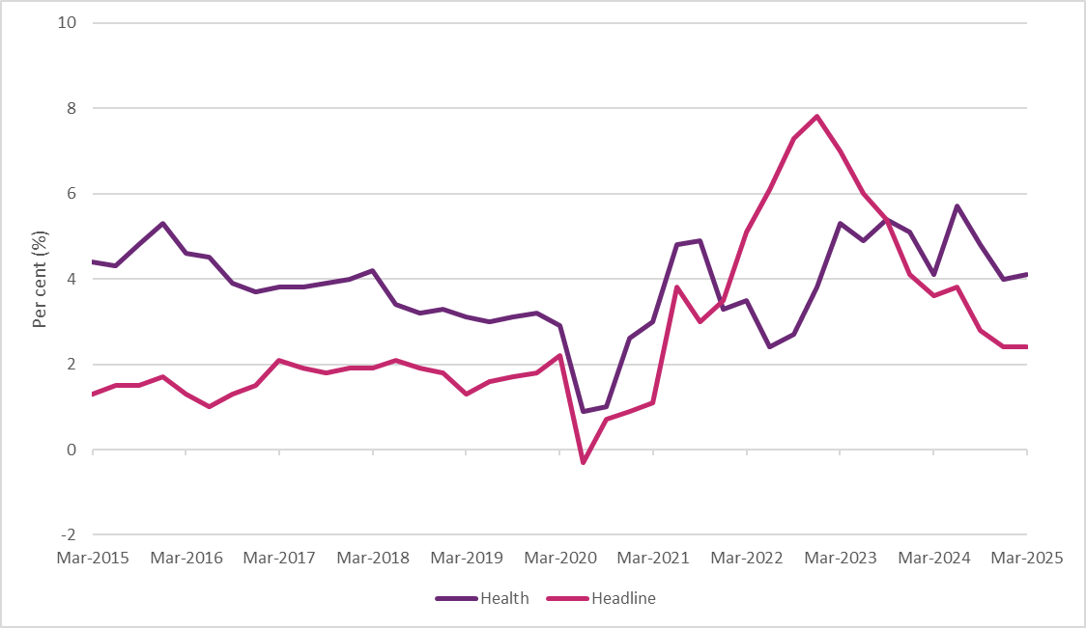
Source: ABS Consumer Price Index, March 2025

Labour Market Conditions
Australia’s labour market has remained resilient over the past year with strong employment growth, the participation rate near record highs, and the unemployment rate close to historical lows. Employment increased by approximately 390,000 people over the year to April 2025. The participation rate rose to 67.1% in April 2025 and the unemployment rate remained steady at 4.1% in April.
The labour market is forecast to remain robust, with employment growth expected to increase at a faster rate and the participation rate expected to remain higher for longer. The unemployment rate is forecast to peak lower at 4.25% by June quarter 2025, which remains low by historical standards.
The HCSA industry is the largest employing and fastest growing industry in the Australian economy. Employment in the industry increased by 78,500 people over the year to February 2025 to 2.3 million people in February 2025, representing 15.8% of total employment. This is consistent with a long-term trend of strong growth in employment within the HCSA industry, having grown at a higher average rate over the last ten years compared to all industries.
Figure 2: Employment growth in All Industries and HCSA industry from 2015 to 2025
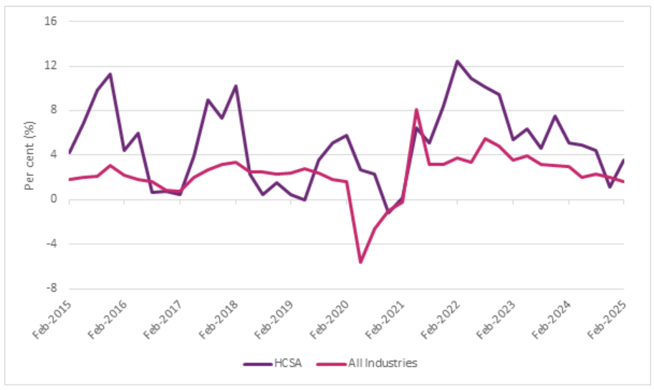
Source: ABS Labour Force, Australia, Detailed, February 2025.

Within the care and support workforce, the largest NDIS-related occupations by employment in February 2025 were aged and disability carers, nursing support and personal care workers, and welfare support workers. Together these occupations represent over 77% of workers in NDIS-related occupations. Demand for workers in the HCSA industry remains strong. There were 59,100 job vacancies in the HCSA in February 2025, which is nearly double their pre-pandemic level of job vacancies. Aged and disabled carers recorded the highest number of vacancies, representing nearly a third of NDIS-related vacancies, followed by nursing support and personal care workers and occupational therapists. This highlights the increasing demand for healthcare and support services in the Australian economy.
Alongside the high number of job vacancies in the HCSA industry, Jobs and Skills Australia considers several NDIS-related occupations to be in shortage. These include aged and disabled carers, nursing support and personal care workers, physiotherapists, speech professionals and audiologists, occupational therapists, and psychologists. However, these shortages are not unique to the NDIS sector and is a challenge faced by the broader HCSA industry and Australian economy.
The disability workforce is expected to continue to increase significantly to support the forecast growth in the NDIS and the HCSA industry. Jobs and Skills Australia projects employment in the HCSA industry to grow by 283,100 people (or 12.5%) over the five years to May 2029. This is the largest growth of all industries and nearly double the increase in the level of employment for the ‘professional, scientific, and technical services’ (second largest industry by level of employment in the economy). Employment for aged and disabled carers is expected to grow by 56,300 people (or 16.7%) over the five years to May 2029.

Figure 3: Projected employment growth for the five largest industries from May 2024 to May 2029
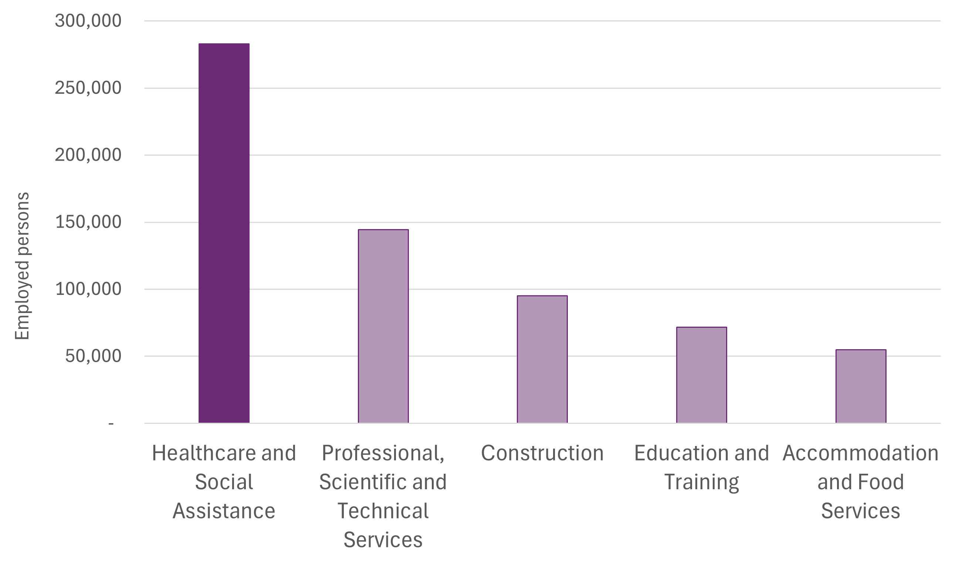
Source: Jobs and Skills Australia

Wage Growth
Wage growth has eased over 2024 after increasing in the previous few years. Wage growth was 3.4% over the year to the March quarter 2025, down from 4.1% in the March quarter 2024 and is now at the second equal lowest growth since December quarter 2022. However, wages are expected to grow over the year ahead, as labour market conditions remain strong, while inflation continues to ease. Wages are expected to grow by 3% in 2024–25 and by 3¼% in 2025–26.
The HCSA industry also recorded an easing in wage growth over 2024, after recording the highest annual growth (5.5%) since records began in the December quarter 2023. Wage growth in the HCSA industry was 3.8% over the year to the March quarter 2025, above the all-industries wage growth rate, suggesting some upward pressure on wages for care and support sector workers.

NDIS Pricing and Award Considerations

NDIA Pricing Workplan
The NDIA currently reviews price limits for all market segments on an annual cycle. While this ensures regular updates, it does not provide for deeper engagement on pricing in complex areas like therapy and disability support worker (DSW) supports that will be necessary to adopt new approaches to pricing.
A multi-year work plan will allow the NDIA to focus on markets where market conditions are evolving and where a more in-depth analysis is required to inform future approaches. It will provide a schedule for reviewing key support types while maintaining flexibility to respond to emerging trends.
The NDIA aims to publish the first iteration of this work plan by the end of 2025. This will include indicative timeline for pricing reviews across major support markets – including therapy, DSW supports, support coordination and plan management.
This approach will enable the NDIA to shift towards more differentiated pricing by:
- Consulting with providers and participants on changes to pricing approaches.
- Leveraging insights from pilots such as the Supported Independent Living and Support Coordination deep dives and blended payments trials.
- Improving data quality to monitor market trends and performance; and
- Adjusting prices incrementally to maintain market stability.
Publishing a multi-year work plan will give providers clarity on the timing and nature of planned reforms and ensure that participants continue to benefit from a stable and functioning market.
Recommendation 1:
The NDIA should commit to publishing a three-year work plan to implement key reforms arising from the Independent Pricing Committee’s Final Report. This work plan should outline a structured schedule for reviewing specific market segments, such as therapy supports and disability support worker-related supports, at defined intervals, rather than conducting a full Annual Pricing Review each year.
The work plan will serve as the primary mechanism for delivering pricing reform, allowing for targeted deep dives, piloting of differentiated pricing approaches, and consultation with stakeholders.

Timing of the Release of the APR
The NDIA aims to reset the Annual Pricing Review cycle to improve transparency, sector confidence, and alignment with government budgeting processes. Future APRs intend to be released earlier in the financial year to allow providers sufficient time to adjust systems and budgets ahead of implementation.
A three-year NDIS pricing work plan, to be published before the end of 2025, will specify the timing and scope of each pricing cycle and sector-specific review, including the integration of pilot and any applicable deep dive findings.
Recommendation 2:
The NDIA should reset the APR cycle by releasing future pricing recommendations earlier in the financial year, to support improved planning, and align with broader government planning and budget cycles. The timing of the next full pricing review will be determined based on the progress of reform initiatives and will be outlined in the NDIA Pricing Workplan.

Nurses Award
On 6 December 2024, the Fair Work Commission (FWC) issued its decision on the Aged Care Work Value Case, introducing staged wage increases for aged care nurses working in residential and home-based settings. On 20 December 2024, the final determination of the decision was released. These increases do not apply to nurses classified as ‘other than aged care employees’.
These staged changes to the awards and minimum wages include:
- In 2025 and 2026, most aged care nurses will receive three equal tranches of wage increases, varying up to 25.5%. Rates of pay have been set aligned to the Educational Services (Teachers) Award 2020 or relative to other Nurse
Award classifications. These increases will be implemented on 1 March 2025, 1 October 2025 and 1 August 2026.
- A new classification structure was introduced into the Nurses Award 2020 (Nurses Award), transitioned from 1 March 2025.
This is in addition to the 15% increase in minimum award wages for aged care nurses that commenced from 30 June 2023, alongside minimum award wage increases for many aged care employees.
To a certain extent, disability support and aged care, and other sectors, compete for the same limited pool of workers (nurses). NDIS nursing price limits were set in 2019 based on higher Award wage benchmarks across the country for each level of nursing. This structure also considers the type of nurse delivering supports to participants with different needs. As nursing price limits have been indexed every year since, the price limits continue to remain competitive compared with the rest of the care sector and attract the nurses to deliver supports for NDIS participants. For reference, assumed wages in 2019 across the 5 levels of nursing range from 3.5% to 24.5% above the equivalent Award wages that came into effect 1 March 2025, before any applicable indexation is taken into account.
The NDIA has reviewed the determination and considers that, on balance, the current nursing price limits continue to remain appropriate. Given the staging of the upcoming Nurses Award changes, the NDIA should continue to monitor access to nursing support and assess the impact of future wage changes in the aged care sector.
For other supports not covered by the DSW Cost Model, including nursing and selected community-based services, price adjustments will be based on a weighted combination of the Australian Bureau of Statistics’ (A B S') Wage Price Index (WPI) and Consumer Price Index (CPI). This ensures indexation reflects broader economic conditions and remains proportionate, evidence based and aligned with provider cost pressures.
Recommendation 3:
The NDIA should increase the price limits for nursing and other supports not covered by Disability Support Worker-related supports, Capital supports or otherwise covered in the APR, effective 1 July 2025. This adjustment should reflect the weighted movement in the Australian Bureau of Statistics Wage Price Index (Australia, total hourly rates of pay excluding bonuses) and the Australian Bureau of Statistics Consumer Price Index (All Groups, weighted average of eight capital cities) over the 12 months to the March Quarter immediately preceding the indexation data (with an 80/20 weighting).

Gender-based Undervaluation - Priority Awards Review
In the Annual Wage Review 2023–24 decision, the Fair Work Commission (FWC) determined to undertake a review on identified classifications in five modern awards. The purpose of the Review was to consider whether the classifications have been the subject of gender-based undervaluation requiring remedy on work value grounds.
These 5 identified Awards were the:
- Aboriginal and Torres Strait Islander Health Workers and Practitioners and Aboriginal Community Controlled Health Services Award 2020,
- Children’s Services Award 2010,
- Health Professionals and Support Services Award 2020 (HPSS Award),
- Pharmacy Industry Award 2020 and
- Social, Community, Home Care and Disability Services Industry Award 2010 (SCHADS Award).
The FWC announced the provisional decision of the Expert Panel on 16 April 2025. It was found that several classifications under the Awards have been the subject of gender-based undervaluation. The Expert Panel further determined that these findings constitute work value reasons justifying the variation of the modern award minimum wage rates applying to each category of employees.
In respect of the SCHADS Award, it has proposed abolishing the current five separate classification structures (Schedules B, C, D, E and F) and implement a single, simplified classification structure based on an alignment with the ‘Caring Skills’ benchmark rate proposed at around $1269.80 per week for a Certificate 3-qualified employee from the Stage 3 Aged Care Award decision. It is also proposed to revoke the E R O as part of the implementation of this new classification structure.
Additionally, for health professional employees covered by the HPSS Award, it is proposed to establish a new, simplified classification and minimum wage rate structure. The new proposed pay structure would distinguish between the different professional occupations based on the Australian Qualifications Framework (AQF) level of the standard educational qualification required for entry into the profession.
More information can be found on the Fair Work Commission’s website.
As this decision remains provisional at the time of preparing the APR, the NDIA will consider the decision and its impact on relevant supports and their pricing once finalised.

Disability Support Worker Related Supports

Context
Disability Support Workers (DSWs) are an essential part of Australia’s care and support workforce, bridging the gap between healthcare services and daily living assistance for individuals with disabilities. DSWs represent the sector’s diversity, working across various settings, from private homes to community-based programs, providing personalised support that enhances the independence of NDIS participants.

Approach to Setting DSW-Related Price Limits
The NDIA uses the Disability Support Worker Cost Model (DSW Cost Model) to estimate the cost that a provider would likely incur to deliver a billable hour of support. The model informs price limits for a range of DSW-related supports and is based on a set of assumptions aligned with minimum wage and employment conditions under the Social, Community, Home Care and Disability Services Industry Award 2010 (SCHADS Award).
Following refinement of the model in 2022, the DSW Cost Model groups provider expenses into 3 broad categories:
- Direct worker employment costs, including wages (based on SCHADS Award levels 2.3-4.4), superannuation (12% from 1 July 2025), leave entitlements, and allowances;
- Operational overheads, covering supervision, rostering, training, and quality assurance, including assumptions around utilisation rates and workforce mix; and
- Corporate overheads, such as accounting, Human Resources, Information Technology, and other business functions.
A margin is also applied to reflect working capital needs. All elements are calculated as a percentage of direct costs, using a multiplicative model structure.
While the NDIA acknowledges that some providers use Enterprise Bargaining Agreements (E B As) or classify workers differently under the SCHADS Award (e.g., Home Care vs Social and Community Services streams), the DSW Cost Model benchmarks are based on Award minimums and remain the most appropriate foundation for setting national price limits.
The DSW Cost Model includes cost assumptions for four skill levels (DSW levels 1-4) to reflect the diversity of tasks and participant needs, but these levels do not limit the types of DSW who may deliver funded supports.
The DSW Cost Model does not function in isolation. It is applied alongside consideration of market conditions, industrial relations changes, regulatory requirements, and workforce dynamics when determining final price settings for DSW-related supports.
More detailed costs and model assumptions are available in Appendix A and on the NDIS website.

Supported Independent Living (SIL) Quality Supports
The NDIA’s SIL Quality Support Pilot is a 12-month initiative under the Quality Supports Program. It is designed to strengthen the evidence base for quality SIL supports and inform future pricing approaches by identifying the characteristics, capabilities, and cost drivers associated with delivering effective, sustainable supports for participants with complex needs.
The pilot engages a cohort of experienced providers, specifically those supporting at least fifty participants and maintaining registration for high-intensity and behaviour support services. These providers will partner with the NDIA to explore how organisational capability, workforce strategies, and support models influence participant outcomes and provider viability. This process is still underway at the time of preparing the APR.
Participating providers will contribute detailed data and qualitative insights across key domains, including:
- Organisational governance and quality management
- Workforce capacity and development
- Participant-centred support models
- Cost structures linked to service complexity and quality delivery
Providers will also participate in Communities of Practice and submit structured evaluations such as case studies, participant engagement summaries, pricing and workforce questionnaires, and financial reports.
The pilot will provide critical insights into the conditions required to deliver consistently high-quality SIL supports. It will also inform potential future pricing pathways, identify what are the value adds that are above minimum requirements which foster better outcomes.
The pilot outcomes will contribute to the NDIA’s market stewardship responsibilities by identifying scalable delivery models and supporting a more evidence-based approach to pricing for quality and practices across the SIL provider market.

Scheme Statistics

Overview of the DSW Market trends
This section analyses trends in participants accessing DSW-related supports, provider growth, payment volumes, and business dynamics for supports priced under the DSW Cost Model. Between January 2022 and December 2024, the number of providers, particularly unregistered, grew substantially, while the average volume of supports delivered per provider declined.
Unregistered providers now support a growing share of participants, especially for those receiving standard supports, but account for a smaller share of overall payments. New provider entry is high across all regions, contributing to declining market share for the largest providers.
The analysis suggests NDIS price limits are contributing to shaping the market in terms of provider entry, scale, and support mix, prompting consideration of whether the current DSW pricing approach is driving the market in the right direction.

DSW Market Statistics
Between July and December 2024, 301,964 NDIS participants claimed at least one DSW-related support, representing approximately 44% of all active participants, a 7% increase from the previous period (Table 1). The number of providers rose by 11% to 136,864 over the same period. (Table 1, Figure 4).
Trends in DSW expenditure differed by registration status. The number of participants receiving DSW-related supports from registered providers increased by 4%, while the number of active registered providers grew by 20% (Table 2). Despite a 14% rise in total payments, the average claim per active registered provider declined by 5% to $1.0 million, suggesting new entrants could be operating at smaller scales (Table 2).
Amongst unregistered providers, both the number of participants accessing services and the number of active unregistered providers increased by around 10%, with total payments rising by 17% to $4.2 billion for the six months to December 2024 (Table 3).
Average claims per active unregistered provider increased by 6% over the same observation period (Table 3).
Table 1: DSW-Related Supports Scheme Statistics – All Providers
Statistics | July – December 2023 | July – December 2024 | Percentage Change
Number of NDIS participants | 283,406 | 301,964 | +7%
Number of active providers | 122,857 | 136,864 | +11%
Total amount claimed by active providers of DSW-related supports | $13.0 billion | $15.0 billion | +15%
Average amount claimed by all active providers of DSW-related supports | $106,180 | $109,414 | +3%
Table 2: DSW-Related Supports Scheme Statistics – Registered Providers
Statistics | July – December 2023 | July – December 2024 | Percentage Change
Number of NDIS participants | 194,667 | 202,684 | +4%
Number of active providers | 8,697 | 10,443 | +20%
Total amount claimed by active providers of DSW-related supports | $9.4 billion | $10.7 billion | +14%
Average amount claimed by all active providers of DSW-related supports | $1.1 million | $1.0 million | -5%
Table 3: DSW-Related Supports Scheme Statistics – Unregistered Providers
Statistics | July – December 2023 | July – December 2024 | Percentage Change
Number of NDIS participants | 163,055 | 179,165 | +10%
Number of active providers | 114,777 | 127,217 | +11%
Total amount claimed by active providers of DSW-related supports | $3.6 billion | $4.2 billion | +17%
Average amount claimed by all active providers of DSW-related supports | $31,348 | $33,214 | +6%
Source: NDIS internal administrative data
Note: Registration status is determined as at the posting date of payment. Some providers may be counted more than once if they changed registration status during the period.

Figure 4 illustrates steady growth in DSW-related supports from January to June 2022 to July to December 2024. Total expenditure on DSW-related supports made up 65.5% of the total scheme expenditure for the six months to December 2024 ($15.0 billion).
Figure 4: NDIS Expenditure on DSW-related Supports since January 2022 Relative to Total NDIS Expenditure
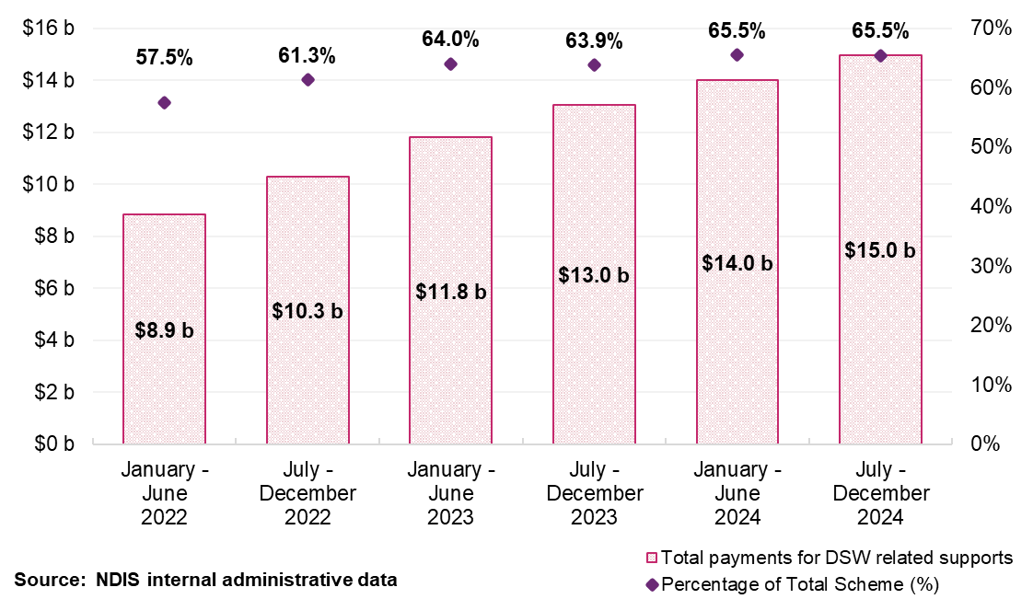

Participants
The top ten DSW-related support items with the highest total payments between July and December 2024 are shown in Table 4.
Standard supports such as Assistance with Self-Care Activities – Standard and Community, Social and Recreational Activities – Standard had the highest participant volumes and were delivered by 83,610 and 89,138 providers respectively – well above the number of registered providers in the Scheme (Table 4).
By contrast, high-intensity supports such as SIL – High Intensity and Assistance with Self-Care Activities – High Intensity were accessed by fewer participants and delivered by 1,478 and 5,223 providers, respectively (Table 4).
This demonstrates how support characteristics can shape who delivers them. Higher intensity supports are more commonly delivered by registered organisations, while standard supports are more broadly distributed, including through unregistered and smaller scale business models.

Table 4: Top 10 largest DSW-related supports (based on payments), July to December 2024
Support Delivered | Total payments ($ million) | Number of Participants | Number of Providers
Assistance in Supported Independent Living Standard | $4,838 | 36,038 | 7,426
Assistance with Self-Care Activities Standard | $3,592 | 147,018 | 83,610
Access Community Social and Recreational Activities Standard | $3,522 | 237,206 | 89,138
Group Activities Standard | $585 | 62,686 | 8,367
STA and Assistance | $449 | 33,593 | 13,993
Assistance in Supported Independent Living High Intensity | $445 | 3,827 | 1,478
Assistance with Self-Care Activities High Intensity | $357 | 6,452 | 5,223
Activity Based Transport | $219 | 159,676 | 37,511
Capacity Building and Training | $197 | 60,456 | 26,719
Supports in Employment | $163 | 19,851 | 2,714
Source: NDIS internal administrative data
Note: payment is on a cash basis.

Providers
Building on earlier trends in provider growth and support delivery, this section examines the structure of the DSW provider market.
The share of total DSW-related payments received by the top 10 providers fell from 9.4% in January 2022 to 6.7% in December 2024 (Figure 5), coinciding with an 11% increase in active providers over the past year (Table 1). This pattern is most pronounced in remote and very remote areas, where the top 10 providers’ market share declined from 43% to 28% and from 36% to 27% for the six months to December 2024, respectively (Figure 6).
While payments increased for both registered and unregistered providers, average claims per provider declined or remained steady. Amongst registered providers, payments rose by 14% while provider numbers grew by 20%, resulting in a 5% decrease in average claims (Table 2). Amongst unregistered providers, a 17% rise in payments accompanied an 11% increase in provider numbers (Table 3).

These trends suggest the market continues to expand but not in terms of scale. Growth appears to be driven more by new entrants, rather than by consolidation or organisational growth. This result suggests that the current price limits may be enabling greater small-scale entry in standard supports while offering limited incentives for providers to scale up or invest in more complex support areas.
Figure 5: Top 10 Providers’ Market Share Against Overall Provider Growth on DSW-related Supports, January 2022 to December 2024
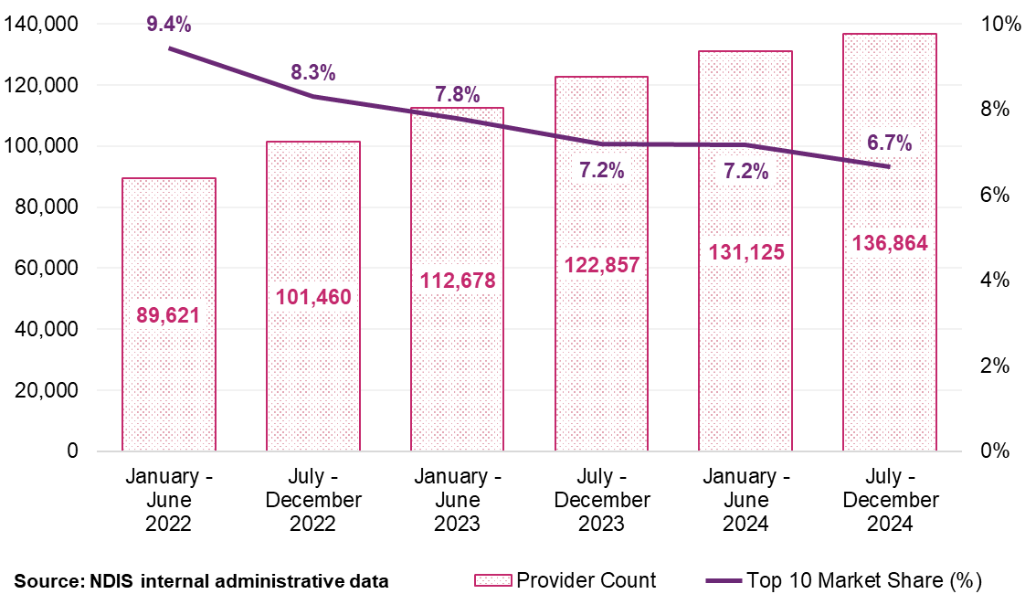

Figure 6: Top 10 Providers’ Market Share by Remoteness for DSW-related Supports, January 2022 to December 2024
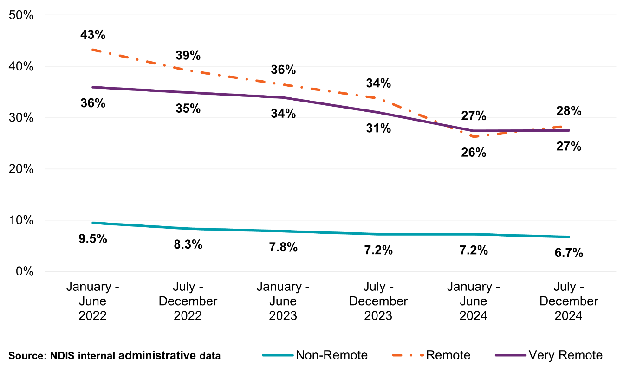

Provider distribution by geographic areas
Patterns in provider growth across geographic areas reflect both increasing market maturity and the rise of new service delivery models. As shown in Table 5 and Table 6, provider numbers have increased across all geographical areas between January 2022 and December 2024, with the strongest growth seen in remote and very remote areas – particularly among unregistered providers.
In remote areas, the number unregistered providers nearly doubled over the observation period, while growth in very remote areas reached 62% (Table 6). This coincided with a sharp decline in market share of the top 10 providers in those areas (Figure 6), suggesting that entry of new providers is reshaping market composition, even in thin markets.
While this may enhance access and flexibility, it also introduces risks. Many of the active providers are smaller scale providers (see Table 7), often operating without the infrastructure, workforce depth or governance frameworks required for sustained service delivery, especially for participants with highly complex conditions. In regions or markets where workforce shortages and service continuity challenges are already common, the viability of small-scale delivery models, particularly under current price limit settings, may warrant further consideration.

Table 5: The Count of Registered Providers by Remoteness for DSW-related Supports, January 2022 to December 2024
Remoteness | January – June  2022 | July – December 2022 | January – June  2023 | July – December 2023 | January – June  2024 | July – December 2024
Non-remote | 8,745 | 9,196 | 8,807 | 8,612 | 9,473 | 10,344
Remote | 430 | 420 | 380 | 388 | 517 | 516
Very remote | 224 | 233 | 227 | 236 | 266 | 260
Total for Registered | 8,814 | 9,286 | 8,893 | 8,697 | 9,572 | 10,443
Source: NDIS internal administrative data
Note: Remoteness of providers uses participants’ address as a proxy. Providers may be counted more than once if providers provide support to participants located across varying remoteness levels.
Table 6: The Count of Unregistered Providers by Remoteness for DSW-related Supports, January 2022 to December 2024
Remoteness | January – June  2022 | July – December 2022 | January – June  2023 | July – December 2023 | January – June  2024 | July – December 2024
Non-remote | 80,125 | 91,418 | 103,028 | 113,419 | 120,924 | 125,628
Remote | 1,020 | 1,093 | 1,199 | 1,374 | 2,117 | 1,991
Very remote | 473 | 530 | 582 | 622 | 689 | 757
Total for Unregistered | 81,152 | 92,491 | 104,263 | 114,777 | 122,518 | 127,217
Source: NDIS internal administrative data
Note: Remoteness of providers uses participants’ address as a proxy. Providers may be counted more than once if providers provide support to participants located across varying remoteness levels.

Legal Entity
Companies and sole traders represent opposite ends of the provider spectrum for DSW-related supports. Companies comprise 18% of active providers but deliver the majority of supports, claiming $11.6 billion at an average of $480,754 per provider (Table 7). In contrast, sole traders accounted for 77% of active providers, but operate at much smaller scale, with average claims of $21,214 despite collectively supporting over 110,000 participants. This pattern reflects the broader structure of the market, where a large number of small providers coexist alongside a smaller group of higher-volume organisations.

Table 7: DSW-Related Supports Scheme Statistics by Legal Entity Type, July to December 2024
Statistics | Company | Government Entity | Partnership (Other) | Trust / Super | Sole trader
Number of NDIS participants | 245,845 | 3,058 | 10,929 | 31,200 | 111,785
Number of active providers | 24,159 | 269 | 2,758 | 4,762 | 104,818
Total amount claimed by active providers of DSW-related supports ($ billion) | $11.61 | $0.15 | $0.18 | $0.72 | $2.22
Average amount claimed by all active providers of DSW-related supports | $480,754 | $565,001 | $65,628 | $151,013 | $21,214
Source: NDIS internal administrative data
Note: Providers with a missing Legal Entity Type are excluded.

Claiming Patterns
Claiming patterns for DSW-related supports have remained relatively stable over the past three years, with most claims made at or near the maximum allowable price. As shown in Table 8, the proportion of claims made at the price limit averaged around 63% across all providers in the six months to December 2024.
Among registered providers, claiming at the price limit has consistently remained above two-thirds of all transactions. This pattern may reflect a range of factors, including the cost of delivering supports, or a broader tendency across the market to claim at the maximum allowable rate.
Claiming behaviour among unregistered providers has been more variable. After rising to 59% in the first half of 2024, the proportion of claims at the price limit fell slightly to 55% for the six months to December 2024 (Table 8).
Table 8: Claiming Patterns at Price Limit Analysis for DSW-Related Supports, January 2022 to December 2024
Claiming patterns – At price limit | January – June  2022 | July – December 2022 | January – June  2023 | July – December 2023 | January – June  2024 | July – December 2024
Registered | 69% | 69% | 71% | 70% | 67% | 68%
Unregistered | 51% | 50% | 58% | 54% | 59% | 55%
All Providers | 65% | 64% | 67% | 64% | 64% | 63%
Source: NDIS internal administrative data

Payment activity for registered providers
An analysis of payment activity for registered providers from January 2022 to December 2024 (Figure 7) shows an evolving provider market. Figure 7 shows that inactive registered providers account for a small proportion (0.3% or less) of the total payments in any six-month period. In comparison, newly active registered providers peaked at 0.9% of total payments between January to June 2024.
Figure 7: DSW-related Registered Provider Activity Movements, January 2022 to December 2024
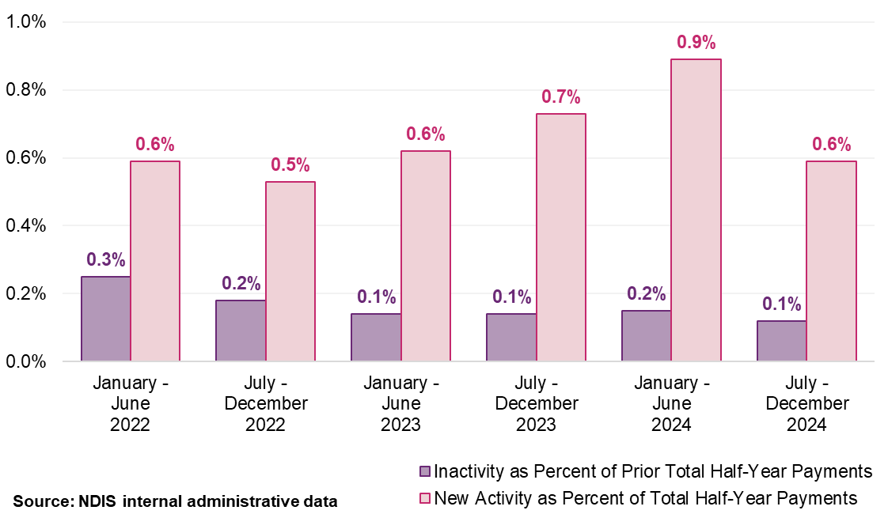
Note: ‘New Activity’ within a half-year period is identified when providers who were inactive in the previous half-year begin to receive payments. Conversely, ‘Inactivity’ is noted when providers that received payments in one half-year do not in the subsequent one. These fluctuations are measured as a percentage of the total payments made within that half-year, or the previous one, in the case of inactivity.

Discussion

Price Limits and Market Structures
The current DSW pricing approach incorporates some differentiation for high intensity, remote and after hours supports but remain largely anchored to flat hourly price limits. This structure has contributed to shaping provider behaviour and market
composition, favouring lower-cost, standardised service models – that is, the ways providers organise their workforce, structure service delivery, and invest in delivering NDIS supports. Providers are increasingly designing their services around financial viability within price limits rather than around the complexity of participant needs.
These dynamics have encouraged rapid growth among lower-overhead providers delivering standard supports, while services requiring higher workforce capability, clinical oversight, or quality investment face greater sustainability pressures. As a result, market diversity risks narrowing over time, particularly for participants with more complex or intensive support needs. Without adjustment, NDIS pricing arrangements, rather than participant choice or regional factors, may dominate how services are delivered across the Scheme.

Need for more differentiated pricing
Strengthening price differentiation offers a pathway to better align pricing with the diversity of service delivery modes and operational contexts across the sector. Current reliance on uniform pricing does not adequately recognise the organisational capability, workforce investment, or governance structures required to deliver mode complex or risk-appropriate supports.
A more deliberate approach to differentiation would help preserve a balanced provider market, supporting both low-complexity and high-complexity service offerings. It would ensure that supports requiring greater investment in quality and participant outcomes remain financially viable and safeguard access across a range of participant needs.
Additionally, maintaining flexibility within the NDIS pricing approach will be important to support innovation and development. Standardised pricing can limit the ability of providers to adapt to evolving participant expectations or develop new models of service delivery. As the DSW market continues to mature, ensuring NDIS pricing support both administrative efficiency and the capacity of service evolution will be critical to long-term market sustainability.

Recommendations
Supports priced under the DSW Cost Model are directly linked to wage decisions under the Fair Work Commission’s SCHADS Award and National Employment Standards. While structured indexation provides certainty for providers to meet minimum legal entitlements for their employees, the NDIA should retain flexibility to respond to changes that impact the NDIS and the disability sector. When making pricing decisions, the NDIA also considers:
- movements in adjacent sectors, such as Aged Care Award decisions,
- changes to applicable Awards, such as the current Gender Undervaluation Priority Awards Review, and
- changes to National Employment Standards, such as the superannuation guarantee (12% from 1 July 2025).
Where appropriate, further review of pricing decisions may be undertaken to assess implications for provider sustainability and Scheme outcomes.
Recommendation 4:
The NDIA should adjust the price limits for supports determined by the NDIS Disability Support Worker Cost Model, effective 1 July 2025. This adjustment should reflect changes in the minimum wage specified in the Social, Community, Home Care, and Disability Services Industry Award 2010, as determined by the Fair Work Commission’s Annual Wage Review, along with any increase in the Superannuation Guarantee.

Therapy Supports

Context
Therapy supports play an important role in assisting NDIS participants to achieve their personal goals. Early therapeutic interventions enhance participant outcomes and reduce long-term cost by building capacity and independence. These supports are delivered by a diverse range of professionals, such as Occupational Therapists, Speech Pathologists, Psychologists, Physiotherapists, and many others, including therapy assistants who operate under the supervision of therapists. This ensures access to therapeutic supports that can best meet participant needs.
Therapy supports are organised into several registration groups, with most therapy supports delivered under three main categories: Therapeutic Supports for improving functional skills (0128), Early Intervention Supports for Early Childhood for children with developmental delays (0118), and Exercise Physiology & Personal Wellbeing Activities for physical health (0126). There are other categories which provide supports for specific needs like behaviour management and hearing services.
NDIS therapy pricing reflects a range of delivery models and participant needs. Price limits vary depending on the support type, whether the supports are delivered individually or in groups, and the location of delivery. The NDIS also allows for claiming of non-face-to-face supports, travel and cancellations. This allows for supports to be delivered flexibility and person centred service delivery. Additional information on the Pricing Arrangements and Price Limits for therapy supports can be found on the NDIS website.
This year’s APR marks the start of broader reforms to strengthen therapy pricing. Informed by the IPC’s framework, the NDIA has taken early steps to transition from a uniform hourly pricing approach to more differentiated therapy pricing. These aim to better reflect differences across therapy types, market structures, and delivery contexts.
The NDIA has used benchmarking data, including relative comparison to 75th percentile rates from the Medicare Benefits Schedule (MBS) and Private Health Insurance (P H I), to assess whether current price limits remain appropriate. These benchmarks were used as reference points, not pricing targets. Where there is strong evidence suggesting a misalignment of price limits with prevailing market rates, an incremental adjustments has been made–. Where data was less conclusive, current price limits have been maintained pending further analysis and review.
Table 9: Price Limits for Therapy Supports as at 1 January 2025
Type of Therapist | NSW/VIC/ QLD/ACT | SA/WA/ TAS/NT | Remote | Very Remote
Art Therapist, Audiologist, Developmental Educator, Dietitian, Music Therapist, Occupational Therapist, Orthoptist, Podiatrist, Rehabilitation Counsellor, Social Worker, Speech Pathologist, and Other Professional | $193.99 | $193.99 | $271.59 | $290.99
Counsellor | $156.16 | $156.16 | $218.62 | $234.24
Exercise Physiologist | $166.99 | $166.99 | $233.79 | $250.49
Physiotherapist | $193.99 | $224.62 | $314.47 | $336.93
Psychologist | $222.99 | $244.22 | $328.76 | $352.25
Therapy Assistant - Level 1 | $56.16 | $56.16 | $78.62 | $84.24
Therapy Assistant - Level 2 | $86.79 | $86.79 | $121.51 | $130.19
Source: NDIS Pricing Arrangements and Price Limits 2024-25

Scheme Statistics

Market Overview
In the six months to December 2024, 412,945 participants received at least one therapy support, around 60% of all active participants, a 9% increase from the same period the previous year (Table 10). Over the same observation period, the number of active therapy providers rose by 5% to 55,370 providers.
Total therapy payments reached $2.4 billion, a 17% increase from the $2.1 billion for the same period in the previous year. The average amount claimed per provider rose by 11% from $39,257 to $43,656 across these time periods.
These payments accounted for approximately 11% of total scheme expenditure between July and December 2024, up from 8.7% of scheme expenditure in the half year period from January to June 2022 (Figure 8).

Table 10: Therapy Supports Schemes Statistics – All Providers
Statistics | July – December 2023 | July – December 2024 | Percentage Change
Total number of NDIS participants | 379,296 | 412,945 | +9%
Total number of active providers | 52,736 | 55,370 | +5%
Total amount claimed by active providers of Therapy supports | $2.1 billion | $2.4 billion | +17%
Average amount claimed by all active providers of Therapy supports | $39,257 | $43,656 | +11%
Source: NDIS internal administrative data
Figure 8: NDIS Expenditure on Therapy Supports Since January 2022 Relative to Total NDIS Expenditure
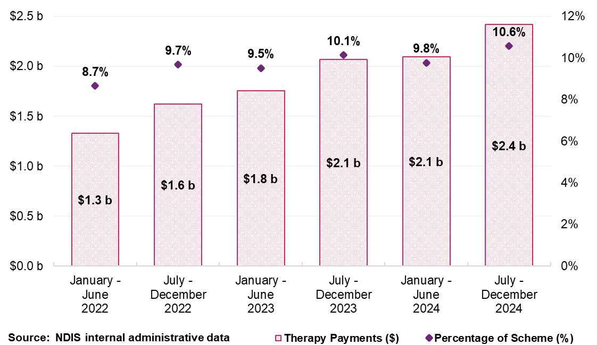

Participants
In the six months to December 2024, five therapies accounted for over three-quarters of all therapy payments: occupational therapists ($511.8 million), early childhood intervention therapists ($449.9 million), behaviour support professionals ($393.0 million), speech pathologists ($232.7 million), and physiotherapists ($222.7 million) (Table 11, Figure 9). Together, these categories represented $1.8 billion in claims, accounting for approximately 75% of the NDIA’s $2.4 billion therapy expenditure during the reporting period as detailed in Figure 10.
Table 11: Scheme Expenditure by Type of Therapist, July to December 2024
Type of Therapist | Total Payments ($ million) | Number of Participants | Number of Providers
Occupational Therapist | $511.8 | 235,928 | 9,054
Early Childhood | $449.9 | 106,254 | 15,103
Behavioural Therapist | $393.0 | 62,649 | 1,660
Speech Pathologist | $232.7 | 121,124 | 5,815
Physiotherapist | $222.7 | 99,208 | 10,087
Psychologist | $193.6 | 105,852 | 13,298
Other Professional | $130.6 | 84,647 | 20,681
Exercise Physiologist | $84.5 | 43,503 | 4,554
Therapy Assistant | $45.2 | 43,032 | 4,267
Social Worker | $27.7 | 16,181 | 2,464
Counsellor | $27.5 | 20,393 | 4,428
Dietitian | $22.9 | 25,462 | 2,116
Podiatrist | $13.0 | 32,545 | 2,833
Music Therapist | $10.0 | 5,762 | 1,062
Miscellaneous | $9.6 | 4,588 | 2,760
Art Therapist | $7.4 | 4,783 | 1,206
Development Educator | $7.0 | 3,639 | 481
Rehabilitation Counsellor | $0.8 | 758 | 295
Orthoptist | $0.7 | 1,234 | 222
Audiologist | $0.4 | 1,061 | 152
Total | $2,417.2 | 412,945 | 55,370
Source: NDIS internal administrative data
Note: The total for both the number of participants and providers represents unique counts with the July to December 2024 period. ‘Other Professional’ refers to a diverse group of therapy providers offering services such as assessments, recommendations, and group therapies, which may encompass a variety of therapy disciplines not individually listed. Total payments also included therapy related travel payment, which was $26.1 million, claimed by 11,779 providers from 136,627 participants.

Figure 9: Largest Ten Therapy Types Based on Total NDIS Payments, January 2022 to December 2024

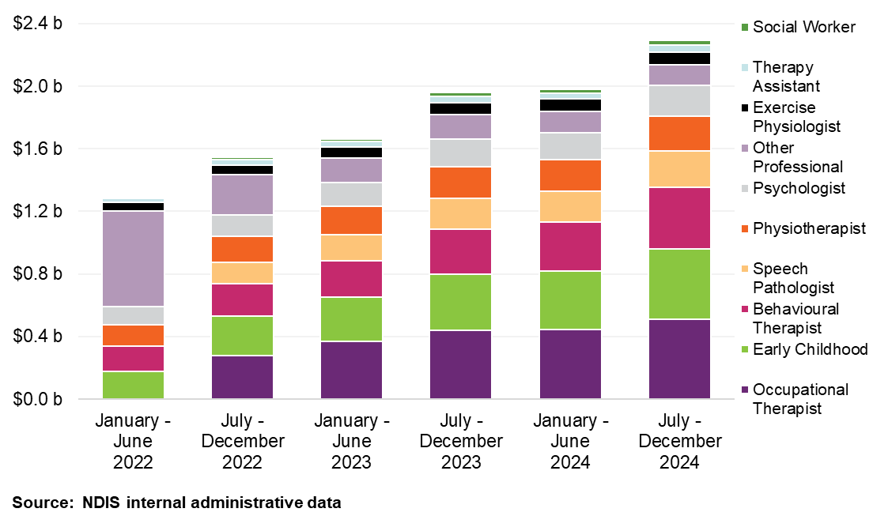
Note: Before July 2022, the NDIA grouped various therapies under ‘Other Therapy’ support. Post-categorisation changes, expenditure on specific support delivered by therapists such as Occupational Therapists and Speech Pathologists are now more distinctly tracked.

Providers

Provider Growth and Registration Trends
The number of providers of therapy support grew to 55,370 in the six months to December 2024, a 5% increase from the same period in the previous year (Table 10). This growth was driven by an increase in the number of unregistered providers, rising by 6% to 48,709 providers. In contrast, the number of registered providers declined slightly by 2% over the same period (Table 12 and Table 13).
Unregistered providers now account for nearly 90% of all therapy providers, but just 38% of total payments (Figure 10). Registered providers, while smaller in number, continue to deliver most therapy support to NDIS participants and receive 62% of total payments. On average, registered providers claimed $206,626 per provider, over 11 times the unregistered provider average of $18,647 per provider.
This contrast reflects a dual market structure: registered providers tend to operate at larger scale, while there are many more unregistered providers whose payment claims are much lower, indicating small scale business models.
Table 12: Therapy Supports Scheme Statistics – Registered Providers
Statistics | July – December 2023 | July – December 2024 | Percentage Change
Number of NDIS participants using registered Therapy providers | 295,097 | 307,193 | +4%
Number of active registered providers of Therapy supports | 7,392 | 7,240 | -2%
Total amount claimed by registered providers of Therapy supports | $1.3 billion | $1.5 billion | +12%
Average amount claimed by registered providers of Therapy supports | $180,913 | $206,626 | +14%
Source: NDIS internal administrative data
Table 13: Therapy Supports Scheme Statistics – Unregistered Providers
Statistics | July – December 2023 | July – December 2024 | Percentage Change
Number of NDIS participants using unregistered Therapy providers | 217,007 | 255,389 | +18%
Number of active unregistered providers of Therapy supports | 45,961 | 48,709 | +6%
Total amount claimed by unregistered providers of Therapy supports | $0.7 billion | $0.9 billion | +26%
Average amount claimed by unregistered providers of Therapy supports | $15,651 | $18,647 | +19%
Source: NDIS internal administrative data
Please note a discrepancy in the total number of ‘active’ therapy providers, attributable to two factors. 1) some providers offer a mix of registered and unregistered supports, leading to their classification in both categories. 2) a small fraction of providers with undetermined registration status contributes to total payment figures but is excluded from detailed tabulation, representing less than 1% of the overall financial transactions.

Figure 10: Total Payments for Therapy Support Items by Provider Registration Status, January 2022 to December 2024
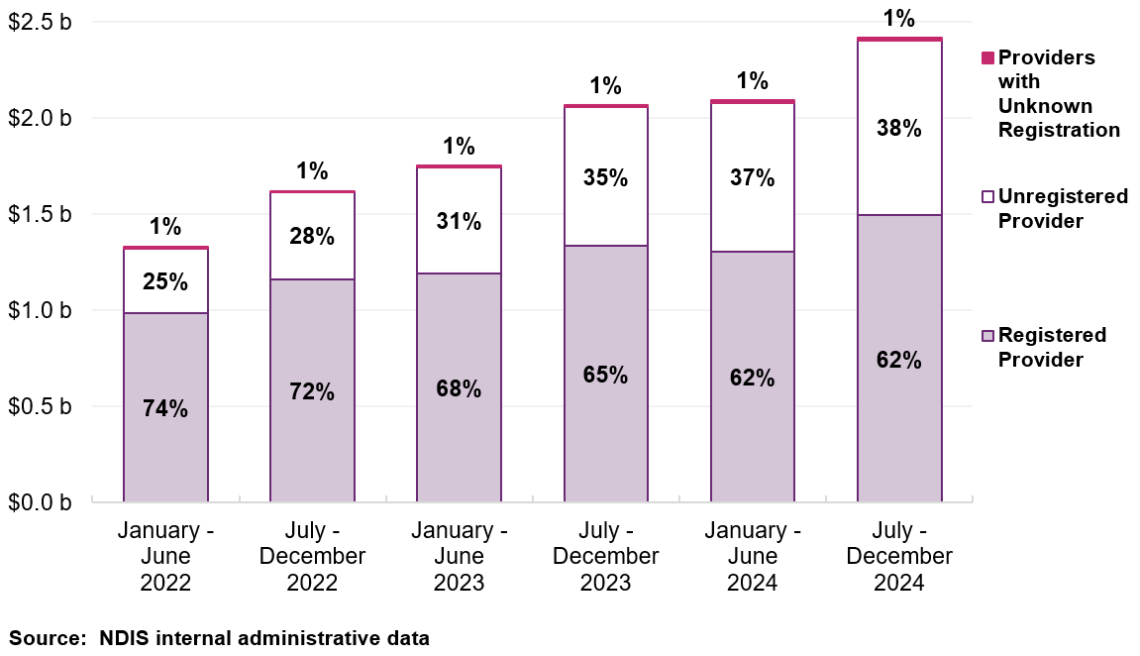

Geographic Spread
The therapy market has evolved not only in size but also in geographic distribution. Between January 2022 and December 2024, the number of unregistered providers more than doubled in remote and very remote areas (Table 15). Over the same period, registered provider numbers declined by 16% in non-remote areas, with growth limited to remote and very remote regions (Table 14).
These patterns suggest that unregistered providers are increasingly filling service gaps in areas where operating at scale may be more challenging. More flexible business models and lower administrative overheads may enable these providers to respond more readily to local demand.
Table 14: Registered Providers by Remoteness for Therapy Supports, January 2022 to December 2024
Remoteness | January –June  2022 | July –December 2022 | January –June  2023 | July –December 2023 | January –June  2024 | July –December 2024
Non-remote | 8,552 | 8,735 | 8,252 | 7,326 | 7,083 | 7,195
Remote | 534 | 520 | 522 | 519 | 616 | 609
Very remote | 282 | 300 | 298 | 324 | 315 | 348
Total for Registered | 8,595 | 8,778 | 8,302 | 7,392 | 7,127 | 7,240
Source: NDIS internal administrative data

Table 15: Unregistered Providers by Remoteness for Therapy Supports, January 2022 to December 2024
Remoteness | January –June  2022 | July –December 2022 | January –June  2023 | July –December 2023 | January –June  2024 | July –December 2024
Non-remote | 34,090 | 37,940 | 41,938 | 45,543 | 47,465 | 48,299
Remote | 583 | 660 | 775 | 944 | 1,368 | 1,343
Very remote | 250 | 299 | 346 | 427 | 515 | 561
Total for Unregistered | 34,350 | 38,206 | 42,260 | 45,961 | 47,941 | 48,709
Source: NDIS internal administrative data
Note: The total for registered providers of therapy supports and total for unregistered providers of therapy supports does not align with the total number of therapy support providers. The reasons for this are: 1) One provider can provide multiple supports, being registered for some supports and unregistered for others (different registration groups) in the same period, so they are accounted for in both groups of providers; 2) Providers with unknown registration are captured in total amounts but not presented in this table as they make up a very small percentage of total payments; and 3) Some participant location details at the time of transaction were not available, so provider remoteness could not be determined.

Market Share and Consolidation
While the therapy market has grown significantly since January 2022, unregistered providers have dominated this growth. During this period, the number of registered providers declined, and the top 10 providers’ share of total therapy payments fell from 11.1% to 10.5% (Figure 11). This shift reflects a broader redistribution of service delivery, with payments increasingly directed to smaller-scale providers.
These changes are more pronounced in remote and very remote areas. In very remote areas, the top 10 providers’ share fell from 46% to 30%, and in remote areas from 34% to 21% (Figure 12). In contrast, their market share in non-remote areas remained stable at around 11% from January 2022 to December 2024.

Figure 11: Top 10 Providers’ Market Share Against Overall Provider Growth for Therapy Supports, January 2022 to December 2024
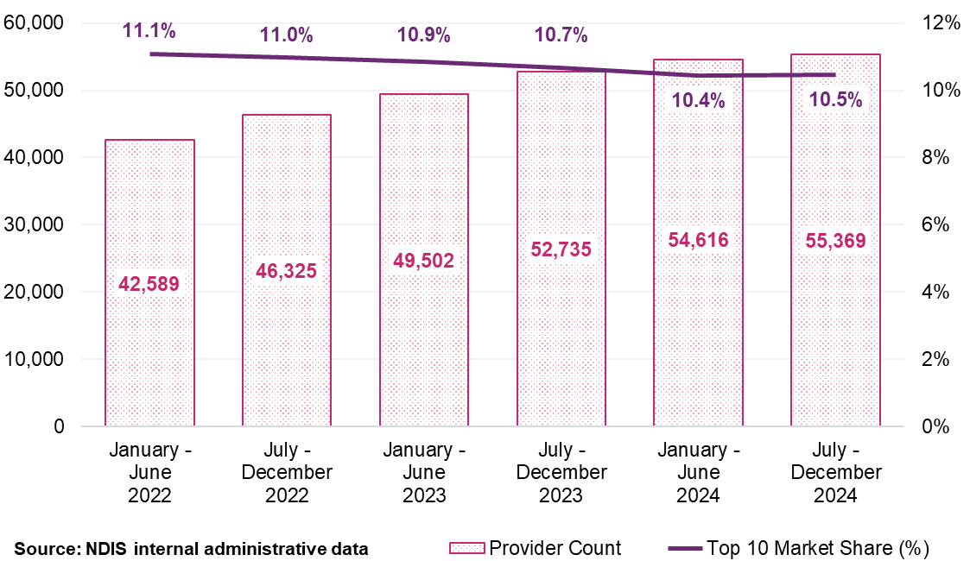

Figure 12: Top 10 Providers’ Market Share by Remoteness for Therapy Supports, January 2022 to December 2024
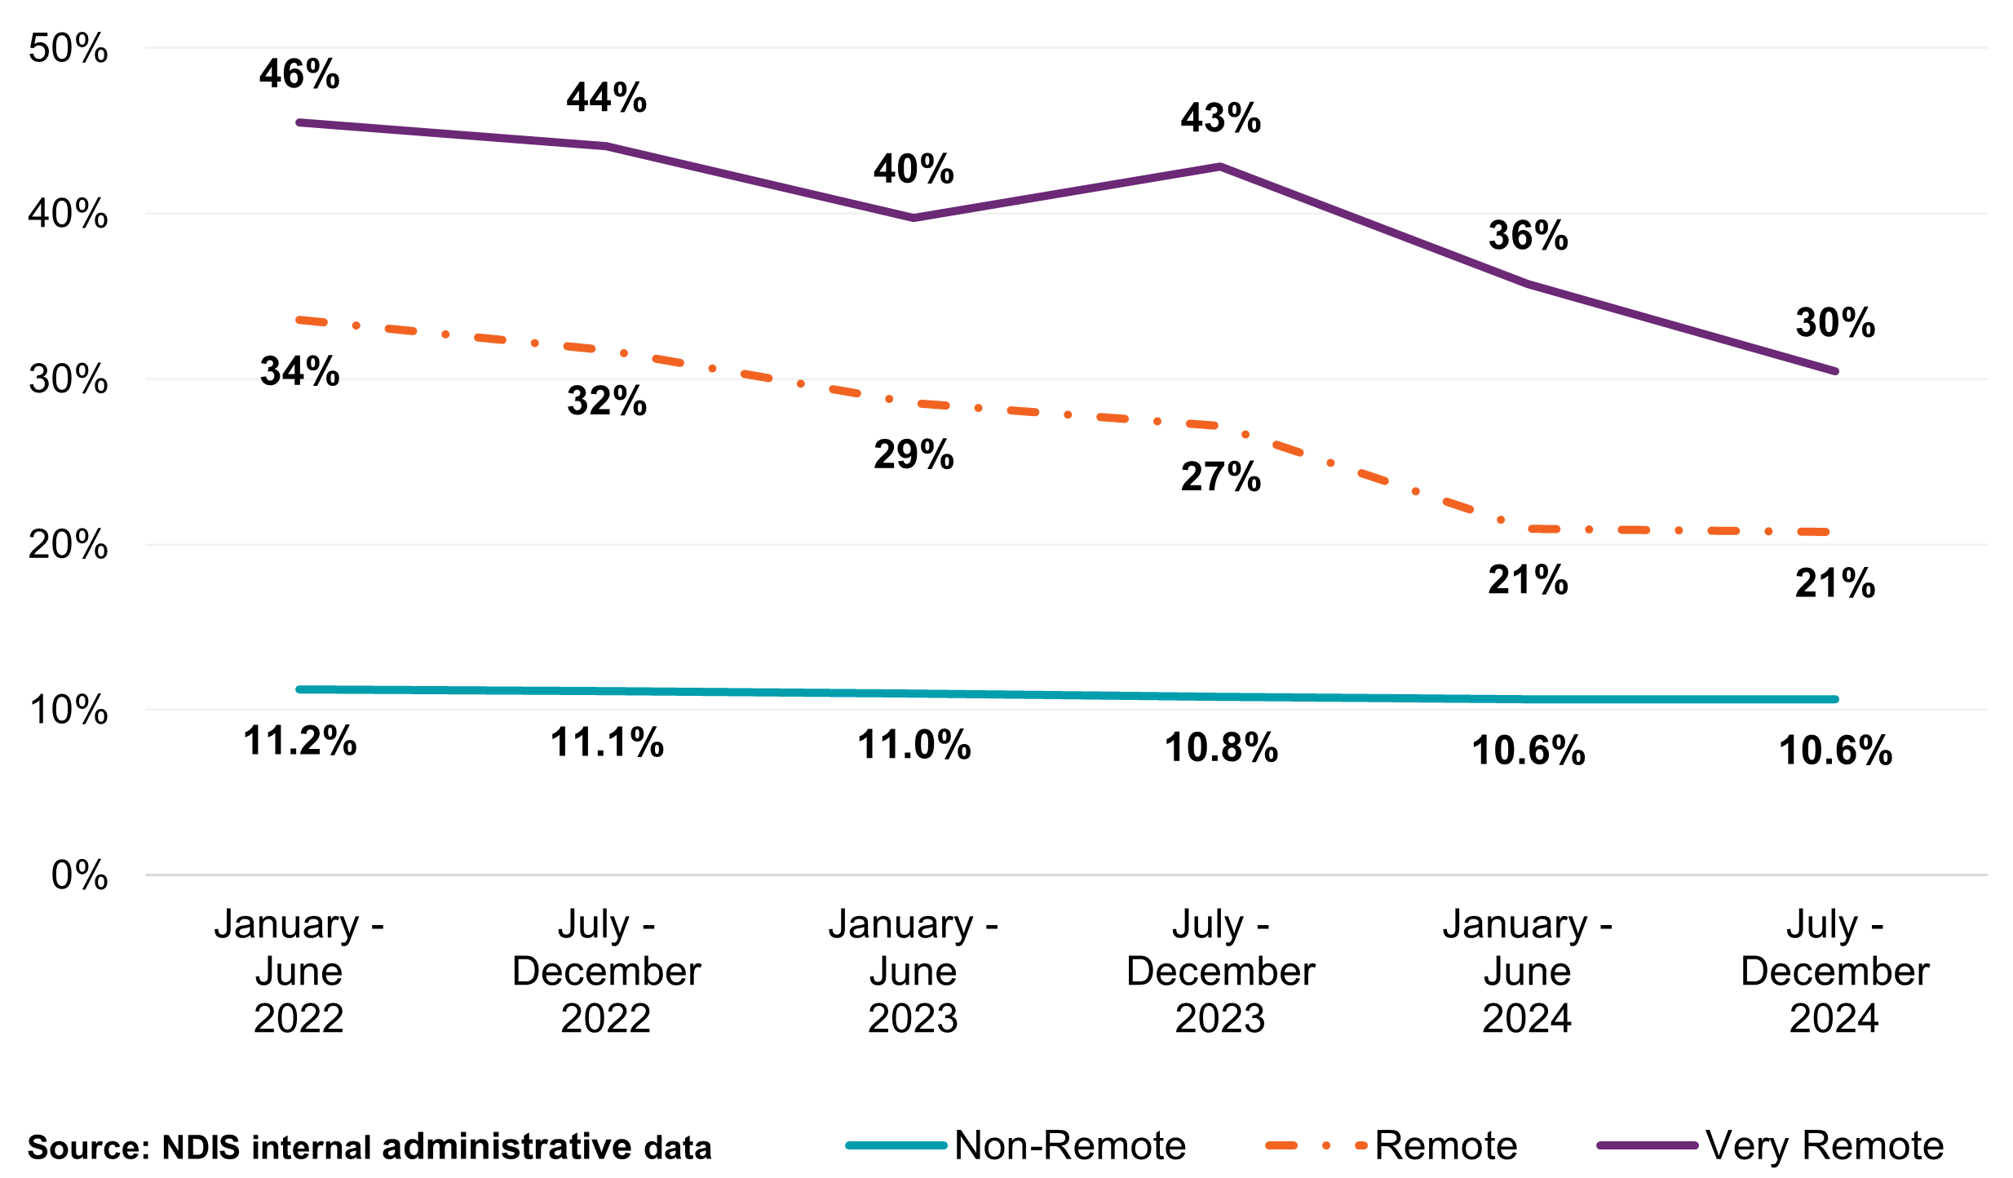

Business Structure - Most supports are provided by Companies
In the six months to December 2024, 17,398 companies delivered therapy supports to 345,492 participants, with an average claim of $97,674 (Table 16). In contrast, 31,503 sole traders supported 146,531 participants, averaging $12,523 in claims. While sole traders make up more than half of all providers of therapy supports, they account for only 16% of total therapy payments.
Since early 2022, the number of companies has grown by 44%, with therapy payments rising from $889.7 million to $1.7 billion. The number of sole traders also grew by nearly 30% with NDIS payments for therapy supports going to sole traders increasing from $232.3 million to $394.5 million (Table 17 and Table 18). This suggests that while the market continues to attract small-scale providers, most service volume and funding remains concentrated with larger, structured business entities.
Table 16: Therapy Supports Scheme Statistics by Legal Entity Type, July to December 2024
Statistics | Company | Government Entity | Partnership (Other) | Trust / Super | Sole Trader
Number of NDIS participants | 345,492 | 4,511 | 12,889 | 99,663 | 146,531
Number of active providers | 17,398 | 134 | 1,200 | 5,084 | 31,503
Total amount claimed by active providers of Therapy supports ($ million) | $1,699.3 | $10.0 | $28.3 | $267.8 | $394.5
Average amount claimed by all active providers of Therapy supports | $97,674 | $74,542 | $23,586 | $52,673 | $12,523
Source: NDIS internal administrative data
Note: Excludes Missing Legal Entity Type.

Table 17: Number of Providers of Therapy Supports by Legal Entity Type, January 2022 to December 2024
Legal Entity Type | January – June  2022 | July – December 2022 | January – June  2023 | July – December 2023 | January – June  2024 | July – December 2024
Company | 12,073 | 13,264 | 14,163 | 15,314 | 16,364 | 17,398
Government Entity | 192 | 194 | 168 | 174 | 163 | 134
Partnership (Other) | 1,193 | 1,280 | 1,273 | 1,244 | 1,219 | 1,200
Trust / Super | 4,430 | 4,684 | 4,888 | 5,009 | 5,053 | 5,084
Sole Trader | 24,252 | 26,289 | 28,168 | 29,919 | 31,243 | 31,503
Total | 42,590 | 46,326 | 49,503 | 52,736 | 54,617 | 55,370
Source: NDIS internal administrative data
Note: Missing Legal Entity Types are not shown in the above table but are included in the total.
Table 18: Payment Amount ($ million) for Therapy Supports by Legal Entity Type, January 2022 to December 2024
Legal Entity Type | January – June  2022 | July – December 2022 | January – June  2023 | July – December 2023 | January – June  2024 | July – December 2024
Company | $889.7 | $1,094.7 | $1,178.0 | $1,396.0 | $1,432.5 | $1,699.3
Government Entity | $7.1 | $7.2 | $7.0 | $8.2 | $7.4 | $10.0
Partnership (Other) | $22.7 | $25.1 | $26.1 | $27.0 | $25.8 | $28.3
Trust / Super | $159.5 | $192.3 | $203.3 | $238.4 | $238.7 | $267.8
Sole Trader | $232.3 | $274.3 | $301.1 | $345.6 | $346.0 | $394.5
Total | $1,311.3 | $1,593.6 | $1,715.4 | $2,015.3 | $2,050.3 | $2,399.9
Source: NDIS internal administrative data
Note: Missing Legal Entity Types are not shown in the above table but are included in the total.

Claiming Analysis
In the six months to December 2024, 65% of therapy claims were made at the NDIS price limit, up from 62% in early 2022 (Table 19). A total of 69% registered providers claimed at the price limits, compared with 59% of unregistered providers six months to December 2024.

While unregistered providers are supporting more participants, they are more likely to claim below the price limits (41% in the six months to December 2024), compared with 31% of registered providers. This variation in claiming behaviour may reflect underlying differences in provider business models, cost structures, or local market conditions. At the same time, there is a consistent increased tendency of claims being made at the NDIS price limit.
Table 19: Claiming Patterns at the NDIS Price Limit Analysis for Therapy Supports, January 2022 to December 2024
Claiming patterns – At price limit | January – June  2022 | July – December 2022 | January – June  2023 | July – December 2023 | January – June  2024 | July – December 2024
Registered | 67% | 68% | 69% | 68% | 68% | 69%
Unregistered | 49% | 53% | 56% | 58% | 59% | 59%
All Providers | 62% | 64% | 65% | 64% | 65% | 65%
Source: NDIS internal administrative data
Note: All Providers above are inclusive of providers with the unknown registration status at the time of the transaction.

Provider Scale and Share of Payments
While the number of providers has grown, most providers continue to operate at a relatively small scale. The therapy market is dominated by small scale providers, with just under half of all therapy providers supporting one or two participants. 65% of all therapy providers support five or fewer participants, and together account for just 5% of therapy payments. In contrast, providers supporting more than 250 participants make up less than 1% of the market but make over 40% of all therapy claims (Table 20).
The distribution highlights how a small number of large-scale providers are delivering a significant share of therapy support, with most other providers operating in either a part-time capacity or have a diverse client base. On average, providers supporting 1-5 participants claimed at less than $10,000 each over six months to December 2024, compared to over $9 million for the largest providers supporting more than 1,000 participants in the same period.
These patterns are consistent with the trends observed across registration status, business structure, and claiming behaviour. Many smaller-scale providers may operate as sole traders or unregistered entities, while larger providers are more likely to be registered with established infrastructure and systems. These differences in scale, cost structure, and administrative capacity may influence how providers respond to price limits.
Table 20: Statistics on the Size of Providers for Therapy Supports, July to December 2024
Size of Provider (number of participants supported) | Number of Providers | Total Payment to Providers (million) | Average Payments to Providers | Share of Total Payment
1 | 20,206 | $32.4 | $1,600 | 1%
2 | 7,169 | $24.9 | $3,500 | 1%
3 | 3,967 | $21.8 | $5,500 | 1%
4 | 2,683 | $20.2 | $7,500 | 1%
5 | 2,163 | $21.5 | $10,000 | 1%
6-10 | 6,140 | $94.3 | $15,400 | 4%
11-50 | 9,929 | $488.5 | $49,200 | 20%
51-100 | 1,624 | $280.7 | $172,800 | 12%
101-250 | 1,048 | $448.8 | $428,300 | 19%
251-1000 | 387 | $482.8 | $1.2m | 20%
1000+ | 54 | $501.4 | $9.3m | 21%
Overall | 55,370 | $2,417.2 | $43,700 | 100%
Source: NDIS internal administrative data
Note: Average payment to providers is rounded up to the nearest hundred.

Business Dynamism
This section examines the activity and changes within the market for therapy supports. Business dynamism refers to the rate at which new providers enter the market and existing providers exit. This is one of many indicators which looks at the market’s health, competitiveness, and its capacity to innovate and meet participants’ needs. To understand the dynamism for therapy supports, the NDIA reviewed the payment activities of providers over a three-year period from January 2022 to December 2024.

Payment Consistency
As shown in Figure 13, there is a clear distinction between registered and unregistered providers and payment consistencies (how often providers claim and receive payments). Among registered providers, the majority of total payments are concentrated among those that have delivered supports across all six half-year periods at 46% of all registered providers but accounts for over 80% of registered payments. This suggests that registered providers represent a relatively stable base.
Unregistered providers show relatively higher levels of short-term activity with the largest group of unregistered providers active for only one half-year period while accounting for the smallest share of the overall payments. However, there is a relatively stable base of unregistered providers (around 18%) delivering therapy over the six half year periods and claiming over 60% of payments to unregistered providers.
Figure 13: Provider Continuity for Therapy Supports by Registration Status and Percentage of Total Payments, January 2022 to December 2024
Registered Providers Unregistered Providers
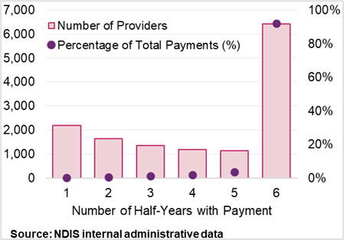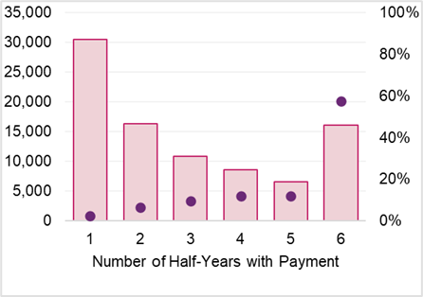

Comparison of provider payments for ‘new activity’ and ‘inactivity’
Figure 14 shows that new provider activity consistently exceeded inactivity since January 2022, indicating new activity within the therapy provider market. Newly
active registered providers accounted for between 0.6% and 1.2% of payments in each half year period. This has generally been at least doubled that of inactive registered providers, who represented just 0.3% or 0.4% of payments over the half-year periods.
Figure 14: Registered Therapy Provider Activity Movements, January 2022 to December 2024
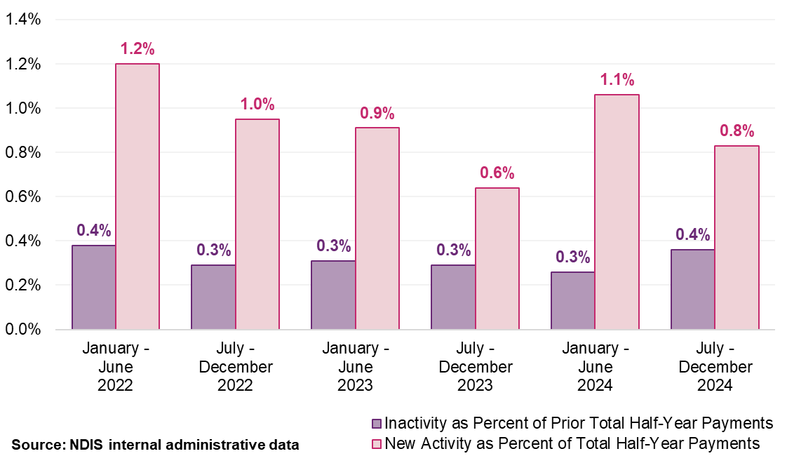
Note: ‘New activity’ is characterised by providers receiving payments in the half-year who did not receive payments in the preceding half-year. Conversely, ‘inactivity’ refers to providers not receiving payments in a half-year after having received payments in the previous one. Each provider’s activity is quantified as a percentage of the total payments within that half-year for new activity, of the prior half-year for inactivity.

Benchmarking Approach and Data Sources

Benchmarking Approach and Improved Data Sources
Benchmarking is an important input to inform the NDIA’s therapy pricing recommendations. It helps ensure that the NDIS therapy price limits remain fair and comparable to other services in the therapy markets. By comparing the NDIS price limits to prices charged in other systems, the NDIA assesses whether price limits continue to remain competitive, support quality, and provide value for money.
This year, the NDIA expanded the volume and quality of data on therapy rates to inform decision-making. This built upon previous data sources in website listings and comparable government funding schemes, which remain in this year’s analysis. The new Medicare Benefits Schedule (MBS) billing and Private Health Insurance (P H I) data allow for greater insight into the actual transactions that occur within the broader marketplace and thus significantly improve the accuracy and coverage of analyses than were previously done. The NDIA is committed to continuous improvement of pricing methodology, as well as better data sources to inform greater market monitoring and transparent pricing. This also in turn informs NDIS pricing impacts on the broader care sector.
The benchmarking analysis uses the 75th percentile of observed pricing as a reference point for comparing NDIS price limits to broader market rates. It does not represent a pricing target. Rather, the NDIA uses this benchmark to understand where NDIS price limits sit in the market and to inform where changes are supported by sufficient and reliable evidence. Any adjustments are being made incrementally and with the impacts on markets to be monitored.
It is important to note that benchmarking analysis provides a market comparison, however, it is not intended to be a costing exercise. This analysis reflects the final price providers charge – not the costs of service delivery. In setting prices, the NDIA also considers how pricing influences provider behaviour, shapes market structure, supports market development, and ensures that services remain available and responsive to participant needs.
In this review, benchmarking forms the evidence base for decisions about whether prices should be maintained, revised, or restructured for the 2025-26 financial year. To ensure robust market comparisons, this review draws on four complementary sources:
- Medicare Benefits Schedule (MBS) Full Fee Data: The NDIA accessed de-identified, aggregated data showing the full fee charged to patients, inclusive of both the government rebate and the patient’s co-payment. This provides an accurate reflection of the market rate set by providers. The data was provided in aggregated form across therapy types, presented in quartiles (25th, median, 75th percentile), which supports benchmarking against typical and upper-end provider charges.
- Private Health Insurance (P H I) Claims Data: Based on de-identified transaction data from a major insurer, this source reflects typical provider charges across different therapies in the private sector. Data is similarly presented in aggregated quartiles.
- Website listings: Previously developed in the Annual Pricing Review (named as private billing rates), a sample of published fees on provider websites, is used to supplement other sources. These are not transaction-based and may reflect NDIS price limit anchoring or high-visibility pricing strategies.

- Comparable Government Schemes: Pricing data from 13 Commonwealth and State schemes, including Transport Accident Commission (T A C), State Insurance Regulatory Authority New South Wales (S I R A), and Department of Veteran’s Affairs (DVA). These benchmarks reflect price limits in other regulated non-NDIS environments.
Together, these sources provide a broader comparison of how therapy services are priced across a range of funding contexts.

Estimating Hourly Rates from Session Based Pricing
Approaches to therapy pricing differ across systems in the care sector. While the NDIS uses hourly price limits that account for both direct and indirect time, other systems typically pay for shorter, direct-care sessions. To enable meaningful comparison, the NDIA uses statistical methods to estimate the implied hourly rates.
Given that both MBS and P H I data lack actual session length data, a regression analysis of 1,738 published website listings (combining 2024 and 2025 collections for 8 therapy types) is undertaken to estimate the implied session length. The model examined the relationship between listed price and session length, was then cross validated using MBS and P H I item descriptors (detailed descriptions of the specific services or procedures covered by the appropriate item code). The NDIA also consulted with allied health peak bodies and providers to gain specific insights. This information allows the NDIA to estimate durations at key percentiles (25th, median, 75th) for each therapy and across different data sources (Table 21).
The estimated durations were then paired with MBS and P H I quartiles to derive hourly equivalents. For example, if the median MBS price for dietetics is $58 with an estimated session duration of 30 minutes, this equates to an hourly rate of $116. If the 75th percentile is $88 with a 38-minute session, the estimated hourly rate becomes $141.
This process allows NDIS price limits, which are uniquely set at hourly, to be meaningfully compared to other session-based pricing approaches. With the additional information and data received by the NDIA this year, the benchmarking analysis provides a better reflection of real transactions that occur in the therapy market, outside of the NDIS. These new sources of information provide greater confidence in the APR and its pricing consideration.

The NDIA acknowledges that the therapy market is maturer than most other disability support markets, with much higher degree of competition for therapy services from consumers outside of the NDIS. As such, the NDIA considers it is appropriate that the 75th percentile in terms of session length is used as the key benchmark for comparisons to MBS and P H I datasets as it reflects the upper range of observed market pricing, without being distorted by outliers. This continues to balance participant choice, allowing a diverse provider market, and value-for-money.
Table 21: Reference session times at selected price quartiles, by P H I and MBS
Therapy | Source | Average Session Length (Minutes) at First Price Quartile | Average Session Length (Minutes) at Median Price | Average Session Length (Minutes) at Third Price Quartile
Physiotherapy | PHI | 43 | 45 | 47
 | MBS | 30 | 30 | 34
Dietetics | PHI | 44 | 50 | 57
 | MBS | 30 | 30 | 38
Podiatry | PHI | 28 | 30 | 33
 | MBS | 30 | 30 | 34
Psychology | PHI | 60 | 60 | 60
 | MBS | 60 | 60 | 60
Exercise Physiology | PHI | n/a | n/a | n/a
 | MBS | 30 | 30 | 38
Occupational Therapy | PHI | 43 | 45 | 49
 | MBS | 33 | 40 | 53
Audiology | PHI | 45 | 45 | 45
 | MBS | 30 | 30 | 45
Speech Pathology | PHI | 41 | 45 | 51
 | MBS | 42 | 50 | 58
In general, it is found that higher prices tend to correspond with longer sessions, although differences in average times are modest for most therapy types. These assumptions introduce a source of sensitivity into the benchmarking results. While efforts have been made to standardise appropriate comparisons, some data considerations remain. These include assumptions about session duration, variation of in scope services, and the nature of listings against actual transactions.
This methodology represents the first step in providing reasonable consideration to best inform meaningful benchmarking comparison. The NDIA considers that this approach is best practice at the time of drafting and is committed to further refine the therapy pricing methodology going forward.

Benchmarking Data Coverage
Table 22 summarises the number of observations available for each therapy support type across data sources. Coverage varies by therapy support type and data sources, which should be considered when interpreting comparative findings.
Table 22: Number of observations from each source of comparative therapy dataset
Therapy | MBS* (transactions) | PHI (transactions) | Other Government schemes***
Psychology | 1,956,161 | 15,427 | 11
Speech Pathology | 86,550 | 4,351 | 8
Occupational Therapy | 80,008 | 6,476 | 9
Audiology | 4,490 | 190** | 0
Dietetics | 354,508 | 10,525 | 3
Podiatry | 3,609,036 | 121,170 | 3
Physiotherapy | 3,148,452 | 830,021 | 10
Social Worker | n/a | n/a | 6
Counselling | n/a | n/a | 6
Exercise Physiology | 337,012 | n/a | 10
Total | 9,576,217 | 988,160 | n/a***
Note: MBS = Medicare Benefit Scheme, P H I = Private Health Insurance.
* MBS item codes used in analysis: Psychology 80010, Speech Pathology 10970, Occupational Therapy 10958, Audiology 10952, Dietetics 10954, Podiatry 10962, Physiotherapy 10960, Exercise Physiology 10953
** All 190 observations are at a single price point
*** Other Government Schemes observations included are for prices that were able to be formed into comparable pricing to the NDIS price limits. MBS was not included due to more targeted analysis.
The MBS data offer the best coverage in terms of pricing of the general population. However, therapy types with sparse data or single-price observations (e.g., audiology in MBS) are still subject to greater data sensitivity due to the small sample size. The NDIA prioritised transparent assumptions and used triangulation across sources to mitigate data gaps where possible.
The benchmarking results in this chapter are informed by this multi-source comparison and provide the evidence base for the Annual Pricing Review’s recommendations for therapy support price limits.

Benchmarking Results and Implications for Price Limits

Overview
This section presents the detailed benchmarking results that underpin the 2024-25 therapy pricing recommendations. Figure 15 below displays the overall results graphically.
In short, MBS and P H I datasets were considered individually to estimate durations at key percentiles (25th, median, 75th) for each therapy type. The estimated durations were then paired with corresponding MBS and P H I quartiles to derive hourly equivalents. MBS and P H I have these results presented individually in Figure 15. The coloured sections represent the 25th, 50th (median) and 75th percentiles. The NDIS price limit for the relevant therapy is the corresponding purple line to allow for easier visual comparison.
See Appendix B for the corresponding Table 37 to Figure 15, detailing session fee, estimated session minutes and calculated hourly rate for each relevant therapy and dataset.
Figure 15 shows that NDIS pricing remains broadly comparable or above the broader therapy market. In some instances, the NDIS pricing appears significantly above the prevailing market rates such as for Physiotherapy. The following sections further explore individual therapy types.

Figure 15: MBS and P H I Converted Hourly Rates for Therapy Types Compared to the Applicable NDIS Price Limits
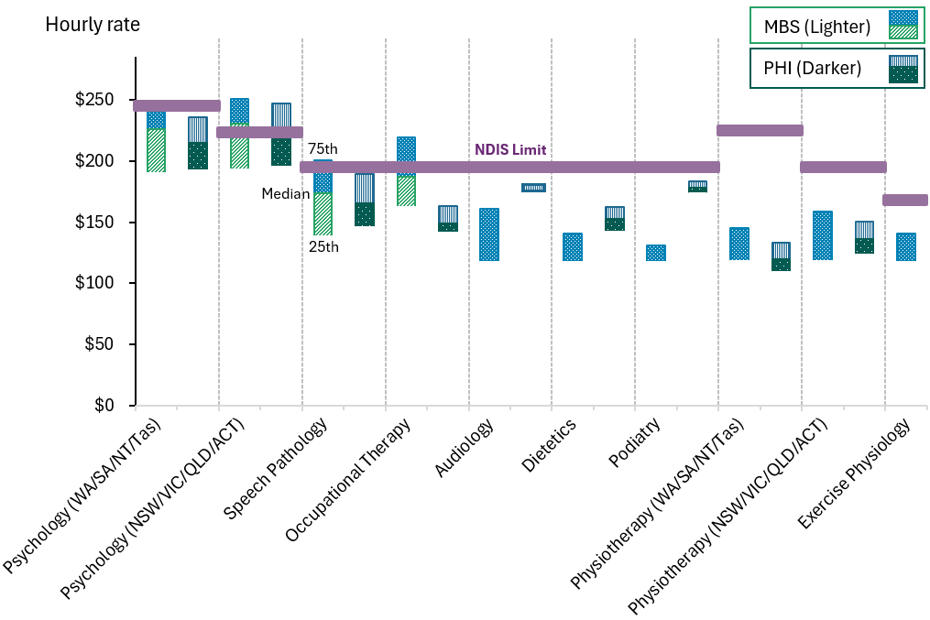
Source: NDIA calculations from MBS and PHI datasets.
Note: Portions (darker parts) of the distribution missing from the Figure is due to some therapies having the 25th percentile equal to the median.

Interpreting Benchmarking Results
While benchmarking shows that NDIS price limits for many therapy types exceed rates seen in other funding systems, this does not, on its own, indicate that current price limits are inappropriate.
Several factors may explain price differences:
- Structural differences in what is funded: NDIS price limits include indirect activities such as note writing, travel, and coordination, whereas MBS and
P H I payments typically fund only direct client contact. The NDIA further funds other auxiliary loading such as report writing and a loading for remote and very remote areas, which is not observed for MBS and P H I payments.
- Participant complexity: NDIS participants may require longer or more specialised therapy sessions than those seen in general healthcare.
- Regulatory and administrative requirements: Compliance requirements under the NDIS are different relative to other settings.
Each therapy type is discussed individually where price adjustment is proposed, drawing on observed MBS and P H I quartiles, converted session durations, and hourly rate comparisons. A summary grouping of all other therapies is also provided.

Psychology
The current NDIS price limits for psychology supports are $222.99 per hour in New South Wales (NSW), Victoria (VIC), Queensland (QLD) and Australian Capital Territory (A C T), and $244.22 per hour in Western Australia (W A) South Australia
(S A), Tasmania (TAS), and Northern Territory (NT).
Benchmarking analysis shows that market prices for psychology services exceed the current NDIS price limits in both jurisdictional groupings:
- The MBS 75th percentile hourly rate is $240.00 in W A/S A/NT/TAS and $251.00 in NSW/VIC/QLD/A C T. The applicable NDIS Psychologist price limit is 1.8% above for W A/SA/NT/TAS but 11.2% below the implied hourly rate for NSW/VIC/QLD/A C T.
- This is supported by P H I, with the 75th percentile hourly rate for general psychology is $236.00 in W A/S A/NT/TAS and $247.00 in NSW/VIC/QLD/ A C T. The applicable NDIS Psychologist price limit is 3.5% above for W A/
SA/NT/TAS but 9.7% below the implied hourly rate for NSW/VIC/QLD/A C T.

- These hourly rates are based on estimated session duration of 60 minutes at the 75th percentile, which was consistent across both the MBS and P H I data sets for psychology.
- The sample sizes include over 1.9 million MBS claims and 15,427 P H I transactions.
Figure 16: MBS and P H I Converted Hourly Rates for Psychology Compared to the Applicable NDIS Price Limits
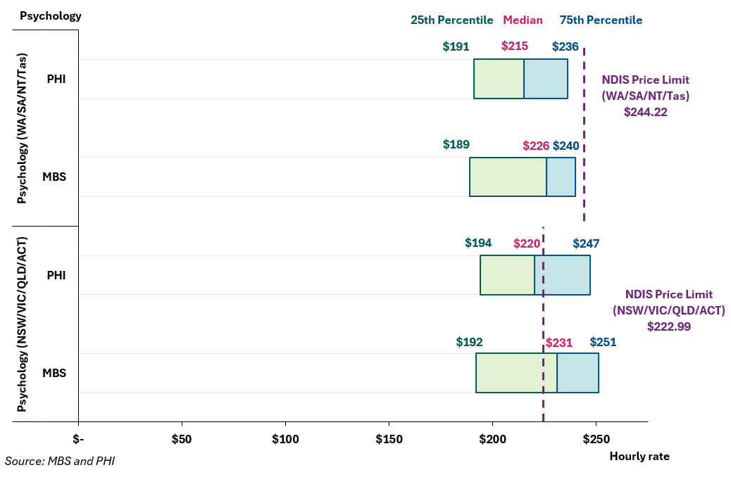

Interpretation and implications – Psychology
Benchmarking shows that NDIS price limits for psychology are generally below MBS and P H I rates, particularly in metropolitan areas. Even in jurisdictions with higher NDIS price limits (W A, S A, NT, TAS), private rates through MBS and P H I remain comparable or higher. These findings support an increase to the price limit for psychology to better align with prevailing market rates and maintain supply.

Physiotherapy
The current NDIS price limits for physiotherapy are $193.99 per hour in NSW, VIC, QLD, and A C T, and $224.62 per hour in W A, S A, NT, and TAS.
Benchmarking data shows that these rates are significantly above both public and private rates for physiotherapy services:
- The MBS 75th percentile hourly rate is $145.30 in W A/S A/NT/TAS and $158.70 in NSW/VIC/QLD/A C T. The applicable NDIS Physiotherapist price limit is 54.6% above the implied hourly rate for W A/S A/NT/TAS and 22.2% for NSW/VIC/QLD/A C T.
- This is supported by P H I with the 75th percentile hourly rate for general psychology is $133.40 in W A/S A/NT/TAS and $150.50 in NSW/VIC/QLD/
A CT. The applicable NDIS Physiotherapist price limit is 68.4% above the implied hourly rate for WA/SA/NT/TAS and 28.9% for NSW/VIC/QLD/A C T.
- The 75th percentile session durations were estimated at 34 minutes (MBS) and 47 minutes (P H I).
- The sample sizes include over 3.1 million MBS claims and 830,021 P H I transactions.
Figure 17: MBS and P H I Converted Hourly Rates for Physiotherapy Compared to the Applicable NDIS Price Limits
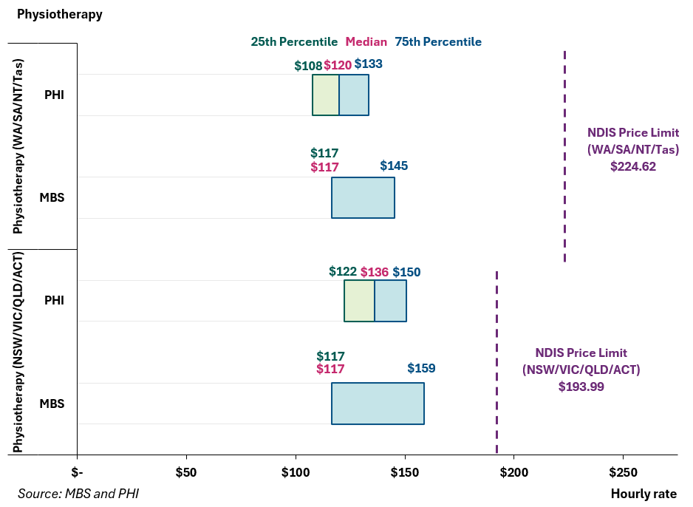

Interpretation and implications – Physiotherapy
NDIS price limits for physiotherapy are above the 75th percentile of both MBS and P H I market rates, even after accounting for session length differences. This suggests current NDIS price limits significantly exceed what providers typically charge in the broader market for non-NDIS clients. The findings support a reduction to the physiotherapy price limit to better align with prevailing market conditions.

Dietetics
The current NDIS price limit for dietetics is $193.99 per hour.
Benchmarking findings indicate that this price is above the P H I and MBS pricing at the upper end of the market distribution:
- The MBS 75th percentile hourly rate is $141.10.
- The P H I 75th percentile hourly rate is $162.30.
- The 75th percentile session durations were estimated at 38 minutes (MBS) and 57 minutes (P H I).
- The sample sizes include 354,508 MBS claims and 10,525 P H I transactions.
The NDIS price limit exceeds MBS benchmarking by 37.5% and P H I by 19.5%, with both public and private data showing consistent session lengths and billing patterns.
Figure 18: MBS and P H I Converted Hourly Rates for Dietetics Compared to the Applicable NDIS Price Limits
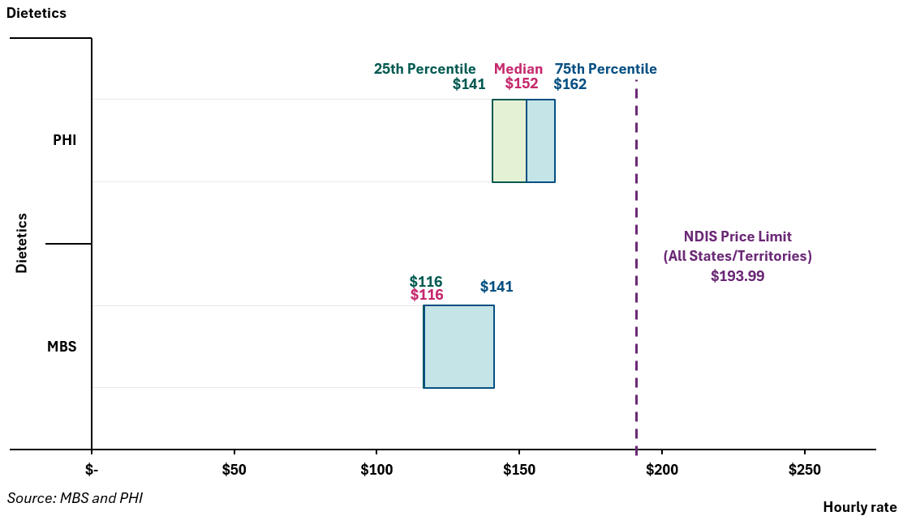

Interpretation and implications – Dietetics
Benchmarking indicates that NDIS price limits for dietetics are significantly above MBS and P H I rates across all jurisdictions, even after adjusting for shorter session durations. In this context, the current NDIS price limit appears higher than necessary to support sustainable service delivery. These findings support a reduction in the price limit to better reflect market conditions.

Podiatry
The current NDIS price limit for podiatry is $193.99 per hour.
Comparative benchmarking shows the following:
- The MBS 75th percentile hourly rate is $131.10.
- The P H I 75th percentile hourly rate is $183.40.
- The 75th percentile session durations were estimated at 34 minutes MBS) and 33 minutes (P H I).
- Sample size includes 3.6 million MBS claims and 121,170 P H I transactions.
The NDIS price limit exceeds MBS benchmarking by 48.0% and P H I by 5.8%, with both public and private data showing consistent session lengths and billing patterns.
Figure 19: MBS and P H I Converted Hourly Rates for Podiatry Compared to the Applicable NDIS Price Limits
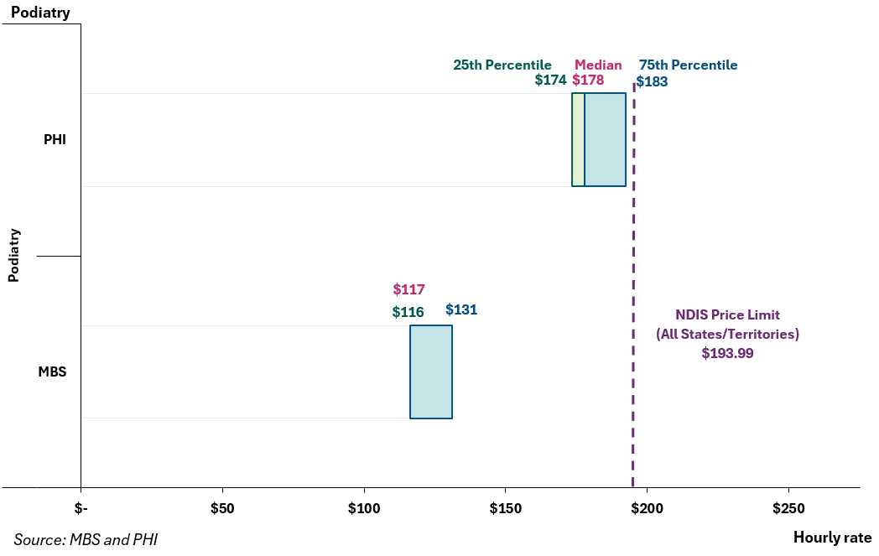

Interpretation and implications – Podiatry
NDIS price limits for podiatry exceed the 75th percentile of P H I and MBS market rate across all jurisdictions, even after accounting for typical session durations. This suggests that current pricing is higher than what is charged in the broader market for non-NDIS clients. These findings support a reduction to the podiatry NDIS price limit to ensure better alignment with observed market rates.

Other therapies
A range of other therapy supports were included in the benchmarking process. Benchmarking results suggest that the NDIS price limits continue to remain appropriate and do not support any price change for financial year 2025–26. In these cases, the comparison of NDIS price limits against external market data showed either broad alignment, marginal differences or insufficient data for consistent conclusions, with no clear indication that current pricing was outside a reasonable market range.
Figure 20: MBS and P H I Converted Hourly Rates for Exercise Physiology, Audiology, Occupational Therapy and Speech Pathology Compared to the Applicable NDIS Price Limits
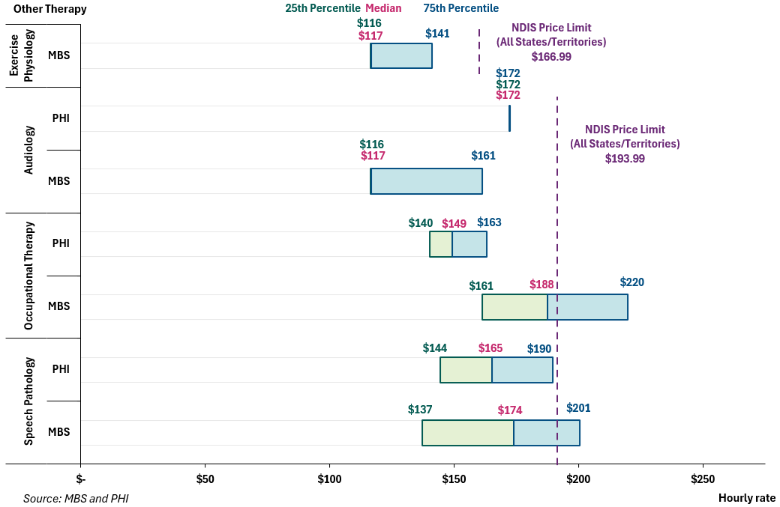

Speech Pathology was found to be closely aligned with benchmark rates at the 75th percentile. The NDIS price limit of $193.99 per hour sits 2.3% above the P H I 75th percentile ($189.70 per hour) and 3.2% below the MBS 75th percentile ($200.50 per hour). Session lengths in both sources were broadly consistent at the 75th percentile, MBS at 58 minutes and P H I at 51 minutes. The sample size was robust, with over 86,000 MBS claims and 4,351 P H I records. These findings suggest that the current NDIS price is within the normal observed market band.
Occupational Therapy presented mixed benchmarking results. The NDIS price limit of $193.99 per hour was 18.9% above the P H I 75th percentile ($163.10 per hour), but 11.7% below the MBS 75th percentile ($219.60 per hour). Session lengths in both sources were broadly consistent at the 75th percentile, MBS at 53 minutes and P H I at 49 minutes. Given the contrasting results and reliable sample size (over 80,000 MBS claims and 6,476 P H I records), the current price limit was assessed as being set within a reasonable range, particularly when accounting for variations in complexity.
Audiology showed moderate divergence between benchmark sources. The NDIS price limit of $193.99 per hour exceeded the MBS 75th percentile ($161.20 per hour) by 20.3% and the P H I benchmark ($172.50 per hour) by 12.5%. Notably, both MBS and P H I transacted prices showed little variation across quartiles, and considering the limited numbers of observations (4,490 for MBS and 190 for PHI), this limits the ability to draw strong conclusions. Given the mixed evidence and small MBS sample size, no change is suggested.
Exercise Physiology could only be benchmarked against MBS data, as P H I data was unavailable. The NDIS price limit of $166.99 per hour exceeded the MBS 75th percentile ($140.80 per hour) by 18.6%, based on a 75th percentile session of 38 minutes across a sample of 337,012 MBS transactions. While this indicates moderate divergence, the lack of P H I benchmark reduces the scope to draw a strong conclusion here. Given the smaller coverage for exercise physiology, it is recommended to maintain the current price limit for now.
Several additional therapy types — including Social Work, Developmental Education, and Early Childhood Educator roles — were not benchmarked due to insufficient data. Where pricing remains unchanged, this reflects a lack of reliable comparative information rather than a determination that price limits are optimal. These types of therapy supports will be considered for further analysis in future pricing cycles, with ongoing efforts to continue improving data coverage.

Interpretation and implications – Other Therapies
The benchmarking analysis highlights clear price differentiations across therapy types in the private market. Both MBS and P H I data shows that hourly rates vary depending on the type of therapy being delivered. In contrast, the NDIS applies limited differentiation with most therapy types priced at the same hourly rate of $193.99. While this approach simplifies administration and reduces complexity, it may not fully reflect the diversity of therapy practices or the way these services are valued in the broader health system. Over time, the NDIA should consider whether a more differentiated pricing approach, aligned to therapy type, would better support provider viability and reflect market conditions while delivering outcomes for participants.
In addition, data limitations affected the ability to benchmark several therapies, particularly where P H I and MBS data was limited or not available. As a result, pricing decision for some therapy types could not be supported with the same level of evidence as for more common disciplines. The NDIA is committed to further work to refine the benchmarking methodology, improve data coverage across therapy types, and strengthen the evidence base for future pricing reviews.

Geographic Patterns in Market Rates
The 2019 Review of Therapy Pricing Arrangements recommended differentiated pricing for psychology and physiotherapy in Western Australia (W A), South Australia (S A), Northern Territory (NT), and Tasmania (TAS), based on observed variation in billing patterns between jurisdictions. At the time, there was some evidence that billing rates in these states were higher, and markets were less competitive. In response, the NDIA introduced higher price limits in these jurisdictions to ensure service availability given limitations in the available data at that time. More information on the Review can be found on the NDIS website.
These arrangements were intended to be provisional. The NDIA now has access to more comprehensive, high-quality data sources, including MBS and P H I claims, that provide a clearer picture of therapy pricing across Australia.

The latest analysis on available transactional datasets do not support current state and territory differentiated NDIS therapy price limits. As shown in Figure 21, average prices for MBS services are consistent across state groupings. To summarise:
- For psychology, the weighted average price per service is $220 per hour in NSW/VIC/QLD/A C T and $218 per hour in W A/S A/NT/TAS
- For physiotherapy, the equivalent hourly averages are $76 and $71 respectively.
- Other therapies, including speech pathology, occupational therapy, and exercise physiology, show similar patterns, with little to no geographic uplift evident in either MBS or P H I data.
In light of the available evidence, analysis suggest that any structural differences between jurisdictions have narrowed or are no longer relevant. In this context, continuing to apply higher price limits in selected jurisdictions would create inconsistency in evidence-based decision-making.
Figure 21: Average Price for Medicare Subsided Services by State and Territory
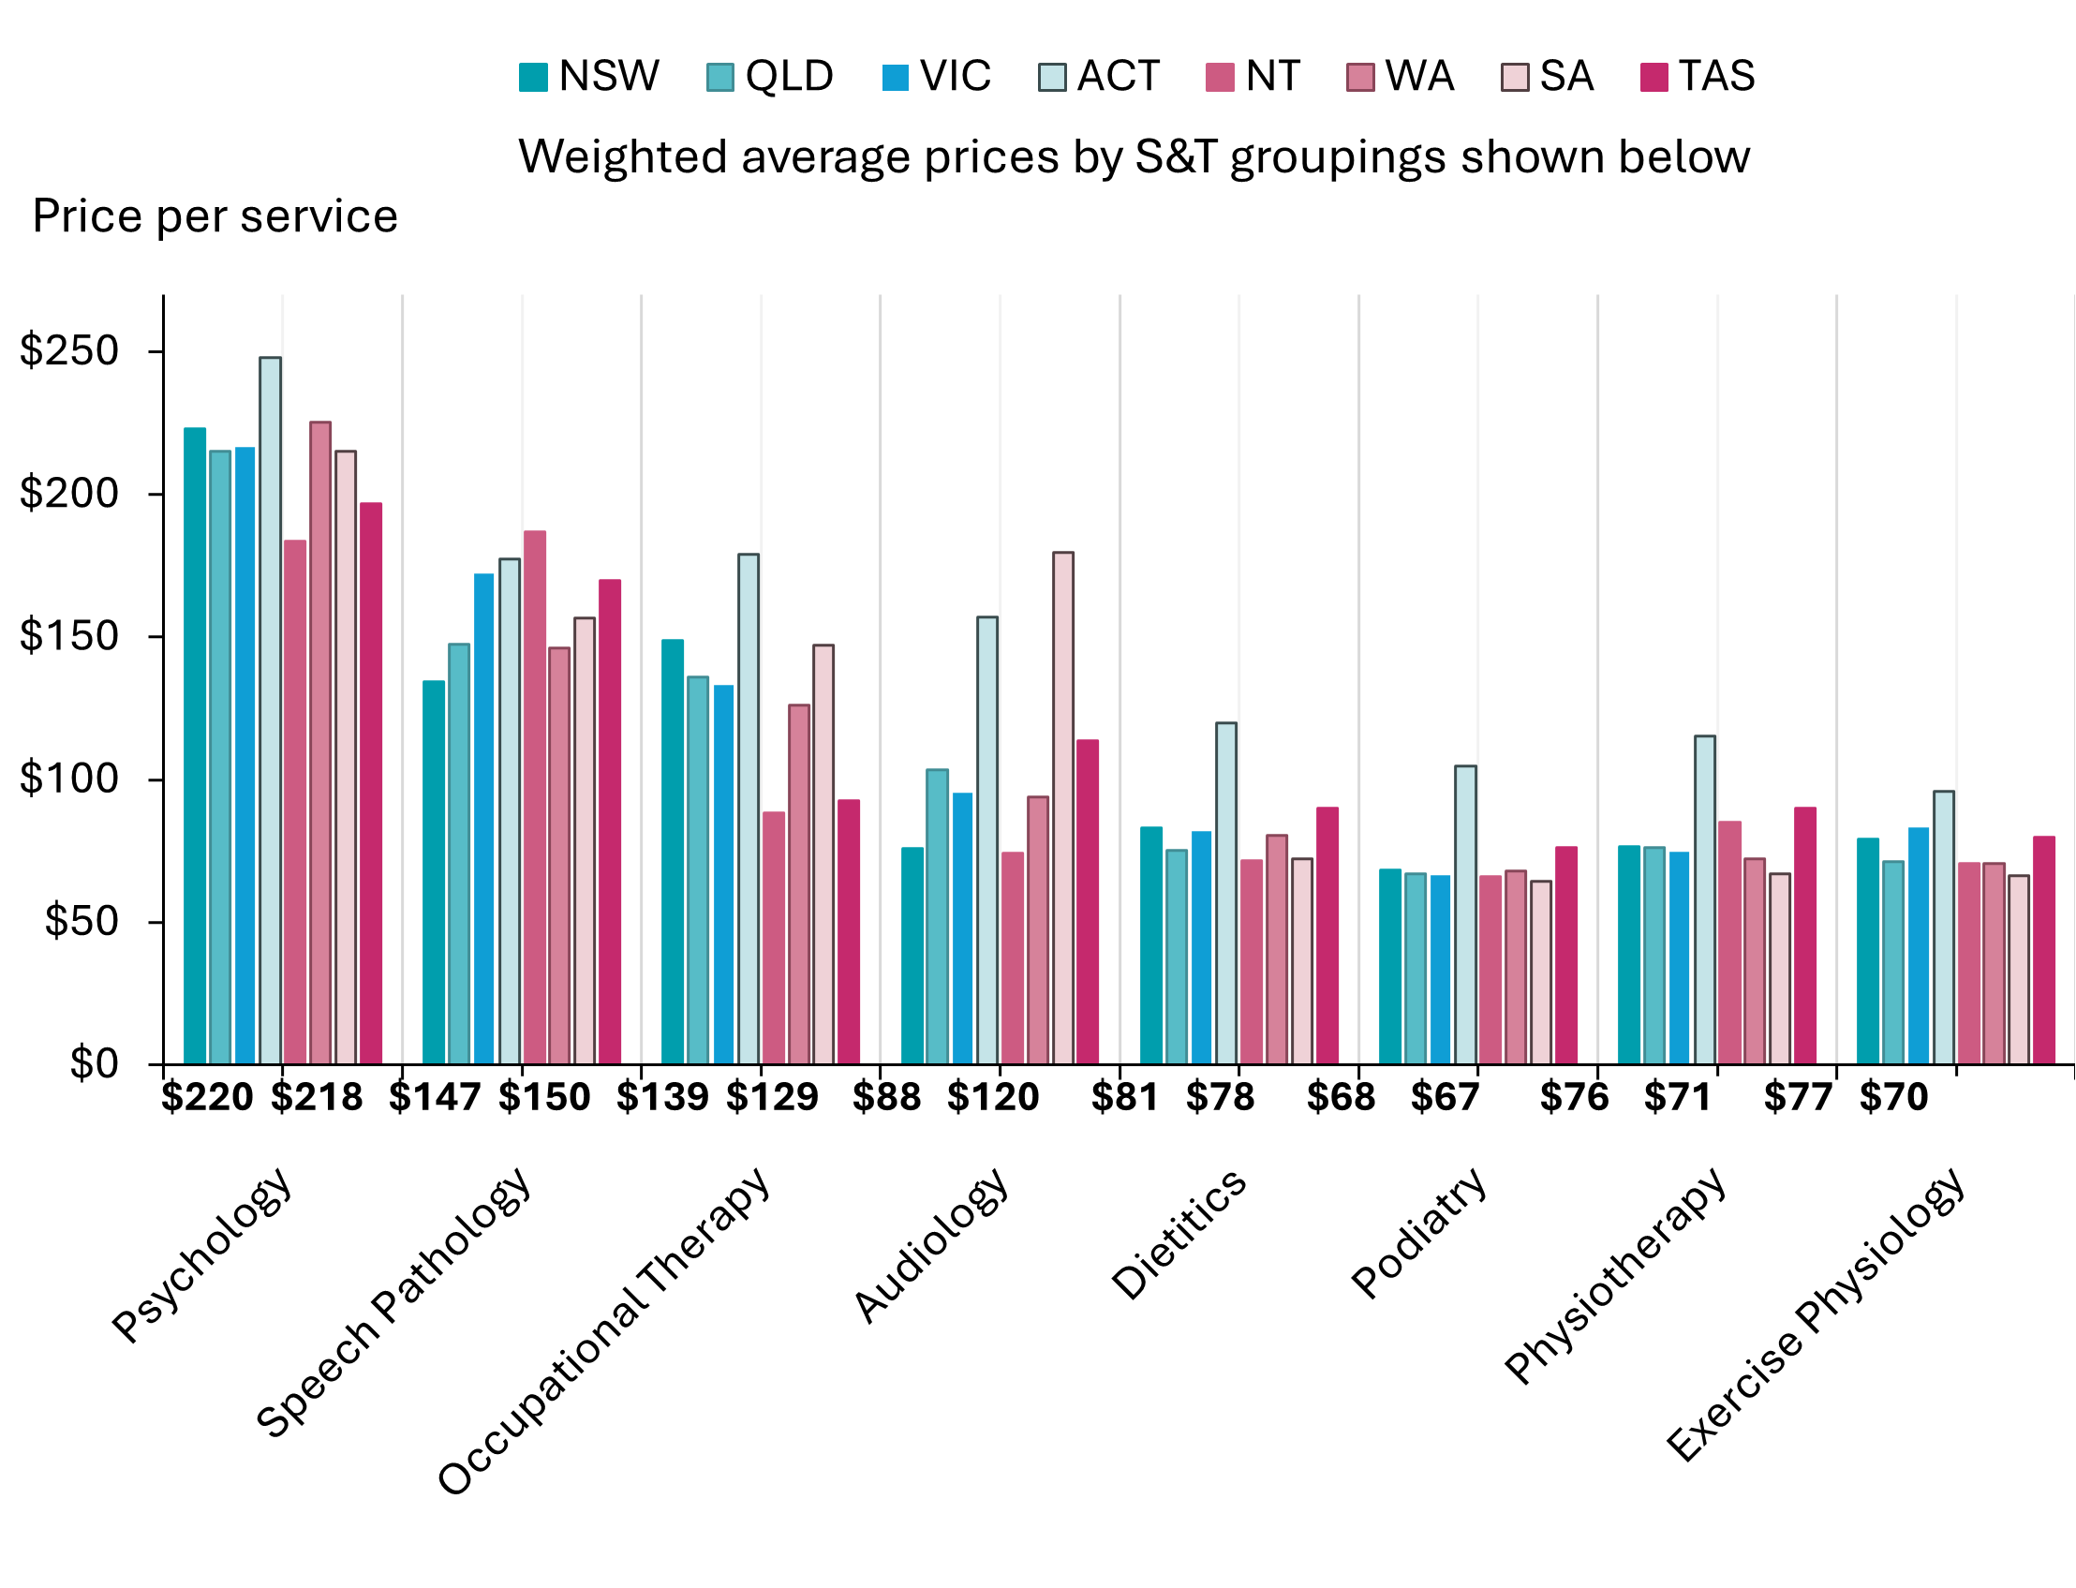
Source: NDIA calculations of MBS dataset.
Note: This figure represents the average price charged per session from MBS data. It is different from the hourly rates as it has not been adjusted for time.

Interpretation and implications – Geographic Patterns in Market Rates
The benchmarking analysis indicates that, while private market rates vary modestly across jurisdictions, the differences are not consistent or substantial enough to justify ongoing price limit differentials between states and territories. In most cases, MBS and P H I data show that pricing variation across jurisdictions is smaller than current differences embedded in NDIS price limits.
In general, given the loading provision under the NDIS, price limits are already 40% higher in remote areas and 50% higher in very remote areas. These findings support the removal of current state-based price limit differences given the lack of variation in pricing across regions. Where localised market challenges exist – such as thin markets or limited workforce availability – targeted non-price mechanisms may be more appropriate than broad-based state and territory price premium.

Other Government Schemes
This section presents benchmarking data from selected Commonwealth and state-funded schemes, including:
- Catastrophic Injuries Support (C I S) Scheme
- ComCare
- Department of Veterans’ Affairs (DVA)
- Home and Community Care Program for Younger People (HACC-PYP)
- Lifetime Support Authority (LSA)
- Motor Accidents Insurance Board (MAIB)
- Medicare Benefit Scheme (MBS)
- National Injury Insurance Scheme Queensland (NIISQ)
- Return To Work South Australia (RTWSA)
- State Insurance Regulatory Authority (S I R A)
- Transport Accident Commission Victoria (T A C)
- WorkCover Western Australia
- WorkSafe Victoria
These schemes fund allied health services for specific populations (e.g., injured workers, veterans, motor accident claimants). Unlike MBS or P H I, many of these schemes typically set explicit time-based rates, and some pricing structures include allowances for both direct and indirect service delivery.
Figure 22 presents NDIS price limits compared to other government funding schemes’ pricing for therapy supports. This has been calculated at a comparable hourly rate and presented in a similar approach to previous APRs for consistency.
Figure 22: Comparison of NDIS Price Limits to other Government Schemes
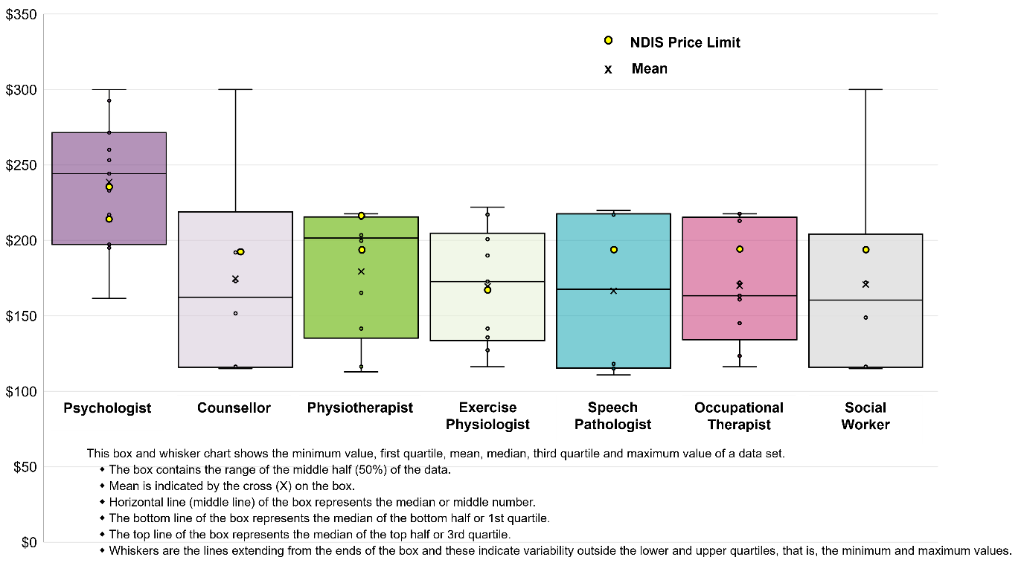
Source: NDIA calculations using prices received from other government funding schemes
Note: The two data points indicating NDIS price limits for Psychologists and Physiotherapists reflect the different price limits for these supports across different states and territories.

Key Observations
The NDIS price limits for therapy supports are generally comparable across government schemes highlighting broad alignment across the schemes. Besides for one NDIS physiotherapy price limit, NDIS therapist price limits are generally between the 50th and 75th percentiles in the calculated bands from the available therapy data received from other schemes.
Physiotherapy and Occupational Therapy are priced consistently lower under these schemes, with most falling between $140 to $190 per hour, compared to $193.99-$224.62 per hour (state and territory special price limit) under the NDIS.
Psychology pricing is somewhat more variable across schemes but is still typically comparable to the NDIS price limit ($222.99-$244.22 per hour state and territory special price limit). However, the NDIS price limits lie below the calculated median across comparative schemes.
It is important to note that these schemes often incorporate defined billing rules and tighter controls on indirect activity, offering pricing models that reflect more structured and regulated environments.
These findings support the view that NDIS price limits are generally aligned with or above regulated benchmarks in other schemes.

Website Listings (Private Billing)
In previous years, in the absence of the P H I and MBS data, therapy benchmark used to be undertaken by manual scrapping website listings (previously named as ‘private billing rates’).
Given the broadening of data sources with significant expansion of sample size, MBS and P H I data are preferred sources of data due to better coverage and representativeness. To baseline the previous methodology with the new methodology, this year the website listings collection was replicated again.
Website listing analysis focusses on the rates that providers publicly list on their websites. NDIS providers can operate in the free market, where they have the flexibility to provide supports to both NDIS participants and non-NDIS participants.
The analysis indicates that median advertised fees for private clients are the same as NDIS price limits are becoming more prevalent, suggesting that the NDIS price limits may be influencing private market prices. This trend limits the value of using advertised private fees as the main benchmarking data source for setting NDIS price limits for therapy supports. With access to more robust datasets from MBS and P H I, less weighting has been put on the website listing dataset this year.
More information on the summary results from this data capture can be found in Appendix C.

Discussion

What the NDIS Price Limits Are Designed to Fund
The NDIS adopts a broader definition of therapy support than other government and private funding mechanisms, allowing providers to claim for a wide range of activities beyond direct face-to-face service delivery. These include non-face-to-face time spent on participant-specific planning, clinical communication, documentation, resource creation, and travel. While this flexibility supports a more holistic model of care, it also complicates price comparison and may influence how providers allocate time across billable and non-billable activities.
In contrast, some government funded schemes such as Medicare and most private health insurance products typically restrict claims to direct contact time with clients. Medicare items are tightly defined, with no separate allowances for indirect tasks such as report writing or coordination with other professionals. Some schemes, like the Department of Veterans Affairs (DVA), allow broader billing where activities demonstrably support participant outcomes – but this is still more constrained than the NDIS pricing approach to therapy support.
This difference in what is funded across schemes has implications for interpreting hourly rates and price limits. A higher hourly price limit under the NDIS may be justified by its broader scope of funded activities. However, this bundling also makes it difficult to determine whether providers are delivering efficient, high-value services, particularly in therapy types where indirect work is more prevalent.

Provider Travel Pricing Arrangements
The NDIS currently allows providers to claim travel time when delivering therapy supports in the community, including up to 30 minutes each way in metropolitan areas and up to 60 minutes in regional areas. Providers may also claim for non-labour travel costs such as vehicle expenses, tolls, and parking. These arrangements are intended to support participant access to therapy where location or mobility challenges make clinic-based service delivery difficult or when best practice supports delivery in the participant’s natural environment.
While travel funding is a key enabler of participant choice and access, particularly in regional areas, the current approach is based solely on time spent travelling, rather than the amount or value of therapy provided. This can create a disconnect between travel claims and participant outcomes and may result in disproportionately high travel charges for short duration supports. In some cases, travel claims may approach or even exceed the cost and time of the direct therapy session itself or in-direct support improving participant outcomes. The current approach to pricing provider travel for therapy supports uses the same applicable price limit for direct and non-face-to-face support times.
To better align travel funding with participant benefit and promote more efficient service delivery models, the NDIS should adopt a proportional limit on travel claims. Limiting the price limit for provider travel for therapy supports to a maximum of 50 per cent of the applicable therapy price limit retain travel as claimable where necessary but does not outweigh the value of the direct or in-direct therapy provided. This approach maintains flexibility in service delivery approaches while minimising the extent to which participant therapy budgets fund travel costs in excess of their therapy costs.

Report Writing
The NDIS permits providers to claim for report writing and related documentation if it is directly linked to a participant’s goals or requested by the NDIA. This includes functional assessments, progress reports, and documentation to support plan reviews. In most cases, the time spent preparing these materials is expected to be billed within the hourly therapy price limit, unless a specific NDIA request allows it to be billed separately under the claim type “mandatory report writing”.
This approach differs from other government and insurance-funded schemes. In many comparable government scheme arrangements, report writing is not included within standard service fees. Instead, funding is provided under separate item numbers or reimbursement categories, usually with strict caps on the time that can be billed and clear expectations regarding the report’s scope, format, and purpose. These models provide greater clarity around when reports are required and how much can be claimed, reducing ambiguity for both providers and funders.
While the current price limit is intended to account for relevant reporting activities, the absence of structured pricing arrangements, such as defined items, caps, or consistent guidance, means that reporting is delivered and claimed in a variety of ways. Providers may differ in how much time they spend on reports, what they consider claimable, and how this work is integrated into therapy delivery. Participants may experience differences in how much of their budget is used for reporting against direct support, and the NDIA has limited visibility over the amount and nature of reporting being undertaken across the Scheme by therapists.
As NDIS reporting demands grow, particularly in areas like functional assessments and plan reassessments, a lack of structure creates uncertainty and inconsistency. There is value in the NDIA exploring more formalised pricing or reporting arrangements to improve consistency, transparency, and oversight, while ensuring that documentation continues to support participant outcomes and represent value-for-money.

Session length and Pricing Practice
It is becoming apparent that session length is emerging as a key structural feature of therapy pricing. Observed claiming patterns, which trend towards the hourly limit rather than a pro-rata of the hourly rate, suggest the need to revisit how pricing design influences service delivery, value-for-money and flexibility across the therapy market in delivering participant outcomes.

Observed Claiming Patterns: The 60-Minute Default
One of the most persistent trends in NDIS therapy claiming is the widespread use of 60-minute sessions. For example, 78% of psychologist claims and 71% of dietitian claims are billed at exactly 60 minutes, with similar patterns observed in speech pathologists and other disciplines. The session length of occupational therapists is somewhat more variable, noting 47% of their sessions are still claimed at the 60-minute mark (Figure 23). Podiatrist claims within the NDIS is also predominantly claimed as hourly sessions (71%), which contrasts with the practices observed in
P H I and MBS for which a 30-minute session is the dominant session length. Recognising that the needs of NDIS participants may be different to beneficiaries claiming under other schemes, this raises the question of the divergence of session length of the NDIS compared to other funding sources and the private market.
Figure 23: Percentage of NDIS Claims Billed at Various Time Durations Across Therapy Support Type
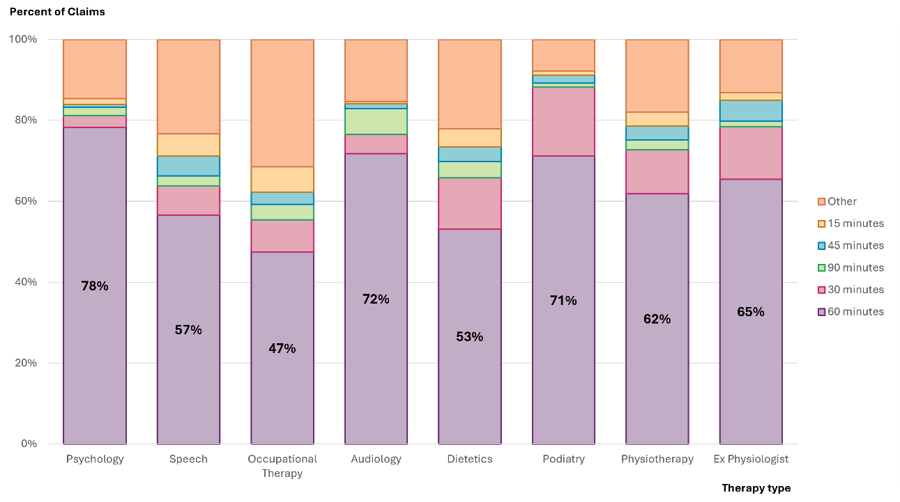
While the number of unregistered providers has grown significantly and now represents nearly 90% of all therapy providers, their claiming patterns have increasingly aligned with those of registered providers. Across both registered and unregistered providers, there is a strong tendency to claim at or near the price limit and to bill in 60-minute blocks.
This convergence in claiming behaviour, despite differences in provider scale, business models, regulatory status, and known variations of participants’ needs, suggests that current pricing arrangements are increasingly acting as the default across the market. Rather than enabling flexible, participant driven service delivery, the current NDIS pricing approach may be shaping provider practices rather than clinical appropriateness or value-for-money.

Structural Constraints in Current NDIS Pricing Design
The dominance of 60-minute claims raises several challenges. Firstly, when services are bundled, it can limit visibility over what is delivered in each session. The NDIS permits billing for relevant non-face-to-face activities, such as preparation, planning, and documentation, but these are not always separately itemised by the relevant claim type. As a result, it can be difficult to determine how much exact time is spent in direct contact with participants and how much ancillary support is delivered.
Second, the pricing limit structure itself may be shaping provider’s behaviour. As most therapy price limits are set as an hourly price limit, and no guidance for claiming for shorter session length, providers may be interpreting the hourly limit as a “standard” or expected amount. In practice, this creates a soft pricing signal that encourages longer session durations than may be required, or taking the price as a session price, irrespective of the time spent delivering the service.
Other funding models offer greater alignment between service duration and pricing structure. For example, the Medicare Benefits Schedule supports itemised billing for different session lengths (e.g., 20 minutes, 30 minutes, 50 minutes, etc.), allowing providers to match pricing to relevant support intensity. These structures also create clearer expectations around typical durations and billing behaviour, providing adequate incentive to support expected outcomes.
While the Scheme does not prescribe session lengths, and the claiming systems allows for pro-rata use up to the hourly price limit, this flexibility does not appear to be consistently exercised in practice. The consistency of 60-minute claims across therapy types and provider types suggests that the price limit may be operating as a “target” price, rather than a ceiling intended to allow flexibility based on service need and duration.
Providers are expected to set prices and structure sessions in a way that reflects participant needs. However, the current NDIS therapy pricing approach may be discouraging variability in session delivery models and disincentivising potential best practice approaches.

Designing for Session Duration Flexibility
A more granular approach to pricing therapy supports delivered to NDIS participants could better support responsive and participant-centred service delivery. For example, displaying pricing in smaller increments, such as 10-minute blocks, would enable providers to more accurately reflect the time spent on different components of supports, including both direct contact and participant-specific preparation or follow-up. Table 23 illustrates how pricing could be applied across different session lengths, using both sub-limit and at-limit rates.
Table 23: Example of Presenting Price Limits across Different Sessions Lengths
Session Length | Provider charging $175 per hour | Provider charging $193.99 per hour (at the price limit)
30 minutes | $87.50 | $97.00
40 minutes | $116.67 | $129.33
50 minutes | $145.83 | $161.66
60 minutes | $175.00 | $193.99
Given how uniquely the NDIS therapy hourly session length is compared with other funding and services, consideration in future pricing design should be given to foster greater use of pro-rata billing, or the introduction of clearer session-based pricing tiers. This would support more efficient use of participant budgets, reduce over-servicing, and enable a more transparent link between pricing and the support delivered to assist promoting clinically appropriate service delivery.

Pathway to Longer-Term Pricing Reform
As discussed in the NDIS Pricing Strategy, market competition would generally be expected to drive competitive pricing, innovation, and improved quality for supports delivered to NDIS participants. However, in practice the NDIA has observed that many therapy support markets are converging around the regulated NDIS price limits, with limited variation across disciplines, service intensity, or provider types.
This convergence suggests that the current pricing approach is functioning less as a maximum and more as a reference for session times and charging rates.
This APR takes the first step to implement incremental changes to NDIS pricing arrangements to support a more diverse, sustainable market capable of delivering therapy supports that are tailored to participant needs. The next phase of reform will consider pricing models that reflect support complexity, delivery settings, and the nature of participant outcomes.
Any changes to pricing will be implemented incrementally to avoid market instability and will be supported by participant and sector consultations.
Future reforms will be informed by clearer service specifications, enhanced provider and claims data, and the outcomes of an in-depth Therapy Pricing Review.

Recommendations

Therapy Pricing Review
The NDIA is observing increasing diversity in business models, practitioner types, and service delivery contexts across the therapy markets. While this reflects a maturing sector, it also highlights emerging challenges with the alignment between current price limits and the way therapy supports are being delivered in practice.
To ensure pricing continues to support participant outcomes, provider sustainability, and service quality, the NDIA will review therapy pricing. This review will assess whether existing price limits remain fit for purpose and inform the development of differentiated pricing approaches aligned with the framework proposed by the IPC.
The review will consider factors such as practitioner qualifications, workforce availability, service settings, regulatory obligations, and the nature of participant outcomes achieved. It will be informed by sector consultations and analysis of provider and market data.
Recommendation 5:
The NDIA should review therapy pricing to assess whether current price limits and market settings remain appropriate for therapy types. This work will inform the development of differentiated pricing approaches consistent with the framework outlined by the IPC.

Removal of State and Territory Special Pricing Arrangements
The existing jurisdictional price premiums for psychology and physiotherapy were introduced in 2019 based on statistical evidence at the time, which showed higher market prices in Western Australia (W A), South Australia (S A), Northern Territory (NT), and Tasmania (TAS) at the time (2019 Review of NDIS Therapy Pricing Arrangements). The original therapy review found no statistically conclusive cost differences but introduced higher limits in select jurisdictions to support market development despite data limitations at the time. These premiums were not intended to be permanent and were to be reviewed once better data became available.
Benchmarking results do not support the continued use of jurisdictionally differentiated pricing for Physiotherapy and Psychology. P H I and MBS data show that 75th percentile hourly rates for these therapies are broadly consistent across all states and territories, including those currently receiving higher NDIS price limits. There is no systematic evidence of higher service costs in W A, S A, NT, or Tasmania that would justify the existing price premium. Both therapy types display stable session durations and similar fee structures nationwide, suggesting that provider charging patterns are not materially influenced by geography.
Considering these findings, a single national price limit would better reflect observed market conditions, promote equity across jurisdictions, and streamline administrative arrangements without compromising support availability. The existing remote and very remote loadings, 40% and 50%, respectively, will continue to remain in place to provide additional support for participants living in those geographies.
Recommendation 6:
The NDIA should remove the state and territory differentiated pricing arrangement for supports delivered by a Physiotherapists and Psychologists from 1 July 2025. The hourly price limits for Physiotherapists and Psychologists in Western Australia, South Australia, Northern Territory, and Tasmania should be aligned with the corresponding price limits in New South Wales, Victoria, Queensland and Australian Capital Territory - forming a national price limit from 1 July 2025.
In Financial Year 24-25 terms, the national price limit for supports delivered by a Psychologist would have been $222.99 per hour, and the national price limit for supports delivered by a Physiotherapist would have been $193.99 per hour prior to the adjustment recommended below.

Psychologist Price Limits
The current NDIS price limit of $222.99 per hour for psychology sit below the 75th percentile of hourly rates observed in both P H I and MBS data sets, which are $247.00 and $251.00 respectively. These benchmarks are based on large-scale transaction data and assume a standard 60-minute session, making them directly comparable to the structure of current NDIS price limits. The size and consistency of this difference suggests the current price limits may not adequately reflect prevailing market rates.
In response, the NDIA proposes a $10 increase to the psychology price limit. This is an incremental adjustment that brings NDIS pricing into closer alignment with the broader market while maintaining price stability prior to the proposed Therapy Pricing Review. It is also consistent with the NDIA’s broader transition to differentiated pricing, as recommended by the IPC.

Recommendation 7:
The NDIA should increase the national price limit for supports delivered by a psychologist by $10 to a new national price limit of $232.99 per hour on 1 July 2025. This increase will apply uniformly across all jurisdictions and, when combined with the removal of jurisdictional loadings, will result in a net reduction in price limits of $11.23 for Psychologists in Western Australia, South Australia, Northern Territory, and Tasmania.
Notwithstanding changes to the NDIS Pricing Arrangements and Price Limits, specifically, this applies to support items: Assessment Recommendation Therapy or Training Supports – Psychologist (01_701_0128_1_3, 15_054_0128_1_3), Specialist Behaviour Intervention Support (11_022_0110_7_3), Behaviour Management Plan Including Training in Behaviour Management Strategies (11_023_0110_7_3), Assessment Recommendation Therapy or Training – EC – Psychologist (01_700_0118_1_3) and Early Childhood Supports – Psychologist (15_001_0118_1_3).

Physiotherapist Price Limits
Benchmarking results indicate that the current NDIS price limit for Physiotherapy significantly exceeds prevailing market rates. Both P H I and MBS data show 75th percentile hourly rates of $150.50 and $158.70 respectively, compared to the current NDIS price limit of $193.99 per hour in eastern jurisdictions. In W A, S A, NT, and Tasmania both P H I and MBS data show 75th percentile hourly rates of $133.40 and $145.30 compared to the NDIS price limit of $224.62 per hour. This equates to the current NDIS price limit being approximately 28.9%% higher than P H I and 22.2% higher than MBS in NSW/VIC/QLD/ACT, and up to 68.4% higher than P H I and 54.6% higher than MBS in W A/S A/NT/TAS. These benchmarks were derived from large-scale billing datasets and converted to hourly rates using validated session duration estimates.
The consistency of these findings across jurisdictions and sources provides a strong rationale to reduce the NDIS price limits for physiotherapy. Doing so will better align with broader market conditions without distorting prices in the wider care sector. A moderate adjustment is recommended to minimise market disruption. This is an incremental adjustment prior to further consideration in the proposed Therapy Pricing Review.

Recommendation 8:
The NDIA should lower the national price limit for supports delivered by a Physiotherapist by $10 to a new national price limit of $183.99 per hour on 1 July 2025. This decrease will apply uniformly across all jurisdictions, and when combined with the removal of jurisdictional loadings, will result in a net reduction in price limits of $40.63 for Physiotherapists in Western Australia, South Australia, Northern Territory, and Tasmania.
Notwithstanding changes to the NDIS Pricing Arrangements and Price Limits, specifically, this applies to support items: Assessment Recommendation Therapy or Training Supports – Physiotherapist (01_721_0128_1_3, 15_055_0128_1_3), Assessment Recommendation Therapy or Training – EC – Physiotherapist (01_720_0118_1_3) and Early Childhood Supports – Physiotherapist (15_003_0118_1_3).

Dietitian Price Limits
Benchmarking results provide a clear basis to revise the NDIS price limit for supports delivered by Dietitians. The current NDIS price limit of $193.99 per hour is substantially higher than both the P H I 75th percentile rate of $162.30 per hour and the MBS 75th percentile rate of $141.10 per hour. This represents a divergence of approximately 19.5% above P H I and 37.5% above MBS. These benchmarks were derived from large-scale billing datasets and converted to hourly rates using validated session duration estimates.
Given the size and consistency of this gap across sources and jurisdictions, there is strong rationale to reduce the NDIS price limit to better align with prevailing market conditions. A modest, incremental reduction is recommended to avoid market disruption. Further adjustment can be considered following the upcoming proposed Therapy Pricing Review.
Recommendation 9:
The NDIA should lower the price limit for supports delivered by a Dietitian by $5 to a new national price limit of $188.99 per hour on 1 July 2025.
Notwithstanding changes to the NDIS Pricing Arrangements and Price Limits, specifically, this applies to support items: Assessment Recommendation Therapy or Training Supports – Dietitian (01_760_0128_3_3, 15_062_0128_3_3), Advice provided by a Dietitian on managing diet for health and well-being (12_025_0128_3_3) and Assessment Recommendation Therapy or Training – EC – Dietitian (01_760_0118_1_3).

Podiatrist Price Limits
Benchmarking data suggest the current NDIS price limit for Podiatrists is above P H I and substantially above MBS market rates. The NDIS limit of $193.99 per hour is 5.8% above the P H I 75th percentile of $183.40 per hour but 48% above the MBS 75th percentile of $131.10. These figures are based on large-scale billing data and converted to hourly rates using validated session durations.
The significant divergence from MBS and the narrow margin over the P H I suggest that the NDIS price limit is at the upper end of observed market rates. A modest reduction would bring the price limit closer to alignment with market rates. Further consideration will be given to podiatry pricing as part of the proposed Therapy Pricing Review.
Recommendation 10:
The NDIA should lower the price limit for supports delivered by a Podiatrist by $5 to a new national price limit of $188.99 per hour on 1 July 2025.
Notwithstanding changes to the NDIS Pricing Arrangements and Price Limits, specifically, this applies to support items: Assessment Recommendation Therapy or Training Supports – Podiatrist (01_663_0128_1_3, 15_619_0128_1_3) and Assessment Recommendation Therapy or Training – EC – Podiatrist (01_663_0118_1_3).

Presentation of Therapy Session Length
It is becoming apparent that session length is emerging as a key structural feature of NDIS therapy pricing. This pattern is particularly concentrated among registered providers (69%) and reflects widespread use of 60-minute sessions across most therapy types. Although current pricing rules allow for pro-rata billing, the price limit appears to operate as the default. Claiming patterns indicate that the hourly benchmark price may be influencing session lengths that don’t always align with industry standards.
The NDIA is also aware of the Department of Health, Disability and Ageing’s Review of MBS Allied Health Chronic Disease Management Services that commenced on 20 August 2024. This MBS review will assess whether services are adequately supporting patients with chronic conditions and whether individual and group MBS allied health services could be improved to better support eligible patients. This includes reviewing session length in delivering those services to patients.

This year the price limits for therapies are presented in 10-minute increments to encourage session lengths that align with participant needs and best practice.
This is not a change to the pricing arrangement, rather a different presentation of information aimed at clarifying that 60-minute sessions are not assumed to be the default and to better align service delivery with participant needs.
This approach begins better alignment and reflection of the standard practice in other health funding models, such as the MBS, and supports better alignment between pricing and participant outcomes. Further consideration of the most appropriate NDIS therapy pricing structure will be reviewed in the proposed Therapy Pricing Review.
Recommendation 11:
The NDIA should present therapy support price limits in 10-minute increments, to encourage greater flexibility in session lengths and improve alignment between claimed time and services delivered. This will be applied as a linear adjustment to the price limit per 10 minutes claimed.
This change would apply alongside existing claiming rules for therapy supports.

Provider Travel Pricing Arrangements
The NDIA proposes to retain all current travel claiming rules for therapy supports, with one modification: the total claimable amount for travel-covering the labour component will be capped at 50% of the relevant therapy hourly price limit. This change will improve the sustainability and equity of travel funding under the Scheme, while continuing to support reasonable provider costs and participant access to supports.
Under the existing arrangements, a provider may claim up to 30 or 60 minutes of travel time per appointment (depending on remoteness), in addition to non-labour costs such as mileage and tolls. In practice this can lead to claims that approach or exceed the value of the therapy service itself, particularly in regional or lower-density areas unless apportioned across several participants. While some degree of compensation for travel is necessary to maintain support access, particularly in thin markets, the current structure creates inconsistency in participant budgets and introduces incentives for inefficient scheduling.
Benchmarking shows that most comparable insurance and health funding systems do not separately reimburse travel at the same magnitude or embed travel costs within a broader bundled price. Introducing a 50% cap maintains alignment with NDIS principles, ensuring participant funds are used efficiently, while recognising that travel remains a legitimate and often necessary component of service delivery.
This change provides clear cost expectations for participants, incentivises more efficient provider scheduling, and ensures that travel claims remain proportionate to the service being delivered. The existing remote and very remote loadings will remain in place to provide additional support for participants living in these locations.
Recommendation 12:
From 1 July 2025, the NDIA should introduce a cap on provider travel claims for therapy supports, limiting the total claimable amount for labour time component, to no more than 50% of the applicable therapy hourly price limit.
This change would apply alongside existing claiming rules and thresholds for therapy supports, including time-based limits by remoteness area, and assist ensure that travel claims remain proportionate to the service delivered.

Support Coordination

Context
Support coordination assists participants make effective use of their NDIS plans. Support coordinators assist participants by identifying and connecting them with funded and mainstream supports, tailoring supports to individual needs and ensuring these align with plan budgets and goals. This role is intended to empower participants, enhancing their ability to exercise choice and control in decision-making and service selection.
Support coordinators require a strong understanding of the local provider market to facilitate access to appropriate supports. This includes sourcing alternative providers when necessary to maintain access to and continuity of supports for participants.
The NDIS pricing approach for support coordination is structured to reflect different levels of participant need and complexity. Supports are available under three categories:
- Level 1: Support Connection
- Level 2: Coordination of Supports
- Level 3: Specialist Support Coordination
Each level has its own price limits designed to ensure participants receive the right level of assistance to build capacity, manage supports effectively, and achieve plan outcomes.
In 2024-25, support coordination can be delivered by both registered and unregistered providers as registration has not been mandatory. However, on 16 September 2024, the Minister for Government Services and the NDIS at the time, announced that registration of all platform providers, support coordinators and SIL providers was required to strengthen the quality and safety of supports. Arrangements to register Support coordinators is anticipated to occur after 1 July 2025.
This section reviews the current pricing arrangements for support coordination, assessing whether the pricing approach supports sustainable service delivery and participant access to high-quality, effective supports.

Quality Supports Program – Support Coordination Pilot
The Support Coordination Pilot and grant opportunity was announced following the 2023-2024 Annual Pricing Review (APR).
The Support Coordination Pilot is gathering evidence to inform quality Support Coordination and identify practices that lead to better outcomes for participants. The pilot enables the NDIA to gain greater insight into the factors that impact the delivery and quality of support coordination and to design the future Navigator functions.
The Support Coordination Pilot involves working closely with a group of established providers over a 12-month period. The selection of providers is based on the service footprint and the numbers of participants that access their services. The insights gained through the pilot will help improve participant outcomes.

Scheme Statistics

Market Overview
Support coordination remains a core part of the Scheme, with 262,994 participants, around 38% of all active participants, accessing these supports in the six months to December 2024. During this period, 10,184 providers delivered support coordination, with total claims reaching $565 million, or around 2.5% of total NDIS payments.
As shown in Table 24 and Figure 24, participant numbers increased by 7% compared to the same time period the year prior, while the number of active providers grew by 15% over the same period. Over this period, the average claim per provider fell by 8% (Table 24).
Growth has been strongest among unregistered providers, with a 28% increase in participant numbers and 26% increase in total claims (Table 26). While registered providers continue to deliver most services and receive the majority of payments ($447 million), their growth has been more modest – up 3% in participant numbers and 2% in payments for the six months to December 2024 (Table 25).

Table 24: Support Coordination Scheme Statistics – All Providers
Statistics | July – December 2023 | July – December 2024 | Percentage Change
Number of NDIS participants | 245,696 | 262,994 | +7%
Number of active providers | 8,823 | 10,184 | +15%
Total amount claimed by active providers of support coordination | $531 million | $565 million | +6%
Average amount claimed by all active providers of support coordination | $60,236 | $55,455 | -8%
Source: NDIS internal administrative data
Table 25: Support Coordination Scheme Statistics – Registered Providers
Statistics | July – December 2023 | July – December 2024 | Percentage Change
Number of NDIS participants | 210,791 | 217,822 | +3%
Number of active providers | 3,686 | 4,153 | +13%
Total amount claimed by active providers of support coordination | $438 million | $447 million | +2%
Average amount claimed by all active providers of support coordination | $118,857 | $107,593 | -9%
Source: NDIS internal administrative data
Table 26: Support Coordination Scheme Statistics – Unregistered Providers
Statistics | July – December 2023 | July – December 2024 | Percentage Change
Number of NDIS participants | 45,270 | 57,874 | +28%
Number of active providers | 5,300 | 6,207 | +17%
Total amount claimed by active providers of support coordination | $93 million | $117 million | +26%
Average amount claimed by all active providers of support coordination | $17,519 | $18,913 | +8%
Source: NDIS internal administrative data

Figure 24: Number of Participants and Providers Claiming Support Coordination Supports, January 2022 to December 2024
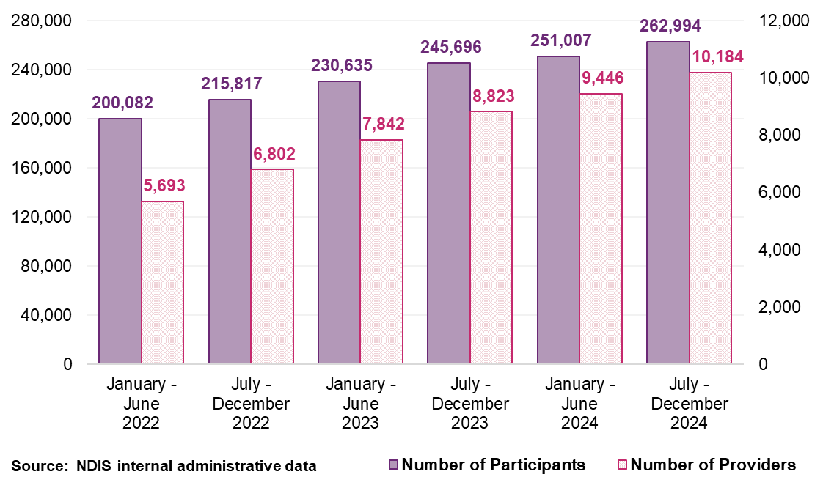

Participants
Between July and December 2024, 247,065 participants accessed Level 2: Coordination of Supports, making it the most claimed support coordination level (Figure 25). Level 1: Support Connection and Psychosocial Recovery Coaching was accessed by 24,957 participants, followed by Level 3: Specialist Support Coordination, accessed by 11,438 participants (Figure 25). Figure 25 shows the distribution of participants using different levels of support coordination. The estimates suggest that the use of support coordination related services continues to show steady increases overtime.

Figure 25: Participants Using Different Levels of Support Coordination Supports
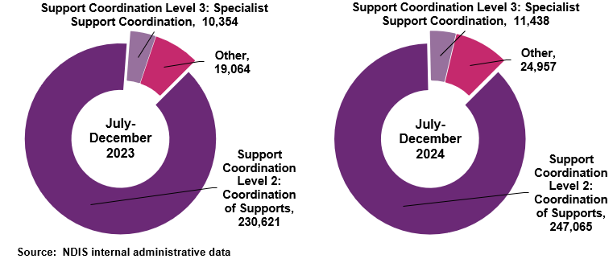
Note: The “Other” category includes Psychosocial Recovery Coaching and Support Coordination Level 1: Support Connection supports.

Providers

Provider Growth
As shown in Figure 26, most providers of support coordination deliver Level 2: Coordination of Supports. Between January 2022 and December 2024, the number of Level 2 providers increased from 5,082 to 8,924, an overall growth of 76% (Figure 26). In comparison, the number of providers delivering Level 3: Specialist Support Coordination grew more modestly, from 1,003 to 1,711 over the same period (Figure 26).

Figure 26: Number of Providers by Support Coordination Level, January 2022 to December 2024
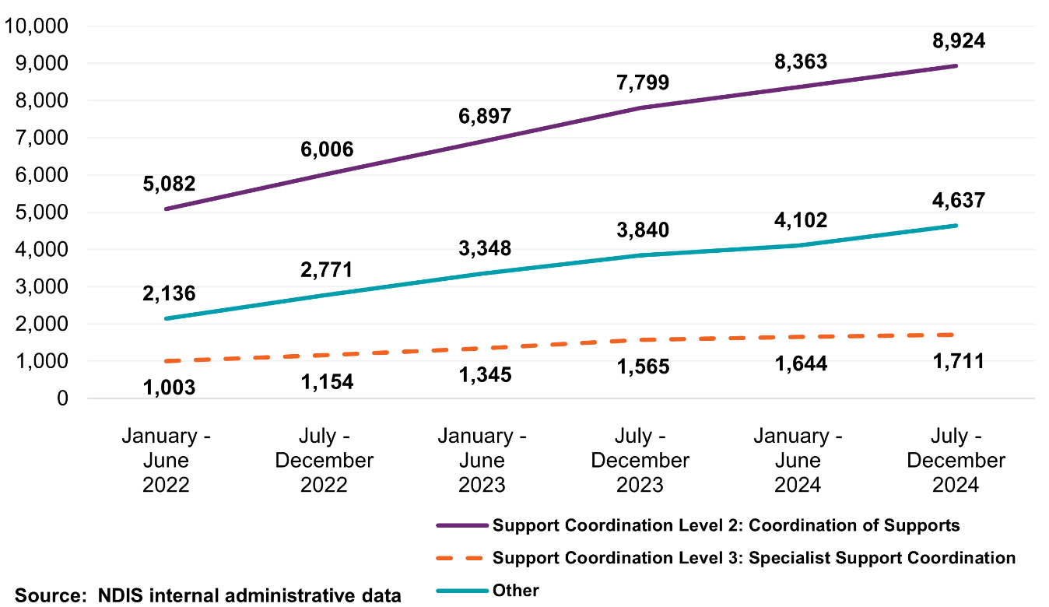
Note: The “Other” category includes Psychosocial Recovery Coaching and Support Coordination Level 1: Support Connection supports.

Provider Concentration
Between January 2022 and December 2024, the number of providers delivering support coordination increased by 79% from 5,693 to 10,184 (Figure 27). Over the same period, the combined market share of the top ten providers declined from 9.1% to 7.5%, suggesting an increasingly distributed provider market.
Figure 28 shows that market share concentration levels vary across geographic areas. In very remote regions, the top ten providers accounted for 45% of payments in the second half of 2024, compared to just 7.3% in non-remote areas. This suggests that while the overall market has become less concentrated, regional delivery remains more reliant on larger providers.
While a less concentrated provider market may be able to provide tailored or community-based models of support, it poses a challenge for provider consistency, workforce capability, and continuity of support.

Figure 27: Changes in Top Ten Provider Market Share Compared to Growth in Support Coordination Providers, January 2022 to December 2024
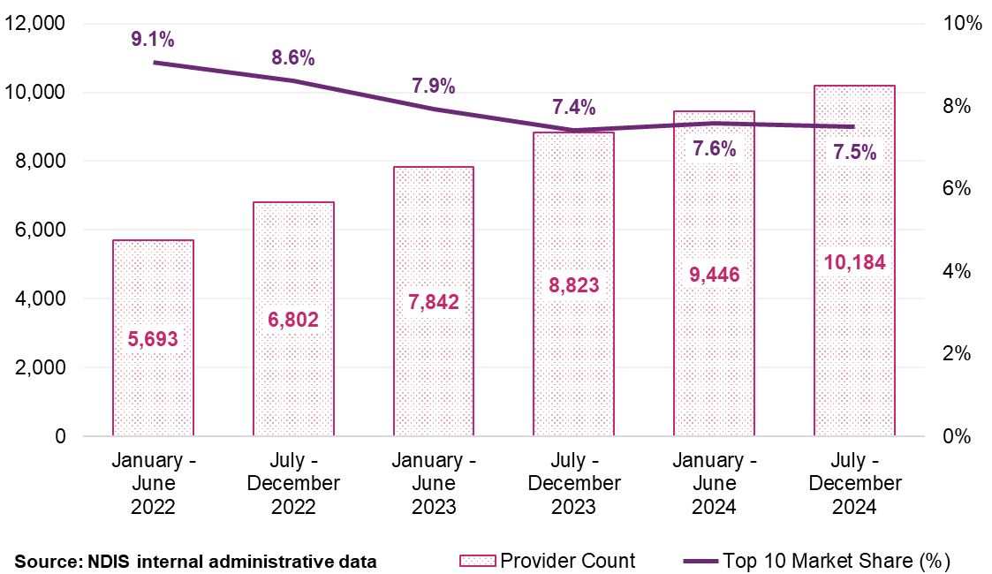
Note: The figure shows market share for both registered and unregistered providers.
Figure 28: Top Ten Provider Market Share by Remoteness for Support Coordination Supports, January 2022 to December 2024
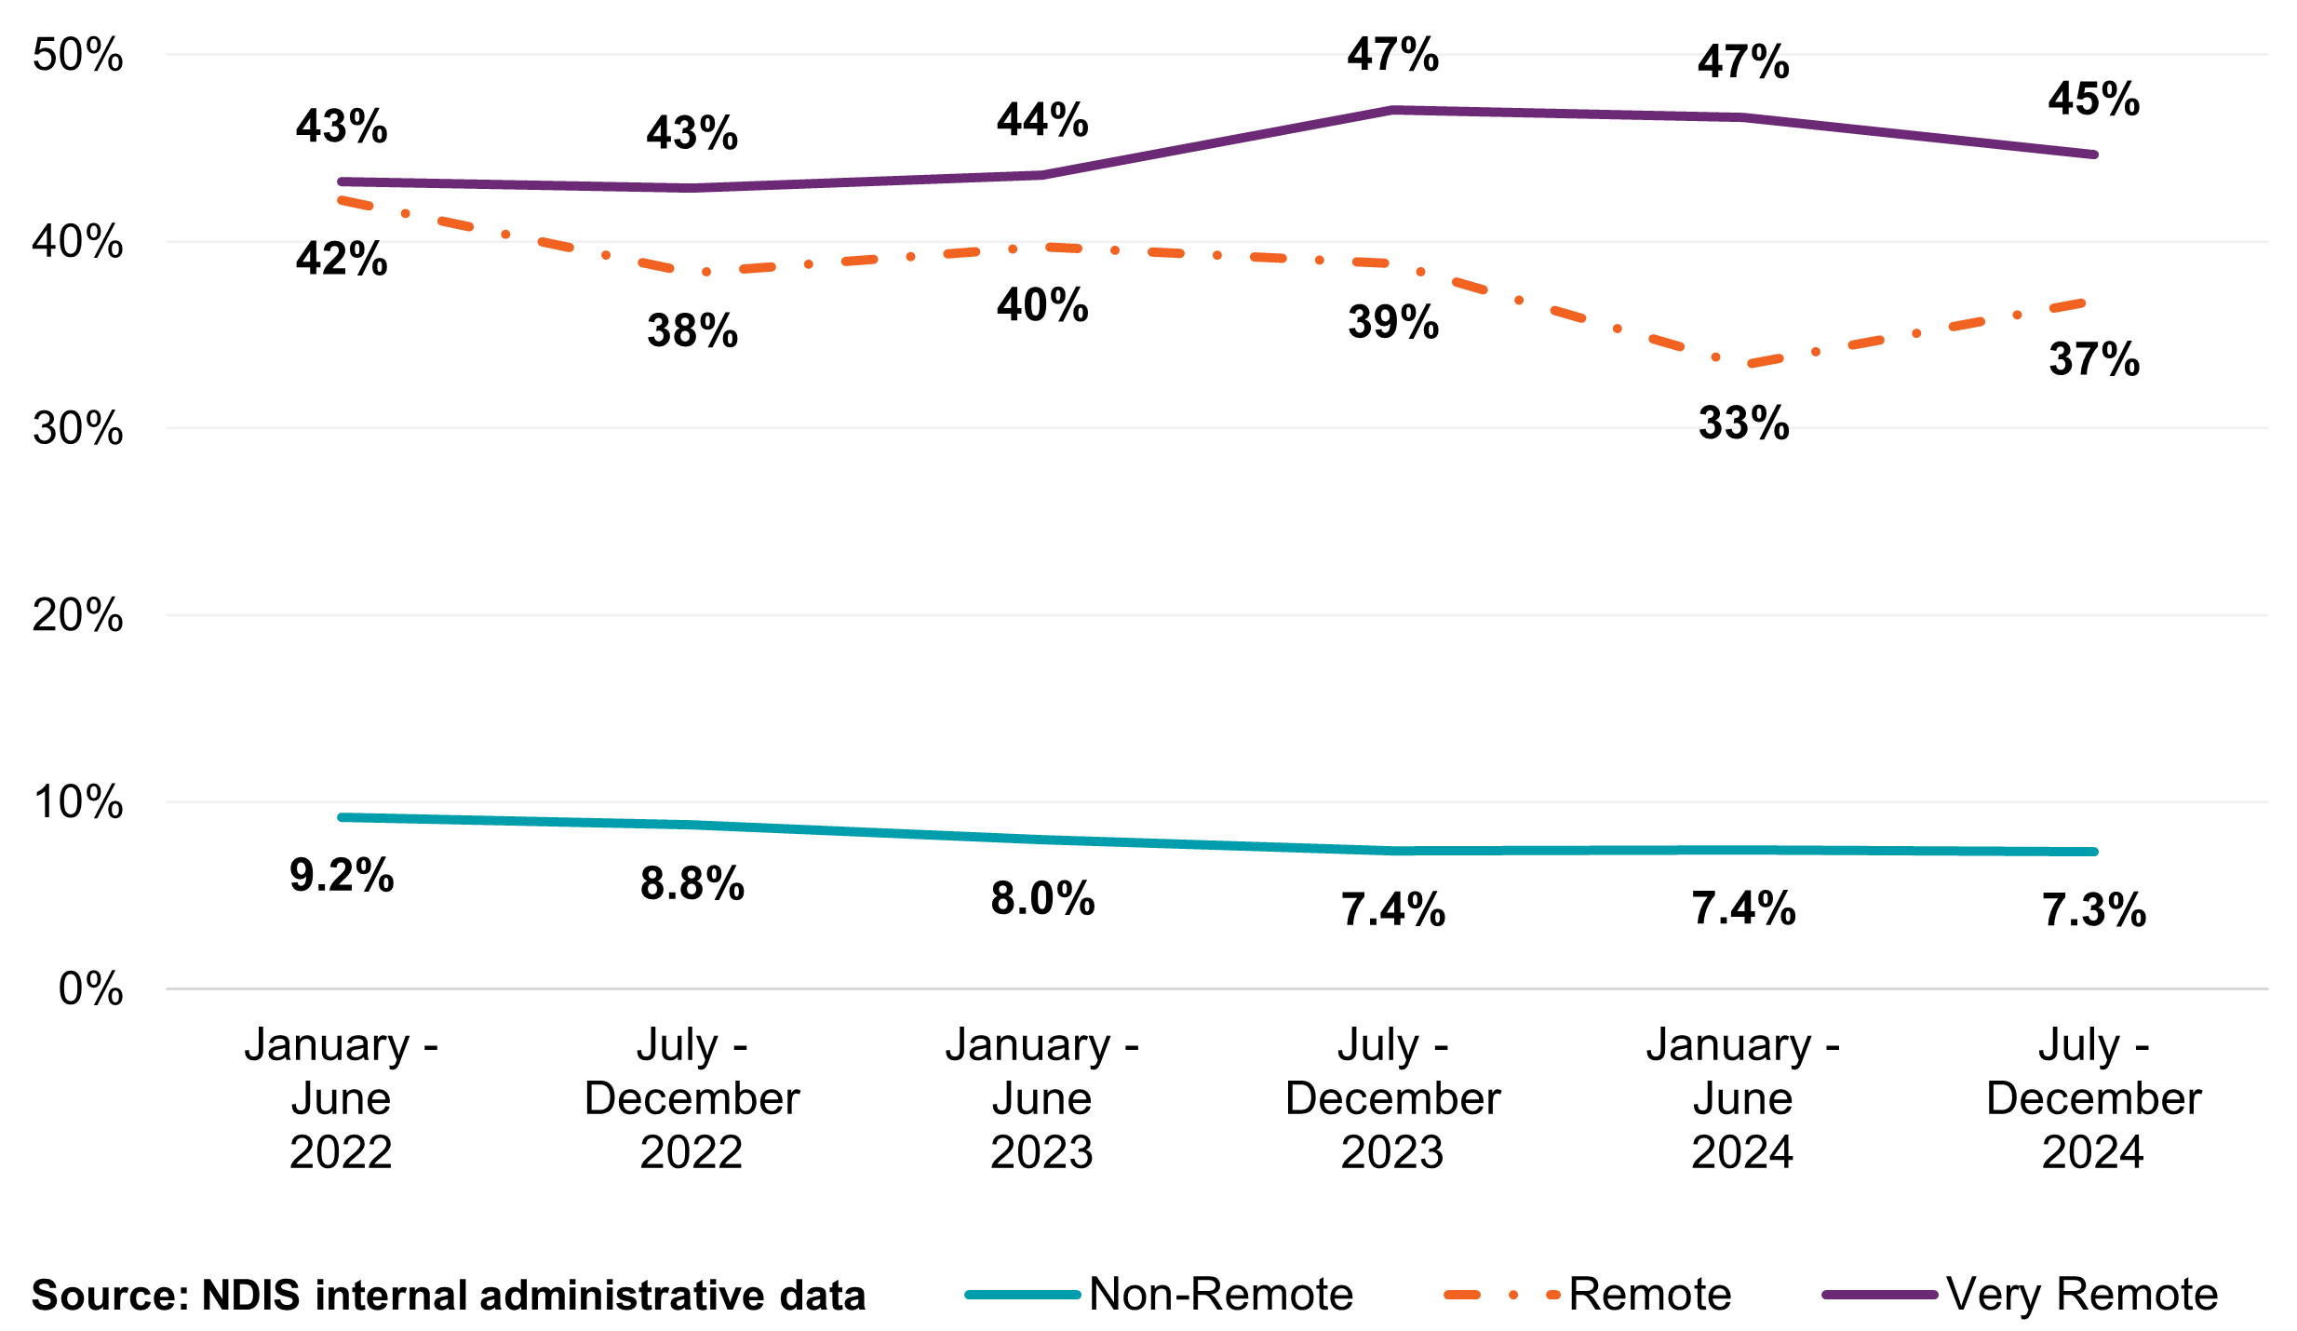

Geographic Spread of Providers
Between January 2022 and December 2024, the number of registered and unregistered support coordination providers increased across all remoteness categories (Table 27 and Table 28). Growth was strongest among unregistered providers, particularly in non-remote areas, where their numbers more than doubled from 2,712 to 6,128 providers (Table 28). In very remote areas, unregistered provider numbers tripled from 47 to 143 providers (Table 28), while registered providers increased modestly from 175 to 227 providers (Table 27). Remote areas saw a similar trend, with unregistered providers growing from 85 to 329 providers (Table 28) and registered providers increasing from 299 to 427 providers (Table 27), respectively.
The results again highlight the changing dynamics in the sector, with greater growth amongst unregistered providers.
Table 27: Registered Providers by Remoteness for Support Coordination Supports, January 2022 to December 2024
Remoteness | January – June  2022 | July – December 2022 | January – June  2023 | July – December 2024 | January – June  2024 | July – December 2024
Non-remote | 3,026 | 3,294 | 3,469 | 3,647 | 3,839 | 4,112
Remote | 299 | 308 | 324 | 362 | 425 | 427
Very remote | 175 | 187 | 199 | 212 | 215 | 227
Total for Registered | 3,044 | 3,332 | 3,503 | 3,686 | 3,877 | 4,153
Source: NDIS internal administrative data
Table 28: Unregistered Providers by Remoteness for Support Coordination Supports, January 2022 to December 2024
Remoteness | January – June  2022 | July – December 2022 | January – June  2023 | July – December 2023 | January – June  2024 | July – December 2024
Non-remote | 2,712 | 3,472 | 4,366 | 5,242 | 5,709 | 6,128
Remote | 85 | 121 | 160 | 197 | 298 | 329
Very remote | 47 | 69 | 80 | 98 | 114 | 143
Total for Unregistered | 2,739 | 3,518 | 4,420 | 5,300 | 5,771 | 6,207
Source: NDIS internal administrative data
Note: Remoteness of providers uses the NDIS participant’s address as a proxy for location. Providers may be counted more than once if a provider provides support to participants located across varying remoteness levels.

Market Composition
Sole traders and companies represent the most active legal entity types delivering support coordination, but they can support participants differently based on their size and scale of operations. Between July and December 2024, companies supported 214,654 participants through 5,303 active providers, with total claims of $442.5 million at an average of $83,445 per provider (Table 29). In contrast, over the same period, sole traders supported 40,997 participants with 4,089 active providers and, claiming $78.3 million in total, an average of $19,152 per provider (Table 29).
Despite making up a larger share of the provider base, between July and December 2024 sole traders accounted for approximately 16% of the total participant volume serviced and claimed 14% of the total support coordination support payments (Table 29). This suggests that sole trader delivery models are typically smaller in scale and support a smaller proportion of participants within the broader Support Coordination market.
Figure 29 and Figure 30 reinforce this pattern, showing that for the period between July and December 2024 most sole traders claim in the lower payment bands, particularly under $50,000, with the volume of these claims concentrated in the unregistered providers group. Companies, on the other hand, are more evenly distributed across higher payment brackets and are more prominent among registered providers over the same period.
Table 29: Support Coordination-Related Supports Scheme Statistics by Legal Entity Type, July to December 2024
Statistics | Company | Government Entity | Partnership (Other) | Trust / Super | Sole trader
Number of NDIS participants | 214,654 | 1,112 | 5,031 | 15,137 | 40,997
Number of active providers | 5,303 | 20 | 246 | 507 | 4,089
Amount claimed by active providers of SC-related supports (million) | $442.5 | $2.0 | $8.8 | $30.0 | $78.3
Average amount claimed by all active providers of SC-related supports | $83,445 | $98,982 | $35,771 | $59,079 | $19,152
Source: NDIS internal administrative data
Figure 29: The Counts of Registered Providers of Support Coordination Supports by Entity Type and Total Payments, July to December 2024
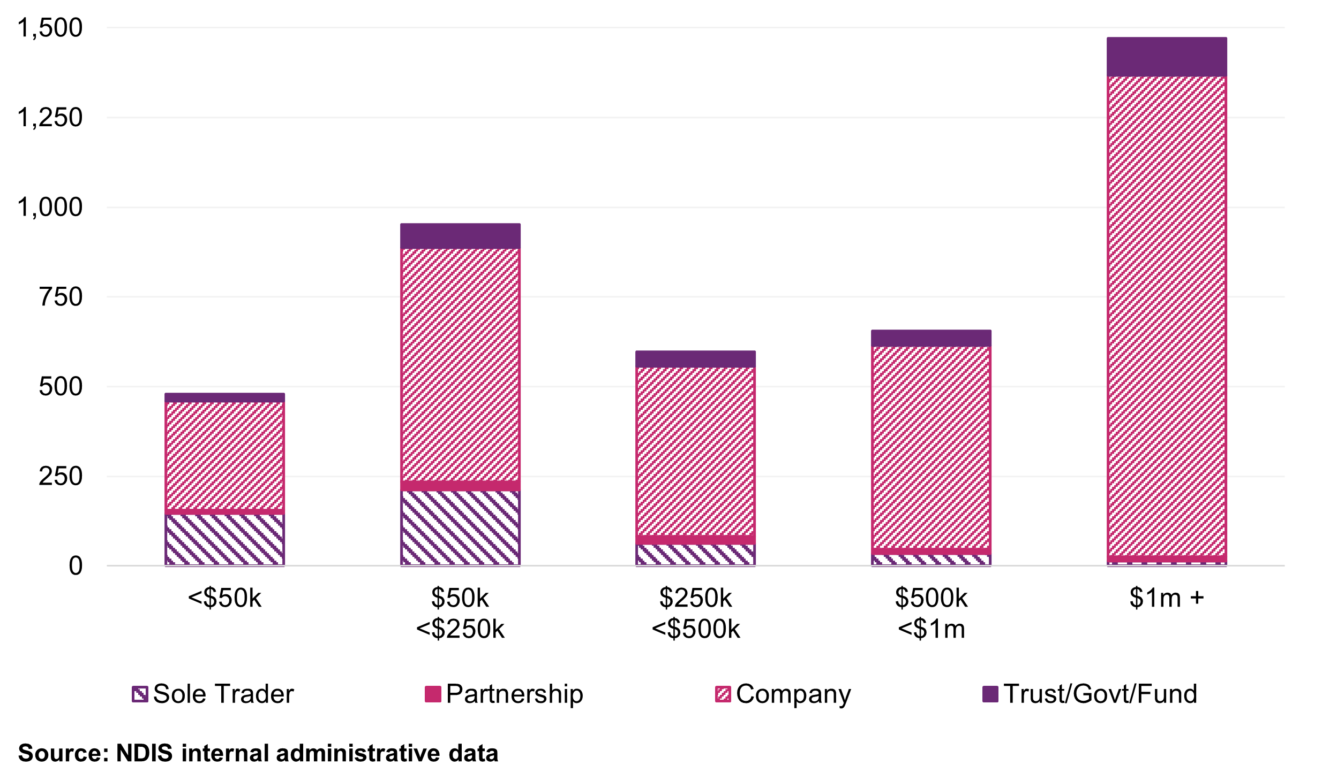
Figure 30: The Counts of Unregistered Providers of Support Coordination Supports by Entity Type and Total Payments, July to December 2024
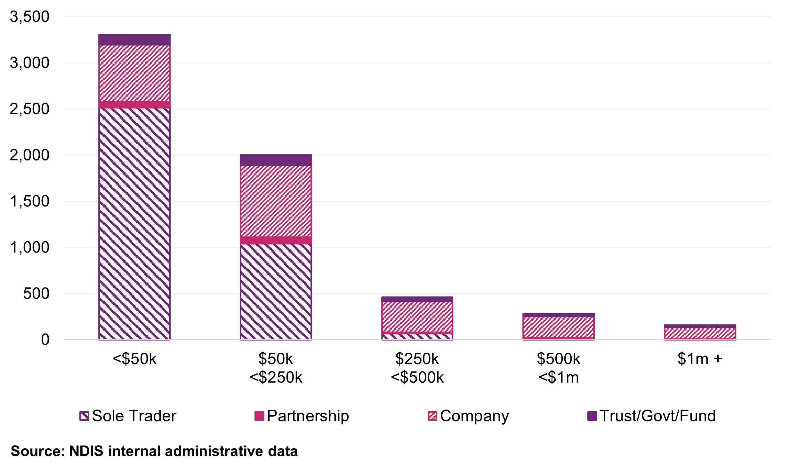

Provider Scale and Revenue Distribution
A total of 5,263 Support coordination providers serviced five or fewer participants in the July to December 2024 period, with those supporting a single participant claiming an average payment of just $2,000 (Table 30). In comparison, providers supporting between 11 and 50 participants, a cohort representing the mid-range of the market scale, averaged $45,700 in claims per provider (Table 30). This significant difference suggests that the lower end of the market is dominated by providers operating at minimal scale, likely with limited infrastructure or short-term engagement (Table 30).
Overall, data suggests that one of the defining features in the support coordinator market is that small providers make up for more than half of the active provider base, and majority of the unregistered support coordination provider market (Table 30).
Table 30: Statistics on the Size of Providers for Support Coordination Supports, July to December 2024
Size of Provider (number of participants supported) | Number of Providers | Total Payments to Providers (million) | Average Payments to Providers | Share of Total Payments
1 | 2,964 | $5.9 | $2,000 | 1%
2 | 920 | $3.8 | $4,200 | 1%
3 | 615 | $3.9 | $6,300 | 1%
4 | 429 | $3.6 | $8,400 | 1%
5 | 335 | $3.6 | $10,800 | 1%
6-10 | 1,110 | $17.3 | $15,600 | 3%
11-50 | 2,552 | $116.7 | $45,700 | 21%
51-100 | 623 | $82.7 | $132,700 | 15%
101-250 | 452 | $128.9 | $285,100 | 23%
251-1000 | 162 | $135.7 | $0.8m | 24%
1000+ | 22 | $62.5 | $2.8m | 11%
Overall | 10,184 | $564.8 | $55,500 | 100%
Source: NDIS internal administrative data
Note: Average revenue is rounded up to the nearest hundred.

Business Dynamism
This section examines the activity and changes within the market for support coordination. Business dynamism refers to the rate at which new providers enter the market and existing providers exit. This is one of many indicators which looks at a market’s health, competitiveness, and its capacity to innovate and meet participants’ needs. The NDIA reviewed the payment activities of providers over a three-year period from January 2022 to December 2024.

The Number of Newly Active Providers Continues to Grow
Figure 31 consistently shows new activity in the support coordination provider market, with particularly strong growth of unregistered providers across the three-year period to December 2024. Between January 2022 and December 2024, more than 9,300 unregistered providers entered the NDIS market.
In the six months to December 2024, there were 1,722 newly active unregistered providers, compared to 483 newly active registered providers (Figure 31). This gap in new activity between unregistered and registered providers has persisted throughout the three-year period. This trend reflects the relatively low barriers to entry and the continued expansion in the number of smaller scale providers such as sole traders.
There was a notable rise in the number of newly active registered providers, increasing from 330 in January to June 2024 to 483 in July to December 2024, the highest half-year figure over the observed period (Figure 31). This may be driven by the announcement in September 2024 on the future mandatory registration required by all support coordination providers.

Figure 31: Newly Active Support Coordination Provider Counts, January 2022 to December 2024
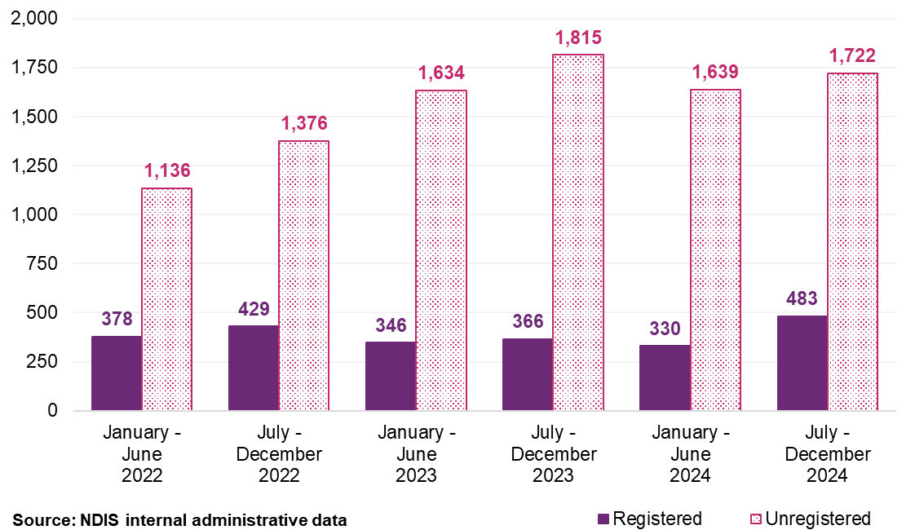

Comparison of provider payments for ‘new activity’ and ‘inactivity’
This section explores payment activities of registered providers over a three-year period from January 2022 to December 2024. ‘New activity’ is characterised by providers receiving payments in the half-year who did not receive payments in the preceding half-year. Conversely, ‘inactivity’ refers to providers not receiving payments in a half-year after having received payments in the previous one. Each provider’s activity is quantified as a percentage of the total payments within that half-year for new activity, of the prior half-year for inactivity. This method provides the best estimation with the data available, recognising it may not reflect all market exits.
Figure 32 shows that new provider activity consistently exceeded measures of inactivity over the observed period, indicating new growth in the provider market. Newly active registered providers accounted for between 1.0% and 2.1% of payments in each half year period, while inactive registered providers only represented between 0.5% and 0.9% of payments (Figure 32). While these percentages are relatively low overall, it suggests a relatively stable support coordination market.
However, when considered alongside total payments, these trends suggest that most providers with ‘new activity’ are operating at a modest scale. This aligns with earlier observations (Table 25) that a significant share of providers support a small number of participants and have relatively low total payment claims.
Figure 32: Registered Support Coordination Provider Activity Movements, January 2022 to December 2024
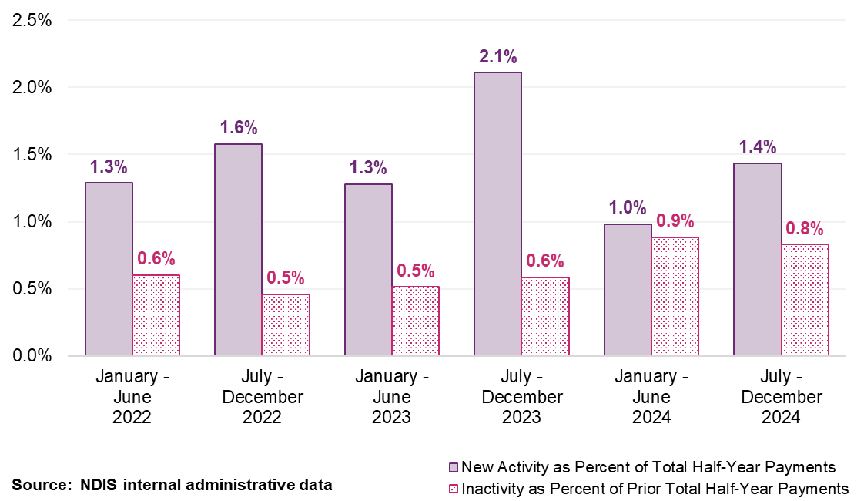
Note: Providers are considered as registered if they were registered at any point in time between January 2022 to December 2024. This does not account for a change in registration status during the period. As a result, historical activity movement is slightly different to previous APR. (i.e. Registered providers, who deregistered in 2021 were included in previous APR but not included in the current APR.).

Payment Consistency
As shown in Figure 31, there are clear differences between the number registered and unregistered providers. Among registered providers, the majority of total payments are concentrated among those that have delivered supports across all six half-year periods (Figure 33). This group represents around 30% of all registered providers but accounts for over 90% of registered payments (Figure 33). This suggests that the registered provider market is characterised by a relatively stable base of providers.
By contrast, unregistered providers show relatively larger short-term activity (Figure 33). The largest share of unregistered providers was active for only one or two half-year periods, accounting for a small share of the overall payments (Figure 33). While some of these providers may operate at small scale, except for some unregistered providers active over all six half-year periods, others may reflect episodic or short-term engagement with the market.

Analyses in this section highlight that the support coordination market is dominated by two distinct groups - long-standing registered providers who have consistently supported a large proportion of participants, and more transient provider segments that are operating at a much smaller scale.
Figure 33: Provider Continuity by Registration Status and Percentage of Total Payments. Registered Providers (Left) and Unregistered Providers (Right), half year periods from January 2022 to December 2024
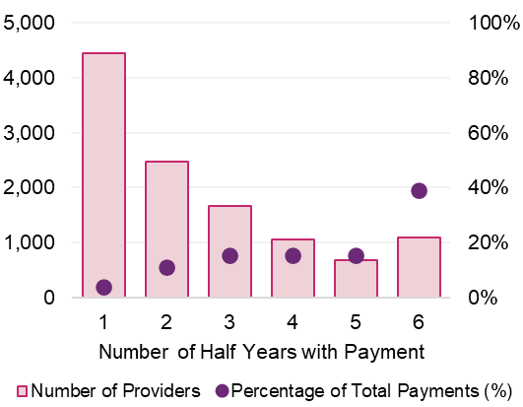
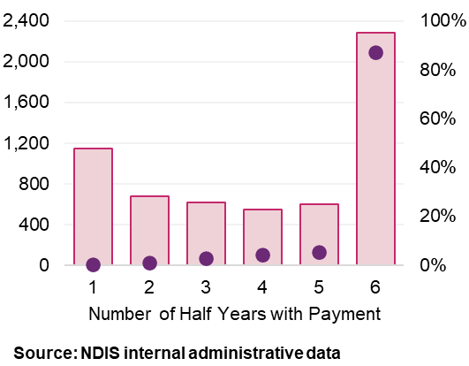
Registered providers Unregistered providers

Discussion
This chapter has explored the market structure and evolving landscape of the support coordination market. There continues to be a significant increase in both the number of providers and participants utilising support coordination services. number of active registered and unregistered providers has grown compared to the same time the previous year, at 13% and 17% respectively (Table 25 and Table 26). This, combined with 7% growth in the number of participants choosing to engage Support coordinators (Table 24), highlights the responsiveness of the support coordination market to meet NDIS participant support needs.
As the broader NDIS environment undergoes reform and adjustment, the NDIA continues to actively monitor and assess the performance and resilience of the support coordination market in its role as market steward. NDIS administrative data has used to assess existing market conditions such as market activity, payment volumes, and geographic distribution.
Current indicators suggest that the support coordination market remains robust and adaptable. Provider activity remains strong among both registered and unregistered providers. Many participants can access supports from a mix of sole traders, small businesses, and mid-sized organisations. The spread of payments across a broad and diverse provider base suggests that participants continue to have meaningful choice, and that capacity exists to manage transitions where individual organisations exit the market.

Recommendations
It is considered reasonable that Level 1: Support Connection supports and Psychosocial Recovery Coaches, which are currently priced using the DSW Cost Model, continue to be indexed in line with the DSW Cost Model. Continuing to align Level 1: Support Connection price limits with the broader DSW pricing approach and framework ensures consistency in cost adjustments. This is particularly in relation to mandatory workforce-related changes considered within the DSW Cost Model that providers must ensure they meet their legal obligations.
Recommendation 13:
The NDIA should index the price limits for Level 1: Support Connection services and Psychosocial Recovery Coaches service in line with the indexation of supports determined by the Disability Support Worker Cost Model in Recommendation 4 on 1 July 2025.
On balance, analyses in the chapter suggest that while the Support Coordination market structure and dynamics have been evolving in recent years, there is limited evidence to suggest that supply is unable to meet participant demand.
The NDIA acknowledges that the support coordination market is still undergoing reform in consideration of upcoming changes regarding Navigators and mandatory registration by the NDIS Quality and Safeguards Commission. The NDIA will continue to monitor the impacts of these reforms on the support coordination market.
The NDIA aims for its broader stewardship activities, including initiatives such as the Support Coordination Quality Supports Pilot, to help build a stronger evidence base for future policy and pricing design alongside these reforms. Together, these measures support a market that remains diverse and capable, while ensuring that participants continue accessing the support they need as the sector evolves.
Recommendation 14:
The NDIA should maintain the existing price limits for Level 2: Coordination of Supports and Level 3: Specialist Support Coordination, in alignment with current NDIS reforms.
This includes “Individualised Living Options - Exploration and Design” support (01_850_0106_1_1), aligned with Level 2 Support Coordination price limit.

Plan Management

Context
Plan management is one of three ways participants can manage their NDIS funding. Participants can engage a registered plan manager to pay invoices, monitor budgets, and maintain financial records on their behalf, where participants can access both registered and unregistered service providers. This option supports participant choice and reduces the administrative burden of managing their plan. Participants may also choose agency or self-management or use a combination of all three options within the same plan.
Plan managers can claim for three types of services they provide under the Improved Life Choices support category:
- A monthly administrative fee for ongoing financial processing
- A one-off establishment payment for plan management, available once per plan
- A capacity-building support, claimable when helping participants build skills to manage funding independently
The first two items are fixed administrative payments, reflecting the operational nature of plan management and must be delivered by registered providers. In contrast, the capacity building support is a claimable service delivered to the participant.
As plan management has become a widely used funding option, the provider market has developed with growth in larger, more specialised organisations that have systems and scale to operate efficiently. This chapter examines the current pricing arrangements, scheme statistics, providers and the market to draw conclusions on potential changes to the pricing framework.

Scheme Statistics

Market Overview
Between July and December 2024, 1,624 registered plan managers submitted at least one claim, processing $13.45 billion in payments from participant plans (Table 31). Of this, $292 million was claimed directly as plan management fees, while the remaining $13.16 billion reflects payments made to other providers on behalf of participants. A total of 448,986 participants, 65% of total NDIS participants, had their funding partly or fully managed by a registered plan manager during this period.
Table 31: Plan Management Scheme Statistics
Statistics | July – December 2023 | July – December 2024 | Percentage Change
Total number of NDIS participants | 400,436 | 448,986 | 12.1%
Total number of active providers | 1,625 | 1,624 | -0.1%
Total amount claimed for plan management fees | $271 million | $292 million | 7.7%
Total number of active providers with claiming fees | 1,332 | 1,377 | 3.4%
Average amount claimed for plan management fees per provider | $203,300 | $211,800 | 4.2%
Source: NDIS internal administrative data
Note: Figures reflect payments made for plan management supports and may differ from the number of providers registered with the NDIS Quality and Safeguards Commission or participants with plan-management funding.
- Active providers are those registered in the plan management group, as reported in the QRDM.
- Active providers with claiming fees are those who submitted claims for set-up or management fees during the period. This definition underpins the analysis unless otherwise stated.
Table 32 shows that plan-managed payments grew by 19.8% compared to the previous six-month period, up from $11.23 billion to $13.45 billion six months to December 2024. Growth over this period was strong across most categories, for instance in Core – Daily Activities (up 20.8%), Core – Community (up 20.6%), and Capacity Building (CB) – Support Coordination (up 25.2%), and CB – Daily Activities (up 16.9%).

Table 32: Total Payment via Active Registered Plan Managers (including plan management fee)
Support Category | July – December 2023  (million) | July – December 2024  (million) | Percentage Change
Core - Transport | $13.7 | $15.2 | 11.0%
Core - Daily Activities | $4,976.5 | $6,013.2 | 20.8%
Core - Consumables | $223.2 | $226.9 | 1.6%
Core - Community | $3,438.1 | $4,147.8 | 20.6%
Capital - Home Modifications | $47.3 | $48.6 | 2.9%
Capital - Assistive Technology | $201.2 | $237.0 | 17.8%
Capacity Building - Support Coordination | $252.6 | $316.2 | 25.2%
Capacity Building - Social and Civic | $64.6 | $75.5 | 16.9%
Capacity Building - Relationships | $40.5 | $78.3 | 93.3%
Capacity Building - Lifelong Learning | $0.0 | $0.1 | 166.1%
Capacity Building - Home Living | $0.4 | $0.4 | 18.4%
Capacity Building - Health and Wellbeing | $9.8 | $8.8 | -10.3%
Capacity Building - Employment | $38.1 | $51.4 | 34.9%
Capacity Building - Daily Activities | $1,647.4 | $1,925.4 | 16.9%
Capacity Building - Choice and Control | $274.6 | $308.9 | 12.5%
Total Payments via Plan Managers (including plan management fee) | $11,228.0 | $13,453.8 | 19.8%
Source: NDIS internal administrative data.
Note: Some support categories have experienced large percentage growth, reflecting increases from small bases. These categories and line items should be interpreted with caution.
The number of participants using registered plan managers to access specific supports also increased significantly. Between July and December 2024, plan-managed claims rose for Capacity Building (CB) - Support Coordination (from 126,598 to 157,529 participants, a 24.4% increase), CB - Employment (from 5,773 to 7,550 participants, 30.8% increase), and CB - Relationships (from 9,260 to 15.235, 64.5% increase) (Table 33). In contrast, a decline in the number of participants using plan managers to claim was observed in CB - Health and Wellbeing (down 13.5%) and Capital - Home Modifications (down 3.3%) over the same period. The distribution of total payments by support type is shown in Figure 34.

Table 33: Number of Participants Using Active Plan Managers
Support Category | July – December 2023 | July – December 2024 | Percentage Change
Core - Transport | 11,111 | 12,598 | 13.4%
Core - Daily Activities | 195,425 | 212,109 | 8.5%
Core - Consumables | 134,970 | 135,665 | 0.5%
Core - Community | 204,214 | 225,988 | 10.7%
Capital - Home Modifications | 3,213 | 3,106 | -3.3%
Capital - Assistive Technology | 28,641 | 33,242 | 16.1%
Capacity Building - Support Coordination | 126,598 | 157,529 | 24.4%
Capacity Building - Social and Civic | 16,622 | 18,441 | 10.9%
Capacity Building - Relationships | 9,260 | 15,235 | 64.5%
Capacity Building - Lifelong Learning | 11 | 32 | 190.9%
Capacity Building - Home Living | 232 | 274 | 18.1%
Capacity Building - Health and Wellbeing | 7,277 | 6,298 | -13.5%
Capacity Building - Employment | 5,773 | 7,550 | 30.8%
Capacity Building - Daily Activities | 328,111 | 368,606 | 12.3%
Capacity Building - Choice and Control | 400,403 | 448,951 | 12.1%
Total | 400,436 | 448,986 | 12.1%
Source: NDIS internal administrative data.

Figure 34: Support Category of Payment via Active Plan Manager and Total Amount Claimed for by Support Category, January 2022 to December 2024
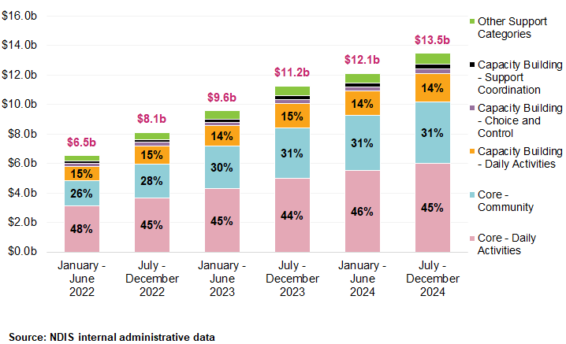

Participants
Figure 35 and Figure 36 illustrate the growth in plan-managed participants and payments over the three years to December 2024. The proportion of participants who are plan-managed increased from 36% to 46%, while the proportion of total Scheme payments processed by plan managers grew from 47% to 61% over the same period.
This increase in participants with plan-management support aligns with the broader trends presented in Table 31, where the number of plan-managed participants grew by 12.1% the six months to December 2024. It also corresponds with changes in the type of support payments being processed by plan managers, as shown in Table 32 and Table 33. The data suggests registered plan managers are overseeing a larger share of both participant budgets and a broader range of supports accessed.

Figure 35: Distribution of Participants (by Payments Made) by Plan Management Type, January 2022 to December 2024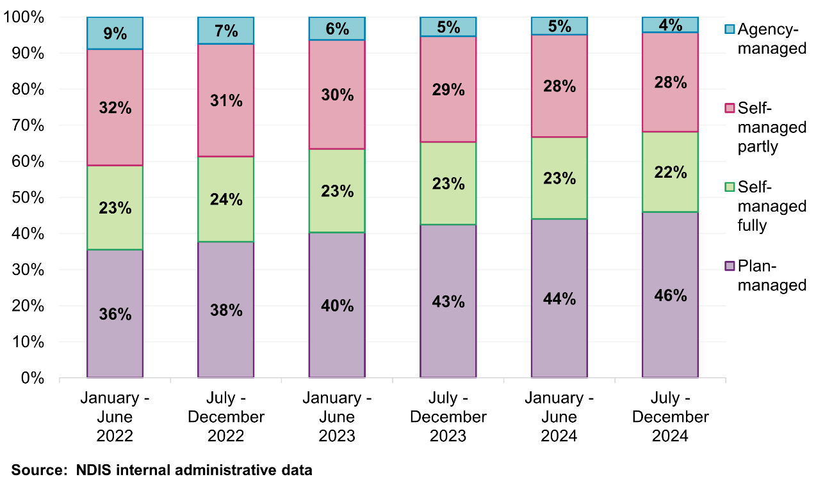
Note: Management type of the participants is determined by the payment management type and is consistent with the Quarterly Report to Disability Ministers.
“Agency-managed” participants refer to participants with only agency-managed payments during the period. “Self-managed partly” participants refer to participants with self-managed payments as well as either agency-managed and/or plan-managed payments during the period. “Self-managed fully” participants refer to participants with only self-managed payments during the period. “Plan-managed” participants refer to participants with only plan-managed payments and those with agency-managed payments during the period.
Proportion of fully plan-managed has been increasing from 66% in January – June 2022 to 79% in July-December 2024.

Figure 36: Distribution of Payments (by Payments Made) by Plan Management Type, January 2022 to December 2024
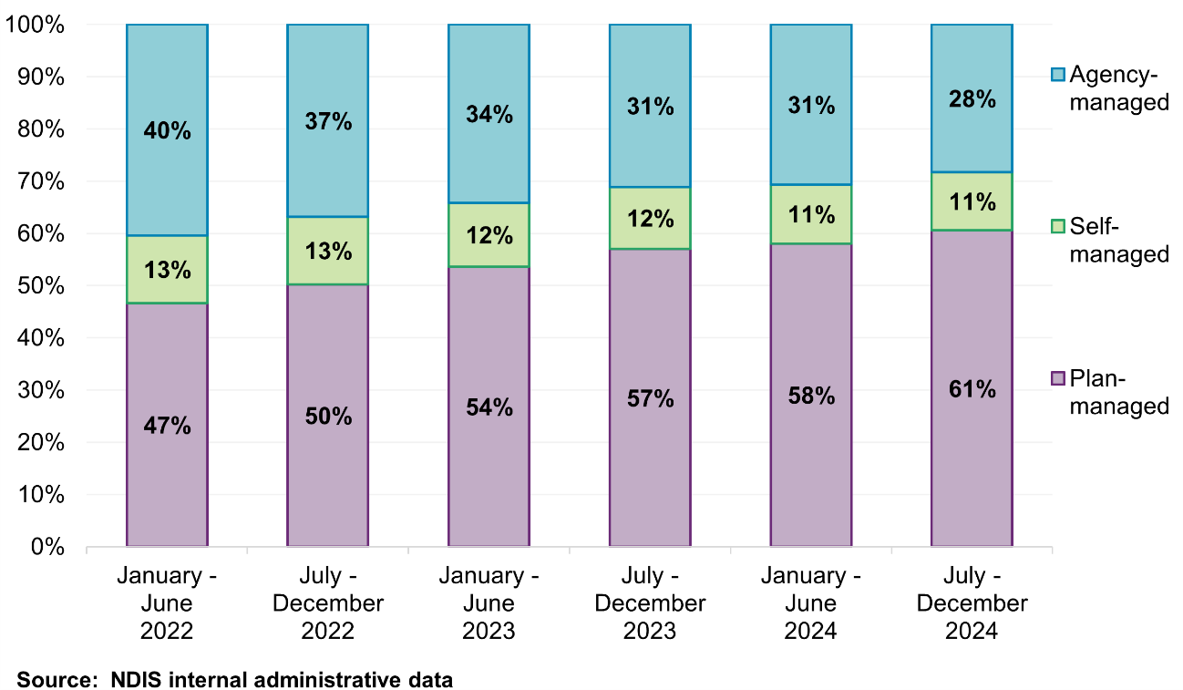
Note: Management type is determined by the payment management type. Payment type can only either be agency-managed, plan-managed or self-managed. Therefore, there is no mixed payment type, in contrast to participants in Figure 35.

Participants with plan managers by remoteness
The use of plan managers amongst participants has grown rapidly in remote areas, with numbers more than doubling from 3,596 to 8,099 participants during the period January 2022 to December 2024. Similarly, very remote areas also experienced solid growth over the past three years (Table 34). This growth has occurred alongside rising market concentration, with the same top 10 providers now accounting for over one-third of plan-managed payments in these regions (Table 35).
Table 34: Participants count by Remoteness for plan management supports, January 2022 to December 2024
Remoteness | January – June  2022 | July – December 2022 | January – June  2023 | July – December 2023 | January – June  2024 | July – December 2024
Non-remote | 288,083 | 322,304 | 357,938 | 392,777 | 409,801 | 440,224
Remote | 3,596 | 4,028 | 4,487 | 4,789 | 7,886 | 8,099
Very remote | 2,497 | 2,817 | 3,090 | 3,266 | 3,518 | 3,767
Overall | 293,878 | 328,823 | 365,080 | 400,436 | 418,052 | 448,986
Source: NDIS internal administrative data.
Note: Participants can be counted in more than once if they have moved locations. Participants with missing remoteness are not shown in the table above but are included in the overall results.

Providers
While the use of plan managers has continued to rise, the number of active registered plan managers has remained relatively stable. Between January 2022 and December 2024, the number of registered plan managers decreased by 5.4%, from 1,717 plan managers to 1,624 plan managers (Figure 37). Over the same period, the number of participants with partly or fully plan-managed funding increased by 53%, from 293,878 to 448,986.
Figure 37: Distribution of Participants and Providers with a Plan Manager, January 2022 to December 2024
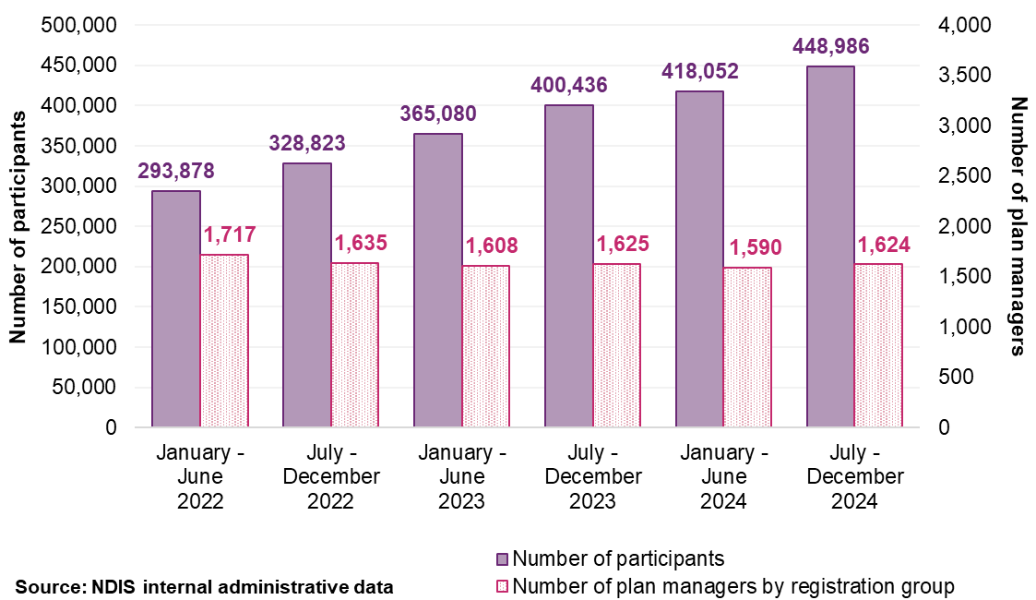

This trend is confirmed by payment data. Figure 38 shows that the five largest plan managers processed a combined $4.2 billion in total payments processed for participants in the six months to December 2024, up from $1.7 billion in early 2022. The composition of the top five has remained largely stable since mid-2023, indicating a period of market stability amongst the largest plan managers. This group of providers accounts for a substantial and growing share of all plan-managed payments, highlighting the role of large, scaled organisations in servicing the majority of the market.

Together, these indicators reflect a shift toward consolidation within the plan management market, with larger providers absorbing much of the growth in demand. These patterns raise important considerations for pricing, particularly in relation to economies of scale, cost structures, and the implications for smaller providers operating with lower participant volumes.
Figure 38: Scheme Expenditure for Largest Five Plan Managers (based on Total Payments processed), January 2022 to December 2024
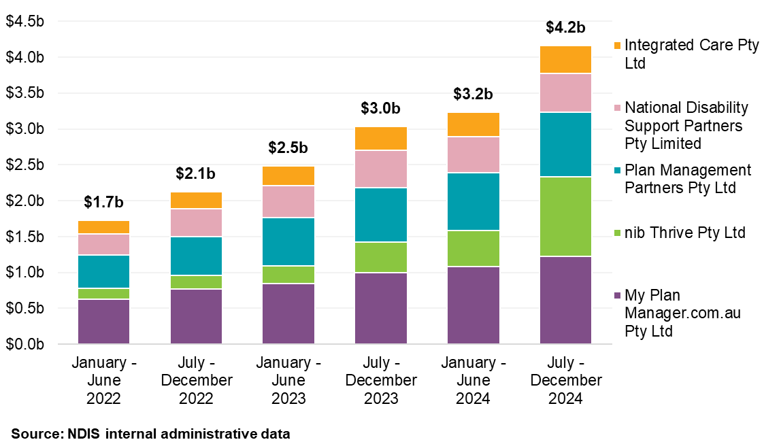
Note: The largest five plan managers are based on total payments from January 2022 to December 2024. This group has remained unchanged since January-June 2023. In 2022, Leap In! Australia Ltd was in the top 5 and nib Thrive was not represented in this group.

Top 10 providers market share by remoteness
The increasing market share held by the top 10 plan managers across all remoteness areas suggests that market consolidation is no longer confined to metropolitan regions (Figure 39). In non-remote areas, the top 10 plan management providers accounted for 41% in the second half of 2024. In remote areas, their market share rose from 27% to 38% between 2022 and 2024, the largest proportional increase of any region. Very remote areas saw a smaller but still notable increase, from 22% to 27% over the same period.
This growth has occurred without significant turnover in the provider base: the same 10 plan managers have maintained their position across the reporting period. These results indicate that large, established providers are now delivering plan management services at scale across all parts of the country, including in regions that have historically required additional pricing support. This is an interesting finding given many plan managers are now operating virtually, rather than providing the more traditional face to face supports.
Figure 39: Top 10 providers market share by Remoteness, January 2022 to December 2024
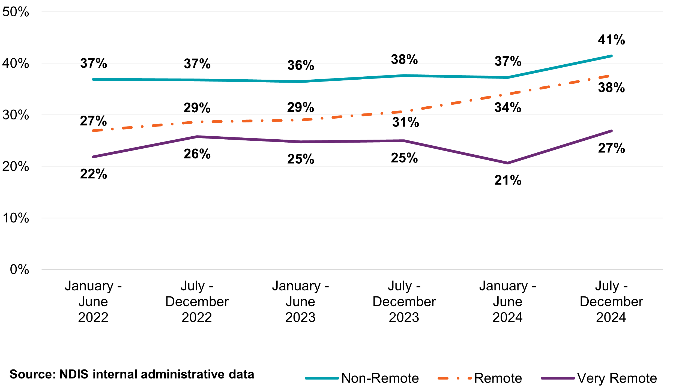
Note: Top 10 providers are determined by total payment processed by the plan managers.

Providers by remoteness
The number of active plan managers increased across all areas between January 2022 and December 2024, with remote and very remote regions growing by 49% and 46% respectively. In contrast, non-remote areas grew by just 15% (Table 35).
This growth suggests that plan managers, particularly large providers, are increasingly capable of servicing participant across all geographic settings. Combined with rising market share for the top 10 providers, these trends indicate that geographic barriers to entry may be diminishing. This has implications for the continued need for remote loadings or location-based pricing adjustments.

Table 35: Active Plan Managers by Remoteness, January 2022 to December 2024
Remoteness | January – June  2022 | July – December 2022 | January – June  2023 | July – December 2023 | January – June  2024 | July – December 2024
Non-remote | 1,190 | 1,262 | 1,278 | 1,325 | 1,356 | 1,373
Remote | 213 | 227 | 247 | 261 | 320 | 317
Very remote | 123 | 137 | 155 | 165 | 172 | 179
Overall | 1,192 | 1,268 | 1,285 | 1,332 | 1,362 | 1,377
Source: NDIS internal administrative data.
Note: Remoteness of plan managers uses participants’ address as a proxy. Plan managers may be counted more than once if they provide support to participants located in multiple remoteness location. This means that the rows will not add up to the totals. Missing remoteness are not shown in the table above but included in the overall results.

Providers by entity types
Entities in the plan management market include companies, sole traders, partnerships, government entities and superannuation trusts/super funds (trusts/supers). The plan management market is overwhelmingly dominated by companies, which account for 74% of active plan management providers and support 398,000 participants, more than 85% of the total participant count who are accessing plan management supports. These plan management companies claimed $279.2 million in plan management fees, with an average of $0.3 million per provider.
By contrast, sole traders and other entities like partnerships and trusts process far smaller volume of payments. For example, the 216 sole traders collectively supported 22,730 participants and claimed $15.7 million in plan management fees, averaging only $0.1 million per provider. See Table 36 for further breakdown.

Table 36: Plan Managers Scheme Statistics by Legal Entity Type for the period of July to December 2024
Statistics | Company | Government Entity | Partnership (Other) | Trust / Super | Sole trader
Number of NDIS participants | 398,131 | 690 | 9,927 | 23,392 | 22,730
Number of active providers | 1,026 | 8 | 33 | 94 | 216
Total amount claimed by active providers (including management fee) (million) | $11,839.1 | $12.2 | $294.5 | $752.4 | $555.6
Average amount claimed as plan management fee (million) | $11.5 | $1.5 | $8.9 | $8.0 | $2.6
Total amount claimed by active providers as plan management fee (million) | $279.2 | $0.3 | $6.9 | $17.2 | $15.7
Average amount claimed as plan management fee (million) | $0.3 | $0.0 | $0.2 | $0.2 | $0.1
Source: NDIS internal administrative data.

Business Dynamism
This section examines the activity and changes within the market for plan management supports. Business dynamism refers to the rate at which new providers enter the market and existing providers exit. This is one of many indicators that reflect a market’s health, competitiveness, and its capacity to innovate and meet participants’ needs. The NDIA reviewed the payment activities of providers over a three-year period from January 2022 to December 2024.

Provider continuity by provider size
The plan management market is characterised by high continuity and low turnover. As shown in Figure 40, 92.8% of all plan-managed payments between January 2022 and December 2024 were processed by providers who were active across all six half-year periods. These 854 providers represent a stable, established core of the plan management market.

In contrast, providers active for only one or two half-year periods accounted for less than 1% of total payments (444 plan managers). This suggests that new or intermittent provider contributed little to overall service delivery.
Figure 40: Plan Managers continuity by percentage of total payments, January 2022 to December 2024
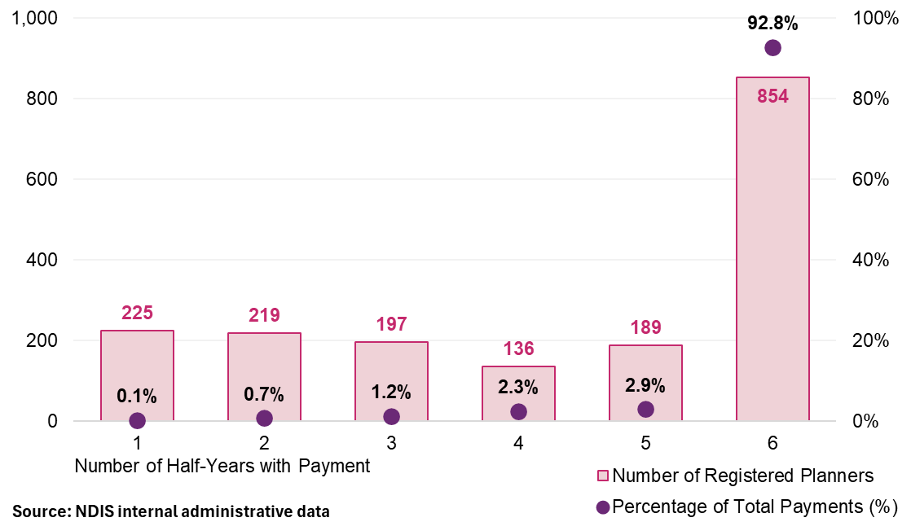
Provider turnover in the plan management market remains low. Across the three-year period, newly active providers accounted for between 0.1% and 0.9% of total plan-managed payments in any given half-year period. Similarly, inactive providers (those potentially exiting the market or claiming episodically) consistently represented less than 1% of payments from the prior period (Figure 41).
These findings confirm that dominant providers are well-established, and most market activity is delivered by a stable cohort of continuing providers.

Figure 41: Registered Plan Manager Activity Movements, January 2022 to December 2024
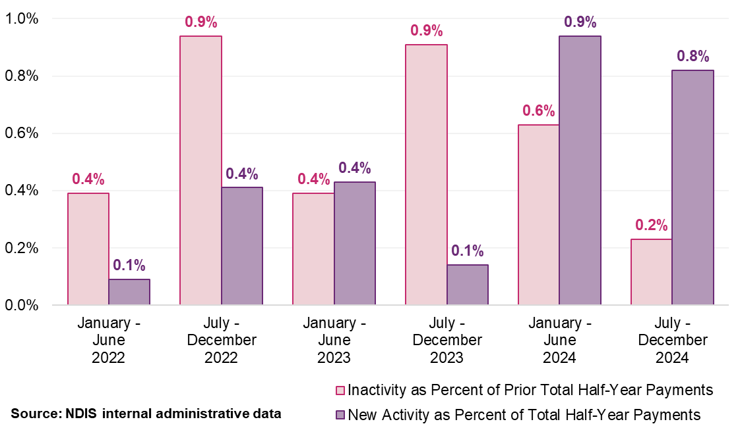
Note: ‘New activity’ is characterised by providers receiving payments in the half-year who did not receive payments in the preceding half-year. Conversely, ‘inactivity’ refers to providers not receiving payments in a half-year after having received payments in the previous one. Each provider’s activity is quantified as a percentage of the total payments within that half-year for new activity, of the prior half-year for inactivity.
Plan managers appear to be operating at scale, that is supporting 20 or more participants. In the second half of 2024, 99.3% of all plan-managed payments were processed by providers supporting more than 20 participants (Figure 42). This share has remained consistently high since 2022, rising slightly from 99%.
In contrast, small-scale providers, those supporting 10 or fewer participants, make up a significant share of the provider count but account for less than 0.5% of total payments. This pattern has remained stable over the three-year period, indicating that small-scale providers are not gaining market share.

Figure 42: Plan Management Providers and Number of Participants that Claimed, January 2022 to December 2024
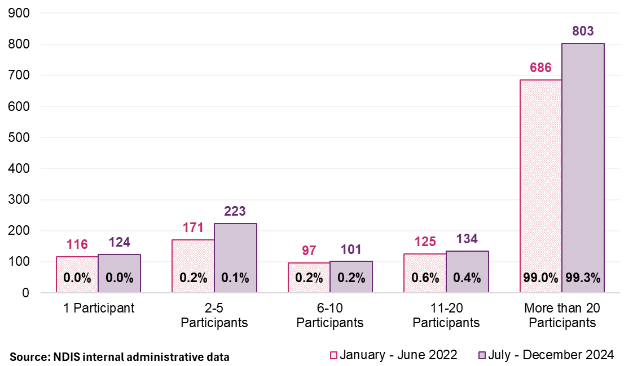

Plan managers providing other services
While 66% of plan managers delivered other supports to their plan-managed participants in the second half of 2024, these services accounted for only 4% of total plan-managed payments, down from 73% in early 2022 (Figure 43). This suggests that most plan managers obtain most of their payments from plan management services alone.
At the same time, the share of providers claiming for only plan management services has increased from 27% to 34%, indicating a gradual shift toward specialisation (Figure 44).
The delivery of both financial oversight and funded supports by the same provider can create a conflict of interest, which may undermine the integrity of plan management, regardless of scale.

Figure 43: Number of Plan Managers claiming other services for their plan managed participants for the period, January 2022 to December 2024
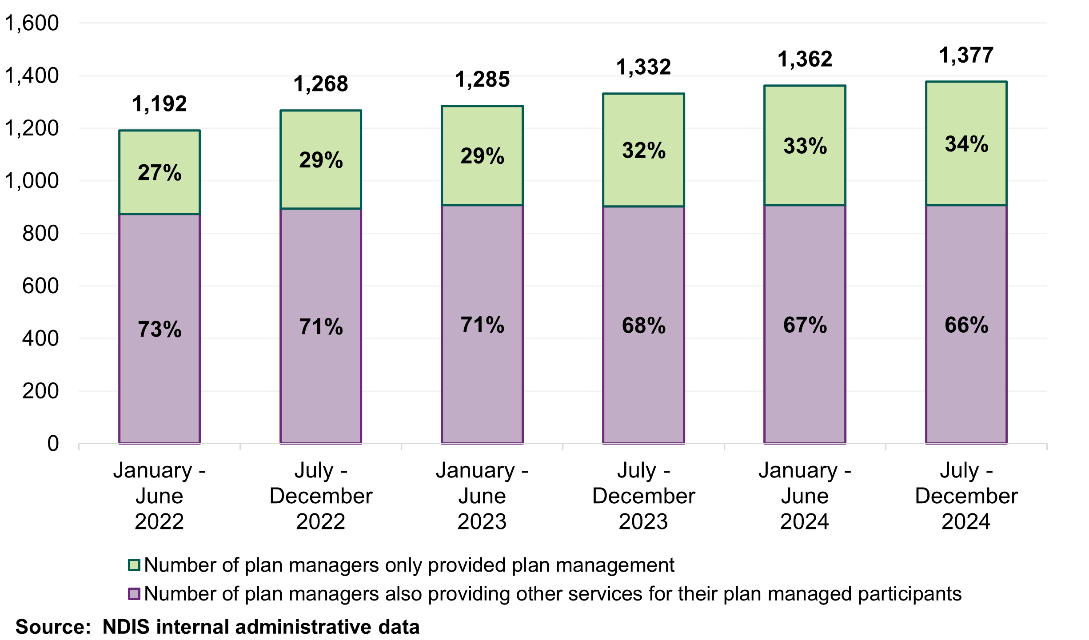
Figure 44: Payment of Plan Managers claiming other services for their plan managed participants for the period, January 2022 to December 2024
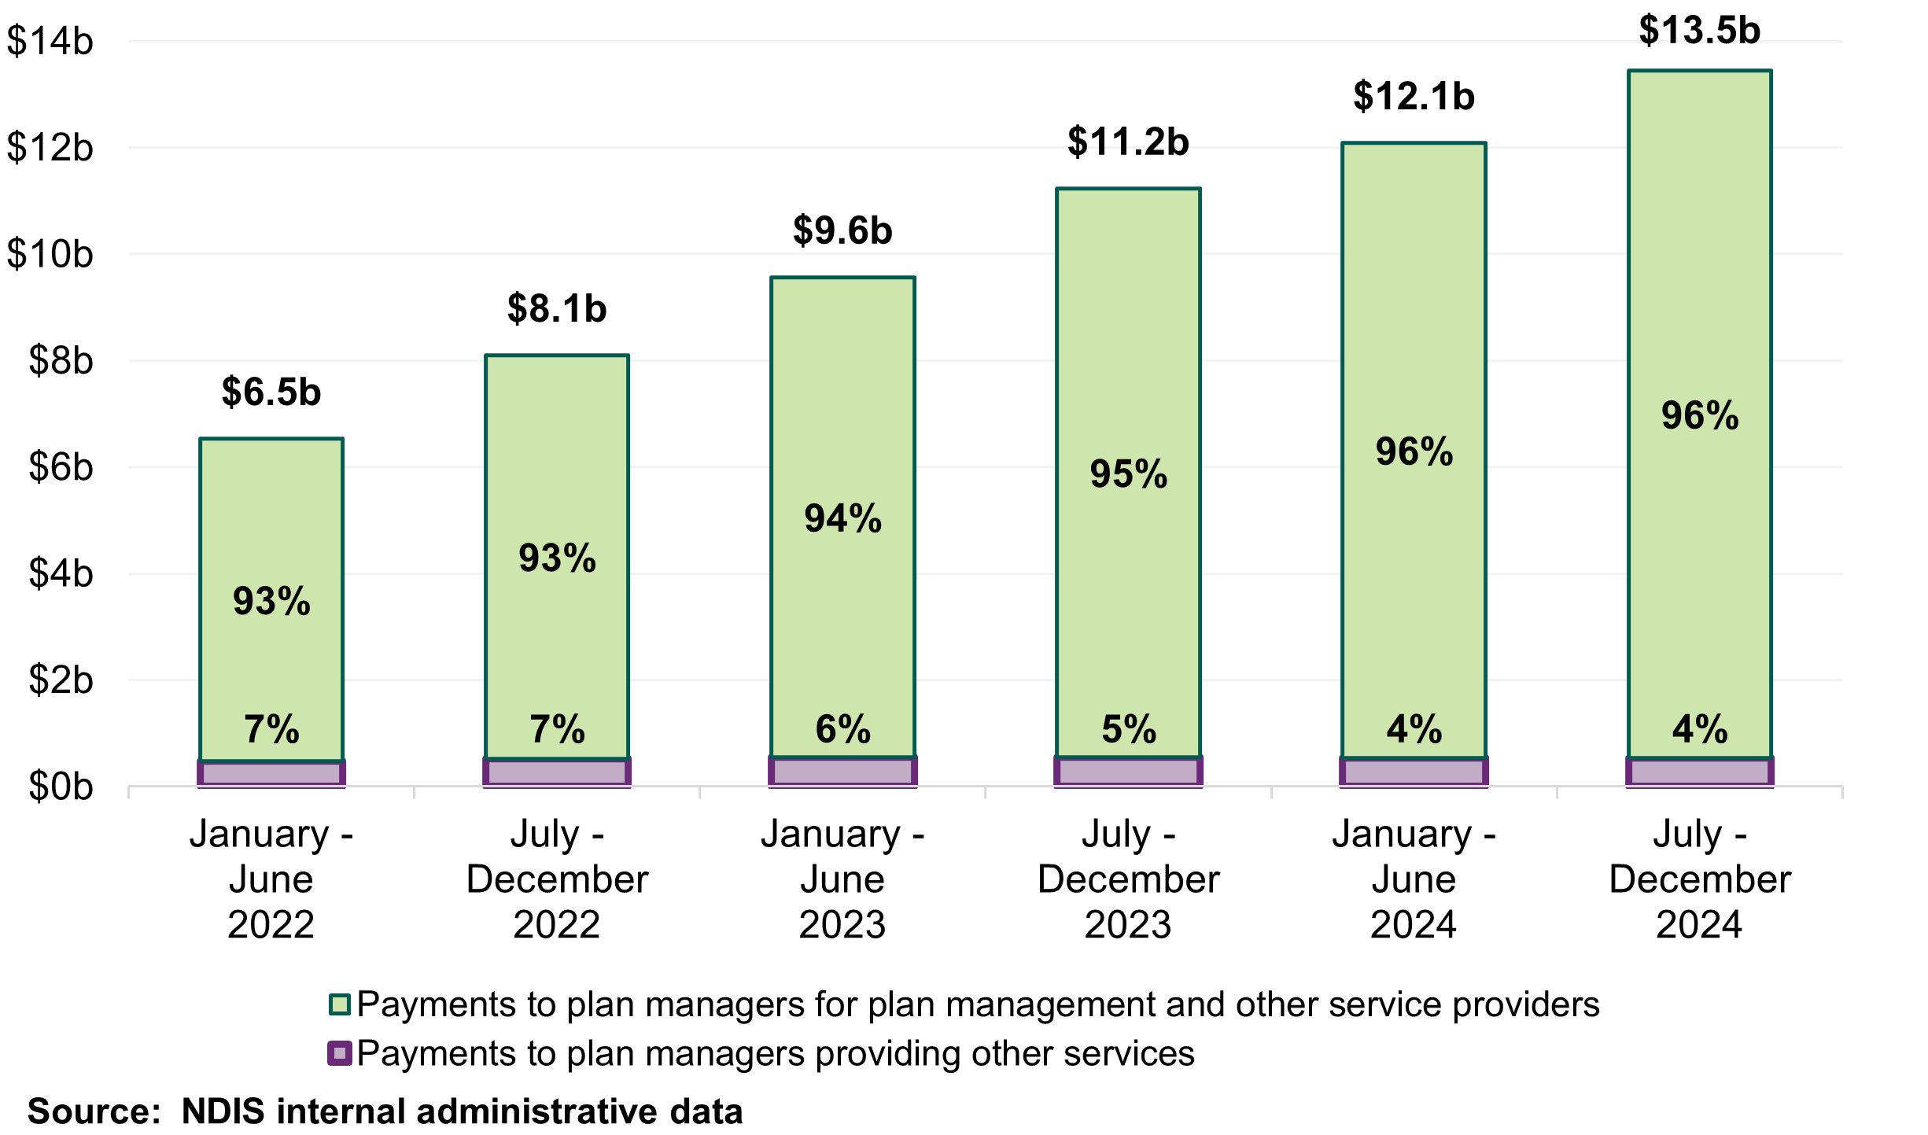

Discussion
The current pricing approach for plan management includes a one-off establishment fee, designed to cover the administrative cost of setting up financial arrangements for each new plan, and reflect any regional loadings that are intended to support service delivery in rural and remote areas. Market data indicates that both components are becoming misaligned with how services are delivered today.
The establishment fee assumes an administrative process at the start of each plan which could involve a face-to-face meeting. However, feedback from participants suggests that the face-to-face meeting has rarely occurred at all given most plan managers operate virtually. In a mature market where most plan managers already support high volumes of ongoing participants, the marginal cost of establishing new financial arrangements is low and therefore should be integrated into routine operations. This appears to be the case with the majority of Plan Managers showing minimal turnover, as between January 2022 and December 2024, 92.8% of plan-managed payments were processed by providers active in every half-year period.
Since January 2022, there has been a significant drop in the proportion of participants’ where set up costs are claimed from their NDIS plans, decreasing from 52.1% to 29.9% in the most recent half year period to December 2024. This is a likely flow-on from auto-extension of participant plans in recent years. Auto-extended plans are not new plans so plan managers are not entitled to make another claim for set up costs from a plan when it is auto-extended. Additionally, as more NDIS participants transition to the new PACE system, there is less need for work related to service bookings, specifically setting up payments for support to participants and adjustments to service bookings throughout a participant’s plan.
Similarly, the case for applying remote and very remote loadings has weakened over time. The number of plan-managed participants in remote areas has more than doubled since 2022, and the top 10 providers now account for up to 38% of plan managed payments in remote regions. This suggests that large-scale providers are servicing remote areas efficiently, and that a virtual service delivery for plan management services is increasingly the norm. Provider counts in remote areas have also grown significantly, which suggests that the barrier for service delivery to remote areas has decreased over time.
These shifts have occurred alongside a gradual move of providers of plan management towards specialisation. While 66% of plan managers still claim for other supports, these claims make up just 4% of total plan-managed payments. The share of providers offering only plan management has increased from 27% to 34%, indicating a clearer delineation between administrative and service delivery roles. In this context, the integrity of financial oversight becomes central – and is best supported by a pricing approach that is simple, consistent and focused on efficiency.

Recommendations
Most providers now operating at scale, with 99.3% of plan-managed payments delivered by providers supporting more than 20 participants. This suggests administrative efficiency, and the monthly fee remains appropriate and sufficient for the ongoing delivery of these functions. Analyses in the chapter suggest that the plan management market has stabilised over time.
Recommendation 15:
The NDIA should maintain the current monthly fee for plan management. This applies to support item 14_034_0127_8_3 – Financial Administration of Plan Management, priced at $104.45 per month.
The establishment fee was intended to cover the administrative setup required at the start of each new plan. However, the majority of plan managers now support ongoing participants across multiple plans, and most are well-established, high-volume providers operating virtually. When also considering the transition to PACE, the administrative cost associated with each new plan becomes minimal and should be absorbed as part of the monthly fee if participants do request a set up meeting. Removing this item simplifies the pricing approach, aligns payment with actual service delivery, and ensures that participant funds are directed toward ongoing financial oversight and support.
Recommendation 16:
The NDIA should remove the one-off establishment fee for plan management effective from 1 July 2025. This applies to support item 14_033_0127_8_3 –Plan Management - Set Up Costs, which is currently priced at $232.35.
Remote and Very Remote loadings were intended to address concerns on costs and access barriers in thin markets. However, plan management is now generally able to be delivered at scale across all geographies virtually. The number of participants in remote and very remote areas has more than doubled since 2022, and the top 10 providers now account for 38% of payments in remote regions.
These providers operate nationally and efficiently, suggesting a virtual operation has become the norm. Removing the loadings supports a simpler, fairer pricing model that reflects actual service delivery and aligns with the NDIA’s pricing principles.
Recommendation 17:
The NDIA should remove remote and very remote loadings for plan management monthly fees, effective from 1 July 2025, and apply a consistent national price. This applies to support item 14_034_0127_8_3 Plan Management - Monthly Fee.

Appendix A: DSW Cost Model Detailed Breakdown
The NDIA uses the Disability Support Worker Cost Model (DSW Cost Model) to estimate the cost that a reasonably efficient provider would incur in delivering a billable hour of support. Its primary aim is to ensure that pricing reflects the cost-of-service delivery.

Parameters of the DSW Cost Model
In 2022, the NDIA simplified the DSW Cost Model. The simplification was prompted by a recognition that the model’s specificity could inadvertently encourage rigid adherence to its parameters as de facto targets, potentially restricting innovation, and adaptability of providers. By consolidating the cost categories into direct worker employment costs, operational overheads, and corporate overheads, the NDIA aimed to reflect the nuanced ways providers manage their resources. The current parameters of the cost model are outlined below:
- Base salary and shift loadings: The cost model is based on permanent worker costs. These are linked to Social, Community, Home Care and Disability Services Industry Award 2010 (SCHADS Award) wage levels 2.3, 2.4/3.1, 3.2 and 4.4.
- Direct on-costs: Includes Superannuation entitlements (currently 11.5%, 12% from 1 July 2025), Annual Leave entitlements (20 days), Personal Leave entitlements including domestic and family violence leave (10.3 days), Long Service Leave entitlements (4.3 days), and Employee Allowances.
- Operational overheads: Covers supervision, quality and safeguarding, training, and workforce rostering costs, alongside provisions for utilisation rates and the mix of permanent versus casual staff and the extent to which overtime is utilised.
- Corporate overheads: Accounts for essential business functions such as accounting, human resources, information technology, legal, and marketing.
- Margin: Which represents the return that the provider makes because of the provision of working capital to the business.
The DSW Cost Model is driven by the relevant SCHADS Award wage movements, operates on a multiplicative basis where operational and corporate overheads, as well as profit margins, are determined as a percentage of the direct costs, including wages and on-costs. Any changes in the wage rates directly affects the entire model’s cost structures.
In setting NDIS price limits for DSW related supports, the model is an important approximation, considered alongside market dynamics, award conditions, and regulatory requirements such as minimum wages and superannuation contributions.

Applicable industrial award
The NDIA recognises that some DSWs are classified as Home Care Employees and others are classified as Social and Community Services Employees under the SCHADS Award. The Cost Model take its parameters from the Social and Community Services Employees section for the SCHADS Award, which has the more generous provisions. The NDIA also recognises that some Disability Support Workers are employed under Enterprise Bargaining Agreements (E B As). However, these E B As must leave the worker no worse off overall than they would be under the relevant Award. Any additional benefits offered by E B As over the Award have been agreed to by providers and are often offset by productivity gains. The NDIA therefore considers the conditions set out in the Social and Community Services Employees section of the SCHADS Award to be the most appropriate foundation for the DSW Cost Model.
The NDIA recognises that providers must employ Disability Support Workers with different skill levels and levels of experience to meet the different needs of participants. The Cost Model therefore has different sets of cost assumptions for four types of workers that will be referred to as DSW Level 1, DSW Level 2, DSW Level 3 and DSW Level 4.

Appendix B: Details of Medicare Benefits Schedule (MBS) and Private Health Insurance (P H I) implied hourly price rate conversions
Table 37: MBS & P H I session fees with corresponding reference times for conversion to an hourly rate
Therapy | Source | Session fee:  25th | Session fee:  Median | Session fee:  75th | Session minutes:  25th | Session minutes:  Median | Session minutes:  75th | Hourly rate:  25th | Hourly rate:  Median | Hourly rate:  75th | NDIS Limit
Psychology (WA/SA/NT/Tas) | PHI | $191.0 | $215.0 | $236.0 | 60.0 | 60.0 | 60.0 | $191.0 | $215.0 | $236.0 | $244.22
Psychology (WA/SA/NT/Tas) | MBS | $188.9 | $226.0 | $240.0 | 60.0 | 60.0 | 60.0 | $188.9 | $226.0 | $240.0 | $244.22
Psychology (NSW/VIC/QLD/ACT) | PHI | $194.0 | $220.0 | $247.0 | 60.0 | 60.0 | 60.0 | $194.0 | $220.0 | $247.0 | $222.99
Psychology (NSW/VIC/QLD/ACT) | MBS | $191.9 | $231.0 | $251.0 | 60.0 | 60.0 | 60.0 | $191.9 | $231.0 | $251.0 | $222.99
Speech Pathology | PHI | $98.0 | $124.0 | $162.0 | 40.7 | 45.0 | 51.2 | $144.4 | $165.3 | $189.7 | $193.99
Speech Pathology | MBS | $96.0 | $145.0 | $194.0 | 42.0 | 50.0 | 58.0 | $137.3 | $174.0 | $200.5 | $193.99
Occupational Therapy | PHI | $100.0 | $112.0 | $133.0 | 42.8 | 45.0 | 48.9 | $140.3 | $149.3 | $163.1 | $193.99
Occupational Therapy | MBS | $90.0 | $125.0 | $192.5 | 33.5 | 40.0 | 52.6 | $161.3 | $187.5 | $219.6 | $193.99
Audiology | PHI | $129.1 | $129.1 | $130.0 | 45.0 | 45.0 | 45.2 | $172.2 | $172.2 | $172.5 | $193.99
Audiology | MBS | $58.0 | $58.3 | $120.0 | 29.9 | 30.0 | 44.7 | $116.3 | $116.6 | $161.2 | $193.99
Dietetics | PHI | $103.0 | $127.0 | $153.0 | 44.0 | 50.0 | 56.5 | $140.6 | $152.4 | $162.3 | $193.99
Dietetics | MBS | $58.0 | $58.3 | $88.3 | 29.9 | 30.0 | 37.6 | $116.3 | $116.6 | $141.1 | $193.99
Podiatry | PHI | $80.0 | $89.0 | $102.0 | 27.7 | 30.0 | 33.4 | $173.5 | $178.0 | $183.4 | $193.99
Podiatry | MBS | $58.0 | $58.3 | $75.0 | 29.9 | 30.0 | 34.3 | $116.3 | $116.6 | $131.1 | $193.99
Physiotherapy (WA/SA/NT/Tas) | PHI | $78.0 | $90.0 | $104.0 | 43.5 | 45.0 | 46.8 | $107.6 | $120.0 | $133.4 | $224.62
Physiotherapy (WA/SA/NT/Tas) | MBS | $58.3 | $58.3 | $79.0 | 30.0 | 30.0 | 32.6 | $116.6 | $116.6 | $145.3 | $224.62
Physiotherapy (NSW/VIC/QLD/ACT) | PHI | $88.0 | $102.0 | $118.0 | 43.2 | 45.0 | 47.0 | $122.2 | $136.0 | $150.5 | $193.99
Physiotherapy (NSW/VIC/QLD/ACT) | MBS | $58.3 | $58.3 | $90.0 | 30.0 | 30.0 | 34.0 | $116.6 | $116.6 | $158.7 | $193.99
Exercise Physiology | PHI | N/A | N/A | N/A | N/A | N/A | N/A | N/A | N/A | N/A | N/A
Exercise Physiology | MBS | $58 | $58 | $88 | 29.9 | 30.0 | 37.6 | $116.3 | $116.6 | $140.8 | $166.99
Source: NDIA calculations from Medicare Benefits Scheme (MBS) and Private Health Insurance (PHI) data
Note: Rounding was applied in the presentation of results.

Appendix C: Summary of website price listing dataset
The 2024-25 sample included at least 50 price observations obtained for each therapy (except audiology). In total, 698 price points were obtained from provider websites. The sample had representation across states and territories, as well as regionality – although observations for certain therapies in the smaller states were difficult to obtain. Each private billing rate observation was converted to effective hourly rates based on the length of consultation offered. Note, prices for weekend, initial consultations and telehealth consultations were excluded from the dataset.
Table 38 displays the number of observations for each corresponding type of therapy captured in the website price listing dataset.
Table 38: FY24-25 Number of Observations of Website Listings by Therapy Type
Therapy | Number of observations
Psychology | 116
Speech Pathology | 77
Occupational Therapy | 50
Audiology | 21
Dietetics | 50
Podiatry | 57
Physiotherapy | 165
Social Worker | 50
Counselling | 50
Exercise Physiology | 62
Total | 698
Figure 45 displays the NDIS price limit relative to the website price listings data for the relevant therapist, compared to the median and the spread of the sampled price listings. Results show that the annual average growth in prices, across all therapies, from the 2023-24 sample to the 2024-25 sample was 7.7%.

Figure 45: Website price listings (25th, 50th and 75th percentile) compared to applicable NDIS price limits
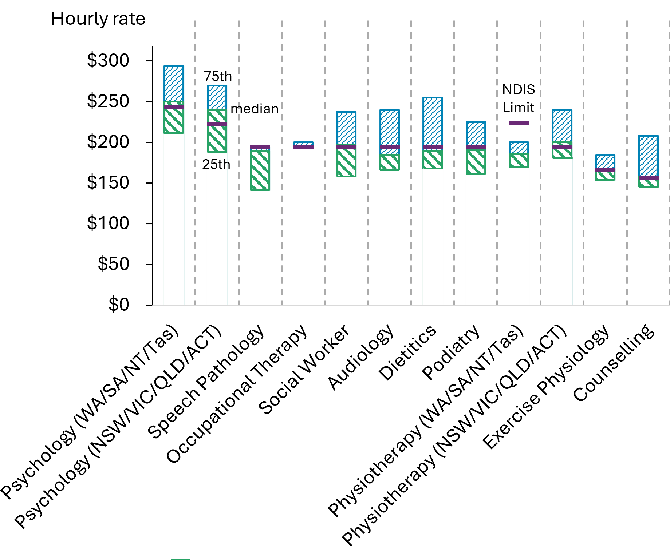

The Treasury. (2025). Budget 2025–26: Budget Paper No. 1: Budget Strategy and Outlook. https://budget.gov.au/content/bp1/download/bp1_2025-26.pdf
Australian Bureau of Statistics. (2025). Australian National Accounts: National Income, Expenditure and Product, December 2024. https://www.abs.gov.au/statistics/economy/national-accounts/australian-national-accounts-national-income-expenditure-and-product/dec-2024
The Treasury. (2025). Budget 2025–26: Budget Paper No. 1: Budget Strategy and Outlook. https://budget.gov.au/content/bp1/download/bp1_2025-26.pdf
Australian Bureau of Statistics. (2025). Consumer Price Index, Australia, March Quarter 2025. https://www.abs.gov.au/statistics/economy/price-indexes-and-inflation/consumer-price-index-australia/mar-quarter-2025
Reserve Bank of Australia. (2025). Statement on Monetary Policy – May 2025. https://www.rba.gov.au/publications/smp/2025/may/
Australian Bureau of Statistics. (2025). Consumer Price Index, Australia, March Quarter 2025. https://www.abs.gov.au/statistics/economy/price-indexes-and-inflation/consumer-price-index-australia/mar-quarter-2025
Australian Bureau of Statistics. (2025). Labour Force, Australia, April 2025. https://www.abs.gov.au/statistics/labour/employment-and-unemployment/labour-force-australia/ apr-2025
ibid
The Treasury. (2025). Budget 2025–26: Budget Paper No. 1: Budget Strategy and Outlook. https://budget.gov.au/content/bp1/download/bp1_2025-26.pdf
ibid
Australian Bureau of Statistics. (2025). Labour Force, Australia, Detailed, February Quarter 2025. https://www.abs.gov.au/statistics/labour/employment-and-unemployment/labour-force-australia-detailed/feb-2025#data-downloads
ibid
ibid
Australian Bureau of Statistics. (2025). Job Vacancies, Australia, February 2025. https://www.abs.gov.au/statistics/labour/jobs/job-vacancies-australia/feb-2025
Jobs and Skills Australia. (2025). Internet Vacancy Index, February 2025. https://www.jobsandskills.gov.au/data/internet-vacancy-index#downloads
Jobs and Skills Australia. (2025). Jobs and Skills Atlas, January 2025. https://www.jobsandskills.gov.au/jobs-and-skills-atlas
Jobs and Skills Australia. (2024). Employment Projections, May 2024 - May 2034. https://www.jobsandskills.gov.au/data/employment-projections
ibid
ibid
Australian Bureau of Statistics. (2025). Wage Price Index, Australia, March 2025. https://www.abs.gov.au/statistics/economy/price-indexes-and-inflation/wage-price-index-australia/mar-2025
The Treasury. (2025). Budget 2025–26: Budget Paper No. 1: Budget Strategy and Outlook. https://budget.gov.au/content/bp1/download/bp1_2025-26.pdf
Australian Bureau of Statistics. (2025). Wage Price Index, Australia, March 2025. https://www.abs.gov.au/statistics/economy/price-indexes-and-inflation/wage-price-index-australia/mar-2025
ibid
Work Value Case – Nurses and Midwives, Fair Work Commission
Information can be found on the FWC website and Department of Health and Aged Care website
Data analysis of registered provider payment activity by the NDIA includes payments made against agency managed plans, which are attributed to registered providers, and payments for plan management services. Providers with an unclear status at the time of transaction or those providing an invalid ABN have been excluded from this analysis.
Data analysis of registered provider payment activity by the NDIA includes payments made against agency managed plans, which are attributed to registered providers, and payments for plan management services. Providers with an unclear status at the time of transaction or those providing an invalid ABN have been excluded from this analysis.
This percentage does not include participants who are partly self-managed and partly plan-managed.

