


School leaver employment support
Provider reported services & outcomes
July 2023 to June 2024

Report produced March 2025
Market Strategy Branch

ndis.gov.au

Sky’s story


It took Sky Grace 2 hours to land a barista job at McDonald’s McCafé in her hometown.
Sky thought she was starting 2 weeks of work experience, but after proving herself in the fast-paced environment she was hired before her first shift had ended.
‘I couldn’t believe it. I was so happy. Then that week the manager called to give me my shifts for the next few weeks. I thought wow, okay,’ Sky recalled with a smile.
Now a valued McCafé team member, Sky, who has Fragile X, an intellectual disability and autism, is employed part-time to do regular paid shifts.
Sky used the employment assistance funding included in her National Disability Insurance Scheme (NDIS) plan to build her skills for work and to find a job.
Sky credits her success to the support she received from Jess, her employment consultant at local NDIS employment provider are-able.
‘We’ve been working together for just over a year now and Jess has helped me so much,’ Sky said. ‘She’s helped me to build my confidence and skills, and I wouldn’t be where I am today without her,’ Sky added.
Jess works with people with disability to overcome employment barriers and to identify suitable job options, so she worked with Sky to understand her interests, skills, strengths, weaknesses, likes and dislikes.
While Jess supported Sky to try different roles through work experience, Sky decided she preferred a job in hospitality, and she needed to develop her skills to become a barista.
Knowing Sky had some experience making coffees, Jess said they talked about what Sky could already do and the additional skills she needed to ensure she could get a paid job.
Somewhat shy, Sky also wanted to build her confidence to engage with customers.

To help build Sky’s work and social skills to work as a barista, Jess set up a portable coffee cart customised to Sky’s needs. It allowed Sky to learn all aspects of the job in a safe and controlled environment.
Every Monday, Sky came in for a couple of hours to practise interacting with customers, taking orders, making coffees, taking money and working out the change,’ Jess said.

A couple of months later when Jess was confident Sky had mastered her barista skills, she reached out to McDonald’s to ask if Sky could do a 2 week work experience placement.
Much to their delight, the manager said yes. But it didn’t take long for Sky to exceed expectations.
‘After just 2 hours on her first shift, the manager turned to me and asked, “Can I keep her?” It was an incredible moment. I think we were both shocked, but Sky truly earned it.
‘McDonald’s has been fantastic,’ Jess added. ‘The staff are incredibly supportive’.
‘Sky is now thriving in a job she loves and she’s grateful for the opportunity to be part of a supportive team who are helping her to grow.’

Contents
School leaver employment support 1
Contents 4
1. Executive summary 6
1.1 Introduction 6
1.2 Employment support provider reporting 6
1.3 Report enhancements 6
1.4 Key findings 7
2. Provider and participant count 9
2.1 Provider count 9
2.2 Participant count 10
3. Participant demographics 10
3.1 Employment support recipients 10
3.2 Location 11
3.3 Primary disability 11
3.4 Age 12
3.5 Gender 12
3.6 Aboriginal or Torres Strait Islanders Status 12
3.7 Culturally and Linguistically Diverse status 13
4. Supports & milestones 14
4.1 Support type hours 14
4.2 Support delivery method 15
4.3 Progress towards milestones – snapshot at each reporting period 15
4.4 Progress towards milestones – cumulative for the year 16
5. Final outcomes 19
6. Final employment outcomes 22
6.1 Employment type 22
6.2 Hours worked 23
6.3 Industry of employment 24
6.4 NDIS supports in employment 25
6.5 Supported wages 25
7. Intermediate employment outcomes 26
7.1 Employment outcomes (July 2023 to June 2024) 26
7.2 Employment type 26
7.3 Hours worked 27
7.4 Industry of employment 28
7.5 NDIS supports in employment 29
7.6 Supported wages 29
8. Model summary 30
8.1 Modelling approach 30
8.2 What helps (or hinders) finding paid employment 31
8.3 Differences in modelled predictors between reporting period ending December 2023 versus the period ending June 2024 32
9. Appendix 33
9.1 Appendix 1 – Methodology for the section titled “Progress towards milestones – cumulative for the year” 33
9.2 Appendix 2 – Model accuracy 35

Executive summary

Introduction

The Agency is committed to ensuring participants have the same opportunities to work as other Australians and the confidence, support, and skills to achieve their work goals.

The NDIS can make a significant difference for young participants by supporting them early to aspire to work, develop skills and connect to the right job role and employer.
Employment assistance is individualised support intended to build a participant’s skills, confidence, and capacity for work.

This sixth edition of the School Leaver Provider Quarterly Report analyses the early intervention employment support provided to participants of school leaving age, their progress and the outcomes they’ve achieved, allowing us to share insights on best practice and the factors that lead to successful employment outcomes.

Employment support provider reporting

Employment support providers submit data through the provider reporting tool (the tool) to the NDIA each quarter. The data submitted includes participants’ demographic details, activities, progress towards milestones, the method of delivery, outcomes achieved, and employment details. The provider confirms the details they are including, particularly the outcomes achieved, with the participant prior to submitting the report to the NDIA.

This report provides insights on the data submitted through the tool, aggregated across all Providers’ that contributed from July 2023 to June 2024.

Report enhancements

Some providers reported additional participants who were active in Q1 and Q2 2024. The additional number of participants are now included in those quarters' totals. This might result in Q3 and Q4 2023 numbers being slightly different to the same periods published in the fifth edition of the report for calendar year 2023.

We encourage participants to discuss the available information with providers when considering selecting or changing providers. Additional questions that participants can ask providers about their service are available here.

The report will feature a participant story, like Sky’s, in each release to showcase a positive employment outcome. Participants, or providers with the consent of the participant, are invited to forward stories to participant.employment@ndis.gov.au.

If you have general feedback or questions about this report, please email participant.employment@ndis.gov.au.

Key findings

The information contained in this report represents data submitted to the Agency by providers of employment assistance to school leavers delivered from July 2023 to June 2024.

For the 12 months ending June 2024, 8,527 young participants aged 15 to 24 had claimed payments for support items “school leaver employment supports” or “employment assistance” for the school leaving age group. This report includes only participants whose providers submitted data to the Agency.

In the previous report, covering the 12 months ending December 2023, the figure reported was 7,688 participants which included only those who claimed payment for school leaver employment supports.

For the period July 2023 to June 2024, providers reported:

Demographics
- 7,326 unique participants received employment assistance to support their transition from school to work of which 2,743 commenced during the year.
- Commencement varies across quarters with the highest number starting in the January to March quarter after leaving school. 630 participants commenced receiving employment supports in July to September 2023, 721 commenced in October to December 2023, 932 commenced in January to March 2024, and 460 commenced in April to June 2024.
- School leaving participants receiving employment supports in the quarter to June 2024 predominantly have autism (62%) or intellectual disability (28%), with 67% being male.
- The majority of employment support recipients are in N S W (34%), followed by V I C (22%), and Q L D (18%).
- 7% of employment support recipients identified as Aboriginal or Torres Strait Islander people. While this is slightly lower than the 9% of all NDIS participants aged 15 to 24 who identify as Aboriginal or Torres Strait Islander, this gap has been slowly closing over time.
- 7% of employment support recipients identified as being from a Culturally and Linguistically Diverse community. This is slightly higher than the 6% of all NDIS participants aged 15 to 24 who identified as being from these communities.
Time spent in training
- 47% of the training time was spent building participants social, presentation, communication and work skills.
- Participants receive supports via group-based activities (50% of support time), one to one support (48% of support time) and via distance or online methods (2%) in the latest quarter.

Exits from school leaver employment
- 2,165 participants were reported as exiting employment supports during the four quarters.
- Of the 2,165 participants who exited:
  - 61% (1,329 out of 2,165) exited without an employment outcome compared to 56% (1,033 out of 1,831) in the previous report (1 year to 31 December 2023).
  - 12% (266 out of 2,165) went on to further study or volunteer work.
  - 22% (478 out of 2,165) achieved open employment outcomes compared to 25% (464 out of 1,831) in the previous report (1 year to 31 December 2023).
  - 4% (92 out of 2,165) achieved supported employment outcomes (in A D E), and this proportion is slightly lower than the 5% (92 out of 1,831) figure from the report of December 2023.
  - 1% (14 out of 2,165) did not have an outcome reported.
- Despite the increase in open employment outcomes from 464 to 478, the total exits increased considerably from 1,831 to 2,165 which caused a reduction in the open employment outcome percentage from 25% to 22%. The likely reason for this decline is the introduction of more stringent reporting requirements, that is, all employment details (including the employment start date) must be provided for employment outcomes to be counted.
- Of the participants who achieved open and supported employment outcomes over the four quarters, 42% were employed on a part time basis while 39% were employed casually, 11% were employed full time.
- Of participants who started employment, 81% worked up to 21 hours per week.
- Of participants who finished employment support with paid employment, 70% worked in retail, hospitality, tourism, trades, manufacturing or operations.
- Of participants who finished employment support with paid employment, 29% said they will be using NDIS supports in employment to maintain their employment (an increase of 4% from the December 2023 report).
- Of participants who finished employment support with paid employment, 20% of employers said they will use supported wages for the participants’ employment.

Interventions compared to outcomes
- Increased time receiving skill specific training was associated with a higher chance of making significant progress towards or fully gaining specific skills.
- Participants who made significant progress or fully achieved the following milestones were more likely to gain paid employment:
  - Employer engagement and job customisation
  - Work skills
  - Work experience
  - Building social, presentation and communication skills
- Participants who spent more time in work experience were more likely to gain paid employment.

Note: Figures in this report have been rounded to the nearest whole percentage.

Provider and participant count

Provider count

Figure 1. Providers represented in reporting – April to June 2024
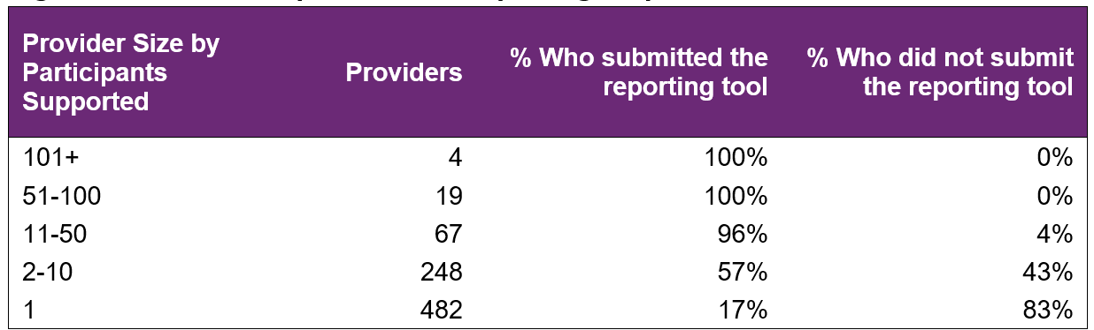
From April to June 2024 (Figure 1), there were 820 providers delivering employment support to school leavers across the country, with 23 providers delivering to 51 or more participants. 67 providers delivered services to 11 to 50 participants and 730 providers delivered supports to 10 or fewer participants. The largest 23 providers delivered support to 41% of participants and reported on them all during the year. Across all providers, data was submitted for 85% of participants.

In the current reporting period, (Figure 2), providers who have 10 or fewer participants have lower submission rates although the proportion of providers submitting data over the 4 quarters has been steadily increasing. Providers with small numbers of participants and those claiming large amounts from participant budgets continue to be the focus of further investigation.

Figure 2. Percentage of providers who submitted the reporting tool – July 2023 to June 2024
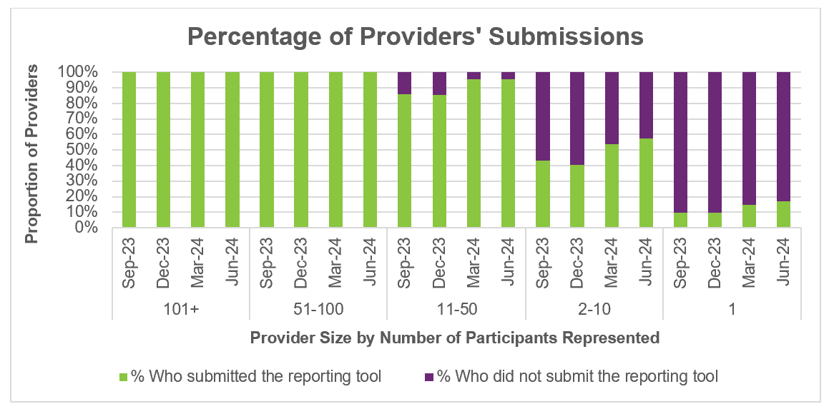

Participant count

Figure 3. Participants represented in reporting – April to June 2024
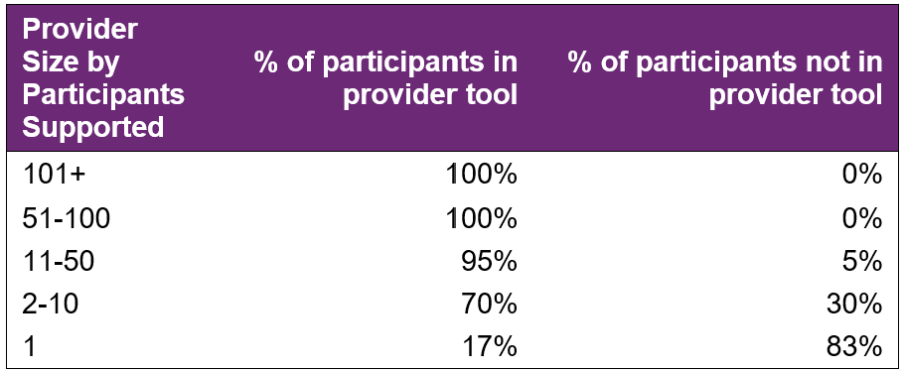
Overall, 15% of school leaving participants who received employment supports in the last quarter were not represented in the reporting submitted by providers. This number is decreasing with each report.

Participant demographics

Employment support recipients

The Provider Reporting Tool data provides information on participants receiving employment support during the year. Participants that started employment support during a previous period and continue to be recipients in the current period are included in the ‘Existing’ numbers, and those that started receiving employment support during the current period are included in the ‘New’ numbers. While participants that exited employment support during the current period are included in the ‘Exited’ numbers.

Note, if the participant exits employment support in a quarter, they will be counted in the ‘Exit’ numbers for that quarter. If that same participant re-enters employment support a few quarters later, they will be counted in the ‘New’ numbers again.

Figure 4. Number of participants
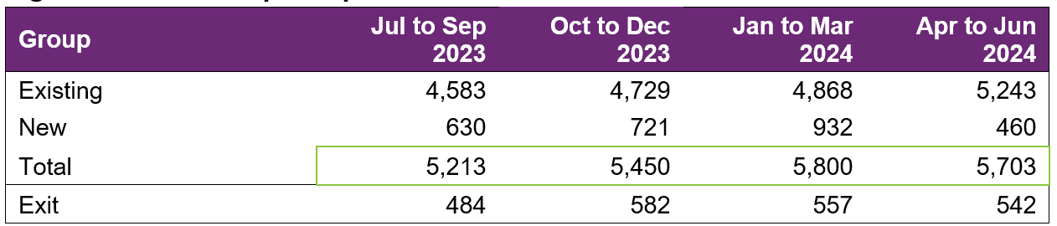
The number of participants receiving employment supports reported by the Provider Reporting Tool (the Tool) has steadily increased over the first 3 quarters, with a slight decrease in the fourth quarter.

Please note that the number of participants reported in this report for the July to September 2023 quarter and the October to December 2023 quarter differs from the previous fifth edition report due to late reporting. Participants who were not reported when the report to December 2023 was compiled but were then reported as having received employment support during the July to September 2023 or October to December 2023 quarters are counted as new in those respective quarters in this report.

Location

Figure 5. State or Territory of residence – number of participants
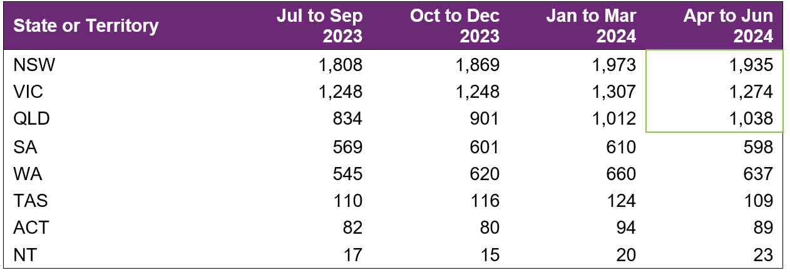
The majority of employment support recipients were in N S W (34%), followed by V I C (22%), and Q L D (18%). For comparison, the top 3 states for all NDIS participants aged 15 to 24 are
N S W (29%), V I C (25%) and Q L D (22%). The over-representation in N S W is partly due to the earlier roll out to full scheme in that state and the influence of the legacy N S W Transition to Work program which involved transition teachers helping students to consider post school options and connecting many with employment providers.

Primary disability

Figure 6. Primary disability – number of participants
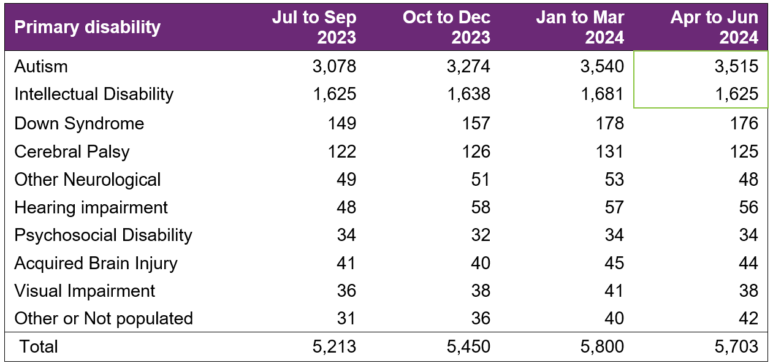
The top primary disabilities experienced by participants utilising these supports in the latest quarter were autism (62%), followed by intellectual disability (28%). For comparison, 62% and 21% of all NDIS participants aged 15-24 report having autism and intellectual disability, respectively.

Age

Figure 7. Age – percentage of participants
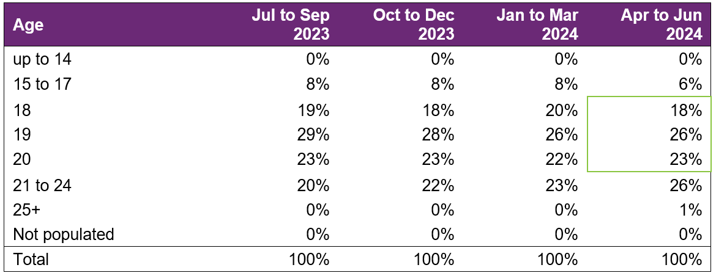
Participants aged 18 to 20 accounted for 67% of employment support recipients. Recipients aged 21 to 24 has steadily grown in proportion over the 4 quarters. While the proportion of recipients aged 15 to 19 has reduced, the count has not changed significantly over the 4 quarters.

Gender

Figure 8. Gender – percentage of participants
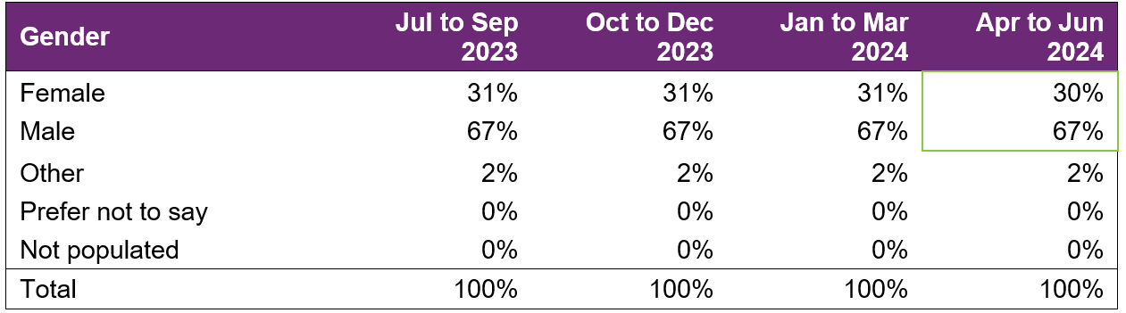
In the most recent quarter, employment support recipients were 30% female and 67% male. In comparison to all NDIS participants aged 15 to 24, 35% were female and 63% were male. This is in line with the high proportion of employment supports recipients reporting autism as the primary disability, as the majority of participants who report autism are males.

Aboriginal or Torres Strait Islanders Status

Figure 9. Aboriginal and Torres Strait Islanders – percentage of participants
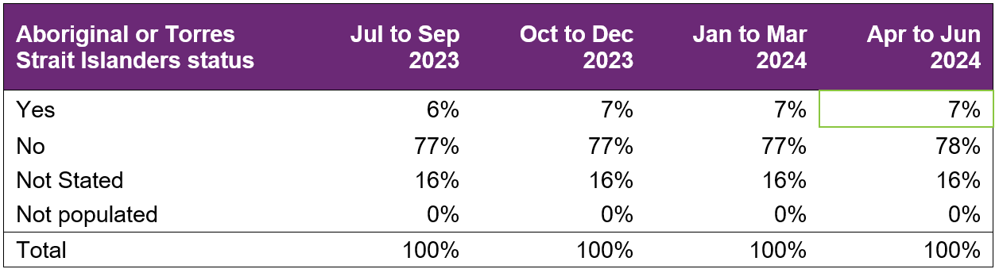

In the most recent period, 7% of employment support recipients identified as Aboriginal or Torres Strait Islander people. This is slightly lower than the 9% of all NDIS participants aged 15 to 24 who identified as Aboriginal or Torres Strait Islander.

Culturally and Linguistically Diverse status

Figure 10. Culturally and linguistically diverse – percentage of participants
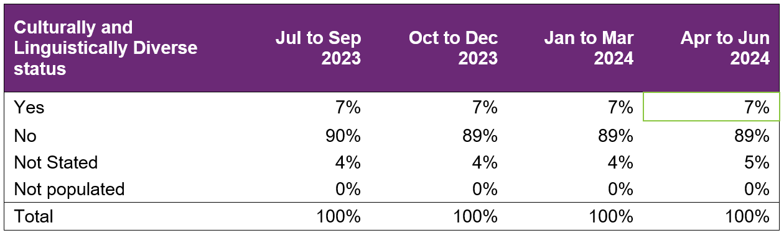
In the most recent period, around 7% of employment support recipients identified as being from a Culturally and Linguistically Diverse community. This is slightly higher than the 6% of all NDIS participants aged 15 to 24 who identified as being from a Culturally and Linguistically Diverse community.
The counts and percentages for this report had been affected by the new computer system and integration of new processes. The counts and percentages are likely to be slightly understated for “Yes” and “No” classes and slightly overstated for “Not stated”.

Supports & milestones

Support type hours

Figure 11. Support type provided – percentage of average hours per participant
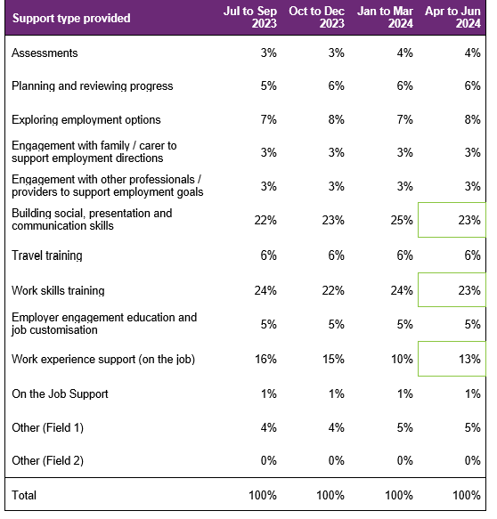
Almost half (47%) of the training time was spent building the participant’s social, presentation, communication, and work skills. The amount of time dedicated to work experience support (on the job) has accounted for 15% of the total training time. Percentages across the board have remained steady over the four quarters.

Support delivery method

Figure 12. Delivery method – percentage of hours
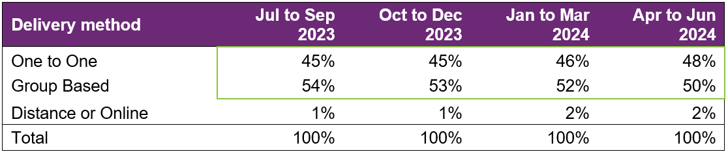
Participants have been excluded from this section where the sum of One to One, Group based, Distance or Online percentages did not equal 100%.
The percentage of one-to-one support has slightly increased over the period, at the expense of group-based support.

Progress towards milestones – snapshot at each reporting period
This section looks at the distribution of progress for participants who worked on a particular milestone (where there are training hours reported for that specific skill), for each reporting period in isolation (non-cumulative).

Social, presentation and communication skill

Figure 13. Social, presentation and communication skill milestone – percentage of participant progress
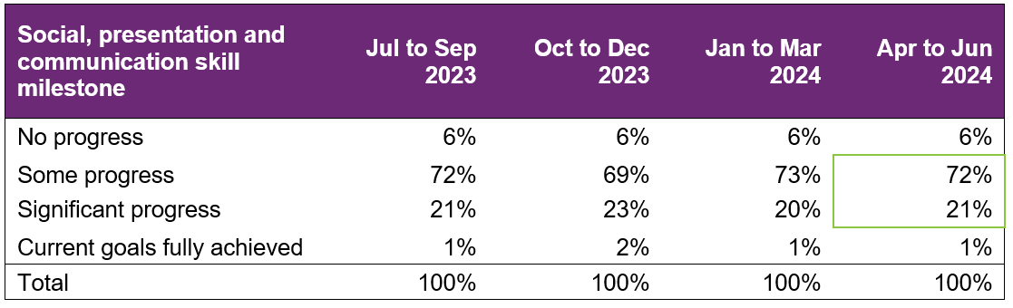
For participants who worked on this specific milestone, 72% reported some progress and 21% reported significant progress in the latest reporting period. Percentages have remained fairly consistent over the 4 quarters.

Travel skill

Figure 14. Travel skill milestone – percentage of participant progress
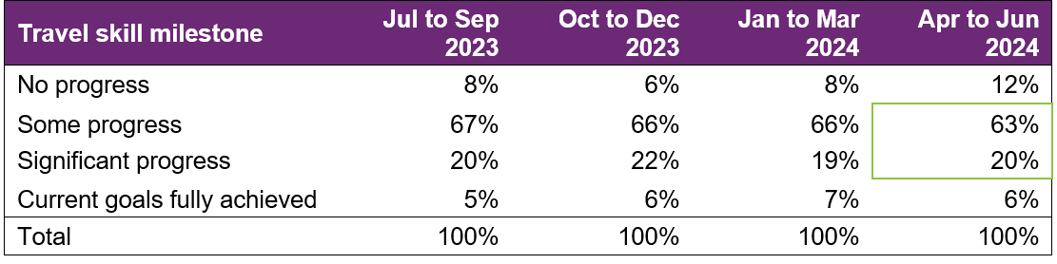
For participants who worked on this specific milestone, 63% reported some progress and 20% reported significant progress. In the last quarter, there was a slight decrease in the percentage with some progress or goals fully achieved.

Work skill

Figure 15. Work skill milestone – percentage of participant progress
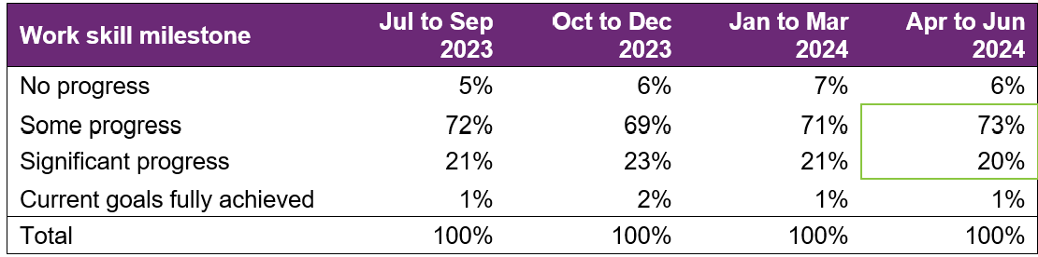
For participants who worked on this specific milestone, 73% reported some progress and 20% reported significant progress. The last quarter saw a slight increase in those making some progress, and a slight decrease in those making significant progress.

Employer engagement, education, and job customisation

Figure 16. Employer engagement, education, and job customisation milestone – percentage of participant progress
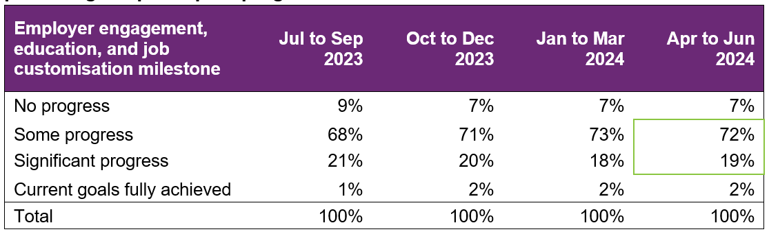
Providers who reported activities as “engaging with employers, educating and customising jobs” for participants reported that 72% made some progress and 19% made significant progress. There was a slight decrease in those making significant progress over the four quarters and a slight increase in those making some progress.

Work experience

Figure 17. Work experience milestone – percentage of participant progress
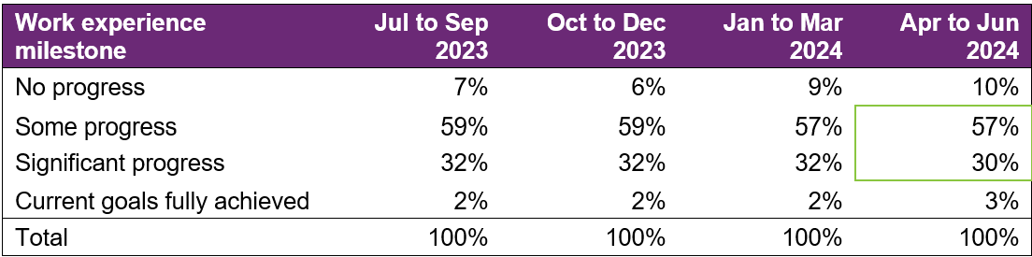
There was a slight decrease in those making significant progress over the 4 quarters, but also a slight uptick in the percentage of participants having all goals fully achieved.

Progress towards milestones – cumulative for the year

The following sections show that more time receiving supports or training is associated with better progress towards mastering specific skills. For each participant, the best progress (across 4 quarters) towards mastering the specific skills is used for this analysis, and compared against the cumulative time receiving employment supports, and training for the specific skills.
Appendix 1 includes more detail on the methodology used in this section.

Social, presentation and communication skill

Figure 18. Social, presentation and communication skill milestone – percentage of participant progress
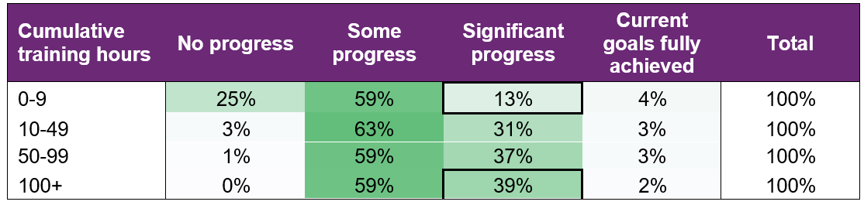
Of the participants who received up to 9 hours of training on social, presentation, and communication skills, around 13% were able to make significant progress towards mastering these skills. This proportion increased to 39% for those who received 100+ hours of the skill-specific training.

Travel skill

Figure 19. Travel skill milestone – percentage of participant progress
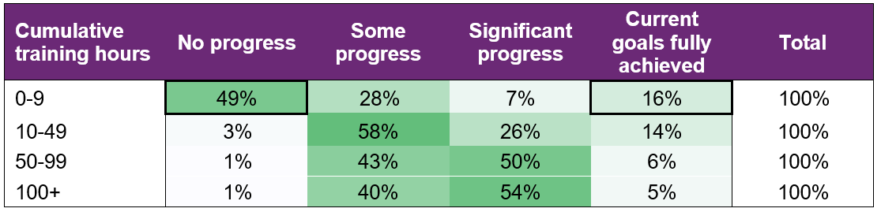
While 16% participants were able to fully achieve their goal within 0-9 hours of training, about half (49%) did not make any progress. This suggests that for some participants, travel skills may be a primary area of focus and that they need only a few hours of personalised support to fully achieve their goals, while others need more than 10 hours of training to start making progress towards their goals.
Note that the unusually decreasing percentage of participants with current goals fully achieved as cumulative training hours increase is due to small numbers in this category.

Work skill

Figure 20. Work skill milestone – percentage of participant progress
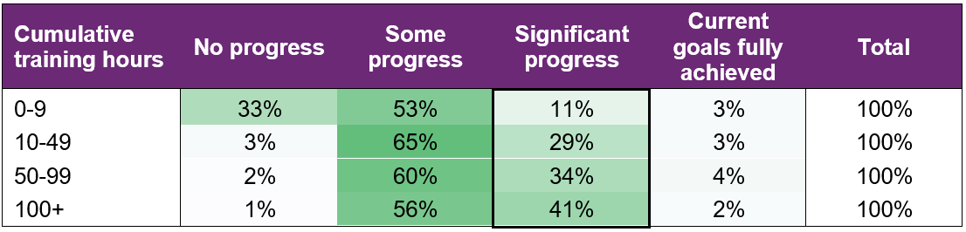
Attaining significant progress in work skills was achieved through more cumulative hours of training demonstrating the need for tailoring this support for the individual.

Employer engagement, education, and job customisation

Figure 21. Employer engagement, education, and job customisation milestone – percentage of participant progress
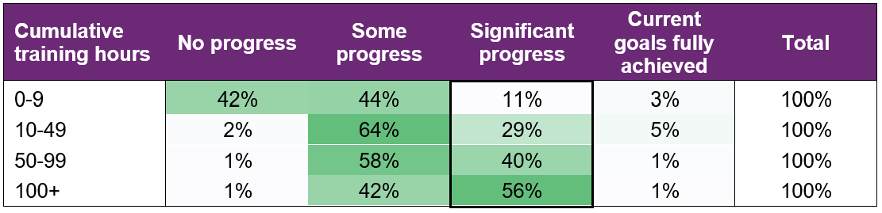
Making significant progress towards employer engagement, education, and job customisation milestones increased markedly with more hours spent on these activities.

In the fourth edition of this report, the percentage of participants making significant progress increased to 44% for 100+ hours of training, compared to 56% in the current report. The substantial fluctuation between the two reports is attributed to the small number of participants in this category (those with 100+ hours of training who achieved significant progress towards the milestones).

Work experience

Figure 22. Work experience milestone – percentage of participant progress
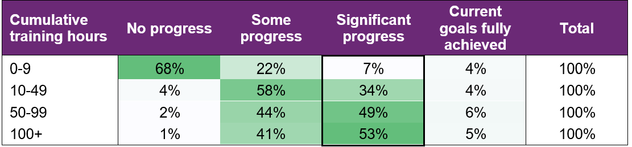
Similarly, making significant progress towards work experience milestones increased consistently with more hours of training.

Final outcomes

This section shows the distribution of outcomes upon exiting employment support (based on the employment support reported end/exit date).

Figure 23. Final outcomes (upon exiting employment support) – number of participants
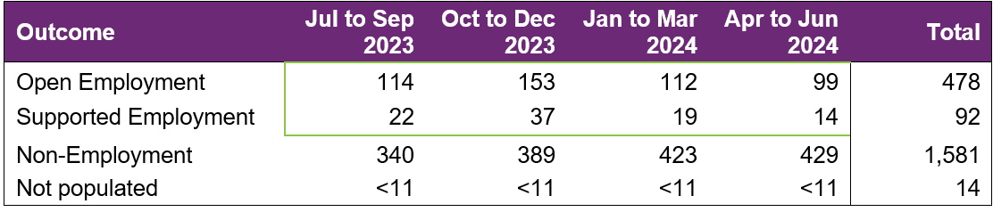
The number of participants finishing employment supports with open or supported employment was higher in the July to September, and October to December quarters. These tend to be seasonally high quarters, as seen in previous versions of this report.

From July 2023 to June 2024, 570 participants finished employment support with open or supported employment.

Figure 24. Final outcomes (upon exiting employment support) – percentage of participants
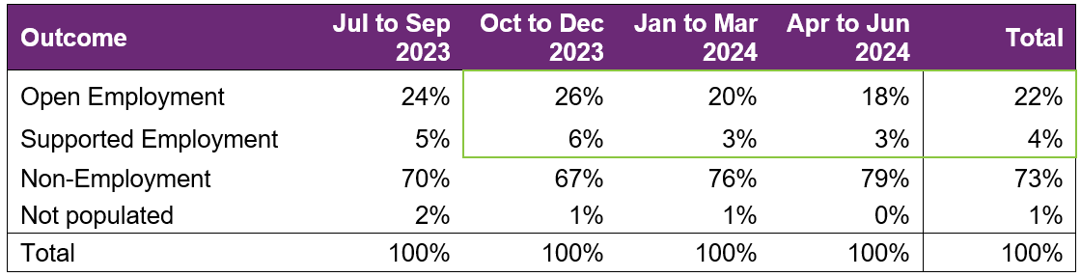
Non-employment outcomes rose in the last 2 quarters, leading to the drop in the proportion of open employment outcomes. The NDIA continues to closely monitor the proportion of open employment outcomes, which decreased from 25% in the previous edition of the report (year to December 2023) to 22% here (year to June 2024).

The following table provides a more granular breakdown of outcomes for participants who exited employment supports from January to December 2023.

Figure 25. Final outcomes breakdown – percentage and total number of participants:
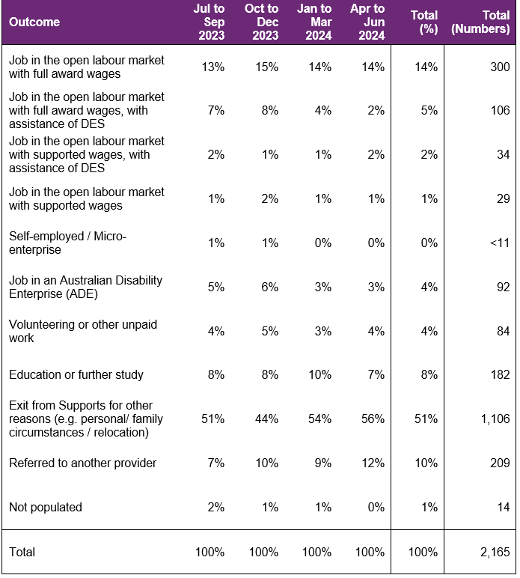
The absolute numbers (non-percentages) have been shown as a total only in the above table (not broken down into individual quarters) due to low volumes in the individual quarter. Individual quarter absolute numbers will be shown once there is sufficient volume.

For participants whose final outcome is Exit from Supports for other reasons, the common reasons reported were:
- personal or family circumstances,
- relocated,
- not engaging or contactable,
- school leaver employment supports funding ended,
- transferred to D E S or another provider,
- not a good fit or ready for employment preparation.

Open employment outcomes comprise of:
- jobs in the open labour market, with full award or supported wages, with or without the assistance of Disability Employment Services (D E S)
- or Self-employment/Micro-enterprise.

A job in an Australian Disability Enterprise (A D E) is classified as Supported Employment. The other categories in the chart above are classified as non-Employment outcomes.

Figure 26. Final outcomes breakdown – participants in open and supported employment, by primary disability – percentage:
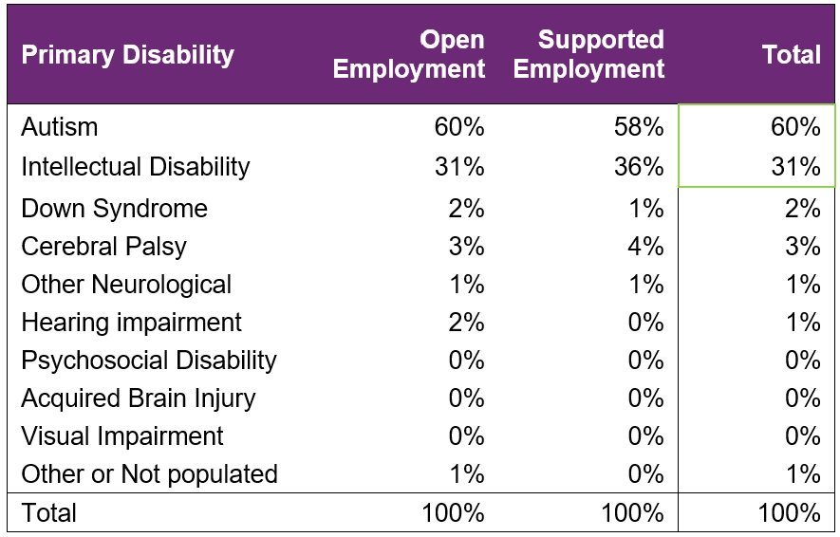
There is a slight underrepresentation of participants with a primary disability of autism who finished in employment - 60% finished in employment versus 62% who received support (from section 3.3).

On the other hand, primary disability of Intellectual Disability seems to be over-represented - 31% finished in employment versus 28% who received support (from section 3.3).

Final employment outcomes

Employment type

Figure 27. Employment type – number of participants

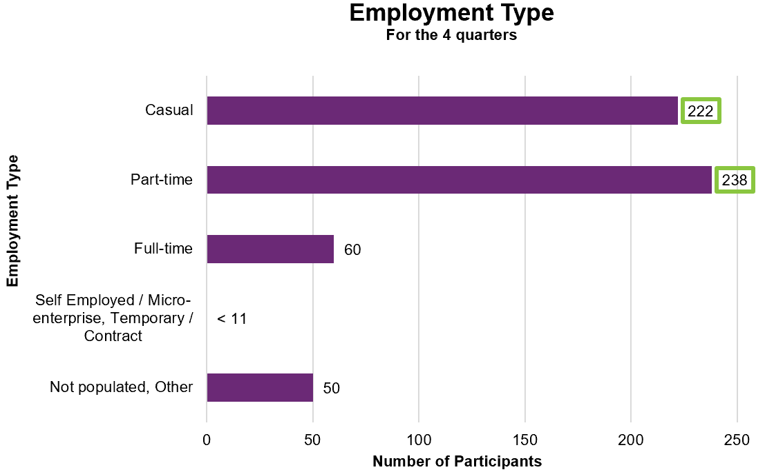

From July 2023 to June 2024, of participants who finished employment support with paid employment, 222 gained casual work while 238 gained part-time work.

Figure 28. Employment type – percentage of participants
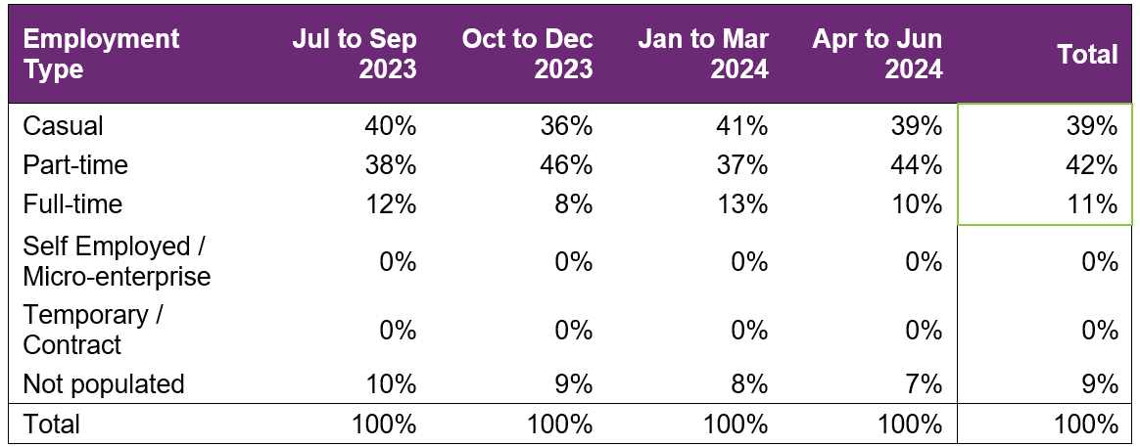
From July 2023 to June 2024, of participants who finished employment support with paid employment, 39% gained casual work while 42% gained part-time work and 11% gained full-time work.

These numbers tend to be somewhat volatile due to small counts.

Hours worked

Figure 29. Hours worked per week – percentage of participants
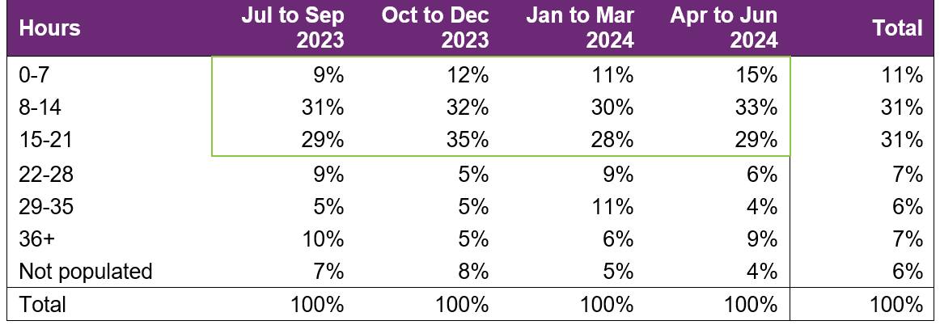
From July 2023 to June 2024, of participants who finished employment support with paid employment, there has been an increase in those who worked up to 21 hours per week over the four quarters. However, as mentioned previously, these numbers tend to be quite volatile due to small counts.

74% of participants who finished employment support with paid employment worked up to 21 hours per week.

Industry of employment

Figure 30. Industry of employment – percentage of participants
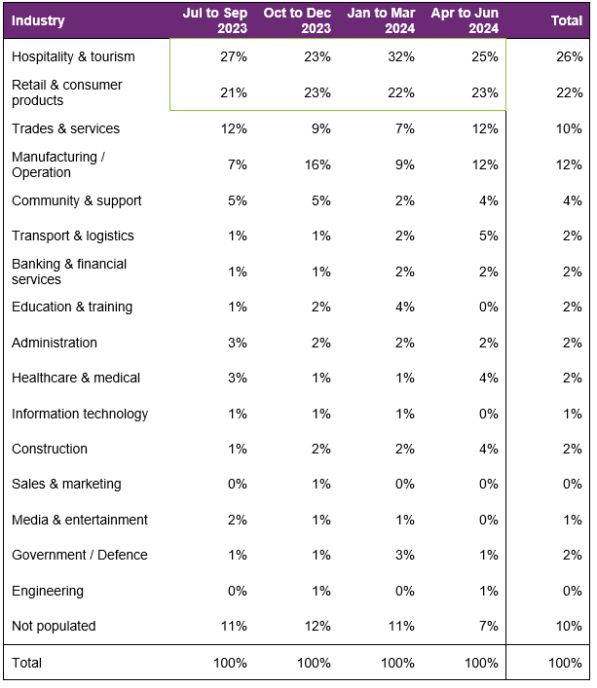
The percentage of participants who worked in Hospitality and tourism fluctuated over the four quarters, while the percentage of participants working in Retail and consumer products remained quite steady. Both are still the top two industries for participants to be employed in over the last four quarters.

From July 2023 to June 2024, of participants who finished employment support with paid employment, 70% work in Hospitality, Tourism, Retail, Trades, Manufacturing, or Operation. This is up from 65% in the previous version of this report (to December 2023).

NDIS supports in employment

Figure 31. Will the participant be utilising NDIS supports in employment? – percentage of participants
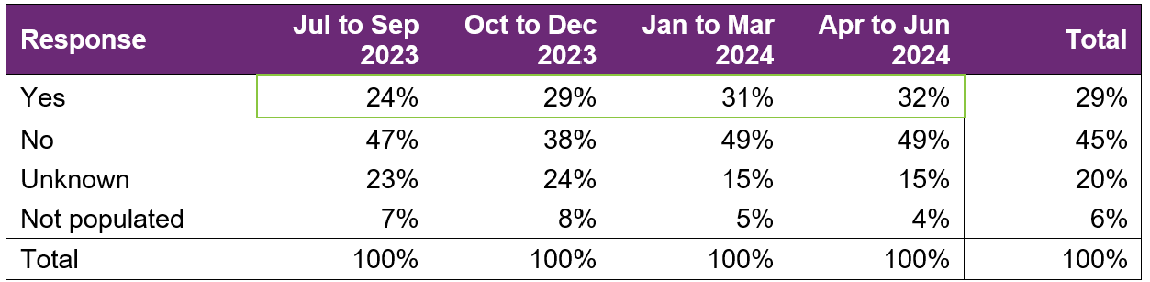
The percentage of participants that will be utilising NDIS supports in employment has continued to increase over the four quarters.

For the 2024 financial year, providers reported 29% of participants who finished employment support with paid employment will be using NDIS supports in employment to maintain their employment. This is an increase from the 25% figure in the fourth version of this report for calendar year 2023.

Supported wages

Figure 32. Will the participant receive a wage determined under the supported wage system? - Percentage of participants
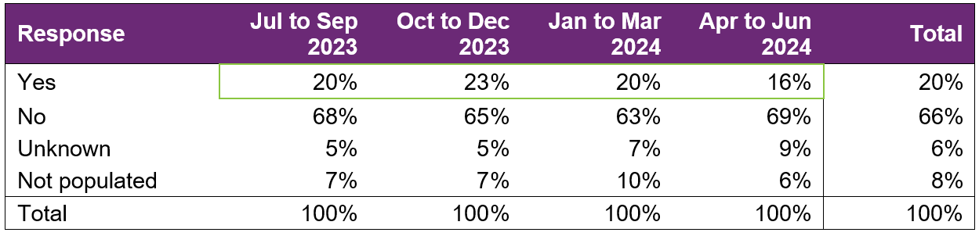
Of participants who finished employment support with paid employment, the percentage who were reported to receive a wage determined under the Supported Wage System (S W S) has remained stable.
Over the 12 months, 20% of participants who commenced paid employment receive a wage determined under the S W S.

Intermediate employment outcomes

This section contains the employment features for all the participants who commenced employment from July 2023 to June 2024. The participants may or may not have exited employment support. Participants with Employment Type "Work Experience" are excluded.

Employment outcomes (July 2023 to June 2024)
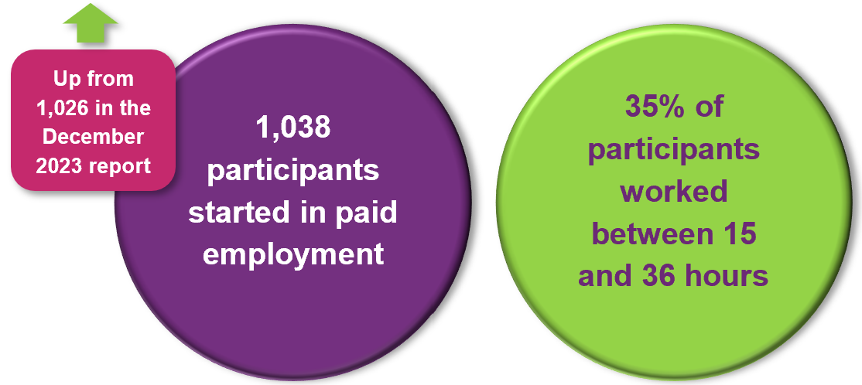
The top 4 industries in which participants started employment were Retail, Hospitality/Tourism, Trades/Services and Manufacturing/Operations.

Employment type

Figure 33. Employment type – number of participants
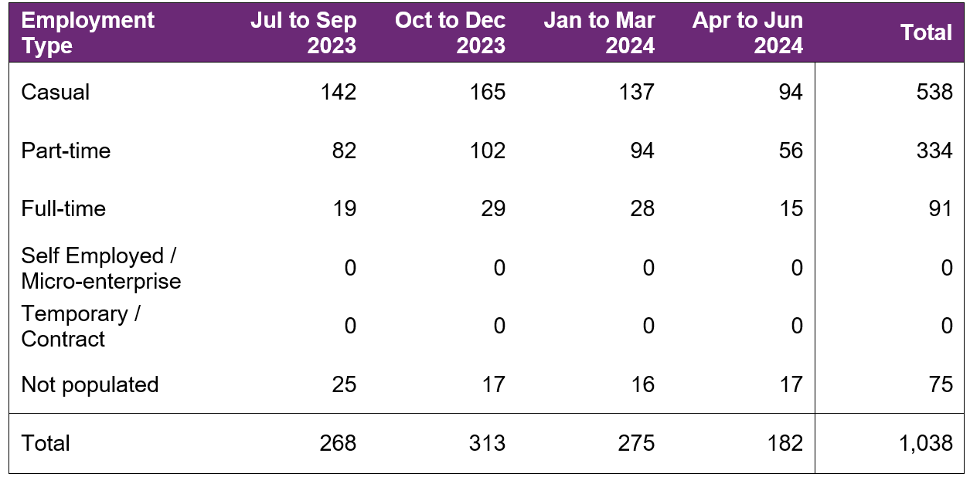
The number of participants commencing casual and part-time employment fluctuated across the four quarters, with a drop in the April to June quarter. This seasonality is also seen in the previous report.

A total of 1,038 participants were reported to have commenced employment from July 2023 to June 2024. During this period, 538 started casual work while 334 started part-time work.

Figure 34. Employment type – percentage of participants
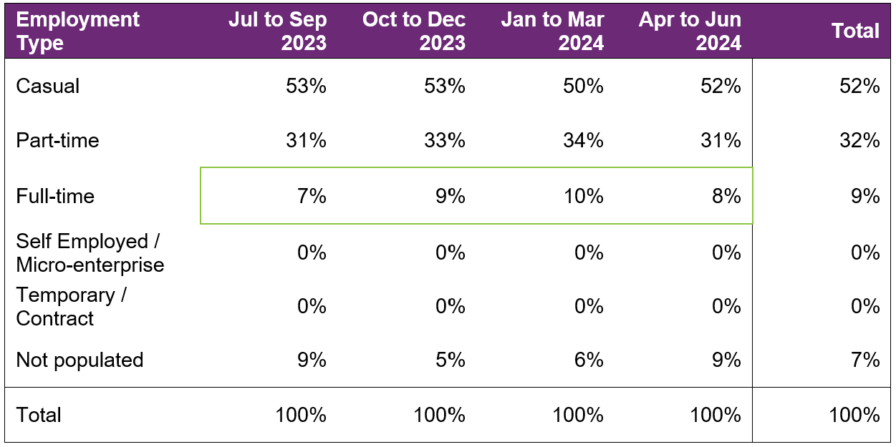
The percentage of participants who started full-time work fluctuated during the period, totalling 9% for the 4 quarters (no change versus the December 2023 report).

From July 2023 to June 2024, of participants who started employment, 52% started casual work, while 32% started part-time work.

Hours worked

Figure 35. Hours worked per week – percentage of participants
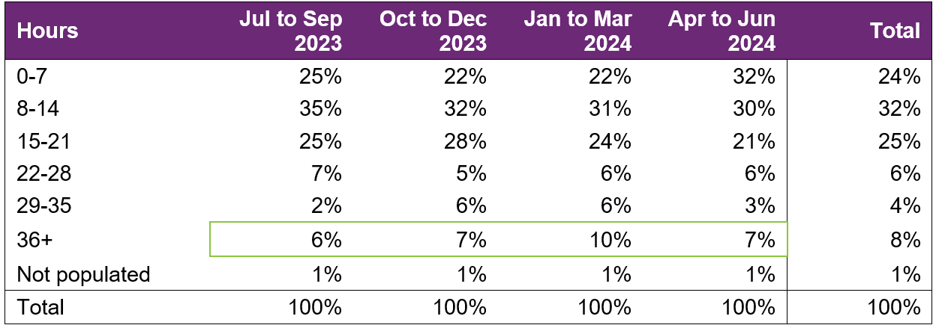
Similarly to the proportion of full-time work, the percentage of those working 36+ hours has not changed significantly over the 4 quarters.

From July 2023 to June 2024, of participants who started employment, 81% worked up to 21 hours per week.

Industry of employment

Figure 36. Industry of employment – percentage of participants
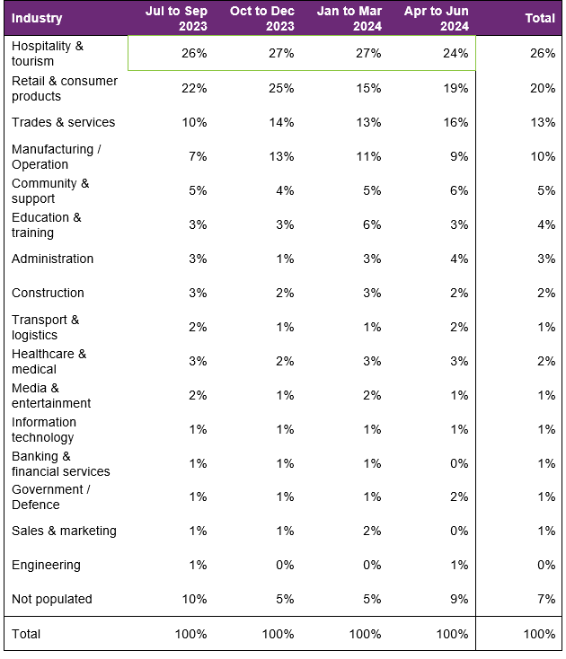
The percentage who worked in hospitality and tourism remained steady across the four quarters, except for a drop in the fourth quarter. There was an increase in the percentage who worked in trades and services over the 4 quarters.
From July 2023 to June 2024, of participants who started employment, 70% worked in Hospitality, Tourism, Retail, Trades, Manufacturing or Operation.

NDIS supports in employment

Figure 37. Will the participant be utilising NDIS supports in employment? – percentage of participants
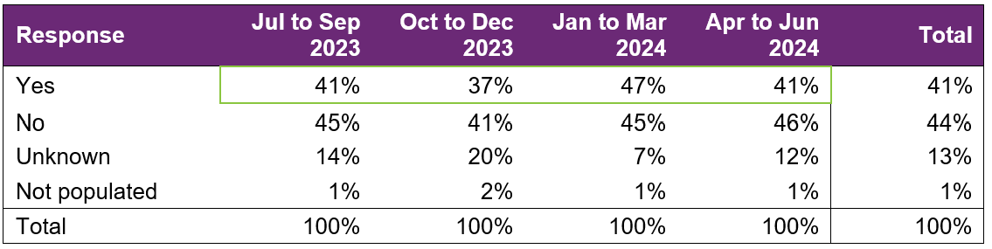

From July 2023 to June 2024, of participants who started employment, providers report 41% will be using NDIS supports in employment to maintain their employment.

This is an increase versus the 36% figure in the December 2023 report.

Supported wages

Figure 38. Will the participant receive a wage determined under the supported wage system? - Percentage of participants
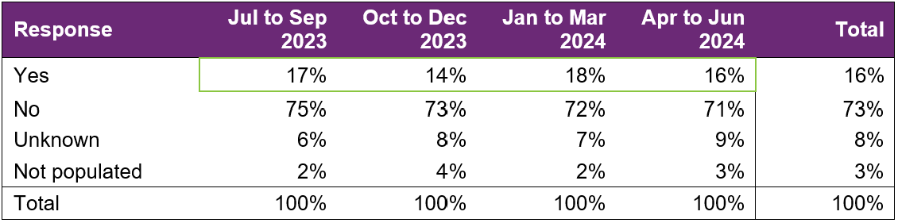
This percentage has fluctuated over the four quarters with no clear trend.

For the year, providers report 16% of the participants who started employment will receive a wage determined under the Supported Wage System (S W S).

Model summary

Modelling approach
A model was built to predict successful employment outcomes, defined as any of the following:
- Job in the open labour market, with full award or supported wages, with or without the assistance of Disability Employment Services (D E S)
- Self-employed / Micro-enterprise
- Supported employment.
The modelling dataset is sourced from the Provider Reporting Tool and NDIA’s own participant data, with the former containing outcomes and support hours and the latter containing characteristics such as Culturally and Linguistically Diverse Status and education activities.
In addition, Socio-Economic Indexes for Areas (S E I F A) data was attached to the modelling dataset, mapping to the 2021 LGA. Note that some LGA names in the Provider Tool were updated to the 2021 LGA due to changes in LGA boundaries between 2016-2021.
The analysis employed an XGBoost machine learning model, an advanced implementation of the Gradient Boosting Machine, to model the relationship between finding paid employment and its key drivers.
The top drivers of finding paid employment, that providers have most direct influence on (ranked in order from most to least important), are:
- Progress made towards achieving employer engagement and job customisation milestones
- Progress made towards achieving work skills milestones
- Progress made towards achieving work experience support milestones
- Progress made towards building social, presentation and communication skills
- Hours spent in work experience support
Appendix 2 has more details on the accuracy of the model.

What helps (or hinders) finding paid employment
Figure 40. Variables that help or hinder finding paid employment – for the model covering period ending in December 2023
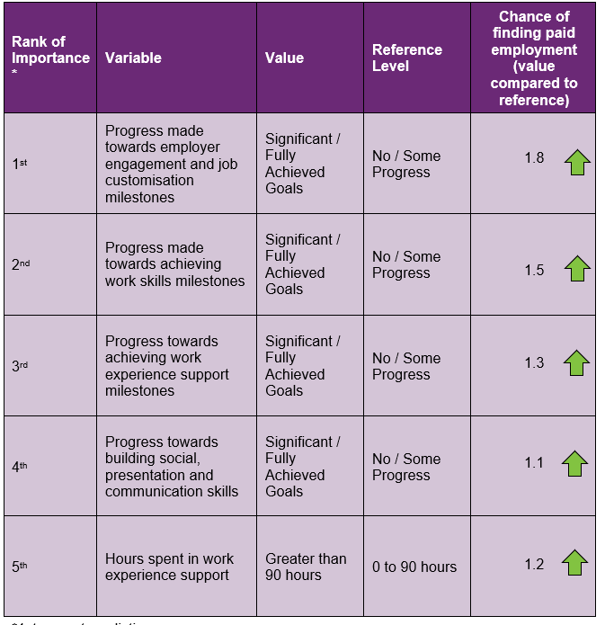
How to interpret the above table:
- Participants who made significant progress towards or fully achieved their employer engagement, education, and job customisation milestones were 1.8 times as likely to find employment compared to participants who made no or some progress towards similar milestones.
- Participants who were spent 90+ hours in work experience support are 1.2 times as likely to find employment compared to participants who spent up to 90 hours in work experience support.

Differences in modelled predictors between reporting period ending December 2023 versus the period ending June 2024
The following table summarises the differences in significant variables in the model covering the period ending in December 2023, versus the model covering the period ending in June 2024.

Figure 41. Differences in significant predictors
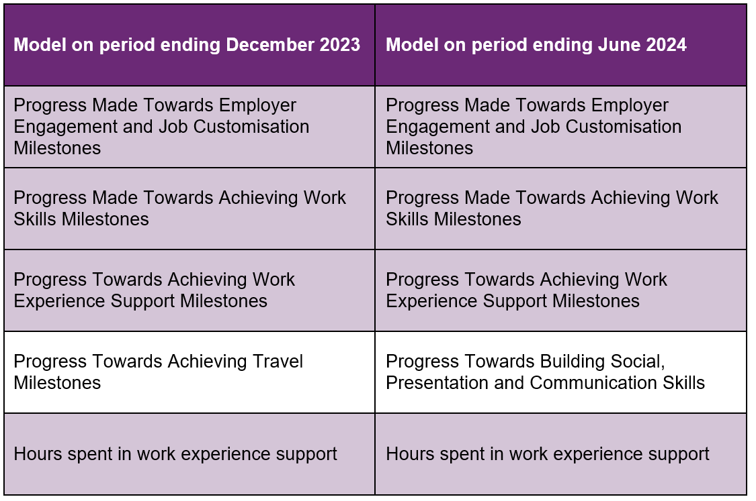

As shown above, the predictor “Progress Towards Achieving Travel Milestones” was significant in the model covering the period ending December 2023 but no longer in the top 5 for the model covering the period ending June 2024. This predictor has been replaced by “Progress Towards Building Social, Presentation and Communication Skills” in the top 5.

The main reason for this is additional data. The modelling insights from the period ending June 2024 data are based on 2,623 observations, which is more than the 2,078 observations used to model the period ending December 2023. These additional observations have led to a slight change in significant predictors although most have stayed the same.

Appendix

Appendix 1 – Methodology for the section titled “Progress towards milestones – cumulative for the year”
This Appendix provides more details on how to interpret the section titled “Progress towards milestones – cumulative for the year,” and the methodology used.
How to interpret the table below

Work experience milestone – percentage of participant progress
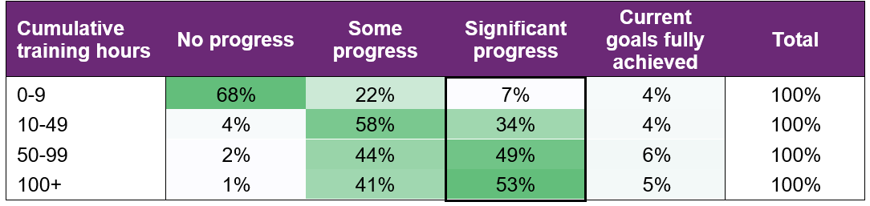
Out of all participants who have received 100+ hours of on-the-job work experience support (cumulative for the year)
- 1% have "No progress" as the best result for the year.
- 41% have "Some progress" as the best result for the year.
- 53% have "Significant progress" as the best result for the year.
- 5% have "Current goals fully achieved" as the best result for the year.
The sum of each row in the above table equals 100%.

Methodology (for cumulative training hours)
The starting universe is all participants reported in the Provider Reporting Tool across the 4 quarters. For each participant, the "cumulative training hours" is then calculated as the total of the milestone-specific training hours reported in the Provider Tool for the 4 quarters. The best progress for the specific milestone is used (of all progress entries reported in the Provider Reporting Tool across the 4 quarters).
For example, if for participant John Smith, below are the progresses and hours reported across the 4 quarters.
Work experience support (on the job)
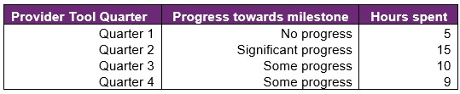
then "cumulative training hours" = 39 = 5 + 15 + 10 + 9 and the progress selected for John is "Significant progress" (the best progress of the 4 quarters). The "cumulative training hours" is then rounded down to the nearest whole number (e.g., 6.75 is rounded down to 6), and grouped into bands. Then for each cumulative training hours group (e.g., 0-9), the percentage of participants in each (best) progress category is calculated so that the sum of the row is 100%.

Appendix 2 – Model accuracy

The generalised linear model presented in Section 8 has the following accuracy:
Figure 42. Model accuracy – Gini and AUC
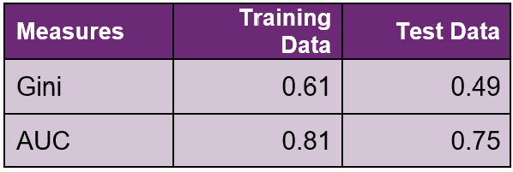
The closer the test set AUC and Gini is to 1, the better the model performance.
The Test Data AUC (and Gini) is typically smaller than the Training Data AUC (and Gini). This is because the model was built on the Training Data, hence predicts more accurately on it. The Test Data Gini and AUC however, give an indication of the model prediction accuracy when the model predicts on unseen data (on which it was not built).
Figure 43. Model accuracy – receiver operating curve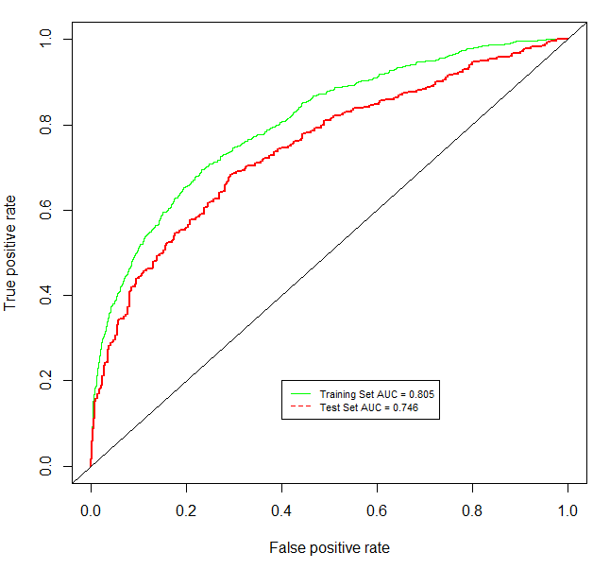

Figure 44. Model accuracy – actual versus predicted
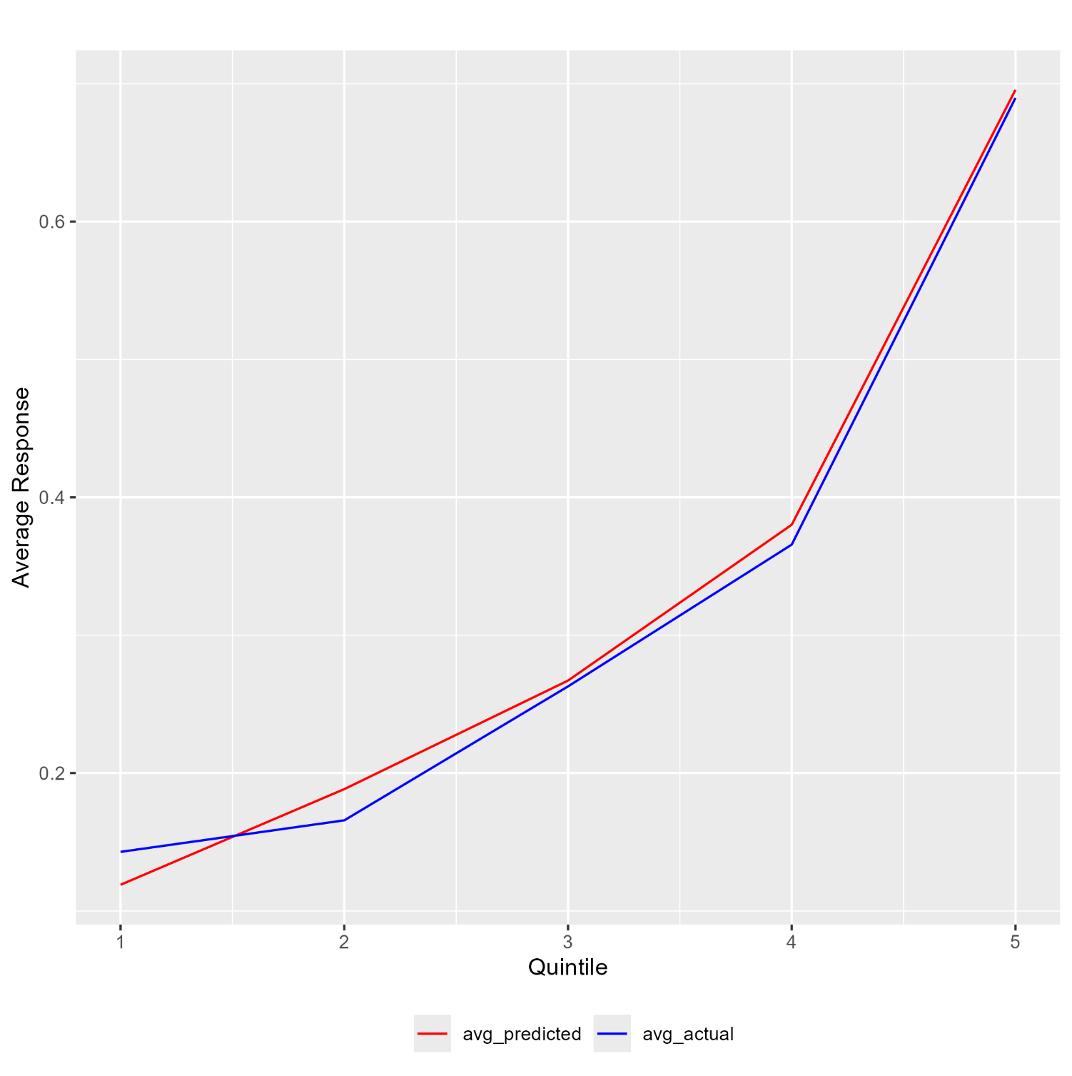

The model predicted probability (red) curve is close to the actual outcome (blue) curve, indicating that the model is able to accurately predict the probability of recipients finding paid employment.

Source: Australian Bureau of Statistics. For further information: Socio-Economic Indexes for Areas (SEIFA): Technical Paper, 2021 | Australian Bureau of Statistics (abs.gov.au) Link to the data: Socio-Economic Indexes for Areas (SEIFA), Australia, 2021 | Australian Bureau of Statistics (abs.gov.au) - Local Government Area, SA1 Distributions, SEIFA 2021.xlsx

