Nunphung le Holh lei Idannak

Kan Tuahto ning

2024–2028
Hakha Chin | Laiholh
Rel Fawi phun
Fawi tein relmi

Hi Tuahto ning hman ningcang
Kanmah | Rampumpi Pumtlinlonak lei Aamahkhaan Rianttuanpiaknak (NDIA) nih hi Tuahto ning  cu a tial.  ‘Kanmah’ timi biafang na hmuh tikah, hi a sullam cu NDIA tinak a si.
Hi Tuahto ning cu rel fawi dingin kanmah nih kan tial.
Cheukhat ruahnak pawl fianter dingah hmaanthlak pawl kan hman.
Anak  A nak lomi | A biapimi biafang pawl kha anak (bold) in kan rak tial.  Hihi a sullam cu cafang pawl kha a chah deuhmi le anak deuhmi an si.
Biafang cazin | Hi biafang pawl a sullam kha kan fianter.  Cahmai 34 ah hi biafang pawl cazin a um.
 | Hihi cu Nunphung le Holh lei Idannak Tuahto ning 2024–2028 Fawite Rel khawh dingin tuahmi a si.
Kan website ah Nunphung le Holh lei Idannak Tuahto ning 2024–2028 tiin na hmuh khawh lai.
www.ndis.gov.au/CALD
Hi Tuahto ning rel dingah bawmh na hal khawh.
Hawikom, innchungkhar chungtel asilole bawmtu minung nih an in bawmh khawh men.
 | Hihi cu a saumi catialmi pakhat a si.
Voi voikhat ah adihlak in rel dih na hau lo.
Caan na la kho.
 | Aboriginal le Torres Strait Tikulh a ummi minung pawl cu kan ram Australia i a ngeitu pawl bantukin kan cohlan hna.
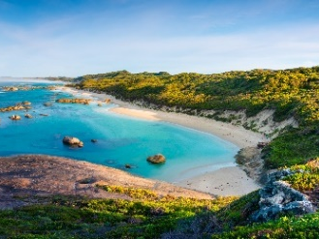 | Anmah cu mi hmaisa a um i hihi a hmangmi an si:  - vawlei pawl  - ti pawl.

Hi Tuahto ning chung ah zeidah a um?
CALD a sullam cu zeidah a si? 5
Tuahto ning nih zei kong dah a chim? 7
Zeiruangah Tuahto ning cu a biapit? 10
Tuahto ning cu zeitindah kan rak tuah? 12
Tuahto ning caah kan i tinhmi pawl cu zeidah an si? 15
Hmailei ah zeidah kan tuah lai? 29
Thawngthanhmi tamdeuh 32
Biafang cazin 34

CALD a sullam cu zeidah a si?
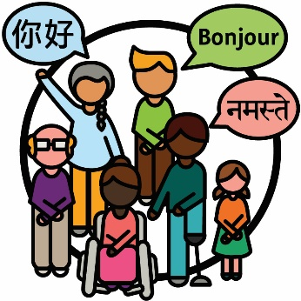 | Nunphung lei le holh lei in i dannak (CALD) minung pawl cu:  - aa dangmi sining dirhmun pawl sin in a rami  - Mirangholh nak in holh dang a hmangmi.
 | Australia ah:
 | - ramdang hrin a simi hi million 8 dengmang an um
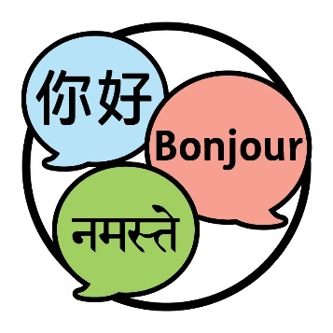 | - holh dang pawl 300 nak tamdeuh an hman.

 | Thil pakhat khat bantukin fianternak na tuah ahcun, minung phu pakhat ah aa telmi na si kha na chim.
 | Australia i a ummi minung i 30% nih CALD minung bantukin an sining an langhter.
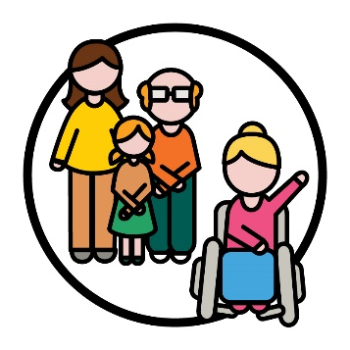 | Rampumpi Pumtlinlonak Aamahkhan Timhlamhnak (NDIS) i aa telmi 10% nih CALD minung bantukin an sining an langhter.
 | Aa telmi pawl cu NDIS ah aa telmi pumtlinglo minung pawl kha an si.

Tuahto ning nih zei kong dah a chim?
Tuahto ning | Nunphung le Holh lei Idannak Tuahto ning  2024-2028 a thar kan tial.  Hihi Tuahtoning tiah kan auh.
 | Hi Tuahto ning cu CALD aa telmi pawl caah NDIS a thadeuh in kan tuah dingmi caah timhtuahmi a si.
 | NDIS he CALD aa telmi pawl nih hmuhtonnak an ngeihmi zeitindah kan thanchoter lai timi zong a fianter.

An hmuhtonmi ah aa telmi cu:
- NDIS hmannak
- NDIS riantuantu
- NDIS riantuanti pawl.
NDIS riantuanti pawl cu riantuanpiaknak hmuh le hman dingah midang pawl a bawmmi an si.
Hi Tuahto ning ah, anmah cu kan riantuanti pawl tiah kan auh hna.

Hi Tuahto ning zong nih zeitindah kan bawmh hna lai timi kha a fianter:
- NDIS chungah i tel dingah CALD mibu pawl
- NDIS hman dingah CALD aa telmi pawl.

Zeiruangah Tuahto ning cu a biapit?
 | Cheukhat CALD minung pawl nih NDIS chung i tel an duh tikah dawnkhaantu pawl tamdeuh an tong.
Dawnkhaantu cu thil pakhat khat tuahnak in an ngoltertu pakhat khat a si:
- tuah na herhmi
- tuah na duhmi.
 | Dawnkhaantu pawl nih CALD minung kha har deuh in a tuah khawh hna, hihi caah:
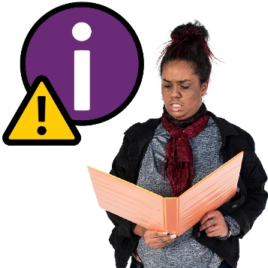 | - NDIS kong thawngthanhmi kawl
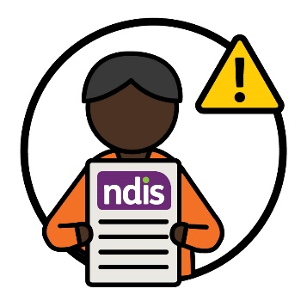 | - NDIS an hman.
Kan riantuantu le riantuanti pawl nih CALD aa telmi pawl bawmh ning kha an i fiang peng
hna lo.
Cheukhat CALD aa telmi pawl nih an herhmi riantuanpiaknak pawl kawl le hman kha a har.
Cun nunphung pawl dihlak caah a himmi riantuanpiaknak pawl zaalak in an um lo.
Na nunphung cu:
- na nunning
- nangmah caah a biapimi a si.
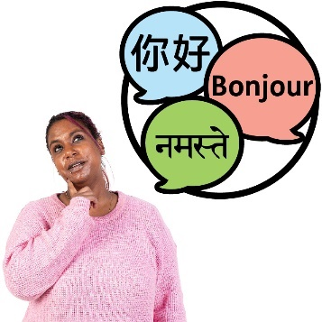 | Adang holh in thawngthanhmi cu CALD minung pawl nih hman dingah a fawi peng lo.
Cun CALD aa telmi kong ah thawngthanhmi zaalak a um lo:
- hmuhtonmi
- herhmi.

Tuahto ning cu zeitindah kan rak tuah?
Tuahto ning tuah dingah pungsan suaitimi kan hman.
Pungsan suaitimi cu minung hna hmunkhat riantuanti tikah a si:
- thil thar pakhat khat tuah
- thil pakhat a riantuan ning kha thanchoter.
 | Aa dangmi minung tampi he rian kan tuanti kha kan fehter, hi ah aa telmi cu:
 | - pumtlinglo a simi CALD minung
 | - an innchungkhar pawl le zohkhenhtu pawl
 | - CALD minung he rian a tuanmi buu
 | - pumtlinglo he rian a tuantimi buu.
Aa dangmi minung pawl he hmunkhat i riantuanti dingah a thabikmi lam pawl kan bawmh cang kha kan fehter.
Tahchunnak ah, meting kan tuah i cuka ah minung pawl nih an ruahmi pawl kha an chim khawh.
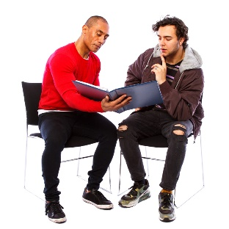 | Cun pakhat cio in biaruahnak kan rak ngei hna.
Rampumpi Miphun te Pumtlinlonak lei Riantuantinak (NEDA) he zong rian kan tuan.
NEDA cu pumtlinglo CALD minung le an chungkhar pawl i covo pawl a bawmmi buu pakhat a si.
Covo pawl | Covo pawl nih minung hna nih zeitindah an in chawnhbiak ding a si mi kong phungphai an si:  - aa ruang in  - aa tluk in.
Ruahnak cheuhmi | NEDA nih kanmah he pumtlinglo CALD minung pawl i covo pawl kongah an ruahnak cheuhmi an chimphuan.  Hi ruahnak cheuhmi cu Tuahto ning ser dingah kan hman.
 | NDIA a leng ah ruahnakcheuhtu phu pakhat kan ser fawn.
Ruahnak cheuhtu phu cu kanmah he rian a tuantimi minung phu pakhat a si:
- ningcang te in a kal maw
- tha deuh in tuah a herh maw.
 | Pumtlinglo CALD minung pawl cu hi ruahnakcheuhtu phu ah a biapimi an si.
Aphichuak  pawl | CALD aa telmi pawl caah aphichuak pawl thadeuh chuahter ning kong ah hi ruahnak cheuhtu i ruahnak cheuhmi kha kan ngai.  Aphichuak pawl cu kan riantuanmi nih minung nunnak pawl a thlen ning kha an si.

Tuahto ning caah kan i tinhmi pawl cu
zeidah an si?
Tlangtaar | Tlangtaar pawl cu kan rian le nunnak aa dang liangluangmi chungin a hung chuakmi a biapimi ruahnak pawl an si.  Tuahno ning nih tlangtaar 6 a ngei.
A tanglei cahmai pawl ah tlangtaar pakhat cio kha kan fianter.
Tlangtar pawl i pakhat cio ah CALD aa telmi pawl a thadeuh in bawmh ding ah kan i tinhmi pawl aa tel.
Tuahsernak lei Timhtuahmi | Kan i tinhmi pawl phak dingah tuah kan herhmi caah timhtuahmi kan ngei.  Hihi kan Tuarsernak lei Timhtuahmi tiah kana uh.  Hihi cahmai 29 ah tamdeuh in kan fianter.

1. Rian kan tuan tikah CALD aa telmi pawl cungah i papeknak
CALD aa telmi pakhat cio nih a herhmi pawl cungah kan i hmaithlak a hau, hihi kan zoh tikah:
- aa telmi nih NDIS an hman ning
- thilsining kong kan chimphuan ning
- kan rian kan tuan ning.

Kan i tinhmi pawl
Nunphung dihlak caah a himmi biafang pawl kan hman khawhmi cungah lungtlinnak a ngeimi midang pawl he riantuanti kan duh.
Cun pumtlinglomi CALD minung tamdeuh NDIS chungah an i tel khawhnak ding fehter kan duh.

 | Hi tuah piak hrimhrim dingmi ah aa telmi cu:
 | - NDIS cu CALD aa telmi pawl caah ruannak a ngeimi
Timhtuahmi | - an NDIS timhtuahmi pawl hman ningcang CALD aa telmi pawl kha tamdeuh hngalhter.
CALD mibu pawl he kan i biakchawnh tikah, si hrimhrim seh ti kan duhmi cu:
- nunphung dihlak caah a himmi
- tha tein rian a tuanmi phawtzamh ding
- NDIS bochan dingah CALD minung pawl bawmh.
Tuahsernak lei Timhtuahmi | Kan Tuahsernak lei Timhtuahmi chung i cahmai 8 ah kan tuahsermi pawl kong cu na rel khawh.  Kan website ah kan Tuahsernak lei Timhtuahmi cu na hmuh khawh lai.  www.ndis.gov.au/CALD

2. Kan riantuantu pawl nih a dikmi thiamnak pawl an
ngeih fehternak
Kan riantuantu le riantuanti pawl nih i fian a haumi:
- CALD aa telmi pawl, an chungkhar pawl le zohkhenhtu pawl he riantuanti ning
- bawmhnak an herhmi.
Riantuanpiaknak pek ning zong an hngalh a hau:
- telhchihmi
- nunphung dihlak caah a himmi.
Pakhat khat cu i tel ciomi a si tikah, aho paoh:
- an i tel kho
- anmah ta bantukin an ruah.

Kan i tinhmi pawl
CALD aa telmi pawl an herhmi i fian kha kan riantuantu le tiantuanti pawl kan duhpiak hna:
- an nunphung
- an holh.
 | Cun an nunphung le holh he an bawmhnak pawl kha tha tein rian a tuan a herh ning.
 | Kan riantuantu le riantuanti pawl kha a himmi lam in riantuanpiak hna seh ti kan duh fawn, hi hna caah:
 | - nunphung kip
 | - thinlung fahnak a ngeimi minung pawl.
Thinlung fahnak cu nangmah cungah thil thalo pakhat khat a cangmi kong na ruah ning a si.
Tahchunnak ah, a tihmi asilole lungretheimi bantukin na um men lai.
Thinlung fahnak nih lam dang in minung kha a hnorsuan khawh.
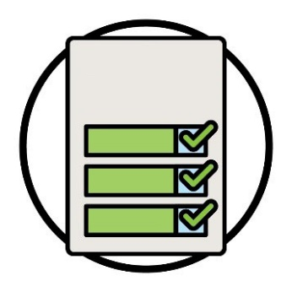  Tuahsernak lei Timhtuahmi | Kan Tuahsernak lei Timhtuahmi chung i cahmai 16 ah kan tuahsermi pawl kong cu na rel khawh.  Kan website ah kan Tuahsernak lei Timhtuahmi cu na hmuh khawh lai.  www.ndis.gov.au/CALD

3. Thawngthanhmi kan phawtzamh ning
Thilsining kong kan chim tikah, i fian dingah a fawi a si a hau:
- CALD mibu pawl
- CALD aa telmi pawl, chungkhar pawl le zohkhenhtu pawl caah.
Thilsining kong chimmi cu a phunphun in a si a hau fawn:
- holh pawl
- formats- video pawl tibantuk.

Kan i tinhmi pawl
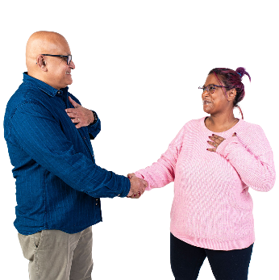 | CALD mibu pawl le aa telmi pawl he thilsining kong chimphuan dingah a thadeuhmi lam pawl kawl kan duh.
 | An hman khawhmi holhlettu i riantuanpiaknak pawl kong kha CALD aa telmi pawl tamdeuh hngalhter kan duh hna.
Holhlettu cu minung pakhat khat:
- nanmah holh a hmangmi
- midang pawl he biakchawnhnak ah nangmah an bawmmi
- minung pakhat khat nih a chimmi naa fiannak ding an bawmmi.
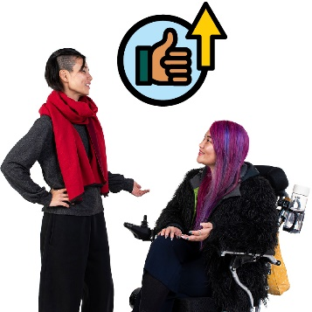 | Holhlettu i riantuanpiaknak a hmangmi CALD aa telmi pawl i hmuhtonnak thanchoter kan duh fawn.
Tuahsernak lei Timhtuahmi | Kan Tuahsernak lei Timhtuahmi chung i cahmai 23 ah kan tuahsermi pawl kong cu na rel khawh.  Kan website ah kan Tuahsernak lei Timhtuahmi cu na hmuh khawh lai.  www.ndis.gov.au/CALD

4. Thimnak le uknak
CALD aa telmi pawl i herhmi pawl a tlinhmi bawmhnak le riantuanpiaknak pawl tamdeuh a um awk a si.
An herhmi pawl he aa tlakmi pechantu pawl hmuh le hman dingah CALD aa telmi pawl nih bawmhnak an herh a hau.
Bawmchantu pawl nih riantuanpiaknak peknak in aa telmi pawl kha an bawmh hna.

Kan i tinhmi pawl
 | CALD mibu pawl he thilsining kong tha tein chimphuan kan duh, hihi tuah ning kong:
 | - NDIS ah an i tel
 | - an nunphung caah a himmi riantuanpiaknak pawl kawl le hman.
 | A thami riantuanpiaknak pawl tamdeuh pek dingah pechantu pawl kha kan duhpiak fawn hna:
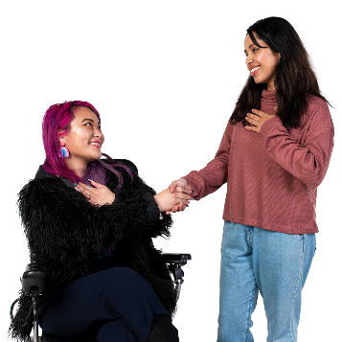 | - nunphung dihlak a upatmi
 | - CALD aa telmi pawl caah tha tein rian a tuanmi
 | - nunphung dihlak caah a himmi.
Tuahsernak lei Timhtuahmi | Kan Tuahsernak lei Timhtuahmi chung i cahmai 31 ah kan tuahsermi pawl kong cu na rel khawh.  Kan website ah kan Tuahsernak lei Timhtuahmi cu na hmuh khawh lai.  www.ndis.gov.au/CALD

5. CALD aa telmi pawl kong data
Rikawt | Data kong kan chim tikah, kan chim duhmi cu:  - thilsining pawl  - thawngthanhmi  - record pawl.
I fian dingah a thadeuhmi data kan herh:
- CALD aa telmi pawl
- bawmhnak an herhmi.
 | Data tamdeuh kan herh, hihi i fian dingah:
 | - riantuanpiaknak pawl kan thangchoter khawh ning
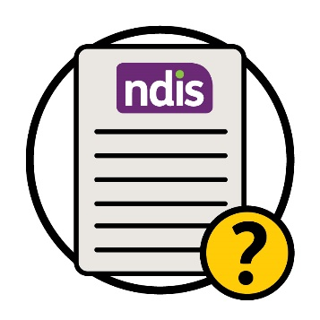 | - NDIS zeitluk tha in dah rian a tuan.

Kan i tinhmi pawl
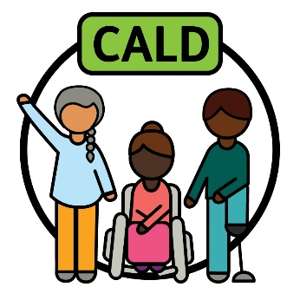 | CALD minung nih an herhmi ‘CALD’ nih a bawm ning fianter kan duh.
 | A thami data laak le hman kha a biapi, cuticun hihi kan tuah khawh lai:
 | - CALD aa telmi pawl caah a thadeuhmi riantuanpiaknak pek dingah
 | - a thami biakhiahnak pawl tuah dingah.
Tuahsernak lei Timhtuahmi | Kan Tuahsernak lei Timhtuahmi chung i cahmai 37 ah kan tuahsermi pawl kong cu na rel khawh.  Kan website ah kan Tuahsernak lei Timhtuahmi cu na hmuh khawh lai.  www.ndis.gov.au/CALD

6. Mibu he kan pehtlaih ning
 | A luancia caan ah tha tein rak phak lomi mibu pawl he pehtlaih dingah a thadeuhmi lam pawl kan kawl a hau.
 | Hi ah aa telmi cu:
 | - hi mibu pawl he thilsining pawl chimphuannak
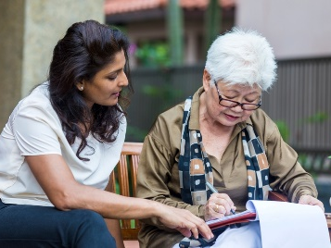 | - riantuanpiaknak pawl mibu pawl i herhmi pawl tlinh hrimhrim dingin tuahnak.

Kan i tinhmi pawl
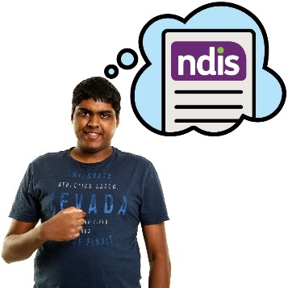 | CALD i pumtlinglo minung pawl nih NDIS an i fian ning thanchoter kan duh.

 | Hi thilsining chimphuannak i aa telmi kong cu:
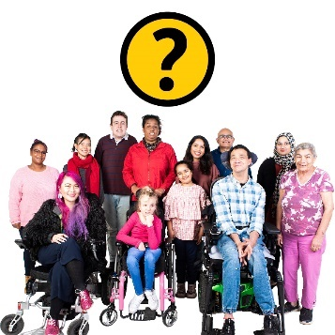 | - NDIS ah aho dah aa tel kho
 | - NDIS hman ning.
 | Pumtlinlonak kong i mibu lungput thlennak a bawmmi thilsining kong chimphuan kan duh fawn.
Lungput pawl cu hihi an si:
- na khuaruahmi
- na ruahmi
- na zumhmi.

Tahchunnak ah, minung cheukhat nih pumtlinlonak kha chia ngai in an ruah.
Cun hi nih hin CALD i pumtlinglo minung kha NDIS hmannak a ngolter khawh hna.
Tuahsernak lei Timhtuahmi | Kan Tuahsernak lei Timhtuahmi chung i cahmai 40 ah kan tuahsermi pawl kong cu na rel khawh.  Kan website ah kan Tuahsernak lei Timhtuahmi cu na hmuh khawh lai.  www.ndis.gov.au/CALD

Hmailei ah zeidah kan tuah lai?
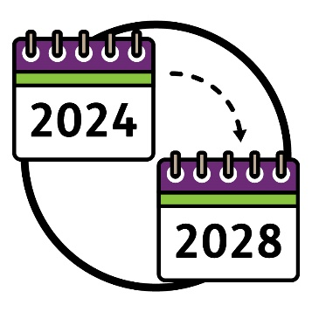 | Tuahno ning cu:  - 2024 ah aa thawk lai  - 2028 ah a dih lai.
 | Tuahsernak lei Timhtuahmi kan tuahmi nih a fiantermi cu:
Tinhmi  pawl | - tuahto ning ah kan i tinhmi pawl phak dingah tuah kan herhmi
 | - tuahsernak pakhat cio i kan tuah te dingmi ningcang
 | - tuahsernak pakhat cio i kan tuah te ding i a raumi caan
Aphichuak pawl | - tuahsernak pakhat cio i aphichuak pawl.
 | Tuahto ning zeitluk tha in dah a kal timi chek dingah Tuahsernak lei Timhtuahmi kan hman lai.
Kan website ah Tuahsernak lei Timhtuahmi cu na hmuh khawh lai.
www.ndis.gov.au/CALD
Fawi tein relmi | Cun kan website ah Tuahsernak lei Timhtuahmi i Rel Fawi deuh in na hmuh khawh lai.  www.ndis.gov.au/CALD
Ripawt | Kum 2024 a dongh lei ah, Tuahto ning bawmh dingah zeitluk dah rian kan tuan cang timi kan ripawt kha chimphuannak kan ngei te lai.
 | Cun Tuahto ning kong ah midang pawl i hmuh ning kha chimphuan kan fial hna lai.

Hi ah aa telmi cu:
- pumtlinglo a simi CALD minung
- mibu phu pawl
- NDIA aleng i ruahnak cheuhtu phu pawl.
Hi nih i fiannak a kan bawmh lai, khoika zawn Tuahto ning dah:
- tha tein rian a tuan
- thancho ter a herh.

Thawngthanhmi tamdeuh
Hi tuahto ning kong i thawngthanhmi tamdeuh hmuhnak caah, zaangfahnak hung kan pehtlaih.
Kan website na zoh khawh.
www.ndis.gov.au
Na kan chawnh khawh.
1800 800 110
Facebook ah follow na kan tuah khawh.
www.facebook.com/NDISAus
Twitter ah follow na kan tuah khawh.
@NDIS
Twitter cu X ti zong in auh a si.

Kanmah he biaruah dingah bawmhnak
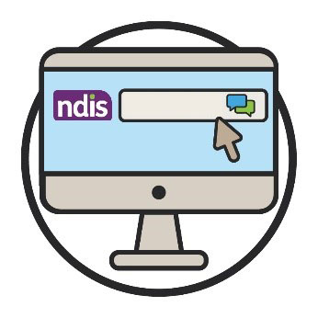  Webchat | Kan website i a cungbik ah a ummi kan webchat tiah hmuhmi hmangin online in na kan chimchawn khawh.  www.ndis.gov.au
 | Mirangholh nak in holh dang na hman ahcun, na chawnh khawh:
Calehnak le Holhlehnak lei Riantuanpiaknak (TIS)
131 450
 | Biachimnak asilole hnatheihnak lei ah chambaunak na ngeih ahcun, na chawnh khawh:
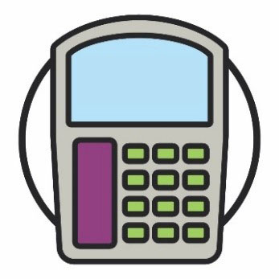  Halo | TTY  1800 555 677
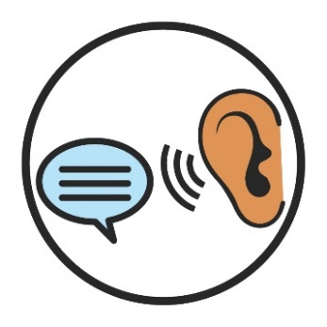 | Chim law Ngai  1800 555 727
Rampumpi huap Chawnhchinnak lei Riantuanpiaknak
133 677
www.accesshub.gov.au/about-the-nrs

Biafang cazin
Hi cazin nih hi catialmi ah anakmi (bold) biafang pawl a sullam kha a fianter.

Lungput pawl
Lungput pawl cu hihi an si:
- na khuaruahmi
- na ruahmi
- na zumhmi.

Ruahnak cheuhtu phu
Ruahnak cheuhtu phu cu kanmah he rian a tuantimi minung phu pakhat a si:
- ningcang te in a kal maw
- tha deuh in tuah a herh maw.

Dawnkhaantu
Dawnkhaantu cu thil pakhat khat tuahnak in an ngoltertu pakhat khat a si:
- tuah na herhmi
- tuah na duhmi.

Tuahtimi-pungsan
Pungsan suaitimi cu minung hna hmunkhat riantuanti tikah a si:
- thil thar pakhat khat tuah
- thil pakhat a riantuan ning kha thanchoter.

Nunphung lei le holh lei in aa dangmi (CALD)
CALD minung pawl cu:
- aa dangmi sining dirhmun pawl sin in a rami
- Mirangholh nak in holh dang a hmangmi.

Nunphung
Na nunphung cu:
- na nunning
- nangmah caah a biapimi a si.
Rikawt | Data  Data kong kan chim tikah, kan chim duhmi cu:  - thilsining pawl  - thawngthanhmi  - record pawl.

Fianter
Thil pakhat khat bantukin fianternak na tuah ahcun, minung phu pakhat ah aa telmi na si kha na chim.

Telhchihmi
Pakhat khat cu i tel ciomi a si tikah, aho paoh:
- an i tel kho
- anmah ta bantukin an ruah.

Holhlettu
Holhlettu cu minung pakhat khat:
- nanmah holh a hmangmi
- midang pawl he biakchawnhnak ah nangmah an bawmmi
- minung pakhat khat nih a chimmi naa fiannak ding an bawmmi.

NDIS riantuanti pawl
NDIS riantuanti pawl cu riantuanpiaknak hmuh le hman dingah midang pawl a bawmmi an si.
Aphichuak pawl | Aphichuak pawl  Aphichuak pawl cu kan riantuanmi nih minung nunnak pawl a thlen ning kha an si.

Aa telmi pawl
Aa telmi pawl cu NDIS ah aa telmi pumtlinglo minung pawl kha an si.

Bawmchantu pawl
Bawmchantu pawl nih riantuanpiaknak peknak in aa telmi pawl kha an bawmh hna.
Covo pawl | Covo pawl  Covo pawl nih minung hna nih zeitindah an in chawnhbiak ding a si mi kong phungphai an si:  - aa ruang in  - aa tluk in.

Tlangtaar | Tlangtar pawl  Tlangtaar pawl cu kan rian le nunnak aa dang liangluangmi chungin a hung chuakmi a biapimi ruahnak pawl an si.

Thinlung fahtuknak
Thinlung fahnak cu nangmah cungah thil thalo pakhat khat a cangmi kong na ruah ning a si.
Tahchunnak ah, a tihmi asilole lungretheimi bantukin na um men lai.
Thinlung fahnak nih lam dang in minung kha a hnorsuan khawh.

Stock hmaanthlak le nunphung he aa pehtlaimi hmaanthlak pawl hmangin Thawngthanhmi Hmuhkhawhnak Phu nih hi Fawi tein Rel dingmi a rak ser. Nawlpeknak tel lo in hmaanthlak pawl cu hmanthan khawh a si men lai lo. Hmaanthlak pawl kongkau i hlathlaimi
pakhat khat caah, zaangfahnak in hika ah zoh visit www.informationaccessgroup.com. Chirchanhmi rian nambar 5212-A.

