my NDIS provider portal

March 2024

Table of Contents
Changes from the last version 4
Introduction 5
What can I do in my NDIS provider portal? 5
Minimum browser requirements 5
Provider Learning Environment 6
How to contact NDIS 7
Access my NDIS provider portal 8
Dashboard 9
Broadcast messages 9
Notifications 10
NDIS Quality and Safeguards Commission 10
Need some help with using the my NDIS provider? 10
Quick links 11
Selecting an organisation 11
Notification Centre 12
my NDIS provider portal navigation 14
My Participants 15
Search for and select a participant 16
View Participant Details 18
About Me 18
Goals 18
Budget 19
Funded Supports 19
Informal community and mainstream supports 20
Participant nominee details 20
Provider roles 20
Request for Service 21
View Support Coordination Requests for Service 21
Respond to a Request for service 25
To Accept 25
To Decline 26
View the details of an accepted Request for service 26
Contact Details 27
Participant context 28
Reporting tasks 28
Submitted reports 28
Reporting tasks 29
Uploading reports for a Request for service 29
Organisation 31
View Organisation details 31
View Bank account details 32
View Employee details 32
Relationship request tab for Plan Managers 33
Downloadable reports 36

Changes from the last version

The following updates have been made to the last published version of the my NDIS provider portal step by step guide.

As of March 2024:
- My participant list has been updated and consolidated (pages 15 to 17)

Introduction
The my NDIS provider portal is a new business system for providers.
This is a separate business system to the myplace provider portal where you currently – and will continue to – manage your transactions with NDIS, and view and manage your services with Participants.
If you are a Specialist Disability Accommodation (SDA) provider, you will already be using the my NDIS provider portal to manage your SDA enrolments.
Registered and unregistered Support Coordinators and Psychosocial Recovery Coaches will be the first to use the new Request for Service function in the my NDIS provider portal.
Registered providers, Plan managers, Registered and unregistered Support Coordinators and Psychosocial Recovery Coaches will be able to view PACE approved participant’s plans and budgets.
Gradually, additional myplace provider portal functionality will be introduced in my NDIS provider portal.

What can I do in my NDIS provider portal?
The my NDIS provider portal currently offers functionality to:
- Select and switch between active organisations,
- View broadcast messages
- View notifications
- Review, accept and decline Request for Service requests,
- View participant details,
- Review and submit your reporting requirement for Request for Service.
- View participant plan and budget, where a participant has given consent.
- View the Provider roles for participant
- Plan managers can request to add, extend and end a relationship with a participant
- View Organisation details
- Download reports
- View Bank account details
- View Employee details
- Extract key participant information in an excel report
- SDA providers can create and manage dwelling enrolments

Minimum browser requirements
To access the my NDIS provider portal. Please use one of following browsers:
- Google Chrome
- Microsoft Edge
- Mozilla Firefox
- Safari on Mac OSX

Provider Learning Environment
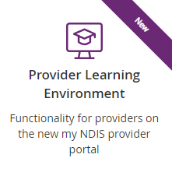
We have released a learning environment to help you learn to use the new my NDIS provider portal. You can log in the provider learning environment via PRODA.
The new learning environment includes walk-through tutorials. The tailored tutorials are available in the learning environment for different provider types and reflect the access providers have within the my NDIS provider portal.
The tutorials have easy to follow steps to help you learn the processes and will be updated with new tutorials as functionality is added to the my NDIS provider portal.

How to contact NDIS

Contact the NDIS by
NDIS Live Webchat  Webchat | Phone  1800 800 110 | Provider Portal Enquiry  myplace provider portal
You can live chat with us about: | You can call us about: | You can use the provider portal to:
- my NDIS provider portal  - Service bookings  - Payment requests  - Quotes  - Referrals  - Request for service  - Searching for a registered provider | - my NDIS provider portal  - Service bookings  - Payment requests  - Quotes  - Referrals  - Request for service  - Searching for a registered provider  - Submitting a general enquiry, feedback, compliment, or a complaint | - Submit a payment enquiry  - Submit a general enquiry, feedback, compliment, or a complaint  - Search for a provider  - Upload documents
Email  enquiries@ndis.gov.au | Contact & Feedback Form  NDIS Online Form | Mail  National Disability Insurance Agency  PO Box 700  Canberra ACT 2601
You can email use about: | You can use the online form to: | You can mail us to:
- Submit a general enquiry, feedback, compliment, or complaint  - Email a document, form report or letter | - Submit a general enquiry, feedback, compliment, or a complaint  - Request a call back | - Send a compliment, complaint or provide feedback,  - Document, form, report or letter

Access my NDIS provider portal
Users can access my NDIS provider portal from the link on the NDIS home page (www.ndis.gov.au).

- Click the Find out more about the test in Tasmania button on the We’re improving the way we deliver the NDIS banner on the NDIS home page.
Figure 1 NDIS Home page showing a link to the Tasmanian test page

2. From this page click the my NDIS provider portal link.
3. You will be taken to the PRODA log in page. Enter your username and password and click the Login button. You will then be taken to my NDIS provider portal.
4. You will need to read and accept the Terms and Conditions.

Note
If you have already signed in to PRODA you will skip the PRODA sign in page.
Once you have logged in you can save the my NDIS provider portal homepage page to your browser favourites.

Dashboard
A dashboard is located when you access the my NDIS provider portal.
The dashboard will provide you with useful information at a quick glance on:
- Broadcast messages
- Notifications
- NDIS Quality and Safeguards Commission
- Need some help
- Quick links
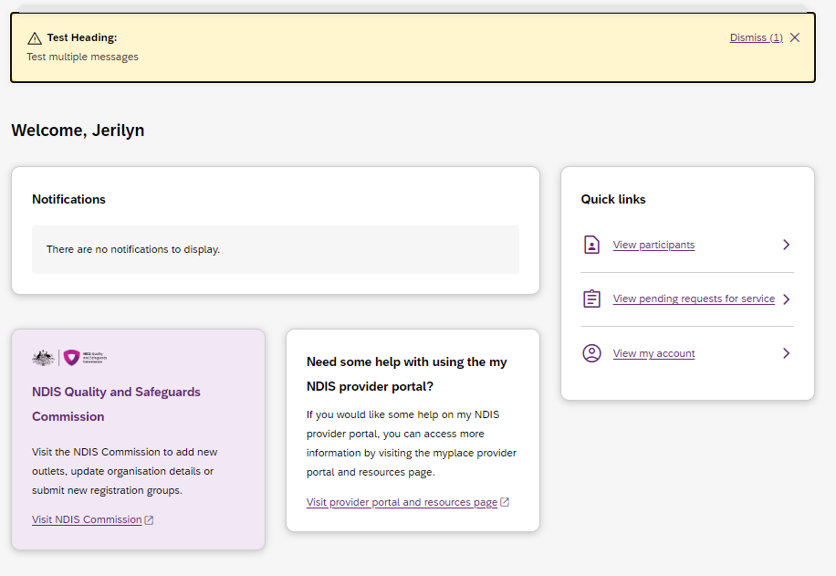
Figure 2 my NDIS provider portal dashboard page

Broadcast messages
A yellow banner will appear when scheduled maintenance to the my NDIS provider portal is planned. The information displayed will be the date and time that the system will be unavailable.

Notifications
This card will display new notifications for:
- A new participant plan has been approved
- Changes have been made to your recorded my provider role
- Changes have been made to your recorded plan manager role.
- Changes have been made to your recorded support coordinator role.
- Changes have been made to your recorded recovery coach role.
- A new my provider role recorded.
- A new plan manager role recorded.
- A new support coordinator role recorded.
- A new recovery coach role recorded.
- A new request for service
- Changes have been made to the participant’s existing plan

You can select the hyperlink of the notifications and it will navigate you to the corresponding tab in the my NDIS provider portal.
- The new request for service notifications will direct you to Request for Service Pending request tab
- All the other notifications will direct you to the Participants record
If you have no notifications then a message will appear advising you that you have no notifications to display.

NDIS Quality and Safeguards Commission
This card has a hyperlink to the NDIS commission.
You can select the hyperlink to navigate to the NDIS Quality and Safeguards Commission to update your registration, organisation, and outlet details.

Need some help with using the my NDIS provider?
This card has a hyperlink to the NDIS provider and portal resource page.
You can select the hyperlink to navigate to the NDIS provider and portal resource page to access the my NDIS provider portal guide.

Quick links
This card has hyperlinks to:
- View participants
- View pending requests for service
- View my account
You can select the hyperlinks to navigate to the to the corresponding tab in the my NDIS provider portal.

Selecting an organisation
If you work on behalf of more than one provider organisation, you can switch between those organisations in the my NDIS provider portal.
When you launch the my NDIS provider portal, you will be prompted to select the organisation you are representing. Click the name of organisation you wish to represent, and you will be taken to the default tab.
Note
If you only work for one provider organisation, you will not see the organisation selection page.
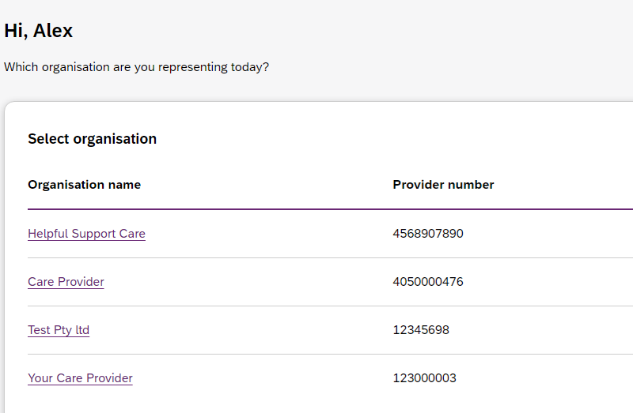
Figure 3 Organisation selector interface

You can change the active organisation while using the portal. Select the dropdown menu by clicking the Acting As button on the top left side of the interface.

Note: You will need to read and acknowledge the Collection Notice which explains what data the NDIS is collecting from me.

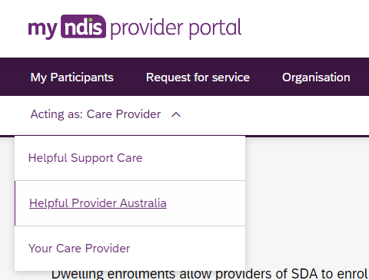
Figure 4 Organisation selector drop-down menu

Notification Centre

A notification bell icon is located on the global navigation bar. This bell icon lets you know how many new notifications have been sent to your organisation today.
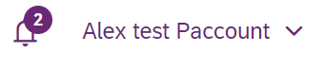
Figure 5 Bell icon for notifications

When you click on the bell notification the Notification Centre will display.
You will be able to view the new notifications for:
- A new participant plan has been approved
- Changes have been made to your recorded my provider role
- Changes have been made to your recorded plan manager role.
- Changes have been made to your recorded support coordinator role.
- Changes have been made to your recorded recovery coach role.
- A new my provider role recorded.
- A new plan manager role recorded.
- A new support coordinator role recorded.
- A new recovery coach role recorded.
- A new request for service
- Changes have been made to the participant’s existing plan

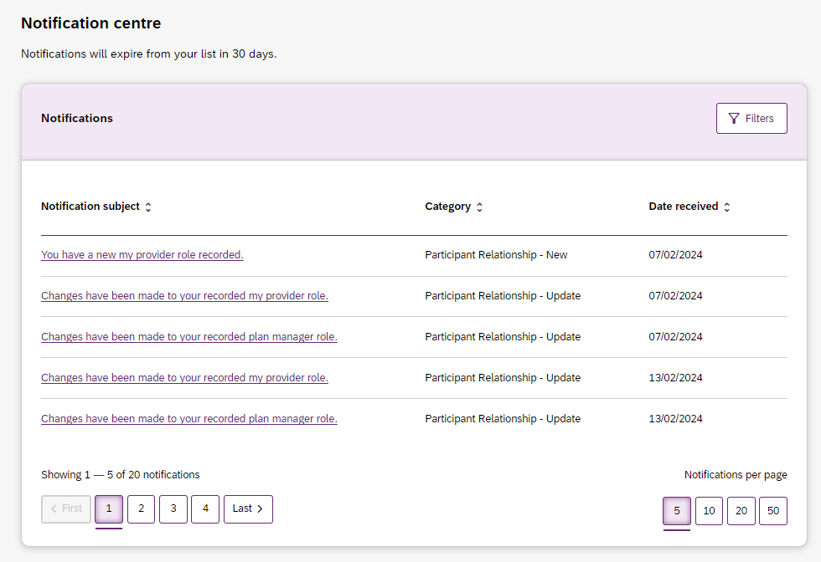
Figure 6 Notification centre

The encircled number beside the bell notification and the Notification centre page shows the number of notifications that you have received today.

my NDIS provider portal navigation

Depending on your organisation’s role you will see a number of tabs in the my NDIS provider portal.
Home: allows you to navigate back to the dashboard
My participants: allows you to search for a participant associated with your organisation and view certain details about them and their plan.
Requests for service: allows you to manage requests for service, respond to requests and submit reports for requests.
Organisation: allows providers to view information about your Organisation, Bank account details and Employees
SDA: allows providers to manage Specialist Disability Accommodation (SDA) dwelling enrolments.
Note
Instructions for using the SDA functions in the my NDIS provider portal are provided
in a separate guide: my NDIS provider portal: Specialist Disability Accommodation (SDA) Dwelling Enrolment (Step-by-step guide).
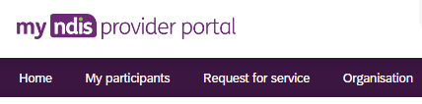
Figure 7 my NDIS provider portal navigation tabs

My Participants

The Participant list allows you to search for a participant and view their plan when the participant has given the NDIA consent to share their plan with you.
The NDIA requires consent from participants to share their plans with providers. Only participants and their nominees can provide the NDIA with the consent to share their plans with providers. Participants have the choice to either share, or not share their plans with you and can withdraw consent at any time.
In addition, you can view other information, including:
- NDIS number,
- Participant name
- Location
- Role start date
- Role end date
- Status
Table 1 Role statuses

Participant status | Definition
New | Within the last 29 days.
Recently started | 29 days from the role start date
Ending soon | 29 days before the role end date

The encircled number beside the My participants heading shows the number of new participant roles.

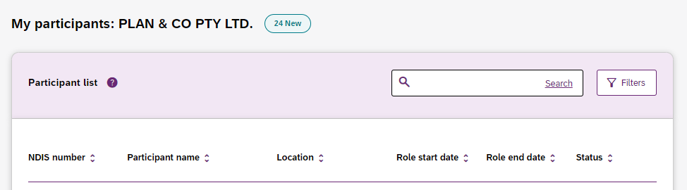
Figure 8 Participant List

Search for and select a participant
To search for a participant:
- Select the My Participants tab.

Figure 9 My Participants tab
2. A list of your active participants will be displayed.
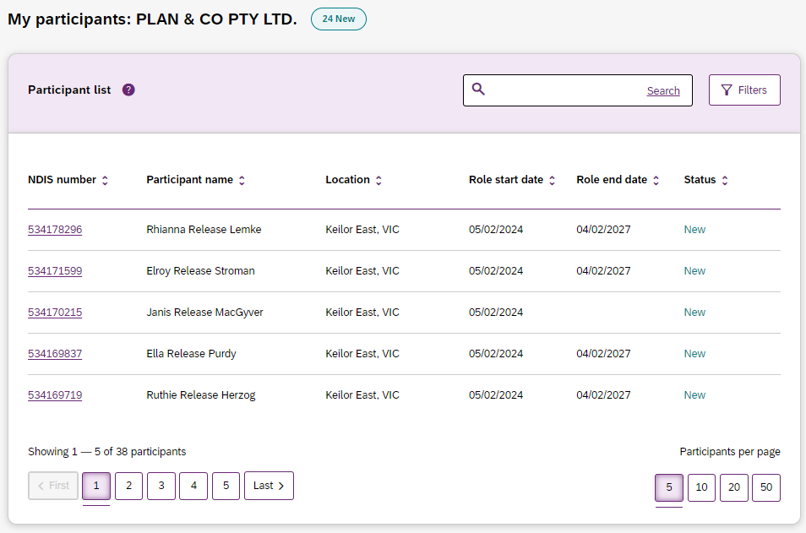
Figure 10 My Participants page
- To search for a participant, enter either the first name, middle name, last name or NDIS number of a participant in the search box and click Search.
- To filter your list. Click on the Filters button. You can filter by choosing the Location, Role start date, Role end date and/or Status and press Apply filters.
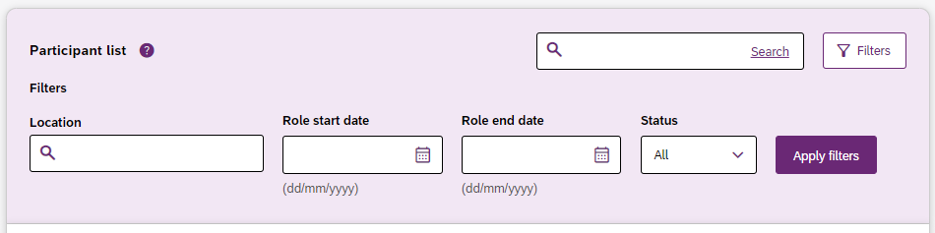
Figure 81 Participant Search Box and Filter options
5. To view the participant’s plan, click on their NDIS number
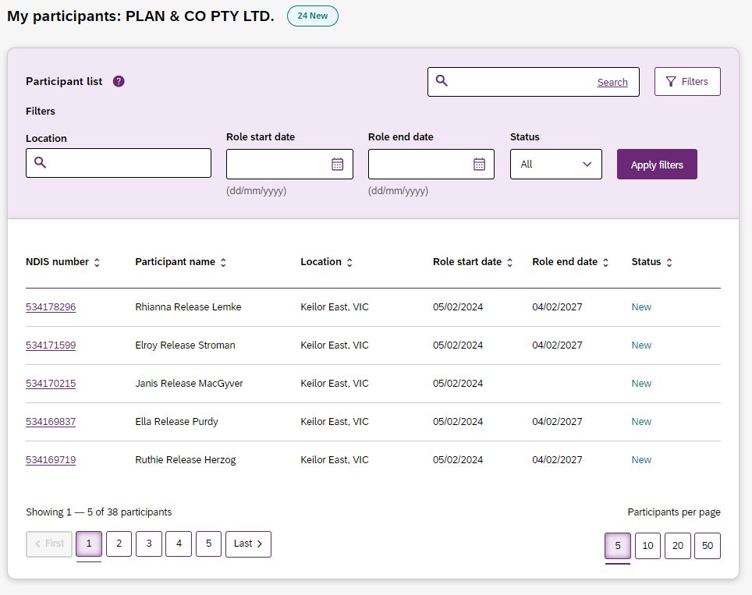
Figure 92 My participants home tab, showing links to the participant details page

View Participant Details
The My Participants page shows the participant’s basic details, including their name, NDIS number, date of birth and contact details.
The NDIA requires consent from participants to share their plans with providers. Only participants and their nominees can provide the NDIA with the consent to share their plans with providers. Participants have the choice to either share, or not share their plans with you and can withdraw consent at any time.
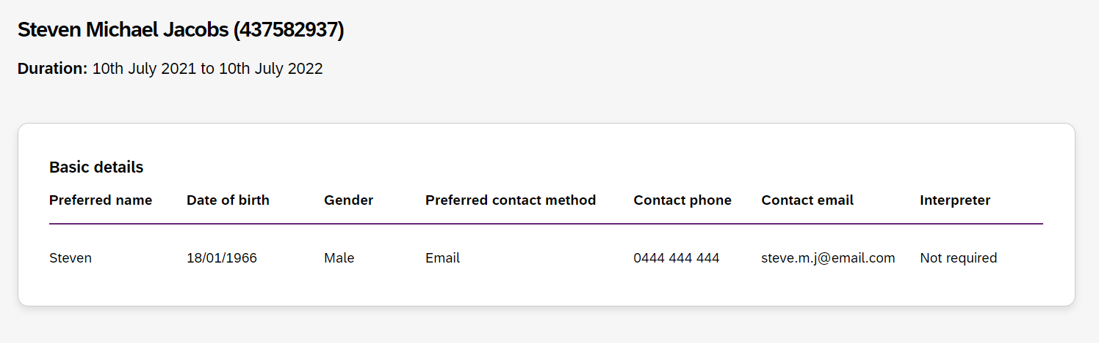
Figure 13 My Participants page showing basic details

Depending on your organisation’s registration the information which is displayed will vary. The following sections may be available:
- About me
- Goals
- Budget
- Funded Supports
- Informal community and mainstream supports, and
- Participant nominee details.
To open each section, click on the relative tab.

About Me
The About me section shows details about the participant's daily life, living arrangements and strengths.
This section is only displayed when a participant has given consent to the support coordinator or psychosocial recovery coaches to view their plan.

Goals
The Goals section outlines a participant's goals and how they will reach them.
This section is only displayed when a participant has given consent to you to view their goals.
By selecting “View goals history” a provider can view a participant’s past goals. A goal appears in this list when a participant informs NDIA that they no longer working towards a goal.
The goals history is only visible when a participant has given for you to view their past goals, and you are either a support coordinator, psychosocial recovery coach or a plan manager.
Note: The my provider role is unable to view past goals.

Budget
The Budget section may include details of each category of funds include in a participant’s plan, including:
- Core flexible: Self-managed funds
- Core flexible: Registered plan managed
- Core flexible: Agency managed
- Stated supports
- Periodic payments

When you have been given consent to view a participant plan and you are:
- Support coordinators or psychosocial recovery coaches you may view all details.
- Plan managers you can only view the plan managed budget details and whether budget is available or exhausted for self-managed and agency managed budgets.

Note: The my provider role is unable to view any budget details

By selecting “View budget history” a provider may view a list of previous budgets and their dates. Selecting a previous budget from this list will display the details of funding for that budget period.

The budget history is only visible when a participant has given permission for you to view their past budgets.

Funded Supports
The Funded supports section shows total funded supports for each support category, and details of the funding available in each category.
When you have been given consent to view a participant funded supports and you are:
- Support coordinators or psychosocial recovery coaches you may view all funded support details
- Plan managers can only view the plan managed funded supports details
Note: The my provider role cannot view any funded support details
By selecting “View funded supports history” a provider may view a list of changes to a participant’s funded supports. Selecting a change from this list will display the details of funded supports at that point in time.

The funded supports history is only visible when a participant has given permission for you to view their funded supports history.

Informal community and mainstream supports
The informal community and mainstream supports section shows information around current supports and new supports for a participant. There are lists for my current supports and new support I want to find.
This section is only displayed when a participant has given consent to the support coordinator or psychosocial recovery coaches to view their plan.

Participant nominee details
The participant nominee detail section shows details for each nominee, the relationship type for a participant and contact details.
This section is displayed for all providers.

Provider roles
The provider roles section shows the role or roles that you have been assigned in the participant’s plan.
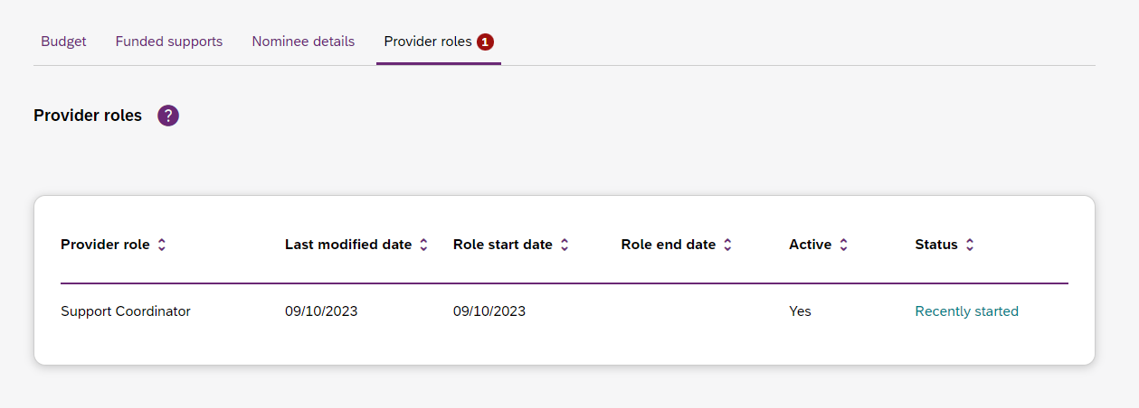
Figure 14 My Participants page showing links to sections with further information

Note: If you are a plan manager, you will see the Extend current role and End current role buttons.
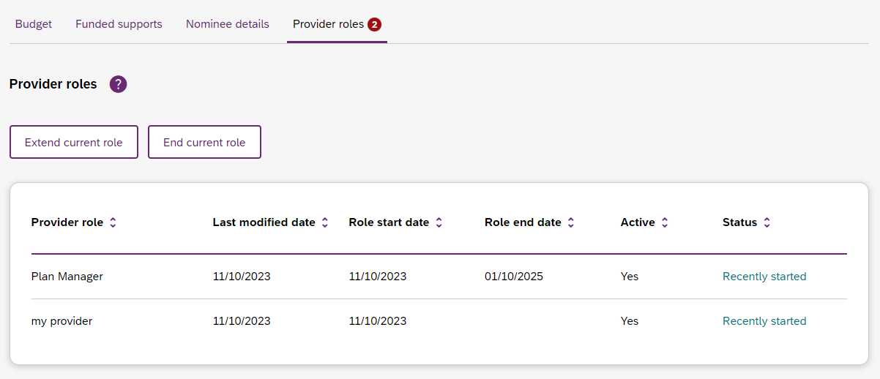
Figure 105 My participant page showing links to extended current role and End current role buttons

The Extend current role button allows you to request an extension to the provider role. You must choose the type of extension you want, that is whether it will be an ongoing relationship or one that has an end date.
The Extend current role button will only appear if the relationship is not ongoing, i.e. it has an end date.
The End current role button allows you to end a current relationship with the participant.

Request for Service
The Request for service tab allows you to manage requests for service, respond to requests and submit reports for requests.

View Support Coordination Requests for Service
To view Support Coordination Requests for Service submitted to your organisation:
1. Select the Request for service tab.
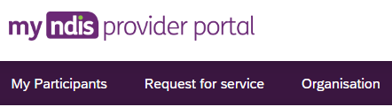
Figure 116 Request for service tab

2. This will display the Request for service page, and links for sections for:
Pending requests: view any pending requests for support coordination services sent to your provider organisation by the Agency. Allows you to review a pending request and either accept or reject the request.
Accepted Requests: view any previously accepted requests for service.
You can now search by:
- Request ID
- NDIS number
- Participant last name
Reporting Tasks: view and complete reporting tasks associated with requests.
Request History: view a history of requests.
You can now Search by:
- Request ID
- Participants full name
- Participants first name
- Participants last name
You can now Filter by:
- Disability
- Status
- Date From
- Date to
The encircled number beside Pending requests link shows the number of outstanding, pending requests for service for your organisation.

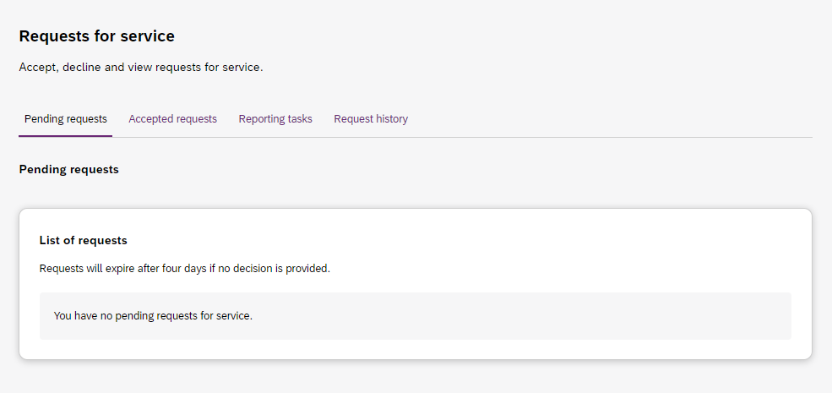
Figure 127 Requests for service page, showing links to sections

3. The Pending requests section will display a list of pending requests for service for your organisation. The following details are included for each request:
Request ID: A unique ID for each request.
Age: The participant’s current age.
Location: The participant’s suburb.
Disability: The main disability experienced by the participant.
Decision due: The due date for a response to the request.
This list can be sorted by column, toggle between ascending and descending sort-order by clicking the column heading.
4. To review the details of a pending request, click the link under the Request ID column.

Figure 138: Opening a request for service

5. The Review pending request page shows some additional details:
Basic details: including the support budget and NDIS contact, as well as limited, anonymised details about the participant.
About Participant: further details about the participant’s disability and whether they require an interpreter.
Additional information section shows further detail about the support being requested.
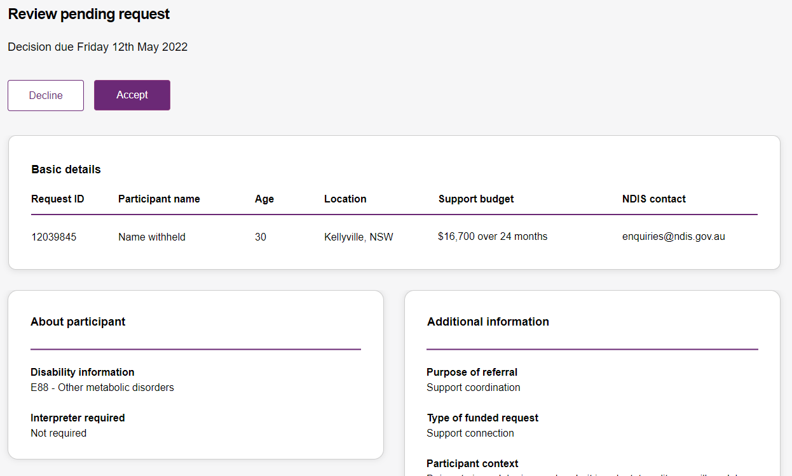
Figure 149 Review pending request page, showing request details.

Respond to a Request for service
Once you have reviewed the information and made a decision you may either accept or decline a request for service before the decision due date.
Figure 20 Decline and accept request buttons

To Accept
1. To accept the Pending request, click the Accept button near the top of the page.
2. You will be prompted to confirm that you have read all the available information, click the Accept request to do so.
3. Your acceptance will be confirmed in a banner displayed across the top of the page.
Figure 21 Prompt to confirm acceptance of a request for service.
Figure 22 Confirmation of successfully accepting of a request for service

To Decline
4. To decline the Pending request, click the Decline button near the top of the page.
5. You will be prompted to provide a reason for declining the request for service
Figure 153 Declining a request for service

- Select the appropriate reason from the dropdown box, the options are:
- No capacity to accept referral
- No capability to accept referral
- Insufficient participant budget to accept referral
- Other
You may leave additional comments about why you declined the request in the textbox. If you selected Other this field is mandatory and you must provide additional comments.
6. Click Decline request to complete.
• The decline will be confirmed in a banner displayed across the top of the page.

View the details of an accepted Request for service
After accepting a request for service, you will be to view to additional details about the participant and the request. This includes:
- Participant name,
- Participant and participant representative contact details,
- Participant context,
- Reporting tasks, and
- Submitted reports.
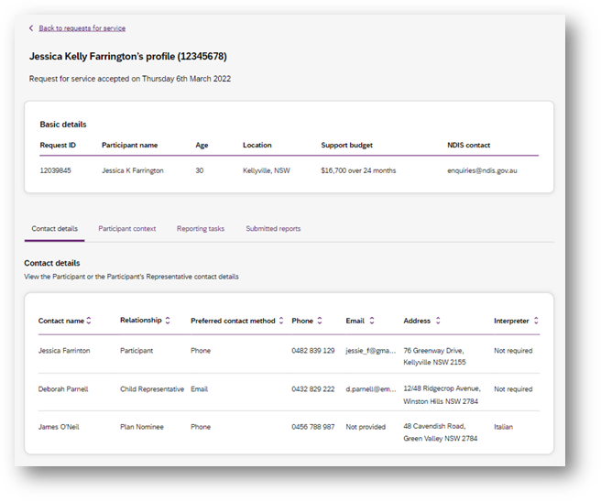
Figure 164 Request for service details page, available after accepting a request

To navigate the details of an accepted request for service use the links on the page
Figure 175 Request for service details page, details links

Contact Details
Contact details of the participant and/or the participant’s representative contact details.

Participant context
Participant context includes additional information about the participant and their disability, including:
- Disability information.
- Whether the participant requires an interpreter, and what language they use.
- Purpose of the referral and type of funded request.
- Report frequency.

Reporting tasks
Reporting tasks shows how often progress reports must be uploaded, and when the next report is due. It also allows for reports to be uploaded.

Submitted reports
Submitted reports shows a history of previously submitted reports for the selected request for service.

Reporting tasks
This tab displays all the reports that are due for your participants in the next 60 days.
1. Select the Request for service tab.
2. This will display the Request for service page, select the link to the Reporting tasks section.
3. This will display a list of reporting tasks for all the organisation’s participants, with columns for:
Request ID: The unique ID for each request.
Participant name: The participant’s current age.
NDIS Number: The participant’s suburb.
Report Type: The main disability experienced by the participant.
Due in: The number of days until the listed report is due, or Overdue if the report is past its due date.
Figure 186 Reporting tasks for accepted requests

• Click the link on the Participant name to access the upload report page.

Uploading reports for a Request for service
1. To upload a report, access the Reporting tasks section of the relevant Request for service details page.
2. On the Reporting tasks page, check the type of report required, the due date and click the Upload report button.
3. You will be prompted to select a report file, files can be uploaded in the following formats and limitations:
File name: 30 characters long
File types: doc, docx, xls, xlsx, csv, pdf, jpeg, jpg, jpe, gif, bmp, png, xml, txt
Document size: 10 MB
4. Click Upload to start the upload and submit the report.
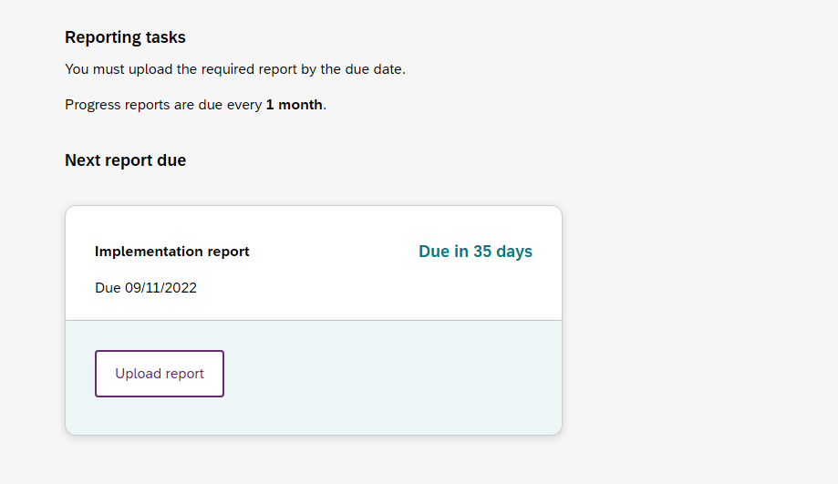
Figure 197 Request for service, report upload page
5. Once complete a banner will appear at the top of the page confirming that you have successfully uploaded a report.
6. You can review previously submitted reports in the previously submitted reports section of the request for service detail page.

Organisation

The Organisation tab allows you to view your Organisation details, Bank account details, Employees and Participants. It also allows you to request reports to extract key information out of the my NDIS provider portal related to PACE participants and PACE claims.
Plan Managers will be able to view a Relationship request tab.

View Organisation details
The Organisation tab shows details stored about your organisation, these are:
- Organisation ID number
- Trading name
- ABN
- Address
- Email address
- Phone number
- Website address
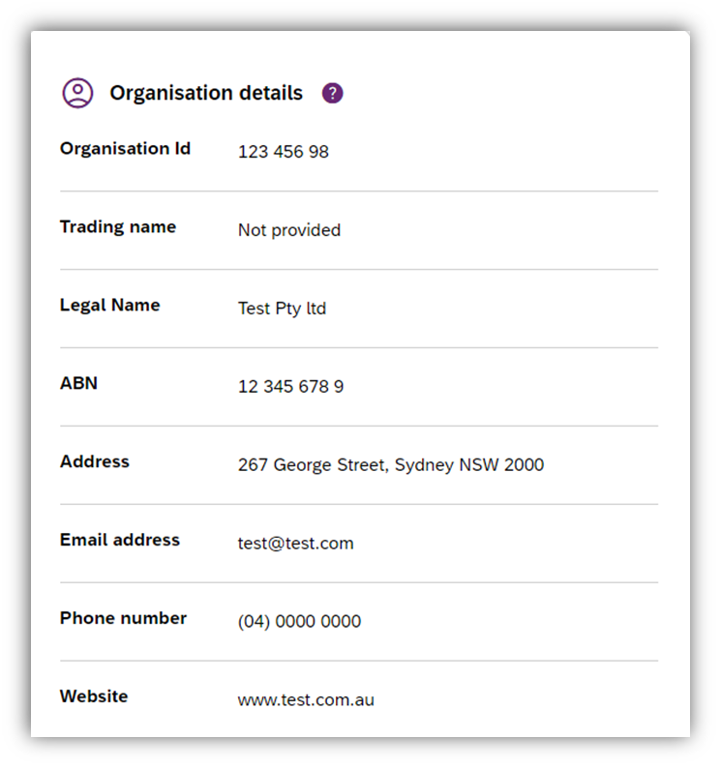
Figure 208 Organisation details

View Bank account details
The Organisation tab also includes details about the bank details stored for your organisation. These are:
- Account name
- BSB
- Account number
- Last updated
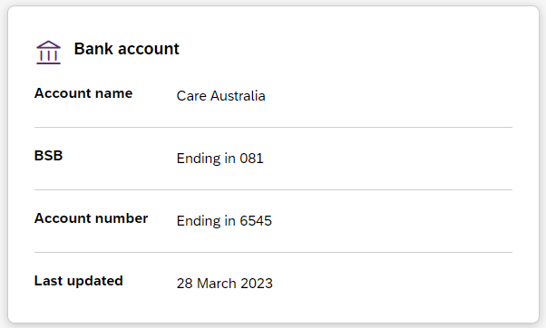
Figure 219 Bank account details
Note: Only Primary contacts and Account Managers can view the Bank account card.
If you have not updated your Bank account details in myplace provider portal, you will see a message asking you to update your bank account details.
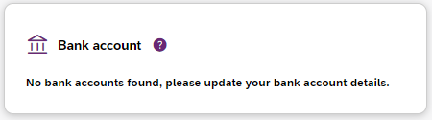
Figure 30 No bank account details stored

View Employee details
To view your Employee’s details, select the Employees tab.
The Employees tab shows a list of your employee’s name, role, start date and end date.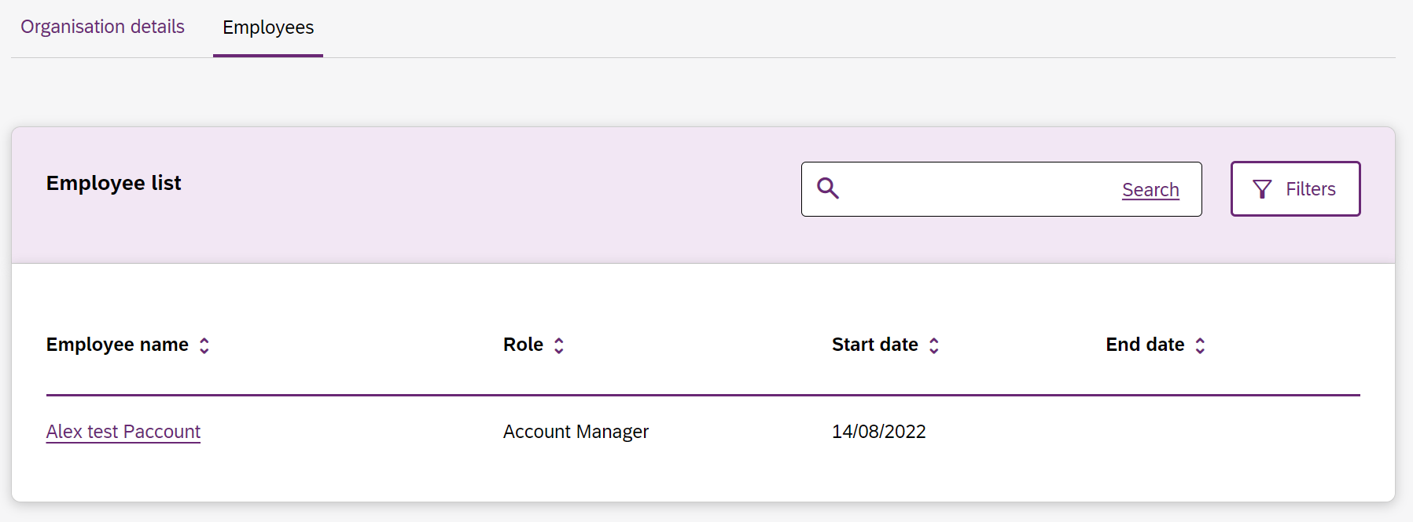
Figure 221 Employee list

To view the Employees history, select the hyperlink on the employee’s name and the role history page will list the employee’s role, start date and end date.
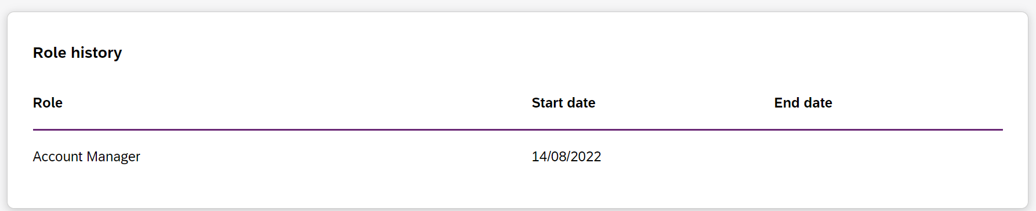
Figure 232 Employee list, Role history

Relationship request tab for Plan Managers
The Relationship Requests tab displays a list of requested relationships. The information available is the Reference number, Participant name (NDIS number), the date the request was submitted, the type of request and request status. 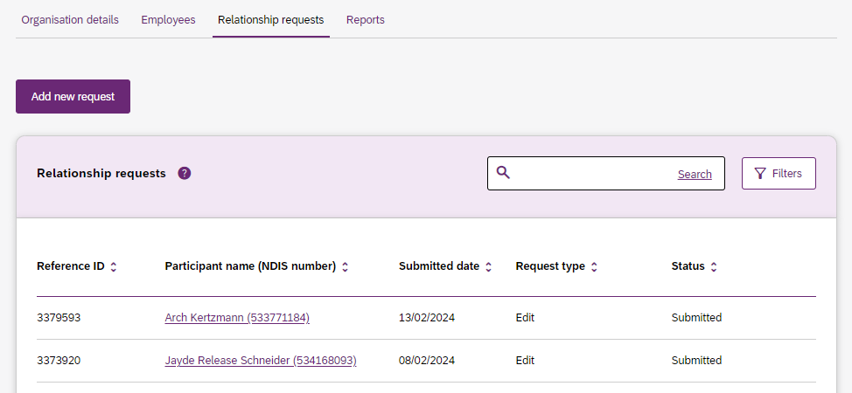
Figure 24 Relationship Requests

Note: The participant’s name is withheld until the relationship request has been approved and/or consent from the participant has been received.
You can add a new participant request by clicking on the Add new request button.
The New relationship request page will open. Complete all the details and select the Submit request button.
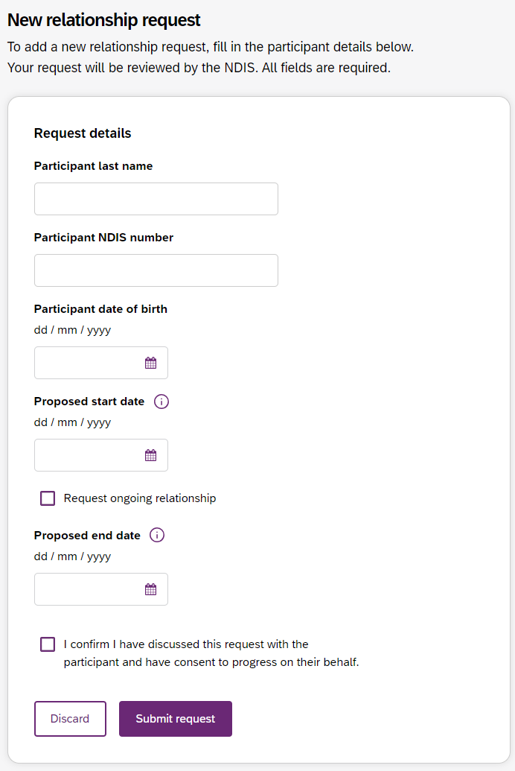
Figure 34 New Relationship Request

If details or information provided is incorrect, then you will be able to view a message on the screen to assist in fixing the incorrect field.

Downloadable reports
The Downloadable Reports tab displays a list of reports requested in the past 24 hours. The information available is the type of report, request submitted date, file generated time, status.

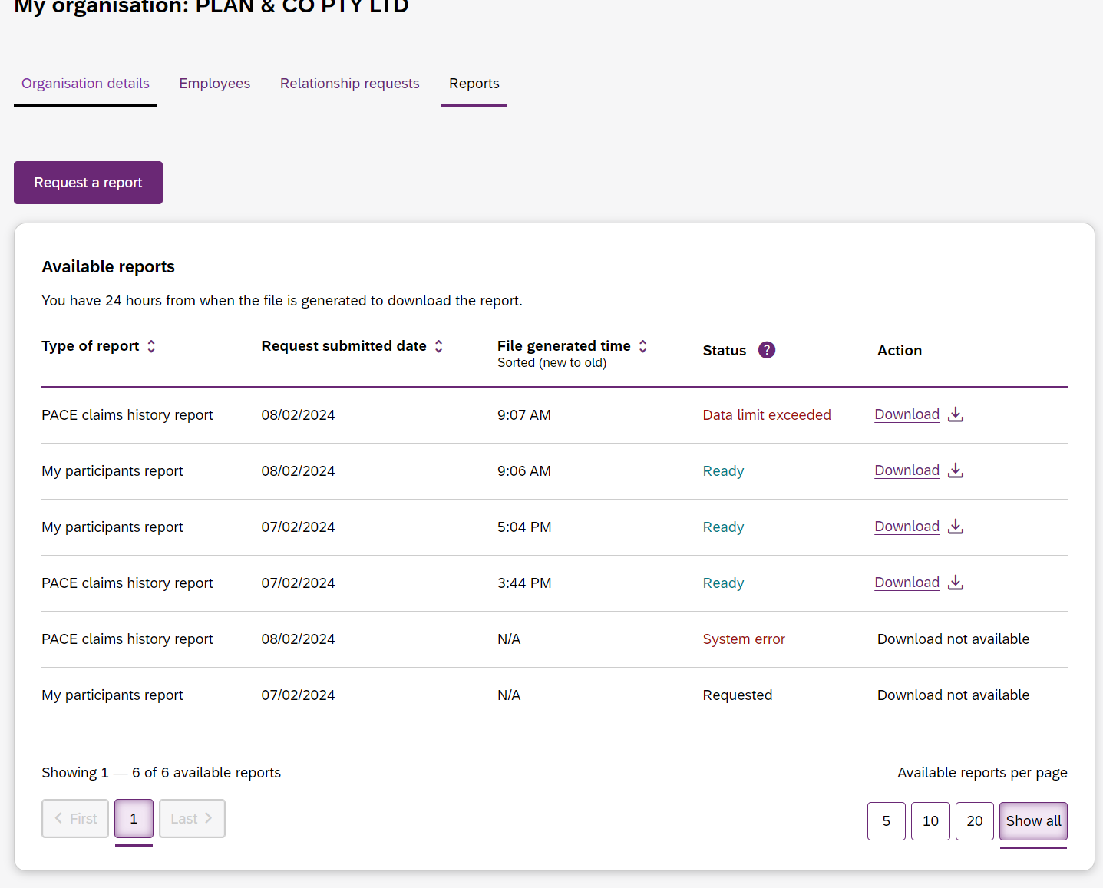

Figure 35 Available reports
You can request a report by clicking the Request a report button, which will open the Request a report page where you can select the type of report you want.
Each type of report has different filters, these are listed in Table 2 (below).
Table 2 Filter options for reports
Report type | Filters
Notifications | Received date from  Received date to  Notification category
My participants | Role start date  Role end date  From date  To date  Provide role
Participant budget report | First letter of participant surnames  Role start date from  Role start date to
PACE claims history report | Claim submitted date  Support start date  Claim Status, or  A Specific claim reference number.
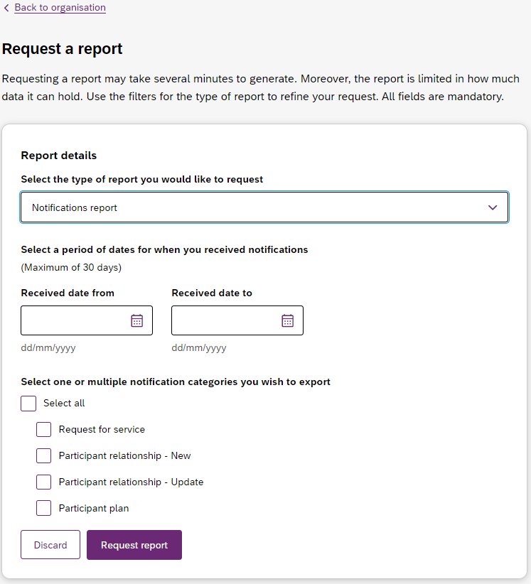
Figure 36 Request a report page showing notifications report.

After submitting your request, it will appear in the Available reports list. When a report is ready you can also download the .csv report file using the link in the action column.
Note: Report files will be available for download for 24 hours. Also, only three reports of each type can be requested every 24 hours.

