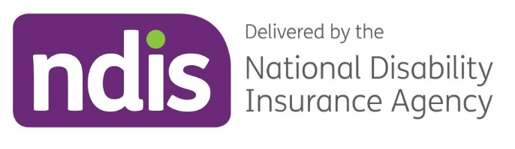

Annual Report
2022–2023
Looking back on our plan to put people
with disability at the centre of the Scheme

Fortunate to be born in the right pocket of time
Julie Penfold says her son Adam ‘was fortunate to be born in the right pocket of time.’
The 12-year-old, who has Down syndrome, transitioned to the Scheme in 2013 when it first trialed in Victoria.
Julie said Adam’s first plan had a good mix of supports. ‘We could use them flexibly as Adam’s needs changed,’ she said.
Non-speaking, speech therapy soon had Adam communicating.
Then with low muscle tone and challenges with fine motor skills, occupational therapy had Adam running around climbing play equipment and confidently using pencils and scissors.
‘We feel fortunate Adam was born in this pocket of time where all these supports have been available to nurture him. They’ve been priceless,’ Julie said.
‘Now Adam’s gone from strength to strength. It’s incredible how far he’s come.
‘We are forever grateful for the impact the NDIS has had and continues to have on enriching Adams’ life.
‘As parents, it’s comforting to know he has support for life, especially when we’re no longer around. It means he can lead his own life and be who he wants to be.’

Contents

Letter of transmittal 4
1 Introduction 5
About this report 5
Acknowledgement 5
1.1 Chair’s review 6
1.2 Chief Executive Officer’s review 7
1.3 The National Disability Insurance Scheme 8
1.4 The National Disability Insurance Agency 8
1.5 Our values 9
1.6 Our aspirations 10
2 Annual Performance Statements 11
2.1 Introduction 12
2.2 Key activity performance 14
3 Financials 22
3.1 Independent audit report 22
3.2 Financial statements 26
4 Financial sustainability 59
4.1 Executive summary 59
4.2 Context for 2022-23 AFSR 59
4.3 June 2023 projection of Scheme expenses 60
5 Management and accountability 64
5.1 Governance 64
5.2 The Board 64
5.3 The Independent Advisory Council 75
5.4 Chief Executive Officer and Strategic Leadership Team 77
5.5 Partners in the community 78
5.6 Workforce management 78
5.7 Staff engagement 81
5.8 Risk management 82
6 Appendices 85
6.1 Enabling legislation 85
6.2 Audit Committee 85
6.3 Work health and safety 86
6.4 Workforce statistics 88
6.5 Executive remuneration policy 91
6.6 Executive remuneration 92
6.7 Reports by parliamentary committees 100
6.8 Judicial decisions and external reviews 101
6.9 Other PGPA reportable items 104
6.10 Advertising and market research 105
6.11 Ecologically sustainable development and environmental performance 106
6.12 Compliance with Carer Recognition Act 107
6.13 Information on other specific statutory provisions 109
6.14 Glossary 111
7 Indexes 114
7.1 Compliance index 114
7.2 Tables index 117
7.3 Figures Index 119

Letter of transmittal
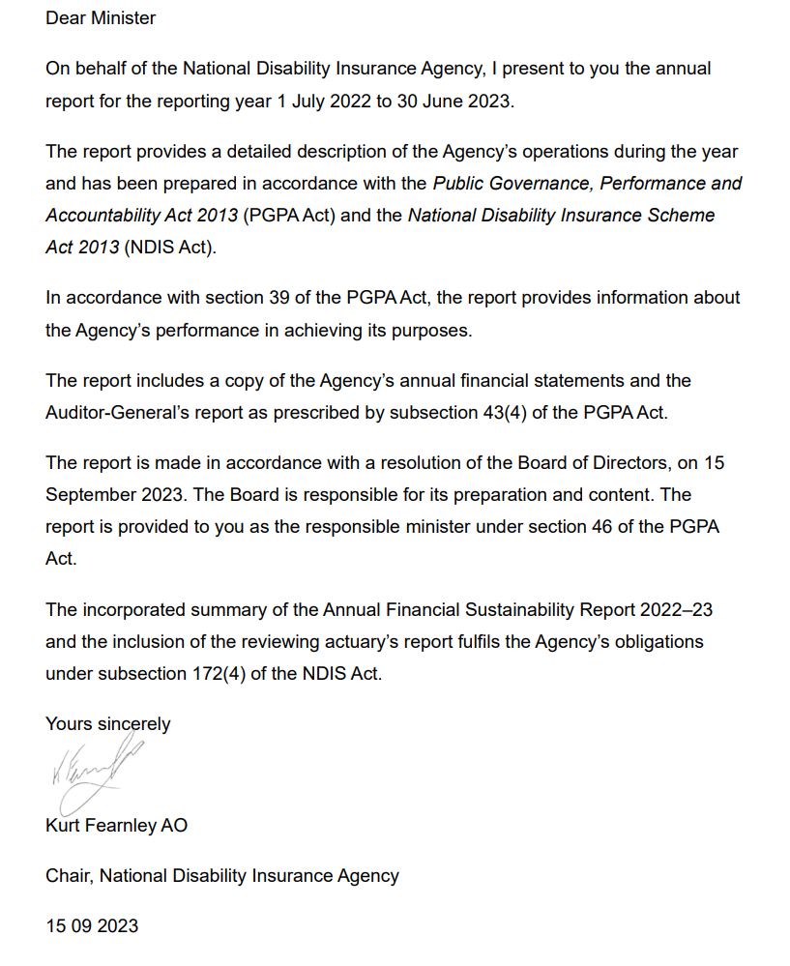
- Introduction

About this report
This is the 10th annual report prepared by the NDIA. The report is prepared in accordance with legislative requirements. It summarises the NDIA’s financial, social and environmental activities from 1 July 2022 until 30 June 2023. This includes how the NDIA fulfilled the principles set out in the National Disability Insurance Scheme Act 2013 (NDIS Act).
Our annual report for the 2022–23 reporting period is more concise than previous NDIA annual reports.
This report provides information for our 4 primary stakeholders:
- our participants
- our providers
- our shareholders (Commonwealth, state and territory governments)
- our people.
It also acknowledges the critical role played by the disability sector.

Acknowledgement
The NDIA Board acknowledges the objectives of the United Nations Convention on the Rights of Persons with Disabilities.
The NDIA Board acknowledges the Traditional Owners and Custodians of country throughout Australia and their continuing connection to land, sea and community. We pay our respects to their Elders, past, present and emerging.

  - Chair’s review
It is an honour to chair the Board of the National Disability Insurance Agency (NDIA).
This year marked 10 years of the National Disability Insurance Scheme (NDIS or the Scheme). The NDIS represents a journey of transformation and empowerment for people with disability.
The core of the NDIS allows participants to exercise choice and control over their supports, providing independence and social inclusion.
We now provide direct supports nation-wide and have more than 610,000 participants. Importantly, many participants are receiving supports related to their disability for the first time.
The Scheme is making a difference to the lives of participants in many ways.
There is an increase in participants’ involvement in community and social activities, with the NDIS continuing to deliver a variety of positive outcomes for participants, families and carers.
There is also an increase in the number of participants in paid work, helping to build on economic, social, community and individual outcomes. More than half of the parents and carers of participants are also now in paid work, demonstrating how the NDIS is transforming lives and positively impacting our whole community.
We have reduced the number of participants waiting for an external review through the continued implementation of an alternative resolution process, which also reduces the number of new cases going to the Administrative Appeals Tribunal (AAT).
We are working with the broader Australian Government on our continued commitment to improving the safe and timely discharge of NDIS participants from hospital.
We have partnered with the First Peoples Disability Network to co-design a new First Nations Strategy and action plan that is culturally appropriate, promotes self-advocacy, provides value, can be measured and reflects the goals and hopes of First Nations people with disability.
These are incredible achievements. But this doesn’t stop us from continuing to improve.
Importantly, we need to continue listening to the voices of people with disability, reminding us of where we’re at and then, as an agency, responding as best as we possibly can to those voices.
Co-design remains a cornerstone of the Agency’s approach, ensuring meaningful engagement with participants and the disability community continues to inform the progress and development of the Scheme.
The initial focus of co-design has been on support for decision-making and for home and living, as well as reinvigorating our focus on specific cohorts, including culturally and linguistically diverse (CALD) and Aboriginal and Torres Strait Islander peoples.
As we look towards the next 10 years, we are working to ensure the NDIS is delivering outcomes for participants.
In October 2022 the Minister for the NDIS, the Hon. Bill Shorten MP, announced a 12-month-long review of the NDIS, with an overarching goal to put people back at the centre of the Scheme. The NDIS Review aims to help restore trust, confidence and pride in the NDIS. It is being co-chaired by a former Chair of the NDIA, Professor Bruce Bonyhady AM, and Ms Lisa Paul AO PSM.
In addition to the review, recommendations from inquiries of the parliamentary Joint Standing Committee on the National Disability Insurance Scheme and from the Royal Commission into Violence, Abuse, Neglect and Exploitation of People with Disability will help to shape the future of the Scheme when they are handed down later in 2023.
These recommendations will also shape the direction of the Agency – one that continues to evolve with the voices and requirements of people with disability.
At Board level, we have introduced a new committee with a dedicated focus on participant outcomes and the strategic direction of the NDIA. This will help to guide any response to the Royal Commission and the NDIS Review, with NDIS participants and people with disability at the heart.
The Board and I are committed to ensuring the Agency is trusted by participants and the community and that together we are building an NDIS that delivers what is needed for people with disability.

Kurt Fearnley AO
NDIA Board Chair

  - Chief Executive Officer’s review
It has been a privilege to lead the NDIA over the past 9 months, particularly as this year marks 10 years since the NDIS began – from grassroots campaigning to becoming a reality. Since then it has grown to support more than half a million Australians. As a world first, the Scheme had no guidebook for getting it right; but as we head into the second decade, we will be guided by the outcomes of the Disability Royal Commission and the NDIS Review.
In the lead-up to the Royal Commission and NDIS Review reports being released, we have worked closely with participants and the wider disability community to deliver an operational reform program start to reshape the NDIS. This includes the Government’s $720 million investment in the NDIA with a focus on a better, more consistent, more equitable experience for participants.
Getting these reforms right and making sure they work and are long lasting requires not only a focus on NDIA delivery, workforce and systems but also a focus on building and maintaining trust with participants and the disability community.
The only way we can do this is by listening to and working with people with disability.
We have had a significant focus on working in partnership with participants and the sector to tackle challenges because we know there is a shared desire to see the Scheme succeed in line with the original vision for it. We want to keep building on this to work together and co-design future reform and implementation.
Many of the ideas on how to improve the Scheme have come from the disability community, including our Independent Advisory Council and disability representative and carers organisations, who have been trying to tackle the challenges facing participants and the Scheme for the best part of a decade.
This input from the sector and participants has been vital to improving a range of policies and programs. For example, in the past year, we released 2 co-designed policies – the Supported Decision-Making Policy and the Participant Safeguarding Policy. We have continued to refine our co-design approach and will co-design the implementation of 6 key initiatives to improve outcomes for participants.
Bringing their knowledge and experience to the table through co-design amplifies the voice of people with disability to ensure we get reforms right. The focus on co-design will remain a key priority for us.
We also know there is a direct link between improving the participant experience and enhancing the capabilities of our staff and partners. Staff and partners who tested our new computer system and improved ways of working in Tasmania told us they can see how it will give them more time to engage directly with participants, focusing on supporting them to get the most out of their plans and connecting with their communities.
Just as we have aimed to listen and respond to participants and the sector, we have gone to staff across the country to gain their input on where we can improve. In March 2023, along with our Strategic Leadership Team, I started a concerted effort to reach all staff across the country in a series of town hall meetings. The goal of these sessions has been to hear from our people about their passion and how we can support them to deliver the Scheme. Our people have provided crucial insights – we heard first-hand from our frontline staff, in particular, about the challenges they face in their everyday work, and we have started addressing these issues so they can better support participants.
We have a big job ahead of us. However, we have focused on positioning and preparing the Agency to deliver reforms and respond to the need for further improvements. The success of the Scheme into the future will be the result of passionate voices across Australia who are working to achieve one goal – an NDIS that works the best it can and that makes all Australians proud.
Chief Executive Officer

Rebecca Falkingham PSM

  - The National Disability Insurance Scheme
The NDIS provides Australians who have a permanent and significant disability with financial support to build capacity, increase independence and establish stronger connections with their community and workplace.
Established in July 2013 to replace the previous primarily state-based welfare system of disability care, the Scheme provides a single, national insurance-based approach to fund support for people with disability, their families and carers.
The NDIS is based on the guiding principles that people with disability:
- have the same rights as all Australians to realise their potential for physical, social, emotional and intellectual development.
- are supported to participate in and contribute to social and economic life to the full extent of their ability.
  - The National Disability Insurance Agency
The NDIA is a corporate Commonwealth entity under the Public Governance, Performance and Accountability Act 2013 (PGPA Act), with statutory authority under the NDIS Act. The NDIS Act, in conjunction with other laws, gives effect to Australia’s obligations under the United Nations Convention on the Rights of Persons with Disabilities. Funding and governance of the Scheme involves the Commonwealth and state and territory governments in accordance with the NDIS Act and inter-governmental agreements.
As a Commonwealth entity, the NDIA is subject to the Commonwealth Performance Framework. The Annual Report (this document) is a key element of the framework, incorporating the NDIA’s performance statements and audited financial statements, which report respectively on our non-financial and financial results. In accordance with the framework, the NDIA also publishes an annual Corporate Plan, our primary non-financial planning document.
The NDIA also provides detailed Quarterly Reports to the Ministerial Council outlining NDIS performance in accordance with the NDIS Act. All reports are available for download on the NDIS website. The NDIA is overseen by the NDIA Board, which has responsibility for ensuring the proper, efficient and effective performance of the NDIA’s functions, setting its strategic direction, ensuring the financial sustainability of the Scheme, and managing risk and ensuring compliance with relevant legislative and statutory requirements. The Board is the accountable authority for the NDIA under the PGPA Act.
The NDIA’s governance also includes the Independent Advisory Council, which provides advice to the Board in accordance with the NDIS Act.

  - Our values
We are focused on developing a capable, engaged and healthy workforce that builds on our reputation as an employer of choice.
We do this through a values-driven culture, based on the values of the Australian Public Service (APS) and supplemented by our own:
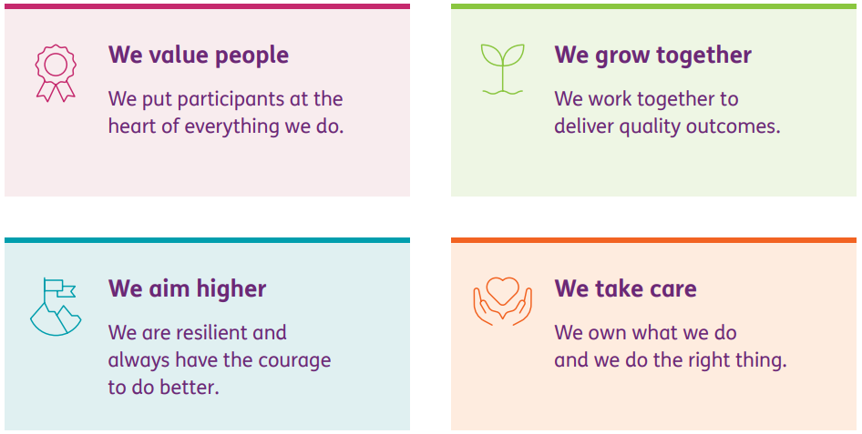
Our people are committed to supporting NDIS participants to achieve their goals. Equally, we are committed to supporting our people to realise the aspirations and goals identified in the Corporate Plan 2022–2026.

  - Our aspirations
Our strategy aligns 5 aspirations to our purpose statement, each with specific strategic goals.
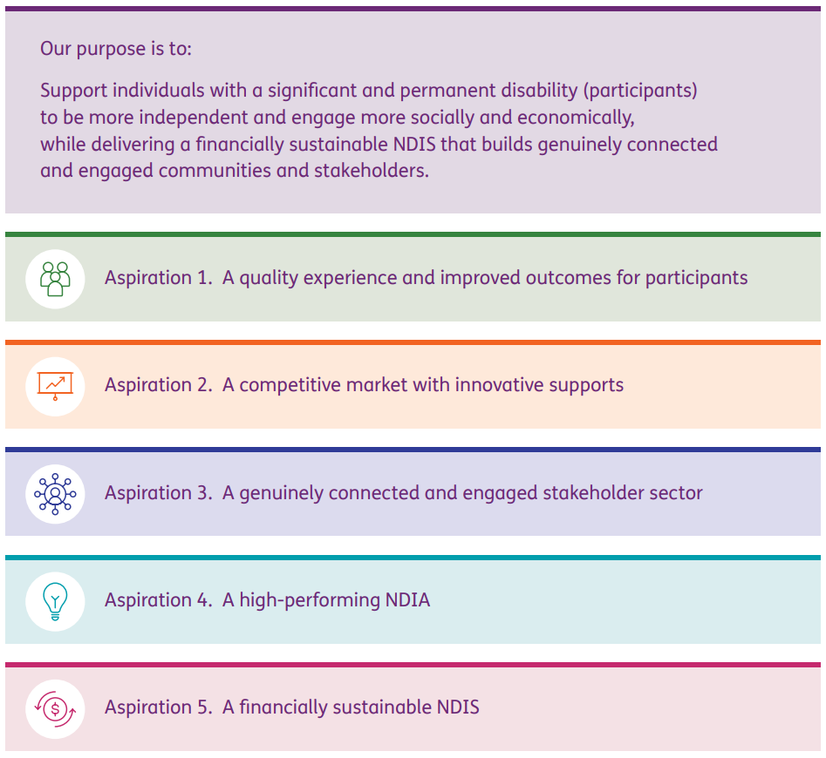
For further information about our aspirations, refer to the NDIA Corporate Plan 2022–2026.

- Annual Performance Statements
National Disability Insurance Agency –
performance statement authority
I, Kurt Fearnley, as the Chair of the Accountable Authority of the National Disability Insurance Agency (NDIA), present the NDIA’s 2022–23 Annual Performance Statements, as required under paragraph 39(1)(a) of the Public Governance, Performance and Accountability Act 2013 (PGPA Act).
In the opinion of the Board, these annual performance statements accurately present the NDIA’s performance in the reporting period and comply with subsection 39(2) of the PGPA Act (section 16F of the PGPA Rule).
Kurt Fearnley
Chair, National Disability Insurance Agency

  - Introduction
As a Commonwealth entity, the NDIA is subject to the Commonwealth Performance Framework. The framework has 3 key elements as outlined in Figure 2.1A

Figure 2.1A: Commonwealth Performance Framework
The Annual Performance Statements are one of the 3 core elements of this performance framework. The NDIA Portfolio Budget Statements 2022–23 (PBS), published in Budget Related Paper No 1.12, and the NDIA Corporate Plan 2022–2026 constitute the remaining 2 components.

Structure and content
The 2022–23 Annual Performance Statements provide the NDIA’s achieved results for the reporting period. This completes the cycle of performance reporting that commenced with the 2022–23 Portfolio Budget Statements, updated in October 2022, and the strategic direction outlined in the NDIA Corporate Plan 2022–23.
The structure of the annual performance measures is consistent with the Corporate Plan 2022–2026, focusing on our work under our key activities – our 5 aspirations – to achieve our purposes.
Each aspiration has a statement analysing the factors contributing to our performance in that area. Results for achievement against the forecast target have been simplified to indicate ‘achieved’, ‘partially achieved’ and ‘not achieved’ within a set tolerance range.
The Agency is reviewing the way it measures performance and will improve its measures and targets following recommendations from public reviews in 2023–24.

Outcome
The outcome for the Agency is to implement a National Disability Insurance Scheme that provides individual control and choice in the delivery of reasonable and necessary supports to improve the independence, social and economic participation of eligible people with disability, their families and carers, and associated referral services and activities.

Program 1.1 – Reasonable and necessary supports for participants
The objective of this program is to provide funding for reasonable and necessary supports to eligible people with disability through consistent, high-quality plans, and to ensure they are in control and have choices to appropriately support their independence and social and economic participation. This program contributes to the outcome by the delivery of financially sustainable funding for participants’ reasonable supports, enabling participants to source services in their plans to pursue their goals.

Program 1.2 – Agency costs
The Agency costs program ensures efficient and effective use of the NDIA operating resources to implement the outcomes of the NDIA. This program contributes to the outcome as it is the primary delivery mechanism for the implementation of the NDIS. The NDIA is responsible for assessing applicants to the NDIS; developing plans, for those who are eligible, in a manner which is based on insurance principles; and administering the payments made under Program 1.1.

  - Key activity performance

Aspiration 1 – A quality experience and improved outcomes for participants
The Agency’s initiatives aimed to facilitate outcomes of economic and social independence for participants and to deliver a quality service for participants and their families, for carers and for providers.

Table 2.2A: Aspiration 1 – performance targets, measures and functions
Performance measure | 2022–23  target | 2022–23 result | Outcome | Method
Participant employment rate | 26% | 22.6% | Not achieved | Calculation is the percentage of participants aged 15 to 64 (working age) who respond ‘yes’ to having a paid job. Sourced quarterly from the Short Form Outcomes Framework questionnaires.
Participant social and community engagement rate | 46% | 41.8% | Partially achieved | Calculation is the percentage of participants aged 15+ who respond ‘yes’ to having been actively involved in a community, cultural or religious group in the last 12 months. Sourced quarterly from the Short Form Outcomes Framework questionnaires.
Children benefiting from the NDIS and no longer needing supports | 6% | 4.7% | Partially achieved | Calculated for the full financial year as the average of 12 monthly results for 2022–23 of children aged 0 to 14 who have received supports from the Scheme under the Early Childhood Approach and are now no longer receiving support.
Participant satisfaction | 76% | 74.9% | Partially achieved | Participant satisfaction survey is conducted monthly by an independent provider, Australian Healthcare Associates. Calculated for the full financial year using the average of the 4 quarterly results published in the Quarterly Report to Disability Ministers.
Participant perception of choice and control | 75% | 76.8% | Achieved | Sourced quarterly from the Short Form Outcomes Framework question ‘Has the NDIS helped you have more choice and control over your life?’. The result is the latest result for participants aged 15+ who have been in the Scheme for at least 2 years.
Participant Service Guarantee timeframes met (%) | 80% | 64.7% | Not achieved | Calculated for the full financial year using the simple average of the 4 quarterly results shown in the Quarterly Report to Disability Ministers.
Families and carers employment rate (%) | 50% | 50.4% | Achieved | Calculated as the percentage of families and carers who respond ‘yes’ to having a paid job (participants of all ages). Sourced quarterly from the Short Form Outcomes Framework questionnaires.
Staff with disability | 19% | 20.8% | Achieved | Sourced from the annual APS Census survey.
Senior Executive Service staff with disability | 12% | 20.8% | Achieved | Sourced from the annual APS Census survey.
Female representation in the Senior Executive Service | 50% | 54.8% | Achieved | Sourced from the annual APS Census survey.

Analysis of performance
The Agency delivers the NDIS as a key part of an ecosystem of supports that Australians with disability rely on. The Agency supports a safe environment for participants, working with the NDIS Quality and Safeguards Commission (NDIS Commission), the Department of Social Services (DSS), all levels of government, participants, staff, partners and the stakeholder sector. Our engagement and work across the disability sector continues to support participants to achieve their goals.
During the reporting period the Agency supported participants to develop their plans and include goals for independence and for social and economic participation. The Agency Quarterly Reports provide details on the progress of the Participant Service Improvement Plan. Typically the Agency has met 55% to 75% of the Participant Service Guarantee timeframes on a month-to-month basis. Participants have had choice and control to implement their plan with support from the Agency, local area coordination partners, and implementation supports built into their plans.
The Agency has observed that participants are reporting greater independence in their NDIS experience, requiring less assistance to navigate and understand the NDIS systems and processes. Participants are becoming more open to making choices about supports and providers that offer services different to those traditionally provided under previous disability systems.
The Agency has observed that participants’ social participation patterns have been affected by actions addressing the COVID-19 pandemic from 2019 to 2022. During the pandemic period, many participants who traditionally accessed day programs were only able to access their community in a limited way. Post-pandemic, many participants are choosing not to return to full-time day programs, instead choosing to be out in the community for one or more days a week.
The Agency acknowledges the importance of families and carers and the role they play in the lives of participants for informal supports. While the result for family and carer employment is stable, this measure is impacted by many variables outside of the Agency’s direct action. The Agency is aware that local employment conditions in regional areas have an impact on work options regardless of NDIS-funded supports for participants they care for and that the cost and lack of availability of childcare require some family members to stay at home to look after children.
The Agency has embedded the NDIA People Strategy and Diversity and Inclusion Framework as part of its activities under Aspiration 4 – high-performing NDIA. These efforts ensure our staff reflect the diversity of the Australian public and are able to support participants through the NDIS journey.

Aspiration 2 – A competitive market with innovative supports
The Agency’s initiatives supported working with participants and other stakeholders to enable the growth of a market of adequate size, quality and innovation.

Table 2.2B: Aspiration 2 – performance targets, measures and functions
Performance measure | 2022–23 target | 2022–23 result | Outcome | Method
Plan utilisation by district  (% of districts that are more than 10 percentage points below the benchmark) | <8% | 7.2% | Achieved | Calculated for the full financial year using the simple average of the 4 quarterly results shown in the published Quarterly Report to Disability Ministers.
Market concentration  (% of districts where the top 10 providers supply more than 85% of the supports) | <9% | 4.4% | Achieved | Calculated for the full financial year using the average of the 4 quarterly results shown in the published Quarterly Report to Disability Ministers.
Providers charging below the price limit (% of markets) | >24% | 21.3% | Not achieved | Calculation is the percentage of providers (from the group that can be measured) charging 90% or less of the pricing limits in the latest price guide. A higher result for this metric implies higher levels of competition in the market (since prices would be at lower levels compared to the maximum prices in the price guide).

Analysis of performance
The Agency manages and monitors NDIS provider market exits and seeks to ensure continued diversity of provider options for participants. Support is provided to update service delivery guidance for partners and planners to ensure provider options are made available to participants. Further work will be progressed on broader market design including levers related to market concentration.
At the Disability Reform Ministers Meeting in October 2022, Ministers discussed the need for the NDIA to work with communities and state and territory governments to use more flexible approaches to address thin markets.
This work is being led by the Commonwealth Department of Health and Aged Care working with the NDIA and multiple other government departments and agencies, including the DSS and the Department of Veterans’ Affairs, on an Integrated Care and Commissioning (ICC) approach.
Market facilitation activities are underway for ICC trial sites in south-eastern New South Wales and Gippsland (Victoria), with NDIA representatives included as members of the ICC regional working groups and Strategic Oversight Group.

Aspiration 3 – A genuinely connected and engaged stakeholder sector
The Agency’s initiatives aimed to develop a strong and engaged stakeholder sector that genuinely collaborates and contributes to the delivery of the NDIS, with confidence in the NDIS.

Table 2.2C: Aspiration 3 – performance targets, measures and functions
Performance measure | 2022–23 target | 2022–23 result | Outcome | Method
General community sentiment and confidence (%) | 70% | 66.3% | Partially achieved | Calculated monthly (internally), through data provided from the community sentiment survey conducted by Hall & Partners, by converting the scores for the 4 brand sentiment measures – reputation, trust, support and positivity towards the Scheme – to a percentage and then calculating the average of the 4 percentages.

Analysis of performance
The NDIA has engaged in co-design with the sector on important aspects of the delivery of the Scheme. To be successful and effective at delivering the Scheme, the Agency requires the voices and input of participants in the development of policies, services and interactions. The NDIA continues to build its engagement capability (including co-design) through the NDIA Engagement Framework.

Over the last year, co-design efforts have focused on 6 priority areas:
- participant safeguarding
- supported decision-making
- information gathering for access and planning (IGAP)
- home and living
- Cultural and Linguistic Diversity Strategy (CALD Strategy)
- First Nations Strategy.

The Minister released the NDIA Participant Safeguarding Policy and Implementation Plan on
10 April 2023, and the Supported Decision Making Policy and Implementation Plan on 4 May 2023.

In May 2023, the IGAP Steering Committee agreed to pause the IGAP project until the recommendations of the NDIS Review have been delivered.

The NDIA is co-designing a Home and Living Framework to inform the way the Scheme supports participants to pursue their home and living goals. The NDIA is currently working on an implementation plan to support the framework. More than 120 hours of co-design has gone into the development of the framework.

The NDIA is co-designing a new CALD Strategy for 2023–2027 and corresponding Action Plan. In the last year, the NDIA has completed engagement with people with disability from CALD backgrounds, nominees, families, carers, providers, and sector stakeholders to co-design actions to address identified challenges. The final CALD Strategy and Action Plan will then be translated and designed, before being released and publicly available by November 2023.
The NDIA is progressing the development of a new First Nations Strategy, to replace the 2017 Aboriginal and Torres Strait Islander Strategy. Over the last year, the NDIA has established the NDIS First Nations Advisory Council.

General community sentiment focuses on sentiment measures of reputation, trust, support, and positivity towards the Scheme. A decrease in community sentiment was observed in May coinciding with media coverage on the announcement of the Budget.

The provider sentiment survey was not conducted in the reporting period due to low provider engagement and response frequency in previous years. The Agency is awaiting the outcomes of external reviews to inform the best measure of performance related to provider experience with the Scheme.

Aspiration 4 – A high-performing NDIA
The Agency’s initiatives aimed to develop a high-performing NDIA that has an engaged workforce with systems and processes that facilitate service excellence.

Table 2.2D: Aspiration 4 – performance targets, measures and functions
Performance measure | 2022–23 target | 2022–23 result | Outcome | Method
NDIA spend (Program 1.2) compared to PBS (%) | 100% | 103% | Partially achieved | Calculation is equal to actual Agency costs divided by Agency costs in the PBS for the year to date (YTD) (from 1 July) on the PBS accrual basis.
NDIA spend (Program 1.2) as proportion of NDIS spend (%) | 6% | 5.2% | Achieved | Calculation is equal to Agency costs as a percentage of Scheme costs for the YTD (from 1 July) on the PBS accrual basis.
Staff engagement (%) | 76% | 77% | Achieved | Sourced from the annual APS Census survey.
Staff wellbeing (%) | 70% | 73% | Achieved | Sourced from the annual APS Census survey.
Staff with disability (%) | 19% | 20.8% | Achieved | Sourced from the annual APS Census survey.
Senior Executive Service staff with disability (%) | 12% | 20.8% | Achieved | Sourced from the annual APS Census survey.
Female representation in the Senior Executive Service (%) | 50% | 54.8% | Achieved | Sourced from the annual APS Census survey.

Analysis of performance
The Agency has been undergoing considerable transformation over the reporting period. The transformation follows from the roadmap contained in the Corporate Plan. We set out in our Corporate Plan our approach to maintaining strong staff engagement and building the NDIA workforce capability to support the achievement of our operational goals. The Agency has embedded its People Strategy and Inclusion and Diversity Framework. Each year the Agency reviews the results from the APS Census. Each branch within the Agency works to address the results and implement change across the year.
The Agency has been progressing with the rollout of its new customer relationship management system (PACE) and testing in Tasmania since November 2022. The test has been valuable for enhancing processes and systems in readiness for national expansion during 2023–24. In addition, we have progressed projects looking at capability for claims at point of support and eInvoicing.
Changes to the measuring of performance for this key activity include the removal of the payment errors/anomalies measure. The performance measure was assessed and identified as not being directly linked to the key activity.

Aspiration 5 – A financially sustainable NDIS
The Agency’s initiatives aimed to deliver a financially sustainable NDIS, based on insurance principles.

Table 2.2E: Aspiration 5 – performance targets, measures and functions
Performance measure | 2022–23 target | 2022–23 result | Outcome | Method
Children benefiting from the NDIS and no longer needing supports (%) | 6% | 4.7% | Partially achieved | Calculated for the full financial year as the average of 12 monthly results for 2022–23 of children aged 0 to 14 who have received supports from the Scheme under the Early Childhood Approach and are now no longer receiving support.
Socioeconomic equity (%) | 104% | 101.7% | Achieved | Calculated as the average annualised plan budget for participants in the top 2 deciles (based on the Australian Bureau of Statistics (ABS) Index of Education and Occupation classification) divided by the average annualised plan budget for participants in the bottom 2 deciles for all states (except the ACT, for which the top and bottom 4 deciles are used). Participants aged 0 to 64 who are not in supported independent living are included in the calculation.
Payment growth compared to healthcare and social assistance wages growth | <2 | 2.3 | Partially achieved | Calculated quarterly using a participant payments inflation rate for the quarter (with a 3-month delay) divided by an ABS wages inflation rate.  Measure compares the actual inflation rate being experienced on participant payments to the relevant published industry wages inflation index.
NDIS annual spend (Program 1.1) compared to PBS (%) | 100% | 103.6% | Not achieved | Actual YTD payments divided by PBS YTD payments. Payments are calculated on an accrual basis.
Payment errors/anomalies (% of program outlay) | <1% | 4.2% | Not achieved | Calculated monthly, inclusive of payments in the financial year to date, and weighted.

Analysis of performance
The NDIS continues to be demand driven, and the Government’s investment in the NDIS will continue to grow.

Scheme costs were higher than target, driven by a higher average cost per participant of $60,700 compared to budget of $59,500 and a higher participant intake for the financial year than budgeted by $18,208.

The payment errors/anomalies percentage has increased over the past 2 years from 1.23% in 2020–21 to 4.17% in 2022–23. This has particularly been observed for supported independent living providers where amounts claimed exceeded the agreed rate in the participant’s plan, and for self-managed participants where the amount paid was not supported by the evidence provided.

A reduction in eligibility reassessments due to resources being diverted to other activities has resulted in fewer children leaving the Scheme than expected. The 2023–24 Budget included a range of measures to address these areas, including an increase in workforce capability and capacity and implementation of a dedicated eligibility reassessment workforce to increase the Agency’s capacity to process eligibility reassessments.

- Financials
  - Independent audit report
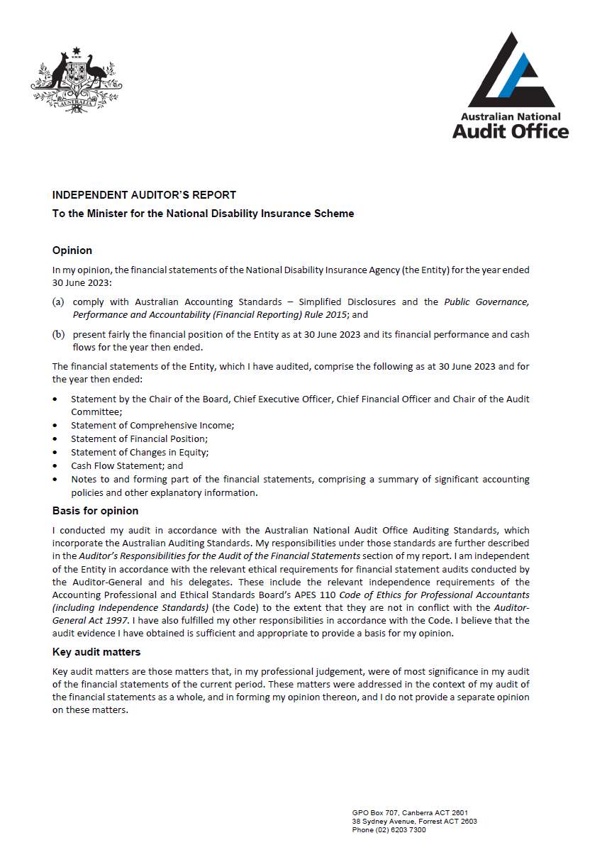
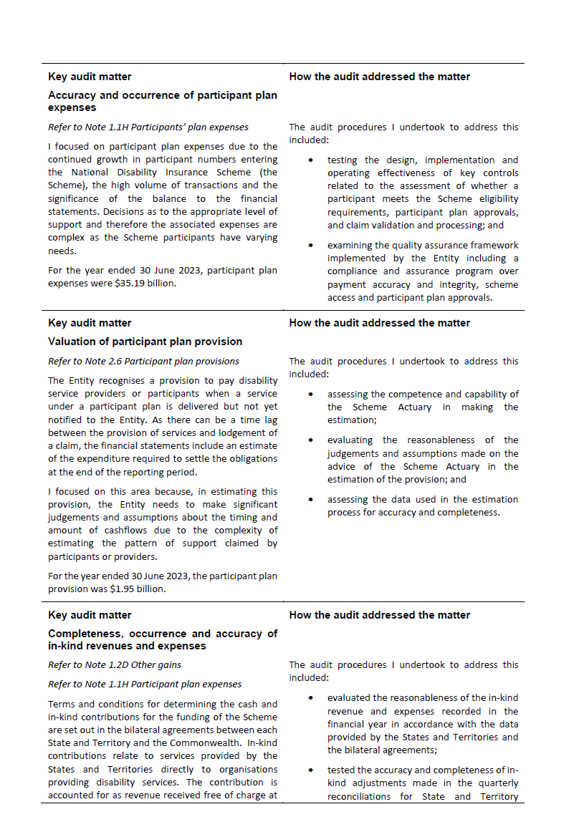
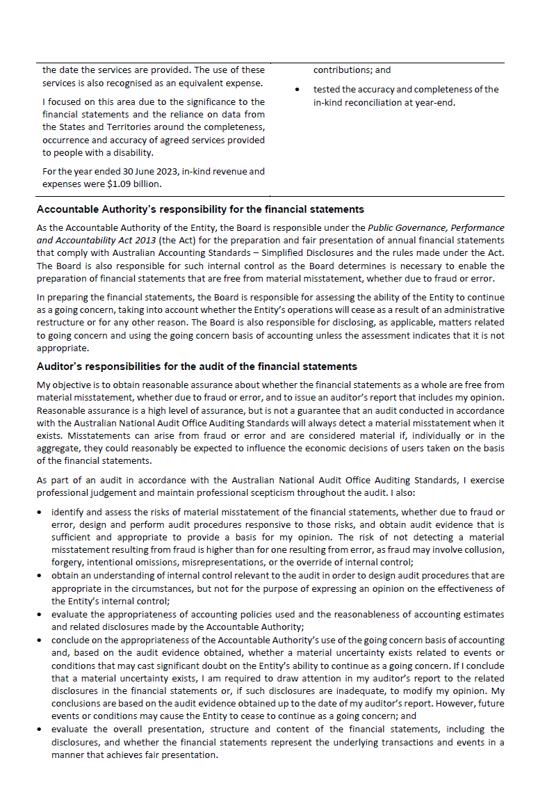

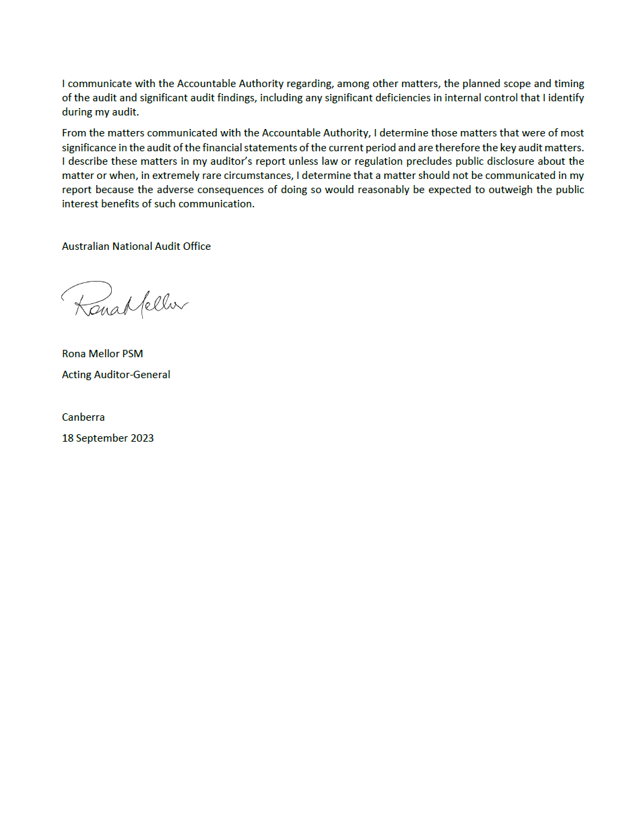

  - Financial statements
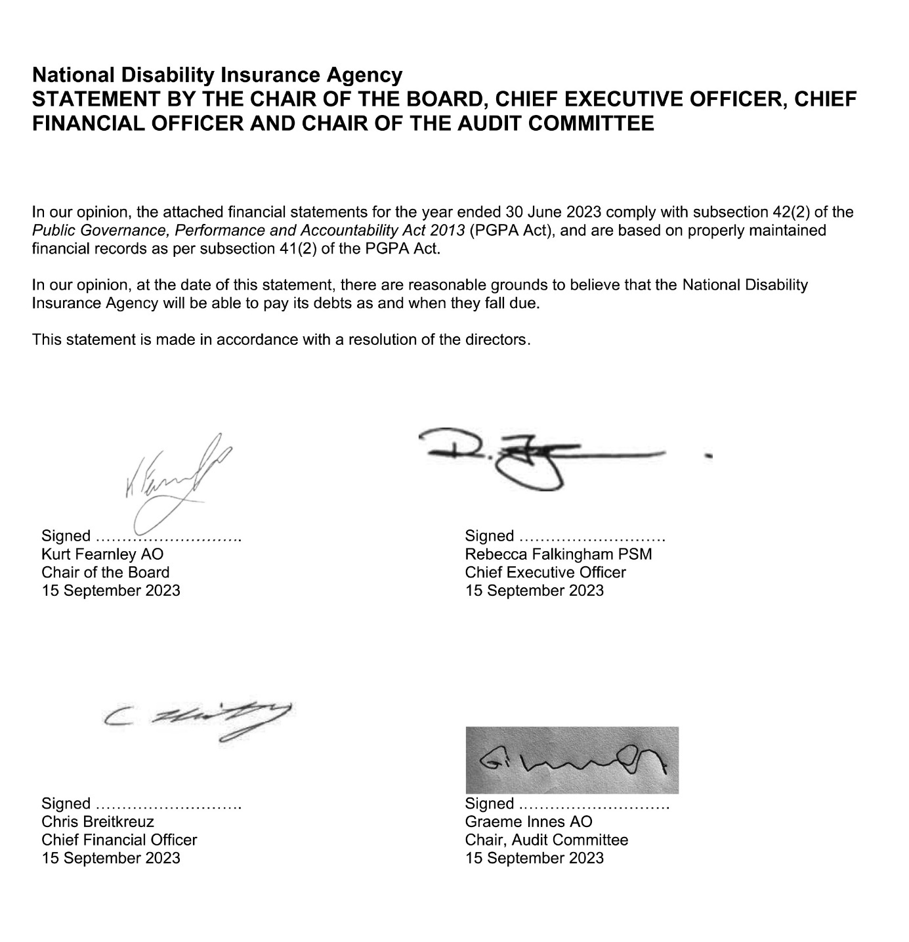

 | Notes | 2023  $'000 |  | 2022  $'000 |  | Original Budget¹  2023  $'000
NET COST OF SERVICES
Expenses
Employee benefits | 1.1A | 551,640 |  | 482,219 |  | 481,228
Suppliers | 1.1B | 604,046 |  | 480,327 |  | 1,219,864
Community partnership costs | 1.1G | 604,346 |  | 560,131 |  | -
Grants | 1.1C | 347 |  | 262 |  | -
Participant plan expenses | 1.1H | 35,193,427 |  | 28,631,144 |  | 33,976,620
Depreciation and amortisation | 2.2A | 65,508 |  | 67,131 |  | 71,426
Finance costs | 1.1D | 1,948 |  | 1,216 |  | 2,945
Impairment loss on financial instruments | 1.1E | - |  | 135 |  | -
Write-down and impairment of other assets | 1.1F | 9,294 |  | 3,942 |  | -
Total expenses |  | 37,030,556 |  | 30,226,507 |  | 35,752,083
OWN-SOURCE INCOME
Own-source revenue
Rendering of services | 1.2A | 34,111,841 |  | 28,179,885 |  | 32,968,623
Interest |  | 259,802 |  | 17,475 |  | 73,951
Rental income | 1.2B | 704 |  | 592 |  | -
Other revenue | 1.2C | 29,420 |  | 23,324 |  | 53,000
Total own-source revenue |  | 34,401,767 |  | 28,221,276 |  | 33,095,574
Gains
Other gains | 1.2D | 1,198,317 |  | 1,015,002 |  | 1,088,200
Total gains |  | 1,198,317 |  | 1,015,002 |  | 1,088,200
Total own-source income |  | 35,600,084 |  | 29,236,278 |  | 34,183,774
Net (cost of)/contribution by services |  | (1,430,472) |  | (990,229) |  | (1,568,309)
Revenue from Government |  | 1,445,361 |  | 1,263,386 |  | 1,445,361
Surplus/(Deficit) |  | 14,889 |  | 273,157 |  | (122,948)
OTHER COMPREHENSIVE INCOME
Items not subject to subsequent reclassification to net cost of services
Changes in asset revaluation reserve |  | 17,285 |  | (1,058) |  | -
Total other comprehensive income |  | 17,285 |  | (1,058) |  | -
Total comprehensive income/(loss) |  | 32,174 |  | 272,099 |  | (122,948)

The above statement should be read in conjunction with the accompanying notes.
¹ Original Budget refers to the figures published in the Portfolio Budget Statements 2022-23, tabled 25 October 2022.

Budget Variances Commentary
Statement of Comprehensive Income
The following major variance explanations between the Original Budget as presented in the October 2022 Portfolio Budget Statements and the 2022–23 financial statements are presented in accordance with Australian Accounting Standards. The 2022-23 Portfolio Budget Statements contain the original financial statements’ budget estimates presented to Parliament in respect of the 2022–23 financial year. The information presented below should be read in the context of the following:
· major variances are determined in accordance with Department of Finance guidelines; and
· the Budget is not audited.

Affected line items | Explanations of major variances
Expenses  Employee benefits | The Agency has employed and retained a higher of level of staff, and experienced lower than expected levels of leave taking.
Expenses  Suppliers, Community partnership costs | There is no Original Budget allocated against community partnership costs line item. The Commonwealth Budget process does not allow for the separate reporting of community partnership costs and supplier expenses and these are reported as a combined total against supplier expenses in the Original Budget. The Agency has split actual expenses to provide greater clarity for users.
Expenses  Participant plan expenses | The Scheme has continued to experience strong growth in participant plan expenses as more participants join the Scheme than anticipated and average package costs rise.
Expenses  Finance Costs | Finance costs have reduced as the Agency has consolidated its lease holdings.
Own-source revenue  Rendering of Services | The Scheme has continued to experience strong growth in participant plan expenses as more participants join the Scheme than anticipated and average package costs rise. Additional funding of $1,123.8m was provided by the Government in Appropriation Act No.3 of 2022-23.
Own-source revenue  Other revenue | This variance reflects compensation payments received by participants which are recovered by the Scheme for supports provided.
Own-source revenue  Interest, Rent, Other revenue | The increase in interest revenue reflects higher than anticipated interest rates
Gains  Other gains | Other gains include in-kind contributions made to the Scheme by state and territory governments. The value of in-kind contributions claimed by the states and territories reflect the growth in participants.
Other Comprehensive Income  Changes in asset revaluation reserve | The external revaluation of the Agency's leasehold improvements resulted in a revaluation increment of $17.3m during the year. This was recorded in the asset revaluation reserve.

 | Notes | 2023  $'000 |  | 2022  $'000 |  | Original  Budget¹  2023  $'000
ASSETS
Financial assets
Cash and cash equivalents | 2.1A | 2,729,779 |  | 1,918,956 |  | 1,146,865
Trade and other receivables | 2.1B | 113,659 |  | 48,920 |  | 42,806
Other financial instruments – term deposits | 2.1C | 1,500,000 |  | 2,465,000 |  | 3,657,769
Total financial assets |  | 4,343,438 |  | 4,432,876 |  | 4,847,440
Non-financial assets
Buildings | 2.2A | 223,813 |  | 217,416 |  | 224,459
Plant and equipment | 2.2A | 9,048 |  | 10,373 |  | 11,381
Other non-financial assets | 2.2B | 26,619 |  | 23,680 |  | 23,680
Total non-financial assets |  | 259,480 |  | 251,469 |  | 259,520
Total assets |  | 4,602,918 |  | 4,684,345 |  | 5,106,960
LIABILITIES
Payables
Suppliers | 2.3A | 594,071 |  | 250,705 |  | 140,690
Other payables | 2.3B | 14,410 |  | 10,984 |  | 635,550
Total payables |  | 608,481 |  | 261,689 |  | 776,240
Interest bearing liabilities
Leases | 2.5 | 147,954 |  | 156,897 |  | 163,325
Total interest bearing liabilities |  | 147,954 |  | 156,897 |  | 163,325
Unearned revenue
Unearned revenue | 2.4 | 506,442 |  | 477,070 |  | -
Total unearned revenue |  | 506,442 |  | 477,070 |  | -
Provisions
Employee leave provisions |  | 109,210 |  | 97,943 |  | 98,250
Participant plan provisions | 2.6 | 1,948,638 |  | 1,963,712 |  | 2,940,149
Provision for provider additional costs | 2.6 | - |  | 475,644 |  | -
Provision for restoration obligations | 2.6 | 5,936 |  | 7,301 |  | 7,855
Total provisions |  | 2,063,784 |  | 2,544,600 |  | 3,046,254
Total liabilities |  | 3,326,661 |  | 3,440,256 |  | 3,985,819
Net assets |  | 1,276,257 |  | 1,244,089 |  | 1,121,141
EQUITY
Contributed equity |  | 205,733 |  | 205,733 |  | 205,733
Asset revaluation reserve |  | 38,364 |  | 21,079 |  | 21,079
Retained surplus |  | 1,032,160 |  | 1,017,277 |  | 894,329
Total equity |  | 1,276,257 |  | 1,244,089 |  | 1,121,141

The above statement should be read in conjunction with the accompanying notes.
¹ Original Budget refers to the figures published in the Portfolio Budget Statements 2022-23, tabled 25 October 2022.

Budget Variances Commentary
Statement of Financial Position
The following major variance explanations between the Original Budget as presented in the October 2022 Portfolio Budget Statements and the 2022–23 financial statements are presented in accordance with Australian Accounting Standards. The 2022-23 Portfolio Budget Statements contain the original financial statements’ budget estimates presented to Parliament in respect of the 2022–23 financial year. The information presented below should be read in the context of the following:
· major variances are determined in accordance with Department of Finance guidelines; and
· the Budget is not audited.
Affected line items | Explanations of major variances
Financial assets  Cash and cash equivalents | Cash comprises cash held on deposit and term deposits with an initial maturity of three months or less. The Budget assumed that the majority of the Agency's available funds would be held in other financial assets due to a low interest environment at the time of the Original Budget. The increase in cash balances over the Original Budget is due to the timing of the Q4 State and Commonwealth contributions being received over Q4 and still to be invested.
Financial assets  Trade and other receivables | Movement is due to increases in participant and other provider receivables reflecting increased compliance reviews of participant and provider expenditure and accrued interest reflecting increase of bank interest rates.
Financial assets  Other financial assets | Other financial assets are term deposits with an initial maturity greater than three months. The decrease in other financial assets compared to the Original Budget is due to the timing of the Q4 State and Commonwealth contributions being received over Q4 and still to be invested.
Non-financial assets  Plant and equipment | ICT acquisitions and fleet cars were lower than anticipated.
Non-financial assets  Other non-financial assets | Prepayment of software licences has increased in line with Agency growth.
Payables  Suppliers | Suppliers includes an amount of $401.3m payable to the Department of Health for Younger People in Residential Aged Care that remains unpaid as at the end of 2022-23. The balance between actuals and Original Budget relates to actuals including personal benefit and other payable amounts worth $146.7m that are included the Other payable line item in the Budget.
Payables  Other payables, Unearned revenue | The Original Budget includes personal benefit and other payable balances which are included as part of Supplier payables in the Statement of Financial Position.
Interest bearing liabilities  Leases | There has been a reduction in the number of building and motor vehicle fleet leases, together with a decrease in liability resulting from the present value impact of lease modifications and terminations.
Provisions  Employee provisions | The Agency has seen strong growth in staffing levels which has impacted on the level of employee leave provisions. In addition, employee leave provisions increased as a result of year-end actuarial assessment and changes in parameters. This balance is highly sensitive to the parameters and will fluctuate widely as a result. The Original Budget is based on historic trend.
Provisions  Participant plan provisions | Reflects an update in the provision calculation methodology to reflect actual payment patterns.
Provisions  Provision for restoration obligations | During 2022-23 the Agency terminated four leases with makegood provisions as part of its on-going optimisation of property holdings.
Equity  Asset revaluation reserve | The external revaluation of the Agency's leasehold improvements resulted in a revaluation increment of $17.3m during the year. This was recorded in the asset revaluation reserve. This was not considered in the Original Budget.
Equity  Retained surplus | The Original Budget did not anticipate the additional funding provided to the Agency at Additional Estimates.

 | Retained Surplus |  |  | Asset Revaluation Reserve |  |  | Contributed Equity |  |  | Total Equity
 | 2023  $'000 | 2022  $'000 | Original  Budget¹  2023  $'000 | 2023  $'000 | 2022  $'000 | Original  Budget¹  2023  $'000 | 2023  $'000 | 2022  $'000 | Original  Budget¹  2023  $'000 | 2023  $'000 | 2022  $'000 | Original  Budget¹  2023  $'000
Opening balance | 1,017,277 | 744,120 | 1,017,277 | 21,079 | 22,137 | 21,079 | 205,733 | 205,733 | 205,733 | 1,244,089 | 971,990 | 1,244,089
Adjustment for rounding | (6) | - | - | - | - | - | - | - | - | (6) | - | -
Adjusted Opening balance | 1,017,271 | 744,120 | 1,017,277 | 21,079 | 22,137 | 21,079 | 205,733 | 205,733 | 205,733 | 1,244,083 | 971,990 | 1,244,089
Comprehensive income
Surplus/(Deficit) for the period | 14,889 | 273,157 | (122,948) | - | - | - | - | - | - | 14,889 | 273,157 | (122,948)
Other comprehensive income | - | - | - | 17,285 | (1,058) | - | - | - | - | 17,285 | (1,058) | -
Total comprehensive income/(loss) | 14,889 | 273,157 | (122,948) | 17,285 | (1,058) | - | - | - | - | 32,174 | 272,099 | (122,948)
Closing balance | 1,032,160 | 1,017,277 | 894,329 | 38,364 | 21,079 | 21,079 | 205,733 | 205,733 | 205,733 | 1,276,257 | 1,244,089 | 1,121,141

The above statement should be read in conjunction with the accompanying notes.

Budget Variances Commentary
Statement of Changes in Equity
Major budget variances for balances contained in the Statement of Changes in Equity have been included in the budget variances commentary for the Statement of Comprehensive Income and the Statement of Financial Position.

¹ Original Budget refers to the figures published in the Portfolio Budget Statements 2022-23, tabled 25 October 2022.

 | Notes | 2023  $'000 |  | 2022  $'000 |  | Original  Budget¹  2023  $'000
OPERATING ACTIVITIES
Cash received
Receipts from Government |  | 1,445,361 |  | 1,263,386 |  | 1,445,361
Rendering of services |  | 34,134,568 |  | 28,171,098 |  | 32,968,623
Interest received |  | 225,495 |  | 11,797 |  | 73,951
GST received |  | 141,879 |  | 128,031 |  | 93,937
Other |  | 27,109 |  | 22,631 |  | 53,000
Total cash received |  | 35,974,412 |  | 29,596,943 |  | 34,634,872
Cash used
Employee benefits |  | 539,546 |  | 473,053 |  | 480,205
Supplier expenses |  | 800,260 |  | 549,186 |  | 1,552,697
Interest payments on lease liabilities |  | 1,555 |  | 1,256 |  | 2,391
Community partnership costs |  | 608,767 |  | 559,766 |  | -
Participant plan expenses |  | 34,109,901 |  | 26,878,414 |  | 32,018,029
GST paid |  | - |  | - |  | 94,152
Grant payments |  | 523 |  | 262 |  | -
Total cash used |  | 36,060,552 |  | 28,461,937 |  | 34,147,474
Net cash from / (used by) operating activities |  | (86,140) |  | 1,135,006 |  | 487,398
INVESTING ACTIVITIES
Cash received
Proceeds from sales of property, plant and  equipment |  | 1,202 |  | 1,286 |  | -
Proceeds from sales of financial instruments |  | 7,985,000 |  | 7,390,000 |  | -
Total cash received |  | 7,986,202 |  | 7,391,286 |  | -
Cash used
Purchase of property, plant & equipment |  | 30,495 |  | 27,299 |  | 31,610
Purchase of financial instruments |  | 7,020,000 |  | 8,360,000 |  | 1,186,440
Total cash used |  | 7,050,495 |  | 8,387,299 |  | 1,218,050
Net cash from / (used by) investing activities |  | 935,707 |  | (996,013) |  | (1,218,050)
FINANCING ACTIVITIES
Cash used
Principal payments of lease liabilities |  | 38,744 |  | 39,121 |  | 41,439
Total cash used |  | 38,744 |  | 39,121 |  | 41,439
Net cash from / (used by) financing activities |  | (38,744) |  | (39,121) |  | (41,439)
Net increase / (decrease) in cash held |  | 810,823 |  | 99,872 |  | (772,091)
Cash and cash equivalents at the beginning of the  reporting period |  | 1,918,956 |  | 1,819,084 |  | 1,918,956
Cash and cash equivalents at the end of the reporting period | 2.1A | 2,729,779 |  | 1,918,956 |  | 1,146,865

The above statement should be read in conjunction with the accompanying notes.
¹Original Budget refers to the figures published in the Portfolio Budget Statements 2022-23, tabled 25 October 2022.

Budget Variances Commentary
Cash Flow Statement
The following major variance explanations between the Original Budget as presented in the October 2022 Portfolio Budget Statements and the 2022–23 financial statements are presented in accordance with Australian Accounting Standards. The 2022-23 Portfolio Budget Statements contain the original financial statements’ budget estimates presented to Parliament in respect of the 2022–23 financial year. The information presented below should be read in the context of the following:
· major variances are determined in accordance with Department of Finance guidelines;
· variances relating to cash flows are a result of the factors explained for net cost of services, assets or liabilities variations. Unless otherwise individually significant, no additional commentary has been included; and
· the Budget is not audited.

Table of Contents
Overview 36
1. Financial Performance 38
1.1. Expenses 38
1.2. Own-Source Revenue and Gains 41
2. Financial Position 44
2.1. Financial Assets 44
2.2. Non-Financial Assets 46
2.3. Payables 48
2.4. Unearned Income 49
2.5. Interest Bearing Liabilities 49
2.6. Provisions 50
3. People and Relationships 52
3.1. Key Management Personnel Remuneration 53
3.2. Related Party Disclosures 53
4. Managing Uncertainties 55
4.1. Contingent Assets and Liabilities 55
4.2. Financial Instruments 56
5. Other Information 58
5.1. Current/Non-current Distinction for Assets and Liabilities 58

Overview

General information

The National Disability Insurance Agency (‘the Agency’) was established on 29 March 2013 by the National Disability Insurance Scheme Act 2013 (‘the Act’). The Agency is an Australian Government controlled not-for-profit entity.

The Scheme has operations in all states and territories of Australia, with its national office at 13 – 19 Malop Street, Geelong, Victoria, 3220.

Objectives of the Agency

The objective of the Agency is to operate under the Act, and in conjunction with other legislation, to give effect to Australia’s obligations under the Convention on the Rights of Persons with Disabilities. In doing so, the Agency supports the independence, social and economic participation of people with a disability.

The Agency is structured to meet the following outcome:

To implement a National Disability Insurance Scheme that provides individual control and choice in the delivery of reasonable and necessary supports to improve the independence, social and economic participation of eligible people with disability, their families and carers, and associated referral services and activities.

The continued existence of the Agency in its present form and with its present programs is dependent on Commonwealth Government policy, continuing funding by Parliament for the Agency’s administration and programs and agreement with state and territory governments. States and territories have continued to provide funding as set out in the bilateral agreements between each state and territory and the Commonwealth.

The Basis of Preparation

The financial statements are required by section 42 of the Public Governance, Performance and Accountability Act 2013.

The financial statements have been prepared in accordance with:
- Public Governance, Performance and Accountability (Financial Reporting) Rule 2015 (FRR); and
- Australian Accounting Standards and Interpretations – including simplified disclosures for Tier 2 Entities under AASB 1060 issued by the Australian Accounting Standards Board (AASB) that apply for the reporting period.

The financial statements have been prepared on an accrual basis and in accordance with the historical cost convention, except for certain assets and liabilities, which are measured at fair value. Except where stated, no allowance is made for the effect of changing prices on the results or the financial position. The financial statements are presented in Australian dollars and values are rounded to the nearest thousand dollars, unless otherwise specified.

New Accounting Standards

Two amending standards (AASB 2021-2 and AASB 2021-6) were adopted earlier than the application date as stated in the standard. These amending standards have been adopted for the 2022-23 reporting period.

The following amending standards were issued prior to the signing of the statement by the accountable authority and chief financial officer, were applicable to the current reporting period and had no material effect on the entity’s financial statements:

Standard/ Interpretation | Nature of change in accounting policy, transitional provisions, and adjustment to financial statements
AASB 2021-2 Amendments to Australian Accounting Standards – Disclosure of Accounting Policies and Definition of Accounting Estimates (AASB 2021-2)  _________________________________  AASB 2021-6 Amendments to Australian Accounting Standards – Disclosure of Accounting Policies: Tier 2 and Other Australian Accounting Standards (AASB 2021-6) | AASB 2021-2 amends AASB 7, AASB 101, AASB 108, AASB 134 and AASB Practice Statement 2. The amending standard requires the disclosure of material, rather than significant, accounting policies, and clarifies what is considered a change in accounting policy compared to a change in accounting estimate.  AASB 2021-6 amends the Tier 2 reporting requirements set out in AASB 1049, AASB 1054 and AASB 1060 to reflect the changes made by AASB 2021-2.  This amending standard is not expected to have a material impact on the Agency’s financial statements for the current reporting period or future reporting periods.

Taxation

The Agency is exempt from all forms of Commonwealth, state, and territory taxation except Fringe Benefits Tax (FBT) and the Goods and Services Tax (GST).

Events after the reporting period

There are no known events occurring after the reporting period that could have a material impact on the financial statements.

- Financial Performance
This section analyses the financial performance of the Agency for the year ended 30 June 2023.

1.1 Expenses
 | 2023  $'000 |  | 2022  $'000
Note 1.1A: Employee benefits
Wages and salaries | 429,897 |  | 380,548
Superannuation
Defined contribution plans | 62,685 |  | 54,550
Defined benefit plans | 10,826 |  | 10,154
Leave and other entitlements | 48,145 |  | 36,844
Separation and redundancies | 87 |  | 123
Total employee benefits | 551,640 |  | 482,219

Accounting Policy
Accounting policies for employee related expenses are contained in Section 3. People and Relationships.
Note 1.1B: Suppliers
Services rendered
Service providers¹ | 351,164 |  | 264,464
Legal expenses | 72,272 |  | 58,771
Information technology expenses | 58,240 |  | 40,943
Shared Services² | 45,903 |  | 53,098
Community connector management fees | 20,153 |  | 17,683
Property operating expenses | 9,706 |  | 10,276
Other | 9,293 |  | 6,685
Travel | 5,981 |  | 2,775
Comcover | 5,936 |  | 5,367
Staff welfare and training | 5,392 |  | 4,644
Market research | 3,815 |  | 4,051
Staff recruitment and relocation | 3,121 |  | 2,183
Translator and interpreter services | 1,705 |  | 2,239
Repairs and maintenance | 781 |  | 1,016
Audit fees | 680 |  | 623
Total services rendered | 594,142 |  | 474,818
Other suppliers
Short-term leases | 2,016 |  | 1,670
Workers compensation expenses | 7,888 |  | 3,839
Total other suppliers | 9,904 |  | 5,509
Total suppliers | 604,046 |  | 480,327

The above lease disclosures should be read in conjunction with the accompanying notes 1.1D, 1.2B, 2.2A & 2.5.

¹ Balance includes contractor and consultant related expenses.
² During 2022-23 the Agency had a Memorandum of Understanding in place that covered the provision of various administrative and operational support services provided by Services Australia.

Accounting Policy
Short-term leases and leases of low-value assets
The Agency has elected not to recognise right-of-use assets and lease liabilities for short-term leases of assets that have a lease term of 12 months or less and leases of low-value assets (less than $10,000 per asset). The Agency recognises the lease payments associated with these leases as an expense on a straight-line basis over the lease term.

Note 1.1C: Grants | 2023  $'000 |  | 2022  $'000
Private sector
Not for profit organisations | 347 |  | 262
Total grants | 347 |  | 262
Grants relate to the Home and Living grants program designed to assist providers with establishment costs associated with Supported Independent Living demonstration projects.

Accounting Policy
Grants
Grant liabilities are recognised to the extent that (i) the services required to be performed by the grantee have been performed or (ii) the grant eligibility criteria have been satisfied, but payments due have not been made.
When the Agency enters into an agreement to make these grants and services, but services have not been performed or criteria satisfied, this is considered a commitment.
Note 1.1D: Finance costs
Interest on lease liabilities | 1,555 |  | 1,256
Unwinding of discount and discount rate movement | 393 |  | (40)
Total finance costs | 1,948 |  | 1,216
The above lease disclosures should be read in conjunction with the accompanying notes 1.1B, 1.2B, 2.2A and 2.5.

Accounting Policy
All borrowing costs are expensed as incurred.
Note 1.1E: Impairment loss on financial instruments
Impairment of financial instruments | - |  | 135
Total impairment loss on financial instruments | - |  | 135

Note 1.1F: Write-down and impairment of other assets
Buildings, plant and equipment | 3,653 |  | -
Participant and provider receivables | 3,173 |  | 3,936
Other receivables | 2,468 |  | 6
Total write-down and impairment of other assets | 9,294 |  | 3,942
Note 1.1G: Community partnership costs
Early Childhood costs | 197,762 |  | 184,582
Exceptionally Complex Support Needs costs | 57 |  | 1,861
Local Area Coordination costs | 406,527 |  | 373,688
Total Community partnership costs | 604,346 |  | 560,131

Early Childhood Costs
This reflects the costs incurred by the Agency of engaging early childhood partners to provide supports to children younger than 7 who have a disability or significantly impaired development.
Exceptionally Complex Support Needs costs
The Exceptionally Complex Support Needs (ECSN) program was a 2 year program that delivered sector capability and development workshops, and a crisis referral service that ceased in 2022. The Agency, together with states and territories, continues to monitor the service system and discuss any areas of continuing need, the range of options available to address issues, and whether responses should be Agency, state/territory, or sector-led. The Agency has continued the crisis component for NDIS participants aged 18 and over who present to key emergency services because of a breakdown of their disability supports and this is reported outside of the ECSN program.
Local Area Coordination Costs
This reflects the costs incurred in funding local area coordination services.
Local Area Coordinators deliver of the following services:
- provision of support and community awareness to prospective participants and local communities to engage with the Scheme;
- support Scheme participants with the implementation of their plans; and
- support Scheme participants with full scheme planning and plan reviews.

Accounting Policy
The costs associated with community partnerships are recognised in accordance with contractual arrangements.
 | 2023  $'000 |  | 2022  $'000
Note 1.1H: Participant plan expenses
Claims received from participants and providers | 34,133,839 |  | 27,230,122
Cost of services received in-kind | 1,088,142 |  | 1,013,000
Other changes to participant plan provisions | (28,554) |  | 388,022
Total participant plan expenses | 35,193,427 |  | 28,631,144

Accounting Policy
The costs associated with participant plan expenses are recognised as and when the Agency receives claims from participants and providers. Accounting policies for expenses resulting from adjustment to the participant plan provision are contained in Section 2.6 – Provisions.
Participant plan expenses
The Agency makes payments to registered providers and participants with self-managed plans for supports delivered in line with a participant’s approved plan. Registered providers and self-managing participants are able to access NDIS portals to submit payment claims for delivered supports. Self-lodgement of claims from providers and participants can lead to payments that are inconsistent with Agency guidance, even where no deliberate fraud is intended by the claimant. To mitigate this risk and to assess the potential financial impact, the Agency maintains an assurance testing program, with regular reviews completed throughout the year.

Errors identified in the review process can be either critical (having a potential negative financial impact) or non-critical (having no or a potentially positive financial impact). All critical errors are subject to further validation, with recovery action, where required and considered to be economical, undertaken in accordance with the Agency’s Debt Management Procedures. The outcomes of this testing are extrapolated to indicate an annualised potential financial impact.

For 2022–23, the estimated potential financial impact of the provider error rates was assessed as being $1,174.3m (4.0% of total provider payments) compared to $606.1m (2.6% of total provider payments) in 2021-22.
The estimated potential financial impact of the participant self-managed plan error rates was assessed as being $228.2m (5.4% of total self-managed participant payments) compared to $244.9m (7.0% of total self-managed participant payments) in 2021-22.
For provider payments, the primary factor driving the increase in estimated error value is the increase in the number of errors found together with the proportional increase in the average error value over the sample group applied against the total value of payments made by the Agency in 2022-23.

For self-managed payments, the decrease in the estimated error value is driven by a significant drop in the number of errors found. This decrease in error rate has offset any increase in the estimated error value arising from the growth of self-managed payments in 2022-23.

- Own-Source Revenue and Gains

OWN SOURCE REVENUE | 2023  $'000 |  | 2022  $'000
Note 1.2A: Rendering of services
Rendering of services in connection with:
Related parties – contributions from Department of Social Services (DSS) | 23,635,070 |  | 18,173,039
External parties – contributions from state and territory governments | 10,476,771 |  | 10,006,846
Total revenue from rendering of services | 34,111,841 |  | 28,179,885

Accounting Policy
Payments to the Agency from the Commonwealth, state and territory governments are recognised as revenue when they become payable to the Agency under the relevant signed agreement. These include payments outlined in the bilateral agreements for the funding of the Scheme. Payments received in advance and any outstanding offsets to be deducted from future period receipts are treated as unearned revenue (refer note 2.4).
The transaction price for the Scheme contributions is the total amount payable by the jurisdictions to fund the Scheme under their bilateral agreements. The bilateral agreements have annual performance obligations.
Note 1.2B: Rental Income
Operating lease:
Subleasing right-of-use assets | 704 |  | 592
Total rental income | 704 |  | 592

Operating Leases
Through a cooperative Social Services portfolio arrangement, the NDIA entered into agreements with DSS and the National Indigenous Australians Agency to occupy some of the NDIA’s properties. The NDIA retains the rights and risks in underlying assets associated with these leases. There are established risk management processes and a governance structure for escalation of issues. As the sublet arrangements are Commonwealth entity to Commonwealth entity, the risk was deemed to be low and could be facilitated through the existing relationship with these entities.

Maturity analysis of operating lease receivables
Within one year | 558 |  | 639
One to two years | 235 |  | 469
Two to three years | 167 |  | 205
Three to four years | 70 |  | 167
Four to five years | - |  | 70
More than 5 years | - |  | -
Total undiscounted lease payments receivable | 1,030 |  | 1,550
The above lease disclosures should be read in conjunction with the accompanying notes 1.1B, 1.1D, 2.2A & 2.5.

 | 2023  $'000 |  | 2022  $'000
Note 1.2C: Other revenue
Compensation receipts | 29,132 |  | 23,165
Cost recoveries | 13 |  | 10
Other miscellaneous revenue | 275 |  | 149
Total other revenue | 29,420 |  | 23,324

Accounting Policy
Compensation
The Agency has powers set out in the NDIS Act and the NDIS Compensation Rules to recover compensation settlements that have been made to participants in certain circumstances. This legislation and its interaction with general compensation law is highly complex. As a result, the Agency’s entitlement to, and the value of, compensation revenue cannot be reliably determined until the circumstances of each case are fully analysed. The legislation also provides the Agency with the option to apply a compensation reduction amount (CRA) to participant plans in lieu of recovering the compensation in a lump sum. Where the Agency elects to apply a CRA to a participant’s plan, a lower level of supports will be provided to the participant in future periods, resulting in a reduction in future participant plan expenses, rather than the recognition of compensation revenue.
Compensation revenue is therefore recognised when the delegate determines that a specified debt recovery amount is appropriate.
From time to time, some compensation debt recovery amounts are subject to the reviewable decisions under section 100 of the NDIS Act and which result in partial or full refunds of the compensation receipts. If a refund is related to compensation receipts initially raised in a previous financial year, the amount is reported in Note 1.1F: Write-down and impairment of other assets, instead of a reversal of compensation receipts in Note 1.2C: Other Revenue.
Further discussion on the recognition and valuation of compensation recoveries is included in Section 4 Managing Uncertainties.

Note 1.2D: Other gains
Reversal/write back of provisions | 1,001 |  | 775
External parties – Contributions in-kind from state and territory governments | 1,088,187 |  | 1,013,000
Reversal of impairment losses | 793 |  | 716
Scheme payment cancellations | 108,135 |  | -
Other | 201 |  | 511
Total gains | 1,198,317 |  | 1,015,002

Accounting Policy
Contributions in-kind from state and territory governments
Contributions in-kind from state and territory governments are termed volunteer services under Australian Accounting Standards as they are received free of charge. Volunteer services are recognised as own-source income when, and only when, a fair value can be reliably determined, and the services would have been purchased if they had not been contributed. Use of these services is recognised as an expense. Volunteer services are recorded as either revenue or gains depending on their nature.
Prior to the commencement of the Scheme, each state and territory government had committed to provide (directly or by engaging service providers) agreed items such as disability services, health services, family support, education, employment, transport and/or housing to people with a disability. The on-going provision of these agreed services on behalf of the Agency is regarded as an in-kind contribution under Australian Accounting Standards and is accounted for as income from the contribution of services at the date when the services are provided. The fair value of these contributions is the unit cost provided by the jurisdiction which is based on the value the jurisdiction has paid under its funding arrangements with the provider.

Key judgements and estimates
Contributions in-kind from state and territory governments
The Agency records income in relation to non-cash or in-kind contributions from state and territory governments at the time when the services are provided to participants. In some cases, the Agency may not have been formally notified that the state or territory government has provided or funded a contribution to a participant. In this circumstance, the Agency makes an estimate of the amount of in-kind contributions provided to participants during the period but not yet notified to the Agency. These estimates are based on the latest available evidence of in-kind supports provided to participants by the state and territory governments.
Accounting Policy
Revenue from Government
Funding received from DSS (received by the Agency as a corporate Commonwealth entity payment item) is recognised as Revenue from Government unless the funding is in the nature of an equity injection or a loan.
Revenue from Government should be read in conjunction with the Statement of Comprehensive Income Budget Variances Commentary.

- Financial Position
This section analyses the Agency’s assets used to conduct its operations and the operating liabilities incurred as a result.
Buildings and plant and equipment, other than right-of-use buildings and vehicles, are carried at fair value in accordance with AASB 13 Fair Value Measurement. The remaining assets and liabilities disclosed in the statement of financial position do not apply the fair value hierarchy.

Employee related information is disclosed in Section 3. People and Relationships.

2.1 Financial Assets
 | 2023  $'000 |  | 2022  $'000
Note 2.1A: Cash and cash equivalents
Cash on hand | 2,729,779 |  | 1,868,956
Term deposits | - |  | 50,000
Total cash and cash equivalents | 2,729,779 |  | 1,918,956

Accounting Policy
Cash is recognised at its nominal amount. This includes cash on hand and term deposits in bank accounts with an original maturity of three months or less that are readily convertible to cash and subject to insignificant risk of changes in value. Term deposits with an original maturity greater than three months are included in Note 2.1C.
Note 2.1B: Trade and other receivables
Goods and services receivables
Goods and services receivables | 76,734 |  | 70,088
Total goods and services receivables | 76,734 |  | 70,088
Other receivables
GST receivable from the Australian Taxation Office | 12,659 |  | 12,951
Pandemic plan provider receivables¹ | 489 |  | 792
Participant and other provider receivables | 59,573 |  | 36,031
Other | 41,012 |  | 6,494
Total other receivables | 113,733 |  | 56,268
Total trade and other receivables (gross) | 190,467 |  | 126,356
Less expected credit loss allowance²
Goods and services receivables | 62,818 |  | 62,817
Participant and other provider receivables | 13,312 |  | 13,801
Other receivables | 189 |  | 26
Pandemic plan provider receivables¹ | 489 |  | 792
Total expected credit loss allowance | 76,808 |  | 77,436
Total trade and other receivables (net) | 113,659 |  | 48,920

During 2022-23 credit terms for goods and services were within 30 days (2022: 30 days).

¹ Pandemic plan provider receivables represent optional advances made by the Agency to eligible registered providers to assist with cash flow and continuity of supports during the COVID-19 pandemic. Refer also to the Accounting Policy below.
² Refer to the Impairment of financial assets section as part of the Accounting Policy Note 4.2.

Accounting Policy
Receivables for goods and services, which have 30-day terms, are recognised at the nominal amounts due less any expected credit loss allowance account. Collectability of debts is reviewed at end of the reporting period. Allowances are made when collectability of the debt is no longer probable.
Note 2.1C: Other financial assets

Term deposits are expected to be recovered within 12 months.

Accounting Policy
Term deposits with an original maturity of three months or less are classified as cash and cash equivalents and are included in Note 2.1A.

- Non-Financial Assets
Note 2.2A: Reconciliation of the opening and closing balances of Buildings and Plant and equipment 2023
 | Buildings  $’000 | Plant and equipment  $’000 | Total  $’000
As at 1 July 2022
Gross book value | 406,949 | 14,799 | 421,748
Accumulated depreciation and impairment | (189,533) | (4,426) | (193,959)
Net book value as at 1 July 2022 | 217,416 | 10,373 | 227,789
Additions
Purchases | 27,764 | 3,541 | 31,305
Right-of-use assets | 14,728 | - | 14,728
Depreciation expense | (23,678) | (4,375) | (28,053)
Depreciation on right-of-use assets | (36,979) | (476) | (37,455)
Revaluations in other comprehensive income | 17,285 | - | 17,285
Impairment recognised in net cost of services | (1,609) | - | (1,609)
Other movements on right-of-use assets | 10,868 | 47 | 10,915
Write offs | (1,982) | (62) | (2,044)
Net book value 30 June 2023 | 223,813 | 9,048 | 232,861
Net book value as at 30 June 2023 represented by:
Gross book value | 373,620 | 17,601 | 391,221
Accumulated depreciation and impairment | (149,807) | (8,553) | (158,360)
Carrying amount as at 30 June 2023 | 223,813 | 9,048 | 232,861
Carrying amount of right-of-use assets as at 30 June 2023 | 133,579 | 131 | 133,710

All items of buildings and plant and equipment were assessed for indications of impairment as at 30 June 2023 and no indicators of impairment were found.

No buildings or plant and equipment are expected to be sold or disposed of within the next 12 months.

Buildings and plant and equipment, other than right-of-use assets, are measured at their estimated fair value in the financial statements and are classified as level 3 assets.

The Agency had contractual commitment for the acquisition of property, plant, equipment and intangible assets as at 30 June 2023 of $14.5m (2022: $8.1m).

All revaluations were conducted in accordance with the revaluation policy stated in the Accounting Policy section below. The fair value measurements of the Agency’s leasehold improvements as at 30 June 2023 were reassessed by Jones Lang LaSalle (JLL), independent valuers. JLL have appropriate qualifications and experience in the fair value measurement of similar assets in the Government sector.

Accounting Policy

Assets are recorded at cost on acquisition except as stated below. The cost of acquisition includes the fair value of assets transferred in exchange and liabilities undertaken. Non-financial assets are initially measured at their fair value plus transaction costs where appropriate.

Assets acquired at no cost, or for nominal consideration, are initially recognised as assets and income at their fair value at the date of acquisition.

Asset recognition threshold
Purchases of leasehold improvements, plant and equipment are recognised initially at cost in the Statement of Financial Position, except for leased Right-of-Use (ROU) assets and purchases costing less than $100,000 which are expensed in the year of acquisition (other than where they form part of a group of similar items which are significant in total). Significant in total is defined as a value equal to or greater than $100,000 for similar items acquired or expected to be acquired over the length of an acquisition project.

The initial cost of an asset includes an estimate of the cost of dismantling and removing the item and restoring the site on which it is located. This is particularly relevant to ‘make good’ provisions in property leases taken up by the Agency where there exists an obligation to restore the property to its original condition.

Leased Right-of-Use Assets
Purchases of leased ROU assets are capitalised at the commencement date of the lease and comprise the initial lease liability amount, including an estimate of any ‘make good’ provision in the lease, initial direct costs incurred when entering into the lease less any lease incentives received. These assets are accounted for by the Agency as separate asset classes to the corresponding assets owned outright but are included in the same column as where the corresponding underlying assets would be presented if they were owned.

On initial adoption of AASB 16 the Agency has adjusted the ROU assets at the date of initial application by the amount of any provision for onerous leases recognised immediately before the date of initial application. Following initial application, an impairment review is undertaken for any ROU lease asset that shows indicators of impairment and an impairment loss is recognised against any ROU lease asset that is impaired. Leased ROU assets continue to be measured at cost after initial recognition in Commonwealth Agency, General Government Sector and Whole of Government financial statements.

Revaluations
Following initial recognition at cost, items of leasehold improvements, plant, and equipment (excluding ROU assets) are carried at fair value (or an amount not materially different from fair value) less accumulated depreciation and accumulated impairment losses.
Valuations are conducted with sufficient frequency to ensure that the carrying value of items does not differ materially from their fair value at each reporting date. The regularity of independent valuations depended on the volatility of movements in market values for the relevant assets.

Revaluation adjustments are made on a class basis. Any revaluation increment is credited to equity under the heading of asset revaluation reserve except to the extent that it reversed a previous revaluation decrement of the same asset class that was previously recognised in the surplus/deficit. Revaluation decrements for a class of assets are recognised directly in the surplus/deficit except to the extent that they reverse a previous revaluation increment for that class.

Any accumulated depreciation as at the revaluation date is eliminated against the gross carrying amount of the asset and the asset is restated to the revalued amount.

Depreciation
Depreciable leasehold improvements, plant, and equipment assets (other than leasehold improvements under construction) are written off to their estimated residual values over their estimated useful lives using the straight-line method of depreciation. The estimated useful lives, residual values and depreciation methods are reviewed at the end of each reporting period, with the effect of any changes in estimates accounted for on a prospective basis. The table below outlines the depreciation rates applying to each class of depreciable asset based on the following useful lives:

Asset class | Useful life
 | 2022-23 | 2021-22
Plant and equipment | 3 to 10 years | 3 to 10 years
Buildings | Term of lease | Term of lease

The depreciation rates for ROU assets are based on the life of the lease term, including options to extend where it is expected that these will be exercised.

Impairment
All assets are assessed for impairment annually. Where indications of impairment exist, the asset’s recoverable amount is estimated, and an impairment adjustment made if the asset’s recoverable amount is less than its carrying amount. The recoverable amount of an asset is the higher of its fair value less costs of disposal and its value in use. Value in use is the present value of the future cash flows expected to be derived from the asset. Where the future economic benefit of an asset is not primarily dependent on the asset’s ability to generate future cash flows, and the asset would be replaced if the Agency were deprived of the asset, its value in use is taken to be its depreciated replacement cost.

Fair Value

All leasehold improvements and plant and equipment are measured at their estimated fair value in the Statement of Financial Position. All leasehold improvements and plant and equipment, other than ROU plant and equipment and computing equipment, held by the Agency are categorised under Level 3 in accordance with the hierarchy listed in AASB 13.

Level 3 measurements use inputs to estimate fair value where there are no observable market prices for the assets being valued. The future economic benefits of the Agency’s leasehold improvements and plant and equipment are not primarily dependent on their ability to generate cash flows. The Agency has not disclosed quantitative information about the significant unobservable inputs for the level 3 measurements in these classes.

Computing equipment are categorised under level 1 in accordance with the hierarchy listed in AASB 13.

Level 1 measurements use quoted prices (unadjusted) in active markets for identical assets or liabilities that the entity can access at the measurement date.

De-recognition
An item of buildings or plant and equipment is derecognised upon disposal or when no further future economic benefits are expected from its use or its disposal.

On de-recognition of a leased ROU asset, the Agency recognises any receipts on closure of the lease as a gain (unless AASB 16 Leases requires otherwise on a sale and leaseback).

Key judgements and estimates

The estimated fair value of leasehold improvements and plant and equipment (excluding ROU assets) is determined annually by an independent valuer using the Cost Approach as these assets do not generally transact with enough frequency or transparency to develop objective opinions of value. The valuation result provided by the independent valuer is subject to management assessment.

The Cost Approach seeks to estimate the amount required to replace the service capacity of an asset at its highest and best use and is determined as either the Replacement Cost of New Assets (RCN) or the Depreciated Replacement Cost (DRC).

Assets Under Construction are valued as RCN determined as the amount a market participant would pay to acquire or construct a new substitute asset of comparable utility and relevant to the asset’s location. Inputs including current local market prices for asset components such as materials and labour costs are utilised in determining RCN.

Leasehold improvements, plant, and equipment (excluding ROU assets) are valued using DRC. Under DRC the replacement costs of new assets are adjusted for physical depreciation and obsolescence such as physical deterioration, functional or technical obsolescence and conditions of the economic environment specific to the asset. For leasehold improvements, the consumed economic benefit/asset obsolescence deduction is generally determined based on the term of the associated lease. All useful life inputs are based on the lower of the tenancy lease term or economic life of the fit-out. If a fit-out installation date has occurred at a time other than the lease commencement date, the asset’s useful life will be based on the lesser of the remaining tenancy lease term or economic life of the fit-out.
 | 2023  $'000 |  | 2022  $'000
Note 2.2B: Other non-financial assets
Participant plan prepayments¹ | 3,165 |  | 3,953
Other prepayments | 23,454 |  | 19,727
Total other non-financial assets | 26,619 |  | 23,680

No indicators of impairment were found for other non-financial assets.

¹ Participant plan prepayments represent payments that have been made to providers in advance of supports being utilised by participants

Accounting Policy
In 2022-23, the Agency fully implemented a voluntary change in accounting policy to increase the prepayment recognition threshold from $15,000 to $500,000. If the policy changes were applied in 2021-22 it would have resulted in a decrease of $3.2 million (representing 13.6%) in the other non-financial assets balance as at 30 June 2022. The purpose of the change was to better align the threshold to the Agency’s asset base and to optimise processes and costs involved in accounting for the immaterial low value items. The Agency has assessed and determined that the impact arising from this change in accounting policy is immaterial and therefore the relevant opening balances have not been restated.

2.3 Payables
 | 2023  $'000 |  | 2022  $'000
Note 2.3A: Suppliers
Trade creditors and accruals | 594,071 |  | 250,705
Total suppliers | 594,071 |  | 250,705

Settlement is expected to be made for suppliers within 20 days (2022: 30 days).

Note 2.3B: Other payables
Salaries and wages | 12,133 |  | 9,115
Superannuation | 2,090 |  | 1,689
Other | 187 |  | 180
Total other payables | 14,410 |  | 10,984

Accounting Policy
Financial liabilities, including supplier and other payables, are initially measured at fair value, net of transaction costs. These liabilities are subsequently measured at amortised cost using the effective interest method, with interest expense recognised on an effective yield basis.
Liabilities are recognised to the extent that the goods or services have been received (and irrespective of having been invoiced).
Accounting policies for Salaries and wages and Superannuation are contained in Section 3. People and Relationships.

2.4 Unearned Income

Note 2.4: Unearned revenue
Revenue received in advance – external entities | 506,442 |  | 477,070
Total unearned revenue | 506,442 |  | 477,070

Accounting Policy
Accounting policies for unearned income are contained in Note 1.2A Rendering of services.

2.5 Interest Bearing Liabilities
Note 2.5: Leases
Lease liabilities
Buildings | 147,810 |  | 156,296
Plant and equipment | 144 |  | 601
Total leases | 147,954 |  | 156,897
Note 2.5: Leases – Maturity
Maturity analysis – contractual undiscounted cash flows
Within 1 year | 31,595 |  | 33,424
Between 1 to 5 years | 81,988 |  | 80,099
More than 5 years | 40,530 |  | 48,770
Total leases | 154,113 |  | 162,293
The Agency, in its capacity, as lessee, has entered into leasing arrangements to meet its operational obligations. These leases are managed through an agreement with Services Australia and JLL under Whole of Government (WoG) arrangements. Each lease has terms and conditions specified in relation to when contingent rent is payable, variable lease payments, renewal or purchase options, annual percentage rent increase, escalation clauses and restrictions. These lease terms are set as per commercial market arrangements.
The above lease disclosures should be read in conjunction with the accompanying notes 1.1B, 1.1D, 1.2B and 2.2A.

Total cash outflow for leases for the year ended 30 June 2023 was $42.3m (2021-22: $42.0m).

Accounting Policy
For all new contracts entered into, the Agency considers whether the contract is, or contains a lease. A lease is defined as ‘a contract, or part of a contract, that conveys the right to use an asset (the underlying asset) for a period of time in exchange for consideration’.
Once it has been determined that a contract is, or contains a lease, the lease liability is initially measured at the present value of the lease payments unpaid at the commencement date, discounted using the interest rate implicit in the lease, if that rate is readily determinable, or the Agency’s incremental borrowing rate.
Subsequent to initial measurement, the liability will be reduced for payments made and increased for interest. It is remeasured to reflect any reassessment or modification to the lease. When the lease liability is remeasured, the corresponding adjustment is reflected in the right-of-use asset or profit and loss depending on the nature of the reassessment or modification.

2.6 Provisions

 | Participant plan provision  $’000 | Provision for restoration obligations  $’000 | Provision for provider additional costs  $’000 | Total  $’000
Carrying amount 1 July 2022 | 1,963,712 | 7,301 | 475,644 | 2,446,657
Additional provisions made | 2,005,426 | 315 | - | 2,005,741
Amounts reversed | (443,996) | (1,405) | (31,088) | (476,489)
Amounts used | (1,576,504) | (426) | (444,556) | (2,021,486)
Unwinding of discount or change in discount rate | - | 151 | - | 151
Closing balance 30 June 2023 | 1,948,638 | 5,936 | - | 1,954,574

The Agency makes a provision for the reasonable and necessary supports provided to participants during the period but not yet notified to the Agency. The provision represents the best estimate of the amount based on available evidence in relation to rates of expenditure by participants and is informed by actuarial analysis.

No liability is recorded for any participant supports to be provided in future reporting periods as the relevant recognition criteria are not met.

The Agency has 34 (2022: 44) agreements for the leasing of premises, which have provisions requiring the entity to restore the premises to their original condition at the conclusion of the lease. The Agency has made a provision to reflect the present value of this obligation.

The 2022 Annual Price Review identified evidence that providers had incurred costs over 2021–22 due to the impacts of COVID-19 and strengthened quality and safeguarding requirements not fully accounted for in the 2021–22 Price Guide and Support Catalogue. In June 2022, the Board approved one-off lump sum payments to registered providers to reimburse these costs for specific support categories and a provision was raised to recognise this obligation. During 2022-23, all provided amounts were utilised or reversed to other gains.

Key judgements and estimates
The Agency recognises a liability for the costs of reasonable and necessary supports at the time that services are provided to participants in the Scheme. Due to the payment and claiming process the Agency may not be aware of all services rendered at the time of closing the financial statements. The Agency makes an estimate of the outstanding liability by reviewing historical payments experience.
Due to the uncertainty around the level of future payments, a net central estimate plus a risk margin is adopted, where the risk margin aligns to a 75% probability of adequacy of the provision. A risk margin of 7.5% (2022: 7.5%) has been incorporated into the Participant Plan Provision. Historically, the risk margin was applied to both of the components that made up the Participant Plan Provision (i.e. the Cash Participant Plan Provision net central estimate and the Residential Aged Care (RAC) net central estimate). From 30 June 2023, the RAC net central estimate has been moved from the Participant Plan Provision account to a separate RAC Payables account, and the risk margin is no longer applied to the RAC net central estimate. The reason for this change is that the outstanding payment amounts related to RAC are now regarded as a payable to an external vendor (Department of Health), rather than as a provision.
For each 0.5 percentage point increase/(decrease) in the risk margin applied to the Participant Plan Provision, the estimated liability would increase/(decrease) by $9.4 million.
One of the outputs from the valuation process is the resulting expected ultimate utilisation rates by support year, where the projected ultimate payments are compared to the aggregated Committed Supports contained within participant’s plans in the relevant period. At 30 June 2023, the utilisation rates shown have been calculated using Committed Supports that allow for projected development, which means that they consider the retrospective changes that occur due to plan shortening and other adjustments such as plan indexation. The allowance of future development in the Committed Supports used to estimate the utilisation rates provides a better indication of where the utilisation rates will ultimately land.
To aid comparability, the utilisation rates shown for 2022 have been re-stated to use Committed Supports that allow for projected development. As at 30 June 2023, the expected ultimate utilisation (excluding risk margin) of Committed Supports by support year is as follows:
2013-14: 64.1% (2022: 64.1%)
2014-15: 74.6% (2022: 74.6%)
2015-16: 74.9% (2022: 74.9%)
2016-17: 67.4% (2022: 67.4%)
2017-18: 70.0% (2022: 70.0%)
2018-19: 71.3% (2022: 71.2%)
2019-20: 71.1% (2022: 70.9%)
2020-21: 72.8% (2022: 72.6%)
2021-22: 75.5% (2022: 76.5%)
2022-23: 77.0%

The above utilisation rates are re-calculated annually by the Scheme Actuary to take into account actual payments made over the year, the latest value of the Participant Plan Provision and the RAC Payable, as well as retrospective changes in the Committed Supports. For the 2022-23 support year, for each 0.5 percentage point increase/(decrease) in the ultimate utilisation rate (excluding risk margin), the estimated liability increases/(decreases) by $229.8 million.
The provision for provider additional costs was estimated based on the following factors:
- historical claims by the relevant providers in the financial year 2021-22;
- additional cost reimbursement factor approved by the Board; and
- the amount documented in the Deed of Agreement sent to the relevant providers.

- People and Relationships
This section describes a range of employment and post-employment benefits provided to our employees and our relationships with other key people.

Accounting Policy
Liabilities for ‘short-term employee benefits’ (as defined in AASB 119 Employee Benefits) and termination benefits expected within twelve months of the end of the reporting period are measured at their nominal amounts.
Leave
The liability for employee benefits includes provision for annual leave and long service leave.
The leave liabilities are calculated on the basis of employees’ remuneration at the estimated salary rates that will be applied at the time the leave is taken, including the Agency’s employer superannuation contribution rates to the extent that the leave is likely to be taken during service rather than paid out on termination.
Superannuation
Agency staff are members of the Commonwealth Superannuation Scheme (CSS), the Public Sector Superannuation Scheme (PSS), the PSS accumulation plan (PSSap) or other superannuation funds held outside the Australian Government. The CSS and PSS are defined benefit schemes for the Australian Government. The PSSap is a defined contribution scheme.
The liability for defined benefits is recognised in the financial statements of the Australian Government and is settled by the Australian Government in due course. This liability is reported in the Department of Finance’s administered schedules and notes.
The Agency makes employer contributions to employee superannuation schemes at rates determined by an actuary to be sufficient to meet the current cost to the Government. The Agency accounts for these contributions as if they were contributions to defined contribution plans.
The liability for superannuation recognised at Note 2.3B Other payables represents contributions outstanding at balance date.
Key Accounting judgements and estimates
The liability for long service leave has been determined by reference to the work of the Australian Government Actuary as at 30 June 2023. The estimate of the present value of the liability for long service leave takes into account attrition rates and pay increases through promotion and inflation. The estimate of future costs requires management and independent actuarial assessment of assumed salary growth rates, future on-cost rates and the experience of employee departures. The future costs are then discounted to present value using market yields on government bonds in accordance with AASB 119.

3.1 Key Management Personnel Remuneration

Key Management Personnel (KMP) are those persons having authority and responsibility for planning, directing, and controlling the activities of the Agency, directly or indirectly. The Agency has determined the Key Management Personnel to be Board members, the Chief Executive, and other members of the Strategic Leadership Team. Despite the formal definition of Key Management Personnel, Board members are independent of management.

Key Management Personnel remuneration is reported in the table below:

 | 2023  $'000 |  | 2022  $'000
Note 3.1: Key Management Personnel Remuneration¹
Short-term employee benefits^{2, 3} | 5,365 |  | 4,935
Post-employment benefits | 568 |  | 395
Other long-term employee benefits | 81 |  | 71
Termination benefits | 237 |  | -
Total Key Management Personnel remuneration expenses⁴ | 6,251 |  | 5,401

The total number of Key Management Personnel that are included in the above table is 33 (2022: 22).

¹ All remuneration in the table above and reported in Appendix 5.6 of the annual report is calculated on an accrual basis.
² Employee benefits include salary and vehicle allowances.
³ Where the Agency engages Key Management Personnel through direct contract arrangements the total contract costs for those individuals are reflected as short-term employee benefits.
⁴ The above Key Management Personnel remuneration excludes the remuneration and other benefits of the Minister and Portfolio Minister. The Minister’s and Portfolio Minister’s remuneration and other benefits are set by the Remuneration Tribunal and are not paid by the Agency. These expenses are reported in the Department of Finance’s administered schedules and notes.

- Related Party Disclosures

Related party relationships:

The Agency is an Australian Government controlled entity, which is governed by an independent Board. For reporting purposes, the Agency’s related parties are the DSS, Services Australia and Key Management Personnel. The definition of Key Management Personnel is included in Note 3.1.

There were no loans to any Key Management Personnel or other related parties during the period (2022: Nil).

Transactions with related parties:
Given the scope of Government activities, related parties may transact with the government sector in the same capacity as ordinary citizens and/or may have family members that are participants in the Scheme. These transactions are conducted at arm’s length and have not been separately disclosed in this note. A number of Key Management Personnel fall into this category. Where the Agency has had interactions with DSS and Services Australia, the financial impact of such interactions has been disclosed in sections 1 and 2 of the financial statements.

Registered Service Providers
Participants who elect to have their plan managed by the Agency must select a registered service provider to deliver the supports in their plan. To become a registered service provider an organisation must submit an application to the NDIS Quality and Safeguards Commission. All applications are assessed against the criteria specified in National Disability Insurance Scheme (Provider Registration and Practice Standards) Rules 2018.

Given the scope of the sector in which the Agency operates, Board members may also hold positions with registered service providers. Directors of the Agency are not involved in any decisions to accept or reject applications to register as a service provider. Transactions between the Agency and registered providers are initiated by the participants rather than the Agency, are at arm’s length and have not been separately disclosed in this note.

The following cash payments were made to parties related to Key Management Personnel members during the financial year:
 |  | 2023  $'000 |  | 2022  $'000
Board Member | Related party and payments for services rendered by the related party¹
Mr Glenn Keys AO | Executive Chair of Aspen Medical Pty Ltd (Aspen). Aspen provided support to the Agency’s COVID-19 Response.  Mr Keys’ term as a Board member finished on 31 December 2022. | 133 |  | 265
Key Management Personnel Executive Members | Related party and payments for services rendered by the related party
Mr Oliver Bladek | Proprietor of Bladek and Company Pty Ltd.  Bladek and Company provided design, digital and strategic services to the Agency.  Mr Bladek left the Agency on 27 January 2022. | - |  | 329
Mr David Gifford | Proprietor of Davegiff Consulting Services Pty Ltd. Davegiff Consulting Services provided scheme actuarial services to the Agency. | 329 |  | 161
Ms Sarah Johnson | Proprietor of Sarah Consulting Pty Ltd.  Sarah Consulting provided scheme actuarial and strategic services to the Agency.  Ms Johnson left the Agency on 30 November 2022. | 324 |  | 484

¹ All payments in the table above are calculated on a cash rather than accrual basis and therefore may differ from any amounts reported in Note 3.2 and Appendix 5.6 of the annual report.

None of the above Key Management Personnel played any role in Agency decisions in relation to their related party transactions noted above.

There were no other related party payments made during the period.

- Managing Uncertainties
This section analyses how the Agency manages financial risks within its operating environment.

4.1 Contingent Assets and Liabilities

Quantifiable Contingencies
As at 30 June 2023, the Agency had no quantifiable contingent assets or liabilities (2022: $Nil).

Unquantifiable Contingencies
Contingent asset – Compensation recoveries
There are provisions set out in the Act and the NDIS Compensation Rules that allow the Agency to recover amounts of compensation that have been paid to, or given up by, Scheme participants. These provisions apply to a number of Scheme participant plans, for which compensation recovery decisions have not yet been made at 30 June 2023. A number of potential compensation cases are in progress at 30 June 2023, which may result in future compensation recoveries by the Agency. Due to the unique circumstances of each case, the Agency is currently unable to estimate the amount that may be recoverable from these cases. These amounts will be recognised as income in future periods when the relevant recognition criteria are met. The accounting policy for compensation receipts is included in Note 1.2C.

Contingent liabilities
As at 30 June 2023, the Agency has a contract with a supplier which includes unquantifiable contingent liabilities. These relate to the indemnification of the supplier for expenses arising from alleged or actual violations of any third-party rights arising from the Agency’s data, alleged or actual use or misuse of the supplier’s intellectual property, software, and subscriptions. The Agency has assessed that it is unlikely that events crystallising these contingent liabilities will occur.

During 2022–23, the Agency was involved in a number of cases before the Administrative Appeals Tribunal. It is not possible to estimate the amounts of any eventual payments that may be required in relation to these claims.

Accounting Policy
Contingent liabilities and contingent assets are not recognised in the Statement of Financial Position but are reported in the notes. They may arise from uncertainty as to the existence of a liability or asset or represent an asset or liability in respect of which the amount cannot be reliably measured. Contingent assets are disclosed when settlement is probable but not virtually certain and contingent liabilities are disclosed when settlement is greater than remote.

- Financial Instruments
 | 2023  $'000 |  | 2022  $'000
Note 4.2A: Categories of financial instruments
Financial assets at amortised cost
Cash and cash equivalents | 2,729,779 |  | 1,918,956
Other receivables | 68,553 |  | 30,640
Other financial assets | 1,500,000 |  | 2,465,000
Total financial assets at amortised cost | 4,298,332 |  | 4,414,596
Financial liabilities measured at amortised cost
Supplier and other payables | 109,634 |  | 192,116
Total financial liabilities at amortised cost | 109,634 |  | 192,116

Note 4.2B: Net gains or losses on financial assets
Financial assets at amortised cost
Interest revenue | 259,802 |  | 17,475
Impairment loss on financial instruments | - |  | 135
Net gains/(losses) on financial assets at amortised cost | 259,802 |  | 17,610
Net gains/(losses) on financial assets | 259,802 |  | 17,610

Accounting Policy
Financial Assets
All of the Agency’s financial assets have been classified as financial assets measured at amortised cost. Financial assets at amortised costs must be:
1. held in order to collect the contractual cash flows; and
2. their cash flows must be solely payments of principal and interest (SPPI) on the principal outstanding amount.
Amortised cost is determined using the effective interest method.
Financial assets are recognised when the entity becomes a party to the contract and, as a consequence, has a legal right to receive cash or a legal obligation to pay cash and derecognised when the contractual rights to the cash flows from the financial asset expire or are transferred upon trade date.
Trade receivables and other receivables are recognised at the nominal amounts due less any impairment allowance amount. The collectability is assessed periodically with impairment allowances made when there is evidence that the Agency will not be able to collect the debt.
The accounting policy for financial assets is contained in Note 2.1 Financial Assets.
Effective Interest Method
Income is recognised on an effective interest rate basis for financial assets that are recognised at amortised cost.
The effective interest method is a method of calculating the amortised cost of a financial instrument and allocating interest income over the relevant period. The effective interest rate is the rate that exactly discounts estimated future cash receipts through the expected life of the financial instrument, or, where appropriate, a shorter period.
Impairment of financial assets
Financial assets are assessed for impairment at the end of each reporting period based on expected credit losses, using the simplified approach for goods and services receivable and other receivables. Based on the Agency’s standard credit terms of 30 days, an impairment allowance is recognised for all goods and services and other receivables outstanding for more than 120 days. Consistent with this policy, an impairment allowance has been recognised for the disputed portion of a contribution from states & territories. The Agency continues to pursue full recovery of this amount and all other impaired debts in accordance with the Agency’s debt recovery policy.
Due to their nature the Agency used the general approach to assess pandemic plan provider receivables for impairment. The Agency recognises an impairment allowance for the pandemic plan receivables where providers

had debts that had not been offset against claims at an agreed rate unless there was an agreed debt repayment plan in place.
The simplified impairment approaches always measure the loss allowance as the amount equal to the lifetime expected credit losses. The general approach measures the loss allowance based on an amount equal to lifetime expected credit losses where risk has significantly increased, or an amount equal to 12‐month expected credit losses if risk has not increased.
Both the simplified and general impairment approaches always measure the loss allowance as the amount equal to the lifetime expected credit losses.

Financial Liabilities
All of the Agency’s financial liabilities have been classified as financial liabilities measured at amortised cost. These liabilities are subsequently measured at amortised cost using the effective interest method, with interest expense recognised on an effective interest basis. Supplier and other payables are recognised at amortised cost. Liabilities are recognised to the extent that the goods or services have been received (and irrespective of having been invoiced).

- Other Information

5.1 Current/Non-current Distinction for Assets and Liabilities

 | 2023  $'000 |  | 2022  $'000
Note 5.1: Current/non-current distinction for assets and liabilities
Assets expected to be recovered in:
No more than 12 months
Cash and cash equivalents | 2,729,779 |  | 1,918,956
Trade and other receivables | 113,659 |  | 48,920
Other financial assets | 1,500,000 |  | 2,465,000
Other non-financial assets | 26,619 |  | 23,353
Total no more than 12 months | 4,370,057 |  | 4,456,229
More than 12 months
Buildings | 223,813 |  | 217,416
Plant and equipment | 9,048 |  | 10,373
Other non-financial assets | - |  | 327
Total more than 12 months | 232,861 |  | 228,116
Total assets | 4,602,918 |  | 4,684,345
Liabilities expected to be settled in:
No more than 12 months
Suppliers | 594,071 |  | 250,705
Other payables | 14,410 |  | 10,984
Unearned revenue | 506,442 |  | 477,070
Leases | 30,048 |  | 33,424
Employee provisions | 31,553 |  | 28,695
Participant plan provisions | 1,880,519 |  | 1,874,364
Provision for provider additional costs | - |  | 475,644
Provision for restoration obligations | 1,607 |  | 2,788
Total no more than 12 months | 3,058,650 |  | 3,153,674
More than 12 months
Leases | 117,906 |  | 123,473
Employee provisions | 77,657 |  | 69,248
Participant plan provisions | 68,119 |  | 89,348
Provision for restoration obligations | 4,329 |  | 4,513
Total more than 12 months | 268,011 |  | 286,582
Total liabilities | 3,326,661 |  | 3,440,256

- Financial sustainability
  - Executive summary
An annual financial sustainability report (AFSR) is required under section 180B of the NDIS Act and provides an assessment of the financial sustainability of the National Disability Insurance Scheme (“the Scheme”, or NDIS). The AFSR is produced using data at 30 June each year and a summary of each year’s AFSR has been included in the NDIA annual report. This 2022-23 AFSR uses data to 30 June 2023 to project future Scheme expenses and these results are referred to as the “June 2023 projections”.
The previous report was the AFSR released on 7 November 2022 (the “2021-22 AFSR”). It was based on data to 30 June 2022, with commentary about experience to 30 June 2022 (the “previous review”). References to the “previous review” refer to results contained within that report, referred to as the “June 2022 projections”.
  - Context for 2022-23 AFSR
Since the previous review, mid-year Scheme projections were undertaken, referred to as the “December 2022 projections”. These were used as the basis for the 2023-24 Budget and included allowances for the expected impact of the decisions taken to lift the NDIA’s capability, capacity, and systems to better support participants (“Budget measures”). The 2023-24 Budget also assumes growth in Scheme expenses from 2025-26 to 2026-27 of 8%, moderating thereafter including allowance for the NDIS Financial Sustainability Framework, which was agreed by National Cabinet as part of the 2023-24 Budget, to achieve this 8% growth target.
The Board acknowledges that the NDIS aims for 8% growth in total costs by July 2026. To achieve this, the Commonwealth has started the work by investing $720 million from 2023-24 to enhance NDIA's support capabilities. We aim to ensure that funds directly benefit people with disabilities and are working closely with the disability community and sector to make necessary improvements. The implementation of the independent NDIS Review's final report will be vital in reaching the 8% growth target.
The Budget measures support participant outcomes and the effective and sustainable operation of the Scheme, through NDIA to implementation of a program of initiatives (“Budget initiatives”) designed to: improve early intervention outcomes for children in the Scheme, improve participant planning processes, and consistency in Home and Living eligibility decisions for participants with complex and high support needs. The NDIA is using a co-design approach to develop and implement the initiatives, working closely with participants, the Independent Advisory Council, Disability Representative and Carer Organisations and the disability sector more broadly. The initiatives are expected to build a genuine commitment to lifetime care and support and greater participant trust in the NDIS supporting them over time, in turn leading to a moderation of future growth in participant plans, and stabilisation of numbers of participants with Supported Independent Living arrangements.
Separately, the 2023 Intergenerational Report (IGR) was published in August 2023, which is based on the 2023-24 Budget projections, allowing for the growth target of 8% in 2026-27, moderating thereafter.
In October 2022, the Minister for the NDIS announced a review of the Scheme to be conducted by an Independent Review Panel. The scope of the review includes the design, operations, and sustainability of the NDIS as well as ways to build a more responsive, supportive, and sustainable market and workforce. The Independent Review Panel is due to provide a final report to the Disability Reform Ministers' Meeting in October 2023. Changes in legislative and policy settings arising from NDIS Review recommendations are anticipated to lead to moderation in Scheme growth, to achieve the target set by National Cabinet which is consistent with the 2023 IGR. As these changes remain uncertain and may materially impact Scheme expenses in the medium term, this summary only shows projected Scheme expenses for three years.

  - June 2023 projection of Scheme expenses
Projected total Scheme expenses on an accrual basis are $41.4 billion in 2023-24, increasing to $50.8 billion in 2025-26. The June 2023 projection of Scheme expenses incorporates revisions to assumptions and changes in future expectations since the previous review, and the December 2022 projections. These updated projections allow for the expected impact of the Budget initiatives, aimed to improve participant outcomes, and overall effectiveness and sustainability of the Scheme.
Scheme expenses are estimated to be 1.6% of GDP in 2023-24, increasing to 1.8% in 2025-26. Table 1 shows that projected Scheme expenses are approximately $2.9 billion higher in the three years to June 2026 compared to the December 2022 projections. They are $5.9 billion higher in the three years to June 2026 compared to the previous review.
The June 2023 projections are $2.9 billion higher than the December 2022 projections in the three years to June 2026 due to the price increases in 2023 (reflecting the Fair Work Commission’s decision on the National Minimum Wage) and increases to normal inflation assumptions.

Table 4.3A: Comparison of 2022-23 AFSR with previous projections
Scheme Expenses ($m)  (accrual basis) | 2023-24 | 2024-25 | 2025-26 | Total 2023-26
June 2023 projections (a) | 41,360 | 46,376 | 50,788 | 138,524
December 2022 projections (b) | 39,977 | 45,315 | 50,348 | 135,640
June 2022 projections (c) | 38,133 | 44,116 | 50,344 | 132,593
Difference ($) (a – b) | 1,383 | 1,060 | 440 | 2,883
Difference (%) (a/b -1) | 3% | 2% | 1% | 2%
Difference ($) (a – c) | 3,227 | 2,260 | 444 | 5,931
Difference (%) (a/c -1) | 8% | 5% | 1% | 4%

Table 4.3B: Movements in projected Scheme expenses since previous review
Scheme Expenses ($m)  (accrual basis) | 2023-24 | 2024-25 | 2025-26 | Total 2023-26
June 2022 projections | 38,133 | 44,116 | 50,344 | 132,593
Immigration changes | 15 | 69 | 147 | 231
Pricing and normal inflation | 607 | 394 | 542 | 1,543
Projections updated for external factors | 38,755 | 44,579 | 51,033 | 134,367
Updates for experience | 696 | 526 | 574 | 1,796
Updates for assumption changes | 1,908 | 1,270 | -819 | 2,359
Total movement for experience and assumptions changes | 2,605 | 1,797 | -245 | 4,157
June 2023 projections | 41,360 | 46,376 | 50,788 | 138,524

It is noted that the June 2023 projections assume Agency resourcing remains relatively constant in real terms and if they do not then Scheme expenses would be expected to be higher than those shown at this review. In the 2023-24 Budget, Agency operating expenses reduce by 22% in 2024-25 and remain lower than those in the Scheme projections thereafter. Agency operating expenses are excluded from the results shown in this summary. More detail is documented in the 2022-23 AFSR.

Letter from Independent Actuary
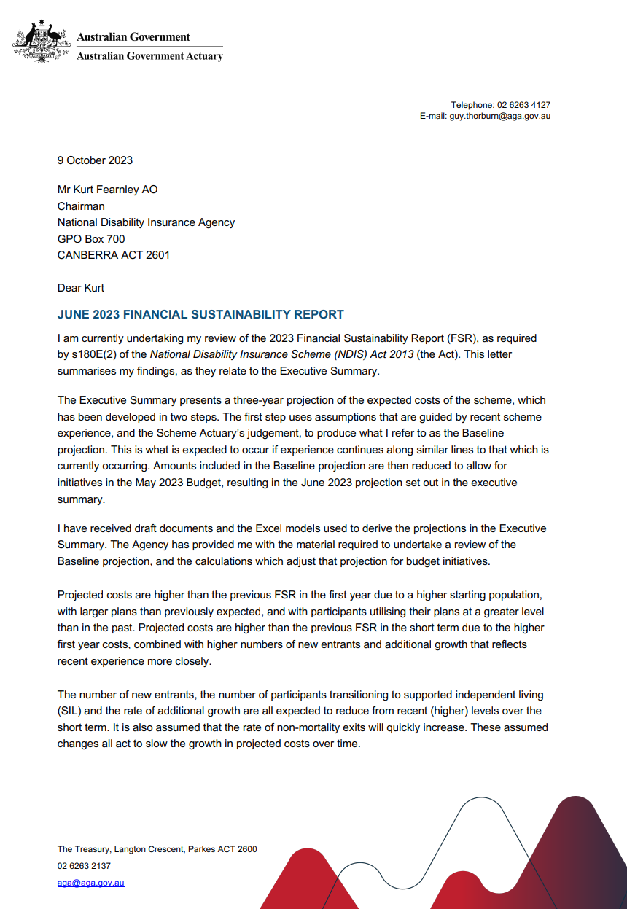
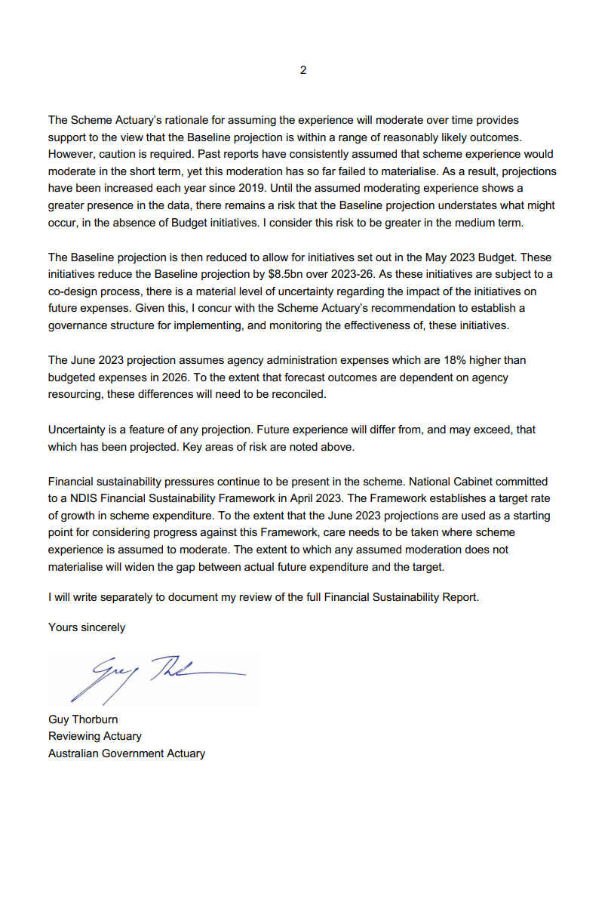
- Management and accountability
  - Governance
The governance model for the NDIA is set out in the NDIS Act.
The Agency is a corporate Commonwealth entity under the Public Governance, Performance and Accountability Act 2013 (PGPA Act) with statutory authority under the National Disability Insurance Scheme Act 2013 (NDIS Act). The NDIS Act sets out the governance model for the Scheme.

Figure 5.1A: Agency governance diagram
    - Responsible Minister
As at 30 June 2023, the Hon. Bill Shorten MP was the Minister for the NDIS. The Minister for the NDIS is responsible for administering the NDIS Act and, with the agreement of states and territories, exercises statutory powers, including the power to make delegated legislation in the form of NDIS Rules and the power to direct the NDIA.

Ministerial Council
The Ministerial Council comprises the Commonwealth, state and territory ministers responsible for disability, who meet as the Disability Reform Ministers. It considers policy matters that relate to the NDIS and advises the Commonwealth Minister about such matters in accordance with its functions as set out in section 12 of the NDIS Act.
  - The Board
In accordance with section 124 of the NDIA Act, the Board operates to:
- ensure the proper, efficient and effective performance of the NDIA’s functions.
- determine objectives, strategies and policies to be implemented by the NDIA.
Board members are appointed by the responsible Commonwealth Minister in consultation with the Disability Ministers of each state and territory. In 2022–23, Board appointments were made by the Hon. Bill Shorten MP in his capacity as Minister for the NDIS.
The Board undertakes an annual review of its functions and committees as part of its commitment to best practice corporate governance. This includes:
- review of Board committee charters to ensure the focus and work effort of the committees uphold the Board’s responsibility as an accountability authority of the NDIA
- review of committee membership to ensure members have appropriate qualifications, knowledge, skills or experience to assist each committee to perform its functions.
Board performance is also reviewed annually in accordance with the Board Audit Committee Charter.
    - Members as at 30 June 2023


Mr Kurt Fearnley AO, Chair
Mr Kurt Fearnley AO is an experienced government and non-government director and 5-time Australian Paralympian.
He is a current Board Commissioner of the Australian Sports Commission and Board Director of the Brisbane 2032 Olympic and Paralympic Organising Committee.
Mr Fearnley is a former member of the boards of several organisations including Paralympics Australia, Life Without Barriers, Australian Volunteers International and the Newcastle Permanent Charitable Foundation.
He was a member of the inaugural NDIS Independent Advisory Council, was Vice Chairperson of the International Paralympic Committee Athletes’ Council, carried out a number of roles for the Gold Coast 2018 Commonwealth Games Organising Committee, and was Co-Captain of the Australian Paralympic Team at the Rio 2016 Paralympics.
Mr Fearnley was awarded an Officer of the Order of Australia (AO) in the General Division in 2018 for his distinguished service to people with disability; as a supporter of, and fundraiser for, Indigenous athletics and charitable organisations; and as a Paralympic athlete.
He was the 2019 NSW Australian of the Year and was awarded an Honorary Doctorate from Griffith University for his contribution to sport and disability advocacy.
Mr Fearnley is a high-school teacher, television presenter, podcaster and broadcaster, and former professional wheelchair athlete.
Mr Fearnley commenced as Chair of the Board on 18 October 2022.
Qualifications: Bachelor of Education and Bachelor of Human Movement, Charles Sturt University.
Chair: People and Remuneration Committee.
Member: Sustainability Committee, ICT and Digital Committee, Risk Committee.
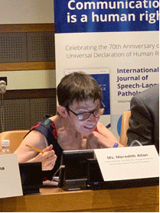

Ms Meredith Allan
Ms Meredith Allan is a former president of the International Society of Alternative and Augmentative Communication (ISAAC), an organisation working to improve the lives of children and adults with complex communication needs. She was the first president to speak via alternative and augmentative communication (AAC).
Ms Allan recently retired from her 30-year career in the public service but continues working as a communication assessor for Scope and lecturer for Deakin University, La Trobe University, University of Newcastle and University of Technology Sydney.
Qualifications: Bachelor of Economics and Bachelor of Arts, Monash University.
Member: Risk Committee, Audit Committee.


Ms Sandra Birkensleigh
Ms Sandra Birkensleigh is an experienced non-executive director, bringing extensive experience in the financial services and insurance industries to the NDIA. Ms Birkensleigh is the Chair of Auswide Bank Limited and currently holds board positions with MLC Limited, Horizon Oil Limited, 7-11 Holdings Limited (and its subsidiaries), Tasmanian Public Finance Corporation, Sunshine Coast Children’s Therapy Centre, Collection House Limited and Adore Beauty Group Limited. She is a member of the Council for the University of the Sunshine Coast, an independent member of the Audit Committee of the Reserve Bank of Australia, and Chair of the Audit and Risk Committee for the Public Trustee of Queensland.
Ms Birkensleigh was formerly a partner with PricewaterhouseCoopers including its governance, risk and compliance practice.
Qualifications: Bachelor of Commerce, University of New South Wales; Chartered Accountant.
Chair: Audit Committee.
Member: Risk Committee and People and Remuneration Committee.



Ms Maryanne Diamond AO
Ms Maryanne Diamond AO has lived with disability all her life. She is an NDIS participant and was employed as a senior executive at the NDIA for 5 years.
Ms Diamond has been employed in the information technology industry, the disability sector, and government. She has extensive experience leading organisations in Australia, including being Executive Officer of Blind Citizens Australia, and inaugural CEO of the Australian Federation of Disability Organisations (AFDO). At the international level, Ms Diamond was President of the World Blind Union from 2008 to 2012, and Chair of the International Disability Alliance from 2014 to 2016.
In 2014, Ms Diamond was appointed an Officer of the Order of Australia (AO) for her distinguished service to people who are blind or have low vision, and her international leadership roles and advocacy for best practice employment opportunities.
Qualifications: Bachelor of Science, Monash University; Graduate Diploma Information Technology, Caulfield Institute of Technology; Graduate of the Australian Institute of Company Directors (GAICD).
Member: Risk Committee, ICT and Digital Committee.


Dr Richard Fejo
Dr Richard Fejo, better known as Richie, is a Larrakia man of direct male descent, through his father, grandfather and great-grandfather.
Dr Fejo has devoted his life to improving education and health outcomes for Aboriginal and Torres Strait Islander people within urban, rural and remote communities.
Dr Fejo previously sat on the City of Darwin’s International Relations Committee and has recently become a committee member of the Northern Territory branch of the Australian Institute of Company Directors.
In 2022, Dr Fejo was awarded an honorary doctorate by Flinders University in recognition of his contribution to education and Indigenous health; he is also the Senior Elder on the Darwin campus at Flinders University.
Dr Fejo also holds the positions of Chair of the Darwin Waterfront Corporation, Chair of the Australia Day Council (NT) and Board member of the Australian Institute of Company Directors. He is a former Chairman of the Larrakia Nation Aboriginal Corporation.
In addition to his service to the community, Dr Fejo is a talented comedian and singer-songwriter, performing regularly around town, and nurturing the next generation of comics.
Qualifications: Honorary Doctorate, Flinders University.



Dr Graeme Innes AM
Dr Graeme Innes AM is a lawyer, author, and company director who was Australia’s Disability Discrimination Commissioner for 9 years.
Dr Innes has been a human rights practitioner for more than 30 years and has been responsible for issues relating to disability, race and human rights.
Dr Innes was made a Member of the Order of Australia (AM) for his work on the development of the Disability Discrimination Act and was a finalist for Australian of the Year. On the international stage, he was a member of the Australian delegation that participated in negotiating the UN Convention on the Rights of People with Disabilities.
Dr Innes led the merger of 4 blindness agencies to form Vision Australia and chaired the board of that agency. He is Chancellor of Central Queensland University and a Director of the State Insurance Regulatory Authority, regulating workers’ compensation and motor vehicle accident insurance in New South Wales. His autobiography Finding a Way achieved popular acclaim in 2016.
Qualifications: Bachelor of Law, Sydney University. Mediator courses with Community Justice Centre NSW and Australian Commercial Dispute Centre. Honorary doctorates from University of Canberra, RMIT University, University of NSW and Edith Cowan University. Fellow of the Australian Institute of Company Directors.
Positions held: Chancellor Central Queensland University. Member of the board of the State Insurance Regulatory Authority of NSW. Member of the board of Healthy North Coast. Member of the board of the Jeffrey Blyth Foundation.
Member: People and Remuneration Committee.


Mrs Joan McKenna Kerr
Mrs Joan McKenna Kerr is an experienced Chief Executive Officer in the field of disability with significant experience as a board director.
She was a member of the Expert Advisory Group reporting to the Select Council of Treasurers and Ministers (COAG) on the development and establishment of the NDIS.
Mrs McKenna Kerr was a member of the inaugural NDIS Independent Advisory Council and Co-Chair of the NDIS Working Party on Eligibility and Assessment.
Her past involvements also include chairing and serving in numerous working parties throughout her career tasked with disability sector reform and sustainability.
Mrs McKenna Kerr is a graduate of Trinity College Dublin, from where she gained a Moderatorship in Sociology. She is also a member of the Australian Institute of Company Directors.
Mrs McKenna Kerr is a former President of National Disability Services (NDS) and the former National Chair of the Australian Advisory Board on Autism.
She has also been involved for the last decade in the sister-state initiative between the Western Australian Government and East Java, Indonesia, assisting in the development of disability services in 5 regional government areas of East Java.
In 2017, Mrs McKenna Kerr was awarded the Asia Pacific Autism Award for a lifetime of service to people with autism and their families.
Qualifications: Bachelor of Arts, Moderatorship in Sociology, Trinity College, Dublin.


Mr Jim Minto
Mr Jim Minto is Chair of Swiss Re Life & Health Australia Ltd, Chair of the Advisory Board of Swiss Reinsurance Company Limited Australia Branch, and Chair of New Zealand based life insurer Partners Life Limited. He is also a Director of Mercer Superannuation Australia Ltd.
Mr Minto retired as Group CEO and Managing Director of life insurer TAL (formerly TOWER Australia) in March 2015. Previously he was Group CEO of the Trans-Tasman TOWER Limited Group and also a Director of Dai-Ichi Life Asia Pacific. Mr Minto has extensive experience in the financial services sector.
A Chartered Accountant, Mr Minto retired in 2015 as Chair of the Association of Superannuation Funds of Australia and was a panel member of the Australian Government’s Review of Natural Disasters Insurance in 2011.
Mr Minto was appointed Acting Chair for the period 18 July 2022 to 17 October 2022.
Qualifications: Chartered Accountant, Massey University.
Chair: Risk Committee and People and Remuneration Committee.
Member: Audit Committee, Sustainability Committee, ICT and Digital Committee
. 

Dr Denis Napthine AO
Dr Denis Napthine has held various senior positions in government and was the 47th Premier of Victoria.
As the Premier, Dr Napthine led the Victorian Government to sign the NDIS Agreement with the then Prime Minister Julia Gillard. He has a long history of active involvement in local and regional services for people with disabilities and their families and carers. Dr Napthine is the parent of a person with disabilities and has previously worked in frontline services for people with disabilities.
In 2020, Dr Napthine was made an Officer of the Order of Australia (AO) for distinguished service to the people and Parliament of Victoria, particularly as Premier, to veterinary science, and to the community. Previously he was the Victorian State Minister for Community Services, which included disability services.
Dr Napthine was appointed as Chair of the NDIA Board on 1 April 2022. He resigned on 18 July 2022. Dr Napthine was reappointed to the Board in October 2022.
Dr Napthine is a Director of GMHBA Limited.
Qualifications: BVSc and MVS (Epidemiology and Preventive Medicine), University of Melbourne; Master of Business Administration (MBA), Deakin University.
Member: Audit Committee, Risk Committee, People and Remuneration Committee.


Ms Estelle Pearson
Ms Estelle Pearson has extensive experience in the insurance and injury compensation sector, having worked as an actuary and consultant in this sector since 1989. She is currently a Director of Finity Consulting Pty Limited and was previously on the Council of the Actuaries Institute, including a term as President in 2015.
Qualifications: BA (Hons) Mathematics, University of Oxford; Fellow of the Institutes of Actuaries of Australia (FIAA).
Chair: Sustainability Committee.
Member: Audit Committee.


Dr Peta Seaton AM
Dr Peta Seaton is a former Chair of Hearing Australia, the Deputy Chair of the Bradman Foundation, and a Non-Executive Director of the Menzies Research Centre, BDCU Alliance Bank, and CARE Australia. Dr Seaton served as a Board Member of the Nepean Blue Mountains Local Health District until 30 June 2023. She is currently the President of the Near Eastern Archaeology Foundation (University of Sydney).
A former NSW parliamentarian and frontbencher, Dr Seaton served as Director of Transition and Director of Strategic Priorities in the NSW Premier’s Office from 2011 to 2014.
In 2017, Dr Seaton was made a Member of the Order of Australia (AM). She lives in regional New South Wales and runs a small farm enterprise.
Qualifications: PhD and BA (Hons), University of Sydney; Graduate of the Australian Institute of Company Directors (GAICD).
Member: Sustainability Committee, ICT and Digital Committee.


Ms Leah van Poppel
Ms Leah van Poppel is Chair of the Victorian NDIS Community Advisory and a member of the NDIS Independent Advisory Council.
A highly respected leader and disability rights advocate, Ms van Poppel was CEO of Women with Disabilities Victoria from 2018 to 2021.
In this position, she worked to empower marginalised women in the community through education and mentoring, as well as research, policy advice and government advocacy.
Previously Ms van Poppel was CEO of Blind Citizens Australia, Manager at Youth Disability Advocacy Service, and NDIS Readiness Project Officer at Australian Federation of Disability Organisations (AFDO).
Qualifications: Bachelor of Arts, Macquarie University.
Member: Sustainability Committee, Risk Committee.

    - Board committees
A number of committees, councils and groups are in place to support the Board in ensuring the NDIA meets its statutory requirements and manages risk. Table 5.2.2A provides the title and role of each committee and its members as at 30 June 2023.

Table 5.2.2A: Board committees and members as at 30 June 2023
Committee | Role | Members
Audit Committee | The Audit Committee assists the Board in the management and oversight of the quality and integrity of the accounting, auditing and financial reporting of the NDIA. It was established in compliance with section 45 of the PGPA Act.  The Australian National Audit Office attends Audit Committee meetings as external auditor, along with the Chief Internal Auditor. | Ms Sandra Birkensleigh (Chair)  Ms Meredith Allan  Mr Jim Minto  Dr Denis Napthine AO  Ms Estelle Pearson
ICT and Digital Committee | The ICT and Digital Committee assists the Board in the management and oversight of the NDIA’s information, communication, technology and digital solutions, including providing input to the Board on the design, development, delivery and performance of the information, communication, technology and digital strategy and systems. | Mr Jim Minto (Chair)  Ms Maryanne Diamond AO  Mr Kurt Fearnley AO  Dr Peta Seaton AM
People and Remuneration Committee | The People and Remuneration Committee assists the NDIA to attract, retain and develop high-performing employees. It oversees strategies, frameworks and programs related to people and remuneration, and provides recommendations to the Board on CEO succession planning. | Mr Kurt Fearnley AO (Chair)  Ms Sandra Birkensleigh  Dr Graeme Innes AM  Dr Denis Napthine AO
Risk Committee | The Risk Committee assists the Board in the management and oversight of the NDIA’s approach to risk management. Its role is to advise the Board on the development and implementation of the NDIA’s overall risk management approach. | Mr Jim Minto (Chair)  Ms Meredith Allen  Ms Sandra Birkensleigh  Ms Maryanne Diamond AO  Dr Denis Napthine AO  Ms Leah van Poppel
Sustainability Committee | The Sustainability Committee provides advice on assessing, monitoring, reporting on and managing the financial sustainability of the Scheme. | Ms Estelle Pearson (Chair) Mr Kurt Fearnley AO  Mr Jim Minto  Dr Peta Seaton AM  Ms Leah van Poppel

    - Board and committee attendance

Table 5.2.3A: Number of meetings attended by Board members in 2022–23
Board member | NDIA Board Eligible | NDIA Board Attended | Audit Committee Eligible | Audit Committee Attended | ICT and Digital Committee Eligible | ICT and Digital Committee Attended | People and Remuneration Committee Eligible | People and Remuneration Committee Attended | Sustainability Committee Eligible | Sustainability Committee Attended | Risk Committee Eligible | Risk Committee Attended
Mr Kurt Fearnley AO (Chair) | 7 | 7 | 0 | 2 | 1 | 2 | 0 | 0 | 2 | 3 | 2 | 3
Ms Meredith Allan | 11 | 11 | 5 | 5 | 0 | 3 | 0 | 2 | 0 | 5 | 4 | 4
Ms Sandra Birkensleigh | 11 | 10 | 5 | 5 | 0 | 0 | 2 | 1 | 0 | 0 | 4 | 4
Professor Jane Burns | 9 | 8 | 0 | 2 | 3 | 2 | 2 | 1 | 0 | 0 | 0 | 0
Ms Maryanne Diamond AO | 7 | 7 | 0 | 2 | 1 | 2 | 0 | 1 | 0 | 3 | 2 | 3
Dr Richard Fejo | 2 | 2 | 0 | 0 | 0 | 0 | 0 | 0 | 0 | 0 | 0 | 0
Mr Graeme Innes AM | 7 | 7 | 0 | 0 | 0 | 0 | 0 | 1 | 0 | 0 | 0 | 0
Mrs Joan McKenna Kerr | 2 | 2 | 0 | 0 | 0 | 0 | 0 | 0 | 0 | 0 | 0 | 0
Mr Jim Minto | 11 | 11 | 2 | 5 | 3 | 2 | 2 | 2 | 6 | 5 | 4 | 4
Dr Denis Napthine AO | 7 | 7 | 2 | 3 | 0 | 2 | 0 | 1 | 0 | 3 | 2 | 3
Ms Estelle Pearson | 11 | 9 | 5 | 3 | 0 | 0 | 0 | 0 | 6 | 6 | 0 | 1
Dr Peta Seaton AM | 11 | 10 | 0 | 3 | 3 | 3 | 0 | 2 | 6 | 5 | 0 | 3
Ms Leah van Poppel | 11 | 10 | 0 | 2 | 0 | 0 | 0 | 0 | 6 | 6 | 2 | 3
Mr Glenn Keys | 6 | 5 | 3 | 0 | 2 | 2 | 2 | 2 | 4 | 0 | 2 | 0
Table note: Board members may attend any Board committee meeting in their capacity as a director. ‘Eligible’ refers to the number of scheduled committee meetings available to be attended by a director as a formal member of the committee. ‘Attended’ refers to the actual number of meetings Board members attended.

    - Board membership
A number of significant changes were made to the NDIA Board in 2022–23.
Dr Denis Napthine AM resigned as Chair on 18 July 2022 and was temporarily replaced by Mr Jim Minto as Acting Chair.
Mr Kurt Fearnley AO was appointed as Chair and commenced his term on 18 October 2022.
Ms Maryanne Diamond and Mr Graeme Innes AM were also appointed to the Board, and Dr Napthine was reappointed to the Board, commencing their terms on 18 October 2022.
Mr Glenn Keys completed his Board appointment on 31 December 2022.
Professor Jane Burns completed her Board appointment on 31 December 2022 and was reappointed until 31 March 2023.
Dr Richard Fejo and Mrs Joan McKenna Kerr were appointed to the Board and commenced their terms in April 2023.
Ms Sandra Birkensleigh, Mr Jim Minto and Ms Estelle Pearson completed their Board appointments on 30 June 2023. Ms Pearson was reappointed until 10 October 2023.

  - The Independent Advisory Council
The Independent Advisory Council (IAC) provides the NDIA Board with independent advice, which the Board must consider when performing its duties, pursuant to section 144 of the NDIS Act.
The IAC, formally appointed by the Minister, is composed of 12 members from across Australia, who are people with disability or experts in disability issues.
IAC members play an integral role in bringing the crucial perspectives of participants, disability sector experts and the broader disability community to the heart of the NDIS and into the NDIA boardroom.
During 2022–23, the IAC continued to engage with the NDIA to provide advice. Key work highlights for the financial year include:
- providing the advice ‘Equity and inclusion in the NDIS’ to the Board.
- developing a statement that underpins intersectionality in all IAC advice and work.
- developing the advice ‘Enhancing behaviour supports in the NDIA’.
- developing the advice ‘Improving the NDIS for children and young people: the importance of being guided by their voice’.
- working alongside the NDIA to progress statements that set out what has been done, or is to be done, in response to IAC advice (Agency response), in line with section 145(b) of the NDIS Act.
- engaging with the NDIS Review and the Minister for the NDIS to provide insight and solutions to NDIS issues that impact participants and the broader disability community.
This year the IAC took a lead role in the NDIA’s co-design efforts, working across various co-design steering committees. IAC representatives provided strategic advice, governance and oversight to some of the following NDIA projects:
- development of a Home and Living Framework and Implementation Plan.
- release of the Supported Decision Making Policy.
- release of the Participant Safeguarding Policy, which had its genesis in the IAC’s June 2021 advice Choice and control to safely live a good life of belonging and citizenship.
Membership of the IAC as at 30 June 2023 consisted of:
- Ms Leah van Poppel, Principal Member
- Ms Kerry Allan
- Dr Leighton Jay
- Adjunct Associate Professor Jennifer Cullen
- Dr George Taleporos
- Dr Sharon Boyce
- Ms Sylvana Mahmic
- Ms Sam Paior
- Mr James Manders
- Mr Mark Tonga
- Ms Liz Reid AM
- Ms Tricia Malowney OAM.
The IAC membership is supported by:
- Gavin Burner, IAC Reference Group Member, a longstanding advocate for people with intellectual disability living in rural and remote areas.
- Dr Ben Gauntlett, Disability Discrimination Commissioner, in his role as expert adviser.
Further information on the IAC is provided on its website at www.ndis-iac.com.au.

  - Chief Executive Officer and Strategic Leadership Team
The Chief Executive Officer (CEO) is responsible for the day-to-day administration of the NDIA under the NDIS Act. Supported by the Strategic Leadership Team (SLT), the CEO executes the Board-approved strategic objectives and policies, in line with the agreed risk appetite.

Organisation structure
Mr Martin Hoffman resigned as CEO effective 1 July 2022.
On 7 October 2022, Ms Rebecca Falkingham PSM was appointed by the NDIA Board as the incoming CEO of the NDIA. Ms Falkingham commenced in the role on 18 October 2022.
Dr Lisa Studdert’s term as Acting CEO ceased on 17 October 2022.

Figure 5.4A: Agency organisation structure

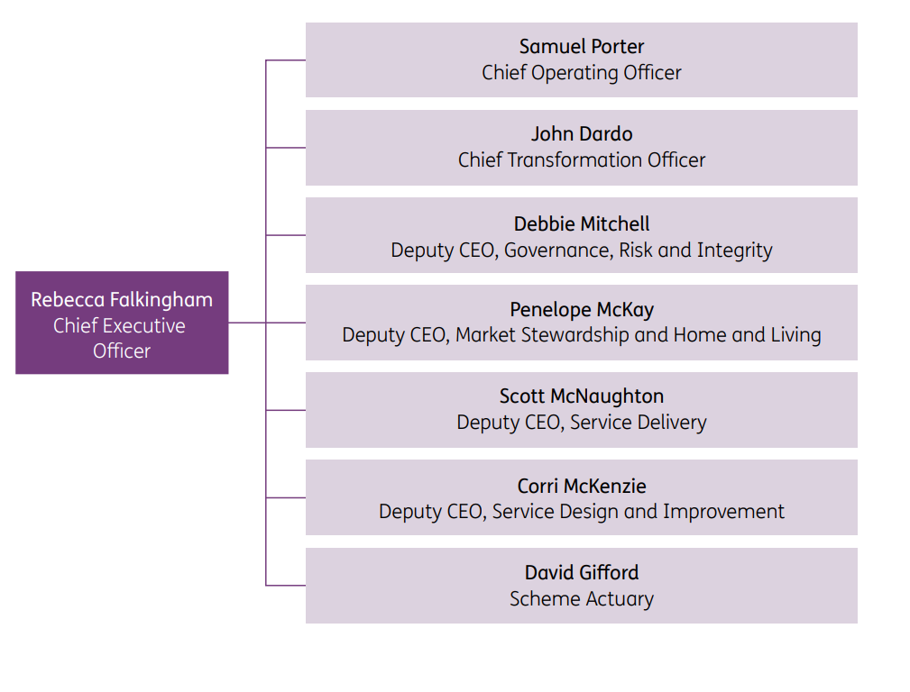

  - Partners in the community
Our partners in the community (PITC) are experienced and qualified organisations with strong local knowledge and understanding of the needs of people with disability. They work with the NDIA to deliver early childhood and local area coordination services to Australians with disability and children younger than 6 with delays in their development.
Our partners are often the first point of contact for participants, making them the face of the Scheme in many communities.
As at 30 June 2023, the PITC program had 25 partner organisations operating in all Australian states and territories, with the exception of remote areas, where the local NDIA team provides support.

Local area coordination partners
Partners delivering local area communication (LAC) services assist people aged 9 years and above to link to the NDIS and to mainstream and community supports within their local area.
LAC partners play an important role in working directly with communities to improve accessibility and inclusion. They can identify supports available for people with disability within their community, even if they are not eligible for an NDIS-funded plan.
LAC partners help people to understand and access the NDIS, discuss goals and supports, gather and document information to support the planning process, and assist people to use their NDIS plan. They also undertake regular check-ins with participants to ensure that their plans are working for them and assist in preparing for plan reassessment.

Early childhood partners
Early childhood partners are local organisations funded by the NDIA to deliver the Early Childhood Approach. The Early Childhood Approach supports children younger than 6 with developmental delay or children younger than 9 with disability, and their families and carers, to develop the skills they need to participate in daily activities and achieve the best possible outcomes throughout their life.
Early childhood partners focus on delivering family-centred supports using a best practice model and supporting connections to mainstream and community services for children and their families and carers.
Early childhood partners offer early connections and early support for children with developmental concerns or developmental delay (for children younger than 6) and support families through the NDIS access and planning process if their child is likely to be eligible and when their child becomes an NDIS participant.
  - Workforce management
To deliver the Scheme, the NDIA needs a capable and committed workforce that is reflective of the broader Australian society. The mix of skills needed by the NDIA continues to evolve, reflecting the needs of participants, carers and their families.
It is critical the NDIA attracts talented, knowledgeable and experienced people, and provides ongoing investment in building capability and training delivery. In particular, the NDIA continues to expand and strengthen its focus on disability and cohort awareness to improve frontline capability and the quality of experience for participants.
As at 30 June 2023, the NDIA workforce was 13,690, comprising:
- 5,652 Australian Public Service (APS) employees (5,441 full-time equivalent and 4,988 average staffing level).
- 2,139 contractors, comprising 2,004 labour hire staff, 126 consultants and 9 system access only contractors.
- 5,899 outsourced workers, comprising 4,917 PITC partner staff, 974 National Contact Centre staff and 8 other outsourced staff.
During 2022–23 the NDIA engaged 1,210 new APS employees, with more than 55% of these in participant-facing roles in the Service Delivery Group. The NDIA’s planner workforce increased by 8.4% in 2022–23 and represented 41.3% of the NDIA’s APS workforce.

NDIA People Strategy
The NDIA People Strategy 2022 supports our passionate and motivated workforce to achieve better outcomes for participants.
The People Strategy supports the NDIA’s values-driven culture in which our people are committed to realising the aspirations and goals identified in the Corporate Plan. It sets out our approach to achieving Aspiration 4 in the Corporate Plan, ‘A high-performing NDIA’, and in particular supporting the delivery of an engaged and capable NDIA.

Disability and diversity employment
The NDIA cares deeply about building a workplace where everyone is valued, connected and included. We seek to support a diverse workforce that is representative of the community we serve. The NDIA Inclusion and Diversity Framework outlines how we will increase the NDIA’s inclusion and diversity practices through the creation of a range of diversity-group inclusion plans.
Since the NDIA was established in 2013, we have sought to be a leading employer of choice for people with disability. In the 2023 APS Census, 19% of NDIA staff identified as having disability.
The NDIA maintains Australian Network on Disability (AND) Disability Confident Recruiter accreditation. We regularly undertake recruitment through affirmative measures to increase the number of staff who identify as a person with disability. The NDIA engages in the RecruitAbility scheme and offers roles and vacancies specifically for people with disabilities (or a specific type of disability).
In July 2022 the NDIA Disability Inclusion Plan 2022–25 was launched, the second such plan since the beginning of the NDIA. This plan has 3 key focus areas: accessibility, employment and career development, and inclusive culture.
The plan outlines the actions the NDIA will take to be a world-leading employer of choice for people with disability and a leading employer for access and inclusion. A critical action in the plan was to conduct an internal deep dive into the workplace experience of people with disability. This deep dive provided a safe space for staff to share feedback and allowed the NDIA to clearly understand areas for improvement. The outcomes of this deep dive will inform a refresh of the Disability Inclusion Plan.
In the 2023 APS Census, 3% of NDIA staff identified as First Nations people.
The NDIA’s Innovate Reconciliation Action Plan (RAP) is being finalised, with input from First Nations staff and stakeholders and support from Reconciliation Australia. This will be the third RAP in the NDIA’s reconciliation program and will build on actions implemented in the previous RAPs. As a commitment of its reconciliation journey, the NDIA participated in Reconciliation Australia’s Workplace RAP Barometer Survey. The survey is administered biannually and measures an organisation’s workforce attitudes and understanding of reconciliation efforts.
In July 2022 the NDIA published its First Nations Employment and Inclusion Plan 2022–25, which has 3 key focus areas: cultural integrity, career pathways, and career development and advancement. This is the second First Nations inclusion plan for the NDIA. It is aligned to the Commonwealth Aboriginal and Torres Strait Islander Workforce Strategy 2020–2024.
In the 2023 APS Census, 9% of NDIA staff identified as LGBTQIA+.
The NDIA published its LGBTIQA+ Inclusion Plan in November 2021 to support LGBTIQA+ staff. The plan has 3 key focus areas: capability and leadership, inclusive policy and practice, and culturally safe workplace.
As at June 2023, all of the plan’s 16 actions are complete. Key outcomes of this inclusion plan include the delivery of Gender Affirmation Guidelines for staff who wish to affirm their gender, participation in ACON’s Welcome Here Project to recognise NDIA offices as LGBTIQA+ safe spaces, and delivery of an NDIA Rainbow Commitment recognising the value and contribution of LGBTIQA+ staff to the success of the NDIS.
Senior Executive Service (SES) Inclusion and Diversity Champions support our Inclusion and Diversity Framework objectives, staff networks, inclusion plans and initiatives. Currently the NDIA has an SES Disability Champion, an SES Indigenous Champion and 2 SES LGBTIQA+ Champions.
The NDIA has been working collaboratively with its staff from culturally and linguistically diverse (CALD) backgrounds to co-design a CALD Inclusion Plan, due to be published towards the end of 2023. This inclusion plan will focus on greater inclusive practice for NDIA staff from CALD backgrounds.
The NDIA’s Inclusion and Diversity Framework commits to inclusion plans for gender equality and families, and the mature-age and intergenerational workforce. Further SES champions will be appointed to these roles as inclusion plans are developed.
The NDIA has established 4 staff diversity networks: the Employees with Disability Network, the First Nations Employee Network, the LGBTIQA+ Staff and Allies Network (Pride@NDIA), and most recently the CALD Staff Network.
The NDIA continues to hold membership of national not-for-profit organisations to support our inclusion initiatives, such as the Australian Network on Disability, the Diversity Council of Australia, and ACON Pride in Diversity.
The NDIA acknowledges and celebrates significant diversity and awareness dates. This year there has been a continued focus on promoting stories from staff representing wide diversity and intersectionality, to provide staff an opportunity to share their stories and lived experience within their workplace. The NDIA will continue to develop inclusion plans with the aim of further progressing how we create and embed inclusive workplace practices for everyone.

Performance management
The NDIA has embedded a strong approach to performance development that supports flexibility and agility in the NDIA’s workforce in its dynamic, fast-paced operating environment.
The NDIA Performance Framework assists staff in aligning their individual performance agreements with the NDIA’s leadership culture.
To ensure it is a high-performing organisation that delivers great outcomes for NDIS participants and stakeholders, the NDIA continues to embed its strong focus on developing employee performance. The NDIA has an employee recognition program that recognises outstanding performance of NDIA staff. No performance-pay arrangements apply.

Ethics policies
The NDIA promotes ethical standards and behaviours relating to its workplaces and employment. All NDIA staff are required to comply with the APS Values, APS Employment Principles and APS Code of Conduct as set out respectively in sections 10, 10A and 13 of the Public Service Act 1999. Additionally, the NDIA Values set out our organisational values and reflect our passion for and commitment to an empowered, inclusive and participant-centred culture.
The NDIA is committed to creating and maintaining a positive and inclusive workplace through the Safe and Respectful Workplace Framework, where everyone is safe, treated fairly and respectfully, and supported to speak up. The NDIA has zero tolerance for unacceptable behaviour, including all forms of bullying, harassment, sexual harassment, discrimination, violence, aggression and victimisation at the workplace or in connection with work. The NDIA has measures in place to prevent, address, report and respond to unacceptable behaviour, and supports are available to all NDIA workers impacted by unacceptable behaviour.
All NDIA workers have an obligation to contribute to our safe and respectful culture. To support workers, the NDIA provides compulsory training programs, staff policies, and guidelines to help staff understand their obligations. Possible breaches of the Code of Conduct are taken seriously, and appropriate action is taken when breaches occur. Managers and staff have access to a range of supports including contact officers, and Early Intervention and Safe and Respectful teams.
The NDIA has policies in place to support transparent, sound and ethical decision-making. This includes a robust review of action process in relation to decisions that impact employees, as outlined in section 33 of the Public Service Act 1999.
Material published on the NDIA’s (internal) intranet includes information on the APS Values, the APS Employment Principles, the APS Code of Conduct, the Merit Protection Commissioner Review of Actions scheme and the Australian Public Service Commission Ethics Advisory Service, which is available to all APS employees who wish to discuss or seek advice on ethical issues that occur in the workplace.
  - Staff engagement
The NDIA works to provide a positive, productive and inclusive workplace – a great place to work for all staff – so that we can best support our participants and continue to improve the Scheme.
Employee engagement drives high performance, as engaged staff are proud of what they do and have a strong connection and commitment to the work that they do. In the 2023 APS Census, the highest positive response related to staff understanding how their role contributes to achieving outcomes for the Australian public, at 94%.
In the 2023 APS Census the NDIA had an 81% response rate, with 5,763 of its workforce (APS employees and labour-hire workers, excluding PITC partner staff) participating. The NDIA Engagement Index, which measures staff job satisfaction and commitment to an organisation, improved from 76% in 2022 to 77% in 2023, 4% higher than the APS average.
The Wellbeing Index measures staff perceptions of how much the NDIA and immediate supervisors care about staff health and wellbeing. This increased from 71% in 2022 to 73% in 2023.
The Census Innovation Index remained at 67% in the 2023 APS Census. This was 2% above the APS average.
The NDIA has maintained a focus on shaping a workplace culture that is inclusive and welcoming, where diversity is embraced and celebrated. This focus seeks to ensure we have a workforce that is diverse and representative of the communities we serve. The NDIA continues to experience strong engagement with staff through its diversity networks, with strong representation in the Employees with Disability Network (around 380 members), First Nations Employee Network (around 137 members), Pride@NDIA (around 430 members), and CALD Staff Network (around 125 members). These networks provide an avenue for the NDIA to engage directly with specific diversity cohorts and receive advice and guidance on creating a more inclusive workplace culture.
  - Risk management
The NDIA has a structured approach to identifying, managing, escalating and communicating key risks. This is critical to the effective and efficient delivery of the Scheme.
The NDIA is committed to ensuring that participant supports, provider services and other critical business functions are maintained or quickly restored in the event of a significant outage, incident or crisis. The proactive use of risk management within the NDIA has allowed us to support effective business planning, operational stability and delivery of corporate aspirations through an evidence-based approach within the appetite set by the Board.
The Chief Risk Officer Division assists the NDIA Board and Strategic Leadership Team (SLT) by providing objective risk reviews, oversight, monitoring and reporting. On an annual basis, the Board determines the risk appetite and strategic risks for the NDIA, which are directly aligned to the Corporate Plan. The Board determined 9 strategic risks for 2022–23 in the areas of participant experience and outcomes, partner performance, provider market quality, financial sustainability, Scheme integrity, stakeholder relationship and trust, and NDIA operational stability. The strategic risks are monitored against key indicators, and performance is reported to the SLT and Board Risk Committee on a quarterly basis. Management of the strategic risks is supported by operational, fraud and compliance, regulatory and project risk assessments and controls which are owned and managed at group or aggregated NDIA level.
The NDIA has an established and practically tested Business Continuity Management Framework to ensure the rapid response and resumption of participant and provider services and critical business activities in emergency situations.
The NDIA’s integrated risk management system provides a single platform for managing operational, strategic and regulatory risks, audit recommendations, incidents and business continuity plans. The system gives accountable executives extended visibility as to the risks and controls within their business and the broader NDIA and underpins quarterly risk reporting to the Board Risk Committee.
The NDIA continues to look for opportunities to optimise, digitise and integrate its risk management frameworks and systems to deliver a more connected, responsive and predictive risk ecosystem.
    - Scheme integrity

Fraud prevention
The NDIA maintains a zero-tolerance approach to fraud and invests heavily in the prevention and detection of noncompliant claiming behaviours, including potential fraud.
The NDIA’s Fraud and Corruption Control Plan outlines how the NDIA is meeting its responsibilities under the Public Governance, Performance and Accountability Act 2013 and the Commonwealth Fraud Control Framework 2017. Our publicly available Fraud Strategy Statement and Compliance and Enforcement Framework describe the NDIA’s approach to managing compliance and enforcement objectives and activities, including fraud and anti-corruption.
The NDIA also continues to undertake preventive initiatives with internal and external stakeholders. In 2022–23 the NDIA ran a comprehensive education and engagement campaign, which coincided with International Fraud Awareness Week, designed to raise awareness about noncompliance and fraud within the Scheme.
In addition, the NDIA continued to work across government to leverage capabilities and support more effective compliance and enforcement activities, including by co-leading the multi-agency Fraud Fusion Taskforce (FFT).

Fraud Fusion Taskforce
In the October 2022 Budget, the Government provided $137.7 million (including $11.4 million of funding for the Integrity Taskforce) in funding over 4 years from 2022–23 to establish the multi-agency FFT to address fraud in the NDIS and other government programs. On 1 November 2022 the FFT commenced operations and it continues to be progressively enabled. Law conformance has been a priority, to ensure a strong legal and ethical basis for the FFT’s work.
On 14 April 2023, the Treasury Laws Amendment (Disclosure of Information to Fraud Fusion Taskforce) Regulations 2023 for the Australian Taxation Office (ATO) and Australian Securities and Investments Commission (ASIC) to share protected information for the purposes of the Taskforce were published and in force. The Fraud Fusion Centre, led by the Australian Criminal Intelligence Commission (ACIC), is gathering intelligence, and investigating multiple criminal syndicates, some having drawn down millions of dollars in funding from hundreds of NDIS participants. The ACIC has established Taskforce Reston, which will enable information sharing by the ACIC for the purposes of the FFT.
On 15 June 2023 the FFT Memorandum of Understanding and Terms of Reference became operational after signing by co-leads Services Australia, the NDIA and FFT member agencies. These documents define working relationships, expectations and responsibilities. A robust ethics and human oversight framework is being developed in consultation with NDIS participants to ensure their voices are heard and they feel safe throughout the operation of the FFT.
Recognising the significant vulnerabilities of the Scheme that are now coming to light, the FFT is strongly focused on driving a whole-of-government approach to strategic prevention. While investigations and prosecutions may help address some fraud in the short term, strategic prevention investments will have the greatest impact in protecting government payment programs in the medium to long term.
A participant and sector Fraud Working Group has been established. There is overwhelming support from participants and their representatives engaged thus far for the NDIA and the Government to reduce fraud and noncompliance and make it easier for people to get it right in each interaction with the NDIS.

Compliance activities
During 2022–23 the NDIA Compliance Program Branch undertook over 12,100 compliance activities (compared to 6,700 in 2021–22) to treat opportunistic and noncompliant payment risks, identified primarily through tip-offs and detected risk profiles. This involved the review of over 59,000 transactions, or more than $150 million in payments. Proactive targeting and reactive measures from the branch resulted in providers cancelling more than 800 incorrect or noncompliant payments, worth $9 million.
In the same period, the Claims and Payments Integrity Team reviewed over 19,000 pre-payment and 40,000 post-payment claims, which resulted in just under $50 million in payment cancellations due to noncompliance (compared to $0.3 million in 2021–22).
During 2022–23 we saw a significant increase (177%) in tip-offs reported to the Agency via the fraud reporting and scams helpline. This increase could in part be attributable to increased media attention due to the FFT and greater public awareness of integrity risks. A total of 17,207 tip-offs were received during 2022–23, compared with 9,673 in 2021–22.

Investigations
The NDIA’s fraud intelligence and investigation function has continued to mature, with more complex fraud and serious noncompliance investigations completed and/or currently before the courts. The establishment of the FFT has expanded the scope and capacity of the Agency to detect and respond to serious and organised crime.
As at 30 June 2023, 44 fraud investigations were in progress and a further 17 matters were being evaluated for possible investigation. Of these, 14 matters are currently before the courts under prosecution.
    - Internal audit
The internal audit function supports effective risk management and operates as a key internal control. The Internal Audit Branch provides independent assurance to management and the Board through the NDIA Board Audit Committee. The internal audit function partners with stakeholders to ensure they understand the NDIA’s strategic direction and risk profile to deliver a fully aligned, risk-focused plan incorporating both assurance and advisory activity. As part of the audit process, findings are raised in consultation with relevant business areas, with an understanding of the operating environment and relevant insights.
During 2022–23 the internal audit team delivered an approved internal audit plan to the Board Audit Committee. This plan is updated on an ongoing basis, with a formal review performed every 6 months to ensure that it remains relevant and aligned to key risks. The outcomes of all audit activity were reported to the Board Audit Committee, and progress on action plans was monitored through an online tracking system. The status of these actions was reported to both management and the NDIA Board through the Audit Committee.
    - External audit
The NDIA maintains a close working relationship with the Australian National Audit Office (ANAO), which provides both external auditing services on the annual financial statements and performance audit services. Details of performance audits undertaken during the year that have an impact on the NDIA are provided in section 5.8. The ANAO audit report on annual financial statements is included in section 3. All management actions taken to address recommendations raised by the ANAO are tracked, with regular reporting on their status to both management and the Board Audit Committee.
- Appendices
  - Enabling legislation
The National Disability Insurance Agency is established under the National Disability Insurance Scheme Act 2013 (NDIS Act) to deliver the National Disability Insurance Scheme. The Agency is a corporate Commonwealth entity under the Public Governance, Performance and Accountability Act 2013 (PGPA Act).
The National Disability Insurance Scheme Amendment (Participant Service Guarantee and Other Measures) Act 2022 introduced changes from 1 July 2022 to increase efficiency and simplify processes for participants, their families and carers. The changes included adding the new section 47A of the NDIS Act to support varying a participant’s plan in some circumstances.
  - Audit Committee
The NDIA Board has established the Audit Committee to assist the Board to oversee its responsibilities and legislative obligations as the NDIA’s accountable authority under:
- section 45 of the PGPA Act
- section 17 of the Public Governance, Performance and Accountability Rule 2014 (PGPA Rule)
- the NDIS Act.
For details of members’ qualifications, knowledge, skills or experience, refer to section 5.2.1. For information on the number of meetings attended / total number of meetings, refer to section 5.2.3

Table 6.2A: Audit Committee remuneration in 2022–23
Member | Total annual remuneration
Mrs Sandra Birkensleigh (Chair) | $16,781
Ms Meredith Allan | $8,395
Mr Jim Minto | $8,395
Dr Denis Napthine AO* | $3,152
Ms Estelle Pearson | $8,395

Charter
The Audit Committee Charter details the committee’s purpose: to oversee the appropriateness of the NDIA’s:
- management of the internal and external audit processes
- financial reporting processes
- performance reporting processes
- system of risk oversight and management
- system of internal control
- process for monitoring compliance with laws and regulations and the Code of Conduct.
The Audit Committee Charter is available to view on the NDIS website.
  - Work health and safety
The NDIA acknowledges its obligations under the Work Health and Safety Act 2011 (Cth) (WHS Act) and the Safety, Rehabilitation and Compensation Act 1988 and takes proactive steps to ensure a positive and effective safety culture.
The NDIA continues to promote consultation, prevention and early intervention in cases of illness and injury and is aligned with a steadfast commitment to safeguard and value NDIA workers. The NDIA continues to review the Work Health and Safety Management System in line with legislative updates and contemporary health, safety and wellbeing practices.
The NDIA’s safety culture continues to mature, with a strong focus on psychosocial risk awareness. The NDIA was proactive in preparing for amendments to the Work Health and Safety (Managing Psychosocial Risk and Other Matters) Regulations 2022, which came into effect on 1 April 2023. The NDIA is administering risk assessment tools to identify and manage psychosocial hazards with business areas, and has supporting policies, procedures and guidelines.
The NDIA supports workers to use flexible working arrangements and takes all reasonably practicable measures to protect its workers by providing a healthy and safe work environment, whether working in the office or working from home.
To support workers impacted by bullying, harassment, discrimination, sexual harassment, violence, aggression and victimisation in the workplace, the NDIA has developed a Safe and Respectful Workplace Framework, which strengthens our approach to managing unacceptable behaviours. This ensures that the NDIA is a safe and respectful workplace that is free from physical and psychosocial harm.
The NDIA’s Family, Domestic and Intimate Partner Violence Support Policy has been revised to strengthen the provisions for all NDIA workers who are experiencing family and domestic violence. These provisions include the availability of a minimum of 10 days paid leave.
In 2022–23 the NDIA reported 3 incidents to Comcare pursuant to section 38 of the WHS Act. All incidents were closed by Comcare without further action being required of the NDIA.

Table 6.3A: Summary of incidents pursuant to section 38 of the WHS Act, 2022–23
Action | Number
Death of a person that required notice to Comcare under s 35 | 0
Serious injury or illness of a person that required notification to Comcare under s 35 | 1
Dangerous incident that required notification to Comcare under s 35 | 2
Investigation conducted under Part 10 | 0
Notice given to Agency under s 90 (provisional improvement notice) | 0
Notice given to Agency under s 191 (improvement notice) | 0
Notice given to Agency under s 195 (prohibition notice) | 0
Directions given to Agency under s 198 (non-disturbance) | 0

  - Workforce statistics

Table 6.4A: All ongoing employees current reporting period (2022–23)
Blank | Male Full time | Male Part time | Male Total | Female Full time | Female Part time | Female Total | Non-binary Full time | Non-binary Part time | Non binary Total | Prefers not to answer Full time | Prefers not to answer Part time | Prefers not to answer Total | Uses different term Full time | Uses different term Part time | Uses different term Total | Total
NSW | 244 | 20 | 264 | 780 | 179 | 959 | 0 | 0 | 0 | 0 | 0 | 0 | 2 | 1 | 3 | 1,226
Qld | 217 | 7 | 224 | 636 | 119 | 755 | 0 | 0 | 0 | 0 | 0 | 0 | 3 | 0 | 3 | 982
SA | 108 | 4 | 112 | 251 | 90 | 341 | 0 | 0 | 0 | 0 | 0 | 0 | 1 | 0 | 1 | 454
Tas | 34 | 2 | 36 | 68 | 17 | 85 | 0 | 0 | 0 | 0 | 0 | 0 | 0 | 0 | 0 | 121
Vic | 487 | 29 | 516 | 1,082 | 258 | 1,340 | 0 | 0 | 0 | 0 | 0 | 0 | 6 | 0 | 6 | 1,862
WA | 74 | 6 | 80 | 223 | 34 | 257 | 0 | 0 | 0 | 0 | 0 | 0 | 0 | 0 | 0 | 337
ACT | 102 | 3 | 105 | 148 | 17 | 165 | 0 | 0 | 0 | 0 | 0 | 0 | 2 | 0 | 2 | 272
NT | 15 | 0 | 15 | 51 | 7 | 58 | 0 | 0 | 0 | 0 | 0 | 0 | 1 | 0 | 1 | 74
External Territories | 0 | 0 | 0 | 0 | 0 | 0 | 0 | 0 | 0 | 0 | 0 | 0 | 0 | 0 | 0 | 0
Overseas | 0 | 0 | 0 | 0 | 0 | 0 | 0 | 0 | 0 | 0 | 0 | 0 | 0 | 0 | 0 | 0
Total | 1,281 | 71 | 1,352 | 3,239 | 721 | 3,960 | 0 | 0 | 0 | 0 | 0 | 0 | 15 | 1 | 16 | 5,328

Table 6.4B: All non-ongoing employees current reporting period (2022–23)
Blank | Male Full time | Male Part time | Male Total | Female Full time | Female Part time | Female Total | Non-binary Full time | Non-binary Part time | Non binary Total | Prefers not to answer Full time | Prefers not to answer Part time | Prefers not to answer Total | Uses different term Full time | Uses different term Part time | Uses different term Total | Total
NSW | 15 | 2 | 17 | 28 | 1 | 29 | 0 | 0 | 0 | 0 | 0 | 0 | 0 | 0 | 0 | 46
Qld | 15 | 1 | 16 | 70 | 5 | 75 | 0 | 0 | 0 | 0 | 0 | 0 | 0 | 0 | 0 | 91
SA | 5 | 0 | 5 | 7 | 1 | 8 | 0 | 0 | 0 | 0 | 0 | 0 | 0 | 0 | 0 | 13
Tas | 1 | 0 | 1 | 0 | 1 | 1 | 0 | 0 | 0 | 0 | 0 | 0 | 0 | 0 | 0 | 2
Vic | 29 | 2 | 31 | 74 | 7 | 81 | 0 | 0 | 0 | 0 | 0 | 0 | 4 | 0 | 4 | 116
WA | 5 | 0 | 5 | 21 | 1 | 22 | 0 | 0 | 0 | 0 | 0 | 0 | 0 | 0 | 0 | 27
ACT | 4 | 0 | 4 | 9 | 1 | 10 | 0 | 0 | 0 | 0 | 0 | 0 | 0 | 0 | 0 | 14
NT | 4 | 0 | 4 | 11 | 0 | 11 | 0 | 0 | 0 | 0 | 0 | 0 | 0 | 0 | 0 | 15
External Territories | 0 | 0 | 0 | 0 | 0 | 0 | 0 | 0 | 0 | 0 | 0 | 0 | 0 | 0 | 0 | 0
Overseas | 0 | 0 | 0 | 0 | 0 | 0 | 0 | 0 | 0 | 0 | 0 | 0 | 0 | 0 | 0 | 0
Total | 78 | 5 | 83 | 220 | 17 | 237 | 0 | 0 | 0 | 0 | 0 | 0 | 4 | 0 | 4 | 324

Table 6.4C: All ongoing employees previous reporting period (2021–22)
Blank | Full time Male | Part time Male | Total male | Full  time Female | Part time Female | Total female | Full time Indeterminate | Part time Indeterminate | Total indeterminate | Total
NSW | 214 | 17 | 231 | 697 | 152 | 849 | 2 | 1 | 3 | 1,083
Qld | 158 | 7 | 165 | 512 | 87 | 599 | 0 | 0 | 0 | 764
SA | 83 | 6 | 89 | 206 | 78 | 284 | 0 | 0 | 0 | 373
Tas | 22 | 2 | 24 | 47 | 17 | 64 | 0 | 0 | 0 | 88
Vic | 418 | 27 | 445 | 938 | 242 | 1,180 | 2 | 0 | 2 | 1,627
WA | 64 | 4 | 68 | 188 | 29 | 217 | 0 | 0 | 0 | 285
ACT | 78 | 6 | 84 | 120 | 19 | 139 | 1 | 0 | 1 | 224
NT | 15 | 0 | 15 | 53 | 7 | 60 | 0 | 0 | 0 | 75
External territories | 0 | 0 | 0 | 0 | 0 | 0 | 0 | 0 | 0 | 0
Overseas | 0 | 0 | 0 | 0 | 0 | 0 | 0 | 0 | 0 | 0
Total | 1,052 | 69 | 1,121 | 2,761 | 631 | 3,392 | 5 | 1 | 6 | 4,519

Table 6.4D: All non-ongoing employees previous reporting period (2021–22)
Blank | Full time Male | Part time Male | Total male | Full  time Female | Part time Female | Total female | Full time Indeterminate | Part time Indeterminate | Total indeterminate | Total
NSW | 22 | 1 | 23 | 76 | 7 | 83 | 0 | 0 | 0 | 106
Qld | 38 | 1 | 39 | 102 | 10 | 112 | 0 | 0 | 0 | 151
SA | 12 | 0 | 12 | 21 | 5 | 26 | 0 | 0 | 0 | 38
Tas | 2 | 0 | 2 | 3 | 2 | 5 | 0 | 0 | 0 | 7
Vic | 46 | 2 | 48 | 108 | 17 | 125 | 0 | 0 | 0 | 173
WA | 9 | 1 | 10 | 29 | 3 | 32 | 0 | 0 | 0 | 42
ACT | 3 | 0 | 3 | 13 | 3 | 16 | 0 | 0 | 0 | 19
NT | 7 | 0 | 7 | 8 | 0 | 8 | 0 | 0 | 0 | 15
External territories | 0 | 0 | 0 | 0 | 0 | 0 | 0 | 0 | 0 | 0
Overseas | 0 | 0 | 0 | 0 | 0 | 0 | 0 | 0 | 0 | 0
Total | 139 | 5 | 144 | 360 | 47 | 407 | 0 | 0 | 0 | 551

Gender statistics
In the 2023 APS Census, 68% of NDIA staff identified as female, 28% as male and 0.4% as non-binary. Of Senior Executive Service (SES) NDIA staff, 56% identified as female and 44% as male.
  - Executive remuneration policy

Executive remuneration
Outlined in this section is information on the NDIA’s remuneration practices, as well as the remuneration paid to the NDIA’s key management personnel, senior executives and other highly paid staff for the year ended 30 June 2023, in accordance with the PGPA Rule.

Remuneration policies, practices and governance arrangements
The Chair and members of the Board are remunerated as per the Remuneration Tribunal (Remuneration and Allowances for Holders of Part-time Public Office) Determination 2022 made under subsections 7(3) and (4) of the Remuneration Tribunal Act 1973.
The CEO of the NDIA is remunerated as per the Remuneration Tribunal (Remuneration and Allowances for Holders of Full-time Public Office) Determination 2022 made under subsections 7(3) and (4) of the Remuneration Tribunal Act 1973.
NDIA SES employees are offered a remuneration and employment conditions package through an individual determination under the Public Service Act 1999 (section 24.1). Packages follow the principles outlined in the NDIA’s Remuneration Policy and comply with the requirements of the Executive Remuneration Management Policy issued by the Australian Public Service Commission, including specific approval by the Public Service Commissioner if required.
Other highly paid staff within the NDIA, excluding SES employees, are remunerated in line with the NDIA Enterprise Agreement 2020–2023. This may include payment of a Higher Duties Allowance as a result of an employee performing higher duties or an individual flexibility arrangement. Remuneration-related policies that underpin the NDIA Enterprise Agreement 2020–2023 include the Remuneration Policy and the Allowances and Reimbursement Policy.
For the purpose of executive remuneration reporting, the scope includes salary, superannuation and executive vehicle benefits (where applicable), as well as any additional salary payments and/or other remuneration benefits for key management personnel and other highly paid staff.
The NDIA Board established the People and Remuneration Committee to assist the Board to fulfil its governance responsibilities for the people and remuneration policies of the NDIA. The disclosure requirements for executive remuneration in financial statements and annual reports for 2022–23 are incorporated in the Public Governance, Performance and Accountability (Financial Reporting) Rule 2015 and Subdivision C of Part 2–3 of the PGPA Rule 2014, respectively.

  - Executive remuneration
    - Key management personnel
During the reporting period ended 30 June 2023, the Agency had 33 Board members and executives who met the definition of key management personnel (KMP). Their names and length of term as KMP are provided in Table 6.6.1A.

Table 6.6.1A: Key management personnel
Name | Position | Term as KMP
Mr Hamish Aikman | Chief People Officer | Part-year – Ceased as KMP 12/3/2023
Ms Meredith Allan | Board Member | Full year
Ms Sandra Birkensleigh | Board Member | Full year
Professor Jane Burns | Board Member | Part-year – Left the Board 31/3/2023
Mr Geoff Campbell | Acting Chief Risk Officer | Part-year – 01/12/2022 to 12/3/2023
Mr John Dardo | Chief Transformation Officer | Part-year – Appointed 29/8/2022
Mr Jeremy Dean | Deputy CEO Participant Experience Delivery | Part-year – Left the Agency 8/12/2022
Ms Maryanne Diamond AO | Board Member | Part-year – Appointed 18/10/2022
Ms Rebecca Falkingham PSM | Chief Executive Officer | Part-year – Appointed 18/10/2022
Mr Kurt Fearnley AO | Chair | Part-year – Appointed 18/10/2022
Ms Jamie Lowe | Acting Deputy CEO Strategy & Service Improvement | Part-year – 1/12/2022 to 15/1/2023
Ms Liz Neville | Acting Deputy CEO Government, Engagement & Legal | Part-year – 4/7/2022 to 12/3/2023
Dr Richard Fejo | Board Member | Part-year – Appointed 1/4/2023
Mr Ian Frew | Chief Information Officer | Part-year – Ceased as KMP 12/3/2023
Mr David Gifford | Scheme Actuary | Full year
Ms Nicole Glazebrook | Chief Financial Officer | Part-year – Ceased as KMP 12/3/2023
Mr Martin Hoffman | Chief Executive Officer | Part-year – Left the Agency 1/7/2022
Dr Graeme Innes AM | Board Member | Part-year – Appointed 18/10/2022
Ms Sarah Johnson | Acting Deputy CEO Strategy & Service Improvement | Part-year – Left the Agency 30/11/2022
Mrs Joan McKenna Kerr | Board Member | Part-year – Appointed 1/4/2023
Mr Glenn Keys AO | Board Member | Part-year – Left the Board 31/12/2022
Penelope McKay | Deputy CEO Market Stewardship and Home & Living | Part-year – Appointed 14/3/2023
Corri McKenzie | Deputy CEO Service Design & Improvement | Part-year – Appointed 16/1/2023
Mr Scott McNaughton | Deputy CEO Service Delivery | Part-year – Appointed 9/12/2022
Ms Debbie Mitchell | Deputy CEO Governance, Risk & Integrity | Part-year – Appointed 23/1/2023
Mr James Minto | Board Member,  (Acting Chair 18/7/2022 to 25/9/2022) | Full year
Dr Denis Napthine AO | Chair  Board Member | Part -year – 1/7/2022 to 18/7/2022  Part- year – 18/10/2022 to 30/6/2023
Ms Estelle Pearson | Board Member | Full year
Ms Leah van Poppel | Board Member | Full year
Mr Samuel Porter | Chief Operating Officer | Part-year – Appointed 3/4/2023
Dr Peta Seaton AM | Board Member | Full year
Ms Lisa Studdert | Deputy CEO Government, Engagement & Legal (Acting Chief Executive Officer 4/7/2022 to 17/10/2022 | Part-year – Left the Agency 5/2/2023
Ms Melissa Woodburn | Chief Risk Officer | Part-year – Left the Agency 6/12/2022

    - Information about remuneration of key management personnel
The remuneration received or due to be received for each of the NDIA’s key management personnel for 2022–23 is shown in Table 6.6.2A.

Table 6.6.2A: Key management personnel remuneration
Name | Position title | Short-term benefits –base salary | Short-term benefits – bonuses | Short-term benefits –other benefits and allowances | Post-employment benefits –superannuation contributions | Other long-term benefits – long service leave | Other long-term benefits | Termination benefits | Total remuneration
Mr Hamish Aikman | Chief People Officer | 317,037 | 0 | 23,977 | 17,608 | 8,013 | 0 | 0 | 342,658
Ms Meredith Allan | Board Member | 80,805 | 0 | 0 | 12,444 | 0 | 0 | 0 | 93,249
Ms Sandra Birkensleigh | Board Member | 89,155 | 0 | 0 | 13,730 | 0 | 0 | 0 | 102,885
Ms Jane Burns | Board Member | 54,349 | 0 | 0 | 8,370 | 0 | 0 | 0 | 62,718
Mr Geoff Campbell | Chief Risk Officer | 68,587 | 0 | 5,636 | 7,520 | 1,884 | 0 | 0 | 83,626
Mr John Dardo | Chief Transformation Officer | 376,291 | 0 | 10,948 | 62,159 | 3,659 | 0 | 0 | 453,057
Mr Jeremy Dean | Deputy CEO Participant Experience Delivery | 248,726 | 0 | 19,644 | 12,163 | 6,565 | 0 | 0 | 287,098
Ms Maryanne Diamond AO | Board Member | 51,038 | 0 | 0 | 7,860 | 0 | 0 | 0 | 58,898
Ms Rebecca Falkingham PSM | Chief Executive Officer | 473,906 | 0 | 36,443 | 18,248 | 12,179 | 0 | 0 | 540,777
Mr Kurt Fearnley AO* | Board Member | 104,700 | 0 | 0 | 16,124 | 0 | 0 | 0 | 120,824
Mr Richard Fejo* | Board Member | 18,030 | 0 | 0 | 2,777 | 0 | 0 | 0 | 20,806
Mr Ian Frew | Chief Information Officer | 283,145 | 0 | 0 | 29,730 | 0 | 0 | 0 | 312,875
Mr David Gifford | Scheme Actuary | 385,066 | 0 | 18,442 | 10,485 | 2,255 | 0 | 0 | 416,248
Ms Nicole Glazebrook | Chief Financial Officer | 293,259 | 0 | 22,565 | 30,791 | 7,541 | 0 | 0 | 354,156
Mr Martin Hoffman | Chief Executive Officer | 2,666 | 0 | 205 | 280 | 69 | 0 | 236,813 | 240,033
Mr Graeme Innes AM | Board Member | 51,038 | 0 | 0 | 8,014 | 0 | 0 | 0 | 59,051
Ms Sarah Johnson | Deputy CEO Strategy & Service Improvement | 280,917 | 0 | 0 | 0 | 0 | 0 | 0 | 280,917
Mr Glenn Keys AO | Board Member | 36,319 | 0 | 0 | 5,171 | 0 | 0 | 0 | 41,490
Ms Jamie Lowe | Deputy CEO Strategy & Service Improvement | 39,938 | 0 | 6,690 | 6,775 | 1,016 | 0 | 0 | 54,420
Ms Penelope McKay | Deputy CEO Market Stewardship and Home & Living | 125,066 | 0 | 10,104 | 27,289 | 3,377 | 0 | 0 | 165,835
Mrs Joan McKenna Kerr* | Board Member | 18,030 | 0 | 0 | 2,777 | 0 | 0 | 0 | 20,806
Ms Corri McKenzie | Deputy CEO Service Design & Improvement | 198,231 | 0 | 15,244 | 20,832 | 5,095 | 0 | 0 | 239,401
Mr Scott McNaughton | Deputy CEO Service Delivery | 194,182 | 0 | 16,022 | 33,209 | 5,355 | 0 | 0 | 248,768
Mr James Minto | Board Member | 101,207 | 0 | 0 | 15,586 | 0 | 0 | 0 | 116,793
Ms Debbie Mitchell | Deputy CEO Governance, Risk & Integrity | 165,289 | 0 | 14,776 | 25,555 | 4,323 | 0 | 0 | 209,943
Dr Denis Napthine AO* | Board Member | 49,364 | 0 | 0 | 7,602 | 0 | 0 | 0 | 56,966
Ms Liz Neville | Deputy CEO Government, Engagement & Legal | 215,586 | 0 | 18,369 | 36,853 | 6,139 | 0 | 0 | 276,947
Ms Estelle Pearson | Board Member | 92,575 | 0 | 0 | 14,257 | 0 | 0 | 0 | 106,832
Mr Samuel Porter | Chief Operating Officer | 129,735 | 0 | 9,977 | 13,651 | 3,334 | 0 | 0 | 156,697
Dr Peta Seaton | Board Member | 58,936 | 0 | 0 | 9,076 | 0 | 0 | 0 | 68,012
Ms Lisa Studdert | Deputy CEO Markets, Government & Engagement | 220,945 | 0 | 22,278 | 44,622 | 7,176 | 0 | 0 | 295,021
Ms Leah Van Poppel | Board Member | 173,330 | 0 | 0 | 26,184 | 0 | 0 | 0 | 199,515
Ms Melissa Woodburn | Chief Risk officer | 117,376 | 0 | 23,077 | 20,187 | 3,369 | 0 | 0 | 164,010

    - Senior executives
The NDIA’s senior executives comprise:
- any official classified as a Senior Executive Band 1, Band 2 or Band 3 under the Public Service Classification Rules 2000
- any official with a position equivalent to a Senior Executive Band 1, Band 2 or Band 3, including contractors and consultants prescribed as officials.
The average remuneration received or due to be received for each of the NDIA’s senior executives who are not key management personnel for the year ended 30 June 2023 is shown in Table 6.6.3A.

Table 6.6.3A: Senior executive remuneration
Senior executive remuneration – total remuneration bands | Senior executive remuneration – number of senior executives | Short-term benefits –average base salary | Short-term benefits – average bonuses | Short-term benefits –average other benefits and allowances | Post-employment benefits – average superannuation contributions | Other long-term benefits –average long service leave | Other long-term benefits – average other long-term benefits | Termination benefits –average termination benefits | Total remuneration – average total remuneration
$0–$220,000 | 99 | 39,340 | 0 | 0 | 5,083 | 947 | 0 | 0 | 45,370
$220,001–$245,000 | 15 | 200,527 | 0 | 140 | 28,140 | 4,770 | 0 | 0 | 233,577
$245,001–$270,000 | 13 | 218,757 | 0 | 3,935 | 29,045 | 5,440 | 0 | 0 | 257,177
$270,001–$295,000 | 15 | 236,258 | 0 | 4,009 | 33,543 | 5,663 | 0 | 0 | 279,473
$295,001–$320,000 | 9 | 258,890 | 0 | 5,821 | 33,587 | 6,307 | 0 | 0 | 304,605
$320,001–$345,000 | 6 | 276,731 | 0 | 3,956 | 43,970 | 5,177 | 0 | 0 | 329,834
$345,001–$370,000 | 4 | 294,657 | 0 | 13,560 | 39,667 | 5,359 | 0 | 0 | 353,243
$370,001–$395,000 | 2 | 358,931 | 0 | 0 | 17,823 | 0 | 0 | 0 | 376,754

    - Other highly paid staff
Other highly paid staff are officials, including contractors and consultants prescribed as officials:
- who are neither key management personnel nor senior executives
- whose total remuneration exceeds $235,000.
The average remuneration received or due to be received for each of the NDIA’s other highly paid staff for the year ended 30 June 2023 is shown in Table 6.6.4A.

Table 6.6.4A: Average remuneration for other highly paid staff
Total remuneration bands | Number of other highly paid staff | Short-term benefits –average base salary | Short-term benefits – average bonuses | Short-term benefits –average other benefits and allowances | Post-employment benefits – average superannuation contribution | Other long-term benefits –average long service leave | Other long-term benefits – average other long-term benefits | Termination benefits – average termination benefits | Total remuneration – average total remuneration
$245,001–$270,000 | 3 | 211,296 | 0 | 0 | 33,036 | 3,618 | 0 | 0 | 247,950
$270,001–$295,000 | 3 | 242,645 | 0 | 0 | 32,597 | 3,927 | 0 | 0 | 279,169

  - Reports by parliamentary committees

Joint Standing Committee on the National Disability Insurance Scheme
The Joint Standing Committee on the National Disability Insurance Scheme (JSC) was appointed by resolution by the House of Representatives on 26 July 2022 and the Senate on 27 July 2022. The committee is composed of 5 senators and 5 members. It is tasked with inquiring into:
- the implementation, performance and governance of the NDIS
- the administration and expenditure of the NDIS
- the current scheme implementation and forecasting
- such other matters in relation to the NDIS as may be referred to it by either House of the Parliament.
In 2022–23 the NDIA participated in 2 inquiries by the JSC:
- Inquiry into General Issues around the Implementation and Performance of the NDIS
- Inquiry into Capability and Culture of the NDIA.
In 2022–23 the JSC tabled one interim report of the Inquiry into Capability and Culture of the NDIA.

Senate Standing Committee on Community Affairs Legislation Committee
In 2022–23 the NDIA appeared at 4 Senate Estimates hearings before the Senate Community Affairs Legislation Committee for Budget and Additional Estimates, including one spill-over hearing for Additional Estimates.

Senate Standing Committee on Community Affairs References Committee
In 2022–23 the Senate Community Affairs References Committee inquired into the barriers to consistent, timely and best practice assessment of attention deficit hyperactivity disorder (ADHD) and support services for people with ADHD. The NDIA attended a hearing on 29 June 2023. The final report of the inquiry is due to be tabled by 27 September 2023.
The committee also inquired into universal access to reproductive healthcare. The NDIA provided input to the Department of Health and Aged Care submission to the inquiry. The committee tabled its final report of the inquiry on 25 May 2023.

Senate Standing Committee on Finance and Public Administration
In 2022–23 the Senate Standing Committee on Finance and Public Administration inquired into the management and assurance of integrity by consulting services. On 16 May 2023 the NDIA provided a submission to the inquiry. The committee was initially due to report by 26 September 2023. On 16 June 2023 the Senate agreed to extend the presentation of the final report until 30 November 2023.

Joint Committee of Public Accounts and Audit
In 2022–23 the Joint Committee of Public Accounts and Audit (JCPAA) inquired into Commonwealth procurement. The NDIA attended a hearing with Services Australia on 14 April 2023.
On 12 May 2023, following the publication of the report of the Independent Review of Services Australia and NDIA Procurement and Contracting (the Watt review), the JCPAA established its own separate inquiry into procurement at Services Australia and the NDIA to specifically consider procurement issues arising from the Watt review.
The JCPAA also inquired into Commonwealth Financial Statements 2021–22: Auditor-General Report No. 8 of (2022–23). The NDIA provided a submission to the inquiry on 6 May 2023 and attended a public hearing on 16 June 2023. In June 2023 the JCPAA tabled its report of the inquiry.
    - Royal Commission

Royal Commission into Violence, Abuse, Neglect and Exploitation of People with Disability
The Royal Commission into Violence, Abuse, Neglect and Exploitation of People with Disability was established in April 2019 in response to community concern about widespread reports of violence against, and the neglect, abuse and exploitation of, people with disability. The Royal Commission is investigating:
- preventing and better protecting people with disability from experiencing violence, abuse, neglect and exploitation
- achieving best practice in reporting, investigating and responding to violence, abuse, neglect and exploitation of people with disability
- promoting a more inclusive society that supports people with disability to be independent and live free from violence, abuse, neglect and exploitation.
In 2022–23 the NDIA responded to 14 notices to produce documents or to give a statement, had 7 witnesses appear at 6 public hearings, and contributed to 11 Commonwealth responses to counsel assisting’s submissions.
The NDIA will support the Australian Government’s response to the Royal Commission’s final report, which was released on 29 September 2023.
  - Judicial decisions and external reviews
The operations of the NDIA and decisions made in the delivery of the NDIS are subject to scrutiny by external entities.

Administrative Appeals Tribunal appeals – Federal Court of Australia
The Federal Court handed down 4 substantive decisions during 2022–23.
Reasons for the decision in National Disability Insurance Agency v Davis [2022] FCA 1002 were published on 29 August 2022, concerning the meaning of a ‘permanent’ impairment under section 24(1)(b) of the NDIS Act. The Court held that the Administrative Appeals Tribunal (AAT) had correctly construed rule 5.4 of the National Disability Insurance Scheme (Becoming a Participant) Rules 2016 (Cth) when it found that a treatment was not ‘available’ because it was not affordable to the participant.
Reasons for the decision in National Disability Insurance Agency v KKTB, by her litigation representative CVY22 [2022] FCAFC 181 were published on 17 November 2022. The Court held that it was open, on the evidence, for the AAT to find that funding for a registered nurse was reasonable and necessary, rather than funding for disability support workers under the supervision of a registered nurse (which was submitted by the Agency as a value-for-money alternative).
Reasons for the decision in National Disability Insurance Agency v Foster [2023] FCAFC 11 were published by the Full Federal Court of Australia on 17 February 2023. The Court agreed with the Agency’s arguments in finding that the AAT had misconstrued rule 5.8 of the National Disability Insurance Scheme (Becoming a Participant) Rules 2016 (Cth) when it deemed Mr Foster to be unable to participate effectively or completely in the activity of self-care due solely to the use of a catheter. The Court also held that the need for lifetime support under section 24(1)(e) of the NDIS Act is in respect of a substantially reduced functional capacity to participate in an ‘activity’ as assessed under section 24(1)(c) of the NDIS Act.
Reasons for the decision in Klewer v National Disability Insurance Agency [2023] FCA 630 were published by the Federal Court of Australia on 15 June 2023. The Court held that the AAT had denied the participant procedural fairness when it doubted the genuineness of Mr Klewer’s views, in circumstances where he had not been called to give evidence. The matter has been remitted for further decision by the Tribunal. The other 5 errors alleged by the participant were dismissed by the Court.

Administrative Appeals Tribunal reviews
The AAT is responsible for independently reviewing a range of decisions made under the NDIS Act, including decisions about whether a person meets the access criteria to become a participant in the Scheme, and relating to supports provided under the Scheme. In 2022–23, 4,333 applications for external merits review were lodged by participants in the AAT. There were 5,779 cases finalised during 2022–23, 98.4% of which were finalised through alternative dispute resolution without requiring a substantive hearing. As at 30 June 2023, 2,915 matters were open; this is a reduction from 34.5% open cases at 1 July 2022. The AAT handed down 92 hearing decisions in 2022–23. The AAT affirmed 42 decisions, varied 16 decisions and set aside 34 decisions.
There were no AAT decisions in 2022–23 that had a significant effect on the operations of the Agency.

Australian Human Rights Commission
The Australian Human Rights Commission (AHRC) is an independent statutory organisation established to protect and promote human rights in Australia and internationally. The AHRC has statutory responsibilities under the Age Discrimination Act 2004, Australian Human Rights Commission Act 1986, Disability Discrimination Act 1992, Racial Discrimination Act 1975, and Sex Discrimination Act 1984, and investigates and resolves complaints about alleged breaches of human rights against the Commonwealth and its agencies. In 2022–23, the NDIA received 8 requests from the AHRC, of which 3 were open at the end of the financial year.

Fair Work Commission
The Fair Work Commission (FWC) is Australia’s national workplace relations tribunal. It was established by the Fair Work Act 2009 and is responsible for administering the provisions of the Fair Work Act.
In 2022–23 the NDIA received 6 applications to the FWC. All 6 applications were discontinued, and one applicant lodged a further application in the Federal Circuit Court. None are still open.

Federal Circuit Court
The Federal Circuit Court (FCC) was established to provide a simple and accessible alternative to litigation in the Federal Court of Australia and the Family Court of Australia and to relieve the workload of those courts. The Federal Circuit and Family Court of Australia Act 2021 directs the FCC to operate informally and to use streamlined procedures. This complements the Parliament’s initiatives to encourage people to engage in a range of dispute resolution processes.
In 2022–23 the NDIA received one application to the FCC, which is still open.

Australian National Audit Office reports
The Australian National Audit Office (ANAO) conducts performance audits of the efficiency and effectiveness of the NDIA’s operations and financial audits of NDIA financial statements. In 2022–23 the ANAO undertook one performance audit report involving the NDIA. This audit, on Effectiveness of the National Disability Insurance Agency’s Management of Assistance with Daily Life Supports, was published on 28 June 2023. It made 15 recommendations, of which 14 related to the NDIA. The NDIA agreed with the 14 recommendations. All ANAO recommendations, from both the performance and the financial audits, are actively monitored and addressed within the necessary timelines with both Strategic Leadership Team and Board Audit Committee oversight.

Freedom of information
Under the Freedom of Information Act 1982 (FOI Act), a person may request access to information that is held by the NDIA. In 2022–23 the NDIA received 1,752 primary requests under the FOI Act. There were 32 requests for internal review of an access decision. The NDIA received notification that 58 requests were subject to applications for a review by the Office of the Australian Information Commissioner. One matter was subject to an application and determination of the AAT.

Participant Information Access scheme
In 2022–23 the NDIA continued processing requests for information under the Participant Information Access (PIA) scheme as an administrative release function outside of the FOI Act. The PIA scheme allows current and prospective participants, as well as nominated representatives, to request personal information held by the NDIA. The PIA scheme is well used by NDIS participants, with the NDIA receiving 4,807 PIA requests in 2022–23.

Merit Protection Commission
The Merit Protection Commission (MPC) is an independent statutory office providing employment services to the APS and the Parliamentary Service. The MPC reviews certain APS engagement and promotion decisions as well as a range of workplace decisions that may impact an APS employee such as leave requests, misconduct outcomes and performance management. It also provides recruitment and inquiry services to agencies.
In 2022–23 the NDIA had 17 applications to the MPC submitted in relation to workplace decisions. On review, 5 of the Agency’s original decisions in these matters were upheld, one decision was varied, one decision was set aside and substituted, 9 applications were not reviewable, and one matter is ongoing.
In 2022–23 the NDIA had 7 applications to the MPC submitted in relation to engagement and promotion decisions. On review, 5 of the Agency’s original decisions were upheld and 2 were withdrawn by the applicant.

Commonwealth Ombudsman
The NDIA is a prescribed authority for the purposes of the Ombudsman Act 1976. Accordingly, the Office of the Commonwealth Ombudsman (OCO) may investigate complaints from individuals, groups or organisations about the administrative actions of the NDIA. The NDIA may receive complaint transfers, section 7A preliminary inquiries, section 8 investigations, and section 12 finalisations of investigation from the OCO. The NDIA and the OCO work collaboratively to resolve complaint issues raised by participants and their representatives, and the NDIA provides information to the OCO to assist in investigations.

NDIS Quality and Safeguards Commission
The NDIS Quality and Safeguards Commission (NDIS Commission) is an independent agency established to improve the quality and safety of NDIS supports and services, regulate NDIS providers, provide national consistency, promote safety and quality services, resolve problems and identify areas for improvement.
The NDIA works collaboratively with the NDIS Commission to resolve complaints and critical incidents involving participants and providers. An operational protocol has been established between the NDIA and the NDIS Commission to share information to ensure the resolution of complaints and the safety of NDIS participants.

New South Wales Ageing and Disability Commission
The NSW Ageing and Disability Commission is an independent agency of the New South Wales Government, established on 1 July 2019 to protect older people and adults with disability from abuse, neglect and exploitation in their family, home and community. The NDIA shares information with the New South Wales Ageing and Disability Commission when requested to ensure the safety of NDIS participants.
  - Other PGPA reportable items

Ministerial directions and government policy orders
The NDIA did not receive any government policy orders or ministerial directions from the Minister for the NDIS in 2022–23.
No instances of significant noncompliance with finance law were reported to the responsible Minister under paragraph 19(1)(e) of the PGPA Act in 2022–23.

Location of major activities or facilities
As at 30 June 2023, the NDIA had staff at over 160 locations across Australia. Approximately 65% of these sites are shared with other agencies to efficiently deliver Australian Government services. We continue to work with other agencies to consolidate into shared sites, where appropriate.

Indemnities and insurance premiums
The NDIA purchased directors’ and officers’ liability cover from Comcover (the Commonwealth’s self-insurance fund). The premium paid in 2022–23 for this cover was $826,614.62 (GST inclusive)

Related entity transactions
Related entity transactions are addressed in the NDIA Financial Statements.

Obtaining information from subsidiaries
Not applicable – the NDIA has no subsidiaries.
  - Advertising and market research
The following information is provided in accordance with section 311A of the Commonwealth Electoral Act 1918 and discloses payments above $15,200.00 (including GST), as specified by the Australian Electoral Commission, to advertising, market research, polling, direct mail and media advertising organisations.

Table 6.10A: Payments to advertising organisations in 2022–23
Organisation | Service provided | Amount paid  $ (including GST)
Universal McCann | Recruitment Advertising | $296,165.48
Blank | Total | $296,165.48

Table 6.10B: Payments to market research organisations in 2022–23
Organisation | Service provided | Amount paid  $ (including GST)
Hall and Partners Pty Ltd | Community Sentiment Insights | $340,560.00
Blank | Total | $340,560.00

Table 6.10C: Payments to polling organisations in 2022–23
Organisation | Service provided | Amount paid  $ (including GST)
Nil | Blank | blank

Table 6.10D: Payments to direct mail organisations in 2022–23
Organisation | Service provided | Amount paid  $ (including GST)
Mailchimp | E-newsletter Distribution Service | $24,211.99
National Mailing and Marketing Pty Ltd | Warehousing and Distribution | $166,360.67
Directsms Pty Ltd | SMS Messaging Service | $17,375.63
Blank | Total | $207,948.29

Table 6.10E: Payments to direct media advertising organisations in 2022–23
Organisation | Service provided | Amount paid  $ (including GST)
Hootsuite Inc | Social Media Management | $40,270.00
Meta Platforms Inc | Social Media Management | $27,759.78
LinkedIn Singapore Pte Ltd | LinkedIn Learning Annual Subscription | $88,561.87
Blank | Total | $156,591.65
The grand total of all payments to advertising, market research, polling, direct mail and media advertising organisations in 2022–23 is $1,001,265.42.

  - Ecologically sustainable development and environmental performance

Fleet and fuel usage
During 2022–23, the Agency reduced its vehicle fleet portfolio by 9, from 107 vehicles to 98 vehicles. Approximately 60% of the NDIA fleet consists of hybrid vehicles, which are powered by a combination of petrol and electric engines.
The Agency is moving towards enhancing its green vehicle footprint by replacing its current vehicles with greener options such as plug-in hybrid electric vehicles, battery electric vehicles and lower CO₂ emitting internal combustion engine vehicles for remote locations.

Air travel
Since the COVID-19 pandemic the Agency has continued to heavily leverage technology such as videoconferencing to minimise the need for travel between locations. Most meetings are now conducted virtually, which has further enhanced collaboration across the Agency.

Property
The NDIA is committed to sustainable development and environmental performance. Through our property activities, we seek a minimum 5 Star Green Star Design and 4.5 Star NABERS Energy Base Building Office Rating, wherever possible.

Carbon emissions
The Agency’s greenhouse gas emissions reporting has been developed using methodology that is consistent with the whole of Australian Government approach as part of the APS Net Zero 2030 policy.

Table 6.11.1A: Greenhouse gas emissions inventory – location-based method
Emission source | Scope 1 kg CO₂-e | Scope 2 kg CO₂-e | Scope 3 kg CO₂-e | Total kg CO2-e
Electricity (location-based approach) | N/A | 1,939,591 | 200,089 | 2,139,680
Natural gas | 37,558 | N/A | 9,479 | 47,037
Fleet vehicles | 108,618 | N/A | 27,112 | 135,730
Domestic flights | N/A | N/A | 1,152,348 | 1,152,348
Other energy | 0 | N/A | 0 | 0
Total kg CO₂-e | 146,176 | 1,939,591 | 1,389,028 | 3,474,795
The electricity emissions reported in Table 6.11.1B are calculated using the market-based method, which accounts for factors such as GreenPower, purchased large generation certificates (LGCs) and/or being located in the ACT.

Table 6.11.1B: Greenhouse gas emissions inventory – market-based method
Emission source | Scope 1 kg CO₂-e | Scope 2 kg CO₂-e | Scope 3 kg CO₂-e | Total kg CO₂-e
Electricity (market-based approach) | N/A | 1,673,670 | 221,515 | 1,895,185
Natural gas | 37,558 | N/A | 9,479 | 47,037
Fleet vehicles | 108,618 | N/A | 27,112 | 135,730
Domestic flights | N/A | N/A | 1,152,348 | 1,152,348
Other energy | 0 | N/A | 0 | 0
Total kg CO₂-e | 146,176 | 1,673,670 | 1,410,454 | 3,230,300

  - Compliance with Carer Recognition Act
Through the Carer Recognition Act 2010, the Australian Government recognises the exceptional contribution made by unpaid carers. The Carer Recognition Act 2010 stipulates that carers should have the same rights, choices and opportunities as other Australians.
The NDIA strives to be an inclusive organisation that supports staff who have caring responsibilities. The NDIA implements initiatives to align with celebrations of Carers Week. The NDIA provides a range of resources for staff who are carers, including information about flexible working arrangements and wellbeing supports.
The NDIA consults with carer organisations to develop support mechanisms and implement reforms. Consultation ensures programs and services continue to consider the needs of carers in addition to those of people with disability and meet the requirements of the Carer Recognition Act 2010.
Subsection 7(1) – each public service agency is to take all practicable measures to ensure that its employees and agents have an awareness and understanding of the Statement for Australia’s Carers.
The NDIA promotes staff awareness and understanding of the principles contained within the Carer Recognition Act 2010 and the Statement for Australia’s Carers through online tools and resources, including guides on the support available to employees with caring responsibilities and also those who support people with caring responsibilities.
Subsection 7(2) – each public service agency’s internal human resources policies, so far as they may significantly affect an employee’s caring role, are to be developed having due regard to the Statement for Australia’s Carers.
The NDIA complies with its obligations under the Carer Recognition Act 2010 and adheres to the principles of the Statement for Australia’s Carers. The NDIA’s Enterprise Agreement 2020–2023 and internal human resources policies are also developed with due regard to the Statement for Australia’s Carers, in areas that may significantly affect an employee’s caring role.
The NDIA supports carers in the workplace through its employment policies, including flexible working arrangements and access to carers leave. The types of flexible working arrangements available to NDIA staff to support carers include:
- part-time work agreements
- agreed work patterns
- work from home / remote work arrangements
- job share arrangements
- individual flexibility arrangements
- purchased leave schemes
- flex leave.
Subsection 8(1) – each public service care agency is to take all practicable measures to ensure that it, and its employees and agents, take action to reflect the principles of the Statement for Australia’s Carers in developing, implementing, providing or evaluating care supports.
The NDIA recognises the essential role carers play in supporting people with disability to pursue their goals. NDIA staff are encouraged to listen to carers and support them in their role.
The NDIA includes information in the participant’s plan about the support they receive from their carers. Carers can also include a carer statement as part of the participant’s plan development, which is recorded in the plan.
When developing the participant’s plan, the NDIA focuses on capacity building and social and economic inclusion for participants. This includes support to build the participant’s independence, daily life supports and short breaks or respite. These supports are important in helping carers to sustain their caring role.
The NDIA recognises that increasing the capacity of the community to help people with disability and increasing community and workforce participation of people with disability improves the situation of carers. The NDIA encourages feedback from carers to inform improvements to the way the Scheme supports their needs. The NDIA also engages with participant and carer stakeholder groups to co-design tools and resources which the NDIS publishes on its website to support them to understand the valuable role carers play in helping participants to increase their community and workforce participation.
Subsection 8(2) – each public service care agency is to consult carers, or bodies that represent carers, when developing or evaluating care supports.
As a respected stakeholder of the NDIA, Carers Australia is consulted and engaged through the NDIA’s Stakeholder Engagement Management model, the NDIA’s Disability Representative and Carer Organisations (DRCO) Forum, and a variety of key projects as a trusted expert. the National Mental Health Consumer and Carer Forum is also a member of the NDIA’s DRCO Forum.
Both Carers Australia and the National Mental Health Consumer and Carer Forum have played an important role in the NDIA’s co-design agenda including the most recent Reform for Outcomes program.
The NDIA acknowledges the right of carers to take a break from their caring role and continues to work with family members and carers and with key sector stakeholders to ensure this is reflected when developing NDIA policy.
The NDIA continues to work closely with the Department of Social Services to ensure the Carer Gateway information portal has up-to-date information regarding support and information available for carers through the NDIS.
  - Information on other specific statutory provisions
The following information addresses other reportable items required by specific statutory provisions.

National Disability Insurance Scheme Act 2013
No directions or ministerial statements were given to the NDIA under sections 121 and 125 of the NDIS Act, and no legislative instruments were made during 2022–23.

Privacy Act 1988
The NDIA complies with its privacy obligations as required under both the Privacy Act 1988 and the NDIS Act.
Compliance includes the NDIA ensuring its practices and procedures are consistent with requirements under the Australian Privacy Principles, the Notifiable Data Breaches Scheme, and the Australian Government Agencies Privacy Code, such as having an established privacy policy and privacy management plan and maintaining privacy incident and privacy impact assessment registers.
The NDIA actively promotes privacy awareness through the appointment of a Privacy Champion and Privacy Officers, and through the ongoing development of training materials for NDIA staff. Advice is also provided to staff regarding the NDIA’s privacy obligations under law, particularly as it relates to ensuring promotion of one of the general principles guiding actions under the NDIS Act, which is to ensure that people with disability have their privacy and dignity respected.
As at 1 July 2022 the NDIA had 5 privacy complaints open from the Office of the Australian Information Commissioner. During 2022–23 an additional 5 complaints were received. Four complaints were resolved during that period.

Freedom of Information Act 1982
The NDIA is subject to the FOI Act and required to make information publicly available as part of the Information Publication Scheme. Consistent with the FOI Act, the NDIA displays a plan showing what information it publishes in accordance with the Information Publication Scheme requirements on its website. To see the NDIA’s plan, go to www.ndis.gov.au.

  - Glossary
    - Definitions
Term | Definition
Administrative Appeals Tribunal (AAT) | An independent body that conducts reviews of administrative decisions made under Commonwealth laws.
Disability sector | Refers to organisations and sole traders who deliver disability support services and the peak bodies that represent them.
Early Childhood Approach | The Early Childhood Approach supports children younger than 6 with developmental delay or children younger than 9 with disability, and their families and carers, to develop the skills they need to participate in daily activities and achieve the best possible outcomes throughout their life.
Insurance approach | Sharing the financial investment in disability services and supports across the community. Placing emphasis on making up-front investments that reduce participants’ calls on the Scheme into the future, including investments in measuring lifetime costs, research and innovation, and community capability development.
Local area coordination partners (LAC partners) | Local organisations working in partnership with the Agency, to help participants, their families and carers access the NDIS.
Partners in the community (PITC) | Our partners in the community (PITC) are experienced and qualified organisations with strong local knowledge and understanding of the needs of people with disability. They work with the NDIA to deliver early childhood and local area coordination services to Australians with disability and children younger than 6 with delays in their development
Plan | A written agreement worked out with the participant, stating their goals and needs, and the reasonable and necessary supports the NDIS will fund for them. Each participant has their own individual plan.
Supported independent living (SIL) | One type of help or supervision with daily tasks to help participants live as independently as possible, while building their skills.

    - Acronyms
Acronym | Description
AAT | Administrative Appeals Tribunal
ABS | Australian Bureau of Statistics
ACIC | Australian Criminal Intelligence Commission
AFDO | Australian Federation of Disability Organisations
AFSR | Annual financial sustainability report
AHRC | Australian Human Rights Commission
AM | Member of the Order of Australia
ANAO | Australian National Audit Office
AO | Order of Australia, Officer in the General Division
APS | Australian Public Service
CALD | Culturally and linguistically diverse
CEO | Chief Executive Officer
DRCO Forum | Disability Representative and Carer Organisations Forum
DSS | Department of Social Services
FCC | Federal Circuit Court
FFT | Fraud Fusion Taskforce
FOI Act | Freedom of Information Act 1982
FWC | Fair Work Commission
GST | Goods and Services Tax
IAC | Independent Advisory Council
ICC | Integrated Care and Commissioning
ICT | Information and communications technology
IGAP | Information gathering for access and planning
KMP | Key management personnel
JCPAA | Joint Committee of Public Accounts and Audit
JSC | Joint Standing Committee on the National Disability Insurance Scheme
LAC | Local area coordination
MPC | Merit Protection Commission
NDIA | National Disability Insurance Agency
NDIS | National Disability Insurance Scheme
NDIS Act | National Disability Insurance Scheme Act 2013
NDIS Commission | NDIS Quality and Safeguards Commission
OCO | Office of the Commonwealth Ombudsman
PBS | NDIA Portfolio Budget Statements 2022–23
PGPA Act | Public Governance, Performance and Accountability Act 2013
PGPA Rule | Public Governance, Performance and Accountability Rule 2014
PIA | Public Information Access scheme
PITC | Partners in the community
RAP | Reconciliation Action Plan
the Scheme | National Disability Insurance Scheme
SES | Senior Executive Service
SLT | Strategic Leadership Team
YTD | Year to date
WHS Act | Work Health and Safety Act 2011 (Cth)

- Indexes
  - Compliance index
Below is the table set out in Schedule 2A of the PGPA Rule. Section 17BE(u) requires this table be included in entities’ annual reports.
PGPA Rule reference | Part of report | Description | Requirement
17BE | Contents of annual report
17BE(a) | 6.1 | Details of the legislation establishing the body | Mandatory
17BE(b)(i) | 6.1 | A summary of the objects and functions of the entity as set out in legislation | Mandatory
17BE(b)(ii) | 1.6 | The purposes of the entity as included in the entity’s corporate plan for the reporting period | Mandatory
17BE(c) | 5.1.1 | The names of the persons holding the position of responsible Minister or responsible Ministers during the reporting period, and the titles of those responsible Ministers | Mandatory
17BE(d) | 6.9 | Directions given to the entity by the Minister under an Act or instrument during the reporting period | If applicable, mandatory
17BE(e) | 6.9 | Any government policy order that applied in relation to the entity during the reporting period under section 22 of the Act | If applicable, mandatory
17BE(f) | 6.9 | Particulars of noncompliance with:  (a) a direction given to the entity by the Minister under an Act or instrument during the reporting period, or  (b) a government policy order that applied in relation to the entity during the reporting period under section 22 of the Act | If applicable, mandatory
17BE(g) | 2.1 | Annual performance statements in accordance with paragraph 39(1)(b) of the Act and section 16F of the rule | Mandatory
17BE(h), 17BE(i) | 6.9 | A statement of significant issues reported to the Minister under paragraph 19(1)(e) of the Act that relates to noncompliance with finance law and action taken to remedy noncompliance | If applicable, mandatory
17BE(j) | 5.2 | Information on the accountable authority, or each member of the accountable authority, of the entity during the reporting period | Mandatory
17BE(k) | 5.4.1 | Outline of the organisational structure of the entity (including any subsidiaries of the entity) | Mandatory
17BE(ka) | 6.4 | Statistics on the entity’s employees on an ongoing and non-ongoing basis, including the following:  (a) statistics on full time employees  (b) statistics on part time employees  (c) statistics on gender  (d) statistics on staff location | Mandatory
17BE(l) | 6.9 | Outline of the location (whether or not in Australia) of major activities or facilities of the entity | Mandatory
17BE(m) | 5.1, 5.2.3, 5.6 | Information relating to the main corporate governance practices used by the entity during the reporting period | Mandatory
17BE(n), 17BE(o) | 3.2 | For transactions with a related Commonwealth entity or related company where the value of the transaction, or if there is more than one transaction, the aggregate of those transactions, is more than $10,000 (inclusive of GST):  (a) the decision-making process undertaken by the accountable authority to approve the entity paying for a good or service from, or providing a grant to, the related Commonwealth entity or related company, and  (b) the value of the transaction, or if there is more than one transaction, the number of transactions and the aggregate of value of the transactions | If applicable, mandatory
17BE(p) | 5.2.4, 5.4.1 | Any significant activities and changes that affected the operation or structure of the entity during the reporting period | If applicable, mandatory
17BE(q) | 6.8 | Particulars of judicial decisions or decisions of administrative tribunals that may have a significant effect on the operations of the entity | If applicable, mandatory
17BE(r) | 6.7, 6.8, 6.13 | Particulars of any reports on the entity given by:  (a) the Auditor-General (other than a report under section 43 of the Act), or  (b) a Parliamentary Committee, or  (c) the Commonwealth Ombudsman, or  (d) the Office of the Australian Information Commissioner | If applicable, mandatory
17BE(s) | 6.9 | An explanation of information not obtained from a subsidiary of the entity and the effect of not having the information on the annual report | If applicable, mandatory
17BE(t) | 6.9 | Details of any indemnity that applied during the reporting period to the accountable authority, any member of the accountable authority or officer of the entity against a liability (including premiums paid, or agreed to be paid, for insurance against the authority, member or officer’s liability for legal costs) | If applicable, mandatory
17BE(taa) | 5.2.3A, 6.2, 6.6.1A | The following information about the audit committee for the entity:  (a) a direct electronic address of the charter determining the functions of the audit committee;  b) the name of each member of the audit committee;  (c) the qualifications, knowledge, skills or experience of each member of the audit committee;  (d) information about each member’s attendance at meetings of the audit committee;  (e) the remuneration of each member of the audit committee
17BE(ta) | 6.6 | Information about executive remuneration | Mandatory

The NDIS Act
NDIS Act  Chapter 6,  Part 5, subsection 172 | Part of report | Description | Requirement
(2)(a) | 6.13 | Details of any directions given under section 121 in the period | Mandatory
(2)(b) | 6.13 | Details of any statements given under section 125 in the period | Mandatory
(2)(c) | 4.1 | Information (including statistics) and analysis that relates to either or both of the following in the period:  (i) participants;  (ii) funding or provision of supports by the Agency | Mandatory
(3) | 6.13 | Any particular information or analysis to be included in the annual report as prescribed by the Minister in legislative instruments | Mandatory
(4)(a) | 4.1 | The summary, that was prepared under section 180B when the annual report was being prepared, of the annual financial sustainability report | Mandatory
(4)(b) | 4.1 | The report of the reviewing actuary’s review under subsection 180E(2) of the summary mentioned in paragraph (4)(a) | Mandatory

Information provided in compliance with other statutory provisions
Act | Part of report | Reference and description | Requirement
Work Health and Safety Act 2011  Schedule 2 | 6.3 | 4(1) – Work Health and Safety  4(2) – Summary of incidents pursuant to section 38 of the WHS Act | Mandatory
Commonwealth Electoral Act 1918 | 6.10 | 311A – Advertising and Market Research | Mandatory
Environment Protection and Biodiversity Conservation Act 1999 | 6.11 | 516A – Ecologically sustainable development and environmental performance | Mandatory
Carer Recognition Act 2010 | 6.12 | 4 – Statement of compliance with Carer Recognition Act | Mandatory
Freedom of Information Act 1982 | 6.13 | 8 – Information Publication Scheme Statement | Mandatory
Privacy Act 1988 | 6.13 | Statement of Compliance | Mandatory
  - Tables index
Table | Description | Page
2.2A | Aspiration 1 – performance targets, measures and functions | 14
2.2B | Aspiration 2 – performance targets, measures and functions | 16
2.2C | Aspiration 3 – performance targets, measures and functions | 17
2.2D | Aspiration 4 – performance targets, measures and functions | 19
2.2E | Aspiration 5 – performance targets, measures and functions | 20
4.3A | Comparison of 2022-23 AFSR with previous projections | 61
4.3B | Movements in project Scheme expenses since previous review | 61
5.2.2A | Board committees and members as at 30 June 2023 | 73
5.2.3A | Number of meetings attended by Board members in 2022–23 | 74
6.2A | Audit Committee remuneration in 2022–23 | 85
6.3A | Summary of incidents pursuant to section 38 of the WHS Act, 2022–23 | 86
6.4A | All ongoing employees current reporting period (2022–23) | 88
6.4B | All non-ongoing employees current reporting period (2022–23) | 89
6.4C | All ongoing employees previous reporting period (2020–21) | 90
6.4D | All non-ongoing employees previous reporting period (2020–21) | 90
6.6.1A | Key management personnel | 92
6.6.2A | Key management personnel remuneration | 94
6.6.3A | Senior Executive remuneration | 98
6.6.4A | Average remuneration for other highly paid staff | 99
6.10A | Payments to advertising organisations in 2022–23 | 105
6.10B | Payments to market research organisations in 2022–23 | 105
6.10C | Payments to polling organisations in 2022–23 | 105
6.10D | Payments to direct mail organisations in 2022–23 | 106
6.10E | Payments to direct media advertising organisations in 2022–23 | 106
6.11.1A | Greenhouse gas emissions inventory – location-based method | 107
6.11.1B | Greenhouse gas emissions inventory – market-based method | 107

  - Figures Index
Figure | Description | Page
2.1A | Commonwealth Performance Framework | 12
5.1A | Agency governance diagram | 64
5.4A | Agency organisation structure | 77

Disclaimer
The material in this document, with the exception of logos, trademarks, third party materials and other content as specified is licensed under Creative CC-BY-NC-ND licence, version 4.0 International. You may share, copy and redistribute the document in any format. You must acknowledge the National Disability Insurance Agency as the owner of all property rights in the reproduced material by using ‘© National Disability Insurance Agency' and you must not use the material for commercial purposes.
If you remix, transform or build upon the material contained in this document, you must not distribute the modified material.



ndis.gov.au

National Disability Insurance Agency
Telephone: 1800 800 110
Webchat ndis.gov.au
Follow us on our social channels
Facebook
Twitter
Instagram
YouTube
LinkedIn
For people who need help with English
TIS: 131 450
For people who are deaf or hard of hearing
TTY: 1800 555 677
Voice relay: 1800 555 727
National Relay Service: relayservice.gov.au

DA0744 ANNUAL REPORT 2022-2023 – OCTOBER 2023

Annual Financial Sustainability Reports | NDIS
Budget Paper No. 2: Budget Measures: Improving the Effectiveness and Sustainability of the National Disability Insurance Scheme, pgs. 197-8.
National Cabinet commits to a sustainable NDIS | Department of Social Services Ministers (dss.gov.au)
2023 Intergenerational Report | Treasury.gov.au
Terms of Reference: Building a strong, effective NDIS | NDIS Review
Scheme expenses relate to the payments made for participant supports and does not include operating expenses. It is based on when the service was provided to the participant recognising some services are paid for after the end of the period.
Chair of the NDIA Board and the People and Remuneration Committee.
Chair of the Audit Committee.
Appointment ended 31 March 2023.
Chair of the ICT and Digital Committee and the Risk Committee.
Chair of the Sustainability Committee.
Appointment ended on 31 December 2022. Chair of the ICT and Digital Committee until 31 December 2023.
In January 2023, Kerry Allan took a leave of absence from her role as IAC Member.
The Engagement Index measures the emotional connection and commitment employees have to working for their organisation. It comprises 3 elements: Say - the extent to which team members are advocates of the organisation. Stay - the extent to which team members are committed to the organisation and want to stay. Strive - the extent to which team members are willing to put in discretionary effort to excel in their jobs and help the organisation succeed. The Wellbeing Index measures the wellbeing of employees within an organisation; it measures both the practical and cultural elements that allow for a sustainable and healthy working environment.
* Indicates part-year Board members; refer to Table 6.6.1A for detail of tenure.
An improvement notice under section 191 of the WHS Act was issued as a result of a site inspection in April 2021. Comcare deemed the NDIA had contravened WHS Act section 19(3)(e), WHS Regulation 42 – Duty to Provide First Aid, due to inadequate first aid facilities at the Wollongong site. The NDIA responded within the set timeframes and Comcare has closed this matter, noting compliance.
Information in this section utilises data from the Agency’s HR Information System.
All data is calculated on an accrual basis.
The NDIA engaged some senior executives through contract arrangements that may include superannuation and long service leave entitlements. All other contract-engaged senior executives’ total contract costs are included as short-term employee benefits.
* Indicates part-year Board members; refer to Table 6.6.1A for detail of tenure.
A Joint Standing Committee on the National Disability Insurance Scheme also operated under the previous parliament, from 2019 until the dissolution of the House of Representatives for the May 2022 federal election.

