National Disability Insurance Scheme
Specialist Disability Accommodation Pricing Review 2022-23
Demand Projections
June 2023
Copyright
© 2023
Copyright of the information contained in this document is owned and protected by the National Disability Insurance Scheme Launch Transition Agency (National Disability Insurance Agency).

Use of National Disability Insurance Agency copyright material
The material in this report, with the exception of logos, trademarks, third party material and other content as specified, is licensed under Creative Commons CC NC licence, version 4.0. With the exception of logos, trademarks, third party material and other content as specified, you may reproduce the material in this document, provided you acknowledge the National Disability Insurance Agency as the owner of all intellectual property rights in the reproduced material by using ‘© National Disability Insurance Scheme Launch Transition Agency 2021’ and do not use the material for commercial purposes.
Reproduction of any Creative Commons material in this document is subject to the CC NC licence conditions available on the Creative Commons site, as is the full legal code for this material.

Disclaimer
The data provided in this document is provided solely for the purpose of enabling public insight into the operation of the National Disability Insurance Scheme (NDIS) and enabling people with a disability to become informed consumers.
The data provided in this document should not be regarded as representative of any forecasts of the NDIS’ actual performance. It is provided to inform of potential gaps in the disability market, but the data alone does not substitute for comprehensive market research.
Users must exercise their own skill and care with respect to the use of the data and should carefully evaluate the completeness and relevance of the data in this document for their purposes.
The National Disability Insurance Agency does not guarantee, and accepts no legal liability whatsoever arising from, or connected to, the use or representation of any data provided in this document.

Contents
Contents 3
Exhibits 3
Introduction 5
Methodology 7
Findings 8
2042 Projections by Region and Design Category 19

Exhibits
Exhibit 1: Overview of SDA demand model methodology 7
Exhibit 2: Projected SDA Demand by Primary Disability 8
Exhibit 3: Projected SDA Demand by Age Group 8
Exhibit 4: Projected SDA demand by Design Category 11
Exhibit 5: Projected SDA Demand by State/Territory 12
Exhibit 6: Projected SDA demand by SA4 Region (number of participants, FY2022 and FY2042) 12
Exhibit 7: Projected SDA demand by SA4 Region 14
Exhibit 8: Top 10 SA4 Regions by Largest Absolute Growth in SDA Demand 18
Exhibit 9: Projected SDA demand in 2042 by SA4 Region and by Design Category 19

Introduction
The National Disability Insurance Agency (NDIA) is committed to providing the Specialist Disability Accommodation (SDA) market with the information it needs to foster continued growth for a thriving market that delivers quality, innovative SDA for participants in the National Disability Insurance Scheme (NDIS).
The NDIA is responsible for the stewardship of a market of NDIS providers who deliver SDA to eligible participants. Over recent years, the NDIA has implemented a number of initiatives to support growth, innovation and sustainability in the SDA market, including:
- SDA Design Standards.
- SDA Limited Cost Assumption Review and following changes to the SDA Rules in March 2020.
- Full responsibility for enrolling SDA dwellings.
- Introducing the SDA Finder, an interactive tool available on the NDIS website to help participants find suitable SDA vacancies across Australia.
- 2022-23 Five-Yearly Review of SDA Pricing Arrangements.
These initiatives have helped drive growth in the SDA market. The NDIA will continue to develop the release of information to the market on key features of expected SDA supply and demand.
The NDIA understands that accurate demand data on participants looking for SDA is important for decision making in the market. Since October 2020, data on the number of participants with SDA included in their plan has been published at the SA3 level in the NDIS Quarterly Report as well as being available on the NDIS data.ndis.gov.au webpages. A downloadable function allows further interrogation of this known demand data.
The NDIA has now developed a 20-year projection model to estimate the expected number of SDA participants at an SA4 Region and Design Category level. This projection is based on the observed propensities for NDIS participants to need SDA, and the Scheme Actuary’s November 2022 interim projections of the future participant numbers and mix.
Note, there is inherent uncertainty in all long-term projections. The projections in this document provide an estimate of SDA demand based on the data and information available. Due to the inherent uncertainty in the assumptions, a range of alternative assumptions could be adopted which would also produce a projection which would not be unreasonable. The projections in this document are limited in time and scope; other more detailed reviews or investigations may identify additional issues or considerations. The results of this work are limited by the availability and quality of data. In particular, the conclusions are based, in part, on assumptions based on NDIS experience. The modelled outcomes are contingent on these assumptions and no consideration of other market events, announcements or other changing circumstances are reflected in these projections.
The NDIA does not guarantee, and accepts no legal liability whatsoever arising from, or connected to, the use or representation of any data provided in this document.

Methodology
The SDA demand projections in this document are underpinned by the Scheme Actuary’s projections that were used to inform the 2023-24 Budget. The relevant results from the projection are the likely participant numbers and profile, at a national level, from June 2023 to June 2042.
The high-level steps of the methodology are outlined in Exhibit 1 below.
Exhibit 1: Overview of SDA demand model methodology
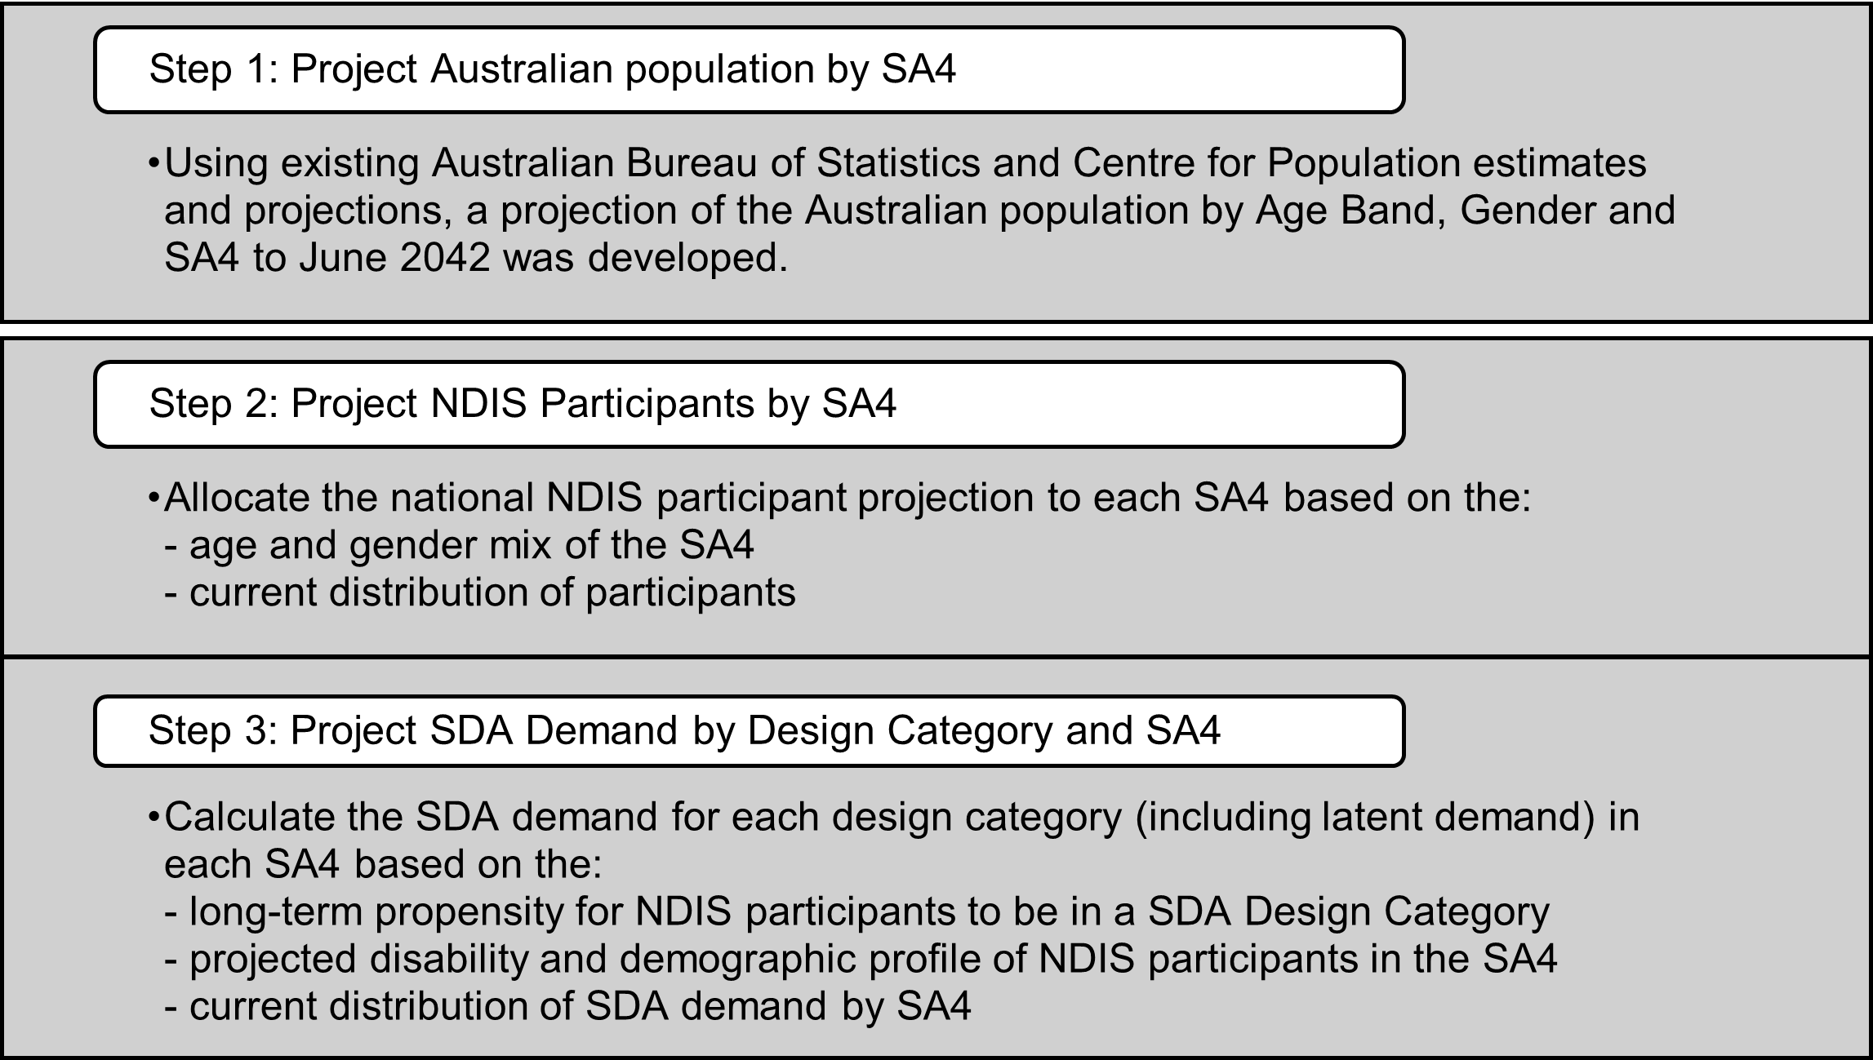
End of Exhibit 1
The critical assumptions underlying the projections are:
- A reliance upon the Scheme Actuary’s projections of future participant numbers.
- The long-term propensity for an existing NDIS participant with a given demographic and disability profile to be in SDA is aligned to the modelled propensities.
- The long-term propensities to be in the NDIS and for SDA demand in any given SA4 will reflect the projected age and gender profile of the SA4 by 2062 (that is, 20 years post the projection period). To achieve this, the observed FY22 propensities are blended with the long-term propensities over time, enabling a smooth progression from current levels.
- No other explicit allowances have been made for changes in policy or Scheme operations from the current settings.

Findings
The NDIA projects that SDA demand will increase from about 22,900 participants in June 2022 to about 36,700 in June 2042, at an average growth rate of 2.4% per annum. This compares to annual growth in the Australian population of 1.2% per annum; growth in the number of NDIS participants of 5.7% per annum and growth in the number of NDIS participants with Supported Independent Living supports of 5.6% per annum.

Projected Demand for SDA by Primary Disability
Illustrates the projected distribution of demand for SDA by (grouped) primary disability. Note, the Other Disability category in this chart consists of participants with a primary disability of Multiple Sclerosis, Other Physical Disability, Spinal Cord Injury or Stroke.
Exhibit 2: Projected SDA Demand by Primary Disability
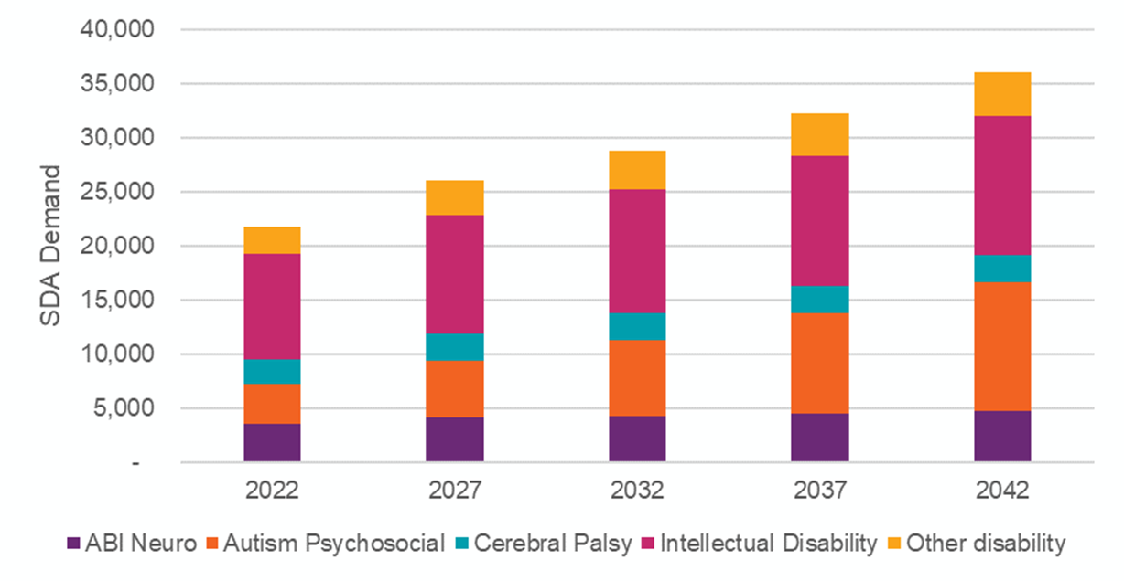
End of Exhibit 2

Projected Demand for SDA by Age Group
Illustrates the projected distribution of demand for SDA by age group. The 45 to 64 year old cohort is consistently the largest cohort. The 25 to 44 cohort has the fastest increase over the projection period as the increasing number of younger participants age through the Scheme.
The SDA demand projections include NDIS participants who are not receiving SDA supports, because they have not sought to have those supports included in their plan.
Exhibit 3: Projected SDA Demand by Age Group
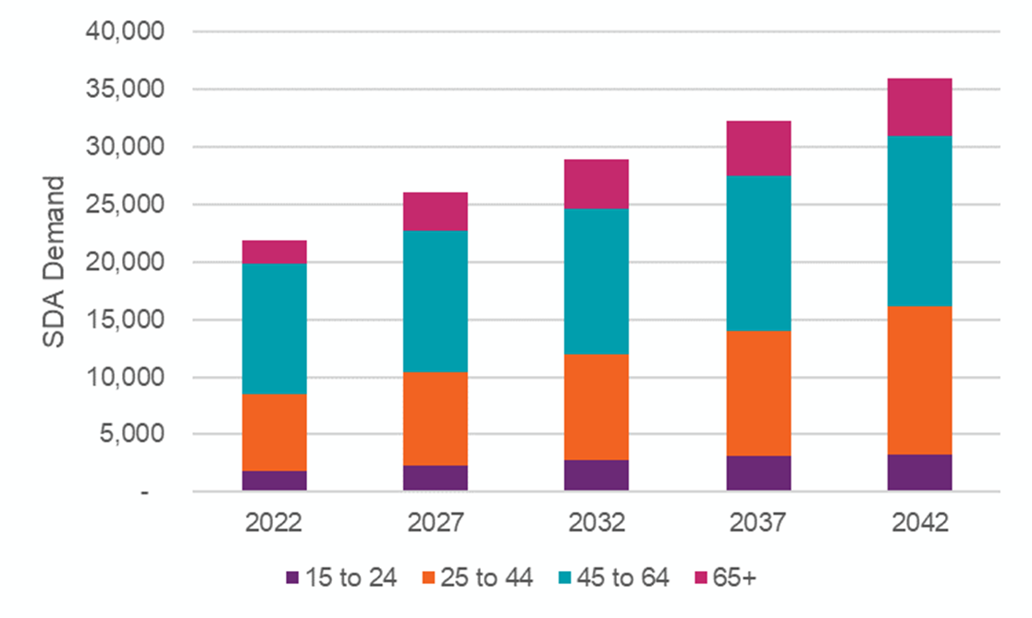
End of Exhibit 3

Projected Demand for SDA by Design Category
The SDA demand by Design Category is show in
Exhibit 4 below. Over the projection period:
- The proportion of SDA demand for Improved Liveability is projected to decline slowly across the projection period to 36% in 2042. However, the absolute demand for Improved Liveability is projected to increase by 3,200 participants over the projection period.
- The SDA demand for High Physical Support is projected to grow over the projection period by 4,800 participants, becoming 31% of total SDA demand in 2042.
- The SDA demand for Fully Accessible is projected to grow by 3,400 participants over the projection period, becoming 21% of total SDA demand in 2042.

Exhibit 4: Projected SDA demand by Design Category
Design Category | 2022 | 2027 | 2032 | 2037 | 2042
Demand for SDA
Improved Liveability | 10,026 | 10,987 | 11,543 | 12,325 | 13,256
Fully Accessible | 4,350 | 5,304 | 5,983 | 6,776 | 7,715
Robust | 1,866 | 2,420 | 2,911 | 3,534 | 4,239
High Physical Support | 6,631 | 8,311 | 9,305 | 10,341 | 11,474
Total | 22,873 | 27,0022 | 29,742 | 32,976 | 36,684
Proportion
Improved Liveability | 44% | 41% | 39% | 37% | 36%
Fully Accessible | 19% | 20% | 20% | 21% | 21%
Robust | 8% | 9% | 10% | 11% | 12%
High Physical Support | 29% | 31% | 31% | 31% | 31%
End of Exhibit 4
The growth in demand for each Design Category is driven by the projected growth in the number of Scheme participants and the relative propensities for each participant to have SDA of a given Design Category.

Projected Demand for SDA by Geography

Total SDA Demand by state
Projected SDA demand by State/Territory is shown in Exhibit 5. NSW and Victoria have the highest proportion of total demand, however demand in Queensland and Western Australia increases the fastest over the projection period. This reflects low SDA participation rates for these states (see Exhibit 5) which are projected to normalise towards the national average over the projection period. Differences in geographical variation not explained by the age and gender mix of the area, such as the impact of the phased roll-out of the Scheme and current SDA supply, are assumed to reduce over the projection period.

Exhibit 5: Projected SDA Demand by State/Territory
State/Territory | 2022 | 2027 | 2032 | 2037 | 2042
New South Wales | 7,333 | 8,688 | 9,497 | 10,416 | 11,410
Victoria | 6,632 | 7,642 | 8,335 | 9,217 | 10,285
Queensland | 3,461 | 4,274 | 4,900 | 5,628 | 6,477
Western Australia | 1,825 | 2,225 | 2,539 | 2,939 | 3,418
South Australia | 2,399 | 2,699 | 2,808 | 2,927 | 3,047
Tasmania | 606 | 717 | 779 | 852 | 922
Australian Capital Territory | 349 | 445 | 517 | 595 | 687
Northern Territory | 268 | 332 | 367 | 402 | 438
Australia | 22,873 | 27,022 | 29,742 | 32,976 | 36,684
End of Exhibit 5

Projected SDA Demand by SA4 Region (number of participants)
Exhibit 6 shows projected SDA demand by SA4 within each State/Territory. Across Australia, SDA demand is currently also projected to remain concentrated in metropolitan areas.
Exhibit 6: Projected SDA demand by SA4 Region (number of participants, FY2022 and FY2042)
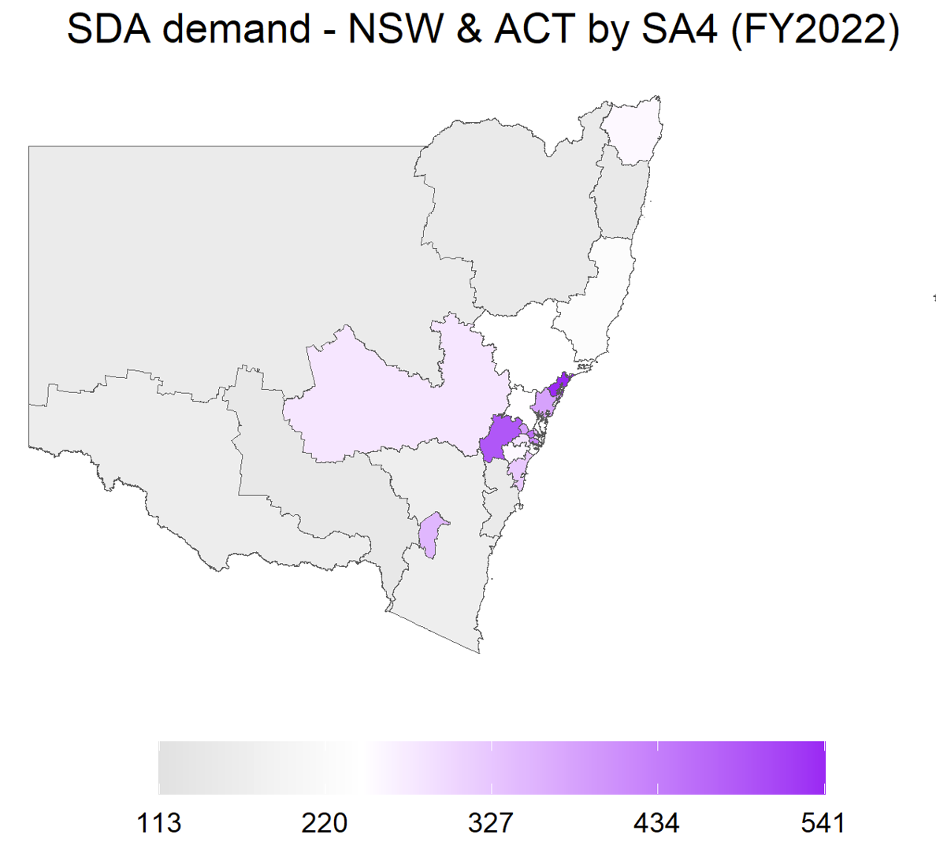 | 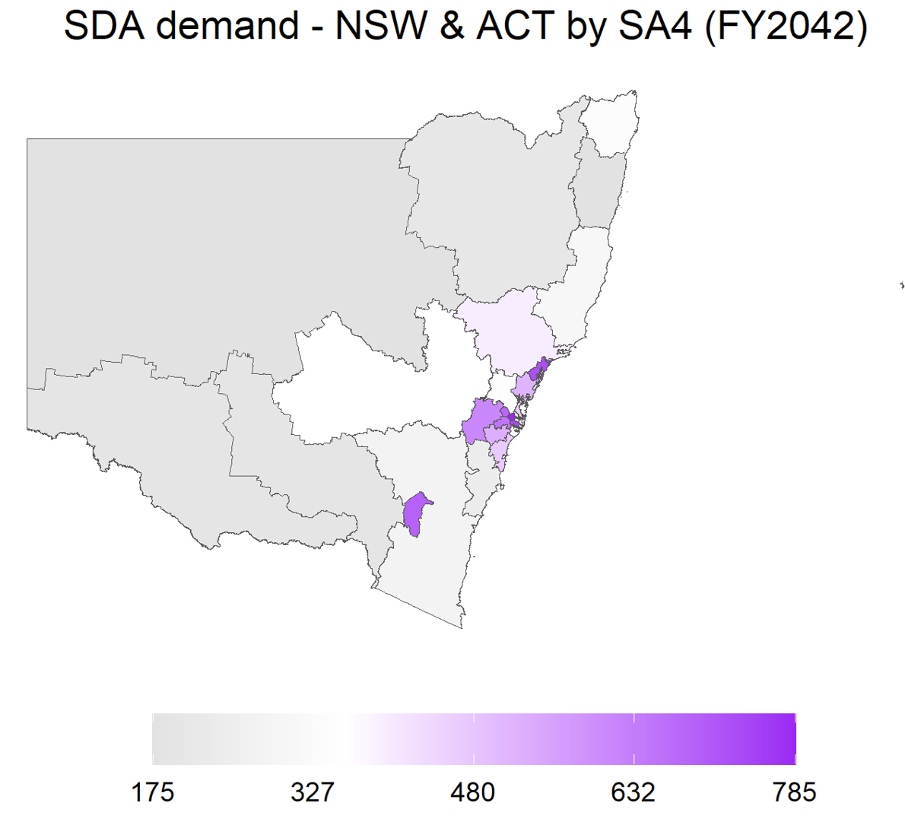
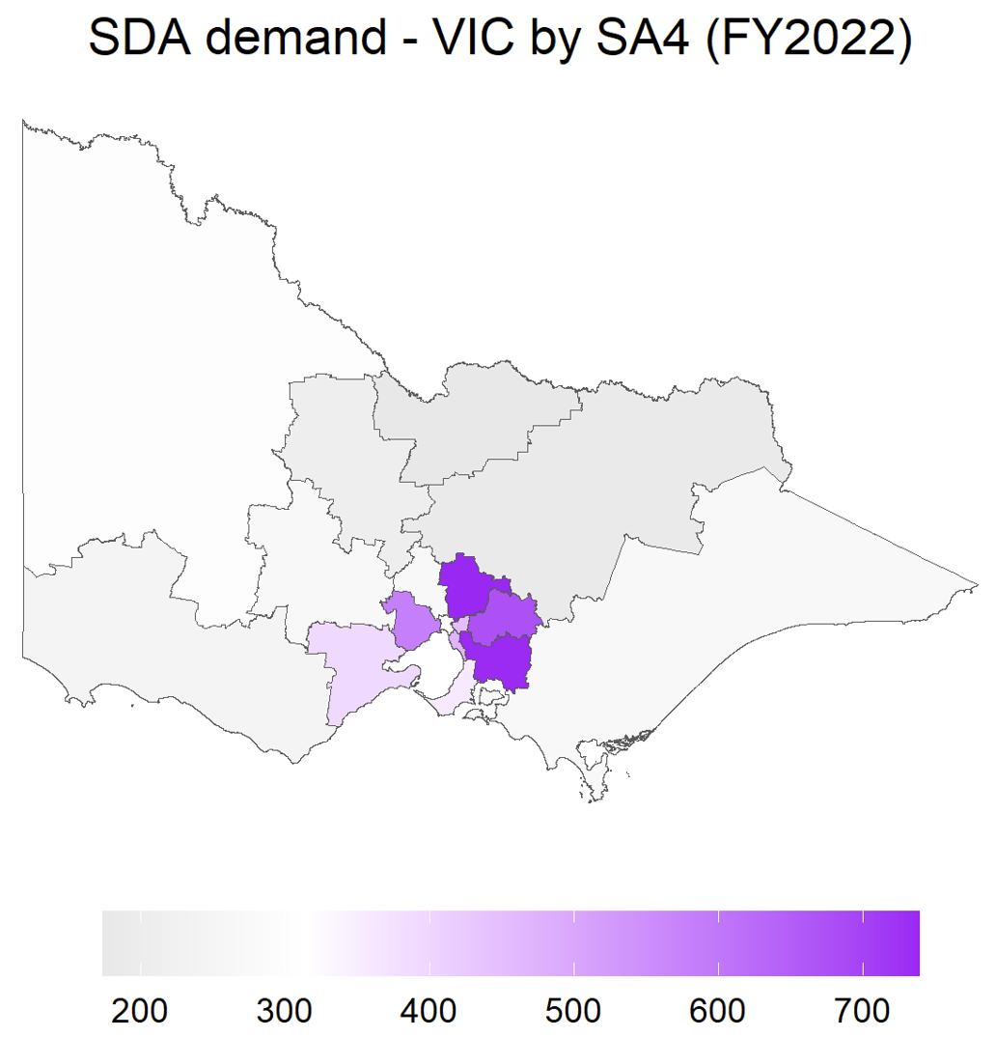 | 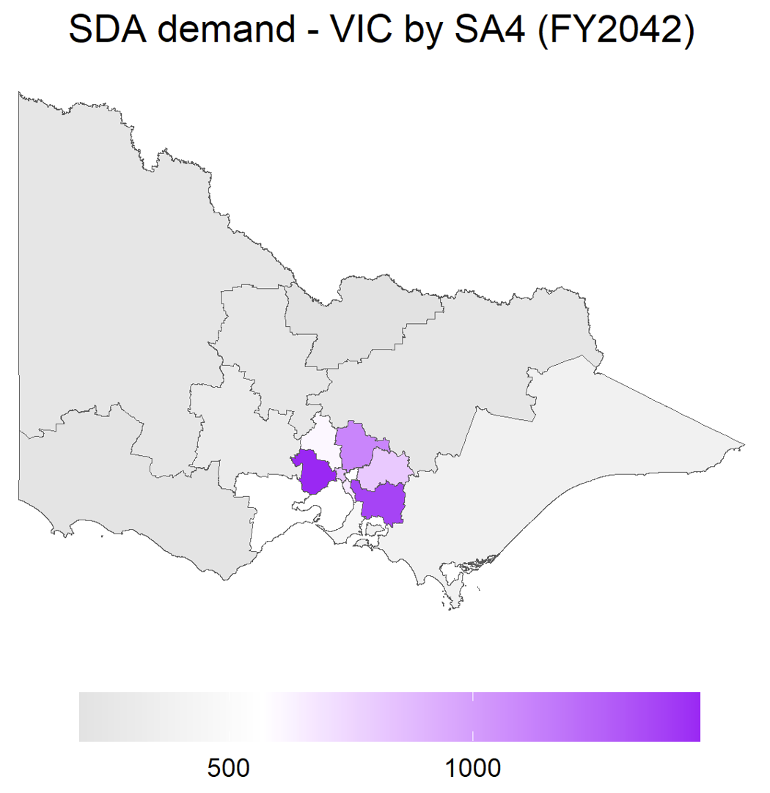
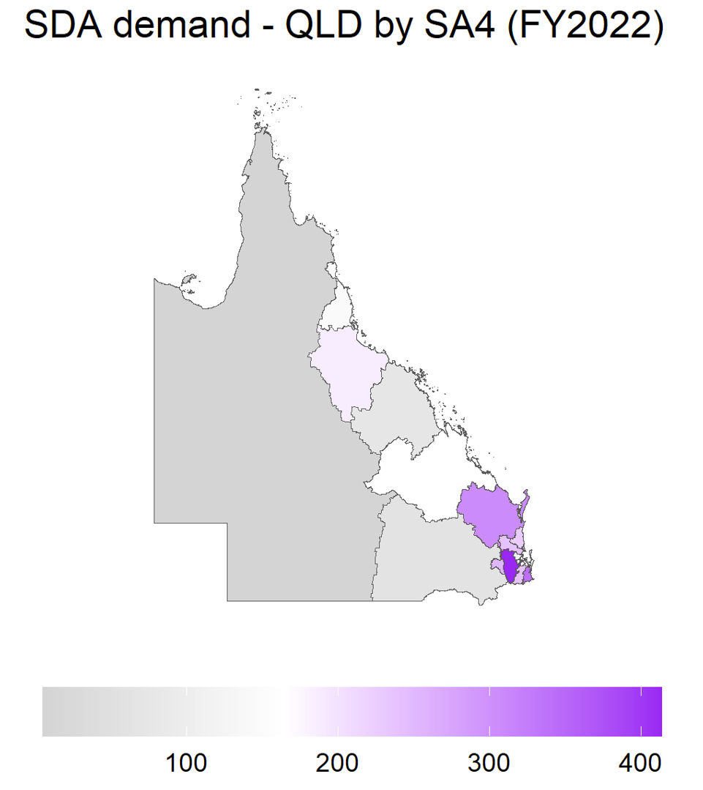 | 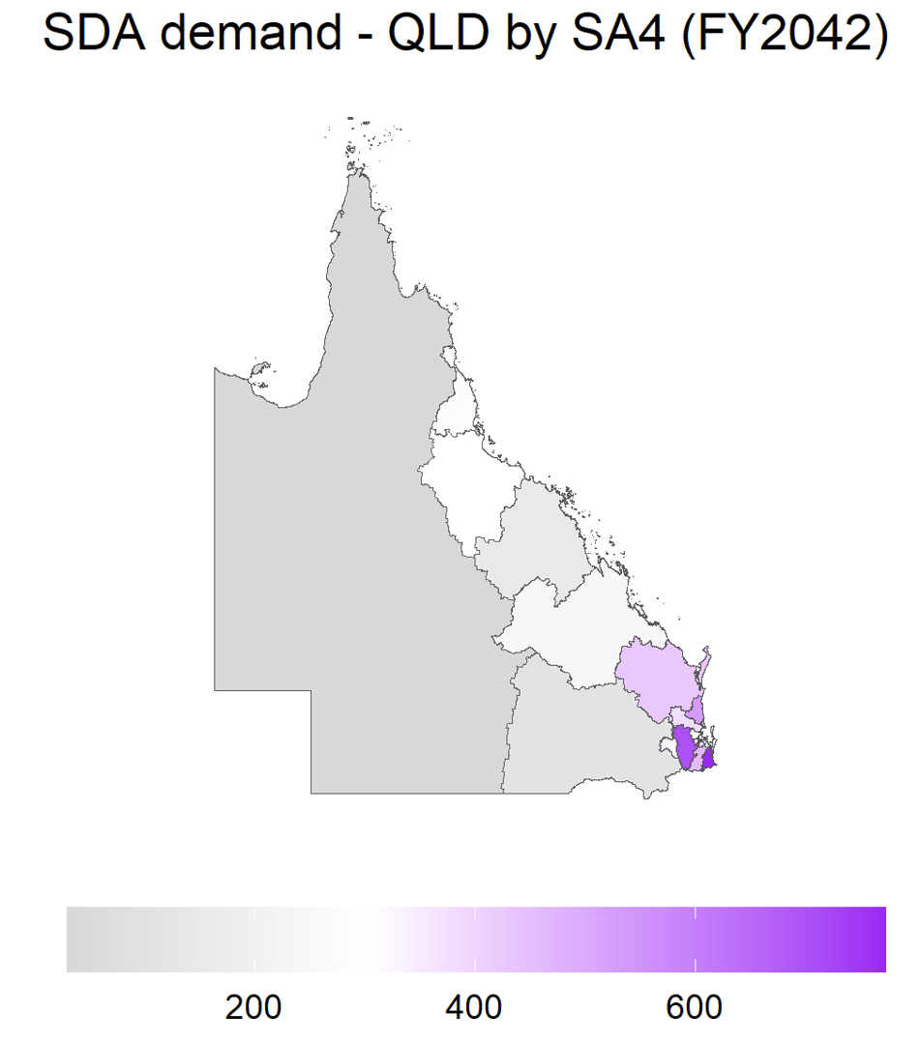
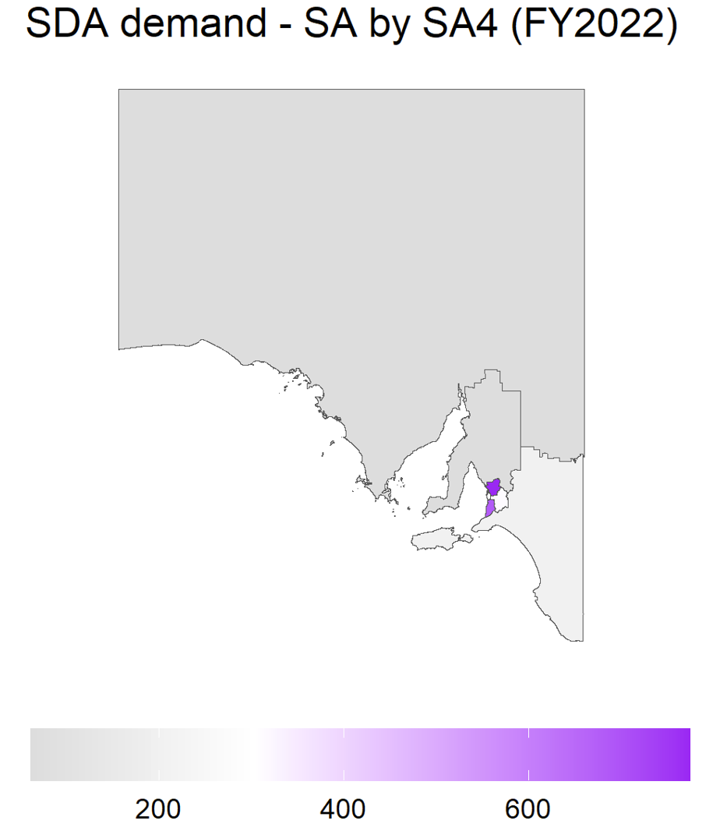 | 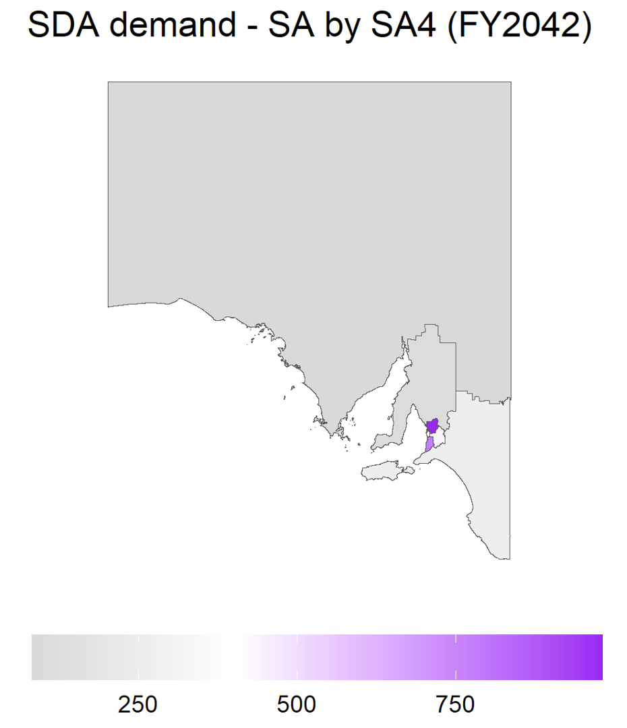
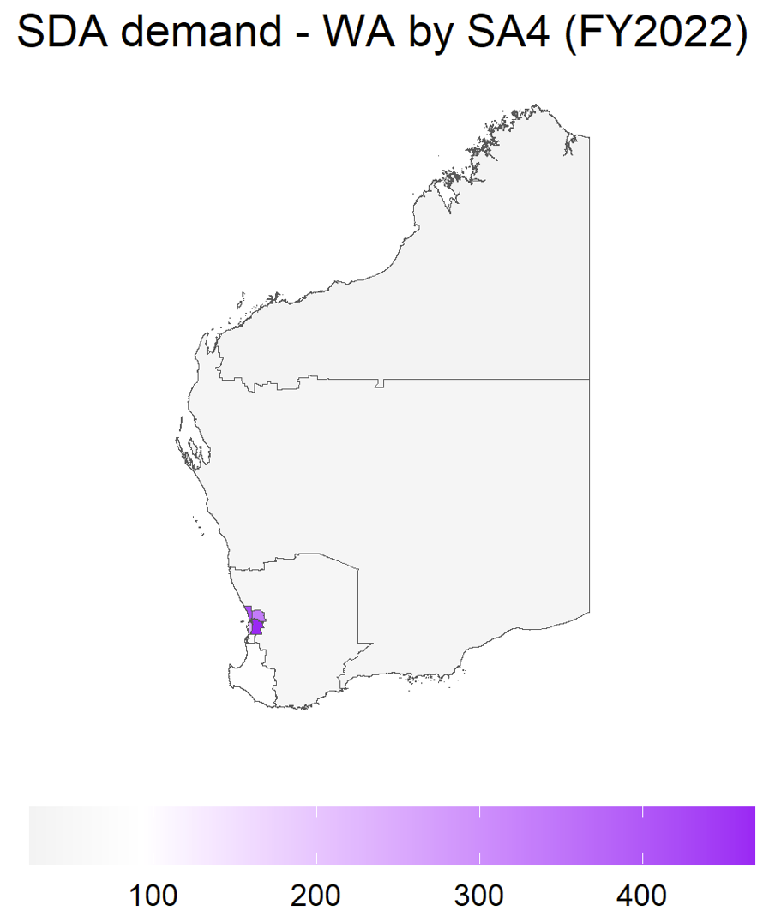 | 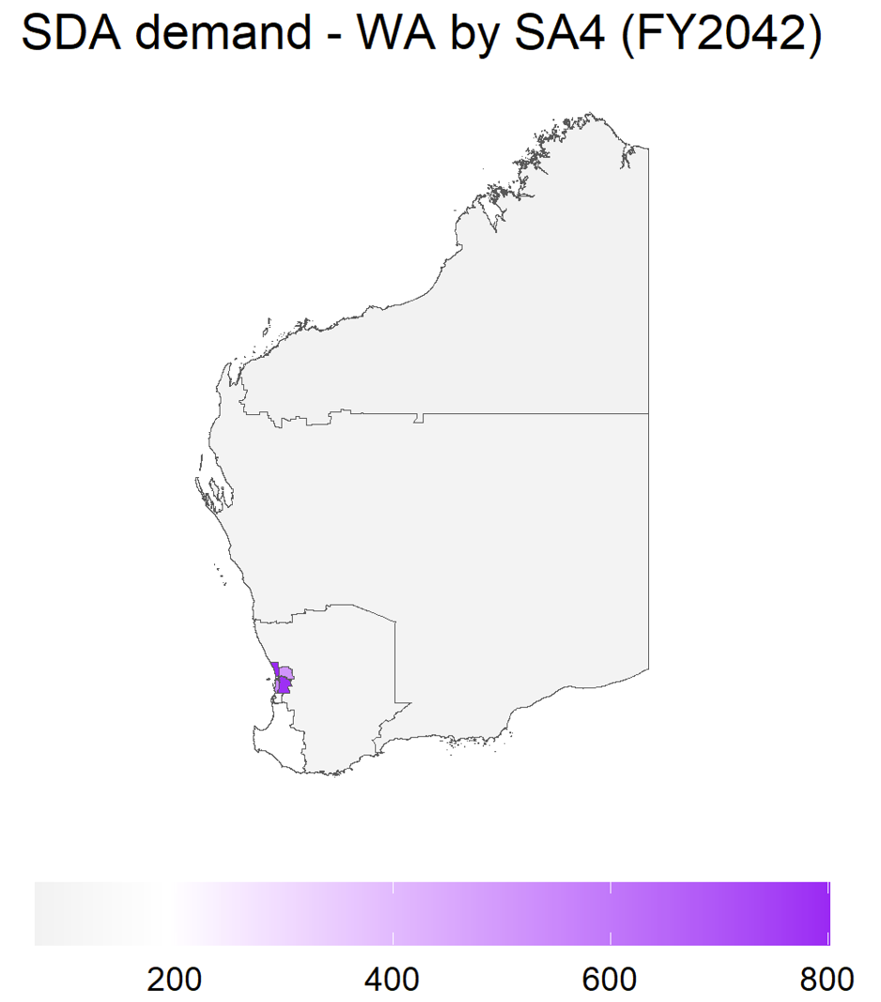
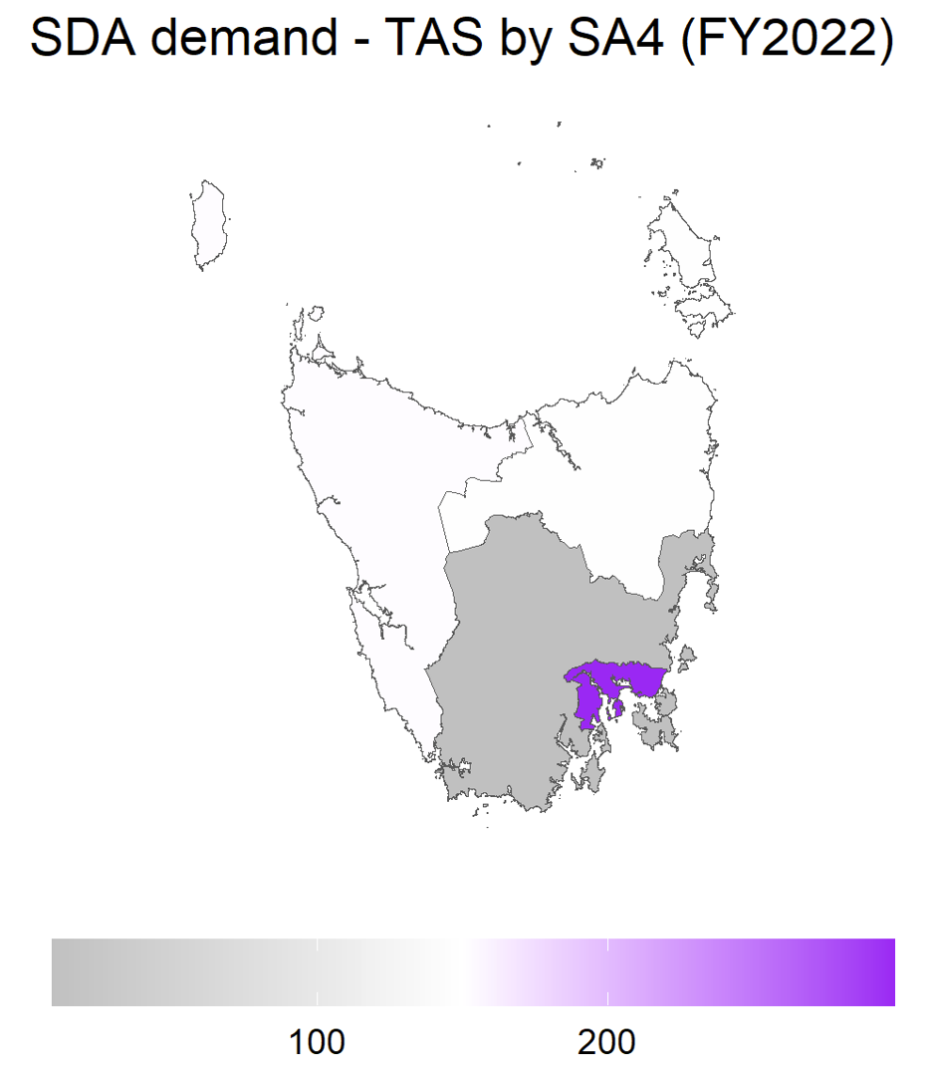 | 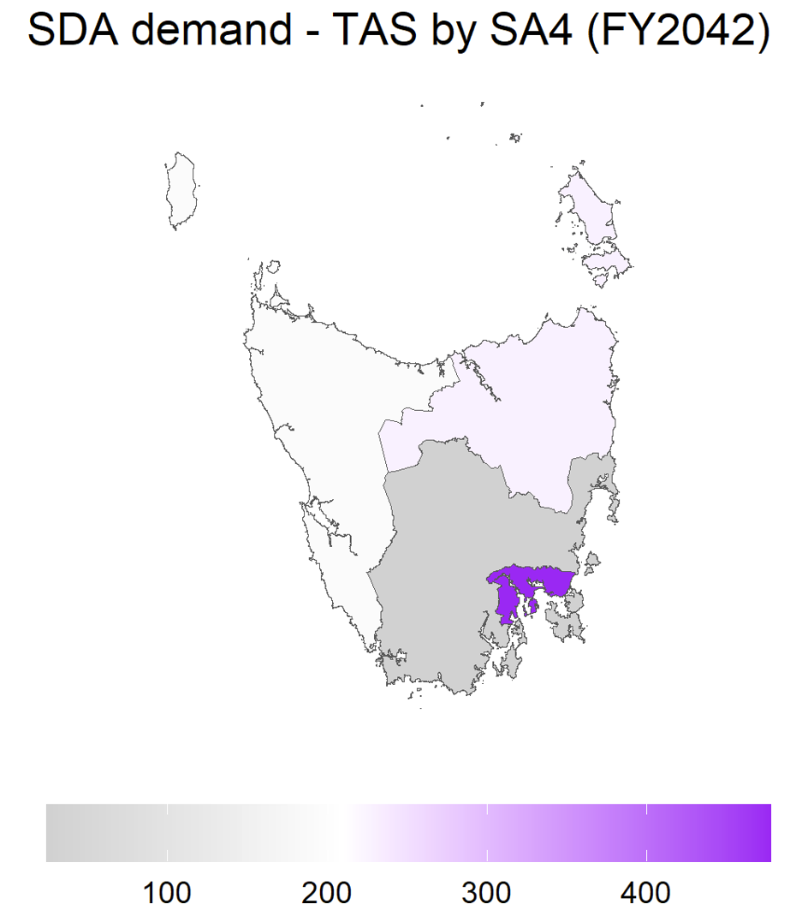
End of Exhibit 6
Exhibit 7: Projected SDA demand by SA4 Region
SA4 Region | 2022 | 2027 | 2032 | 2037 | 2042
New South Wales | n/a | n/a | n/a | n/a | n/a
Capital Region | 172 | 203 | 226 | 251 | 279
Central Coast | 381 | 442 | 467 | 493 | 513
Central West | 280 | 316 | 334 | 349 | 357
Coffs Harbour - Grafton | 150 | 160 | 167 | 171 | 179
Far West and Orana | 155 | 168 | 172 | 176 | 177
Hunter Valley excluding Newcastle | 241 | 294 | 326 | 359 | 393
Illawarra | 322 | 376 | 405 | 437 | 467
Mid North Coast | 228 | 258 | 272 | 289 | 306
Murray | 165 | 181 | 186 | 194 | 197
New England and North West | 155 | 176 | 185 | 194 | 205
Newcastle and Lake Macquarie | 540 | 633 | 670 | 703 | 723
Richmond - Tweed | 254 | 290 | 309 | 327 | 340
Riverina | 143 | 164 | 171 | 183 | 195
Southern Highlands and Shoalhaven | 155 | 186 | 206 | 225 | 241
Sydney - Baulkham Hills and Hawkesbury | 244 | 278 | 293 | 315 | 347
Sydney - Blacktown | 384 | 474 | 530 | 595 | 677
Sydney - City and Inner South | 142 | 201 | 257 | 328 | 413
Sydney - Eastern Suburbs | 113 | 155 | 192 | 238 | 289
Sydney - Inner South West | 418 | 506 | 570 | 645 | 734
Sydney - Inner West | 155 | 191 | 222 | 263 | 312
Sydney - North Sydney and Hornsby | 230 | 295 | 341 | 394 | 454
Sydney - Northern Beaches | 243 | 280 | 289 | 303 | 322
Sydney - Outer South West | 254 | 325 | 385 | 450 | 526
Sydney - Outer West and Blue Mountains | 488 | 550 | 572 | 593 | 610
Sydney - Parramatta | 457 | 556 | 622 | 698 | 786
Sydney - Ryde | 341 | 380 | 390 | 401 | 409
Sydney - South West | 281 | 375 | 450 | 543 | 650
Sydney - Sutherland | 242 | 275 | 288 | 299 | 309
Victoria | n/a | n/a | n/a | n/a | n/a
Ballarat | 271 | 287 | 293 | 298 | 307
Bendigo | 210 | 227 | 236 | 247 | 262
Geelong | 392 | 449 | 488 | 528 | 570
Hume | 187 | 202 | 213 | 223 | 240
Latrobe - Gippsland | 269 | 300 | 316 | 342 | 375
Melbourne - Inner | 311 | 413 | 521 | 660 | 829
Melbourne - Inner East | 450 | 493 | 510 | 537 | 574
Melbourne - Inner South | 470 | 540 | 573 | 614 | 662
Melbourne - North East | 738 | 857 | 922 | 1004 | 1107
Melbourne - North West | 270 | 347 | 417 | 503 | 606
Melbourne - Outer East | 673 | 730 | 748 | 776 | 806
Melbourne - South East | 737 | 898 | 1031 | 1191 | 1378
Melbourne - West | 581 | 776 | 962 | 1191 | 1464
Mornington Peninsula | 355 | 395 | 411 | 434 | 458
North West | 302 | 298 | 276 | 258 | 243
Shepparton | 175 | 187 | 188 | 193 | 194
Warrnambool and South West | 241 | 243 | 230 | 218 | 210
Queensland | n/a | n/a | n/a | n/a | n/a
Brisbane - East | 135 | 170 | 197 | 228 | 261
Brisbane - North | 163 | 193 | 220 | 250 | 288
Brisbane - South | 166 | 216 | 269 | 331 | 410
Brisbane - West | 118 | 145 | 160 | 180 | 202
Brisbane Inner City | 112 | 155 | 199 | 258 | 329
Cairns | 144 | 178 | 206 | 240 | 282
Central Queensland | 163 | 190 | 205 | 223 | 243
Darling Downs - Maranoa | 61 | 74 | 85 | 96 | 109
Gold Coast | 340 | 440 | 528 | 637 | 772
Ipswich | 414 | 508 | 561 | 627 | 701
Logan - Beaudesert | 238 | 294 | 343 | 397 | 461
Mackay - Isaac - Whitsunday | 74 | 95 | 112 | 133 | 155
Moreton Bay - North | 238 | 285 | 316 | 349 | 380
Moreton Bay - South | 122 | 158 | 187 | 221 | 264
Queensland - Outback | 5 | 6 | 13 | 20 | 30
Sunshine Coast | 224 | 298 | 365 | 444 | 536
Toowoomba | 251 | 287 | 300 | 312 | 324
Townsville | 185 | 220 | 247 | 274 | 301
Wide Bay | 308 | 362 | 387 | 408 | 429
Western Australia | n/a | n/a | n/a | n/a | n/a
Bunbury | 84 | 107 | 128 | 154 | 186
Mandurah | 76 | 94 | 108 | 126 | 144
Perth - Inner | 101 | 123 | 143 | 167 | 196
Perth - North East | 336 | 392 | 422 | 463 | 510
Perth - North West | 417 | 511 | 588 | 684 | 801
Perth - South East | 468 | 563 | 622 | 697 | 785
Perth - South West | 244 | 312 | 375 | 454 | 551
Western Australia - Outback (North) | 23 | 29 | 39 | 52 | 71
Western Australia - Outback (South) | 36 | 46 | 56 | 71 | 86
Western Australia - Wheat Belt | 40 | 48 | 58 | 71 | 88
South Australia | n/a | n/a | n/a | n/a | n/a
Adelaide - Central and Hills | 311 | 358 | 382 | 409 | 437
Adelaide - North | 774 | 876 | 909 | 946 | 979
Adelaide - South | 683 | 752 | 766 | 771 | 774
Adelaide - West | 301 | 339 | 357 | 379 | 404
Barossa - Yorke - Mid North | 65 | 76 | 84 | 94 | 106
South Australia - Outback | 61 | 69 | 71 | 78 | 83
South Australia - South East | 204 | 229 | 239 | 250 | 264
Tasmania | n/a | n/a | n/a | n/a | n/a
Hobart | 298 | 356 | 391 | 435 | 477
Launceston and North East | 147 | 179 | 196 | 213 | 228
South East | 10 | 11 | 14 | 18 | 26
West and North West | 151 | 171 | 178 | 186 | 191
Australian Capital Territory | n/a | n/a | n/a | n/a | n/a
Australian Capital Territory | 349 | 445 | 517 | 595 | 687
Northern Territory | n/a | n/a | n/a | n/a | n/a
Darwin | 160 | 205 | 229 | 255 | 282
Northern Territory - Outback | 108 | 127 | 138 | 147 | 156
Australia | 22,873 | 27,022 | 29,742 | 32,976 | 36,684
END OF EXHIBIT 7
As Exhibit 8 illustrates, it is projected that ten (10) SA4 Regions will account for one-third of all the growth in SDA demand over the next two decades:
- 2 SA4 Regions in New South Wales: Sydney - South West and Sydney - Parramatta
- 5 SA4 Regions in Victoria: Melbourne - West, Melbourne - South East, Melbourne - Inner, Melbourne - North East, and Melbourne - North West
- 1 SA4 Region in Queensland: Gold Coast
- 1 SA4 Region in Western Australia: Perth - North West
- 1 SA4 Region in the Australian Capital Territory
Exhibit 8: Top 10 SA4 Regions by Largest Absolute Growth in SDA Demand
State | SA4 Region | Growth in Demand  2022 to 2042  (Number) | Growth in Demand  2022 to 2042  (%)
VIC | Melbourne - West | 883 | 152%
VIC | Melbourne - South East | 641 | 87%
VIC | Melbourne - Inner | 518 | 167%
QLD | Gold Coast | 432 | 127%
WA | Perth - North West | 384 | 92%
NSW | Sydney - South West | 369 | 131%
VIC | Melbourne - North East | 369 | 50%
ACT | Australian Capital Territory | 338 | 97%
VIC | Melbourne - North West | 336 | 124%
NSW | Sydney - Parramatta | 329 | 72%
End of Exhibit 8
Demand is projected to grow fastest (in terms of percentage increase) over the next two decades in the following five SA4 regions (excludes regions with growth of less than 50):
- Brisbane Inner City, where demand is projected to grow by 194%.
- Sydney - City and Inner South, where demand is projected to grow by 191%.
- Melbourne - Inner, where demand is projected to grow by 167%.
- Sydney - Eastern Suburbs, where demand is projected to grow by 156%.
- Melbourne - West, where demand is projected to grow by 152%.

2042 Projections by Region and Design Category
Exhibit 9 sets out the projected demand for SDA in 2042 for each SA4 Region by Design Category.
Exhibit 9: Projected SDA demand in 2042 by SA4 Region and by Design Category
SA4 Region | Improved Liveability | Fully Accessible | Robust | High Physical Support | Total
New South Wales | n/a | n/a | n/a | n/a | n/a
Capital Region | 92 | 56 | 34 | 97 | 279
Central Coast | 173 | 101 | 65 | 174 | 513
Central West | 126 | 69 | 66 | 96 | 357
Coffs Harbour - Grafton | 57 | 38 | 22 | 62 | 179
Far West and Orana | 61 | 36 | 27 | 53 | 177
Hunter Valley exc Newcastle | 124 | 82 | 52 | 135 | 393
Illawarra | 173 | 85 | 55 | 154 | 467
Mid North Coast | 117 | 59 | 35 | 95 | 306
Murray | 81 | 35 | 23 | 58 | 197
New England and North West | 73 | 47 | 21 | 64 | 205
Newcastle and Lake Macquarie | 228 | 135 | 76 | 284 | 723
Richmond - Tweed | 124 | 63 | 36 | 117 | 340
Riverina | 71 | 36 | 22 | 66 | 195
Southern Highlands and Shoalhaven | 93 | 42 | 34 | 72 | 241
Sydney - Baulkham Hills and Hawkesbury | 137 | 72 | 40 | 98 | 347
Sydney - Blacktown | 228 | 149 | 81 | 219 | 677
Sydney - City and Inner South | 152 | 77 | 59 | 125 | 413
Sydney - Eastern Suburbs | 109 | 54 | 38 | 88 | 289
Sydney - Inner South West | 253 | 143 | 84 | 254 | 734
Sydney - Inner West | 113 | 60 | 39 | 100 | 312
Sydney - North Sydney and Hornsby | 174 | 84 | 51 | 145 | 454
Sydney - Northern Beaches | 105 | 73 | 33 | 111 | 322
Sydney - Outer South West | 174 | 106 | 69 | 177 | 526
Sydney - Outer West and Blue Mountains | 196 | 138 | 90 | 186 | 610
Sydney - Parramatta | 295 | 158 | 82 | 251 | 786
Sydney - Ryde | 155 | 82 | 46 | 126 | 409
Sydney - South West | 228 | 126 | 78 | 218 | 650
Sydney - Sutherland | 119 | 58 | 35 | 97 | 309
Victoria | n/a | n/a | n/a | n/a | n/a
Ballarat | 138 | 59 | 40 | 70 | 307
Bendigo | 90 | 41 | 37 | 94 | 262
Geelong | 213 | 89 | 66 | 202 | 570
Hume | 81 | 55 | 26 | 78 | 240
Latrobe - Gippsland | 152 | 71 | 58 | 94 | 375
Melbourne - Inner | 343 | 145 | 76 | 265 | 829
Melbourne - Inner East | 181 | 147 | 84 | 162 | 574
Melbourne - Inner South | 206 | 185 | 72 | 199 | 662
Melbourne - North East | 385 | 290 | 111 | 321 | 1107
Melbourne - North West | 192 | 172 | 74 | 168 | 606
Melbourne - Outer East | 241 | 269 | 104 | 192 | 806
Melbourne - South East | 501 | 288 | 173 | 416 | 1378
Melbourne - West | 500 | 350 | 154 | 460 | 1464
Mornington Peninsula | 167 | 88 | 75 | 128 | 458
North West | 76 | 65 | 38 | 64 | 243
Shepparton | 69 | 44 | 23 | 58 | 194
Warrnambool and South West | 69 | 39 | 25 | 77 | 210
Queensland | n/a | n/a | n/a | n/a | n/a
Brisbane - East | 96 | 53 | 29 | 83 | 261
Brisbane - North | 102 | 60 | 28 | 98 | 288
Brisbane - South | 160 | 78 | 43 | 129 | 410
Brisbane - West | 84 | 29 | 16 | 73 | 202
Brisbane Inner City | 128 | 65 | 28 | 108 | 329
Cairns | 89 | 71 | 27 | 95 | 282
Central Queensland | 87 | 67 | 22 | 67 | 243
Darling Downs - Maranoa | 48 | 21 | 9 | 31 | 109
Gold Coast | 257 | 160 | 80 | 275 | 772
Ipswich | 269 | 133 | 87 | 212 | 701
Logan - Beaudesert | 153 | 90 | 61 | 157 | 461
Mackay - Isaac - Whitsunday | 60 | 31 | 16 | 48 | 155
Moreton Bay - North | 128 | 77 | 46 | 129 | 380
Moreton Bay - South | 90 | 54 | 28 | 92 | 264
Queensland - Outback | 9 | 7 | 3 | 11 | 30
Sunshine Coast | 179 | 111 | 63 | 183 | 536
Toowoomba | 131 | 63 | 31 | 99 | 324
Townsville | 100 | 73 | 37 | 91 | 301
Wide Bay | 150 | 107 | 47 | 125 | 429
Western Australia | n/a | n/a | n/a | n/a | n/a
Bunbury | 72 | 37 | 19 | 58 | 186
Mandurah | 45 | 44 | 14 | 41 | 144
Perth - Inner | 71 | 37 | 18 | 70 | 196
Perth - North East | 215 | 100 | 54 | 141 | 510
Perth - North West | 350 | 142 | 82 | 227 | 801
Perth - South East | 335 | 147 | 77 | 226 | 785
Perth - South West | 222 | 109 | 57 | 163 | 551
Western Australia - Outback (North) | 23 | 16 | 8 | 24 | 71
Western Australia - Outback (South) | 26 | 28 | 8 | 24 | 86
Western Australia - Wheat Belt | 32 | 18 | 9 | 29 | 88
South Australia | n/a | n/a | n/a | n/a | n/a
Adelaide - Central and Hills | 157 | 80 | 49 | 151 | 437
Adelaide - North | 362 | 173 | 111 | 333 | 979
Adelaide - South | 274 | 181 | 76 | 243 | 774
Adelaide - West | 144 | 80 | 48 | 132 | 404
Barossa - Yorke - Mid North | 40 | 20 | 14 | 32 | 106
South Australia - Outback | 32 | 16 | 9 | 26 | 83
South Australia - South East | 105 | 53 | 33 | 73 | 264
Tasmania | n/a | n/a | n/a | n/a | n/a
Hobart | 203 | 95 | 55 | 124 | 477
Launceston and North East | 72 | 50 | 25 | 81 | 228
South East | 10 | 5 | 3 | 8 | 26
West and North West | 70 | 44 | 21 | 56 | 191
Australian Capital Territory | n/a | n/a | n/a | n/a
Australian Capital Territory | 288 | 121 | 76 | 202 | 687
Northern Territory | n/a | n/a | n/a | n/a | n/a
Darwin | 98 | 75 | 28 | 81 | 282
Northern Territory - Outback | 55 | 33 | 15 | 53 | 156
Australia | 13,256 | 7,715 | 4,239 | 11,474 | 36,684
End of Exhibit 9

