Provider instruction to transfer quarterly reporting tool data
This leaflet provides instructions to transfer participant data from your existing reporting tool to a new version of the Provider Reporting Tool. The worksheet is protected, and Cells AH and AL are locked to avoid overwriting formulas. Participant data can still be copied over in sections as per the following steps listed below.
Step One
- In your current tool select data from Cell B12 across to Cell L and down to the final row containing participant information
- Press Ctrl C to copy the data

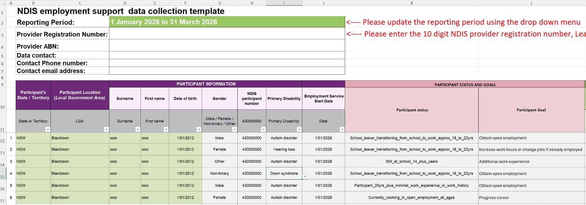
- In the new tool Select Cell B12

- Right click and select Paste Option 123

- Confirm the Participant Status and Participant Goal relevant for each of your participant is correct, remember if the participant started as a ‘school leaver’, the status would remain ‘school leaver’ until they are exited. You will also complete the remainder of the report including hours of support relevant for the reporting period in Columns M – AG
Step Two
- We do not recommend that hours of support be copied from one reporting tool to the next as we would expect that this will be different each quarter, however, if any of this additional data is to be copied from the old tool to the new tool this can be done by selecting data in Cells M12 across to AG12 and down to the final row containing participant information
- Press Ctrl C to copy the data
- In the new tool select Cell M12
- Right click and select Paste Option ‘123’

- We would expect that any hours of support and milestones achieved that have been copied need to be reviewed and amended accordingly

Step Three
- In your current tool select Cell AI12 across to Cell AK12 and down to the last row containing participant information

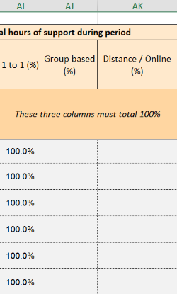
- Press Ctrl C to copy the data
- In the new tool select Cell AI12
- Right click and select Paste Option 123

Step Four:
- In your current tool select data from Cell AM12 across to Cell AO12 and down to the final row containing participant information
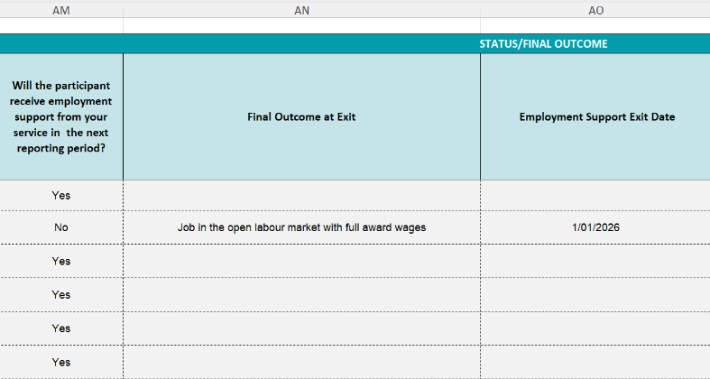

- Press Ctrl C to copy the data
- In the new tool select Cell AM12
- Right click and select Paste Option ‘123’

- Notes should be entered manually at Column AP to ensure formulas are not overwritten.

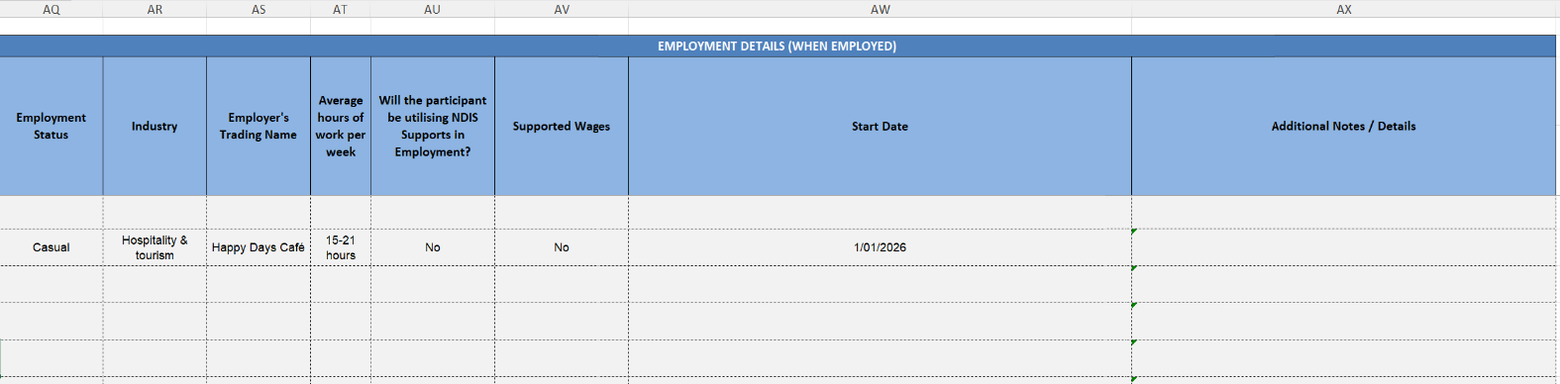

Step Five:
- In your current tool select data from Cell AQ12 across to Cell AX12 and down to the final row containing participant information.
- Press Ctrl C to copy the data
- In the new tool Select Cell AQ12
- Right click and select Paste Option ‘123’

Step Six:
- You will not be able to delete rows due to the sheet protection and locked cells so any participant details that are no longer required due to exits can be deleted and leave a blank row. This will be amended from our end.

If you need support, please contact us at participant.employment@ndis.gov.au.

End of instructions

