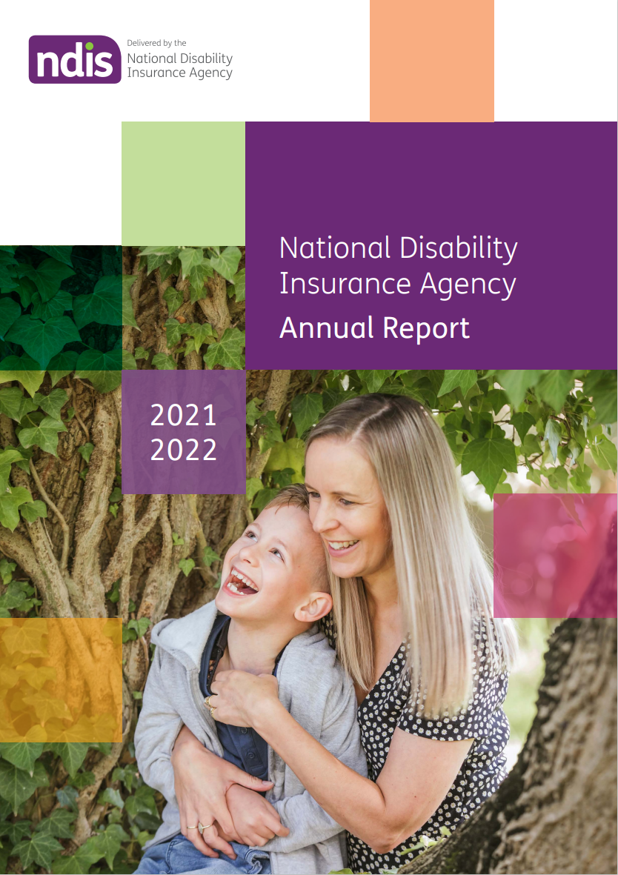

Ace (pictured on cover with his mother Bianca)
Ace lives with a rare neuro-degenerative disorder called Aicardi-Goutières syndrome (AGS), which affects his brain, muscle control and movement.
He uses a wheelchair, needs care and assistance with everyday activities, and is non-verbal.
For years, Ace struggled to communicate his needs and wants to those around him. That all changed when a communication device, funded through Ace’s NDIS plan, unlocked his world.
Ace also receives other NDIS supports, including the assistance of his support worker Kat, who cares for him twice a week.
‘The NDIS has been absolutely life-changing for us. It’s helping to keep us together as a family, it’s helping Ace live his life to the absolute fullest and we’re a happier, more cohesive family’, says Bianca, Ace’s mum.
‘Ace has a degenerative condition, so he should be getting worse, but he’s actually getting better. Almost every month he blows us away with something new he can do, it’s amazing.’

Table of contents
1 Introduction 6
Acknowledgement 6
Commitment 6
1.1 Chair’s review 6
1.2 Acting Chief Executive Officer’s review 8
1.3 The National Disability Insurance Scheme 9
1.4 The National Disability Insurance Agency 10
2 Building a better NDIS 11
2.1 How far we have come 11
2.2 Where we are today 22
2.2.1 NDIA aspirations 22
2.2.2 NDIA Values 24
2.2.3 Key achievements in 2021–22 24
2.3 How we intend to move forward 46
3 Financials 47
3.1 Financial statements 52
3.2 Financial Sustainability Report 2021‒22 82
3.2.1 Executive summary 82
3.3 Annual performance statements 116
4 Management and accountability 128
4.1 Governance 128
4.1.1 Responsible Minister 128
4.1.2 Ministerial Council 128
4.2 The Board 128
4.2.1 Directors as at 30 June 2022 129
4.2.2 Board committees 133
4.2.3 Board and committee attendance 134
4.2.4 Board membership changes 135
4.3 The Independent Advisory Council (IAC) 135
4.4 The Chief Executive Officer and Executive Leadership Team 136
4.4.1 Organisation structure 136
4.5 Partners in the community (PITC) 137
4.6 Workforce management 138
4.7 Staff engagement 140
4.8 Risk management 141
4.8.1 Scheme integrity 141
4.8.2 Internal audit 142
4.8.3 External audit 143
5 Appendices 144
5.1 Enabling legislation 144
5.2 Audit Committee 144
5.3 Work health and safety 145
5.4 Workforce statistics 146
5.5 Executive remuneration policy 148
5.6 Executive remuneration 149
5.6.1 Key management personnel 149
5.6.2 Information about remuneration of key management personnel 151
5.6.3 Senior executives 153
5.6.4 Other highly paid staff 154
5.7 Reports by parliamentary committees 156
5.7.1 Royal Commission 157
5.8 Judicial decisions and external reviews 157
5.9 Other PGPA reportable items 160
5.10 Advertising and market research 161
5.11 Ecologically sustainable development and environmental performance 162
5.12 Compliance with Carer Recognition Act 162
5.13 Information on other specific statutory provisions 164
5.14 Glossary 165
5.14.1 Definitions 165
5.14.2 Acronyms 165
6 Indexes 168
6.1 Compliance index 168
6.2 Tables index 172
6.3 Figures index 173

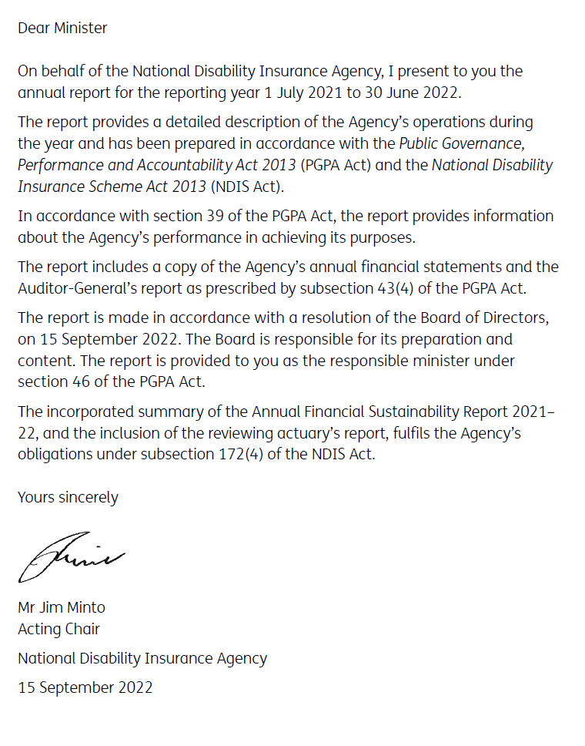
- Introduction
The National Disability Insurance Agency (the Agency or NDIA) Annual Report 2021-22 is prepared in accordance with legislative requirements. It summarises the NDIA’s performance from 1 July 2021 until 30 June 2022. This includes how the NDIA fulfilled the principles set out in the National Disability Insurance Scheme Act 2013 (NDIS Act).

Acknowledgement
The NDIA acknowledges the Aboriginal and Torres Strait Islander peoples of this nation and the Traditional Custodians of the lands across which our Agency conducts our business. We pay our respects to the custodians of the land on which we work as well as their ancestors and Elders, past, present and emerging.
The NDIA is committed to honouring Aboriginal and Torres Strait Islander peoples’ unique cultural and spiritual relationships to the land, waters, seas and their rich contribution to society.

Commitment
We affirm our commitment to fellow Australians with disability; and to the mission of the NDIS to contribute to a just and inclusive Australia where all can reach their full potential and contribution. We support the objectives of the United Nations Convention on the Rights of Persons with Disabilities.
  - Chair’s review
It has been a landmark year for the National Disability Insurance Scheme (NDIS) with participant numbers pushing past half a million, ending the year at 534,655. There was a net increase of 68,036 participants, or 14.6%, over the year.
The Scheme is a huge step forward for most people with disability, who had to rely on families and traditional supports in the past. The design of the Scheme is unique but it is also complex. With each participant having a personalised plan based on their level of functional capacity, each person has his or her own expectations of appropriate reasonable and necessary supports to be funded in their plan. This will always see levels of public comment and demand as participants and their advocates seek to have their personal expectations fully met.
Before the Scheme, supports or services were provided in standardised ways. The Scheme design focuses on participants finding, selecting and negotiating their own supports and service providers – a challenge for many who have not been in this position before. Many providers charge full price limits or charge premium prices for individual items. Over time it is reasonable to expect that we should see benefits from greater buying power that will allow participants to get better value and more services from their funding. Any steps that can help make the Scheme and accessing supports easier to navigate is a priority.
While we know there is certainly room for improvement in how the Scheme is delivered, there is no doubt the funding of supports through the Scheme is creating a real difference to the lives of a great many people with disability.
There is an increasing focus now on outcomes for participants to help each person live a better life. This Annual Report contains information on areas such as community and employment participation. This is based on surveys and feedback, and tracking the impact of the Scheme over time. Outcomes being achieved by people with disability will be one of the main focuses of governments as they continue to assess the costs of the Scheme.
The impact of COVID-19 on all Scheme stakeholders has started to ease; however, without doubt, the pandemic has created a great deal of challenge and disruption. Our staff, support workers and providers worked hard during the pandemic to try to ensure the best possible delivery to participants in times of great difficulty. The east coast flooding events in early 2022 created additional stresses and pressure on participants, their families and supporters as well as various service providers.
Even in the face of these challenges, there have been many highlights. In 2021–22:
- Total payments to participants were $28.6 billion, an increase of just over $5 billion on the previous financial year.
- The average payment per participant was $55,200. Five years ago it was $32,300.
- For participants who now have 6 or more plans the average payments was $92,900. The average payment relating to their first plan was $30,300. Their plan values have tripled over those 6 or more plans.
- Of the 534,655 participants with an approved plan at the end of the year, 82,863 were children younger than 7 years old. The number of NDIS participants as a proportion of the Australian population peaks between the ages of 5 and 7, at 6.8%.
- A total of 208,265 participant plan reviews were conducted between 1 July 2021 and
31 December 2021; of those plan reviews, 2,069 resulted in an Administrative Appeals Tribunal case. We continue to work hard on improving complaint and appeal processes. At 30 June 2022, 93% of complaints were being resolved within 21 days.
Generally, as this Annual Report shows, service levels have continued to improve with most Participant Service Guarantee measures being met. I thank the NDIA staff and management for their ongoing focus on improvement during the year.
A Scheme of this size and complexity requires very strong underlying technology and processes together with skilled people to deliver it effectively, into the future and for more participants. Work has continued through this year on the design of new technology systems to provide the capability to better support delivery of the Scheme. It will enable participants to interface with the Scheme in modern ways. Trial of the first phase of the new technology will commence prior to the end of 2022. The redesign of payment systems will be part of the new technology rollout, which is expected to happen progressively over the next 2 years.
Co-design work with the disability community continued this year and will be a cornerstone of the operation of the Scheme into the future. Working together in this way allows better solutions to be designed and a greater sense of ownership by all parties. I thank all those involved in helping design better processes.
The Independent Advisory Council (IAC) continues to perform valuable work around co-design and advice to the Board on key matters. On behalf of the Board, I thank the IAC for their insightful contributions.
The past year has seen significant changes in the Board. Former Chairman Helen Nugent retired on 31 December 2021, with Dr Denis Napthine stepping into the role from 1 April and subsequently stepping down on 15 July 2022. I thank them both, and all members of the Board, for their tremendous efforts in guiding the delivery of the NDIS. CEO Martin Hoffman left the Agency at the conclusion of the 2021–22 financial year. Dr Lisa Studdert has ably stepped into the role, pending the selection of a new CEO. I thank both Martin and Lisa for their leadership of the NDIA and I thank all staff for their tremendous efforts.
The new Government was elected in May 2022 and the new Minister for the NDIS, the Hon Bill Shorten MP, has since outlined an agenda for improvements that will enhance the Scheme. The agenda includes a review of the Scheme. The NDIA Board and management look forward to working with the Government to address the outcomes of the review.
Despite concerns about the cost of the Scheme in a wider societal sense, it does have a tremendous purpose and delivers transformative benefits for so many. The challenge for us all now is how we can preserve these benefits while ensuring the Scheme remains affordable for government.
Jim Minto
Acting Chair
  - Acting Chief Executive Officer’s review
The period of 2021–22 was a year of progress and change for the National Disability Insurance Scheme (NDIS).
At the National Disability Insurance Agency (NDIA) we worked hard to make significant improvements, streamline services and engage more extensively with the sector, in line with participants’ needs and expectations.
The NDIS Amendment (Participant Service Guarantee and Other Measures) Act 2021, which passed in both houses of Parliament in 2022, will allow for easier payments and plan variations. It legislates the Participant Service Guarantee (PSG), which the Agency was already implementing administratively. The PSG, along with the Participant Service Charter and Participant Service Improvement plans, sets out our commitment to meeting participants’ expectations and improving the NDIS experience and outcomes.
The past year was also a period of significant growth.
At 30 June 2022, there were 534,655 participants receiving support from the NDIS, with more than 300,000 of these receiving supports for the very first time. We welcomed more than 60,000 new participants to the Scheme in the 2021–22 year.
Importantly, participants from diverse backgrounds are entering the Scheme at increasing rates.
At 30 June 2022, 38,846 participants in the Scheme identified as Aboriginal and Torres Strait Islander, now representing 7.3% of all participants. There was also a steady increase in the number of participants who identified as culturally and linguistically diverse (CALD), which is now 49,201, or 9.2% of all participants. Aligned to these areas of growth, the Agency continues to refresh its strategies for reaching specific cohorts and delivering appropriate supports.
The Agency has continued to respond to significant events, including the ongoing COVID-19 pandemic and severe weather events. We distributed more than 5 million RAT tests Australia-wide in the first part of 2022, to support participants and workers in supported independent living (SIL) settings. In response to extensive flooding in Queensland and New South Wales in March 2022, we provided immediate support to those who had been directly impacted, including putting new SIL arrangements in place for some participants.
We continued to strive for Scheme delivery improvements that will benefit participants and partners. Over the past year, we have had an increased focus on engagement with the sector, particularly through intensive, genuine co-design. We released our Engagement Framework in March, which outlines our commitment to engage and work with the disability community on significant changes and improvements. The framework was developed with the disability sector to guide, support and strengthen our engagement with the disability community – through co-design, consultation and information sharing – now and into the future.
One of the key areas of our Scheme improvement work has been in the development of home and living options to support participants to have more choice and control over where they live, who they live with and the supports they use. This has included consultation in the past 12 months with participants and the sector on SIL services through surveys, workshops and the introduction of home and living demonstration projects to develop, test, evaluate and promote better practice.
We have also concentrated on redesigning our systems and processes. We know there is a direct link between making it easier for our staff and partners to do their job and delivering a better NDIS experience for participants and providers. We are working to ensure our processes are robust and our systems are responsive. We have made considerable progress with our Operational Guidance Refresh project, improving how we communicate Scheme policy and decision-making information. Updated Operational Guidelines and ‘Would we fund it?’ guides are published on our website.
Our systems improvement work will continue in 2022–23, with the roll-out of a contemporary, custom-built participant-facing system. It promises to bring significant improvements to the quality and efficiency of our service delivery.
In May, with the new Government sworn in, the Hon Bill Shorten MP was appointed the Minister for the NDIS. Minister Shorten is working closely with the Agency and the disability community in delivering on election commitments and the Government’s forward agenda. These priorities include a commitment to reduce the number of NDIS-related disputes at the Administrative Appeals Tribunal, an increased focus on fraud prevention and detection, continued support to participants, families and providers to respond to COVID-19 and improvements in the timely and safe discharge of NDIS participants from hospital settings.
While there is significant work ahead of us, I know everyone in the Agency who is working to deliver the Scheme – from our Board to our frontline staff – is committed to making the Scheme the best it can be. I thank NDIA staff and our partners in the community for their exceptional efforts to deliver the Scheme over the past year.
It is vital to acknowledge the contribution of participants, families and carers who generously gave continuous, high-quality advice and feedback – through groups such as the Participant Reference Group – to improve the participant experience.
And of course, I would like to thank the Australian disability community more broadly for their insights and feedback. The NDIA Board, leadership and staff are committed to working closely with you to continue Scheme improvements and make it even better in the year ahead.
Dr Lisa Studdert
Acting Chief Executive Officer
  - The National Disability Insurance Scheme
The National Disability Insurance Scheme (NDIS or the Scheme) provides Australians who have a permanent and significant disability with financial support to build capacity, increase independence and establish stronger connections with their community and workplace.
Established in July 2013 to replace the previous primarily state-based welfare system of disability care, the Scheme provides a single, national insurance-based approach to fund support for people with disability, their families and carers.
The NDIS is based on the guiding principles that people with disability:
- have the same rights as all Australians to realise their potential for physical, social, emotional and intellectual development
- are supported to participate in and contribute to social and economic life to the full extent of their ability.

NDIS insurance principles
The NDIS is founded on 5 insurance principles:
          - Evidence-based decision-making
          - Consistency in decision-making
          - Regular monitoring of experience to manage emerging risks
          - Lifetime and person-centric approach
          - Early investment to drive lifetime participant outcomes.
Using these principles, the NDIA makes evidence-based decisions on access and funding by drawing on the data that is collected on each and every participant. The NDIA also takes a lifetime, person-centric approach to funding supports for people with disability, where early investment in disability-related supports is expected to drive better outcomes for participants, their families and carers over their lifetime.
For further information, read the Council of Australian Governments’ Principles to Determine the Responsibilities of the NDIS and other Service Systems.
  - The National Disability Insurance Agency
The NDIA is a corporate commonwealth entity under the PGPA Act, with statutory authority under the NDIS Act. The NDIS Act, in conjunction with other laws, gives effect to Australia’s obligations under the United Nations Convention on the Rights of Persons with Disabilities. Funding and governance of the Scheme involves the Commonwealth and state and territory governments in accordance with the NDIS Act and inter-governmental agreements.
As a Commonwealth entity, the NDIA is subject to the Commonwealth Performance Framework. The Annual Report (this document) is a key element of the framework, incorporating the NDIA’s performance statements and audited financial statements, which report respectively on our non-financial and financial results. In accordance with the framework, the NDIA also publishes an annual Corporate Plan, our primary non-financial planning document.
The NDIA also provides detailed quarterly reports to the Ministerial Council outlining NDIS performance in accordance with the NDIS Act. All reports are available for download on the NDIS website. The NDIA is overseen by the NDIA Board, which has responsibility for ensuring the proper, efficient and effective performance of the NDIA’s functions, setting its strategic direction, ensuring the financial sustainability of the Scheme, and managing risk and ensuring compliance with relevant legislative and statutory requirements. The Board is the accountable authority for the NDIA under the PGPA Act. Information on Board members is provided in section 4.2 of this report.
The NDIA’s governance structure also includes the Independent Advisory Council (IAC), which provides advice to the Board in accordance with the NDIS Act. Further information on the IAC is provided in section 4.3 of this report.

- Building a better NDIS
The NDIS is delivering significant benefits to Australians with disability. As at 30 June 2022, 534,655 people with disability across Australia are receiving support. More than half of these participants are receiving supports for the first time. Participant outcomes in many cases are life-changing. Some outcomes for participants continue to improve the longer they are in the Scheme.
We have worked hard to deliver the NDIS for Australians with disability, but we know there is still more to do.
We continue to work to support participants to find paid employment. There has been a 10% increase in paid workforce participation for participants aged 15–24. We are also seeing an increase in employment rates amongst carers the longer their participant is in the Scheme, from 46% at entry to 55% at the fifth plan review.
We are committed to the continuity of essential service delivery and support for participants. The Participant Service Charter, the Participant Service Guarantee (PSG) and the Participant Service Improvement Plan (SIP) set out our objectives to deliver a Scheme that meets the expectations of participants and improves outcomes and experiences, with the NDIA well on the way to meeting most of the agreed measures.
The NDIS Amendment (Participant Service Guarantee and Other Measures) Act 2021 introduced changes from 1 July 2022 that will increase efficiency and simplify processes for participants, their families and carers, with regular transparent reporting measuring NDIA performance against those measures. The NDIA welcomed these changes and commenced measuring performance against the PSG metrics prior to the legislation of the Participant Service Charter and PSG.
The NDIA, our Board members and senior executives are committed to working with state and territory governments and the disability community to deliver better outcomes for people with disability, improve Scheme processes and address priority issues. We are committed to listening to the voices of the disability community in making decisions and working with them in building a better NDIS.
  - How far we have come
The NDIS has grown substantially over its 9 years of operation. Our reach has expanded – from 4 trial sites in selected geographic locations, to delivering the Scheme in all states and territories across Australia.
Support payments to participants and the average payment per participant have steadily risen over time.
This growth is mirrored in the NDIS-related workforce and provider market across the country.
There are now more than 12,000 people working directly to deliver the Scheme, with around half of those within the NDIA and the other half employed by the NDIA’s partners in the community – community organisations that work with the NDIA to deliver the Scheme at a local level.
Tens of thousands more workers are delivering services through providers engaged by our participants, including disability support workers and a range of allied health professionals.

Participant numbers
The number of active participants has increased from 29,719 in 2016, after 3 years of the NDIS trial, to 534,655 in 2021–22, 6 years later.
Figure 2.1A: Growth in participant numbers
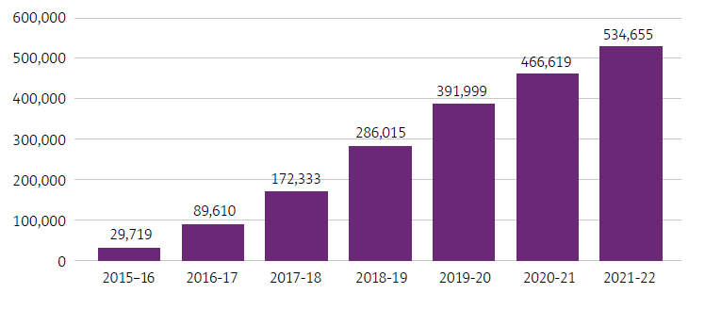

Participant support payments
Participant support expenses are amounts incurred by the NDIA for supports to participants. In 2021–22, these amounts continued to increase. Over the last 5 years, total expenses have grown from $2,238 million to $28,631 million.
Figure 2.1B: Growth in participant support payments
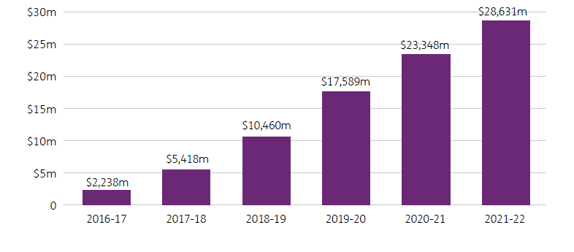
Figure 2.1C: Average payment per participant
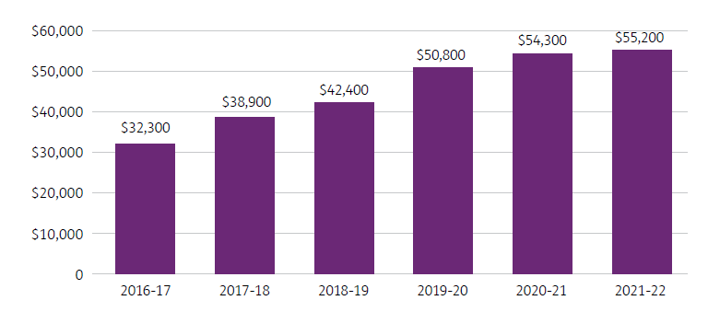
Both the average (mean) payment per participant and the median payment per participant provide useful information. In the NDIS, the average payment is higher than the median payment because there is a skewed distribution, with a small number of participants receiving very high-value supports and a large number receiving low-value supports.
Trends in average and median payments per participant between 1 July 2019 and 30 June 2022 indicate that average payments have increased by 9.2% per annum, and median payments have increased by 13.7% per annum.
Figure 2.1D: Average and median payments for years ending 30 June – all participants
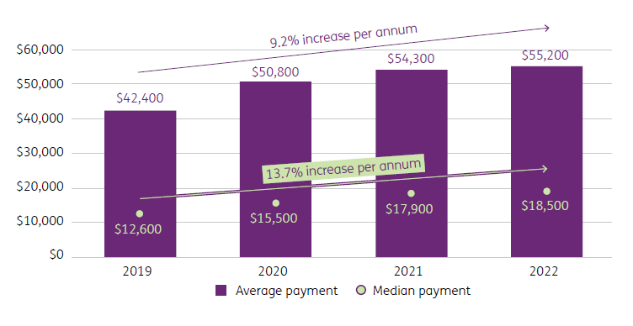
Analysis of the changes in average and median payment over time by whether participants are in supported independent living (SIL) indicates that the average annual increase in both average and median payments has been consistently high across both participant groups. Specifically, the average payment has increased for participants in SIL by 11.9%, and the average payment has increased for participants not in SIL by 14.4% per year. These averages are higher than the overall average (of 9.2%), as the proportion of participants in SIL has decreased over the period. Also, the median payment has increased for participants in SIL by 14.5%, and the median payment has increased for participants not in SIL by 15.3% per year.
Figure 2.1E: Average and median payments for years ending 30 June – participants in SIL
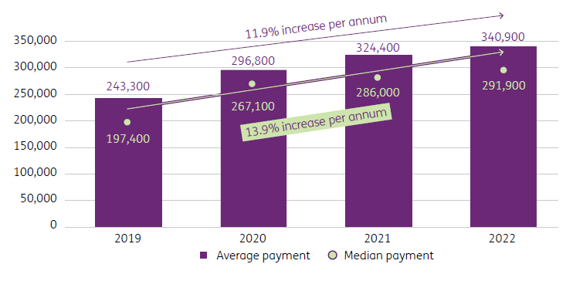
Figure 2.1F: Average and median payments per years ending 30 June – participants not in SIL
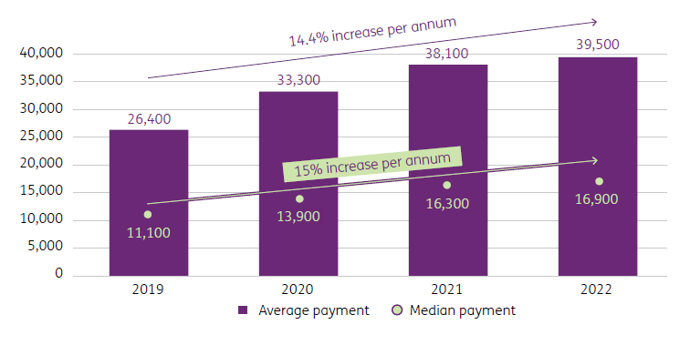
For participants not in SIL, average payments have increased at a faster rate for adults (particularly those aged over 35) and reflect a material increase in the hours of attendant care support these participants are receiving over time. Large increases are also evident in the median payment.
Although average and median payments have increased for all age groups, younger participants have significantly lower payments compared to older participants. For example, for participants not in SIL, those aged 0 to 14 years had average payments of $18,700 in the year to 30 June 2022, compared to $41,900 for those aged 15 to 24 years and $60,100 for those aged 45 to 54 years. With more younger participants entering the Scheme over time, the overall average and median payments will therefore be lower, partly offsetting the increases otherwise observed. Generally, increases were largest between 2019 and 2020, compared to more recent years.
Figure 2.1G: Average and median payments per year – by age group (participants not in SIL)
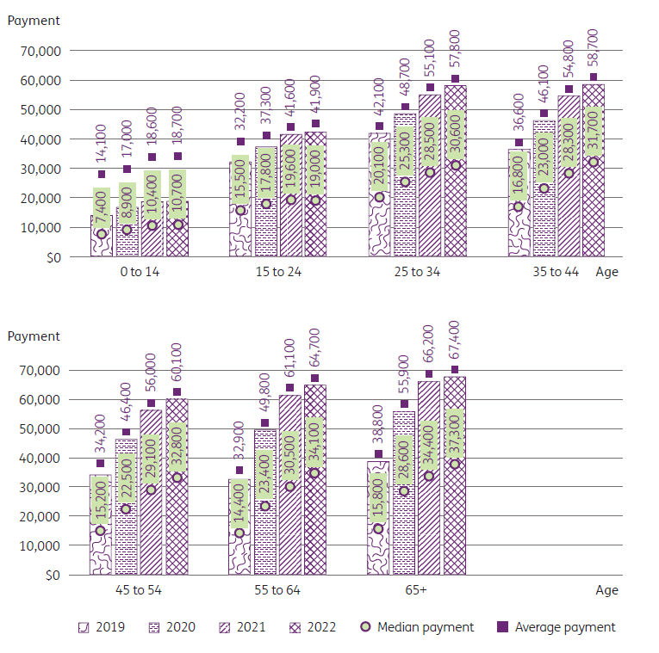

Plan budgets
Plan budgets detail the financial value of supports contained in a participant’s NDIS plan that are approved to support participant needs and outcomes. In some cases, participants do not use all of their plan budget. The amounts used are referred to as payments (see figures 2.1B and 2.1C). Over the last 5 years, total plan budgets have grown from $3,244 million to $36,055 million.
Figure 2.1H: Plan budgets
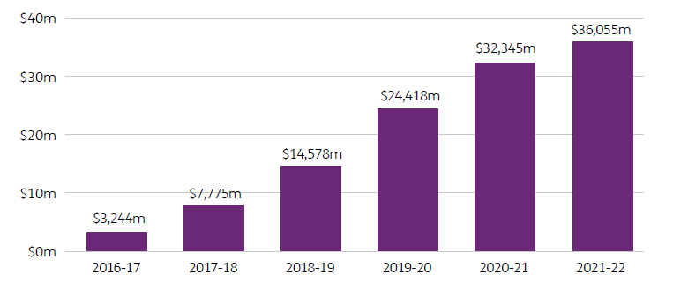

Number of providers
There has also been an increase in the number of providers supporting NDIA-managed participants, from 4,005 as at 30 June 2017 to 18,347 as at 30 June 2022. This is growth of more than 4.5 times since 2017.
Figure 2.1I Change in number of providers registered to support participants since 2017
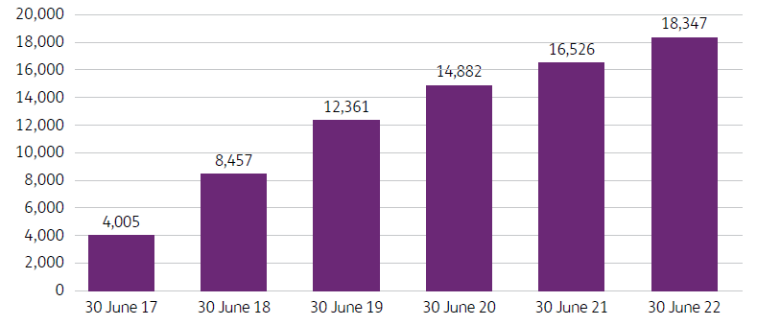

Children in the NDIS
The NDIA continues to build on the existing national early childhood approach to ensure the delivery of a world-leading model that provides evidence-based, high-quality and timely supports to young children and families that are embedded in an integrated and collaborative early childhood ecosystem.

Early connections
As part of the NDIA’s early childhood approach, early connections with NDIS supports are available for children younger than 7 years old with disability or delays in their development. Early connections provide quick access to assistance in the crucial early years of a child’s development. Families can access this support regardless of whether the child is eligible for the NDIS.
As at 30 June 2022, there were 82,863 children younger than 7 years old with a NDIS plan, and a further 11,686 accessing early connections.
Figure 2.1J: Children younger than 7 years old in the NDIS as at 30 June 2022
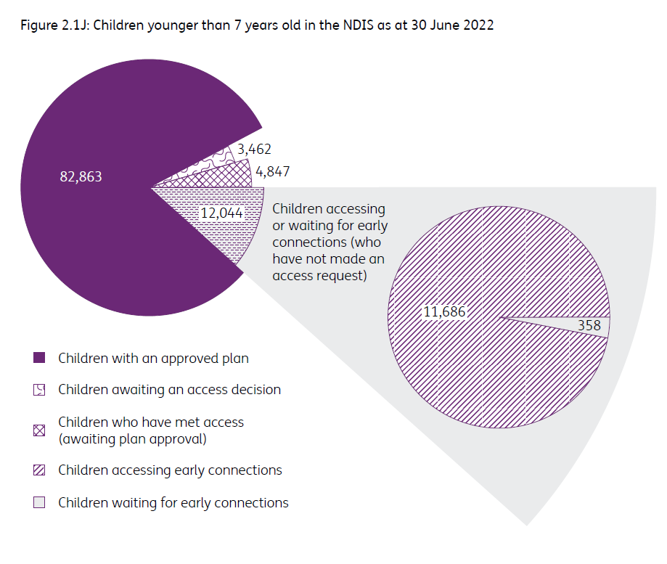

Early childhood early intervention reset
In November 2020, the NDIA undertook a review of its early childhood early intervention (ECEI) approach. Good progress has been made on implementing the resulting ECEI reset recommendations. For example:
- We have provided updated information that explains what the early childhood approach is and how early connections and early supports fit into the approach. We have ensured this information is accessible, appropriate and translated for communities who need information in their language. Parents and carers told us that the early childhood approach was difficult to understand, and they helped us develop a clear and simple visual to explain the supports available.
- We have developed new guidance and an updated early childhood provider report form to ensure progress and outcomes are captured in a consistent format. The new form and additional guidance material explains what information the NDIS needs in order to understand how a type of support has been helping a child and family work towards their goals. It also helps providers understand NDIS expectations so they can streamline their processes and communicate clearly with families about the supports and outcomes being achieved.
- We have implemented a streamlined early childhood planning process to allow early childhood partners to focus on their important work in early supports and early connections. This means that children and families will receive the supports they need early, to achieve the best possible outcomes.
- We have improved guidance and practice across the NDIA to better support families leaving the NDIS at the appropriate time. The early childhood approach aims to ensure children and families receive support when they need it. It is also expected that these supports will assist children and families to meet their goals so they are able to transition to the next stage of their life.
- Collaborative relationships are being developed with health services, educational services, and Aboriginal and Torres Strait Islander community organisations through consultation on remote and very remote early childhood. Improved processes to support applications for Aboriginal and Torres Strait Islander children to access the NDIS have been put in place, with support from the NDIA for those who need more information or assistance.
Over the next 12 months, the ECEI reset will progress the remaining recommendations by working closely with the early childhood sector to ensure our work continues to improve access to timely, targeted and individualised early childhood supports for children with developmental delay or disability and their families.

Participant experience and outcomes
Despite COVID-19, rates of participation in community and social activities have increased, while the overall rate of participation in work is stable.
Figures 2.1K and 2.1P highlight the outcomes for participants who have been in the Scheme for at least 2 years.

Participation in community and social activities
Participants’ community and social participation has increased in the 2 years since they first entered the Scheme. In addition, participation in community and social activities has continued to increase, for all age groups, the longer participants have been in the Scheme.
Combining all age groups, the increase for participants who have been in the Scheme for 2 years is 5 percentage points (from 35% to 40%), and the increase for participants who have been in the Scheme for 5 years is 14 percentage points (from 35% to 49%).

Figure 2.1K: Change in the percentage of participants engaging in social activities who have been in the Scheme for 2, 3, 4 or 5 years (participants aged 15 years and over)
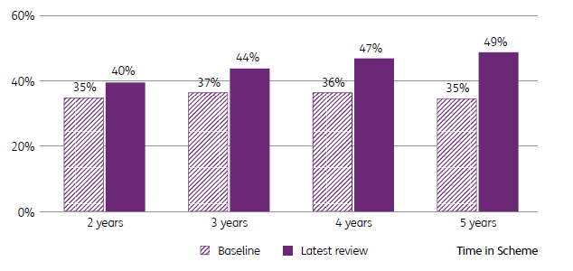

Participation in work
Looking at all participants who are of working age (15 to 64 years), the percentage of participants in work has increased slightly, from 20% to 21%, for those who have been in the Scheme for 2 years. There has also been an increase of 1 percentage point for participants who have been in the Scheme for 5 years (from 26% to 27%).
Figure 2.1L: Change in the percentage of participants in work who have been in the Scheme for 2, 3, 4 or 5 years (participants aged 15 to 64 years)
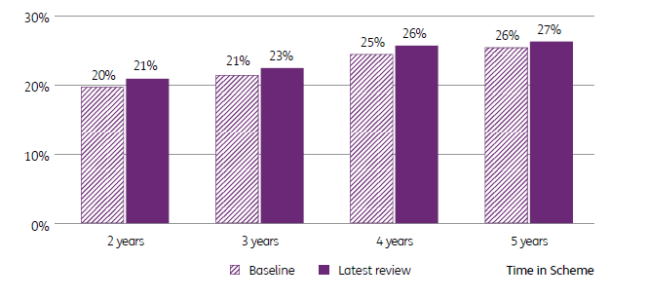

Participant views of outcomes
At each participant plan review, participants who entered the Scheme on or after 1 July 2016 are asked ‘Has the NDIS helped?’ allowing the NDIA to gain valuable longitudinal insights.
Figure 2.1M: Has the NDIS improved how your child fits into community life? (aged 0 to before starting school)
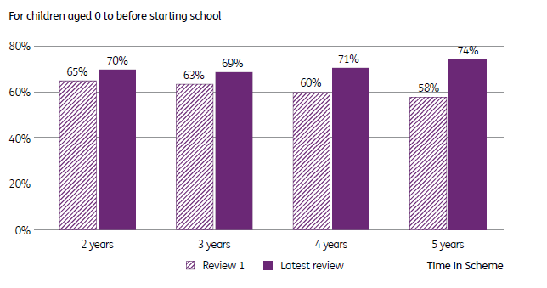

Figure 2.1N: Has the NDIS helped your child to become more independent? (children aged from starting school to 14 years)
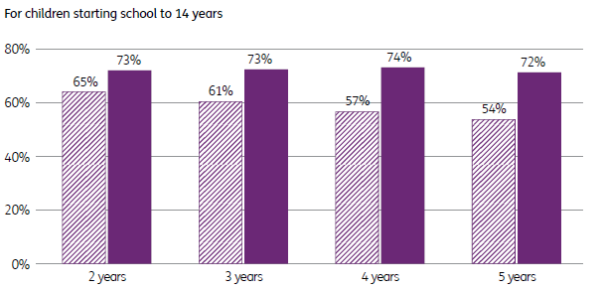

Figure 2.1O: Has the NDIS helped you with daily living activities? (young adults aged 15 to 24 years)
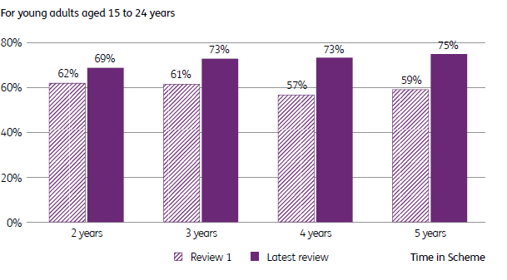

Figure 2.1P: Has your involvement with the NDIS improved your health and wellbeing? (adults aged 25+ years)
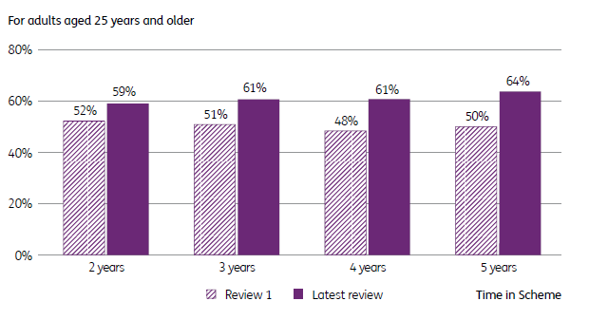

  - Where we are today
Our continued focus is on delivering the Scheme of today while preparing for, and improving, the Scheme of the future.
The NDIA has continued to respond to the ongoing impact of the COVID-19 global pandemic. Initially our attention was on ensuring continuity of support in the early stages of the pandemic. However, our focus has shifted over the past year to supporting vaccination efforts and reinforcing the disability workforce to address staff shortages with ongoing attention on participant, staff and provider safety. The pandemic challenged us to be innovative and has resulted in some adjusted processes being adopted on an ongoing basis. The NDIA and Scheme are better for it.
The Scheme continues to grow rapidly, with 19,291 participants gaining access in the last quarter. However, in recent years, our attention has shifted from bringing a large number of participants into the Scheme to improving the experience and outcomes a participant has with the Scheme.
The NDIA has a strong emphasis on solutions-focused continuous improvement. We have delivered 24 of the 51 commitments in the SIP and continue to make progress on the remaining commitments.
The NDIA is committed to putting people with disability into the centre of the NDIS by co-designing changes to the Scheme with input from people with disability and the broader disability community.
This year we launched a new Engagement Strategy that, at its heart, commits to rebuilding trust between the NDIA and the disability community. We are focusing on a transparent engagement process that gives people the opportunity to participate in co-designing improvements to the Scheme. The NDIA Engagement Framework has been developed with disability sector representatives to guide, support and strengthen NDIA engagement with the disability community now and into the future. More detail on the NDIA Engagement Framework is provided under ‘A connected and engaged stakeholder sector’ in section 2.2.3.
We are working with providers to address issues such as thin markets, particularly in rural and remote settings, and pricing.
We have an increased focus on the role of digital platforms in improving the participant experience, launching the my NDIS app to make plan self-management easier.
    - NDIA aspirations
The purpose of the NDIA is to support individuals with a significant and permanent disability (participants) to be more independent and engage more socially and economically, while delivering a financially sustainable NDIS that builds genuinely connected and engaged communities and stakeholders.
This purpose is supported by 5 aspirations, as outlined in the NDIA Corporate Plan 2021–25 and illustrated in Figure 2.2.1A. To view the current NDIA Corporate Plan, go to ndis.gov.au.
Figure 2.2.1A: National Disability Insurance Agency Purpose and Aspirations (2021–2025)
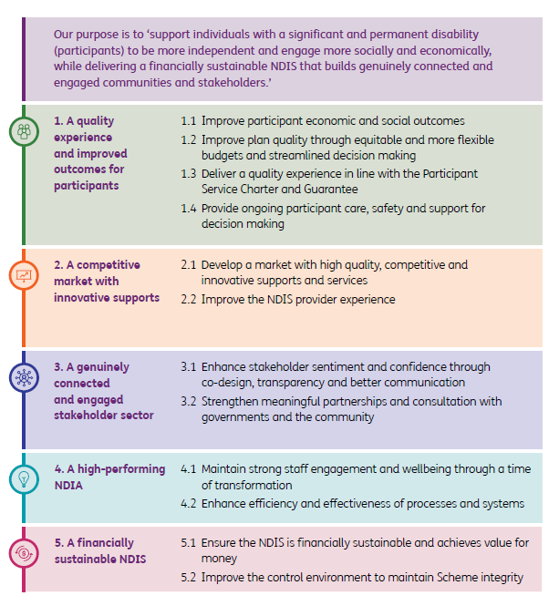

    - NDIA Values
The NDIA operates according to a set of 4 key values, illustrated in Figure 2.2.2A. These values, which were developed in consultation with staff and partners, reflect our passion for and commitment to an empowered, inclusive and participant-centred culture.
Figure 2.2.2A: National Disability Insurance Agency Values
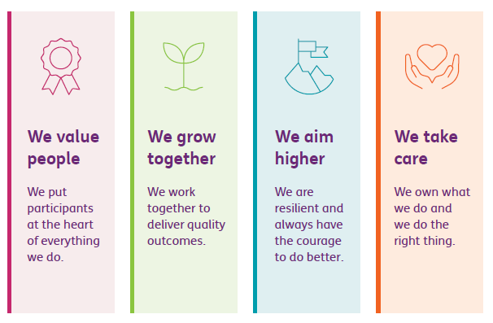
Additionally, all NDIA staff follow the APS Values and Code of Conduct, which require all staff to be impartial, committed to service, accountable, respectful and ethical.
    - Key achievements in 2021–22
While the challenges of the COVID-19 pandemic continued throughout 2021–22, the NDIA delivered positive outcomes for participants, providers, staff and partners. Key achievements in 2021–22 are outlined on this page and the next and are discussed in greater detail throughout the remainder of this section.
Our most important achievement is that we are making a difference in the lives of people with disability. Reported participant outcomes show the positive impacts the Scheme continues to have in the lives of participants.
- We have seen improvements in employment supports and clearer pathways to employment for participants. The Scheme is positively influencing employment outcomes for families and carers of participants as well.
- There were notable improvements in the service standards measured in the PSG this year. The NDIA also delivered on 24 out of the 51 commitments in the SIP and began implementing a further 21 commitments.
- There was a continued focus on participants entering the NDIS who are Aboriginal and Torres Strait Islander, culturally and linguistically diverse (CALD), or living in remote and very remote areas. This included co-designing strategies to support measurable outcomes for CALD and First Nations participants, and a branch within the NDIA dedicated to supporting the delivery of the NDIS in remote communities across Australia.
- Participants continued to be supported to pursue their home and living goals to have more choice and control over where they live, who they live with, and how they are supported. This included helping younger participants currently living in residential aged care to explore alternative home and living options.
- There was extensive consultation with people with disability, their families and carers and other stakeholders to guide our approach to empowering participants to make decisions and remain in control of their lives. This included the development of a partnership with Inclusion Australia to engage participants and people with disability to co-design a proposed policy on Support for Decision Making.
- The NDIA continued to work with stakeholders to build an informed and sustainable provider marketplace that responds to the needs of all participants. Work to identify thin markets continued, including prioritising market intervention projects based on highest participant need.
- There were notable improvements in specialist disability accommodation (SDA), and the total number of enrolled SDA dwellings continued to increase this year. The NDIA launched an online interactive platform (the SDA Finder) to help participants to find suitable SDA homes, and use of this tool has been strong.
- Work began on a co-design project to deliver the large-scale reform required to improve home and living arrangements for NDIS participants. The NDIA also established the Home and Living Demonstration Projects to bring participants and providers together to design and deliver better home and living supports.
- There were significant improvements in our approach to engaging with stakeholders including through the establishment of a Participant Advocate to ensure participants are involved in decision-making, and the launch of the Participant First engagement initiative. We continued to build on our strong relationships with the disability sector and extended our engagements with rural and remote communities.
- The NDIA continued to invest in the development and use of research and evidence to inform decisions made by the NDIA. The insights we generate continue to support positive participant outcomes and inform best practice policy and program activities. We also continued our commitment to the public sharing of de-identified data.
- The NDIA National Contact Centre answered 1.085 million calls this year and customer satisfaction with the telephony service remained high. The use of webchat has grown since the release of the NDIA smartphone application. In 2021–22 the NCC answered 985,000 webchats, 80.8% of which were answered within 20 seconds.
- The NDIA’s 2022 Australian Public Service Census results demonstrate an increase in the Wellbeing Index from 66% from the 2021 census to 71%. This is 5% higher than the APS overall. It places the NDIA 44 of 98 agencies overall and is 29 places higher than 2021.

Support for participants and disability workers through the COVID-19 pandemic
Throughout 2021–22, the NDIA continued to support participants and disability workers during the COVID-19 pandemic. We coordinated our efforts across government, including with the Department of Social Services (DSS), the NDIS Quality and Safeguards Commission (NDIS Commission), Services Australia, the Department of Health (DOH), and state and territory governments. We engaged extensively with participant groups and advocates, peak provider bodies and the broader disability sector to inform our various measures and support arrangements. We also prioritised COVID-19 related calls to the NDIA through a dedicated phone line.
As Australia responded to the COVID-19 Omicron variant outbreak, the NDIA continuously refined its services to keep participants safe through a range of measures, including the following.
To increase access to vaccinations and testing, we:
- expanded the availability of financial payments for providers supporting NDIS participants and workers to attend COVID-19 vaccination appointments
- joined forces with the Pharmacy Guild of Australia to make it easier for participants to book and receive COVID-19 vaccinations through their local pharmacies
- distributed 6.8 million rapid antigen test (RAT) kits fortnightly to SIL providers and allowed participants and SIL providers to claim the cost of RATs when required to undergo testing.
To help with additional expenditure incurred as a result of COVID-19, we:
- prioritised participant requests for additional or ‘top-up’ funding for their plans as a result of the impacts of COVID-19
- increased price limits for a range of supports in recognition of increased expenditure due to COVID-19
- allowed participants to access core support funding to pay for low-cost assistive technology (AT) items necessary to ensuring continuity of supports, and for someone to cook and shop for them.
To better coordinate and support workforce responses to COVID-19, we:
- worked with providers and sector representatives to develop the COVID-19 Workforce Response Framework
- replaced the NDIA’s support for participant contingent care panels in Victoria, New South Wales and the Australian Capital Territory with a single national response to help providers in all jurisdictions manage COVID-19 workforce challenges
- provided a national clinical first response support to SIL providers struggling to manage COVID-19 outbreaks
- provided online information sessions and webinars on COVID-19 preparedness, infection control and outbreak management practices, workforce supports, and support resources available.
These initiatives have helped to lower infection rates for participants compared to the general population and have minimised the impact of COVID-19 outbreaks on the service provider workforce.
In recognition of the significant work done by providers and the additional costs of keeping participants safe during COVID-19 and improvements to rostering systems to adapt to changes to the SCHADS Award, the incoming government authorised the NDIA to make a one-off lump sum payment to eligible registered providers announced on 22 June 2022. Work will continue next year to implement strengthened measures to inform, support and protect people with disability from COVID-19.

Employment for participants and their families/carers
The NDIA recognises the critical role of employment in boosting the wellbeing, economic security and social inclusion of people with disability. The COVID-19 pandemic continued to impact the economy and many job markets, and significantly interrupted capacity-building for participants to prepare for employment.
Despite these challenges, the NDIA delivered initiatives to improve employment supports and provide clear pathways to employment. Key achievements in 2021-22 include:
- collaborating with National Disability Services and Australian Disability Enterprises to establish a community of practice and facilitate change in the employment market by sharing good practice, research findings and examples of innovative employment models
- commencing a review of school leaver employment supports to address concerns about the current structure and improve employment outcomes for participants
- commissioning research to determine key factors that help people with disability, particularly those with intellectual disability, autism and psychosocial disability, to find and sustain employment
- refreshing the NDIA’s ‘Pathways to Post School Life’ presentation for school leavers, families and teachers
- delivering a ‘Planning Essentials for Employment’ training module to more than 500 NDIA staff and providers
- establishing a National Employment Network, consisting of planners, local area coordinators (LACs) and community and provider engagement staff, to increase capability to help participants find employment
- raising the targets of LACs and Early Childhood Partners for employment of people with disability from 15% to 20%.

A quality experience and improved outcomes for participants
The NDIA continues to focus on ensuring participants realise the full benefits of this social reform. Over the past 12 months, significant improvements have been made, resulting in performance improvements across many of the PSG measures.

Participant Service Guarantee
In July 2020, the NDIA introduced the PSG to explain what participants can expect when they interact with the NDIA. The PSG sets timeframes for key NDIS processes such as access, plan approvals, plan reviews and nominee changes. The timeframes were legislated on 30 March 2022 and received Royal Assent on 1 April 2022. Prior to the legislation passing, we reduced the reported service level agreement (SLA) timeframes for several PSGs to align with the legislative requirements. This included reducing the participant-requested review SLA from 42 to 28 days, and reviewable decisions from 90 to 60 days. Over the last 12 months, targeted operational strategies have been implemented to manage work volumes and timeframes. This has seen an increase in performance across many of the PSGs. For example:
- 99% of decisions were explained within the 28-day timeframe after the request for explanation was received, compared to 70% a year ago
- 100% of access decisions were made within the service guarantee timeframe of 21 days, consistent across the last year
- 96% of plans were in the planning phase within 21 days after an access decision was made, compared to 82% a year ago (note that a new business process was introduced to measure this metric from 1 July 2021)
- 90% of first plans for participants aged 7 years and above are approved within the 56-day timeframe, compared to 80% a year ago
- 96% of first plans for participants aged 0 to 6 years are within the 90-day timeframe, compared to 91% a year ago
- 100% of participant-requested review decisions were completed within the 21-day timeframe, compared to 91% a year ago
- 96% of reviews of reviewable decisions were completed within the 60-day timeframe, compared to 89% in the first quarter of the year
- 99% of participant-requested nominee requests were cancelled within the 14-day timeframe, compared to 86% a year ago.

Participant Service Improvement Plan
The NDIA SIP sets out the tangible actions we will deliver to build a better NDIS and ensure the Scheme meets participants’ expectations. It makes good on our promises in the Participant Service Charter and PSG and reflects the feedback participants have given us. Over the past year, the NDIA delivered on 24 out of the 51 commitments in the SIP, including:
- more support to help participants to use their plan, to find both disability services and mainstream supports
- proactively checking in with participants, especially when they may be in a vulnerable situation
- improved cultural and disability awareness training for our frontline teams
- meeting and trying to exceed the time standard commitments for service levels
- rolling out the new my NDIS mobile app to help participants manage their plan more easily
- focusing on goals supporting our participants to gain employment if that is what they want.
The NDIA has commenced implementing a further 21 commitments.
To help the community understand how we make decisions, we continue to improve the NDIS Operational Guidelines. They are being written in plain English and use more consistent language and less jargon. We are supporting and promoting the voices of children, young people and adults in their own plans, while also working closely with parents and carers.

Participant satisfaction
The NDIA gathers responses at the 4 primary stages of the participant pathway – access, pre-planning, planning, and plan review – to allow for a comprehensive understanding of the participant experience at each stage of the pathway. The NDIA is focused on making fair, consistent, reasonable and necessary decisions.
Figure 2.2.3A: Rating of experience with the NDIS as at 30 June 2022
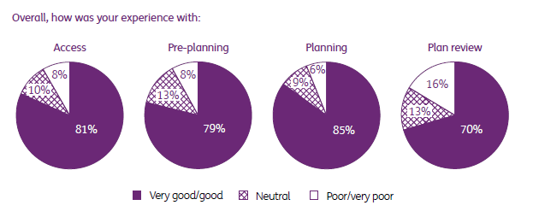

Figure 2.2.3B: Trend of satisfaction across the pathway (% very good/good)
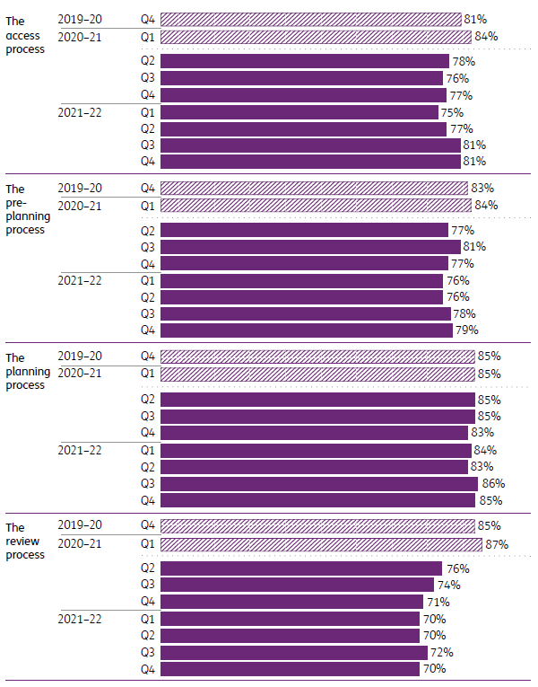

Key trends in complaints
Over 2021–22, the percentage of total complaints that have been open for more than 21 days remained stable, with 3% still open after 21 days as at 30 June 2022.
Figure 2.2.3C: Open complaints and percentage that have been open for more than 21 days
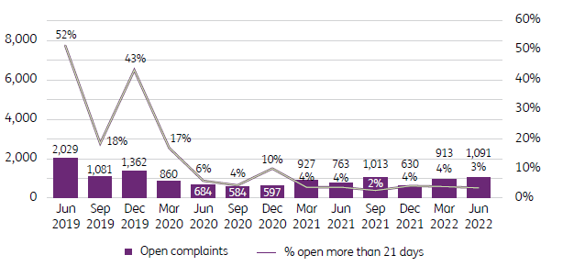

Figure 2.2.3D: Closed complaints and percentage completed within 21-day timeframe
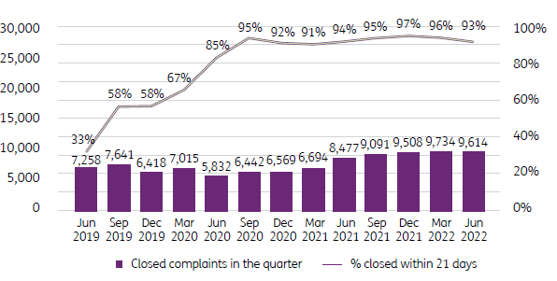

Participant diversity
The NDIA continues to provide targeted support for people who are Aboriginal and Torres Strait Islander, culturally and linguistically diverse (CALD), and living in remote and very remote areas, to access the NDIS.
The NDIA continues to co-design strategies to support measurable outcomes for CALD and First Nations participants. Each strategy is being co-designed with CALD or First Nations stakeholders respectively, including participants, families, carers and the sector. As we progress, further information on the Aboriginal and Torres Strait Islander Strategy and Cultural and Linguistic Diversity Strategy will be available on the NDIS website.
The NDIA continues to review and enhance the NDIS experience and outcomes for people with disability living in remote Australia.
Currently the NDIA is working towards building an approach that supports prioritisation and better coordination of cross-functional activities, projects and programs to improve service delivery in remote and very remote areas.
The NDIA’s National Remote Services (NRS) Branch supports the delivery of the NDIS in remote communities across Australia. We want people with disability from every community to access the supports and services they need. We respect First Nations cultures and the need to build on community strengths through collaboration, engagement and co-design. We also:
- develop innovative and sustainable solutions to unique challenges
- engage with internal business areas to improve the outcomes for participants living in remote and Aboriginal and Torres Strait Islander communities and their families
- manage and coordinate the delivery of a specialist community connector network (service partners)
- provide expert advice and input into NDIA strategies, including the Rural and Remote Strategy, the Reconciliation Action Plan and the First Nations Employee Network.
We are committed to working collaboratively with all stakeholders, including state and territory governments, to promote better outcomes for people with disability and improving their confidence in the NDIA. This is a critical issue and work is underway to appoint a senior officer with responsibility to address service delivery issues in rural and remote locations.
As part of its collaboration across government, private and community sectors, the NDIA is playing a pivotal role in driving outcomes through Australia’s Disability Strategy 2021–2031 (the Strategy). The Strategy was launched on 3 December 2021 and is Australia’s national disability policy framework. It sets out a plan for continuing to improve the lives of people with disability in Australia over the next 10 years. A range of reports on progress of the Strategy’s actions and outcome areas will be published and available at the Disability Gateway website.

Supporting NDIS participants to pursue their home and living goals
The NDIA is developing a policy to guide how we support participants to pursue their home and living goals. The aim is to give participants more choice and control over where they live, who they live with and the supports they use.
The NDIA released a consultation paper on the proposed policy in June 2021. We:
- talked with over 1,000 people in virtual and in-person engagement sessions, and published a report summarising what we heard during these consultations
- established a steering committee to advise on how we can work in partnership with the disability community and broader stakeholder groups to finalise the policy
- started co-design of the policy with a ‘core design group’ of participants, providers and disability representative organisations in June 2022.
      - Younger People in Residential Aged Care Strategy
On 25 November 2019, in response to the Interim Report of the Royal Commission into Aged Care Quality and Safety, the Younger People in Residential Aged Care Strategy 2020–25 (YPIRAC Strategy) was jointly developed by the Department of Social Services (DSS), the Department of Health and Aged Care (DoHAC) and the NDIA.
The YPIRAC Strategy sets out targets which seek to ensure that, except in exceptional circumstances, there are:
- no people under the age of 65 entering residential aged care by 2022
- no people under the age of 45 living in residential aged care by 2022
- no people under the age of 65 living in residential aged care by 2025.
A Joint Agency Taskforce (combining DSS, DOH and the NDIA) continues to progress work on the YPIRAC Strategy in partnership with a Stakeholder Reference Group (consisting of sector representatives), state and territory governments, and younger people and their families. The YPIRAC Strategy covers all people under the age of 65 living in, or at risk of entering, residential aged care. It also provides choice to Aboriginal and Torres Strait Islander people between 50 and 64 years of age who are eligible for the aged care system.
The NDIA continues to support participants at risk of entering residential aged care, and those already living in residential aged care, to move into more age-appropriate accommodation. Between 1 July 2021 and 30 June 2022, 178 participants transitioned from residential aged care into age-appropriate settings. Of these, 32 exited to their own home (rented or owned), 39 exited to SDA, 91 exited to other shared living arrangements using SIL funding or to other group residential settings, and 16 are in other types of accommodation settings.

Supporting younger people living in residential aged care
The NDIA continues to support younger participants currently living in residential aged care to explore alternative home and living options. The NDIA’s team of 88 specialist YPIRAC planners hold regular check-ins and dedicated conversations with participants, their families and carers to understand and support younger participants’ home and living goals and ensure
decision-making is fully informed and current.
To further support the work of the specialist YPIRAC planners, the NDIA has established a dedicated team to provide intensive, proactive and individualised support to source age-appropriate accommodation and services for NDIS participants under the age of 65 who are currently living in, or at risk of entering, residential aged care.
As at 30 June 2022, there were 2,530 participants aged under 65 years in residential aged care with an approved NDIS plan, including 64 who were aged under 45 years (2.5%).
In addition to fewer participants entering residential aged care, since 1 July 2016, a total of 819 participants who had been in residential aged care have been moved to more appropriate accommodation.
The NDIA has significantly reduced the number of participants entering residential aged care and continues to support participants already living in residential aged care to move into more age-appropriate accommodation, if that is their choice.

Empowering NDIS participants’ decisions
The NDIA is developing a policy to guide our approach to empowering participants to make decisions and remain in control of their lives.
The NDIA released a consultation paper on the proposed Support for Decision Making policy in June 2021. In 2021–22, we:
- consulted widely with people with disability, their families and carers and other stakeholders about the consultation paper; and published a report about what stakeholders told us. Key themes in the report covered the development of the policy and implementation plan and what is required to support people with disability to make decisions, including that:
  - the policy should uphold the rights of people with disability and recognise the importance of relationships
  - effective supported decision-making needs time, funding and choice of skilled decision supporters
  - we need to co-design the policy and plan with the disability community
  - we need to make the policy and implementation plan as easy to understand as possible.
- established a steering committee to advise on how we can work in partnership with the disability community and broader stakeholder groups to finalise the policy
- established a partnership with Inclusion Australia to work with people with disability to co-design the policy.

Competitive market
The NDIA works with stakeholders to build an informed and sustainable provider marketplace that responds to the needs of all participants.
We aim to improve the NDIS provider experience through:
- regular consultation, education and events
- reducing barriers to investment and innovation by improving information
- simplifying how providers work with the NDIA, including how they get paid
- clarifying pricing arrangements and guidance
- analysing data to identify markets with few providers and/or low uptake of NDIS supports (see ‘Thin markets’) and intervening to address the causes.
In 2021–22, the NDIA held targeted education sessions for providers about operational and policy changes to the NDIS. We delivered more than 117 information and education sessions, with over 16,614 registered attendees. These sessions included monthly virtual engagement sessions to help providers to successfully operate within the Scheme, covering a broad range of topics including assistive technology and employment supports.
In November 2021, the NDIA released a paper, ‘Improving Support Coordination for NDIS Participants’, which summarised what we heard during consultations and clarified the role of support coordinators. We held information sessions for support coordinators and other sector representatives to highlight the paper. We then offered capacity and skills development workshops covering topics and themes identified in our consultations.

Thin markets
The NDIA continues to identify thin markets and prioritise market intervention projects based on highest participant need. As of 30 June 2022, there are 26 projects underway. Project teams work with the community to understand local needs; and with providers and others to resolve issues such as poor market connections, low demand and other barriers to service provision.
In 2021–22, we completed 9 market intervention projects:
- In Doomadgee, Queensland, we intervened to improve the market across all supports, for all NDIS participants. Most participants in the area identify as Aboriginal or Torres Strait Islander. The intervention resulted in 3 providers entering the market: a locally based core supports provider and 2 therapy providers – one fly-in-fly-out and the other offering virtual services. Average plan spend improved strongly, especially for core supports. Establishing a community-based core provider has increased participant engagement and plan uptake and also provides a more visible NDIS presence in the community.
- In Woorabinda, Queensland, we focused on a target cohort of 13 participants, all identifying as Aboriginal or Torres Strait Islander. The intervention resulted in 4 new providers entering the market, offering core supports and therapy and the establishment of a provider network. Average plan spend improved strongly, with several participants starting to access services having not previously been using their NDIS plan.
- In King Island, Tasmania, we intervened to improve participants’ connections to core daily activities providers. The intervention resulted in participants having better connections to NDIS providers and more choice and control. It also increased provider awareness of data and insights available to them to understand demand in the area.
- In Alice Springs, Northern Territory, we intervened to increase the use of all types of supports by 96 participants. Most of these participants identified as Aboriginal or Torres Strait Islander. The project resulted in improved market connections and support for participants to obtain the services they were seeking. Average plan spend increased by more than 300% and a number of providers commenced or recommenced NDIS service delivery in the area.
- In MacDonnell, Northern Territory, we intervened to improve the connectivity and functionality of the market for 41 NDIS participants. As a result of this work, the average plan spend per participant almost doubled and a range of providers commenced or recommenced NDIS service delivery in the area.
- In Derwent Valley, Tasmania, we sought to understand why participants may not be connecting to services. This project supported 9 participants who had not previously received any services from the NDIS to connect to services.
- In Broome, Western Australia, we facilitated a coordinated funding proposal to deliver orthotics and prosthetic assessments and supports to 19 participants. The project enabled support coordinators to work together to pool participant funds and engage providers, resulting in successful delivery of assessments and services to participants.
- In Golden Plains, Victoria, we sought to resolve participants’ barriers to implementing their NDIS plan. The project gave us a better understanding of participants’ readiness to engage with services in the area. It also promoted the Provider Finder as a helpful tool for connecting providers and participants.
- In Circular Head, Tasmania, we intervened to support 18 participants who were using little of their plan budgets. Most of these participants identified as Aboriginal and Torres Strait Islander. This enabled all participants to activate their NDIS plans, connect with NDIS providers and increase their choice and control. It also helped local providers understand better the support needs of local participants.

Specialist Disability Accommodation
The NDIA works to continuously improve the SDA experience for participants and strengthen the market for providers. In 2021–22, we engaged extensively with participants, the SDA Reference Group and the SDA sector to understand how to provide greater clarity on SDA eligibility and how to improve processes and the timeliness of decisions.
We also launched the SDA Finder − an online interactive platform that helps participants to find suitable SDA homes and enables providers to advertise their SDA vacancies and access SDA demand data. Use of this tool has been strong.
The NDIA continues to improve SDA supply and demand data through the SDA Quarterly Report. The SDA Quarterly Report can be accessed on the NDIS website.
The number of active participants with SDA supports has increased by 13% annually over the last 3 years, reaching 19,358 as at 30 June 2022. The average plan budget for SDA supports has also increased by around 9% per annum, leading to an increase in total SDA supports in participant plans by around 23% per annum, from $144 million as at 30 June 2019 to $271 million as at 30 June 2022.
Total SDA payments have increased by 49% annually over the last 3 years, from $56 million to $186 million. The average SDA payments per participant has also increased, by 27% per annum.
      - Supported independent living pricing and policy reform
The NDIA is undertaking a co-design project to deliver the large-scale reform required to improve home and living for NDIS participants (refer to ‘Supporting NDIS participants to pursue their home and living goals’ in section 2.2.3). We continue to improve and advance participants’ SIL experience through our existing home and living systems and processes.
In November 2021, the NDIA began a program of work called Making SIL Better. In phase one of this program, we have:
- consolidated the decision and plan build and implementation functions to make the process quicker and less complicated
- improved the wording of the decision letters we send to providers and participants to make the reasoning clearer and the process more transparent
- improved our approach to managing material changes to SIL support needs, to provide a minimum period of time for a participant to safely transition, and standards of care while new support arrangements are put in place
- implemented a simplified weekly claiming process to reduce administrative burden
- implemented a payment to providers for unplanned exits to reduce unplanned spend for providers and to help stabilise support arrangements for the remaining participants
- designed a provider engagement approach for initiatives to improve understanding within the SIL market.
In addition, the NDIA is promoting growth in the individualised living options (ILO) market so that participants have alternatives to SIL.

Home and Living Demonstration Projects
Participants and providers have told us about the importance of finding, recognising and promoting new ways for participants to pursue their home and living goals.
In response, the NDIA established a new initiative called Home and Living Demonstration Projects to bring participants and providers together to design and deliver better home and living supports.
The first round of projects focuses on designing better practices for participants receiving 24/7 support through SIL, using the existing funding in participant plans.
In September 2021, the NDIA invited providers to submit proposals for projects that they would like to test and evaluate. From these, we selected a group of projects to implement. The selection process was based on each project’s potential to achieve positive outcomes for participants and the NDIS.
The project implementation phase began in May 2022.

Pricing
The NDIA announced the outcomes of the 2021–22 Annual Pricing Review on 22 June 2022. The review’s key decisions include the following:
- Price limits for supports delivered by disability support workers have increased by 9% overall.
- The NDIA committed on 22 June 2022 to making up to $514 million available in a one-off payment to eligible registered providers to recognise the costs of keeping participants safe, particularly during COVID-19 including; improving their rostering systems in response to the change to the SCHADS Award and the significant increases in overheads not previously taken into account during the 2021–22 financial year.
- The price limits for SDA and other capital supports have increased by 5.1% based on the change in the consumer price index.
- The Temporary Transformation Payment loading of 7.5%, initially established in 2019, reduces to 3.0% from 1 July 2022.
- Providers will be able to use the transitional pricing arrangements for group-based supports for an additional 12 months.
As part of the new pricing arrangements, the NDIA clarified that:
- high-intensity supports are now in line with NDIS Commission definitions, with a single price limit varying by time and day of the week
- providers of core supports to participants in remote and very remote areas are now subject to the same pricing arrangements for provider travel as providers of capacity-building supports in these areas
- Geraldton (Western Australia) and its surrounding area, along with Cardwell (Queensland) are classified as remote in an extension of the NDIA’s isolated towns policy
- providers of core and capacity-building supports who travel to deliver supports to participants can now claim for ‘return provider travel’ when the provider is required to pay this to the worker
- the short-notice cancellation period has been extended to 7 days from 1 July 2022 in line with a change in the Social, Community, Home Care and Disability Services Industry Award.
As part of its ongoing role as market steward, the NDIA aims to continue partnering with the sector to assist providers with identifying opportunities for increased efficiency and to facilitate better participant access to pricing information.

A connected and engaged stakeholder sector
Improved engagement with stakeholders is key to effectively addressing the significant challenges facing the Scheme. The NDIA has developed a comprehensive sector framework for engaging with stakeholders and continues to build and maintain collaborative partnerships with participants, their families, carers, providers, the disability sector, the community, and the Commonwealth and state and territory governments throughout 2021–22.
As part of our commitment to strengthening our engagement with the disability community, we have developed the NDIA Engagement Framework.
The NDIA Engagement Framework has been developed with disability sector representatives to guide, support and strengthen our engagement with the disability community now and into the future.
The disability community has strongly encouraged us to take a ‘learn by doing’ approach when co-designing important NDIS projects or initiatives. This means we will continually review our approaches and this framework to make sure we engage in meaningful ways that deliver improved outcomes for people with disability.
As we learn by doing, we will also document and publish the processes and lessons we have learned in partnership with the disability community.

Participant advocacy
The NDIA recognises that participants are the experts in disability. To learn from participants, hear their voices and keep their interests at the heart of everything we do, we need our business teams to be talking directly with them.
In 2021–22, we appointed Donna Purcell as the NDIS Participant Advocate and Branch Manager of Participant Advocacy. Donna is also the NDIA Disability Champion.

Participant First
The Participant First engagement initiative, launched in 2020, gives NDIA business teams direct access to the experience and expertise of participants and their families and carers.
Membership of this initiative has almost doubled since July 2021, with over 4,000 participants, families and carers electing to be involved in activities to improve the NDIS.
In 2021–22, NDIA staff engaged directly with over 1,200 Participant First members through focus groups, one-on-one interviews, working groups and testing groups for a range of projects. These projects include redeveloping Operational Guidelines, policies and processes; and revising easy read guides and other publications on the NDIS website.
Nine participants have become members of the NDIA’s priority policy co-design steering committees. We anticipate that over 300 participants will be involved in further co-design activities directly with the NDIA or through the Participant Engagement Panel (PEP).
The PEP was established in September 2021 to support engagement with harder to reach cohorts such as Aboriginal and Torres Strait Islander participants, CALD participants, and participants with intellectual disability and complex communication supports.

Reference groups
The NDIA has a number of reference groups, advisory groups and working groups drawn from stakeholders who provide advice to the NDIA on the design, development and implementation of aspects of the Scheme. These groups have clear terms of reference and deliverables linked to the NDIA Corporate Plan. Current reference groups include our:
- Disability Representative and Carers Organisation (DRCO) Forum
- Participant Reference Group (PRG)
- Autism Advisory Group (AAG)
- NDIS Mental Health Sector Reference Group (NMHSRG)
- Industry Chief Executive (ICE) Forum
- Pricing Reference Group
- Specialist Disability Accommodation (SDA) Reference Group
- Co-design Advisory Group.

Disability Representative and Carers Organisation Forum
The NDIS DRCO Forum continues to be a platform for the disability sector to engage, discuss and collaborate directly with the NDIA on important areas of work relating to the operation and implementation of the NDIS. Membership consists of 27 CEOs from disability representative and carer organisations. The DRCO Forum met 4 times in the past 12 months, including a CALD Strategy Workshop and a Home and Living Workshop with all DRCO members invited to participate.

Participant Reference Group
The PRG was refreshed in January 2022 with 7 new members and 13 members extended for another year. In 2021–22, the group met 10 times, with activities including supporting the development of a Self-Management Policy, a LAC Best Practice Service Model and a Market Intervention Model. The PRG has also reviewed and provided input to the NDIS website’s Plan Implementation Directory, the access process for participants applying to the Scheme, and resources on pricing arrangements and limits.

Autism Advisory Group
The AAG continued to provide advice to the NDIA on how to deliver the best outcomes for autistic people in Australia.
The AAG’s members contribute their expertise and access to a broad range of networks on autism to ensure the NDIA is taking an informed approach to issues relating to autism and the NDIS that is collaborative and evidence based.
The AAG met 4 times in 2021–22 and focused on 3 key functions in the delivery of the annual work plan:
- provision of expert advice to the NDIA on delivering the best outcomes for autistic adults and children
- identification of emerging issues and concerns in relation to the design, development and implementation of the NDIS for autistic people and collaboration with the NDIA to determine solutions
- assistance to the NDIA in the provision of clear and consistent communications to autistic people and their families about the NDIS.
Key areas of focus for the AAG in 2021–22 included the ECEI reset; person-centred assessments; research on early interventions for children with autism spectrum disorder; and NDIS supports for participants with challenging and complex issues.
Through the past year the AAG has welcomed 3 new members who bring further lived experience, sector leadership and practice knowledge to the group.

NDIS Mental Health Sector Reference Group
The NMHSRG continues to be a strong national advisory mechanism between the NDIA and national stakeholder representatives involved in the psychosocial disability and mental health sectors. Through this platform, the NDIA and a broad range of psychosocial disability stakeholders collaborate directly, hear feedback about issues affecting participants with psychosocial disability in the NDIS, and address policy and practice issues in the psychosocial disability space.
The NMHSRG met 4 times in the last 12 months. Its membership consists of 22 member organisations, representing key parts of the psychosocial disability and mental health sectors and including 4 consumer representatives and 2 family and carer representatives. Members of the NMHSRG have been integral in guiding the development of the NDIS Psychosocial Disability Recovery-Oriented Framework. In the last 12 months, the terms of reference and membership were refreshed to place the NMHSRG in a strong position to guide the implementation of this framework over the next 3 years.

Industry Chief Executive Forum
The purpose of the ICE Forum is to engage with NDIS provider peak bodies and provider representatives on improvements to the NDIS and the NDIA’s processes and practices.
The ICE Forum provides an opportunity for 2-way collaboration whereby the NDIA can test policies, practices and processes to improve the NDIS with ICE Forum members and to gather views and feedback on key issues from members. The ICE Forum gives members the opportunity to engage directly with the NDIA CEO.
The ICE Forum has provided advice on a number of topics, including thin markets, workforce and employment, payment systems, the NDIA’s COVID-19 response, participant advocacy and service delivery, assistive technology, home and living policy development, market intermediaries (support coordination and plan management) and pricing. The ICE Forum met virtually 3 times during the past 12 months.

Pricing Reference Group
The Pricing Reference Group was established in 2018 in response to the Independent Pricing Review. It provides advice to the Board through the CEO. Through the Pricing Reference Group, the NDIA has a formal process to review NDIS pricing arrangements, conduct robust market reviews and determine how to consult and engage with sector stakeholders. This process includes evaluation and endorsement of the Annual Pricing Review outcomes.
During 2021–22, the group provided advice on the pricing arrangements for disability support workers, support coordination, plan management, therapy, group supports, Temporary Transformation Payment, SIL and SDA. The group met 6 times over the past 12 months.

Specialist Disability Accommodation Reference Group
The SDA Reference Group was established in early 2019. Its membership was refreshed through an expression of interest in early 2021. Another review of membership is planned in early 2023.
The mandate of the SDA Reference Group is to continue to advise and provide support on the development of the SDA market.
The NDIA has commenced engagement with the SDA Reference Group on the 2022-23 SDA Pricing Review Terms of Reference, as required under the SDA Pricing and Payments Framework. SDA Reference Group members have also provided apposite feedback in the early-stage development of the SDA Quarterly Data Report.
The SDA Reference Group met 3 times in 2021-22.

Co-design Advisory Group
The Co-design Advisory Group provides strategic advice to the NDIA on the implementation of co-design and other engagement processes with the disability community. Its members include a cross-section of representatives from the disability sector, IAC, DSS and the NDIA.
Co-design Advisory Group members meet monthly and work collaboratively to build a shared understanding of the issues the NDIS is facing and other current and emerging priorities for co-design and consultation. Members provide strategic advice on the timing and approaches to implement and evaluate co-design and other engagement processes. They also represent the disability community’s perspective on issues facing the NDIS and gather feedback on the co-design priorities and approaches with peers and members to ensure disability community representation and appropriate expertise is included in co-design initiatives.
The Co-design Advisory Group met 10 times in the past 12 months.

Community engagement
In 2021–22, NDIA representatives attended conferences and other events to speak to participants, families, carers, the disability sector, community organisations and government agencies about the NDIS. In total we participated in more than 1,500 engagements across the country. A large percentage of these were virtual events.
These engagements involved speaking with key NDIS audiences, including participants, families and carers, disability advocates and peak organisations and a wide variety of state and territory services that interact with the NDIS.
We engaged in a variety of ways, from forums to workshops and expos, as well as monthly community stakeholder updates in each state and territory.
Our community engagement focuses on supporting NDIS participants, improving the participant experience and building strong relationships with the disability sector.

Community Sector Updates
In 2021–22, the NDIA started holding Community Sector Update sessions to keep community stakeholders informed about the latest changes to the NDIS. The sessions were held online and followed by a written update. We held 46 update sessions, with 3,800 attendees and/or email recipients. Topics included the PEP, the NDIS Commission, and the latest advice on supporting participants during the COVID-19 pandemic.

Engagement with rural and remote communities
As part of its Aboriginal and Torres Strait Islander Strategy, the NDIA commenced a pilot project to trial a new solution – Mobile Max hubs – to deliver information and resources to remote communities in Australia. Mobile Max hubs are outdoor digital devices that connect people to the NDIS via a touchscreen and free wi-fi hotspot. This innovation makes NDIS information accessible to people without a private internet connection. It also provides a platform for the community to share local information and stories. The first Mobile Max hub arrived at the MacDonnell Regional Shire Office in Kintore, Northern Territory, in May 2022. A second unit was installed in the Townsville NDIA office 29 June 2022.
To increase support for First Nations Australians with disability, the NDIA has engaged the National Aboriginal Community Controlled Health Organisation to provide Aboriginal Disability Liaison Officers (ADLOs). ADLOs work with partners in the community to identify and support First Nations people to access the NDIS. This initiative contributes to the NDIA’s actions under the National Agreement on Closing the Gap.

Improved communications with participants
In 2021–22, the NDIA used proactive and targeted communications to keep participants up to date about new NDIS initiatives, how to access NDIS services, and how to request changes to their NDIS plans or access funding if they were affected by COVID-19 or by natural disasters.

COVID-19 vaccination
A key priority in 2021–22 was to remove barriers to COVID-19 vaccination for participants. We promoted accessible vaccination venues and the support available from providers and governments. We geographically targeted this communication to areas with lower vaccination rates.
One of our partners in the community, Settlement Services International, trialled a proactive outreach program to help participants access the vaccine. We also delivered information sessions and reached out to providers located near vaccine service hubs.

Fraud and noncompliance
In November 2021, the NDIA ran an information campaign focused on fraud and noncompliance issues to help participants and providers understand their responsibilities. The campaign coincided with Scam Awareness Week and Fraud Awareness Week. It included information sessions, fact sheets, an animation about noncompliance, updated website information, a social media campaign and engagement through NDIS newsletters.

Changes to the Scheme
As part of our commitment in the SIP, the NDIA kept participants informed of changes being made to improve the NDIS. We released new and improved Scheme guidelines and produced accessible information resources to help participants understand the simplified process to get funding for assistive technology.

Research and evaluation
The NDIA is committed to investing in the development and use of research evidence to inform decisions it makes. The new Research and Evaluation Strategy (2022–27) was endorsed by the Board at its 30 June 2022 meeting. The strategy focuses on building evidence across 4 broad topic areas: home and living; early interventions; information gathering for access and planning; and markets and employment. Each topic area will focus on generating new evidence, measuring outcomes and benefits, exploring new innovative approaches and technologies to benefit participants, and identifying research translation opportunities.
Over the past year, 12 research or evaluation projects have been completed. Examples of these projects are:
- the publication of ‘Guides for understanding supports’ on the NDIS website. These guides provide NDIS participants with information about evidence-based supports and are designed in collaboration with NDIS participants and their families and carers, peak bodies and NDIA staff. They are located alongside the Operational Guidelines and ‘Would we fund it?’ resources. The first guides – on understanding employment supports – were released in April 2022. There is also a checklist to help NDIS participants gather information about supports. New guides will focus on early interventions for children who are deaf or hard of hearing; social, civic and community participation; and assistive technology.
- an evidence review and mixed-methods research on understanding the barriers and enablers to social and community participation and the effectiveness of interventions to support NDIS participants with autism, intellectual disability or psychosocial disability. The findings from this research described which interventions/supports improve community participation outcomes and the information and supports required by participants, and their families, carers and service delivery staff to help develop community participation goals and enable participants to be more connected and included in their community. These findings have been built into service design and delivery to embed best practice principles into the work of partners and planners. The NDIA will also use this research to develop guides for participants that can help them have conversations with their support team about social participation opportunities and the types of support that can assist.
- a review of published literature, a horizon scan of similar funding schemes, and engagement with around 850 NDIS participants to hear their views and experiences of self-directed or self-managed disability funding. The NDIA used this information to inform a new policy to support participants to self-manage their budgets in a way that is efficient, consistent and easier than before.
- mixed-methods research that examined how capacity-building supports enable NDIS participants to live in or progress towards individualised living. This research was undertaken in partnership with Scope Australia. The findings provide an understanding of the support participants require to build their daily life skills and knowledge and an awareness that this might come from many different systems and services, as well as informal supporters. The NDIA will use these findings to support implementation of the new Home and Living Policy.

Public data sharing
Data sharing is critical to the success of the NDIS.
Public data sharing and open data allows people with disabilities, and their families and carers, to benefit more from the Scheme. Transparency of this data will drive continuous improvement in participant outcomes, ensure value for money investment and support a financially sustainable NDIS.
The privacy of participants is of paramount importance. The NDIA has applied de-identification methods so that the only data being released is non-personal and does not identify individuals.
Public data sharing also enables the NDIA to better exercise its functions under the NDIS Act, including its requirement to:
- deliver the NDIS
- manage, advise and report on the financial sustainability of the NDIS
- develop and enhance the disability sector, including by facilitating innovation, research and contemporary best practice in the sector
- build community awareness of disabilities and the social contributors to disabilities
- collect, analyse and exchange data about disabilities and the supports (including early intervention supports) for people with disability
- undertake research relating to disabilities, the supports (including early intervention supports) for people with disability, and the social contributors to disabilities.
On 31 May 2022, the NDIA released NDIS data, refreshing downloadable data and the explore data visualisation tool on data.ndis.gov.au with information up to the end of 31 March 2022.
The NDIA will be providing more data for public access in stages as the Scheme grows and will provide it in various formats.

A high-performing NDIA
The NDIA aspires to be a high-performing organisation with the right people, capabilities and systems to deliver its operational goals in a participant-centric way. As at 30 June 2022, the total NDIS workforce was 12,596, including 5,070 Australian Public Service employees, 1,893 labour-hire workers and contractors, and 5,633 people employed by the NDIA’s partners in the community and contact centre partners. In 2021-22, the NDIA continued to deliver further improvements in systems, processes and data management to deliver the Scheme more efficiently and effectively.

An engaged and capable NDIA
A key focus in 2021-22 was the development and deployment of a continuous improvement approach for the frontline workforce. This approach, known as CI Connect, uses quantitative analysis to make informed decisions about topics that would have the greatest impact on participant outcomes.
Since the launch of CI Connect in May 2021, there have been 10 topics deployed across 19 eLearning training modules to a target audience of over 7,000 employees. As at 30 June 2022, the eLearning modules have been completed 64,295 times.
Each year the NDIA participates in the APS Census. The census is a staff perception survey open to both APS employees and labour-hire workers. It captures attitude and opinion data on important issues such as wellbeing, innovation, leadership, learning and development, and engagement of the APS workforce. The results of the 2022 APS Census showed an increase in the NDIA’s Engagement Index from 74% in 2021 to 76% in 2022. This remained above the overall Engagement Index of all APS agencies. It places the NDIA 29th of 98 APS agencies for engagement. Positive results showed that inclusive workplace culture continues to drive engagement, while 91% of survey respondents believed strongly in the NDIA’s purpose and were committed to its goals. Overall, NDIA results are higher than the APS average for all questions. Many NDIA wellbeing results are the most positive they have been since the introduction of the Wellbeing Index in 2018.

Work health and safety
The NDIA’s work health and safety management system continues to improve in line with organisational maturity. There has been an emphasis on enhancing and strengthening the existing control environment through targeted risk assessments, with the implementation of NDIA site specific risk registers providing assurance that risks are being controlled at the site level. The NDIA continues to focus on psychosocial risk and has worked closely with Comcare and worker representatives to improve consultation and implement risk management strategies.
In addition:
- The 2022 APS Census results indicate NDIA staff wellbeing is improving. Compared to 2021, there was an 11 percentage point increase in workers’ belief that the NDIA cared about their health and wellbeing, and a 9 percentage point increase in the NDIA’s performance in promoting health and wellbeing.
- The NDIA National Health and Safety Committee reflects our commitment to worker consultation, with a number of key issues ranging from COVID-19 to psychosocial injury and wellbeing discussed at this forum.
- We have enhanced our wellbeing service offering to include SMS support, topical and targeted webinars and mental health first aid training in response to the challenges our workers have experienced during the pandemic.
- We have developed a suite of COVID-19 related documents and risk assessments, with the COVID Safe plan key in outlining how the NDIA provides a physically and psychologically safe workplace. This has enabled the NDIA to reinforce its internal business continuity practices while providing continued support for NDIS participants during COVID-19 outbreaks.
During 2021–22, the NDIA had 3,350 COVID-19 incidents and 1,700 COVID-19 positive cases reported; and reported 3 cases of workplace transmission to Comcare.

NDIA National Contact Centre
The NDIA National Contact Centre (NCC) delivers personal and high-quality NDIS contact services for people with disability, their families and carers, service providers and other organisations. Serco Citizen Services has been delivering the NCC service since June 2018, operating from Dandenong and Newborough in Victoria.
Financial year 2021-22 was a challenging time for the NCC, with operations needing to be flexible to respond to various impacts including COVID-19 response, vaccination programs, and natural disasters. At times, the NCC was also affected by staff resourcing issues related to the COVID-19 pandemic and natural disasters. However, results significantly improved in the second half of the financial year.
Telephony performance improved in the final quarter of the year to 78.8% of calls being answered within 60 seconds and an average answer time of 51 seconds. For the full financial year, the NCC achieved 71.1% of calls being answered within 60 seconds and an average answer time of 1 minute and 16 seconds.
Customer satisfaction with the NCC telephony service remained strong throughout the year, with 82.2% of respondents indicating that their satisfaction with the service was ‘High’ or ‘Very High’ in the post-call survey. In the final quarter this increased to 84.2%. Over the year there were 123,903 responses to the survey in total. Contributing to this positive result was the introduction of ‘virtual hold’ for peak periods – a technology which enables callers to hang up and receive an automatic call-back when a customer service officer is available, rather than waiting on hold.
A total of 1.085 million calls were answered by the NCC, consistent with the prior year’s result (1.07 million).
Figure 2.2.3E: National Contact Centre telephony performance 2021–22
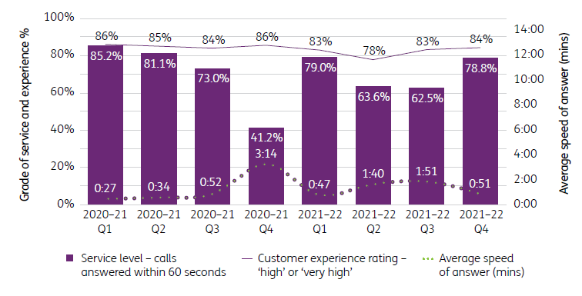
The NCC’s non-voice channels continued to grow during the 2021–22 financial year. Email processing increased from 862,800 to $1.07 million year on year. In December 2021, the NCC transitioned to a new processing platform that reduced email response wait times to less than one day on average during the fourth quarter, resulting in significant service improvements for participants. Email volumes have reduced since the introduction of the new system, with faster response times and new system capability avoiding the need for repeat and follow-up email requests.
The use of webchat has seen high growth since the release of the NDIA smartphone application. In 2021–22, the NCC answered 985,000 webchats − a significant increase from 525,000 in the prior year. Of these, 80.8% were answered within 20 seconds. This service continues to grow as a channel of choice for many participants.
Figure 2.2.3F: National Contact Centre volume of work completed 2021‒22
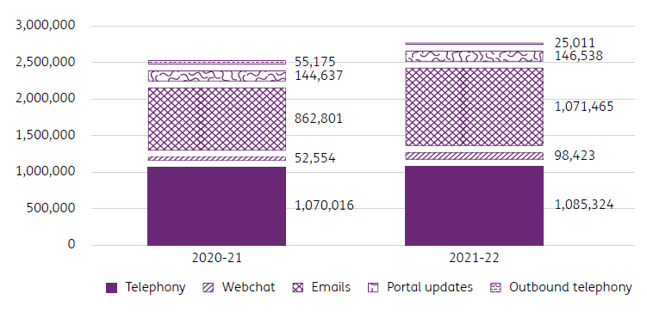

Information and communications technology systems
In 2021–22 the Office of the Chief Information Officer began delivery of the NDIA’s new ICT operational environment, including desktop and network services. This will be managed and controlled by NDIA staff. The new NDIA desktop and network services provide a modern workplace experience for staff and partners, which significantly enhances efficiency, choice and control and enables our staff to more effectively service participants. Key to this is the provision of improved accessibility options.
The key focus of the ICT Strategic Projects team was the design and build of a new customer relationship management (CRM) business system, PACE, which will replace the existing CRM delivered and supported by Services Australia. Our new CRM will support the end-to-end participant journey, moving all business processes for NDIA and partners in the community onto one system. The new CRM system will:
- support the NDIA to meet key commitments in the SIP and the NDIA Corporate Plan, and requirements of recent amendments to the NDIS Act
- better support planning processes and reasonable and necessary decision-making
- introduce in-system controls to ensure practices comply with policy and legislation
- provide an improved experience for participants, frontline staff, partners in the community, and providers, including meeting accessibility requirements WCAG 2.1AA.
A refreshed participant web portal solution was moved into the pilot phase, seeking feedback from 500 self-managed participants on its potential functionality. The pilot was successful, and the resulting feedback was used as input into development of the new participant portal.
The NDIA’s Salesforce platform was further expanded to incorporate email-to-case capability for the NCC, enabling contact centre staff to respond to enquiries more efficiently.
The my NDIS participant mobile app moved into general release in October 2021. There are now approximately 50,000 participants using the app to review their available budget, make claims and store receipts. The app has generally received excellent reviews on both the iOS and Android app stores.

Protective security
The NDIA is committed to increasing its protective security maturity and awareness to assist staff and partners in the delivery of the Scheme.
The Protective and Cyber Security Branch is responsible for implementing the requirements of the Australian Government security frameworks and associated legislation. This is achieved by providing strategic and operational information, guidance, policy and procedures and advice across:
- security governance
- information security
- personnel security
- physical security
- cyber security
- security incident management and investigations.
Key achievements include:
- increased security training (face to face or via eLearning)
- standard physical and electronic security requirements for NDIA tenancies and buildings
- enhanced NDIA procurement guidelines and processes to support security considerations
- enhanced pre-employment and ongoing suitability processes for the NDIA
- ongoing identification, management and strategy to mitigate NDIA-specific security risks.

A financially sustainable Scheme
A financially sustainable Scheme achieves positive outcomes for participants throughout their lives and is affordable now and into the future. This relies on sound investment in supports that will deliver the positive outcomes people with disability deserve.
The Annual Financial Sustainability Report (AFSR) 2021-22 provides an assessment of the financial sustainability of the NDIS, as is required under the NDIS Act (section 180B). It is prepared by the Scheme Actuary, using data as at 30 June each year. The AFSR was independently peer reviewed by the Australian Government Actuary. Refer to section 3.2 for a summary of the AFSR.
  - How we intend to move forward
The NDIA continues to focus on improving participant experience and outcomes.
We will continue to put participants at the centre of everything we do – listening and responding to their needs so we can support people with disability to live the life they choose and contribute to a more inclusive Australia.
While the NDIA looks for opportunities for improvement across the board, it is focused on key areas including employment opportunities for participants, fraud and compliance, hospital discharge and reducing the number of cases referred to the Administrative Appeals Tribunal.
We are working to build, test and implement a bespoke customer relationship management business system that will improve processes for participants. It will also deliver efficiency benefits to staff and drive consistency and compliance through built-in quality and integrity controls. Extensive testing will ensure we get the system right for participants and staff.
The way forward is actively collaborative. Our Engagement Framework will ensure the views and experiences of people with disability underpin the decisions we make. In establishing our co-design function, we have taken a ‘learn by doing’ approach and we are working in partnership with the disability sector to design and implement improvements to the Scheme that will have a positive impact for participants. Critically, we will engage with people with disability, the sector and state and territory governments to develop a new person-centred model for assessments, consistent with the legislative requirements as set out in the NDIS Act.
- Financials
Independent Auditor’s Report
Statement by the Chairman, Chief Executive Officer, Chief Financial Officer and Chair of the Audit Committee
Financial statements

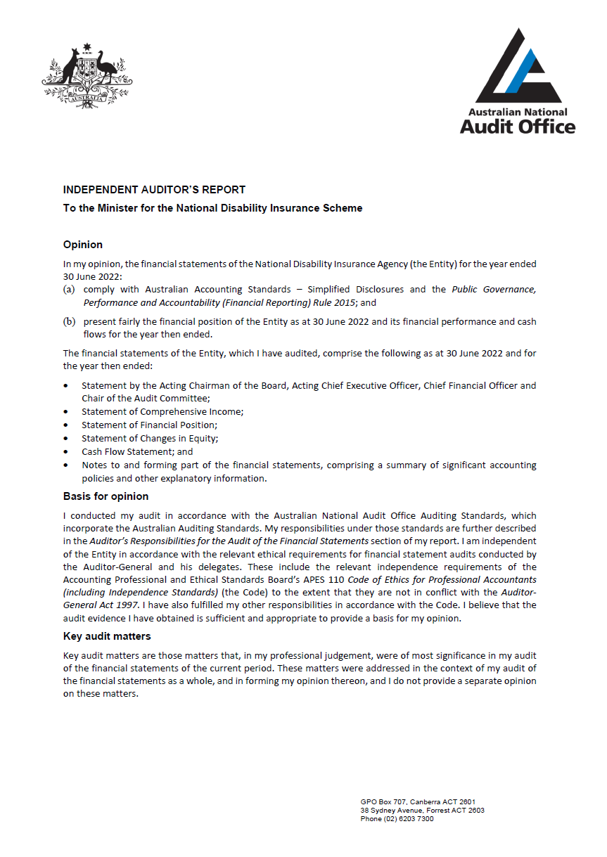
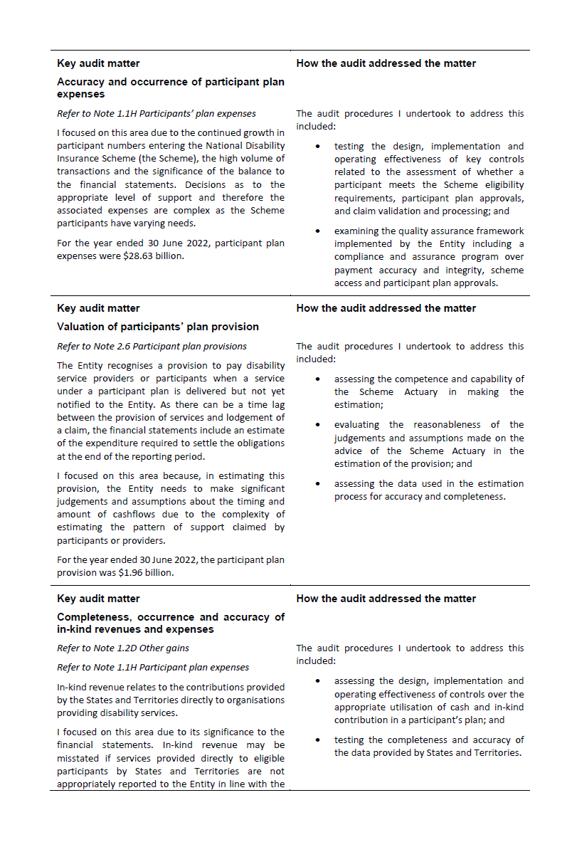
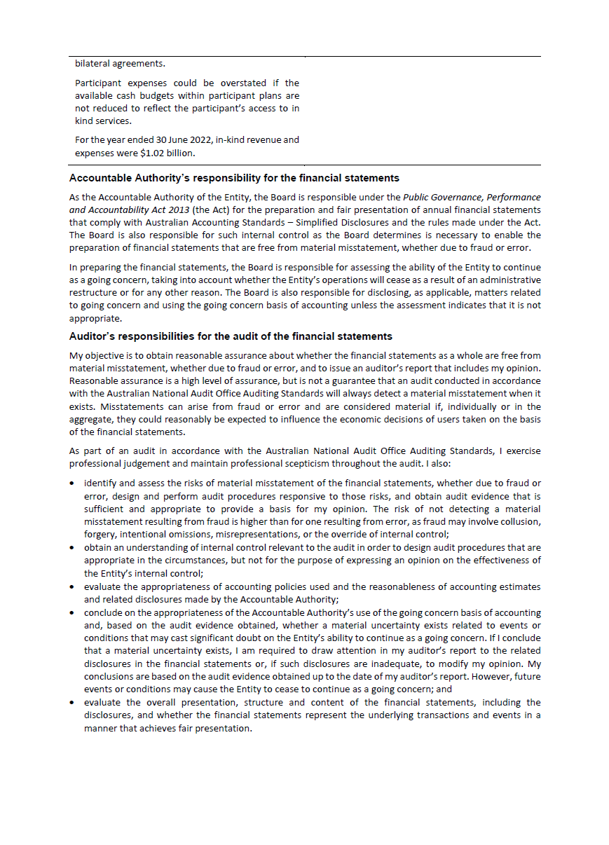
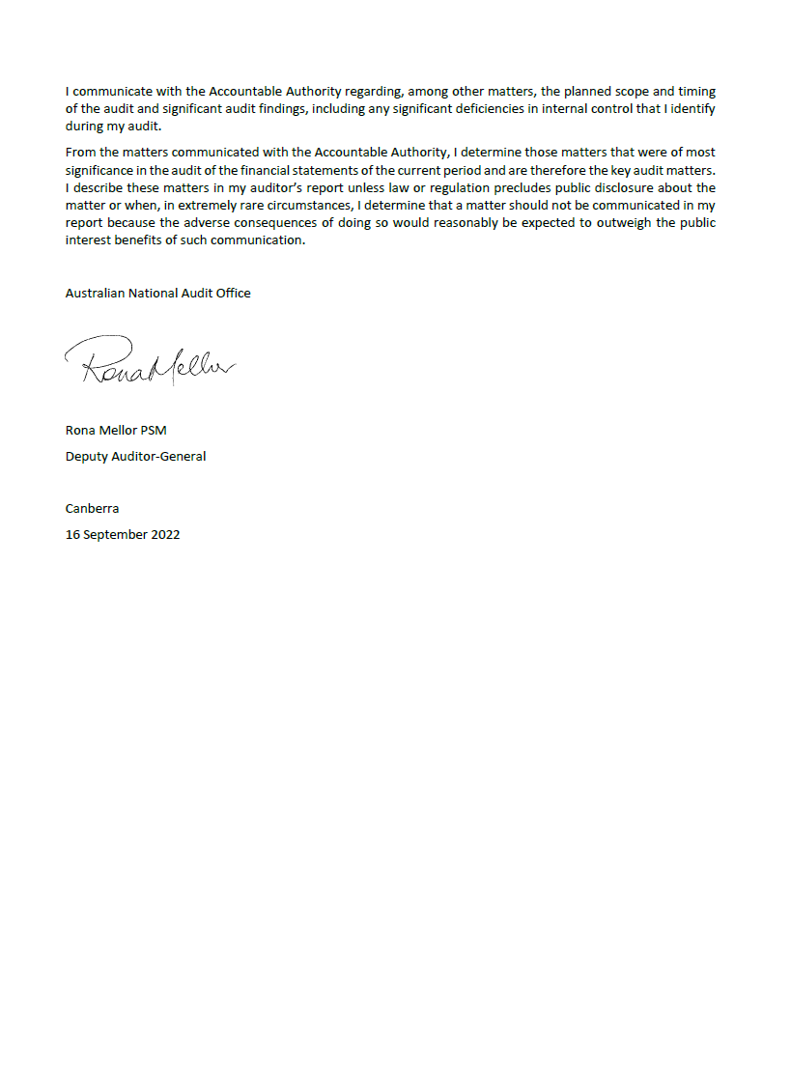
  - Financial statements
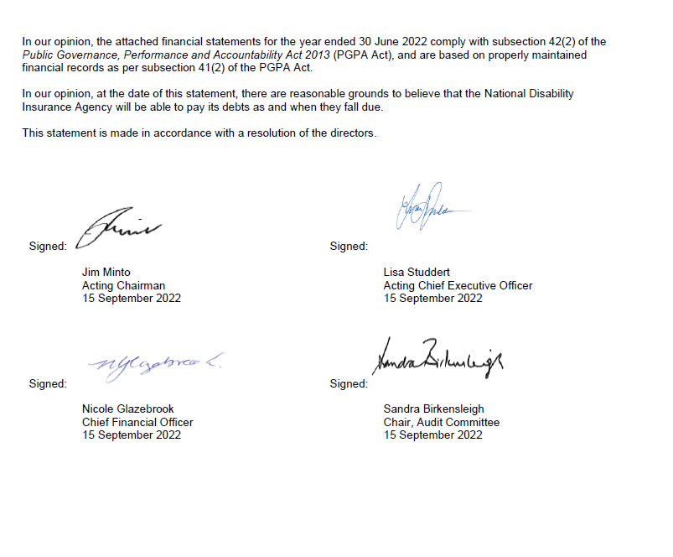
Original
Budget¹
 |  | 2022 |  | 2021 |  | 2022
 | Notes | $'000 |  | $'000 |  | $'000
NET COST OF SERVICES
Expenses
Employee benefits | 1.1A | 482,219 |  | 437,154 |  | 446,066
Suppliers | 1.1B | 480,327 |  | 450,502 |  | 960,735
Community partnership costs | 1.1G | 560,131 |  | 524,050 |  | -
Grants | 1.1C | 262 |  | 27,127 |  | -
Participant plan expenses | 1.1H | 28,631,144 |  | 23,347,597 |  | 26,486,528
Depreciation and amortisation | 2.2A | 67,131 |  | 66,430 |  | 72,322
Finance costs | 1.1D | 1,216 |  | 2,394 |  | 2,865
Impairment loss on financial instruments | 1.1E | 135 |  | - |  | -
Write-down and impairment of other assets | 1.1F | 3,942 |  | 65,078 |  | -
Total expenses |  | 30,226,507 |  | 24,920,332 |  | 27,968,516
OWN-SOURCE INCOME
Own-source revenue
Rendering of services | 1.2A | 28,179,885 |  | 22,091,325 |  | 25,217,568
Interest |  | 17,475 |  | 9,854 |  | 8,563
Rental income | 1.2B | 592 |  | 2,833 |  | -
Other revenue | 1.2C | 23,324 |  | 24,583 |  | -
Total own-source revenue |  | 28,221,276 |  | 22,128,595 |  | 25,226,131
Gains
Other gains | 1.2D | 1,015,002 |  | 1,390,186 |  | 1,268,960
Total gains |  | 1,015,002 |  | 1,390,186 |  | 1,268,960
Total own-source income |  | 29,236,278 |  | 23,518,781 |  | 26,495,091
Net (cost of)/contribution by services |  | (990,229) |  | (1,401,551) |  | (1,473,425)
Revenue from Government |  | 1,263,386 |  | 1,208,878 |  | 1,237,457
Surplus/(Deficit) |  | 273,157 |  | (192,673) |  | (235,968)
OTHER COMPREHENSIVE INCOME
Items not subject to subsequent reclassification to net cost of services
Changes in asset revaluation reserve |  | (1,058) |  | - |  | -
Total other comprehensive income |  | (1,058) |  | - |  | -
Total comprehensive income/(loss) |  | 272,099 |  | (192,673) |  | (235,968)

The above statement should be read in conjunction with the accompanying notes.
¹ Original Budget refers to the figures published in the Portfolio Budget Statements 2021–22 .

Budget Variances Commentary
Statement of Comprehensive Income
Affected line items | Explanations of major variances
Expenses  Grants | The responsibility for the Information, Linkages and Capacity-building Program was transferred from the Agency to the Department of Social Services effective 31 January 2021 and therefore the budget for grant payments was nil. The Agency introduced Home and Living grants program to support the demonstration project initiative during the 2021–22 financial year which was not anticipated at the time of the Budget.
Expenses  Participant plan expenses | The Scheme has continued to experience strong growth in participant plan expenses as more participants join the Scheme than anticipated and average package costs rise. Additional funding was provided at MYEFO of $2,737m to fund these additional expenses which is not reflected in the Original Budget disclosure.
Expenses  Finance Costs | Finance costs have reduced with a reduction in the number of building and fleet leases and the impact of the change in accounting standard which was not fully anticipated in the Budget.
Expenses  Impairment loss on financial instruments, Write-down and impairment of other assets | The Agency has continued to improve its debt management procedures. The majority of the write-offs relate to low value debts not economically feasible to recover.
Own-source revenue  Rendering of Services | The Scheme has continued to experience strong growth in participant plan expenses as more participants join the Scheme than anticipated and average package costs rise. Additional funding was provided at MYEFO of $2,737m which is not reflected in the Original Budget disclosure.
Own-source revenue  Interest, Rent, Other revenue | The increase in Interest revenue reflects higher than expected interest rates noting the Agency continues to actively invest surplus cash in term deposits to increase its returns, this is reflected in the Purchases of financial instruments. Rent reflects subleases to other Commonwealth entities to optimise utilisation of property resources. Other revenue includes compensation payments received by the participants which are recovered by the Scheme for supports provided. Rent and compensation receipts are not included in Agency budget considerations.
Gains  Other gains | Other gains include in-kind contributions made to the Scheme by state and territory governments. The programs subject to in-kind contributions will continue to reduce as their services are transferred to the Scheme, the variance to budget reflects a higher than expected transition rate. The value of in-kind contributions claimed by the states and territories was also lower than anticipated in the Budget.
Revenue from Government | At MYEFO the Agency received additional Commonwealth funding of $25.9m to support NDIA initiatives.
Other Comprehensive Income  Changes in asset revaluation reserve | The review of the Agency's leasehold improvements resulted in a revaluation decrement of $1.1m during the year. This was recorded in the asset revaluation reserve. This was not considered in the budget.

Original
Budget¹
 |  | 2022 |  | 2021 |  | 2022
 | Notes | $'000 |  | $'000 |  | $'000
ASSETS
Financial assets
Cash and cash equivalents | 2.1A | 1,918,956 |  | 1,819,084 |  | 3,073,650
Trade and other receivables | 2.1B | 48,920 |  | 55,498 |  | 399,374
Other financial assets | 2.1C | 2,465,000 |  | 1,495,000 |  | 140,000
Total financial assets |  | 4,432,876 |  | 3,369,582 |  | 3,613,024
Non-financial assets²
Buildings | 2.2A | 217,416 |  | 241,269 |  | 276,983
Plant and equipment | 2.2A | 10,373 |  | 1,238 |  | 12,506
Other non-financial assets | 2.2B | 23,680 |  | 18,615 |  | 7,566
Total non-financial assets |  | 251,469 |  | 261,122 |  | 297,055
Total assets |  | 4,684,345 |  | 3,630,704 |  | 3,910,079
LIABILITIES
Payables
Suppliers | 2.3A | 250,705 |  | 206,540 |  | 168,708
Other payables | 2.3B | 10,984 |  | 7,612 |  | 771,832
Total payables |  | 261,689 |  | 214,152 |  | 940,540
Interest bearing liabilities
Leases | 2.5 | 156,897 |  | 163,871 |  | 208,267
Total interest bearing liabilities |  | 156,897 |  | 163,871 |  | 208,267
Unearned revenue
Unearned revenue | 2.4 | 477,070 |  | 522,576 |  | -
Total unearned revenue |  | 477,070 |  | 522,576 |  | -
Provisions
Employee leave provisions |  | 97,943 |  | 92,109 |  | 80,226
Participant plan provisions | 2.6 | 1,963,712 |  | 1,658,922 |  | 1,898,980
Provision for provider additional costs | 2.6 | 475,644 |  | - |  | -
Provision for restoration obligations | 2.6 | 7,301 |  | 7,084 |  | 7,980
Total provisions |  | 2,544,600 |  | 1,758,115 |  | 1,987,186
Total liabilities |  | 3,440,256 |  | 2,658,714 |  | 3,135,993
Net assets |  | 1,244,089 |  | 971,990 |  | 774,086
EQUITY
Contributed equity |  | 205,733 |  | 205,733 |  | 205,733
Asset revaluation reserve |  | 21,079 |  | 22,137 |  | 22,137
Retained surplus |  | 1,017,277 |  | 744,120 |  | 546,216
Total equity |  | 1,244,089 |  | 971,990 |  | 774,086

The above statement should be read in conjunction with the accompanying notes.
¹ Original Budget refers to the figures published in the Portfolio Budget Statements 2021–22 .
² Reported balances of buildings, plant and equipment right-of-use assets associated with the Agency’s leases. Refer to Note 2.5 for further details.
Budget Variances Commentary
Statement of Financial Position
Affected line items | Explanations of major variances
Financial assets  Cash and cash equivalents | Cash comprises cash held on deposit and term deposits with an initial maturity of three months or less. The Budget assumed that the majority of the Agency's available funds would be held in Cash and cash equivalents due to a low interest environment at the time of the Budget. The Agency has actively sought to achieve higher investment returns through the use of longer term deposits which are included in Other financial assets.
Financial assets  Trade and other receivables | The Budget assumed that cash contributions would be monthly in arrears and spread equally across the year, while actual contributions were received in advance in accordance with the Agency's quarterly in advance invoicing procedure.
Financial assets  Other financial assets | Other financial assets are term deposits with an initial maturity greater than three months. The Agency has actively sought to achieve higher investment gains through the use of longer term deposits.
Non-financial assets  Buildings | The Budget assumed that the Agency would occupy a greater number of premises. During 2021–22 , the Agency has continued consolidate its property footprint, reducing both the number of lease arrangements and the value of right-of-use and leasehold improvement assets. In addition, there has been a delay in capital purchases, as a result of COVID-19 resource shortages.
Non-financial assets  Plant and equipment | During 2021–22 the Agency initiated a program to deliver inhouse technology capability, providing a faster, more secure and accessible user experience, including the purchase of new laptop devices. The impact of COVID-19 has delayed the full roll out of this program, and it is now expected to finalise in 2022-23.
Non-financial assets  Other non-financial assets | The Agency negotiated to acquire key software licences at discounted pricing through the use of a prepayments mechanism at a higher rate than anticipated in the Budget.
Liabilities  Suppliers | Suppliers includes an amount payable to the Department of Health for Younger People in Residential Aged Care that remains unpaid as at the end of 2021–22 . The balance in Suppliers is predominantly driven by the timing of expenditure recognised and relevant payment terms.
Liabilities  Other payables, Unearned revenue | The Budget does not separately disclose amounts attributable to Other payables and Unearned revenue. Unearned revenue relates to credits for in-kind contributions estimated but not awarded. The balance of in-kind contributions has been decreasing as states and territories finalise the transfer of relevant programs to the Scheme. While a reduction in in-kind contributions was included in the Budget, the transfer of the programs has proceeded at a rate greater than anticipated.
Interest bearing liabilities  Leases | There has been a reduction in the number of building and motor vehicle fleet leases, together with a decrease in liability resulting from the present value impact of lease modifications and terminations. In addition, these impacts were not envisaged in the Original Budget.
Provisions  Employee provisions | The Agency has seen strong growth in staffing levels which has impacted on the level of employee leave provisions. In addition, employee leave provisions increased as a result of year-end actuarial assessment and changes in parameters. This balance is highly sensitive to the parameters and will fluctuate widely as a result. The budget is based on historic trend.
Provisions  Provision for provider additional costs | The provision for the one-off payments to providers arising from the 2022-23 Annual Pricing Review was not contemplated at the time of the Budget.
Retained surplus | The Budget did not anticipate the additional funding provided to the Agency at Additional Estimates.

 | Retained Surplus |  |  | Asset Revaluation Reserve |  |  | Contributed Equity |  |  | Total Equity
 |  |  | Original  Budget¹ |  |  | Original  Budget¹ |  |  | Original  Budget¹ |  |  | Original  Budget¹
 | 2022 | 2021 | 2022 | 2022 | 2021 | 2022 | 2022 | 2021 | 2022 | 2022 | 2021 | 2022
 | $'000 | $'000 | $'000 | $'000 | $'000 | $'000 | $'000 | $'000 | $'000 | $'000 | $'000 | $'000
Adjusted opening balance | 744,120 | 936,793 | 782,184 | 22,137 | 22,137 | 22,137 | 205,733 | 205,733 | 205,733 | 971,990 | 1,164,663 | 1,010,054
Comprehensive income
Surplus/(Deficit) for the period | 273,157 | (192,673) | (235,968) | - | - | - | - | - | - | 273,157 | (192,673) | (235,968)
Other comprehensive income |  |  |  | (1,058) |  |  |  |  |  | (1,058) | - | -
Total comprehensive income/(loss) | 273,157 | (192,673) | (235,968) | (1,058) | - | - | - | - | - | 272,099 | (192,673) | (235,968)
Closing balance | 1,017,277 | 744,120 | 546,216 | 21,079 | 22,137 | 22,137 | 205,733 | 205,733 | 205,733 | 1,244,089 | 971,990 | 774,086

The above statement should be read in conjunction with the accompanying notes.

Budget Variances Commentary
Statement of Changes in Equity
Major budget variance for balances contained in the Statement of Changes in Equity have been included in the budget variances commentary for the Statement of Comprehensive Income and the Statement of Financial Position.

¹ Original Budget refers to the figures published in the Portfolio Budget Statements 2021–22 .

Original
Budget¹
 |  | 2022 |  | 2021 |  | 2022
 | Notes | $'000 |  | $'000 |  | $'000
OPERATING ACTIVITIES
Cash received
Receipts from Government |  | 1,263,386 |  | 1,208,878 |  | 1,237,457
Rendering of services |  | 28,171,098 |  | 22,232,204 |  | 25,217,568
Interest received |  | 11,797 |  | 10,890 |  | 8,563
GST received |  | 128,031 |  | 133,134 |  | 96,083
Other |  | 22,631 |  | 27,667 |  | -
Total cash received |  | 29,596,943 |  | 23,612,773 |  | 26,559,671
Cash used
Employee benefits |  | 473,053 |  | 423,079 |  | 444,964
Supplier expenses |  | 549,186 |  | 689,361 |  | 1,062,500
Interest payments on lease liabilities |  | 1,256 |  | 2,249 |  | 2,322
Community partnership costs |  | 559,766 |  | 499,816 |  | -
Participant plan expenses |  | 26,878,414 |  | 21,238,538 |  | 25,175,184
Grant payments |  | 262 |  | 29,447 |  | -
Total cash used |  | 28,461,937 |  | 22,882,490 |  | 26,684,970
Net cash from / (used by) operating activities |  | 1,135,006 |  | 730,283 |  | (125,299)
INVESTING ACTIVITIES
Cash received
Proceeds from sales of property, plant and  equipment |  | 1,286 |  | 183 |  | -
Proceeds from sales of financial instruments |  | 7,390,000 |  | 2,185,000 |  | -
Total cash received |  | 7,391,286 |  | 2,185,183 |  | -
Cash used
Purchase of property, plant & equipment |  | 27,299 |  | 13,162 |  | 22,667
Purchase of financial instruments |  | 8,360,000 |  | 3,540,000 |  | -
Total cash used |  | 8,387,299 |  | 3,553,162 |  | 22,667
Net cash from / (used by) investing activities |  | (996,013) |  | (1,367,979) |  | 22,667
FINANCING ACTIVITIES
Cash used
Principal payments of lease liabilities |  | 39,121 |  | 40,460 |  | 40,255
Total cash used |  | 39,121 |  | 40,460 |  | 40,255
Net cash from / (used by) financing activities |  | (39,121) |  | (40,460) |  | (40,255)
Net increase / (decrease) in cash held |  | 99,872 |  | (678,156) |  | (188,221)
Cash and cash equivalents at the beginning of the  reporting period |  | 1,819,084 |  | 2,497,240 |  | 3,261,871
Cash and cash equivalents at the end of the reporting period | 2.1A | 1,918,956 |  | 1,819,084 |  | 3,073,650

The above statement should be read in conjunction with the accompanying notes.
¹Original Budget refers to the figures published in the Portfolio Budget Statements 2021–22 .

Budget Variances Commentary
Cash Flow Statement
Affected line items | Explanations of major variances
Operating activities  Rendering of Services | The Scheme has continued to experience strong growth in participant plan expenses as more participants join the Scheme than anticipated and average package costs rise. Additional funding was provided at MYEFO of $2,737m to fund these additional expenses.
Operating activities  Interest received | Interest revenue reflects the impact of higher interest rates than anticipated in the Budget. The Agency has actively sought to achieve higher investment returns through the use of longer termed deposits that capitalise on the stronger interest rates through a balanced approach considering both the liquidity and potential returns.
Operating activities  GST received | The higher level of GST received reflects the budget assumption of an overall lower level of activity in the Scheme.
Operating activities  Other | Primarily reflects compensation receipts which are reimbursements from participants where funded supports are also covered by compensation payments received by the participants. Compensation receipts were not included in the Budget estimates.
Operating Activities  Interest payments on lease liabilities | Interest payments have decreased due to higher reductions in the numbers of building and fleet leases than anticipated in the Budget.
Operating activities  Grant payments | The responsibility for the Information, Linkages and Capacity-building Program was transferred from the Agency to the Department of Social Services effective 31 January 2021 and therefore the budget for grant payments was nil. The Agency introduced Home and Living grants program to support the demonstration project initiative during the 2021–22 financial year which was not anticipated at the time of the Budget.
Investing Activities  Proceeds from sales of property, plant and equipment | Proceeds from sales of property, plant and equipment relate primarily to the disposal of fleet assets. This disposal activity was not included in the Budget.
Investing activities  Purchase of Property, Plant and Equipment | The Budget assumed a greater value of desktop computing acquisitions than actually occurred. This reduction was offset by a greater than budgeted value of leasehold improvement expenditure predominately associated with the Parramatta (NSW) and Richmond (VIC) office developments.
Investing activities  Proceeds from sale of financial instruments, Purchase of financial instruments | The Agency did not budget for investment in term deposits because of the low interest rate environment. During 2021–22 , the Agency has actively sought to achieve higher investment gains through the use of longer term deposits which is reflected in the value of the Purchase of financial instruments.

Financial Statements
Table of Contents
Overview 61
Financial Performance 62
Expenses 62
Own-Source Revenue and Gains 65
Financial Position 68
Financial Assets 68
Non-Financial Assets 70
Payables 73
Unearned Income 73
Interest Bearing Liabilities 73
Provisions 74
People and Relationships 76
Key Management Personnel Remuneration 77
Related Party Disclosures 77
Managing Uncertainties 79
Contingent Assets and Liabilities 79
Financial Instruments 80
Other Information 81
Current/Non-current Distinction for Assets and Liabilities 81

Overview

General information

The National Disability Insurance Agency (‘the Agency’) was established on 29 March 2013 by the National Disability Insurance Scheme Act 2013 (‘the Act’). The Agency is an Australian Government controlled not-for-profit entity.

The Scheme has operations in all states and territories of Australia, with its national office at 13 – 19 Malop Street, Geelong, Victoria, 3220.

Objectives of the Agency

The objective of the Agency is to operate under the Act, and in conjunction with other legislation, to give effect to Australia’s obligations under the Convention on the Rights of Persons with Disabilities. In doing so, the Agency supports the independence, social and economic participation of people with a disability.

The Agency is structured to meet the following outcome:

To implement a National Disability Insurance Scheme that provides individual control and choice in the delivery of reasonable and necessary supports to improve the independence, social and economic participation of eligible people with disability, their families and carers, and associated referral services and activities.

The continued existence of the Agency in its present form and with its present programs is dependent on Commonwealth Government policy, continuing funding by Parliament for the Agency’s administration and programs and agreement with state and territory governments. States and territories have continued to provide funding as set out in the bilateral agreements between each state and territory and the Commonwealth.

The Basis of Preparation

The financial statements are required by section 42 of the Public Governance, Performance and Accountability Act 2013.

The financial statements have been prepared in accordance with:
- Public Governance, Performance and Accountability (Financial Reporting) Rule 2015 (FRR); and
- Australian Accounting Standards and Interpretations – including simplified disclosures for Tier 2 Entities under AASB 1060 issued by the Australian Accounting Standards Board (AASB) that apply for the reporting period.

The financial statements have been prepared on an accrual basis and in accordance with the historical cost convention, except for certain assets and liabilities, which are measured at fair value. Except where stated, no allowance is made for the effect of changing prices on the results or the financial position. The financial statements are presented in Australian dollars and values are rounded to the nearest thousand dollars, unless otherwise specified.

New Accounting Standards

All new/revised/amending standards and/or interpretations that were issued prior to the sign-off date and are applicable to the current reporting period did not have a material effect on the entity’s financial statements. The application of AASB 1060, from 1 July 2021, involves some reduction in disclosure compared to the reduced disclosure requirements framework with no impact on the Agency’s reported financial statements.

Taxation

The Agency is exempt from all forms of Commonwealth, state and territory taxation except Fringe Benefits Tax (FBT) and the Goods and Services Tax (GST).

Events after the reporting period

There are no known events occurring after the reporting period that could have a material impact on the financial statements.

1. Financial Performance
This section analyses the financial performance of the Agency for the year ended 30 June 2022.

1.1 Expenses
 | 2022 |  | 2021
 | $'000 |  | $'000
Note 1.1A: Employee benefits
Wages and salaries | 380,548 |  | 335,186
Superannuation
Defined contribution plans | 54,550 |  | 47,249
Defined benefit plans | 10,154 |  | 12,432
Leave and other entitlements | 36,844 |  | 41,798
Separation and redundancies | 123 |  | 489
Total employee benefits | 482,219 |  | 437,154

Accounting Policy
Accounting policies for employee related expenses are contained in Section 3. People and Relationships.
Note 1.1B: Suppliers
Services rendered
Service providers¹ | 264,464 |  | 230,939
Shared Services² | 53,098 |  | 78,021
Legal expenses | 58,771 |  | 21,607
Community connector management fees | 17,683 |  | 25,797
Travel | 2,775 |  | 1,971
Property operating expenses | 10,276 |  | 10,544
Information technology expenses | 40,943 |  | 40,323
Staff welfare and training | 4,644 |  | 4,586
Comcover | 5,367 |  | 5,212
Market research | 4,051 |  | 3,707
Translator and interpreter services | 2,239 |  | 7,140
Staff recruitment and relocation | 2,183 |  | 1,821
Repairs and maintenance | 1,016 |  | 1,266
Audit fees | 623 |  | 627
Other | 6,685 |  | 11,723
Total services rendered | 474,818 |  | 445,284
Other suppliers
Short-term leases | 1,670 |  | 3,090
Workers compensation expenses | 3,839 |  | 2,128
Total other suppliers | 5,509 |  | 5,218
Total suppliers | 480,327 |  | 450,502

Accounting Policy
Short-term leases and leases of low-value assets
The Agency has elected not to recognise right-of-use assets and lease liabilities for short-term leases of assets that have a lease term of 12 months or less and leases of low-value assets (less than $10,000). The Agency recognises the lease payments associated with these leases as an expense on a straight-line basis over the lease term.
¹ Balance includes contractor and consultant related expenses.
² During 2021-2022 the Agency had a Memorandum of Understanding in place that covered the provision of various administrative and operational support services provided by Services Australia.

 | 2022 |  | 2021
Note 1.1C: Grants | $'000 |  | $'000
Public sector
State and territory governments | - |  | 568
Private sector
For profit organisations | - |  | 1,525
Not for profit organisations | 262 |  | 25,034
Total grants | 262 |  | 27,127
In 2021–22 , the Agency introduced Home and Living grants to assist providers with establishment costs associated with Supported Independent Living demonstration projects.
During 2020-21, the Agency provided a range of grants in order to promote improved outcomes for people with a disability, their families and their carers through investment in disability research, increased social and community participation, innovation and education. The responsibility for the delivery of Community Inclusion and Capacity Development Grants transferred to the Department of Social Services on 31 January 2021.

Accounting Policy
Grants
Grant liabilities are recognised to the extent that (i) the services required to be performed by the grantee have been performed or (ii) the grant eligibility criteria have been satisfied, but payments due have not been made.
Note 1.1D: Finance costs
Interest on lease liabilities | 1,256 |  | 1,912
Unwinding of discount and discount rate movement | (40) |  | 482
Total finance costs | 1,216 |  | 2,394
The above lease disclosures should be read in conjunction with the accompanying notes 1.1B, 1.2B, 2.2A and 2.5.

Accounting Policy
All borrowing costs are expensed as incurred.
Note 1.1E: Impairment loss on financial instruments
Impairment of financial instruments | 135 |  | -
Total impairment loss on financial instruments | 135 |  | -

Note 1.1F: Write-down and impairment of other assets
Buildings | - |  | 105
Goods and Services - external parties | - |  | 62,817
Participant and provider receivables | 3,936 |  | 2,154
Other receivables | 6 |  | 2
Total write-down and impairment of other assets | 3,942 |  | 65,078

Note 1.1G: Community partnership costs
Early Childhood Early Intervention costs | 184,582 |  | 163,859
Exceptionally Complex Support Needs costs | 1,861 |  | 4,477
Local Area Coordination costs | 373,688 |  | 355,714
Total Community partnership costs | 560,131 |  | 524,050

Early Childhood Early Intervention Costs
This reflects the costs incurred by the Agency of engaging early childhood partners to provide supports to children aged between 0-6 years who have a disability or significantly impaired development.
Exceptionally Complex Support Needs costs
This reflects the costs incurred to improve outcomes and experience for participants with exceptionally complex support needs.
Local Area Coordination Costs
This reflects the costs incurred in funding local area coordination services.
Local Area Coordinators deliver of the following services:
- provision of support and community awareness to prospective participants and local communities to engage with the Scheme;
- support Scheme participants with the implementation of their plans; and
- support Scheme participants with full scheme planning and plan reviews.

Accounting Policy
The costs associated with community partnerships are recognised in accordance with contractual arrangements.
 | 2022 |  | 2021
 | $'000 |  | $'000
Note 1.1H: Participant plan expenses
Claims received from participants and providers | 27,230,122 |  | 21,874,535
Cost of services received in-kind | 1,013,000 |  | 1,368,744
Other changes to participant plan provisions | 388,022 |  | 104,318
Total participant plan expenses | 28,631,144 |  | 23,347,597

Accounting Policy
The costs associated with participant plan expenses are recognised as and when the Agency receives claims from participants and providers. Accounting policies for expenses resulting from adjustment to the participant plan provision are contained in Section 2.6 – Provisions.
Participant plan expenses
The Agency makes payments to registered providers and participants with self-managed plans for supports delivered in line with a participant’s approved plan. Registered providers and self-managing participants are able to access NDIS portals to submit payment claims for delivered supports. Self-lodgement of claims from providers and participants can lead to payments that are inconsistent with Agency guidance, even where no deliberate fraud is intended by the claimant. To mitigate this risk and to assess the potential financial impact the Agency maintains an assurance testing program, with regular reviews completed throughout the year. During 2021–22 the Agency increased the level of resourcing focused on this program enabling a significant increase in the number of transactions subject to review.

Errors identified in the review process can be either critical (having a potential negative financial impact) or non-critical (having no or a potentially positive financial impact). All critical errors are subject to further validation, with recovery action, where required and considered to be economical, undertaken in accordance with the Agency’s Debt Management Procedures. The outcomes of this testing are extrapolated to indicate an annualised potential financial impact.

For 2021–22, the estimated potential financial impact of the provider error rates was assessed as being $606.1m (2.6% of total provider payments) compared to $242.9m (1.3% of total provider payments) in 2020-21.

The estimated potential financial impact of the participant self-managed plan error rates was assessed as being $244.9m (7.0% of total self-managed participant provider payments) compared to $27.9m (0.9% of total self-managed participant payments) in 2020-21.
For both categories of payments the primary factor driving the increase in estimated error value is the increase in the number of errors found together with the proportional increase in the average error value over the sample group applied against the total value of payments made by the Agency in 2021–22 .

1.2 Own-Source Revenue and Gains

OWN SOURCE REVENUE | 2022 |  | 2021
 | $'000 |  | $'000
Note 1.2A: Rendering of services
Rendering of services in connection with:
Related parties - contributions from Department of Social Services | 18,173,039 |  | 12,941,352
External parties - contributions from state and territory governments | 10,006,846 |  | 9,149,973
Total revenue from rendering of services | 28,179,885 |  | 22,091,325

Accounting Policy
Cash contributions to the Agency from the Commonwealth, state and territory governments are recognised as revenue when they become payable to the Agency under the relevant signed agreement. These include cash contributions outlined in the bilateral agreements for the funding of the Scheme and funding provided by the DSS for the Agency’s former grant programs. Cash contributions received in advance and any outstanding cash contribution offsets to be deducted from future period cash contribution receipts are treated as unearned revenue (refer note 2.4).
The transaction price for the Scheme contributions is the total amount of cash contributions payable by the jurisdictions to fund the Scheme under their bilateral agreements. The bilateral agreements have annual performance obligations.
Note 1.2B: Rental Income
Operating lease:
Subleasing right-of-use assets | 592 |  | 2,833
Total rental income | 592 |  | 2,833

Operating Leases
Through a cooperative Social Services portfolio arrangement, the NDIA entered into agreements with DSS and the National Indigenous Australians Agency to occupy some of the NDIA’s properties. The NDIA retains the rights and risks in underlying assets associated with these leases. There are established risk management processes and a governance structure for escalation of issues. As the sublet arrangement is Commonwealth entity to Commonwealth entity, the risk was deemed to be low and could be facilitated through the existing relationship with these entities.

Maturity analysis of operating lease receivables
Within one year | 639 |  | 592
One to two years | 469 |  | 639
Two to three years | 205 |  | 469
Three to four years | 167 |  | 205
Four to five years | 70 |  | 167
More than 5 years | - |  | 70
Total undiscounted lease payments receivable | 1,550 |  | 2,142
The above lease disclosures should be read in conjunction with the accompanying notes 1.1B, 1.1D, 2.2A & 2.5.

 | 2022 |  | 2021
 | $'000 |  | $'000
Note 1.2C: Other revenue
Compensation receipts | 23,165 |  | 20,637
Cost recoveries | 10 |  | 32
Return of prior year grant funds | - |  | 3,824
Other miscellaneous revenue | 149 |  | 90
Total other revenue | 23,324 |  | 24,583

Accounting Policy
Compensation
The Agency has powers set out in the NDIS Act and the NDIS Compensation Rules to recover compensation settlements that have been made to participants in certain circumstances. This legislation and its interaction with general compensation law is highly complex. As a result, the Agency’s entitlement to, and the value of, compensation revenue cannot be reliably determined until the circumstances of each case are fully analysed. The legislation also provides the Agency with the option to apply a compensation reduction amount (CRA) to participant plans in lieu of recovering the compensation in a lump sum. Where the Agency elects to apply a CRA to a participant’s plan, a lower level of supports will be provided to the participant in future periods, resulting in a reduction in future participant plan expenses, rather than the recognition of compensation revenue.
Compensation revenue is therefore recognised when the delegate determines that a specified debt recovery amount is appropriate.
Further discussion on the recognition and valuation of compensation recoveries is included in Section 4 Managing Uncertainties.
Note 1.2D: Other gains
Reversal/write back of provisions | 775 |  | (337)
External parties - Contributions in-kind from state and territory governments | 1,013,000 |  | 1,368,744
Reversal of impairment losses | 716 |  | 21,474
Other | 511 |  | 305
Total gains | 1,015,002 |  | 1,390,186

Accounting Policy
Contributions in-kind from state and territory governments
Contributions in-kind from state and territory governments are termed volunteer services under Australian Accounting Standards as they are received free of charge. Volunteer services are recognised as own-source income when, and only when, a fair value can be reliably determined, and the services would have been purchased if they had not been contributed. Use of these services is recognised as an expense. Volunteer services are recorded as either revenue or gains depending on their nature.
Prior to the commencement of the Scheme, each state and territory government had committed to provide (directly or by engaging service providers) agreed items such as disability services, health services, family support, education, employment, transport and/or housing to people with a disability. The on-going provision of these agreed services on behalf of the Agency is regarded as an in-kind contribution under Australian Accounting Standards and is accounted for as income from the contribution of services at the date when the services are provided. The fair value of these contributions is the unit cost provided by the jurisdiction which is based on the value the jurisdiction has paid under its funding arrangements with the provider.

Key judgements and estimates
Contributions in-kind from state and territory governments
The Agency records income in relation to non-cash or in-kind contributions from state and territory governments at the time when the services are provided to participants. In some cases, the Agency may not have been formally notified that the state or territory government has provided or funded a contribution to a participant. In this circumstance, the Agency makes an estimate of the amount of in-kind contributions provided to participants during the period but not yet notified to the Agency. These estimates are based on the latest available evidence of in-kind supports provided to participants by the state and territory governments.
Accounting Policy
Revenue from Government
Funding received from the DSS (received by the Agency as a corporate Commonwealth entity payment item) is recognised as Revenue from Government unless the funding is in the nature of an equity injection or a loan.
Revenue from Government should be read in conjunction with the Statement of Comprehensive Income Budget Variances Commentary.

2. Financial Position
This section analyses the Agency’s assets used to conduct its operations and the operating liabilities incurred as a result.
Buildings and plant and equipment, other than right-of-use buildings and vehicles, are carried at fair value in accordance with AASB 13 Fair Value Measurement. The remaining assets and liabilities disclosed in the statement of financial position do not apply the fair value hierarchy.

Employee related information is disclosed in Section 3. People and Relationships.

2.1 Financial Assets
 | 2022 |  | 2021
 | $'000 |  | $'000
Note 2.1A: Cash and cash equivalents
Cash on hand | 1,868,956 |  | 829,084
Term deposits | 50,000 |  | 990,000
Total cash and cash equivalents | 1,918,956 |  | 1,819,084

Accounting Policy
Cash is recognised at its nominal amount. This includes cash on hand and term deposits in bank accounts with an original maturity of three months or less that are readily convertible to cash and subject to insignificant risk of changes in value. Term deposits with an original maturity greater than three months are included in Note 2.1C.
Note 2.1B: Trade and other receivables
Goods and services receivables
Goods and services receivables | 70,088 |  | 106,807
Total goods and services receivables | 70,088 |  | 106,807
Other receivables
GST receivable from the Australian Taxation Office | 12,951 |  | 8,684
Pandemic plan provider receivables¹ | 792 |  | 2,775
Participant and other provider receivables | 36,031 |  | 11,830
Other | 6,494 |  | 773
Total other receivables | 56,268 |  | 24,062
Total trade and other receivables (gross) | 126,356 |  | 130,869
Less impairment loss allowance²
Goods and services receivables | 62,817 |  | 62,817
Participant and other provider receivables | 13,801 |  | 10,681
Other receivables | 26 |  | 246
Pandemic plan provider receivables¹ | 792 |  | 1,627
Total impairment loss allowance | 77,436 |  | 75,371
Total trade and other receivables (net) | 48,920 |  | 55,498

During 2021-2022 credit terms for goods and services were within 30 days (2021: 30 days).

¹ Pandemic plan provider receivables represent optional advances made by the Agency to eligible registered providers to assist with cash flow and continuity of supports during the COVID-19 pandemic. Refer also to the Accounting Policy below.
² Refer to the Impairment of financial assets section as part of the Accounting Policy below.

Accounting Policy
Receivables for goods and services, which have 30 day terms, are recognised at the nominal amounts due less any impairment allowance account. Collectability of debts is reviewed at end of the reporting period. Allowances are made when collectability of the debt is no longer probable.
Note 2.1C: Other financial assets

Term deposits are expected to be recovered within 12 months.

Accounting Policy
Term deposits with an original maturity of three months or less are classified as cash and cash equivalents and are included in Note 2.1A.

Accounting Policy - Financial Assets - General
Financial assets
Trade receivables and other receivables are recognised at the nominal amounts due less any impairment allowance amount. The collectability is assessed periodically with impairment allowances made when there is evidence that the Agency will not be able to collect the debt.
The Agency classifies all of its financial assets according to their nature and purpose at the time of recognition. Financial assets are recognised and derecognised upon trade date.
Effective Interest Method
Income is recognised on an effective interest rate basis for financial assets that are recognised at amortised cost.
The effective interest method is a method of calculating the amortised cost of a financial instrument and allocating interest income over the relevant period. The effective interest rate is the rate that exactly discounts estimated future cash receipts through the expected life of the financial instrument, or, where appropriate, a shorter period.
Impairment of financial assets
Financial assets are assessed for impairment at the end of each reporting period based on Expected Credit Losses, using the simplified approach for goods and services receivable and other receivables. Based on the Agency’s standard credit terms of 30 days, an impairment allowance is recognised for all goods and services and other receivables outstanding for more than 120 days. Consistent with this policy, an impairment allowance has been recognised for the disputed portion of a contribution from states & territories. The Agency continues to pursue full recovery of this amount and all other impaired debts in accordance with the Agency’s debt recovery policy.
Due to their nature the Agency used the general approach to assess pandemic plan provider receivables for impairment. During 2020-21, the Agency recognised an impairment allowance for the pandemic plan receivables where providers had debts that had not been offset against claims at an agreed rate, unless there was an agreed debt repayment plan in place.
Both the simplified and general impairment approaches always measure the loss allowance as the amount equal to the lifetime expected credit losses.

2.2 Non-Financial Assets
Note 2.2A: Reconciliation of the opening and closing balances of Buildings and Plant and equipment 2022
 | Buildings | Plant & equipment | Total
 | $’000 | $’000 | $’000
As at 1 July 2021
Gross book value | 366,855 | 3,700 | 370,555
Accumulated depreciation and impairment | (125,586) | (2,462) | (128,048)
Net book value as at 1 July 2021 | 241,269 | 1,238 | 242,507
Additions
Purchases | 14,984 | 12,125 | 27,109
Right-of-use assets | 30,257 | 232 | 30,489
Depreciation expense | (26,729) | (2,335) | (29,064)
ROU Depreciation expense | (37,218) | (849) | (38,067)
Revaluations in other comprehensive income | (1,058) | - | (1,058)
Other movements on right-of-use assets | (4,089) | (38) | (4,127)
Net book value 30 June 2022 | 217,416 | 10,373 | 227,789
Net book value as at 30 June 2022 represented by:
Gross book value | 406,949 | 14,799 | 421,748
Accumulated depreciation and impairment | (189,533) | (4,426) | (193,959)
Carrying amount as at 30 June 2022 | 217,416 | 10,373 | 227,789
Carrying amount of right-of-use assets as at 30 June 2022 | 144,962 | 560 | 145,522

All items of buildings and plant and equipment were assessed for indications of impairment as at 30 June 2022 and no indicators of impairment were found.

No buildings or plant and equipment are expected to be sold or disposed of within the next 12 months.

Buildings and plant and equipment, other than right-of-use assets, are measured at their estimated fair value in the financial statements and are classified as level 3 assets.

The Agency had contractual commitment for the acquisition of property, plant, equipment and intangible assets of $8,069,728 as at 30 June 2022.

All revaluations were conducted in accordance with the revaluation policy stated in the Accounting Policy section below. The fair value measurements of the Agency’s leasehold improvements as at 30 June 2022 were reassessed by Jones Lang LaSalle (JLL), independent valuers. JLL have appropriate qualifications and experience in the fair value measurement of similar assets in the Government sector.

Accounting Policy

Assets are recorded at cost on acquisition except as stated below. The cost of acquisition includes the fair value of assets transferred in exchange and liabilities undertaken. Non-financial assets are initially measured at their fair value plus transaction costs where appropriate.

Assets acquired at no cost, or for nominal consideration, are initially recognised as assets and income at their fair value at the date of acquisition.

Asset recognition threshold
Purchases of leasehold improvements, plant and equipment are recognised initially at cost in the Statement of Financial Position, except for leased Right-of-Use (ROU) assets and purchases costing less than $100,000 which are expensed in the year of acquisition (other than where they form part of a group of similar items which are significant in total). Significant in total is defined as a value equal to or greater than $100,000 for similar items acquired or expected to be acquired over the length of an acquisition project.

The initial cost of an asset includes an estimate of the cost of dismantling and removing the item and restoring the site on which it is located. This is particularly relevant to ‘make good’ provisions in property leases taken up by the Agency where there exists an obligation to restore the property to its original condition.

In 2021–22 , the Agency implemented a voluntary change in accounting policy to increase the recognition threshold for non-right of use assets from $5,000 to $100,000. The change would have resulted in a decrease of $1.37 million (representing 1.02% of the leasehold improvements and make good) in the “Buildings and Plant and equipment” balance as at 30 June 2021. The purpose of the change was to better align the threshold to the Agency’s asset base and to optimise processes and costs involved in accounting for the immaterial low value items. The Agency has assessed and determined that the impact arising from this change in accounting policy is immaterial and therefore the relevant opening balances have not been restated.

Leased Right-of-Use Assets
Purchases of leased ROU assets are capitalised at the commencement date of the lease and comprise the initial lease liability amount, including an estimate of any ‘make good’ provision in the lease, initial direct costs incurred when entering into the lease less any lease incentives received. These assets are accounted for by Commonwealth lessees as separate asset classes to the corresponding assets owned outright but are included in the same column as where the corresponding underlying assets would be presented if they were owned.

On initial adoption of AASB 16 the Agency has adjusted the ROU assets at the date of initial application by the amount of any provision for onerous leases recognised immediately before the date of initial application. Following initial application, an impairment review is undertaken for any ROU lease asset that shows indicators of impairment and an impairment loss is recognised against any ROU lease asset that is impaired. Leased ROU assets continue to be measured at cost after initial recognition in Commonwealth Agency, General Government Sector and Whole of Government financial statements.

Revaluations
Following initial recognition at cost, items of leasehold improvements, plant and equipment (excluding ROU assets) are carried at fair value (or an amount not materially different from fair value) less accumulated depreciation and accumulated impairment losses. Valuations are conducted with sufficient frequency to ensure that the carrying value of items does not differ materially from their fair value at each reporting date. The regularity of independent valuations depended on the volatility of movements in market values for the relevant assets.

Revaluation adjustments are made on a class basis. Any revaluation increment is credited to equity under the heading of asset revaluation reserve except to the extent that it reversed a previous revaluation decrement of the same asset class that was previously recognised in the surplus/deficit. Revaluation decrements for a class of assets are recognised directly in the surplus/deficit except to the extent that they reverse a previous revaluation increment for that class.

Any accumulated depreciation as at the revaluation date is eliminated against the gross carrying amount of the asset and the asset is restated to the revalued amount.

Depreciation
Depreciable leasehold improvements, plant and equipment assets (other than leasehold improvements under construction) are written off to their estimated residual values over their estimated useful lives using the straight-line method of depreciation. The estimated useful lives, residual values and depreciation methods are reviewed at the end of each reporting period, with the effect of any changes in estimates accounted for on a prospective basis. The table below outlines the depreciation rates applying to each class of depreciable asset based on the following useful lives:

Asset class | Useful life
Plant and equipment | 3 to 10 years
Leasehold improvements | 1 to 15 years

The depreciation rates for ROU assets are based on the life of the lease term, including options to extend where it is expected that these will be exercised.

Impairment
All assets are assessed for impairment annually. Where indications of impairment exist, the asset’s recoverable amount is estimated, and an impairment adjustment made if the asset’s recoverable amount is less than its carrying amount. The recoverable amount of an asset is the higher of its fair value less costs of disposal and its value in use. Value in use is the present value of the future cash flows expected to be derived from the asset. Where the future economic benefit of an asset is not primarily dependent on the asset’s ability to generate future cash flows, and the asset would be replaced if the Agency were deprived of the asset, its value in use is taken to be its depreciated replacement cost.

Fair Value
All leasehold improvements and plant and equipment are measured at their estimated fair value in the Statement of Financial Position. All leasehold improvements and plant and equipment, other than ROU plant and equipment and computing equipment, held by the Agency are categorised under Level 3 in accordance with the hierarchy listed in AASB 13.

Level 3 measurements use inputs to estimate fair value where there are no observable market prices for the assets being valued. The future economic benefits of the Agency’s leasehold improvements and plant and equipment are not primarily dependent on their ability to generate cash flows. The Agency has not disclosed quantitative information about the significant unobservable inputs for the level 3 measurements in these classes.

Computing equipment are categorised under level 1 in accordance with the hierarchy listed in AASB 13.

Level 1 measurements use quoted prices (unadjusted) in active markets for identical assets or liabilities that the entity can access at the measurement date

De-recognition
An item of buildings or plant and equipment is derecognised upon disposal or when no further future economic benefits are expected from its use or its disposal.

On de-recognition of a leased ROU asset the Agency recognises any receipts on closure of the lease, as a gain (unless AASB 16 Leases requires otherwise on a sale and leaseback).

Key judgements and estimates

The estimated fair value of leasehold improvements and plant and equipment (excluding ROU assets) is determined annually by an independent valuer using the Cost Approach and is subject to management assessment.

The Cost Approach seeks to estimate the amount required to replace the service capacity of an asset at its highest and best use and is determined as either the Replacement Cost of New Assets (RCN) or the Depreciated Replacement Cost (DRC).

Assets Under Construction are valued as RCN determined as the amount a market participant would pay to acquire or construct a new substitute asset of comparable utility and relevant to the asset’s location. Inputs including current local market prices for asset components such as materials and labour costs are utilised in determining RCN.

Leasehold improvements, plant and equipment (excluding ROU assets) are valued using DRC. Under DRC the replacement costs of new assets are adjusted for physical depreciation and obsolescence such as physical deterioration, functional or technical obsolescence and conditions of the economic environment specific to the asset. For leasehold improvements, the consumed economic benefit/asset obsolescence deduction is determined based on the term of the associated lease.

 | 2022 |  | 2021
 | $'000 |  | $'000
Note 2.2B: Other non-financial assets
Participant plan prepayments¹ | 3,953 |  | 4,538
Other prepayments | 19,727 |  | 14,077
Total other non-financial assets | 23,680 |  | 18,615

No indicators of impairment were found for other non-financial assets.
¹ | Participant plan prepayments represent payments that have been made to providers in advance of supports being utilised by participants.

2.3 Payables
 | 2022 |  | 2021
 | $'000 |  | $'000
Note 2.3A: Suppliers
Trade creditors and accruals | 250,705 |  | 206,461
Other | - |  | 79
Total suppliers | 250,705 |  | 206,540

Settlement is expected to be made for suppliers within 30 days (2021: 30 days).

Note 2.3B: Other payables
Salaries and wages | 9,115 |  | 6,370
Superannuation | 1,689 |  | 1,114
Other | 180 |  | 128
Total other payables | 10,984 |  | 7,612

Accounting Policy
Financial liabilities, including supplier and other payables, are initially measured at fair value, net of transaction costs. These liabilities are subsequently measured at amortised cost using the effective interest method, with interest expense recognised on an effective yield basis.
Liabilities are recognised to the extent that the goods or services have been received (and irrespective of having been invoiced).
Accounting policies for Salaries and wages and Superannuation are contained in Section 3. People and Relationships.

2.4 Unearned Income

Note 2.4: Unearned revenue
Revenue received in advance - external entities | 477,070 |  | 522,576
Total unearned revenue | 477,070 |  | 522,576

Accounting Policy
Accounting policies for unearned income are contained in Note 1.2A Rendering of services.

2.5 Interest Bearing Liabilities
Note 2.5: Leases
Lease liabilities
Buildings | 156,296 |  | 162,597
Plant and equipment | 601 |  | 1,274
Total leases | 156,897 |  | 163,871

Note 2.5: Leases - Maturity
Maturity analysis - contractual undiscounted cash flows
Within 1 year | 33,424 |  | 36,279
Between 1 to 5 years | 80,099 |  | 86,338
More than 5 years | 48,770 |  | 47,420
Total leases | 162,293 |  | 170,037

The Agency, in its capacity, as lessee, has entered into leasing arrangements to meet its operational obligations. These leases are managed through an agreement with Services Australia and JLL under Whole of Government (WoG) arrangements. Each lease has terms and conditions specified in relation to when contingent rent is payable, variable lease payments, renewal or purchase options, annual percentage rent increase, escalation clauses and restrictions. These lease terms are set as per commercial market arrangements.
The above lease disclosures should be read in conjunction with the accompanying notes 1.1B, 1.1D, 1.2B and 2.2A.

Total cash outflow for leases for the year ended 30 June 2022 was $39.12m.

Accounting Policy
For all new contracts entered into, the Agency considers whether the contract is, or contains a lease. A lease is defined as ‘a contract, or part of a contract, that conveys the right to use an asset (the underlying asset) for a period of time in exchange for consideration’.
Once it has been determined that a contract is, or contains a lease, the lease liability is initially measured at the present value of the lease payments unpaid at the commencement date, discounted using the interest rate implicit in the lease, if that rate is readily determinable, or the Agency’s incremental borrowing rate.
Subsequent to initial measurement, the liability will be reduced for payments made and increased for interest. It is remeasured to reflect any reassessment or modification to the lease. When the lease liability is remeasured, the corresponding adjustment is reflected in the right-of-use asset or profit and loss depending on the nature of the reassessment or modification.
Refer to Notes 1.1B, 1.1D, 1.2B and 2.2A for other accounting policies for leases.

2.6 Provisions
Reconciliation of provisions
 | Participant plan provision | Provision for restoration obligations | Provision for provider additional costs | Total
 | $’000 | $’000 | $’000 | $’000
Carrying amount 1 July 2021 | 1,658,922 | 7,084 | - | 1,666,006
Additional provisions made | 1,992,994 | 675 | 475,644 | 2,469,313
Amounts reversed | (308,875) | (660) | - | (309,535)
Amounts used | (1,379,329) | - | - | (1,379,329)
Unwinding of discount or change in discount rate | - | 202 | - | 202
Closing balance 30 June 2022 | 1,963,712 | 7,301 | 475,644 | 2,446,657

The Agency makes a provision for the reasonable and necessary supports provided to participants during the period but not yet notified to the Agency. The provision represents the best estimate of the amount based on available evidence in relation to rates of expenditure by participants and is informed by actuarial analysis.

No liability is recorded for any participant supports to be provided in future reporting periods as the relevant recognition criteria are not met.

The Agency has 44 (2021: 50) agreements for the leasing of premises, which have provisions requiring the entity to restore the premises to their original condition at the conclusion of the lease. The Agency has made a provision to reflect the present value of this obligation.

The 2022 Annual Price Review identified evidence that providers have incurred costs over 2021–22 due to the impacts of COVID-19 and strengthened quality and safeguarding requirements not fully accounted for in the 2021–22 Price Guide and Support Catalogue. In June 2022, the Board approved one-off lump sum payments to registered providers to reimburse these costs for specific support categories. The Agency has raised a provision to recognise this obligation.

Key judgements and estimates
The Agency recognises a liability for the costs of reasonable and necessary supports at the time that services are provided to participants in the Scheme. Due to the payment and claiming process the Agency may not be aware of all services rendered at the time of closing the financial statements. The Agency makes an estimate of the outstanding liability by reviewing historical payments experience and analysing the expected utilisation of committed supports. The expected utilisation rates are a significant factor in the estimation of the outstanding liability. Using Participant Plan levels as at the 30 June 2022 for each 0.5% increase or decrease in the utilisation rate the estimated liability increases or decreases by $180.1m.
When estimating the provision for the services rendered but not yet claimed, the Agency assumes future payments experience is relatively consistent with historical experience, allowing for a margin of error, known as the risk margin, which seeks to allow for volatility in payment patterns in order to maintain a 75% probability of sufficiency of the provision.
A risk margin of 7.5%, reflecting that historic variability in payments experience may not reflect future variability, is incorporated into the provision. For each 0.5 percentage point increase or decrease in the risk margin, the estimated liability would increase/decrease by $9.8m.
As at 30 June 2022, the expected utilisation of committed support provision raised by financial years is as follows:
2016-17: 67.42% (2021: 67.42%)
2017-18: 70.00% (2021: 69.93%)
2018-19: 71.19% (2021: 71.18%)
2019-20: 70.90% (2021: 70.39%)
2020-21: 72.57% (2021: 74.21%)
2021–22 : 73.06%

The above utilisation rates are re-assessed annually by the Scheme Actuary to take into account actual claims made on prior period participant plans.
The provision for provider additional costs was estimated based on the following factors:
- historical claims by the relevant providers in the financial year 2021–22 ;
- additional cost reimbursement factor approved by the Board; and
- the amount documented in the Deed of Agreement sent to the relevant providers.

3. People and Relationships
This section describes a range of employment and post-employment benefits provided to our employees and our relationships with other key people.

Accounting Policy
Liabilities for ‘short-term employee benefits’ (as defined in AASB 119 Employee Benefits) and termination benefits expected within twelve months of the end of the reporting period are measured at their nominal amounts.
Leave
The liability for employee benefits includes provision for annual leave and long service leave.
The leave liabilities are calculated on the basis of employees’ remuneration at the estimated salary rates that will be applied at the time the leave is taken, including the Agency’s employer superannuation contribution rates to the extent that the leave is likely to be taken during service rather than paid out on termination.
Superannuation
Agency staff are members of the Commonwealth Superannuation Scheme (CSS), the Public Sector Superannuation Scheme (PSS), the PSS accumulation plan (PSSap) or other superannuation funds held outside the Australian Government. The CSS and PSS are defined benefit schemes for the Australian Government. The PSSap is a defined contribution scheme.
The liability for defined benefits is recognised in the financial statements of the Australian Government and is settled by the Australian Government in due course. This liability is reported in the Department of Finance’s administered schedules and notes.
The Agency makes employer contributions to employee superannuation schemes at rates determined by an actuary to be sufficient to meet the current cost to the Government. The Agency accounts for these contributions as if they were contributions to defined contribution plans.
The liability for superannuation recognised at Note 2.3B Other payables represents contributions outstanding at balance date.
Key Accounting judgements and estimates
The liability for long service leave has been determined by reference to the work of the Australian Government Actuary as at 30 June 2022. The estimate of the present value of the liability for long service leave takes into account attrition rates and pay increases through promotion and inflation. The estimate of future costs requires management and independent actuarial assessment of assumed salary growth rates, future on-cost rates and the experience of employee departures. The future costs are then discounted to present value using market yields on government bonds in accordance with AASB 119.

3.1 Key Management Personnel Remuneration

Key Management Personnel (KMP) are those persons having authority and responsibility for planning, directing and controlling the activities of the Agency, directly or indirectly. The Agency has determined the Key Management Personnel to be Board members, the Chief Executive and other members of the Executive Leadership Team. Despite the formal definition of Key Management Personnel, Board members are independent of management.
Key Management Personnel remuneration is reported in the table below:

 | 2022 |  | 2021
 | $’000 |  | $’000
Note 3.1: Key Management Personnel Remuneration¹
Short-term employee benefits^{2, 3} | 4,935 |  | 4,975
Post-employment benefits | 395 |  | 378
Other long-term employee benefits | 71 |  | 67
Total Key Management Personnel remuneration expenses⁴ | 5,401 |  | 5,420

The total number of Key Management Personnel that are included in the above table is 22 (2021: 20).

¹ All remuneration in the table above and reported in Appendix 5.6 of the annual report is calculated on an accrual basis.
² Employee benefits include salary and vehicle allowances.
³ Where the Agency engages Key Management Personnel through direct contract arrangements the total contract costs for those individuals are reflected as short-term employee benefits.
⁴ The above Key Management Personnel remuneration excludes the remuneration and other benefits of the Minister and Portfolio Minister. The Minister’s and Portfolio Minister’s remuneration and other benefits are set by the Remuneration Tribunal and are not paid by the Agency. These expenses are reported in the Department of Finance’s administered schedules and notes.

3.2 Related Party Disclosures

Related party relationships:

The Agency is an Australian Government controlled entity, which is governed by an independent Board. For reporting purposes the Agency’s related parties are the DSS, Services Australia and Key Management Personnel. The definition of Key Management Personnel is included in Note 3.1.

There were no loans to any Key Management Personnel or other related parties during the period (2021: Nil).

Transactions with related parties:
Given the scope of Government activities, related parties may transact with the government sector in the same capacity as ordinary citizens and/or may have family members that are participants in the Scheme. These transactions are conducted at arm’s length and have not been separately disclosed in this note. A number of Key Management Personnel fall into this category. Where the Agency has had interactions with DSS and Services Australia, the financial impact of such interactions have been disclosed in sections 1 and 2 of the financial statements.

Registered Service Providers
Participants who elect to have their plan managed by the Agency must select a registered service provider to deliver the supports in their plan. To become a registered service provider an organisation must submit an application to the NDIS Quality and Safeguards Commission. All applications are assessed against the criteria specified in National Disability Insurance Scheme (Provider Registration and Practice Standards) Rules 2018.

Given the scope of the sector in which the Agency operates, a number of Board members also hold positions with registered service providers. Directors of the Agency are not involved in any decisions to accept or reject applications to register as a service provider. Transactions between the Agency and registered providers are initiated by the participants rather than the Agency, are at arm’s length and have not been separately disclosed in this note.

The following cash payments were made to parties related to Key Management Personnel members during the financial year:
 |  |  | 2022 |  | 2021
 |  |  | $'000 |  | $'000
Board Member | Related party and payments for services rendered by the related party¹
Mr Glenn Keys AO | Executive Chair of Aspen Medical Pty Ltd (Aspen). Aspen provided support to the Agency’s COVID-19 Response. |  | 265 |  | 353
Key Management Personnel Executive Members | Related party and payments for services rendered by the related party
Ms Sarah Johnson | Proprietor of Sarah Consulting Pty Ltd.  Sarah Consulting provided scheme actuarial services to the Agency.  Acting Deputy CEO Design, Digital and Strategy. |  | 484 |  | 442
Mr Oliver Bladek | Proprietor of Bladek and Company Pty Ltd.  Bladek and Company provided design, digital and strategic services to the Agency.  Deputy CEO Design, Digital and Strategy until 27 January 2022. |  | 329 |  | 433
Mr David Gifford | Proprietor of Davegiff Consulting Services Pty Ltd. Davegiff Consulting Services provided scheme actuarial services to the Agency.  Acting Deputy Scheme Actuary - Key Management Personnel executive member from 31 January 2022. |  | 161 |  | -

¹ All payments in the table above are calculated on a cash rather than accrual basis and therefore may differ from any amounts reported in Note 3.2 and Appendix 5.6 of the annual report.

None of the above Key Management Personnel played any role in Agency decisions in relation to their related party transactions noted above.

There were no other related party payments made during the period.

4. Managing Uncertainties
This section analyses how the Agency manages financial risks within its operating environment.

4.1 Contingent Assets and Liabilities

Quantifiable Contingencies
As at 30 June 2022, the Agency had no quantifiable contingent assets or liabilities (2021: $Nil).

Unquantifiable Contingencies
Contingent asset – Compensation recoveries
There are provisions set out in the Act and the NDIS Compensation Rules that allow the Agency to recover amounts of compensation that have been paid to, or given up by, Scheme participants. These provisions apply to a number of Scheme participant plans, for which compensation recovery decisions have not yet been made at 30 June 2022. A number of potential compensation cases are in progress at 30 June 2022, which may result in future compensation recoveries by the Agency. Due to the unique circumstances of each case, the Agency is currently unable to estimate the amount that may be recoverable from these cases. These amounts will be recognised as income in future periods when the relevant recognition criteria are met. The accounting policy for compensation receipts is included in Note 1.2C.

Contingent liabilities
As at 30 June 2022, the Agency has entered into a contract with a supplier which includes unquantifiable contingent liabilities. These relate to the indemnification of the supplier for expenses arising from alleged or actual violations of any third-party rights arising from the Agency’s data, alleged or actual use or misuse of the supplier’s intellectual property, software and subscriptions. The Agency has assessed that it is unlikely that events crystallising these contingent liabilities will occur.

During 2021–22, the Agency was involved in a number of cases before the Administrative Appeals Tribunal. It is not possible to estimate the amounts of any eventual payments that may be required in relation to these claims.

Accounting Policy
Contingent liabilities and contingent assets are not recognised in the Statement of Financial Position but are reported in the notes. They may arise from uncertainty as to the existence of a liability or asset or represent an asset or liability in respect of which the amount cannot be reliably measured. Contingent assets are disclosed when settlement is probable but not virtually certain and contingent liabilities are disclosed when settlement is greater than remote.

4.2 Financial Instruments
 | 2022 |  | 2021
 | $'000 |  | $'000
Note 4.2A: Categories of financial instruments
Financial assets at amortised cost
Cash and cash equivalents | 1,918,956 |  | 1,819,084
Other receivables | 30,640 |  | 42,707
Other financial assets | 2,465,000 |  | 1,495,000
Total financial assets at amortised cost | 4,414,596 |  | 3,356,791
Financial liabilities measured at amortised cost
Supplier and other payables | 192,116 |  | 151,830
Total financial liabilities at amortised cost | 192,116 |  | 151,830

Note 4.2B: Net gains or losses on financial assets
Financial assets at amortised cost
Interest revenue | 17,475 |  | 9,854
Impairment loss on financial instruments | 135 |  | -
Net gains/(losses) on financial assets at amortised cost | 17,610 |  | 9,854
Net gains/(losses) on financial assets | 17,610 |  | 9,854

Accounting Policy
Financial Assets
All of the Agency’s financial assets have been classified as financial assets measured at amortised cost. Financial assets at amortised costs must be:
1. held in order to collect the contractual cash flows; and
2. their cash flows must be solely payments of principal and interest (SPPI) on the principal outstanding amount.
The accounting policy for financial assets is contained in Note 2.1 Financial Assets.
Financial Liabilities
All of the Agency’s financial liabilities have been classified as financial liabilities measured at amortised cost. These liabilities are subsequently measured at amortised cost using the effective interest method, with interest expense recognised on an effective interest basis. Supplier and other payables are recognised at amortised cost. Liabilities are recognised to the extent that the goods or services have been received (and irrespective of having been invoiced).

5. Other Information

5.1 Current/Non-current Distinction for Assets and Liabilities

 | 2022 |  | 2021
 | $'000 |  | $'000
Note 5.1: Current/non-current distinction for assets and liabilities
Assets expected to be recovered in:
No more than 12 months
Cash and cash equivalents | 1,918,956 |  | 1,819,084
Trade and other receivables | 48,920 |  | 55,498
Other financial assets | 2,465,000 |  | 1,495,000
Other non-financial assets | 23,353 |  | 18,572
Total no more than 12 months | 4,456,229 |  | 3,388,154
More than 12 months
Buildings | 217,416 |  | 241,269
Plant and equipment | 10,373 |  | 1,238
Other non-financial assets | 327 |  | 43
Total more than 12 months | 228,116 |  | 242,550
Total assets | 4,684,345 |  | 3,630,704
Liabilities expected to be settled in:
No more than 12 months
Suppliers | 250,705 |  | 206,540
Other payables | 10,984 |  | 7,612
Unearned revenue | 477,070 |  | 522,576
Leases | 33,424 |  | 34,905
Employee provisions | 28,695 |  | 27,017
Participant plan provisions | 1,874,364 |  | 1,546,924
Provision for provider additional costs | 475,644 |  | -
Provision for restoration obligations | 2,788 |  | 663
Total no more than 12 months | 3,153,674 |  | 2,346,237
More than 12 months
Leases | 123,473 |  | 128,966
Employee provisions | 69,248 |  | 65,092
Participant plan provisions | 89,348 |  | 111,998
Provision for restoration obligations | 4,513 |  | 6,421
Total more than 12 months | 286,582 |  | 312,477
Total liabilities | 3,440,256 |  | 2,658,714

  - Financial Sustainability Report 2021‒22
    - Executive summary
An Annual Financial Sustainability Report (AFSR) is required under section 180B of the NDIS Act and provides an assessment of the financial sustainability of the National Disability Insurance Scheme (‘the Scheme’, or NDIS). The AFSR is produced using data at 30 June each year and a summary of each year’s AFSR has been included in the NDIA annual report. This report uses data to 30 June 2022 to project the future expenses of the Scheme.
References to the ‘previous review’ throughout this report refer to results contained within the 2020-21 AFSR.

Financial sustainability
The NDIS Insurance Principles and Financial Sustainability Manual outlines the NDIS’s insurance model in detail and defines financial sustainability as the state where:
- The Scheme is successful on the balance of objective measures and projections of economic and social participation and independence, and on participants’ views that they are getting enough money to buy enough goods and services to allow them reasonable access to life opportunities – that is, reasonable and necessary support
- Contributors think that the cost is and will continue to be affordable, under control, represents value for money and, therefore, remain willing to contribute.

2021‒22 financial projection of Scheme expenses
Projected total Scheme expenses on an accrual basis are $34.0 billion in 2022–23, increasing to $89.4 billion in 2031–32. Projected Scheme expenses on an accrual basis, for the 4 years to June 2026, have been estimated to be $166.6 billion.
Table 3.2.1A: Baseline projection of Scheme expenses
Scheme expenses ($m) | 2022-23 | 2023-24 | 2024-25 | 2025-26 | 2031-32 | 2022-26
Scheme expenses (cash basis)
Scheme expenses (0–64) | 30,931 | 34,357 | 39,364 | 44,519 | 76,700 | 149,171
Scheme expenses (65+) | 2,544 | 3,211 | 4,099 | 5,081 | 11,389 | 14,934
Total Scheme expenses (cash basis) | 33,475 | 37,568 | 43,463 | 49,599 | 88,089 | 164,105
Scheme expenses (accrual basis)
Scheme expenses (0–64) | 31,394 | 34,874 | 39,955 | 45,187 | 77,843 | 151,411
Scheme expenses (65+) | 2,582 | 3,259 | 4,160 | 5,157 | 11,559 | 15,158
Total Scheme expenses (accrual basis) | 33,976 | 38,133 | 44,116 | 50,344 | 89,403 | 166,569
Total Scheme Expenses (% of GDP) | 1.48% | 1.61% | 1.77% | 1.93% | 2.55% | 1.70%
It is important to recognise that the projected Scheme expenses are shown in nominal terms, i.e. that future dollars of estimated Scheme expenses include the effects of inflation over time. This impact of inflation increases over the longer term and so is particularly significant for the result in 2031-32. Expressing Scheme expenses as a proportion of GDP is a way of removing the impacts of economic inflation. Scheme expenses are estimated to be 1.48% of GDP in 2022-23, increasing to 2.55% in 2031-32.
In considering longer term projections it is recommended that users refer to expenses as a proportion of GDP rather than nominal dollar figures as these provide a more meaningful measure of Scheme expenses.
The level of uncertainty associated with the Scheme projections also increases over the longer term. In particular, there is a wide range of plausible outcomes for the 2031-32 year as shown in Table 3.2.1B. The 5th percentile and 95th percentile results form a 90% confidence interval for the range of expected outcomes for projected Scheme expenses. The 90% confidence interval is $31.8 billion to $37.4 billion or 1.38% to 1.63% of GDP for 2022-23. This increases to $72.7 billion to $115.0 billion or 2.07% to 3.28% of GDP for 2031–32.
Table 3.2.1B: Range of plausible outcomes of Scheme expenses
2021–22 AFSR | 2022-23 | 2023-24 | 2024-25 | 2025-26 | 2031-32 | 2022-26
Scheme expenses ($m)
Baseline projection | 33,976 | 38,133 | 44,116 | 50,344 | 89,403 | 166,569
5th percentile projection | 31,844 | 35,224 | 40,069 | 45,108 | 72,700 | 152,246
95th percentile projection | 37,439 | 43,844 | 51,853 | 59,926 | 114,973 | 193,061
% of GDP
Baseline projection | 1.48% | 1.61% | 1.77% | 1.93% | 2.55% | 1.70%
5th percentile projection | 1.38% | 1.49% | 1.61% | 1.73% | 2.07% | 1.56%
95th percentile projection | 1.63% | 1.85% | 2.08% | 2.29% | 3.28% | 1.97%
The projected Scheme expenses are approximately $8.8 billion higher than the previous review in the 4 years to June 2026, and about $21.4 billion higher in 2031-32 (Table 3.2.1C).
Table 3.2.1C: Comparison of 2021‒22 AFSR with 2020–21 AFSR
Projected Scheme expenses ($m) | 2022-23 | 2023-24 | 2024-25 | 2025-26 | 2031-32 | 2022-26
2021‒22 AFSR (a) | 33,976 | 38,133 | 44,116 | 50,344 | 89,403 | 166,569
2020-21 AFSR (b) | 33,886 | 37,973 | 41,373 | 44,551 | 68,049 | 157,782
Difference ($) (a – b) | 90 | 160 | 2,743 | 5,793 | 21,354 | 8,786
Difference (%) (a/b – 1) | 0.3% | 0.4% | 6.6% | 13.0% | 31.4% | 5.6%
The sources of variance between this projection and the previous review are shown in Table 3.2.1D.

Table 3.2.1D: Movements in Scheme expenses since previous review due to experience and updated assumptions
Projected Scheme expenses ($m) | 2022-23 | 2023-24 | 2024-25 | 2025-26 | 2031-32 | 2022-26
2020–21 AFSR | 33,886 | 37,973 | 41,373 | 44,551 | 68,049 | 157,782
Update for participant population | 894 | 969 | 999 | 1,026 | 1,321 | 3,887
Update average payment assumptions | -1,686 | -1,921 | -2,116 | -2,253 | -3,765 | -7,977
Update for 2022–23 Annual Pricing Review | 1,242 | 835 | 915 | 993 | 1,608 | 3,984
Subtotal: updates for experience and Annual Pricing Review | 450 | -118 | -203 | -234 | -836 | -105
Update for all changes to participant population assumptions | 82 | 409 | 876 | 1,304 | 4,825 | 2,671
Update for normal inflation | 0 | 327 | 518 | 735 | 1,200 | 1,579
Update for additional inflation | -442 | -458 | 1,553 | 3,988 | 16,164 | 4,642
Total updates for all changes | 90 | 160 | 2,743 | 5,793 | 21,354 | 8,786
Past experience and the Annual Pricing Review have resulted in a projection which is essentially unchanged (a $0.1 billion reduction) for the 4 years (2022–26), comprising:
- a $3.9 billion increase due to higher than expected numbers of participants and a different mix of participants compared with expected
- an $8.0 billion reduction due to lower than expected average payments per participant in 2021‒22, and hence a lower starting point for the projection. This is driven by several factors including prolonged lockdowns due to the COVID-19 pandemic and workforce shortages materialising in the second half of 2021‒22, impacting availability of support workers
- a $4.0 billion increase due to the 2022‒23 Annual Pricing Review (APR). The update to prices in the APR reflects the Fair Work Commission increase to the national minimum wage for disability support workers as well as additional inflationary pressures related to attendant care in the current COVID-19 impacted environment.
Future assumptions result in an increase of $8.9 billion for the 4 years (2022‒26), comprising:
- a $2.7 billion increase due to higher new entrant assumptions and assumptions of fewer participants leaving the Scheme to better reflect recent experience
- a $1.6 billion increase due to higher expectations regarding normal inflation after 2022‒23. Normal inflation refers to the increases in the prices paid for supports and reflects both average increases to wage inflation and the consumer price index (CPI)
- a $4.6 billion increase due to changes in additional inflation assumptions. Additional inflation (in addition to normal inflation) may arise from a variety of sources including future price increases in excess of normal inflation, increased volumes of service being utilised by participants, reductions in levels of informal support received by participants and increases in the scope of supports provided by the Scheme.

Information and data used for analysis
The actuarial analysis underpinning this report relies upon the NDIA’s case management system, finance system and data warehouse, as well as external sources (such as various industry benchmarks and population surveys). The analysis in this report is based on data at 30 June 2022, unless stated otherwise. The sources of data are summarised in Table 3.2.1E.
Table 3.2.1E: Summary of data utilised for actuarial analysis
Data | Description
Access requests to the NDIS | - Demographic information (age, gender identity, disability, geographic location, living arrangements and other participant profile information)  - Contact details  - Access request date  - Outcome of request (for example: eligible, ineligible)
Payments to service providers | - Service provider submitting the claim for payment  - Participant for whom the support was provided  - The support item and cost of support provided  - Dates of when the support was provided  - Method of plan management used
Payments to participants | - Participant submitting the claim for payment  - The support category provided  - Total amount spend on support category  - Period of reimbursement
NDIS participant plans | - Plan approval date  - Length of plan  - All plan budgets included in the plan  - Level of function
In-kind supports data | - Unit record in-kind support details from state/territory programs including details on support type, level and duration of coverage.
Data on outcomes | - For participants entering the Scheme from 1 July 2016, data on outcomes has been collected from 99% of all participants, with the intention to collect information from all participants.
Financial information | - Data from the SAP CRM system were reconciled with financial information in SAP.
ABS Survey of Disability, Ageing and Carers | - Prevalence of disability in Australia, including demographic and socio-economic profile of people with disabilities.
Economic information | - Government economic forecasts for GDP  - Inflation indicators
Demographic information | - Australian Life Tables 2018–2020 – published in November 2021  - Population forecasts – estimated for the 2021 Intergenerational Report  - Budget 2022–23: population projections, Australia, 2021‒22 to 2032–33 from the Centre for Population Projections

Projection model
An experience-based projection model continues to be used to project Scheme participant numbers, average payments per participant, and total Scheme expenses reported in the AFSR. As with previous AFSRs, the 2021‒22 AFSR is based on projecting average payments made for supports for 2,052 participant cohorts. The average payments for each cohort are then multiplied by projected participant numbers and summed across all cohorts to arrive at the total Scheme expenses.
To enable a closer alignment to the NDIA’s plan budget setting process, the projection model has been enhanced to include a projection of future plan budgets. This complements the total projection of Scheme expenses and allows future utilisation rates to be estimated.
Assumptions have been set considering factors both internal and external to the Scheme. External factors include broader macroeconomic factors, insofar as they impact the Scheme. Internal factors include trends in past numbers of participants and average payments per participant.
As with any projection, there is uncertainty in the results. As the Scheme continues to mature, the expected trajectory of Scheme experience and projected expenses can change materially, resulting from the decisions and actions of the Government and NDIA and the Australian and global economic climate. Two approaches have been used to illustrate the drivers of uncertainty and the estimated impacts those have on the projection results:
- testing the sensitivity of projected Scheme expenses to changes in specific key assumptions
- projecting Scheme expenses using a stochastic model which provides a more holistic view of the interaction between material risks facing the Scheme and the variability in these risk factors.

Number of participants
The number of actual participants in the Scheme each year, and the projected number of future participants at this review compared to those from the previous review, are presented in Figure 3.2.1A. At 30 June 2026 it is estimated that there will be 741,077 participants in the Scheme, and by 30 June 2032 it is estimated that the number of participants will increase to 1,017,522. The current projections indicate a higher rate of growth in projected participant numbers, compared to the previous review.
Figure 3.2.1A: Comparison of participant numbers to previous review
The drivers in the growth in the number of participants are the rate of new entrants to the Scheme and the rate at which participants leave the Scheme.
It is also important to note that the mix of participants in the Scheme is changing over time. A high proportion of recent new entrants to the Scheme are children and/or have a high reported level of function compared with existing participants. Both children and those with a high level of function tend to have lower support needs than other participants. As a result, the average payment per new entrant to the Scheme is lower than that of existing participants, and so the increase in participant numbers does not necessarily lead to an increase in Scheme expenses of the same magnitude.

New entrants
The rate of new entrants to the Scheme continues to be high, including in the geographical areas where the Scheme has been operating for several years. As an example, the rate of new entrants in geographical areas that commenced in 2014 was 380 participants per 100,000 population aged between 0 and 64 over the year ended 31 March 2022. This is approximately 40% higher than the 2020–21 AFSR assumed rate of 272 participants per 100,000 population aged between 0 and 64, and about 23% higher than the rate assumed at this review of 308 per 100,000 population aged between 0 and 64.
Figure 3.2.1B: Expected new entrant rate together with observed experience for the year ended 31 March 2022 by financial phasing year
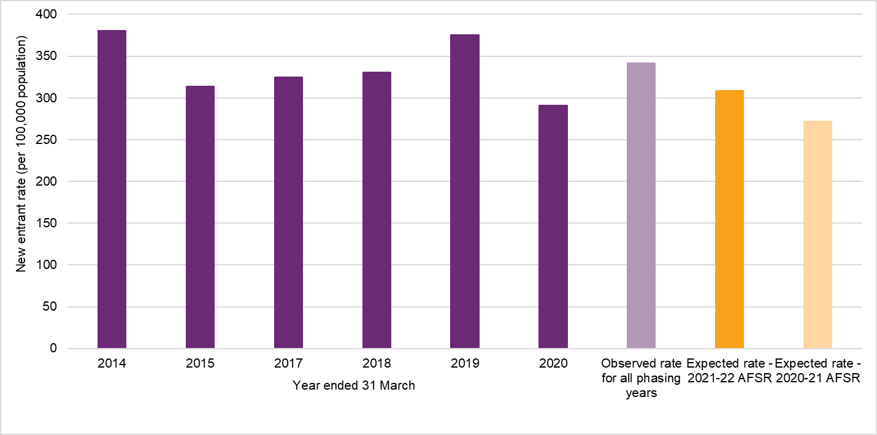
The new entrant assumption adopted at this review (308 participants per 100,000 population aged between 0 and 64) is 14% higher than the rate assumed in the previous review. The approach to modelling new entrants has evolved over time in response to the emerging experience and available data. More recently, the observed experience of new participants entering the Scheme has stabilised such that the new entrant rates adopted at this review have been estimated solely based on a method which relies on currently observed experience, whilst noting that the assumed number of new participants in the medium to long term is below the number recently observed.

Participants leaving the Scheme
A proportion of participants leaving the Scheme was always expected within the original Scheme design, as one of the Scheme’s objectives is that early investment and intervention should lead to capacity-building and greater community and workforce participation where support from the NDIS is no longer required.
The experience of participants leaving the Scheme has changed materially since the last full review, which was completed in 2019 (using 2018 experience). The refinement to the eligibility reassessment process during 2019 and ongoing operational improvements since then have had a significant impact on the underlying experience, whilst the COVID-19 lockdown restrictions have had a significant though transitory impact on the experience since 2020.
The actual overall rates of participants leaving the Scheme from 2019 to 2021 were much lower than the long-term rate of 1.67% per annum adopted in the 2020–21 AFSR. As a result, overall rates of participants leaving the Scheme have been revised downwards from 1.67% to 1.19% (based on the participant mix at 30 June 2021).

Participants with supported independent living
Since the previous review, analysis has been undertaken to understand the composition of the participants new to supported independent living (SIL) arrangements between those participants transitioning from existing schemes and those who were new to disability supports.
Figure 3.2.1C shows that the revised projection is slightly higher than at the previous review. This reflects a higher number of participants having moved into SIL arrangements due to the clearing of backlogs of home and living decisions. While this initiative is well progressed, at this review a higher number of participants has been assumed to move into SIL in the future compared with the 2020–21 AFSR (with an increase of approximately 300 to 400 additional SIL participants per year).
Figure 3.2.1C: Experience to date and projections of participants new to SIL
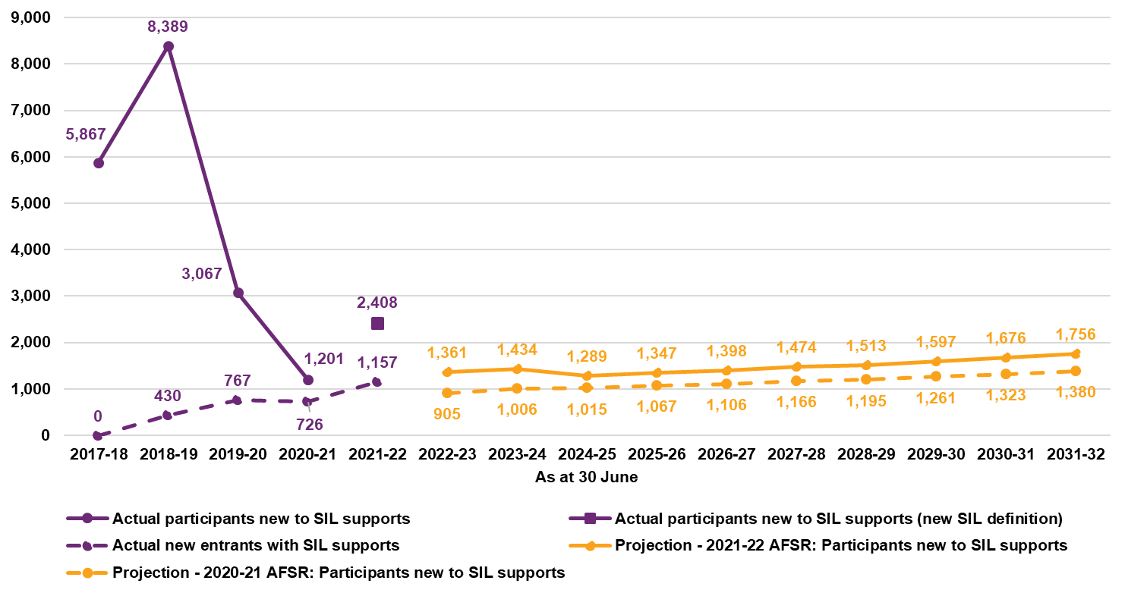

Payments experience 2021–22
From 1 July 2021 to 30 June 2022, $27.6 billion in payments for supports were made on a cash basis across all participants. This was $1.2 billion or 4.2% less than the 2020–21 AFSR estimate of $28.8 billion. Total payments on an accrual basis were $28.6 billion, 2.0% lower than the 2020–21 AFSR estimate of $29.2 billion.
A significant component of the variance is estimated to be related to systemic impacts from COVID-19 on the supply of and demand for disability support services. Supply-side impacts that are likely to have driven lower payment experience include disability workforce shortages, mobility restrictions and workforce absenteeism from COVID illness and isolation requirements. Demand-side impacts include participant or family wariness of accessing supports due to COVID exposure and participant COVID infection and illness.
The impacts of the primary drivers of the variance in the Scheme expenses for 2021‒22 are summarised in Table 3.2.1F.
Table 3.2.1F: Estimated drivers of variation in Scheme expenses in 2021‒22
Drivers of variation | Estimated  impact ($m) | Estimated impact (%)
Participant numbers | +15 | -1%
Participant mix | -126 | 10%
Systematic supply and demand impacts | -440 | 37%
Provider compliance | -65 | 5%
Residential aged care variance | -175 | 15%
Total explained | -792 | 66%
Unexplained variation | -413 | 34%
Total variation (Actual less expected on cash basis) | -1,204 | 100%
In summary, the variance in Scheme expenses for 2021‒22 compared with expected is explained by:
- systematic disruptions to demand for and supply of services (estimated to be $440 million or 37% of total variation)
- a lower than expected expense for participants in residential aged care (estimated to be $175 million or 15% of total variation)
- the mix of new entrants which have a relatively low per participant expense, (partially offset by higher than expected participant numbers overall) – estimated to be $111 million or 9%
- activities to address provider compliance
- other items which are not explained as they are not able to be quantified.

Average payments per participant
Despite the lower than expected Scheme expenses in 2021‒22, the average payment increased between 2020–21 and 2021‒22 by 1.6% to about $55,200 per participant. This is lower than the increases observed in previous periods. Average payments have increased by 9.2% p.a. over the last 3 years (Figure 3.2.1D).
Figure 3.2.1D: Average annualised payments over time ($)
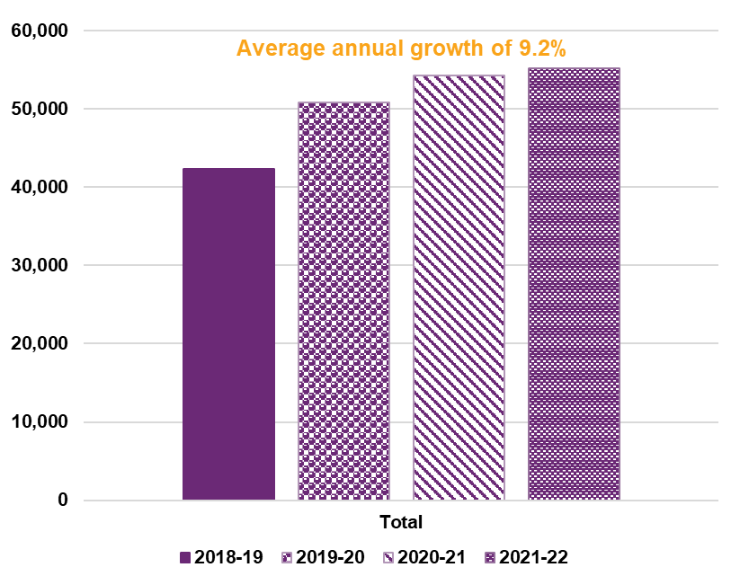
Over the past 4 years, the mix of participants in the Scheme has changed. That is, as the Scheme has rolled out across the country, the proportion of participants by different characteristics has changed. In particular, the proportion of children in the Scheme at June 2022 is much higher compared to the proportion at June 2019, and the proportion of participants with SIL in the Scheme at June 2022 is lower compared to the proportion at June 2019.
In 2021‒22, average payments increased by 5.1% for participants with SIL and 3.6% for participants without SIL compared to 1.6% overall. Over the last 3 years, the average annualised payment has increased for participants with SIL by 11.9%, and the average annualised payment has increased for participants without SIL by 14.4% as shown in Figure 3.2.1E.
Figure 3.2.1E: Average annualised payments over time by SIL status ($)
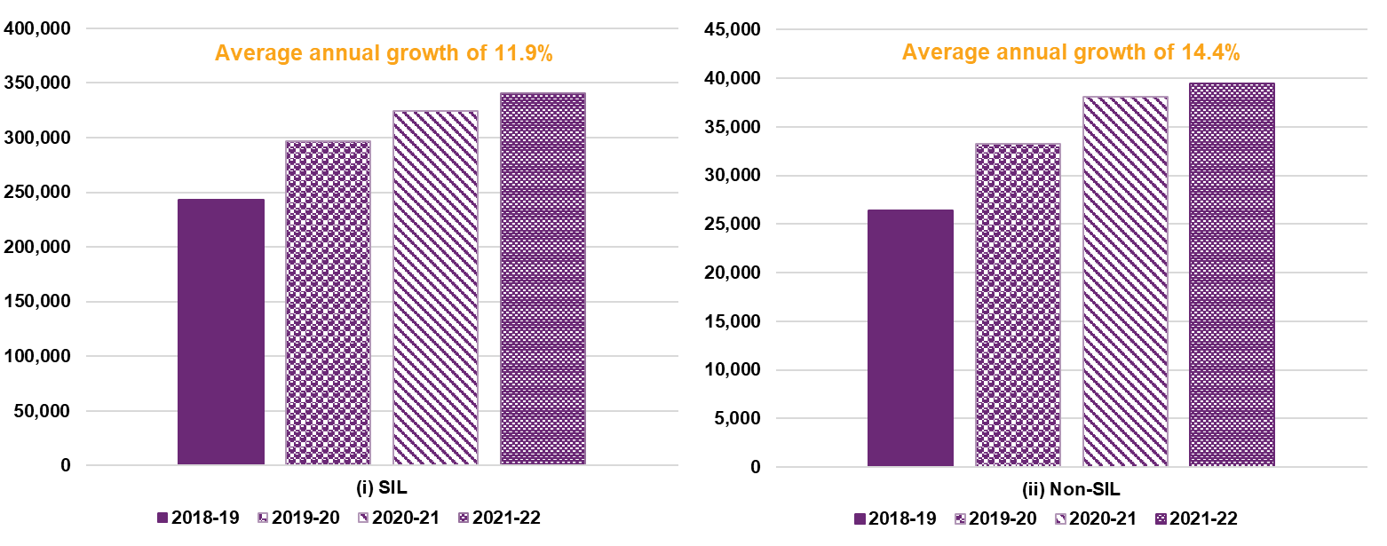
Figure 3.2.1F shows the change in average payment over time by age band for participants without SIL. The average annual increase over the last 3 years for participants aged 0 to 14 was 10% p.a., the average increase for participants aged 15 to 24 years was 9% p.a., the average increase for participants aged 25 to 64 was 19% p.a., and the average increase for participants aged over 65 was 20% p.a. For participants without SIL, average payments have increased at a faster rate for adults (those aged over 25). This reflects a material increase in the hours of attendant care support these participants are receiving over time.
Figure 3.2.1F: Average annualised payments over time for participants without SIL by
age band ($)
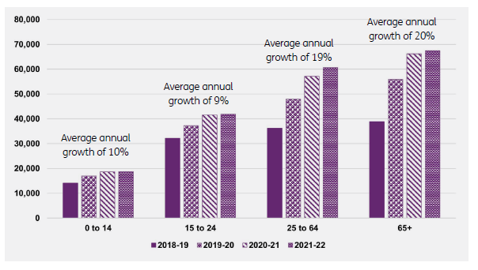
For age groups other than 25–64 years, the average annualised payment was very similar in 2021‒22 compared with 2020–21, while the age group 25–64 saw an increase of 6% in average payment.

Inflation
An analysis has been undertaken to quantify the components driving historic inflation. Table 3.2.1G sets out the high-level results of the experience analysis where inflation is measured as the yearly change in average payments.
Table 3.2.1G: Breakdown of past observed inflation
Item of inflation | 2018-19 | 2019-20 | 2020-21 | 2021‒22 | Average  2018-22 | Average 2019-22
Observed inflation | 9.2% | 19.7% | 6.9% | 1.6% | 9.2% | 9.2%
less normal inflation and price reviews | 6.4% | 12.0% | 2.1% | 2.4% | 5.6% | 5.4%
less change in mix | 2.4% | -4.7% | -6.6% | -4.5% | -3.5% | -5.3%
Additional inflation | 0.5% | 12.4% | 11.4% | 3.7% | 7.0% | 9.0%
Figure 3.2.1G sets out the quarterly rate of annualised plan inflation over the 3 years to June 2022, as well as the rolling 12-month average plan inflation rate. Total plan inflation is divided into inflation which occurs at plan review (interplan inflation) and inflation which occurs within a plan between reviews (intraplan inflation). At June 2022, total plan inflation for the previous
12-month period was 8.9% p.a., of which intraplan inflation made up 6.4% p.a. The rate has increased over the past 6 months, having been 5.6% for the 12 months to 31 December 2021.
Figure 3.2.1G: Plan inflation for active participants
Plan inflation was also high over the preceding 2 years, averaging 22.5% in 2019–20 and 9.3% in 2020–21. This has been observed in other social insurance schemes in Australia and New Zealand, in the absence of substantial legislative or policy change.

Inflation assumptions
Normal inflation assumptions have been selected based on the increases in price limits from the 2022–23 Annual Pricing Review (2022–23 APR) and on recent economic forecasts and inflationary expectations.
Additional inflation assumptions have been selected which are higher than those in the 2020–21 AFSR, with the exception of the first 2 years of the projection. However, they are still well below the average historical experience of the Scheme.
In 2022–23 and 2023–24, it is expected that additional inflation will continue to be constrained by supply-side impacts of workforce shortages and also potentially by COVID-19 related effects. These constraints are expected to subside by 2024–25 and a higher rate of additional inflation is assumed, albeit lower than the rates observed in 2019–20 and 2020–21. This level of inflation is then expected to decrease marginally in 2025–26 before reducing to a long-term rate of 2% per annum. The long-term rate of additional inflation reflects that under the current parameters of the Scheme, inflationary pressures in excess of the general economic environment are likely to reduce as the Scheme continues to mature but will remain present.
Normal inflation has been combined with additional inflation rates to calculate total inflation. Table 3.2.1H details the underlying normal and additional inflation assumptions adopted for each projection year, with a comparison made to historic inflation experience. The adopted inflation assumptions compared with those from the previous review are shown in Figure 3.2.1H.
Table 3.2.1H: Comparison of historic inflation experience and adopted total inflation
Inflation on payments | Actual | Projection year
Inflation on payments | Average  2019-22 | 2022-23 | 2023-24 | 2024-25 |  | 2025-26 | 2031-32
June 2021‒22 AFSR
Normal inflation (inc APR) | 5.4% | 7.2% | 2.6% | 3.6% |  | 3.6% | 3.3%
Additional inflation | 9.0% | 3.4% | 3.0% | 6.0% |  | 5.0% | 2.0%
Total inflation (excl. change in mix) | 14.5% | 10.6% | 5.6% | 9.6% |  | 8.6% | 5.3%
Change in mix | -5.3% | -2.7% | -3.3% | -2.5% |  | -1.9% | -0.4%
Total inflation (incl change in mix) | 9.2% | 7.7% | 2.1% | 6.9% |  | 6.6% | 4.8%

Figure 3.2.1H: Comparison of adopted total inflation with previous review
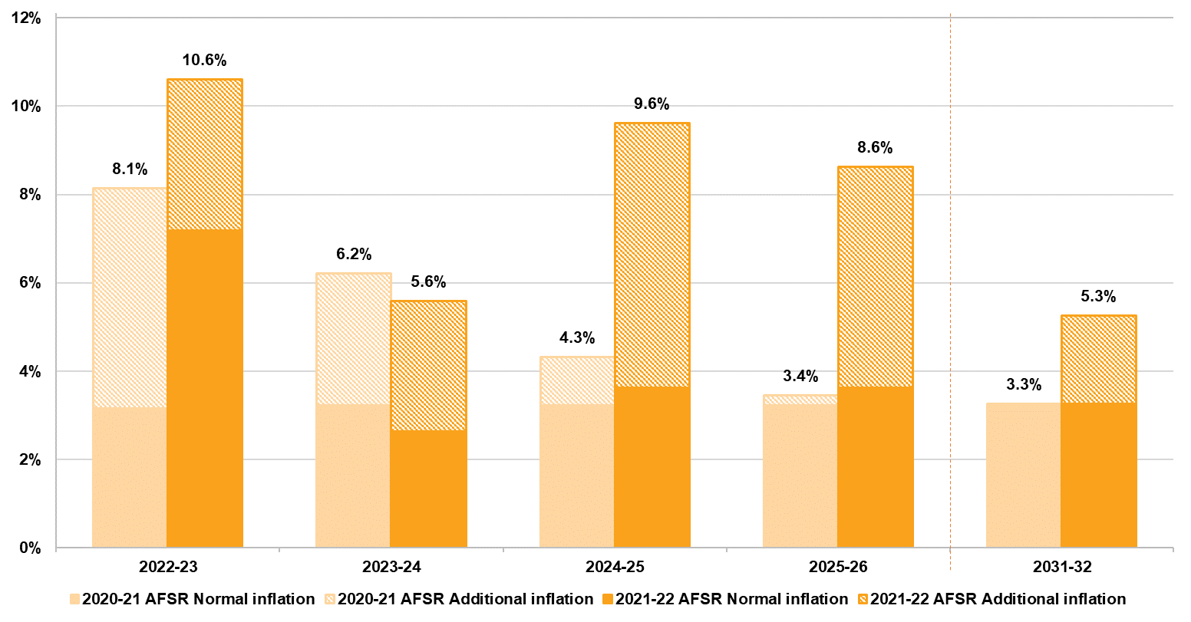
Overall higher normal inflation is adopted reflective of the 2022–23 APR and higher forecasts in relation to future inflation. Higher additional inflation assumptions (in addition to normal inflation) have been set taking into consideration:
- a deeper analysis of additional inflation has been undertaken, identifying various sources. This indicates that additional inflation has been driven by changes in participant level of function, a broadening in the types of supports utilised by participants, and an increase in the volumes of supports utilised, particularly in relation to attendant care. This analysis shows more detail regarding the forces driving the additional inflation and provides a stronger justification for the higher additional inflation assumed.
- in their Review of NDIA actuarial forecast model and drivers of Scheme costs, Taylor Fry concluded that a projection of costs which is higher than the 2020-21 AFSR model would not be unreasonable. Taylor Fry noted that the allowance for additional inflation in the 2020-21 AFSR was likely to be on the low side given the significant upside risk related to inflation facing the Scheme.
- observed additional inflation in payments over 2021‒22 was 5.4%, and there is reasonable evidence that growth in payments would have been higher had it not been for both demand-side and supply-side effects arising from COVID-19. These effects have been estimated to have reduced payments by approximately, 2–3%, meaning the underlying additional inflation for 2021‒22 was approximately 7–8%, considerably higher than future assumptions at the previous review.
- current plan decision-making resulted in increases in plans of approximately 9% over 2021‒22, with an annualised rate of 12% over the quarter to June 2022. These figures included price increases of approximately 2%, meaning that real growth in plan values was approximately 7% over the 2021‒22 year and 10% in the quarter to June 2022, rates which are also considerably higher than future inflation assumptions at the previous review.
- any reduction in inflation from current levels will necessarily require fewer plan increases and/or more plan reductions relative to current, and there remains considerable uncertainty about the likelihood of this in the short to medium term as there are few substantive legislative, policy or operational responses currently planned to mitigate these plan increases. Furthermore exploratory initiatives in identifying and assessing fraud and compliance matters impacting the Scheme have commenced. Due to these initiatives being in their preliminary stages of implementation, their impact on inflation levels was unclear at the time of assumption selections. These initiatives will continue to be closely monitored and will be appropriately factored in at future reviews as greater clarity on the estimated impact is better understood.

Operating expenses
The NDIA maintains a detailed activity-based costing of its operations. The operating expenses adopted in this AFSR are based on this internal model. In 2021‒22 actual operating expenses (at $1,590 million) were lower than budgeted in the Portfolio Budget Statements (PBS) by $83 million, or 4.9% (Table 3.2.1I). In 2021‒22 operating expenses represented 5.6% of Scheme expenses for participant supports, which is lower than the 2020-21 result of 6.3% of Scheme expenses.
Table 3.2.1I: Actual operating expenses compared to expectations for 2021‒22
Operating expenses – full year to 30 June 2022 | $m
Actual | 1,590
Budget (from 2022–23 PBS) | 1,672
Difference (Actual – Budget) | -83
Operating expenses, as a percentage of Scheme expenses, are projected to reduce over time, as the relative cost of bringing new participants into the Scheme is expected to reduce, and because the average payment per participant is expected to increase at a faster rate than the inflation rate assumed to underpin the Scheme’s operating expenses. Operating expenses are forecast to be 5.2% of Scheme expenses for participant supports in 2022–23, reducing to 4.2% in 2025–26, and 3.4% in 2029–30.
The forecast operating expenses of $1,780 million in 2022–23 are approximately $190 million (or 12%) higher than actual operating expenses in 2021‒22 (and $107 million higher than the amount allowed for in 2021‒22 in the 2022-23 PBS). However, this variance is regarded as relatively small in the context of the sustainability risks relating to Scheme expenses which are identified in this report, and the recommended operating expense range in the 2017 Productivity Commission study report, of 7 to 10% of Scheme expenses. In adopting an estimate which is considerably higher than both the actual and budgeted expenses in 2021‒22, it is noted that significant investments are required, to develop stronger noncompliance payment controls and fraud mitigation measures, as well as to achieve a continued focus on improvement in participant experience (as prescribed by the Participant Service Guarantee (PSG) which was legislated in 2022). This investment needs to take the form of frontline capability and capacity, as well as strategic investments in broader organisation capabilities.

Scenario analysis and uncertainty
The projections presented in this report represent the ‘baseline’ estimate of Scheme population and expenses. There is considerable uncertainty in relation to these projections, and the actual expense may vary from the baseline projections, possibly significantly.
In the 2020‒21 AFSR, a set of combined scenarios were used to illustrate a plausible range of projected Scheme expenses. Since the previous review, a stochastic model of the AFSR projections has been developed which provides a more rigorous approach to measuring the level of uncertainty in the projected Scheme expenses. The stochastic simulation results in the projected Scheme expenses are shown in Figure 3.2.1I.
Figure 3.2.1I: Projected total annualised Scheme expenses ($m) with uncertainty bands
The 90% confidence interval for the range of expected outcomes for projected Scheme expense is:
- $31.8 billion to $37.4 billion for the year ending 30 June 2023, a range of $5.6 billion (16% of the baseline estimate)
- $154.8 billion to $192.7 billion for the 4 years to 30 June 2026, a range of $37.9 billion (23% of the baseline estimate)
- $73.0 billion to $116.78 billion for the year ending 30 June 2032, a range of $43.8 billion (49% of the baseline estimate).
For any given level of confidence, the range of expected outcomes widens with the duration of the projection, reflecting the increased uncertainty of assumptions and future experience in the longer term.
The key risks determined as part of the risk analysis were additional inflation, model specification risk, normal inflation, the numbers of new entrants to the Scheme and projected plan utilisation.

Outcomes
A holistic assessment of Scheme financial sustainability requires consideration of both the costs of participant funding and the associated benefit the funding provides for participants in enabling them to pursue the desired goals and outcomes.
In the NDIA Corporate Plan 2021‒25, Aspiration 1 is ‘a quality experience and improved outcomes for participants’. Aligned to Aspiration 1 are specific performance metrics, such as the proportion of participants in work and the proportion of participants involved in community and social activities. The NDIA had a target of 24% of working-age participants in paid employment by June 2022, with the achieved result of 23% slightly below this target. For participants aged 15 and over, the percentage of participants actively involved in the community was 43% compared to the 2021‒22 target of 48%.
The NDIS Outcomes Framework also measures outcomes for the families and carers of participants, recognising that the outcomes for people with a disability and the people who support them are likely to be closely linked. The percentage of parents/carers of participants in a paid job is 50% compared to the 2021‒22 target of 49%.
On the whole, perceptions of the Scheme have been positive, with participants and their families/carers more likely to report that the Scheme had helped them in various areas of their lives the longer the participant was in the Scheme.
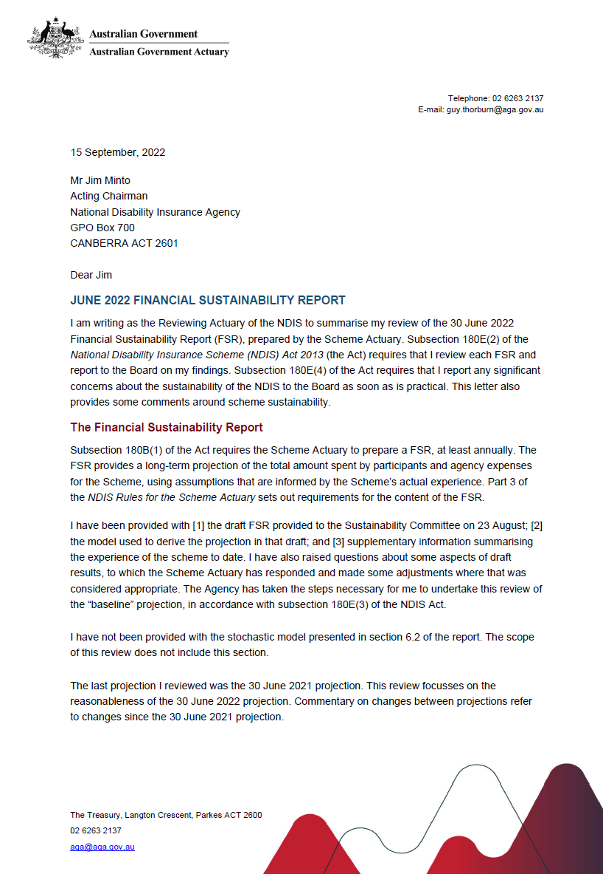
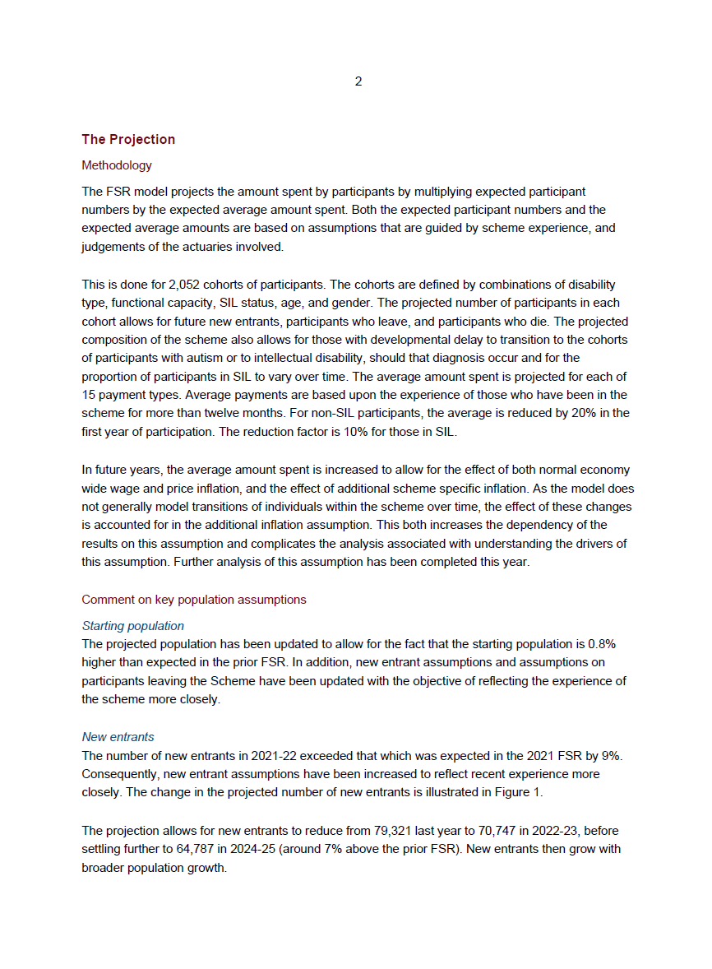
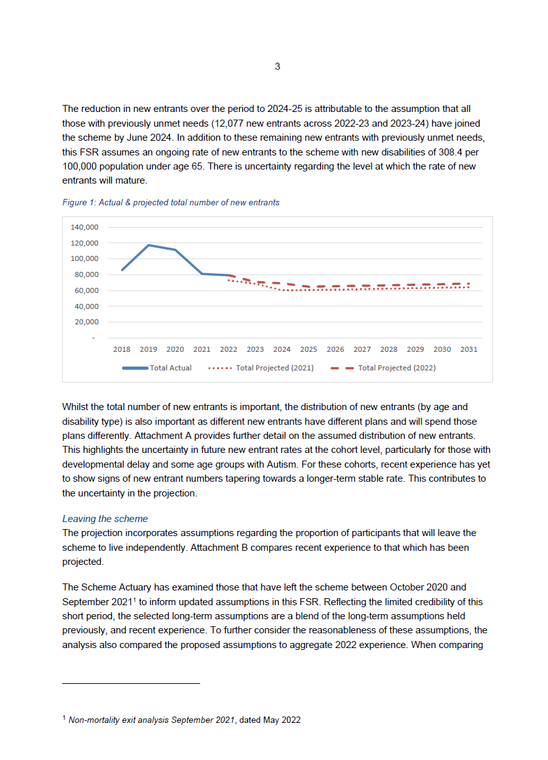

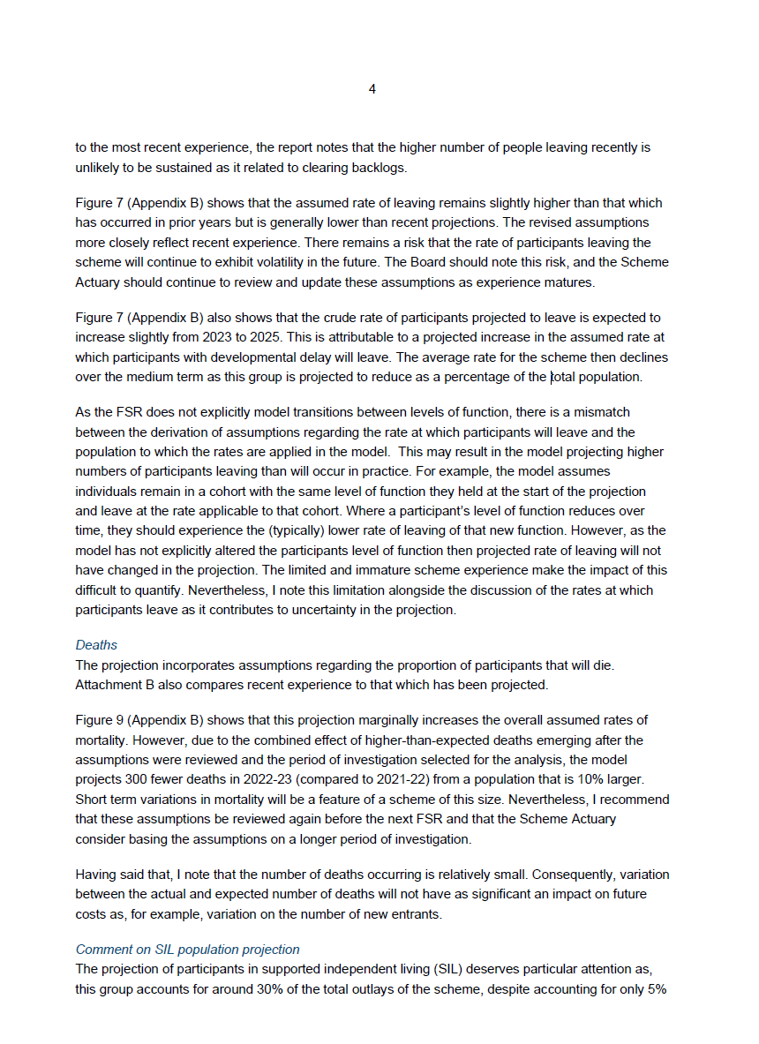
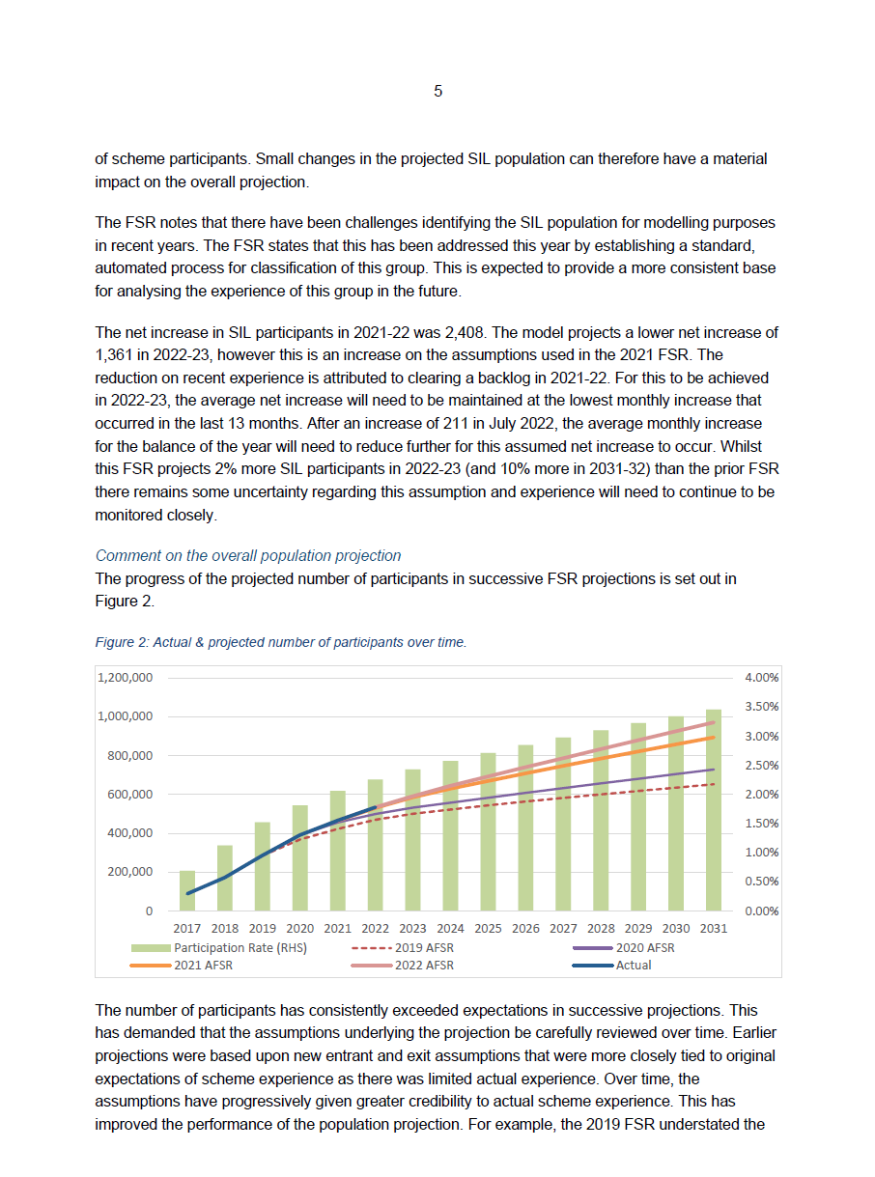

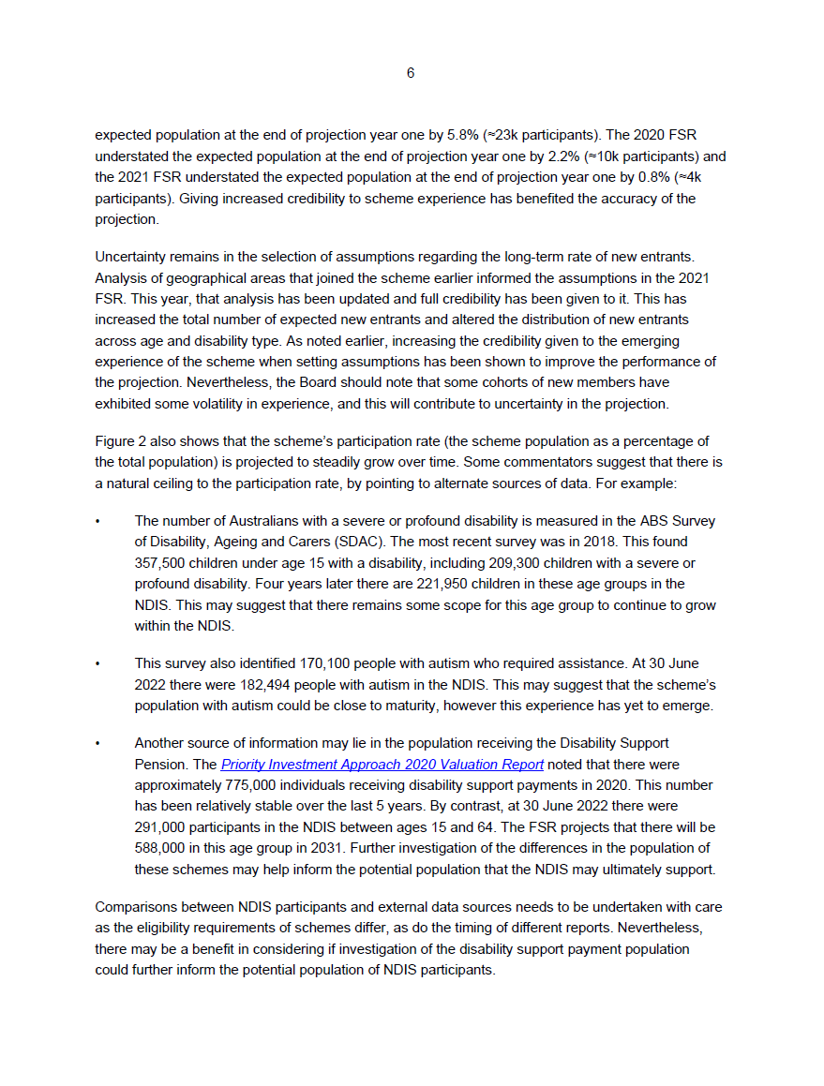

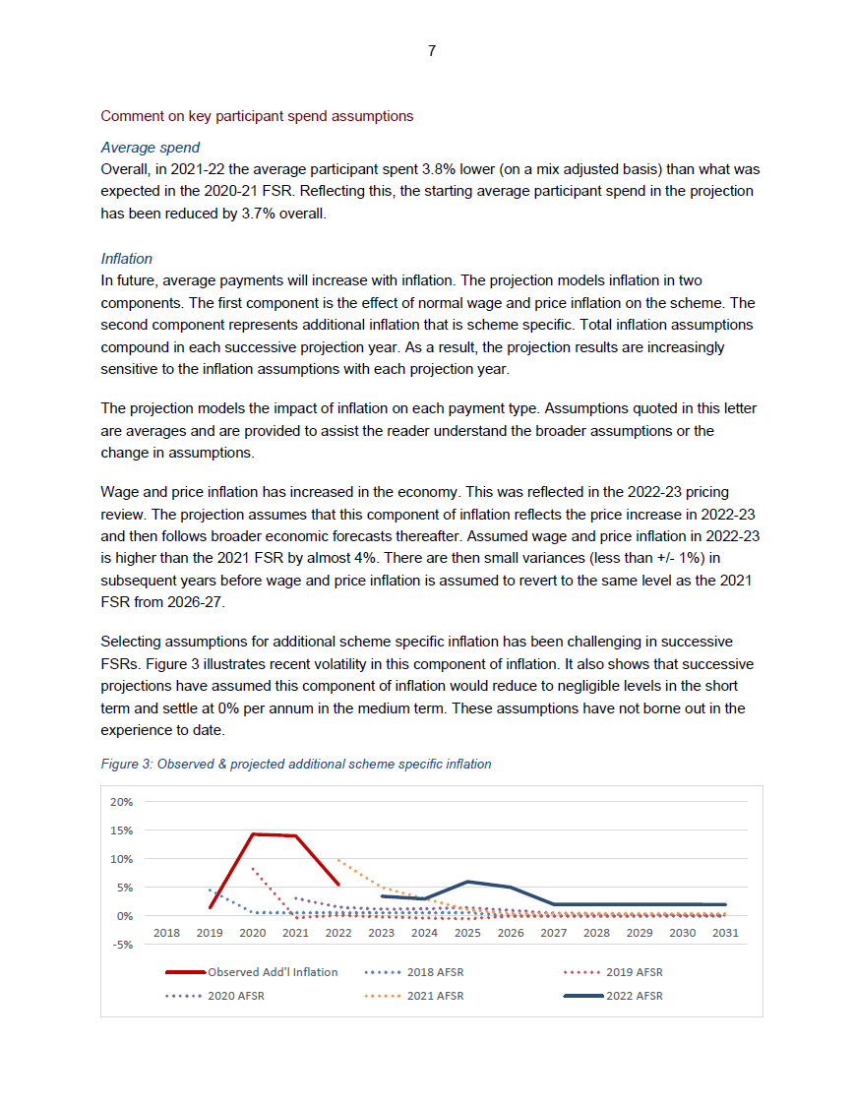
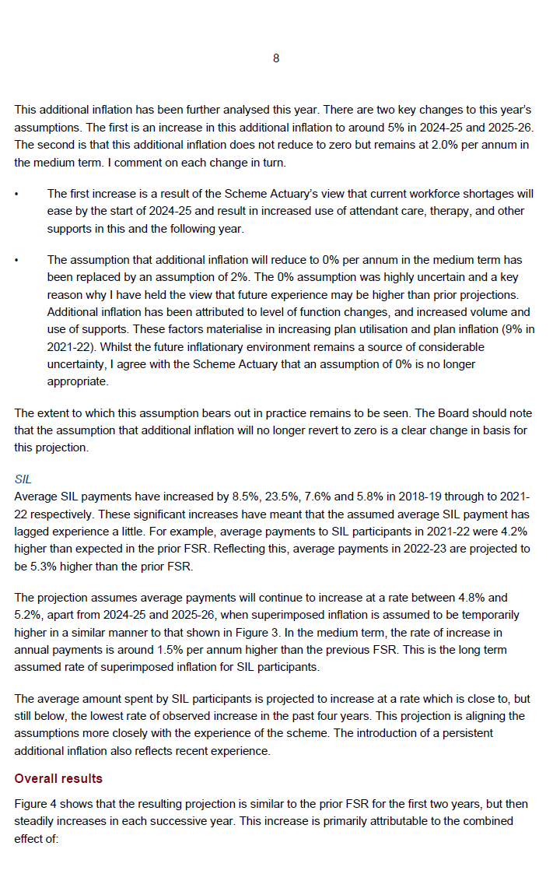
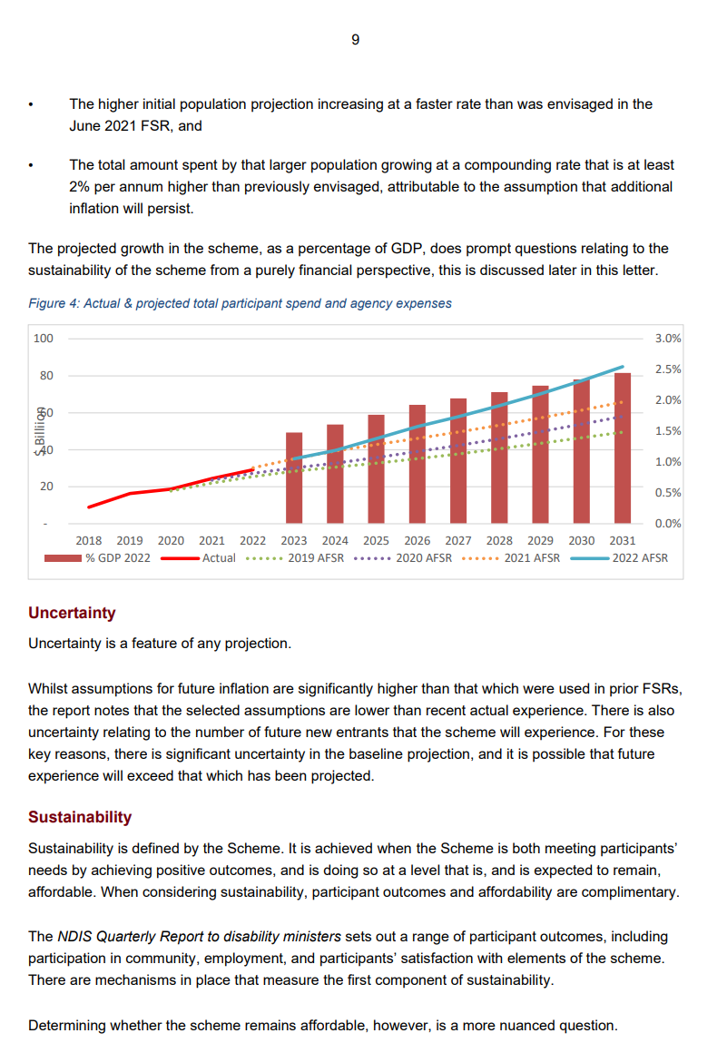
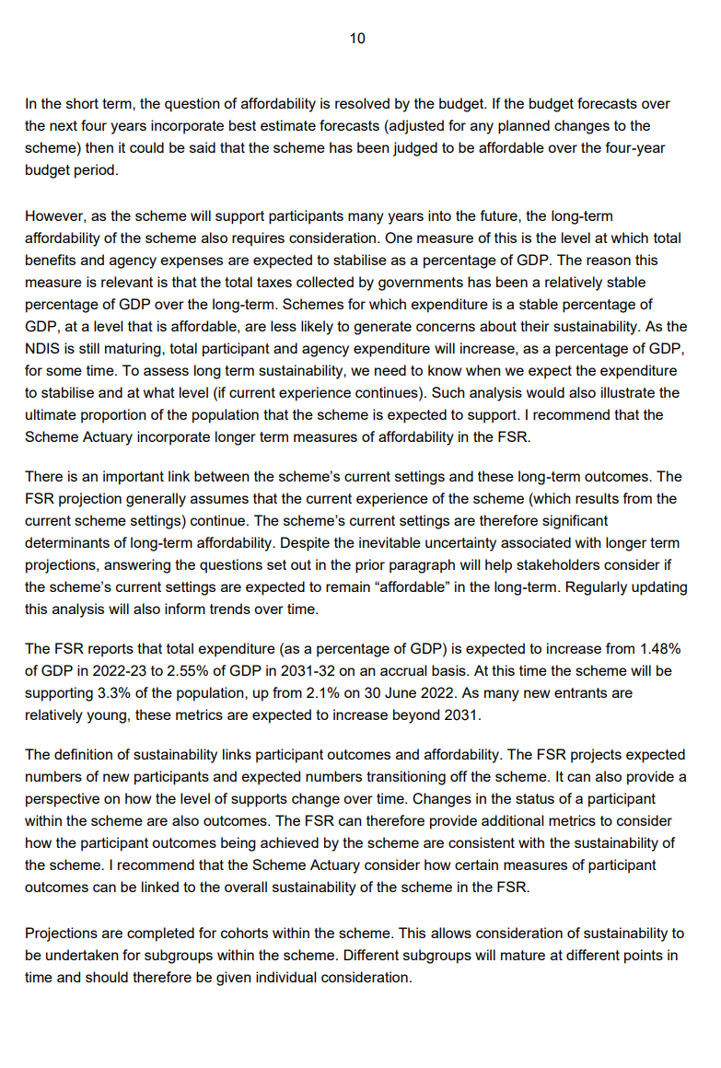
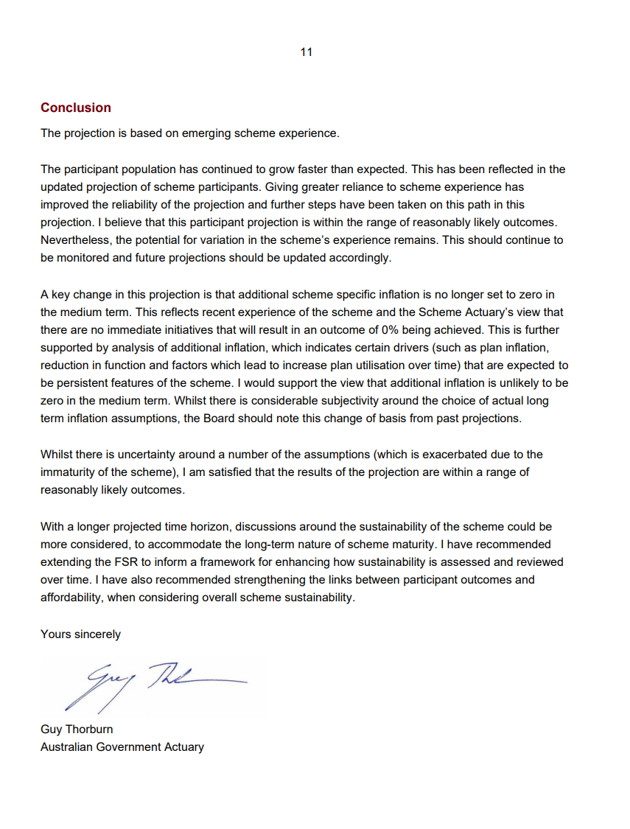

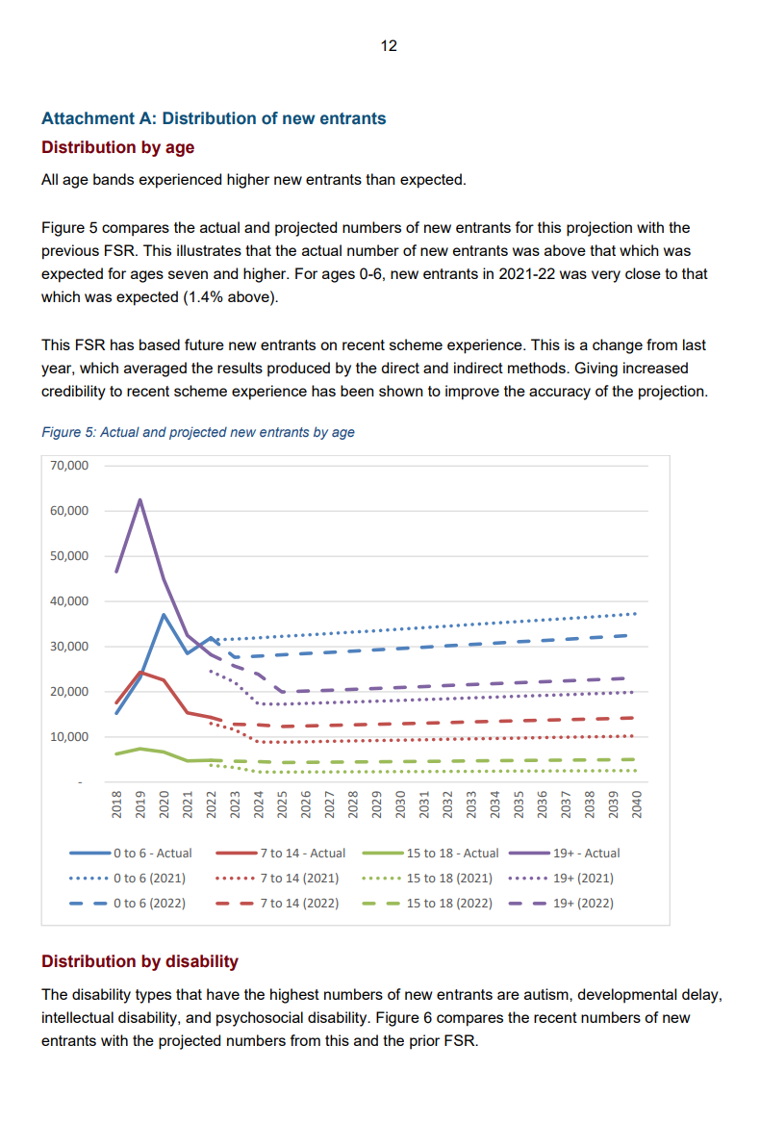
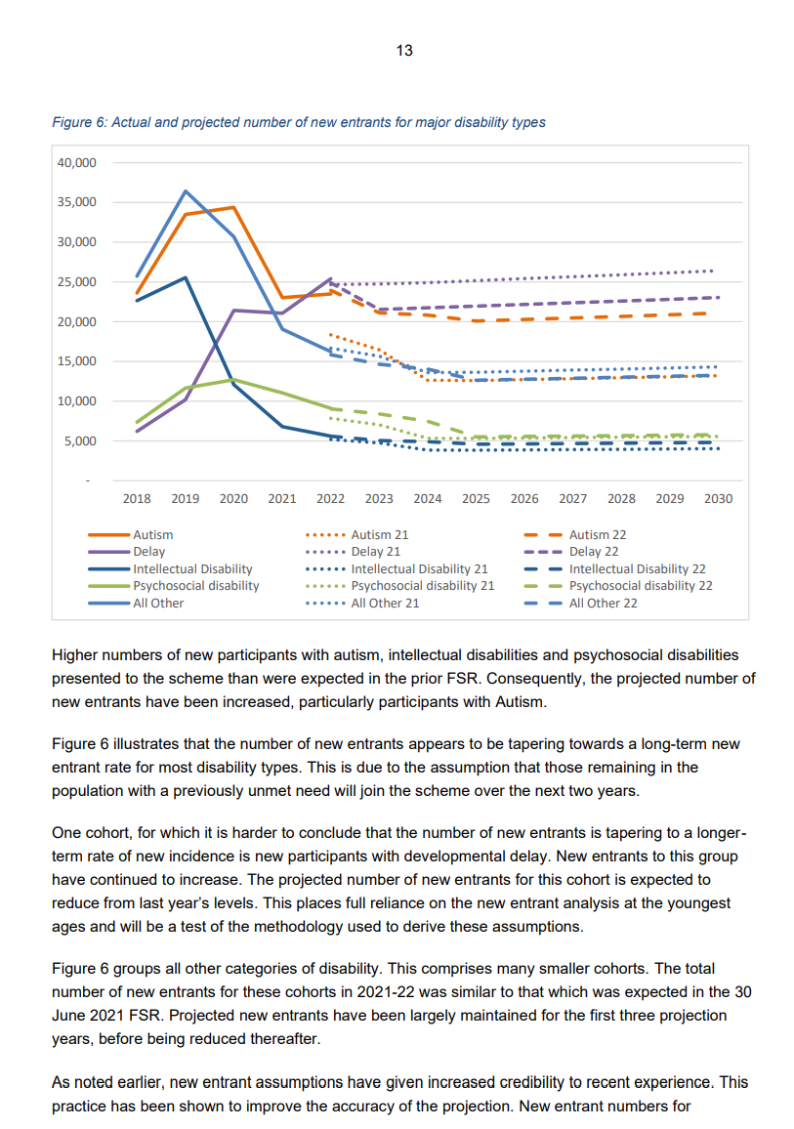
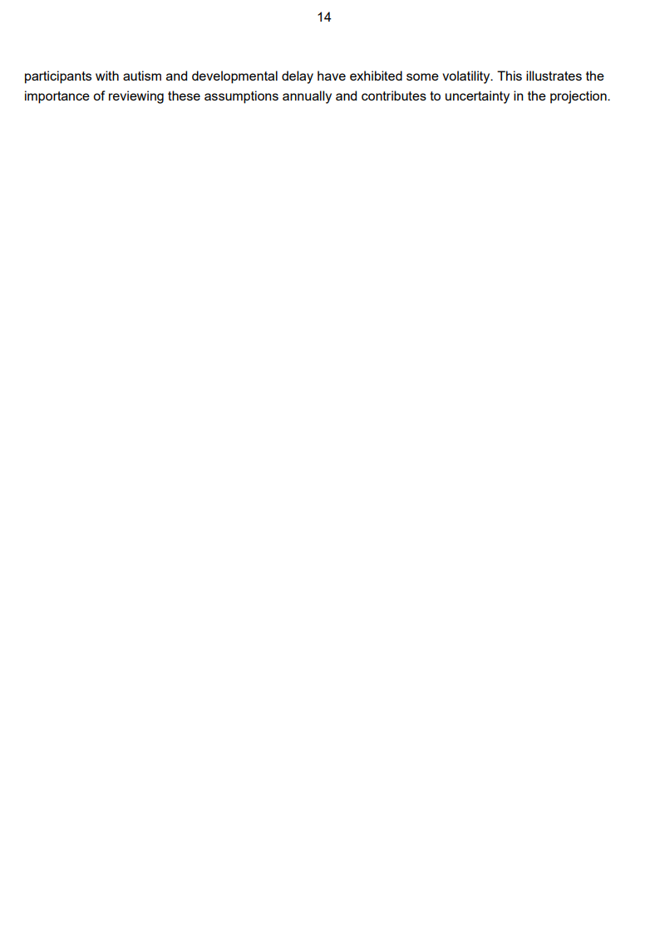
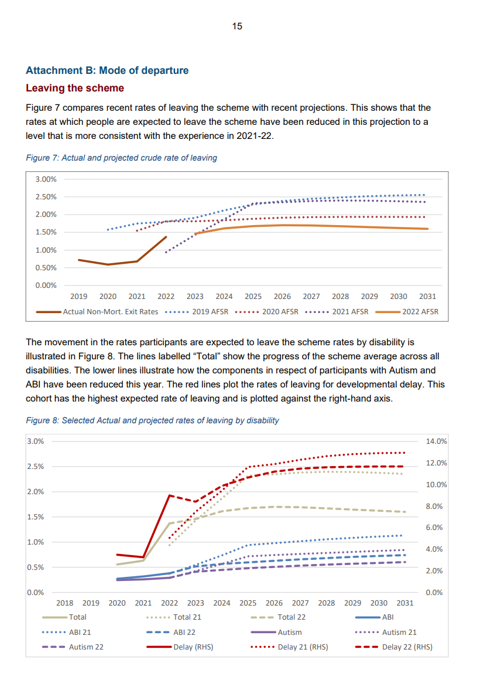
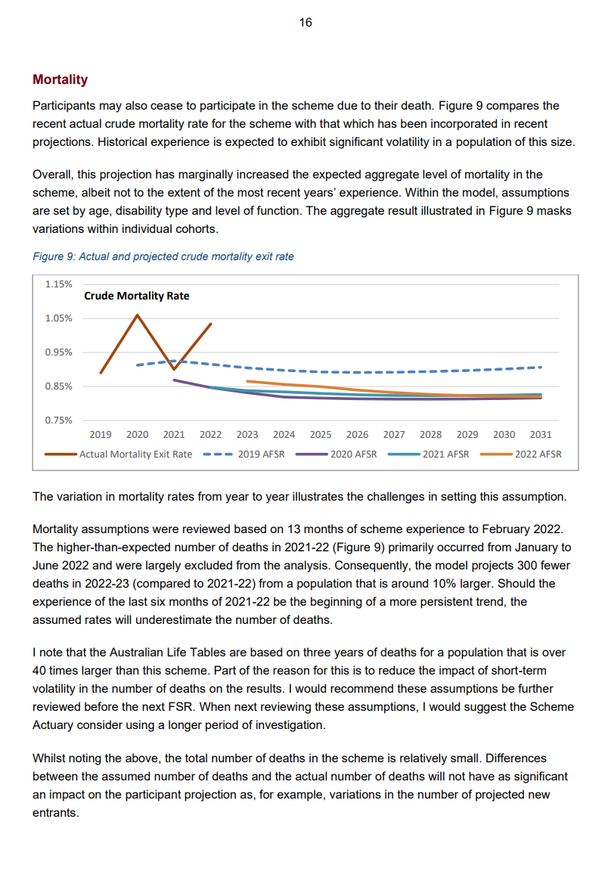
  - Annual performance statements
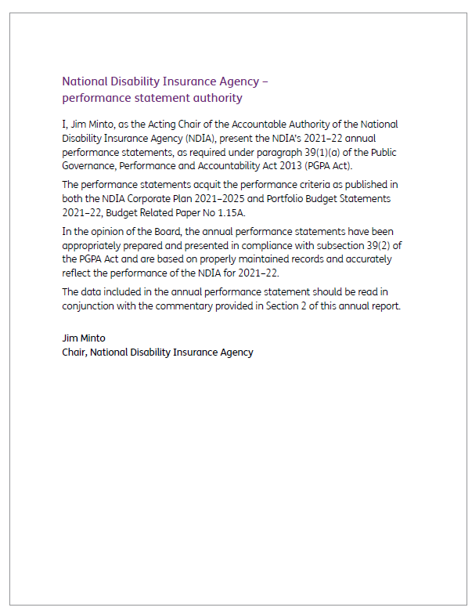

Introduction
As a Commonwealth entity, the NDIA is subject to the Commonwealth Performance Framework. The framework has 3 key elements as outlined in Figure 3.3A.
Figure 3.3A: Commonwealth Performance Framework
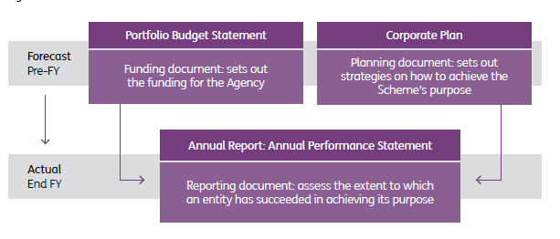
The annual performance statements are one of the 3 core elements of this performance framework. The NDIA Portfolio Budget Statements 2021–22 (PBS), published in Budget Related Paper No 1.12, and the NDIA Corporate Plan 2021–25 constitute the remaining 2 components.

Structure and content
The annual performance statement is structured around the metrics outlined in section 5 of the NDIA Corporate Plan 2021–25. The metrics outlined in the Corporate Plan allow the NDIA to track progress against the strategy outlined in the Corporate Plan.
The structure of the performance metrics and targets provides a high-level scorecard of our progress towards delivering enhanced participant outcomes, while maintaining long-term financial affordability. To assist in understanding the results, the individual metrics have been categorised as follows:
- Participant and Scheme outcomes
- Participant and stakeholder sentiment
- Scheme financial sustainability and integrity
- Scheme operating performance
- Market performance
- Agency operating performance
The metrics are also designed to provide a longitudinal understanding of the performance and impact of the Scheme.
The selection of these metrics addresses how the Agency will achieve its purpose and has been cross-referenced to the outcomes published in the 2020–21 PBS.
The statement outlines our results and analysis against each performance metric or target.

Performance measurement
The NDIA uses multiple metrics to assess its performance towards achieving its purpose statement contained in the NDIA Strategy Framework. The metrics in the NDIA Corporate Plan 2021–25 describe the NDIA’s long-term focus.
Performance is monitored regularly with monthly reports being presented to both the Board and the Executive Leadership Team.
The result against each of the specified metrics comes from 1 of 5 primary sources within the Agency:
- Actuarial analysis of Scheme administrative data
- Audited NDIA financial statements
- The APS annual census survey
- Participant satisfaction and outcomes surveys
- NDIA employee systems.

Performance results

Participant and Scheme outcomes
Participant and Scheme outcomes are measured by:
- participant employment rate (%)
- participant social and community engagement rate (%)
- families and carers employment rate (%)
- children benefiting from the Scheme and no longer needing supports (%)
- socio-economic equity.
Table 3.3A: Participant and Scheme outcomes
Performance metric | 2020-21 Result | 2021–22 Result | 2021–22 Target | Analysis
Participant employment rate (%)  Baseline: 22% | 22% | 23% | 24% | Results are sourced from the Short Form Outcomes Framework questionnaires. The metric is calculated at 30 June 2022 for participants who have been in the Scheme for at least 2 years, and are aged between 15 and 64 years.  The underlying rate of participants employed has remained relatively similar to the baseline result. The ongoing impact of COVID-19 and associated social restrictions could be partly attributable to the target not being met.
Participant social and community engagement rate (%)  Baseline: 36% | 45% | 43% | 48% | Results are sourced from the Short Form Outcomes Framework questionnaires. The metric is calculated at 30 June 2022 for participants who have been in the Scheme for at least 2 years.  The overall result is lower than the previous year. However, there has still been improvement from the baseline. The ongoing impact of COVID-19 and associated social restrictions can be partly attributable to the target not being met this year.
Families and carers employment rate (%) | 48% | 50% | 49% | Results are sourced from the Short Form Outcomes Framework questionnaires. The metric is calculated at 30 June 2022 for participants who have been in the Scheme for at least 2 years.  The overall result is higher than the target. Supports provided to participants who have been part of the Scheme for more than 2 years have enabled their families and carers to increase participation in employment.
Children benefiting from the Scheme and no longer needing supports (%) | 4.5% | 5.8% | 5.5% | This performance measure was introduced to the Corporate Plan in  2021–22 and includes all children aged 0 to 14 who have been helped by the Scheme under the early childhood approach and are now no longer receiving support.  Effectiveness of early childhood intervention supports covered by the Scheme increased above target. In particular there was increased focus on children who have received early intervention support and can now be supported by mainstream and community services outside of the NDIS.
Socio-economic Equity | 106% | 104% | 100% | The purpose of this metric is to measure whether participants are being treated fairly and equitably, in terms of the supports they are receiving, across different socio-economic groupings. In particular, the metric measures whether plan budgets are consistent across different socio-economic areas within Australia.  The result indicates that participants in higher socio-economic areas continue to receive higher plan budgets than those in lower socio-economic areas.

Participant and stakeholder sentiment
Participant and stakeholder sentiment is measured by:
- participant satisfaction (%)
- participant perception of choice and control (%)
- general community sentiment and confidence (%)
- provider sentiment and confidence (%).
Table 3.3B: Participant and stakeholder sentiment
Performance metric | 2020-21 Result | 2021–22 Result | 2021–22 Target | Analysis
Participant satisfaction (%) | 75% | 75% | 78% | The metric is calculated using the average of the 4 quarterly results published in the Quarterly Report to disability ministers.  The metric is sourced from the monthly participant satisfaction survey conducted by an independent provider, Australian Healthcare Associates.  Satisfaction is measured by the percentage of ‘good’ and ‘very good’ responses to the question regarding a participant’s experience with the NDIS.  The result is the weighted average result across the 4 stages of the participant pathway (access, pre-planning, planning, plan review).  Satisfaction with the Scheme has remained the same between this financial year and last financial year.
Participant perception of choice and control (%)  Baseline: 66% | 75% | 76% | 75% | Results are sourced from the Short Form Outcomes Framework questionnaires. The metric is calculated at 30 June 2022 for participants who have been in the Scheme for at least 2 years.  This positive result is a significant improvement from baseline and is slightly above target.
General community sentiment and confidence (%) | 68% | 67% | 70% | This metric is sourced using the results of the monthly community sentiment survey conducted independently by Hall & Partners.  The survey was initiated in August 2020 and is calculated using 4 measures of brand sentiment towards the Agency (reputation, trust, support and positivity). The metric is calculated using the average of the 12 monthly results.  While this year’s results are slightly lower, the monthly results since August 2020 (when the survey commenced), have been reasonably steady between 65% and 70%. Throughout the year the Agency increased engagement with participants and their families and carers, to co-design improvements to the NDIS.
Provider sentiment and confidence (%) | 62% | 54% | 62% | The provider sentiment and confidence survey is undertaken once a year (December 2021). The metric is calculated as the rating out of 10, converted to a percentage, for a provider’s overall experience with the Agency.  The result reflects the experience of 10% of all providers at the time the survey was conducted, with the result returning to  pre-pandemic levels.  Other factors that may have impacted the result include ongoing labour shortages, and increased compliance practice targeting payments.  The Agency is working on improving provider experience through the new CRM system (PACE), including through a new provider portal.

NDIS financial sustainability and integrity
Scheme financial sustainability and integrity is measured by:
- payment growth compared to healthcare and social assistance wages growth
- NDIS annual spend (Program 1.1) compared to PBS (%).

Table 3.3C: Scheme financial sustainability and integrity
Performance metric | 2020-21 Result | 2021–22 Result | 2021–22 Target | Analysis
Payment growth compared to healthcare and social assistance wages growth | 4.7 times | 1.8 times | <3  times | The payments inflation rate is calculated as the average payment for all participants in the 12 months to 30 June 2022 (with a 3-month delay), divided by the average payment for all participants in the 12 months prior.  The intention of this metric is to compare the actual inflation rate being experienced on participant payments to the relevant published industry wages inflation index. The results show that participant payment growth was within the target.  This metric does not allow for the changing mix of participants over time – that is, it does not take into account the high number of children entering the Scheme in recent years (noting children, on average, have lower payment amounts than adults). If the same group of participants is considered at the 2 time points (that is, participants who entered the Scheme in the most recent 12 months are excluded), payment growth would be 9.4 times the growth of wages in the healthcare and social assistance industry.
NDIS annual spend (Program 1.1) compared to PBS (%) | 107% | 98% | 100% | This metric is calculated as Scheme expenses in 2021–22 (Program 1.1) divided by expenses in the March PBS.  The result was within the target range.

NDIS operating performance
Scheme operating performance is measured by:
- Participant Service Guarantee timeframes met (%)
- plan utilisation by region (%).
Table 3.3D: NDIS operating performance
Performance metric | 2020-21 Result | 2021–22 Result | 2021–22 Target | Analysis
Participant Service Guarantee (PSG) timeframes met (%) | 47% | 51% | 100% | The calculation is based on PSG metrics always achieving the target.  The NDIA has been voluntarily measuring against the PSG timeframes as part of our quarterly and annual reporting. In 2021–22 the Agency reported against 17 of the 20 metrics. The quarterly reports to disability ministers track each metric, with metrics marked as ‘on track’ if more than 95% of decisions are made within the timeframe. The proportion of PSG metrics considered ‘on track’ increased throughout the year from 35% in July 2021 to 75% in June 2022. The average for the year was 51%.  The Agency continues to review and monitor progress towards achievement of the PSG timeframes. Specific action plans are in place to address PSG metrics that are currently not achieving targets. All PSG metrics will be used to measure performance in the 2022–23 period.
Plan utilisation by region (%) | 7.5% | 7.5% | <8% | This performance measure is the number of service districts, out of 80 in total, where the average utilisation rate of plan budgets is more than 10 percentage points lower than the national benchmark.  The purpose of this metric is to measure the extent of low utilisation (of plan budgets) across geographic regions. Low utilisation may be an indication of low levels of available supports and/or underdeveloped markets.  Overall, the result met the target. The Agency has undertaken a number of thin market interventions to improve utilisation.

Market performance
Market performance is measured by:
  - market concentration (%)
  - providers charging below the price limit (%).
Table 3.3E: Market performance
Performance metric | 2020–21 Result | 2021–22 Result | 2021–22 Target | Analysis
Market concentration (%) | 7.5% | 8.4% | <10% | This performance measure is the number of service districts, out of 80 in total, where 85% or more payments are paid to the top 10 providers.  The purpose of this metric is to measure the market concentration across geographic regions. Higher market concentration may be an indication of low levels of pricing competition (and higher prices), a lack of available supports and/or underdeveloped markets.  Overall, this result met the Agency’s target. The Agency has undertaken a number of thin market interventions to improve market concentration, which has kept the Agency within the target.
Providers charging below the price limit (%) | 24% | 22% | 24% | The purpose of this metric is to measure the efficiency of pricing and the level of competition between providers. The metric shows the percentage of providers who are charging 90% or less of the pricing limits in the latest NDIS Pricing Arrangements and Price Limits. A higher result implies higher levels of competition in the market.  The result is slightly lower than the target. Across the year the Agency has observed a larger proportion of payments at the price cap across a number of support categories including capacity-building, choice and control, consumables, and support coordination, which has driven this result. Further impacts of COVID may have resulted in more providers charging at the price limit rather than below.

NDIA operating performance
NDIA operating performance is measured by:
- NDIA spend (Program 1.2) compared to PBS (%)
- NDIA spend (Program 1.2) as proportion of Scheme spend (%)
- payment errors/anomalies (% of program outlay)
- staff engagement (%)
- staff wellbeing %
- staff with disability (%)
- Senior Executive Service staff with disability (%)
- female representation in the Senior Executive Service (%).
Table 3.3F: NDIA operating performance
Performance metric | 2020-21 Result | 2021–22 Result | 2021–22 Target | Analysis
NDIA spend (Program 1.2) compared to PBS (%) | 99% | 95.3% | 100% | This performance measure is the Agency expense (Program 1.2) divided by estimated Agency expenses in the Portfolio Budget Statements.  This result is within the acceptable range for the Agency’s activities conducted through the reporting period.
NDIA spend (Program 1.2) as proportion of Scheme spend (%) | 6.5% | 5.6% | 7% | This metric is calculated using the operating expense (Program 1.2) divided by the Scheme expense (Program 1.1). The purpose of this metric is to measure the efficiency of the NDIA in its administration of the Scheme.  The Agency has continued to focus on strategic improvements as per the Corporate Plan. The result is lower than target.  It should be noted that this percentage is a function of Scheme and Agency appropriation in the PBS, hence 7% may be above the Agency budget.
Payment errors/anomalies (% of program outlay) | 1.2% | 3.2% | <1% | This metric is calculated annually as the estimated financial impact of payment errors ($) as a percentage of total participant payments. The metric is calculated separately for registered providers and self-managed participants.  In 2020–21, the error rate was 1.3% for registered providers and 0.9% for self-managed participants.  In 2021–22 , the error rate was 2.6% for registered providers and 7.0% for self-managed participants.  The result is above target. The Agency has progressed strategies that aim to reduce the financial impact of payment errors and anomalies. Implementation of this work continues into 2022–23.
Staff engagement (%) | 74% | 76% | >78% | This metric is sourced from the annual APS Census survey. This survey is deployed in May/June each year.  The results of the June 2022 census indicate an increase in overall staff engagement from the previous year of 2%, and is 3% higher than the APS average. This result is slightly below target.
Staff wellbeing (%) | 66% | 71% | 70% | The measure’s result is sourced from the annual APS Census survey.  The result of the June 2022 census indicates an increase in overall staff wellbeing from the previous year and is 3% higher than the APS average. This result is above target.  Agency staff have had to adapt to working flexibly during the COVID-19 pandemic.
Staff with disability (%) | 17% | 18% | 17% | The measure’s result is sourced from the annual APS Census survey and is for Australian public servants and labour hire contractors. Being a leader in the employment of people with disability is important to the NDIA.  This result is above target and an increase of 1% from last year. Further, it is 8% higher than the APS average.  The Agency continues to deliver activities that place it as an exemplar within the APS.
Senior Executive Service Staff with disability (%) | 12% | 9% | 11% | This metric is calculated annually and is sourced from the annual APS Census survey.  The result is below target; however, this is 3 percentage points higher than the APS average.  Given this is a small population, small movements can have a significant impact on this result.  The Agency is committed to being an exemplar within the APS.  The Agency has maintained its affirmative measures, review of retention rates, and manager support. The Agency acknowledges that it can still do better.
Female representation in the Senior Executive Service (%) | 56% | 58% | 50% | This performance measure is calculated as the number of female staff in active SES positions (acting and permanent) divided by the total number of active SES positions.  The result is above target, with female representation in the SES increasing across the year. Agency activities have supported female representation in the SES.  The Agency will continue with its activities that support the whole-of-government actions for gender equality.

- Management and accountability
  - Governance
The governance model for the NDIA is set out in the NDIS Act.
The Agency is a corporate commonwealth entity under the Public Governance, Performance and Accountability Act 2013 (PGPA Act) with statutory authority under the National Disability Insurance Scheme Act 2013 (NDIS Act). The NDIS Act sets out the governance model for the Scheme.
Figure 4.1A: Agency governance diagram
    - Responsible Minister
As at 30 June 2022, the Hon Bill Shorten was the Minister for the NDIS. The Minister for the NDIS is responsible for administering the NDIS Act and, with the agreement of states and territories, exercises statutory powers, including the power to make delegated legislation in the form of NDIS Rules and the power to direct the NDIA. Senator the Hon Linda Reynolds CSC was Minister for the NDIS from 30 March 2021 to 23 May 2022. The Hon Bill Shorten was appointed Minister for the NDIS following the 2022 federal election.
    - Ministerial Council
The Ministerial Council comprises the Commonwealth, state and territory ministers responsible for disability, who meet as the Disability Reform Ministers. It considers policy matters that relate to the NDIS and advises the Commonwealth Minister about such matters in accordance with its functions as set out in section 12 of the NDIS Act.
  - The Board
The Board, in accordance with section 124 of the NDIS Act:
- ensures the proper, efficient and effective performance of the NDIA’s functions
- determines objectives, strategies and policies to be followed by the NDIA.
Board membership is determined by the responsible Commonwealth Minister in consultation with the states and territories.
As part of good corporate governance, the Board undertakes a review of itself and its committees each year. This includes an annual review of the Board committee charters to ensure correct alignment of committee functions in supporting the Board’s responsibility as accountable authority of the NDIA, and a review of committee memberships, which resulted in changes to committee membership to optimise operations. Board performance is also reviewed annually in accordance with the Board Charter.
    - Directors as at 30 June 2022


Mr Jim Minto, Acting Chair
Jim is Chair of Swiss Re Life & Health Australia Ltd, Chair of the Advisory Board of Swiss Reinsurance Company Limited Australia Branch and Chair of New Zealand based life insurer Partners Life Limited. He is also a Director of Mercer Superannuation Australia Ltd.
Jim retired as Group CEO and Managing Director of life insurer TAL (formerly TOWER Australia) in March 2015. Previously Jim was Group CEO of the Trans-Tasman TOWER Limited Group and also a Director of Dai-Ichi Life Asia Pacific. Jim has extensive experience in the financial services sector.
A Chartered Accountant, Jim retired in 2015 as Chair of the Association of Superannuation Funds of Australia and was a panel member of the Australian Government’s Review of Natural Disasters Insurance in 2011.
Qualifications: Chartered Accountant, Massey University.
Chair: Risk Committee and People and Remuneration Committee.
Member: Audit Committee, Sustainability Committee and ICT and Digital Committee.
Jim was appointed Acting Chair for the period 1 January 2022 to 31 March 2022. While in this role, he was not a member of the Audit Committee. Jim was reappointed as Acting Chair on 18 July 2022.

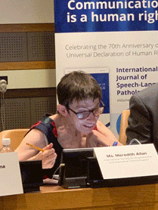
Ms Meredith Allan
Meredith is a former President of the International Society of Alternative and Augmentative Communication (ISAAC) − an organisation working to improve the lives of children and adults with complex communication needs. Meredith was the first president to speak via alternative and augmentative communication (AAC).
Meredith recently retired from her 30-year career in the Public Service but continues working as a communication assessor for Scope and as a lecturer for Deakin University, La Trobe University, University of Newcastle and University of Technology Sydney.
Qualifications: Bachelor of Economics and Bachelor of Arts, Monash University.
Member: Risk Committee and Audit Committee.

Ms Sandra Birkensleigh
Sandra is an experienced non-executive director, bringing extensive experience in the financial services and insurance industries to the NDIA. Sandra is the Chair of Auswide Bank Limited and currently holds board positions with MLC Limited, Horizon Oil Limited, 7-11 Holdings Limited (and its subsidiaries), Tasmanian Public Finance Corporation, Sunshine Coast Children’s Therapy Centre, Collection House Limited and Adore Beauty Group Limited.
Sandra is a member of the Council for the University of the Sunshine Coast, an independent member of the Audit Committee of the Reserve Bank of Australia, and Chair of the Audit and Risk Committee for the Public Trustee of Queensland. Sandra was formerly a partner with PricewaterhouseCoopers including its governance, risk and compliance practice.
Qualifications: Bachelor of Commerce from the University of New South Wales and a Chartered Accountant.
Chair: Audit Committee.
Member: Risk Committee and People and Remuneration Committee.

Professor Jane Burns
Jane is a health strategist with extensive experience in suicide prevention, mental health, wellbeing and innovation.
Jane is Chair of the National Advisory Committee for Open Arms – Veterans & Families Counselling; and Chair of Swiss 8. Jane is a Non-Executive Director with the Applied Positive Psychology Learning Institute and Mind Medicine Australia.
Jane is an experienced C-suite executive and was the founder and CEO of the Young and Well Cooperative Research Centre.
While working with industry and the non-government organisation (NGO) sector Jane has held joint appointments at the University of California, San Francisco and the University of Sydney. Jane is an enterprise professorial fellow at the University of Melbourne.
In recognition of her achievements in entrepreneurship Jane won the category of Social Enterprise for the 2015 Australian Financial Review and Westpac Group 100 Women of Influence, and was a Victorian Finalist in the 2017 Telstra Business Women’s Awards.
Jane is currently a strategic consultant to TogetherAI and Clarity+.
Qualifications: Doctor of Philosophy (PhD), Bachelor of Arts (Hons) (Psychology) from the University of Adelaide and Graduate of the Australian Institute of Company Directors (GAICD).
Member: ICT and Digital Committee and People and Remuneration Committee.

Mr Glenn Keys AO
Glenn has been a member of the NDIS Board since inception. Glenn has long been involved in efforts to improve the lives of people with disability through his involvement in the Special Olympics, the Down Syndrome Association and the disability housing sector.
Glenn has a health sector background as co-founder and Executive Chairman of Aspen Medical, and founder and Chairman of Project Independence, an initiative offering home ownership to people with disability.
Glenn was awarded an Officer in the General Division (AO) in the 2017 Queen’s Birthday Honours List for his distinguished service to disability, business and commerce, and as an advocate for corporate social responsibility. He was named 2015 ACT Australian of the Year and was a board member of the organising committee for the Australian Invictus Games 2018. Glenn has a child with an intellectual disability.
Qualifications: Bachelor of Mechanical Engineering from the University of New South Wales.
Chair: ICT and Digital Committee.
Member: People and Remuneration Committee.

Ms Estelle Pearson
Estelle has extensive experience in the insurance and injury compensation sector, having worked as an actuary and consultant in this sector since 1989. Estelle is currently a Director of Finity Consulting Pty Limited and was previously on the Council of the Actuaries Institute, including a term as President in 2015.
Qualifications: Bachelor of Arts (Hons) (Mathematics) from the University of Oxford; Fellow of the Institute of Actuaries Australia (FIAA).
Chair: Sustainability Committee.
Member: Audit Committee.

Ms Leah van Poppel
Leah is Chair of the Victorian NDIS Community Advisory Council and the Principal Member of the NDIS Independent Advisory Council (IAC).
A highly respected leader and disability rights advocate, Leah was CEO of Women with Disabilities Victoria from 2018 to 2021. In this position, she worked to empower marginalised women in the community through education and mentoring, as well as research, policy advice and government advocacy.
Previously Leah was CEO of Blind Citizens Australia, Manager at Youth Disability Advocacy Service, and NDIS Readiness Project Officer at Australian Federation of Disability Organisations (AFDO).
Qualifications: Bachelor of Arts, Macquarie University.
Member: Sustainability Committee.

Dr Peta Seaton AM
Peta is a member of the Nepean Blue Mountains Local Health District and is the Principal of Strategic Consulting Board.
Peta is a former Chair of Hearing Australia, Deputy Chair of the Bradman Foundation and a Non-Executive Director of the Menzies Research Centre, BDCU Alliance Bank, Bundanon Trust and CARE Australia. Peta is the President of the Near Eastern Archaeology Foundation (University of Sydney).
A former New South Wales parliamentarian and frontbencher, Peta is a public sector policy and reform professional with particular experience in health and human services and served as Director of Transition and Director of Strategic Priorities in the New South Wales Premier’s Office from 2011 to 2014.
In 2017, Peta was made a member of the Order of Australia (AM). Peta lives in regional New South Wales and runs a small farm enterprise.
Qualifications: Doctor of Philosophy (PhD) and Bachelor of Arts (Hons) from University of Sydney and Graduate of the Australian Institute of Company Directors (GAICD).
Member: Sustainability Committee and ICT and Digital Committee.
Dr Denis Napthine AO, former Chair and Board member
Member: Risk Committee.
Denis was appointed as Chair of the NDIA Board on 1 April 2022. He resigned on 18 July 2022.

Dr Helen Nugent AO former Chair
Helen stepped down as NDIA Board Chair on 31 December 2021.
    - Board committees
A number of committees, councils and groups are in place to support the Board in ensuring the NDIA meets its statutory requirements and manages risk. Table 4.2.2A provides the title and role of each committee and its members as at 30 June 2022.
Table 4.2.2A: Board committees and members as at 30 June 2022
Committee | Role | Members
Audit Committee | The Audit Committee assists the Board in the management and oversight of the quality and integrity of the accounting, auditing and financial reporting of the NDIA. It was established in compliance with section 45 of the PGPA Act.  The Australian National Audit Office attends Audit Committee meetings as external auditor, along with the Chief Internal Auditor. | Ms Sandra Birkensleigh (Chair)  Ms Estelle Pearson  Mr Jim Minto  Ms Meredith Allan
ICT and Digital Committee | The ICT and Digital Committee assists the Board in the management and oversight of the NDIA’s information, communication, technology and digital solutions, including providing input to the Board on the design, development, delivery and performance of the information, communication, technology and digital strategy and systems. | Mr Glenn Keys AO (Chair)  Professor Jane Burns  Mr Jim Minto  Dr Peta Seaton AM
People and Remuneration Committee | The People and Remuneration Committee assists the NDIA to attract, retain and develop high-performing employees. It oversees strategies, frameworks and programs related to people and remuneration, and provides recommendations to the Board on CEO succession planning. | Mr Jim Minto (Chair)  Ms Sandra Birkensleigh  Mr Glenn Keys AO  Professor Jane Burns
Risk Committee | The Risk Committee assists the Board in the management and oversight of the NDIA’s approach to risk management. Its role is to advise the Board on the development and implementation of the NDIA’s overall risk management approach. | Mr Jim Minto (Chair)  Dr Denis Napthine AO  Ms Meredith Allan  Ms Sandra Birkensleigh
Sustainability Committee | The Sustainability Committee provides advice on assessing, monitoring, reporting on and managing the financial sustainability of the Scheme. | Ms Estelle Pearson (Chair)  Mr Jim Minto  Ms Leah van Poppel  Dr Peta Seaton AM
Refer to section 5.2 for information about the Audit Committee Charter.
    - Board and committee attendance
Table 4.2.3A: Number of meetings attended by Board members in 2021–22
Board member | NDIA Board |  | Audit Committee |  | ICT and Digital Committee |  | People and Remuneration Committee |  | Sustainability Committee |  | Risk Committee
Board member | Eligible | Attended | Eligible | Attended | Eligible | Attended | Eligible | Attended | Eligible | Attended | Eligible | Attended
Dr Denis Napthine AO (Chair) | 6 | 6 |  |  |  |  |  |  |  |  | 2 | 2
Mr Jim Minto | 11 | 11 | 3 | 3 | 2 | 2 | 2 | 2 | 6 | 6 | 4 | 4
Ms Sandra Birkensleigh | 11 | 10 | 4 | 4 |  |  | 4 | 3 |  |  | 2 | 2
Professor Jane Burns | 11 | 11 |  |  | 4 | 2 | 2 | 1 |  |  | 2 | 1
Mr Glenn Keys AO | 11 | 9 |  |  | 4 | 4 | 4 | 4
Ms Estelle Pearson | 11 | 11 | 4 | 4 |  |  |  |  | 6 | 6
Dr Peta Seaton AM | 6 | 6 |  |  | 2 | 2 |  |  | 1 | 1
Ms Meredith Allan | 6 | 6 |  |  |  |  |  |  |  |  | 2 | 2
Ms Leah van Poppel | 6 | 5 |  |  |  |  |  |  | 1 | 1
Dr Helen Nugent (former Chair) | 5 | 5 |  | 4 | 2 | 2 | 2 | 2 | 4 | 4 | 2 | 2
Table note: Board directors may attend any Board committee meeting in their capacity as a director. ‘Eligible’ refers to the number of scheduled committee meetings available to be attended by a director as a formal member of the committee. ‘Attended’ refers to the actual number of meetings attended.
    - Board membership changes
On 17 December 2021, the then Minister for the NDIS, Senator the Hon Linda Reynolds CSC, announced a number of appointments and reappointments to the Board. Four new members were appointed to the Board with effect from 1 January 2022: Ms Leah van Poppel, Dr Peta Seaton AM, Ms Meredith Allan and Dr Denis Napthine. Of the remaining current members, Mr Jim Minto, Professor Jane Burns, Ms Estelle Pearson, Ms Sandra Birkensleigh and Mr Glenn Keys AO were all reappointed to the Board.
Former Chair Dr Helen Nugent AO and Board member Ms Robyn Kruk AO stepped down on 31 December 2021 when their terms expired. Both had served 2 terms, having been appointed to the Board on 1 January 2017. Mr Jim Minto served as acting Chair from 1 January 2022.
On 25 March 2022, Minister Reynolds announced the appointment of Dr Denis Napthine AO as Chair of the NDIA Board. Dr Napthine began his term as Chair on 1 April 2022.
Dr Denis Napthine resigned as Chair of the NDIA Board on 18 July 2022 and Mr Jim Minto was reappointed as Acting Chair.
  - The Independent Advisory Council (IAC)
The IAC provides the Board with independent advice, which the Board must consider when performing its duties. The IAC, formally appointed by the Minister, is composed of people with disability, families and carers, and disability experts. It brings the crucial perspectives of these stakeholders to the work of the NDIA and the design of the Scheme. Further information on the IAC is provided on its website at www.ndis-iac.com.au.
The IAC plays an integral role in bringing the views of participants, families and disability sector experts to the heart of the NDIS by providing independent advice on the experience of its members, its expert adviser and their networks.
During 2021–22, the IAC continued to engage with the NDIA to provide advice. Key highlights for the financial year include:
- the appointment of Ms Leah van Poppel as new Principal Member of the Council on 1 January 2022
- the review and establishment of 4 formal IAC reference groups focusing on home and living; children, young people and families; intellectual disability; and equity and inclusion. The reference groups support the development of the IAC’s advice
- the provision of formal advice to the Board in the areas of equity in the NDIS, Scheme reform and behaviour support. The NDIA will continue to work with the IAC to progress the implementation of current and past advice
- extensive informal engagement with the NDIA on several priority areas including self-management, research and evaluation, early childhood intervention, support for decision-making, and home and living supports.
Membership of the IAC as at 30 June 2022 was:
- Ms Leah van Poppel, Principal Member
- Ms Kerry Allan-Zinner
- Dr Leighton Jay
- Adj Prof Jennifer Cullen
- Dr George Taleporos
- Dr Sharon Boyce
- Ms Sylvana Mahmic
- Ms Sam Paior
- Mr James Manders
- Mr Mark Tonga
- Ms Liz Reid AM
- Ms Tricia Malowney OAM.
The IAC is supported by Dr Ben Gauntlett, Disability Discrimination Commissioner, in his role as expert adviser.
  - The Chief Executive Officer and Executive Leadership Team
The Chief Executive Officer (CEO) is responsible for the day-to-day administration of the NDIA under the NDIS Act. Supported by the Executive Leadership Team (ELT), the CEO executes the Board-approved strategic objectives and policies, in line with the agreed risk appetite.

4.4.1 Organisation structure
As at 30 June 2022 there were 3 groups, 4 divisions and the Scheme Actuary represented on the ELT.
Figure 4.4.1A: Agency organisational structure (NB. Mr Martin Hoffman resigned as CEO effective 1 July 2022; Dr Lisa Studdert assumed the Acting CEO role on 1 July 2022).
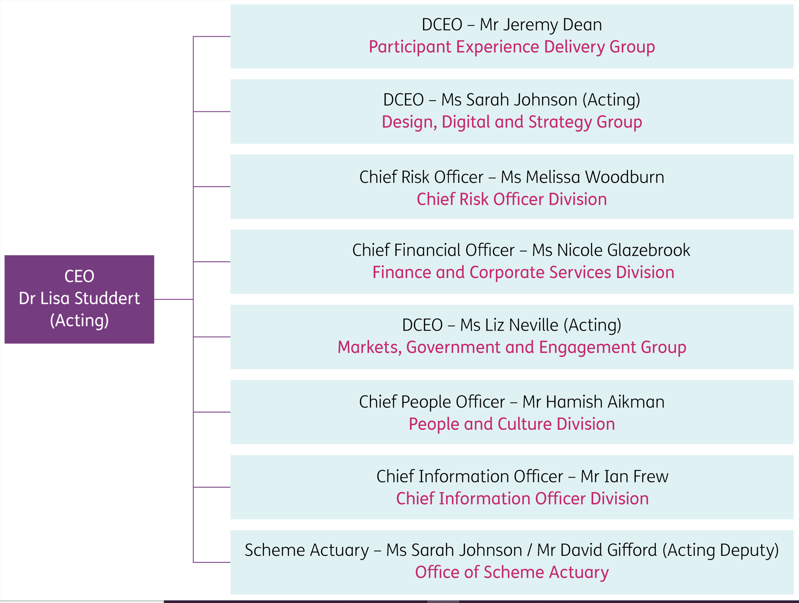

  - Partners in the community (PITC)
Our PITC partners are experienced and qualified organisations with strong local knowledge and understanding of the needs of people with disability. They work with the NDIA to deliver local area coordination and early childhood services to Australians with disability. Our partners are often the first point of contact for participants, making them the face of the Scheme in many communities.
As at 30 June 2022, the PITC program had 25 partner organisations operating in all Australian states and territories, with the exception of remote areas, where the local NDIA team provides support.

Local area coordination (LAC) partners in the community
Partners delivering LAC services assist people aged 7 years and above to link to the NDIS and to mainstream and community supports within their local area.
LAC partners play an important role in working directly with communities to improve accessibility and inclusion. They can identify supports available for people with disability within their community, even if they are not eligible for a NDIS-funded plan.
LACs help people to understand and access the NDIS, discuss goals and supports through the planning process, and assist people to use their NDIS plan.

Case study
A local area coordination (LAC) partner organisation established a project involving a partnership between various justice stakeholders including magistrates, First Nations Elders, the state health service, and the community justice group. The project was aimed at building the capacity of those working in justice to increase awareness of disability, identify NDIS participants who were involved in the justice system and develop a better understanding of how the functional impacts of disability can contribute to a person with disability coming into contact with the justice system. The project involved working directly with people identified through the justice system so that they could be linked with community and mainstream services and supported to understand the NDIS and either apply for the NDIS or use their existing NDIS plan to connect to appropriate supports.
The LAC organisation has been invited by local Elders and magistrates to expand its services. Connecting people to appropriate funding, to community and mainstream services, and back to the community has played a big role in reducing reoffending behaviour and is sustainable.

Early childhood (EC) partners in the community
Partners in the community delivering early EC services support children younger than 7 years with developmental delay (including development concerns) or disability, and their families and carers, to develop the skills they need to participate in daily activities and achieve the best possible outcomes throughout their life.
EC partners focus on delivering family-centred supports using a best practice model and supporting connections to mainstream and community services for children and their families and carers.
EC partners offer early connections and early support for children with developmental concerns or developmental delay (for children younger than 7 years) and support families through the NDIS access and planning process if their child requires longer term early childhood intervention supports.

Case study
An early childhood partner engaged with a number of Neighbourhood Houses to facilitate the establishment of early support groups. This was in response to a trend of increased referrals in a number of service areas. The focus of the groups varied, based on the needs of communities. The outcomes have been:
● shorter waitlists for early supports, with increased opportunities for targeted group programs
● families being supported to better understand their children’s needs
● linkages built for children and their families in the local community.
In addition to these outcomes, the partner organisation has been able to connect with the local toy library. This has provided a great opportunity to link families with a local service so they can use play equipment during the group sessions.
  - Workforce management
To deliver the Scheme, the NDIA needs a capable and committed workforce that is reflective of the broader Australian society. The mix of skills needed by the NDIA continues to evolve, reflecting the needs of participants, carers and their families. It is critical the NDIA attracts talented, knowledgeable and experienced people, and provides ongoing investment in building capability and training delivery. In particular, the NDIA continues to expand and strengthen its focus on disability and cohort awareness to improve frontline capability and the quality of experience for participants.
As at 30 June 2022, the NDIA workforce was 12,596, comprising:
- 5,070 Australian Public Service (APS) employees (4,872 full-time equivalent and 4,458 average staffing level)
- 1,893 contractors, comprising 1,789 labour hire staff, 90 consultants and 14 system access only contractors
- 5,633 outsourced workers, comprising 4,813 PITC partner staff, 808 National Contact Centre staff and 12 other outsourced staff.
During 2021–22, the NDIA engaged 1,434 new APS employees, with more than 58% of these in participant-facing roles. The NDIA’s planner workforce increased by 3.5% in 2021–22 and represented 42.5% of the NDIA’s APS workforce.

Disability and diversity employment
We are committed to building a workplace where everyone who comes into contact with the NDIA is valued, connected and included. The NDIA Inclusion and Diversity Framework supports a diverse workforce that is representative of the community we serve and aims to increase the NDIA’s inclusion and diversity practices through the creation of a range of diversity-group inclusion action plans.
Since the NDIA was established in 2013, it has championed employment of people with disability. In the 2022 APS Census, 18% of NDIA staff identified as having disability.
The NDIA has continued to progress disability-confident recruiter status through affirmative measures. These are designed to increase the representation of people with disabilities at the NDIA (and more broadly across the APS). The NDIA engages in the RecruitAbility scheme and offers roles and vacancies specifically for people with disabilities (or a specific type of disability).
In December 2021, as part of the celebrations for International Day of People with Disability, the NDIA launched ‘NDIA Employees with Disability: Our commitment to you’. This commitment was commissioned and endorsed by the Employees with Disability Network. It outlines the actions the NDIA will take to support our staff with disability, focusing on culture, inclusion, accessibility and workplace adjustments, learning and development.
We have undertaken thorough consultation to develop the NDIA’s next Disability Inclusion Plan to support staff with disability. The plan is scheduled for release in 2022, with actions that focus on accessibility, inclusive culture, employment and career development.
The NDIA’s Reconciliation Action Plan (RAP) is currently under development, with input from First Nations staff and stakeholders and support from Reconciliation Australia. This will be the third RAP in the NDIA’s reconciliation program and will build on actions implemented in our previous RAPs.
In the second half of 2022, the NDIA will release its new First Nations Employment and Inclusion Plan, which will focus on employment and career development opportunities for First Nations staff. This is the second First Nations inclusion plan for the NDIA and is aligned to the Commonwealth Aboriginal and Torres Strait Islander Workforce Strategy 2020–2024.
In the 2022 APS Census, 3% of NDIA staff identified as First Nations people.
The NDIA released the NDIA LGBTIQA+ Inclusion Plan in November 2021 to support LGBTIQA+ staff. The plan has 3 focus areas:
- capability and leadership
- inclusive policy and practice
- culturally safe workplace.
As at June 2022, 11 of the plan’s 16 actions are completed, in progress or ongoing.
In the 2022 APS Census, 8% of NDIA staff identified as LGBTQIA+.
SES Inclusion and Diversity Champions support our Inclusion and Diversity Framework objectives, staff networks, inclusion plans and initiatives. Currently the NDIA has an SES Disability Champion, an SES Indigenous Champion and an SES LGBTIQA+ Champion.
In March 2022, the NDIA conducted its first annual Inclusion and Diversity Survey to help measure outcomes and progress against the Inclusion and Diversity Framework and associated inclusion plans and to build an inclusive workplace culture. The survey had responses from 1,357 staff, across a variety of diversity factors and backgrounds, and gave us more insights into the intersectionality of our workforce.
The NDIA’s Inclusion and Diversity Framework commits to inclusion plans for gender equality and families, people from culturally and linguistically diverse (CALD) backgrounds, and the mature-age and intergenerational workforce. Further SES champions will be appointed to these roles as inclusion plans are developed.
In the 2022 APS Census, 70% of NDIA staff identified as female and 27% as male. For SES, 54% identified as female and 46% as male.
The NDIA has established 4 staff diversity networks: Employees with Disability Network, First Nations Employee Network, LGBTIQA+ Staff and Allies Network, and most recently People from CALD Backgrounds Staff Network.
The NDIA continues to hold membership of national not-for-profit organisations to support our inclusion initiatives, such as the Australian Network on Disability, the Diversity Council of Australia, and ACON Pride in Diversity.
The NDIA acknowledges and celebrates significant diversity and awareness dates. This year there has been a continued focus on promoting stories from staff representing wide diversity and intersectionality, to provide staff an opportunity to share their stories and lived experience within their workplace. The NDIA will continue to develop inclusion plans with the aim of further progressing how we create an inclusive workplace for everyone.

Ethics policies
The NDIA promotes ethical standards and behaviours relating to its workplaces and employment. All NDIA staff are required to comply with the APS Values and Code of Conduct as set out in section 13 of the Public Service Act 1999.
Possible breaches of the Code of Conduct are taken seriously, and action is taken when breaches occur. The NDIA has in place compulsory training programs, staff policies, and guidelines to help staff to understand their obligations and to support good workplace behaviour. Managers and staff have access to a network of officers trained to provide information and support to staff who have concerns about workplace behaviours, including bullying, harassment and discrimination. These officers receive a fortnightly allowance to undertake this role, as set out in the NDIA Enterprise Agreement 2020-2023.
Material published on the NDIA’s (internal) intranet includes information on the APS Values, the APS Employment Principles, the APS Code of Conduct and the Ethics Advisory Service, which is available to all APS employees who wish to discuss or seek advice on ethical issues that occur in the workplace.
  - Staff engagement
The NDIA works to provide a positive, productive and inclusive workplace – a great place to work for all staff – so that we can best support our participants and continue to improve the Scheme. Employee engagement drives high performance, as engaged staff are proud of what they do and have a strong connection and commitment to the work that they do. In the 2022 APS Census, the highest responses are aligned to staff’s connection to purpose, willingness to go above and beyond and positive team culture, at 95%.
In the 2022 APS Census, the NDIA had an 85% response rate, with 5,220 of its workforce (APS employee and labour-hire workers, excluding PITC partner staff) participating. The NDIA Engagement Index, which measures staff job satisfaction and commitment to an organisation, improved from 74% in 2021 to 76% in 2022, 3% higher than the APS average.
The Wellbeing Index measures staff perceptions on how well the NDIA and immediate supervisors care about staff health and wellbeing. This increased from 66% in 2021 to 71% in 2022. Results also indicated an increase in staff feeling supported by their immediate supervisor.
The Census Innovation Index remained at 67% in the 2022 APS Census. This was 2% above the APS average.
The NDIA has continued to place great importance on being an inclusive and welcoming workplace where diversity is embraced and celebrated, to ensure we have a workforce that is diverse and representative of the communities we serve. The NDIA continues to experience strong engagement with staff through its diversity networks, with strong representation on the Employees with Disability Network (around 200 members), First Nations Employee Network (around 90 members) and LGBTIQA+ Staff and Allies Network (around 135 members). These networks provide an avenue for the NDIA to engage directly with specific diversity cohorts and receive advice and guidance on creating a more inclusive workplace culture.
  - Risk management
The NDIA has a structured approach to identifying, managing, escalating and communicating key risks. This is critical to the effective and efficient delivery of the Scheme. The NDIA is committed to ensuring that participant supports, provider services and other critical business functions are maintained or quickly restored in the event of a significant outage, incident or crisis. The proactive use of risk management within the NDIA has allowed us to support effective business planning, operational stability and delivery of corporate aspirations through an evidence-based approach within the appetite set by the Board.
The Chief Risk Officer Division assists the Board and ELT by providing objective risk reviews, oversight, monitoring and reporting. On an annual basis, the Board determines the risk appetite and strategic risks for the NDIA, which are directly aligned to the Corporate Plan. The Board determined 10 strategic risks for 2021–22 in the areas of participant experience and outcomes, partner performance, provider market growth and quality, financial sustainability, Scheme integrity, stakeholder engagement and NDIA operational stability. The strategic risks are monitored against key indicators, and performance is reported to the ELT and Board Risk Committee on a quarterly basis. Management of the strategic risks is supported by operational, fraud and compliance, regulatory and project risk assessments and controls which are owned and managed at group or aggregated NDIA level.
The NDIA has an established and practically tested Business Continuity Management Framework (most recently tested during the COVID-19 pandemic and east coast flood events) to ensure the rapid response and resumption of participant and provider services and critical business activities in emergency situations.
The NDIA’s integrated risk management system provides a single platform for managing operational, strategic and regulatory risks, audit recommendations, incidents and business continuity plans. The system gives accountable executives extended visibility as to the risks and controls within their business and the broader NDIA and underpins quarterly risk reporting to the Board Risk Committee.
The NDIA continues to look for opportunities to optimise, digitise and integrate its risk management frameworks and systems to deliver a more connected, responsive and predictive risk ecosystem.
    - Scheme integrity

Payment noncompliance and fraud
The NDIA maintains a zero-tolerance approach to fraud and invests heavily in the prevention and detection of noncompliant claiming behaviours, including potential fraud.
The NDIA’s Fraud and Corruption Control Plan outlines how the NDIA is meeting its responsibilities under the Public Governance, Performance and Accountability Act 2013 and the Commonwealth Fraud Control Framework 2017. Our publicly available Fraud Strategy Statement and Compliance and Enforcement Framework describe the NDIA’s approach to managing compliance and enforcement objectives and activities, including fraud and anti-corruption.
The NDIA continues to invest in its capability to prevent, detect and respond to payment noncompliance and fraud. Throughout 2021–22, the NDIA commenced work, in consultation with the NDIS Commission, to develop and test new claims and payment compliance capabilities, targeting fraudulent and unethical provider behaviours.
The NDIA also continues to undertake preventative initiatives with internal and external stakeholders. In 2021–22, the NDIA ran a comprehensive education and engagement campaign designed to raise awareness about noncompliance and fraud within the Scheme. The campaign, which coincided with International Fraud Awareness Week and Scams Awareness Week, provided a channel for stakeholders to identify and express their understanding of noncompliance and fraud issues and build their awareness.
In addition, the NDIA continued to work across government to leverage capabilities and support more effective compliance and enforcement activities, including with the NDIS Commission, Australian Federal Police, Australian Criminal Intelligence Commission, Services Australia and AUSTRAC.

Compliance activities
In July 2021, the NDIA established the Compliance Response Team to increase its capacity to proactively identify and respond to potential noncompliance. Since its establishment, the Compliance Response Team has completed 5,087 engagements with providers where data analytics has identified anomalies in claims submitted by these providers. This proactive approach has resulted in providers cancelling more than 38,700 incorrect or noncompliant payments, worth almost $44.8 million.
The team also works with providers to raise awareness of their responsibilities and educate them on how to be compliant when claiming. Data modelling has shown that this activity has positively impacted claiming behaviour by tens of millions of dollars.
In 2021–22, the NDIA received more than 9,230 tip-offs through the fraud reporting and scams helpline. The most common behaviour reported in the tip-offs was providers overcharging participants for supports. The NDIA analysed all tip-offs received, and most were deemed suitable for further compliance review or retained as useful intelligence.
Given the impacts of the COVID-19 pandemic, the NDIA has adapted how it engages providers and participants on compliance matters to accommodate individual circumstances.

Investigations
The NDIA’s investigation function has continued to mature, with successful investigations completed or currently before the courts. The NDIS Fraud Taskforce, a multi-agency partnership with the Australian Federal Police and Services Australia, has assisted the NDIA to develop effective detection and responses to serious and organised fraud against the Scheme.
As at 30 June 2022, 35 fraud investigations in total were in progress and a further 8 matters were being evaluated for possible investigation. Of these, 14 matters are currently before the courts under prosecution.
    - Internal audit
The internal audit function works to successfully implement effective risk management and control. The internal audit team provides independent assurance to management and the Board through the Board Audit Committee, and also works with management to improve the risk and control environment. It works with stakeholders to ensure they understand the NDIA’s strategic direction and risk profile to deliver a fully aligned, risk-focused plan incorporating both assurance and advisory engagements. Through its stakeholder engagements, findings are raised with an understanding of the operating environment and relevant insights are communicated.
During 2021–22 the internal audit team delivered an approved internal audit plan to the Board Audit Committee. This plan is regularly updated, with a formal review performed every 6 months to ensure that it remains relevant and is focused on the key risks facing the NDIA. The results of all audits were reported to the Board Audit Committee, and progress on action plans to manage issues was monitored through an online tracking system. The status of these actions was reported to both the ELT and the Board through the Audit Committee.
In addition to raising formal issues, the internal audit team provides an awareness and action rating for each assurance engagement. This rating focuses on the risk management culture of the areas audited. The results are included as part of the report delivered to the ELT and the Board Audit Committee. This method of reporting assists in further maturing the level of risk management culture across the NDIA.
    - External audit
The NDIA maintains a close working relationship with the Australian National Audit Office (ANAO), which provides both external auditing services on the annual financial statements and performance audit services. Details of the performance audit delivered during the year that have an impact on the NDIA are provided in section 5.8. The ANAO’s audit report on the annual financial statements is included in section 3. All management actions taken to address recommendations raised by the ANAO are closely tracked, with regular reporting on their status to both the ELT and the Board Audit Committee.
- Appendices
  - Enabling legislation
The National Disability Insurance Agency (NDIA) is established under the National Disability Insurance Scheme Act 2013 (NDIS Act) to deliver the National Disability Insurance Scheme (NDIS or the Scheme). The NDIA is a corporate commonwealth entity under the Public Governance, Performance and Accountability Act 2013 (PGPA Act).
  - Audit Committee
The NDIA Board has established the Audit Committee to assist the Board to oversee its responsibilities and legislative obligations as the NDIA’s accountable authority under:
- section 45 of the PGPA Act
- section 17 of the Public Governance, Performance and Accountability Rule 2014 (PGPA Rule)
- the NDIS Act.
For details of members’ qualifications, knowledge, skills or experience, refer to section 4.2.1. For information on the number of meetings attended / total number of meetings, refer to section 4.2.3.
Table 5.2A: Audit Committee remuneration
Member | Total annual remuneration
Mrs Sandra Birkensleigh | $16,330
Ms Robyn Kruk AO | $4,130
Mr John Langoulant AO | $2,409
Mr Jim Minto | $6,194
Ms Estelle Pearson | $8,160

Charter
The Audit Committee Charter details the committee’s purpose, to oversee the appropriateness of the NDIA’s:
- management of the internal and external audit processes
- financial reporting processes
- performance reporting processes
- system of risk oversight and management
- system of internal control
- process for monitoring compliance with laws and regulations and the Code of Conduct.
The Audit Committee Charter is available to view on the NDIS website.
  - Work health and safety
The NDIA’s safety culture continues to mature, with a strong focus on managing compliance and psychosocial risk. The NDIA acknowledges its obligations under the Work Health and Safety Act (Cth) 2011 (WHS Act) and the Safety, Rehabilitation and Compensation Act 1988 and takes proactive steps to ensure compliance.
The NDIA takes all reasonably practicable measures to protect workers by providing a healthy and safe work environment, whether working in the office or at home, with the majority of workers opting into hybrid working arrangements.
The Work Health and Safety Management System framework promotes consultation, prevention and early intervention in cases of illness and injury and is aligned with a steadfast commitment to safeguard and value NDIA workers.
The NDIA continues to meet frequently with Comcare and Commonwealth Public Sector Union (CPSU) representatives relating to potential psychological risks from excessive workloads affecting workers within the NDIA’s National Delivery Division. The regulator has indicated informally it is satisfied with the initiatives implemented by the NDIA to address these concerns. The 2022 census results highlight the impact of these improvements and staff perceptions with respect to emotionally demanding work, workloads and capacity, work stress and burnout, all of which have 9 to 13 percentage point improvement from 2021.
In 2021–22, the NDIA reported 6 incidents to Comcare pursuant to section 38 of the WHS Act. All incidents were closed by Comcare without further action being required of the NDIA.
Table 5.3A: Summary of incidents pursuant to section 38 of the WHS Act, 2021–22
Action | Number
Death of a person that required notice to Comcare under s 35 | 0
Serious injury or illness of a person that required notification to Comcare under s 35 | 3
Dangerous incident that required notification to Comcare under s 35 | 3
Investigation conducted under Part 10 | 0
Notice given to Agency under s 90 (provisional improvement notice) | 0
Notice given to Agency under s 191 (improvement notice) | 1
Notice given to Agency under s 195 (prohibition notice) | 0
Directions given to Agency under s 198 (non-disturbance) | 0
  - Workforce statistics
Table 5.4A: All ongoing employees current reporting period (2021–22)
 | Male |  |  | Female |  |  | Indeterminate |  |  | Total
 | Full time | Part time | Total  male | Full  time | Part time | Total  female | Full time | Part time | Total indeterminate
NSW | 214 | 17 | 231 | 697 | 152 | 849 | 2 | 1 | 3 | 1,083
Qld | 158 | 7 | 165 | 512 | 87 | 599 | ‒ | ‒ | ‒ | 764
SA | 83 | 6 | 89 | 206 | 78 | 284 | ‒ | ‒ | ‒ | 373
Tas | 22 | 2 | 24 | 47 | 17 | 64 | ‒ | ‒ | ‒ | 88
Vic | 418 | 27 | 445 | 938 | 242 | 1,180 | 2 | ‒ | 2 | 1,627
WA | 64 | 4 | 68 | 188 | 29 | 217 | ‒ | ‒ | ‒ | 285
ACT | 78 | 6 | 84 | 120 | 19 | 139 | 1 |  | 1 | 224
NT | 15 | - | 15 | 53 | 7 | 60 | ‒ | ‒ | ‒ | 75
External territories | ‒ | ‒ | ‒ | ‒ | ‒ | ‒ | ‒ | ‒ | ‒ | ‒
Overseas | ‒ | ‒ | ‒ | ‒ | ‒ | ‒ | ‒ | ‒ | ‒ | ‒
Total | 1,052 | 69 | 1,121 | 2,761 | 631 | 3,392 | 5 | 1 | 6 | 4,519
Table 5.4B: All non-ongoing employees current reporting period (2021–22)
 | Male |  |  | Female |  |  | Indeterminate |  |  | Total
 | Full time | Part time | Total male | Full  time | Part time | Total female | Full time | Part time | Total indeterminate
NSW | 22 | 1 | 23 | 76 | 7 | 83 | ‒ | ‒ | ‒ | 106
Qld | 38 | 1 | 39 | 102 | 10 | 112 | ‒ | ‒ | ‒ | 151
SA | 12 | ‒ | 12 | 21 | 5 | 26 | ‒ | ‒ | ‒ | 38
Tas | 2 | ‒ | 2 | 3 | 2 | 5 | ‒ | ‒ | ‒ | 7
Vic | 46 | 2 | 48 | 108 | 17 | 125 | ‒ | ‒ | ‒ | 173
WA | 9 | 1 | 10 | 29 | 3 | 32 | ‒ | ‒ | ‒ | 42
ACT | 3 | ‒ | 3 | 13 | 3 | 16 | ‒ | ‒ | ‒ | 19
NT | 7 | ‒ | 7 | 8 | ‒ | 8 | ‒ | ‒ | ‒ | 15
External territories | ‒ | ‒ | ‒ | ‒ | ‒ | ‒ | ‒ | ‒ | ‒ | ‒
Overseas | ‒ | ‒ | ‒ | ‒ | ‒ | ‒ | ‒ | ‒ | ‒ | ‒
Total | 139 | 5 | 144 | 360 | 47 | 407 | ‒ | ‒ | ‒ | 551

Table 5.4C: All ongoing employees previous reporting period (2020–21)
 | Male |  |  | Female |  |  | Indeterminate |  |  | Total
 | Full time | Part time | Total male | Full  time | Part time | Total female | Full time | Part time | Total indeterminate
NSW | 173 | 20 | 193 | 541 | 139 | 680 | 1 | ‒ | 1 | 874
Qld | 111 | 6 | 117 | 364 | 63 | 427 | ‒ | ‒ | ‒ | 544
SA | 51 | 8 | 59 | 172 | 58 | 230 | ‒ | ‒ | ‒ | 289
Tas | 19 | 1 | 20 | 38 | 14 | 52 | ‒ | ‒ | ‒ | 72
Vic | 317 | 22 | 339 | 715 | 202 | 917 | ‒ | ‒ | ‒ | 1,256
WA | 40 | 4 | 44 | 135 | 21 | 156 | ‒ | ‒ | ‒ | 200
ACT | 57 | 3 | 60 | 97 | 15 | 112 | ‒ | ‒ | ‒ | 172
NT | 20 |  | 20 | 44 | 5 | 49 | ‒ | ‒ | ‒ | 69
External territories | ‒ | ‒ | ‒ | ‒ | ‒ | ‒ | ‒ | ‒ | ‒ | ‒
Overseas | ‒ | ‒ | ‒ | ‒ | ‒ | ‒ | ‒ | ‒ | ‒ | ‒
Total | 788 | 64 | 852 | 2,106 | 517 | 2,623 | 1 | ‒ | 1 | 3,476

Table 5.4D: All non-ongoing employees previous reporting period (2020–21)
 | Male |  |  | Female |  |  | Indeterminate |  |  | Total
 | Full time | Part time | Total male | Full  time | Part time | Total female | Full time | Part time | Total indeterminate
NSW | 39 | ‒ | 39 | 117 | 8 | 125 | ‒ | ‒ | ‒ | 164
Qld | 33 | 1 | 34 | 115 | 21 | 136 | 1 | ‒ | 1 | 171
SA | 19 | ‒ | 19 | 51 | 5 | 56 | ‒ | ‒ | ‒ | 75
Tas | 2 | ‒ | 2 | 3 | - | 3 | ‒ | ‒ | ‒ | 5
Vic | 78 | 2 | 80 | 176 | 34 | 210 | – | – | – | 290
WA | 13 | ‒ | 13 | 44 | 7 | 51 | ‒ | ‒ | ‒ | 64
ACT | 16 | ‒ | 16 | 31 | 4 | 35 | ‒ | ‒ | ‒ | 51
NT | 4 | ‒ | 4 | 9 | ‒ | 9 | ‒ | ‒ | ‒ | 13
External territories | ‒ | ‒ | ‒ | ‒ | ‒ | ‒ | ‒ | ‒ | ‒ | ‒
Overseas | ‒ | ‒ | ‒ | ‒ | ‒ | ‒ | ‒ | ‒ | ‒ | ‒
Total | 204 | 3 | 207 | 546 | 79 | 625 | 1 | ‒ | 1 | 833
  - Executive remuneration policy

Executive remuneration
Outlined in this section is information on the NDIA’s remuneration practices, as well as the remuneration paid to the NDIA’s key management personnel, senior executives and other highly paid staff for the year ended 30 June 2022 in accordance with the PGPA Rule.

Remuneration policies, practices and governance arrangements
The Chair and members of the Board are remunerated as per the Remuneration Tribunal (Remuneration and Allowances for Holders of Part-time Public Office) Determination 2021 made under subsections 7(3) and (4) of the Remuneration Tribunal Act 1973.
The CEO of the NDIA is remunerated as per the Remuneration Tribunal (Remuneration and Allowances for Holders of Full-time Public Office) Determination 2021 made under subsections 7(3) and (4) of the Remuneration Tribunal Act 1973.
NDIA SES employees are offered a remuneration and employment conditions package through an individual determination under the Public Service Act 1999 (section 24.1). Packages follow the principles outlined in the NDIA’s Remuneration Policy and comply with the requirements of the Executive Remuneration Management Policy issued by the Australian Public Service Commission, including specific approval by the Public Service Commissioner if required.
Other highly paid staff within the NDIA, excluding SES employees, are remunerated in line with the NDIA Enterprise Agreement 2020–2023. This may include payment of a Higher Duties Allowance as a result of an employee performing higher duties or an individual flexibility arrangement. Remuneration-related policies that underpin the NDIA Enterprise Agreement 2020–2023 include the Remuneration Policy and the Allowances and Reimbursement Policy.
For the purpose of executive remuneration reporting, the scope includes salary, superannuation and executive vehicle benefits (where applicable), as well as any additional salary payments and/or other remuneration benefits for key management personnel and other highly paid staff.
The NDIA Board established the People and Remuneration Committee to assist the Board to fulfil its governance responsibilities for the people and remuneration policies of the NDIA. The disclosure requirements for executive remuneration in financial statements and annual reports for 2021–22 are incorporated in the Public Governance, Performance and Accountability (Financial Reporting) Rule 2015 and Subdivision C of Part 2–3 of the PGPA Rule 2014, respectively.
  - Executive remuneration
    - Key management personnel
During the year ended 30 June 2022, in addition to the Board, the NDIA had senior executive or equivalent officials who met the definition of key management personnel. Table 5.6.1A lists names and lengths of term for key management personnel.
Table 5.6.1A: Key management personnel

Name
Dr Helen Nugent AC | Board Chairman | Part year – to 31 December 2021

Mr Jim Minto | Board Member and (Acting Chairman  1 January 2022 to 31 March 2022) | Full year

Dr Denis Napthine AO | Board Chairman (from 1 April 2022) | Part year – from 1 January 2022

Ms Meredith Allan | Board Member | Part year – from 1 January 2022

Ms Sandra Birkensleigh | Board Member | Full year

Professor Jane Burns | Board Member | Full year

Mr Glenn Keys AO | Board Member | Full year

Ms Robyn Kruk AO | Board Member | Part year – to 31 December 2021

Mr John Langoulant AO | Board Member | Part year – to 15 October 2021

Ms Estelle Pearson | Board Member | Full year

Ms Leah van Poppel | Board Member | Part year – from 1 January 2022

Dr Peta Seaton AM | Board Member | Part year – from 1 January 2022

Mr Martin Hoffman | Chief Executive Officer | Full year

Mr Hamish Aikman | Chief People Officer | Full year

Mr Oliver Bladek | DCEO Design, Digital and Strategy | Part year – to 28 January 2022

Mr Jeremy Dean | DCEO Participant Experience Delivery | Full year

Mr Ian Frew | Chief Information Officer | Full year

Mr David Gifford | Acting Deputy Scheme Actuary | Part year – from 13 January 2022

Ms Nicole Glazebrook | Chief Financial Officer | Full year

Ms Sarah Johnson | Scheme Actuary  Acting DCEO Design, Digital and Strategy (from 31 January 2022) | Full year

Ms Lisa Studdert | DCEO Markets, Government & Engagement | Full year

Ms Melissa Woodburn | Chief Risk Officer | Full year

    - Information about remuneration of key management personnel
The remuneration received or due to be received for each of the NDIA’s key management personnel for 2021–22 is shown in Table 5.6.2A.
Table 5.6.2A: Key management personnel remuneration
 |  | Short-term benefits |  |  | Post-employment benefits | Other long-term benefits |  | Termination benefits | Total remuneration
Name | Position/title | Base salary | Bonuses | Other benefits and allowances | Superannuation contributions | Long service leave | Other long-term benefits
Board members
Dr Helen Nugent AC | Board Chairman | $71,265 | - | - | $10,975 | - | - | - | $82,240
Mr James Minto | Board Member and (Acting Chairman 1 January 2022 to 31 March 2022) | $98,530 | - | - | $15,174 | - | - | - | $113,704
Dr Denis Napthine AO | Board Chairman (from 1 April 2022) | $53,050 | - | - | $8,257 | - | - | - | $61,307
Ms Meredith Allen | Board Member | $34,840 | - | - | $5,365 | - | - | - | $40,206
Ms Sandra Birkensleigh | Board Member | $86,807 | - | - | $13,368 | - | - | - | $100,176
Professor Jane Burns | Board Member | $70,473 | - | - | $10,853 | - | - | - | $81,325
Mr Glenn Keys AO | Board Member | $70,473 | - | - | $10,885 | - | - | - | $81,357

 |  | Short-term benefits |  |  | Post-employment benefits | Other long-term benefits |  | Termination benefits | Total remuneration
Name | Position/title | Base salary | Bonuses | Other benefits and allowances | Superannuation contributions | Long service leave | Other long-term benefits
Ms Robyn Kruk AO | Board Member | $53,529 | - | - | $8,244 | - | - | - | $61,773
Mr John Langoulant AO | Board Member | $24,998 | - | - | $3,850 | - | - | - | $28,848
Ms Estelle Pearson | Board Member | $90,861 | - | - | $13,993 | - | - | - | $104,854
Ms Leah van Poppel | Board Member | $83,877 | - | - | $12,917 | - | - | - | $96,794
Dr Peta Seaton AM | Board Member | $37,864 | - | - | $5,831 | - | - | - | $43,695
Executive Leadership Team
Mr Martin Hoffman | Chief Executive Officer | $719,816 | - | - | $28,147 | $17,700 | - | - | $765,663
Mr Hamish Aikman | Chief People Officer | $448,761 | - | $4,723 | $23,699 | $11,257 | - | - | $488,440
Mr Oliver Bladek | DCEO Design, Digital and Strategy | $289,052 | - | - | - | - | - | - | $289,052
Mr Jeremy Dean | DCEO Participant Experience Delivery | $552,233 | - | $5,061 | $27,606 | $14,593 | - | - | $599,493
Mr Ian Frew | Chief Information Officer | $381,750 | - | - | $38,175 | - | - | - | $419,925

 |  | Short-term benefits |  |  | Post-employment benefits | Other long-term benefits |  | Termination benefits | Total remuneration
Name | Position/title | Base salary | Bonuses | Other benefits and allowances | Superannuation contributions | Long service leave | Other long-term benefits
Mr David Gifford | Acting Deputy Scheme Actuary | $160,149 | - | - | - | - | - | - | $160,149
Ms Nicole Glazebrook | Chief Financial Officer | $395,781 | - | $5,308 | $44,654 | $10,226 | - | - | $455,969
Ms Sarah  Johnson | Scheme Actuary  Acting DCEO Design, Digital and Strategy (from 31 January 2022) | $468,574 | - | - | - | - | - | - | $468,574
Ms Lisa Studdert | DCEO Markets, Government & Engagement | $368,302 | - | $29,938 | $68,033 | $9,318 | - | - | $475,591
Ms Melissa Woodburn | Chief Risk Officer | $298,979 | - | $29,766 | $45,386 | $7,578 | - | - | $381,709
Total |  | $4,859,964 | - | $74,796 | $395,410 | $70,672 | - | - | $5,400,842

    - Senior executives
The NDIA’s senior executives comprise:
- any official classified as a Senior Executive Band 1, Band 2 or Band 3 under the Public Service Classification Rules 2000
- any official with a position equivalent to a Senior Executive Band 1, Band 2 or Band 3, including contractors and consultants prescribed as officials.
The average remuneration received or due to be received for each of the NDIA’s senior executives who are not key management personnel for the year ended 30 June 2022 is shown in Table 5.6.3A.
Table 5.6.3A: Average remuneration for senior executives who are not key management personnel
Senior executive remuneration |  | Short-term benefits |  |  | Post-employment benefits | Other long-term benefits |  | Termination benefits | Total remuneration
Total remuneration bands | Number of senior executives | Average base salary | Average bonuses | Average other benefits and allowances | Average superannuation contributions | Average long service leave | Average other long-term benefits | Average termination benefits | Average total remuneration
$0–$220,000 | 34 | $101,554 | - | $3,108 | $12,220 | $1,796 | - | - | $118,678
$220,001–$245,000 | 9 | $203,691 | - | $8,594 | $25,044 | $4,067 | - | - | $241,395
$245,001–$270,000 | 18 | $206,349 | - | $10,346 | $27,009 | $5,118 | - | $5,090 | $253,912
$270,001–$295,000 | 15 | $229,223 | - | $13,848 | $31,623 | $4,995 | - | - | $279,689
$295,001–$320,000 | 4 | $252,982 | - | $15,143 | $31,169 | $2,909 | - | - | $302,202
$320,001–$345,000 | 5 | $267,050 | - | $17,197 | $41,776 | $6,936 | - | - | $332,959
$345,001–$370,000 | 2 | $298,548 | - | $4,649 | $46,467 | $7,325 | - | - | $356,990
$370,001–$395,000 | 3 | $338,869 | - | $42 | $37,839 | $2,021 | - | - | $378,771
$395,001–$420,000 | - | - | - | - | - | - | - | - | -
$420,001–$445,000
$445,001–$470,000 | 1 | $406,372 | - | - | $40,637 | 0 | - | - | $447,009
$470,001–$495,000 | - | - | - | - | - | - | - | - | -

    - Other highly paid staff
Other highly paid staff are officials, including contractors and consultants prescribed as officials:
- who are neither key management personnel nor senior executives
- whose total remuneration exceeds $235,000.
The average remuneration received or due to be received for each of the NDIA’s other highly paid staff for the year ended 30 June 2022 is shown in Table 5.6.4A.
Table 5.6.4A: Average remuneration for other highly paid staff
 |  | Short-term benefits |  |  | Post-employment benefits | Other long-term benefits |  | Termination benefits | Total remuneration
Total remuneration bands | Number of other highly paid staff | Average base salary | Average bonuses | Average other benefits and allowances | Average superannuation contribution | Average long service leave | Average other long-term benefits | Average termination benefits | Average total remuneration
$245,001–$270,000 | 3 | $167,340 | - | $52,844 | $29,760 | $3,649 | - | - | $253,593
$295,001–$320,000 | 1 | $146,568 | - | $99,883 | $45,687 | $3,765 | - | - | $295,902

  - Reports by parliamentary committees

Joint Standing Committee on the National Disability Insurance Scheme
The Joint Standing Committee on the National Disability Insurance Scheme (JSC) was appointed by resolution by the House of Representatives on 4 July 2019 and the Senate on 22 July 2019. Prior to dissolution in 2022 for the federal election, the committee was composed of 5 senators and 5 members. The committee was tasked with inquiring into:
- the implementation, performance and governance of the NDIS
- the administration and expenditure of the NDIS
- such other matters in relation to the NDIS as may be referred to it by either House of the Parliament.
In 2021–22, the NDIA participated in 3 inquiries by the JSC:
- Inquiry into Independent Assessments
- Inquiry into General Issues around the Implementation and Performance of the NDIS
- Inquiry into Current Scheme Implementation and Forecasting.
In 2021–22, the JSC tabled 6 reports:
- Inquiry into Independent Assessments
- Inquiry into the NDIS Workforce – interim report
- Inquiry into General Issues – 2021 report
- Inquiry into the NDIS Quality and Safeguards Commission
- Inquiry into Current Scheme Implementation and Forecasting
- General Issues – Work of the Committee in the 46th Parliament.

Senate Standing Committee on Community Affairs Legislation Committee
In 2021–22, the NDIA appeared at 4 Senate Estimates hearings before the Senate Community Affairs Legislation Committee for Budget and Additional Estimates, including one spill-over hearing for Additional Estimates.

Senate Standing Committee on Community Affairs References Committee
In 2021–22, the Senate Community Affairs References Committee continued its inquiry into the purpose, intent and adequacy of the Disability Support Pension, for which agencies in the social services portfolio, including the NDIA, attended in October 2021. The final report of the inquiry was tabled in February 2022.
The Senate Community Affairs References Committee also inquired into the National Disability Insurance Scheme Amendment (Participant Service Guarantee and Other Measures) Bill 2021, for which the NDIA and the NDIS Quality and Safeguards Commission attended a hearing in November 2021. The final report was tabled in November 2021.

Senate Standing Committee on Finance and Public Administration
In 2021–22, the Senate Standing Committee on Finance and Public Administration inquired into the current capability of the Australian Public Service (APS). The NDIA, along with other APS agencies, attended a hearing in July 2021. The final report was tabled in November 2021.

Joint Committee of Public Accounts and Audit
In 2021–22, the Joint Committee of Public Accounts and Audit completed an inquiry into Auditor-General Reports Nos 14, 26, 28 and 47 (2020‒21), for which the NDIA made a submission in October 2021 and attended a hearing in March 2022.

5.7.1 Royal Commission

Royal Commission into Violence, Abuse, Neglect and Exploitation of People with Disability
The Royal Commission into Violence, Abuse, Neglect and Exploitation of People with Disability (Disability RC) was established in April 2019 in response to community concern about widespread reports of violence against, and the neglect, abuse and exploitation of, people with disability. The Disability RC is investigating:
- preventing and better protecting people with disability from experiencing violence, abuse, neglect and exploitation
- achieving best practice in reporting, investigating and responding to violence, abuse, neglect and exploitation of people with disability
- promoting a more inclusive society that supports people with disability to be independent and live free from violence, abuse, neglect and exploitation.
In 2021–22, the NDIA responded to 36 notices to produce documents or to give a statement, had 9 witnesses appear at 6 public hearings, and contributed to 3 Commonwealth responses to counsel assisting’s submissions relating to justice and provider case studies, an issues paper on culturally and linguistically diverse people with disability, and a Commonwealth response relating to COVID-19.
  - Judicial decisions and external reviews
The operations of the NDIA and decisions made in the delivery of the NDIS are subject to scrutiny by external entities.

Administrative Appeals Tribunal appeals – Federal Court of Australia
Reasons for the decision in QDKH, by his litigation representative BGJF v NDIA [2021] FCAFC 189, were published by the Full Federal Court of Australia on 29 October 2021. The Court held that the Administrative Appeals Tribunal’s jurisdiction was not limited to considering supports which were ‘put before’ the internal reviewer, as held by the Tribunal.
In 2021–22, 7 appeals from Tribunal decisions were lodged in the Federal Court (5 by the NDIA and 2 by participants) for which decisions have not yet been handed down.

Administrative Appeals Tribunal reviews
The Administrative Appeals Tribunal is responsible for independently reviewing a range of decisions made under the NDIS Act, including decisions about whether a person meets the access criteria to become a participant in the Scheme, and the supports provided under the Scheme.
In 2021–22, 5,943 applications for external merits review were lodged by participants in the Tribunal. The majority of cases were finalised without requiring a substantive hearing. As at 30 June 2022, 4,408 matters were open. The Administrative Appeals Tribunal (AAT) handed down 120 hearing decisions in 2021–22. It affirmed 40 decisions, varied 45 decisions and set aside 35 decisions. There were no Tribunal decisions in 2021–22 that had a significant effect on the operations of the NDIA.
The NDIA continues to look for better ways to reduce the AAT caseload. The NDIA has commenced development of an expert review alternative dispute resolution program to improve the participant experience and reduce the impact on the legal system.

Australian Human Rights Commission
The Australian Human Rights Commission (AHRC) is an independent statutory organisation established to protect and promote human rights in Australia and internationally. The AHRC has statutory responsibilities under the Age Discrimination Act 2004, Australian Human Rights Commission Act 1986, Disability Discrimination Act 1992, Racial Discrimination Act 1975, and Sex Discrimination Act 1984, and investigates and resolves complaints about alleged breaches of human rights against the Commonwealth and its agencies. In 2021–22, the NDIA received 13 requests from the AHRC, of which 2 were open at the end of the year.

Australian National Audit Office reports
The Australian National Audit Office (ANAO) conducts performance audits of the efficiency and effectiveness of the NDIA’s operations and financial audits of NDIA financial statements. In 2021–22, the ANAO undertook one performance audit report involving the NDIA. This audit, on Management of Staff Leave in the Australian Public Service, was published on 30 June 2022. There were 4 recommendations raised, of which 2 related to the NDIA. The NDIA agreed with the 2 recommendations. All ANAO recommendations, from both the performance and financial audits, are actively monitored and addressed within the necessary timelines with both Executive Leadership Team and Board Audit Committee oversight.

Commonwealth Ombudsman
The NDIA is a prescribed authority for the purposes of the Ombudsman Act 1976. Accordingly, the Office of the Commonwealth Ombudsman (OCO) may investigate complaints from individuals, groups or organisations about the administrative actions of the NDIA. There are 4 types of primary contacts that the NDIA will generally receive from the OCO: complaint transfers, section 7A preliminary inquiries, section 8 investigations, and section 12 finalisations of investigation.
At the beginning of the year there were 6 open complaints. In 2021–22, the NDIA received 208 complaint transfers from the OCO, of which 15 were open at the end of the year.

Fair Work Commission
The Fair Work Commission (FWC) is Australia’s national workplace relations tribunal. It was established by the Fair Work Act 2009 and is responsible for administering the provisions of the Fair Work Act.
In 2021–22, the NDIA received 6 applications to the FWC. One of the applications was discontinued and 2 were settled. Three are still open.

Federal Circuit Court
The Federal Circuit Court (FCC) was established to provide a simple and accessible alternative to litigation in the Federal Court of Australia and the Family Court of Australia and to relieve the workload of those courts. The FCC Act directs the FCC to operate informally and to use streamlined procedures. This complements the Parliament’s initiatives to encourage people to engage in a range of dispute resolution processes.
In 2021–22, the NDIA received no applications to the FCC.

Freedom of information
Under the Freedom of Information Act 1982 (FOI Act), a person may request access to information that is held by the NDIA. In 2021–22 the NDIA received 1,901 primary requests under the FOI Act. There were 39 requests for internal review of an access decision. The NDIA received notification that 18 requests were subject to a review by the Office of the Australian Information Commissioner.

Participant Information Access scheme
In 2021–22, the NDIA continued processing requests for information under the Public Information Access scheme (PIA) as an administrative release function outside of the FOI Act. The PIA allows current and prospective participants, as well as nominated representatives, to request personal information held by the NDIA. The PIA continues to be well used by participants, with the NDIA receiving 3,334 PIA requests in
2021–22.

Merit Protection Commission
The Merit Protection Commission (MPC) is an independent statutory office providing employment services to the APS and the Parliamentary Service. The MPC reviews employees’ concerns about matters affecting their employment, such as recruitment, discipline (misconduct) and performance management. It also provides recruitment and inquiry services to agencies.
In 2021–22 the NDIA had 5 applications to the MPC accepted. One of the Agency’s original decisions was upheld and one decision was set aside and substituted. Two were not reviewable. One matter is ongoing.

NDIS Quality and Safeguards Commission
The NDIS Quality and Safeguards Commission (NDIS Commission) is an independent agency established to improve the quality and safety of NDIS supports and services, regulate NDIS providers, provide national consistency, promote safety and quality services, resolve problems and identify areas for improvement.
In 2021–22, the NDIA received 678 complaints from the NDIS Commission.
The NDIA works collaboratively with the NDIS Commission to resolve critical incidents involving participants and providers. A protocol has been established for the Participant Critical Incident team to accept referrals of participant critical incidents from the NDIS Commission. In 2021–22, 208 participant critical incidents were received from the NDIS Commission. During the same period 632 complaints were sent by the NDIA to the NDIS Commission. In addition, the NDIA referred 207 participant critical incidents to the NDIS Commission.

New South Wales Ageing and Disability Commission
From July 2016, the New South Wales Ombudsman’s office has had a standing inquiry into allegations of abuse and neglect of adults with disability in the community, such as in the family home. The New South Wales Ageing and Disability Commission (NSW ADC) has now been established, and from 1 July 2019 it has been the appropriate oversight body to better protect adults with disability and older people from abuse, neglect and exploitation in home and community settings.
In 2021‒22, the NDIA received 137 complaints from the NSW ADC.
The Participant Critical Incident team received 31 participant critical incidents from the NSW ADC in 2021-22. There are not equivalent bodies to the NSW ADC in other jurisdictions, and the NDIA does not have a formal information-sharing memorandum of understanding in place with an equivalent body.
  - Other PGPA reportable items

Ministerial directions and government policy orders
The NDIA did not receive any government policy orders or ministerial directions from the Minister for the NDIS in 2021–22. No instances of significant noncompliance with finance law were reported to the responsible Minister under paragraph 19(1)(e) of the PGPA Act in 2021–22.

17BE (l) – Outline of the location of major activities or facilities
As at 30 June 2022, the NDIA had staff at over 160 locations across Australia. Approximately 63% of these sites are shared with other agencies to efficiently deliver Australian Government services. We continue to work with other agencies to consolidate into shared sites, where appropriate.

Related entity transactions
Related entity transactions are addressed in the NDIA Financial Statements.

Obtaining information from subsidiaries
Not applicable – the NDIA has no subsidiaries.

Indemnities and insurance premiums
The NDIA purchased directors’ and officers’ liability cover from Comcover (the Commonwealth’s self-insurance fund). The premium paid in 2021–22 for this cover was $742,490.45 (GST inclusive).
  - Advertising and market research
The following information is provided in accordance with section 311A of the Commonwealth Electoral Act 1918 and discloses payments above $14,500.00 (including GST), as specified by the Australian Electoral Commission, to advertising, market research, polling, direct mail and media advertising organisations.
Table 5.10A: Payments to advertising organisations: 1 July 2021 to 30 June 2022
Organisation | Service provided | Amount paid  $ (including GST)
Brio Group Pty Ltd | Participant, family and carers outcomes report | $49,854
Hootsuite Inc | Social media management | $20,135
Iconinc Pty Ltd | Website maintenance | $262,454
 | Total: | $332,443
Table 5.10B: Payments to market research organisations: 1 July 2021 to 30 June 2022
Organisation | Service provided | Amount paid  $ (including GST)
Hall and Partners Pty Ltd | Qualitative research | $325,600
 | Total: | $325,600
Table 5.10C: Payments to polling organisations: 1 July 2021 to 30 June 2022
Organisation | Service provided | Amount paid  $ (including GST)
Nil
Table 5.10D: Payments to direct mail organisations: 1 July 2021 to 30 June 2022
Organisation | Service provided | Amount paid  $ (including GST)
E-Bisglobal Pty Ltd | Printing management services | $375,035
National Mailing and Marketing Pty Ltd | Warehousing and distribution | $110,318
Directsms Pty Ltd | Outbound SMS | $16,067
Mailchimp | Participant newsletter | $36,835
 | Total: | $538,255
Table 5.10E: Payments to media advertising organisations: 1 July 2021 to 30 June 2022
Organisation | Service provided | Amount paid  $ (including GST)
Universal McCann | Recruitment advertising | $231,052
 | Total: | $231,052
  - Ecologically sustainable development and environmental performance

Fleet vehicle and fuel usage
During 2021–22, the NDIA reduced its vehicle fleet by 82, from 189 to 107. Approximately 60% of the NDIA fleet are hybrids, and the use of e10 fuel is encouraged to reduce our environmental impact. A hybrid is a combination petrol and electric driven vehicle, where the vehicle uses an internal combustion engine with a battery, generator and electric motor to reduce vehicle emissions. The NDIA leases hybrid models as these contribute towards a green fleet and maintain their value within the second-hand market.

Property
The NDIA is committed to sustainable development and environmental performance. Through our property activities, we seek a minimum 5 Star Green Star Design and 4.5 Star NABERS Energy Base Building Office Rating, wherever possible.
  - Compliance with Carer Recognition Act
Through the Carer Recognition Act 2010, the Australian Government recognises the exceptional contribution made by unpaid carers. The Carer Recognition Act 2010 stipulates that carers should have the same rights, choices and opportunities as other Australians.
The NDIA strives to be an inclusive organisation that supports staff who have caring responsibilities. The NDIA implements initiatives to align with celebrations of Carers Week. The NDIA provides a range of resources for staff who are carers, including information about flexible working arrangements and wellbeing supports.
The NDIA consults with carer organisations to develop support mechanisms and implement reforms. Consultation ensures programs and services continue to consider the needs of carers in addition to those of people with disability and meet the requirements of the Carer Recognition Act 2010.
Subsection 7(1) – each public service agency is to take all practicable measures to ensure that its employees and agents have an awareness and understanding of the Statement for Australia’s Carers.
The NDIA promotes staff awareness and understanding of the principles contained within the Carer Recognition Act 2010 and the Statement for Australia’s Carers through online tools and resources, including guides on the support available to employees with caring responsibilities and also those who support people with caring responsibilities.
Subsection 7(2) – each public service agency’s internal human resources policies, so far as they may significantly affect an employee’s caring role, are to be developed having due regard to the Statement for Australia’s Carers.
The NDIA complies with its obligations under the Carer Recognition Act 2010 and adheres to the principles of the Statement for Australia’s Carers. The NDIA’s Enterprise Agreement 2020–2023 and internal human resources policies are also developed with due regard to the Statement for Australia’s Carers, in areas that may significantly affect an employee’s caring role.
The NDIA supports carers in the workplace through its employment policies, including flexible working arrangements and access to carers leave. The types of flexible working arrangements available to NDIA staff to support carers include:
- part-time work agreements
- agreed work patterns
- work from home / remote work arrangements
- job share arrangements
- individual flexibility arrangements
- purchased leave schemes
- flex leave.
Subsection 8(1) – each public service care agency is to take all practicable measures to ensure that it, and its employees and agents, take action to reflect the principles of the Statement for Australia’s Carers in developing, implementing, providing or evaluating care supports.
The role of carers is recognised by the NDIA as a highly relevant factor when developing participants’ NDIS plans. Carers are included in the planning process and are recognised in the ‘informal care’ sections of participant plans. Participant plans are developed with a focus on capacity-building and social and economic inclusion for participants. At the request of the person they care for, carers can help with goal setting, assessment and the planning process. Carers can include a carer statement as part of the participant’s plan development, and this statement is recorded in the plan.
Increasing the capacity of the community to help people with disability, and increasing the community and workforce participation of people with disability, improves the situation of carers. The NDIA encourages feedback from carers to inform improvements to the way the Scheme supports their needs.
Subsection 8(2) – each public service care agency is to consult carers, or bodies that represent carers, when developing or evaluating care supports.
As a respected stakeholder of the NDIA, Carers Australia is consulted and engaged through the NDIA’s Stakeholder Engagement Management model, the NDIA’s Disability Representative and Carer Organisations (DRCO) Forum, and a variety of key projects as a trusted expert. Recently the National Mental Health Consumer and Carer Forum has been added to the NDIA’s list of Disability Representative and Carer Organisations and as a member of the NDIA’s DRCO Forum.
The NDIA acknowledges the right of carers to take a break from their caring role and continues to work with Carers Australia to ensure this is reflected when developing NDIA policy. The NDIA has worked closely with the Department of Social Services to ensure the Carer Gateway information portal has up-to-date information regarding support available for carers through the NDIS, including guides and links to relevant content on the NDIS website, often located on carer-specific pages.

  - Information on other specific statutory provisions
The following information addresses other reportable items required by specific statutory provisions.

National Disability Insurance Scheme Act 2013
No directions or ministerial statements were given to the NDIA under sections 121 and 125 of the NDIS Act, and no legislative instruments were made during 2021–22.

Privacy Act 1988
The NDIA complies with its privacy obligations as required under both the Privacy Act 1988 and the NDIS Act.
Compliance includes the NDIA ensuring its practices and procedures are consistent with requirements under the Australian Privacy Principles, the Notifiable Data Breaches Scheme, and the Australian Government Agencies Privacy Code, such as having an established privacy policy and privacy management plan and maintaining privacy incident and privacy impact assessment registers.
The NDIA actively promotes privacy awareness through the appointment of a Privacy Champion and Privacy Officer, and through the ongoing development of training materials for NDIA staff. Advice is also provided to staff regarding the NDIA’s privacy obligations under law, particularly as it relates to ensuring promotion of one of the general principles guiding actions under the NDIS Act, which is to ensure that people with disability have their privacy and dignity respected.
As at 1 July 2021, the NDIA had 5 privacy complaints open from the Office of the Australian Information Commissioner. During 2021-22 an additional 94 complaints were received. Seven complaints were resolved during that period.

Freedom of Information Act 1982
The NDIA is subject to the FOI Act and required to make information publicly available as part of the Information Publication Scheme. Consistent with the FOI Act, the NDIA displays a plan showing what information it publishes in accordance with the Information Publication Scheme requirements on its website. To see the NDIA’s plan, go to www.ndis.gov.au.

  - Glossary
    - Definitions
Term | Definition
Administrative Appeals Tribunal (AAT) | An independent body that conducts reviews of administrative decisions made under Commonwealth laws.
Disability sector | Refers to organisations and sole traders who deliver disability support services and the peak bodies that represent them.
Early childhood early intervention (ECEI) approach | This is the approach delivered by the NDIS to support children aged under 7 years with developmental delay or disability and their families/carers to achieve better long-term outcomes through support services in their local community, regardless of diagnosis. The ECEI approach is based on the principles of best practice in early childhood intervention and allows for access to timely, targeted and individualised early childhood intervention supports for children.
Individual living options (ILOs) | Living arrangements that focus on the individual. They include living alone, co-residency, host arrangements and living together options. They are an alternative to group home services.
Insurance approach | Sharing the financial investment in disability services and supports across the community. Placing emphasis on making up-front investments that reduce participants’ calls on the Scheme into the future, including investments in measuring lifetime costs, research and innovation, and community capability development.
Local area coordinators/  coordination (LACs/LAC) | Local organisations working in partnership with the Agency, to help participants, their families and carers access the NDIS.
Partners in the community (PITC) | Community-based organisations who work with the NDIA to deliver the NDIS. People between the ages of 7 and 64 years of age will work with the LAC partner in their local government area. Children under 7 years of age who have a developmental delay or disability will work with the early childhood partner in their local government area.
Plan | A written agreement worked out with the participant, stating their goals and needs, and the reasonable and necessary supports the NDIS will fund for them. Each participant has their own individual plan.
Specialist disability accommodation (SDA) | A range of housing designed for people with extreme functional impairment or very high needs.
Supported independent living (SIL) | One type of help or supervision with daily tasks to help participants live as independently as possible, while building their skills.

    - Acronyms
AAG ‒ Autism Advisory Group
ACE ‒ Alternative Cloud Environment
ADLOs ‒ Aboriginal Disability Liaison Officers
AFDO ‒ Australian Federation of Disability Organisations
AFSR ‒ Annual Financial Sustainability Report
AHRC ‒ Australian Human Rights Commission
AM ‒ Member of the Order of Australia
ANAO ‒ Australian National Audit Office
AO ‒ Order of Australia, Officer in the General Division
APS ‒ Australian Public Service
ASL ‒ average staffing level
CALD ‒ culturally and linguistically diverse
CCE ‒ Corporate Commonwealth Entity
CEO ‒ Chief Executive Officer
CRM ‒ customer relationship management
DRC ‒ Royal Commission into Violence, Abuse, Neglect and Exploitation of People with Disability
DRCO Forum ‒ Disability Representative and Carers Organisation Forum
DSS ‒ Department of Social Services
EC ‒ early childhood
ECEI ‒ Early childhood early intervention
ELT ‒ Executive Leadership Team
FCC ‒ Federal Circuit Court
FOI Act ‒ Freedom of Information Act 1982
FWC ‒ Fair Work Commission
GST ‒ Goods and Services Tax
IAC ‒ Independent Advisory Council
ICE Forum ‒ Industry Chief Executive Forum
ICT ‒ information and communications technology
ILOs ‒ individualised living options
KMP ‒ key management personnel
JSC ‒ Joint Standing Committee on the National Disability Insurance Scheme
LAC ‒ Local area coordinator
MPC ‒ Merit Protection Commission
NCC ‒ National Contact Centre
NDIA ‒ National Disability Insurance Agency
NDIS ‒ National Disability Insurance Scheme
NDIS Act ‒ National Disability Insurance Scheme Act 2013
NDIS Commission ‒ NDIS Quality and Safeguards Commission
NDIS or the Scheme ‒ National Disability Insurance Scheme
NMHSRG ‒ NDIS Mental Health Sector Reference Group
NSW ADC ‒ New South Wales Ageing and Disability Commission
OCO ‒ Office of the Commonwealth Ombudsman
PBS ‒ NDIA Portfolio Budget Statements 2021–22
PEP ‒ Participant Engagement Panel
PGPA Act ‒ Public Governance, Performance and Accountability Act 2013
PGPA Rule ‒ Public Governance, Performance and Accountability Rule 2014
PIA ‒ Public Information Access scheme
PITC ‒ Partners in the community
PRG ‒ Participant Reference Group
PSG ‒ Participant Service Guarantee
RAP ‒ Reconciliation Action Plan
RAT ‒ rapid antigen test
Scheme ‒ National Disability Insurance Scheme
SDA ‒ specialist disability accommodation
SES ‒ Senior Executive Service
SIL ‒ supported independent living
SIP ‒ Participant Service Improvement Plan
SLA ‒ service level agreement
WHS ‒ Work health and safety
WHS Act ‒ Work Health and Safety Act 2011
YPIRAC Strategy ‒ Younger People in Residential Aged Care Strategy 2020–25
- Indexes
  - Compliance index
Below is the table set out in Schedule 2A of the PGPA Rule. Section 17BE(u) requires this table be included in entities’ annual reports.
PGPA Rule reference | Part of report | Description | Requirement
17BE | Contents of annual report
17BE(a) | 5.1 | Details of the legislation establishing the body | Mandatory
17BE(b)(i) | 3.3, 5.1 | A summary of the objects and functions of the entity as set out in legislation | Mandatory
17BE(b)(ii) | 2.2.1, 5.1 | The purposes of the entity as included in the entity’s corporate plan for the reporting period | Mandatory
17BE(c) | 4.1.1 | The names of the persons holding the position of responsible Minister or responsible Ministers during the reporting period, and the titles of those responsible Ministers | Mandatory
17BE(d) | 5.9 | Directions given to the entity by the Minister under an Act or instrument during the reporting period | If applicable, mandatory
17BE(e) | 5.9 | Any government policy order that applied in relation to the entity during the reporting period under section 22 of the Act | If applicable, mandatory
17BE(f) | 5.9 | Particulars of noncompliance with:  (a) a direction given to the entity by the Minister under an Act or instrument during the reporting period, or  (b) a government policy order that applied in relation to the entity during the reporting period under section 22 of the Act | If applicable, mandatory
17BE(g) | 3.3 | Annual performance statements in accordance with paragraph 39(1)(b) of the Act and section 16F of the rule | Mandatory
17BE(h), 17BE(i) | 5.9 | A statement of significant issues reported to the Minister under paragraph 19(1)(e) of the Act that relates to noncompliance with finance law and action taken to remedy noncompliance | If applicable, mandatory
17BE(j) | 4.2 | Information on the accountable authority, or each member of the accountable authority, of the entity during the reporting period | Mandatory
17BE(k) | 4.4.2 | Outline of the organisational structure of the entity (including any subsidiaries of the entity) | Mandatory
17BE(ka) | 5.4 | Statistics on the entity’s employees on an ongoing and non-ongoing basis, including the following:  (a) statistics on full time employees  (b) statistics on part time employees  (c) statistics on gender  (d) statistics on staff location | Mandatory
17BE(l) | 5.9 | Outline of the location (whether or not in Australia) of major activities or facilities of the entity | Mandatory
17BE(m) | 4.1, 4.2.3, 4.6 | Information relating to the main corporate governance practices used by the entity during the reporting period | Mandatory
17BE(n), 17BE(o) | 3.1 | For transactions with a related Commonwealth entity or related company where the value of the transaction, or if there is more than one transaction, the aggregate of those transactions, is more than $10,000 (inclusive of GST):  (a) the decision-making process undertaken by the accountable authority to approve the entity paying for a good or service from, or providing a grant to, the related Commonwealth entity or related company, and  (b) the value of the transaction, or if there is more than one transaction, the number of transactions and the aggregate of value of the transactions | If applicable, mandatory
17BE(p) | 4.2.4, 4.4.1 | Any significant activities and changes that affected the operation or structure of the entity during the reporting period | If applicable, mandatory
17BE(q) | 5.8 | Particulars of judicial decisions or decisions of administrative tribunals that may have a significant effect on the operations of the entity | If applicable, mandatory
17BE(r) | 5.7, 5.8, 5.13 | Particulars of any reports on the entity given by:  (a) the Auditor-General (other than a report under section 43 of the Act), or  (b) a Parliamentary Committee, or  (c) the Commonwealth Ombudsman, or  (d) the Office of the Australian Information Commissioner | If applicable, mandatory
17BE(s) | 5.9 | An explanation of information not obtained from a subsidiary of the entity and the effect of not having the information on the annual report | If applicable, mandatory
17BE(t) | 5.9 | Details of any indemnity that applied during the reporting period to the accountable authority, any member of the accountable authority or officer of the entity against a liability (including premiums paid, or agreed to be paid, for insurance against the authority, member or officer’s liability for legal costs) | If applicable, mandatory
17BE(ta) | 5.6 | Information about executive remuneration | Mandatory

The NDIS Act
NDIS Act  Chapter 6,  Part 5, subsection 172 | Part of report | Description | Requirement
(2)(a) | 5.13 | Details of any directions given under section 121 in the period | Mandatory
(2)(b) | 5.13 | Details of any statements given under section 125 in the period | Mandatory
(2)(c) | 3.3 | Information (including statistics) and analysis that relates to either or both of the following in the period:  (i) participants;  (ii) funding or provision of supports by the Agency. | Mandatory
(3) | 5.13 | Any particular information or analysis to be included in the annual report as prescribed by the Minister in legislative instruments | Mandatory
(4)(a) | 3.2 | The summary, that was prepared under section 180B when the annual report was being prepared, of the annual financial sustainability report | Mandatory
(4)(b) | 3.2 | The report of the reviewing actuary’s review under subsection 180E(2) of the summary mentioned in paragraph (4)(a). | Mandatory

Information provided in compliance with other statutory provisions
Act | Part of report | Reference and description | Requirement
Work Health and Safety Act 2011  Schedule 2 | 5.3 | 4(1) — Work Health and Safety  4(2) — Summary of incidents pursuant to section 38 of the WHS Act | Mandatory
Commonwealth Electoral Act 1918 | 5.10 | 311A – Advertising and Market Research | Mandatory
Environment Protection and Biodiversity Conservation Act 1999 | 5.11 | 516A – Ecologically sustainable development and environmental performance | Mandatory
Carer Recognition Act 2010 | 5.12 | 4 – Statement of compliance with Carer Recognition Act | Mandatory
Freedom of Information Act 1982 | 5.13 | 8 – Information Publication Scheme Statement | Mandatory
Privacy Act 1988 | 5.13 | Statement of Compliance | Mandatory

  - Tables index
Tables |  | Page
3.2.1A | Baseline projection of Scheme expenses | 82
3.2.1B | Range of plausible outcomes of Scheme experiences | 83
3.2.1C | Comparison of 2021-22 AFSR with 2020-21 AFSR | 83
3.2.1D | Movements in Scheme expenses wince previous review due to experience and updated assumptions | 84
3.2.1E | Summary of data utilised for actuarial analysis | 85
3.2.1F | Estimated drivers of variation in Scheme expenses in 2021-22 | 90
3.2.1G | Breakdown of past observed inflation | 92
3.2.1H | Comparison of historic inflation experience and adopted total inflation | 94
3.2.1I | Actual operating expenses compared to expectations for 2021-22 | 96
3.3A | Participant and Scheme outcomes | 118
3.3B | Participants and stakeholder sentiment | 120
3.3C | Scheme financial sustainability and integrity | 122
3.3D | NDIS operating performance | 123
3.3E | Market performance | 124
3.3F | NDIA operating performance | 125
4.2.2A | Board committees and members as at 30 June 2022 | 133
4.2.3A | Number of meetings attended by Board members in 2021-22 | 134
5.2A | Audit Committee renumeration | 144
5.3A | Summary of incidents pursuant to section 38 of the WHS Act, 2021-22 | 145
5.4A | All ongoing employees current reporting period (2021-22) | 146
5.4B | All non-ongoing employees current reporting period (2021-22) | 146
5.4C | All ongoing employees previous reporting period (2020-2021) | 147
5.4D | All non-ongoing employees previous reporting period (2020-21) | 148
5.6.1A | Key management personnel | 149
5.6.2A | Key management personnel renumeration | 151
5.6.3A | Average renumeration for senior executives who are not key management personnel | 154
5.6.4A | Average renumeration for other highly paid staff | 155
5.10A | Payments to advertising organisations: 1 July 2021 to 30 June 2022 | 161
5.10B | Payments to market research organisations: 1 July 2021 to 30 June 2022 | 161
5.10C | Payments to polling organisations: 1 July 2021 to 30 June 2022 | 161
5.10D | Payments to direct mail organisations: 1 July 2021 to 30 June 2022 | 161
5.10E | Payments to media advertising organisations: 1 July 2021 to 30 June 2022 | 161
  - Figures index
Figures |  | Page
2.1A | Growth in participant numbers | 12
2.1B | Growth in participant support payments | 12
2.1C | Average payment per participant | 13
2.1D | Average and median payments for years ending 30 June – all participants | 13
2.1E | Average and median payments for years ending 30 June – participants in SIL | 14
2.1F | Average and median payments years ending 30 June – participants not in SIL | 14
2.1G | Average and median payments per year – by age group (participants not in SIL) | 15
2.1H | Plan budgets | 16
2.1I | Change in number of providers registered to support participants since 2017 | 16
2.1J | Children younger than 7 years old in the NDIS as at 30 June 2022 | 17
2.1K | Change in the percentage of participants engaging in social activities who have been in the Scheme for 2, 3, 4 or 5 years (participants aged 15 years and over) | 19
2.1L | Change in the percentage of participants in work who have been in the Scheme for 2, 3, 4 or 5 years (participants aged 15 to 64 years) | 19
2.1M | Has the NDIS improved how your child fits into community life? (aged 0 to before starting school) | 20
2.1N | Has the NDIS helped your child to become more independent? (children aged from starting school to 14 years) | 20
2.1O | Has the NDIS helped you with daily living activities? (young adults aged 15 to 24 years) | 21
2.1P | Has your involvement with the NDIS improved your health and wellbeing? (adults aged 25+ years) | 21
2.2.1A | National Disability Insurance Agency Purpose and Aspirations (2021-2025) | 23
2.2.2A | National Disability Agency Values | 24
2.2.3A | Rating of experience with the NDIS as at 30 June 2022 | 28
2.2.3B | Trend of satisfaction across the pathway (%very good/good) | 29
2.2.3C | Open complaints and percentage that have been open for more than 21days | 30
2.2.3D | Closed complaints and percentage completed within 21-day timeframe | 30
2.2.3E | National Contact Centre telephony performance 2021-22 | 44
2.2.3F | National Contact Centre volume of work completed 2021-22 | 44
3.2.1A | Comparison of participant numbers to previous review | 86
3.2.1B | Expected new entrant rate together with observed experience for the year ended 31 March 2022 by financial phasing year | 88
3.2.1C | Experience to date and projections of participants new to SIL | 89
3.2.1D | Average annualised payments overtime ($) | 91
3.2.1E | Average annualised payments over time by SIL Status ($) | 91
3.2.1F | Average annualised payments overtime for participants without SIL by age band ($) | 92
3.2.1G | Plan inflation for active participants | 93
3.2.1H | Comparison of adopted total inflation with previous review | 94
3.2.1I | Projected total annualised Scheme expenses ($m) with uncertainty bands | 97
3.3A | Commonwealth Performance Framework | 117
4.1A | Agency governance diagram | 128
4.4.1A | Agency organisational structure as at 30 June 2022 | 136

Back cover
The material in this document, with the exception of logos, trademarks, third party materials and other content as specified is licensed under Creative Commons CC-BY-NC-ND licence, version 4.0 International. You may share, copy and redistribute the document in any format. You must acknowledge the National Disability Insurance Agency as the owner of all intellectual property rights in the reproduced material by using ‘© National Disability Insurance Agency ’ and you must not use the material for commercial purposes.
If you remix, transform or build upon the material contained in this document, you must not distribute the modified material.

For more information about this report, please contact:
National Disability Insurance Agency:
- telephone 1800 800 110
For people with hearing or speech loss:
- TTY 1800 555 677
For speak and listen:
- telephone 1800 555 727 then ask for 1800 800 110
For people who need help with English:
- for a free-of-charge translator, interpreter or other assistance, phone 1800 800 110
If you are an internet relay user:
- visit the National Relay Service website (external) and ask for 1800 800 110
This report can be accessed online at NDIS website
Find us on Facebook/NDISAus
Follow us on Twitter@NDIS

This section compares baseline indicator results when participants entered the Scheme, with results measured at the most recent participant plan review for each respondent. Trial participants are excluded.
Participant satisfaction results for prior quarters have been restated using data as at 30 June 2022 due to retrospective changes in the underlying data. These changes mainly arise from lags in data collection.
The numbers of complaints reported for the most recent quarter may still increase, as there is a lag in data collection. However, any increase is not expected to have a material impact on the results.
There were a further 2,006 participants aged 65 years or over in residential aged care with an approved NDIS plan.
SDA provider payments have not been handled in a timely fashion, due to issues with service bookings. This has resulted in a large backlog of payments. To address the problem, the NDIA is introduced a new SDA line item from 1 July 2022 to ensure providers have an easier way to claim for services delivered to participants. The NDIA has also addressed historic outstanding SDA payments by making off-system payments to providers directly. The $186 million total SDA payments made in 2022 includes off-system payments of $10.5 million made in June 2022.
The Australian Government Actuary is currently the Peer Review Actuary as per the NDIS Act (section 180D).
Insurance Principles and Financial Sustainability Manual (PDF Download)
Scheme expenses relates to the payments made for participant supports and does not include operating expenses. It is based on when the service was provided to the participant, recognising some services are paid for after the end of the period.
The projected Scheme expenses for 2029-30 on an accrual basis are projected to be $74.1 billion, in comparison with $59.3 billion reported in the 2020-21 AFSR.
The 2020-21 AFSR was adopted in the 2022-23 Portfolio Budget Statement estimates (PBS) and therefore reflects the most recent budget estimates. Hence, no separate comparison with the PBS is shown.
At the previous review, additional inflation was referred to as ‘superimposed inflation’.
SAP is a software company that makes enterprise software. Also known as Systems, Applications and Products in Data Processing.
Participant cohorts are based on age, primary disability type, recorded level of function, gender identity, whether a participant is in supported independent living arrangements, and duration in the Scheme.
A stochastic model is used to estimate probability distributions of potential outcomes by allowing for random variation in one or more inputs over time. In this case, the inputs which are varied are the assumptions and risks which are most uncertain in the projection of Scheme expenses.
No new entrant rate is shown for the 2016 year as no geographic region phased into the Scheme in that year.
The ongoing process of reviewing participant eligibility for the Scheme.
Due to operational changes since July 2020, there has been a known issue with identifying participants with SIL. From May 2022 onwards, an automated and a more accurate method has been applied in identifying participants with SIL, leading to restatement of both the actual and expected number of participants with SIL from July 2020 to April 2022. This issue is now resolved; therefore no further restatement is expected going forward.
Participants new to SIL supports includes both new entrants to the Scheme with SIL supports and existing participants who transitioned to SIL arrangements during the period. The numbers of participants new to SIL supports up to 2020–21 are based on the previous method of identifying participants with SIL. The number for 2021–22 is based on the new method used from May 2022 and so includes a restatement of the prior periods to 2021–22.
Payments on an accrual basis include an expense of $476 million for one-off provider payments and $91 million for the cost of residential aged care.
Calculated as $126 million minus $15 million or 10% minus 1%
Average annualised payments have been calculated on a cash basis using the 12 months over each year ending 30 June.
The result for additional inflation in 2018–19 may be impacted by the high number of new entrants in the Scheme during transition.
Change in mix refers to the impact on inflation of changes in the profile of the participant population (i.e, more new entrants in cohorts with a lower than average payment per participant would lead to a negative impact) rather than changes in the average payment per participant within specific cohorts. This is excluded from additional inflation as it is explicitly modelled in the AFSR. In this table, change in mix excludes the inflation impact of change in reported level of function over time. This impact is included in additional inflation.
Additional inflation in 2021–22 has been impacted by COVID-19 and by workforce shortages and the supply of disability support workers.
Under the NDIS legislation amendments, from 1 July 2022’ ‘plan review’ will be referred to as ‘plan reassessment’. An internal review of decisions at the request of a participant will continue to use the word ‘review’. The terminology as it applied up until 30 June 2022 is used in this report.
Intraplan inflation tends to occur when a participant’s needs and situation change before a plan is due to be renewed. Often the plan is ended early and a new plan is put in place, and if the participant has spent more than expected, the value of the first plan is adjusted retrospectively. Intraplan inflation can also occur when the expected cost of a high-value capital item is used in a plan but is then updated with an actual quoted cost.
This result was partly driven by plan indexation of approximately 11.9% applied in July 2019 to reflect NDIS price increases.
An example is the ACC (Accident Compensation Corporation) in New Zealand (https://www.acc.co.nz/assets/corporate-documents/3360178450/financial-condition-report-2012.pdf).
https://www.rba.gov.au/publications/smp/2022/aug/economic-outlook.html
Total expected inflation shown is lower than normal inflation plus additional inflation because the change in mix of participants is expected to lead to reductions in average payment per participant (before allowing for normal inflation and additional inflation). The historic average shown implicitly includes change in mix, and so the most appropriate comparison to experience is the total including change in mix.
https://www.dss.gov.au/sites/default/files/documents/01_2022/review-ndia-actuarial-forecast-model-and-drivers-scheme-costs.pdf
Productivity Commission 2017, National Disability Insurance Scheme (NDIS) Costs, Study Report, Canberra (page 412).
Model specification risk is the risk that the inputs and parameters of the model used to estimate future experience is not a true representation of Scheme processes or participant behaviour, and that this leads to biases in the projections. This risk is high at this review, given the NDIS cost processes are still evolving, meaning a limited history for assumption setting, as well as some limitations in the data available for analysis.
The NDIA Corporate Plan 2022–26 has also been released and includes the same Aspiration 1. However, the 2021–25 version is referenced in this report, as it includes targets for 2021–22 on outcomes-based performance metrics against which experience for the 2021-22 year can be measured.
NDIA Corporate Plan 2021–25.
The NDIS outcomes framework questionnaires measure the medium-term and long-term benefits of the Scheme on participants across the eight domains of choice and control, relationships, health and wellbeing, work, daily living activities, lifelong learning and social, community and civic participation.
The ‘baseline’ is the metric when participants enter the Scheme – that is, before the NDIS can influence the result.
Both children who have received initial supports (but not an approved plan) and those who have had an approved plan are included in the measure. The ‘exits’ in the period are expressed as an annualised percentage of exposure. Exposure is equal to the active participants aged 0 to 14 with approved plans and those receiving initial supports in the period.
This is calculated as average annualised plan budgets of the top 2 deciles (top 20%) divided by the average annualised plan budget of the bottom 2 deciles (bottom 20%). Active participants aged 0 to 64 are included in the calculation.
The name of the metric has been amended in the 2021–25 Corporate Plan (pg. 43) and the calculation method has been simplified to include all payments.
Included in the annual financial statements.
In June 2022 16 of the metrics were reported against due to insufficient data for one of the PSG metrics. From August 2022, reporting has resumed for 17 metrics.
In July 2021, 6 of 17 metrics (35%) were on track, and in June 2022, 12 of 16 metrics (75%) were on track.
Percentage of regions where plan utilisation is more than 10% below the benchmark.
Percentage of regions where the top 10 providers supply more than 85% of the supports.
Percentage of payments that are below the price limit stipulated in the NDIS Pricing Arrangement and Price Limits.
Included in the annual financial statements.
Payment errors relate to either fraud, misuse or material payment error in the provision of payment for supports.
The 2020–21 result of 77% was taken from the APS Census conducted in November 2020 and has been updated to reflect the census produced in July 2021 to be in line with ongoing census timings.
The 2020–21 result of 70% was taken from the APS Census conducted in November 2020 and has been updated to reflect the census produced in July 2021 to be in line with ongoing census timings..
Chair of the NDIA Board.
Chair of the Risk Committee.
Chair of the Audit Committee.
The Engagement Index measures the emotional connection and commitment employees have to working for their organisation. It comprises 3 elements: Say - the extent to which team members are advocates of the organisation. Stay - the extent to which team members are committed to the organisation and want to stay. Strive - the extent to which team members are willing to put in discretionary effort to excel in their jobs and help the organisation succeed. The Wellbeing Index measures the wellbeing of employees within an organisation; it measures both the practical and cultural elements that allow for a sustainable and healthy working environment.
An improvement notice under section 191 of the WHS Act was issued as a result of a site inspection in April 2021. Comcare deemed the NDIA had contravened WHS Act section 19(3)(e), WHS Regulation 42 – Duty to Provide First Aid, due to inadequate first aid facilities at the Wollongong site. The NDIA responded within the set timeframes and Comcare has closed this matter, noting compliance.
All data is calculated on an accrual basis
The NDIA engaged some senior executives through contract arrangements that may include superannuation and long service leave entitlements. All other contract-engaged senior executives’ total contract costs are included as short-term employee benefits
Remuneration for acting key management personnel is reported only for the period in which they act

