

Provider quarterly report - School leaver employment

January – December 2021
September 2022
Market Innovation & Employment Branch

ndis.gov.au
Justin’s story
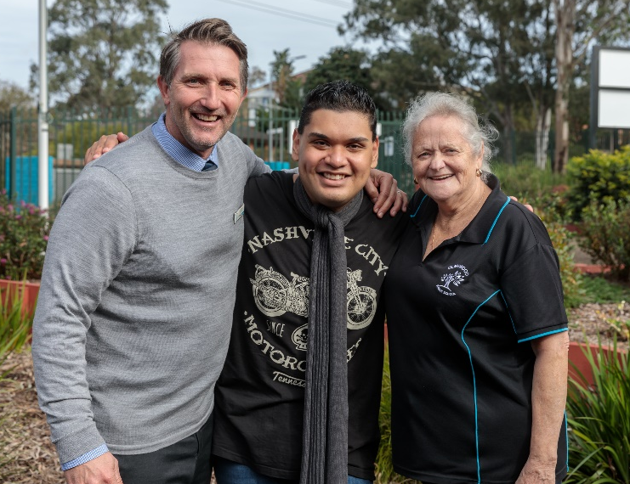
Justin’s story
Despite the challenges of a global pandemic, nearly 6 years after Justin Tala first started working at the Glenwood Public School, he continues to be a valued employee and an important member of the school community.
“As a school, things have of course been a bit challenging with the pandemic, but Justin has been able to continue to do his role and has been very adaptable,” Glenwood Public School Principal Jay McInney says.
“I don’t think the kids or staff see Justin as a person with a disability. They just see Justin as Justin, someone who does important jobs around the school, who likes to converse with teachers, who is always saying hello”.
“Justin is a very positive presence in our school. He lifts people’s spirits and is part of our school community.”
Justin, 24, who lives with a moderate intellectual disability and autism, began working at Glenwood Public School in 2016 after he set himself the goal of finding a job after leaving school.
With School Leaver Employment Support funded through the National Disability Insurance Scheme (NDIS), Justin connected with a local employment provider.
The provider worked with Justin to help build his skills and confidence before supporting Justin to secure an ongoing position at the school.
Today, Justin is a well-known and much-loved member of school staff who is passionate about his work and has built solid connections with other staff.
“I love working at the school,” Justin says. “Everyone is nice. I have a staff uniform and a name badge”.
“I like doing different jobs like laminating and organising the books. It makes me happy.”
Justin’s daily routine starts with a round of photocopying and delivering class materials to teachers. He then moves on to recycling, administration, filing, sorting class readers and other necessary jobs around the school.
“Justin does a variety of time-consuming jobs that might otherwise take teachers and office staff away from other work they need to do,” Jay says.
“Things like laminating and sharpening pencils, arranging books – they may seem like trivial tasks, but they need to be done and they make a big difference to our teachers and staff.”
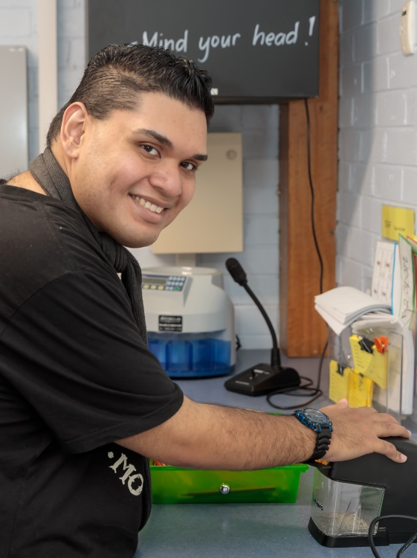
“Justin is part of our school community, and everyone knows his family too, so there’s that interconnectedness and those relationships that are built beyond the four walls of the school,” he says.
“That’s very important, because what that is doing is forging that link between schools and community. It’s forging that link for Justin between his workplace and the community.”
Justin’s mother Carmen says her son’s work provides him with a daily routine and strong sense of purpose he might otherwise not have.
“He feels important that he’s working because he feels that he’s doing something good, which makes him very happy,” Carmen says.
“When Justin was finishing high school, I was very nervous about what was going to happen to him. I was thinking, ‘What kind of job is my son going to do? Who is going to employ my son? How are they going to treat my son?’
“Now I feel more secure. My son has this great work experience and is surrounded by beautiful people who really care about him.”


Contents
Provider quarterly report - School leaver employment January – December 2021 1
1. Executive summary 7
1.1 Vision 7
1.2 Employment support provider reporting 7
1.3 Proposed modelling and report enhancements 8
1.4 Key findings 8
2. Participant demographics 10
2.1 Employment support recipients 10
2.2 Location 11
2.3 Primary disability 12
2.4 Age 13
2.5 Gender 14
2.6 Aboriginal or Torres Strait Islanders status 15
2.7 Culturally and Linguistically Diverse status 16
3. Supports & milestones 17
3.1 Support type hours 17
3.2 Support delivery method 18
3.3 Progress towards milestones – Snapshot at each reporting period 18
3.4 Progress towards milestones – Cumulative up to December 2021 24
4. Final outcomes 26
5. Final employment outcomes 30
5.1 Employment type 30
5.2 Hours worked 31
5.3 Industry of employment 32
5.4 NDIA Supports in Employment 33
5.5 Supported wages 34
6. Intermediate employment outcomes 35
6.1 Employment outcomes this quarter (October – December 2021) 35
6.2 Employment type 36
6.3 Hours worked 38
6.4 Industry of employment 39
6.5 NDIA Supports in Employment 40
6.6 Supported wages 41
7. Model summary 42
7.1 Modelling approach 42
7.2 What helps (or hinders) finding paid employment 43
8. Appendix 47
8.1 Appendix 1 – Methodology for the section titled “Progress Towards Milestones – Cumulative up to December 2021” 47
8.2 Appendix 2 – Model Accuracy 48

Executive summary

Vision
In 2019 the NDIA released the NDIS Participant Employment Strategy (the Strategy), which sets out the vision, commitment and plan for supporting participants to find and keep meaningful employment. The vision of the Strategy is that participants have the same opportunities to work as other Australians, and the confidence, support and skills to take advantage of those opportunities. Our goal is to have 30% of working age participants in meaningful employment by 30 June 2023. As at December 2021, 22% of working age participants were in paid employment. One of the 6 priority areas in the NDIS Participant Employment Strategy Action Plan 2021/2022 is to improve the path between education to work.
School leaver employment support is an early intervention support intended to smooth the transition from school to employment by building a young participant’s skills, confidence, and capacity for work.
These supports are intended to be individualised and are generally provided for a period of up to 2 years commencing in the final year of school, bridging gaps in mainstream services by recognising that many NDIS participants require significant investment early to gain the generic competencies needed for work.

Employment support provider reporting
Employment support providers are required to submit data through the provider reporting tool (the tool) to the NDIA each quarter. The data submitted includes participants’ demographic details, activities, progress towards milestones, outcomes achieved, and employment details.
The quarterly report was made mandatory in January 2021, with increasing numbers of providers reporting throughout each quarter in 2021.
This report provides insights on the data submitted through the tool, aggregated across all providers’ that contributed from January to December 2021.
The report will be released on a regular basis, with improvements incorporated as the data matures.

Proposed modelling and report enhancements
Enhanced features are planned for the Quarter 1 and 2 2022 report with the inclusion of a provider section to demonstrate the proportion of providers contributing to the report, the number of participants they’re reporting on and the amount of support provided within the quarter.
At each release this report will feature a participant story, like Justin’s, showcasing a positive employment outcome achieved. Participants or providers with the consent of the participant, are invited to forward stories to participant.employment@ndis.gov.au .
If you have general feedback or questions about this report, please email participant.employment@ndis.gov.au .

Key findings
The information contained in this report represents data submitted to the Agency by providers of school leaver employment supports for the participants for whom they provided service from January to December 2021.
As at December 2021, approximately 6,397 participants age 15-24 either had school leaver employment support included in their active plan, or had claimed school leaver employment supports. Out of these, only participants for whom service had been provided, and whose data providers submit to the Agency are included in this report.
For January to December 2021, providers report:
- 4,530 unique participants received school leaver employment supports.
- 990 participants commenced receiving school leaver employment supports in Q1, 435 commenced in Q2, 327 commenced in Q3, and 334 commenced in Q4.
- Participants receiving school leaver employment supports predominantly have autism (51%) or intellectual disability (36%), with 67% being male.
- The majority of employment support recipients are in NSW (41%), followed by VIC (24%), and QLD (14%).
- In the most recent period, around 6% of employment support recipients identified as Aboriginal or Torres Strait Islander people. This is slightly lower than the 8% of all NDIS participants age 15-24 who identify as Aboriginal or Torres Strait Islander people.
- In the most recent period, around 7% of employment supports recipients identified as being from a Culturally and Linguistically Diverse community. The proportion out of all NDIS participants age 15-24 is also 7%.
- Around half of the training time was spent building the participant’s social, presentation, communication and work skills.
- The large increase in distance or online learning in July to September 2021 coincided with the COVID-19 Delta variant outbreaks and lockdowns (mainly in NSW and VIC). This has decreased in October to December 2021, but not fully back to pre-July 2021 level.
- More time receiving employment supports or skill specific training was associated with a higher chance of making significant progress towards, or fully gaining the specific skills.
- 817 participants were reported to exit school leaver employment supports during the four quarters.
- Of the 817 participants who exited employment supports, 46% of participants exited without an employment outcome, 33% of those who exited achieved an employment outcome: 27% in open employment and 6% in an ADE. 22% did not report any outcome.
- From January to December 2021, 265 participants finished employment support with open or supported employment.
- Of the participants who gained paid employment over the four quarters, 43% were employed on a part time basis while 34% were employed casually, 5% were employed full time.
- From January to December 2021, of participants who started employment, 71% worked up to 21 hours per week. The percentage that work 8-21 hours per week has been generally increasing over time.
- From January to December 2021, of participants who finished employment support with paid employment, 73% worked in retail, hospitality, tourism, trades, manufacturing or operation.
- From January to December 2021, of participants who started employment, 26% said they will be using NDIS supports in employment to maintain their employment. This % has been generally decreasing over time.
- From January to December 2021, for more than a third of participants (37%) who finished employment support with paid employment, the employers said they will use supported wages for the participants’ employment.
- Participants who made significant progress or fully achieved their goals in relation to developing work skills, employer engagement and job customisation milestones were more likely to gain paid employment.
- Participants who fully achieved their work experience milestone goals were more likely to gain paid employment.
- Higher levels of one to one support increased the chance of finding paid employment

Figures in this report have been rounded to the nearest whole percentage.

Participant demographics

Employment support recipients
Number of participants
Group | Jan to Mar  2021 | Apr to Jun  2021 | Jul to Sep  2021 | Oct to Dec  2021
Existing | 2,444 | 3,318 | 3,549 | 3,687
New | 990 | 435 | 327 | 334
Total | 3,434 | 3,753 | 3,876 | 4,021
Exit | 116 | 204 | 189 | 308

The number of participants receiving employment supports reported by the Provider Reporting Tool (the Tool) shows slight and steady increase over time.
Employment support recipients
Notes
- Existing: started employment support before the period
- New: started employment support in the period
- Exit: exits employment support in the period

The above numbers are from the Provider Reporting Tool data that providers submit to the NDIA quarterly. If in the data supplied, a participant exits employment support in one period (counted in "Exit" numbers above), and a few periods later re-enters employment support, the participant will be counted in the "New" numbers again.

Location
State or Territory of residence – number of participants
State or Territory | Jan to Mar  2021 | Apr to Jun  2021 | Jul to Sep  2021 | Oct to Dec  2021
NSW | 1,492 | 1,577 | 1,597 | 1,660
VIC | 827 | 912 | 945 | 983
QLD | 485 | 535 | 558 | 553
SA | 269 | 310 | 329 | 366
WA | 216 | 258 | 277 | 293
TAS | 68 | 85 | 92 | 91
ACT | 74 | 71 | 73 | 70
NT | <11 | <11 | <11 | <11

The majority of employment support recipients were in NSW (41%), followed by VIC (24%), and QLD (14%). For comparison, the top 3 states for all NDIS participants age 15-24 are NSW (31%), VIC (24%) and QLD (20%). The over-representation in NSW is partly due to the legacy NSW Transition to Work program, on which employment support is modelled.

Primary disability
Primary disability - number of participants
Primary disability | Jan to Mar  2021 | Apr to Jun  2021 | Jul to Sep  2021 | Oct to Dec  2021
Autism | 1,709 | 1,879 | 1,968 | 2,067
Intellectual Disability | 1,307 | 1,420 | 1,430 | 1,460
Down Syndrome | 127 | 135 | 141 | 140
Cerebral Palsy | 83 | 92 | 96 | 98
Other Neurological | 54 | 52 | 53 | 58
Hearing impairment | 38 | 42 | 47 | 52
Psychosocial Disability | 36 | 41 | 47 | 48
Acquired Brain Injury | 36 | 43 | 40 | 39
Visual Impairment | 22 | 22 | 24 | 25
Other or Not populated | 22 | 27 | 30 | 34
Total | 3,434 | 3,753 | 3,876 | 4,021

The top primary disabilities experienced by participants utilising these supports were by far autism (51%), followed by intellectual disability (36%). For comparison, 51% and 30% of all NDIS participants age 15-24 experience autism and intellectual disability respectively.

Age
Age - % of participants
Age | Jan to Mar  2021 | Apr to Jun  2021 | Jul to Sep 2021 | Oct to Dec  2021
up to 14 | 0% | 1% | 1% | 1%
15 to 17 | 7% | 6% | 6% | 7%
18 | 27% | 23% | 18% | 21%
19 | 32% | 33% | 33% | 33%
20 | 20% | 22% | 24% | 22%
21 to 24 | 11% | 14% | 16% | 15%
25+ | 0% | 0% | 1% | 1%
Not populated | 2% | 2% | 2% | 2%
Total | 100% | 100% | 100% | 100%

76% of employment support recipients were age 18-20.

Gender
Gender % of participants
Gender | Jan to Mar  2021 | Apr to Jun  2021 | Jul to Sep  2021 | Oct to Dec  2021
Female | 30% | 31% | 31% | 31%
Male | 68% | 67% | 67% | 67%
Other | 0% | 0% | 0% | 1%
Prefer not to say | 0% | 0% | 0% | 0%
Not populated | 2% | 1% | 1% | 2%
Total | 100% | 100% | 100% | 100%

In the most recent period, employment support recipients were 31% female and 67% male. This is comparable to all NDIS participants age 15-24, where 34% were female and 65% were male. This is also in line with the high proportion of employment supports recipients experiencing autism as the primary disability, as the majority of participants who experience autism are males.

Aboriginal or Torres Strait Islanders Status
Aboriginal and Torres Strait Islanders - % of participants
Aboriginal or Torres Strait Islanders status | Jan to Mar  2021 | Apr to Jun  2021 | Jul to Sep  2021 | Oct to Dec  2021
Yes | 5% | 5% | 6% | 6%
No | 75% | 75% | 75% | 75%
Not Stated | 20% | 20% | 19% | 19%
Not populated | 0% | 0% | 0% | 0%
Total | 100% | 100% | 100% | 100%

In the most recent period, around 6% of employment support recipients identified as Aboriginal or Torres Strait Islander people. This is slightly lower than the 8% of all NDIS participants age 15-24 who identified as Aboriginal or Torres Strait Islander people.

Culturally and Linguistically Diverse status
Culturally and Linguistically Diverse - % of participants
Culturally and Linguistically Diverse status | Jan to Mar  2021 | Apr to Jun  2021 | Jul to Sep  2021 | Oct to Dec  2021
Yes | 7% | 7% | 7% | 7%
No | 92% | 92% | 93% | 92%
Not Stated | 1% | 1% | 1% | 1%
Not populated | 0% | 0% | 0% | 0%
Total | 100% | 100% | 100% | 100%

In the most recent period, around 7% of employment support recipients identified as being from a Culturally and Linguistically Diverse community.

The proportion out of all NDIS participants age 15-24 was the same.

Supports & milestones

Support type hours
Support type provided - % of hours per participant
Support type provided | Jan to Mar  2021 | Apr to Jun  2021 | Jul to Sep  2021 | Oct to Dec  2021
Assessments | 4% | 4% | 4% | 3%
Planning and reviewing progress | 6% | 5% | 6% | 6%
Exploring employment options | 9% | 8% | 11% | 10%
Engagement with family / carer to support employment directions | 4% | 3% | 3% | 4%
Engagement with other professionals / providers to support employment goals | 3% | 2% | 3% | 3%
Building social, presentation and communication skills | 23% | 24% | 25% | 23%
Travel training | 4% | 5% | 3% | 4%
Work skills training | 22% | 25% | 26% | 24%
Employer engagement education and job customisation | 6% | 6% | 5% | 5%
Work experience support (on the job) | 12% | 16% | 9% | 13%
Other (Field 1) | 5% | 2% | 3% | 3%
Other (Field 2) | 2% | 2% | 2% | 1%
Total | 100% | 100% | 100% | 100%

The low percentage of work experience (support on the job) in July to September 2021 coincided with the COVID-19 Delta variant outbreaks and lockdowns (mainly in NSW and VIC), which has since rebounded.
Around half of the training time was spent building the participant’s social, presentation, communication, and work skills.
From a separate analysis (NDIS Outcomes Framework Employment Deep Dive 31 December 2020), gaining work experience was also listed as one of the top supports participants think will help them get a job.

Support delivery method
Delivery method - % of hours
Delivery method | Jan to Mar  2021 | Apr to Jun  2021 | Jul to Sep  2021 | Oct to Dec  2021
One to One | 36% | 39% | 43% | 43%
Group Based | 62% | 57% | 32% | 46%
Distance or Online | 2% | 3% | 25% | 11%
Total | 100% | 100% | 100% | 100%

The large increase in distance or online learning in July to September 2021 coincided with the COVID-19 Delta variant outbreaks and lockdowns (mainly in NSW and VIC). This had partly reversed in October to December 2021.

Note: Participants have been excluded from this section where the sum of One to One, Group based, Distance or Online percentages did not equal 100%.

Progress towards milestones – snapshot at each reporting period
This section looks at the distribution of progress for participants who worked on a particular milestone (where there are training hours reported for that specific skill), for each reporting period in isolation (non-cumulative).
To assist in interpretation of data, comments below each table summarise progress in the final quarter of the year. Comments below each chart describe trends across the different quarters.

Social, presentation and communication skill
Social, presentation and communication skill milestone - participant progress %
Social, presentation and communication skill milestone | Jan to Mar  2021 | Apr to Jun  2021 | Jul to Sep  2021 | Oct to Dec  2021
No progress | 6% | 4% | 6% | 5%
Some progress | 72% | 70% | 70% | 69%
Significant progress | 21% | 25% | 23% | 24%
Current goals fully achieved | 1% | 1% | 1% | 1%
Total | 100% | 100% | 100% | 100%

For participants who worked on this specific milestone, 69% reported some progress and almost a quarter reported significant progress.

The distribution has been consistent over time.

Travel skill
Travel skill milestone - participant progress %
Travel skill milestone | Jan to Mar  2021 | Apr to Jun  2021 | Jul to Sep  2021 | Oct to Dec  2021
No progress | 6% | 5% | 8% | 8%
Some progress | 62% | 57% | 64% | 66%
Significant progress | 25% | 29% | 23% | 21%
Current goals fully achieved | 7% | 8% | 5% | 5%
Total | 100% | 100% | 100% | 100%

For participants who worked on this specific milestone, 66% reported some progress and 21% reported significant progress.

For July – September 2021, there was a lower % of participants reporting significant progress and current goal fully achieved, coinciding with the COVID-19 Delta variant outbreaks and lockdowns (mainly in NSW and VIC). This trend seems to have continued to the October – December 2021 quarter.

Work skill
Work skill milestone - participant progress %
Work skill milestone | Jan to Mar  2021 | Apr to Jun  2021 | Jul to Sep  2021 | Oct to Dec  2021
No progress | 6% | 4% | 5% | 6%
Some progress | 70% | 70% | 70% | 64%
Significant progress | 23% | 25% | 24% | 25%
Current goals fully achieved | 1% | 1% | 1% | 5%
Total | 100% | 100% | 100% | 100%

For participants who worked on this specific milestone, 64% reported some progress and 25% reported significant progress.

There was an increase in the % of participants fully achieving the work skill goal in the October – December 2021 quarter, potentially coinciding with the end of an annual training program.

Employer engagement, education, and job customisation
Employer engagement, education, and job customisation milestone - participant progress %
Employer engagement, education, and job customisation milestone | Jan to Mar  2021 | Apr to Jun  2021 | Jul to Sep  2021 | Oct to Dec  2021
No progress | 5% | 4% | 4% | 7%
Some progress | 76% | 71% | 74% | 69%
Significant progress | 17% | 23% | 20% | 21%
Current goals fully achieved | 2% | 2% | 2% | 2%
Total | 100% | 100% | 100% | 100%

Providers who reported activities as “engaging with employers, educating and customising jobs” for participants reported that 69% made some progress and 21% made significant progress.

The % of participants showing significant progress reduced in July to September, coinciding with the COVID-19 Delta variant outbreaks and lockdowns (mainly in NSW and VIC). This had somewhat reversed in the October to December quarter.

Work experience
Work experience milestone - participant progress %
Work experience milestone | Jan to Mar  2021 | Apr to Jun  2021 | Jul to Sep  2021 | Oct to Dec  2021
No progress | 4% | 3% | 6% | 5%
Some progress | 56% | 53% | 59% | 52%
Significant progress | 35% | 40% | 33% | 40%
Current goals fully achieved | 5% | 4% | 2% | 3%
Total | 100% | 100% | 100% | 100%

Of the participants engaging in work experience in the most recent quarter, 52% were reported as making some progress, and 40% were reported as making significant progress.

For July – September 2021, there was lower % of participants reporting significant progress and current goal fully achieved, coinciding with the COVID-19 Delta variant outbreaks and lockdowns (mainly in NSW and VIC). This has rebounded in the October – December 2021 quarter.

Progress towards milestones – cumulative up to December 2021
The following sections show that more time receiving supports or training is associated with better progress towards mastering specific skills. For each participant, the best progress (across 4 quarters) towards mastering the specific skills is used for this analysis, and compared against the cumulative time receiving employment supports, and training for the specific skills.
Appendix 1 includes more detail on the methodology used in this section.

Social, presentation and communication skill
Social, presentation and communication skill milestone - % of participant progress
Cumulative training hours | No progress | Some progress | Significant progress | Current goals fully achieved | Total
0-9 | 21% | 64% | 12% | 3% | 100%
10-49 | 4% | 62% | 32% | 2% | 100%
50-99 | 1% | 59% | 37% | 2% | 100%
100+ | 1% | 53% | 43% | 3% | 100%
Participants who had received up to 9 hours of training on social, presentation, and communication skills only had a 12% chance of making significant progress towards mastering these skills. This chance increased to 43% after 100+ hours of the skill-specific training.

Travel skill
Travel skill milestone - % of participant progress
Cumulative training hours | No progress | Some progress | Significant progress | Current goals fully achieved | Total
0-9 | 39% | 30% | 8% | 23% | 100%
10-49 | 4% | 53% | 33% | 10% | 100%
50-99 | 3% | 29% | 51% | 18% | 100%
100+ | 2% | 12% | 61% | 26% | 100%
The fact that 23% fully achieved their goal with 0-9 hours of training but 26% required 100+ hours of training is an illustration of how individualised the support needs to be (for some participants travel skills may be a primary area of focus).

Work skill
Work skill milestone - % of participant progress
Cumulative training hours | No progress | Some progress | Significant progress | Current goals fully achieved | Total
0-9 | 31% | 56% | 11% | 2% | 100%
10-49 | 4% | 58% | 35% | 3% | 100%
50-99 | 1% | 60% | 35% | 4% | 100%
100+ | 0% | 47% | 42% | 10% | 100%
Significant progress was achieved through more cumulative hours of training in work skills, illustrating how individually tailored the support needs to be.

Employer engagement, education, and job customisation
Employer engagement, education, and job customisation milestone - % of participant progress
Cumulative training hours | No progress | Some progress | Significant progress | Current goals fully achieved | Total
0-9 | 36% | 49% | 13% | 2% | 100%
10-49 | 3% | 63% | 30% | 4% | 100%
50-99 | 1% | 53% | 40% | 6% | 100%
100+ | 0% | 51% | 43% | 7% | 100%
The chance of making significant progress towards employer engagement, education, and job customisation milestones increased markedly up to 100 hours of training.

Work experience
Work experience milestone - % of participant progress
Cumulative training hours | No progress | Some progress | Significant progress | Current goals fully achieved | Total
0-9 | 61% | 29% | 6% | 4% | 100%
10-49 | 4% | 49% | 41% | 6% | 100%
50-99 | 1% | 35% | 59% | 5% | 100%
100+ | 0% | 30% | 60% | 10% | 100%
The chance of making significant progress towards work experience milestones increased markedly up to 100 hours of training.

Final outcomes
This section shows the distribution of outcomes upon exiting employment support (based on the employment support reported end/exit date).

From January to December 2021, 265 participants finished employment support with open or supported employment.
Final outcomes (upon exiting employment support) - % of participants
Outcome | Jan to Mar  2021 | Apr to Jun  2021 | Jul to Sep  2021 | Oct to Dec  2021 | Total
Open Employment | 20 | 50 | 42 | 105 | 217
Supported Employment | <11 | 14 | <11 | 19 | 48
Non-Employment | 60 | 98 | 98 | 118 | 374
Not populated | 28 | 42 | 42 | 66 | 178

The number finishing employment supports with open or supported employment was lower in July to September, which coincided with the COVID-19 Delta variant outbreaks and lockdowns (mainly in NSW and VIC).
This was followed by a rebound in October to December, which coincided with the end of lockdowns.

From January to December 2021, around a third of participants finished employment support with open or supported employment.
Final outcomes (upon exiting employment support) - % of participants
Outcome | Jan to Mar  2021 | Apr to Jun  2021 | Jul to Sep  2021 | Oct to Dec  2021 | Total
Open Employment | 17% | 25% | 22% | 34% | 27%
Supported Employment | 7% | 7% | 4% | 6% | 6%
Non-Employment | 52% | 48% | 52% | 38% | 46%
Not populated | 24% | 21% | 22% | 21% | 22%
Total | 100% | 100% | 100% | 100% | 100%

The % finishing with open or supported employment was lower in July to September, which coincided with the COVID-19 Delta variant outbreaks and lockdowns (mainly in NSW and VIC).
This was followed by a rebound in October to December, coinciding with the end of lockdowns.
The following charts and tables provide more granular breakdown of outcomes for participants who exited employment supports from January to December 2021.

For participants whose final outcome is ‘Exit from school leaver employment supports’, the common reasons reported were; funding ended or school leaver employment supports finished after 2 years, participant transferred to DES or another program/provider, participant not engaging or non contactable, health and/or mental health, or personal reasons.
Open employment outcomes comprise of:
- jobs in the open labour market, with full award or supported wages, with or without the assistance of Disability Employment Services (DES)
- or Self-employment/Micro-enterprise
A job in an Australian Disability Enterprise (ADE) is classified as Supported Employment.
The other categories in the chart above are classified as Non-Employment outcomes.

Final outcomes (upon exiting employment support) - % of participants
Outcome | Jan to Mar  2021 | Apr to Jun  2021 | Jul to Sep  2021 | Oct to Dec  2021 | Total (%) | Total (Numbers)
Education or further study | 3% | 5% | 4% | 3% | 4% | 31
Exit from School Leaver Employment Supports | 32% | 29% | 31% | 19% | 26% | 216
Job in an Australian Disability Enterprise (ADE) | 7% | 7% | 4% | 6% | 6% | 48
Job in the open labour market with full award wages | 8% | 14% | 8% | 10% | 10% | 83
Job in the open labour market with full award wages, with assistance of DES | 3% | 6% | 5% | 7% | 6% | 46
Job in the open labour market with supported wages | 2% | 2% | 5% | 2% | 3% | 21
Job in the open labour market with supported wages, with assistance of DES | 2% | 2% | 3% | 14% | 7% | 55
Referred to a DES | 5% | 1% | 1% | 1% | 2% | 13
Referred to another provider | 3% | 1% | 5% | 6% | 4% | 34
Self-employed / Micro-enterprise | 3% | 0% | 1% | 2% | 1% | 12
Volunteering or other unpaid work | 8% | 11% | 11% | 9% | 10% | 80
Not populated | 24% | 21% | 22% | 21% | 22% | 178
Total | 100% | 100% | 100% | 100% | 100% | 817

The absolute numbers (non percentages) have been shown as Total only in the above table (not broken down into individual quarters) due to low volume in the individual quarter. Individual quarter absolute numbers will be shown once there is enough volume.

Final employment outcomes

Employment type

From January to December 2021, of participants who finished employment support with paid employment, 89 gained casual work while 115 gained part-time work.
The number of participants finishing with part-time or full-time employment was lower in July to September, which coincided with the COVID-19 Delta variant outbreaks and lockdowns (mainly in NSW and VIC).

From January to December 2021, of participants who finished employment support with paid employment, 34% gained casual work while 43% gained part-time work.
Employment type - % of participants
Employment Type | Jan to Mar  2021 | Apr to Jun  2021 | Jul to Sep  2021 | Oct to Dec  2021 | Total
Casual | 36% | 25% | 37% | 36% | 34%
Part-time | 32% | 47% | 45% | 44% | 43%
Full-time | 7% | 9% | 8% | 2% | 5%
Self Employed / Micro-enterprise | 0% | 2% | 0% | 5% | 3%
Temporary / Contract | 0% | 0% | 0% | 2% | 1%
Work Experience | 4% | 0% | 0% | 0% | 0%
Not populated | 21% | 17% | 10% | 11% | 14%
Total | 100% | 100% | 100% | 100% | 100%
The % of participants who gained part-time work has been stable in the last two periods.

Hours worked

From January to December 2021, of participants who finished employment support with paid employment, 71% worked up to 21 hours per week.
Hours worked per week - % of participants
Hours | Jan to Mar  2021 | Apr to Jun  2021 | Jul to Sep  2021 | Oct to Dec  2021 | Total
0-7 | 25% | 8% | 14% | 8% | 11%
8-14 | 25% | 17% | 24% | 27% | 24%
15-21 | 18% | 39% | 24% | 44% | 36%
22-28 | 0% | 6% | 10% | 4% | 5%
29-35 | 11% | 2% | 4% | 5% | 5%
36+ | 0% | 8% | 10% | 3% | 5%
Not populated | 21% | 20% | 12% | 10% | 14%
Total | 100% | 100% | 100% | 100% | 100%
The % of participants who worked 8-21 hours per week have been generally increasing over time.

Industry of employment

From January to December 2021, of participants who finished employment support with paid employment, 73% work in Hospitality, Tourism, Retail, Trades, Manufacturing, or Operation.
Industry of employment - % of participants
Industry | Jan to Mar  2021 | Apr to Jun  2021 | Jul to Sep  2021 | Oct to Dec  2021 | Total
Hospitality & tourism | 11% | 27% | 22% | 36% | 29%
Retail & consumer products | 14% | 11% | 20% | 23% | 19%
Trades & services | 25% | 17% | 22% | 10% | 16%
Manufacturing / Operation | 11% | 9% | 12% | 8% | 9%
Community & support | 11% | 3% | 2% | 2% | 3%
Transport & logistics | 0% | 5% | 0% | 2% | 2%
Banking & financial services | 0% | 3% | 4% | 1% | 2%
Education & training | 0% | 3% | 4% | 0% | 2%
Administration | 4% | 0% | 0% | 2% | 1%
Healthcare & medical | 0% | 2% | 0% | 2% | 1%
Information technology | 0% | 2% | 2% | 1% | 1%
Construction | 0% | 0% | 2% | 1% | 1%
Sales & marketing | 0% | 0% | 0% | 1% | 0%
Media & entertainment | 0% | 0% | 0% | 0% | 0%
Government / Defence | 0% | 0% | 0% | 0% | 0%
Engineering | 0% | 0% | 0% | 0% | 0%
Not populated | 25% | 19% | 8% | 11% | 14%
Total | 100% | 100% | 100% | 100% | 100%
The % who worked in Hospitality, Tourism, and Retail has generally been increasing over time.

NDIA Supports in Employment

From January to December 2021, of participants who finished employment support with paid employment, 18% said they will be using NDIS Supports in Employment to maintain their employment.
Will the participant be utilising NDIA Supports in Employment? - number of participants
Employment support exit period: 2021
Response | Jan to Mar | Apr to Jun | Jul to Sep | Oct to Dec | Total
Yes | 39% | 9% | 12% | 20% | 18%
No | 25% | 47% | 57% | 56% | 51%
Unknown | 7% | 20% | 20% | 13% | 15%
Not populated | 29% | 23% | 10% | 10% | 15%
Total | 100% | 100% | 100% | 100% | 100%

This % has been increasing between the April and December period, but was lower than the % between the January and March period.

Supported wages

From January to December 2021, for 37% of participants who finished employment support with paid employment, providers reported employers will use supported wages for the participants’ employment.
Will the employer use supported wages for the participant's employment? - % of participants
Response | Jan to Mar  2021 | Apr to Jun  2021 | Jul to Sep  2021 | Oct to Dec  2021 | Total
Yes | 25% | 31% | 39% | 43% | 37%
No | 43% | 45% | 43% | 35% | 40%
Unknown | 7% | 3% | 2% | 6% | 5%
Not populated | 25% | 20% | 16% | 15% | 18%
Total | 100% | 100% | 100% | 100% | 100%

This % has been generally increasing over time.

Intermediate employment outcomes
This section contains the employment features for all of the participants who commenced employment from Quarter 1 to Quarter 4 2021. The participants may or may not have exited employment support. Participants with Employment Type “Work Experience” are excluded.

Employment outcomes this quarter (October – December 2021)
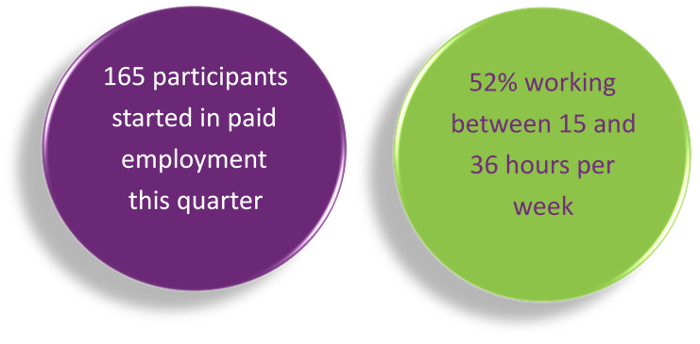
The top 4 industries in which participants started employment were Retail, Hospitality/Tourism, Trades/Services and Manufacturing/Operations.

Employment type
A total of 527 participants commenced employment during 2021.

From January to December 2021, of participants who started employment, 253 started casual work while 182 started part-time work.
Employment type - number of participants
Employment Type | Jan to Mar  2021 | Apr to Jun  2021 | Jul to Sep  2021 | Oct to Dec  2021 | Total
Casual | 47 | 74 | 56 | 76 | 253
Part-time | 26 | 52 | 42 | 62 | 182
Full-time | <11 | 15 | <11 | <11 | 36
Self Employed / Micro-enterprise | <11 | <11 | <11 | <11 | 15
Temporary / Contract | <11 | <11 | <11 | 11 | 24
Not populated | <11 | <11 | <11 | <11 | 17
Total | 91 | 150 | 121 | 165 | 527

The number of participants finishing with casual, part-time, and full-time employment were lower in July to September, which coincided with the COVID-19 Delta variant outbreaks and lockdowns (mainly in NSW and VIC).
The number of participants in casual and part-time employment had somewhat rebounded in October to December.

From January to December 2021, of participants who started employment, just under half started casual work, while 35% started part-time work.
Employment type - % of participants
Employment Type | Jan to Mar  2021 | Apr to Jun  2021 | Jul to Sep  2021 | Oct to Dec  2021 | Total
Casual | 52% | 49% | 46% | 46% | 48%
Part-time | 29% | 35% | 35% | 38% | 35%
Full-time | 8% | 10% | 7% | 3% | 7%
Self Employed / Micro-enterprise | 2% | 3% | 2% | 4% | 3%
Temporary / Contract | 8% | 2% | 2% | 7% | 5%
Not populated | 2% | 1% | 7% | 3% | 3%
Total | 100% | 100% | 100% | 100% | 100%

The % who started part-time work has been increasing over time.

Hours worked

From January to December 2021, of participants who started employment, 80% worked up to 21 hours per week.
Hours worked per week - % of participants
Hours | Jan to Mar  2021 | Apr to Jun  2021 | Jul to Sep  2021 | Oct to Dec  2021 | Total
0-7 | 29% | 22% | 15% | 16% | 20%
8-14 | 31% | 36% | 35% | 27% | 32%
15-21 | 19% | 23% | 26% | 40% | 28%
22-28 | 11% | 5% | 8% | 7% | 7%
29-35 | 5% | 3% | 4% | 5% | 5%
36+ | 4% | 10% | 9% | 3% | 7%
Not populated | 1% | 1% | 2% | 2% | 2%
Total | 100% | 100% | 100% | 100% | 100%

The % of participants who worked 15-21 hours per week has been steadily increasing.

Industry of employment

From January to December 2021, of participants who started employment, 73% worked in Hospitality, Tourism, Retail, Trades, Manufacturing or Operation.
Industry of employment - % of participants
Industry | Jan to Mar  2021 | Apr to Jun  2021 | Jul to Sep  2021 | Oct to Dec  2021 | Total
Hospitality & tourism | 26% | 24% | 23% | 33% | 27%
Retail & consumer products | 19% | 21% | 20% | 20% | 20%
Trades & services | 13% | 16% | 13% | 13% | 14%
Manufacturing / Operation | 12% | 14% | 14% | 9% | 12%
Community & support | 10% | 6% | 7% | 5% | 7%
Education & training | 4% | 4% | 3% | 2% | 3%
Administration | 3% | 1% | 2% | 7% | 3%
Construction | 2% | 2% | 3% | 0% | 2%
Transport & logistics | 1% | 2% | 2% | 2% | 2%
Healthcare & medical | 0% | 1% | 2% | 2% | 1%
Media & entertainment | 0% | 2% | 1% | 1% | 1%
Information technology | 3% | 1% | 2% | 0% | 1%
Banking & financial services | 0% | 1% | 2% | 1% | 1%
Government / Defence | 1% | 0% | 1% | 1% | 1%
Sales & marketing | 1% | 1% | 0% | 1% | 1%
Engineering | 0% | 0% | 0% | 0% | 0%
Not populated | 3% | 4% | 7% | 4% | 4%
Total | 100% | 100% | 100% | 100% | 100%

The % who worked in hospitality and tourism has been steadily decreasing over time between January and September, but rebounded in October to December, coinciding with the easing of COVID-19 restrictions and the opening of international borders.

NDIS Supports in Employment

From January to December 2021, of participants who started employment, 26% said they will be using NDIS Supports in Employment to maintain their employment.
Will the participant be utilising NDIS Supports in Employment? - % of participants
Response | Jan to Mar  2021 | Apr to Jun  2021 | Jul to Sep  2021 | Oct to Dec  2021 | Total
Yes | 41% | 20% | 20% | 28% | 26%
No | 38% | 53% | 57% | 56% | 52%
Unknown | 15% | 22% | 17% | 12% | 16%
Not populated | 5% | 5% | 7% | 4% | 5%
Total | 100% | 100% | 100% | 100% | 100%

This % has been generally decreasing from January to September, but increased during October to December.

Supported wages

From January to December 2021, for 24% of participants who started employment, the employers said they will use supported wages for the participants’ employment.
Will the employer use supported wages for the participant's employment? - % of participants
Response | Jan to Mar  2021 | Apr to Jun  2021 | Jul to Sep  2021 | Oct to Dec  2021 | Total
Yes | 19% | 25% | 15% | 32% | 24%
No | 63% | 63% | 73% | 54% | 62%
Unknown | 3% | 3% | 4% | 4% | 4%
Not populated | 15% | 9% | 8% | 10% | 10%
Total | 100% | 100% | 100% | 100% | 100%

This % has increased in the most recent period.

Model summary

Modelling approach
A model was built to predict successful employment outcomes, defined as any of the following:
- Job in the open labour market, with full award or supported wages, with or without the assistance of Disability Employment Services (DES)
- Self-employed / Micro-enterprise
- Supported employment.
The modelling dataset is sourced from the Provider Reporting Tool and NDIA’s own participant data, with the former containing outcomes and support hours and the latter containing characteristics such as Culturally and Linguistically Diverse status and education activities.
Using 3 statistical techniques, we determine the significant predictors of employment success. Ranked in order from the most to least important the significant predictors are:
- Progress made towards achieving employer engagement and job customisation milestone
- State or Territory
- Progress in achieving work experience milestones
- Progress made towards achieving work skills milestones
- Percentage of support delivered through one-to-one settings.
A Generalised Linear Model was then constructed using the above significant variables.
Appendix 2 has more details on the accuracy of the model.

What helps (or hinders) finding paid employment
Rank of Importance * | Variable | Value | Reference Level | Chance of finding paid employment (value compared to reference)
1st | Progress made towards Employer engagement and job customisation milestones | Significant / Fully Achieved Goals | No / Some Progress | 1.7
2nd | State | QLD | NSW / ACT | 0.7
3rd | Progress towards achieving Work experience support milestones | Fully Achieved Goals | No / Some / Significant Progress | 1.9
4th | Progress made towards achieving Work skills milestones | Significant / Fully Achieved Goals | No / Some Progress | 1.5
5th | % of support delivered through One-To-One settings | 51% to 100% | 0% to 50% | 1.4
* 1st = most predictive
How to interpret the above table:
- Participants who made significant progress towards or fully achieved their employer engagement, education, and job customisation milestones were 1.7 times as likely to find employment compared to participants who made no or some progress towards similar milestones.
- Participants living in Queensland were 0.7 times as likely to find employment compared to those living in New South Wales / Australian Capital Territory.
The following charts are the graphical versions of the variables in the above table.
Participants who made significant progress towards or fully achieved their employer engagement, education, and job customisation milestones were 1.7 times as likely to find employment compared to participants who made no or some progress towards similar milestones.
Participants living in Queensland were 0.7 times as likely to find employment compared to those living in NSW / ACT.
This is consistent with Queensland having the highest unemployment rate as at December 2021.
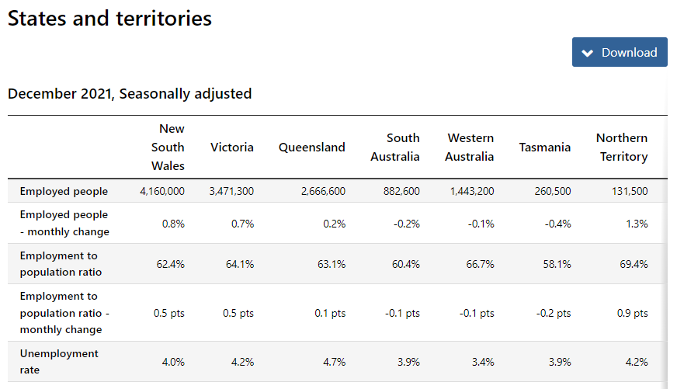
Source: https://www.abs.gov.au/statistics/labour/employment-and-unemployment/labour-force-australia/dec-2021#states-and-territories
Future iterations of the model can progressively replace state or territory with other variables that can more directly explain paid employment outcome (data availability and resource permitting), for example unemployment rate (above), availability of jobs in the area, participant’s distance to large population centres, etc.
Participants who fully achieved their work experience milestones were 1.9 times as likely to find employment compared to participants who had not.
Participants who made significant progress towards or fully achieved their work skills milestones were 1.5 times as likely to find employment compared to participants who made no or some progress towards similar milestones.
Participants who receive 51% to 100% of support in one-to-one settings were 1.4 times as likely to find employment compared to those who received 0% to 50% of support in one-to-one settings.

Appendix

Appendix 1 – Methodology for the section titled “Progress Towards Milestones – Cumulative up to December 2021”
This Appendix provides more details on how to interpret the section titled “Progress towards Milestones - Cumulative up to December 2021”, and the methodology used.
How to interpret the table below
Work experience milestone - % of participant progress
Cumulative training hours | No progress | Some progress | Significant progress | Current goals fully achieved | Total
0-9 | 61% | 29% | 6% | 4% | 100%
10-49 | 4% | 49% | 41% | 6% | 100%
50-99 | 1% | 35% | 59% | 5% | 100%
100+ | 0%  v | 30% | 60% | 10% | 100%

Out of all participants who have received 100+ hours of on-the-job work experience support (cumulative up to December 2021)
- 0% have "No progress" as the best result up to December 2021
- 30% have "Some progress" as the best result up to December 2021
- 60% have "Significant progress" as the best result up to December 2021
- 10% have "Current goals fully achieved" as the best result up to December 2021
The sum of each row in the above table equals 100%.
Methodology (for cumulative training hours)
The starting universe is all participants reported in the Provider Reporting Tool across the 4 quarters, from January to December 2021. For each participant, the "cumulative training hours" is then calculated as the total of the milestone-specific training hours reported in the Provider Tool from January to December 2021. The best progress for the specific milestone is used (of all progress entries reported in the Provider Reporting Tool across the 4 quarters, from January to December 2021).
For example, if for participant John Smith, following are the progresses and hours reported across the 4 quarters;

Work experience support (on the job)
Provider Tool Quarter | Progress towards milestone | Hours spent
Jan-Mar 2021 | No progress | 5
Apr-Jun 2021 | Significant progress | 15
Jul-Sep 2021 | Some progress | 10
Oct-Dec 2021 | Some progress | 9

then "cumulative training hours" = 39 = 5 + 15 + 10 + 9 and the progress selected for John is "Significant progress" (the best progress of the 4 quarters). The "cumulative training hours" is then rounded down to the nearest whole number (e.g. 6.75 is rounded down to 6), and grouped into bands. Then for each cumulative training hours group (e.g. 0-9), the % of participants in each (best) progress category is calculated so that the sum of the row is 100%.

Appendix 2 – Model Accuracy

The generalised linear model presented in Section 7 has the following accuracy:

Measures | Train Set | Test Set
Gini | 0.40 | 0.44
AUC | 0.70 | 0.72

The closer the test set AUC and Gini is to 1, the better the model performance.
Test set AUC (and Gini) is larger than training set AUC (and Gini) since the number of observations in the test set is quite small (436) relative to the training set (1309).
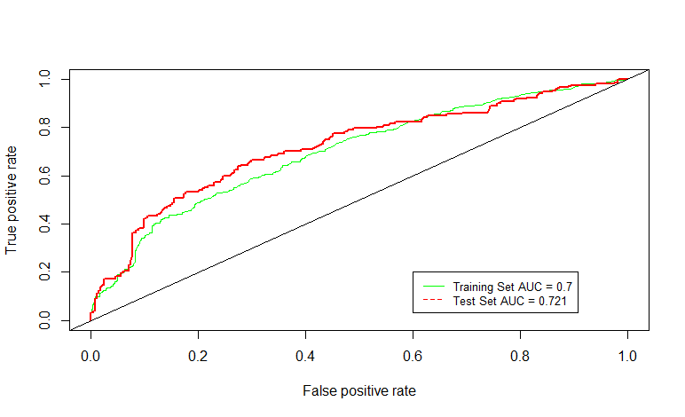

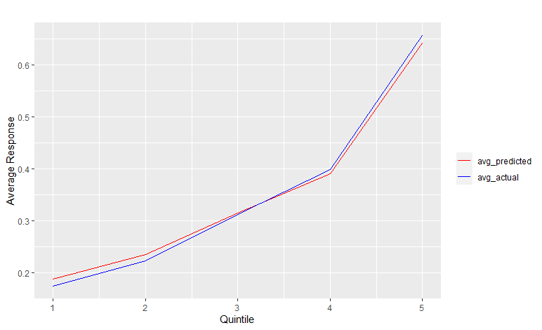
The model predicted probability (red) curve is close to the actual outcome (blue) curve, indicating that the model is able to closely predict the probability of recipients finding paid employment.

