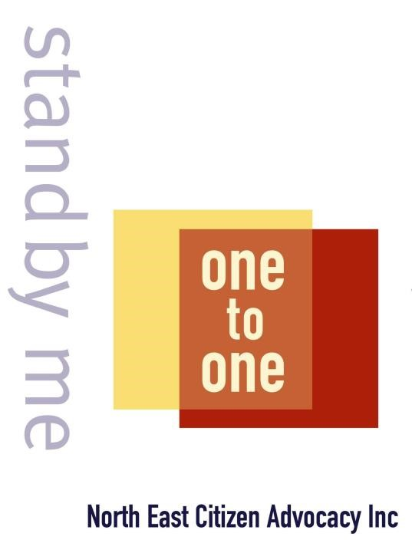

Advocacy and Supported Decision Making NDIA Consultation Paper Response

Amelia McMurray
DRC Advocate North East Citizen Advocacy drc@citizenadvocacy.com.au

1 | P a g e

At North East Citizen Advocacy, we provide advocacy support to adults with intellectual disability living in the North Eastern suburbs of Melbourne. Our responses to the questions outlined in the supported decision-making paper are detailed below, and can be understood within the context of the specific cohort that we provide service to.
The most effective, long-term measure of assisting people with disabilities to make decisions for themselves is to facilitate self-advocacy. People with disability are not typically taught that they can and should make decisions for themselves. Decision making skills are learnt over time, and through experience. This approach should be wholistic and across all areas of one's life; autonomy does not exist in a vacuum. An approach towards people with disability that views them as autonomous individuals with capacity to determine their own life choices should be encouraged across all areas of society, and from a young age. It is all very well to value the individual’s autonomy in a NDIS planning context, but if the individual has never been offered the option of choice, they may not have the necessary language, or understanding to engage in this process.
If an individual is not able to self-advocate, or requires assistance in decision making, advocates are often well placed to support them. This is by virtue of two factors which inform both ideology and practice:
- They possess knowledge of formal systems, processes, and relevant human rights frameworks. People who are in an advocate role often are privy to the inner workings of systems that may be overwhelming and confusing for people to navigate who have no formal experience in these areas.
- The basic ethos of disability advocacy itself is to elevate the voice of the individual, bolstering their autonomy. The promotion and protection of human rights is at the heart of disability advocacy work. The advocate should be recognised as a means by which an individual requiring support can more comfortably interface with systems and processes. The individual being supported should be recognised as the expert in their own experience. The ideal outcome of this approach is that an individual's capacity for self-advocacy and autonomous decision making is increased.
There are some challenges faced by advocates seeking to assist people with disability within the current model of supported decision making as it pertains to the NDIS planning context.
A distinct lack of parties involved in the supported decision making process who truly know and understand the individual’s wants and needs is a major concern. A person’s care team, made up of support workers and house coordinators, can change regularly, and therefore may lack the historical context and/or experience to provide support to make decisions on behalf of the person who they view as a customer. The care team may also make decisions that reflect available staff and resources and not necessarily decisions that represent the wish of the person. Care teams need to have consistent personnel that remain with the person for many years. They also need to demonstrate that choice has been afforded to the individual before making recommendations on their behalf. It has been observed that care teams who have this consistency are well placed to provide a wholistic understanding of the individual.
It is also important to recognise that members of a care team may possess a conflict of interest.
This arises from their position as people who are employed by the individual they are supporting, and whose loyalty ultimately lies with their service-providing organisation. They are not an independent party. In more severe circumstances, this conflict of interest can result in undue influence, wherein the service provider attempts to leverage their power as a perceived “expert” in the individual’s life as a means of furthering their own agenda. In this particular
2 | P a g e

dynamic, an advocate operates as an independent party, whose agenda lies solely with advancing the human rights and autonomy of the individual in question.
People with disabilities who are non-verbal or have cognitive disability are also currently experiencing a disadvantage in NDIS planning process, as meetings are currently being held via phone due to covid restrictions. Planning meetings conducted over the phone remove body-language as a major cue for ascertaining the way an individual is thinking or feeling. A phonecall-based interaction also does not allow for the full breadth of human communication to be explored. For many people with cognitive disability, a phonecall does not allow adequate social context in which to accurately express themselves. When the conversation in question holds significant ramifications for one’s future, such as planning for NDIS funding, feeling comfortable and able to express oneself accurately is extremely important.
Phone-based planning meetings immediately disqualify the individual from self-advocacy, and necessitates the involvement of a supportive decision maker. Video-link, or socially distanced and covid-safe in person procedures should be considered as an option for people with cognitive disability, when undertaking NDIS planning meetings.
It has also been observed that planners often ask questions of the individual, but don’t provide any context. They might ask “Do you want funding so you can find a job?” To which the individual may reply that yes, of course they want such a thing. What is not provided in this scenario are more details about what kind of job would likely be available to the individual, and what the processes of obtaining such a position would actually look like. Without such context given, individuals can end up in situations wherein they have funding to put towards something like gaining employment, but the job they end up with is not meaningful to them, and likely not a position they would have agreed to, had they known from the beginning how it would feel. This feeds in again to the idea that when people have not historically been afforded choice and autonomy in their lives, they may not know that there is not just one single option available to them.
The breadth of options, and alternatives should be presented to individuals to afford them the opportunity to exercise decision making skills. Full participation in decision making allows for mechanisms for person with disability to change their mind and are able to view the plan before final approval.
In summary, encouraging self-advocacy across all facets of everyday life for people with disabilities is the most effective means of facilitating their capacity to make decisions for themselves. In instances where someone is not able to make a decision by themselves and requires a supportive decision maker, this person should ideally be an independent party who knows the individual in question well and whose agenda is to champion the human rights and voice of the individual in question.
Every situation is different and advocates can provide the family and care teams with information about the rights of individuals to make their own decisions. The NDIS planning process, if it seeks to truly integrate a supported decision-making model into its approach, ought to re-assess the way it approaches communication with people who have cognitive disability. Planning must be accessible to people with alternate means of communication, and must detail and explore options and alternatives. People with disability should be connected with advocates earlier and NDIS planners should remain consistent over time.

Support for Decision Making consultation submission

Name: North East Citizen Advocacy (VIC)
Date and time submitted: 9/2/2021 2:16:00 AM

How can we help people with disability make decisions for themselves?
- Resources: Yes
- Information: Yes
- Decision Guides: Yes
- Having a person help: Yes
- Other: No

Who are the best people to help you (or a person with a disability) to make decisions?
- Family: Yes
- Friends: Yes
- Peer Support Networks: Yes
- Mentors: No
- Coordinators: No
- LAC: No
- NDIA Partners: No
- Advocates: Yes
- Service Providers: No
- Other: No

What should they do to help with decision-making?
No answer recorded

How can they get better at helping?
- Getting to know the participant well: Yes
- Doing some training on decision support: Yes
- By having resources and information about providing decision support: Yes
- Other: No

How can we make sure the right people are helping?
- They are chosen by the NDIS Participant as a decision supporter: No
- They value the rights of people to make decisions with support: Yes
- They are a registered provider: No
- They enable the participant to take risks: Yes
- Other: No

What should decision supporters know about so they can better help people with disability make decisions?
- Guidelines for decision supporters: Yes
- Scenarios or Examples: Yes
- Information Sessions: Yes
- Support Networks: Yes
- Other: No

Can you tell us about a time when someone helped you (or a person with disability) to make a big decision?
Not applicable

What worked well?
No answer recorded

What could have been better?
No answer recorded

What is the best way to support people with disability to make decisions about their NDIS plan?
- Practice: Yes
- Peer Support Networks: Yes
- Information and Resources: Yes
- Guidance Tools: Yes
- Not Sure: No
- Other: No

Are there different things to consider for people with different disabilities or cultural backgrounds?
An intellectual disability: No
A disability that impacts how they think, a cognitive impairment: No
A psychosocial disability: No
A disability that impacts their ability to communicate: No
From a CALD community: No
From an Aboriginal or Torres Strait Islander Community: No
From the LGBTIQA community: No

How can we help reduce conflict of interest?
No response recorded

How can we help reduce undue influence?
No response recorded

What are your concerns (if any) around people with disability being more involved in making decisions for themselves?
No response recorded

What else could we do to help people with disability to make decisions for themselves? Is there anything missing?
No response recorded

Do you have any feedback on our proposed actions in Appendix C of the paper?
No response recorded

