

Final report – Financial Benchmarking Survey
National Disability Insurance Agency
May 2022

Contents
Glossary i
Executive Summary ii
1 Introduction 6
1.1 About the National Disability Insurance Scheme 6
1.2 About the survey 7
1.3 Disaggregation of survey population 7
1.4 Overview of survey respondents 9
1.5 Structure of this Report 12
2 Approach and methodology 14
2.1 Data collection 14
2.2 Data cleaning 14
2.3 Caveat on data quality 18
3 Key cost parameters 19
3.1 Base rate of pay for DSWs 19
3.2 Base rate of pay for FLS 22
3.3 Span of control 24
3.4 Permanent and casual workforce 27
3.5 Salary on-costs 30
3.6 Standard hours of work 33
3.7 Utilisation – Disability support workers 33
3.8 Utilisation – Front-line supervisors 42
3.9 Overheads and EBITDA as a percentage of costs 48
3.10 Shift loadings 53
4 Employment conditions 58
4.1 Leave entitlements 58
4.2 Awards and Enterprise Bargaining Agreements 63
4.3 Allowances 64
4.4 Fringe benefits 66
5 Information on provider prices 69
5.1 TTP claim in 2020-21 69
5.2 Setting of prices 69
5.3 Price schedules for NDIS and non-NDIS participants 70
6 Drivers of key parameters 71
6.1 Overhead costs (as a percentage of direct labour costs) 72
6.2 Organisation service level expenses 75
6.3 Percentage of staff that are permanently employed (all staff) 78
6.4 Average hourly wage of a disability support worker 81
6.5 Average hourly wage of supervisors 83
6.6 Span of control (by headcount) 85
6.7 Utilisation (DSW) 87
6.8 EBITDA (as a percentage of total costs) 90
7 Review of survey process 92
7.1 Response rate 92
7.2 Improvements to the survey 92
7.3 Opportunities for improvement in future iterations 93
8 References 95
Limitation of our work 193
General use restriction 193

Charts
Chart 3.1 : Box plot (LHS) and PDF (RHS) of DSW base pay responses 18
Chart 3.2 : Box plot (LHS) and PDF (RHS) of FLS base pay responses 21
Chart 3.3 : Box plot (LHS) and PDF (RHS) of span of control responses, based on FTE 22
Chart 3.4 : Box plot (LHS) and PDF (RHS) of span of control responses, based on HC 23
Chart 3.5 : Box plot (LHS) and PDF (RHS) of permanent and casual workforce responses 25
Chart 3.6 : Box plot (LHS) and PDF (RHS) of workers compensation premium (%) responses 29
Chart 3.7 : Box plot of DSW utilisation billable time (%) responses 32
Chart 3.8 : PDF of DSW utilisation billable time (%) responses 32
Chart 3.9 : Box plot of DSW utilisation non-billable time (%) responses 33
Chart 3.10 : PDF of DSW non-billable time (%) responses 33
Chart 3.11 : Box plot of FLS utilisation billable time (%) responses 41
Chart 3.12 : PDF of FLS utilisation billable time (%) responses 42
Chart 3.13 : Box plot of FLS utilisation non-billable time (%) responses 42
Chart 3.14 : PDF of FLS utilisation non-billable time (%) responses 43
Chart 3.15 : Box plot (LHS) and PDF (RHS) of overheads as a percentage of direct labour costs (%) responses 47
Chart 3.16 : Box plot (LHS) and PDF (RHS) of EBITDA as a percentage of total costs (%) responses 48
Chart 3.17 : Box plot of shift loadings (afternoon and night shifts, permanent and casual) 53
Chart 3.18 : Box plot of shift loadings (weekend and public holiday shifts, permanent and casual) 53
Chart 3.19 : PDF of shift loadings (afternoon and night shifts, permanent and casual) 54
Chart 3.20 : PDF of shift loadings (weekend and public holiday shifts, permanent and casual) 54
Chart 3.21 : Casual and permanent staffing arrangements for night shifts, weekends and public holidays, survey responses (%) 55
Chart 4.1 : Box plot of long service leave (hours per annum) 57
Chart 4.2 : PDF of long service leave (hours per annum) 58
Chart 4.3 : PDF of annual leave and personal leave (hours per annum) 58
Chart 4.4 : Payment arrangements of survey respondents 61
Chart 4.5 : Awards used to assess EBAs against the Better Off Overall Test 62
Chart D.1 : Correlations between key variables of interest and overhead costs 178
Chart D.2 : Correlations between key variables of interest and organisation service level expenses 180
Chart D.3 : Correlations between key variables of interest and permanent employment rate 182
Chart D.4 : Correlations between key variables of interest and the average hourly wage of a disability support worker 185
Chart D.5 : Correlations between key variables of interest and the average hourly wage of supervisors 187
Chart D.6 : Correlations between key variables of interest and span of control 189
Chart D.7 : Correlations between key variables of interest and utilisation rate 191
Chart D.8 : Correlations between key variables of interest and EBITDA 193

Tables
Table 1.1 : Definitions for disaggregation of organisational size by NDIS revenue 9
Table 1.2 : Summary of survey response rates for the 2019-20 and 2020-21 survey iterations 9
Table 1.3 : Size of organisation by NDIS revenue of survey respondents and providers in the NDIA dataset 10
Table 1.4 : The primary state jurisdiction of survey respondents and NDIA dataset providers, by participant count 10
Table 1.5 : The number of service types operated by survey respondents and NDIA dataset providers, by revenue 11
Table 1.6 : Tenure of survey respondents 11
Table 1.7 : The proportion of survey respondents who have operated for less than 12 months operating in each service group 12
Table 1.8 : Taxation status characteristics from providers in 2019-20 12
Table 2.1 : Questions where implausible responses were removed 16
Table 2.2 : Questions/calculated fields where outliers were removed using the IQR method 17
Table 3.1 : Weighted average pay for DSWs 20
Table 3.2 : Comparison with 2019-20 survey: Weighted average pay for DSWs 20
Table 3.3 : Weighted average pay for DSWs by NDIS revenue size of organisation 21
Table 3.4 : Weighted average pay for DSWs by MMM region, by revenue 21
Table 3.5 : Weighted average pay for DSWs by service type, by revenue 21
Table 3.6 : Weighted average pay for DSWs by main state jurisdiction the provider operates in, by revenue 22
Table 3.7 : Supervision costs and span of control 22
Table 3.8 : Comparison with 2019-20 survey: FLS base rate of pay 23
Table 3.9 : Weighted average pay for FLSs by MMM region, by revenue 23
Table 3.10 : Weighted average pay for FLSs by service type, by revenue 24
Table 3.11 : Supervision costs and span of control 24
Table 3.12 : Comparison with 2019-20 survey: Span of control 24
Table 3.13 : Span of control by headcount by size of organisation, based on revenue 25
Table 3.14 : Span of control by headcount by service type, based on revenue 26
Table 3.15 : Span of control by headcount by main state jurisdiction the provider operates in, based on revenue 26
Table 3.16 : Permanent employment rate (across all staff) 27
Table 3.17 : Comparison with 2019-20 survey: Permanent employment rate 27
Table 3.18 : Permanent employment rate for all staff by MMM region, by revenue 28
Table 3.19 : Permanent employment rate for all staff by organisation share of NDIS revenue 28
Table 3.20 : Permanent employment rate for all staff by NDIS revenue size of organisation 29
Table 3.21 Permanent employment rate for all staff by main state jurisdiction the provider operates in, by revenue 29
Table 3.22 : Permanent employment rate for all staff by service type, by revenue 30
Table 3.23 : Salary on-costs, as a percentage of base salary – Superannuation 30
Table 3.24 : Comparison with 2019-20 survey: Superannuation 30
Table 3.25 : Breakdown of survey responses regarding approach to workers compensation 31
Table 3.26 : Salary on-costs, as a percentage of base salary – Workers compensation 31
Table 3.27 : Comparison with 2019-20 survey: Workers compensation 31
Table 3.28 : Workers compensation by service type, by revenue 32
Table 3.29 : Standard working hours per day for full time DSWs and FLSs 33
Table 3.30 : Comparison with 2019-20 survey: Standard working hours per day 33
Table 3.31 : Utilisation of DSWs (% of total time) 33
Table 3.32 : Comparison with 2019-20 survey: Utilisation of DSWs 34
Table 3.33 : Utilisation of DSWs in smaller organisations, by NDIS revenue 37
Table 3.34 : Utilisation of DSWs in medium organisations, by NDIS revenue 37
Table 3.35 : Utilisation of DSWs in larger organisations, by NDIS revenue 38
Table 3.36 : Utilisation of DSWs by service type, based on revenue – Supported Independent Living 38
Table 3.37 : Utilisation of DSWs by service type, based on revenue – High Intensity DPA 39
Table 3.38 : Utilisation of DSWs by service type, based on revenue – Employment 39
Table 3.39 : Utilisation of DSWs by service type, based on revenue – Daily Personal Activities 39
Table 3.40 : Utilisation of DSWs by the main state jurisdiction the provider operates in, by revenue - Victoria 40
Table 3.41 : Utilisation of DSWs by the main state jurisdiction the provider operates in, by revenue – Northern Territory 41
Table 3.42 : Utilisation of DSWs by the main state jurisdiction the provider operates in, by revenue – Australian Capital Territory 41
Table 3.43 : Utilisation of FLS (%) 42
Table 3.44 : Comparison with 2019-20 survey: Utilisation of FLS 42
Table 3.45 : Utilisation of FLS in smaller organisations, by NDIS revenue 45
Table 3.46 : Utilisation of FLS in medium organisations, by NDIS revenue 46
Table 3.47 : Utilisation of FLS in larger organisations, by NDIS revenue 46
Table 3.48 : Utilisation of FLS in by service type, based on revenue – Supported Independent Living 47
Table 3.49 : Utilisation of FLS in by service type, based on revenue - Employment 47
Table 3.50 : Utilisation of FLS in by service type, based on revenue – High Intensity DPA 48
Table 3.51 : Overheads and EBITDA as a percentage of costs 48
Table 3.52 : Comparison with 2019-20 survey: Overheads and EBITDA as a share of costs 49
Table 3.53 : Share of overheads categories 50
Table 3.54 : Overheads and EBITDA as a percentage of costs in smaller organisations, by NDIS revenue 51
Table 3.55 : Overheads and EBITDA as a percentage of costs in medium organisations, by NDIS revenue 51
Table 3.56 : Overheads and EBITDA as a percentage of costs in larger organisations, by NDIS revenue 51
Table 3.57 : Overheads and EBITDA as a percentage of costs by main state jurisdiction, by revenue – Australian Capital Territory 52
Table 3.58 : Overheads and EBITDA as a percentage of costs by main state jurisdiction, by revenue – New South Wales 52
Table 3.59 : Overheads and EBITDA as a percentage of costs by service type – Employment 52
Table 3.60 : Overheads and EBITDA as a percentage of costs by service type – Groups 53
Table 3.61 : Impact of shift loadings on cost per billable hour, as a % of hourly base rate of pay 53
Table 3.62 : Permanent and casual staff shift loading percentiles 54
Table 3.63 : Comparison with 2019-20 survey: Permanent and casual shift loading 54
Table 4.1 : Number of leave hours accrued by full time DSWs per year of service 58
Table 4.2 : Comparison with 2019-20 survey: Annual and long service leave 59
Table 4.3 : Proportion of full time DSWs entitled to more than the minimum number of hours of annual and personal leave 61
Table 4.4 : Proportion of providers whose annual leave accrual depends upon shift worker status or other factors 61
Table 4.5 : Proportion of providers whose personal leave accrual depends upon shift worker status or other factors 62
Table 4.6 : Proportion of providers whose casual staff are entitled to accrue long service leave 62
Table 4.7 : The proportion of staff within each organisation who receive an allowance 64
Table 4.8 : Comparison with 2019-20 survey: The proportion of staff within each organisation who receive an allowance 65
Table 4.9 : Types of allowances paid by service providers 65
Table 4.10 : Average dollar amount paid per worker (DSW and FLS) for vehicle and other allowances as a proportion of base rate of pay 66
Table 4.11 : Comparison with 2019-20 survey: Allowances 66
Table 4.12 : Average dollar amount paid for FTE worker (DSW and FLS) for fringe benefits 66
Table 4.13 : Comparison with 2019-20 survey: Average dollar amount paid for FTE worker (DSW and FLS) for fringe benefits 66
Table 4.14 : Average dollar amount paid for FTE worker (DSW and FLS) for fringe benefits, by size of organisation (based on revenue) 67
Table 4.15 : Average dollar amount paid for FTE worker (DSW and FLS) for fringe benefits, by not-for-profit status 67
Table 4.16 : Average dollar amount paid for FTE worker (DSW and FLS) for fringe benefits, by service group 67
Table 5.1 : Proportion of survey respondents who set service prices at the NDIS Pricing Arrangements and Price Limits 69
Table 6.1 : Parameters considered in the regression analysis 71
Table 6.2 : Regression analysis – overhead costs as a percentage of direct labour costs 73
Table 6.3 : Regression analysis – Dependent variable: organisation service level expenses (natural log) 76
Table 6.4 : Regression analysis – Dependent variable: Permanent employment rate (% of all staff that are permanently employed) 79
Table 6.5 : Regression analysis – Dependent variable: Average wage of a disability support worker 81
Table 6.6 : Regression analysis – Dependent variable: Average wage of a supervisors 83
Table 6.7 : Regression analysis – Span of control (by headcount) (natural log) 85
Table 6.8 : Regression analysis – Utilisation of support workers 88
Table 6.9 : Regression analysis – EBITDA as a percentage of total costs 91
Table 7.1 : Breakdown of the number of survey submissions received and number of service providers covered by a survey return 92
Table C.1 : Removal of ‘zero’ responses 107
Table C.2 : Removal of providers with less than 12 months of financial data 107
Table C.3 : Summary of descriptive statistics 108
Table C.4 : Limitations with direct comparison of survey results between the 2019-20 and 2020-21 iterations 112
Table C.5 : Summary of data cleaning applied to online survey extract 114
Table C.6 : Summary of results: DSW weighted average pay ($) 117
Table C.7 : Summary of results: FLS weighted average pay ($) 118
Table C.8 : Summary of results: Span of control (FTE) 120
Table C.9 : Summary of results: Span of control (by headcount) 121
Table C.10 : Summary of results: Permanent employment rate (by headcount) (%) 123
Table C.11 : Summary of results: Permanent employment rate (FTE) (%) 124
Table C.12 : Summary of results: Superannuation (%) 126
Table C.13 : Summary of results: Workers compensation premium (%) 127
Table C.14 : Summary of results: DSW total billable time 128
Table C.15 : Summary of results: DSW Billable time (excluding billable travel) 130
Table C.16 : Summary of results: DSW Billable travel 131
Table C.17 : Summary of results: DSW Non-billable travel 133
Table C.18 : Summary of results: DSW Training 134
Table C.19 : Summary of results: DSW Breaks 135
Table C.20 : Summary of results: DSW Client-related administration 137
Table C.21 : Summary of results: DSW Non-client related administration 138
Table C.22 : Summary of results: FLS Total billable time 140
Table C.23 : Summary of results: FLS Billable time (time spent providing direct support to participants) 141
Table C.24 : Summary of results: FLS Billable travel 143
Table C.25 : Summary of results: FLS Other travel 144
Table C.26 : Summary of results: FLS Supervising staff 145
Table C.27 : Summary of results: FLS Self training 147
Table C.28 : Summary of results: FLS Breaks 148
Table C.29 : Summary of results: FLS Client-related administration 150
Table C.30 : Summary of results: FLS General administration 151
Table C.31 : Summary of results: Overheads as share of direct labour costs (%) 153
Table C.32 : Summary of results: EBITDA as a share of total expenses (%) 154
Table C.33 : Summary of results: Fringe benefits ($) 156
Table C.34 : Sample size for disaggregation categories 158
Table C.35 : Workers compensation classifications of survey respondents 159
Table C.36 : Other factors relevant in the calculation of annual leave accrual 162
Table C.37 : Other factors relevant in the calculation of personal leave accrual 163
Table C.38 : Other factors relevant in the calculation of annual leave accrual 164
Table C.39 : Recognised Awards used by providers 165
Table C.40 : Enterprise Bargaining Agreements details of providers (as per responses entered into the survey) 166
Table D.1 : Variables used in the regression analysis 173
Table D.2 Quantile regression analysis – overhead costs as a percentage of direct labour costs 175
Table D.3 Quantile regression analysis –organisation service level expenses 177
Table D.4 Quantile regression analysis – permanent employment rate 180
Table D.5 Quantile regression analysis –the average hourly wage of a disability support worker 182
Table D.6 Quantile regression analysis –the average hourly wage of supervisors 184
Table D.7 Quantile regression analysis –span of control 187
Table D.8 Quantile regression analysis –utilisation rate 189
Table D.9 Quantile regression analysis –EBITDA 191

Figures
Figure 2.1 : Summary of data cleaning process 13

Glossary
Acronym | Full name
ABN | Australian Business Number
ATO | Australian Taxation Office
DPA | Daily Personal Activities
DSW | Disability support worker
EBA | Enterprise Bargaining Agreement
EBITDA | Earnings Before Interest, Tax, Depreciation and Amortisation
FBT | Fringe benefits tax
FLS | Front-line supervisor
FTE | Full time equivalent
HC | Headcount
HIDPA | High Intensity Daily Personal Activities
IQR | Interquartile Range
LHS | Left hand side
MMM | Modified Monash Model
NDIA | National Disability Insurance Agency
NDIS | National Disability Insurance Scheme
NFP | Not-for-profit
PC | Percentile
PDF | Probability Distribution Function
RHS | Right hand side
SCHADS | Social, Community, Home Care and Disability Services
SIL | Supported Independent Living
TTP | Temporary Transformation Payment

Executive Summary
About the Financial Benchmarking Survey
As part of its role as a market steward, the National Disability Insurance Agency (NDIA) administers an annual Financial Benchmarking Survey to collect information on staffing numbers, costs and earnings of support providers in the National Disability Insurance Scheme (NDIS). The survey data is gathered, analysed and published to assist providers to benchmark their financial performance against their peers. The data is also used to inform the price limits that the NDIA sets for many supports.
Deloitte Access Economics was engaged to design, administer and analyse the Financial Benchmarking Survey for the 2020-21 financial year.
Service providers were eligible to complete the survey if they operated in at least one of the following six service group categories:
- 104: High Intensity Daily Personal Activities
- 107: Daily Personal Activities
- 115: Assistance with Daily Life Tasks in a Group of Shared Living Arrangement (SIL)
- 125: Assistance to Access Community, Social and Recreational Activities
- 133: Employment Supports
- 136: Group and Centre Based Activities.
Any eligible service provider was able to complete the survey, however the survey was mandatory for those who had claimed the Temporary Transformation Payment (TTP) or intended to claim TTP before 30 June 2022.
Over the 10-week fielding period, from 29 November 2021 to 4 February 2022, 1,043 responses were submitted online. These responses were then combined with 46 additional responses received through Ability Roundtable, creating a total survey sample of 1,089 submissions.
At the time of writing, there were also 1,196 responses still in progress. However, these responses were not included in the analysis outlined in this report as they were not submitted by the due date. However, it should be noted that of these responses, 66% did not have any details entered meaning providers exited the survey before completing any questions. A further 10% of responses were a duplicate in that the provider details entered matched a survey return that was already submitted. Accordingly, only 24% of the 1,196 in progress responses were identifiable and were not a duplicate response.
Survey results
Deloitte performed statistical and econometric analysis on the final survey sample, with the results presented throughout this Report. The key findings from this analysis for several key parameters are also summarised below.
Base rate of pay for disability support workers (DSWs)
 | Mean | 25th PC | 50th PC | 75th PC
Base pay DSW ($) | 31.28 | 28.75 | 30.67 | 33.43
The weighted average base rate of pay for DSWs is calculated by multiplying the midpoint of each pay bracket by the proportion of staff being paid within each pay bracket. The average is then taken across each calculation to give an average base rate of pay that is adjusted for the proportion of staff working at each pay level. Over three quarters of all survey respondents paid their employees under a recognised Award and 70.0% specifically reported using the Social, Community, Home Care and Disability Services Award (SCHADS Award). The weighted average wage rates for DSWs displayed a full range of $22.42 to $65.00 per hour, although results revealed a narrow interquartile range (IQR) of $4.68 per hour. This indicates the DSW workforce is broadly paid in accordance with pre-determined rates such as a recognised Award.
Across all survey respondents, the average estimated base wage paid to DSWs was $31.28 per hour. The survey analysis also revealed that the average base pay for DSWs was higher where:
- each DSW supported a higher number of participants, on a fulltime equivalent (FTE) basis
- service providers paid a higher average wage to their frontline supervisors (FLS)
- service providers offered SIL services.
Supervision costs
 | Mean | 25th PC | 50th PC | 75th PC
Span of control (by headcount) | 10.6 x | 13.2 x | 7.5 x | 4.0 x
FLS base rate of pay ($) | 41.09 | 35.00 | 39.37 | 45.00
The span of control (by headcount) reported by service providers exhibited a wide variation which reflected the variety of service provider types captured by the survey from small to large organisations. The survey results indicated that on average, each FLS oversaw 10.6 DSWs. Survey analysis also found the number of DSWs supervised by each FLS increased as an organisation’s NDIS revenue or participant count increased. The average span of control also varied by the service type offered by service providers, as those offering Employment Services were associated with a lower span of control whereas SIL service providers were associated with higher span of control.
In relation to the costs of supervision, the survey results revealed an average base rate of pay of $41.09 per hour for FLSs. Further analysis revealed that the average base pay for FLS:
- decreased as the participant count of service providers increased
- was higher among service providers offering Group and Centre Based Activities.

Permanent and casual employment arrangements
 | Mean | 25th PC | 50th PC | 75th PC
Permanent employment rate – All staff (%) | 48.1 | 77.6 | 44.6 | 16.7
Permanent employment rate – DSW (%) | 36.5 | 66.7 | 28.3 | 3.0
Permanent employment rate - FLS (%) | 91.9 | 100.0 | 100.0 | 100.0
Of all survey respondents, 85.7% reported they employed a mix of permanent and casual staff. Of these service providers, the average proportion of DSW and FLS staff within each organisation who were permanently employed was 48.1%. The permanent employment rate varied by staff type and FLSs on average had a higher proportion of permanent staff compared to DSWs at 91.9% and 36.5% respectively.
Survey analysis revealed the permanent employment rate of the total workforce (for DSWs and FLSs) was higher for service providers:
- located in remote regions
- supporting a higher number of participants
- classified as small or large by employment size (by FTE)
- offering SIL services.
Service providers who employed both permanent and casual staff were also asked to report the shift loadings paid to each group on afternoon, night, weekend and public holiday shifts. The results revealed that the highest shift loading for both permanent and casual staff was paid on public holidays, with an average loading above the standard hourly rate of 123.0% and 138.4% respectively. Public holidays also exhibited the most pronounced difference between permanent and casual staff where the average loading for casual staff was 15.3% higher than permanent staff.
Survey results also revealed that service providers were more likely to employ more casual staff than permanent staff on night, weekend and public holiday shifts. Across all shift categories, 39.3% of service providers employed more casual staff, 20.6% employed more permanent staff and 29.5% employed approximately the same amount of casual and permanent staff.
Salary on-costs
 | Mean | 25th PC | 50th PC | 75th PC
Superannuation (%) | 9.5 | 9.5 | 9.5 | 9.5
Workers compensation premium (%) | 3.2 | 2.0 | 2.5 | 4.0
The majority of staff reported paying the mandated minimum rate of superannuation at 9.5% of base salary including leave. Of all survey respondents, 21.5% reported a superannuation rate above 9.5%, with the maximum value, being 15.5% of base salary including leave.
In relation to workers compensation, 3.1% of all survey respondents reported they self-insure with insurance against excess loss and 1.9% reported they self-insure without reinsurance against excess loss. The remaining 95.0% of survey respondents reported paying a workers compensation premium to an insurer.
Of the service providers who pay to an insurer, the average premium amount paid was 3.2%. The responses for workers compensation premium were also positively skewed, with the majority of responses sitting below 3.0%.
Standard hours of work
The survey results revealed that an average working day for full time DSWs and FLSs is 7.5 hours. This suggests the average working week for full time DSWs and FLSs is 37.5 hours, which in line with most recognised Awards that set a 38-hour work week.
Utilisation
 | Mean | 25th PC | 50th PC | 75th PC
Total billable utilisation - DSW (%) | 78.9 | 90.0 | 82.0 | 72.0
Total billable utilisation - FLS (%) | 25.5 | 45.0 | 20.0 | 5.0
The survey asked respondents to report the utilisation of DSWs and FLSs by estimating the proportion of their time spent on various billable and non-billable tasks.
The total billable utilisation of DSWs refers to the proportion of time spent on billable support to participants and billable travel time. On average, DSWs had a total utilisation of 78.9%. Further analysis revealed this average increased:
- as the organisation’s amount of NDIS revenue increased
- as the organisation participant count increased (where service providers already had a high utilisation rate)
- for not-for-profit organisations.

Although service providers were also asked to estimate the proportion of time FLSs spent on various activities, the utilisation rate of FLS should not be directly compared the utilisation rate of DSWs, as the focus of each role differs. However, the survey results revealed that FLSs do spend a portion of their total time on billable tasks in many organisations. Services providers reported a wide range of responses for total FLS utilisation but on average, FLSs spent 25.5% of their time on providing billable support to participants and billable travel. The primary non-billable tasks for FLS on average were client-related administration (29.3%) and supervising and training other staff (18.4%).

Overheads as a percentage of direct labour costs
 | Mean | 25th PC | 50th PC | 75th PC
Overheads (excluding interest and depreciation) as a share of direct labour costs (%) | 44.2 | 21.8 | 35.9 | 56.3
The survey results revealed that on average, service providers’ overheads (excluding interest and depreciation) were 44.2% of direct labour costs of DSW and FLS staff. It should be noted that these results relate to service providers’ entire organisation, as service providers’ responses were not limited to NDIS-funded activities only. The results exhibited a wide range of responses with a positively skewed distribution. This was expected given that providers reported in the context of their entire organisation and the survey cohort reported a wide range of total organisational expenses.
Further analysis revealed the average share of overheads (excluding interest and depreciation) as a proportion of direct labour costs increased where service providers:
- received a smaller amount of NDIS revenue
- supported a higher number of participants
- offered Group and Centre Based Activities.
EBITDA as a percentage of total costs
 | Mean | 25th PC | 50th PC | 75th PC
EBITDA as a share of total costs (%) | 13.3 | 21.4 | 10.9 | 3.9
The survey results also examined Earnings Before Interest, Tax, Depreciation and Amortisation (EBITDA) as a share of total expenses. The results revealed that on average, EBITDA was 13.3% of total expenses. The results also exhibited a relatively normal distribution and a wide range of results from -21.0% to 47.0%, being a range of 68.0% with outliers removed. The average share of EBITDA as a proportion of total expenses was higher where service providers:
- offered Employment services
- received a balance of revenue from the NDIS and other sources.

Introduction

About the National Disability Insurance Scheme
The National Disability Insurance Scheme (NDIS) provided disability support for over 500,000 people with disabilities as at 31 December 2021. Designed to work as a deregulated market of service providers, the cost of services under the NDIS is one of the most important factors in ensuring value for participants, the correct provision of care, and the long-term viability of the Scheme in supporting Australians with a disability.
The provision of supports for participants in the NDIS is subject to regulation by the National Disability Insurance Agency (NDIA, Agency) and the NDIS Quality and Safeguards Commission (Commission) through the provisions of the National Disability Insurance Scheme Act 2013 and its subordinate legislation. The NDIA has a role, as market steward, to create an efficient and sustainable marketplace through a diverse and competitive range of suppliers who are able to meet the structural changes created by a consumer-driven market.
Where possible, the NDIA utilises market mechanisms to deliver the level of supply required to meet participant demand at market clearing (efficient) prices. In underdeveloped markets (due to factors such as imperfect and asymmetric information or reduced competition), regulating the market is necessary to ensure that participant demand is met, the required mix of supports is supplied by providers, and the Scheme moves towards efficient prices.
Price controls are in place to ensure that participants receive value for money in the supports that they receive. In the short to medium term, price controls are required for some disability supports because the markets for disability goods and services are not yet fully developed. The longer-term goal of the NDIA is to remove regulatory mechanisms from the markets for disability supports. The NDIA continually monitors and reviews its price control framework and other market settings to determine whether they are still appropriate. Annual Pricing Reviews are an important part of that monitoring and review process.
As part of their role as market steward, the NDIA introduced the Temporary Transformation Payment (TTP) which service providers could access from 1 July 2019, which provided a 7.5% loading on top of the current price control limit. The purpose of the TTP was to assist providers to continue transforming their businesses in the move towards a more competitive marketplace. The loading was initially set at 7.5% but was reduced to 6% on 1 July 2020 and to 4.5% on 1 July 2021. It is scheduled to be further reduced to 3% on 1 July 2022 and to 1.5% on 1 July 2023. The loading will not apply from 1 July 2024.
Provision of the TTP is contingent on service providers meeting three requirements:
- publication of service prices, to reduce informational asymmetries between service providers, competitors, and clients
- listing up-to-date business contact details on the NDIS website, to encourage greater access for clients
- participating in annual NDIA approved market benchmarking, either through a benchmarking service provider (e.g. the Ability Roundtable benchmarking program) or through participation in the Financial Benchmarking Survey.

About the survey
The Financial Benchmarking Survey is an annual survey that collects information on staffing numbers, costs and earnings of support providers in the NDIS. The survey allows service providers to better under the distribution of operational efficiency within the market and to benchmark their organisation’s performance against that of their peers. The survey also provides valuable information to the NDIA to monitor the broader market for possible market failures or opportunities for future deregulation.

The previous two iterations of the annual benchmarking survey were conducted by Deloitte Access Economics which collected information relating to the 2018-19 and 2019-20 financial years. The 2018-29 survey iteration collected data only from providers who had claimed the TTP, while the 2019-20 iteration was open to all providers who operated under the relevant services, regardless of whether they had claimed TTP.
The 2020-21 Financial Benchmarking Survey used a similar scope to the 2019-20 survey, whereby providers were invited to complete the survey regardless of whether they claimed TTP. The survey was mandatory for service providers who had claimed TTP or intended to claim TTP before 30 June 2022. However, providers who do not claim TTP were also invited to participate.
The 2020-21 survey respondents were advised to respond to questions in the context of all NDIS-funded services in the following support categories, where possible:
- Assistance with Daily Life
  - Daily Personal Activities (DPA)
  - High Intensity DPA
  - Assistance with Daily Life Tasks in a Group or Shared Living Arrangement (Supported Independent Living - SIL)
- Participation in Community, Social and Civic activities
  - Assistance to Access Community, Social and Recreational Activities
  - Group and Centre based activities
  - Employment Supports
The NDIA engaged Deloitte Access Economics to design and field the 2020-21 iteration of the Financial Benchmarking Survey. This included designing and administering the survey online as well as analysing the survey extract alongside additional data received from another NDIA-approved benchmarking survey, the Ability Roundtable. This report provides detailed data, statistical and econometric analysis of the results from the survey, as well as a review of the survey process.
The NDIA was also provided with a declaration of adherence to data security, storage and management requirements (see Appendix A).

Disaggregation of survey population
Many service providers operate across different jurisdictions and provide a variety of service types. Accordingly, the NDIA provided an internal dataset (referred to in this Report as the “NDIA dataset”) which provided additional NDIS revenue data for each provider. This dataset also included a breakdown of the total NDIS revenue each provider received in each state jurisdiction, Modified Monash Model (MMM) region and each of the following six service groups categories:
- 104: High Intensity Daily Personal Activities
- 107: Daily Personal Activities
- 115: Assistance with Daily Life Tasks in a Group of Shared Living Arrangement (SIL)
- 125: Assistance to Access Community, Social and Recreational Activities
- 133: Employment Supports
- 136: Group and Centre Based Activities.
The NDIA dataset and survey data were then matched using each service providers’ identification number and/or Australian Business Number (ABN) to categorise each provider according to several primary characteristics. This was used to assess the representativeness of the survey sample discussed in Section 1.4. It was also used to disaggregate the survey results to identify further trends in the data. The disaggregated results for these cohorts are also presented in the remaining sections of this Report.
It should be noted that the Ability Roundtable data was only analysed as a whole and the service providers were not categorised into different cohorts for disaggregated results. This is because the Ability Roundtable data was provided in a de-identified format which meant it was not possible to match providers to the NDIA dataset.
Each service provider in the Financial Benchmarking Survey was classified as either a not-for-profit (NFP) or for-profit organisation using the survey data from question 3. They were also disaggregated according to their geographical location, using revenue to determine their state jurisdiction and primary MMM region.
Providers were also characterised according to the proportion of their total revenue that was sourced from the NDIS. Each provider was classified according to whether their total NDIS revenue made up less than 25.0%, 26.0 to 50.0%, 51.0 to 75.0% or more than 75.0% of their total revenue reported for the financial year.
Providers were also disaggregated by service group by weighting their responses according to the revenue claimed in each of the six service group categories listed above. This was performed by assigning a weight to each service provider based upon the proportion of revenue received in each service group relative to the broader sector.
Finally, service providers were broken down by organisation size according to the amount of revenue they received from the NDIS. The NDIA dataset was used to determine the amount of NDIS revenue received by each survey respondent for the 2020-21 financial year. This data revealed a wide distribution of NDIS revenue received by organisations and most service providers sat at either the lower or higher end of the distribution. This could be due to the fact that the survey was completed by a wide range of providers, from sole traders to larger organisations operating across multiple jurisdictions. The distribution of NDIS revenue data was then examined in consultation with the NDIA to select arbitrary thresholds to categorise providers as ‘small’, ‘medium’ and ‘large’. This ensured the size categories were appropriate given the distribution of the data and were also consistent with the 2019-20 survey iteration. The threshold values used to define each cohort for organisation size are outlined in Table 1.1.

            - : Definitions for disaggregation of organisational size by NDIS revenue
Category for provider size according to NDIS revenue | Threshold values
Small ($) | 0 – 999,999
Medium ($) | 1,000,000 – 6,999,999
Large ($) | 7,000,000+

Overview of survey respondents
The NDIA provided Deloitte Access Economics with a list of 6,810 service providers to invite to complete the survey (referred to in this Report as the “distribution list”). Each service provider on the distribution list was categorised according to whether their participation was compulsory or optional, depending on whether they had made a claim for TTP.
At the time the survey closed, 1,043 responses were received through the online survey platform, which yielded a response rate of 15.3%. Table 1.2 provides a breakdown of the survey response rate as well as a comparison to the 2019-20 survey iteration. This shows the total number of responses received increased from the previous year, with an additional 24 responses submitted compared to the 2019-20 iteration. However, the overall responses rate was lower than the previous iteration which was caused by a larger distribution list in 2020-21 iteration.
            - : Summary of survey response rates for the 2019-20 and 2020-21 survey iterations
Survey iteration | Number of responses submitted | Number of providers invited to complete the survey | Proportion of providers who complete the survey (%)
2020-21 | 1,043 | 6,810 | 15.3
2019-20 | 1,019 | 3,218 | 32.0
Change | + 24 | +3,592 | -16.7
The 1,043 survey responses were then matched to the distribution list and the NDIA dataset to gather more information on the characteristics of the survey sample. Of the submitted survey responses, 83.0% matched with the NDIA’s ‘compulsory participation’ list.
Characteristics of the survey sample were also compared against the NDIA dataset to examine the representativeness of survey sample against the larger list of providers in the NDIA dataset. It should be noted that it was not possible to analyse the representativeness of the survey sample against the entire sector, as no public data was available relating to the sector as a whole.
In terms of organisation size by NDIS revenue as per Table 1.3, 41.0% of service providers were classified as a “small” organisation and 16.2% were classified as “large”. As seen in Table 1.3, this is consistent with the larger list of providers in the NDIA dataset, where the majority of providers are classified as “small” and the smallest proportion are classified as “large”.

            - : Size of organisation by NDIS revenue of survey respondents and providers in the NDIA dataset
Organisation size (revenue) | Proportion of survey respondents | Proportion of providers in NDIA dataset
Smaller (%) | 41.0 | 56.3
Medium (%) | 34.2 | 15.3
Larger (%) | 16.2 | 6.2
The survey sample and NDIA dataset were also compared using the primary jurisdiction of operation. Each provider was assigned a primary state of operation according to the jurisdiction in which they received the largest share of revenue. Table 1.4 illustrates that survey respondents primarily operated in New South Wales (30.1%), Victoria (22.5%) and Queensland (17.9%), whilst the lowest proportion of providers operated in the Australian Capital Territory (1.8%) and Northern Territory (1.2%).
            - : The primary state jurisdiction of survey respondents and NDIA dataset providers, by participant count
Primary jurisdiction (by revenue) |  | Proportion of survey respondents | Proportion of providers in NDIA dataset
NSW (%) | 30.1 |  | 28.3
VIC (%) | 22.5 |  | 18.9
QLD (%) | 17.9 |  | 15.5
SA (%) | 7.6 |  | 6.0
WA (%) | 7.4 |  | 4.7
TAS (%) | 3.0 |  | 2.0
ACT (%) | 1.8 |  | 1.7
NT (%) | 1.2 |  | 1.3
Service providers were eligible to complete the survey if they operated in at least one of the following six service group categories:
- 104: High Intensity Daily Personal Activities
- 107: Daily Personal Activities
- 115: Assistance with Daily Life Tasks in a Group of Shared Living Arrangement (SIL)
- 125: Assistance to Access Community, Social and Recreational Activities
- 133: Employment Supports
- 136: Group and Centre Based Activities.

The overall number of service groups covered by each service provider was also examined using revenue data for each service provider who matched to the NDIA dataset. Table 1.5 illustrates that survey respondents were more likely to operate across 3 to 6 service groups, as 33.8% of providers operated across 5 to 6 services and 31.4% operated across 3 to 4 services.
            - : The number of service types operated by survey respondents and NDIA dataset providers, by revenue
Number of service types operated by providers | Proportion of survey respondents | Proportion of providers in NDIA dataset
1 to 2 service types (%) | 19.5 | 15.2
3 to 4 service types (%) | 31.4 | 17.2
5 to 6 service types (%) | 33.8 | 14.3
Additional questions were included in this year’s survey to obtain further information on how long each organisation had been in operation. Table 1.6 illustrates that 48.9% of service provider organisations have operated for more than ten years, whilst 8.4% commenced operations in the past 12 months.
            - : Tenure of survey respondents
Length of operation | Proportion of respondents
Less than 12 months (%) | 8.4
1 to 2 years (%) | 11.7
3 to 6 years (%) | 24.0
7 to 10 years (%) | 7.1
10 or more years (%) | 48.9
Of the 8.4% of respondents shown in Table 1.6 who operated for less than 12 months, Table 1.7 shows the proportion who operated in each service group. This indicates that 43.5% of providers who operated for less than 12 months provided Assistance to Access Community, Social and Recreational Activities services and 41.3% provided Daily Personal Activities services.

            - : The proportion of survey respondents who have operated for less than 12 months operating in each service group
Service group operated by providers | Proportion of survey respondents who operated for less than 12 months
Assistance to Access Community, Social and Recreational Activities (%) | 43.5
DPA (%) | 41.3
High Intensity DPA (%) | 20.7
SIL (%) | 18.5
Group and Centre Based Activities (%) | 18.5
Employment supports (%) | 7.6
Survey respondents were also asked several questions regarding their organisation’s key taxation status characteristics, including the NFP status and payment of income tax. Table 1.8 outlines the proportion of survey respondents who identified with each characteristic.
            - : Taxation status characteristics from providers in 2019-20
Provider characteristic | Proportion of respondents
Registered with the Australian Charities and Not-For-Profits Commission in 2020-21 (%) | 47.1
Registered as a Deductible Gift Recipient with the Australian Taxation Office in 2020-21 (%) | 45.3
Income Tax Exempt Organisation for income tax purposes in 2020-21 (%) | 46.7
Registered public benevolent institution endorsed by the ATO for FBT concessions in 2020-21 (%) | 44.9
Paid payroll tax in 2020-21 (%) | 45.7
Paid income tax or company tax in 2020-21 (%) | 48.3

Structure of this Report
The remainder of this Report presents the results from the Financial Benchmarking Survey. The Report is structured as follows:
Section 2: Approach and methodology. This Section outlines the approach taken to administer the 2020-21 Financial Benchmarking Survey as well as the data cleaning approaches used on the final survey extract.

Section 3: Key cost parameters. This Section presents the results of the survey analysis for the key parameters, including key descriptive statistics and the disaggregated results by different provider characteristics. Section 3 also compares the non-disaggregated results with the results of the 2019-20 financial year.

Section 4: Employment conditions. This Section presents results from the survey regarding service providers’ employment conditions, including leave entitlements, allowances and remuneration Awards and Enterprise Bargaining Agreements (EBAs).
Section 5: Information on provider prices. This Section provides a summary of the survey responses related to reasons for setting prices at or below the NDIS Price Limit, and any variation in prices for NDIS clients compared to other clients.

Section 6: Drivers of key parameters. This Section presents the results of the regression analysis to identify key ‘drivers’ of selected parameters to inform providers of opportunities for greater efficiency.

Section 7: Review of survey process. This Section provides reflections on the survey process, including identified opportunities for improvements to future iterations of the survey.

Approach and methodology
The survey was developed by Deloitte Access Economics, in consultation with the NDIA. The survey was fielded in the Qualtrics survey platform and contained 51 questions which covered a range of financial and staffing information including: staff numbers, base rates of pay, the number of hours worked, utilisation, revenue, and expenses. This Section outlines the data collection and cleaning process. A copy of the survey questions and further detail on the survey fielding process are provided in Appendix B.

Data collection
The survey received 1,043 responses through the online platform. The survey contained 51 survey questions which were all compulsory to complete. However, of the 51 survey questions, 17 were only applicable to certain service providers, such as questions relating to permanent and casual staffing arrangements, EBAs and allowances. Therefore, all submissions received via the online survey platform provided a minimum of 34 question responses and additional responses were received where questions were applicable to each service provider.
An additional 46 responses were also received from service providers who participated through the Ability Roundtable. This yielded a total count of 1,089 completed responses when combined with the Financial Benchmarking Survey submissions.
To increase the data available for analysis, and to reduce the respondent burden, the survey data received through the online platform was linked to the NDIA dataset which comprised the following data points for each service provider registered with the NDIA:
- NDIS total revenue
- revenue and participant count by state and territory of operation
- revenue and participant count by MMM region
- revenue and participant count by service type for the following service types:
  - Daily Personal Activity (DPA)
  - High Intensity DPA
  - Supported Independent Living (SIL)
  - Participation in Community, Social and Civic Activities
  - Specialised Supported Employment (Employment Services)
  - Group and Centre Based Activities (Group Supports).

The two datasets were linked using each survey respondent’s NDIA provider number and Australian Business Number (ABN), which were common to both datasets. Of the 1,043 responses received, three service providers could not be matched with the NDIA dataset, being less than 1.0% of the survey responses.

It should be noted that the Ability Roundtable survey responses were not matched to the NDIA dataset and accordingly, were not disaggregated by the categories outlined in Section 1.3. This is because the survey data was provided in a deidentified format that could not be matched with the relevant information in the NDIA dataset.

Data cleaning
Once the survey closed on 4 February 2022, the survey extract was downloaded and cleaned using a variety of techniques, prior to commencing analysis. It should be noted that data cleaning was only conducted on the 1,043 responses received through the online survey platform. This is because Ability Roundtable performed separate data cleaning and sense checking for the 46 responses prior to Deloitte’s analysis.
Figure 2.1 summarises the data cleaning process undertaken on the survey extract. A copy of the survey questions are provided in Appendix B.
                - : Summary of data cleaning process
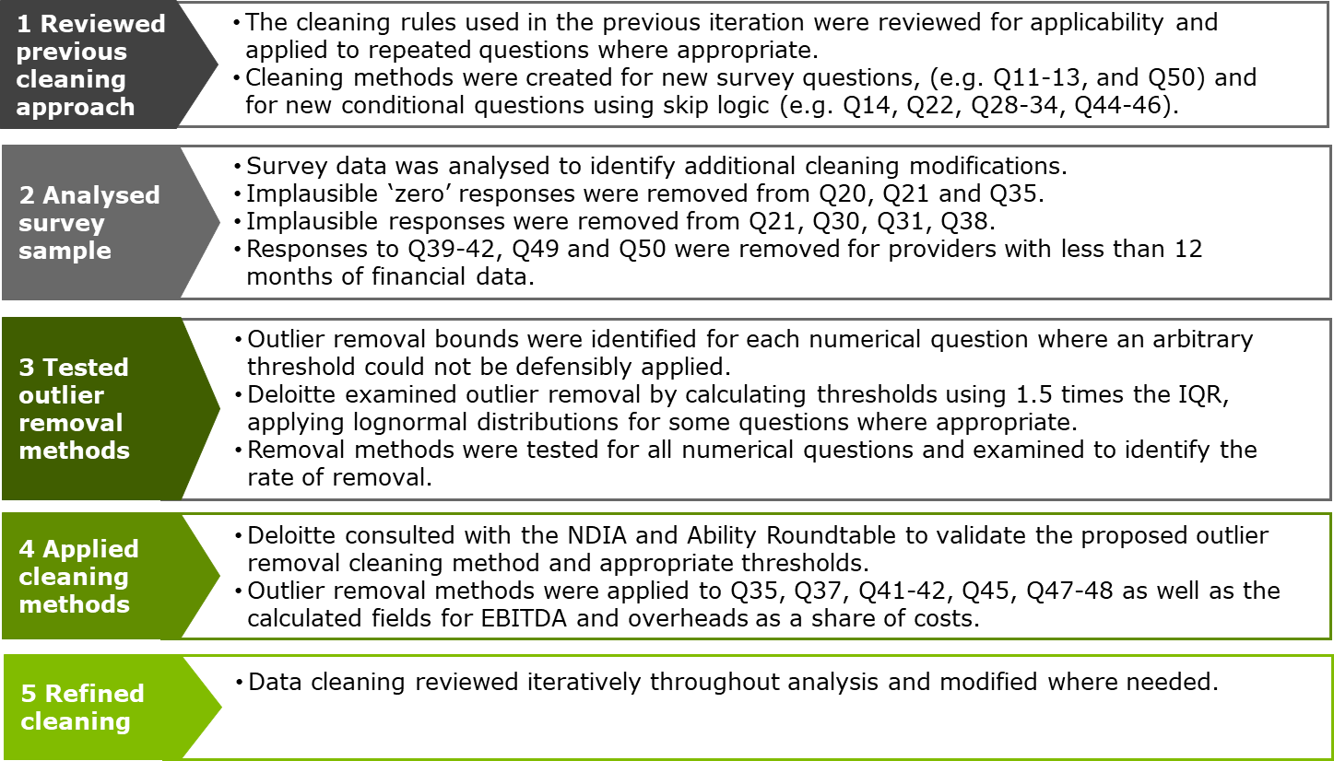
Four primary methods of data cleaning were employed:
- removal of inappropriate ‘zero’ responses
- removal of service providers with less than 12 months of financial data for specific questions
- removal of responses considered implausible (see further details below)
- removing of outliers for specific questions (see further details below).

Data cleaning was conducted to remove ‘zero’ responses where this was considered implausible given the context of the question. This methodology was only applied to compulsory questions, where it has been interpreted to indicate that respondents did not have the information readily available, and/or did not understand the question. The questions where cleaning was applied to inappropriate ‘zero’ responses are outlined in Appendix C.
Some responses relating to financial data were also removed where service providers had not operated for a full financial year. This is because it was not appropriate to pro rata survey responses if a service provider held less than 12 months of financial data, given that financial figures often do not follow a consistent linear approach each month. The questions where responses with less than 12 months of financial data were removed are outlined in Appendix C.
For some questions, thresholds were developed to remove responses considered implausible based on current industry practices and standards. As seen in Table 2.1, the highest rate of removal occurred for question 31 regarding annual leave loadings, with a rate of removal of 2.2% of total responses.

            - : Questions where implausible responses were removed
Question number | Question | Rate of implausible responses (%)
31 | Are staff paid a loading when they are on annual leave? | 2.2
21 | What are the standard working hours per day for fulltime equivalent (FTE) disability support workers and front-line super staff in the organisation? | 1.7
38 | What percentage of base salary was paid as superannuation by your organisation in 2020-21? | 0.3
30 | What proportion of staff are entitled to more than the minimum number of hours of annual leave that you specified above? | 0.1
To improve the statistical significance of the results by reducing the variability of the survey data received, a data cleaning method was also undertaken to remove outliers. The approach classified any response outside of 1.5 times the interquartile range (IQR) as an outlier to be removed. This methodology was only applied to specific questions where a non-statistical threshold would have otherwise been used to filter out extreme responses. Note that in some cases it was most appropriate to apply this methodology using the lognormal distribution of the survey responses.
This approach resulted in the highest rate of removal for question 35 and question 45, as presented in Table 2.2. This is partly due to the smaller sample size of answers provided for these questions. For example, organisations with casualised workforces did not answer question 35 regarding long service leave and organisations that self-insure did not answer question 45 regarding workers compensation premiums.
It should also be noted that the majority of responses removed using the IQR outlier removal method would be considered implausible. For example, question 35 asked service providers to report the number of hours of long service leave accrued per worker, however outlier values aligned more with the total number of long service leave hours accrued across the whole organisation. Further, the IQR outlier removal method was applied to the calculation of Earnings Before Interest, Tax, Depreciation and Amortisation (EBITDA) as a share of total expenses, which relied upon several financial questions in the survey as inputs. This method captured and removed extreme datapoints that resulted from respondent errors when inputting financial data into the survey. For example, where service providers reported extremely high revenue but low service level expenses which would not be deemed plausible given their other responses.

            - : Questions/calculated fields where outliers were removed using the IQR method
Question number | Question | Rate of outlier responses (%)
35 | How many hours of long service leave is a person employed as a fulltime equivalent (FTE) disability support worker in your organisation entitled to accrue for each year of service? | 37.1
45 | For the jurisdiction where your organisation generates the largest source of its NDIS revenue, what was the workers compensation premium that your organisation paid, as a proportion of wages and salaries? | 21.8
37 | What shift loadings above the standard hourly base rate apply to people employed by your organisation on a casual or permanent basis? [Casual employee – Saturday shift] | 15.4
Calculated Field | EBITDA as a share of Total Expenses | 14.2
37 | What shift loadings above the standard hourly base rate apply to people employed by your organisation on a casual or permanent basis? [Permanent employee – Saturday shift] | 13.5
Calculated Field | Overheads (excluding Interest and Depreciation) as a share of Direct Labour Costs | 10.5
48 | For front-line supervisors, on average, over the financial year which ended in 2021 what proportion of time did they spend on the following activities? | 10.4
47 | For disability support workers, on average, over the financial year which ended in 2021 what proportion of time did they spend on the following activities? | 10.3
37 | What shift loadings above the standard hourly base rate apply to people employed by your organisation on a casual or permanent basis? [Permanent employee – Night shift] | 9.7
42 | What is the average dollar amount per worker (direct support and front-line supervisor) per year, for the allowance you pay that are not vehicle allowance? | 8.7
37 | What shift loadings above the standard hourly base rate apply to people employed by your organisation on a casual or permanent basis? [Casual employee – Night shift] | 8.1
37 | What shift loadings above the standard hourly base rate apply to people employed by your organisation on a casual or permanent basis? [Permanent employee – Afternoon shift] | 7.8
37 | What shift loadings above the standard hourly base rate apply to people employed by your organisation on a casual or permanent basis? [Casual employee – Afternoon shift] | 7.2
41 | What is the average dollar amount per worker (direct support and front-line supervisor) per year, for vehicle allowances? | 7.0
37 | What shift loadings above the standard hourly base rate apply to people employed by your organisation on a casual or permanent basis? [Casual employee – Sunday shift] | 5.7
37 | What shift loadings above the standard hourly base rate apply to people employed by your organisation on a casual or permanent basis? [Casual employee – Public holiday shift] | 0.1

Caveat on data quality
The results presented in this Report reflect only the responses of providers who completed the survey from the distribution list. In particular, it is important to note that the results presented:
- Are affected by small sample sizes for some categories. Some questions and disaggregation categories were only relevant for certain providers which resulted in small sample sizes for some parameters. Results that are impacted by small sizes are flagged throughout the Report.
- Depend on the accuracy and completeness of responses given by survey respondents. Although Help Text was provided to help service providers answer questions consistently and accurately, it is possible that some service providers made errors or answered the survey with less accuracy.
- Depend on the context in which providers answered each question. Although Help Text was included to guide service providers on how to answer certain questions, a wide range of organisation types responded to the survey and some may not have been able to answer all questions in the specified context.

Key cost parameters
This Section and Appendix C present the results of the statistical and econometric analysis that was conducted following the data collection and cleaning described in Section 2. The results from the expanded dataset presented in this Section have focused on the interesting/notable findings, with full results presented in Appendix C. Results presented in this Section include:
- Section 3.1: Base rate of pay for DSWs
- Section 3.2: Base rate of pay for FLS
- Section 3.3: Span of control
- Section 3.4: Permanent and casual workforce
- Section 3.5: Salary on-costs
- Section 3.6: Standard hours of work
- Section 3.7: Utilisation – Disability support workers
- Section 3.8: Utilisation – Front-line supervisors
- Section 3.9: Overheads and EBITDA as a percentage of costs
- Section 3.10: Shift loadings
The key results of analysis for each of these parameters are presented in Section 3, with additional results presented in Appendix C, as follows:
- Section 3:
  - The mean and median, 10th, 25th, 75th and 90th percentile results for each response.
  - A comparison with the results from the 2019-20 survey. The key descriptive statistics from the 2019-20 iteration are provided for each cost parameter to identify any variation between the 2019-20 and 2020-21 survey results. It is important to note that direct comparison may not be possible for some parameters where the data cleaning or analysis techniques have changed between years.
  - Box plots, Probability Density Functions (PDFs) and frequency histogram distributions of survey results where applicable, with commentary describing key considerations of the results. For visual clarity, the box plots exclude responses which were considered to be outliers (defined as 1.5 times outside the upper and lower quartiles). As such, the charts in the box plots may not match exactly with the results in the corresponding tables.
- Appendix C:
  - The minimum and maximum values, as well as the 5th, 10th, 25th, 50th, 75th, 90th and 95th percentiles.
  - The standard deviation, skew and kurtosis.
  - Additional disaggregated results for each costs parameter.
  - Summary of any limitations in direct comparisons between the 2019-20 and 2020-21 survey iterations, including the differences in data cleaning and analysis.

Base rate of pay for DSWs
The 2020-21 survey sought information from each service provider on the distribution of the pay rates for its DSWs and front-line supervisors (FLSs) across ten categories. From the responses, a weighted average salary was calculated for each organisation. Table 3.1 shows that on average the estimated base rate paid to DSWs by service providers was $31.28. Further analysis on wages for DSWs is provided in Section 6.4.
            - : Weighted average pay for DSWs
 | Mean | 10th PC | 25th PC | 50th PC | 75th PC | 90th PC
Base pay DSW ($) | 31.28 | 26.23 | 28.75 | 30.67 | 33.43 | 36.25
When looking at the variation in base rate of pay across years, Table 3.2 shows the average base rate of pay for DSWs has remained consistent at a nominal level with the 2019-20 survey, which showed an average base rate of $31.57. When including an adjustment for year on year price changes (based on the Fair Work Commissions increase 2020-21 in the minimum wage), the base rate of pay for DSWs on average has decreased slightly.
            - : Comparison with 2019-20 survey: Weighted average pay for DSWs
Results from 2019-20 survey | Mean | 10th PC | 25th PC | 50th PC | 75th PC | 90th PC
Base pay DSW ($) | 31.57 | 26.43 | 28.72 | 30.57 | 33.50 | 36.27
Base pay DSW, Adjusted for Fair Work Commissions 1.75% Increase ($) | 32.12 | 26.89 | 29.22 | 31.11 | 34.08 | 36.90
As per the PDF Chart 3.1, the weighted average DSW wage rates were in the range of $22.42 to $65.00 per hour, which is indicative of DSWs operating across multiple levels. The results reveal 25th and 75th percentiles of $28.75 and $33.43 respectively, showing a narrow IQR of $4.69 per hour. This is consistent with the results from the previous financial year and may indicate the DSW workforce is broadly paid in accordance with pre-determined rates such as the SCHADS Award.
              - : Box plot (LHS) and PDF (RHS) of DSW base pay responses
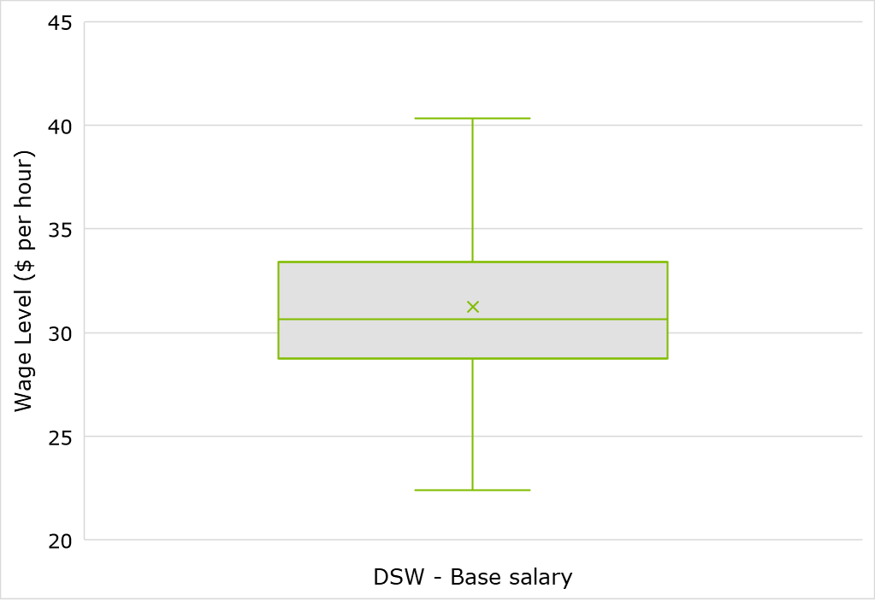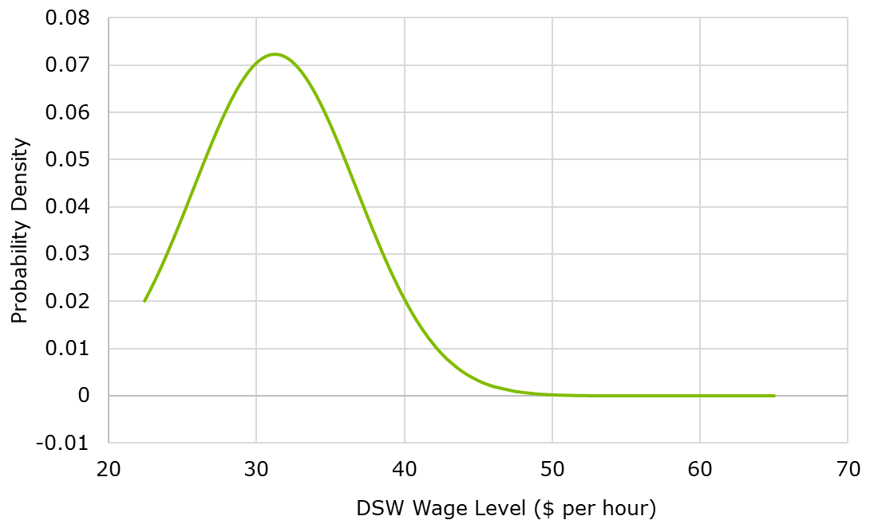
The survey results displayed in Table 3.3 show that the average base rate of pay for DSWs tended to decrease as organisation size increased, with larger service providers reporting the lowest average DSW base rate of pay at $30.51.

            - : Weighted average pay for DSWs by NDIS revenue size of organisation
 | Mean | 10th PC | 25th PC | 50th PC | 75th PC | 90th PC
Smaller ($) | 31.45 | 24.34 | 28.33 | 30.97 | 34.02 | 36.87
Medium ($) | 30.65 | 26.25 | 28.75 | 30.17 | 32.73 | 35.90
Larger ($) | 30.51 | 26.22 | 28.96 | 30.36 | 31.82 | 34.16
As seen in Table 3.4, the average base rate of pay for DSWs was higher for service providers located in remote regions. Service providers in metropolitan regions (MMM region ≤3) on average reported a lower DSW base rate of pay of $30.88 whilst those in a remote MMM region (≥6) had an average of $33.73.
            - : Weighted average pay for DSWs by MMM region, by revenue
 | Mean | 10th PC | 25th PC | 50th PC | 75th PC | 90th PC
≤3 (%) | 30.88 | 26.06 | 28.59 | 30.44 | 33.21 | 36.25
4-5 (%) | 31.40 | 26.25 | 28.48 | 30.21 | 33.08 | 37.59
≥6 (%) | 33.73 | 24.34 | 28.03 | 32.20 | 36.39 | 51.95
The DSW base rate of pay also varied by types of services provided. Table 3.5 illustrates that service providers offering High Intensity DPA and Group services had the highest base rate of pay for DSWs within their organisations, with an average of $31.48 and $31.18 respectively. Service providers offering DPA and Employment services had the lowest DSW base rate of pay with an average of $30.04 and $30.43 respectively.
            - : Weighted average pay for DSWs by service type, by revenue
 | Mean | 10th PC | 25th PC | 50th PC | 75th PC | 90th PC
High Intensity DPA ($) | 31.48 | 26.25 | 28.92 | 31.02 | 33.75 | 37.60
DPA ($) | 30.04 | 23.85 | 27.79 | 29.30 | 32.13 | 36.25
Part in Comm Soc Civ ($) | 30.57 | 24.85 | 28.14 | 29.99 | 33.43 | 36.25
SIL ($) | 31.09 | 27.16 | 29.25 | 30.62 | 32.38 | 34.93
Employment ($) | 30.43 | 23.69 | 26.48 | 29.60 | 32.91 | 36.81
Groups ($) | 31.18 | 26.48 | 29.06 | 31.10 | 33.36 | 35.42
The average base rate of pay for DSWs was also varied by service providers’ geographical location. Organisations primarily operating in the Australian Capital Territory, Northern Territory and Tasmania, all reported base rates of pay for DSWs higher than the national average. As seen in
Table 3.6, service providers operating in South Australia as their primary state jurisdiction of operation had the lowest average DSW base rate of pay at $30.03.
            - : Weighted average pay for DSWs by main state jurisdiction the provider operates in, by revenue
 | Mean | 10th PC | 25th PC | 50th PC | 75th PC | 90th PC
NSW | 30.84 | 26.25 | 28.75 | 30.45 | 32.93 | 36.25
QLD | 31.28 | 26.01 | 28.38 | 30.09 | 33.75 | 36.58
VIC | 30.85 | 25.00 | 28.70 | 30.64 | 33.09 | 36.25
WA | 30.99 | 26.00 | 28.75 | 30.57 | 31.93 | 36.25
SA | 30.03 | 24.09 | 27.46 | 29.78 | 33.21 | 36.76
ACT | 33.51 | 26.89 | 29.86 | 32.18 | 35.42 | 36.07
NT | 32.30 | 22.48 | 28.74 | 32.97 | 36.67 | 38.85
TAS | 31.57 | 23.38 | 28.75 | 30.84 | 33.81 | 40.13
For further details and outputs on base rate of pay for DSWs, see Appendix C.

Base rate of pay for FLS
This Section examines the survey results for DSW and FLS span of control as well as the base rate of pay for FLSs. Wages for supervisor staff are also analysed further in Section 6.5.
Table 3.11 illustrates the average base rate of pay for FLSs was estimated at $41.09 per hour.
            - : Supervision costs and span of control
 | Mean | 10th PC | 25th PC | 50th PC | 75th PC | 90th PC
FLS base rate of pay ($) | 41.09 | 31.25 | 35.00 | 39.37 | 45.00 | 53.31
When looking at the variation in base rate of pay across years, Table 3.8 shows the average base rate of pay for FLSs has increased slightly at a nominal level with the 2019-20 survey, which showed an average base rate of $40.28. When including an adjustment for year on year price changes (based on the Fair Work Commissions increase 2020-21 in the minimum wage), the base rate of pay for FLSs on average has remained consistent.

            - : Comparison with 2019-20 survey: FLS base rate of pay
Results from 2019-20 survey | Mean | 10th PC | 25th PC | 50th PC | 75th PC | 90th PC
FLS base salary ($) | 40.28 | 30.42 | 33.75 | 38.61 | 43.13 | 53.75
Base pay FLS Fair Work Commissions 1.75% Increase ($) | 40.99 | 30.95 | 34.34 | 39.28 | 43.89 | 54.69
Chart 3.2 shows the FLS wage distributions exhibit the same full range of values as the DSW wages, with responses between $22.42 per hour and $65.00; a range of $42.58 per hour. However, the IQR was broader for FLS at $10.00 per hour.
              - : Box plot (LHS) and PDF (RHS) of FLS base pay responses
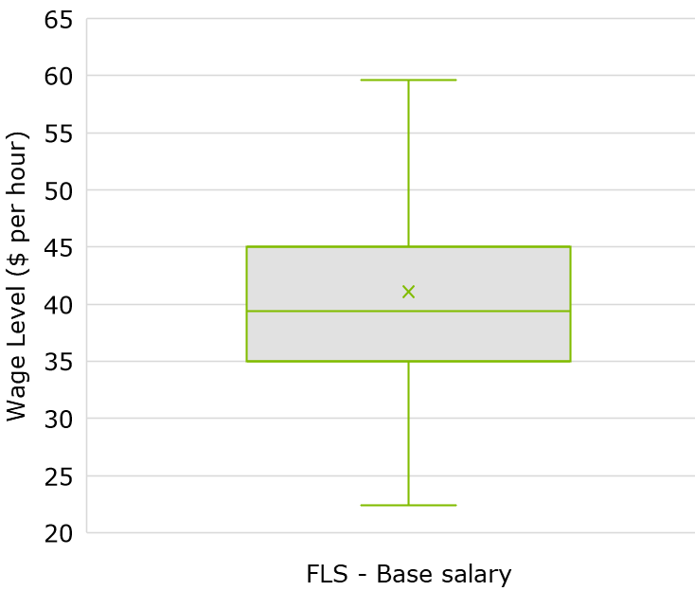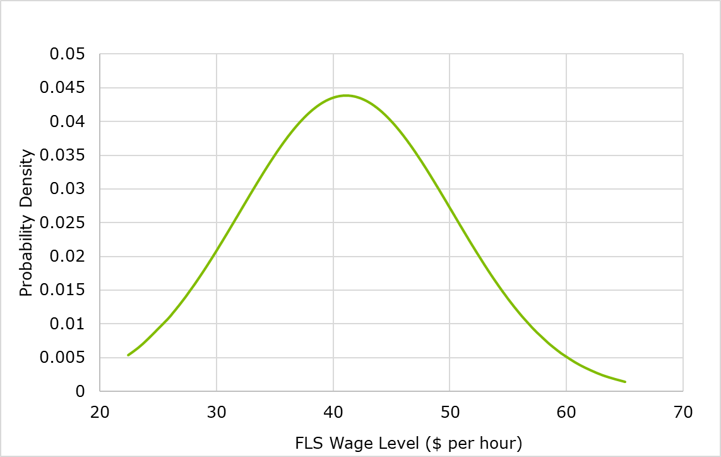
As seen in Table 3.9, the average base rate of pay for FLS was higher for service providers located in remote regions. Service providers in metropolitan regions (MMM region ≤3) on average reported a lower base rate of pay of $40.91 whilst those in a remote MMM region (≥6) had an average of $42.78.
            - : Weighted average pay for FLSs by MMM region, by revenue
 | Mean | 10th PC | 25th PC | 50th PC | 75th PC | 90th PC
≤3 (%) | 40.91 | 31.25 | 35.00 | 39.30 | 45.00 | 51.77
4-5 (%) | 42.30 | 31.90 | 35.93 | 40.55 | 45.62 | 58.00
≥6 (%) | 42.78 | 25.58 | 37.56 | 42.27 | 47.50 | 61.00
The FLS base rate of pay also varied by types of services provided. Table 3.10 illustrates that service providers offering Group and SIL services had the highest FLS base rate of pay, with an average of $42.46 and $41.70 respectively. Service providers offering Employment and DPA services had the lowest FLS base rate of pay with an average of $37.72 and $39.39 respectively.

            - : Weighted average pay for FLSs by service type, by revenue
 | Mean | 10th PC | 25th PC | 50th PC | 75th PC | 90th PC
High Intensity DPA ($) | 41.54 | 31.25 | 35.15 | 40.62 | 45.83 | 53.75
DPA ($) | 39.39 | 30.53 | 33.75 | 38.12 | 42.75 | 48.86
Part in Comm Soc Civ ($) | 40.66 | 31.25 | 35.00 | 39.37 | 44.56 | 50.62
SIL ($) | 41.70 | 33.39 | 36.38 | 40.31 | 45.00 | 51.75
Employment ($) | 37.72 | 27.47 | 31.87 | 36.42 | 42.50 | 48.75
Groups ($) | 42.46 | 32.50 | 36.46 | 42.50 | 47.18 | 52.19
For further details and outputs on base rate of pay for FLSs, see Appendix C.

Span of control
‘Span of control’ refers to the ratio of DSWs to FLSs, being the number of DSWs that each FLS is directly responsible for supervising, which can be calculated on a headcount of FTE basis. This Section examines the survey results for DSW and FLS span of control. Organisation span of control is also analysed further in Section 6.6.
On average, the survey results indicated that service providers’ span of control based on headcount was 10.6 to 1. This means that each supervisor oversees 10.6 DSWs, on average, on a headcount basis. In comparison, Table 3.11 also shows that service providers’ average span of control on an FTE basis was 6.1 DSWs to 1 FLS.
            - : Supervision costs and span of control
 | Mean | 10th PC | 25th PC | 50th PC | 75th PC | 90th PC
Span of control (FTE) | 6.1x | 13.0x | 7.6x | 4.3x | 2.0x | 1.0x
Span of control (by headcount) | 10.6x | 21.5x | 13.2x | 7.5x | 4.0x | 1.7x
The costs of supervision in 2020-21 were higher than those reported in the 2019-20 survey, as the previous survey results exhibited a higher span of control. In the 2019-20 survey, service providers reported an average span of control by FTE of 7.3 DSWs per FLS compared to 6.1 DSWs reported in the 2020-21 financial year. The average FLS base rate of pay also increased slightly, from $40.28 per hour in 2019-20 to $41.09 in 2020-21.

            - : Comparison with 2019-20 survey: Span of control
Results from 2019-20 survey | Mean | 10th PC | 25th PC | 50th PC | 75th PC | 90th PC
Span of control (FTE) | 7.3x | 14.4x | 9.0x | 5.3x | 2.5x | 1.0x
Span of control (by headcount) | 13.1x | 26.6x | 15.3x | 9.6x | 5.0x | 2.8x
As seen in Chart 3.3, span of control (based on FTE) has a narrow IQR of 5.58x. There are a number of more extreme values below the 25th percentile of 9.0x, which leads to a mean lying above the median, and a long tail on the upper end of responses in the PDF. This variation in span of control likely reflects the variety of provider types captured. For instance, as seen in Table 3.13, larger providers were more likely to report higher spans of control. FTE
              - : Box plot (LHS) and PDF (RHS) of span of control responses, based on FTE
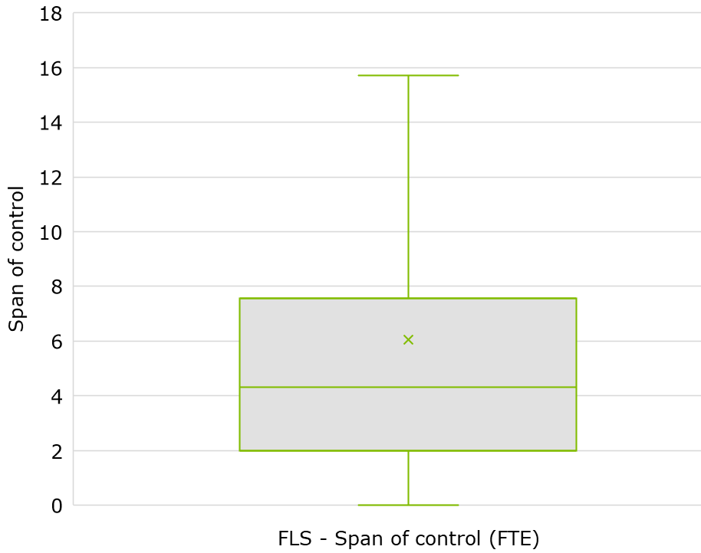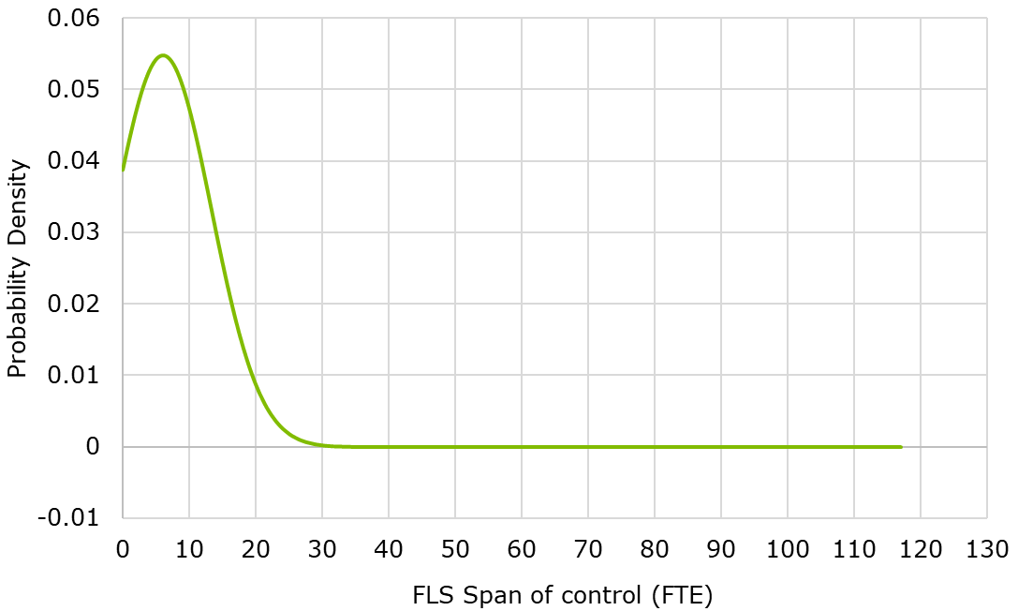

              - : Box plot (LHS) and PDF (RHS) of span of control responses, based on headcount
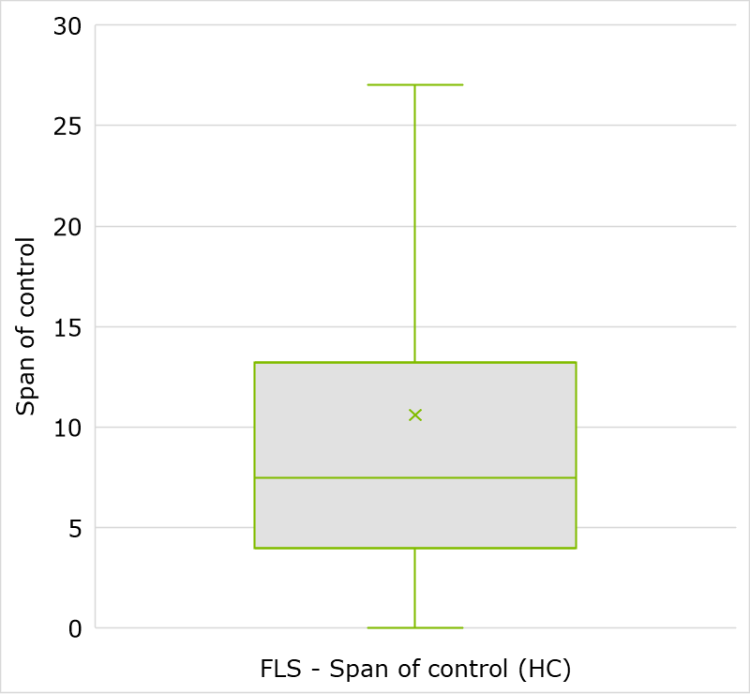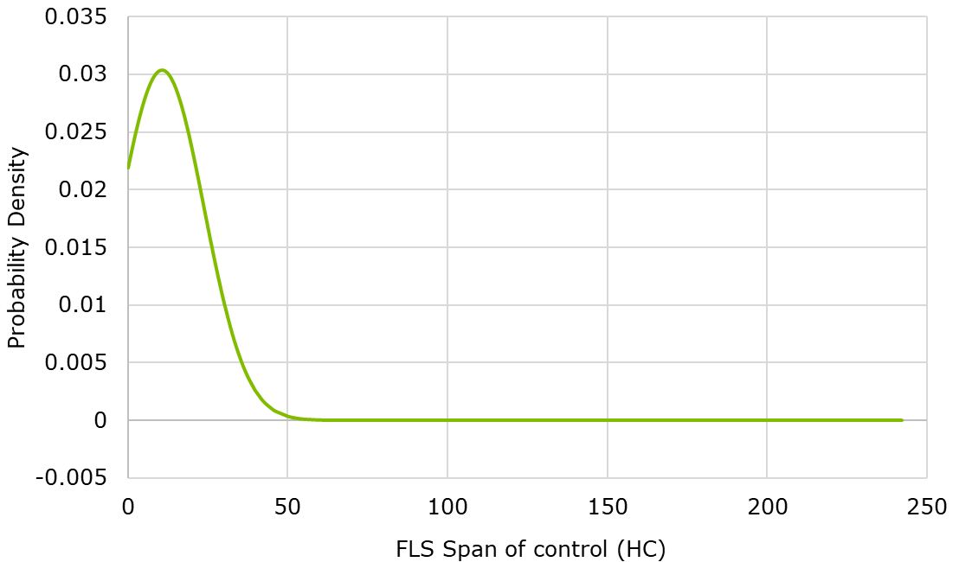
When disaggregating by size of organisation based on revenue, Table 3.13 presents a direct relationship with span of control on a headcount basis. This is because span of control increased with organisation size, showing 16.7 DSWs per 1 FLS on average for larger service providers at the highest point.
            - : Span of control by headcount by size of organisation, based on revenue
 | Mean | 10th PC | 25th PC | 50th PC | 75th PC | 90th PC
Small | 8.1x | 18.0x | 11.0x | 6.0x | 3.0x | 1.0x
Medium | 12.4x | 22.9x | 14.7x | 8.9x | 5.7x | 3.3x
Large | 16.7x | 32.9x | 21.0x | 13.0x | 7.8x | 4.2x
Service providers’ span of control (on a headcount basis) varied by the service type offered by survey respondents. Table 3.14 displays service providers offering Employment and Group services had the lowest span of control, on average. Higher span of control appeared in service providers offering SIL and DPA services at 14.4x and 13.3x respectively.
            - : Span of control by headcount by service type, based on revenue
 | Mean | 10th PC | 25th PC | 50th PC | 75th PC | 90th PC
HIDPA | 13.2x | 22.7x | 16.5x | 9.5x | 5.7x | 3.1x
DPA | 13.3x | 26.0x | 16.6x | 9.0x | 5.6x | 3.4x
Part Soc Comm Civ | 11.3x | 21.0x | 14.0x | 8.2x | 5.0x | 3.1x
SIL | 14.4x | 26.3x | 17.5x | 10.5x | 6.8x | 4.5x
Employment | 6.1x | 13.1x | 7.6x | 4.6x | 1.4x | 1.0x
Groups | 8.6x | 17.0x | 11.3x | 6.7x | 4.4x | 2.5x
Span of control also varied by the location of service provider, as presented in Table 3.15. South Australia, Western Australia and Tasmania had the highest span of control by headcount at 13.6x, 11.9x and 11.9x respectively. Service providers operating in Northern Territory had an average span of control below the national average, with 10.5 DSWs to 1 FLS.
            - : Span of control by headcount by main state jurisdiction the provider operates in, based on revenue
 | Mean | 10th PC | 25th PC | 50th PC | 75th PC | 90th PC
NSW | 11.5x | 22.1x | 13.5x | 7.6x | 4.0x | 1.1x
QLD | 11.0x | 22.4x | 15.0x | 9.0x | 5.0x | 2.6x
VIC | 10.6x | 21.0x | 13.3x | 7.5x | 5.0x | 2.0x
WA | 11.9x | 26.7x | 17.0x | 9.4x | 5.2x | 3.0x
SA | 13.6x | 33.8x | 15.5x | 7.8x | 4.3x | 1.3x
ACT | 11.3x | 21.5x | 14.3x | 9.3x | 6.6x | 4.1x
NT | 10.5x | 34.2x | 12.3x | 7.4x | 5.2x | 1.7x
TAS | 11.9x | 26.9x | 16.9x | 8.8x | 6.3x | 3.0x
For further details and outputs on span of control, see Appendix C.

Permanent and casual workforce
Service providers were asked to indicate whether they employed permanent staff, casual staff or a mix of both staff types. Of all survey respondents, 6.2% reported they only employed permanent staff and 8.1% reported they only employed casual staff. The remaining 85.7% of survey respondents were then asked to indicate the number of DSWs and FLSs who were employed as permanent and casual.
Of the service providers who employed a mix of permanent and casual staff, an average of 48.1% of the total workforce was permanently employed across DSW and FLS staff, based on headcount. However, when disaggregated by staff types, Table 3.16 indicates that on average, DSWs are more likely to be employed casually than FLSs, with average permanent employment rates of 36.5% and 91.9% respectively.
            - : Permanent employment rate (across all staff)
 | Mean | 10th PC | 25th PC | 50th PC | 75th PC | 90th PC
Permanent employment rate – All staff (%) | 48.1 | 100.0 | 77.6 | 44.6 | 16.7 | 7.4
Permanent employment rate – DSW (%) | 36.5 | 85.7 | 66.7 | 28.3 | 3.0 | 0.0
Permanent employment rate - FLS (%) | 91.9 | 100.0 | 100.0 | 100.0 | 100.0 | 66.7
The permanent employment rate for FLS remained relatively consistent with the 2019-20 survey, with 91.0% of FLS permanently employed in 2019-20 compared to 91.9% in 2020-21. However, the average proportion of DSWs permanently employed decreased across years, from 43.8% in 2019-20 to 36.5% in 2020-21.
            - : Comparison with 2019-20 survey: Permanent employment rate
Results from 2019-20 survey | Mean | 10th PC | 25th PC | 50th PC | 75th PC | 90th PC
Permanent employment rate – DSW (%) | 43.8 | 100.0 | 79.7 | 40.6 | 6.5 | 0.0
Permanent employment rate - FLS (%) | 91.0 | 100.0 | 100.0 | 100.0 | 100.0 | 50.0
The box plot shown in Chart 3.5 demonstrates the permanent employment rate for the total workforce has a wide IQR, from 16.7% to 77.6%. This likely reflects the different permanent employment rates across DSWs and FLS as well as the range of business models across service providers. The majority of responses lie under 50.0%, indicating that in general, most staff are casually employed.
              - : Box plot (LHS) and PDF (RHS) of permanent and casual workforce responses
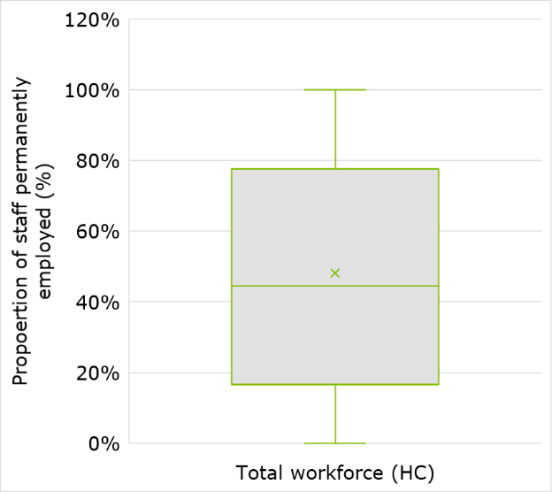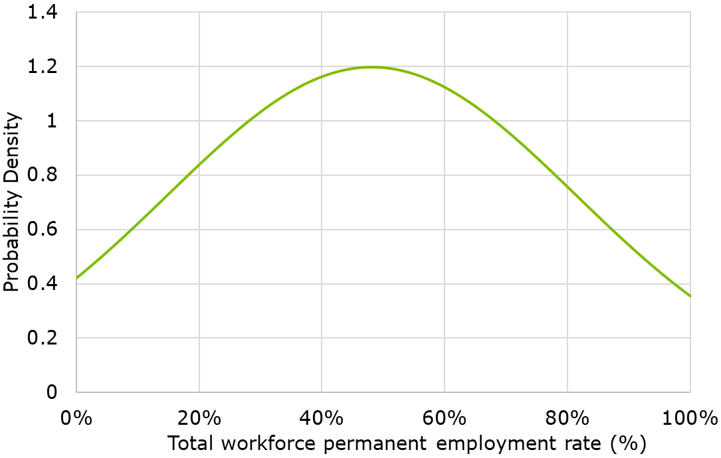
When disaggregating based on MMM region classification, Table 3.18 shows that the permanent employment rate for all staff increases by the regionality of the organisation. The most remote service providers had an average permanent employment rate of 64.5%.
            - : Permanent employment rate for all staff by MMM region, by revenue
 | Mean | 10th PC | 25th PC | 50th PC | 75th PC | 90th PC
≤3 (%) | 46.0 | 100.0 | 74.9 | 39.9 | 15.5 | 7.1
4-5 (%) | 56.0 | 100.0 | 83.7 | 61.6 | 27.6 | 9.4
≥6 (%) | 64.5 | 100.0 | 96.2 | 71.4 | 44.4 | 3.2
In contrast, the results indicate there is an inverse relationship between service providers’ proportion of revenue received from the NDIS and the average permanent employment rate for all staff. As seen in Table 3.19, the permanent employment rate increases as service providers’ proportion of NDIS revenue decreases.
            - : Permanent employment rate for all staff by organisation share of NDIS revenue
 | Mean | 10th PC | 25th PC | 50th PC | 75th PC | 90th PC
≤25% total revenue (%) | 60.9 | 100.0 | 91.4 | 67.2 | 30.9 | 12.0
26-50% total revenue (%) | 51.8 | 100.0 | 87.8 | 48.1 | 16.8 | 7.0
51-75% total revenue (%) | 47.5 | 89.6 | 71.6 | 50.0 | 19.4 | 9.0
>75% total revenue (%) | 41.8 | 100.0 | 69.1 | 32.3 | 13.1 | 5.5
Table 3.20 illustrates that compared with large and small service providers, medium sized service providers had the lowest average permanent employment rate at 45.0%.
            - : Permanent employment rate for all staff by NDIS revenue size of organisation
 | Mean | 10th PC | 25th PC | 50th PC | 75th PC | 90th PC
Smaller (%) | 45.9 | 100.0 | 82.6 | 35.1 | 14.5 | 6.3
Medium (%) | 45.0 | 96.4 | 72.1 | 39.5 | 14.1 | 7.4
Larger (%) | 54.9 | 94.3 | 78.1 | 60.7 | 26.9 | 10.5
When disaggregating by primary geographical location, Table 3.21 reveals the permanent employment rate for all staff was above the national average in Tasmania, Western Australia and New South Wales. Service providers who primarily operate in Tasmania held the highest rate of permanent employment with an average of 56.4%, compared to those in Northern Territory at 36.5%.
            - Permanent employment rate for all staff by main state jurisdiction the provider operates in, by revenue
 | Mean | 10th PC | 25th PC | 50th PC | 75th PC | 90th PC
NSW (%) | 48.8 | 100.0 | 74.8 | 46.5 | 20.0 | 8.5
QLD (%) | 43.8 | 100.0 | 77.7 | 30.0 | 13.2 | 6.3
VIC (%) | 46.9 | 100.0 | 77.8 | 41.7 | 15.5 | 6.5
WA (%) | 51.4 | 100.0 | 82.4 | 55.7 | 17.3 | 7.3
SA (%) | 46.0 | 100.0 | 76.4 | 45.6 | 14.2 | 6.7
ACT (%) | 45.3 | 95.5 | 79.3 | 35.3 | 17.0 | 9.6
NT (%) | 36.5 | 72.5 | 65.7 | 38.7 | 7.0 | 0.9
TAS (%) | 56.4 | 100.0 | 86.3 | 55.1 | 30.5 | 10.8
The permanent employment rate (based on headcount) for all staff also varied by types of services provided. Table 3.22 shows service providers offering DPA and Participation in Community, Social and Civic Activities services had the lowest rates of permanent employment across their organisations, with an average of 35.2% and 40.0% respectively. Service providers offering Employment and Group services had the highest permanent employment rates on average, with 78.1% and 61.5% respectively.
            - : Permanent employment rate for all staff by service type, by revenue
 | Mean | 10th PC | 25th PC | 50th PC | 75th PC | 90th PC
High Intensity DPA (%) | 45.6 | 100.0 | 73.8 | 40.9 | 13.8 | 6.7
DPA (%) | 35.2 | 96.4 | 51.7 | 20.6 | 10.3 | 6.5
Part in Comm Soc Civ (%) | 40.0 | 96.4 | 67.5 | 28.6 | 14.8 | 7.7
SIL (%) | 51.7 | 92.9 | 75.8 | 55.5 | 22.1 | 10.4
Employment (%) | 78.1 | 100.0 | 100.0 | 86.3 | 70.4 | 37.1
Groups (%) | 61.5 | 100.0 | 85.0 | 65.7 | 41.0 | 21.1
For further details and outputs on the permanent employment rate, see Appendix C.

Salary on-costs
The survey asked respondents about the superannuation and workers compensation premium paid to their staff.
The survey results in Table 3.23 show that the majority of staff reported paying the mandated minimum rate of superannuation at 9.5% of base salary including leave. Of all survey respondents, 21.5% reported a superannuation rate above 9.5%. These results were consistent with the 2019-20 financial year, as seen in Table 3.24. The average superannuation amount was slightly higher than the 2019-20 survey. One potential reason for this discrepancy is that some service providers with an entirely casualised workforce in the 2019-20 survey iteration answered with 0.0%, which brought down the average result.
            - : Salary on-costs, as a percentage of base salary – Superannuation
 | Mean | 10th PC | 25th PC | 50th PC | 75th PC | 90th PC
Superannuation (%) | 9.5 | 9.5 | 9.5 | 9.5 | 9.5 | 10.0
            - : Comparison with 2019-20 survey: Superannuation
Results from 2019-20 survey | Mean | 10th PC | 25th PC | 50th PC | 75th PC | 90th PC
Superannuation (%) | 9.3 | 9.5 | 9.5 | 9.5 | 9.5 | 9.5
The survey also asked respondents whether their organisation self-insures or pays a workers compensation premium to an insurer. Table 3.25 summarises the responses provided by survey respondents.

            - : Breakdown of survey responses regarding approach to workers compensation
Approach to workers compensation | Proportion of survey respondents
Pay workers compensation to an insurer (%) | 95.0
Self-insurer with insurance against excess loss (%) | 3.1
Self-insure without insurance against excess loss (%) | 1.9
Of the 95.0% of survey respondents who pay a workers compensation premium to an insurer, the average premium amount paid was 3.2%, as seen in Table 3.26. This is slightly higher than the results reported in the 2019-20 survey as seen in Table 3.27, which revealed an average of 2.6%. It should be noted that the slightly higher average may be explained, in part, by amendments to the survey question in 2020-21, which filtered out responses from self-insuring organisations. In the 2019-20 iteration, self-insuring organisations were not filtered out which likely lowered the average given that self-insurers will inevitably have lower premiums. In the 2019-20 survey, all service providers were asked to report a workers compensation premium and it was not possible to filter out responses by self-insuring organisations.
            - : Salary on-costs, as a percentage of base salary – Workers compensation
 | Mean | 10th PC | 25th PC | 50th PC | 75th PC | 90th PC
Workers compensation premium (%) | 3.2 | 1.2 | 2.0 | 2.5 | 4.0 | 5.5

            - : Comparison with 2019-20 survey: Workers compensation
Results from 2019-20 survey | Mean | 10th PC | 25th PC | 50th PC | 75th PC | 90th PC
Workers compensation premium (%) | 2.6 | 1.1 | 1.9 | 2.3 | 3.5 | 4.2
As seen in Chart 3.6, the workers compensation premiums paid is positively skewed, with the median value sitting at 2.5%. The outlier removal technique employed eliminated any responses over 14.4%, which is reflected in the mean lying above the median value.
              - : Box plot (LHS) and PDF (RHS) of workers compensation premium (%) responses
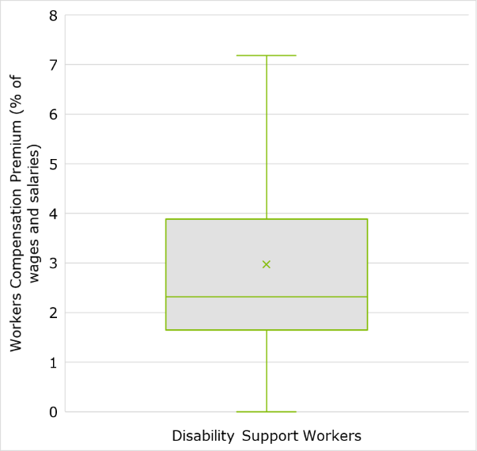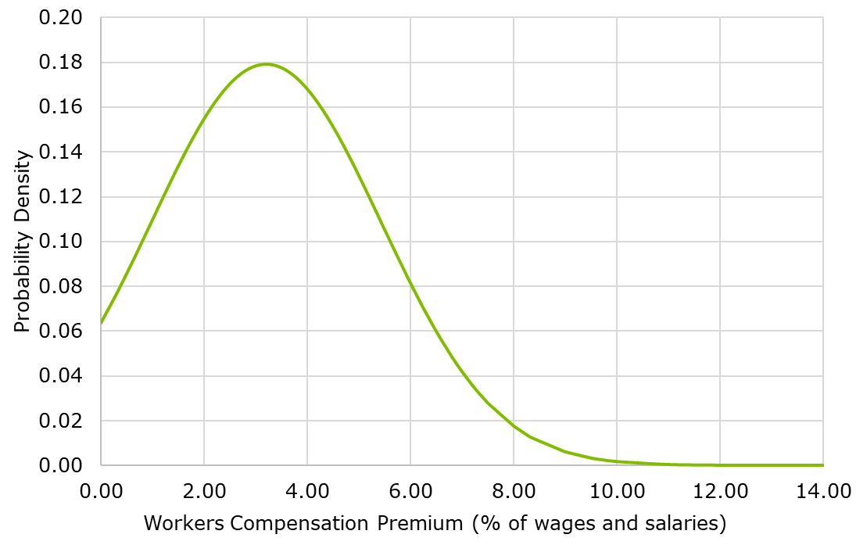
When disaggregated by service type, Table 3.28 displays that service providers offering Employment services exhibited, on average, the highest workers compensation premium at 3.7%. Service providers offering SIL and DPA service also reported higher worker compensation premiums than the survey average, both at 3.3%. The lowest workers compensation premium, on average, was reported by service providers offering Group services at 2.5%.
            - : Workers compensation by service type, by revenue
 | Mean | 10th PC | 25th PC | 50th PC | 75th PC | 90th PC
High Intensity DPA (%) | 3.2 | 1.3 | 2.0 | 2.9 | 4.0 | 5.0
DPA (%) | 3.3 | 1.4 | 2.0 | 2.6 | 4.0 | 5.5
Part in Comm Soc Civ (%) | 3.1 | 1.0 | 1.8 | 2.3 | 3.7 | 5.4
SIL (%) | 3.3 | 1.4 | 2.0 | 2.7 | 4.0 | 5.5
Employment (%) | 3.7 | 1.7 | 2.1 | 2.9 | 4.7 | 6.9
Groups (%) | 2.5 | 1.0 | 1.4 | 2.0 | 3.0 | 4.6
Service providers were also asked to list their organisation’s workers compensation classification. The most common classifications were:
- Residential Care Services
- Non-Residential Care Services
- Other Social Assistance Services
- Social Assistance Services
- Home Care Services.

Appendix C provides a full list of the responses, with an approximate provider count due to the varied nature of responses. Further details and outputs on the workers compensation premium are also provided in Appendix C.

Standard hours of work
The survey results revealed that an average working day for full time DSWs and FLSs is 7.5 hours. Table 3.29 shows there is only a moderate level of variation among service providers.
            - : Standard working hours per day for full time DSWs and FLSs
 | Mean | 10th PC | 25th PC | 50th PC | 75th PC | 90th PC
Hours per day | 7.5 | 7.0 | 7.5 | 7.6 | 7.6 | 8.0

            - : Comparison with 2019-20 survey: Standard working hours per day
Results from 2019-20 survey | Mean | 10th PC | 25th PC | 50th PC | 75th PC | 90th PC
Hours per day | 7.5 | 7.0 | 7.5 | 7.6 | 7.6 | 8.0

Utilisation – Disability support workers
Not all working hours are billable. For example, the SCHADS Award states that a DSW should have a ten-minute paid break from work every four hours. DSWs also need to undertake training and perform administrative and other ad-hoc tasks, as part of their working hours. The Model also considers that more highly skilled workers with more responsibilities may require more non-billable hours to maintain their skills and deal with other issues. Accordingly, the survey asked respondents to provide the utilisation of DSWs and FLSs separately.
Table 3.31 illustrates that the total billable utilisation for DSWs reported by service providers was 78.9% on average. Results concerning the FLS utilisation are provided in section 3.8.
            - : Utilisation of DSWs (% of total time)
 | Mean | 10th PC | 25th PC | 50th PC | 75th PC | 90th PC
Total billable utilisation (%) | 78.9 | 94.0 | 90.0 | 82.0 | 72.0 | 60.0
Billable time (excluding billable travel (%) | 73.5 | 91.0 | 85.0 | 77.6 | 65.0 | 50.0
Billable travel (%) | 5.4 | 12.0 | 9.0 | 4.0 | 0.1 | 0.0
Non-billable travel time (%) | 3.2 | 10.0 | 5.0 | 2.0 | 0.0 | 0.0
Training (%) | 4.8 | 10.0 | 5.0 | 5.0 | 2.0 | 1.0
Breaks (%) | 3.0 | 7.9 | 5.0 | 2.0 | 0.0 | 0.0
Non-billable client-related administration | 5.1 | 10.9 | 7.0 | 4.0 | 1.0 | 0.0
Non-billable general administration and other tasks (e.g. team meetings) | 4.9 | 10.0 | 5.0 | 4.0 | 1.0 | 0.0
Table 3.32 shows the breakdown of results for DSW utilisation from the 2019-20 financial year. However, it should be noted that direct comparison of the results for DSW utilisation between 2019-20 and 2020-21 is limited as the data cleaning approach differed between years.
            - : Comparison with 2019-20 survey: Utilisation of DSWs
Results from 2019-20 survey | Mean | 10th PC | 25th PC | 50th PC | 75th PC | 90th PC
Total billable utilisation (%) | 81.8 | 97.0 | 91.0 | 83.0 | 75.0 | 65.0
Billable time (excluding billable travel (%) | 77.0 | 95.0 | 88.0 | 80.0 | 70.0 | 60.0
Billable travel (%) | 4.9 | 10.0 | 6.5 | 3.0 | 0.0 | 0.0
Non-billable travel time (%) | 2.6 | 10.0 | 5.0 | 0.0 | 0.0 | 0.0
Training (%) | 2.2 | 10.0 | 5.0 | 3.0 | 1.0 | 0.0
Breaks (%) | 3.8 | 6.4 | 5.0 | 0.0 | 0.0 | 0.0
Non-billable client-related administration | 3.3 | 10.0 | 5.0 | 2.0 | 0.0 | 0.0
Non-billable general administration and other tasks (e.g. team meetings) | 3.6 | 10.0 | 5.0 | 2.0 | 0.0 | 0.0
Chart 3.7 and Chart 3.8 show that billable time (excluding billable travel) forms a large portion of total billable time. Billable time (excluding billable travel) has a mean below the median and longer left-side tail, whereas billable travel has a mean above the median and long right-side tail.
              - : Box plot of DSW utilisation billable time (%) responses
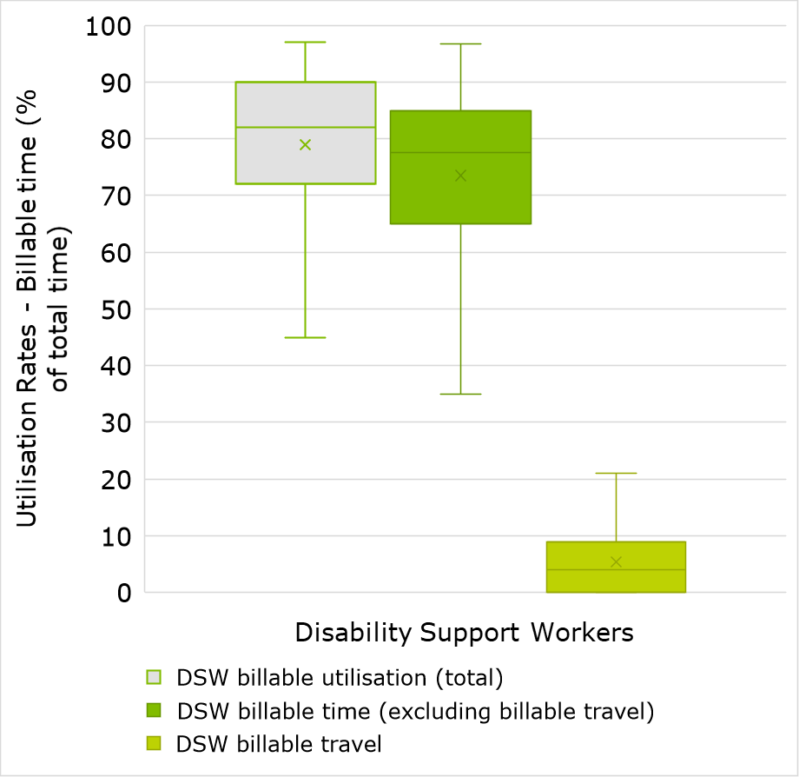
              - : PDF of DSW utilisation billable time (%) responses
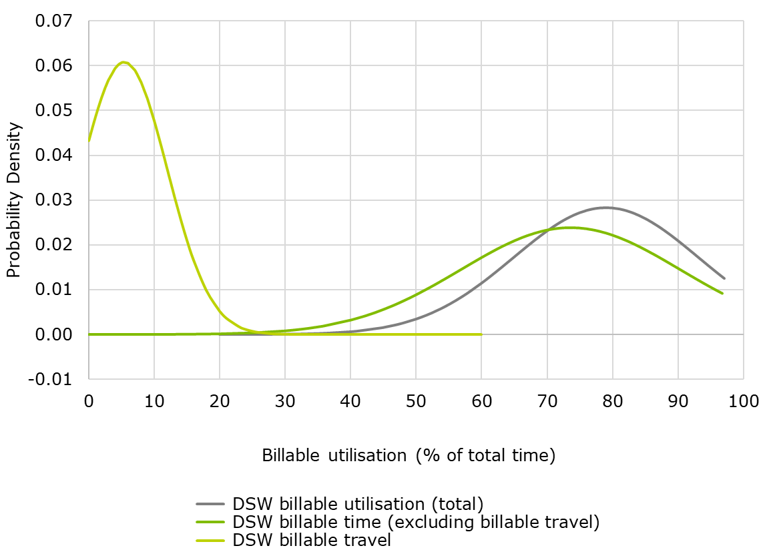
In relation to non-billable tasks, Chart 3.9 and Chart 3.10 show that the responses for utilisation of each non-billable category all exhibit longer right-side tails and the means consistently lie above the median.
              - : Box plot of DSW utilisation non-billable time (%) responses
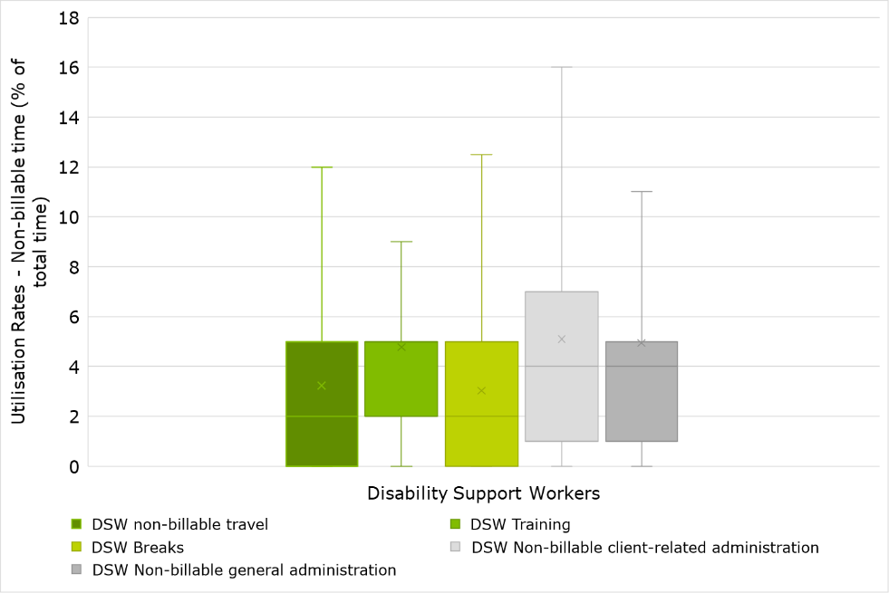
              - : PDF of DSW non-billable time (%) responses
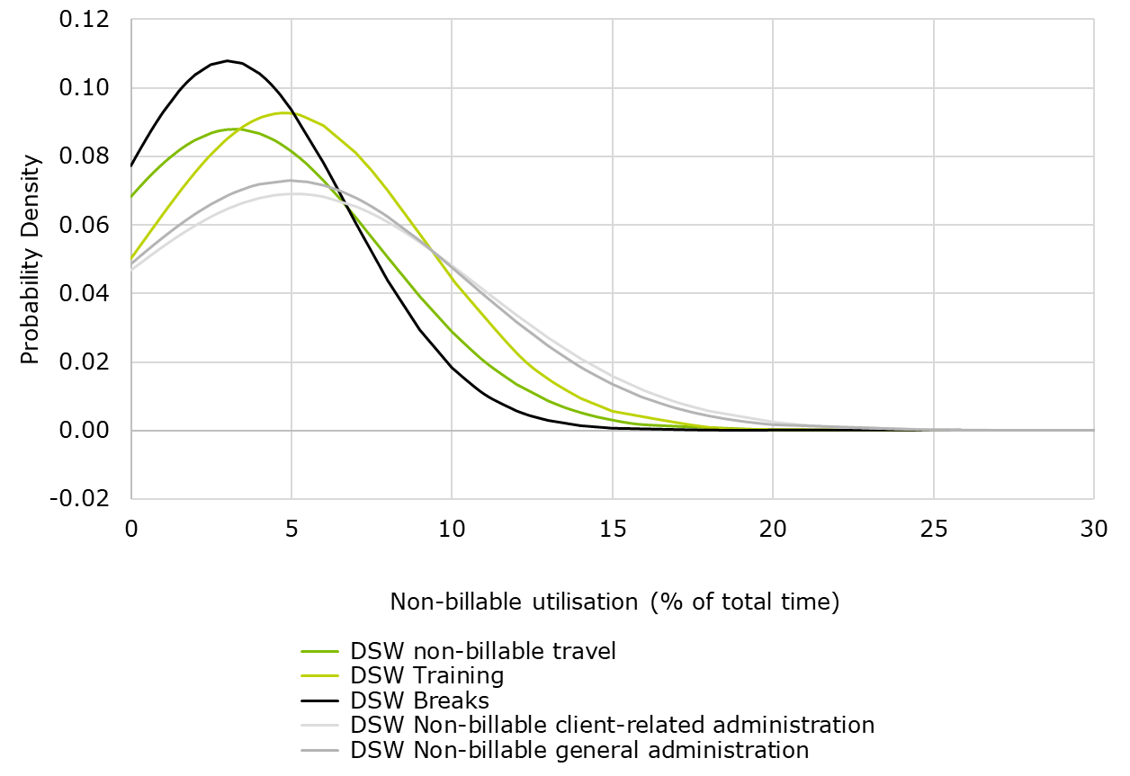
Outlined in Table 3.33, Table 3.33 and Table 3.34, the results reported by service providers illustrates that total billable utilisation of DSWs increases with organisation size.

            - : Utilisation of DSWs in smaller organisations, by NDIS revenue
 | Mean | 10th PC | 25th PC | 50th PC | 75th PC | 90th PC
Total billable utilisation (%) | 75.7 | 92.5 | 89.3 | 80.0 | 69.8 | 55.9
Billable time (excluding billable travel (%) | 69.3 | 90.0 | 83.0 | 72.0 | 60.0 | 45.0
Billable travel (%) | 6.3 | 15.0 | 10.0 | 5.0 | 0.0 | 0.0
Non-billable travel time (%) | 3.9 | 10.0 | 5.0 | 2.0 | 0.0 | 0.0
Training (%) | 5.4 | 10.0 | 8.3 | 5.0 | 2.0 | 1.0
Breaks (%) | 3.2 | 8.5 | 5.0 | 2.0 | 0.0 | 0.0
Non-billable client-related administration (%) | 6.0 | 15.0 | 10.0 | 5.0 | 1.0 | 0.0
Non-billable general administration and other tasks (e.g. team meetings) (%) | 5.8 | 13.5 | 7.8 | 5.0 | 2.0 | 0.0

            - : Utilisation of DSWs in medium organisations, by NDIS revenue
 | Mean | 10th PC | 25th PC | 50th PC | 75th PC | 90th PC
Total billable utilisation (%) | 80.6 | 95.0 | 90.0 | 84.0 | 75.0 | 62.0
Billable time (excluding billable travel (%) | 76.0 | 90.7 | 86.0 | 79.9 | 70.0 | 60.0
Billable travel (%) | 4.7 | 10.0 | 6.0 | 4.0 | 1.0 | 0.0
Non-billable travel time (%) | 2.9 | 10.0 | 5.0 | 1.0 | 0.0 | 0.0
Training (%) | 4.4 | 10.0 | 5.0 | 4.0 | 2.0 | 1.0
Breaks (%) | 2.9 | 7.0 | 5.0 | 2.0 | 0.0 | 0.0
Non-billable client-related administration (%) | 4.8 | 10.0 | 6.0 | 4.0 | 1.0 | 0.0
Non-billable general administration and other tasks (e.g. team meetings) (%) | 4.5 | 10.0 | 5.0 | 3.0 | 1.0 | 0.0

            - : Utilisation of DSWs in larger organisations, by NDIS revenue
 | Mean | 10th PC | 25th PC | 50th PC | 75th PC | 90th PC
Total billable utilisation (%) | 84.7 | 95.0 | 92.0 | 85.0 | 79.6 | 75.0
Billable time (excluding billable travel (%) | 80.8 | 93.0 | 90.0 | 82.0 | 75.0 | 65.0
Billable travel (%) | 3.8 | 10.0 | 5.0 | 2.0 | 0.0 | 0.0
Non-billable travel time (%) | 2.1 | 5.0 | 3.0 | 1.0 | 0.0 | 0.0
Training (%) | 3.6 | 7.3 | 5.0 | 3.0 | 1.5 | 1.0
Breaks (%) | 2.5 | 7.0 | 5.0 | 1.0 | 0.0 | 0.0
Non-billable client-related administration (%) | 3.5 | 8.0 | 5.0 | 3.0 | 1.0 | 0.0
Non-billable general administration and other tasks (e.g. team meetings) (%) | 3.7 | 7.2 | 5.0 | 3.0 | 1.0 | 0.1
When disaggregating by the service types offered by service providers, the results in Table 3.36 to Table 3.39 show service providers offering SIL and High Intensity DPA services exhibited the highest average total utilisation at 82.1% and 79.9% respectively. This was driven by billable time (excluding billable travel) only, as both services exhibited the highest average billable time (excluding billable travel) but lower average billable travel time compared to other service groups. Employment services exhibited the lowest average total billable utilisation at 76.7%, followed by those offering DPA services at 77.8%.
            - : Utilisation of DSWs by service type, based on revenue – Supported Independent Living
 | Mean | 10th PC | 25th PC | 50th PC | 75th PC | 90th PC
Total billable utilisation (%) | 82.1 | 95.0 | 90.0 | 85.0 | 76.0 | 69.0
Billable time (excluding billable travel (%) | 77.7 | 91.6 | 87.0 | 80.0 | 70.0 | 60.0
Billable travel (%) | 4.3 | 10.0 | 5.0 | 3.0 | 1.0 | 0.0
Non-billable travel time (%) | 2.4 | 5.0 | 5.0 | 1.0 | 0.0 | 0.0
Training (%) | 4.3 | 10.0 | 5.0 | 3.0 | 2.0 | 1.0
Breaks (%) | 2.4 | 6.3 | 5.0 | 1.0 | 0.0 | 0.0
Non-billable client-related administration | 4.4 | 10.0 | 6.0 | 4.0 | 1.0 | 0.0
Non-billable general administration and other tasks (e.g. team meetings) | 4.7 | 10.0 | 5.0 | 5.0 | 2.0 | 0.0
            - : Utilisation of DSWs by service type, based on revenue – High Intensity DPA
 | Mean | 10th PC | 25th PC | 50th PC | 75th PC | 90th PC
Total billable utilisation (%) | 79.9 | 94.0 | 90.0 | 83.0 | 75.0 | 64.0
Billable time (excluding billable travel (%) | 74.8 | 90.0 | 85.0 | 79.3 | 65.0 | 60.0
Billable travel (%) | 5.2 | 12.0 | 8.0 | 5.0 | 1.0 | 0.0
Non-billable travel time (%) | 3.3 | 8.0 | 5.0 | 2.0 | 0.0 | 0.0
Training (%) | 4.4 | 10.0 | 5.0 | 5.0 | 2.0 | 1.0
Breaks (%) | 3.0 | 7.0 | 5.0 | 2.0 | 0.0 | 0.0
Non-billable client-related administration | 4.6 | 10.0 | 5.0 | 3.0 | 0.0 | 0.0
Non-billable general administration and other tasks (e.g. team meetings) | 4.7 | 10.0 | 5.0 | 5.0 | 1.5 | 0.0

            - : Utilisation of DSWs by service type, based on revenue – Employment
 | Mean | 10th PC | 25th PC | 50th PC | 75th PC | 90th PC
Total billable utilisation (%) | 76.7 | 93.0 | 90.0 | 80.0 | 70.0 | 55.0
Billable time (excluding billable travel (%) | 74.3 | 90.0 | 89.0 | 79.0 | 70.0 | 54.0
Billable travel (%) | 2.4 | 5.0 | 3.0 | 0.1 | 0.0 | 0.0
Non-billable travel time (%) | 1.9 | 5.0 | 2.8 | 0.0 | 0.0 | 0.0
Training (%) | 5.6 | 15.0 | 8.0 | 5.0 | 1.5 | 1.0
Breaks (%) | 3.7 | 7.0 | 5.0 | 4.0 | 1.0 | 0.0
Non-billable client-related administration | 6.6 | 15.0 | 9.0 | 4.0 | 2.0 | 0.0
Non-billable general administration and other tasks (e.g. team meetings) | 4.6 | 10.0 | 8.0 | 3.0 | 1.0 | 0.0

            - Utilisation of DSWs by service type, based on revenue – Daily Personal Activities
 | Mean | 10th PC | 25th PC | 50th PC | 75th PC | 90th PC
Total billable utilisation (%) | 77.8 | 94.0 | 90.0 | 80.0 | 70.0 | 60.0
Billable time (excluding billable travel (%) | 71.8 | 90.0 | 85.0 | 75.0 | 63.0 | 50.0
Billable travel (%) | 6.0 | 11.0 | 10.0 | 5.0 | 1.0 | 0.0
Non-billable travel time (%) | 4.1 | 10.0 | 5.0 | 2.0 | 0.0 | 0.0
Training (%) | 5.6 | 10.0 | 7.0 | 5.0 | 2.0 | 1.0
Breaks (%) | 3.3 | 10.0 | 5.0 | 2.0 | 0.0 | 0.0
Non-billable client-related administration | 4.4 | 10.0 | 5.0 | 3.0 | 0.5 | 0.0
Non-billable general administration and other tasks (e.g. team meetings) | 5.5 | 10.0 | 10.0 | 5.0 | 2.0 | 0.0
DSW utilisation also varied by geographical location. As illustrated in Table 3.40 to 0 , Victoria and Australian Capital Territory both had the highest average total utilisation at 80.3% each. These results were driven by different components of billable time. Victoria had the highest average billable time (excluding billable travel) at 75.7% but the third lowest billable travel time at 4.6%. The Australian Capital Territory on the other hand had the highest billable travel time at 6.6% but one of the lowest billable time (excluding billable travel) at 73.7%. The Northern Territory reported the lowest average total utilisation rate at 74.4%.
            - : Utilisation of DSWs by the main state jurisdiction the provider operates in, by revenue - Victoria
 | Mean | 10th PC | 25th PC | 50th PC | 75th PC | 90th PC
Total billable utilisation (%) | 80.3 | 94.0 | 90.0 | 83.0 | 75.0 | 60.0
Billable time (excluding billable travel (%) | 75.7 | 90.9 | 86.0 | 80.0 | 70.0 | 50.0
Billable travel (%) | 4.6 | 10.0 | 5.0 | 2.0 | 0.0 | 0.0
Non-billable travel time (%) | 2.4 | 8.0 | 5.0 | 0.0 | 0.0 | 0.0
Training (%) | 4.1 | 10.0 | 5.0 | 3.0 | 1.8 | 1.0
Breaks (%) | 2.8 | 6.4 | 5.0 | 2.0 | 0.0 | 0.0
Non-billable client-related administration (%) | 5.3 | 12.0 | 8.0 | 5.0 | 1.0 | 0.0
Non-billable general administration and other tasks (e.g. team meetings) (%) | 5.1 | 10.0 | 6.0 | 4.0 | 2.0 | 1.0

            - : Utilisation of DSWs by the main state jurisdiction the provider operates in, by revenue – Northern Territory
 | Mean | 10th PC | 25th PC | 50th PC | 75th PC | 90th PC
Total billable utilisation (%) | 74.4 | 93.5 | 83.0 | 76.0 | 63.5 | 60.0
Billable time (excluding billable travel (%) | 69.9 | 92.0 | 82.3 | 71.0 | 55.8 | 51.5
Billable travel (%) | 4.5 | 10.0 | 8.8 | 4.5 | 0.3 | 0.0
Non-billable travel time (%) | 3.0 | 6.7 | 5.8 | 3.5 | 0.0 | 0.0
Training (%) | 5.1 | 17.0 | 7.5 | 3.0 | 2.0 | 0.0
Breaks (%) | 5.7 | 15.6 | 7.0 | 5.0 | 1.5 | 0.0
Non-billable client-related administration (%) | 8.2 | 17.1 | 12.0 | 9.0 | 3.5 | 0.0
Non-billable general administration and other tasks (e.g. team meetings) (%) | 3.7 | 9.7 | 5.0 | 3.0 | 1.3 | 0.0

            - : Utilisation of DSWs by the main state jurisdiction the provider operates in, by revenue – Australian Capital Territory
 | Mean | 10th PC | 25th PC | 50th PC | 75th PC | 90th PC
Total billable utilisation (%) | 80.3 | 95.0 | 88.3 | 84.5 | 72.3 | 68.3
Billable time (excluding billable travel (%) | 73.7 | 88.2 | 82.1 | 75.0 | 66.0 | 54.8
Billable travel (%) | 6.6 | 15.0 | 10.8 | 5.0 | 3.0 | 0.0
Non-billable travel time (%) | 2.5 | 5.1 | 5.0 | 1.9 | 0.0 | 0.0
Training (%) | 3.6 | 6.4 | 5.0 | 3.0 | 1.9 | 1.0
Breaks (%) | 3.4 | 8.2 | 6.0 | 3.8 | 0.0 | 0.0
Non-billable client-related administration (%) | 6.3 | 14.1 | 10.0 | 5.0 | 1.0 | 0.0
Non-billable general administration and other tasks (e.g. team meetings) (%) | 3.9 | 8.2 | 5.0 | 3.4 | 1.8 | 0.0
Section 6.7 provides additional analysis on the relationships between utilisation and other variables. Further details and outputs on DSW utilisation rates are provided in Appendix C.

Utilisation – Front-line supervisors
Service providers were also asked to estimate the proportion of time FLSs spent on various activities, including providing billable support to participants and supervising other staff. As it is generally considered a supervisory role, FLSs are not assumed to provide any billable support to participants. Accordingly, the utilisation rate of FLS should not be directly compared with the utilisation rate of DSWs, as the focus of each role differs.
The survey results revealed that FLSs in many organisations spend a portion of their total time on billable tasks. This can be seen in Table 3.43 which illustrates that on average, FLSs spent 25.5% of their time on billable tasks, being direct support to participants and billable travel.
            - : Utilisation of FLS (%)
 | Mean | 10th PC | 25th PC | 50th PC | 75th PC | 90th PC
Total utilisation (%) | 25.5 | 60.0 | 45.0 | 20.0 | 5.0 | 0.0
Time spent providing direct support to clients (%) | 22.6 | 58.6 | 40.0 | 15.0 | 5.0 | 0.0
Billable travel time associated with direct support to clients (%) | 2.9 | 10.0 | 5.0 | 0.0 | 0.0 | 0.0
Other travel time (%) | 3.3 | 10.0 | 5.0 | 2.0 | 0.0 | 0.0
Time spent supervising or training other staff (%) | 18.4 | 40.0 | 25.0 | 14.0 | 6.6 | 4.0
Self-training (%) | 4.9 | 10.0 | 5.0 | 5.0 | 2.0 | 0.0
Breaks (%) | 3.4 | 7.0 | 5.0 | 2.0 | 0.0 | 0.0
Client-related administration (%) | 29.3 | 65.0 | 42.5 | 23.0 | 10.0 | 5.0
General administration and other tasks (e.g. team meetings) (%) | 15.3 | 32.7 | 20.0 | 10.0 | 5.0 | 4.0
Table 3.44 shows a breakdown of results for FLS utilisation from the 2019-20 financial year. The results show that FLS total billable time increased slightly, from 24.5% in 2019-20 to 25.5% in 2020-21. This was primarily driven by an increase in billable travel, which increased from 2.0% to 2.9%. It should be noted however that direct comparison of FLS utilisation across years is limited as the utilisation categories and data cleaning methods used differed between years.
            - : Comparison with 2019-20 survey: Utilisation of FLS
Results from 2019-20 survey | Mean | 10th PC | 25th PC | 50th PC | 75th PC | 90th PC
Total billable time (%) | 24.5 | 70.0 | 45.0 | 10.0 | 0.0 | 0.0
Billable time (exc billable travel) (%) | 22.5 | 68.0 | 40.0 | 10.0 | 0.0 | 0.0
Billable travel (%) | 2.0 | 5.0 | 1.5 | 0.0 | 0.0 | 0.0
Non-billable travel (%) | 4.2 | 10.0 | 5.0 | 0.0 | 0.0 | 0.0
Training (%) | 2.8 | 15.0 | 10.0 | 5.0 | 2.0 | 0.0
Breaks (%) | 7.0 | 8.0 | 5.0 | 0.0 | 0.0 | 0.0
Client related admin (%) | 28.9 | 70.0 | 46.5 | 20.0 | 5.0 | 0.0
NDIS Quality and Safety Compliance Commission (%) | 12.1 | 30.0 | 20.0 | 10.0 | 5.0 | 0.0
General admin and other tasks (%) | 20.5 | 50.0 | 29.8 | 15.0 | 6.0 | 1.0
Chart 3.11 and Chart 3.12 show that providers reported a wide range of responses for total FLS utilisation, with total billable time ranging from 0.0% to 84.0%, with outliers removed. The billable time and billable travel for FLS also exhibit long right-side tails with the mean above the median in both categories.
              - : Box plot of FLS utilisation billable time (%) responses
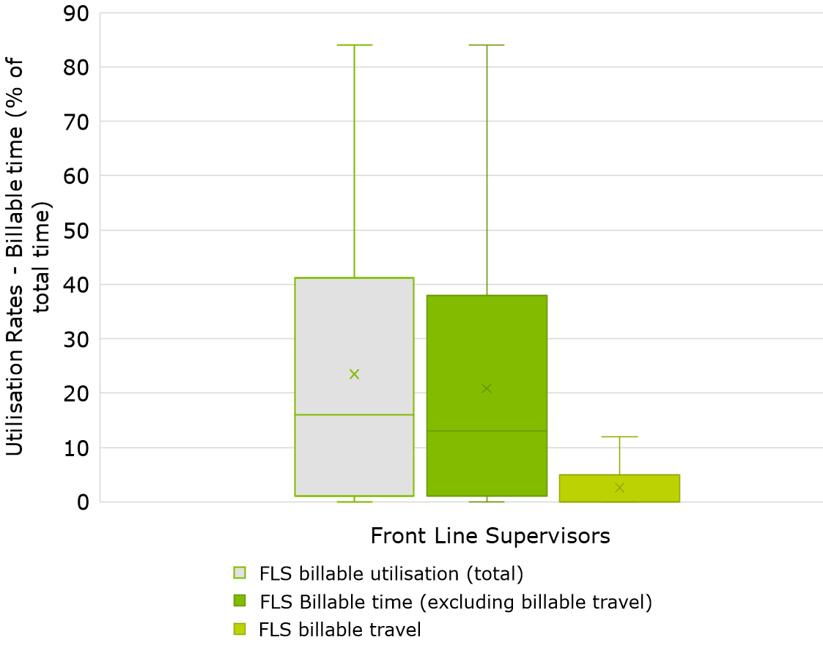
              - : PDF of FLS utilisation billable time (%) responses
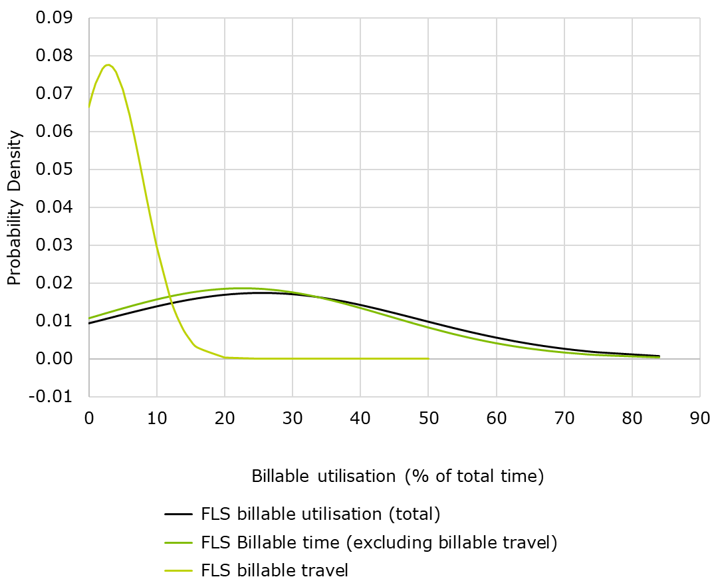
In relation to non-billable tasks, Chart 3.13 and Chart 3.14 show that providers reported a wide range of responses for non-billable tasks, which also varied greatly across categories. The non-billable tasks for FLS all exhibited longer right-side tails with the mean above the median.
              - : Box plot of FLS utilisation non-billable time (%) responses
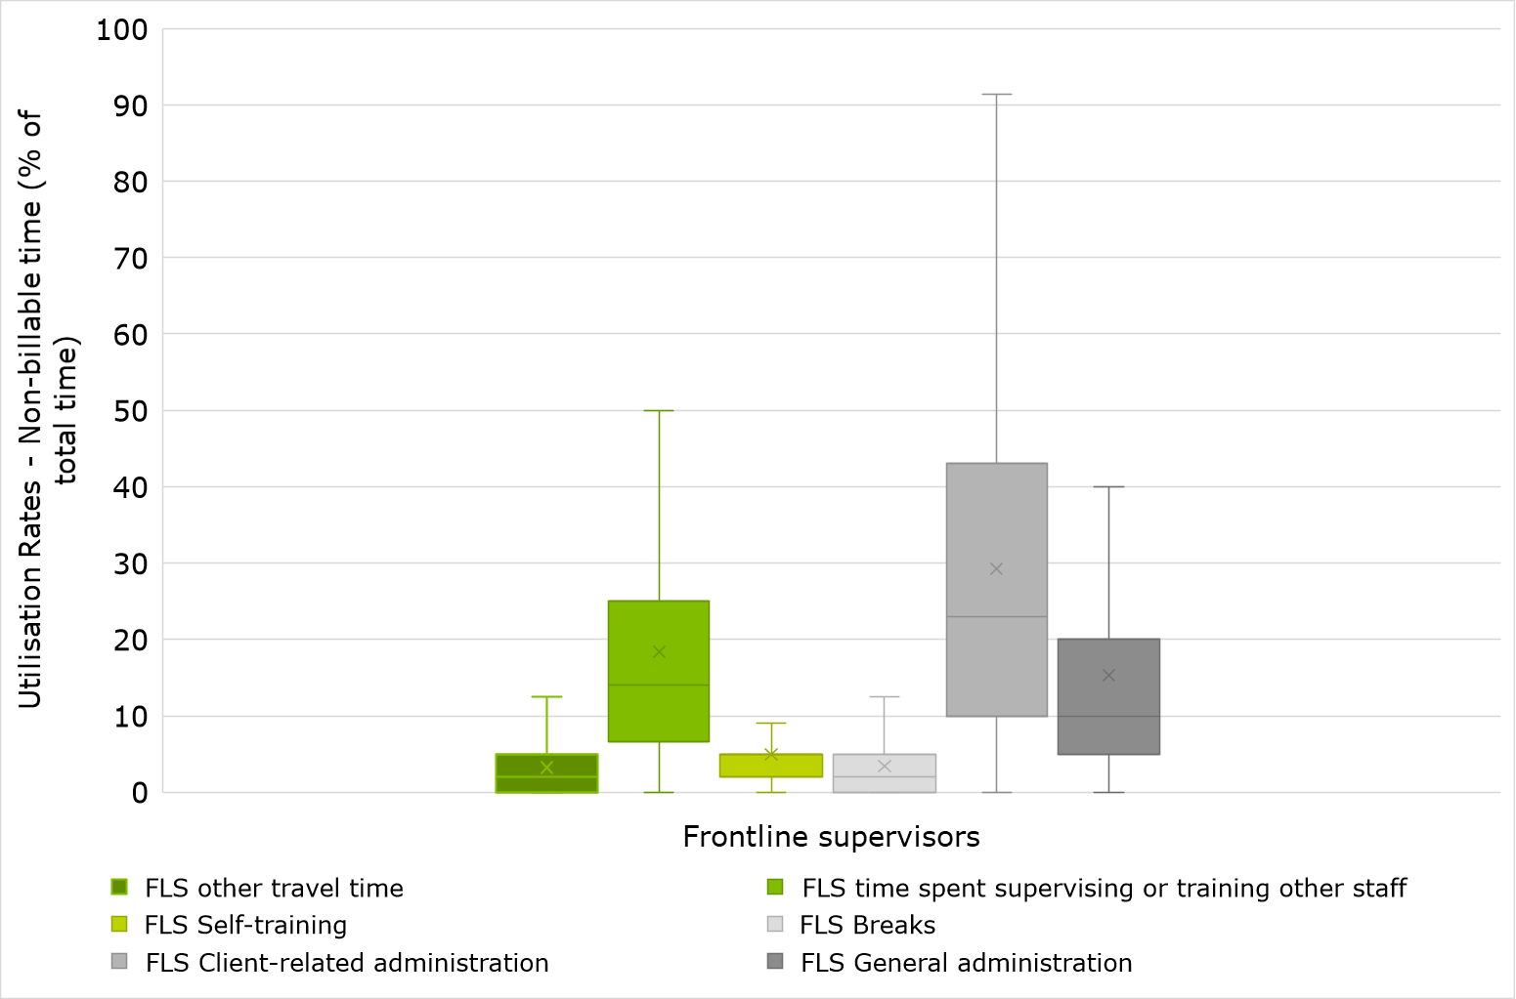

              - : PDF of FLS utilisation non-billable time (%) responses
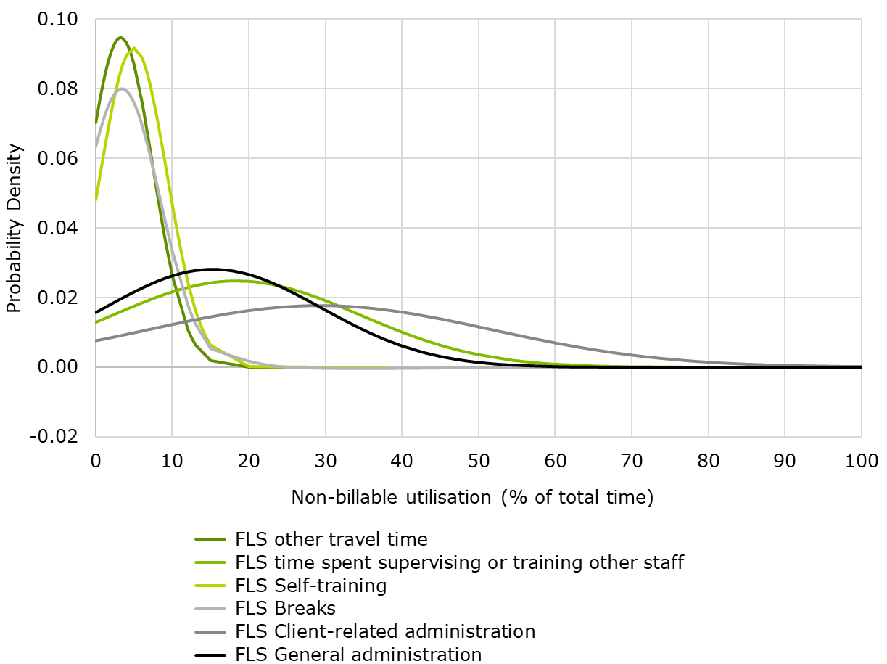
Table 3.45 to Table 3.47 illustrate FLS utilisation in smaller, medium and larger organisations according to revenue. The results illustrate that on average, FLS spend a higher proportion of time on billable activities in smaller organisations compared to larger organisations, with a mean of 25.9% and 23.5% respectively.
            - : Utilisation of FLS in smaller organisations, by NDIS revenue
 | Mean | 10th PC | 25th PC | 50th PC | 75th PC | 90th PC
Total utilisation (%) | 25.9 | 60.0 | 45.0 | 20.0 | 5.0 | 0.0
Billable time (time spent providing direct support to participants) (%) | 22.3 | 50.0 | 40.0 | 15.0 | 4.0 | 0.0
Billable travel (%) | 3.6 | 10.0 | 5.0 | 0.0 | 0.0 | 0.0
Other travel (%) | 3.8 | 10.0 | 5.0 | 2.0 | 0.0 | 0.0
Supervising staff (%) | 18.2 | 40.0 | 25.0 | 12.0 | 6.3 | 3.9
Self-training (%) | 5.6 | 10.0 | 8.0 | 5.0 | 2.0 | 0.0
Breaks (%) | 3.9 | 9.8 | 5.0 | 3.3 | 0.0 | 0.0
Client-related administration (%) | 28.2 | 60.0 | 44.8 | 20.0 | 10.0 | 5.0
General administration (%) | 14.3 | 30.1 | 20.0 | 10.0 | 5.0 | 3.0

            - : Utilisation of FLS in medium organisations, by NDIS revenue
 | Mean | 10th PC | 25th PC | 50th PC | 75th PC | 90th PC
Total utilisation (%) | 24.9 | 62.0 | 43.5 | 20.0 | 5.0 | 0.0
Billable time (time spent providing direct support to participants) (%) | 22.7 | 60.0 | 40.0 | 15.0 | 5.0 | 0.0
Billable travel (%) | 2.2 | 5.0 | 4.3 | 0.0 | 0.0 | 0.0
Other travel (%) | 2.8 | 8.5 | 5.0 | 1.0 | 0.0 | 0.0
Supervising staff (%) | 18.6 | 40.0 | 25.0 | 15.0 | 7.0 | 4.5
Self-training (%) | 4.7 | 10.0 | 5.0 | 5.0 | 2.0 | 0.0
Breaks (%) | 3.1 | 6.5 | 5.0 | 2.0 | 0.0 | 0.0
Client-related administration (%) | 31.4 | 70.0 | 45.0 | 25.0 | 13.0 | 7.0
General administration (%) | 14.5 | 32.1 | 20.0 | 10.0 | 5.0 | 4.0
            - : Utilisation of FLS in larger organisations, by NDIS revenue
 | Mean | 10th PC | 25th PC | 50th PC | 75th PC | 90th PC
Total utilisation (%) | 23.5 | 59.9 | 40.0 | 20.0 | 5.0 | 0.0
Billable time (time spent providing direct support to participants) (%) | 21.8 | 57.4 | 40.0 | 19.0 | 4.0 | 0.0
Billable travel (%) | 1.6 | 5.0 | 2.0 | 0.0 | 0.0 | 0.0
Other travel (%) | 2.9 | 10.0 | 5.0 | 2.0 | 0.0 | 0.0
Supervising staff (%) | 18.3 | 40.0 | 25.0 | 15.0 | 8.0 | 2.0
Self-training (%) | 3.8 | 10.0 | 5.0 | 3.0 | 1.0 | 0.0
Breaks (%) | 3.0 | 7.0 | 5.0 | 2.0 | 0.0 | 0.0
Client-related administration (%) | 31.0 | 64.6 | 44.8 | 25.0 | 14.0 | 5.0
General administration (%) | 17.4 | 35.8 | 25.0 | 10.0 | 6.0 | 4.0
When disaggregating by service type offered by service providers, the results in Table 3.48 to Table 3.50 show that service providers delivering Employment and SIL as their principal service had the highest average FLS utilisation. Service providers offering High Intensity DPA as their principal service group had the lowest FLS utilisation on average.
            - : Utilisation of FLS in by service type, based on revenue – Supported Independent Living
 | Mean | 10th PC | 25th PC | 50th PC | 75th PC | 90th PC
Total utilisation (%) | 26.7 | 62.0 | 50.0 | 20.0 | 6.0 | 0.0
Billable time (time spent providing direct support to participants) (%) | 24.3 | 60.0 | 40.0 | 20.0 | 5.0 | 0.0
Billable travel (%) | 2.4 | 8.0 | 3.5 | 0.0 | 0.0 | 0.0
Other travel (%) | 2.8 | 8.0 | 5.0 | 2.0 | 0.0 | 0.0
Supervising staff (%) | 18.6 | 40.0 | 25.0 | 15.0 | 9.0 | 5.0
Self-training (%) | 4.7 | 10.0 | 5.0 | 5.0 | 2.0 | 0.0
Breaks (%) | 2.9 | 7.0 | 5.0 | 2.0 | 0.0 | 0.0
Client-related administration (%) | 28.4 | 60.0 | 42.0 | 22.0 | 10.0 | 5.0
General administration (%) | 15.9 | 35.0 | 21.0 | 10.0 | 5.0 | 5.0
            - : Utilisation of FLS in by service type, based on revenue - Employment
 | Mean | 10th PC | 25th PC | 50th PC | 75th PC | 90th PC
Total utilisation (%) | 32.5 | 70.0 | 60.0 | 28.3 | 15.0 | 5.0
Billable time (time spent providing direct support to participants) (%) | 31.2 | 70.0 | 50.0 | 28.3 | 12.0 | 5.0
Billable travel (%) | 1.3 | 5.0 | 0.0 | 0.0 | 0.0 | 0.0
Other travel (%) | 1.5 | 5.0 | 2.0 | 0.0 | 0.0 | 0.0
Supervising staff (%) | 20.8 | 50.0 | 25.0 | 15.0 | 6.0 | 4.0
Self-training (%) | 4.6 | 10.0 | 8.0 | 3.0 | 1.0 | 0.0
Breaks (%) | 3.5 | 8.0 | 5.0 | 3.0 | 2.0 | 0.0
Client-related administration (%) | 22.5 | 50.0 | 30.0 | 20.0 | 7.0 | 4.0
General administration (%) | 14.6 | 30.0 | 20.0 | 10.0 | 5.0 | 3.0

            - : Utilisation of FLS in by service type, based on revenue – High Intensity DPA
 | Mean | 10th PC | 25th PC | 50th PC | 75th PC | 90th PC
Total utilisation (%) | 23.0 | 60.0 | 40.0 | 20.0 | 2.0 | 0.0
Billable time (time spent providing direct support to participants) (%) | 20.5 | 53.0 | 30.0 | 15.0 | 2.0 | 0.0
Billable travel (%) | 2.5 | 8.0 | 5.0 | 0.0 | 0.0 | 0.0
Other travel (%) | 3.4 | 10.0 | 5.0 | 2.0 | 0.0 | 0.0
Supervising staff (%) | 17.0 | 40.0 | 25.0 | 12.0 | 5.0 | 2.0
Self-training (%) | 4.7 | 10.0 | 5.0 | 5.0 | 1.5 | 0.0
Breaks (%) | 3.4 | 6.6 | 5.0 | 3.5 | 0.0 | 0.0
Client-related administration (%) | 33.1 | 70.0 | 50.0 | 25.0 | 10.0 | 5.0
General administration (%) | 15.4 | 30.0 | 20.0 | 10.0 | 5.0 | 3.3
Further details and outputs on FLS utilisation rates are provided in Appendix C.

Overheads and EBITDA as a percentage of costs
The results for reported overheads (excluding interest and depreciation) as a share of direct labour costs is presented in Table 3.51. On average, the results show that overheads are 44.2%, as a share of direct labour costs. The table also displays service providers EBITDA as a percentage of total costs which was calculated from various financial line items asked within the survey. These results showed that on average, service provider’s reported EBITDA as a share of total costs of 13.3%.
            - : Overheads and EBITDA as a percentage of costs
 | Mean | 10th PC | 25th PC | 50th PC | 75th PC | 90th PC
Overheads (excluding interest and depreciation) as a share of direct labour costs (%) | 44.2 | 12.0 | 21.8 | 35.9 | 56.3 | 85.8
EBITDA as a share of total costs (%) | 13.3 | 37.0 | 21.4 | 10.9 | 3.9 | -3.8
Table 3.52 shows the results for overheads and EBITDA as a proportion of costs from the 2019-20 financial year. The results show that overheads as a proportion of direct labour costs has decreased over time, with a mean of 51.9% in 2019-20 to 44.2% in 2020-21. Further, EBITDA as a proportion of total costs increased between years, as EBITDA was on average 10.3% of total costs in 2019-20 and increased to 13.3% of total costs in 2020-21. These results may indicate improvements in operational efficiency or improved accuracy of financial reporting among service providers.
            - : Comparison with 2019-20 survey: Overheads and EBITDA as a share of costs
Results from 2019-20 survey | Mean | 10th PC | 25th PC | 50th PC | 75th PC | 90th PC
Overheads (excluding interest and depreciation) as a share of direct labour costs (%) | 51.9 | 17.2 | 28.1 | 43.1 | 66.1 | 104.7
EBITDA as a share of total costs (%) | 10.3 | 24.8 | 15.9 | 8.4 | 2.0 | 0.0
It should be noted that service providers were asked to report the direct labour costs and overheads for their entire organisation, meaning their responses were not limited to the costs associated with NDIS-funded activities. This resulted in a wide range of direct labour costs and overheads being reported and a higher variance of results. It should be noted that as part of the data cleaning process, outliers above 149.5% were removed based on the IQR outlier removal method. Responses of zero were also removed.
With outliers removed, the results for overheads as a percentage of direct labour costs had a wide range with a positively skewed distribution, as shown in Chart 3.15. The reported overheads proportion also resulted in an IQR of 34.5%, with the majority of responses sitting below 50.0%.
              - : Box plot (LHS) and PDF (RHS) of overheads as a percentage of direct labour costs (%) responses
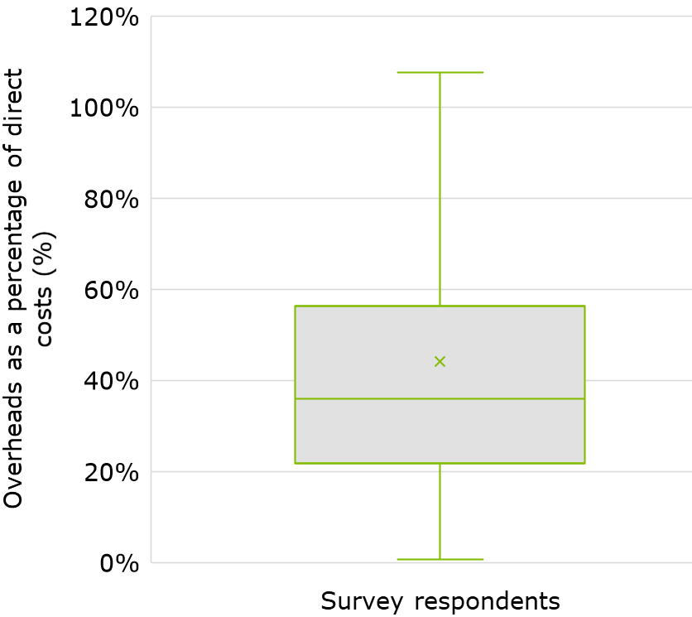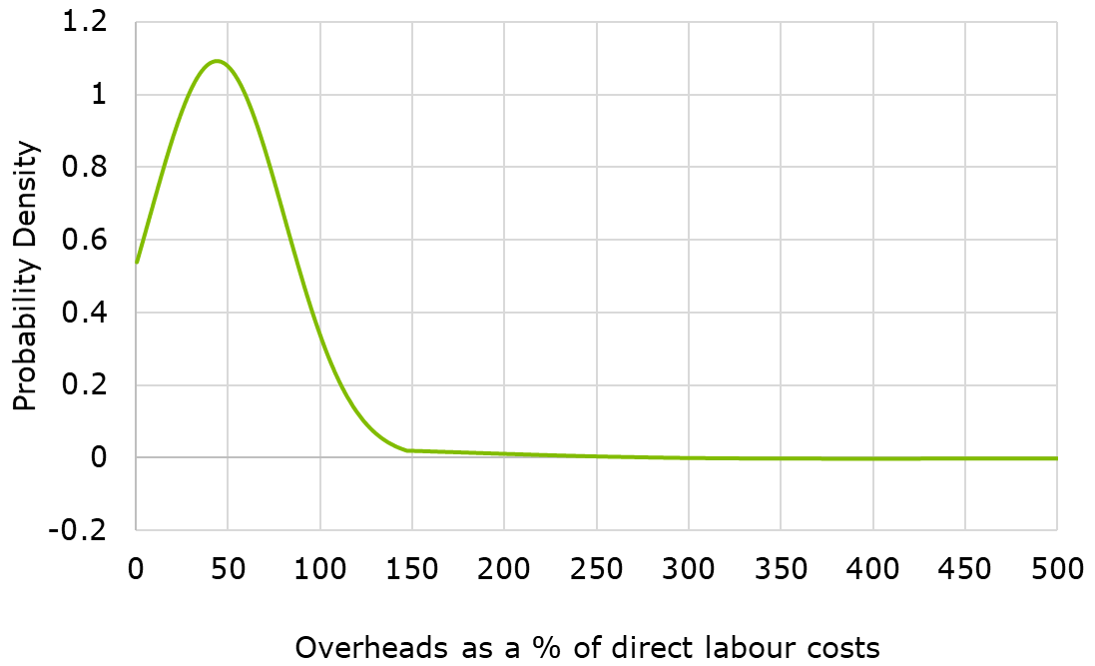

Chart 3.16 shows that EBITDA as a percentage of total costs also had a wide range of responses with a relatively normal distribution and a range of 68.0% with outlier values removed.
              - : Box plot (LHS) and PDF (RHS) of EBITDA as a percentage of total costs (%) responses
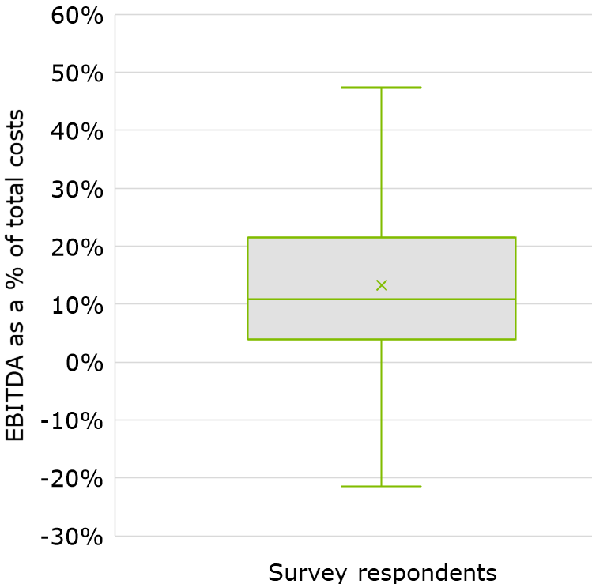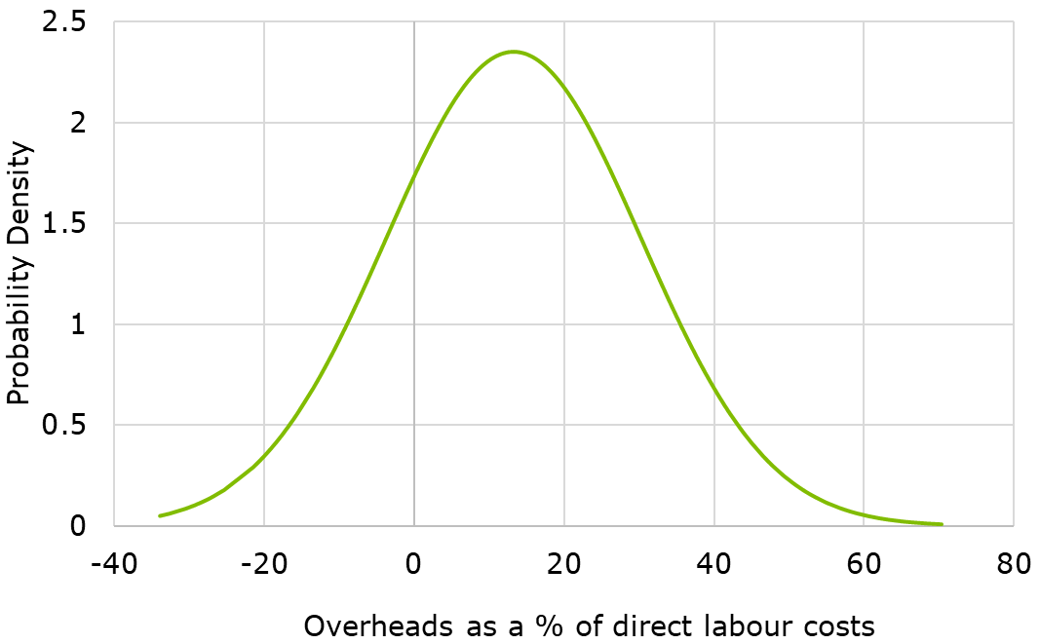
A breakdown of overheads is provided in Table 3.53. The salaries of non-service level staff were the highest reported category at 37.5% of total overhead costs, followed by other operational expenses at 19.9%.
            - : Share of overheads categories
Category | Share of total (%)
Employee expenses for other nonservice level staff | 37.5
Other operational expenses | 19.9
Depreciation and amortisation expenses | 12.0
Facility and occupancy costs, incl. repairs and maintenance | 7.9
IT and other costs | 5.2
Income tax paid | 3.9
Audit, consulting, legal expenses | 3.3
Insurance premiums | 2.7
Motor vehicle fleet costs | 2.2
Interest expense | 1.6
Marketing | 1.2
Payroll tax | 1.1
Fundraising costs | 0.9
Rates, land taxes, stamp duties | 0.7
Total | 100.0
Table 3.54, Table 3.55 and Table 3.56 show that smaller organisations had the highest share of overheads (45.5%) and EBITDA (14.3%). The share of EBITDA as a proportion of total costs decreased with organisation size by NDIS revenue. The same trend applied to overheads as a percentage of direct labour costs
            - : Overheads and EBITDA as a percentage of costs in smaller organisations, by NDIS revenue
 | Mean | 10th PC | 25th PC | 50th PC | 75th PC | 90th PC
Overheads (excluding interest and depreciation) as a share of direct labour costs (%) | 45.5 | 12.0 | 21.9 | 37.7 | 58.9 | 96.7
EBITDA as a share of total costs (%) | 14.3 | 40.5 | 23.8 | 11.5 | 3.3 | -5.0
            - : Overheads and EBITDA as a percentage of costs in medium organisations, by NDIS revenue
 | Mean | 10th PC | 25th PC | 50th PC | 75th PC | 90th PC
Overheads (excluding interest and depreciation) as a share of direct labour costs (%) | 41.6 | 9.6 | 19.4 | 34.5 | 56.7 | 82.3
EBITDA as a share of total costs (%) | 14.0 | 37.8 | 22.9 | 12.4 | 3.9 | -2.6
            - : Overheads and EBITDA as a percentage of costs in larger organisations, by NDIS revenue
 | Mean | 10th PC | 25th PC | 50th PC | 75th PC | 90th PC
Overheads (excluding interest and depreciation) as a share of direct labour costs (%) | 41.3 | 14.6 | 23.6 | 34.9 | 54.2 | 77.2
EBITDA as a share of total costs (%) | 11.4 | 28.1 | 17.1 | 10.4 | 4.4 | -0.5
Table 3.57 indicates that service providers operating in the Australian Capital Territory as their primary jurisdiction had the lowest overheads as a proportion of direct labour costs (37.0%) and the highest EBITDA as a percentage of total costs (19.8%). While organisations in New South Wales had the lowest EBITDA as a proportion of total costs (12.1%) and the second highest overheads as a percentage of direct labour costs (44.5%), as seen in Table 3.58.

            - : Overheads and EBITDA as a percentage of costs by main state jurisdiction, by revenue – Australian Capital Territory
 | Mean | 10th PC | 25th PC | 50th PC | 75th PC | 90th PC
Overheads (excluding interest and depreciation) as a share of direct labour costs (%) | 37.0 | 10.1 | 17.4 | 32.2 | 37.8 | 87.3
EBITDA as a share of total costs (%) | 19.8 | 47.2 | 21.9 | 14.7 | 12.6 | 7.4
            - : Overheads and EBITDA as a percentage of costs by main state jurisdiction, by revenue – New South Wales
 | Mean | 10th PC | 25th PC | 50th PC | 75th PC | 90th PC
Overheads (excluding interest and depreciation) as a share of direct labour costs (%) | 44.5 | 11.9 | 22.0 | 37.3 | 58.4 | 91.5
EBITDA as a share of total costs (%) | 12.1 | 37.8 | 20.1 | 10.2 | 3.0 | -7.0
When disaggregated by service type, Table 3.59 shows that service providers offering Employment services had, on average, the highest overheads as a share of direct labour costs (63.0%) and the highest EBITDA as a proportion of total costs (20.2%). Organisations offering Group services experienced, on average, the lowest EBITDA as a percentage of total costs (11.2%) and the second highest overheads as a share of direct labour costs (52.4%), as presented in Table 3.60.
            - : Overheads and EBITDA as a percentage of costs by service type – Employment
 | Mean | 10th PC | 25th PC | 50th PC | 75th PC | 90th PC
Overheads (excluding interest and depreciation) as a share of direct labour costs (%) | 63.0 | 16.7 | 29.8 | 50.9 | 98.6 | 119.9
EBITDA as a share of total costs (%) | 20.2 | 46.5 | 33.0 | 16.1 | 7.8 | 1.3

            - : Overheads and EBITDA as a percentage of costs by service type – Groups
 | Mean | 10th PC | 25th PC | 50th PC | 75th PC | 90th PC
Overheads (excluding interest and depreciation) as a share of direct labour costs (%) | 52.4 | 16.2 | 29.5 | 48.6 | 65.6 | 98.6
EBITDA as a share of total costs (%) | 11.2 | 29.1 | 18.7 | 11.8 | 4.6 | -4.5
Additional analysis on overheads and EBITDA as a percentage of total costs is presented in Section 6.1 and Section 6.8 respectively. For further details and outputs on overheads and EDITDA as a percentage of costs, see Appendix C.

Shift loadings
The following tables set out the survey results with respect to shift loadings for afternoon, night, weekend and public holiday shifts. These results incorporate the responses from all service providers, regardless of whether they operated under a recognised Award.
Table 3.61 shows that public holidays provided the highest shift loading for both permanent and casual staff, with an average loading above the standard hourly rate of 123.0% and 138.3%, respectively. Service providers applied a similar rate to their permanent and casual staff on Sundays, with only a 5.0% difference in these shift loadings on average. The most pronounced difference was seen on public holiday shifts where the average loading for casual staff was 15.3% higher than permanent staff.
            - : Impact of shift loadings on cost per billable hour, as a % of hourly base rate of pay
 | Permanent |  | Casual |  | Difference
 | Mean | Median | Mean | Median | Mean | Median
Afternoon shift (%) | 8.9 | 12.5 | 15.9 | 12.5 | 7.0 | 0.0
Night shift (%) | 10.9 | 15.0 | 19.0 | 15.0 | 8.1 | 0.0
Saturday shift (%) | 37.3 | 50.0 | 46.3 | 50.0 | 9.0 | 0.0
Sunday shift (%) | 85.9 | 100.0 | 90.9 | 100.0 | 5.0 | 0.0
Public Holiday shift (%) | 123.0 | 150.0 | 138.3 | 150.0 | 15.3 | 0.0
Consistent with the above results, Table 3.62 presents the shift loadings of casual and permanent staff at the 25th and 75th percentiles. Again, the largest difference between the shift loadings applied to permanent and casual staff occurs on public holidays. In contrast, afternoon shifts had the smallest difference between permanent and casual staff shift loadings, with this difference increasing for each shift type. Unsurprisingly, higher shift loadings were consistently applied to the casual workforce. Over the range of results, the difference between casual and permanent shift loadings was most pronounced on public holidays.
            - : Permanent and casual staff shift loading percentiles
 | Permanent |  | Casual |  | Difference
 | 25th PC | 75th PC | 25th PC | 75th PC | 25th PC | 75th PC
Afternoon shift (%) | 0.0 | 12.5 | 8.0 | 25.0 | 8.0 | 12.5
Night shift (%) | 0.0 | 15.0 | 10.7 | 30.0 | 10.7 | 15.0
Saturday shift (%) | 1.5 | 50.0 | 36.9 | 75.0 | 35.4 | 25.0
Sunday shift (%) | 25.0 | 100.0 | 73.3 | 125.0 | 48.3 | 25.0
Public Holiday shift (%) | 25.0 | 150.0 | 100.0 | 175.0 | 75.0 | 25.0
The variation in shift loadings between casual and permanent staff is varied from that of the 2019-20 financial year, as seen in Table 3.63. The average shift loading for permanent staff decreased slightly for all shift types except for Sunday shifts which increased from 73.1% to 85.9%. For casual staff, the average shift loadings for Saturday, Sunday and public holiday shifts increased. The biggest change was seen in Sunday shifts which had an average loading of 88.3% in 2019-20 and 90.9% in 2020-21.

In 2019-20, the most pronounced difference between casual and permanent loadings was seen on Sunday shifts, with a mean difference of 15.3%. In 2020-21, the most pronounced difference was seen on public holiday shifts with a mean difference of 15.4%.
            - : Comparison with 2019-20 survey: Permanent and casual shift loading
 | Permanent |  | Casual |  | Difference
 | Mean | Median | Mean | Median | Mean | Median
Afternoon shift (%) | 9.4 | 12.5 | 15.6 | 12.5 | 6.2 | 0.0
Night shift (%) | 11.7 | 15.0 | 18.3 | 15.0 | 6.7 | 0.0
Saturday (%) | 59.0 | 50.0 | 45.5 | 50.0 | -13.4 | 0.0
Sunday (%) | 73.1 | 100.0 | 88.3 | 100.0 | 15.3 | 0.0
Public loading (%) | 132.0 | 150.0 | 132.9 | 150.0 | 1.0 | 0.0
The following charts illustrate that casual employees had a higher variance in shift loadings compared to permanent employees. The box plots and PDFs in Chart 3.17 to Chart 3.20 show a wider range of loadings for casual employees for Afternoon, Night and Saturday shifts. There was no difference in range between permanent and casual employee shift loadings for Sunday shifts and Public Holiday shifts.

Saturday shifts for both permanent and casual employees had a narrower distribution, as seen in Chart 3.19 to Chart 3.20. Public holiday shifts had the widest distribution for both casual and permanent employees, followed by Sunday shifts, showing that these shifts tend to have the most variance in the approach to assigning loadings.

              - : Box plot of shift loadings (afternoon and night shifts, permanent and casual)
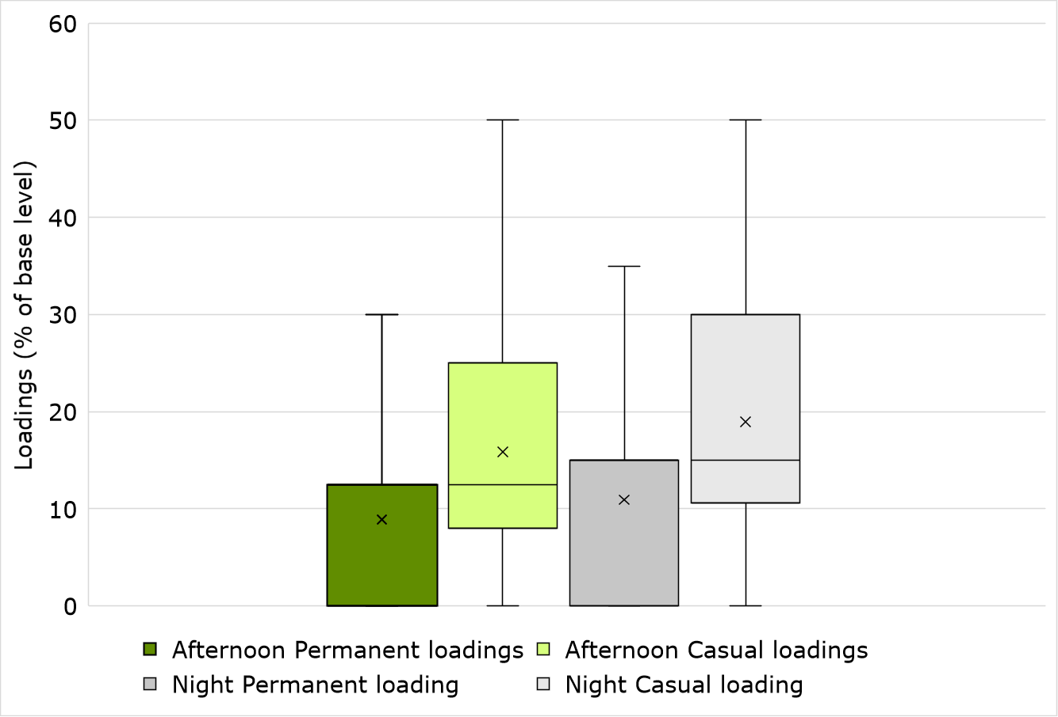
              - : Box plot of shift loadings (weekend and public holiday shifts, permanent and casual)
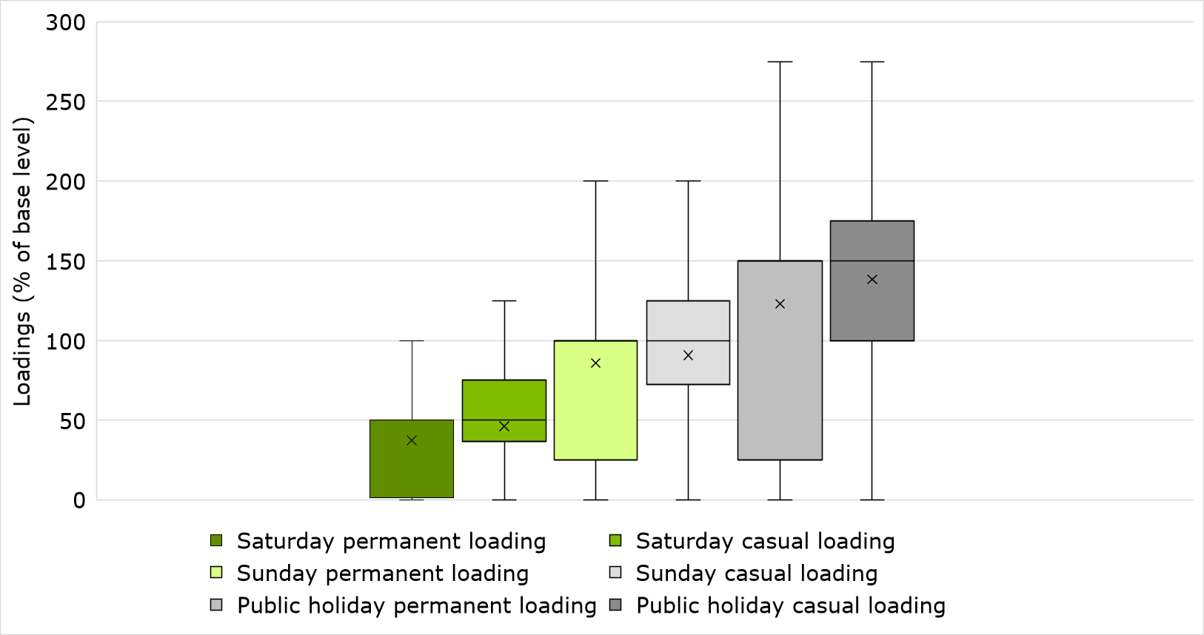
              - : PDF of shift loadings (afternoon and night shifts, permanent and casual)
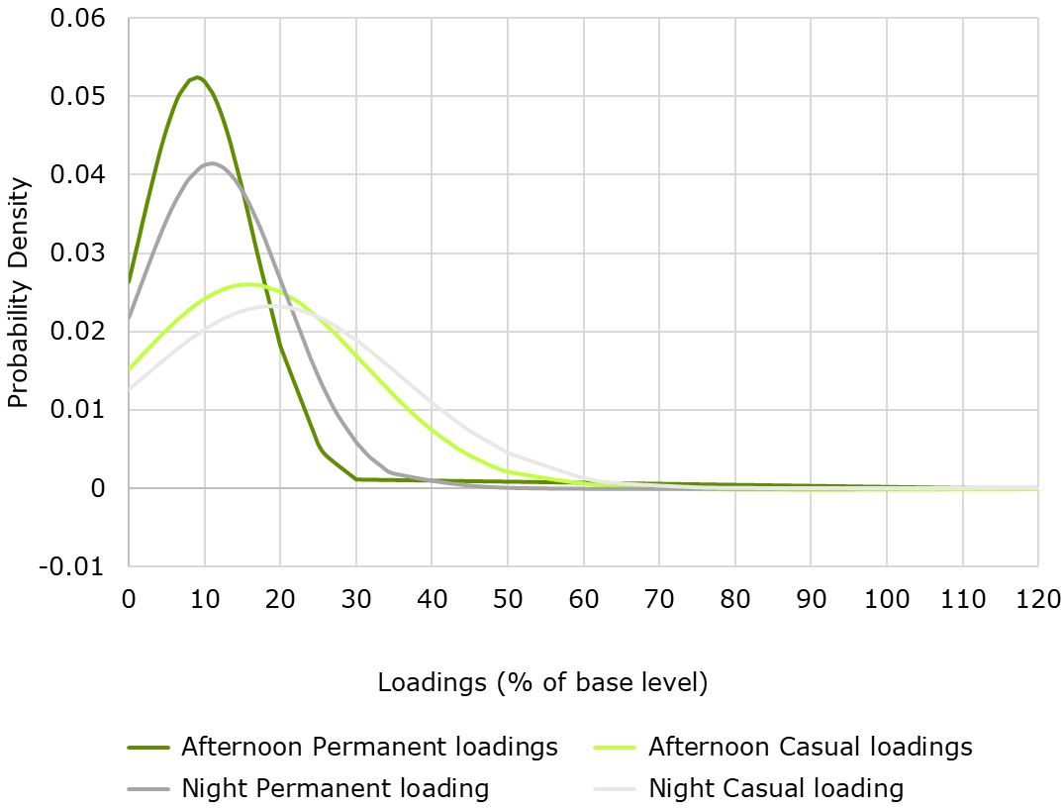
              - : PDF of shift loadings (weekend and public holiday shifts, permanent and casual)
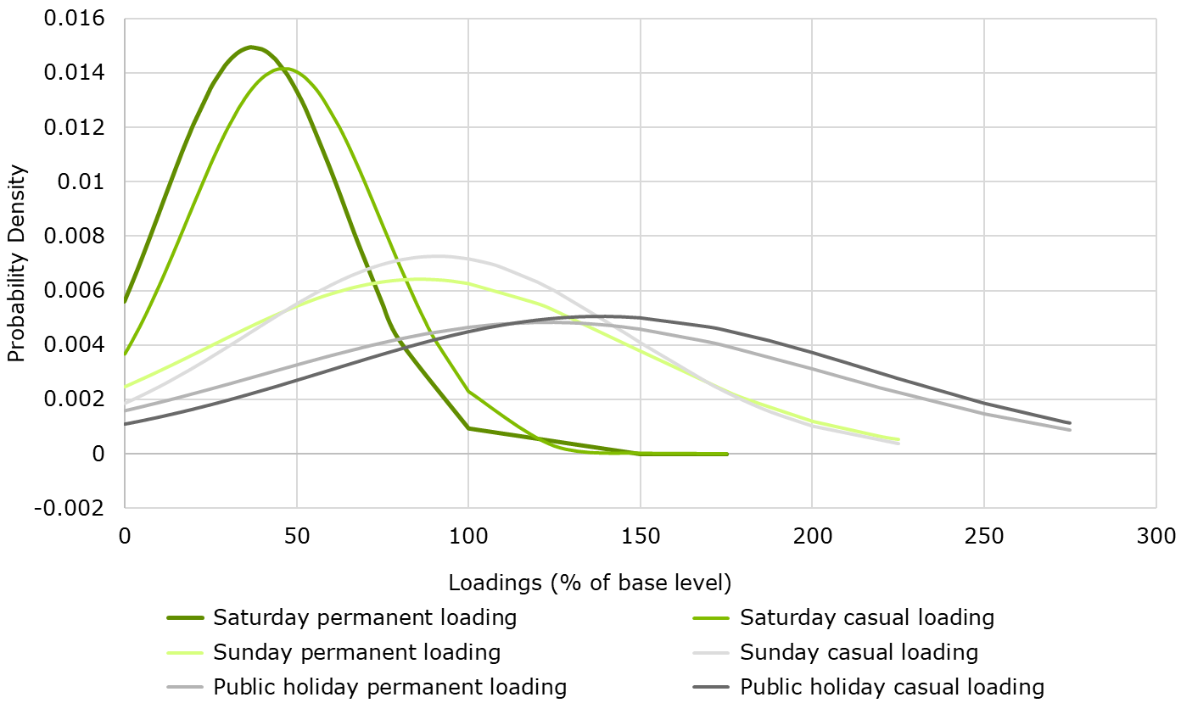
Service providers were also asked whether their organisation utilised more permanent or casual staff on night, weekend and public holiday shifts. The results show that across all shift categories, 39.3% of service providers employed more casual staff and 29.5% employed approximately the same proportion of casual and permanent staff.
Chart 3.21 shows the proportion of responses disaggregated by shift category, which shows minimal variation across shift types. The proportion of providers who employed “a lot more” casual staff on nights, Saturday, Sunday and public holiday shifts was 28.7%, 30.3%, 29.9% and 29.0% respectively. 10.6% of providers indicated they did not offer support in one of the shift categories listed.
              - : Casual and permanent staffing arrangements for night shifts, weekends and public holidays, survey responses (%)
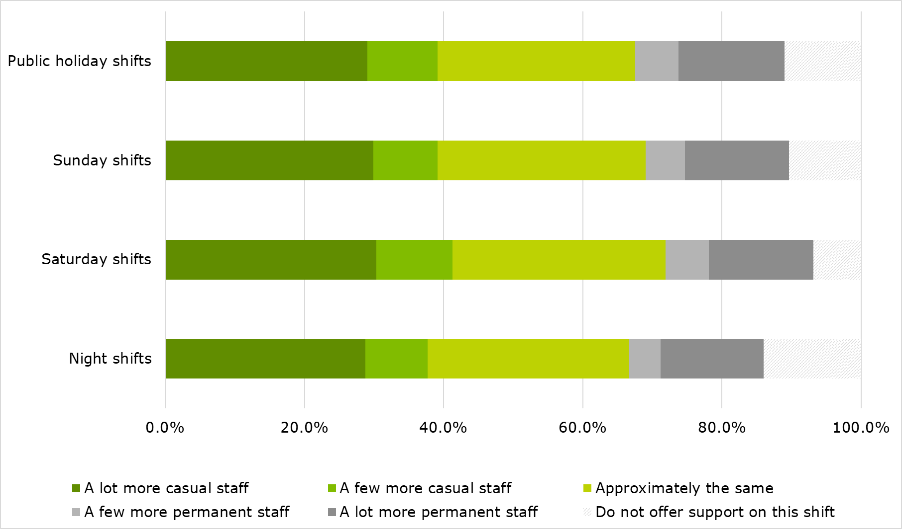

Employment conditions
This Section presents results from the survey regarding service providers’ employment conditions, including leave entitlements, allowances and remuneration Awards and EBAs.

Leave entitlements

Minimum leave entitlement
The survey results indicated that full time DSWs accrue the following allowances per year of service, on average:
- a minimum of 154.9 hours of annual leave
- up to 37.4 hours of long service leave
- at least 77.8 hours of personal leave.

Table 4.1 outlines the survey results for full time DSWs leave allowances across all organisations paying under both SCHADS and non-SCHADS arrangements.
            - : Number of leave hours accrued by full time DSWs per year of service
 | Mean | 10th PC | 25th PC | 50th PC | 75th PC | 90th PC
Allowance for annual leave (hours per year) | 154.9 | 152.0 | 152.0 | 152.0 | 152.0 | 152.0
Allowance for long service leave (hours per year) | 37.4 | 32.0 | 32.9 | 33.0 | 45.0 | 49.4
Allowance for personal leave (hours per year) | 77.8 | 76.0 | 76.0 | 76.0 | 76.0 | 76.0
Over 85.0% of survey respondents selected the default response option for the number of annual and personal leave hours accrued per year of service (152.0 and 76.0 hours respectively). Across both questions, approximately 14.0% of remaining service providers responded with ‘other’ and specified the number of hours accrued per year of service within their organisation. With a small number of responses removed in line with the data cleaning methodology, these responses ranged from 70.0 to 304.0 hours for annual leave and 76.0 to 190.0 hours for personal leave. Further, these results revealed that across both questions, approximately 6.0% of service providers offer more than 152.0 and 76.0 hours of annual and personal leave per year of service respectively.
The minimum number of hours of annual leave accrued on average is slightly higher than that of the previous financial year. Table 4.2 shows the results for minimum annual leave and long service leave accrued in the 2019-20 financial year, which reveals the average number of hours of annual leave increased from 147.1 to 154.9 hours per annum, whilst long service leave increased from 30.3 to 37.4 hours per annum.

            - : Comparison with 2019-20 survey: Annual and long service leave
Results from 2019-20 survey | Mean | 10th PC | 25th PC | 50th PC | 75th PC | 90th PC
Allowance for annual leave (hours per year) | 147.1 | 0.0 | 152.0 | 152.0 | 152.0 | 190.0
Allowance for long service leave (hours per year) | 30.3 | 0.0 | 12.8 | 32.9 | 43.1 | 49.4
Chart 4.1 and Chart 4.2 show the long service leave responses have an IQR of 12.1, with the 25th percentile sitting at 32.9 and the 75th percentile sitting at 45.0 hours per annum. The distribution is positively skewed, with a longer right-side tail and the mean lying above the median.
              - : Box plot of long service leave (hours per annum)
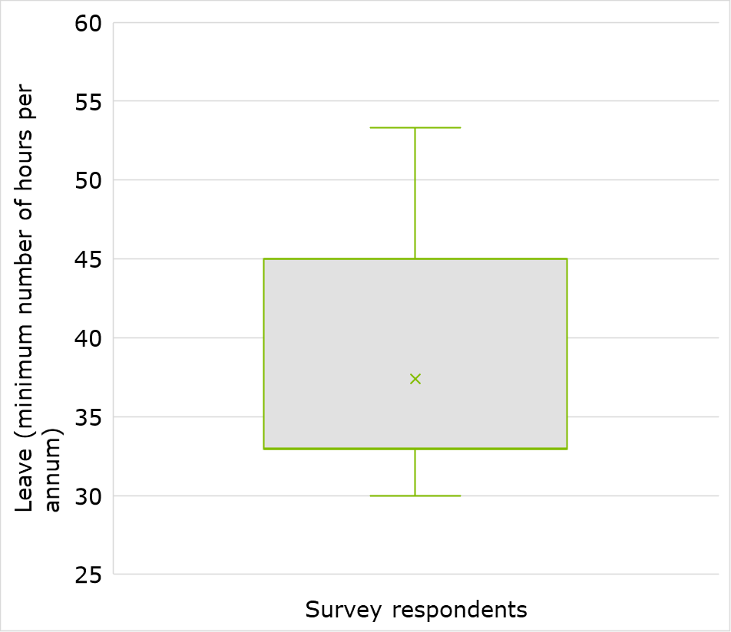
              - : PDF of long service leave (hours per annum)
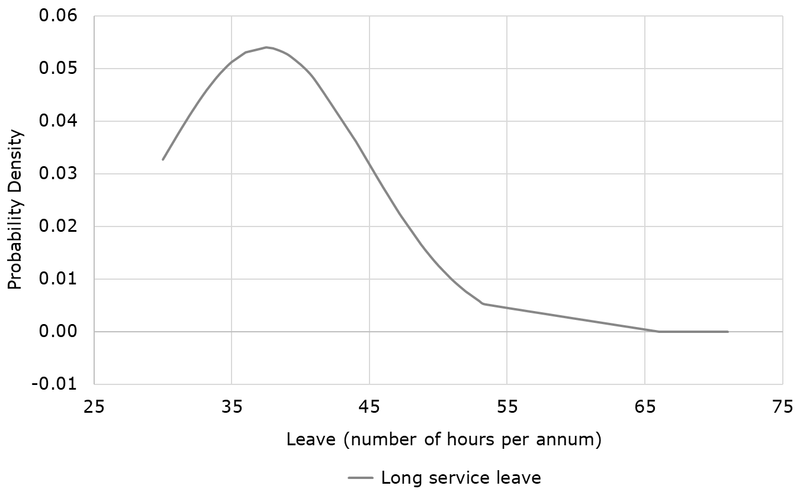
Table 4.1 and Chart 4.3 show there is a bias towards the default responses for annual leave (152.0 hours) and personal leave (76.0 hours). This led to an IQR of zero for annual leave and personal leave, and accordingly they were not included as a box plot.
              - : PDF of annual leave and personal leave (hours per annum)
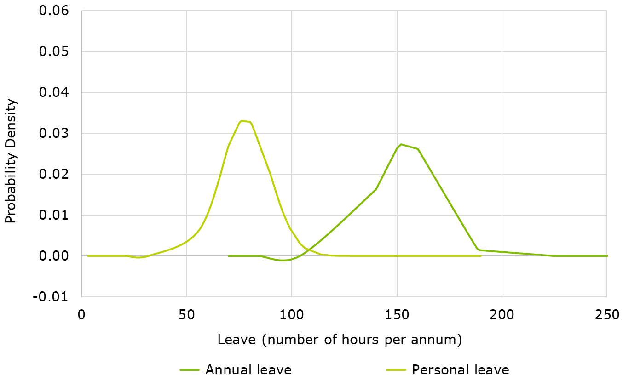

Calculation of leave entitlements
This section presents the entitlements to annual, long service and personal leave accrual reported by survey respondents.
As discussed in Section 4.1.1, some staff accrue more than the minimum number of hours of leave per year of service. This is consistent with the results depicted in Table 4.3 which indicates that on average, 16.0% of full time DSWs are entitled to more than the minimum hours of annual leave and 7.2% accrue more than the minimum hours of personal leave.
            - : Proportion of full time DSWs entitled to more than the minimum number of hours of annual and personal leave
 | Mean | 10th PC | 25th PC | 50th PC | 75th PC | 90th PC
Annual leave (% of full time DSWs) | 16.0 | 0.0 | 0.0 | 0.0 | 20.0 | 68.0
Personal leave (% of full time DSWs) | 7.2 | 0.0 | 0.0 | 0.0 | 0.0 | 20.0
Service providers were asked whether the calculation of annual leave entitlements depended on the staff members’ shift worker status. More than half of survey respondents (62.7%) indicated that their organisation does not determine annual leave based on shift worker status, as shown in Table 4.4.
Service providers were also asked to specify what factors are relevant to calculated annual leave. 37.3% of service providers reported that their organisation provides an extra week of annual leave to shift workers, with the remaining service providers determining annual leave on factors outside of shift worker status. 10.7% provided additional details via a free text field regarding how annual leave is calculated within their organisation. The most common factors noted in the free text responses were the number of hours staff worked on weekends or the use of a recognised Award.
Notably, several answers listed these other factors as ‘zero’ or that this question was not applicable to their organisation because they hold a casualised workforce. Although a skip logic was inserted into this question to circumvent service providers with casualised workforces, this response is likely due to an error when service providers were completing the question regarding casual and permanent staffing arrangements. Accordingly, the true proportion of service providers who calculate annual leave accrual according to some other factor is likely to be lower than the value shown in Table 4.4.
            - : Proportion of providers whose annual leave accrual depends upon shift worker status or other factors
Does annual leave accrual depend upon shift worker status? | Proportion of providers
Yes, one week extra annual leave for shift workers (%) | 37.3
No, annual leave does not depend upon shift worker status (%) | 62.7
In addition to the factors described above, common responses revealed that annual leave accrual depends upon other factors such as:
- in line with an EBA or other recognised Award
- an extra week if the employee works ten weekends per year (minimum four hours per shift)
- pro rata based on the number of hours worked
- an extra two weeks if the employee is a residential support worker
- a set amount given to all employees per year.

A summary of all survey responses provided to this free text question are outlined in Appendix C.

Table 4.5 shows the proportion of providers who determine the accrual of personal leave according to shift work status or some other factor.

            - : Proportion of providers whose personal leave accrual depends upon shift worker status or other factors
Does personal leave accrual depend upon shift worker status? | Proportion of providers
No, personal leave does not depend upon shift worker status (%) | 92.4
Yes, personal leave depends upon shift worker status or other factors (%) | 7.6

The results revealed that 92.4% of service providers do not determine personal leave accrual based on shift worker status. The remaining 7.6% of organisations report that they calculate personal leave according to shift worker status or some other factor, such as:

- pro rata basis according to the number of hours worked
- an employee’s total years of service
- in accordance with an EBA or other recognised Award
- a fixed amount awarded to all employees.

A summary of all free text survey responses provided in relation to personal leave accrual is outlined in Appendix C.
Of the service providers who reported that personal leave does not depend on shift worker status, a large proportion did not provide any further detail or an alternative factor in the free text box. These responses typically indicated that the question was not applicable to their situation due to holding a casualised workforce. Hence, the actual proportion of survey respondents who determine personal leave accrual according to some other factor is likely to be lower than the value shown in Table 4.5.

Table 4.6 reveals that 65.2% of service providers allow their casual staff to accrue long service leave, while 22.2% of organisations do not provide this allowance. Moreover, 9.6% of service providers allow some casual staff to accrue long service leave depending upon the state jurisdiction where the employee works and 2.9% of service providers calculate leave using some other factor such as an employee’s continuous length of service or the number of hours worked per month above a minimum threshold. A summary of all survey responses provided to this free text question are outlined in Appendix C.
            - : Proportion of providers whose casual staff are entitled to accrue long service leave
Are casual staff entitled to accrue long service leave? | Proportion of providers
All casual staff entitled to accrue long service leave (%) | 65.2
Some casual staff, depending on whether the state in which the employee works has a portable longer service leave scheme (%) | 9.6
Some casual staff, depending upon other reasons (%) | 2.9
No casual staff entitled to accrue long service leave (%) | 22.2

It is important to note that service providers with an entirely permanent workforce did not answer this question, as a skip logic was inserted into the survey to ensure it was only answered by organisations that employ casual staff.

Awards and Enterprise Bargaining Agreements
The survey asked service providers whether the majority of their DSW and FLS staff were paid in line with a recognised Award, EBA or another payment arrangement. This Section presents the results for the pay Awards and agreements used by survey respondents.
Chart 4.4 illustrates that over three quarters of all service providers paid their employees under a recognised Award, with the most common being the Social, Community, Home Care and Disability Services Industry Award (SCHADS Award), which was listed by 70.0% of service providers. It should be noted that it was not possible to accurately determine the proportion of service providers who paid under each part of the SCHADS Award. This is because service providers responded to this question in a free-text box and the majority who cited the SCHADS Award did not report any further detail.
              - : Payment arrangements of survey respondents
Of the 10.2% of service providers who reported using a recognised non-SCHADS Award, the most commonly reported Awards included:
- Supported Employment Services Award [MA000103]
- Health Professionals and Support Services Award 2020 [MA000027]
- Nurses Award 2020 [MA000034].

A full list of the recognised Awards used by providers is outlined in Appendix C.
Several service providers listed multiple Awards, for example where there may have been multiple service providers entered per survey return or where different Awards are used for different groups of staff.
Chart 4.4 also shows that 13.4% of survey respondents reported using an EBA. These service providers were then asked to provide further details including the EBA name, start date, end date and the Award used to assess the EBA against the Better Off Overall Test. Chart 4.5 shows that the majority of service providers used the SCHADS Award for the Better Off Overall Test, with 68% applying the Social and Community Services Employee Sector part and 13% applying the Home Care Employees part of the SCHADS Award.
              - : Awards used to assess EBAs against the Better Off Overall Test
A full list of the EBA details reported by service providers is included in Appendix C.
Of the 6.3% of service providers who indicated they use a payment arrangement other than a recognised Award or EBA, 10.0% indicated that they do pay some staff under the SCHADS Award. Accordingly, the actual proportion of service providers who pay according to another recognised Award may be slightly lower than the survey data indicates. These service providers reported that they selected ‘Other payment arrangement’ as they pay a portion of their staff under the SCHADS Award, with other staff being paid above the Award rate or under an alternative arrangement. A full list of the alternative payment arrangements used by service providers is outlined in Appendix C.

Allowances
The survey gathered information from service providers regarding the type of allowances paid to their staff and the proportion of workers within their organisation who receive an allowance. Survey results showed that 71.0% of all service providers pay their workers an allowance. Within this group, the average proportion of staff within each organisation who receive an allowance was 69.0%, as outlined in Table 4.7. This was slightly lower than the results reported in the 2019-20 survey, as the average proportion of staff within each organisation who received an allowance in 2019-20 was 73.5% as seen in Table 4.8.
            - : The proportion of staff within each organisation who receive an allowance
 | Mean | 10th PC | 25th PC | 50th PC | 75th PC | 90th PC
Proportion of staff within each organisation who receive an allowance (%) | 69.0 | 10.0 | 35.0 | 84.0 | 100.0 | 100.0

            - : Comparison with 2019-20 survey: The proportion of staff within each organisation who receive an allowance
Results from 2019-20 survey | Mean | 10th PC | 25th PC | 50th PC | 75th PC | 90th PC
Proportion of staff within each organisation who receive an allowance (%) | 73.5 | 20.0 | 51.0 | 90.0 | 100.0 | 100.0
For service providers who pay an allowance, the survey asked them to specify the types of allowances paid to staff. As outlined in Table 4.9 the allowance most commonly paid is the reimbursement of travelling expenses (59.6%), followed by on-call (57.7%) and first aid (53.8%) allowances.
Service providers were able to select multiple allowances in the survey and of the 71.0% of respondents who pay an allowance, 84.0% reported that they paid more than one type of allowance to their staff.
            - : Types of allowances paid by service providers
Type of allowance | Proportion of providers
Travelling expenses reimbursement | 59.6
On call allowance | 57.7
First aid allowance | 53.8
Vehicle allowance | 52.3
Meal allowance | 27.1
Other allowances (please specify): | 27.1
Telephone reimbursement | 21.3
Laundry allowance | 13.1
Uniform allowance | 8.0
Special or protective clothing reimbursement | 4.8

The proportion of service providers who pay their employees ‘other’ allowances not included in Table 4.9 was 27.1%. Of these service providers who pay ‘other’ allowances, the most commonly reported allowance was ‘sleepover shifts’. It should also be noted that some service providers who selected ‘other’ allowances listed allowances in the free-text box that were already covered by an existing category, such as telephone, travel or vehicle allowances. Accordingly, the proportion of service providers who pay ‘other’ allowances is likely lower than the figure shown in Table 4.9. A full list of the ‘other’ allowances reported by service providers is outlined in Appendix C.

Of the 71.0% of service providers who pay their workers an allowance, 52.3% pay a vehicle allowance, which covers some of an employee’s expenses of operating a vehicle for delivering client services. Table 4.10 shows the amount paid per worker for vehicle allowances and other allowances is (on average) 1.4% and 0.8% of the employee’s base pay, respectively.
            - : Average dollar amount paid per worker (DSW and FLS) for vehicle and other allowances as a proportion of base rate of pay
 | Mean | 10th PC | 25th PC | 50th PC | 75th PC | 90th PC
Vehicle allowance (%) | 1.4 | 0.0 | 0.2 | 0.9 | 1.9 | 3.4
Other allowances (non-vehicle allowances) (%) | 0.8 | 0.0 | 0.1 | 0.5 | 1.1 | 1.9
As seen in Table 4.11, the average dollar amount paid for other allowances as a proportion of base rate of pay was consistent with the previous financial year, at 0.8% and 0.8% respectively. The proportion of base pay that is paid for vehicle allowances increased in 2020-21 compared to the previous financial year, at 1.4% and 1.0% respectively.
            - : Comparison with 2019-20 survey: Allowances
Results from 2019-20 survey | Mean | 10th PC | 25th PC | 50th PC | 75th PC | 90th PC
Vehicle allowance (%) | 1.0 | 0.1 | 0.2 | 0.7 | 1.6 | 2.4
Other allowances (non-vehicle allowances) (%) | 0.8 | 0.1 | 0.2 | 0.5 | 1.2 | 2.1

Fringe benefits
The survey results showed that 11.2% of all service providers pay their workers fringe benefits. It should be noted that this amount does not include those who pay fringe benefits as part of a salary sacrificing scheme.
Table 4.12 illustrates that of the service providers who pay their workers fringe benefits, the average amount paid per FTE worker was $7,629.94 throughout the 2020-21 financial year. This was lower than the average amount reported in the 2019-20 survey as seen in Table 4.13 where the average amount of fringe benefits paid to staff was $10,801.10 per FTE worker.
            - : Average dollar amount paid for FTE worker (DSW and FLS) for fringe benefits
 | Mean | 10th PC | 25th PC | 50th PC | 75th PC | 90th PC
Amount of fringe benefits paid per FTE worker ($) | 7,629.94 | 30.00 | 200.00 | 1,500.00 | 15,900.00 | 18,479.95
            - : Comparison with 2019-20 survey: Average dollar amount paid for FTE worker (DSW and FLS) for fringe benefits
Results from 2019-20 survey | Mean | 10th PC | 25th PC | 50th PC | 75th PC | 90th PC
Amount of fringe benefits paid per FTE worker ($) | 10,801.10 | 161.70 | 1,446.25 | 14,878.09 | 15,900.00 | 18,273.60
When disaggregating the 2020-21 results by organisation size (by NDIS revenue), the average fringe benefits payment per FTE worker increased as organisation size increased. As seen in Table 4.14, the average fringe benefit paid was $6,110.56 for smaller organisations, compared to $8,520.64 for larger organisations.
            - : Average dollar amount paid for FTE worker (DSW and FLS) for fringe benefits, by size of organisation (based on revenue)
 | Mean | 10th PC | 25th PC | 50th PC | 75th PC | 90th PC
Small ($) | 6,110.56 | 19.78 | 143.00 | 713.00 | 12,943.00 | 18,248.00
Medium ($) | 8,391.48 | 100.20 | 245.50 | 4,613.00 | 15,900.00 | 18,550.00
Large ($) | 8,520.64 | 12.00 | 58.00 | 9,633.00 | 15,900.00 | 18,223.64

Table 4.15 also illustrates that the average amount of fringe benefits paid per FTE worker was higher for organisations registered as an NFP compared to for-profit organisations, at $8,673.26 and $5,740.76 respectively.
            - : Average dollar amount paid for FTE worker (DSW and FLS) for fringe benefits, by not-for-profit status
 | Mean | 10th PC | 25th PC | 50th PC | 75th PC | 90th PC
For profit ($) | 5,740.76 | 18.33 | 80.00 | 300.00 | 14,441.69 | 16,260.00
NFP ($) | 8,673.26 | 46.00 | 243.25 | 4,681.50 | 15,900.00 | 18,553.00
The average fringe benefits payment per FTE worker also varied significantly by types of services provided. Table 4.16 displays that service providers offering High Intensity DPA and SIL services reported above the average survey results, at $16,396.39 and $9,811.42 respectively. While Employment service providers presented the lowest average fringe benefits payment per FTE workers within their organisations at $2,945.87.
            - : Average dollar amount paid for FTE worker (DSW and FLS) for fringe benefits, by service group
 | Mean | 10th PC | 25th PC | 50th PC | 75th PC | 90th PC
High Intensity DPA ($) | 16,396.39 | 150.00 | 9,633.00 | 15,900.00 | 27,577.00 | 29,330.00
DPA ($) | 6,201.67 | 17.22 | 136.00 | 1,249.00 | 10,642.00 | 17,500.00
Part in Comm Soc Civ ($) | 5,402.48 | 46.00 | 150.00 | 702.00 | 10,000.00 | 15,900.00
SIL ($) | 9,811.42 | 30.00 | 241.00 | 10,642.00 | 15,900.00 | 18,200.00
Employment ($) | 2,945.87 | 70.00 | 122.31 | 276.00 | 290.00 | 15,900.00
Groups ($) | 5,607.33 | 30.00 | 70.00 | 611.53 | 14,441.69 | 15,900.00

For further details and outputs on fringe benefits, see Appendix C.

Information on provider prices
This Section provides a summary of the responses related to reasons for setting prices at or below the NDIS Price Limit, and any variation in prices for NDIS clients compared to other clients.

TTP claim in 2020-21
Of the survey sample, 72.6% of service providers reported that they had claimed for support items that were subject to the TTP arrangements in 2020-21.
It should be noted that the proportion who claimed TTP only includes service providers who had already made a claim prior to the survey closure on 4 February 2022. As service providers are able to make a TTP claim until 30 June 2022 for 2020-21 financial year, there may be a proportion of service providers who had not claimed the TTP at the time of responding to the survey but are planning to claim prior to the end of June 2022.

Setting of prices
As shown in Table 5.1, 83.4% of service providers reported always setting service prices for NDIS participants at the NDIS Price Limit. There were 15.7% of service providers who reported sometimes setting prices at the NDIS Price Limit, and less than 1.0% reported always setting prices below the NDIS Price Limit.
            - : Proportion of survey respondents who set service prices at the NDIS Pricing Arrangements and Price Limits
 | Proportion of providers (%)
Always at the Price Limit | 83.4
Sometimes at the Price Limit / sometimes below the Price Limit | 15.7
Always below the Price Limit | 0.9
Where providers answered “always/sometimes below the Price Limit”, a free text box captured reasons for offering prices below the NDIS Price Limit. The responses provided were often consistent with those reported in the 2019-20 survey, with the three primary reasons being:
- If a participant has limited funds remaining on their plan, service providers may charge below the Price Limit to ensure continuity of support until their plan is renewed and a new price can be negotiated.
- Service providers may negotiate with participants to lower prices on a case-by-case basis, where a plan does not meet their needs and they require additional support.
- Some service providers reported they charge below the Price Limit to remain competitive against other service providers and retain participants.

The free-text responses revealed several specific types of support where service providers may charge prices below the NDIS Price Limit, including:
- Short-term accommodation where the care provided is less than 24 hours, for example when the participant’s care is reduced due to receiving support for Participation in Community, Social and Civic activities in the same day.
- Shared service arrangements where there are multiple participants receiving support. In such cases, service providers may split the cost of the support among the number of participants to reduce usage on individual plan budgets.
- Transport costs, particularly where participants have limited funding remaining on their plan or reside in remote regions that require higher mileage to access supports. In such cases, service providers may reduce the amount charged per kilometre or may charge a fixed fee. Services which are often charged on a fixed-fee basis, such as leisure programs, whereby service providers may charge the fixed fee or divide the fixed fee by the number of hours of support provided.

Price schedules for NDIS and non-NDIS participants
Of the survey sample, 27.5% of service providers reported setting different price schedules for NDIS participants compared to other clients. Service providers who answered “different price schedules” were asked to provide further detail in a free text box. Similar to the 2019-20 survey, the primary reason reported for offering different prices to NDIS participants compared to other clients was due to serving clients under different funding schemes with their own price models. A range of funding schemes were cited by service providers, with the most common being:
- Transport Accident Commission (TAC)
- Commonwealth Home Support Program (CHSP)
- Home Care Package Services (HCP)
- Community Visitors Scheme (CVS)
- Disability Support for Older Australians Program (DSOA)
- Veterans Home Care (VHC).

Other reasons given by service providers for charging different prices to non-NDIS clients included:
- Private clients or those accessing brokerage services may be charged different prices. Most service providers who cited this reason did not specify the difference in pricing, however some did state that these clients were often subject to higher prices.
- Service providers may charge different prices depending on the support complexity, such as the client’s needs or the support ratio.

Drivers of key parameters
This Section and Appendix D present the results of the regression analysis. The objective of this analysis is to identify key ‘drivers’ of selected parameters to inform providers of opportunities for greater efficiency. The parameters that were modelled in this analysis are presented in Table 6.1.
            - : Parameters considered in the regression analysis
Key parameters | Variable description
Overheads costs | Total overhead costs as a percentage of total direct labour costs. Overheads costs include: non-service level staff, insurance premiums, rent and fittings, fleet costs, marketing, accounting and audit costs, fundraising costs, payroll tax, IT costs, and other costs.
Organisation service level expenses | Total direct labour costs, which includes front-line staff costs, supervisor costs.
Permanent employment rate | The percentage of total FTE that are employed permanently.
Average hourly wages of support workers | The weighted average hourly wage of support workers within an organisation.
Average hourly wages of supervisors | The weighted average hourly wage of supervisors within an organisation.
Span of control | The number of support workers / the number of supervisors.
Utilisation rate of support workers | The percentage of support worker time spent on billable work.
EBITDA | Earnings before tax and amortisation as a percentage of total costs.

The regression analysis also assesses how each parameter varies by the types of services provided by an organisation. Types of services include:
- DPA
- High intensity DPA
- SIL
- Participation in Community, Social and Civic Activities
- Specialised Supported Employment
- Group and Centre Based Activities.
To remain consistent throughout the analysis, as well as to reduce the risk of issues associated with collinearity, the degree to which organisations provide DPA services are never included explicitly in the regression analysis.
The results of each regression analysis are discussed in the remainder of this Section in the order they are presented in Table 6.1. For further information on the regression analysis, including a list of variables and their definitions used in the analysis, the regression analytical framework, diagnostic tests and robustness checks, see Appendix D. It is important to note that results reported in this chapter may differ to summary data reported throughout the remainder of the report. This is for two reasons; a regression analysis reports conditional values, holding other variables constant; the sample size of the regression analyses differs due to a different outlier removal technique.

Overhead costs (as a percentage of direct labour costs)
The OLS regression results provide several important insights into the drivers of overhead costs among organisations for the average service provider (Table 6.2). Findings include:
Overhead costs as a percentage of direct labour costs increase with the size of an organisation (as measured by number of participants). At the mean of the regression, a 1% increase in participants is associated with a 0.03 percentage point increase in overhead costs.
Quantile regression analysis provides further insights into the relationship between overhead costs and organisation size across different service providers. The results show that organisation size is associated with higher overhead costs for organisations with lower overhead costs at the 25th and 50th percentile of the overhead cost distribution. However, there is insufficient evidence to confirm a relationship between the organisations with larger overhead costs (those at the 75th percentile of the overhead cost distribution) and organisation size (See Appendix D.2).
NDIA funding is associated with reduced overhead costs. A one percentage point increase in revenue received from NDIA (as a percentage of total revenue) is associated with a -0.12 percentage point decline in overhead costs as a percentage of direct labour costs.
Analysis for the 2019-20 and 2020-21 NDIA survey data shows that increased NDIA funding (as a percentage of total revenue) is associated with reduced overhead costs and direct labour costs per participant, once controlling for the size of an organisation and complexity of an organisation’s client base (proxied by NDIS revenue per client). However, overhead costs per participant tend to decline at a statistically significantly higher rate than direct labour costs per participant, as revenue from the NDIA increases.
The relationship between percentage of revenue received from SIL and overhead costs is dynamic. As the percentage of revenue received from SIL services increases from 0% to 49%, overhead costs tend to increase by 0.21% for a one percentage point increase in the proportion of total revenue from SIL services. As the percentage of revenue from SIL services increases from 50% to 100%, overhead costs (as a percentage of direct labour costs) tend to decline by 0.21% for a one percentage point increase in the permanent employment rate.
Group and Centre Based Activities service providers have higher overhead costs. A one percentage point increase in revenue received from Group and Centre Based Activities services is associated with a 0.07 percentage point increase in overhead costs as a percentage of direct labour costs. This finding is robust to the inclusion and exclusion of other explanatory variables.
Quantile regression analysis provides further insights into the relationship between overhead costs and revenue received from Group and Centre Based Activities services for different service providers. The results show that there is no relationships between overhead costs and revenue received from Group and Centre Based Activities services for organisations with higher overhead costs (those at the 75th percentile) (See Appendix D.2).
Organisations that sometimes or always charge below the NDIS Price Limit tend to have lower overhead costs. However, this relationship is only statistically significant for organisations that have lower overhead costs. An organisation that sometimes or always charges clients below the NDIS price has overhead costs (as a percentage of direct labour costs) that are approximately 5.9 percentage points lower than other organisations.
Quantile regression analysis provides further insights into the relationship between organisations that sometimes or always charges clients below the NDIS price and overhead costs. The results show that this relationship is only statistically significant (at a 5% significance level) for organisations with low overhead costs (those at the 25th percentile). This indicates that variation in overhead costs for organisations with higher overhead costs (those at the 50th and 75th percentile) is not associated with the likelihood that an organisation sometimes or always charges clients below the NDIS price (See Appendix D.2).

            - : Regression analysis – overhead costs as a percentage of direct labour costs
Variables of interest | Coefficient | Interpretation of results | Average value across sample
Participants (natural log) | 0.026*** | A one per cent increase in participants is associated with a 0.03 percentage point increase in overhead costs. This is not statistically significantly different than the regression results using the 2019-20 NDIA survey. | 96
Percentage of revenue from NDIA | -0.124*** | A one percentage point increase in the percentage of revenue from NDIA is associated with a 0.12 percentage point decrease in overhead costs. This is not statistically significantly different than the regression results using the 2019-20 NDIA survey. | 70.4%
Percentage of revenue from SIL services | 0.428*** | Including percentage of revenue from SIL services and its squared value in the regression means that the relationship between overhead costs and percentage of revenue from SIL is dynamic.  At the mean of the regression, a one percentage point increase in revenue received from SIL services (as a percentage of total revenue) is associated with a 0.04% increase in overhead costs as a percentage of direct labour costs. This is lower than the regression results from the 2019-20 NDIA survey.  However, overhead costs increase at a decreasing rate as revenue received from SIL services (as a percentage of total revenue) increases from 0% to 49%. Overhead costs then begin to decrease slightly as revenue from SIL exceeds 49% of total revenue. | 44.9%
Squared - Percentage of revenue from SIL services | -0.431*** | - | -
Percentage of revenue from Group and Centre Based Activities services | 0.065* | Only significant at the 10% level. Therefore, there is insufficient evidence to conclude that a relationship exists. This variable was statistically significant at the 5% level in the regression results using the 2019-20 NDIA survey. | 15.7%
Indicator variable: equals 1 if Organisation sometimes or always charges below the NDIS price level | -0.059** | An organisation that sometimes or always charges clients below the NDIS price has overhead costs that are approximately 5.9 percentage points lower than other organisations. This is a new variable in the 2020-21 NDIA survey. | 13.4%^
Indicator variable: equals 1 if organisation receives some revenue in Victoria | -0.068*** | An organisation that receives some revenue in the state of Victoria has overhead costs that are approximately 6.8 percentage points lower than other organisations. This variable was not statistically significant at the 5% level in the regression results using the 2019-20 NDIA survey. | 29.6%^
Intercept | 0.397*** | The average level of overhead costs as a percentage of direct labour costs is 39.7%, after holding all other explanatory variables at zero. | -
R² | 0.17 | - | -
Observations | 630 | - | -
Notes: ***significant at 1% level, ** significant at 5% level, *significant at 10% level. Only variables with a significance level of 5% or lower are considered as a significant finding. ^Indicates the proportion of the sample that are associated with the variable. Additional variables that were included in the regression analysis include: headcount span of control (natural log), If an organisation is a Not for Profit, percentage of revenue received from operations in QLD or SA, indicator variables for the percentage of revenue from each service type that equals 1 if a provider receives some revenue from that service type; and indicator variables for the percentage of revenue from each state that equals 1 if a provider receives some revenue from the following states: QLD or SA.

Organisation service level expenses
The regression results provide several important insights into the drivers of organisation service level expenses among organisations (Table 6.3). Findings include:
Larger providers experience economies of scale with regards to organisation service level expenses. Overall, a 1% increase in participants is associated with a 0.6% increase in organisation service level expenses, at the mean. This means that as organisations increase in size (as measured by the number of participants), organisation service level expenses per client tend to decline (as clients increase at a faster rate than organisation service level expenses). This is likely a result of providers being able to share costs across clients as their client base grows.
Providers with a larger span of control have higher organisation service level expenses. A 1% increase in the span of control is associated with a 0.25% increase in organisation service level expenses, once controlling for the size of a provider and the complexity of clients. This means that providers with more staff per supervisor tend to have higher organisation service level expenses.
Organisations with a higher permanent employment rate have higher organisation service level expenses. A one percentage point increase in the permanent employment rate is associated with a 0.4% increase in organisation service level expenses.
NDIA funding is associated with reduced organisation service level expenses. A one percentage point increase in revenue received from NDIA (as a percentage of total revenue) is associated with a 0.8% decline in organisation service level expenses, once holding other variables constant, such as organisation size and staffing structure.
SIL providers have greater organisation service level expenses. A one percentage point increase in revenue received from SIL services is associated with a 0.8% increase in organisation service level expenses. This is likely due to the higher needs of SIL participants.
Providers of Participation in Community, Social and Civic Activities, Group and Centre Based Activities or Specialised Supported Employment have higher organisation service level expenses. This finding is in comparison with DPA and High intensity DPA service providers. Quantile regression analysis provides further insights into this relationship. The results show that the relationship between a focus in service provision of Participation in Community, Social and Civic Activities, Group and Centre Based Activities services or Specialised Supported Employment and organisation service level expenses is more pronounced for organisations with high organisation service level expenses (those at the 50th and 75th percentile) (See Appendix D).
            - : Regression analysis – Dependent variable: organisation service level expenses (natural log)
Variables of interest | Coefficient | Interpretation of results | Average value across sample
Participants (natural log) | 0.642*** | A 1% increase in participants is associated with a 0.64% increase in organisation service level expenses, at the mean. This is not statistically significantly different than the regression results using the 2019-20 NDIA survey. | 114
Span of control (natural log) | 0.224*** | A 1% increase in the span of control is associated with a 0.22% increase in organisation service level expenses. This is not statistically significantly different than the regression results using the 2019-20 NDIA survey. | 9.3
Permanent employment rate | 0.390*** | A 1 percentage point increase in the permanent employment rate is associated with a 0.39% increase in organisation service level expenses. This variable was not statistically significant at the 5% level in the regression results using the 2019-20 NDIA survey. | 55.5%
Percentage of revenue from NDIA | -5.009*** | Including percentage of revenue from NDIA and its squared value in the regression means that the relationship between organisation service level expenses and NDIA revenue is dynamic.  At the mean of the regression, a one percentage point increase in revenue received from the NDIA (as a percentage of total revenue) is associated with a 0.77% decline in organisation service level expenses. This is consistent with the regression results from the 2019-20 NDIA survey.  However, organisation service level expenses decrease at a decreasing rate as revenue received from the NDIA (as a percentage of total revenue) increases from 0% to 82%. Organisation service level expenses then begin to increase slightly as revenue from the NDIA exceeds 82% of total revenue. | 67.6%
Percentage of revenue from NDIA - squared | 3.105*** | - | -
Percentage of revenue from SIL services | 0.848*** | A one percentage point increase in revenue received from SIL services is associated with a 0.8% increase in organisation service level expenses. This is statistically significantly different lower than the regression results using the 2019-20 NDIA survey. | 43.2%
Percentage of revenue from Participation in Community, Social and Civic Activities services | -0.705*** | A one percentage point increase in revenue received from Participation in Community, Social and Civic Activities services is associated with a 0.5% decrease in organisation service level expenses. This is not statistically significantly different than the regression results using the 2019-20 NDIA survey. | 27.1%
Percentage of revenue from Specialised Supported Employment services | -0.335*** | A one percentage point increase in revenue received from Specialised Supported Employment services is associated with a 0.3% decrease in organisation service level expenses. This variable was not statistically significant at the 5% level in the regression results using the 2019-20 NDIA survey. | 11.6%
Percentage of revenue from Group and Centre Based Activities services | -0.681*** | A one percentage point increase in revenue received from Group and Centre Based Activities services is associated with a 0.7% decrease in organisation service level expenses. This variable was not statistically significant at the 5% level in the regression results using the 2019-20 NDIA survey. | 15.6%
Indicator variable: equals 1 if Organisation is a NFP | 0.384** | A NFP organisation has organisation service level expenses that are approximately 0.38% higher than other organisations. This is not statistically significantly than the regression results using the 2019-20 NDIA survey. | 59.6%^
Intercept | 12.708*** | The average level of organisation service level expenses is $330,380, after holding all other explanatory variables at zero. | -
R² | 0.72 | - | -
Observations | 647 | - | -
Notes: ***significant at 1% level, ** significant at 5% level, *significant at 10% level. Only variables with a significance level of 5 or lower are considered as a significant finding. ^Indicates the proportion of the sample that are associated with the variable. Variables that were included in the regression analysis but were not significant at the 10% level include: weighted average wages of all front-line staff; utilisation rate of DSWs; utilisation rate of front-line managers; an indicator variable that equals 1 is an organisation always charges below the NDIS price level; indicator variables for the percentage of revenue from each state that equals 1 if a provider receives some revenue from the following states: VIC; and indicator variables for the percentage of revenue from each service type that equals 1 if a provider receives some revenue from that service type.

Percentage of staff that are permanently employed (all staff)
The regression results provide several important insights into the drivers of the permanent employment rate among organisations (Table 6.4). Findings include:
Permanent employment rates increase with the number of clients, holding staff constant. At the mean of the regression, a 1% increase in participants is associated with a 0.035 percentage point increase in the permanent employment rate when holding the number of FTE constant.
Smaller and larger providers have higher permanent employment rates than the average provider. As providers increase in size from 0 FTE to 35 FTE, the permanent employment rate declines by approximately 0.6 percentage points for each additional FTE. However, as for each additional FTE above 35 FTE, the permanent employment rate increases by approximately 0.03 percentage points.
This finding is likely due to the different mix of permanent-casual staff in organisations of different sizes. Small organisations (particularly very small organisations) are likely to require a greater number of permanent staff to fill ‘essential positions’ such as administrative roles, and have little capacity to employ casual staff. Therefore, when these organisations begin to grow, they add casual staff at a higher rate than additional permanent staff to support these ‘essential positions’. However, once an organisation employs more than approximately 35 FTE, they tend to add permanent positions at a greater rate than casual positions as they grow.
NDIA funding is associated with reduced permanent employment rates. A one percentage point increase in revenue received from NDIA (as a percentage of total revenue) is associated with a 0.12 percentage point decline in the permanent employment rate. This relationship holds even once controlling for the size of an organisation (as organisations that receive a greater proportion of their revenue from the NDIA tend to be smaller). There is no evidence that this finding is due to differences in the types of staffing associated with organisations that receive revenue from the NDIA, and those that do not (i.e. organisations do not differ in the distribution of FTE across DSW, FLS and back office).
Group and Centre Based Activities services, Specialised Supported Employment services providers and High intensity DPA have a higher rate of permanent employees. This finding is in comparison with DPA service providers.
SIL providers have a higher rate of permanent employees. A one percentage point increase in revenue received from SIL services is associated with a 0.3 percentage point increase in the permanent employment rate.
Organisations that sometimes or always charge below the NDIS Price Limit tend to have lower permanent employment rates. An organisation that sometimes or always charges clients below the NIDS price have permanent employment rates that are approximately 7.3 percentage points lower than other organisations.

            - : Regression analysis – Dependent variable: Permanent employment rate (% of all staff that are permanently employed)
Variables of interest | Coefficient | Interpretation of results | Average value across sample
Participants (natural log) | 0.035*** | A 1% increase in participants is associated with a 0.04 percentage point increase in the permanent employment rate, at the mean. This is not statistically significantly different than the regression results using the 2019-20 NDIA survey. | 114
FTE (natural log) | -0.116*** | Including FTE (natural log) and its squared value in the regression means that the relationship between FTE and the permanent employment rate is dynamic.  At the mean of the regression, a unit increase in FTE is associated with a 0.003% decline in the permanent employment rate.  However, the permanent employment rate of an organisation declines at a declining rate as FTE per organisation increases from 0 to 35. The permanent employment rate then begins to increase as FTE exceeds 35 per organisation.  These results are consistent with the regression results using the 2019-20 NDIA survey. | 31.9
Squared – FTE (natural log) | 0.016*** | - | -
Span of control (natural log) | -0.086*** | A 1% increase in the span of control is associated with a 0.09 percentage point decrease in the permanent employment rate, at the mean. This is not statistically significantly different than the regression results using the 2019-20 NDIA survey. | 9.4
Percentage of revenue from NDIA | -0.124*** | A one percentage point increase in revenue received from NDIA is associated with a 0.12 percentage point decline in the permanent employment rate. This is not statistically significantly different than the regression results using the 2019-20 NDIA survey. | 65.5%
Percentage of revenue from High intensity DPA services | 0.171*** | A one percentage point increase in revenue from High intensity DPA services is associated with a 0.17 percentage point increase in permanent employment rate. This variable was not statistically significant at the 5% level in the regression results using the 2019-20 NDIA survey. | 13.4%
Percentage of revenue from Group and Centre Based Activities services | 0.416*** | A one percentage point increase in revenue from Group services is associated with a 0.4 percentage point increase in permanent employment rate. This is not statistically significantly different than the regression results using the 2019-20 NDIA survey. | 17.1%
Percentage of revenue from Supported Employment services | 0.395*** | A one percentage point increase in revenue from Employment services is associated with a 0.4 percentage point increase in the permanent employment rate. This is not statistically significantly different than the regression results using the 2019-20 NDIA survey. | 13.2%
Percentage of revenue from SIL services | 0.326*** | A one percentage point increase in revenue received from SIL is associated with a 0.3 percentage point increase in the permanent employment rate. This is not statistically significantly different than the regression results using the 2019-20 NDIA survey. | 42.7%
Indicator variable: equals 1 if Organisation is a NFP | 0.125*** | Organisations that are NFP have permanent employment rates that are 12.5 percentage points higher than other organisations. This variable was not statistically significant at the 5% level in the regression results using the 2019-20 NDIA survey. | 61.0%^
Indicator variable: equals 1 if Organisation sometimes or always charges below the NDIS price level | -0.073*** | Organisations that sometimes or always charge clients less than the NDIS price have permanent employment rates that are 7.3 percentage points lower than other organisations. This is a new variable in the 2020-21 NDIA survey. | 14.0%^
Intercept | 0.717*** | The average permanent employment rate for organisations is 72%, after holding all other explanatory variables at zero. | -
R² | 0.48 | - | -
Observations | 593 | - | -
Notes: ***significant at 1% level, ** significant at 5% level, *significant at 10% level. Only variables with a significance level of 5% or lower are considered as a significant finding. ^Indicates the proportion of the sample that are associated with the variable. Variables that were included in the regression analysis but were not significant at the 10% level include weighted average wages of all front-line staff; the percentage of total revenue received from operations in urban areas; the percentage of total revenue received from operations in urban areas; ; indicator variables for the percentage of revenue from each state that equals 1 if a provider receives some revenue from the following states: NSW, VIC, QLD or SA; and indicator variables for the percentage of revenue from each service type that equals 1 if a provider receives some revenue from that service type.

Average hourly wage of a disability support worker
The regression results provide several important insights into the drivers of the average wages paid to support workers across providers (Table 6.5). Findings include:
Average support worker wages increase with the number of participants they support. Overall, a 1% increase in the number of participants per FTE is associated with a $0.02 increase in the average wage paid to a support worker. This indicates that support workers that are asked to manage a larger cohort of participants tend to be remunerated at a higher rate per hour.
Average support worker wages increase with the wages of supervisors. A $1 increase in the average wage paid to supervisors is associated with a $0.18 increase in the average wage paid to a support worker.
SIL providers pay higher wages to support workers than other service providers. However, this relationship is only statistically significant for organisations that have a lower average wage. Overall, a one percentage point increase in revenue received from SIL services is associated with a $0.01 increase in the average wage paid to a support worker.
Quantile regression analysis provides further insights into the relationship between SIL providers and average wages paid to DSWs. The results show that this relationship is only statistically significant for organisations with lower average wages (those at the 25th percentile). This indicates that variation in wages for organisations with higher average wages (those at the 50th and 75th percentile) is not associated with the provision of SIL (See Appendix D.5).
            - : Regression analysis – Dependent variable: Average wage of a disability support worker
Variables of interest | Coefficient | Interpretation of results | Average value across sample
Participants (natural log) | -1.840*** | A 1% increase in the participants is associated with a $0.02 decrease in the average wage paid to a support worker. This is statistically significantly greater than the regression results using the 2019-20 NDIA survey. | 115
Participants per FTE (natural log) | 2.007*** | A 1% increase in the number of participants per FTE is associated with a $0.02 increase in the average wage paid to a support worker. This is statistically significantly greater than the regression results using the 2019-20 NDIA survey. | 36.9
Average hourly wage of supervisors | 0.629*** | Including the average hourly wage of a supervisor and its squared value in the regression means that the relationship between average supervisor wages and support worker wages is dynamic.  As the average supervisor wage increases from $0 to $55, the average wage of a disability worker increases at a decreasing rate. However, as the average wage for supervisors increases above $55, the average wage paid to a disability worker begins to decline. At the means of the regression, a $1 increase in the average wage of supervisor workers is associated with a $0.18 increase in the average wage paid to a support workers. These results are consistent with the regression results using the 2019-20 NDIA survey. | $40.7
Squared - Average hourly wage of supervisors | -0.005*** | - | -
Percentage of revenue from NDIA | 1.651*** | A one percentage point increase in revenue received from NDIA is associated with a $0.02 increase in the average wage of support workers. This variable was not statistically significant at the 5% level in the regression results using the 2019-20 NDIA survey. | 67.3%
Percentage of revenue from SIL services | 1.422*** | A one percentage point increase in revenue received from SIL services is associated with a $0.01 increase in the average wage paid to a support worker. These results are consistent with the regression results using the 2019-20 NDIA survey. | 43.8%
Indicator variable: equals 1 if Organisation is a NFP | 1.013*** | Organisations that are NFP pay, on average support workers $1 more than other organisations. This variable was not statistically significant at the 5% level in the regression results using the 2019-20 NDIA survey. | 59.6%^
Intercept | 13.122*** | The average hourly wage paid to support workers is $13.1, after holding all other explanatory variables at zero. | -
R² | 0.24 | - | -
Observations | 573 | - | -
Notes: ***significant at 1% level, ** significant at 5% level, *significant at 10% level. Only variables with a significance level of 5% or lower are considered as a significant finding. ^Indicates the proportion of the sample that are associated with the variable. Variables that were included in the regression analysis but were not significant at the 10% level include: utilisation rate of DSWs; percentage of revenue from regional and remote service delivery; Percentage of revenue from High intensity DPA services; indicator variables for the percentage of revenue from each state that equals 1 if a provider receives some revenue from the following states: NSW, VIC, QLD, WA or SA; and indicator variables for the percentage of revenue from each service type that equals 1 if a provider receives some revenue from that service type.

Average hourly wage of supervisors
The regression results provide several important insights into the drivers of the average wages paid to supervisors across service providers (Table 6.6). Findings include:
Average supervisor wages decrease with the number of participants supported per FTE. A 1% increase in participants per FTE is associated with a $0.01 decrease in the average wage paid to supervisors. This is in contrast to the findings of the relationship between participants per FTE and average wages of DSWs (Table 6.5). This suggest that DSWs wages are more responsive to changes in demand for services than supervisors.
Group and Centre Based Activities providers tend to pay higher wages to supervisors. Overall, a one percentage point increase in revenue received from Group and Centre Based Activities services is associated with a $0.04 increase in the average wage paid to supervisors.
            - : Regression analysis – Dependent variable: Average wage of a supervisors
Variables of interest | Coefficient | Interpretation of results | Average value across sample
Average wage of DSWs | 0.510*** | A $1 increase in the average wage paid to DSWs is associated with a $0.51 increase in the average wage paid to a supervisor. This is not statistically significantly different than the regression results using the 2019-20 NDIA survey. | $30.4
Participants per FTE (natural log) | -0.712*** | A 1% increase in participants per FTE is associated with a $0.01 decrease in the average wage paid to supervisors. This variable was not statistically significant at the 5% level in the regression results using the 2019-20 NDIA survey. | 37.3
Percentage of revenue from NDIA | -9.155*** | Including percentage of revenue from NDIA and its squared value in the regression means that the relationship between average supervisor wages and NDIA revenue is dynamic.  At the mean of the regression, a one percentage point increase in revenue received from the NDIA (as a percentage of total revenue) is associated with a $0.03 increase in average supervisor wages. This is consistent with the regression results from the 2019-20 NDIA survey.  However, average wages decrease at a decreasing rate as revenue received from the NDIA (as a percentage of total revenue) increases from 0% to 67%. Average wages then begin to increase slightly as revenue from the NDIA exceeds 67% of total revenue. | 66.6%
Squared - Percentage of revenue from NDIA | 7.064*** | - | -
Span of control (natural log) | 0.563* | Coefficient is only significant at the 10% level. Therefore, there is insufficient evidence to conclude that a relationship exists. | 14.3
Utilisation rate of supervisors | -2.294** | A 1% increase in the utilisation rate of supervisors is associated with a $0.03 decrease in the average wage paid to supervisors. This variable was not statistically significant at the 5% level in the regression results using the 2019-20 NDIA survey. | 28.1%
Percentage of revenue from High intensity DPA | 2.509* | Coefficient is only significant at the 10% level. Therefore, there is insufficient evidence to conclude that a relationship exists. | 13.3%
Percentage of revenue from employment services | -3.540* | Coefficient is only significant at the 10% level. Therefore, there is insufficient evidence to conclude that a relationship exists. | 11.2%
Percentage of revenue from Group and Centre Based Activities services | 3.800*** | A one percentage point increase in revenue received from Group and Centre Based Activities services is associated with a $0.04 increase in the average wage paid to supervisors. This is not statistically significantly different than the regression results using the 2019-20 NDIA survey. | 16.8%
Percentage of revenue from Participation in Community, Social and Civic Activities services | 1.966* | Coefficient is only significant at the 10% level. Therefore, there is insufficient evidence to conclude that a relationship exists. | 27.6%
Indicator variable: equals 1 if Organisation is a NFP | 2.577*** | Organisations that are NFP pay, on average support workers $2.5 more than other organisations. This is not statistically significantly different than the regression results using the 2019-20 NDIA survey. | 60.8%^
Intercept | 25.601*** | The average hourly wage paid to supervisors is $25.6, after holding all other explanatory variables at zero. | -
R² | 0.26 | - | -
Observations | 565 | - | -
Notes: ***significant at 1% level, ** significant at 5% level, *significant at 10% level. Only variables with a significance level of 5 or lower are considered as a significant finding. ^Indicates the proportion of the sample that are associated with the variable. Variables that were included in the regression analysis but were not significant at the 10% level include: permanent employment rate for supervisors; indicator variables for the percentage of revenue from each state that equals 1 if a provider receives some revenue from the following states: NSW, VIC, QLD, WA or SA; and indicator variables for the percentage of revenue from each service type that equals 1 if a provider receives some revenue from that service type.

Span of control (by headcount)
The regression results provide several important insights into the drivers of span of control across providers (Table 6.7). Findings include:
The span of control ratio increases as an organisation grows. Overall, a 1% increase in the number of participants is associated with a 0.39% increase in the span of control ratio. This indicates that as organisations grow in size, they tend to increase the number of support workers per supervisor.
The provision of employment services is associated with a lower level of span of control. Overall, a one percentage point increase in revenue received from employment services is associated with a 1.4% decline in the span of control ratio.
SIL providers tend to have a higher span of control. Overall, a one percentage point increase in revenue received from SIL services is associated with a 0.33% increase in the span of control ratio.
The relationship between span of control and the permanent employment rate is dynamic. As the permanent employment rate increases from 0% to 75%, the span of control ratio tends to decline by 0.70% for a one percentage point increase in the permanent employment rate. As the permanent employment rate increases from 75% to 100%, the span of control ratio tends to decline by 0.40% for a one percentage point increase in the permanent employment rate.
            - : Regression analysis – Span of control (by headcount) (natural log)
Variables of interest | Coefficient | Interpretation of results | Average value across sample
Participants per FTE (natural log) | -0.338*** | A 1% increase in the number of participants per FTE is associated with a 0.34% decrease in the span of control ratio. Significant at 1%. This is not statistically significantly different than the regression results using the 2019-20 NDIA survey. | 35.2
Participants (natural log) | 0.394*** | A 1% increase in the number of participants is associated with a 0.39% increase in the span of control ratio. This is statistically significantly greater than the regression results using the 2019-20 NDIA survey. | 111
Average wage of DSWs | -0.028*** | A $1 increase in the average wage of support workers is associated with a 2.86% decrease in the span of control ratio. This variable was not statistically significant at the 5% level in the regression results using the 2019-20 NDIA survey. | $30.6
Permanent employment rate | -2.033*** | Including the permanent employment rate and its squared value in the regression means that the relationship between the span of control ratio and the permanent employment rate is dynamic.  At the mean of the regression, a one percentage point increase in the permanent employment rate is associated with a 0.5% decrease in the span of control ratio. This is consistent with the regression results from the 2019-20 NDIA survey.  However, the span of control ratio increases at a decreasing rate as the permanent employment rate increases from 0% to 75%. The span of control ratio then begins to increase slightly as the permanent employment rate exceeds 75%. | 55.4%
Permanent employment rate - squared | 1.365*** | - | -
Percentage of revenue from employment services | -1.445** | A one percentage point increase in revenue received from employment services is associated with a 1.4% decline in the span of control ratio. This is not statistically significantly different than the regression results using the 2019-20 NDIA survey. | 10.2%
Percentage of revenue from SIL services | 0.326*** | A one percentage point increase in revenue received from SIL services is associated with a 0.33% increase in the span of control ratio. This variable was not statistically significant at the 5% level in the regression results using the 2019-20 NDIA survey. | 43.5%
Intercept | 2.861*** | The average span of control ratio for an organisation is approximately 17.5, after holding all other explanatory variables at zero. | -
R² | 0.34 | - | -
Observations | 610 | - | -
Notes: ***significant at 1% level, ** significant at 5% level, *significant at 10% level. Only variables with a significance level of 5% or lower are considered as a significant finding. Variables that were included in the regression analysis but were not significant at the 10% level include: An indicator variable that equals 1 if an organisation is a NFP; indicator variables for the percentage of revenue from each state that equals 1 if a provider receives some revenue from the following states: NSW, VIC, QLD, WA or SA; indicator variables that equal 1 if a provider receives a proportion of revenue from service delivery in regional and remote areas; and indicator variables for the percentage of revenue from each service type that equals 1 if a provider receives some revenue from that service type.

Utilisation (DSW)
The regression results provide several important insights into the drivers of the utilisation rate of DSWs across providers (Table 6.8). Findings include:
The utilisation rate increases as an organisation grows. However, this relationship is only statistically significant for organisations that have a high utilisation rate. Overall, a 1% increase in the number of participants is associated with a 0.03 percentage point increase in the utilisation rate of support workers. This finding is consistent, once holding constant the number of FTE an organisation employs.
Quantile regression analysis provides further insights into the relationship between organisation size and the utilisation rate of DSW. The results show that this relationship is only statistically significant for organisations with higher utilisation rates (those at the 75th percentile). This indicates that variation in the utilisation rate of DSWs for organisations with lower utilisation rates (those at the 25th and 50th percentile) does not vary with the size of an organisation (See Appendix D.8).
Not-for-profit organisations have a higher utilisation rate, on average. Organisations that are NFP have a utilisation rate that is 5.2% higher than other organisations. This finding is robust to the inclusion of other variables that characterise an organisation’s structure, including overhead costs, FTE, organisation size, and average wages.
Providers that receive a larger proportion of their revenue from the NDIA have higher utilisation rates of support workers. However, this relationship is only statistically significant for organisations that have a low utilisation rate. Overall, a one percentage point increase in the revenue received from the NDIA (as a percentage of total revenue) is associated with a 0.05 percentage point increase in the utilisation rate of support workers.
Quantile regression analysis provides further insights into the relationship between the proportion of revenue received from the NDIA and the utilisation rate of DSW. The results show that this relationship is only statistically significant for organisations with lower utilisation rates (those at the 25th percentile). This indicates that variation in the utilisation rate of DSWs for organisations with higher utilisation rates (those at the 50th and 75th percentile) does not vary with the proportion of revenue received from the NDIA (See Appendix D.8).
Organisations that sometimes or always charge below the NDIS Price Limit tend to have higher utilisation rates. An organisation that always charges clients below the NIDS price has a support worker utilisation rate that is approximately 2.8 percentage points higher than other organisations.

            - : Regression analysis – Utilisation of support workers
Variables of interest | Coefficient | Interpretation of results | Average value across sample
Participants (natural log) | 0.025*** | A 1% increase in the number of participants is associated with a 0.03 percentage point increase in the utilisation rate of support workers. This is not statistically significantly different than the regression results using the 2019-20 NDIA survey. | 115.3
Permanent employment rate (DSW) | -0.172*** | Including the permanent employment rate and its squared value in the regression means that the relationship between the utilisation rate of support workers and the permanent employment rate is dynamic.  At the mean of the regression, a one percentage point increase in the permanent employment rate is associated with a 0.06 percentage point decrease in the utilisation rate of support workers.  However, the utilisation rate decreases at a decreasing rate as the permanent employment rate increases from 0% to 70%. The utilisation rate then begins to increase as the permanent employment rate exceeds 70%. This variable was not statistically significant at the 5% level in the regression results using the 2019-20 NDIA survey. | 44.1%
Squared - Permanent employment rate (DSW) | 0.125*** | - | -
Percentage of revenue from NDIA | 0.052*** | A one percentage point increase in the revenue received from the NDIA (as a percentage of total revenue) is associated with a 0.05 percentage point increase in the utilisation rate of support workers. This is not statistically significantly different than the regression results using the 2019-20 NDIA survey. | 67.4%
Indicator variable: equals 1 if Organisation always charges below the NDIS price level | 0.028*** | An organisation that always charges clients below the NDIS price has a support worker utilisation rate that is approximately 2.8 percentage points higher than other organisations. This is a new variable in the 2020-21 NDIA survey. | 13.9%
Indicator variable: equals 1 if Organisation is a NFP | 0.052*** | Organisations that are NFP have a utilisation rate that is 5.2% higher than other organisations. This variable was not statistically significant at the 5% level in the regression results using the 2019-20 NDIA survey. | 59.7%^
Intercept | 0.737*** | The average utilisation rate for an organisation is approximately 74%, after holding all other explanatory variables at zero. | -
R² | 0.15 | - | -
Observations | 584 | - | -
Notes: ***significant at 1% level, ** significant at 5% level, *significant at 10% level. Only variables with a significance level of 5% or lower are considered as a significant finding. Variables that were included in the regression analysis but were not significant at the 10% level include: the number of participants per FTE (natural log); indicator variables for the percentage of revenue from each state that equals 1 if a provider receives some revenue from the following states: NSW, VIC, QLD, WA or SA; indicator variable that equals 1 if a provider receives a proportion of revenue from service delivery in remote areas; and indicator variables for the percentage of revenue from each service type that equals 1 if a provider receives some revenue from that service type.

EBITDA (as a percentage of total costs)
The regression results provide several important insights into the drivers of service provider EBITDA (Table 6.9). Findings include:
Organisations that have lower overhead costs (as a percentage of direct labour costs) have higher EBITDA. However, this relationship is only statistically significant for organisations that have a high EBITDA. A one percentage point increase in overhead costs as a percentage of direct labour costs is associated with a 0.1 percentage point decline in EBITDA.
Quantile regression analysis provides further insights into the relationship between the overhead costs and EBITDA reported by an organisation. The results show that this relationship is only statistically significant for organisations with higher EBITDA (as a percentage of total costs) (those at the 75th percentile). This indicates that variation in EBITDA for organisations with lower EBITDA (those at the 25th and 50th percentile) does not vary with overhead costs (See Appendix D.9).
Providers that receive a balance of revenue from the NDIA and other sources tend to have higher EBITDA (as a percentage of total costs) than organisations that receive a majority of their revenue from the NDIA, or from non-NDIA sources. As the percentage of revenue received from the NDIA increases from 0% to 55%, the reported EBITDA tends to increase by 0.1% for a one percentage point increase in the proportion of revenue received from the NDIA. As the percentage of revenue received from the NDIA rate increases from 55% to 100%, reported EBITDA tends to decline by 0.1% for a one percentage point increase in the proportion of revenue received from the NDIA.

            - : Regression analysis – EBITDA as a percentage of total costs
Variables of interest | Coefficient | Interpretation of results | Average value across sample
Overhead costs as a percentage of direct labour costs | -0.097** | A one percentage point increase in overhead costs as a percentage of direct labour costs is associated with a 0.1 percentage point decline in EBITDA. This variable was not statistically significant at the 5% level in the regression results using the 2019-20 NDIA survey. | 31.6%
Percentage of revenue received from NDIA | 0.258*** | Including the percentage of revenue received from NDIA and its squared value in the regression means that the relationship between EBITDA (as a percentage of total costs) and the percentage of revenue received from NDIA is dynamic.  At the mean of the regression, a one percentage point increase in the revenue received from the NIDA (as a percentage of total revenue) is associated with a 0.09 percentage point decrease in EBITDA as a percentage of total costs. This contrasts with the findings of the regression results using the 2019-20 NDIA survey.  However, EBITDA (as a percentage of total costs) increases as the percentage of revenue received from NDIA increases from 0% to 55%. EBITDA (as a percentage of total costs) then begins to decrease as the percentage of revenue received from NDIA exceeds 55%. | 66.3%
Squared - Percentage of revenue received from NDIA | -0.257*** | - | -
Indicator variable: equals 1 if Organisation is a NFP | -0.049*** | Organisations that are NFP have, on average, an EBITDA as a percentage of total costs utilisation rate that is 4.9 percentage points lower than other organisations. This variable was not statistically significant at the 5% level in the regression results using the 2019-20 NDIA survey. | 64.0%^
Intercept | 0.234*** | The average EBITDA ( as a percentage of total costs) is approximately 23%, after holding all other explanatory variables at zero. | -
R² | 0.07 | - | -
Observations | 550 | - | -
Notes: ***significant at 1% level, ** significant at 5% level, *significant at 10% level. Only variables with a significance level of 5% or lower are considered as a significant finding. ^Indicates the proportion of the sample that are associated with the variable. Variables that were included in the regression analysis but were not significant at the 10% level include: FTE (natural log); weighted average wages of all service staff; the number of participants per FTE (natural log); utilisation rate of support workers; an indicator variable that equals 1 if an organisation always charges below the NDIA price level.

Review of survey process
The NDIA engaged Deloitte Access Economics to design and field the 2020-21 Financial Benchmarking Survey to collect information on staffing numbers and costs of NDIS support providers. This Section provides reflections on the survey process, including identified opportunities for improvements to future iterations of the survey.
The objective of the survey was to compare the relative performance of providers across key parameters and to provide information that can be used to monitor the disability services market over time. This allows disability service providers to gauge their performance against their peers to support their transition to a more open and competitive market. It also enables the NDIA to identify possible market failures or opportunities for future deregulation. The metrics and analysis presented in preceding chapters show that the survey achieved both objectives.

Response rate
Deloitte was provided with an initial distribution list of 6,810 providers. This was comprised of 2,442 providers for whom the survey was compulsory as NDIA records showed the provider had claimed TTP. Of the 6,810 providers, 1,089 submissions were received in total from the NDIA Financial Benchmarking Survey and the Ability Roundtable. However, survey responses were able to list multiple organisations in one survey return and accordingly, some submissions covered multiple service providers. This resulted in responses from a total of 1,120 providers across 1,089 submissions. Table 7.1 provides a breakdown of the number of submissions received and the number of service providers covered by a survey return across both surveys.
            - : Breakdown of the number of survey submissions received and number of service providers covered by a survey return
Survey: | Number of survey submissions received | Total number of service providers covered by a survey return
NDIA Financial Benchmarking Survey | 1,043 | 1,062
Ability Roundtable | 46 | 58
Total | 1,089 | 1,120
As mentioned in Section 1.4, the 2020-21 survey yielded a higher number of total responses than the previous iteration, with an additional 24 submissions via the NDIA Financial Benchmarking Survey and an additional 11 responses received via the Ability Roundtable.

Improvements to the survey
Several modifications were made to the 2020-21 survey planning and administration process, which contributed to an enhanced and more streamlined approach compared with the 2019-20 survey. Enhancements to the survey planning and preparation process included:
- Additional survey questions with conditional logic. In designing the 2020-21 survey, Deloitte examined each question for their applicability to different types of providers and included additional questions with skip logic to ensure all questions were tailored to each provider’s circumstances. As an example, providers with an entirely casualised workforce could skip questions related to employment conditions for permanent employees.
- Additional question on provider tenure. This question was included at the beginning of the survey to identify organisations that had operated for less than a year. This was used to ensure respondents who had been in operation for less than one year were not included in the analysis of certain questions (e.g. questions related to financial information).
- Streamlined questions relating to financial information. Survey questions relating to financial information were consolidated into an itemised financial table to help providers answer the questions with more clarity and consistency. This compares with the 2019-20 survey where financial information was collected through individual questions.
- Updated User Guide document. The User Guide developed for the 2019-20 was amended to include additional Frequently Asked Questions and definitions on common terms. These amendments drew on the queries and feedback raised at the help-desk during the previous iteration of the survey. This improved data integrity by ensuring providers answered questions in the same context with the same classifications for common terms (e.g. what is considered a fringe benefit or a travel expense).
- Extended survey fielding period. The survey was released to providers on 29 November 2021 and closed at 5pm on 4 February 2022. This 8-week fielding period allowed providers an additional 4 weeks to complete the survey, as compared with the 2019-20 survey. Although the majority of service providers submitted their response in the final week, the additional time allowed providers more time to consider the survey and ask clarifying questions to the help-desk. The extended fielding time also improved stakeholder management as it resulted in less extension requests and complaints that were submitted to the survey help-desk compared to the previous year.
- Extended notice of Informational Webinar. Providers were given an additional week of notice regarding the survey and Informational Webinar invitation. The Webinar was held on 25 November 2021 and provided an overview of the survey questions and example answers. It also provided a forum for providers to ask questions. The longer notice period may have contributed to a higher attendance rate for the webinar which hosted 694 attendees, compared to 465 who attended last year. A recording of the webinar was also made publicly available and had 547 views at the time of survey closure.

Deloitte also drew upon learnings from the 2019-20 survey iteration to identify strategies to improve the survey response rate. Several strengths from the previous iteration were again applied in the design and administration of the 2020-21 survey, including:
- Provision of the survey questionnaire in Adobe PDF format with the initial invitation email. This allowed providers to gather complex financial information from various sources and personnel within their organisation (e.g. finance, human resources, etc.) prior to populating the survey online.
- Promotion of the survey by the National Disability Services (NDS). NDS promoted the survey to their members. This helped to improve the response rate and overcome scepticism as to the authenticity and legitimacy of the survey observed in the previous iteration of the survey.
- A layered approach to communications. Initial communications and announcements from the NDIA were followed by communications from Deloitte. This aided in establishing authenticity and legitimacy of the survey. It also helped to improve the response rate and convey the importance of survey completion, particularly for providers who had claimed TTP and were required to complete the survey.

Opportunities for improvement in future iterations
Deloitte also reviewed the frequently asked questions raised at the survey help-desk and the approaches used for data cleaning and analysis to identify opportunities for improvements to future iterations of the survey.
A summary of suggestions for future iterations of the survey include:
- Further amend the User Guide and survey help-text to include more detailed definitions of key terms. While additional help-text and definitions were provided in this year’s survey iteration, frequently asked questions raised at the survey help-desk identified areas where further clarification could assist providers (e.g. definition of operational expense classifications and other revenue).
- Provide more detailed examples in the survey to improve provider understanding and reduce the risk of implausible responses. Several questions in the 2020-21 survey received implausible responses which may have been the result of service providers misinterpreting the question. Providing more detail and practical calculation examples in the help-text for certain questions may improve data quality. For example, a calculation example may help respondents determine a more accurate utilisation rate to take into account the total hours worked (including overtime) rather than the paid hours only. This may reduce the likelihood of providers reporting 100% utilisation rate which is deemed an implausible response. Similar calculation examples may also improve data quality for questions relating to workers compensation premium and shift loadings, as these questions required additional data cleaning to remove implausible responses which were likely caused by misinterpretation.
- Continue to consider internal financial reporting approaches to support input of financial information for service providers. Questions relating to financial information were consolidated into an itemised table in the 2020-21 survey to improve service provider understanding and support easier financial reporting. Given the wide range of providers completing the survey, future iterations should continue to consider common internal reporting approaches for different organisations to ensure the financial reporting question and itemised categories align with these approaches as much as possible. This would reduce the need for providers to make their own calculations which may improve accuracy of reporting and improve data quality.
- Explore service providers’ motivation to complete the survey to implement evidence-based strategies to increase the response rate. Although the 2020-21 survey iteration achieved a higher total number of responses, future iterations should continue to explore strategies to improve the survey response rate. This should include consideration of how NDIS service providers may be motivated to complete the survey to ensure future communication and survey design are tailored to optimise survey uptake.

References
National Disability Insurances Agency (NDIA) (2021), 2020-21 Annual Pricing Review 2021-22 Consultation Paper, retrieved from <https://www.ndis.gov.au/providers/pricing-arrangements>.
NDIA (2022), The NDIS in each state, retrieved from <https://www.ndis.gov.au/understanding/ndis-each-state>.

- Declaration of adherence to data security, storage and management requirements

I, Luke Condon as Partner of Deloitte Access Economics Pty Ltd (ABN 19 954 628 041) (hereinafter referred to as ‘Deloitte Access Economics’), declare that Deloitte Access Economics has complied with the terms of the Contract for the Provision of the 2020-21 NDIA Financial Benchmarking Survey dated 20 October 2021.
The declaration is made for the Survey conducted from November 2021 to February 2022, in respect of data relating to disability services rendered over their last financial year. Specifically, we declare that we have complied with the terms outlined in Section 2 of the Contract “Time frame and Deliverables” as well as Section 5 of the Contract “Customer Material to be provided by Customer”.


Luke Condon
Partner, Deloitte Access Economics

- Survey questions
- Survey process
The survey fielding period took place from 29 November 2021 to 4 February 2022, with Deloitte Access Economics providing a help desk service via email during this time to assist providers that had questions or difficulties.
Providers were notified of the upcoming survey and invited to attend an informational webinar for further information on the purpose, timeline and scope of the survey. The informational webinar hosted 694 attendees and included a Q&A feature where providers could submit questions. These questions were used to provide further guidance on how to complete several questions.
The providers were sent a survey link in an invitation email issued on 29 November 2021, which included a short description of the purpose and timeline of the survey, as well as the help desk contact details for any queries. To assist providers in completing the survey, a survey user guide was also developed by drawing upon the frequently asked questions raised during the survey period in last year’s survey iteration and the informational webinar. This guide was attached to the invitation email along with a copy of the full survey questionnaire and a link to the informational webinar recording.
Deloitte issued reminder emails to providers on 17 January 2022, 31 January 2022 and 3 February 2022 to providers who had not yet completed the survey. The reminder emails contained links to the survey, user guide and recorded informational webinar, as well as a notice that the survey would close on 4 February 2022.
- Provider information questions
Provider information
Details of the organisation(s) and the person completing the form.
- How many separate organisations are covered under this service return?

  - 1 Organisation
  - 2 Organisations
  - 3 Organisations
  - 4 Organisations
  - 5 Organisations

- Please provide the legal name, ABN (Australian Business Number) and NDIA Provider Number of all organisations that are covered by this service return.

  - Legal name
  - ABN
  - NDIS Provider Number

- Please provide the following details for the person who is completing the ‘survey return’ on behalf of the organisation(s).

  - What is the person’s First Name?
  - What is the person’s Last Name?
  - What organisation does the person work for?
  - What is the person’s role in the organisation?
  - What is the person’s email address?
  - What is the person’s telephone number?

Type of Provider
If the form covers more than one organisation, then these questions apply to the lead or largest organisation.
- Was the organisation registered with the Australian Charities and Not-For-Profits Commission in 2020-21?

  - Yes
  - No

- Was the organisation registered as a Deductible Gift Recipient with the Australian Taxation Office in 2020-21?

  - Yes
  - No

- Was the organisation an Income Tax Exempt Organisation for income tax purposes in 2020-21?

  - Yes
  - No

- Was the organisation a registered public benevolent institution endorsed by the ATO for FBT concessions in 2020-21?

  - Yes
  - No

- Did the organisation pay payroll tax in 2020-21?

  - Yes
  - No

- Did the organisation pay income tax or company tax in 2020-21?

  - Yes
  - No

Size of the Provider
- How many NDIS participants did the organisation(s) covered by this ‘survey return’ supply services to in 2020-21?

  - Number of NDIS Participants

Tenure of the Provider
- Considering your organisations financial year which ended in 2021, did your organisation commence operations during this period?

  - Yes, I therefore have less than twelve months of financial data to report on in this survey
  - No, I therefore have a full twelve months of financial data to report on in this survey.

- How many months of organisational financial data are you reporting on in this survey?

  - Number of months

- For how many years has your organisation been in operation?

  - Number of years

People employed by the Provider
- What types of staff do you employ?

  - Only permanent staff
  - Only casual staff
  - Both permanent and casual staff

Temporary Transformation Payment & other pricing questions
- Did any of the organisations covered by this survey return claim for support items that were subject to the Temporary Transformation Payment arrangements in 2020-21?

  - Yes
  - No

- Did all the organisations covered by this survey return who claimed for support items that were subject to the Temporary Transformation Payment arrangements in 2020-21 list and keep up-to-date their business contact details in the Provider Finder in 2020-21?

  - Yes
  - No

- Did all the organisations covered by this survey return who claimed for support items that were subject to the Temporary Transformation Payment arrangements in 2020-21 publish their service prices on its website in 2020-21?

  - Yes
  - No

If answered “Yes”, please provide a valid link(s) to all published service prices.
- Does the organisation always set its service prices for NDIS participants at the amounts set out in the NDIS Pricing Arrangements and Price Limits (previously known as the NDIS Price Guide), or did it offer supports at a price below the NDIS Price Limit?

  - Always at the Price Limit
  - Sometimes at the Price Limit / sometimes below the Price Limit
  - Always below the Price Limit

If your organisation sometimes or always offers services at a price below the NDIS Price Limit, please provide more information.

- Does your organisation have different price schedules for NDIS participants and other clients?

  - Yes
  - No

If answered “Yes”, please provide more information.

Workforce profile – Disability Support Workers and Frontline Supervisors
Unless specified otherwise, questions should be answered in the context of only NDIS-funded services in these support categories:
- Assistance with Daily Life
  - Daily Personal Activities
  - High Intensity Daily Personal Activities
  - Assistance with Daily Life Tasks in a Group or Shared Living Arrangement (Supported Independent Living)
- Participation in Community, Social and Civic activities
  - Assistance to Access Community, Social and Recreational Activities
  - Group and Centre based activities
  - Employment Supports.

- As of 30 June 2021, how many of the organisation’s disability support workers and front-line supervisor staff were permanent and casual? Please report in terms of headcount and on a fulltime equivalent (FTE) basis. Please do not include relief hires in your staff count.

  - Headcount – Disability support workers
  - Headcount – Front-line supervisors
  - Headcount – Other staff
  - FTE – Disability support workers
  - FTE – Front-line supervisors
  - FTE – Other staff

- What are the standard working hours per day for fulltime equivalent (FTE) disability support workers and front-line supervisor staff in the organisation?

  - Number of hours
  - Number of minutes

- Compared to weekdays, do your staffing arrangements on weekends and public holidays tend to rely upon more permanent or casual staff?
Night shifts

  - A lot more casual staff
  - A few more casual staff
  - Approximately the same
  - A few more permanent staff
  - A lot more permanent staff
  - Do not offer support on weekends

- Compared to weekdays, do your staffing arrangements on weekends and public holidays tend to rely upon more permanent or casual staff?
Saturday shifts

  - A lot more casual staff
  - A few more casual staff
  - Approximately the same
  - A few more permanent staff
  - A lot more permanent staff
  - Do not offer support on weekends

- Compared to weekdays, do your staffing arrangements on weekends and public holidays tend to rely upon more permanent or casual staff?
Sunday shifts

  - A lot more casual staff
  - A few more casual staff
  - Approximately the same
  - A few more permanent staff
  - A lot more permanent staff
  - Do not offer support on weekends

- Compared to weekdays, do your staffing arrangements on weekends and public holidays tend to rely upon more permanent or casual staff?
Public holiday shifts

  - A lot more casual staff
  - A few more casual staff
  - Approximately the same
  - A few more permanent staff
  - A lot more permanent staff
  - Do not offer support on weekends

Wage and salary questions
This section asks questions about your payment arrangements for your disability support staff and front-line supervisors only.
Unless specified otherwise, questions should be answered in the context of only NDIS-funded services in these categories:
- Assistance with Daily Life
  - Daily Personal Activities
  - High Intensity Daily Personal Activities
  - Assistance with Daily Life Tasks in a Group or Shared Living Arrangement (Supported Independent Living)
- Participation in Community, Social and Civic activities
  - Assistance to Access Community, Social and Recreational Activities
  - Group and Centre based activities
  - Employment Supports.
Where this is not possible, please answer the question in the context of all supports funded through the NDIS.

- Does your organisation pay the majority of its disability support staff and front-line supervisors delivering NDIS services in line with a recognised Award?

  - Yes, we pay in line with a recognised Award
  - No, we pay according to an Enterprise Bargaining Agreement. Please specify.
  - No, we do not pay according to an Award OR an Enterprise Bargaining Agreement. Please specify.

- Which Award do you use?

- If you pay according to an Enterprise Bargaining Agreement (EBA), complete the following information.

  - Name of the EBA
  - Start date of the EBA
  - End date of the EBA

- When the EBA was assessed against the Better Off Overall test, against which Award was it tested?

  - The Social and Community Services Employees Sector part of the Social, Community, Home Care and Disability Services Industry Award 2010 SCHADS Award [MA000100])
  - The Home Care Employees part of the Social, Community, Home Care and Disability Services Industry Award 2010 SCHADS Award [MA000100])
  - Another Award (please specify)

- Please enter the number of disability support worker and front-line supervisor staff you employ (based on headcount) against each of the following pay levels as at 30 June 2021 (i.e. before the increase in award wages on 1 July 2021.)
Distribution – Disability Support Staff

- ≤$25.00
- $25.01-$27.49
- $27.50-$29.99
- $30.00-$32.49
- $32.50-$34.99
- $35.00-$37.49
- $37.50-$39.99
- $40.00-$44.99
- $45.00-$49.99
- ≥$50.00

- Please enter the number of disability support worker and front-line supervisor staff you employ (based on headcount) against each of the following pay levels as at 30 June 2021 (i.e. before the increase in award wages on 1 July 2021.)
Distribution – Front-line Supervisors

  - ≤$25.00
  - $25.01-$27.49
  - $27.50-$29.99
  - $30.00-$32.49
  - $32.50-$34.99
  - $35.00-$37.49
  - $37.50-$39.99
  - $40.00-$44.99
  - $45.00-$49.99
  - ≥$50.00

Annual leave
- What is the minimum number of hours of annual leave that a person employed as a fulltime equivalent (FTE) disability support worker in your organisation is entitled to accrue per year of service?

  - 152 hours (4 weeks a year)
  - Other amount (please specify)

- Does the number of hours of annual leave that a person employed as a fulltime equivalent (FTE) disability support worker in your organisation is entitled to accrue per year of service depend upon whether or not they are a shift worker, or on some other factor?

  - No
  - Yes, one week extra annual leave if they are a shift worker
  - Other (please specify)

- What proportion of staff are entitled to more than the minimum number of hours of annual leave that you specified above?

- Are staff paid a loading when they are on annual leave?

  - No
  - Yes – 17.5%
  - Yes – Other amount (please specify)

Personal leave
- What is the minimum number of hours of personal leave that a person employed as a fulltime equivalent (FTE) disability support worker in your organisation is entitled to accrue per year of service?

  - 76 hours (10 days)
  - Other amount (please specify)

- Does the number of hours of personal leave that a person employed as a fulltime equivalent (FTE) disability support worker in your organisation is entitled to accrue per year of service depend upon whether or not they are a shift worker, or on some other factor?

  - No
  - Yes (please specify)

- What proportion (%) of staff are entitled to more than the minimum number of hours of personal leave that you specified above?

Long service leave
- How many hours of long service leave does a person employed as a fulltime equivalent (FTE) disability support worker in your organisation accrue for each year of service?

- Are casual staff entitled to accrue long service leave benefits in your organisation?

  - Yes, all casual staff
  - Some, depends on whether the state in which the employee works has a portable long service leave scheme
  - Some, other reason (please specify)
  - None

Shift loadings
- What shift loadings above the standard hourly base rate apply to people employed by your organisation on a casual or permanent basis?
Permanent Employee

- Afternoon shift
- Night shift
- Saturday
- Sunday
- Public Holiday

- What shift loadings above the standard hourly base rate apply to people employed by your organisation on a casual or permanent basis?
Casual Employee

- Afternoon shift
- Night shift
- Saturday
- Sunday
- Public Holiday

Superannuation
- What percentage of base salary was paid as superannuation by your organisation in 2020-21?

Allowances and benefits
- Does your organisation pay its workers any allowance(s) and if so, what is the proportion of workers (%) who receive an allowance?

  - Yes, the proportion of workers in our organisation who are paid an allowance is:
  - No, our organisation does not pay any of its workers an allowance

- You have indicated that some or all workers in your organisation are paid an allowance. Please tick all types of allowances that your organisation pays to any of your workers:

  - First aid allowance
  - Laundry allowance
  - Meal allowance
  - On call allowance
  - Special or protective clothing reimbursement
  - Uniform allowance
  - Telephone reimbursement
  - Travelling expenses reimbursement
  - Vehicle allowance
  - Other allowances (please specify)

- What is the average dollar amount per worker (direct support and front-line supervisor), per year, for vehicle allowances?

- What is the average dollar amount per worker (direct support and front-line supervisor) per year, for the allowances you pay that are not vehicle allowance?

- Does your organisation pay its workers any fringe benefits?

  - Yes, the amount paid per FTE worker is:
  - No, our organisation does not pay any of its workers fringe benefits.

- Please select the option that best represents how your organisation approaches workers compensation:

  - Our organisation pays a workers compensation premium to an insurer
  - Our organisation self-insures with insurance against excess loss
  - Our organisation self-insures without reinsurance against excess loss

- For the jurisdiction where your organisation generates the largest source of its NDIS revenue, what was the workers compensation premium that your organisation paid, as a proportion of wages and salaries? This will be shown on your workers compensation premium notice relating to the 2020-2021 financial year.

- How was your organisation classified for workers’ compensation purposes, in the jurisdiction where you earn the largest share of your NDIS revenue? (For example, “Social Assistance Services” or “Residential Care Services”)

Utilisation
This section will ask you questions about your organisation's staff utilisation.
Utilisation refers to how workers use the number of available hours when they are at work – that is, hours when they are not on leave.
- For disability workers, on average, over the financial year which ended in 2021, what proportion of time did they spend on the following activities?
  - Billable time (i.e. including face to face supports and billable non-face to face supports, but excluding billable travel)
  - Billable travel time
  - Non billable travel time
  - Training
  - Breaks
  - Non billable client-related administration
  - Non billable general administration and other tasks (e.g. team meetings)
  - Total

- For front-line supervisors, on average, over the financial year which ended in 2021, what proportion of time did they spend on the following activities?
  - Time spent providing direct support to clients (i.e. any time that meets the Agency’s definition of billable time)
  - Billable travel time associated with direct support clients (i.e. any time that meets the Agency’s definition of billable time)
  - Other travel time
  - Time spent supervising or training other staff
  - Self-training (i.e. time spent on your own professional development, not the training of other staff)
  - Breaks
  - Client-related administration
  - General administration and other tasks (e.g. team meetings)
  - Total

- For your organisation’s financial year which ended in 2021, what was your organisation’s total current assets and total current liabilities as at the beginning of period and end of period?

  - Total current assets - Beginning of financial year value ($)
  - Total current assets - End of financial year value ($)
  - Total current liabilities - Beginning of financial year value ($)
  - Total current liabilities - End of financial year value ($)

- For your organisation’s financial year which ended in 2021, what was your revenue and operating expenses?

  - Revenue
    - Revenue from NDIS participants
    - All other revenue (from all other sources)

  - Service Level Expenses
    - Employee expenses for front-line staff
    - Employee expenses for front-line supervisor staff
    - Direct consumables

  - Operational Expenses
    - Insurance premiums
    - Facilities and occupancy costs, incl repairs and maintenance
    - Motor vehicle fleet costs
    - Marketing
    - Audit, consulting, legal expenses
    - IT and other costs
    - Payroll tax
    - Rates, land taxes, stamp duties
    - Fundraising costs
    - Employee expenses for other nonservice level staff (i.e. staff that are not front-line service staff, front-line supervisors, supported employees or included in any of the above categories)
    - Other (excludes costs of goods sold / direct consumables)

  - Other Expenses
    - Depreciation and amortization expenses
    - Interest expense
    - Income tax paid

Closing Question
- Please confirm that the answers provided in this benchmarking survey are true and honest statements consistent with your organisation’s financial accounts.

- Additional data output
- Data cleaning: Questions where ‘zero’ responses were removed
            - : Removal of ‘zero’ responses
Question number | Question | Rate of ‘zero’ responses (%)
28 | What is the minimum number of hours of annual leave that a person employed as a fulltime equivalent (FTE) disability support worker in your organisation is entitled to accrue per year of service? | 4.6
32 | What is the minimum number of hours of personal leave that a person employed as a fulltime equivalent (FTE) disability support worker in your organisation is entitled to accrue per year of service? | 4.5
21 | What are the standard working hours per day for fulltime equivalent (FTE) disability support workers and front-line super staff in the organisation? | 0.7

- Data cleaning: Questions where responses were removed due to providers with less than 12 months of financial data
            - : Removal of providers with less than 12 months of financial data
Question number | Question | Rate of responses removed (%)
41 | What is the average dollar amount per worker (direct support and front-line supervisor) per year, for vehicle allowances? | 19.6
42 | What is the average dollar amount per worker (direct support and front-line supervisor) per year, for the allowance you pay that are not vehicle allowance? | 12.7
43 | Does your organisation pay its workers any fringe benefits? | 11.3
49 | For your organisation’s financial year which ended in 2021, what was your organisation’s total current assets and total current liabilities as at the beginning of the period and end of period? | 8.4
50 | For your organisation’s financial year which ended in 2021, what was your revenue and operating expenses? | 8.4

- Descriptive statistics for costs parameters
            - : Summary of descriptive statistics
 | Min | 5th PC | 10th PC | 25th PC | 50th PC | 75th PC | 90th PC | 95th PC | Max | STD | Skew | Kurtosis
Utilisation
DSW Total utilisation (billable time + billable travel) | 20.0 | 95.0 | 94.0 | 90.0 | 82.0 | 72.0 | 60.0 | 50.0 | 97.0 | 14.1 | -1.4 | 2.5
DSW Billable time (excluding billable travel) | 0.0 | 94.0 | 91.0 | 85.0 | 77.6 | 65.0 | 50.0 | 40.0 | 96.7 | 16.8 | -1.4 | 2.6
DSW Billable travel | 0.0 | 20.0 | 12.0 | 9.0 | 4.0 | 0.1 | 0.0 | 0.0 | 60.0 | 6.6 | 2.7 | 12.2
DSW Non billable travel time | 0.0 | 10.9 | 10.0 | 5.0 | 2.0 | 0.0 | 0.0 | 0.0 | 33.0 | 4.5 | 2.3 | 7.0
DSW Training | 0.0 | 10.0 | 10.0 | 5.0 | 5.0 | 2.0 | 1.0 | 0.0 | 35.0 | 4.3 | 2.1 | 6.9
DSW Breaks | 0.0 | 10.0 | 7.9 | 5.0 | 2.0 | 0.0 | 0.0 | 0.0 | 30.0 | 3.7 | 1.8 | 5.5
DSW Non billable client-related administration | 0.0 | 15.0 | 10.9 | 7.0 | 4.0 | 1.0 | 0.0 | 0.0 | 50.0 | 5.8 | 2.2 | 7.8
DSW Non-billable general administration and other tasks (e.g. team meetings) | 0.0 | 15.0 | 10.0 | 5.0 | 4.0 | 1.0 | 0.0 | 0.0 | 40.0 | 5.5 | 2.6 | 9.3
FLS total utilisation (billable time + billable travel) | 0.0 | 68.0 | 60.0 | 45.0 | 20.0 | 5.0 | 0.0 | 0.0 | 84.0 | 22.8 | 0.6 | -1.0
FLS Time spent providing direct support to clients | 0.0 | 64.8 | 58.6 | 40.0 | 15.0 | 5.0 | 0.0 | 0.0 | 84.0 | 21.4 | 0.7 | -0.7
FLS Billable travel time associated with direct support to clients | 0.0 | 10.0 | 10.0 | 5.0 | 0.0 | 0.0 | 0.0 | 0.0 | 50.0 | 5.1 | 3.2 | 15.5
FLS Other travel time | 0.0 | 10.0 | 10.0 | 5.0 | 2.0 | 0.0 | 0.0 | 0.0 | 30.0 | 4.2 | 1.8 | 4.0
FLS Time spent supervising or training other staff | 0.0 | 50.0 | 40.0 | 25.0 | 14.0 | 6.6 | 4.0 | 1.0 | 90.0 | 16.1 | 1.5 | 2.6
FLS Self-training (i.e. time spent on your own professional development, not the training of other staff | 0.0 | 10.0 | 10.0 | 5.0 | 5.0 | 2.0 | 0.0 | 0.0 | 38.0 | 4.4 | 1.9 | 7.4
FLS Breaks | 0.0 | 10.0 | 7.0 | 5.0 | 2.0 | 0.0 | 0.0 | 0.0 | 100.0 | 5.0 | 9.8 | 170.6
FLS Client-related administration | 0.0 | 75.0 | 65.0 | 42.5 | 23.0 | 10.0 | 5.0 | 4.0 | 100.0 | 22.5 | 0.9 | 0.0
FLS General administration and other tasks (e.g. team meetings) | 0.0 | 40.0 | 32.7 | 20.0 | 10.0 | 5.0 | 4.0 | 2.0 | 100.0 | 14.2 | 2.2 | 7.1
Base rate of pay
Base rate of pay - DSW ($) | 22.42 | 23.06 | 26.23 | 28.75 | 30.67 | 33.43 | 36.25 | 38.75 | 65.00 | 5.44 | 2.41 | 12.15
Base rate of pay - FLS ($) | 22.42 | 28.75 | 31.25 | 35.00 | 39.37 | 45.00 | 53.31 | 65.00 | 65.00 | 9.10 | 0.93 | 0.94
Span of control
Span of control (by headcount) | 0.0x | 27.9x | 21.5x | 13.2x | 7.5x | 4.0x | 1.7x | 0.7x | 242.0x | 13.1x | 7.5x | 107.9x
Span of control (FTE) | 0.0x | 17.8x | 13.0x | 7.6x | 4.3x | 2.0x | 1.0x | 0.0x | 117.0x | 7.3x | 5.7x | 66.0x
Salary on costs
Workers compensation premium (%) | 0.0 | 1.0 | 1.2 | 2.0 | 2.5 | 4.0 | 5.5 | 9.3 | 14.0 | 2.2 | 1.9 | 4.2
Superannuation (%) | 0.0 | 9.5 | 9.5 | 9.5 | 9.5 | 9.5 | 10.0 | 10.0 | 15.5 | 1.3 | -5.9 | 43.2
Standard working hours
Hours per day | 1.0 | 6.0 | 7.0 | 7.5 | 7.6 | 7.6 | 8.0 | 8.0 | 10.0 | 0.9 | -3.9 | 22.3
Overheads and EBITDA as a share of costs
Overheads (excluding interest and depreciation) as a share of direct labour costs | 0.7 | 8.1 | 12.0 | 21.8 | 35.9 | 56.3 | 85.8 | 109.8 | 595.6 | 36.6 | 5.1 | 62.8
EBITDA as a % of total costs | -33.8 | 47.3 | 37.0 | 21.4 | 10.9 | 3.9 | -3.8 | -11.1 | 70.3 | 17.0 | 0.5 | 1.3
Shift loadings
Afternoon casual loading (%) | 0.0 | 0.0 | 0.0 | 8.0 | 12.5 | 25.0 | 37.5 | 38.0 | 200.0 | 15.3 | 2.9 | 25.2
Night casual loading (%) | 0.0 | 0.0 | 0.0 | 10.7 | 15.0 | 30.0 | 40.0 | 40.9 | 200.0 | 17.1 | 2.3 | 16.2
Saturday casual loading (%) | 0.0 | 0.0 | 0.0 | 36.9 | 50.0 | 75.0 | 75.0 | 75.0 | 175.0 | 28.1 | 0.4 | 1.7
Sunday casual loading (%) | 0.0 | 0.0 | 0.0 | 73.3 | 100.0 | 125.0 | 175.0 | 200.0 | 225.0 | 55.0 | 0.1 | -0.2
Public Holiday casual loading (%) | 0.0 | 0.0 | 0.0 | 100.0 | 150.0 | 175.0 | 250.0 | 275.0 | 275.0 | 78.9 | -0.3 | -0.5
Permanent employment rate
Permanent employment rate (%) | 0.0 | 100.0 | 100.0 | 77.6 | 44.6 | 16.7 | 7.4 | 4.0 | 100.0 | 33.3 | 0.2 | -1.4
Permanent employment rate - DSW (%) | 0.0 | 96.2 | 85.7 | 66.7 | 28.3 | 3.0 | 0.0 | 0.0 | 100.0 | 33.3 | 0.4 | -1.2
Permanent employment rate - FLS (%) | 0.0 | 47.4 | 100.0 | 100.0 | 100.0 | 100.0 | 66.7 | 47.4 | 100.0 | 19.9 | -2.9 | 8.1

- Limitations with direct comparison between 2019-20 and 2020-21 survey results
            - : Limitations with direct comparison of survey results between the 2019-20 and 2020-21 iterations
Cost parameter | Comparison with calculation approach used in 2019-20 survey
Permanent employment rate for total workforce (Section 3.4) | The 2019-20 results for permanent employment rate of all staff. This is because 2019-20 results included permanent employment rate for DSW, FLS and back office staff, whereas the 2020-21 results include DSW and FLS only.  Direct comparison between 2019-20 and 2020-21 results is possible for the permanent employment rate for DSWs and FLSs separately.
Workers compensation (Section 3.5) | The data cleaning approach used in the 2019-20 and 2020-21 surveys differed.  In 2019-20, outliers were removed on upper end using 1.5xIQR removal method and values less than or equal to 0 were removed given negative lower outlier removal value.  In 2020-21, outliers were also removed using the 1.5xIQR removal method. However, given the distribution of the data, the outlier removal method was applied using the lognormal distribution.
DSW Utilisation (Section 3.7) | The data cleaning approach used in the 2019-20 and 2020-21 surveys differed.  In 2019-20, values were removed if smaller than 0% or larger than 100%. Responses were also removed if billable time < 50%.  In 2020-21, outliers were removed using the 1.5xIQR removal method. Given the distribution of the data, the outlier removal method was applied using the lognormal distribution.
FLS Utilisation (Section 3.8) | The utilisation categories and data cleaning approach used in the 2019-20 and 2020-21 surveys differed.  In 2019-20, the FLS utilisation question included the same categories as the DSW utilisation tasks whereas the 2020-21 included categories that were specific to FLS tasks such as supervision of staff and self-training.  In 2019-20, values were removed if smaller than 0% or equal/larger than 100%. In 2020-21, outliers were removed using the 1.5xIQR removal method. Given the distribution of the data, the outlier removal method was applied using the lognormal distribution.
Overheads as a share of direct labour costs (Section 3.9) | In the 2019-20 survey, overheads were calculated as a share of direct labour costs, with direct labour costs consisting of service level expenses plus direct consumables.  In the 2020-21 survey, overheads were calculated as a share of direct labour costs, with direct labour costs consisting of service level expenses only. Direct consumables were excluded from the denominator.
Personal leave (Section 4.1.1) | In the 2019-20 survey, a large proportion of service providers reported personal leave of 152 hours per annum despite not being a plausible response, as this is the standard value for annual leave accrual. This skewed the results and accordingly, the results were not included in the 2019-20 report to the same extent as annual and long service leave.  The survey question was amended in 2020-21 with additional help-text to improve data quality for personal leave responses.
Long service leave (Section 4.1.1) | The data cleaning approach used in the 2019-20 and 2020-21 surveys differed.  In 2019-20, responses were removed for organisations with an entirely casualised workforce. Outliers were also removed using the 1.5xIQR method.  In 2020-21, organisations with an entirely casualised workforce were also excluded from the question. Outliers were removed from the higher end of the distribution using 1.5xIQR method to determine the upper bound. However, a threshold of 30.0 hours was used at the lower end to reflect legal obligations of service providers.

- Data cleaning summary
            - : Summary of data cleaning applied to online survey extract
Item (question or calculation) | Data cleaning performed
Q20. As of 30 June 2021, how many of the organisation’s disability support workers and front-line supervisor staff were permanent and casual? Please report in terms of headcount and FTE basis. Please do not include relief hires in your staff count. | Removed if total organisation headcount was equal to zero.  Removed if FTE was reported greater than the headcount.  Removal flag also created if an organisation reported no DSWs or FLS, to be used in calculated fields.
Calculated field: Permanent employment rate for DSW | Removed if total DSW headcount or FTE equalled zero.
Calculated field: Permanent employment rate for FLS | Removed if total FLS headcount or FTE equalled zero.
Calculated field: Span of control (FTE), ratio of direct service staff to supervisors | Removed if total FLS FTE equalled zero.
Calculated field: Span of control (by headcount), ratio of direct service staff to supervisors | Removed if total FLS headcount equalled zero.
Q21. What are the standard working hours per day for fulltime equivalent (FTE) disability support workers and front-line supervisor staff in the organisation? | Removed if response equalled zero, or was reported as greater than ten hours.
Q28. What is the minimum number of hours of annual leave that a person employed as a fulltime equivalent (FTE) disability support worker in your organisation is entitled to accrue per year of service? | Removed if response equalled zero.
Q30. What proportion of staff are entitled to more than the minimum number of hours of annual leave that you specified above? | Removed if response was reported as greater than 100.0%.
Q31. Are staff paid a loading when they are on annual leave? | Removed if free-text response did not specify a loading percentage.
Q32. What is the minimum number of hours of personal leave that a person employed as a fulltime equivalent (FTE) disability support worker in your organisation is entitled to accrue per year of service? | Removed if response equalled zero.
Q35. How many hours of long service leave is a person employed as a fulltime equivalent (FTE) disability support worker in your organisation entitled to accrue for each year of service? | Used the 1.5xIQR removal method, applied to the lognormal distribution, to remove outliers against an upper threshold. Outliers also removed if below the legal threshold of 30.0 hours.
Q37. What shift loadings above the standard hourly base rate apply to people employed by your organisation on a casual or permanent basis? | Outliers removed using 1.5xIQR removal method for Afternoon shifts, Night shifts, Saturday shifts, Sunday casual shifts and Public Holiday casual shifts individually.  No outliers were detected for Sunday permanent or Public Holiday permanent shifts.
Q38. What percentage of base salary was paid as superannuation by your organisation in 2020-21? | Removed responses if reported as greater than 20.0%.
Q41. What is the average dollar amount per worker (direct support and frontline supervisor) per year, for vehicle allowances? | Removed responses if the organisation had less than 12 months of financial data.  Outliers removed using 1.5xIQR removal method.
Q42. What is the average dollar amount per worker (direct support and front-line supervisor) per year, for the allowances you pay that are not vehicle allowance? | Removed responses if the organisation had less than 12 months of financial data.  Outliers removed using 1.5xIQR removal method.
Q43. Does your organisation pay its workers any fringe benefits? | Removed responses if the organisation had less than 12 months of financial data.  Outliers removed using 1.5xIQR removal method.
Q45. For the jurisdiction where your organisation generates the largest source of its NDIS revenue, what was the workers compensation premium that your organisation paid, as a proportion of wages and salaries? | Outliers removed using 1.5xIQR removal method, applied to the lognormal distribution of the data.
Q47. For disability support workers, on average, over the financial year which ended in 2021 what proportion of time did they spend on the following activities? | Outliers removed using 1.5xIQR removal method, applied to the lognormal distribution of the data.
Q48. For front-line supervisors, on average, over the financial year which ended in 2021, what proportion of time did they spend on the following activities? | Outliers removed using 1.5xIQR removal method, applied to the lognormal distribution of the data. Note only an upper threshold was imposed.
Q49. For your organisation’s financial year which ended in 2021, what was your organisation’s total current assets and total current liabilities as at the beginning of period and end of period? | Removed responses if the organisation had less than 12 months of financial data.  Removed responses where service providers had intentionally answered the question incorrectly (e.g. reporting $1 for all asset and liabilities categories).
Q50. For your organisation’s financial year which ended in 2021, what was your revenue and operating expenses? | Removed responses if the organisation had less than 12 months of financial data.  Removed responses where service providers had intentionally answered the question incorrectly (e.g. reporting $1 for all revenue and expense categories).
Calculated field: EBITDA as a share of total costs | Outliers removed using 1.5xIQR removal method.
Calculated field: Overheads as a share of direct labour costs | Outliers removed using 1.5xIQR removal method.

- DSW weighted average pay ($) disaggregated results
            - : Summary of results: DSW weighted average pay ($)
 | Mean | 10th PC | 25th PC | 50th PC | 75th PC | 90th PC | Sample size
Total sample
DSW weighted average pay ($) | 31.28 | 26.23 | 28.75 | 30.67 | 33.43 | 36.25 | 1,048
By size (revenue)
Small ($) | 31.45 | 24.34 | 28.33 | 30.97 | 34.02 | 36.87 | 399
Medium ($) | 30.65 | 26.25 | 28.75 | 30.17 | 32.73 | 35.90 | 352
Large ($) | 30.51 | 26.22 | 28.96 | 30.36 | 31.82 | 34.16 | 166
By state
NSW ($) | 30.84 | 26.25 | 28.75 | 30.45 | 32.93 | 36.25 | 298
QLD ($) | 31.28 | 26.01 | 28.38 | 30.09 | 33.75 | 36.58 | 181
VIC ($) | 30.85 | 25.00 | 28.70 | 30.64 | 33.09 | 36.25 | 226
WA ($) | 30.99 | 26.00 | 28.75 | 30.57 | 31.93 | 36.25 | 76
SA ($) | 30.03 | 24.09 | 27.46 | 29.78 | 33.21 | 36.76 | 74
ACT ($) | 33.51 | 26.89 | 29.86 | 32.18 | 35.42 | 36.07 | 19
NT ($) | 32.30 | 22.48 | 28.74 | 32.97 | 36.67 | 38.85 | 12
TAS ($) | 31.57 | 23.38 | 28.75 | 30.84 | 33.81 | 40.13 | 31
By NFP
For-profit ($) | 31.17 | 24.70 | 28.33 | 30.42 | 33.75 | 36.51 | 568
NFP ($) | 31.36 | 26.48 | 29.00 | 30.73 | 33.32 | 36.25 | 432
By MMM (revenue)
≤3 ($) | 30.88 | 26.06 | 28.59 | 30.44 | 33.21 | 36.25 | 822
4-5 ($) | 31.40 | 26.25 | 28.48 | 30.21 | 33.08 | 37.59 | 81
≥6 ($) | 33.73 | 24.34 | 28.03 | 32.20 | 36.39 | 51.95 | 14
By service type
High Intensity DPA ($) | 31.48 | 26.25 | 28.92 | 31.02 | 33.75 | 37.60 | 535
DPA ($) | 30.04 | 23.85 | 27.79 | 29.30 | 32.13 | 36.25 | 710
Part in Comm Soc Civ ($) | 30.57 | 24.85 | 28.14 | 29.99 | 33.43 | 36.25 | 781
SIL ($) | 31.09 | 27.16 | 29.25 | 30.62 | 32.38 | 34.93 | 519
Employment ($) | 30.43 | 23.69 | 26.48 | 29.60 | 32.91 | 36.81 | 226
Groups ($) | 31.18 | 26.48 | 29.06 | 31.10 | 33.36 | 35.42 | 583
By % NDIS revenue
≤25% total revenue ($) | 31.34 | 24.39 | 28.03 | 30.92 | 33.75 | 36.50 | 152
26-50 % total revenue ($) | 30.33 | 23.90 | 27.96 | 29.91 | 32.80 | 35.60 | 102
51-75% total revenue ($) | 30.63 | 26.26 | 28.60 | 30.36 | 31.88 | 34.93 | 161
>75% total revenue ($) | 31.27 | 26.25 | 28.75 | 30.41 | 33.43 | 36.29 | 495

- FLS weighted average pay ($) disaggregated results
            - : Summary of results: FLS weighted average pay ($)
 | Mean | 10th PC | 25th PC | 50th PC | 75th PC | 90th PC | Sample size
Total sample
FLS weighted average pay ($) | 41.09 | 31.25 | 35.00 | 39.37 | 45.00 | 53.31 | 1,030
By size (revenue)
Small ($) | 41.08 | 29.79 | 33.75 | 38.75 | 47.50 | 57.62 | 398
Medium ($) | 41.02 | 31.92 | 35.99 | 40.00 | 44.76 | 50.67 | 346
Large ($) | 41.11 | 33.75 | 36.38 | 40.31 | 44.08 | 48.03 | 169
By state
NSW ($) | 41.43 | 31.25 | 34.97 | 39.82 | 46.61 | 53.48 | 302
QLD ($) | 41.71 | 31.25 | 36.25 | 41.54 | 46.16 | 53.75 | 179
VIC ($) | 40.49 | 30.57 | 34.19 | 38.78 | 44.81 | 52.39 | 224
WA ($) | 40.71 | 32.93 | 36.25 | 40.62 | 44.16 | 47.50 | 73
SA ($) | 39.50 | 30.43 | 33.75 | 37.75 | 43.38 | 57.00 | 76
ACT ($) | 44.00 | 36.60 | 39.24 | 42.18 | 46.09 | 65.00 | 19
NT ($) | 44.36 | 33.25 | 37.03 | 44.50 | 51.37 | 55.90 | 12
TAS ($) | 39.28 | 32.19 | 35.03 | 39.62 | 42.77 | 47.64 | 28
By NFP
For-profit ($) | 40.49 | 30.49 | 33.75 | 38.71 | 44.48 | 56.21 | 550
NFP ($) | 41.80 | 33.16 | 36.71 | 41.51 | 45.82 | 50.81 | 432
By MMM (revenue)
≤3 ($) | 40.91 | 31.25 | 35.00 | 39.30 | 45.00 | 51.77 | 817
4-5 ($) | 42.30 | 31.90 | 35.93 | 40.55 | 45.62 | 58.00 | 82
≥6 ($) | 42.78 | 25.58 | 37.56 | 42.27 | 47.50 | 61.00 | 14
By service type
High Intensity DPA ($) | 41.54 | 31.25 | 35.15 | 40.62 | 45.83 | 53.75 | 532
DPA ($) | 39.39 | 30.53 | 33.75 | 38.12 | 42.75 | 48.86 | 706
Part in Comm Soc Civ ($) | 40.66 | 31.25 | 35.00 | 39.37 | 44.56 | 50.62 | 771
SIL ($) | 41.70 | 33.39 | 36.38 | 40.31 | 45.00 | 51.75 | 518
Employment ($) | 37.72 | 27.47 | 31.87 | 36.42 | 42.50 | 48.75 | 228
Groups ($) | 42.46 | 32.50 | 36.46 | 42.50 | 47.18 | 52.19 | 584
By % NDIS revenue
≤25% total revenue ($) | 42.84 | 31.12 | 36.60 | 42.50 | 47.50 | 59.93 | 154
26-50 % total revenue ($) | 40.15 | 31.25 | 35.18 | 38.75 | 42.70 | 51.54 | 101
51-75% total revenue ($) | 40.65 | 32.50 | 35.00 | 39.26 | 44.16 | 50.41 | 159
>75% total revenue ($) | 41.16 | 31.25 | 34.97 | 38.84 | 45.43 | 53.57 | 486

- Span of control (FTE) disaggregated results
            - : Summary of results: Span of control (FTE)
 | Mean | 10th PC | 25th PC | 50th PC | 75th PC | 90th PC | Sample size
Total sample
Span of control (FTE) | 6.1x | 13.0x | 7.6x | 4.3x | 2.0x | 1.0x | 887
By size (revenue)
Small | 4.7x | 10.5x | 6.3x | 3.0x | 1.6x | 0.2x | 320
Medium | 6.8x | 13.0x | 7.8x | 5.0x | 3.0x | 1.0x | 321
Large | 9.4x | 18.8x | 12.5x | 7.1x | 4.5x | 2.4x | 157
By state
NSW | 6.8x | 15.0x | 8.5x | 4.5x | 2.0x | 0.7x | 264
QLD | 5.9x | 12.5x | 7.8x | 5.1x | 2.5x | 0.7x | 160
VIC | 6.3x | 12.9x | 8.0x | 5.0x | 2.3x | 1.0x | 191
WA | 6.8x | 15.3x | 9.0x | 5.4x | 2.8x | 1.2x | 66
SA | 7.3x | 17.4x | 8.0x | 4.3x | 2.1x | 0.7x | 64
ACT | 5.8x | 11.3x | 7.2x | 5.5x | 3.1x | 2.8x | 18
NT | 9.1x | 33.9x | 11.5x | 5.1x | 3.3x | 1.6x | 12
TAS | 5.1x | 11.7x | 6.6x | 4.6x | 2.5x | 1.1x | 23
By NFP
For-profit | 5.8x | 12.4x | 7.0x | 3.9x | 1.5x | 0.3x | 439
NFP | 6.9x | 14.0x | 8.5x | 5.2x | 3.0x | 1.6x | 401
By MMM (revenue)
≤3 | 6.4x | 13.0x | 7.8x | 4.8x | 2.3x | 0.9x | 710
4-5 | 7.9x | 18.2x | 10.4x | 5.0x | 3.3x | 2.0x | 75
≥6 | 5.1x | 12.6x | 6.9x | 4.0x | 2.0x | 0.6x | 13
By service type
High Intensity DPA | 7.5x | 14.2x | 8.6x | 5.3x | 3.1x | 1.9x | 475
DPA | 6.9x | 14.3x | 8.2x | 5.0x | 2.8x | 1.4x | 597
Part in Comm Soc Civ | 6.0x | 12.1x | 7.4x | 4.4x | 2.5x | 1.2x | 657
SIL | 8.9x | 18.1x | 11.3x | 6.4x | 4.0x | 2.4x | 458
Employment | 3.6x | 6.9x | 5.3x | 3.0x | 1.1x | 0.8x | 207
Groups | 5.8x | 12.0x | 7.2x | 5.0x | 2.6x | 1.8x | 515
By % NDIS revenue
≤25% total revenue | 5.2x | 10.2x | 6.7x | 3.5x | 2.0x | 1.0x | 135
26-50 % total revenue | 6.0x | 12.0x | 6.7x | 4.8x | 2.2x | 0.7x | 88
51-75% total revenue | 7.4x | 14.6x | 9.0x | 5.1x | 3.0x | 1.7x | 149
>75% total revenue | 6.8x | 14.4x | 8.9x | 5.2x | 2.5x | 0.8x | 416

- Span of control (by headcount) disaggregated results
            - : Summary of results: Span of control (by headcount)
 | Mean | 10th PC | 25th PC | 50th PC | 75th PC | 90th PC | Sample size
Total sample
Span of control (by headcount) | 10.6x | 21.5x | 13.2x | 7.5x | 4.0x | 1.7x | 948
By size (revenue)
Small | 8.1x | 18.0x | 11.0x | 6.0x | 3.0x | 1.0x | 359
Medium | 12.4x | 22.9x | 14.7x | 8.9x | 5.7x | 3.3x | 327
Large | 16.7x | 32.9x | 21.0x | 13.0x | 7.8x | 4.2x | 161
By state
NSW | 11.5x | 22.1x | 13.5x | 7.6x | 4.0x | 1.1x | 276
QLD | 11.0x | 22.4x | 15.0x | 9.0x | 5.0x | 2.6x | 168
VIC | 10.6x | 21.0x | 13.3x | 7.5x | 5.0x | 2.0x | 208
WA | 11.9x | 26.7x | 17.0x | 9.4x | 5.2x | 3.0x | 69
SA | 13.6x | 33.8x | 15.5x | 7.8x | 4.3x | 1.3x | 72
ACT | 11.3x | 21.5x | 14.3x | 9.3x | 6.6x | 4.1x | 18
NT | 10.5x | 34.2x | 12.3x | 7.4x | 5.2x | 1.7x | 12
TAS | 11.9x | 26.9x | 16.9x | 8.8x | 6.3x | 3.0x | 24
By NFP
For-profit | 11.0x | 22.3x | 13.2x | 7.3x | 4.0x | 1.0x | 486
NFP | 11.2x | 22.1x | 14.4x | 8.5x | 5.0x | 2.6x | 414
By MMM (revenue)
≤3 | 11.6x | 22.8x | 14.3x | 8.4x | 4.6x | 2.0x | 754
4-5 | 10.5x | 21.0x | 13.5x | 7.0x | 5.0x | 3.1x | 79
≥6 | 6.8x | 17.5x | 10.1x | 6.0x | 2.0x | 1.0x | 14
By service type
High Intensity DPA | 13.2x | 22.7x | 16.5x | 9.5x | 5.7x | 3.1x | 493
DPA | 13.3x | 26.0x | 16.6x | 9.0x | 5.6x | 3.4x | 636
Part in Comm Soc Civ | 11.3x | 21.0x | 14.0x | 8.2x | 5.0x | 3.1x | 700
SIL | 14.4x | 26.3x | 17.5x | 10.5x | 6.8x | 4.5x | 477
Employment | 6.1x | 13.1x | 7.6x | 4.6x | 1.4x | 1.0x | 212
Groups | 8.6x | 17.0x | 11.3x | 6.7x | 4.4x | 2.5x | 536
By % NDIS revenue
≤25% total revenue | 8.9x | 20.6x | 10.5x | 6.0x | 3.6x | 1.8x | 143
26-50 % total revenue | 10.7x | 23.1x | 13.8x | 8.1x | 4.3x | 1.1x | 91
51-75% total revenue | 12.5x | 22.0x | 15.0x | 8.3x | 5.1x | 3.0x | 152
>75% total revenue | 12.1x | 23.6x | 15.6x | 9.0x | 5.0x | 2.6x | 444

- Permanent employment rate by headcount (%) disaggregated results
            - : Summary of results: Permanent employment rate (by headcount) (%)
 | Mean | 10th PC | 25th PC | 50th PC | 75th PC | 90th PC | Sample size
Total sample
Permanent employment rate by headcount (%) | 48.1 | 100.0 | 77.6 | 44.6 | 16.7 | 7.4 | 898
By size (revenue)
Small (%) | 45.9 | 100.0 | 82.6 | 35.1 | 14.5 | 6.3 | 334
Medium (%) | 45.0 | 96.4 | 72.1 | 39.5 | 14.1 | 7.4 | 319
Large (%) | 54.9 | 94.3 | 78.1 | 60.7 | 26.9 | 10.5 | 157
By state
NSW (%) | 48.8 | 100.0 | 74.8 | 46.5 | 20.0 | 8.5 | 256
QLD (%) | 43.8 | 100.0 | 77.7 | 30.0 | 13.2 | 6.3 | 163
VIC (%) | 46.9 | 100.0 | 77.8 | 41.7 | 15.5 | 6.5 | 203
WA (%) | 51.4 | 100.0 | 82.4 | 55.7 | 17.3 | 7.3 | 67
SA (%) | 46.0 | 100.0 | 76.4 | 45.6 | 14.2 | 6.7 | 70
ACT (%) | 45.3 | 95.5 | 79.3 | 35.3 | 17.0 | 9.6 | 16
NT (%) | 36.5 | 72.5 | 65.7 | 38.7 | 7.0 | 0.9 | 11
TAS (%) | 56.4 | 100.0 | 86.3 | 55.1 | 30.5 | 10.8 | 24
By NFP
For-profit (%) | 39.8 | 100.0 | 68.0 | 27.0 | 11.8 | 5.1 | 445
NFP (%) | 55.1 | 100.0 | 79.4 | 58.3 | 27.2 | 10.4 | 406
By MMM (revenue)
≤3 (%) | 46.0 | 100.0 | 74.9 | 39.9 | 15.5 | 7.1 | 721
4-5 (%) | 56.0 | 100.0 | 83.7 | 61.6 | 27.6 | 9.4 | 76
≥6 (%) | 64.5 | 100.0 | 96.2 | 71.4 | 44.4 | 3.2 | 13
By service type
High Intensity DPA (%) | 45.6 | 100.0 | 73.8 | 40.9 | 13.8 | 6.7 | 482
DPA (%) | 35.2 | 96.4 | 51.7 | 20.6 | 10.3 | 6.5 | 615
Part in Comm Soc Civ (%) | 40.0 | 96.4 | 67.5 | 28.6 | 14.8 | 7.7 | 674
SIL (%) | 51.7 | 92.9 | 75.8 | 55.5 | 22.1 | 10.4 | 459
Employment (%) | 78.1 | 100.0 | 100.0 | 86.3 | 70.4 | 37.1 | 213
Groups (%) | 61.5 | 100.0 | 85.0 | 65.7 | 41.0 | 21.1 | 520
By % NDIS revenue
≤25% total revenue (%) | 60.9 | 100.0 | 91.4 | 67.2 | 30.9 | 12.0 | 146
26-50 % total revenue (%) | 51.8 | 100.0 | 87.8 | 48.1 | 16.8 | 7.0 | 89
51-75% total revenue (%) | 47.5 | 89.6 | 71.6 | 50.0 | 19.4 | 9.0 | 147
>75% total revenue (%) | 41.8 | 100.0 | 69.1 | 32.3 | 13.1 | 5.5 | 417

- Permanent employment rate by FTE (%) disaggregated results
            - : Summary of results: Permanent employment rate (FTE) (%)
 | Mean | 10th PC | 25th PC | 25th PC | 75th PC | 90th PC | Sample size
Total sample
Permanent employment rate by FTE (%) | 60.0 | 100.0 | 94.5 | 63.8 | 28.7 | 13.5 | 865
By size (revenue)
Small (%) | 56.3 | 100.0 | 94.4 | 54.1 | 25.0 | 11.4 | 315
Medium (%) | 56.2 | 100.0 | 86.5 | 56.2 | 26.1 | 12.6 | 315
Large (%) | 64.9 | 100.0 | 89.2 | 74.6 | 37.7 | 19.1 | 153
By state
NSW (%) | 58.0 | 100.0 | 87.9 | 60.9 | 30.9 | 14.4 | 252
QLD (%) | 55.6 | 100.0 | 94.4 | 53.3 | 23.0 | 14.9 | 157
VIC (%) | 58.6 | 100.0 | 90.0 | 63.9 | 26.6 | 9.2 | 195
WA (%) | 62.7 | 100.0 | 98.5 | 69.0 | 34.3 | 13.4 | 64
SA (%) | 55.2 | 100.0 | 84.5 | 55.6 | 26.8 | 15.8 | 65
ACT (%) | 55.1 | 97.9 | 87.4 | 51.4 | 30.0 | 14.5 | 16
NT (%) | 48.1 | 97.9 | 89.4 | 49.0 | 10.0 | 1.4 | 11
TAS (%) | 68.7 | 100.0 | 94.7 | 78.3 | 40.5 | 32.9 | 23
By NFP
For-profit (%) | 51.1 | 100.0 | 86.1 | 46.7 | 20.0 | 8.7 | 419
NFP (%) | 64.9 | 100.0 | 91.5 | 71.4 | 40.8 | 18.9 | 399
By MMM (revenue)
≤3 (%) | 57.0 | 100.0 | 89.4 | 58.3 | 26.6 | 13.6 | 698
4-5 (%) | 64.5 | 100.0 | 94.6 | 67.6 | 36.9 | 18.2 | 73
≥6 (%) | 73.0 | 100.0 | 100.0 | 89.7 | 54.2 | 3.0 | 12
By service type
High Intensity DPA (%) | 55.8 | 100.0 | 88.4 | 55.1 | 25.0 | 11.3 | 472
DPA (%) | 46.2 | 100.0 | 71.5 | 37.8 | 20.0 | 9.5 | 593
Part in Comm Soc Civ (%) | 52.4 | 100.0 | 83.9 | 45.4 | 25.0 | 15.0 | 655
SIL (%) | 62.8 | 100.0 | 89.4 | 69.5 | 37.7 | 17.3 | 448
Employment (%) | 87.7 | 100.0 | 100.0 | 99.1 | 83.6 | 61.8 | 211
Groups (%) | 74.2 | 100.0 | 95.9 | 79.5 | 60.8 | 34.4 | 511
By % NDIS revenue
≤25% total revenue (%) | 70.5 | 100.0 | 100.0 | 81.6 | 44.9 | 25.1 | 140
26-50 % total revenue (%) | 61.8 | 100.0 | 98.8 | 63.2 | 33.7 | 13.8 | 89
51-75% total revenue (%) | 58.4 | 97.6 | 82.6 | 64.7 | 31.6 | 16.6 | 143
>75% total revenue (%) | 52.4 | 100.0 | 83.7 | 51.7 | 21.3 | 9.1 | 404

- Superannuation (%) disaggregated results
            - : Summary of results: Superannuation (%)
 | Mean | 10th PC | 25th PC | 50th PC | 75th PC | 90th PC | Sample size
Total sample
Superannuation (%) | 9.5 | 9.5 | 9.5 | 9.5 | 9.5 | 10.0 | 1,086
By size (revenue)
Small (%) | 9.4 | 9.5 | 9.5 | 9.5 | 10.0 | 10.0 | 426
Medium (%) | 9.6 | 9.5 | 9.5 | 9.5 | 9.5 | 10.0 | 357
Large (%) | 9.6 | 9.5 | 9.5 | 9.5 | 9.5 | 10.0 | 169
By state
NSW (%) | 9.4 | 9.5 | 9.5 | 9.5 | 9.5 | 10.0 | 314
QLD (%) | 9.6 | 9.5 | 9.5 | 9.5 | 9.6 | 10.0 | 186
VIC (%) | 9.6 | 9.5 | 9.5 | 9.5 | 10.0 | 10.0 | 234
WA (%) | 9.7 | 9.5 | 9.5 | 9.5 | 9.5 | 10.0 | 77
SA (%) | 9.4 | 9.5 | 9.5 | 9.5 | 9.5 | 10.0 | 790
ACT (%) | 9.7 | 9.5 | 9.5 | 9.5 | 10.0 | 10.0 | 19
NT (%) | 9.6 | 9.5 | 9.5 | 9.5 | 9.9 | 10.0 | 12
TAS (%) | 9.5 | 9.5 | 9.5 | 9.5 | 9.5 | 9.9 | 31
By NFP
For-profit (%) | 9.4 | 9.5 | 9.5 | 9.5 | 9.5 | 10.0 | 596
NFP (%) | 9.5 | 9.5 | 9.5 | 9.5 | 9.5 | 10.0 | 441
By MMM (revenue)
≤3 (%) | 9.5 | 9.5 | 9.5 | 9.5 | 9.5 | 10.0 | 855
4-5 (%) | 9.7 | 9.5 | 9.5 | 9.5 | 10.0 | 10.0 | 83
≥6 (%) | 8.9 | 4.8 | 9.5 | 9.5 | 9.6 | 10.0 | 14
By service type
High Intensity DPA (%) | 9.5 | 9.5 | 9.5 | 9.5 | 9.5 | 10.0 | 545
DPA (%) | 9.5 | 9.5 | 9.5 | 9.5 | 9.5 | 10.0 | 726
Part in Comm Soc Civ (%) | 9.4 | 9.5 | 9.5 | 9.5 | 9.5 | 10.0 | 795
SIL (%) | 9.6 | 9.5 | 9.5 | 9.5 | 9.5 | 10.0 | 526
Employment (%) | 9.8 | 9.5 | 9.5 | 9.5 | 10.0 | 10.0 | 231
Groups (%) | 9.6 | 9.5 | 9.5 | 9.5 | 9.5 | 10.0 | 595
By % NDIS revenue
≤25% total revenue (%) | 9.7 | 9.5 | 9.5 | 9.5 | 9.5 | 10.0 | 161
26-50 % total revenue (%) | 9.4 | 9.5 | 9.5 | 9.5 | 9.5 | 10.0 | 105
51-75% total revenue (%) | 9.5 | 9.5 | 9.5 | 9.5 | 9.5 | 10.0 | 164
>75% total revenue (%) | 9.5 | 9.5 | 9.5 | 9.5 | 9.5 | 10.0 | 513

- Workers compensation premium (%) disaggregated results
            - : Summary of results: Workers compensation premium (%)
 | Mean | 10th PC | 25th PC | 50th PC | 75th PC | 90th PC | Sample size
Total sample
Workers compensation premium (%) | 3.2 | 1.2 | 2.0 | 2.5 | 4.0 | 5.5 | 809
By size (revenue)
Small (%) | 3.4 | 1.0 | 2.0 | 2.6 | 4.0 | 7.5 | 286
Medium (%) | 3.0 | 1.2 | 1.8 | 2.4 | 3.9 | 5.1 | 285
Large (%) | 3.2 | 1.3 | 2.0 | 2.6 | 4.0 | 5.9 | 152
By state
NSW (%) | 3.7 | 1.0 | 2.2 | 3.0 | 4.5 | 7.0 | 230
QLD (%) | 2.7 | 1.0 | 1.3 | 2.0 | 3.0 | 5.0 | 131
VIC (%) | 3.0 | 1.2 | 1.7 | 2.1 | 3.0 | 6.4 | 187
WA (%) | 3.6 | 1.6 | 2.3 | 3.0 | 4.0 | 6.0 | 67
SA (%) | 3.1 | 1.5 | 2.0 | 2.5 | 4.0 | 4.6 | 53
ACT (%) | 4.0 | 2.2 | 3.1 | 3.8 | 4.8 | 6.0 | 16
NT (%) | 2.5 | 1.0 | 1.6 | 2.6 | 3.3 | 4.1 | 10
TAS (%) | 3.5 | 2.0 | 2.6 | 3.0 | 4.1 | 5.4 | 29
By NFP
For-profit (%) | 3.5 | 1.4 | 2.0 | 2.9 | 4.0 | 7.3 | 402
NFP (%) | 2.9 | 1.0 | 1.6 | 2.3 | 3.9 | 5.0 | 361
By MMM (revenue)
≤3 (%) | 3.2 | 1.2 | 1.9 | 2.5 | 4.0 | 5.6 | 648
4-5 (%) | 3.0 | 1.0 | 2.0 | 2.4 | 3.4 | 5.8 | 64
≥6 (%) | 4.4 | 1.5 | 2.5 | 2.9 | 6.0 | 9.7 | 11
By service type
High Intensity DPA (%) | 3.2 | 1.3 | 2.0 | 2.9 | 4.0 | 5.0 | 440
DPA (%) | 3.3 | 1.4 | 2.0 | 2.6 | 4.0 | 5.5 | 566
Part in Comm Soc Civ (%) | 3.1 | 1.0 | 1.8 | 2.3 | 3.7 | 5.4 | 631
SIL (%) | 3.3 | 1.4 | 2.0 | 2.7 | 4.0 | 5.5 | 433
Employment (%) | 3.7 | 1.7 | 2.1 | 2.9 | 4.7 | 6.9 | 186
Groups (%) | 2.5 | 1.0 | 1.4 | 2.0 | 3.0 | 4.6 | 476
By % NDIS revenue
≤25% total revenue (%) | 3.3 | 1.0 | 1.5 | 2.4 | 4.0 | 6.9 | 122
26-50 % total revenue (%) | 3.0 | 1.0 | 1.7 | 2.3 | 3.9 | 5.5 | 80
51-75% total revenue (%) | 3.1 | 1.1 | 1.9 | 2.6 | 3.9 | 5.0 | 136
>75% total revenue (%) | 3.2 | 1.3 | 2.0 | 2.4 | 4.0 | 5.4 | 386

- DSW utilisation (%) disaggregated results – Total billable time
            - : Summary of results: DSW total billable time
 | Mean | 10th PC | 25th PC | 50th PC | 75th PC | 90th PC | Sample size
Total sample
DSW utilisation – Total billable time (%) | 78.9 | 94.0 | 90.0 | 82.0 | 72.0 | 60.0 | 940
By size (revenue)
Small (%) | 75.7 | 92.5 | 89.3 | 80.0 | 69.8 | 55.9 | 354
Medium (%) | 80.6 | 95.0 | 90.0 | 84.0 | 75.0 | 62.0 | 319
Large (%) | 84.7 | 95.0 | 92.0 | 85.0 | 79.6 | 75.0 | 146
By state
NSW (%) | 78.3 | 95.0 | 90.0 | 82.5 | 70.3 | 60.0 | 260
QLD (%) | 80.0 | 94.0 | 90.0 | 83.0 | 74.5 | 60.0 | 165
VIC (%) | 80.3 | 94.0 | 90.0 | 83.0 | 75.0 | 60.0 | 204
WA (%) | 80.1 | 92.0 | 88.5 | 83.0 | 75.0 | 66.3 | 66
SA (%) | 77.0 | 95.0 | 89.9 | 80.0 | 70.0 | 50.0 | 68
ACT (%) | 80.3 | 95.0 | 88.3 | 84.5 | 72.3 | 68.3 | 18
NT (%) | 74.4 | 93.5 | 83.0 | 76.0 | 63.5 | 60.0 | 12
TAS (%) | 79.9 | 95.0 | 90.0 | 81.5 | 70.0 | 65.0 | 26
By NFP
For-profit (%) | 77.2 | 93.0 | 89.9 | 80.0 | 70.0 | 60.0 | 499
NFP (%) | 80.6 | 95.0 | 90.0 | 84.0 | 75.0 | 60.0 | 393
By MMM (revenue)
≤3 (%) | 79.0 | 94.0 | 90.0 | 82.0 | 72.0 | 60.0 | 727
4-5 (%) | 82.3 | 95.0 | 90.0 | 84.0 | 77.8 | 65.0 | 78
≥6 (%) | 73.1 | 90.5 | 84.5 | 76.0 | 60.0 | 52.9 | 14
By service type
High Intensity DPA (%) | 79.9 | 94.0 | 90.0 | 83.0 | 75.0 | 64.0 | 485
DPA (%) | 77.8 | 94.0 | 90.0 | 80.0 | 70.0 | 60.0 | 637
Part in Comm Soc Civ (%) | 79.2 | 94.0 | 90.0 | 83.0 | 71.0 | 60.0 | 706
SIL (%) | 82.1 | 95.0 | 90.0 | 85.0 | 76.0 | 69.0 | 469
Employment (%) | 76.7 | 93.0 | 90.0 | 80.0 | 70.0 | 55.0 | 204
Groups (%) | 78.8 | 94.8 | 90.0 | 80.0 | 70.0 | 60.0 | 538
By % NDIS revenue
≤25% total revenue (%) | 75.7 | 92.0 | 88.5 | 78.0 | 70.0 | 55.9 | 133
26-50 % total revenue (%) | 78.7 | 93.0 | 90.0 | 80.0 | 70.0 | 60.0 | 90
51-75% total revenue (%) | 81.3 | 94.0 | 90.0 | 84.0 | 76.5 | 65.0 | 149
>75% total revenue (%) | 80.3 | 95.0 | 90.0 | 83.0 | 74.0 | 62.0 | 445

- DSW utilisation (%) disaggregated results – Billable time (excluding billable travel)
            - : Summary of results: DSW Billable time (excluding billable travel)
 | Mean | 10th PC | 25th PC | 50th PC | 75th PC | 90th PC | Sample size
Total sample
DSW utilisation – Billable time (%) | 73.5 | 91.0 | 85.0 | 77.6 | 65.0 | 50.0 | 940
By size (revenue)
Small (%) | 69.3 | 90.0 | 83.0 | 72.0 | 60.0 | 45.0 | 354
Medium (%) | 76.0 | 90.7 | 86.0 | 79.9 | 70.0 | 60.0 | 319
Large (%) | 80.8 | 93.0 | 90.0 | 82.0 | 75.0 | 65.0 | 146
By state
NSW (%) | 72.7 | 91.0 | 85.8 | 78.0 | 65.0 | 50.0 | 165
QLD (%) | 74.4 | 91.0 | 85.0 | 76.0 | 69.4 | 55.0 | 165
VIC (%) | 75.7 | 90.9 | 86.0 | 80.0 | 70.0 | 50.0 | 204
WA (%) | 75.0 | 90.2 | 85.0 | 79.6 | 68.0 | 60.0 | 66
SA (%) | 72.0 | 90.0 | 85.0 | 75.0 | 61.3 | 49.0 | 68
ACT (%) | 73.7 | 88.2 | 82.1 | 75.0 | 66.0 | 54.8 | 18
NT (%) | 69.9 | 92.0 | 82.3 | 71.0 | 55.8 | 51.5 | 12
TAS (%) | 75.4 | 90.3 | 90.0 | 75.0 | 65.0 | 60.0 | 26
By NFP
For-profit (%) | 70.8 | 90.0 | 83.0 | 75.0 | 60.0 | 50.0 | 499
NFP (%) | 76.2 | 91.1 | 87.4 | 80.0 | 70.0 | 55.4 | 393
By MMM (revenue)
≤3 (%) | 73.8 | 90.0 | 85.0 | 79.0 | 65.0 | 52.9 | 727
4-5 (%) | 76.7 | 93.1 | 85.3 | 80.0 | 70.0 | 50.0 | 78
≥6 (%) | 66.6 | 85.5 | 80.5 | 71.3 | 53.0 | 45.0 | 14
By service type
High Intensity DPA (%) | 74.8 | 90.0 | 85.0 | 79.3 | 65.0 | 60.0 | 485
DPA (%) | 71.8 | 90.0 | 85.0 | 75.0 | 63.0 | 50.0 | 637
Part in Comm Soc Civ (%) | 73.2 | 90.0 | 85.0 | 77.0 | 65.0 | 50.0 | 706
SIL (%) | 77.7 | 91.6 | 87.0 | 80.0 | 70.0 | 60.0 | 469
Employment (%) | 74.3 | 90.0 | 89.0 | 79.0 | 70.0 | 54.0 | 204
Groups (%) | 74.6 | 91.0 | 86.0 | 79.0 | 68.0 | 55.0 | 538
By % NDIS revenue
≤25% total revenue (%) | 70.3 | 90.0 | 81.6 | 72.0 | 60.0 | 45.7 | 133
26-50 % total revenue (%) | 74.2 | 90.5 | 86.0 | 76.5 | 65.0 | 50.0 | 90
51-75% total revenue (%) | 77.2 | 91.0 | 86.6 | 80.0 | 70.0 | 60.0 | 149
>75% total revenue (%) | 74.8 | 91.0 | 85.0 | 80.0 | 68.0 | 55.0 | 445

- DSW utilisation (%) disaggregated results – Billable travel
            - : Summary of results: DSW Billable travel
 | Mean | 10th PC | 25th PC | 50th PC | 75th PC | 90th PC | Sample size
Total sample
DSW utilisation – Billable travel (%) | 5.4 | 12.0 | 9.0 | 4.0 | 0.1 | 0.0 | 940
By size (revenue)
Small (%) | 6.3 | 15.0 | 10.0 | 5.0 | 0.0 | 0.0 | 354
Medium (%) | 4.7 | 10.0 | 6.0 | 4.0 | 1.0 | 0.0 | 319
Large (%) | 3.8 | 10.0 | 5.0 | 2.0 | 0.0 | 0.0 | 146
By state
NSW (%) | 5.6 | 13.0 | 10.0 | 4.0 | 0.8 | 0.0 | 260
QLD (%) | 5.7 | 10.8 | 9.5 | 5.0 | 1.0 | 0.0 | 165
VIC (%) | 4.6 | 10.0 | 5.0 | 2.0 | 0.0 | 0.0 | 204
WA (%) | 5.1 | 10.3 | 7.3 | 5.0 | 1.0 | 0.0 | 66
SA (%) | 4.9 | 12.2 | 7.8 | 5.0 | 0.0 | 0.0 | 68
ACT (%) | 6.6 | 15.0 | 10.8 | 5.0 | 3.0 | 0.0 | 18
NT (%) | 4.5 | 10.0 | 8.8 | 4.5 | 0.3 | 0.0 | 12
TAS (%) | 4.5 | 10.0 | 7.8 | 5.0 | 0.0 | 0.0 | 26
By NFP
For-profit (%) | 6.4 | 15.0 | 10.0 | 5.0 | 1.0 | 0.0 | 499
NFP (%) | 4.4 | 10.0 | 5.0 | 2.5 | 0.0 | 0.0 | 393
By MMM (revenue)
≤3 (%) | 5.2 | 10.0 | 8.0 | 4.0 | 0.0 | 0.0 | 727
4-5 (%) | 5.6 | 15.0 | 8.0 | 4.0 | 1.0 | 0.0 | 78
≥6 (%) | 6.5 | 17.5 | 10.0 | 5.0 | 2.0 | 0.0 | 14
By service type
High Intensity DPA (%) | 5.2 | 12.0 | 8.0 | 5.0 | 1.0 | 0.0 | 485
DPA (%) | 6.0 | 11.0 | 10.0 | 5.0 | 1.0 | 0.0 | 637
Part in Comm Soc Civ (%) | 6.0 | 13.0 | 10.0 | 5.0 | 1.0 | 0.0 | 706
SIL (%) | 4.3 | 10.0 | 5.0 | 3.0 | 1.0 | 0.0 | 469
Employment (%) | 2.4 | 5.0 | 3.0 | 0.1 | 0.0 | 0.0 | 204
Groups (%) | 4.2 | 10.0 | 5.0 | 3.0 | 0.0 | 0.0 | 538
By % NDIS revenue
≤25% total revenue (%) | 5.4 | 13.0 | 10.0 | 3.0 | 0.0 | 0.0 | 133
26-50 % total revenue (%) | 4.4 | 10.0 | 5.3 | 2.5 | 0.0 | 0.0 | 90
51-75% total revenue (%) | 4.1 | 10.0 | 5.0 | 3.0 | 0.0 | 0.0 | 149
>75% total revenue (%) | 5.5 | 12.0 | 10.0 | 5.0 | 1.0 | 0.0 | 445

- DSW utilisation (%) disaggregated results – Non-billable travel
            - : Summary of results: DSW Non-billable travel
 | Mean | 10th PC | 25th PC | 50th PC | 75th PC | 90th PC | Sample size
Total sample
DSW utilisation – Non-billable travel (%) | 3.2 | 10.0 | 5.0 | 2.0 | 0.0 | 0.0 | 940
By size (revenue)
Small (%) | 3.9 | 10.0 | 5.0 | 2.0 | 0.0 | 0.0 | 354
Medium (%) | 2.9 | 10.0 | 5.0 | 1.0 | 0.0 | 0.0 | 319
Large (%) | 2.1 | 5.0 | 3.0 | 1.0 | 0.0 | 0.0 | 146
By state
NSW (%) | 3.9 | 10.0 | 5.0 | 2.0 | 0.0 | 0.0 | 260
QLD (%) | 3.1 | 10.0 | 5.0 | 2.0 | 0.0 | 0.0 | 165
VIC (%) | 2.4 | 8.0 | 5.0 | 0.0 | 0.0 | 0.0 | 204
WA (%) | 3.1 | 10.0 | 5.0 | 2.0 | 0.0 | 0.0 | 66
SA (%) | 3.7 | 10.0 | 5.0 | 1.5 | 0.0 | 0.0 | 68
ACT (%) | 2.5 | 5.1 | 5.0 | 1.9 | 0.0 | 0.0 | 18
NT (%) | 3.0 | 6.7 | 5.8 | 3.5 | 0.0 | 0.0 | 12
TAS (%) | 2.8 | 9.3 | 5.0 | 1.5 | 0.0 | 0.0 | 26
By NFP
For-profit (%) | 3.8 | 10.0 | 5.0 | 2.5 | 0.0 | 0.0 | 499
NFP (%) | 2.6 | 6.8 | 4.0 | 1.0 | 0.0 | 0.0 | 393
By MMM (revenue)
≤3 (%) | 3.3 | 10.0 | 5.0 | 2.0 | 0.0 | 0.0 | 727
4-5 (%) | 2.7 | 5.3 | 5.0 | 1.0 | 0.0 | 0.0 | 78
≥6 (%) | 1.7 | 5.5 | 3.5 | 0.0 | 0.0 | 0.0 | 14
By service type
High Intensity DPA (%) | 3.3 | 8.0 | 5.0 | 2.0 | 0.0 | 0.0 | 485
DPA (%) | 4.1 | 10.0 | 5.0 | 2.0 | 0.0 | 0.0 | 637
Part in Comm Soc Civ (%) | 4.0 | 10.0 | 5.0 | 2.0 | 0.0 | 0.0 | 706
SIL (%) | 2.4 | 5.0 | 5.0 | 1.0 | 0.0 | 0.0 | 469
Employment (%) | 1.9 | 5.0 | 2.8 | 0.0 | 0.0 | 0.0 | 204
Groups (%) | 2.0 | 5.0 | 3.0 | 0.0 | 0.0 | 0.0 | 538
By % NDIS revenue
≤25% total revenue (%) | 2.8 | 10.0 | 5.0 | 0.0 | 0.0 | 0.0 | 133
26-50 % total revenue (%) | 3.4 | 10.0 | 5.0 | 2.0 | 0.0 | 0.0 | 90
51-75% total revenue (%) | 2.7 | 8.0 | 5.0 | 1.0 | 0.0 | 0.0 | 149
>75% total revenue (%) | 3.3 | 10.0 | 5.0 | 2.0 | 0.0 | 0.0 | 445

- DSW utilisation (%) disaggregated results – Training
            - : Summary of results: DSW Training
 | Mean | 10th PC | 25th PC | 50th PC | 75th PC | 90th PC | Sample size
Total sample
DSW utilisation – Training (%) | 4.8 | 10.0 | 5.0 | 5.0 | 2.0 | 1.0 | 940
By size (revenue)
Small (%) | 5.4 | 10.0 | 8.3 | 5.0 | 2.0 | 1.0 | 354
Medium (%) | 4.4 | 10.0 | 5.0 | 4.0 | 2.0 | 1.0 | 319
Large (%) | 3.6 | 7.3 | 5.0 | 3.0 | 1.5 | 1.0 | 146
By state
NSW (%) | 5.0 | 10.0 | 5.0 | 5.0 | 2.0 | 1.0 | 260
QLD (%) | 4.4 | 10.0 | 5.0 | 3.0 | 2.0 | 1.0 | 165
VIC (%) | 4.1 | 10.0 | 5.0 | 3.0 | 1.8 | 1.0 | 204
WA (%) | 5.8 | 10.0 | 7.0 | 5.0 | 2.9 | 1.4 | 66
SA (%) | 5.1 | 10.0 | 6.8 | 5.0 | 2.0 | 0.5 | 68
ACT (%) | 3.6 | 6.4 | 5.0 | 3.0 | 1.9 | 1.0 | 18
NT (%) | 5.1 | 17.0 | 7.5 | 3.0 | 2.0 | 0.0 | 12
TAS (%) | 4.1 | 10.0 | 5.0 | 4.0 | 1.8 | 0.1 | 26
By NFP
For-profit (%) | 5.4 | 10.0 | 7.0 | 5.0 | 2.0 | 1.0 | 499
NFP (%) | 4.1 | 10.0 | 5.0 | 3.0 | 1.6 | 1.0 | 393
By MMM (revenue)
≤3 (%) | 4.7 | 10.0 | 5.0 | 5.0 | 2.0 | 1.0 | 727
4-5 (%) | 3.8 | 10.0 | 5.0 | 3.0 | 1.7 | 1.0 | 78
≥6 (%) | 5.1 | 14.5 | 5.3 | 5.0 | 2.5 | 0.0 | 14
By service type
High Intensity DPA (%) | 4.4 | 10.0 | 5.0 | 5.0 | 2.0 | 1.0 | 485
DPA (%) | 5.6 | 10.0 | 7.0 | 5.0 | 2.0 | 1.0 | 637
Part in Comm Soc Civ (%) | 4.5 | 10.0 | 5.0 | 4.0 | 2.0 | 1.0 | 706
SIL (%) | 4.3 | 10.0 | 5.0 | 3.0 | 2.0 | 1.0 | 469
Employment (%) | 5.6 | 15.0 | 8.0 | 5.0 | 1.5 | 1.0 | 204
Groups (%) | 3.6 | 10.0 | 5.0 | 3.0 | 1.0 | 0.0 | 538
By % NDIS revenue
≤25% total revenue (%) | 4.4 | 10.0 | 5.0 | 3.8 | 1.6 | 1.0 | 133
26-50 % total revenue (%) | 5.2 | 10.0 | 6.0 | 4.0 | 2.0 | 1.0 | 90
51-75% total revenue (%) | 3.8 | 10.0 | 5.0 | 3.0 | 1.0 | 1.0 | 149
>75% total revenue (%) | 4.8 | 10.0 | 5.0 | 5.0 | 2.0 | 1.0 | 445

- DSW utilisation (%) disaggregated results – Breaks
            - : Summary of results: DSW Breaks
 | Mean | 10th PC | 25th PC | 25th PC | 75th PC | 90th PC | Sample size
Total sample
DSW utilisation – Breaks (%) | 3.0 | 7.9 | 5.0 | 2.0 | 0.0 | 0.0 | 940
By size (revenue)
Small (%) | 3.2 | 8.5 | 5.0 | 2.0 | 0.0 | 0.0 | 354
Medium (%) | 2.9 | 7.0 | 5.0 | 2.0 | 0.0 | 0.0 | 319
Large (%) | 2.5 | 7.0 | 5.0 | 1.0 | 0.0 | 0.0 | 146
By state
NSW (%) | 3.2 | 10.0 | 5.0 | 2.0 | 0.0 | 0.0 | 260
QLD (%) | 2.7 | 7.0 | 5.0 | 1.0 | 0.0 | 0.0 | 165
VIC (%) | 2.8 | 6.4 | 5.0 | 2.0 | 0.0 | 0.0 | 204
WA (%) | 2.0 | 6.3 | 3.3 | 0.8 | 0.0 | 0.0 | 66
SA (%) | 3.6 | 10.0 | 5.0 | 3.0 | 0.0 | 0.0 | 68
ACT (%) | 3.4 | 8.2 | 6.0 | 3.8 | 0.0 | 0.0 | 18
NT (%) | 5.7 | 15.6 | 7.0 | 5.0 | 1.5 | 0.0 | 12
TAS (%) | 3.1 | 7.9 | 4.7 | 1.5 | 0.0 | 0.0 | 26
By NFP
For-profit (%) | 3.2 | 10.0 | 5.0 | 2.0 | 0.0 | 0.0 | 499
NFP (%) | 2.8 | 7.0 | 5.0 | 1.0 | 0.0 | 0.0 | 393
By MMM (revenue)
≤3 (%) | 2.9 | 7.0 | 5.0 | 2.0 | 0.0 | 0.0 | 727
4-5 (%) | 3.0 | 8.2 | 5.0 | 2.0 | 0.0 | 0.0 | 78
≥6 (%) | 3.3 | 8.5 | 6.6 | 2.0 | 0.0 | 0.0 | 14
By service type
High Intensity DPA (%) | 3.0 | 7.0 | 5.0 | 2.0 | 0.0 | 0.0 | 485
DPA (%) | 3.3 | 10.0 | 5.0 | 2.0 | 0.0 | 0.0 | 637
Part in Comm Soc Civ (%) | 3.0 | 8.0 | 5.0 | 1.6 | 0.0 | 0.0 | 706
SIL (%) | 2.4 | 6.3 | 5.0 | 1.0 | 0.0 | 0.0 | 469
Employment (%) | 3.7 | 7.0 | 5.0 | 4.0 | 1.0 | 0.0 | 204
Groups (%) | 3.1 | 7.0 | 5.0 | 2.0 | 0.0 | 0.0 | 538
By % NDIS revenue
≤25% total revenue (%) | 3.4 | 7.0 | 5.0 | 3.0 | 0.0 | 0.0 | 133
26-50 % total revenue (%) | 3.1 | 7.0 | 5.0 | 2.0 | 0.0 | 0.0 | 90
51-75% total revenue (%) | 3.1 | 7.0 | 5.0 | 2.0 | 0.0 | 0.0 | 149
>75% total revenue (%) | 2.6 | 7.0 | 5.0 | 1.0 | 0.0 | 0.0 | 445

- DSW utilisation (%) disaggregated results – Client related administration
            - : Summary of results: DSW Client-related administration
 | Mean | 10th PC | 25th PC | 50th PC | 75th PC | 90th PC | Sample size
Total sample
DSW utilisation – Client related admin (%) | 5.1 | 10.9 | 7.0 | 4.0 | 1.0 | 0.0 | 940
By size (revenue)
Small (%) | 6.0 | 15.0 | 10.0 | 5.0 | 1.0 | 0.0 | 354
Medium (%) | 4.8 | 10.0 | 6.0 | 4.0 | 1.0 | 0.0 | 319
Large (%) | 3.5 | 8.0 | 5.0 | 3.0 | 1.0 | 0.0 | 146
By state
NSW (%) | 4.7 | 10.0 | 5.0 | 3.0 | 0.0 | 0.0 | 260
QLD (%) | 4.8 | 10.0 | 7.0 | 3.0 | 1.0 | 0.0 | 165
VIC (%) | 5.3 | 12.0 | 8.0 | 5.0 | 1.0 | 0.0 | 204
WA (%) | 3.7 | 10.0 | 5.0 | 2.0 | 0.0 | 0.0 | 66
SA (%) | 5.9 | 11.2 | 8.8 | 5.0 | 1.0 | 0.0 | 68
ACT (%) | 6.3 | 14.1 | 10.0 | 5.0 | 1.0 | 0.0 | 18
NT (%) | 8.2 | 17.1 | 12.0 | 9.0 | 3.5 | 0.0 | 12
TAS (%) | 6.1 | 15.3 | 10.0 | 5.0 | 0.6 | 0.0 | 26
By NFP
For-profit (%) | 5.1 | 10.0 | 8.0 | 5.0 | 1.0 | 0.0 | 499
NFP (%) | 5.2 | 11.0 | 7.0 | 4.0 | 1.0 | 0.0 | 393
By MMM (revenue)
≤3 (%) | 5.1 | 10.0 | 7.0 | 4.0 | 1.0 | 0.0 | 727
4-5 (%) | 4.0 | 10.0 | 5.3 | 2.5 | 1.0 | 0.0 | 78
≥6 (%) | 8.1 | 21.0 | 12.0 | 7.5 | 2.8 | 0.0 | 14
By service type
High Intensity DPA (%) | 4.6 | 10.0 | 5.0 | 3.0 | 0.0 | 0.0 | 485
DPA (%) | 4.4 | 10.0 | 5.0 | 3.0 | 0.5 | 0.0 | 637
Part in Comm Soc Civ (%) | 4.7 | 10.0 | 6.0 | 3.0 | 1.0 | 0.0 | 706
SIL (%) | 4.4 | 10.0 | 6.0 | 4.0 | 1.0 | 0.0 | 469
Employment (%) | 6.6 | 15.0 | 9.0 | 4.0 | 2.0 | 0.0 | 204
Groups (%) | 7.5 | 18.0 | 10.0 | 5.0 | 2.0 | 0.0 | 538
By % NDIS revenue
≤25% total revenue (%) | 7.4 | 15.6 | 10.0 | 5.0 | 2.0 | 0.0 | 133
26-50 % total revenue (%) | 4.6 | 12.0 | 5.3 | 2.0 | 0.0 | 0.0 | 90
51-75% total revenue (%) | 5.1 | 12.0 | 7.5 | 4.0 | 1.0 | 0.0 | 149
>75% total revenue (%) | 4.3 | 10.0 | 5.0 | 3.0 | 1.0 | 0.0 | 445

- DSW utilisation (%) disaggregated results – Non-client related administration
            - : Summary of results: DSW Non-client related administration
 | Mean | 10th PC | 25th PC | 50th PC | 75th PC | 90th PC | Sample size
Total sample
DSW utilisation – Non-client related admin (%) | 4.9 | 10.0 | 5.0 | 4.0 | 1.0 | 0.0 | 940
By size (revenue)
Small (%) | 5.8 | 13.5 | 7.8 | 5.0 | 2.0 | 0.0 | 354
Medium (%) | 4.5 | 10.0 | 5.0 | 3.0 | 1.0 | 0.0 | 319
Large (%) | 3.7 | 7.2 | 5.0 | 3.0 | 1.0 | 0.1 | 146
By state
NSW (%) | 4.9 | 10.0 | 5.0 | 3.0 | 1.0 | 0.0 | 260
QLD (%) | 5.0 | 10.0 | 5.3 | 4.0 | 1.0 | 0.5 | 165
VIC (%) | 5.1 | 10.0 | 6.0 | 4.0 | 2.0 | 1.0 | 204
WA (%) | 5.3 | 12.2 | 6.1 | 4.0 | 2.0 | 0.6 | 66
SA (%) | 4.7 | 10.3 | 5.0 | 4.5 | 1.0 | 0.0 | 68
ACT (%) | 3.9 | 8.2 | 5.0 | 3.4 | 1.8 | 0.0 | 18
NT (%) | 3.7 | 9.7 | 5.0 | 3.0 | 1.3 | 0.0 | 12
TAS (%) | 4.0 | 10.0 | 6.0 | 3.0 | 0.0 | 0.0 | 26
By NFP
For-profit (%) | 5.3 | 10.0 | 6.0 | 5.0 | 2.0 | 0.0 | 499
NFP (%) | 4.6 | 10.0 | 5.0 | 3.0 | 1.0 | 0.0 | 393
By MMM (revenue)
≤3 (%) | 4.9 | 10.0 | 5.0 | 4.0 | 1.0 | 0.0 | 727
4-5 (%) | 4.1 | 10.0 | 5.0 | 3.0 | 1.2 | 1.0 | 78
≥6 (%) | 8.7 | 32.5 | 9.5 | 5.0 | 2.0 | 0.5 | 14
By service type
High Intensity DPA (%) | 4.7 | 10.0 | 5.0 | 5.0 | 1.5 | 0.0 | 483
DPA (%) | 5.5 | 10.0 | 10.0 | 5.0 | 2.0 | 0.0 | 645
Part in Comm Soc Civ (%) | 4.9 | 10.0 | 5.0 | 5.0 | 2.0 | 0.0 | 707
SIL (%) | 4.7 | 10.0 | 5.0 | 5.0 | 2.0 | 0.0 | 475
Employment (%) | 4.6 | 10.0 | 8.0 | 3.0 | 1.0 | 0.0 | 205
Groups (%) | 4.3 | 10.0 | 5.0 | 5.0 | 2.0 | 0.0 | 536
By % NDIS revenue
≤25% total revenue (%) | 6.2 | 15.0 | 8.5 | 5.0 | 1.0 | 0.0 | 133
26-50 % total revenue (%) | 5.1 | 14.8 | 8.3 | 3.0 | 1.0 | 0.2 | 90
51-75% total revenue (%) | 4.0 | 10.0 | 5.0 | 3.0 | 1.0 | 0.0 | 149
>75% total revenue (%) | 4.5 | 10.0 | 5.0 | 3.0 | 1.0 | 0.0 | 445

- FLS utilisation (%) disaggregated results – Total billable time
            - : Summary of results: FLS Total billable time
 | Mean | 10th PC | 25th PC | 50th PC | 75th PC | 90th PC | Sample size
Total sample
FLS utilisation – Total billable time (%) | 25.5 | 60.0 | 45.0 | 20.0 | 5.0 | 0.0 | 923
By size (revenue)
Small (%) | 25.9 | 60.0 | 45.0 | 20.0 | 5.0 | 0.0 | 348
Medium (%) | 24.9 | 62.0 | 43.5 | 20.0 | 5.0 | 0.0 | 314
Large (%) | 23.5 | 59.9 | 40.0 | 20.0 | 5.0 | 0.0 | 155
By state
NSW (%) | 25.8 | 60.0 | 45.0 | 20.0 | 5.0 | 0.0 | 270
QLD (%) | 24.0 | 60.0 | 40.1 | 20.0 | 4.8 | 0.0 | 166
VIC (%) | 23.7 | 61.8 | 40.5 | 15.0 | 2.0 | 0.0 | 190
WA (%) | 21.1 | 58.0 | 35.0 | 12.5 | 1.0 | 0.0 | 69
SA (%) | 29.1 | 60.0 | 50.0 | 25.0 | 6.3 | 0.0 | 69
ACT (%) | 33.0 | 70.3 | 61.8 | 25.0 | 10.0 | 0.0 | 18
NT (%) | 38.3 | 64.9 | 52.8 | 43.5 | 23.0 | 0.0 | 12
TAS (%) | 21.5 | 53.6 | 40.0 | 15.0 | 1.0 | 0.0 | 23
By NFP
For-profit (%) | 27.0 | 62.0 | 50.0 | 20.0 | 5.0 | 0.0 | 479
NFP (%) | 24.0 | 60.0 | 40.2 | 20.0 | 5.0 | 0.0 | 396
By MMM (revenue)
≤3 (%) | 24.9 | 60.0 | 44.0 | 20.0 | 5.0 | 0.0 | 727
4-5 (%) | 25.8 | 57.6 | 46.3 | 25.0 | 5.5 | 0.0 | 77
≥6 (%) | 32.2 | 66.0 | 54.0 | 38.0 | 5.0 | 0.0 | 13
By service type
High Intensity DPA (%) | 23.0 | 60.0 | 40.0 | 20.0 | 2.0 | 0.0 | 483
DPA (%) | 23.7 | 56.0 | 40.0 | 20.0 | 3.0 | 0.0 | 645
Part in Comm Soc Civ (%) | 23.3 | 60.0 | 42.0 | 15.0 | 3.0 | 0.0 | 707
SIL (%) | 26.7 | 62.0 | 50.0 | 20.0 | 6.0 | 0.0 | 475
Employment (%) | 32.5 | 70.0 | 60.0 | 28.3 | 15.0 | 5.0 | 205
Groups (%) | 25.6 | 57.0 | 45.0 | 20.0 | 5.5 | 0.0 | 536
By % NDIS revenue
≤25% total revenue (%) | 23.2 | 60.0 | 46.8 | 15.0 | 0.0 | 0.0 | 136
26-50 % total revenue (%) | 25.2 | 63.2 | 40.0 | 20.0 | 5.0 | 0.0 | 91
51-75% total revenue (%) | 25.2 | 60.0 | 43.5 | 20.0 | 5.0 | 0.0 | 146
>75% total revenue (%) | 25.7 | 62.0 | 45.0 | 20.0 | 5.0 | 0.0 | 440

- FLS utilisation (%) disaggregated results – Billable time (time spent providing direct support to participants)
            - : Summary of results: FLS Billable time (time spent providing direct support to participants)
 | Mean | 10th PC | 25th PC | 50th PC | 75th PC | 90th PC | Sample size
Total sample
FLS utilisation – Billable time (%) | 22.6 | 58.6 | 40.0 | 15.0 | 5.0 | 0.0 | 923
By size (revenue)
Small (%) | 22.3 | 50.0 | 40.0 | 15.0 | 4.0 | 0.0 | 348
Medium (%) | 22.7 | 60.0 | 40.0 | 15.0 | 5.0 | 0.0 | 314
Large (%) | 21.8 | 57.4 | 40.0 | 19.0 | 4.0 | 0.0 | 155
By state
NSW (%) | 22.8 | 60.0 | 40.0 | 15.0 | 5.0 | 0.0 | 270
QLD (%) | 21.4 | 55.6 | 38.1 | 15.0 | 2.0 | 0.0 | 166
VIC (%) | 21.4 | 55.0 | 40.0 | 14.5 | 1.0 | 0.0 | 190
WA (%) | 18.7 | 55.0 | 30.0 | 10.0 | 1.0 | 0.0 | 69
SA (%) | 26.1 | 60.0 | 45.0 | 25.0 | 5.0 | 0.0 | 69
ACT (%) | 31.0 | 70.0 | 56.3 | 23.6 | 9.8 | 0.0 | 18
NT (%) | 32.6 | 56.5 | 48.8 | 32.5 | 22.5 | 0.0 | 12
TAS (%) | 19.5 | 53.6 | 30.0 | 10.0 | 1.0 | 0.0 | 23
By NFP
For-profit (%) | 23.4 | 59.0 | 40.0 | 19.0 | 5.0 | 0.0 | 479
NFP (%) | 21.9 | 55.3 | 39.5 | 15.0 | 5.0 | 0.0 | 396
By MMM (revenue)
≤3 (%) | 22.1 | 58.2 | 40.0 | 15.0 | 5.0 | 0.0 | 727
4-5 (%) | 23.8 | 55.0 | 42.5 | 20.0 | 5.0 | 0.0 | 77
≥6 (%) | 27.2 | 57.2 | 47.5 | 30.0 | 4.0 | 0.0 | 13
By service type
High Intensity DPA (%) | 20.5 | 53.0 | 30.0 | 15.0 | 2.0 | 0.0 | 483
DPA (%) | 20.7 | 50.0 | 37.0 | 15.0 | 2.0 | 0.0 | 645
Part in Comm Soc Civ (%) | 20.7 | 55.0 | 40.0 | 10.0 | 1.0 | 0.0 | 707
SIL (%) | 24.3 | 60.0 | 40.0 | 20.0 | 5.0 | 0.0 | 475
Employment (%) | 31.2 | 70.0 | 50.0 | 28.3 | 12.0 | 5.0 | 205
Groups (%) | 23.0 | 50.0 | 40.0 | 20.0 | 5.0 | 0.0 | 536
By % NDIS revenue
≤25% total revenue (%) | 20.8 | 53.6 | 40.0 | 11.3 | 0.0 | 0.0 | 136
26-50 % total revenue (%) | 23.0 | 56.6 | 37.0 | 20.0 | 5.0 | 0.0 | 91
51-75% total revenue (%) | 23.2 | 60.0 | 40.0 | 20.0 | 5.0 | 0.0 | 146
>75% total revenue (%) | 22.8 | 60.0 | 40.0 | 15.0 | 5.0 | 0.0 | 440

- FLS utilisation (%) disaggregated results – Billable travel
            - : Summary of results: FLS Billable travel
 | Mean | 10th PC | 25th PC | 50th PC | 75th PC | 90th PC | Sample size
Total sample
FLS utilisation – Billable travel (%) | 2.9 | 10.0 | 5.0 | 0.0 | 0.0 | 0.0 | 923
By size (revenue)
Small (%) | 3.6 | 10.0 | 5.0 | 0.0 | 0.0 | 0.0 | 348
Medium (%) | 2.2 | 5.0 | 4.3 | 0.0 | 0.0 | 0.0 | 314
Large (%) | 1.6 | 5.0 | 2.0 | 0.0 | 0.0 | 0.0 | 155
By state
NSW (%) | 3.0 | 10.0 | 5.0 | 0.0 | 0.0 | 0.0 | 270
QLD (%) | 2.6 | 10.0 | 5.0 | 0.0 | 0.0 | 0.0 | 166
VIC (%) | 2.4 | 9.9 | 3.0 | 0.0 | 0.0 | 0.0 | 190
WA (%) | 2.4 | 10.0 | 4.0 | 0.0 | 0.0 | 0.0 | 69
SA (%) | 3.0 | 10.0 | 5.0 | 1.0 | 0.0 | 0.0 | 69
ACT (%) | 2.0 | 7.8 | 5.0 | 0.0 | 0.0 | 0.0 | 18
NT (%) | 5.7 | 15.0 | 13.5 | 2.0 | 0.0 | 0.0 | 12
TAS (%) | 2.0 | 6.2 | 5.0 | 0.0 | 0.0 | 0.0 | 23
By NFP
For-profit (%) | 3.7 | 10.0 | 5.0 | 1.0 | 0.0 | 0.0 | 479
NFP (%) | 2.0 | 5.0 | 2.0 | 0.0 | 0.0 | 0.0 | 396
By MMM (revenue)
≤3 (%) | 2.7 | 10.0 | 5.0 | 0.0 | 0.0 | 0.0 | 727
4-5 (%) | 2.0 | 5.0 | 4.5 | 0.0 | 0.0 | 0.0 | 77
≥6 (%) | 5.1 | 15.0 | 12.5 | 1.0 | 0.0 | 0.0 | 13
By service type
High Intensity DPA (%) | 2.5 | 8.0 | 5.0 | 0.0 | 0.0 | 0.0 | 483
DPA (%) | 2.9 | 10.0 | 5.0 | 0.0 | 0.0 | 0.0 | 645
Part in Comm Soc Civ (%) | 2.6 | 10.0 | 5.0 | 0.0 | 0.0 | 0.0 | 707
SIL (%) | 2.4 | 8.0 | 3.5 | 0.0 | 0.0 | 0.0 | 475
Employment (%) | 1.3 | 5.0 | 0.0 | 0.0 | 0.0 | 0.0 | 205
Groups (%) | 2.7 | 5.0 | 2.0 | 0.0 | 0.0 | 0.0 | 536
By % NDIS revenue
≤25% total revenue (%) | 2.4 | 9.3 | 3.0 | 0.0 | 0.0 | 0.0 | 136
26-50 % total revenue (%) | 2.1 | 7.4 | 3.0 | 0.0 | 0.0 | 0.0 | 91
51-75% total revenue (%) | 2.0 | 5.0 | 2.1 | 0.0 | 0.0 | 0.0 | 146
>75% total revenue (%) | 2.9 | 10.0 | 5.0 | 0.0 | 0.0 | 0.0 | 440

- FLS utilisation (%) disaggregated results – Other travel
            - : Summary of results: FLS Other travel
 | Mean | 10th PC | 25th PC | 50th PC | 75th PC | 90th PC | Sample size
Total sample
FLS utilisation – Other travel (%) | 3.3 | 10.0 | 5.0 | 2.0 | 0.0 | 0.0 | 923
By size (revenue)
Small (%) | 3.8 | 10.0 | 5.0 | 2.0 | 0.0 | 0.0 | 348
Medium (%) | 2.8 | 8.5 | 5.0 | 1.0 | 0.0 | 0.0 | 314
Large (%) | 2.9 | 10.0 | 5.0 | 2.0 | 0.0 | 0.0 | 155
By state
NSW (%) | 3.5 | 10.0 | 5.0 | 2.0 | 0.0 | 0.0 | 270
QLD (%) | 3.5 | 10.0 | 5.0 | 2.0 | 0.0 | 0.0 | 166
VIC (%) | 2.5 | 7.9 | 5.0 | 0.5 | 0.0 | 0.0 | 190
WA (%) | 3.7 | 10.0 | 5.0 | 2.0 | 0.0 | 0.0 | 69
SA (%) | 3.7 | 10.0 | 5.0 | 2.0 | 0.0 | 0.0 | 69
ACT (%) | 2.7 | 10.0 | 5.0 | 0.0 | 0.0 | 0.0 | 18
NT (%) | 3.4 | 9.4 | 5.0 | 3.0 | 0.3 | 0.3 | 12
TAS (%) | 3.0 | 5.0 | 5.0 | 3.0 | 0.0 | 0.0 | 23
By NFP
For-profit (%) | 3.9 | 10.0 | 5.0 | 2.5 | 0.0 | 0.0 | 479
NFP (%) | 2.5 | 8.0 | 5.0 | 1.0 | 0.0 | 0.0 | 396
By MMM (revenue)
≤3 (%) | 3.4 | 10.0 | 5.0 | 2.0 | 0.0 | 0.0 | 727
4-5 (%) | 2.3 | 7.0 | 5.0 | 0.5 | 0.0 | 0.0 | 77
≥6 (%) | 2.9 | 7.2 | 5.0 | 3.0 | 0.0 | 0.0 | 13
By service type
High Intensity DPA (%) | 3.4 | 10.0 | 5.0 | 2.0 | 0.0 | 0.0 | 483
DPA (%) | 3.8 | 10.0 | 5.0 | 2.0 | 0.0 | 0.0 | 645
Part in Comm Soc Civ (%) | 3.5 | 10.0 | 5.0 | 2.0 | 0.0 | 0.0 | 707
SIL (%) | 2.8 | 8.0 | 5.0 | 2.0 | 0.0 | 0.0 | 475
Employment (%) | 1.5 | 5.0 | 2.0 | 0.0 | 0.0 | 0.0 | 205
Groups (%) | 2.3 | 5.0 | 5.0 | 1.0 | 0.0 | 0.0 | 536
By % NDIS revenue
≤25% total revenue (%) | 3.1 | 10.0 | 5.0 | 1.0 | 0.0 | 0.0 | 136
26-50 % total revenue (%) | 2.9 | 6.0 | 5.0 | 2.0 | 0.0 | 0.0 | 91
51-75% total revenue (%) | 2.6 | 5.0 | 5.0 | 1.0 | 0.0 | 0.0 | 146
>75% total revenue (%) | 3.4 | 10.0 | 5.0 | 2.0 | 0.0 | 0.0 | 440

- FLS utilisation (%) disaggregated results – Supervising staff
            - : Summary of results: FLS Supervising staff
 | Mean | 10th PC | 25th PC | 50th PC | 75th PC | 90th PC | Sample size
Total sample
FLS utilisation – Supervising staff (%) | 18.4 | 40.0 | 25.0 | 14.0 | 6.6 | 4.0 | 923
By size (revenue)
Small (%) | 18.2 | 40.0 | 25.0 | 12.0 | 6.3 | 3.9 | 348
Medium (%) | 18.6 | 40.0 | 25.0 | 15.0 | 7.0 | 4.5 | 314
Large (%) | 18.3 | 40.0 | 25.0 | 15.0 | 8.0 | 2.0 | 155
By state
NSW (%) | 17.4 | 40.0 | 25.0 | 10.0 | 6.6 | 3.0 | 270
QLD (%) | 19.4 | 40.0 | 29.3 | 15.0 | 10.0 | 5.0 | 166
VIC (%) | 17.8 | 40.0 | 20.5 | 12.0 | 5.0 | 2.3 | 190
WA (%) | 18.9 | 45.0 | 25.0 | 13.0 | 5.0 | 2.0 | 69
SA (%) | 20.9 | 50.0 | 30.0 | 15.0 | 8.9 | 2.0 | 69
ACT (%) | 20.2 | 47.5 | 30.0 | 13.5 | 9.1 | 3.9 | 18
NT (%) | 18.3 | 51.0 | 23.8 | 17.5 | 5.8 | 2.9 | 12
TAS (%) | 17.5 | 40.0 | 30.0 | 15.0 | 7.0 | 0.0 | 23
By NFP
For-profit (%) | 16.9 | 35.0 | 22.0 | 12.0 | 6.5 | 3.0 | 479
NFP (%) | 19.7 | 45.6 | 30.0 | 15.0 | 6.3 | 4.0 | 396
By MMM (revenue)
≤3 (%) | 18.4 | 40.0 | 25.0 | 15.0 | 7.0 | 4.0 | 727
4-5 (%) | 18.6 | 46.0 | 24.5 | 10.0 | 7.3 | 2.8 | 77
≥6 (%) | 13.6 | 28.0 | 22.5 | 10.0 | 5.0 | 3.2 | 13
By service type
High Intensity DPA (%) | 17.0 | 40.0 | 25.0 | 12.0 | 5.0 | 2.0 | 483
DPA (%) | 17.2 | 40.0 | 25.0 | 12.0 | 5.0 | 3.0 | 645
Part in Comm Soc Civ (%) | 19.0 | 42.5 | 25.0 | 15.0 | 8.5 | 4.0 | 707
SIL (%) | 18.6 | 40.0 | 25.0 | 15.0 | 9.0 | 5.0 | 475
Employment (%) | 20.8 | 50.0 | 25.0 | 15.0 | 6.0 | 4.0 | 205
Groups (%) | 20.1 | 40.0 | 30.0 | 15.0 | 8.0 | 5.0 | 536
By % NDIS revenue
≤25% total revenue (%) | 20.0 | 40.3 | 30.0 | 15.0 | 5.0 | 1.7 | 136
26-50 % total revenue (%) | 20.1 | 54.8 | 30.0 | 10.0 | 5.0 | 3.0 | 91
51-75% total revenue (%) | 17.1 | 40.0 | 23.0 | 12.5 | 5.8 | 2.7 | 146
>75% total revenue (%) | 18.2 | 40.0 | 25.0 | 15.0 | 9.0 | 5.0 | 440

- FLS utilisation (%) disaggregated results – Self training
            - : Summary of results: FLS Self training
 | Mean | 10th PC | 25th PC | 50th PC | 75th PC | 90th PC | Sample size
Total sample
FLS utilisation – Self training (%) | 4.9 | 10.0 | 5.0 | 5.0 | 2.0 | 0.0 | 923
By size (revenue)
Small (%) | 5.6 | 10.0 | 8.0 | 5.0 | 2.0 | 0.0 | 348
Medium (%) | 4.7 | 10.0 | 5.0 | 5.0 | 2.0 | 0.0 | 314
Large (%) | 3.8 | 10.0 | 5.0 | 3.0 | 1.0 | 0.0 | 155
By state
NSW (%) | 5.3 | 10.0 | 7.0 | 5.0 | 2.0 | 0.0 | 270
QLD (%) | 5.2 | 10.0 | 8.0 | 5.0 | 2.0 | 0.0 | 166
VIC (%) | 4.5 | 10.0 | 5.0 | 5.0 | 2.0 | 0.0 | 190
WA (%) | 4.4 | 10.0 | 5.0 | 4.0 | 1.3 | 0.0 | 69
SA (%) | 4.8 | 10.0 | 7.0 | 5.0 | 1.0 | 0.0 | 69
ACT (%) | 4.5 | 10.0 | 5.0 | 5.0 | 2.8 | 0.0 | 18
NT (%) | 5.3 | 10.0 | 8.5 | 5.0 | 2.0 | 1.3 | 12
TAS (%) | 4.1 | 8.4 | 5.0 | 5.0 | 2.0 | 0.0 | 23
By NFP
For-profit (%) | 5.7 | 10.0 | 10.0 | 5.0 | 2.0 | 0.0 | 479
NFP (%) | 4.2 | 10.0 | 5.0 | 4.0 | 1.0 | 0.0 | 396
By MMM (revenue)
≤3 (%) | 5.0 | 10.0 | 5.0 | 5.0 | 2.0 | 0.0 | 727
4-5 (%) | 4.4 | 10.0 | 5.0 | 5.0 | 2.0 | 1.0 | 77
≥6 (%) | 5.8 | 10.0 | 8.0 | 5.0 | 5.0 | 1.8 | 13
By service type
High Intensity DPA (%) | 4.7 | 10.0 | 5.0 | 5.0 | 1.5 | 0.0 | 483
DPA (%) | 5.5 | 10.0 | 10.0 | 5.0 | 2.0 | 0.0 | 645
Part in Comm Soc Civ (%) | 4.9 | 10.0 | 5.0 | 5.0 | 2.0 | 0.0 | 707
SIL (%) | 4.7 | 10.0 | 5.0 | 5.0 | 2.0 | 0.0 | 475
Employment (%) | 4.6 | 10.0 | 8.0 | 3.0 | 1.0 | 0.0 | 205
Groups (%) | 4.3 | 10.0 | 5.0 | 5.0 | 2.0 | 0.0 | 536
By % NDIS revenue
≤25% total revenue (%) | 4.5 | 10.0 | 5.0 | 5.0 | 1.1 | 0.0 | 136
26-50 % total revenue (%) | 4.3 | 10.0 | 5.0 | 4.0 | 2.0 | 0.0 | 91
51-75% total revenue (%) | 4.3 | 10.0 | 5.0 | 5.0 | 1.0 | 0.0 | 146
>75% total revenue (%) | 5.2 | 10.0 | 7.1 | 5.0 | 2.0 | 0.0 | 440

- FLS utilisation (%) disaggregated results – Breaks
            - : Summary of results: FLS Breaks
 | Mean | 10th PC | 25th PC | 50th PC | 75th PC | 90th PC | Sample size
Total sample
FLS utilisation – Breaks (%) | 3.4 | 7.0 | 5.0 | 2.0 | 0.0 | 0.0 | 923
By size (revenue)
Small (%) | 3.9 | 9.8 | 5.0 | 3.3 | 0.0 | 0.0 | 348
Medium (%) | 3.1 | 6.5 | 5.0 | 2.0 | 0.0 | 0.0 | 314
Large (%) | 3.0 | 7.0 | 5.0 | 2.0 | 0.0 | 0.0 | 155
By state
NSW (%) | 3.2 | 8.0 | 5.0 | 2.0 | 0.0 | 0.0 | 270
QLD (%) | 3.8 | 7.0 | 5.0 | 2.0 | 0.0 | 0.0 | 166
VIC (%) | 3.3 | 6.5 | 5.0 | 3.0 | 0.0 | 0.0 | 190
WA (%) | 3.1 | 7.0 | 5.0 | 1.0 | 0.0 | 0.0 | 69
SA (%) | 3.5 | 8.0 | 5.0 | 3.0 | 0.0 | 0.0 | 69
ACT (%) | 4.0 | 8.2 | 6.0 | 5.0 | 0.0 | 0.0 | 18
NT (%) | 5.2 | 12.6 | 7.0 | 5.0 | 1.5 | 1.5 | 12
TAS (%) | 2.3 | 6.6 | 4.0 | 2.0 | 0.0 | 0.0 | 23
By NFP
For-profit (%) | 3.5 | 8.0 | 5.0 | 3.0 | 0.0 | 0.0 | 479
NFP (%) | 3.2 | 7.0 | 5.0 | 2.0 | 0.0 | 0.0 | 390
By MMM (revenue)
≤3 (%) | 3.4 | 7.0 | 5.0 | 2.5 | 0.0 | 0.0 | 727
4-5 (%) | 3.2 | 6.0 | 5.0 | 2.0 | 0.0 | 0.0 | 77
≥6 (%) | 3.5 | 7.0 | 6.0 | 5.0 | 0.0 | 0.0 | 13
By service type
High Intensity DPA (%) | 3.4 | 6.6 | 5.0 | 3.5 | 0.0 | 0.0 | 483
DPA (%) | 3.3 | 7.0 | 5.0 | 3.0 | 0.0 | 0.0 | 645
Part in Comm Soc Civ (%) | 3.5 | 8.0 | 5.0 | 3.0 | 0.0 | 0.0 | 707
SIL (%) | 2.9 | 7.0 | 5.0 | 2.0 | 0.0 | 0.0 | 475
Employment (%) | 3.5 | 8.0 | 5.0 | 3.0 | 2.0 | 0.0 | 205
Groups (%) | 3.3 | 6.5 | 5.0 | 3.0 | 0.0 | 0.0 | 536
By % NDIS revenue
≤25% total revenue (%) | 4.5 | 7.0 | 5.0 | 3.0 | 0.0 | 0.0 | 136
26-50 % total revenue (%) | 3.0 | 6.9 | 5.0 | 2.0 | 0.0 | 0.0 | 91
51-75% total revenue (%) | 3.4 | 7.0 | 5.0 | 3.0 | 0.0 | 0.0 | 146
>75% total revenue (%) | 3.0 | 7.0 | 5.0 | 2.0 | 0.0 | 0.0 | 440

- FLS utilisation (%) disaggregated results – Client related administration
            - : Summary of results: FLS Client-related administration
 | Mean | 10th PC | 25th PC | 50th PC | 75th PC | 90th PC | Sample size
Total sample
FLS utilisation – Client admin (%) | 29.3 | 65.0 | 42.5 | 23.0 | 10.0 | 5.0 | 923
By size (revenue)
Small (%) | 28.2 | 60.0 | 44.8 | 20.0 | 10.0 | 5.0 | 348
Medium (%) | 31.4 | 70.0 | 45.0 | 25.0 | 13.0 | 7.0 | 314
Large (%) | 31.0 | 64.6 | 44.8 | 25.0 | 14.0 | 5.0 | 155
By state
NSW (%) | 29.1 | 62.7 | 41.1 | 24.3 | 10.0 | 5.0 | 270
QLD (%) | 29.1 | 60.0 | 40.0 | 25.0 | 13.8 | 5.0 | 166
VIC (%) | 32.1 | 70.0 | 50.0 | 25.0 | 10.0 | 5.0 | 190
WA (%) | 32.8 | 65.0 | 49.0 | 25.0 | 13.8 | 8.0 | 69
SA (%) | 26.4 | 60.0 | 37.5 | 20.0 | 10.0 | 5.0 | 69
ACT (%) | 24.0 | 50.4 | 44.8 | 20.0 | 10.0 | 4.5 | 18
NT (%) | 20.3 | 52.1 | 27.5 | 13.0 | 10.0 | 6.5 | 12
TAS (%) | 40.1 | 86.8 | 70.0 | 35.0 | 15.0 | 5.4 | 23
By NFP
For-profit (%) | 28.1 | 61.0 | 42.0 | 20.0 | 10.0 | 5.0 | 479
NFP (%) | 30.9 | 68.3 | 45.0 | 25.0 | 14.0 | 7.0 | 396
By MMM (revenue)
≤3 (%) | 30.0 | 65.0 | 45.0 | 25.0 | 10.0 | 5.0 | 727
4-5 (%) | 30.4 | 65.8 | 47.0 | 24.0 | 12.0 | 5.0 | 77
≥6 (%) | 26.2 | 58.8 | 45.0 | 15.0 | 10.0 | 7.0 | 13
By service type
High Intensity DPA (%) | 33.1 | 70.0 | 50.0 | 25.0 | 10.0 | 5.0 | 483
DPA (%) | 32.4 | 69.0 | 50.0 | 25.0 | 10.0 | 7.0 | 645
Part in Comm Soc Civ (%) | 31.4 | 70.0 | 50.0 | 24.5 | 10.0 | 7.0 | 707
SIL (%) | 28.4 | 60.0 | 42.0 | 22.0 | 10.0 | 5.0 | 475
Employment (%) | 22.5 | 50.0 | 30.0 | 20.0 | 7.0 | 4.0 | 205
Groups (%) | 30.7 | 65.0 | 40.0 | 25.0 | 15.0 | 7.0 | 536
By % NDIS revenue
≤25% total revenue (%) | 28.4 | 60.0 | 40.0 | 20.0 | 10.0 | 5.0 | 136
26-50 % total revenue (%) | 29.3 | 64.0 | 45.0 | 22.0 | 10.0 | 5.2 | 91
51-75% total revenue (%) | 32.3 | 70.0 | 50.0 | 25.0 | 14.5 | 5.0 | 146
>75% total revenue (%) | 29.7 | 65.0 | 45.0 | 25.0 | 10.0 | 5.0 | 440

- FLS utilisation (%) disaggregated results – General administration
            - : Summary of results: FLS General administration
 | Mean | 10th PC | 25th PC | 50th PC | 75th PC | 90th PC | Sample size
Total sample
FLS utilisation – General admin (%) | 15.3 | 32.7 | 20.0 | 10.0 | 5.0 | 4.0 | 923
By size (revenue)
Small (%) | 14.3 | 30.1 | 20.0 | 10.0 | 5.0 | 3.0 | 348
Medium (%) | 14.5 | 32.1 | 20.0 | 10.0 | 5.0 | 4.0 | 314
Large (%) | 17.4 | 35.8 | 25.0 | 10.0 | 6.0 | 4.0 | 155
By state
NSW (%) | 15.6 | 36.8 | 20.0 | 10.0 | 5.0 | 3.4 | 270
QLD (%) | 15.1 | 30.0 | 20.0 | 10.0 | 5.0 | 4.0 | 166
VIC (%) | 16.0 | 34.8 | 20.0 | 10.0 | 5.0 | 4.0 | 190
WA (%) | 16.1 | 35.0 | 22.6 | 10.0 | 5.0 | 3.9 | 69
SA (%) | 11.7 | 30.0 | 15.0 | 10.0 | 5.0 | 1.0 | 69
ACT (%) | 11.6 | 23.8 | 16.3 | 10.0 | 5.0 | 1.8 | 18
NT (%) | 9.2 | 18.5 | 15.0 | 9.5 | 3.3 | 2.0 | 12
TAS (%) | 11.6 | 23.0 | 15.0 | 10.0 | 5.0 | 2.7 | 23
By NFP
For-profit (%) | 14.8 | 30.0 | 20.0 | 10.0 | 5.0 | 4.0 | 479
NFP (%) | 15.4 | 33.6 | 20.0 | 10.0 | 5.0 | 3.6 | 396
By MMM (revenue)
≤3 (%) | 15.0 | 32.0 | 20.0 | 10.0 | 5.0 | 3.2 | 727
4-5 (%) | 15.3 | 35.0 | 20.0 | 10.0 | 5.2 | 4.8 | 77
≥6 (%) | 15.8 | 33.6 | 30.0 | 10.0 | 6.5 | 2.8 | 13
By service type
High Intensity DPA (%) | 15.4 | 30.0 | 20.0 | 10.0 | 5.0 | 3.3 | 483
DPA (%) | 14.1 | 30.0 | 20.0 | 10.0 | 5.0 | 3.0 | 645
Part in Comm Soc Civ (%) | 14.3 | 30.0 | 20.0 | 10.0 | 5.0 | 4.0 | 707
SIL (%) | 15.9 | 35.0 | 21.0 | 10.0 | 5.0 | 5.0 | 475
Employment (%) | 14.6 | 30.0 | 20.0 | 10.0 | 5.0 | 4.0 | 205
Groups (%) | 13.7 | 30.0 | 20.0 | 10.0 | 5.0 | 3.0 | 536
By % NDIS revenue
≤25% total revenue (%) | 16.3 | 38.5 | 20.0 | 10.0 | 5.0 | 3.0 | 136
26-50 % total revenue (%) | 15.2 | 34.6 | 20.0 | 11.0 | 5.0 | 3.2 | 91
51-75% total revenue (%) | 15.1 | 34.3 | 21.5 | 10.0 | 5.0 | 2.7 | 146
>75% total revenue (%) | 14.7 | 30.0 | 20.0 | 10.0 | 5.0 | 4.0 | 440

- Overheads as a share of direct labour costs (%) disaggregated results
            - : Summary of results: Overheads as share of direct labour costs (%)
 | Mean | 10th PC | 25th PC | 50th PC | 75th PC | 90th PC | Sample size
Total sample
Overheads as a share of direct labour costs (%) | 44.2 | 12.0 | 21.8 | 35.9 | 56.3 | 85.8 | 860
By size (revenue)
Small (%) | 45.5 | 12.0 | 21.9 | 37.7 | 58.9 | 96.7 | 313
Medium (%) | 41.6 | 9.6 | 19.4 | 34.5 | 56.7 | 82.3 | 305
Large (%) | 41.3 | 14.6 | 23.6 | 34.9 | 54.2 | 77.2 | 156
By state
NSW (%) | 44.5 | 11.9 | 22.0 | 37.3 | 58.4 | 91.5 | 255
QLD (%) | 43.8 | 10.1 | 20.3 | 35.6 | 62.5 | 89.8 | 154
VIC (%) | 40.7 | 9.8 | 16.2 | 31.4 | 55.2 | 84.0 | 192
WA (%) | 45.0 | 16.3 | 23.5 | 37.0 | 55.2 | 92.1 | 60
SA (%) | 43.4 | 13.2 | 21.7 | 37.8 | 58.0 | 80.2 | 61
ACT (%) | 37.0 | 10.1 | 17.4 | 32.2 | 37.8 | 87.3 | 16
NT (%) | 40.8 | 20.6 | 23.6 | 27.8 | 44.6 | 124.2 | 11
TAS (%) | 43.3 | 23.8 | 34.0 | 40.0 | 52.2 | 66.0 | 25
By NFP
For-profit (%) | 40.3 | 10.1 | 18.3 | 32.7 | 52.5 | 84.1 | 426
NFP (%) | 46.3 | 13.9 | 23.9 | 39.5 | 60.2 | 88.3 | 388
By MMM (revenue)
≤3 (%) | 42.5 | 11.4 | 21.1 | 35.6 | 56.0 | 84.7 | 692
4-5 (%) | 46.2 | 13.9 | 21.5 | 36.0 | 60.3 | 96.5 | 73
≥6 (%) | 70.3 | 27.8 | 42.0 | 51.3 | 104.3 | 143.1 | 9
By service type
High Intensity DPA (%) | 42.5 | 11.4 | 21.5 | 34.1 | 55.7 | 88.0 | 475
DPA (%) | 38.0 | 10.8 | 18.2 | 30.4 | 51.4 | 76.8 | 614
Part in Comm Soc Civ (%) | 41.3 | 9.6 | 19.7 | 35.6 | 55.7 | 81.0 | 675
SIL (%) | 42.5 | 13.7 | 23.0 | 34.7 | 51.4 | 79.5 | 461
Employment (%) | 63.0 | 16.7 | 29.8 | 50.9 | 98.6 | 119.9 | 202
Groups (%) | 52.4 | 16.2 | 29.5 | 48.6 | 65.6 | 98.6 | 517
By % NDIS revenue
≤25% total revenue (%) | 54.6 | 17.2 | 27.2 | 50.4 | 71.9 | 106.9 | 133
26-50 % total revenue (%) | 49.6 | 12.7 | 26.0 | 38.0 | 59.8 | 110.4 | 76
51-75% total revenue (%) | 47.2 | 14.2 | 27.7 | 42.5 | 65.8 | 85.8 | 152
>75% total revenue (%) | 37.3 | 9.9 | 17.8 | 29.8 | 48.7 | 76.6 | 453

- EBITDA as a share of total expenses (%) disaggregated results
            - : Summary of results: EBITDA as a share of total expenses (%)
 | Mean | 10th PC | 25th PC | 50th PC | 75th PC | 90th PC | Sample size
Total sample
EBITDA as a share of total expenses (%) | 13.3 | 37.0 | 21.4 | 10.9 | 3.9 | -3.8 | 826
By size (revenue)
Small (%) | 14.3 | 40.5 | 23.8 | 11.5 | 3.3 | -5.0 | 301
Medium (%) | 14.0 | 37.8 | 22.9 | 12.4 | 3.9 | -2.6 | 294
Large (%) | 11.4 | 28.1 | 17.1 | 10.4 | 4.4 | -0.5 | 152
By state
NSW (%) | 12.1 | 37.8 | 20.1 | 10.2 | 3.0 | -7.0 | 242
QLD (%) | 13.6 | 31.4 | 22.4 | 10.8 | 4.7 | -2.0 | 144
VIC (%) | 13.8 | 37.9 | 22.9 | 11.8 | 4.0 | -4.4 | 184
WA (%) | 12.9 | 34.9 | 20.1 | 10.5 | 2.6 | -4.8 | 61
SA (%) | 17.9 | 49.4 | 25.2 | 14.1 | 6.4 | -3.3 | 62
ACT (%) | 19.8 | 47.2 | 21.9 | 14.7 | 12.6 | 7.4 | 16
NT (%) | 14.4 | 54.0 | 34.6 | 11.1 | 5.6 | -26.7 | 12
TAS (%) | 13.3 | 31.1 | 24.7 | 10.1 | 5.1 | 0.6 | 26
By NFP
For-profit (%) | 14.0 | 39.5 | 24.8 | 12.6 | 3.1 | -8.1 | 397
NFP (%) | 13.1 | 31.6 | 19.1 | 10.5 | 4.5 | -2.4 | 383
By MMM (revenue)
≤3 (%) | 13.5 | 37.8 | 21.9 | 11.2 | 3.9 | -3.8 | 668
4-5 (%) | 14.4 | 34.5 | 21.1 | 13.2 | 4.4 | -2.6 | 66
≥6 (%) | 16.4 | 40.3 | 31.2 | 20.4 | 7.4 | -21.1 | 13
By service type
High Intensity DPA (%) | 13.6 | 38.1 | 22.5 | 10.7 | 3.4 | -2.4 | 465
DPA (%) | 13.3 | 38.4 | 22.3 | 10.9 | 3.8 | -7.2 | 588
Part in Comm Soc Civ (%) | 13.6 | 36.4 | 22.4 | 11.3 | 3.8 | -3.9 | 647
SIL (%) | 13.7 | 35.8 | 20.6 | 12.2 | 5.1 | -1.7 | 439
Employment (%) | 20.2 | 46.5 | 33.0 | 16.1 | 7.8 | 1.3 | 190
Groups (%) | 11.2 | 29.1 | 18.7 | 11.8 | 4.6 | -4.5 | 505
By % NDIS revenue
≤25% total revenue (%) | 13.7 | 40.3 | 19.3 | 10.0 | 4.8 | -3.6 | 138
26-50 % total revenue (%) | 15.9 | 41.1 | 25.6 | 13.5 | 3.8 | -1.8 | 78
51-75% total revenue (%) | 14.7 | 37.4 | 22.8 | 11.5 | 5.9 | 1.3 | 142
>75% total revenue (%) | 12.7 | 37.0 | 21.7 | 11.3 | 3.0 | -8.2 | 422

- Fringe benefits ($) disaggregated results
            - : Summary of results: Fringe benefits ($)
 | Mean | 10th PC | 25th PC | 50th PC | 75th PC | 90th PC | Sample size
Total sample
Fringe benefits ($) | 7,629.94 | 30.00 | 200.00 | 1,500.00 | 15,900.00 | 18,479.95 | 81
By size (revenue)
Small ($) | 6,110.56 | 19.78 | 143.00 | 713.00 | 12,943.00 | 18,248.00 | 21
Medium ($) | 8,391.48 | 100.20 | 245.50 | 4,613.00 | 15,900.00 | 18,550.00 | 37
Large ($) | 8,520.64 | 12.00 | 58.00 | 9,633.00 | 15,900.00 | 18,223.64 | 21
By state
NSW ($) | 8,289.21 | 10.00 | 295.00 | 1,080.00 | 15,900.00 | 18,550.00 | 29
QLD ($) | 6,280.24 | 35.47 | 210.00 | 528.00 | 15,886.00 | 17,960.00 | 11
VIC ($) | 9,616.53 | 42.80 | 95.50 | 9,633.00 | 18,024.97 | 27,927.60 | 17
WA ($) | 5,857.50 | 24.00 | 290.00 | 4,613.00 | 11,602.50 | 15,676.68 | 13
By NFP
For-profit ($) | 5,740.76 | 18.33 | 80.00 | 300.00 | 14,441.69 | 16,260.00 | 23
NFP ($) | 8,673.26 | 46.00 | 243.25 | 4,681.50 | 15,900.00 | 18,553.00 | 56
By MMM (revenue)
≤3 ($) | 7,863.02 | 30.00 | 162.50 | 3,785.38 | 15,900.00 | 18,234.99 | 68
4-5 ($) | 7,550.40 | 10.34 | 290.00 | 702.00 | 15,900.00 | 27,174.00 | 11
By service type
High Intensity DPA ($) | 16,396.39 | 150.00 | 9,633.00 | 15,900.00 | 27,577.00 | 29,330.00 | 57
DPA ($) | 6,201.67 | 17.22 | 136.00 | 1,249.00 | 10,642.00 | 17,500.00 | 62
Part in Comm Soc Civ ($) | 5,402.48 | 46.00 | 150.00 | 702.00 | 10,000.00 | 15,900.00 | 72
SIL ($) | 9,811.42 | 30.00 | 241.00 | 10,642.00 | 15,900.00 | 18,200.00 | 53
Employment ($) | 2,945.87 | 70.00 | 122.31 | 276.00 | 290.00 | 15,900.00 | 33
Groups ($) | 5,607.33 | 30.00 | 70.00 | 611.53 | 14,441.69 | 15,900.00 | 68
By % NDIS revenue
≤25% total revenue ($) | 8,213.74 | 39.99 | 150.00 | 4,613.00 | 15,900.00 | 18,556.00 | 23
51-75% total revenue ($) | 8,886.64 | 10.00 | 111.73 | 840.00 | 16,562.50 | 28,564.50 | 14
>75% total revenue ($) | 7,385.27 | 30.00 | 210.00 | 2,957.75 | 15,886.00 | 16,951.05 | 35

- Total sample size by disaggregation category
            - : Sample size for disaggregation categories
Disaggregation | Category | Sample size
Organisation size by NDIS revenue | Small | 428
 | Medium | 357
 | Large | 169
State jurisdiction | NSW | 314
 | QLD | 187
 | VIC | 235
 | WA | 77
 | SA | 79
 | ACT | 19
 | NT | 12
 | TAS | 31
MMM | ≤ 3 | 856
 | 4 & 5 | 84
 | ≥ 6 | 14
NFP status | FP | 599
 | NFP | 441
Proportion of NDIS revenue | 0 to 25% | 161
 | 26 to 50% | 105
 | 51 to 75% | 164
 | 76 to 100% | 514

- Workers compensation classification
            - : Workers compensation classifications of survey respondents
Workers compensation classification group (as per responses reported in survey) | Count of providers  (approximate)
Residential Care Services | 527
Other Social Assistance Services | 113
Non-residential Care Services | 85
Home Care Services | 49
Other Residential Care Services | 32
Other Health Care Service | 16
Disabilities Assistance Service | 11
Disability Assistance Service | 11
Supported Independent Living | 11
Disability Services | 10
Other Allied Health Services | 10
Other Interest Group Services | 10
Disability Care Services | 9
Social Assistance Services | 9
Adult, Community & Other Education | 8
Other Education & Training | 8
Aged Care Residential Services | 7
Health Care Service | 7
Social & Community Participation | 7
Social Support Services | 7
Allied Health Services | 6
Cleaning Services | 6
Disability Care | 6
Local Government Administration | 6
Social and Residential Care Services | 6
Supported Employment | 6
Aged care | 5
Arts and Education | 5
Assistance with Daily Living | 5
Assistance with self-care | 5
Daily Activity Assistance | 5
Employment Placement Services | 5
Employment Supports | 5
NDIS Provider | 5
Special School Education | 5
Community Support | 4
Interest groups NEC 096290 | 4
Nursing Services | 4
Personal Care Assistance | 4
Respite Care Services | 4
Social Community Services | 4
Support Coordination | 4
Aged Care & Community Services | 3
Daily Living | 3
Equipment Provider | 3
Home Care Nursing | 3
Industry Code 731101 | 3
Mental Health Care | 3
Residential Aged Care Services | 3
Retailer | 3
SCHADS | 3
Accommodation | 2
Community Access | 2
Community Health | 2
Health and Community Services | 2
Home Construction | 2
Household Task Services | 2
In Home Care and Community Care and Support | 2
Management Advice and Related Consulting Service | 2
NDIS Support Work | 2
Physiotherapy Service | 2
SAS | 2
Short Term Accommodation | 2
Social Services | 2
Training and Other Services | 2
Transport | 2
Accident Insurance | 1
Administrative Services | 1
Adult training and support services | 1
Aged and Disability Care Industrial Special Risks | 1
Aged and Disability Care Industrial Special Risks | 1
Aged and/or Disability Care | 1
ANZSIC: 860900 | 1
Assistance with self care | 1
Assistance with Social, Economic and Community Participation | 1
Assistance with daily activities | 1
Builder/ Maintenance | 1
Care Service / Cleaning Service | 1
Community Assistance | 1
Community Care and Support | 1
Community Care Provider | 1
Community Colleges Australia | 1
Community Participation | 1
Community Sector | 1
Community Services | 1
Community Social and Daily Activities | 1
Contract Packing Services | 1
Corporate Head Office | 1
Cover is split over services, Day Service, Residential Service | 1
Daily and Social Services | 1
DISABILITIES ASSISTANCE SERVICE | 1
Disability Service Provider | 1
Education and Training | 1
Equipment Rental and Sales | 1
Financial Management | 1
Financial Services | 1
General workers | 1
Health Care & Social Assistance | 1
Home for the disadvantaged operation | 1
House Construction | 1
Innovation community participation | 1
IT services | 1
Light Industrial / Recycling | 1
Manufacturing | 1
Meal Delivery Services | 1
Medical Health Service | 1
Multipurpose Service | 1
NDIS-Social Assistance Services | 1
Neighbourhood House | 1
Nursing Home Operation | 1
Other Group Services | 1
Packaging Services | 1
Parents and Citizens Association | 1
Project Management | 1
Residential Cleaning Service | 1
Riding School Operation | 1
Roadside Spraying & Mowing | 1
Sales | 1
Services to Carers and Respite Centre for Dementia patients | 1
Services to Carers and Respite Centre for Dementia patients | 1
Social and Interpersonal Skills and or lifestyle training | 1
Social, and Recreational Activities | 1
Special School Education | 1
Sports & Physical Recreation Administrative service | 1
Sports and Services to Sport | 1
St John of God Accord Outreach Services | 1
Therapist | 1
Welfare Service N.E.C | 1
Wheelchair Sales and Service | 1

- ‘Other factors’ relevant in the calculation of annual leave accrual
            - : Other factors relevant in the calculation of annual leave accrual
Responses by providers to question 29 (as per responses reported in survey)
Only permanent staff accrue 0.077/hours
1 extra week (5 weeks in total) accrued if more than 4 hours worked across more than 10 weekends per year
1 extra week leave for shift work and 6 weeks in total for day services employees who were employed prior to 1 March 2020
190 hours (5 weeks per year) for a shift worker (residential employee) and 228 hours (6 weeks per year) for centre-based staff where shutdown period is greater than four weeks (day service employee)
2 weeks extra leave for Residential support workers
5 weeks leave for all staff
All leave is accrued based on the EBA
An additional week if they work more than 10 weekend shifts in the year
As per hours worked
As per Enterprise Bargaining Agreement
As per the Award
As per Contract Services
Disability Support Staff accrue 152 weeks of annual leave per year. Office based administrative staff that do not work shift work accrue 140 hours of annual leave per annum
Staff are entitled to 228 hours if employed as a permanent employee prior to 1 March 2020, otherwise staff accrue 152 hours
Grandfather of old Award entitles staff to 6 weeks annual leave, being 228 hours
Higher level of leave accrual is agreed for employees on previous agreements
If they meet the requirement of Saturday and Sunday work
In line with the Award, should the Support Worker work more weekends the standard leave will change to reflect penalty rates
1 additional week for permanent disability support workers on 33 hour per week rotating roster
1 week extra annual leave if staff work more than 5 weekends. An extra 2 weeks accrued if grandfather clause exist in new agreement for existing day services.
1 week extra annual leave if they work over 7 days
Only those that work on weekends
Pro-rata based on hours worked
Residential staff have the ability to accrue 2 extra weeks of annual leave per their Award
Shift worker & old Award accrue 6 weeks
Shift worker (works Sunday shifts) is entitled to 1 additional week of annual leave. An employee who works 70 or more sleepover shifts is entitled to 6 weeks total annual leave per year (2 additional weeks)
Some staff are paid above 4 weeks as negotiated
Staff employed in Accommodation receive an extra 1 week's leave if more than 10 weekends are worked. Staff employed in Day Centre receive 6 weeks annual leave per year
The Residential Award get an extra 2 weeks due to the Enterprise Bargaining Agreement
Staff can accumulate no matter if they are a shift worker or not
Yes, 1 week extra annual leave if they are a weekend worker under the HSU Disability Services Union Collective Agreement 2006 2009. They accrue 2 weeks extra if they come under the Disability Services Victoria (part1) Collective Agreement 2008

- ‘Other factors’ relevant in the calculation of personal leave accrual
            - : Other factors relevant in the calculation of personal leave accrual
Responses by providers to question 33 (as per responses reported in survey)
During the 2nd, 3rd and 4th years, 106.4 hours are accrued, thereafter 159.6 hours are accrued
Accrue as per hours worked
Accrues annually
All leave is accrued based on the Enterprise Bargaining Agreement
All staff are entitled to accrue personal leave each year
An employee is entitled to the following amount of paid personal sick leave/carer's leave: up to 12 days in the first year of service; up to 14 days in the second, third and fourth year of service; up to 21 days in the following years of service
As a ratio of total hours worked
As per Employee Agreement
Awards do afford more than 10 days for certain employees
Contract Services
Depending in which location and which Collective Agreement the staff come under
Depending on the hours they work leave is accrued weekly
Disability support workers with more than 5 years of service are entitled to 21 days SL
Full time entitled to 76hrs per years but shift workers entitled to 96 hours per year
Flexi Part Time
FTE shift workers accrue 95 hours
Grandfathered residential staff have a greater personal leave entitlement
Leave is calculated on number of hours worked
Length of employment
Length of Service
Ordinary hours
Pending contract hours
Per award
Permanent Fulltime
Personal leave increases from 10 days to 12 days after 1 year of service
Pro rata
Pro rata pending if they are a shift worker
Separate entitlements under Legacy Employment Agreement
Shift worker
Sick days increase over length of service up to 21 days a year
Some employees have grandfathered entitlements 136.8 hours per year
Staff on old EA receive 11 days per year
Sub-contractors
the award states 15 days per year
Victoria Disability Support Workers accrue personal leave according to their Enterprise Bargaining Agreements (12, 14, 21 days)

- ‘Other factors’ relevant in the calculation of long service leave accrual
            - : Other factors relevant in the calculation of annual leave accrual
Responses by providers to question 39 (as per responses reported in survey)
All staff are part of the portable long service scheme by the Victorian government
All staff are under Q Leave Portable Long Service Leave
All staff that are with us for a long period are permanent
All workers permanent
Bonus paid to contractors
Calculated as per the Portable Long Service Leave Authority Victoria
Casual staff accrue long service leave as per the applicable legislation surrounding casual employees long service leave and casual conversion.
Certain conditions apply, such as not having a gap of longer than 3 months.
Dependent upon continuous service
Depending on how many hours a week casual staff work
depending on length of service
Depends on the start date of employment at time of commencement with our organisation and the applicable award at that time.
Employee can choose to have PLSL entitlements withheld or paid as part of their wages
Have choice to have contract or be casual
If a casual transfers to a permanent role, service is recognised and their start date is preserved.
If consistent hours
If the employee has portable long service
It depends on how long they have worked for the company and come to an agreement paid leave
Need to meet the LSL requirements of minimum hours per month
Only after they have worked for us for 7 years and converted
Only if converted to permanent at a later date
Only if they have worked 10 years of continuous employment
Outsource Disability Support Workers
Portable Long Service Leave
Portable long service leave - casual employees are entitled to accrue LSL, but this is based on the number of hours work
Some if they work ongoing as part of portable long service leave
There is only 1 employee. Me
They would need to maintain continuous service up to the state based requirements to be eligible for LSL
This is now managed by the Long Service Leave Benefits Scheme
Yes, dependant on their years of continuous service

- Recognised Awards reported by providers
            - : Recognised Awards used by providers
Summary responses to question 24 (as per responses reported in survey) | Count of providers (approximate)
Social, Community, Home Care and Disability Services Industry Award 2010 SCHADS Award [SCHADS MA000100] | 718
Health Professionals and Support Services Award [MA000027] | 17
Supported Employment Services Award 2020 [MA000103] | 16
Disability Service Award | 7
Social and Community Services Award | 5
Victorian Disability Services (NGO) Agreement 2019 | 4
NSW Local Government Award 2020 | 4
Cleaning Service Award MA000022 | 4
Aged Care Award 2010 | 4
Nurses Award 2020 [MA000034] | 6
Labour Market Assistance Industry Award (MA000099) | 3
SA Public Sector Salaried Employees Interim Award | 2
Healthcare Workers | 2
Gardening Award | 2
Victorian Stand-alone Community Health Services (Health and Allied Services, Managers and Administrative Officers) Multiple Enterprise Agreement 2018-2022 | 1
Teaching Service Agreement 2013 | 1
Storage Services and Wholesale Award 2020 | 1
Sporting Organisation Award | 1
South Australian Government Health Ancillary Employees Award | 1
SA Government Parity Weekly Paid Enterprise Agreement 2017 | 1
SA Government Ancillary Employees Award | 1
Queensland P and C Award | 1
Office Staff Award | 1
Neighbourhood Houses and Adult Community Education Centres Collective Agreements | 1
Managers and Administrative Award | 1
General Retail Industry Award | 1
Educational Services (Schools) General Staff Award 2020 | 1
Educational Services (Post Secondary Education) Award 2010 | 1
Driver Coaches and Administrative | 1
Disability Services Award | 1
Crown Employees Ageing, Disability and Home Care (Community Living Award 2015) | 1
Community Services Agreement | 1
Commercial Passenger Vehicles of Victoria | 1
Clerks - Private Sector Award [MA000002] | 1
ADE Supported Award | 1
(NSW) Local Government Award 2020 | 1
Manufacturing and Associated Award | 1
Neighbourhood Houses and Adult Community Education Centres Collective Agreements | 1
Building and Construction General On-site Award | 1
Builders Carpenters SA | 1
Bluecross Community and Residential Care Services Group, ANMF and HSU Enterprise Agreement 2017 | 1

- Enterprise Bargaining Agreement details of providers
            - : Enterprise Bargaining Agreements details of providers (as per responses entered into the survey)
Name of EBA (as per uncleaned responses reported in survey) | Start Date | End Date
2008 Centacare Community and Disability Services Union Collective Agreement | 1/2/2008 | 31/1/2011
Access Australia Group Limited Enterprise Agreement 2021 in progress | 1/7/2019 | 30/6/2023
ALARA Qld Limited Enterprise Agreement 2015 | 8/4/2016 | 15/4/2019
Alzheimer's Australia WA Ltd. Staff Enterprise Agreement 2016 | 27/7/2016 | 19/7/2019
Anglicare SA LTD, Australian Services Union Social Community, Disability Clerical, Allied Health and Miscellaneous Employee Agreement | 23/2/2017 | 30/6/2017
Anglicare Tasmania Inc Bargaining Agreement | 3/9/2021 | 31/5/2023
Araluen Day Services Agreement and Araluen Residential and Support Services EA | 1/12/2011 | 1/10/2015
Avivo Live Life Community Based Agreement 2018 | 17/2/2020 | 9/2/2023
Blue Care/Wesley Mission Brisbane Administration Employees Enterprise Agreement 2013 | 24/04/2014 | 30/06/2016
Blue Care/Wesley Mission Brisbane Care and Support Employees Enterprise Agreement 2013 | 23/06/2015 | 30/06/2016
Blue Care/Wesley Mission Brisbane Nursing Employees Enterprise Agreement 2013 | 19/4/2013 | 30/6/2016
Broadmeadows Disability Service Single Enterprise Agreement 2011 | 30/9/2011 | 30/9/2015
Calvary Home Care Services (Calvary Silver Circle) Workers EA 2010 (various states VIC/Tas; SA & NT | 3/2/2010 | 10/2/2014
Carers ACT Enterprise Agreement 2014 | 4/10/2014 | 4/10/2017
CatholicCare, Diocese of Wollongong (Catholic Family Welfare Services) Enterprise Agreement 2020 | 28/12/2020 | 27/12/2023
Cerebral Palsy Support Network Inc Home and Personal Care Employees (Casual) | 2006 | 2009
City of Cockburn Enterprise Agreement 2019-2022 | 13/12/2019 | 11/8/2022
City of Playford Enterprise Agreement 2021 | 1/8/2021 | 30/6/2024
CLRS Enterprise Agreement | 19/3/2010 | 28/6/2021
Coastlink Extended Certified Agreement 2008 | 25/8/2008 | 25/8/2025
Communities@Work Enterprise Agreement | 29/2/2016 | 28/2/2019
Community Living Options Enterprise Agreement 2019 | 1/4/2021 | 1/11/2023
Community Sector Multiple Enterprise Agreement 2014-2018 | 11/3/2016 | 31/12/2018
Community Service Employees Multi Enterprise Agreement | 6/10/2018 | 30/6/2020
Community Support Workers Industrial Agreement 2015/Residential Support Workers Industrial Agreement 2015 | 1/12/2015 | 31/12/2018
Community Transport Industry (NSW) Multi Enterprise Agreement 2011 | 23/12/2011 | 30/9/2015
Community Vision Australia Limited Disability and Aged Care Agreement 2019 | 20/12/2019 | 20/12/2022
Cooinda Terang Inc and HSU Disability Services Union Collective Agreement 2006 - 2009 | 2006 | 30/6/2009
Disability Living Incorporated Enterprise Agreement 2016 | 2/11/2016 | 8/11/2019
DL and CCMC Pty Ltd (Just Better Care) Field Staff Enterprise Agreement 2021-2025 | 9/7/2021 | 2/7/2025
Endeavour Foundation Union Collective Agreement 2009 | 2009 | 2022
Enhanced Lifestyles Inc (Lifestyle Attendants) Enterprise Agreement 2015 | 14/1/2016 | 30/9/2018
Eskleigh Foundation Incorporated Enterprise Agreement 2019 | 28/10/2020 | 31/7/2021
Family Based Care Association North West Inc Enterprise Agreement 2017 | 29/5/2018 | 21/5/2021
GCLA EA Agreement 2016 New agreement in 2022 | 31/1/2017 | 31/1/2021
George Gray Centre Inc. and Australian Education Union Collective Agreement | 1/7/2008 | 30/6/2022
Gold Coast Community Lifestyles Ltd Enterprise Agreement 2020 | 13/11/2020 | 12/11/2023
Golden City Support Services Resi Agreement 2009 | 29/6/2010 | 30/6/2022
Good Samaritan Industries Enterprise Agreement 2019 | 1/7/2019 | 30/6/2020
Greek Orthodox Community of St George & GOC Staff Enterprise Agreement | 21/4/2010 | 21/4/2023
Headway Gold Coast Collective Agreement 2009 | 5/5/2009 | 1/1/2100
Help At Home Inc Enterprise Agreement 2010 | 9/9/2010
HelpingMinds Staff Agreement 2016 | 1/7/2016 | 1/7/2022
Homecare Plus Enterprise Agreement 2011 | 15/6/2011 | 31/12/2022
Imagine Therapeutic Services Australia | 1/7/2019 | 30/6/2022
Inala Enterprise Agreement 2014 | 20/5/2014 | 31/12/2016
Ivanhoe Diamond Valley Centre Disability Services Victoria (part 1) Collective Agreement 2008 and Ivanhoe Diamond Valley Centre and HSU Disability Services Union Collective Agreement 2006 2009 | 1/1/2006 | 31/12/2009
Javas Care Pty Ltd Enterprise Bargaining Agreement 2015 | 22/1/2015
JBC Brisbane North Enterprise Agreement 2015 | 22/12/2015
Jesuit Social Services Collective Agreement (2006-2009) | 18/12/2006 | 17/12/2009
JI Care Services | 1/9/2021 | 1/9/2099
Just Better Care Central Coast Enterprise Agreement | 1/12/2015 | 1/12/2019
Just Better Care Gippsland Enterprise Agreement 2020 | 25/6/2020 | 25/6/2024
Just Better Care Multi Enterprise Agreement 2018 | 30/5/2018 | 22/5/2022
Karakan Employees' Collective Agreement 2008 | 30/6/2009 | 30/6/2012
Kirinari Community Services Hume Riverina Branch | 21/4/2006 | 21/4/2008
Kyeema Support Services Inc Enterprise Agreement 2018 | 20/12/2018 | 31/12/2020
LHMU + WENDY'S HOME SERVICES ENTERPRISE AGREEMENT | 2003 | 2006
Li-Ve Tasmania Enterprise Bargaining Agreement 2020 | 1/4/2020 | 1/4/2023
Lutheran Services Enterprise Agreement 2019 | 19/11/2019 | 21/3/2023
MA000100 | 19/9/2020 | 19/9/2022
Mallee Accommodation & Support Program Ltd T/A MASP (AG2016/5670) MALLEE ACCOMMODATION & SUPPORT PROGRAM LTD ENTERPRISE AGREEMENT 2016 | 30/11/2016 | 30/6/2019
Marymead Collective Teamwork Agreement 2013-2015 | 25/12/2013 | 30/6/2015
MEA 2011 | 1/6/2011 | 1/12/2022
Melba Support Services Inc Enterprise Agreement 2020-2023 | 6/4/2020 | 30/6/2023
Mental Health Association of Central Australia Enterprise Agreement 2020 | 31/3/2020 | 31/3/2023
Minda Incorporated Enterprise Agreement No. 9, 2016 | 31/1/2017 | 30/6/2019
MIRRIDONG SERVICES INC DISABILITY SERVICES VICTORIA (PART 1) ENTERPRISE AGREEMENT 2005 | 28/3/2006 | 30/6/2006
Montagu Community Living Union Collective Agreement 2015 | 28/10/2016 | 30/6/2017
Mosaic Support Services & HACSU Enterprise Agreement 2019-2022. (AG2019/1504) | 1/7/2019 | 30/6/2022
Multi Employer Enterprise Agreement | 1/7/2011 | 30/6/2099
NDNS Enterprise Agreement 2014 | 24/3/2014 | 24/3/2018
Neighbourhood Houses and Adult Community Education Centres Agreement 2010 | 13/5/2011 | 1/7/2011
Neighbourhood Houses and Adult Community Education Centres Collective Agreement 2016 | 22/12/2016 | 1/12/2019
New Horizons Enterprise Agreement 2018 | 26/10/2018 | 30/6/2021
Onemda Association Disability Services VIC (Part 1) Enterprise Agreement 2008 | 2008 | 2025
Orana Australia Ltd & United Voice Enterprise Agreement 2018 | 7/2/2019 | 7/2/2022
Prestige In-home Care Enterprise Agreement 2012 | 1/1/2012 | 13/6/2015
Residential Disability Services Care and Support Employees Enterprise Agreement 2019 | 24/7/2019 | 3/5/2022
Richmond Fellowship Tasmania Inc. Enterprise Agreement 2018 | 12/7/2019 | 30/12/2021
Richmond Wellbeing Incorporated Enterprise Agreement 2019 | 1/7/2019 | 1/7/2022
Shaping Outcomes Key Worker Specialist Collective Agreement 2019 | 22/11/2019 | 22/11/2022
Sharing Places Collective Agreement | 12/1/2012 | 5/1/2015
Sir Moses Montefiore Jewish Home Enterprise Agreement | 16/10/2014 | 16/10/2016
Spectrum Migrant Resource Centre Multicultural Home Support Service and Disability Service MHSS/DSS) Enterprise Agreement 2011 | 25/9/2011 | //2015
St John of God Accord - Residential Services EA 2018 | 12/3/2019 | 31/3/2021
Synapse Lifestyle Support Workers Enterprise Agreement 2012 | 19/7/2012 | 19/7/2015
Tasmanian Disability Services Industry Multi- Employer Enterprise Agreement 2011 | 1/7/2011 | 30/6/2012
The Individual Supported Accommodation Service & Community / Disability Employees Enterprise Agreement 2012 | 24/7/2012 | 7/8/2016
The McCallum DS Heath Services Union Enterprise Agreement | 1/7/2006 | 1/7/2009
The Whiddon Group Agreement 2017 | 1/10/2017 | 1/10/2020
Total Recreation Enterprise Agreement 2012 (AE899774) | 1/7/2012 | 1/7/2027
UnitingCare Community Enterprise Agreement 2012-2014 | 5/2/2013 | 4/2/2015
Valmar Support Services Ltd Enterprise Agreement 2016 | 8/8/2016 | 31/7/2018
Victorian Disability Service (NGO) (2019) | 1/7/2020 | 30/6/2021
Victorian Disability Service (NGO) Agreement (2019) MEA | 1/3/2020 | 31/12/2022
Victorian Public Health Sector (Health and Allied Services, Managers & Administrative Workers) Single Interest Enterprise Agreement 2016-2020 | 8/12/2016 | 30/9/2020
Victorian Standalone Community Health Services (Health and Allied Services. Managers and Administrative Officers) Multiple Enterprise Agreement 2018-2022 | 22/5/2019 | 1/2/2022
Villa Maria Society & HSU Disability Services Union Collective Agreement 2006-2009 (underpinned by SCHADS Home Care Sector) | 1/7/2006 | 30/6/2009
Wintringham collective agreement | 19/2/2021 | 30/4/2024
Xavier Children's Support Network Specialist and Support Employees Enterprise Agreement 2014 | 11/7/2014 | 30/6/2017
YPC Municipal Officers Enterprise Agreement No 5, 2019 | 1/7/2019 | 30/6/2022

- Data analysis
This appendix provides additional information related to the regression analysis conducted in Chapter 6, including an overview of the analytical framework and methodology, a description of the variables used in the analysis and how they are calculated, and additional supportive information regarding the regression analysis.
- Methodology and approach of the regression analysis
- Analytical framework and methodology
Regression analysis was conducted using a four-step methodology. Each step is discussed in succession below.

Broad model design
The analysis incorporated a broad-to-specific model design framework. A broad model was initially designed, based on correlation analysis and a theoretical framework regarding the ‘drivers’ of a specific variable. This broad model also included interactive terms to test theories on the dynamic relationships of variables. OLS regression was used as the initial technique for all regressions.

Diagnostic tests
A range of diagnostic checks were conducted to ensure that the broad model was correctly specified, as well as to determine if OLS regression was an appropriate technique to use for the data. Diagnostic tests included:

- Tests for linearity: Linearity was tested through the use of augmented-component-plus-residual plots. This analysis assesses the suitability of a linear relationship between an independent variable and the dependent variable, holding other variables constant. If a variable was not identified to have a linear relationship, different transformations of the variable were included (such as square, cubic or log transformation).
- Tests for outliers: This analysis used the Cooks D test to identify potential outliers within the regression model. Leverage plots were then used to identify which outliers should be removed. The model with and without outliers was then tested to assess whether removing the outliers improved the model fit.
- Tests for heteroskedasticity: Heteroskedasticity was assessed using a Breusch-Pagan / Cook-Weisberg test for heteroskedasticity. Different transformations of the dependent variable were tested if heteroskedasticity was found in the error terms of the regression. However, if no suitable and logical transformation could be identified, the regression was run using robust standard errors.
- Tests for normality in the residuals: Residuals for the regression were assessed through an assessment of the skewedness and kurtosis of the distribution of the error term. Due to the size of the sample, if the error term approximated a normal distribution, an OLS regression was deemed as appropriate. If the error term was not approximately normally distributed, different transformations of the dependent variable were considered (such as a log transformation), in addition to different regression techniques.
- Tests for multicollinearity: Variance inflation factors are used to test for multicollinearity. This test assesses the change in variance of the model when including other variables. Highly correlated variables were removed from the regression, after testing its impacts on other regressors.
- Specification tests: Ramsey RESET test is conducted to determine there are any specification issues in the regression analysis. If specification issues did exist, the broad model was assessed using additional variables, as well as different transformations of regressors.

Specific model selection
Once a valid broad regression model was identified, the analysis used a backwards step-wise process to identify a specific regression model. This process involved remove insignificant variables, based on its impact on specific information criteria. The following information criteria were used to identify a more suitable model.
- Akaike information criterion (AIC): A prediction error score that penalises model complexity. AIC was used as the primary model selection criteria. If a model had an improved AIC (lower AIC score), then this model was identified as more suitable.
- Adjusted R-squared: An adjusted version of R-squared (model fit) that takes into account the number of predictors in the model. This criteria is used to assess a preferred model when AIC does not change, or changes only marginally.
- Out-of-sample prediction: This test divides the dataset randomly into training and testing segments of the data. The regression model is then trained on a proportion of the data and the prediction error is tested on the training segment of the data. An out-of-sample prediction error is then determined from this process. This criteria is used to assess a preferred model when AIC does not change, or changes only marginally.
Once a specific model was identified, it was put through the diagnostic tests one more time (as described above) to ensure that the specific model remains valid.
Robustness checks
Additional regression techniques were used for data when it was unclear that OLS regression was the best technique. The results for these analyses are presented in this appendix to provide an additional robustness assessment of the OLS regression findings.
Variables and definitions
A number of explanatory variables were used in this analysis. Table D.1 provides a list of all variables that were tested in the regression analysis, as well as the definition of variables.

            - : Variables used in the regression analysis
Variable | Definition
Participant related variables
Participants (natural log) | Number of participants served by a provider. This variable is transformed using its natural log.
Participants / FTE | Number of participants / total FTE.
Employment related variables
FTE | Total FTE of all staff
Span of control (by headcount) (natural log) | Headcount of DSW / headcount of FLS. This variable is transformed using its natural log.
Utilisation rate of DSW | The proportion of DSW time spent on billable work
Utilisation rate of supervisors | The proportion of FLS time spent on billable work
Permanent employment rate (FTE) | Percentage of all FTE that are permanent
Permanent employment rate (DSW) | Percentage of DSWs that are permanent
Average wage of DSWs | The weighted average wage of DSWs
Average hourly wage of supervisors | The weighted average wage of FLS
Organisational costs and related variables
Organisation service level expenses | The sum of costs of DSW and FLS employee expenses.
Overhead costs (as a percentage of direct labour costs) | The sum of all overhead costs (such as marketing, accounting and audit costs, and insurance) as a percentage of employee expenses for DSWs and FLSs.
Costs per participant | Total costs / participants
Revenue related variables
EBITDA | Earnings before interest, tax, depreciation and amortisation as a percentage of total costs.
Revenue | Total revenue received by an organisation.
Revenue per participant | Total revenue / participants.
Percentage of revenue from NDIA | Total revenue from the NDIA as a percentage of total revenue received by the provider.
Percentage of revenue from High Intensity Daily Personal Activities | Total revenue from High Intensity Daily Personal Activities service delivery as a percentage of total NDIS revenue received by the provider.
Percentage of revenue from Participation in Community, Social and Civic Activities | Total revenue from Participation in Community, Social and Civic Activities service delivery as a percentage of total NDIS revenue received by the provider.
Percentage of revenue from Specialised Supported Employment services | Total revenue from Specialised Supported Employment service delivery as a percentage of total NDIS revenue received by the provider.
Percentage of revenue from SIL services | Total revenue from Supported Independent Living service delivery as a percentage of total NDIS revenue received by the provider.
Percentage of revenue from Group and Centre Based Activities services | Total revenue from Group and Centre Based Activities service delivery as a percentage of total NDIS revenue received by the provider.
Degree of diversification of revenue across service types | Ranges from 0 to 1, where 0 indicates that an organisation receives all of its revenue from 1 service type.
Indicator variable: equals 1 if Organisation is an NFP | The organisation registered with the Australian charities and Not-For-Profits Commission in 20209-21
Other variables
Provider paid employees under SCHADS Award. | Equals 1 if an organisation paid their employees under the SCHADS Award.
Indicator variable: equals 1 if Organisation sometimes or always charges below the NDIS price level | Equals 1 if an organisation sometimes or always charges below the NDIS price level.
Provider claimed TTP | Equals 1 if an organisation claimed a transition payment in the past 12 months.
Number of states or territories operating in | The number of states or territories an organisation operates in. Ranges from 1 to 4, where 4 equates to a provider that has operations in 4 or more states/
State indicators | Variables that equal 1 if a provider receives some revenue from a particular state.
Operates in a metropolitan area | Variables that equal 1 if a provider receives some revenue from a metropolitan area.

- Overhead costs
This section presents some additional information related to the overhead cost regression analysis conducted in section 6.1.

- Correlation analysis
Correlation analysis of selected variables of interest and overhead costs (as a percentage of direct labour costs) are presented in Chart D.1.
              - : Correlations between key variables of interest and overhead costs
- Quantile regression results
Quantile regression analysis for the 25th, 50th and 75th percentiles of overhead costs (as a percentage of direct labour costs) are presented in Table D.2.
            - Quantile regression analysis – overhead costs as a percentage of direct labour costs
Variables of interest | 25th percentile | 50th percentile | 75th percentile | Interpretation of results
Participants (natural log) | 0.029*** | 0.034*** | 0.024* | The relationship between size of an organisation and overhead costs as a percentage of direct labour costs is consistent across organisations at the 25th and 50th percentile. However, there is insufficient evidence to confirm a relationship between the 75th percentile and organisation size.
Percentage of revenue from NDIA | -0.136*** | -0.166*** | -0.112** | The relationship between proportion of revenue received from NDIA and overhead costs as a percentage of direct labour costs is consistent across organisations with low overhead costs (those at the 25th percentile) and those at the median and 75th percentiles.
Percentage of revenue from SIL services | 0.406*** | 0.410*** | 0.447** | The relationship between proportion of revenue received from SIL and overhead costs as a percentage of direct labour costs is statistically significant for organisations with low overhead costs (those at the 25th percentile) and those at the median and 75th percentiles.
Squared - Percentage of revenue from SIL services | -0.380*** | -0.393** | -0.464** | -
Percentage of revenue from Group and Centre Based Activities services | 0.127** | 0.139*** | 0.051 | The relationship between proportion of revenue received from Group and Centre Based Activities and overhead costs as a percentage of direct labour costs is consistent across organisations with low overhead costs (those at the 25th percentile) and those at the median. However, the relationship is not statistically significant at the 75th percentile.
Indicator variable: equals 1 if Organisation sometimes or always charges below the NDIS price level | -0.070*** | -0.062* | -0.053 | The relationship between an organisation that sometimes or always charges below the NDIS price and overhead costs as a percentage of direct labour costs is only statistically significant for organisations at the 25th percentile.
Indicator variable: equals 1 if organisation receives some revenue in Victoria | -0.050*** | -0.087*** | -0.057* | The relationship between an organisation that has services in Victoria and overhead costs as a percentage of direct labour costs is only statistically significant for organisations at the 25th and the 50th percentile.
Intercept | 0.206*** | 0.351*** | 0.568*** | Holding all explanatory variables equal to zero, the 25th percentile of overhead costs as a percentage of direct labour costs is 20.6%, the median is 35.1% and the 75th percentile is 56.8%.
Number of observations: 630
Notes: ***significant at 1% level, ** significant at 5% level, *significant at 10% level. Only variables with a significance level of 5% or lower are considered as a significant finding. ^Indicates the proportion of the sample that are associated with the variable. Additional variables that were included in the regression analysis include: headcount span of control (natural log), If an organisation is a Not for Profit, percentage of revenue received from operations in QLD or SA, indicator variables for the percentage of revenue from each service type that equals 1 if a provider receives some revenue from that service type; and indicator variables for the percentage of revenue from each state that equals 1 if a provider receives some revenue from the following states: QLD or SA.

- Organisation service level expenses
This section presents some additional information related to the organisation service level expenses regression analysis conducted in Section 6.2.

- Correlation analysis
Correlation analysis of selected variables of interest and organisation service level expenses are presented in Chart D.2.
              - : Correlations between key variables of interest and organisation service level expenses
- Quantile regression results
Quantile regression analysis for the 25th, 50th and 75th percentiles of organisation service level expenses are presented in Table D.2.
            - Quantile regression analysis –organisation service level expenses
Variables of interest | 25th percentile | 50th percentile | 75th percentile | Interpretation of results
Participants (natural log) | 0.662*** | 0.663*** | 0.664*** | The relationship between size of an organisation and organisation service level expenses is consistent across organisations at the 25th, 50th and 75th percentile.
Span of control (natural log) | 0.147** | 0.224*** | 0.159** | The relationship between span of control and organisation service level expenses is consistent across organisations at the 25th, 50th and 75th percentile.
Percentage of revenue from NDIA | -3.885*** | -4.811*** | -5.356*** | The relationship between proportion of revenue received from the NDIA and organisation service level expenses is consistent across organisations at the 25th, 50th and 75th percentiles.
Squared - Percentage of revenue from NDIA | 2.309*** | 2.859*** | 3.412*** | -
Permanent employment rate | 0.368* | 0.310** | 0.444** | The relationship between the permanent employment rate and organisation service level expenses is consistent across organisations at the 25th, 50th and 75th percentiles.
Percentage of revenue from SIL services | 0.877*** | 0.770*** | 0.769** | The relationship between proportion of revenue received SIL services and organisation service level expenses is consistent across organisations at the 25th, 50th and 75th percentiles.
Percentage of revenue from Participation in Community, Social and Civic Activities services | -0.638** | -0.890*** | -0.935*** | The relationship between the percentage of revenue from Participation in Community, Social and Civic Activities services and organisation service level expenses is more pronounced across organisations with larger organisation service level expenses (those at the 50th and 75th percentile) than those at the 25th percentile.
Percentage of revenue from Specialised Supported Employment services | 0.164 | -0.349 | -0.799*** | The relationship between the percentage of revenue from Employment services and organisation service level expenses is more pronounced across organisations with larger organisation service level expenses (those at the 75th percentile) than those at the 25th and 50th percentile.
Percentage of revenue from Group and Centre Based Activities services | -0.518** | -0.898*** | -0.932*** | The relationship between the percentage of revenue from Group and Centre Based Activities services and organisation service level expenses is more pronounced across organisations with larger organisation service level expenses (those at the 50th and 75th percentile) than those at the 25th and 50th percentile.
Indicator variable: equals 1 if Organisation is a NFP | 0.388*** | 0.355*** | 0.284** | The relationship between NFP organisations and organisation service level expenses is more pronounced across organisations with smaller organisation service level expenses (those at the 25th and 50th percentile) than those at the 75th percentile.
Intercept | 11.547*** | 12.795*** | 13.712*** | Holding all explanatory variables equal to zero, the 25th percentile of organisation service level expenses is $103,466, the median is $360,411 and the 75th percentile is $901,667.
Number of observations: 641
Notes: ***significant at 1% level, ** significant at 5% level, *significant at 10% level. Only variables with a significance level of 5 or lower are considered as a significant finding. ^Indicates the proportion of the sample that are associated with the variable. Variables that were included in the regression analysis but were not significant at the 10% level include: weighted average wages of all front-line staff; utilisation rate of DSWs; utilisation rate of front-line managers; an indicator variable that equals 1 is an organisation always charges below the NDIS price level; indicator variables for the percentage of revenue from each state that equals 1 if a provider receives some revenue from the following states: VIC; and indicator variables for the percentage of revenue from each service type that equals 1 if a provider receives some revenue from that service type.
- Permanent employment rate
This section presents some additional information related to the permanent employment rate regression analysis conducted in section 6.3.

- Correlation analysis
Correlation analysis of selected variables of interest and the permanent employment rate are presented in Chart D.3.
              - : Correlations between key variables of interest and permanent employment rate

- Quantile regression results
Quantile regression analysis for the 25th, 50th and 75th percentiles of permanent employment rate are presented in Table D.4.
            - Quantile regression analysis – permanent employment rate
Variables of interest | 25th percentile | 50th percentile | 75th percentile | Interpretation of results
Participants (natural log) | 0.036** | 0.041** | 0.024** | The relationship between the number of participants an organisation has and the permanent employment is consistent across organisations at the 25th, 50th and 75th percentile.
Span of control (natural log) | -0.099*** | -0.098*** | -0.068*** | The relationship between span of control and the permanent employment is consistent across organisations at the 25th, 50th and 75th percentile.
FTE (natural log) | -0.139*** | -0.145*** | -0.106** | The relationship between FTE and the permanent employment is consistent across organisations at the 25th, 50th and 75th percentile.
Squared - FTE (natural log) | 0.022*** | 0.020*** | 0.014** | -
Percentage of revenue from NDIA | -0.126** | -0.079 | -0.117** | The relationship between percentage of revenue from NDIA and the permanent employment rate is statistically significant at the 25th and 75th percentile, but not at the 50th percentile. However, it is important to note that these coefficients are not statistically significantly different than each other.
Percentage of revenue from SIL services | 0.330*** | 0.372*** | 0.326** | The relationship between proportion of revenue received SIL services and the permanent employment rate is consistent across organisations at the 25th, 50th and 75th percentiles.
Percentage of revenue from High intensity DPA services | 0.092 | 0.246*** | 0.159 | The relationship between percentage of revenue from High intensity DPA services and the permanent employment rate is statistically significant at the 50th percentile, but not at the 25th and 75th percentile. However, it is important to note that these coefficients are not statistically significantly different than each other.
Percentage of revenue from Specialised Supported Employment services | 0.441*** | 0.441*** | 0.362*** | The relationship between the percentage of revenue from Employment services and the permanent employment rate is consistent across organisations at the 25th, 50th and 75th percentiles.
Percentage of revenue from Group and Centre Based Activities services | 0.504*** | 0.454*** | 0.361*** | The relationship between the percentage of revenue from Group and Centre Based Activities services and the permanent employment rate is consistent across organisations at the 25th, 50th and 75th percentiles.
Indicator variable: equals 1 if Organisation is a NFP | 0.112*** | 0.132*** | 0.165*** | The relationship between NFP organisations and the permanent employment rate is consistent across organisations at the 25th, 50th and 75th percentiles.
Indicator variable: equals 1 if Organisation sometimes or always charges below the NDIS price level | -0.097** | -0.060** | -0.079* | The relationship between an organisation that sometimes or always charges below the NDIS price and the permanent employment rate is consistent across organisations at the 25th, 50th and 75th percentiles.
Intercept | 0.704*** | 0.668*** | 0.776*** | Holding all explanatory variables equal to zero, the 25th percentile of permanent employment rate is 70.4%, the median is 66.8% and the 75th percentile is 77.6%.
Number of observations: 593
Notes: ***significant at 1% level, ** significant at 5% level, *significant at 10% level. Only variables with a significance level of 5% or lower are considered as a significant finding. ^Indicates the proportion of the sample that are associated with the variable. Variables that were included in the regression analysis but were not significant at the 10% level include weighted average wages of all front-line staff; the percentage of total revenue received from operations in urban areas; the percentage of total revenue received from operations in urban areas; ; indicator variables for the percentage of revenue from each state that equals 1 if a provider receives some revenue from the following states: NSW, VIC, QLD or SA; and indicator variables for the percentage of revenue from each service type that equals 1 if a provider receives some revenue from that service type.
- Average hourly wage of a disability support worker
This section presents some additional information related to the average hourly wage of a disability support worker regression analysis conducted in section 6.4.

- Correlation analysis
Correlation analysis of selected variables of interest and the average hourly wage of a disability support worker are presented in Chart D.4.
              - : Correlations between key variables of interest and the average hourly wage of a disability support worker

- Quantile regression results
Quantile regression analysis for the 25th, 50th and 75th percentiles of the average hourly wage of a disability support worker are presented in Table D.5.
            - Quantile regression analysis –the average hourly wage of a disability support worker
Variables of interest | 25th percentile | 50th percentile | 75th percentile | Interpretation of results
Participants (natural log) | -1.862*** | -1.335** | -1.644*** | The relationship between the number of participants an organisation has and the average hourly wage of a disability support worker is consistent across organisations at the 25th, 50th and 75th percentile.
Participants per FTE (natural log) | 1.986*** | 1.481** | 1.821*** | The relationship between participants per FTE and the average hourly wage of a disability support worker is consistent across organisations at the 25th, 50th and 75th percentile.
Average hourly wage of supervisors | 0.731*** | 0.520*** | 0.824*** | The relationship between the average hourly wage of supervisors and the average hourly wage of a disability support worker is consistent across organisations at the 25th, 50th and 75th percentile.
Squared - Average hourly wage of supervisors | -0.007*** | -0.004*** | -0.007*** | -
Percentage of revenue from NDIA | 1.772** | 0.779 | 1.652** | The relationship between percentage of revenue from NDIA and the average hourly wage of a disability support worker is statistically significant at the 25th and 75th percentile, but not at the 50th percentile. However, it is important to note that these coefficients are not statistically significantly different than each other.
Percentage of revenue from SIL services | 2.459*** | 1.244** | 0.954 | The relationship between proportion of revenue received SIL services and the average hourly wage of a disability support worker is more pronounced for organisations that have a lower average hourly wage (those at the 25th percentile).
Intercept | 9.730** | 15.173*** | 11.295** | Holding all explanatory variables equal to zero, the 25th percentile of the average hourly wage of a disability support worker is $9.7, the median is $15.2 and the 75th percentile is $11.3.
Number of observations: 573
Notes: ***significant at 1% level, ** significant at 5% level, *significant at 10% level. Only variables with a significance level of 5% or lower are considered as a significant finding. ^Indicates the proportion of the sample that are associated with the variable. Variables that were included in the regression analysis but were not significant at the 10% level include: utilisation rate of DSWs; percentage of revenue from regional and remote service delivery; Percentage of revenue from High intensity DPA services; indicator variables for the percentage of revenue from each state that equals 1 if a provider receives some revenue from the following states: NSW, VIC, QLD, WA or SA; and indicator variables for the percentage of revenue from each service type that equals 1 if a provider receives some revenue from that service type.
- Average hourly wage of supervisors
This section presents some additional information related to the average hourly wage of supervisors regression analysis conducted in section 6.5.

- Correlation analysis
Correlation analysis of selected variables of interest and the average hourly wage of supervisors are presented in Chart D.5.
              - : Correlations between key variables of interest and the average hourly wage of supervisors

- Quantile regression results
Quantile regression analysis for the 25th, 50th and 75th percentiles of the average hourly wage of supervisors are presented in Table D.6.
            - Quantile regression analysis –the average hourly wage of supervisors
Variables of interest | 25th percentile | 50th percentile | 75th percentile | Interpretation of results
Average wage of DSWs | 0.488*** | 0.504*** | 0.490*** | The relationship between the average hourly wage of DSWs and the average hourly wage of supervisors is consistent across organisations at the 25th, 50th and 75th percentile.
Participants per FTE (natural log) | -0.954*** | -0.272 | -0.268 | The relationship between participants per FTE and the average hourly wage of supervisors is statistically significant at the 25th percentile, but not at the 50th and 75th percentiles. However, it is important to note that these coefficients are not statistically significantly different than each other.
Percentage of revenue from NDIA | -10.562* | -5.081 | -10.737** | The relationship between percentage of revenue from NDIA and the average hourly wage of supervisors is statistically significant at the 25th and 75th percentile, but not at the 50th percentile. However, it is important to note that these coefficients are not statistically significantly different than each other.
Squared - Percentage of revenue from NDIA | 8.934* | 3.134 | 7.354** | -
Span of control (natural log) | 0.582 | 0.227 | 0.766** | The relationship between span of control and the average hourly wage of supervisors is statistically significant at the 75th percentile, but not at the 25th and 50th percentile. However, it is important to note that these coefficients are not statistically significantly different than each other.
Utilisation rate of supervisors | -1.902 | -2.402** | -3.523*** | The relationship between the utilisation rate of supervisors and the average hourly wage of supervisors is more pronounced for organisations that have a higher average hourly wage (those at the 75th percentile).
Percentage of revenue from High intensity DPA | 3.864* | 2.542 | 3.114* | The relationship between the percentage of revenue from High intensity DPA and the average hourly wage of supervisors is consistent across organisations at the 25th, 50th and 75th percentile.
Percentage of revenue from employment services | -1.627 | -4.583* | -4.168* | The relationship between the percentage of revenue from employment services and the average hourly wage of supervisors is consistent across organisations at the 25th, 50th and 75th percentile.
Percentage of revenue from Group and Centre Based Activities services | 4.380** | 1.649 | 4.931*** | The relationship between percentage of revenue from Group and Centre Based Activities and the average hourly wage of supervisors is statistically significant at the 25th and 75th percentiles, but not at the 50th percentile. However, it is important to note that these coefficients are not statistically significantly different than each other.
Percentage of revenue from Participation in Community, Social and Civic Activities services | 2.623* | 0.368 | 1.212 | The relationship between the percentage of revenue from Participation in Community, Social and Civic Activities services and the average hourly wage of supervisors is consistent across organisations at the 25th, 50th and 75th percentile.
Indicator variable: equals 1 if Organisation is a NFP | 2.673*** | 2.676*** | 2.041*** | The relationship between NFP organisations and the average hourly wage of supervisors is consistent across organisations at the 25th, 50th and 75th percentiles.
Intercept | 19.267*** | 24.373*** | 29.500*** | Holding all explanatory variables equal to zero, the 25th percentile of the average hourly wage of supervisors is $19.3, the median is $24.3 and the 75th percentile is $29.5.
Number of observations: 565
Notes: ***significant at 1% level, ** significant at 5% level, *significant at 10% level. Only variables with a significance level of 5 or lower are considered as a significant finding. ^Indicates the proportion of the sample that are associated with the variable. Variables that were included in the regression analysis but were not significant at the 10% level include: permanent employment rate for supervisors; indicator variables for the percentage of revenue from each state that equals 1 if a provider receives some revenue from the following states: NSW, VIC, QLD, WA or SA; and indicator variables for the percentage of revenue from each service type that equals 1 if a provider receives some revenue from that service type.
- Span of control (by headcount)
This section presents some additional information related to span of control regression analysis conducted in section 6.6.

- Correlation analysis
Correlation analysis of selected variables of interest and span of control are presented in Chart D.6.
              - : Correlations between key variables of interest and span of control
- Quantile regression results
Quantile regression analysis for the 25th, 50th and 75th percentiles of span of control are presented in Table D.7.
            - Quantile regression analysis –span of control
Variables of interest | 25th percentile | 50th percentile | 75th percentile | Interpretation of results
Participants per FTE (natural log) | 0.458*** | 0.435*** | 0.335*** | The relationship between the participants per FTE and span of control is consistent across organisations at the 25th, 50th and 75th percentile.
Participants (natural log) | -0.428*** | -0.384*** | -0.289** | The relationship between participants and span of control is consistent across organisations at the 25th, 50th and 75th percentile.
Permanent employment rate | -1.999*** | -1.966*** | -2.240*** | The relationship between the permanent employment rate and span of control is consistent across organisations at the 25th, 50th and 75th percentile.
Squared - Permanent employment rate | 1.402*** | 1.348*** | 1.338**
Average wage of DSWs | -0.028*** | -0.031*** | -0.038** | The relationship between the average wage paid to DSWs and span of control is consistent across organisations at the 25th, 50th and 75th percentile.
Percentage of revenue from employment services | -1.461*** | -1.375*** | -1.470*** | The relationship between the proportion of revenue received from employment services and span of control is consistent across organisations at the 25th, 50th and 75th percentile.
Percentage of revenue from SIL services | 0.330** | 0.366** | 0.343** | The relationship between the proportion of revenue received from SIL and span of control is consistent across organisations at the 25th, 50th and 75th percentile.
Intercept | 2.359*** | 2.795*** | 3.751*** | Holding all explanatory variables equal to zero, the 25th percentile of span of control is 10.6, the median is 16.4 and the 75th percentile is 42.6.
Number of observations: 610
Notes: ***significant at 1% level, ** significant at 5% level, *significant at 10% level. Only variables with a significance level of 5% or lower are considered as a significant finding. Variables that were included in the regression analysis but were not significant at the 10% level include: An indicator variable that equals 1 if an organisation is a NFP; indicator variables for the percentage of revenue from each state that equals 1 if a provider receives some revenue from the following states: NSW, VIC, QLD, WA or SA; indicator variables that equal 1 if a provider receives a proportion of revenue from service delivery in regional and remote areas; and indicator variables for the percentage of revenue from each service type that equals 1 if a provider receives some revenue from that service type.

- Utilisation rate (DSW)
This section presents some additional information related to utilisation rate of DSW regression analysis conducted in section 6.7.

- Correlation analysis
Correlation analysis of selected variables of interest and utilisation rate are presented in Chart D.7.
              - : Correlations between key variables of interest and utilisation rate

- Quantile regression results
Quantile regression analysis for the 25th, 50th and 75th percentiles of utilisation rate are presented in Table D.8.
            - Quantile regression analysis –utilisation rate
Variables of interest | 25th percentile | 50th percentile | 75th percentile | Interpretation of results
Participants (natural log) | 0.007 | 0.021 | 0.029*** | The relationship between number of participants and utilisation rate of DSW is more pronounced for organisations with a higher utilisation rate (those at the 75th percentile).
Percentage of revenue from NDIA | 0.097*** | 0.051* | 0.029 | The relationship between the proportion of revenue received by the NDIA and the utilisation rate of DSW is more pronounced for organisations with a lower utilisation rate (those at the 25th percentile).
Permanent employment rate (DSW) | -0.121* | -0.243*** | -0.143*** | The relationship between the permanent employment rate and the utilisation rate is consistent across organisations at the 25th, 50th and 75th percentile.
Squared - Permanent employment rate (DSW) | 0.096 | 0.175*** | 0.079
Indicator variable: equals 1 if Organisation always charges below the NDIS price level | 0.027* | 0.029** | 0.015 | The relationship between the likelihood of an organisation sometimes or always charging below the NDIS price level and the utilisation rate of DSW is more pronounced for organisations with a lower utilisation rate (those at the 25th and 50th percentile). However, it is important to note that these coefficients are not statistically significantly different than each other.
Indicator variable: equals 1 if Organisation is a NFP | 0.085*** | 0.047*** | 0.034*** | The relationship between an organisation’s NFP status and the utilisation rate of DSW is consistent across organisations at the 25th, 50th and 75th percentile.
Intercept | 0.634*** | 0.767*** | 0.857*** | Holding all explanatory variables equal to zero, the 25th percentile of the utilisation rate for DSW is 63.4%, the median is 76.7% and the 75th percentile is 85.7%.
Number of observations: 584
Notes: ***significant at 1% level, ** significant at 5% level, *significant at 10% level. Only variables with a significance level of 5% or lower are considered as a significant finding. Variables that were included in the regression analysis but were not significant at the 10% level include: An indicator variable that equals 1 if an organisation is a NFP; indicator variables for the percentage of revenue from each state that equals 1 if a provider receives some revenue from the following states: NSW, VIC, QLD, WA or SA; indicator variables that equal 1 if a provider receives a proportion of revenue from service delivery in regional and remote areas; and indicator variables for the percentage of revenue from each service type that equals 1 if a provider receives some revenue from that service type.

- EBITDA
This section presents some additional information related to EBITDA (as a percentage of total costs) regression analysis conducted in section 6.8.

- Correlation analysis
Correlation analysis of selected variables of interest and EBITDA are presented in Chart D.8.
              - : Correlations between key variables of interest and EBITDA

- Quantile regression results
Quantile regression analysis for the 25th, 50th and 75th percentiles of EBITDA are presented in Table D.9.
            - Quantile regression analysis –EBITDA
Variables of interest | 25th percentile | 50th percentile | 75th percentile | Interpretation of results
Overhead costs as a percentage of direct labour costs | -0.057 | -0.049 | -0.127*** | The relationship between overhead costs and EBITDA (as a percentage of total costs) is more pronounced for organisations with higher reported levels of EBITDA (as a percentage of total costs) (those at the 75th percentile).
Percentage of revenue received from NDIA | 0.124 | 0.187** | 0.252** | The relationship between proportion of revenue from the NDIA and EBITDA (as a percentage of total costs) is more pronounced for organisations with higher reported levels of EBITDA (as a percentage of total costs) (those at the 75th percentile). However, it is important to note that these coefficients are not statistically significantly different than each other.
Squared - Percentage of revenue received from NDIA | -1.22 | -0.173** | -0.246** | -
Indicator variable: equals 1 if Organisation is a NFP | -0.013 | -0.043** | -0.065** | The relationship between an organisation’s NFP status and reported levels of EBITDA (as a percentage of total costs) is more pronounced for organisations with higher reported levels of EBITDA (as a percentage of total costs) (those at the 50th and 75th percentile).
Intercept | 0.093 | 0.216*** | 0.412*** | Holding all explanatory variables equal to zero, the 25th percentile of EBITDA (as a percentage of total costs) is 9.3% (not statistically significantly different than zero), the median is 21.6% and the 75th percentile is 41.2%.
Number of observations: 584
Notes: ***significant at 1% level, ** significant at 5% level, *significant at 10% level. Only variables with a significance level of 5% or lower are considered as a significant finding. Variables that were included in the regression analysis but were not significant at the 10% level include: FTE (natural log); weighted average wages of all service staff; the number of participants per FTE (natural log); utilisation rate of support workers; an indicator variable that equals 1 if an organisation always charges below the NDIA price level.

Limitation of our work

General use restriction
This report is prepared solely for the use of the National Disability Insurance Agency. This report is not intended to and should not be used or relied upon by anyone else and we accept no duty of care to any other person or entity. The report has been prepared for the purpose set out in the contract dated 20 October 2021. You should not refer to or use our name or the advice for any other purpose.

The interquartile range (IQR) is a measure used to describe the variability within a distribution of results. The IQR is the difference between the values at the 25th and 75th percentiles, which measures the range of values that sit in the middle of the distribution.
Note that these proportions do not total 100%, as 10.6% of survey respondents indicated they did not offer support on these shifts.
NDIA (2022), The NDIS in each state, retrieved from <https://www.ndis.gov.au/understanding/ndis-each-state>.
NDIA (2021), 2020-21 Annual Pricing Review 2021-22 Consultation Paper, retrieved from <https://www.ndis.gov.au/providers/pricing-arrangements>.
Ibid.
Above n 4.
NDIA (2021), 2020-21 Annual Pricing Review 2021-22 Consultation Paper, retrieved from <https://www.ndis.gov.au/providers/pricing-arrangements>.
Ibid.
Ability Roundtable is an approved financial benchmarking service for disability service providers. The Ability Roundtable included the same survey questions as the NDIA Financial Benchmarking Survey to allow both datasets to be analysed together.
The Modified Monash Model (MMM) is a measure used to define the remoteness and population size of a location. An MMM region of ≤3 refers to metropolitan areas, regional centres and large rural towns. An MMM region of 4 to 5 refers to small and medium sized rural towns. An MMM region of ≥6 refers to remote and very remote communities.
Note: The categories in Table 1.1 do not sum to 100.0% as some providers have no revenue listed in any category and other providers cannot be matched based on their provider number or ABN.
Note: These categories do not sum to 100% as some providers have no revenue listed in any category and other providers cannot be matched based on their provider number or ABN.
Note: These categories do not sum to 100% as some providers have no revenue listed in any category and other providers cannot be matched based on their provider number or ABN.
Note: These categories do not sum to 100% as some providers operated in multiple service groups, meaning they were counted in multiple categories, whilst other providers had no revenue data listed in any service category.
Note: These categories do not sum to 100% as some providers have no revenue listed in any category and other providers cannot be matched based on their provider number or ABN.
The interquartile range (IQR) is a measure used to describe the variability within a distribution of results. The IQR is the difference between the values at the 25th and 75th percentiles, which measures the range of values that sit in the middle of the distribution.
PDFs indicate the relative likelihood that the value of a continuous random variable equals any given point in the sample space. PDFs are provided in the Report for survey responses that approximate a normal distribution.
LHS = left hand side; RHS = right hand side.
Note this Table does not include the 2019-20 results for permanent employment rate of the ‘total workforce’, as direct comparison between years was not possible for this parameter. This is because the permanent employment rate for ‘total workforce’ in the 2019-20 results included permanent employment rate for DSW, FLS and back office staff, whereas the 2020-21 ‘total workforce’ included DSW and FLS only.
Note: Direct comparison of the results for workers compensation premium between 2019-20 and 2020-21 is limited as the data cleaning approach differed between years. In 2019-20 outliers were removed on the higher end of the distribution using 1.5xIQR removal approach. In 2020-21, outliers were removed at both ends of the distribution using 1.5xIQR method, applied to the lognormal transformation of the data. Further information about the parameters where direct comparison is limited it provided in Appendix C.
Note: Direct comparison of the results for DSW utilisation between 2019-20 and 2020-21 is limited as the data cleaning approach differed between years. In 2019-20 responses were removed if <50.0% or >100.0%. In 2020-21, outliers were removed at both ends of the distribution using 1.5xIQR method, applied to the lognormal distribution of data. Further information about the parameters where direct comparison is limited it provided in Appendix C.
Note: Direct comparison of the results for FLS utilisation between 2019-20 and 2020-21 is limited as the utilisation categories and data cleaning approach differed between years. In 2019-20, responses were removed if <0.0% or >99.0%. In 2020-21, outliers were removed at both ends of the distribution using 1.5xIQR method, using lognormal distribution of data. The 2020-21 survey also included different categories that were specific to FLS tasks such as supervision of staff and self-training. Further information about the parameters where direct comparison is limited it provided in Appendix C.
It should be noted that outlier removal was only applied to the online survey submissions (1,043 responses) and was not applied to the 46 Ability Roundtable responses. Accordingly, the maximum value for FLS utilisation exceeds the cleaning threshold applied to the online survey extract. This is because Ability Roundtable undertook data cleaning prior to delivering the data extract to Deloitte.
Note: Direct comparison of the results for overheads as a share of costs between 2019-20 and 2020-21 is limited as the calculation approach differed between years. In 2019-20, overheads were calculated as a share of direct costs, being employee expenses and direct consumables. In 2020-21, direct consumables were excluded from the denominator. Further information about the parameters where direct comparison is limited it provided in Appendix C.
These values differ slightly from the results reported in the 2019-20 survey due to an amendment to the data analysis. To allow for direct comparison across years, the 2019-20 survey results have been recalculated for inclusion in this Report.
This table does not include the 2019-20 results for the minimum hours of personal leave accrued as the previous Results for personal leave showed 27.3% of service providers responded with the default number of hours of annual leave (152.0 hours) rather than the industry standard of 10 days per year.
Note: Direct comparison of the results for long service leave accrual between 2019-20 and 2020-21 is limited as the data cleaning approach differed between years. In 2019-20 outliers were removed at both ends of the distribution using 1.5xIQR method. In 2020-21, outliers were removed using 1.5xIQR applied to the lognormal distribution of data on the higher end of the distribution and a threshold of 30.0 hours was applied at the lower end of the distribution. Further information about the parameters where direct comparison is limited it provided in Appendix C.
Note that annual leave and personal leave are not included as both had an IQR of 0 given the majority of responses were pulled from a categorical question.
Being the Social and Community Services Employees Sector and the Home Care Employees part of the SCHADS Award.
Note the descriptive statistics were calculated for the entire survey sample, being the responses received through the online survey (1,043 responses) and Ability Roundtable (46 responses). Accordingly, the minimum and maximum values for some parameters may lay outside the bounds of the data cleaning thresholds. This is because data cleaning was only applied to the submissions received through the online survey platform (1,043 responses) and cleaning was not applied to the 46 Ability Roundtable responses (as Ability Roundtable undertook data cleaning and sense checking before providing the extract to Deloitte).
Note: Given the small number of responses received for this variable, combined with the small sample size of some disaggregation categories, this table only includes disaggregations where all descriptive statistics could be presented without an error.
This table depicts how the entire survey sample was categorised, however the sample size for each variable may vary, due to responses being removed during the various stages of data cleaning. Service group disaggregation categories were excluded from this table due to the sample size variation in applying a weighted approach based on revenue, thus not appropriate to be included here.

