Help for your child younger than 9

If you have concerns about your child’s development, we can connect you to the right supports

Our early childhood approach helps children younger than 6 with developmental delay or children younger than 9 with disability, and their families, to access the right support when they need it.

It’s about giving children and their families, supports so children can have the best possible start in life.

Your child doesn’t need a diagnosis to get help
Children younger than 6 do not need a diagnosis to get support through our early childhood approach.
If you have concerns about your child’s development, talking to a professional who knows your child best is a good place to start. This could be your child’s doctor, early childhood educator or child health nurse.
Concerns about your child’s development might include how they:
- play and move around
- do things to take care of themselves
- socialise with other children
- communicate what they want.
Compared with other children their own age.
After talking with your child’s health or education professional, our early childhood partners can help connect you and your child to the right supports.

Our early childhood partners deliver our approach
Early childhood partners are local organisations we fund to deliver the early childhood approach. Our early childhood partners have professional teams with experience and clinical expertise to work with young children with developmental delay or disability and their families.
Your local early childhood partner will:
- work with you to understand your child’s needs
- recommend what early connections are best for your child.

Early connections support your child regardless of NDIS eligibility
Early connections will make sure you get the right supports and services for your child’s individual needs.
They could be things like valuable information, connecting you to community and other government services, early supports or help to apply to the NDIS.
Learn more about how early childhood partners support child development in Our guidelines - early childhood approach and Our guidelines - early connections.

Early supports build you and your child’s capacity
Early supports work to build you and your child’s capacity to promote everyday learning in your home and other community environments.
An early childhood partner may recommend early supports if your child is younger than 6 and has developmental concerns.
Learn more about early supports in Our guidelines - early connections.

Apply to the NDIS
If your child has a developmental delay or a disability your early childhood partner can support you to put together information and evidence to help work out if your child is eligible to apply for the NDIS. If your child transitions from early connections to become an NDIS participant, then your early childhood partner will work with you to develop your child’s NDIS plan.
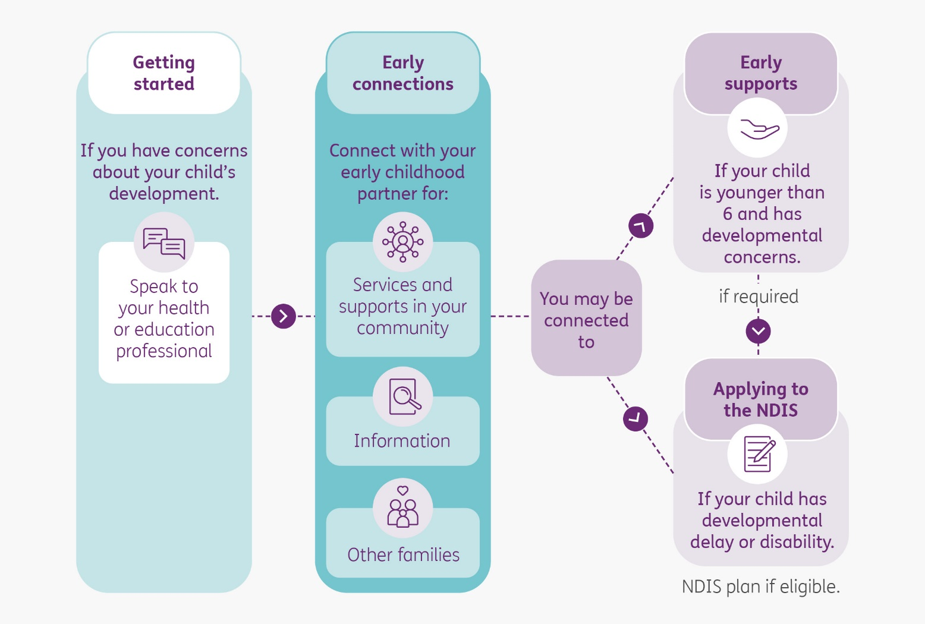
To learn more about being eligible for the NDIS go to our Applying to the NDIS guideline.
For more information | If you have any concerns about your child’s development, talking to a professional who knows your child best is a good place to start.  If you live in an area with no early childhood partner, you can contact the NDIS online at Contact Us or call 1800 800 110.
Your early childhood partner’s contact details | Click or tap here to enter text.

