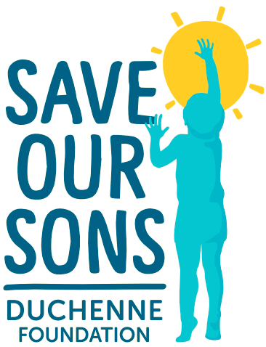
12 May 2021
NDIA Consultation -Interventions for Children on the Autism Spectrum
Save our Sons Duchenne Foundation (SOSDF) seeks to provide this brief note as part of the NDIA consultation on interventions for children on the autism spectrum.

SOSDF is the peak body for Duchenne and Becker muscular dystrophy in Australia and we are responsible for funding critical research, investment, hospital infrastructure and services for our community. We also provide important advocacy and representation to our community which is highly disempowered, disadvantaged and largely lacking voice in policy and decision-making circles.

The NDIS provides critical support to our community and has been instrumental in improving the quality of life for young boys/men and their families and carers.

A number of boys with Duchenne (DMD) and Becker (BMD) are also on the autism spectrum and there is clear evidence of an association between the two conditions. Unfortunately, the autism suffered by these boys is too often overshadowed in the NDIS planning process given the focus on the highly visible and complex physical aspects of DMD and BMD - and the progressive deterioration in muscle capacity which characterises this condition.

DMD/BMD and autism warrant dual diagnosis and NDIS interventions which comprehensively address both conditions and on an appropriate basis. Much of the feedback we get from our community suggests that this is currently not the case with the autism being largely overlooked by the physical concerns and needs of boys and young men with DMD/BMD. The behavioural issues subsequently often get “out of hand” and to the point where chemical restraints may be required.

SOSDF is therefore advocating a more wholistic approach to this “comorbidity” which delivers support and assistance in appropriate measure to both conditions. This will mean that additional funding will doubtless be required and more comprehensive NDIS plans, going to both conditions, developed in consultation with boys, their families, and carers.

Lance Dale
Advocacy Officer

