Compliance and Enforcement Framework

March 2020

Contents
Version Control 3
Glossary 3
1. Compliance and Enforcement 4
1.1 Purpose 4
1.2 Requirements 4
2. Compliance Approach 6
2.1 Compliance Principles 7
2.2 Compliance Priorities 7
3. Compliance Governance 8
3.1 Risk Management 8
3.2 Internal Relationships 9
3.3 External Relationships 9
4. Compliance Activities 11
4.1 Prevention Strategies 11
4.1.1 Education and Outreach 12
4.1.2 Industry Engagement 12
4.2 Detection Strategies 12
4.2.1 Tip-Offs 12
4.2.2 Data Matching and Analytics 13
4.2.3 Intelligence and Information Sharing 13
4.3 Compliance Monitoring 14
4.3.1 Proactive Compliance 14
4.3.2 Compliance Reviews 15
4.3.3 Investigations 16
4.4 Enforcement Strategies 16
4.4.1 Criminal Enforcement 17
4.4.2 Civil Actions 17
4.4.3 Administrative Actions 18
4.4.3.1 Debt Recovery 18
4.4.3.2 Consideration of Registration 19
5. Further Information 19

Version Control
Version | Date | Author | Description
0.1 | June 2019 | Scheme Integrity Branch | Development of document
1.0 | March 2020 | NDIA Executive Leadership Team  NDIA Board | Endorsement of document
1.1 | April 2020 | Scheme Integrity Branch | Accessibility updates

Glossary
Term | Definition
AAT | Administrative Appeals Tribunal
ACCC | Australian Competition and Consumer Commission
AFP | Australian Federal Police
ASAN | Australian Scams Awareness Network
AUSTRAC | Australian Transaction Reports and Analysis Centre
CDPP | Commonwealth Director of Public Prosecutions
Corporate Plan | NDIS Corporate Plan 2019-2023
DSS | Department of Social Services
The Framework | NDIA Compliance and Enforcement Framework
NDIA or Agency | National Disability Insurance Agency
NDIS Act 2013 | National Disability Insurance Scheme Act 2013
NDIS Commission | NDIS National Quality and Safeguards Commission
NDIS or Scheme | National Disability Insurance Scheme
NDIS Rules | Nation Disability Insurance Scheme Rules
PGPA | Public Governance, Performance and Accountability
The Taskforce | NDIS Fraud Taskforce

Compliance and Enforcement
The National Disability Insurance Agency (NDIA, or the Agency) aims to increase the ability of individuals with a significant and permanent disability to be more independent, and to engage more socially and economically, while delivering a financially sustainable National Disability Insurance Scheme (NDIS, or the Scheme) that inspires community and stakeholder confidence.
The Agency places people with disability at the centre of everything we do, while recognising and respecting the important role played by carers, providers and disability groups. In this context, the Agency has taken a participant-centric approach to delivering disability services, transitioning from a government-provider funding model to a model that provides participant choice and control over the supports and services that they receive.
The nature, environment and profile of the Scheme, including the vulnerable status of many participants, means there are a wide range of potential compliance and enforcement risks that may threaten the Scheme’s integrity. Incidents of non-compliance can reduce the amount, quality and safety of supports and services provided to participants; affect the health and wellbeing of participants; and undermine the socio-economic multipliers that effective disability support provides to the Australian community.

Purpose
The Compliance and Enforcement Framework (the Framework) outlines the principles adopted by the Agency toward compliance and enforcement, and the Agency’s compliance and enforcement objectives, activities and tools. The Framework aligns with the NDIS Corporate Plan 2019-23 and Fraud Strategy.
The Framework should assist providers to understand their duties, obligations and responsibilities, as well as the tools the Agency has to mitigate risk. This Framework should also assist participants, nominees and partners understand their obligations, as well as actions the Agency may consider in relation to compliance.

Requirements
The National Disability Insurance Scheme Act 2013 (NDIS Act) outlines the legislative requirements underpinning the Scheme, with some specific requirements also in a suite of National Disability Insurance Scheme Rules (NDIS Rules), Criminal Code Act 1995, Crimes Act 1914 and Anti-Money Laundering and Counter Terrorism Financing Act 2006.
An important overarching requirement, found in section 46 of the NDIS Act, is that NDIS amounts are spent in accordance with a participant’s plan. The NDIS Act provides the Agency powers to obtain information, recover debts and bring legal proceeding against person for non-compliance.
The NDIS Act also sets out the objects and principles of the Scheme. Key objects and guiding principles outlined in the NDIS Act include:
- Support the independence and social and economic participation of people with disability,
- Enable people with disability to exercise choice and control in the pursuit of their goals and the planning and delivery of their supports,
- People with disability should be supported to exercise choice, including in relation to taking reasonable risks, in the pursuit of their goals and the planning and delivery of their supports, and
- People with disability should have their privacy and dignity respected.
There is a community expectation that the NDIS Act is complied with and that providers, participants, nominees and partners are responsible for understanding and upholding the objects and principles of the NDIS Act. The Agency aims to make it easy for providers, participants, nominees and partners to comply with the objects and principles, see Section 5 titled Further Information of this Framework, for information on where to find resources and guidance on understanding and upholding the objects and principles of the NDIS Act.
This Framework is intended to provide an overview of compliance and enforcement options, as well as provide information on when the use of each option is appropriate. It does not reduce, extend or modify legislative obligations contained in the NDIS Act, NDIS Rules or elsewhere.

Compliance Approach
The Agency’s approach to compliance and enforcement is primarily based on the attitude, behaviours and actions demonstrated by providers, participants, nominees and partners in their engagement with the Scheme and the Agency.
The Agency understands that the majority of providers, participants, nominees and partners are willing and able to comply with the requirements of the Scheme. The Agency works with these groups to promote good compliance practices and intervene appropriately when non-compliance is identified. Figure 1 illustrates how the Agency aims to make it easy to comply by offering support, education and guidance to those who are willing to do the right thing. It also illustrates how the Agency makes it difficult to not comply by using higher intensity interventions for those who have made a decision to not comply. The Framework will explore in Section 4, titled Compliance Activities, the different activities the Agency may take to support compliance. See Section 5, titled Further Information, on resources and guidance to support voluntary compliance.
This approach to compliance allows the Agency to focus on those who require more specialised management, ensuring effective and efficient use of Agency resources:
Figure 1: the Agency’s Compliance Posture
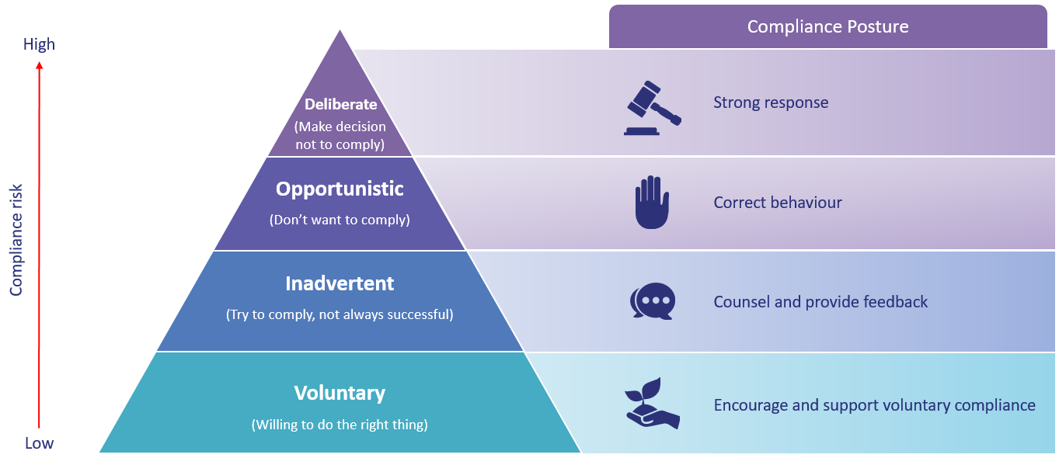
It should be noted that providers, participants, nominees and partners may demonstrate a range of compliance behaviours across different areas. For instance, a provider may demonstrate voluntary compliance with their requirements for claiming payments from a plan, but may be non-compliant with their requirements for protecting the privacy of participants.
In these circumstances, the Agency tailors the compliance approach to assist providers, participants, nominees and partners to maintain their voluntary compliance and also address any issues of non-compliance across the full scope of their activities.

Compliance Principles
In applying this approach to compliance and enforcement, the Agency is guided by the following principles:
- Participant focused: Compliance and enforcement activities are participant focused, with participant safety and access to the Scheme at the core of the Policy. Compliance and enforcement activities are undertaken to ensure that participants receive their full entitlements, including choice and control over planning activities.
- Risk-based: Compliance and enforcement activities are undertaken through a risk-based approach to ensure resources are effectively allocated towards addressing the most serious and systemic risks. The Agency will assess the seriousness, nature and circumstances of each matter and prioritise issues which pose the most serious risk to participants and/or the Scheme.
- Proportionate: Compliance and enforcement activities will be equivalent to the risk being managed. Agency decisions concerning compliance and enforcement will be determined by the Agency’s view of the alleged issue of non-compliance.
- Deterrence: Decisions regarding compliance and enforcement activities will consider the need to deter a recurrence of serious risks. Deterrence will be considered both for the matter, group or persons concerned as well as wider deterrence against organised exploitation of the Scheme.

Compliance Priorities
In taking actions to encourage, strengthen and enforce compliance with the Scheme and in alignment with the Agency’s compliance principles and legislative requirements, the Agency will always prioritise the following areas:
- Protect and promote the safety, wellbeing and welfare of participants, in accordance with the objects of the NDIS Act,
- Meet the Agency’s function of identifying and managing risks and issues relevant to the financial sustainability of the Scheme pursuant to s. 118(1)(b)(ii) of the NDIS Act,
- Comply with the Agency’s duties pursuant to the Public Governance, Performance and Accountability (PGPA) Act 2013, including the duty at section 16 to maintain systems for risk oversight, management and control,
- Protect personal information in accordance with the Privacy Act 1988 (including the Australian Privacy Principles), and comply with information handling provisions in the NDIS Act,
- Provide effective communication and outreach to providers, participants, nominees and partners on their compliance requirements and obligations, that are found within the NDIS Rules, and
- Have mechanisms to detect and investigate fraud, as required by the Public Governance, Performance and Accountability Rule 2014.

Compliance Governance
The Framework should be read in conjunction with the NDIS Corporate Plan 2019-2023 (the Corporate Plan) and the Agency’s Fraud Strategy. The Corporate Plan outlines the Agency’s vision, mission and aspirations, whereas the Fraud Strategy outlines the Agency’s approach to preventing, detecting and responding to fraud.

Risk Management
The Agency takes a risk-based approach to compliance and enforcement activities, which considers the risk posed to the safety and wellbeing of participants, and the context of the alleged non-compliance on a case by case basis.
The Agency continues to monitor all levels of risk, this risk-based approach aims to deliver better Scheme compliance while minimising the impact on providers, participants, nominees and partners. This approach seeks to address the more serious risks and systemic non-compliance through the effective allocation of resources, while avoiding unnecessary costs to the Agency, partners, participants and the Australian community.
The Agency’s risk-based approach is coupled with a three lines of defence model of compliance. In this model, the Scheme Integrity Branch works with the first line of defence teams, such as the Agency’s Service Delivery and Access and Planning teams, Local Area Coordinators, Partners in the Community and Provider Assurance teams, to operationalise the Agency’s risk management against non-compliance. These teams are responsible for the implementation of policies, processes, procedures and internal controls, and their ongoing improvement. The Scheme Integrity Branch, as part of the Agency’s assurance and compliance function, provides the second line of defence by undertaking a range of activities to prevent, respond and defend against risks. The third line of defence is constituted by both internal and external audit, which provides independent monitoring and review of the Agency’s risk governance, management and controls.

Internal Relationships
The Agency is responsible for receiving and assessing allegations of fraud against the Scheme, pursuing criminal action, undertaking compliance action in relation to misuse of Scheme funding, and holding national regulatory intelligence about providers.
The Agency has a range of capabilities to detect, prevent and respond to instances of non-compliance including fraud. The Agency conducts ongoing intelligence and monitoring activities, and is supported by a dedicated Scheme Integrity analytics team. These capabilities provide the Agency with the capability to conduct identity management activities; data matching; and application of analytics to proactively detect instances of non-compliance through targeted risk profiling techniques.
The Agency is also supported by the NDIS Fraud Taskforce (the Taskforce). The Taskforce is a partnership between the Agency, the Australian Federal Police (AFP) and Services Australia, which provides investigatory and intelligence support to the Agency. The NDIS Fraud Taskforce is constituted by more than 100 dedicated personnel, and is focused on preventing and disrupting large-scale fraud, by identifying persons of interest and conducting investigations

External Relationships
The Agency works closely with other Commonwealth agencies, including law enforcement agencies as needed. In some cases, the Agency works jointly with these entities, but in other instances the Agency may refer a matter to another entity. The Agency’s key relationships and their core responsibilities are outlined below.
National Disability Insurance Scheme Quality and Safeguards Commission (NDIS Commission): The NDIS Commission has a range of functions including provider compliance and enforcement and has monitoring and investigation powers conferred by the NDIS Act. The NDIS Commission is also responsible for investigating non-compliance with the NDIS Code of Conduct, Provider Registration and Practice Standards, and other quality and safeguard requirements where applicable. The Agency will refer matters and findings arising from compliance activities and detection and enforcement strategies that identify quality, safeguarding and/or registration suitability concerns to the Commission.
Australian Federal Police (AFP), State and Territory Law Enforcement: The Agency works with the AFP and State and Territory law enforcement agencies. The Agency’s investigative capability is enhanced through access to the expertise of AFP agents. The AFP is responsible for investigating referred cases involving criminal conduct, including fraud. They are also an integral part of the NDIS Fraud Taskforce.
The Australian Transaction Reports and Analysis Centre (AUSTRAC): The Agency has a working relationship with AUSTRAC. AUSTRAC is Australia’s financial intelligence unit with regulatory responsibility for anti-money laundering and counter-terrorist financing.
Australian Competition and Consumer Commission (ACCC): The Agency is a member of the ACCC’s Australian Scams Awareness Network (ASAN). The Agency attends network meetings and identifies and addresses Agency and Scheme related scams.
Department of Social Services (DSS): The Agency maintains a strong working relationship with DSS, as the policy and financial owner responsible for the Scheme.
Commonwealth Director of Public Prosecutions (CDPP): Regular meetings occur between the Agency’s fraud teams and the CDPP to support close alignment of investigation processes and the preparation of briefs of evidence.

Compliance Activities
As illustrated in Figure 2, the Agency undertakes a range of compliance activities and conducts targeted compliance actions to address emerging issues. These activities assist providers, participants, nominees and partners to understand their obligations and requirements.
Figure 2: the Agency’s Compliance Toolkit
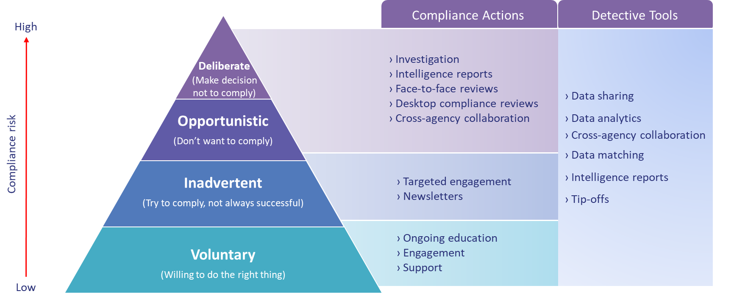
The Agency is committed to facilitating voluntary compliance, but balances this with the need to deter unlawful behaviour and correct non-compliance. This balance is necessary for a sustainable Scheme which ensures ongoing participant access to required supports.

Prevention Strategies
The Agency acknowledges that most providers, participants, nominees and partners are willing and able to comply with the requirements of the Scheme. For this reason, a key aspect of the Agency’s compliance activities is to support voluntary compliance through education and engagement, minimise the compliance burden where possible, and identify trends, risks and issues for the Scheme that can be effectively remediated.
The Agency will use different communication platforms and channels to promote voluntary compliance and provide guidance and support to those who are trying to meet their compliance responsibilities. Awareness raising in relation to fraud, including scams, using various platform and channels are also a key prevention strategy. The Agency will use the media to support deterrence efforts in publicising fraud prosecutions and sending a clear message that the NDIA has zero tolerance for fraud against the NDIS and its participants.

Education and Outreach
The Agency uses targeted education and outreach campaigns to provide information about responsibilities, compliance obligations and the Agency’s approach to compliance.
Education and communication will be targeted to the circumstances of providers, participants, nominees and partners to ensure they are aware of both their rights and responsibilities under the Scheme. The Agency considers prevention of a breach always preferable to taking action after a breach has occurred.

Industry Engagement
The Agency engages across the disability sector to promote awareness and understanding of the Agency’s compliance approach and compliance requirements under the Scheme. The Agency uses a range of channels to communicate with the disability sector, participants, providers, partners and the Australian community. These avenues include the NDIS website, newsletters, the provider and participant portals and social media channels.

Detection Strategies
The Agency uses a combination of proactive and reactive detection strategies to support its compliance program. Risk-based detection activities assist the Agency to target its resources and detect potential instances of non-compliance at the earliest point in time.
The Agency undertakes a program of detection activities, including data matching and analytics, fraud detection profiling, audits and tip-offs. This allows the Agency to monitor compliance, detect trends and identify risks.

Tip-Offs
The Agency maintains a number of avenues (including phone and email) for interested parties to make complaints or queries about potential compliance issues or emerging behaviours within the Scheme. The Agency receives tip-offs from a range of sources, including Agency staff, other agencies and decision makers.
All participants, providers, nominees, Agency staff, partners and members of the public can report suspected issues of non-compliance or fraud to the Agency. If something seems unusual or you suspect someone may be committing fraud against the Scheme, the Agency encourages you to contact us through the following channels:
Fraud Reporting Hotline
1800 650 717
Fraud Reporting Mailbox
fraudreporting@ndis.gov.au
All reports undergo an assessment to determine appropriate next steps. All information the Agency handles is managed confidentially by compliance officers in accordance with the Privacy Act 1988.

Data Matching and Analytics
The use of proactive data monitoring and analysis is one of the most effective controls for preventing fraud, and when applied can considerably reduce the financial impact of fraud on the Agency. For this reason, the Agency applies data driven controls to prevent and detect non-compliance and fraud.
The Agency conducts data matching activities with data sourced from commercial sources, other government agencies and data registries (such as State and Territory Registries of Births, Deaths and Marriages).
The Agency’s data matching activities are coupled with analytical capabilities and actuarial modelling, which allows the Agency to identify high-risk activities, non-compliant participant plan usage and other potential areas of risk.
Case Study | Data Matching
The Agency periodically undertakes a matching activity with the Death Register from Births, Deaths and Marriages. Where the death of a scheme participant is identified, a review of the participant’s record is undertaken. Any claims for payments made subsequent to the date of death are reviewed for compliance. Depending on the outcome of the review compliance action may be taken.

Intelligence and Information Sharing
The Agency undertakes ongoing monitoring activities to identify signals of potential non-compliance. The Agency proactively and reactively develops intelligence products to support its functions.
Case Study | Intelligence and Information Sharing
The Scheme Integrity Branch’s intelligence team uses information sourced from internal sources and external entities, including government agencies and financial institutions, to identify trends that may indicate non-compliance. This information is applied by the intelligence team to determine the scope of fraudulent behaviour, avenues for future enquiry by the Agency, and to detect individuals of interest.
The Agency has used this information to identify trends in bank account payments to follow the flow of funds between individuals to identify the suspected perpetrators of fraudulent activity. The Agency was able to identify sufficient details to initiate debt recovery actions.
The Agency has also used information to identify potentially fraudulent claims made by a provider, where the provider was also the nominee for a participant. It was identified that the funds were not spent in accordance with the plan. The culmination of this information resulted in the Service Delivery team, undertaking a plan review and changing the participant to an Agency managed plan, consequently mitigating the risk to the participant.

Compliance Monitoring

Proactive Compliance
The Agency conducts targeted activities to prevent any adverse impact to participant entitlements as a result of non-compliance or fraud. The Agency proactively contacts participants that may have been adversely affected by non-compliance or fraud to identify whether services were provided as claimed under the participants plan, the extent of the possible impact and advise participants of the matter as appropriate. Where services have not been provided, the participant’s funds may be reinstated to ensure their continued access to required supports.
Case Study | Proactive Compliance
The Agency’s identified that a provider had claimed cleaning services at an hourly rate for a period in excess of the actual hours spent providing the cleaning services.
The Agency established that the service had been provided for a three hour period, not the 24 hour period claimed by the provider. NDIA considered the provider’s actions and calculated the value of the debt. The Agency advised the participant of the on-going matter, that they may wish to seek services from an alternate provider and reinstated funds to the participant’s plan.
NDIA considered the severity of the provider’s actions, calculated the value of the debt, and raised the debt against the provider. The NDIA recorded the behaviour against the provider’s record and repeats behaviour will be used to inform discussions with the NDIS Commission about continued registration. The Agency considered the nature and timing of the claim and considered reinstating the funds to the participant’s plan.

Compliance Reviews
Different business areas of the Agency conduct compliance and business assurance programs across their areas of focus. The Scheme Integrity team undertakes targeted engagement and desktop and face-to-face reviews to address actual, potential and suspected instances of non-compliance. A risk-based approach is taken to determine the type and scope of the review, depending on the risk posed to participants and Scheme sustainability. The Agency’s reviews may focus on particular compliance requirements, particular standards, or particular aspects of the Scheme.
The Agency may contact providers, participants or nominees for their cooperation in the selected review process. The Agency’s review approach is graduated and proportionate to the level of the actual, potential or suspected instance of non-compliance.
A targeted engagement is the Agency’s first response when addressing inadvertent non-compliance. During a target engagement the Agency will contact, via email or telephone, participants, nominees or providers regarding an identified instance of non-compliance. The Agency may then provide targeted educational material to the provider, participant or nominee to clarify their responsibilities and obligations under the Scheme.
Desktop compliance reviews are used by the Agency to address opportunistic non-compliance, through information gathering and analysis. During desktop compliance reviews the Agency may use powers under sections 53 and 55 of the NDIS Act to obtain information from participants, nominees, providers or other relevant persons or entities. These powers enable the Agency to request information it reasonably believes that the person holds, which could include documentation such as invoices, quotes, case notes, appointment schedules and other paperwork. This is to understand the context of a potential non-compliance. The Agency may ask a provider, participant or nominee to provide this information through various methods, including uploading it to the myplace port or via email. If necessary, the Agency may ask for information more than once where additional information is required or becomes available.
In some instances, the Agency may undertake a face-to-face review. Pursuant to a notice provided under section 55 of the NDIS Act, the Agency may require a provider or other person to appear before a specified NDIA Officer at a specified time and place to answer questions. Prior to the issue of a notice under section 55 and any requirement to answer questions in person, the Agency may call, email or send letters to the relevant provider or other person to request information relevant to the review. A face-to-face review may require, and the section 55 notice will stipulate; an interview with the notice recipient; inspections of documentation that the Agency can request the notice recipient to bring to NDIA premises (s. 56(2)(b), 56(4)(a)); and/or additional document requests and collection.

Investigations
While the Agency intends to use education and support to ensure compliance, at times it is necessary to undertake investigations into possible non-compliance. An investigation may be conducted in response to compliance review outcomes, tip-offs, data matching, data analytics and other intelligence activities.
Where the Agency has identified that a matter should be investigated, the Agency will work with other agencies in undertaking compliance activities. This may involve an exchange of information, or more direct engagement in joint activities for example working with the AFP and Services Australia, as part of the NDIS Fraud Taskforce; and referral of provider compliance matters to the NDIS Commission.
Investigations may include the compilation and collection of statutory declarations, information requests, witness statements and evidence gathering.
Investigations undertaken by the Agency comply with requirements of the Commonwealth Fraud Control Framework, and the Australian Government Investigation Standards.

Enforcement Strategies
Where an instance of non-compliance has been identified, the Agency will apply an appropriate and proportionate enforcement response to remediate the non-compliance. In considering the appropriate action, the Agency may consider mitigating or aggravating circumstances, the steps taken to prevent future non-compliance, and the impact on participant safety, wellbeing or access to Scheme entitlements.
Figure 3: the Agency’s Enforcement Response
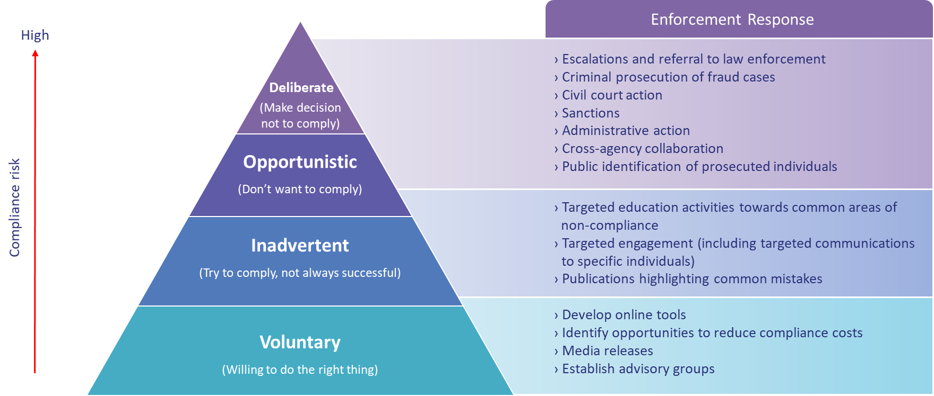

Criminal Enforcement
Criminal activity against the Agency or the Scheme may be referred to the Commonwealth Director of Public Prosecutions for prosecution. Criminal penalties are provided for in the NDIS Act. For example, section 57 of the NDIS Act, where it is an offence for a person to refuse or fail to comply with a section 55 request to give information or produce a document.
In addition to the criminal offences found in the NDIS Act, Part 7.3 of the Criminal Code Act 1995 outlines a number of offences relating to fraud against the Commonwealth. Other relevant offences which may be referred to the CDPP can be found in Chapter 7 of the Criminal Code Act 1995, the Crimes Act 1914 and the Anti-Money Laundering and Counter Terrorism Financing Act 2006.
Case Study | Criminal Enforcement
A number of calls were received by the NDIA in 2018 regarding payment concerns for a particular provider and were referred to the Agency’s fraud investigation team.
Initial investigation identified a provider (Langmann Care) had claimed funds from more than 20 participants, without any apparent services being provided. Within the first 90 days of the investigation, payments to the provider were blocked, affected participants were informed and funds were restored to the participant plans.
A more detailed investigation was undertaken with 230 witness statements taken across four states. In October 2018, Mohamed Omar was arrested, charged and bailed. In January 2019 Mr Omar pleaded guilty to all four criminal code indictments, and in July 2019 was sentenced to four years in jail.

Civil Actions
Civil penalties are provided for in the NDIS Act and do not result in criminal sanctions. Civil penalty provisions are prosecuted to a different standard of proof than Criminal matters. Civil penalty provisions reflect the need for economic deterrence to non-compliance in some circumstances. Enforcement of civil penalties and initiation of civil court proceedings can be commenced without referral to the CDPP.
Where a provider, participant or other relevant entity does not comply with Agency requests, they may be subject to a civil penalty. The Agency may commence civil proceedings, as provided by subsection 183(1) of the NDIS Act, to recover any debt owed to the Agency under the NDIS Act.

Administrative Actions
The Agency may pursue administrative actions to protect participant entitlements and Scheme access. Administrative actions open to the Agency include, suspension of plans under section 41 of the NDIS Act, cancellation or suspension of nominee appointments under sections 90 and 91 of the NDIS Act, and referral of the matter to the NDIS Commission for consideration of suitability for registration.
Administrative actions do not require the Agency to go to court. A provider, participant, nominee or partner who is subject to an administrative action may be able to appeal some decisions to the Administrative Appeals Tribunal (AAT).

Debt Recovery
Claims for payment that are not legitimate are able to be cancelled and rejected in the NDIS system. If a payment has already been made, section 182 of the NDIS Act specifies situations where a debt is owed to the Agency, for example:
- When a payment has been made to a person who is not entitled, to receive that payment (for example, where the payment has been made as a result of an administrative error, a false or misleading statement or a contravention of the NDIS Act or NDIS Rules); and
- When an NDIS amount has not been spent in accordance with a participant’s plan.
In addition to commencing civil proceedings, the Agency may take administrative steps to recover these debts. These include the Agency’s ability to, under section 185 of the NDIS Act, require financial institutions to return incorrectly paid NDIS amounts to the Agency. The Agency may also compel, under sections 186 and 187 of the NDIS Act, information from or about a person owing a debt to the Agency. Non-compliance with this this request is an offence under section 189 of the NDIS Act.

Consideration of Registration
Cases where the Agency has identified quality or safety concerns, or other matters affecting a provider’s suitability for registration, will be escalated to the NDIS Commission for their consideration (in all jurisdictions except Western Australia). The NDIS Commission’s Compliance and Enforcement Policy outlines the range of enforcement actions available to the NDIS Commission, including compliance notices, infringement notices, civil penalty proceedings, revocation of provider registration and banning orders.
Where serious non-compliance has been identified in Western Australia, the Agency will escalate the issue internally to consider provider suitability for registration, and whether a provider’s registration should be revoked under section 72 of the NDIS Act. The Agency may consult with relevant quality and safeguard authorities throughout this process to ensure we take the appropriate response to non-compliance.

Further Information
Operational Guidelines can be found on the NDIS website.
If you would like to report a suspected incident of fraud you can do so by emailing fraudreporting@ndis.gov.au, or telephoning the fraud reporting hotline on 1800 650 717.
For general information about the Agency and the Scheme, including supporting guidance, information, and information sessions, please visit NDIS.gov.au.

The NDIS Rules are legislative instruments made under the NDIS Act 2013 which set out detailed operational obligations and requirements for participants, providers and nominees. The NDIS Rules should be read in conjunction with the NDIS Act.
For example, sections 53 and 55 of the NDIS Act provide the NDIA power to obtain information from persons for specified purposes to ensure the integrity of the Scheme. Under Section 57 of the NDIS Act, failure to provide the information requested under section 55 of the NDIS Act could result in a criminal penalty. Section 186 of the NDIS Act provides the Agency power to obtain information from a person who owes a debt to the Agency.
For example, section 182(3) of the NDIS Act provides for debt recovery for debts arising where funds are not spent in accordance with the Participant’s Plan (non-compliance with section 46 of the NDIS Act). Section 184 of the NDIS Act allows for arrangements for payment of a debt.
For example, section 183 of the NDIS Act allows the Agency to bring legal proceedings to recover a debt.
s. 181E(d) NDIS Act
For further information, refer to NDIS (Provider Registration and Practice Standards) Rules 2018.
For further information, refer to NDIS (Code of Conduct) Rules 2018.
See for example, sections 57, 185 and 189 of the NDIS Act 2013.
From 1 December 2020, providers in all jurisdictions, including Western Australia, will be regulated by the NDIS Commission.

