NDIS myplace provider portal
Step-by-step guide
Part 3. Managing your correspondence

September 2020

Table of Contents
Changes from the last version 3
How to contact NDIS 4
Managing correspondence and messages 5
Inbox 5
Messages 6
Starting a new instant message 6
Continuing a previous conversation 7

Changes from the last version
The following updates have been made to the last published version of the myplace provider portal step-by-step guide:
- Minor changes to wording.

How to contact NDIS

Contact the NDIS by
NDIS Webchat  You can live chat with us about:  - myplace provider portal  - Service bookings  - Payment requests  - Quotes  - Referrals  - Request for service  - Searching for a register provider | Phone  1800 800 110  You can call us about:  - myplace provider portal  - Service bookings  - Payment requests  - Quotes  - Referrals  - Request for service  - Searching for a register provider  - Submitting a general enquiry, feedback, compliment or a complaint | provider portal  You can use the provider portal to:  - Submit a payment enquiry  - Submit a general enquiry, feedback, compliment or a complaint  - Search for a provider  - Upload documents
Email us  enquiries@ndis.gov.au  You can email us about :  - Submitting a general enquiry, feedback, compliment or a complaint  - Emailing a document, form report or letter | Contact and Feedback form  NDIS Online Form  You can use the Online form to:  - Submit a general enquiry, feedback, compliment or a complaint  - Request a call back | Mailing address  National Disability  Insurance Agency  GPO Box 700  Canberra ACT 2601  You can mail us:  - Compliment, complaint or provide feedback,  - Document, form, report or letter

Managing correspondence and messages

Inbox
All messages and letters sent to your organisation will appear in the Inbox. When you open the Inbox, you will see all messages, not just those relating to you or your participants. The number next to messages is the number of new (unread) messages received.
- Select the Inbox tile on the myplace home page.
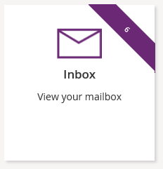
- Your Inbox displays messages and letters received from NDIA.
Note: See Part 2 – Maintaining your information - How Frequently Can NDIA Contact Me? to choose how often you wish to be notified.
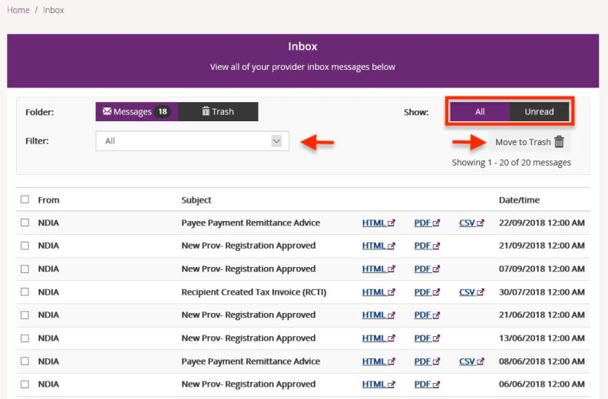
- Select Unread to show only messages that have not been opened.
- You can limit the list of messages to a particular type. Select the message type from the Filter drop-down.
- When you have processed a message, you can delete it by moving it to Trash. Select the check box to the left of the messages you wish to delete, select the Move to Trash link to delete all the selected messages.
- Select the blue file type link to open the message. The message will open in a separate window to enable you to continue processing in the portal while the message is open.
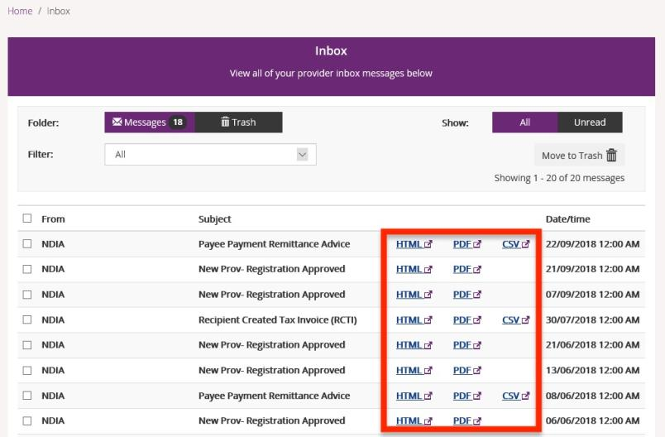

Messages
You can have online conversations with your participants through the instant messaging function.

Starting a new instant message
- Select the Messages tile on the myplace home page.
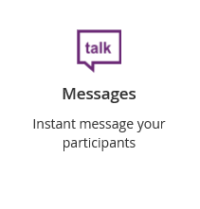
- Enter the participant’s NDIS Number and Last Name then select Search.
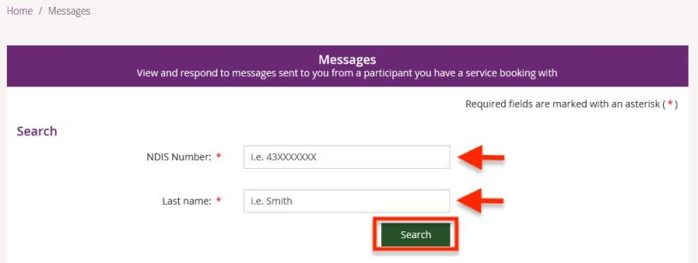
The Your Conversation window displays.
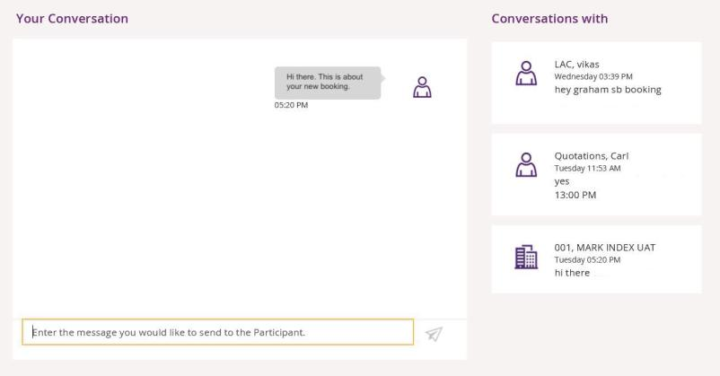

- Type your message in the message field which (highlighted by a yellow rectangular box).
- Select the paper aeroplane icon on the right hand side of the message field to send.

Continuing a previous conversation
You can carry on past conversations by searching for the participant or finding the participant under the Conversations with panel.
- To search for the participant, refer to starting a new instant message in Step 2 above.
- If the participant is shown in the Conversations with panel on the right-hand side of the window, simply click on the participant and your conversation will be displayed.

