Nunphung le Holh lei Idannak

Kan Tuahsernak lei Timhtuahmi

2024–2028
Hakha Chin | Laiholh
Rel Fawi phun
Fawi tein relmi

Hi Tuahsernak lei Timhtuahmi hman ning
Kanmah | Rampumpi Pumtlinlonak Aamahkhan Riantuanpiaknak (NDIA) nih hi Tuahsernak lei Timhtuahmi cu a tial.  ‘Kanmah’ timi biafang na hmuh tikah, hi a sullam cu NDIA tinak a si.
Hi Tuahsernak lei Timhtuahmi cu rel fawi ding phun in kan tial.
Cheukhat ruahnak pawl fianter dingah hmaanthlak pawl kan hman.
Anak  A nak lomi | A biapimi biafang pawl kha anak (bold) in kan  rak tial.  Hihi a sullam cu cafang pawl kha a chah deuhmi le anak deuhmi an si.
Biafang  cazin | Hi biafang pawl a sullam kha kan fianter.  Cahmai 47 ah hi biafang pawl langhtermi a um.
 | Hihi cu Nunphung le Holh lei Idannak Tuahto ning Tuahsernak lei Timhtuahmi 2024-2028 i Rel Fawi phun pakhat a si.
Kan website ah Nunphung le Holh lei Idannak Tuahto ning Tuahsernak lei Timhtuahmi 2024-2028 kha na hmuh khawh lai.
www.ndis.gov.au/CALD
Hi Tuahsernak lei Timhtuahmi rel dingah bawmh na hal khawh.
Hawikom, innchungkhar chungtel asilole bawmtu minung nih an in bawmh khawh men.
 | Hihi cu a saumi catialmi pakhat a si.
Voi voikhat ah adihlak in rel dih na hau lo.
Caan na la kho
 | Aboriginal le Torres Strait Tikulh a ummi minung pawl cu kan ram Australia i a ngeitu pawl bantukin kan cohlan hna.
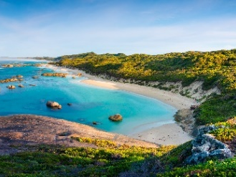 | Anmah cu mi hmaisa a um i hihi a hmangmi an si:  - vawlei pawl  - ti pawl.

Hi Tuahsernak lei Timhtuahmi ah zeidah a um?
CALD a sullam cu zeidah a si? 5
Kan Tuahsernak lei Timhtuahmi kong 7
1. Rian kan tuan tikah CALD aa telmi pawl cungah i papeknak 8
2. Kan riantuantu pawl nih a dikmi thiamnak pawl an
ngeihmi fehternak 16
3. Thawngthanhmi kan phawtzamh ning 23
4. Thimnak le uknak 31
5. CALD aa telmi pawl kong data 37
6. Mibu he kan pehtlaih ning 40
Thawngthanhmi tamdeuh 45
Biafang langhtermi cazin 47

CALD a sullam cu zeidah a si?
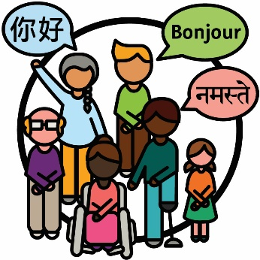 | Nunphung lei le holh lei in i dannak (CALD) minung pawl cu:  - aa dangmi sining dirhmun pawl sin in a rami  - Mirangholh nak in holh dang a hmangmi.
 | Australia ah:
 | - ramdang ah hrin a simi hi million 8 dengmang an um
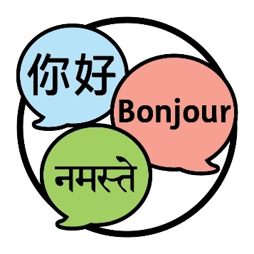 | - holh dang pawl 300 nak tamdeuh  an hman.

 | Thil pakhat khat bantukin fianternak na tuah ahcun, minung phu pakhat ah aa telmi na si kha na chim.
 | Australia i a ummi minung i 30% nih CALD minung bantukin an sining an langhter.
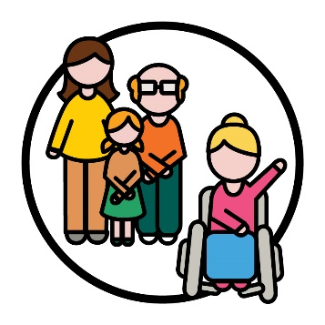 | Rampumpi Pumtlinlonak Aamahkhan Timhlamhnak (NDIS) i aa telmi 10% nih CALD minung bantukin an sining an langhter.
 | Aa telmi pawl cu NDIS ah aa telmi pumtlinglo minung pawl kha an si.

Kan Tuahsernak lei Timhtuahmi kong
Tuahto ning | Nunphung le Holh lei Idannak Tuahto ning  2024-2028 a thar kan tial.  Hihi Tuahtoning tiah kan auh.  Tuahto ning cu CALD aa telmi pawl caah NDIS tha deuh in kan tuah dingmi caah timhtuahmi a si.
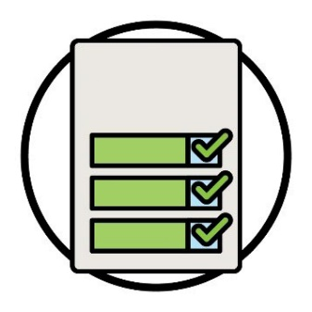  Tuahsernak  lei  Timhtuahmi | Hi Tuahsernak lei Timhtuahmi nih Tuahto ning zeitindah kan bawmh lai timi kha a fianter.
Aphichuak pawl  Tuahsernak  pawl | Hi nih a fiantermi cu:  - kan tuah dingmi tuahsernak pawl  - kan duhmi aphichuak pawl.  Aphichuak pawl cu kan riantuanmi nih minung nunnak pawl a thlen ning kha an si.
 | NDIS he aa telmi pawl nih hmuhtonnak an ngeihmi a thanchotermi a thadeuhmi aphichuak pawl ngeih kha kan duh.
 | Hi Tuahsernak lei Timhtuahmi nih tuahsernak nih rian a tuan le tuanlo kan theihter hna ning kha a fianter fawn lai.

1. Rian kan tuan tikah CALD aa telmi pawl cungah i papeknak

Tuahsernak 1
NDIA chung i cheukhat a biapimi biafang pawl a sullam kha aho paoh hngalhter dingah ah mibu chung i a dang pawl he rian kan tuanti lai.
Kan tuah hrimhrim ding mi cu hi biafang pawl cu nunphung pawl dihlak caah a himmi an si kha.
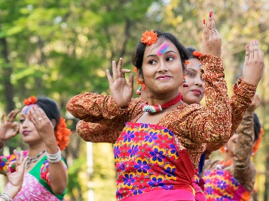 | Na nunphung cu:  - na nunning  - nangmah caah a biapimi a si.
 | Nunphung lei himnak timi biafang pawl a sullam kha aho paoh nih an hngalhnak dingah kan tuah hrimhrim lai.
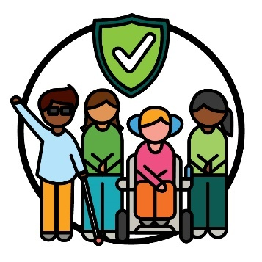 | Nunphung lei himnak cu:  - minung nunphung kan upat piak hna  - a himmi in i ruah dingah kan tuah piak hna  - anmah ta ah i ruah dingin kan bawmh hna.
Nunphung lei ah aa tlakmi le lehnak lei riantuanpiaknak timi biafang pawl a sullam kha aho paoh nih an hngalhnak dingah kan tuah hrimhrim fawn lai.
Nunphung lei ah aa tlakmi le lehnak lei riantuanpiaknak cu riantuanpiaknak pawl nih minung pawl i an hmanmi nunphung pawl le zumhnak pawl upat piak khi a si.
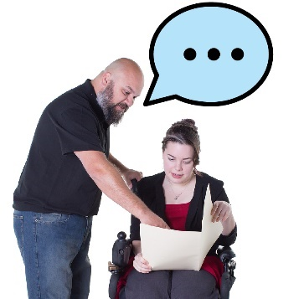 | Hi biafang pawl cu ningcang tein kan hman hrimhrim lai:  - thawngthanhmi kan phawtzamh tikah  - aa telmi pawl kan bawmh hna ning ah.
Hi biafang pawl a sullam kha kan riantuantu pawl le NDIS riantuanti pawl an i fiannak ding ah kan tuah hrimhrim fawn lai.
NDIS riantuanti pawl cu riantuanpiaknak hmuh le hman dingah midang pawl a bawmmi an si.
Hi Tuahsernak lei Timhtuahmi ah, kan riantuanti pawl kha kan auh hna.
Nunphung dihlak caah a himmi biafang pawl telh dingah thawngthanhmi le riantuanpiaknak pawl kan tharchuah lai.
Hi tuahsernak san a tlaih le tlaihlo kha kan chek lai, kan tharchuahmi zuldawi pengnak hmangin.

Tuahsernak 2
Lamhmuhsaknak pawl | NDIS a riantuan ning kong ah kan lamhmuhsaknak pawl cu kan tharchuah lai.  Thawngthanhnak ah kan telh dingmi pawl cu:  - nunphung dihlak caah a himmi  - aa telmi pawl nih an i fian dingmi biafang pawl hman  - i tel ciomi si.
Pakhat khat cu i tel ciomi a si tikah, aho paoh:
- an i tel kho
- anmah ta bantukin an i ruah.
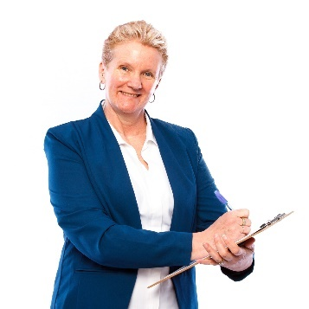 | Hi tuahsernak san a tlaih le tlaihlo kha kan chek lai, hi pawl a zuldawi peng maw timi hmangin:  - kan tharchuahmi lamhmuhsaknak cu zeidah a si  - CALD aa telmi pawl herhmi a bawmmi lamhmuhsaknak pawl.

Tuahsernak 3
CALD aa telmi pawl herhmi tha deuh in i fian dingah NDIA timhtuahtu pawl kan bawmh hna lai.
NDIA suaisamhtu cu minung pakhat khat:
- timhtuahmi thar a tuahtu
- timhtuahmi pawl a thlengtu.
Hi ah hin holh kha dawnkhaantu pakhat bantuk a si tikah CALD aa telmi pawl ningcang kong ah thawngthanhmi aa tel.
Dawnkhaantu cu thil pakhat khat tuahnak in an ngoltertu pakhat khat a si:
- tuah na herhmi
- tuah na duhmi.

 | Holh dang pawl in thawngthanhmi hmuh le hman ning kha timhtuahtu pawl kan theihter hrimhrim hna lai.
 | Hi tuahsernak san a tlaih le tlaihlo kha kan chek lai, CALD aa telmi pawl zeizat nih dah hihi zuldawi in an um:
 | - holh dang pawl NDIS thawngthanhmi an hman
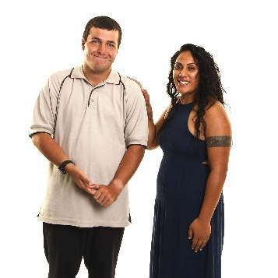 | - an herhmi bawmhnak an ngah
 | - anmah ca timhtuahtu he a thami hmuntonnak an ngeihmi an phawtzamh.

Tuahsernak 4
Australia caah mithar pawl bawmh ningcang kong ah kan riantuantu pawl le riantuanti pawl kha thawngthanhmi kha kan phawtzamh lai.
Hi ah hin ralzaam pawl caah a himmi bawmhnak aa tel.
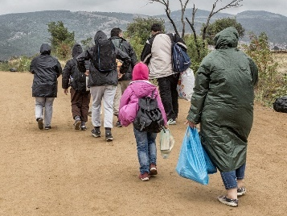 | Ralzaam cu a ram chuahtaak a herhmi minung pakhat a si:  - puarhrang ruang ah – minung pakhat khat nih fahnak an pek tikah  - cu ticun him tein an um kho lai.
 | Hi thawngthanhmi cu kan riantuantu pawl le riantuanti pawl nih tamdeuh an hmuh le hman khawh ding ah kan tuah hrimhrim lai.
Hi tuahsernak san a tlaih le tlaihlo kha kan chek lai, ralzaam le Australia caah mithar zeizat nih dah:
- NDIS ah an i tel
- NDIS an hman.

Tuahsernak 5
 | NDIS ah i tel dingin minung pawl tha deuh in bawmh dingah adang acozah buu pawl he rian kan tuanti lai.
Hi ah aa telmi cu:
- ralzaam pawl
- Australia ah mithar pawl.
NDIS ah i tel dingin Australia caah mithar pawl fawi deuh in tuahpiaknak kongkau ah thawngthanhmi cu kan hman lai.
Hi ah hin an tuah cangmi zohfelnak aa tel.
Zohfelnak | Zohfelnak pawl cu rian kan tuan ning pawl an si:  - na pumtlinlonak nih na nunnak a hnorsuan ning  - NDIS sin in na herhmi bawmhnak pawl.
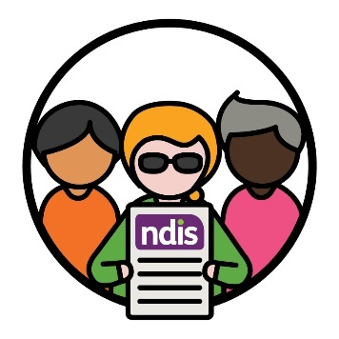 | Hi tuahsernak san a tlaih le tlaihlo kha kan chek lai, NDIS ah i tel dingin ralzaam le Australia caah mi thar pawl zeizat dah an i tel timi hmangin.

Tuahsernak 6
NDIS Komisin | Kan riantuan dingmi caah phungphai a thar ser dingah NDIS Chiatthatnak le Himnak lei zohfelnak Komisin he rian kan tuanti lai.  NDIS Komisin tiah kan auh hna.
NDIS Komisin nih NDIS ah aa telmi pumtlinglo minung pawl kha a fehter hna:
- a himmi
- a thami riantuanpiak an ngah.
Hi phungphai pawl nih CALD pumtlinglo pawl kha a bawmh hna lai:
- kanmah he an ruahnak pawl chimphuan
- NDIA a tuahmi biakhiahnak pawl biahal.
 | An ruahnak pawl chimphuan dingin CALD pumtlinglo pawl bawmh dingah a thabikmi lam in rian kan tuan lai.
Hi tuahsernak san a tlaih le tlaihlo kha kan chek
lai, CALD pumtlinglo minung zeizat nih dah an hmuhtonmi kha kanmah sin ah an chimphuan
timi hmang in.

2. Kan riantuantu pawl nih a dikmi thiamnak pawl an ngeih fehternak

Tuahsernak 7
Kan riantuantu pawl le riantuanti pawl caah cawnpiaknak prokarem a thar kan tuah lai.
Hi prokarem tuah dingah mibu le acozah buu pawl he rian kan tuanti lai.
CALD minung pawl he a himmi lam in pehtlaih ning hngalhnak ah hi cawnpiaknak nih kan riantuantu pawl le riantuanti pawl kha a bawmh hna lai.
Hi tuahsernak san a tlaih le tlaihlo kha kan chek lai, zeizat dah kan ruantuantu le riantuanti pawl nih:
- cawnpiaknak an lim
- nunphung dihlak caah a himmi lam pawl in minung bawmh ning an i fian.
Hi tuahsernak san a tlaih le tlaihlo kha kan chek lai, kan riantuantu pawl le riantuanti pawl he a thadeuhmi hmuhtonnak pawl an ngeih kha CALD aa telmi nih an kan chimhmi hmangin.

Tuahsernak 8
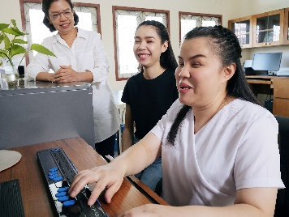 | Kanmah caah rian a tuan dingmi CALD minung tamdeuh kan bawmh hna lai.  Hi ah hin CALD pumtlinglo pawl an i tel.
Timhtuahmi | CALD riantuantu tamdeuh rian kan pek dingmi phawtzamh dingah timhtuahmi kan ngei fawn lai.
Hi tuahsernak san a tlaih le tlaihlo kha kan chek lai, NDIA riantuantu zeizat nih dah:
- pumtlinlonak an ngeih
- CALD dirhmun pawl in a rami an si.

Tuahsernak 9
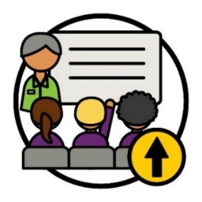 | Kan riantuantu pawl le riantuanti pawl sinah cawnpiaknak prokarem tamdeuh pek dingah midang pawl he rian kan tuanti lai.
 | Hihi tuah dingah mibu le acozah buu pawl he rian kan tuanti lai.
 | Bawmhnak pawl pek ningcang kan riantuantu pawl le riantuanti pawl nih an hngalhnak dingah hi cawnpiaknak nih bawmh dingin kan tuah hrimhrim lai:
 | - nunphung dihlak caah a himmi
 | - thinlung fahnak a tongmi minung pawl bawmh.
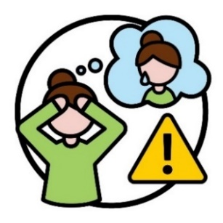 | Thinlung fahnak cu nangmah cungah thil thalo pakhat khat a cangmi kong ah na ruah ning a si.  Tahchunnak ah, a tihmi asilole lungretheimi bantukin na um men lai.  Thinlung fahnak nih lam dang in minung kha a hnorsuan khawh.
 | Hi tuahsernak san a tlaih le tlaihlo kha kan chek lai, zeizat:
 | - riantuantu pawl le riantuanti pawl nih hi cawnpiaknak an lim
 | - CALD aa telmi pawl nih kan riantuantu pawl le riantuanti pawl he a thami hmuhtonnak pawl an chimphuan lai.

Tuahsernak 10
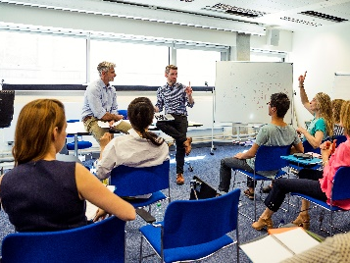 | Holhnak lei bawmhnak pawl hman ning kong ah kan riantuantu pawl le riantuanti pawl kha kan cawnpiak hna lai.  Hi ah hin holhlettu pawl an i tel.
Holhlettu cu minung pakhat khat:
- nanmah holh a hmangmi
- midang pawl he biakchawnhnak ah nangmah an bawmmi
- minung pakhat khat nih a chimmi naa fiannak dingah an bawmmi.

Hi nih hin kan riantuantu pawl le riantuanti pawl a bawmh hrimhrim hna lai:
- holh lei bawmhnak pawl kawl ning le hman ning hngalh
- holhlettu pawl he tha deuh in biakchawnh.
Hi tuahsernak san a tlaih le tlaihlo kha kan chek lai, zulhdawinak pekmi hmangin, zeizat:
- riantuantu pawl le riantuanti pawl nih hi cawnpiaknak an lim
- CALD aa telmi pawl nih holhlettu riantuannak pawl an hman.

Tuahsernak 11
 | NDIA nih rian a tuannak ding hmun pakhat ser dingah timhtuahmi kan ngei lai:
 | - nunphung dihlak caah a himmi
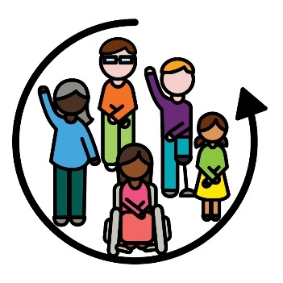 | - i tel ciomi.
Hi tuahsernak san a tlaih le tlaihlo kha kan chek lai, CALD minung zeizat nih dah:
- kanmah caah rian an tuan peng
- an pawcawmnak rian thanchoter khawh.
 | Pawcawmnak rian cu naa thimmi rian zaw ah na kalmi lam pakhat a si.

Tuahsernak 12
Adang riantuantu pawl he an thiamnak pawl chimphuan dingah kan riantuantu pawl le riantuanti pawl caah phu pakhat kan ser lai.
Tahchunnak ah, Auslan tibantuk thiamnak pawl.
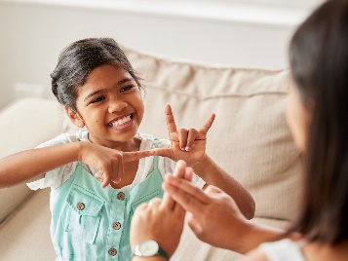 | Hihi a sullam cu hnachet asilole khuatheihnak aa harhmi minung pawl kha tha deuh in kan bawmh khawh hna lai tinak a si.
 | Hi tuahsernak san a tlaih le tlaihlo kha kan chek lai, hnachet asilole khuatheihnak aa harhmi minung pawl kha kan riantuantu pawl le riantuanti pawl zeizat nih dah a thadeuh in an bawmh hna timi hmangin.
 | Hi tuahsernak san a tlaih le tlaihlo kha kan chek lai, hnachet asilole khuatheihnak aa harhmi minung pawl nih an chimmi ngaihnak hmangin:
 | - zeitluk tha in dah kan bawmh hna
 | - NDIS bawmhnak pawl kawl ding le hman dingah zeitluk fawi dah a si.

3. Thawngthanhmi kan phawtzamh ning

Tuahsernak 13
 | Lamhmuhsaknak a thar kan tuah lai:
- CALD pumtlinglo pawl le a thabikin
pehtlaih ning
 | - lamdang in thawngthanhmi phawtzamh ning.
 | Hi lamhmuhsaknak pawl tuah dingah, hi pawl he rian kan tuanti lai:
NDIS Komisin | - NDIS Komisin
 | - CALD pumtlinglo minung pawl a bawmmi buu pawl.

 | Hi lamhmuhsaknak pawl nih hi pawl he a tha deuhmi biakchawnh dingah kan hman lai, CALD:
 | - aa telmi pawl
 | - mibu pawl.
 | Hi tuahsernak san a tlaih le tlaihlo kha kan chek lai, hi pawl an biangaihnak in:
 | - CALD aa telmi pawl
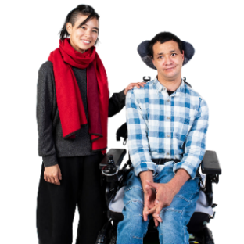 | - CALD pumtlinglo a bawmmi minung
 | - bawmchantu pawl.
 | Bawmchantu pawl nih riantuanpiaknak peknak hmangin pumtlinglo minung kha an bawmh hna.

Tuahsernak 14
Kan online riantuanpiaknak pawl hman dingah CALD mibu pawl caah fawi deuh in kan tuah lai.
Tahchunnak ah, NDIS website.
 | Hihi kan tuah lai, hihi hmangin:
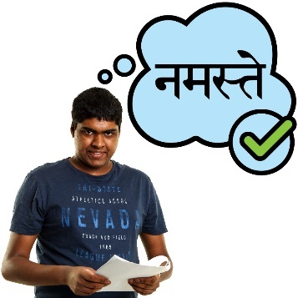 | - CALD minung pawl nih an i fian khawhmi holh pawl in thawngthanhmi chimphuannak
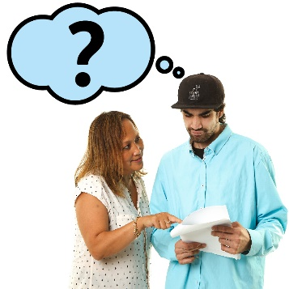 | - an theih lomi holh in thawngthanhnak kan chimphuan tikah CALD minung pawl bawmhnak.
 | Hi tuahsernak san a tlaih le tlaihlo kha kan chek lai, CALD zeitluk minung tamdeuh nih kan online riantuanpiaknak an hman timi hmangin.

Tuahsernak 15
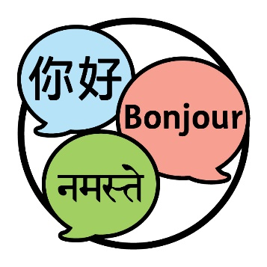 | NDIS kong phawtzamh kan herhmi holh pawl in lamhmuhsaknak pawl kan tuah lai.  Hihi a sullam cu CALD minung tamdeuh nih NDIS kong an i fiang kho tinak a si.
 | Hi lamhmuhsaknak pawl tuah dingah, hi pawl he rian kan tuanti lai:
 | - CALD mibu pawl
NDIS Komisin | - NDIS Komisin
 | - CALD pumtlinglo minung pawl a bawmmi buu pawl.

 | Hi tuahsernak san a tlaih le tlaihlo kha kan chek lai, zeizat:
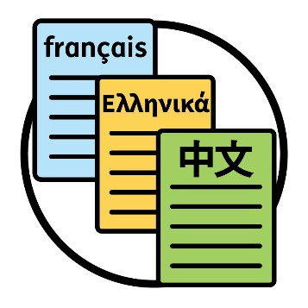 | - Mirangholh in a si lomi kan phawtzamhmi catialmi pawl
 | - NDIS kong ah anmah holh in thawngthanhmi an hmuh khawhnak kha CALD minung pawl nih an kan chimh.

Tuahsernak 16
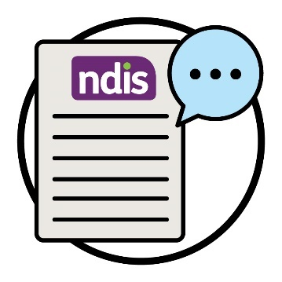 | NDIS fianter dingah kan hmanmi biafang pawl cheukhat an um.  Hi biafang pawl nih a sawh duhmi pawl fianter dingah aa dangmi holh pawl nih hmuh khawhnak kan tuah lai.
 | Hi nih hin NDIS kong i thawngthanhmi kha minung tamdeuh nih i fiannak kha a bawmh lai.
 | CALD aa telmi pawl he NDIS kong chimphuan dingah holhlettu pawl zong a bawmh hna lai.
 | Hi tuahsernak san a tlaih le tlaihlo kha kan chek lai, holhlettu zeizat nih dah hihi a tuah timi hmangin:
 | - NDIS tha deuh in ifian dingah cawnpiaknak an lim
 | - kan bawmhnak thilri pawl an hman.

Tuahsernak 17
Holhlettu riantuanpiaknak kha zeitluk in dah an hmuh i an hman timi kong kha CALD minung pawl he thawngthanhmi kan phawtzamh lai.

Hi ah aa telmi cu CALD:
- mibu pawl
- aa telmi pawl
- bawmchantu pawl.
Hi tuahsernak san a tlaih le tlaihlo kha kan chek lai, holhlettu pawl riantuanpiaknak kha zeitluk dah an hman timi hmangin.
Hi ah aa telmi cu:
- CALD aa telmi pawl
- kan riantuantu pawl le riantuanti pawl
- bawmchantu pawl.
Hi riantuanpiaknak pawl he an hmuhtonmi kong ah a kan chimhmi zong kan ngai lai.

Tuahsernak 18
CALD aa telmi pawl he meting pawl tuahnak ding kongkau i kan i timhtuah ning kha kan tharchuah lai.
Hi ah aa telmi cu:
- CALD aa telmi pawl caah holhlettu hmannak
- a sau deuhmi meting pawl tuahnak.
Hi meting pawl kan i timhtuahmi ning kha riantuantu pawl le riantuanti pawl dihlak nih an i fian ding kha kan tuah hrimhrim lai.
Hi tuahsernak san a tlaih le tlaihlo kha kan chek lai, zeizat:
- CALD aa telmi pawl bawmh dingah meting pawl ah holhlettu pawl hman an si
- CALD aa telmi pawl nih an meting pawl ah holhlettu pawl he a thadeuhmi hmuhtonnak
an ngeihmi kong kha a kan chimh.

4. Thimnak le uknak

Tuahsernak 19
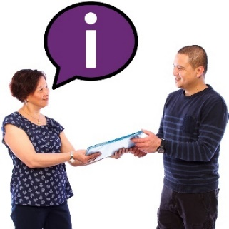 | Bawmchantu pawl he thawngthanhmi phawtzamh dingah NDIS he rian kan tuanti lai.  Hi ah hin nunphung dihlak caah an riantuanpiaknak pawl cu a himmi a sinak feh ter dingah bawmchantu nih tuah a herhmi kong thawngthanhnak aa tel.
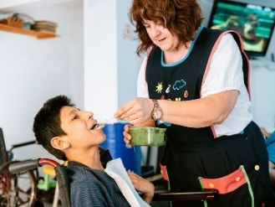 | Hi nih hin CALD aa telmi pawl nih an herh ning in bawmh ning aa fiangmi bawmchantu tamdeuh a chuahter lai.
 | Hi tuahsernak san a tlaih le tlaihlo kha kan chek lai, thawngthanhmi kongah riantuanpiaknak lei bawmchantu pawl nih an chimmi ngaihnak hmangin.
 | Tahchunnak ah, thawngthanhmi nih zeitluk tha in dah hihi caah a bawmhnak timi kong an chim lai:
 | - CALP minung herhmi a bawmmi bawmhnak pawl tha deuh in i fian
 | - nunphung dihlak caah a himmi riantuanpiaknak pawl pek.

Tuahsernak 20
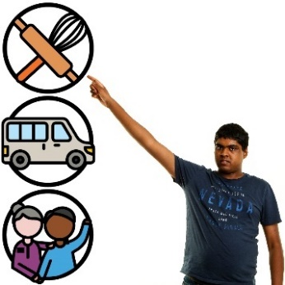 | Thimnak le thingnak tamdeuh ngeih dingah CALD aa telmi pawl bawmh dingah NDIS Komisin he rian kan tuanti lai.
 | Hi ah hin CALD aa telmi pawl he thawngthanhmi phawtzamhnak aa tel, hihi an tuah khawh:
 | - anmah bawmtu pawl thim
 | - anmah bawmtu pawl thlen
Phunzainak | - Phunzainak tuah.
Phunzainak na tuah tikah, minung pakhat khat kha na chimh lai:
- pakhat khat tlamtlinlonak
- pakhat khat tha tein rian a tuanlonak.
Hi tuahsernak san a tlaih le tlaihlo kha kan chek lai, CALD aa telmi pawl zeizat hrawng nih dah hihi an i fian:
- anmah caah a tha dingmi bawmchantu hngalh ning
- phunzainak tuah ning
- thimnak le thingnak ah an covo pawl.
Covo  pawl | Covo pawl nih minung hna nih zeitindah an in chawnhbiak ding a si mi kong phungphai an si:  - aa ruang in  - aa tluk in.

Tuahsernak 21
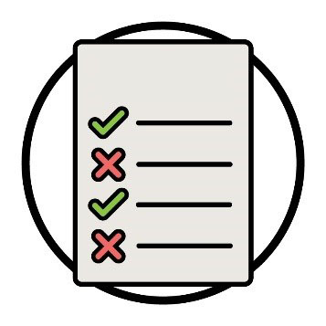  Phungphai pawl | Bawmchantu pawl nih a zulh hrimhrim dingmi phungphai a thar pawl ser dingah NDIS Komisin he rian kan tuanti lai.

Hi phungphai pawl nih bawmchantu pawl i riantuanpiaknak pawl a pek hrimhrim dingmi cungah aa hmaithlak lai:
- hman dingah nunphung dihlak caah a himmi
- thinlung fahnak a rak tongmi CALD aa telmi pawl bawmh.
Hi phungphai pawl kan ser tikah, bawmchantu pawl le CALD aa telmi pawl he kan phawtzamh lai.
Bawmchantu pawl le CALD aa telmi pawl nih zeitluk tha in dah phungphai pawl rian an tuan timi kong an chimmi kan ngaih lai.
Hi tuahsernak san a tlaih le tlaihlo kha kan chek lai, hi phungphai pawl a zulmi riantuanpiaknak pawl bawmchantu zeizat nih dah an pek timi hmangin.

Tuahsernak 22
CALD Pumtlinglo pawl a bawmmi cheukhat buu pawl nih an tonmi dawnkhaantu pawl kan zoh lai.
Hi dawnkhaantu pawl hloh dingah adang acozah buu pawl he rian kan tuanti lai.
NDIS riantuanpiaknak tamdeuh a pe khomi CALD pumtlinglo a bawmmi buu pawl kan siter hrimhrim lai.
Hi tuahsernak san a tlaih le tlaihlo kha kan chek lai, buu zeizat nih dah dawnkhaantu tlawmte an hmuhton timi hmangin.

Tuahsernak 23
 | Holhlettu pawl tamdeuh nih hi kong tamdeuh an i fiannak dingah adang acozah buu pawl he rian kan tuanti lai:
 | - NDIS
Covo  pawl | - pumtlinglo pawl i covo pawl.
 | CALD aa telmi pawl a bawm khomi holhlettu tamdeuh an um ding kha kan fehter lai.
 | Holhlettu pawl a bawm dingmi prokarem zeizat dah an um zong kan chek fawn lai.
 | Hi tuahsernak san a tlaih le tlaihlo kha kan chek lai, NDIS he CALD aa telmi pawl bawmh dingah holhlettu ngah khawh a simi pawl hmangin.

5. CALD aa telmi pawl kong data

Tuahsernak 24
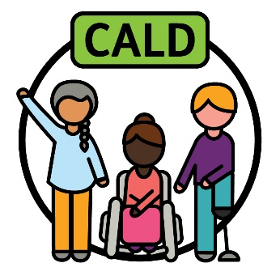 | ‘CALD’ nih a sawh duhmi kan fianter ning ah a lungtlingmi midang pawl he rian kan tuanti lai.
 | Rian kan tuanti lai, anmah he hin:
 | - CALD mibu pawl
 | - adang acozah buu pawl.
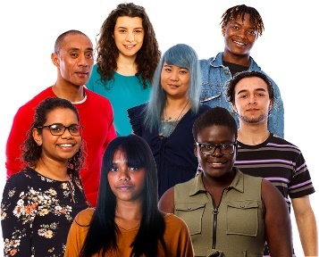 | CALD nih a bawmhmi kan fianter ning:  - CALD minung dihlak  le  - aa dangmi an hmuhton pawl.
 | CALD mibu pawl hi a tha tiah an lungtlin tikah a that kha kan hngalh lai.
 | ‘CALD’ kan fianter ning bawmh dingah data kan lak ning kha kan tharchuah lai.
Rikawt | Data kong kan chim tikah, kan chim duhmi cu:  - thilsining pawl  - thawngthanhmi  - record pawl.
Hi tuahsernak san a tlaih le tlaihlo kha kan chek lai, data kan lakmi azat hmangin.
Hi ah hin CALD aa telmi pawl herhmi a bawmtu data aa tel.

Tuahsernak 25
Kherhlainak kan tuah lai i CALD aa telmi pawl sin in data a thar kan phawtzamh lai.
Hi hin hin a thami biakamnak pawl tuah dingah kan riantuantu pawl le riantuanti pawl a bawmh hna lai.
CALD aa telmi pawl sin in data kan laak ning kha kan tharchuah lai.
Hi tuahsernak san a tlaih le tlaihlo kha kan chek lai, CALD aa telmi pawl kong data ka laakmi kha minung zeidat nih dah an hman timi.
Hi tuahsernak san a tlaih le tlaihlo kha kan chek lai, minung pawl nih biakamnak an tuah ning ah data nih a hnorsuan ning ngaihnak in.
Hi ah hin kan riantuantu pawl le riantuanti pawl an i tel.

6. Mibu he kan pehtlaih ning

Tuahsernak 26
 | CALD mibu pawl he thawngthanhmi chimphuan ning kongah timhtuahnak kan ngei lai:
 | - NDIS
 | - CALD pumtlinglo pawl i covo pawl.
Hi timhtuahnak nih pumtlinlonak cungah cheukhat mibu thinlungput pawl thlennak a bawmh lai.
Na lungput pawl cu na khuaruahmi, na ruahmi le na zumhmi an si.
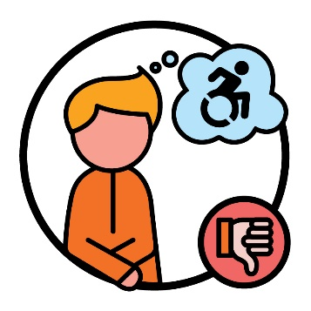 | Tahchunnak ah, minung cheukhat nih pumtlinlonak kha chia ngai in an ruah.  Hi nih hin CALD pumtlinglo pawl kha NDIS hman a ngolter khawh hna.
 | Hi tuahto ning tuah dingah anmah he rian kan tuanti lai:
 | - CALD mibu pawl
NDIS Komisin | - NDIS Komisin.
 | Hi tuahsernak san a tlaih le tlaihlo kha kan chek lai, zeizat:
 | - CALD aa telmi pawl NDIS ah an i tel zat
 | - CALD mibu pawl nih NDIS an i fian ning le hman ning.

Tuahsernak 27
 | Mibu buu pawl chung in cawlcanghnak pawl kan bawmh lai:
 | - NDIS kong thawngthanhmi chimphuan
 | - CALD mibu pawl chungah pumtlinlonak kong lungput thanchoter.
 | Hi tuahsernak san a tlaih le tlaihlo kha kan chek lai, zeizat hrawng dah CALD an i tel:
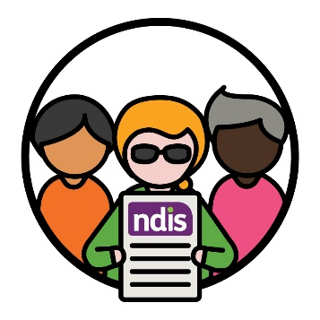 | - NDIS
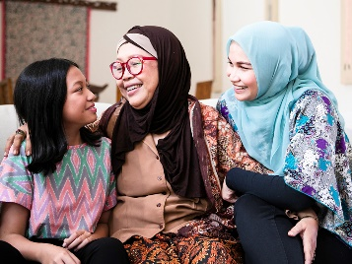 | - mibu buu pawl sinin cawlcanghnak pawl.

 | Hi tuahsernak san a tlaih le tlaihlo kha kan chek lai, zeizat hrawng dah CALD mibu pawl nih:
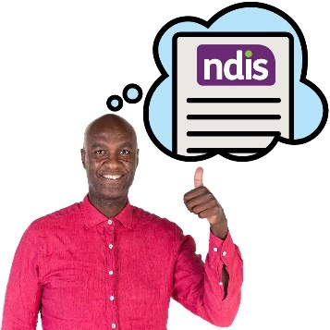 | - NDIS an i fian
 | - Pumtlinlonak an i fian
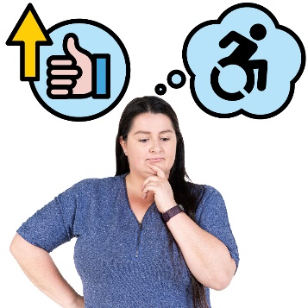 | - Pumtlinlonak ah a thadeuhmi lungput  an ngeih.

Tuahsernak 28
NDIS a leng ah riantuanpiaknak lei thiamnak pawl ser dingah mibu buu pawl he rian kan tuanti lai.
Tahchunhnak ah, siibawi pawl.
NDIS ah i tel dingin CALD pumtlinglo pawl bawmh ningcang i fian dingah hi riantuanpiaknak tamdeuh kan tuah hrimhrim lai.
Hi tuahsernak san a tlaih le tlaihlo kha kan chek lai, kan bawmhmi prokarem zeizat nih dah hi thiamnak pawl sernak lei riantuanpiaknak a bawmh.
Hi tuahsernak san a tlaih le tlaihlo kha kan chek fawn lai, hihi ngaihnak in:
- NDIS kong ah ruahnak cheuhmi lei riantuanpiaknak pawl kongah CALD mibu nih an chimmi
- hi riantuanpiaknak pawl nih prokarem pawl nih zeitluk tha in dah a kan bawmhnak kong a kan chimh lai.

Thawngthanhmi tamdeuh
Hi Tuahsernak lei Timhtuahmi kong thawngthanhmi tamdeuh hmuhnak caah, zaangfahnak in hung kan pehtlai.
Kan website na zoh khawh.
www.ndis.gov.au
Na kan chawnh khawh.
1800 800 110
Facebook ah follow na kan tuah khawh.
www.facebook.com/NDISAus
Twitter ah follow na kan tuah khawh.
@NDIS
Twitter cu X ti zong in auh a si.

Kanmah he biaruah dingah bawmhnak
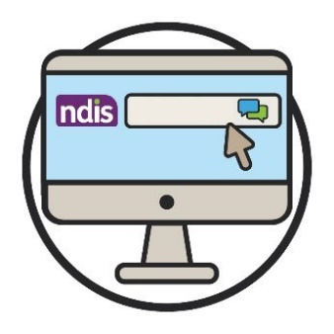  Webchat | Kan website i a cungbik ah a ummi kan webchat tiah hmuhmi hmangin online in na kan chimhchawn khawh.  www.ndis.gov.au
 | Mirangholh nak in holh dang na hman ahcun, na chawnh khawh:
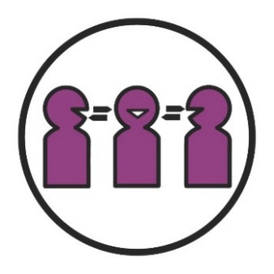 | Calehnak le Holhlehnak lei Riantuanpiaknak (TIS)  131 450
 | Biachimnak asilole hnatheihnak lei ah chambaunak na ngeih ahcun, na chawnh khawh:
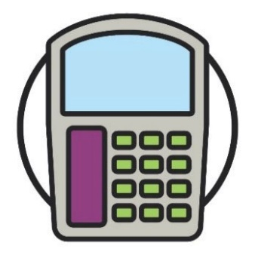  Halo | TTY  1800 555 677
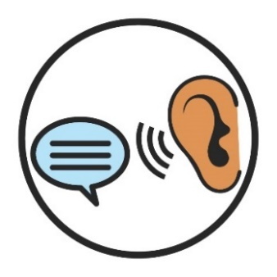 | Chim law Ngai  1800 555 727
Rampumpi huap Chawnhchinnak lei Riantuanpiaknak
133 677
www.accesshub.gov.au/about-the-nrs

Biafang langhtermi cazin
Hi langhtermi cazin nih hin hi timhtuahmi chung i a ummi anak biafang pawl kha an sullam a fianter.
Zohfelnak | Zohfelnak pawl  Zohfelnak pawl cu rian kan tuan ning pawl an si:  - na pumtlinlonak nih na nunnak a hnorsuan ning  - NDIS sin in na herhmi bawmhnak pawl.

Lungput pawl
Na lungput pawl cu na khuaruahmi, na ruahmi le na zumhmi an si.

Dawnkhaantu
Dawnkhaantu cu thil pakhat khat tuahnak in an ngoltertu pakhat khat a si:
- tuah na herhmi
- tuah na duhmi.

Pawcawmnak rian
Pawcawmnak rian cu naa thimmi rian zawn ah na kalmi lam pakhat a si.

Phunzainak
Phunzainak na tuah tikah, minung pakhat khat kha na chimh lai:
- pakhat khat tlamtlinlonak
- pakhat khat tha tein rian a tuanlonak.

Nunphung lei himnak
Nunphung lei himnak cu:
- minung nunphung kan upat piak hna
- a himmi i ruah dingah kan tuah piak hna
- anmah ta ah i ruah dingin kan bawmh hna.

Nunphung lei le holh lei in aa dangmi (CALD)
CALD minung:
- aa dangmi sining dirhmun pawl sin in a rami
- Mirangholh nak in holh dang a hmangmi.

Nunphung lei in aa tlakmi le lehnak lei riantuanpiaknak
Nunphung lei ah aa tlakmi le lehnak lei riantuanpiaknak cu riantuanpiaknak pawl nih minung pawl i an hmanmi nunphung pawl le zumhnak pawl upat piak khi a si.

Nunphung
Na nunphung cu:
- na nunning
- nangmah caah a biapimi a si.
Rikawt | Data  Data kong kan chim tikah, kan chim duhmi cu:  - thilsining pawl  - thawngthanhmi  - record pawl.

Fianter
Thil pakhat khat bantukin fianternak na tuah ahcun, minung phu pakhat ah aa telmi na si kha na chim.

Telhchihmi
Pakhat khat cu i tel ciomi a si tikah, aho paoh:
- an i tel kho
- anmah ta bantukin an ruah.

Holhlettu
Holhlettu cu minung pakhat khat:
- nanmah holh a hmangmi
- midang pawl he biakchawnhnak ah nangmah an bawmmi
- minung pakhat khat nih a chimmi naa fiannak dingah an bawmmi.

NDIA timhtuahtu
NDIA suaisamhtu cu minung pakhat khat:
- timhtuahmi thar a tuahtu
- timhtuahmi pawl a thlengtu.

NDIS riantuanti pawl
NDIS riantuanti pawl cu riantuanpiaknak hmuh le hman dingah midang pawl a bawmmi an si.
NDIS Komisin | NDIS Chiatthatnak le Himnak lei zohfelnak Komisin (NDIS Komisin)  NDIS Komisin nih NDIS ah aa telmi pumtlinglo minung pawl kha a fehter hna:  - a himmi  - a thami riantuanpiak an ngah.
Aphichuak pawl | Aphichuak pawl  Aphichuak pawl cu kan riantuanmi nih minung nunnak pawl a thlen ning kha an si.

Aa telmi pawl
Aa telmi pawl cu NDIS ah aa telmi pumtlinglo minung pawl kha an si.

Bawmchantu pawl
Bawmchantu pawl nih riantuanpiaknak peknak hmangin pumtlinglo minung kha an bawmh hna.

Ralzaam
Ralzaam cu a ram chuahtaak a herhmi minung pakhat kha a si:
- puarhrannak ruangah
- cu ticun him tein an um kho lai.

Covo pawl | Covo pawl  Covo pawl nih minung hna nih zeitindah an in chawnhbiak ding a si mi kong phungphai an si:  - aa ruang in  - aa tluk in.
Tuahto ning | Tuahto ning  Tuahto ning cu thil pawl tha deuh in kan tuah khawhnak dingah timhtuahmi pakhat a si.
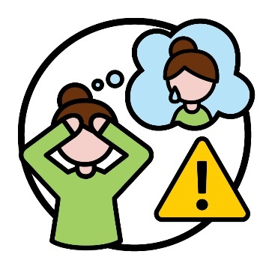 | Thinlung fahtuknak  Thinlung fahnak cu nangmah cungah thil thalo pakhat khat a cangmi kong na ruah ning a si.  Tahchunnak ah, a tihmi asilole lungretheimi bantukin na um men lai.  Thinlung fahnak nih lam dang in minung kha a hnorsuan khawh.

Stock hmaanthlak le nunphung he aa pehtlaimi hmaanthlak pawl hmangin Thawngthanhmi Hmuhkhawhnak Phu nih hi Fawi tein
Rel dingmi a rak ser. Nawlpeknak tel lo in hmaanthlak pawl cu hmanthan khawh a si men lai lo. Hmaanthlak pawl kongkau
i hlathlaimi pakhat khat caah, zaangfahnak in hika ah hin zoh visit www.informationaccessgroup.com. Chirchanhmi rian nambar 5212-B.

