School leaver employment support

Provider reported services - Summary

July 2021 – June 2022

Market Innovation & Employment Branch
ndis.gov.au
Justin’s story
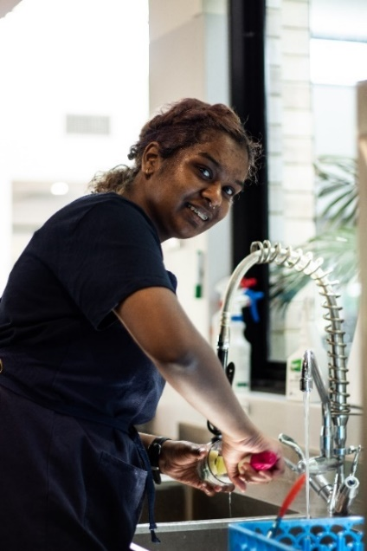
Priscilla’s story

Like many young people, 19 year old Priscilla Ragesh wasn’t sure what she wanted to do when she was ready to leave school.
Priscilla, who embraces her Singaporean and Indian heritage, lives with an intellectual disability, which impacts her memory, learning and understanding.
“Sometimes I can’t remember long words and sometimes I find it difficult to read the text book and the questions, so I need to ask for help,” she says.
“School was up and down and friendship wise, it was challenging, it was difficult to make friends.”
Despite a sometimes rocky road at school, Priscilla has many reasons to be smiling these days.
After leaving school, the Geelong teenager received specialised School Leaver Employment Supports, funded through the National Disability Insurance Scheme (NDIS).
The supports have led Priscilla to a positive new pathway in her life.
She has discovered a passion and a talent for working with children and she’s getting paid for doing what she loves.
Priscilla now works 4 days a week at the Pipsqueaks Early Learning Centre and is also studying for formal childcare qualifications.
She does a range of jobs at work, including helping to set up the classroom and yard, and putting sunscreen on the children. She’s also enjoying teaching the kids how to say hello in Tamil.
“I discovered that I love working with kids,” Priscilla says. “We have a lot of fun together. They love it when we make silly faces and have a joke with them. They just laugh. I love playing ‘superhero’ with them.”
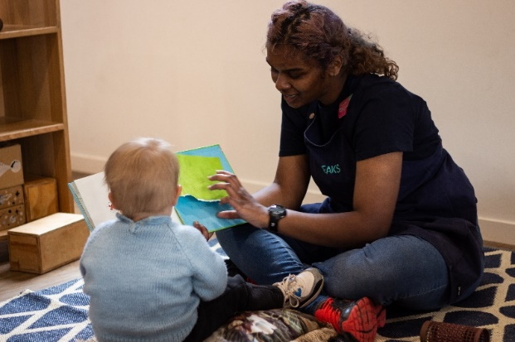
Priscilla’s supported employment journey was about exploring options, building skills, and finding work that would suit her best.
With the help of NDIS provider genU, Priscilla took part in an extensive ‘discovery’ process over 12 months.
She developed an action plan, which included goals to gain experience and find employment.
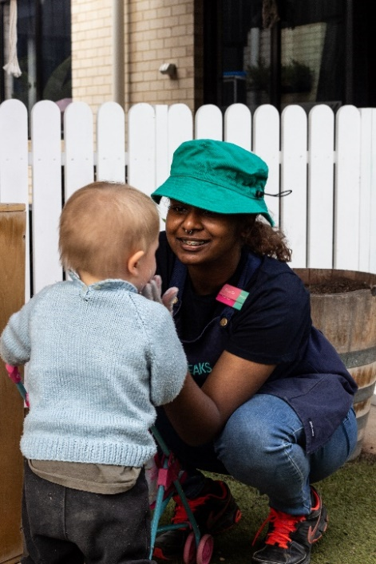
Priscilla took part in several work experience placements in the hospitality industry, which helped to build her general employment skills and knowledge.
She enjoyed learning kitchen hand, customer service and cleaning skills along the way.
This led to 2 days a week of paid employment as a kitchenhand at Pipsqueaks where genU provided Disability Awareness Training to staff.
Before long, Priscilla was a valued member of the team and realised she loved working with children.
“GenU helped to find and recommend me for the position with Pipsqueaks and the volunteering has given me some great experiences,” Priscilla says.
“My support workers have always been helpful and encouraging and I feel safe and respected by the staff at work.
“The supports have helped me gain more confidence and to start a different journey in my life.
“I’m happy I can be more independent and achieve what I want to achieve.”
Priscilla continues to be supported through the NDIS with funded employment supports. She receives ongoing mentoring and coaching to continue to build her skills. She also has help with her studies 2 days a week.
Priscilla is learning a range of soft employment skills, such as problem solving, and how to communicate with staff and customers.
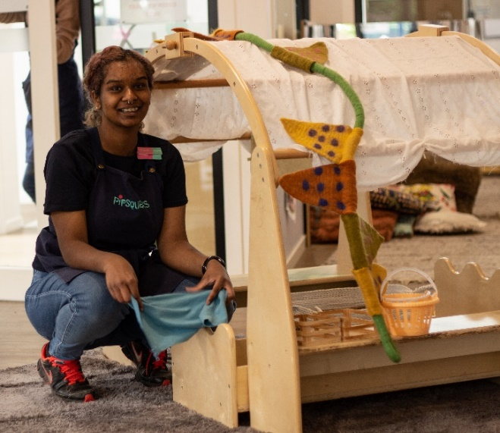
“All of these skills are important to ensuring Priscilla maintains her employment,” genU support worker Allison Strauch says.
Priscilla is proudly now at the tail end of a TAFE Certificate III in Childcare.
She says her new skills and confidence have also helped with making new friends.
“My life has changed a lot with the supports from the NDIS,” Priscilla says.
“I’m very happy, I feel a lot more confident in what I’m doing. I feel really happy because I can be with people, I feel comfortable with, and I can achieve what I want to achieve.
“I have new friends who I met at TAFE, and I’m really enjoying my life.”

Executive summary

Purpose
A template for reporting employment outcomes for young participants receiving “school leaver employment supports” was distributed to providers for completion from January 2021. The reports are completed at the end of each quarter and submitted to NDIA for collation and analysis.
This report is the second edition and contains results for the 12 months July 2021 to June 2022. The first edition was for calendar year 2021 and can be accessed here. The purpose of the report is to give visibility to the outcomes being achieved through school leaver employment funding. This allows providers to benchmark their own results against those for the sector as a whole. It also allows participants to request providers to advise their results and they can compare with whole of sector figures.
The analysis will be updated at 6 monthly intervals to provide results for the preceding 12 months. This will give a rolling view of outcomes achieved over the latest 12 months to provide a wholistic picture of the peaks and troughs which may occur over the course of the period. For example more young people may start receiving employment supports in January to March, following their graduation from high school.
The next report to be published in June 2023 will analyse data for the calendar year 2022 and will include the names of providers along with their results. Providers will have an opportunity to review and verify their results before the report is published. This means that participants will be better informed about the performance of any provider they are considering.
Provider self reporting is not the ideal system although spot audits to verify results are to be conducted during 2023 pending redevelopment of the NDIA participant record system which will facilitate recording of employment status.

Key findings
The information contained in this report represents data submitted to the Agency by providers of school leaver employment supports for the participants for whom they provided service from July 2021 to June 2022.
As at June 2022, approximately 6,709 young participants aged 15 to 24 either had funding for school leaver employment support included in their active plan, or had claimed payment for school leaver employment supports. Out of these, only those participants who accessed a service and whose data was submitted by providers are included in this report.

Employment support recipients
As reported by providers, 5,874 unique participants received school leaver employment supports. 2,214 commenced between 1 July 2021 and 30 June 2022.

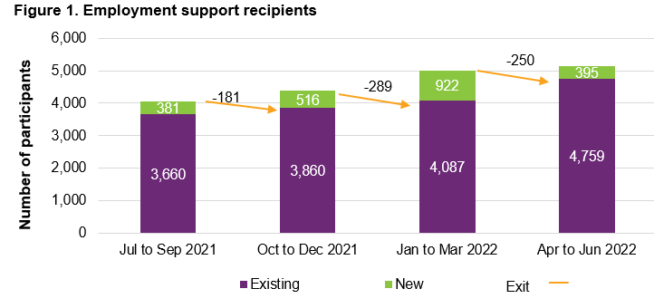
381 participants commenced receiving school leaver employment supports in Q3 2021, 516 commenced in Q4 2021, 922 commenced in Q1 2022, and 395 commenced in Q2 2022.
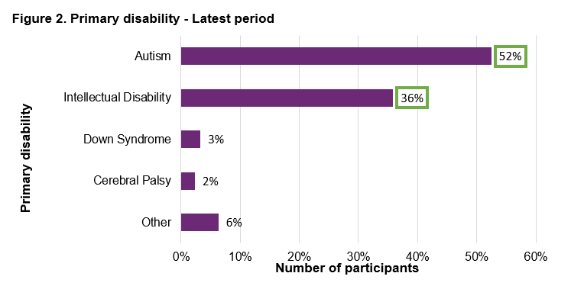
Participants receiving school leaver employment supports predominantly have autism with 52% or intellectual disability with 36%, 67% being male. Other disability includes; other neurological, hearing impairment, psychosocial disability, acquired brain injury, visual impairment, and other / not populated.
The majority of employment support recipients are in NSW (40%), followed by V I C (25%), and QLD (14%).
In the most recent quarter April to June 2022, 6% of employment support recipients identified as Aboriginal or Torres Strait Islander people. This is slightly lower than the 8% of all NDIS participants aged 15 to 24 who identify as Aboriginal or Torres Strait Islander.
In the most recent quarter, 7% of employment support recipients identified as being from a Culturally and Linguistically Diverse community. This is slightly higher than the 6% of all NDIS participants aged 15 to 24 who identified as being from these communities.

Outcomes
1,045 participants were reported to exit school leaver employment supports from July 2021 to June 2022.
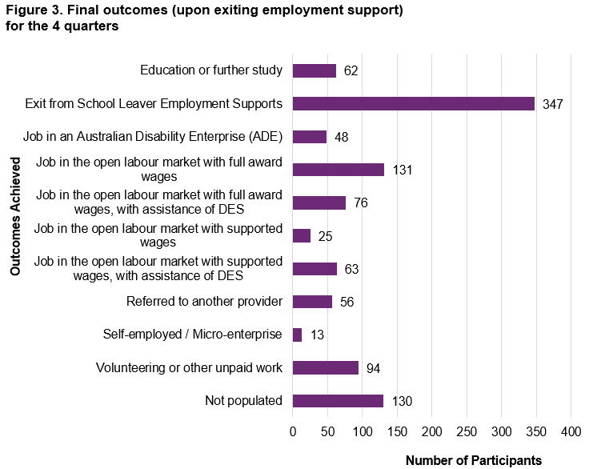

Of the 1,045 participants who exited employment supports in the 12 month period a total of 356 (34%) participants finished employment support with open or supported employment- 29% in open employment and 5% in an A D E. 53% of participants exited support without an employment outcome. Providers reported 9% went on to do volunteering or other unpaid work, 5% were referred to other providers, 6% went on to further education or study while 33% reported they exited support for a variety of other reasons including personal or family reasons, relocation, participant dissatisfaction with the service or coming to the end of 2 years of support . We are investigating the experience of participants for whom services ceased due to funding coming to an end to ensure providers assisted them with evidence for their subsequent planning meeting.

Providers did not report any outcome for 12% of exiting participants which is a decrease from 22% who did not report any outcome in December 2021. Providers are reminded about the need to fully complete the report and providers who do not do so in future will have their data omitted from the final results.
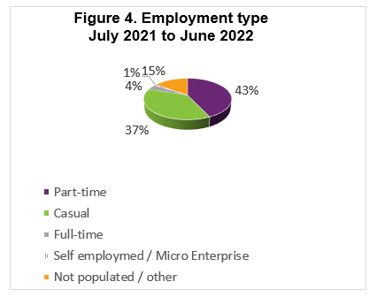
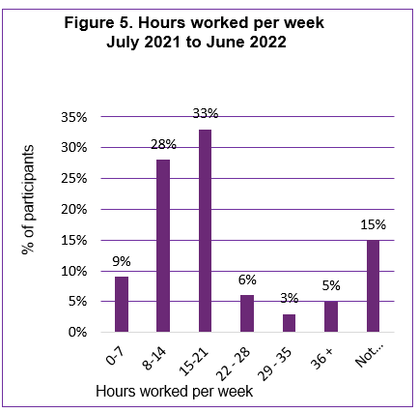
Of participants who started employment over the 4 quarters, 70% worked up to 21 hours per week. 70% worked in Retail, Hospitality, Tourism, Trades, Manufacturing, or Operation.

From July 2021 to June 2022, of participants who finished employment support with paid employment, providers reported that 17% said they will be using NDIS supports in employment to maintain their employment. This percentage has been generally decreasing over time. Providers reported employers will use supported wages for just under a third of participants (29%) who finished employment support with paid employment.

2.3 Supports that helped to achieve outcomes
Around half of all training time was spent building the participant’s social, presentation, communication, and work skills. The analysis for this 12 month period produced similar results to those obtained in calendar year 2021.
Figure 6. Delivery methods
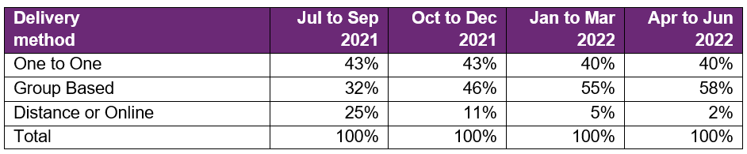
The large percentage of distance or online learning in July to September 2021 coincided with the COVID 19 Delta variant outbreaks and lockdowns (mainly in NSW and V I C). This had reversed in October to December 2021 and continued to drop through to the latest quarter.

Participants whose provider spent more time engaging and training the employerand in job customisation were more likely to gain paid employment.

Participants who made significant progress or fully achieved their goals in relation to developing work skills, employer engagement and job customisation milestones were more likely to gain paid employment.

Participants who fully achieved their work experience milestones were more likely to gain paid employment.

A full report is available on the NDIS website. For questions or general feedback, please email participant.employment@ndis.gov.au.

