Trent Tolra
Branch Manager, Agency Policy Policy, Advice and Research Division National Disability Insurance Agency

By email agencypolicy@ndis.gov.au

9 September 2021

Home and Living Consultation

Dear Trent,

Thank you for the opportunity to contribute to the NDIA Home and Living Consultation.

AHPA was pleased to participate in an allied health provider workshop on this topic on 19th August 2021. We greatly appreciated the workshop, which lived up to its description as a genuine conversation with us. We hope that we can engage with the NDIA via similar formats in the future.

In addition to our comments on home and living issues expressed at the workshop, AHPA notes that the Australian Government supported, or supported in principle, 25 of the 45 recommendations in the Joint Standing Committee on the NDIS Report into Supported Independent Living.1 With respect to the remaining 20 recommendations, the Government referred to ongoing reforms being progressed by the NDIA.2

AHPA therefore anticipates participating in the development and implementation of the Joint Standing Committee recommendations, including associated policy and NDIS practice; as well as in the development of an NDIS Home and Living Policy.

We would appreciate the opportunity to regularly participate in a provider group alongside the IAC, or a similar structure, in order to facilitate our contribution.

Other than the comments above, AHPA regards it as eminently appropriate that we defer to the views of NDIS participants and their advocates on home and living matters.

1 Joint Standing Committee on the National Disability Insurance Scheme (‘JSC’), General Issues Report (December 2020), Appendix 1.
2 JSC, General Issues Report, paragraph 1.16.

Yours sincerely
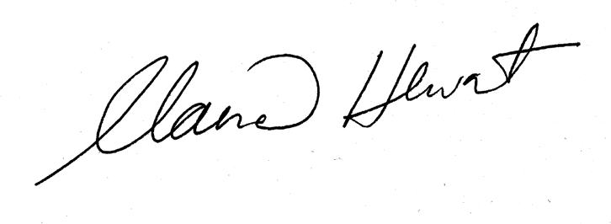
Claire Hewat
Chief Executive Officer

