NDIS Participant portal – Reactivate portal access

Introduction
It is important that nominees and child representatives access the participant portal by using their correct account details, not the participant’s details. This enables us to protect participant privacy, while ensuring nominees and child representatives can still access the information they need to. It also helps us to improve the portal for participants, their nominees and child representatives.
Please use these instructions to unlink your existing NDIS portal account from your myGov account, and relink using your new activation code. Before you begin, you will need a new activation code. If you haven’t received a new activation code, please contact the NDIS directly on 1800 800 110 or contact us here.

Changes from the last version
The following updates have been made to the last published version of the reactivate portal access guide:
- Inclusion of Terms and Conditions and Privacy Notice process (Page 7 to 8)

Step 1: Unlink myGov and participant portal
- Log into myGov (my.gov.au) by entering your username or email and password.

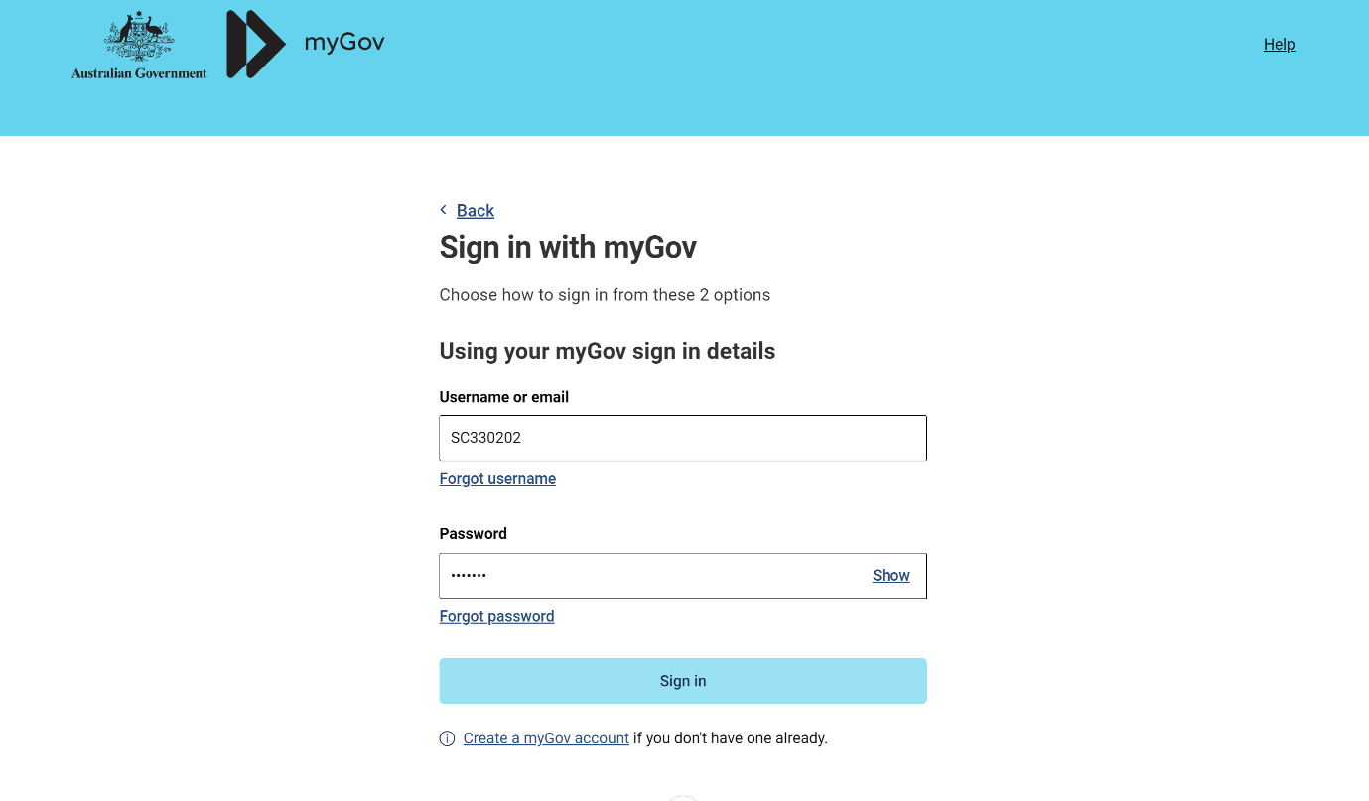

- To unlink your myGov account from your NDIS account, select View and link services under Linked Services.
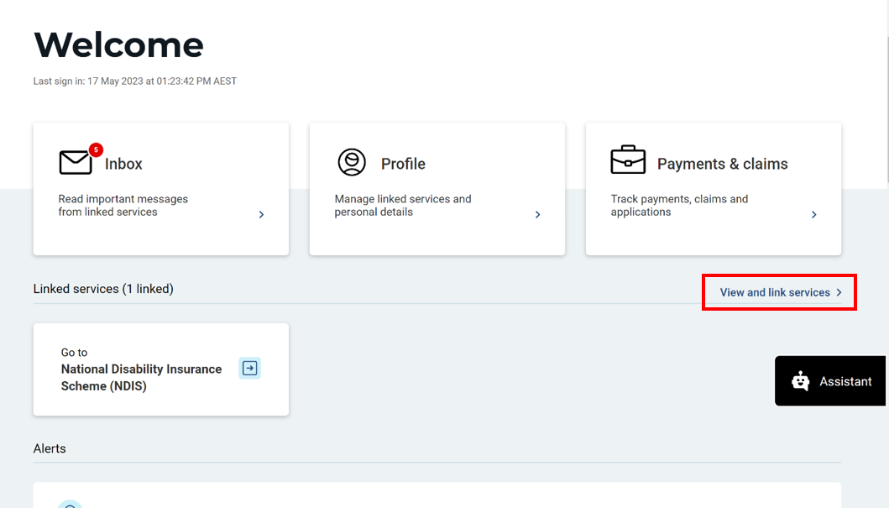

- Under Profile: Linked Services, select unlink next to National Disability Insurance Scheme (NDIS). 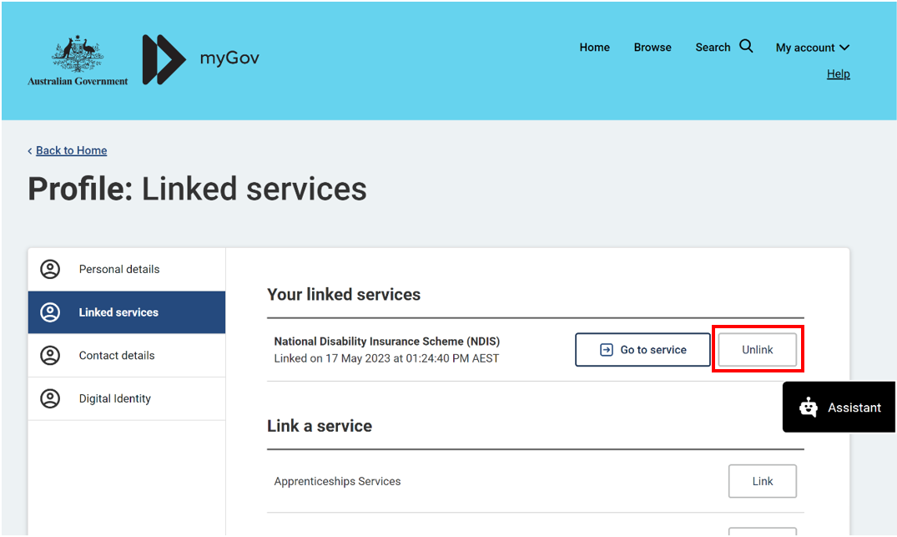
- Select Confirm to finalise unlinking.
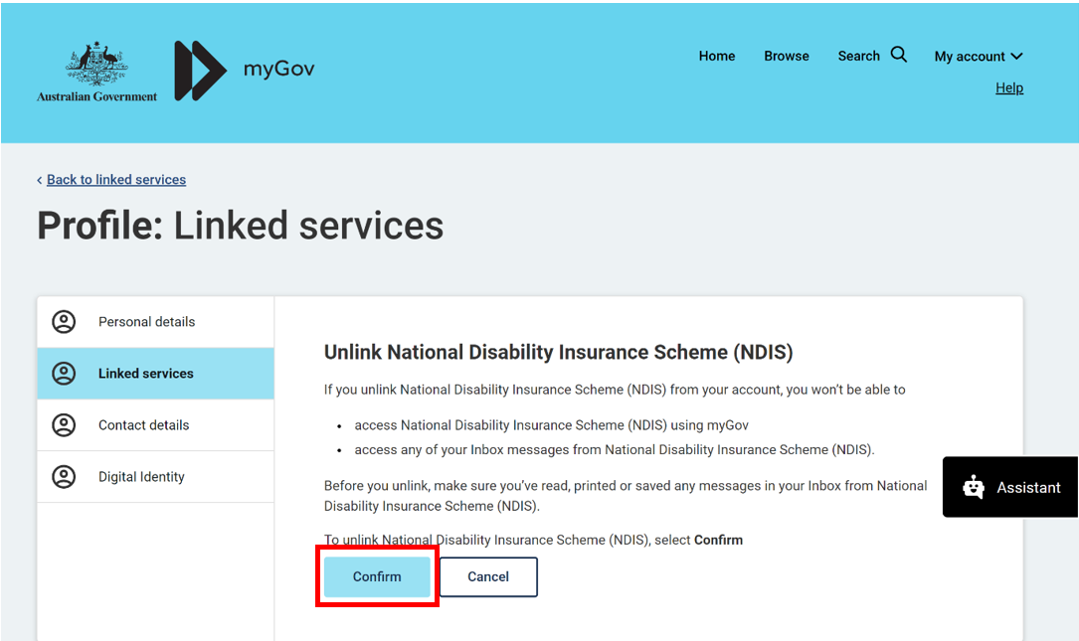

- Sign out of myGov.

Step 2: Relink myGov and participant portal with new activation code
- Sign into myGov (my.gov.au) using your existing username and password.

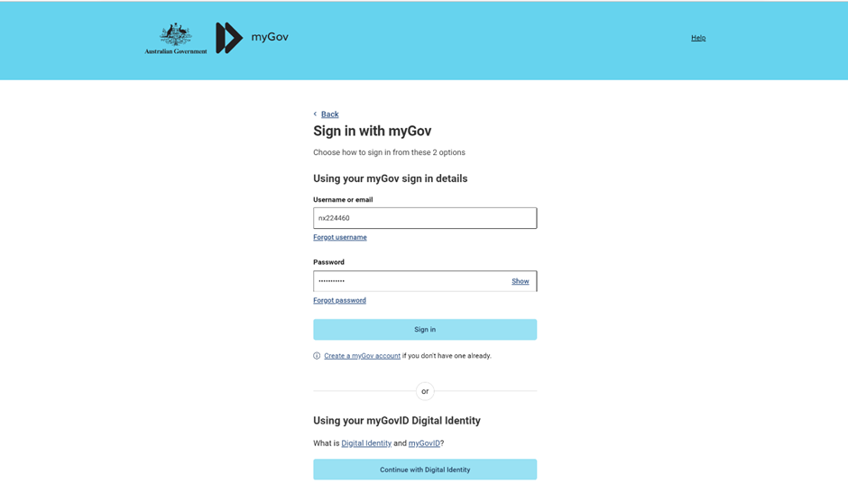
- To link your myGov account to your NDIA record, select Link a Service.
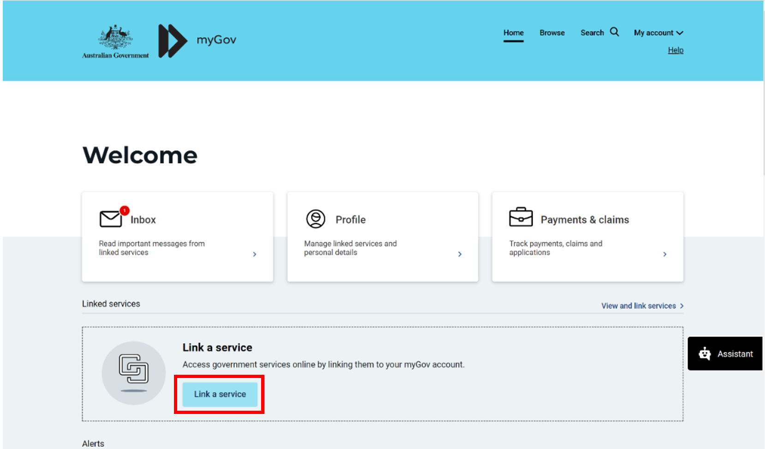

- Then choose National Disability Insurance Scheme (NDIS) and select Link.
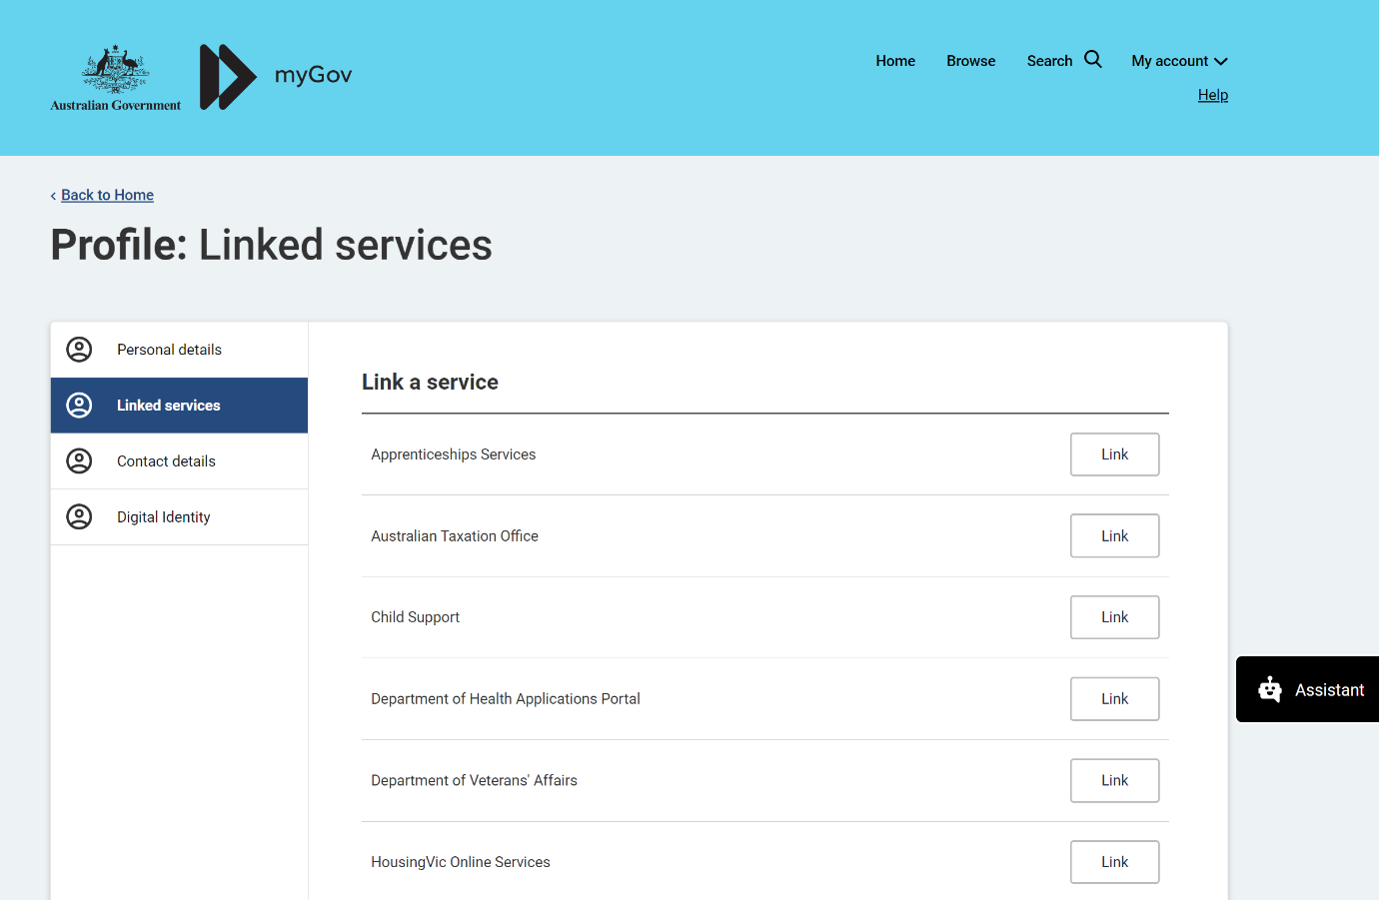

- Type in your NDIS Activation Code, your Last Name, and your Date of Birth, then click the Submit button at the bottom of the screen. You only need to put in the NDIS activation code the first time you access the portal. This screen will not display again.
Note: You can request an activation code by contacting NDIS on 1800 800 110 or here.

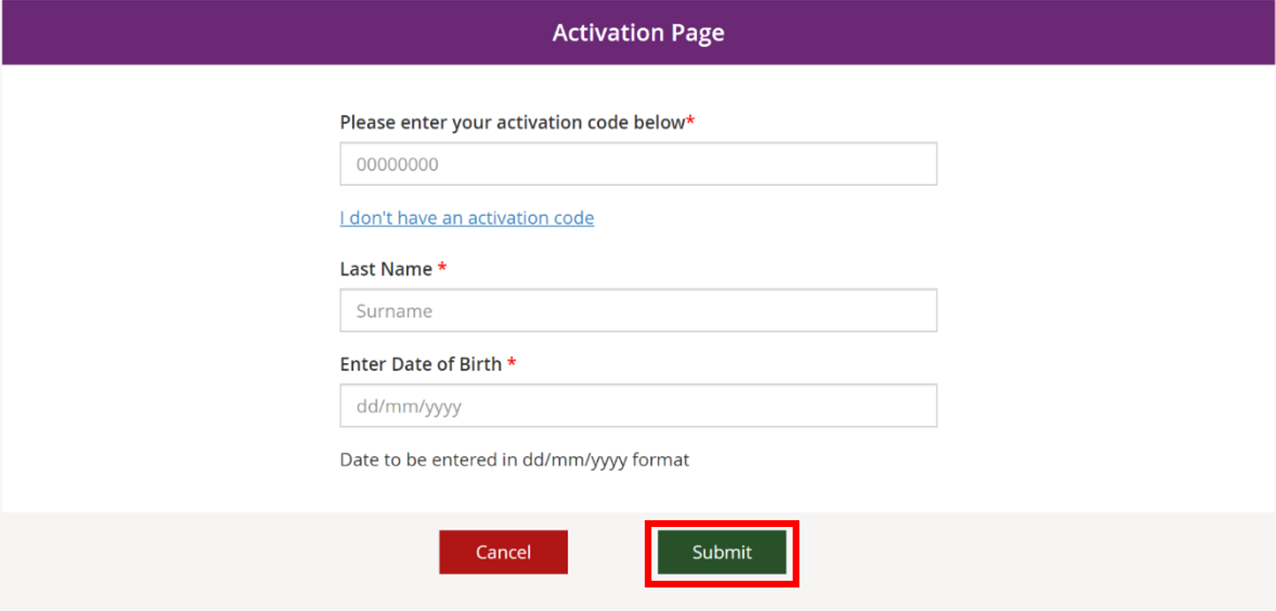
- The Terms and conditions will be displayed the first time you sign into the portal or when there have been updates that you need to be aware of. Move the scrollbar to read the Terms and conditions.
- Once you have read the Terms and conditions, select the checkbox located next to I have read and agree with the terms and conditions and press the I agree button to continue.
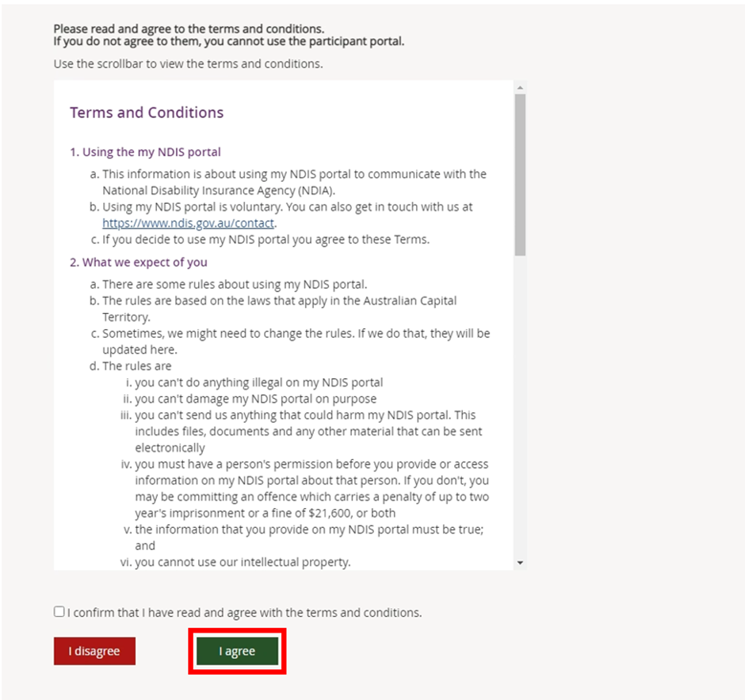
- The Privacy Notice will be displayed. Once you have read the Privacy Notice, select the checkbox located next to I have read and agree with the Privacy notice and press I agree button to continue.
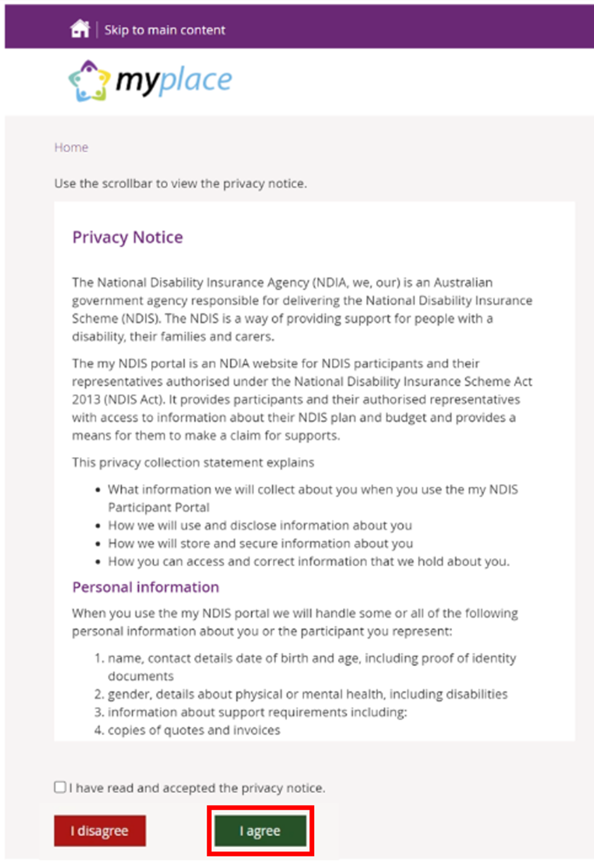
- You have reactivated your NDIS participant portal account. The participant portal page displays.

If you need any further support, you can contact the NDIS directly on 1800 800 110 or contact us here.

