**NDIS myplace portal**

**Step-by-step guide**

**My payment request**

#### May 2024

## Table of Contents

Table of Contents 2

Changes from the last version 3

My Payment Request 3

Add My Payment Request 4

View My Payment Requests 9

Cancel Payment Requests 12

My Messages 15

Leaving Feedback 16

Logging out of myplace 17

## Changes from the last version

The following updates have been made to the last published version of the myplace portal step-by-step guide:

* General updates

## My Payment Request

Through **My Payment Request** you can create payment requests (only for self-managed participants) and view all past payment requests (including periodic transport).

**Note:**

* If you have a new plan in the new computer system, you must sign into the my NDIS portal to make a claim against your current plan.
* You will be able to see, filter and search for claims made against your previous plan in the myplace portal.
* You may be able to claim for services and supports up to 90 days after the old plan has expired in the myplace portal.

1. Click **My Payment Request** on the homepage.

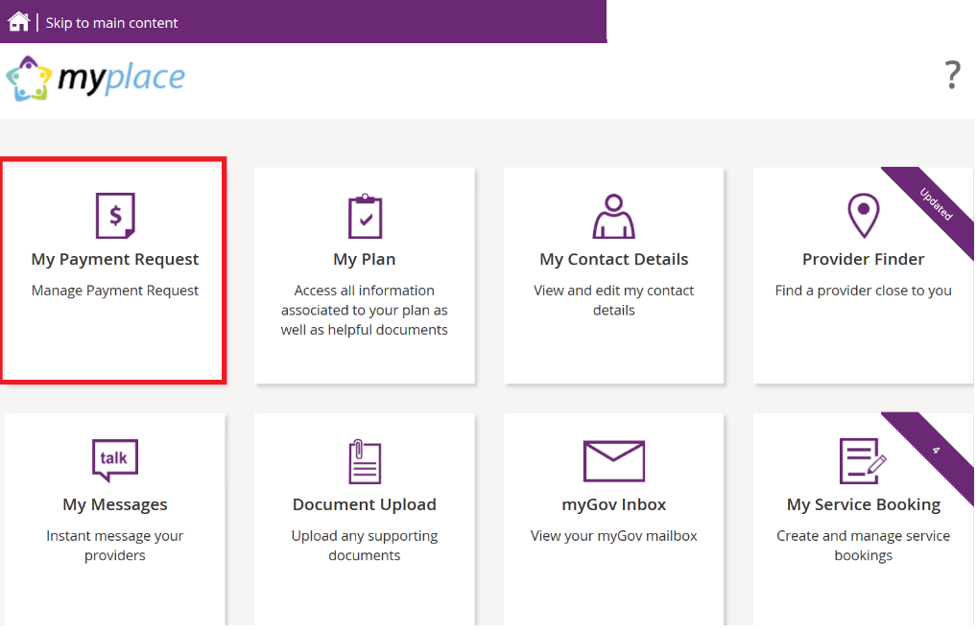

The **My Payment Request** screen displays.

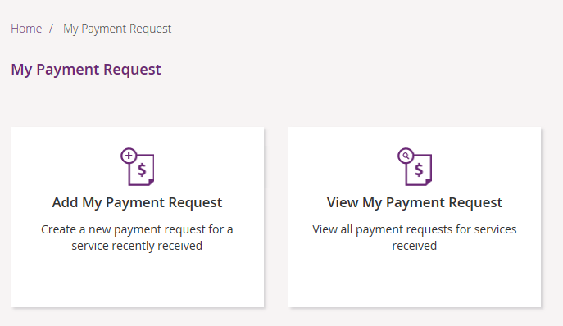

You have two tiles:

* **Add My Payment Request** – to create new payment requests.
* **View My Payment Request** – to see the details of all payment requests that have been submitted.

## Add My Payment Request

This section is only for self-managed funded supports. Payment requests for funding that is Agency managed or plan managed will be submitted by providers.

Ensure you have your bank account details recorded (in **My Contact Details**) before you submit your payment request.

1. Click the **Add My Payment Request** tile on the **My Payment Request** screen.

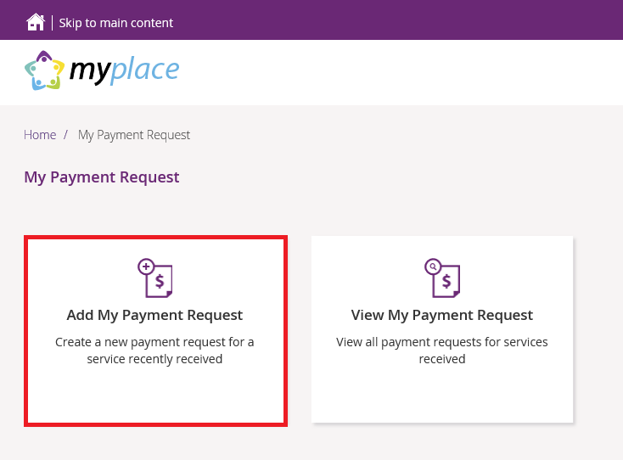

The **Add Payment Request** screen displays.

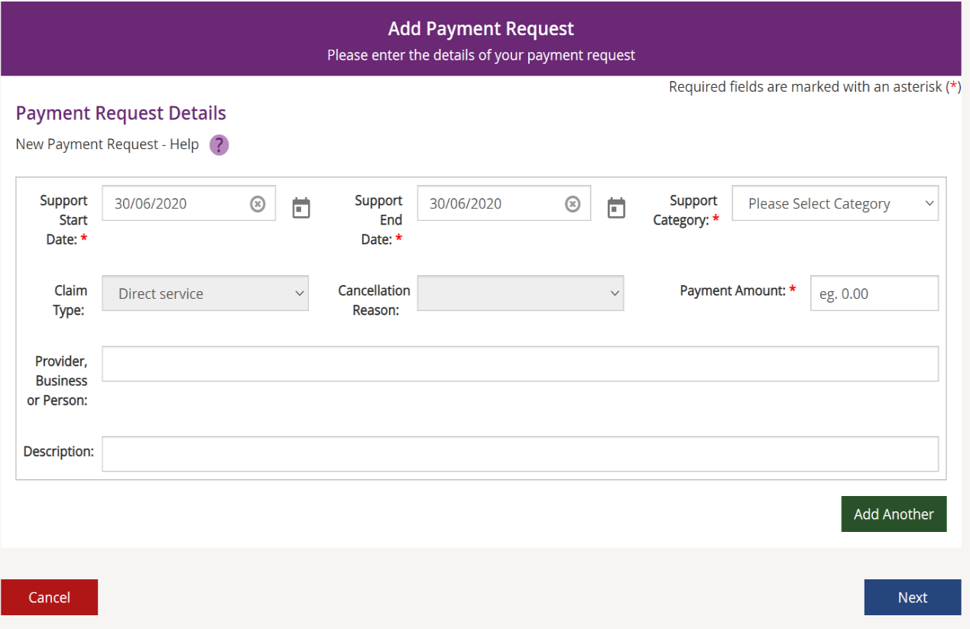

1. Enter the details of your payment request. The **Support Start Date field** and **Support** **End Date** field will default to today’s date (change if required). Select the **Support Category** and **Claim Type** from the drop-down list and enter the **Payment Amount**.
2. To help you track your payments, please enter the name of the payee in the **Provider, Business or Person** field and the **Description** of the payment. The provider, business or person name and description field are both optional fields.

**Note**: For more than one payment request, click the **Add Another** button in the lower right-hand corner of the window.

1. Once all details have been entered, click the **Next b**utton on the lower right-hand side of window.

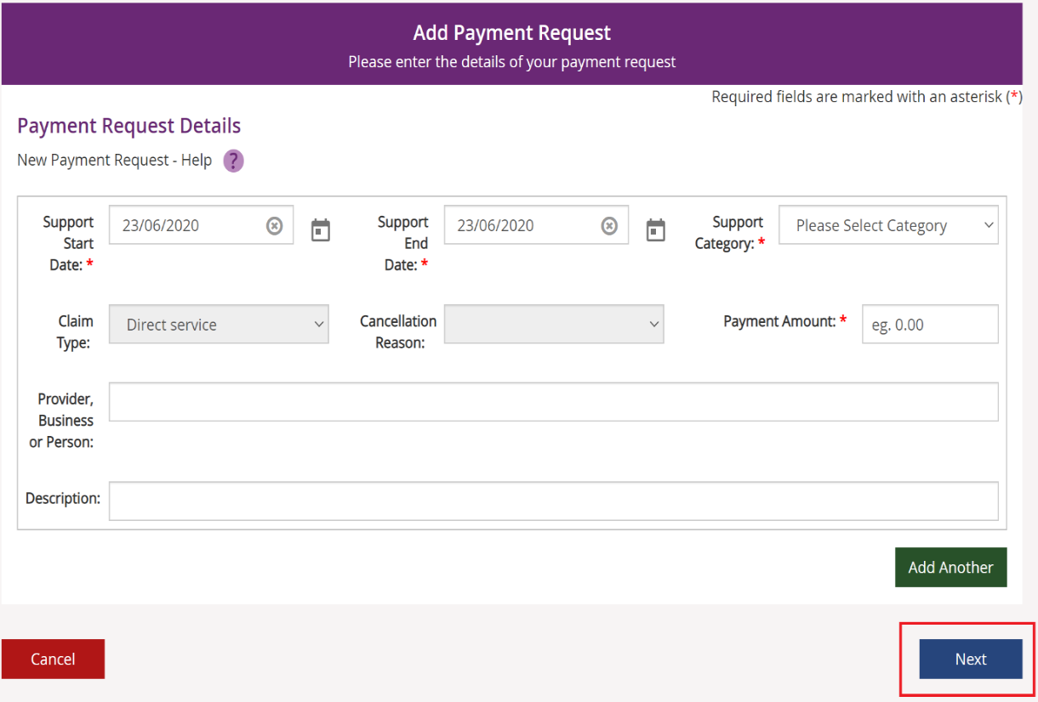

The **Preview** page displays.

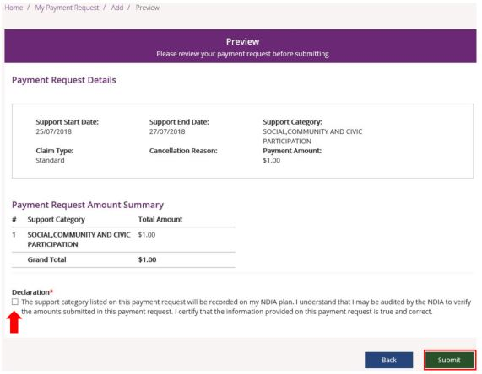

1. Check the details are correct and then tick the **Declaration** box. Click the **Submit** button on the bottom right-hand side of screen.
2. The **Confirmation** screen displays, stating that your payment request has been received.

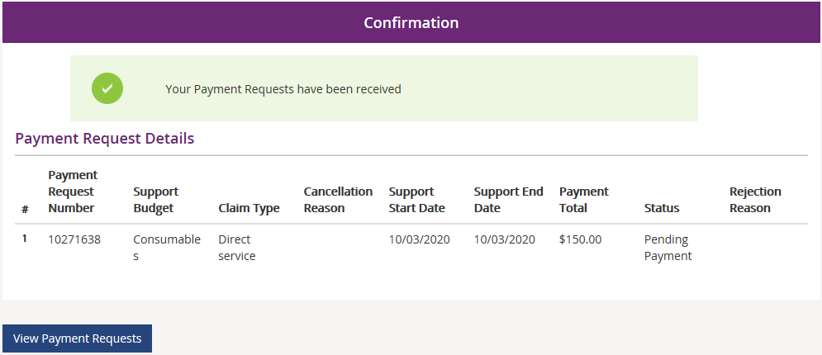

You can return to the home page or go to **View Payment Requests**.

## View My Payment Requests

You can view the payment requests that were submitted by you, a provider or an NDIA staff member. Periodic transport payments can also be viewed in this screen.

1. Click the **My Payment Request** tile on the home page.
2. Select the **View My Payment Request** tile.

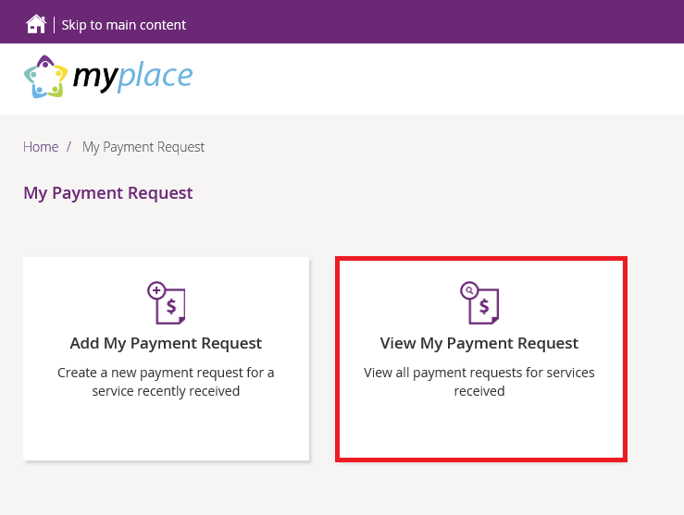

The **View Payment Requests** page displays.

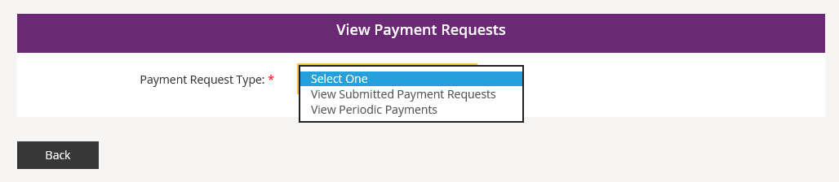

1. Choose the **Payment Request Type** from the drop-down menu. The following steps are an example for submitted payment requests.
2. For **View Submitted Payment Requests**, the following screen displays.

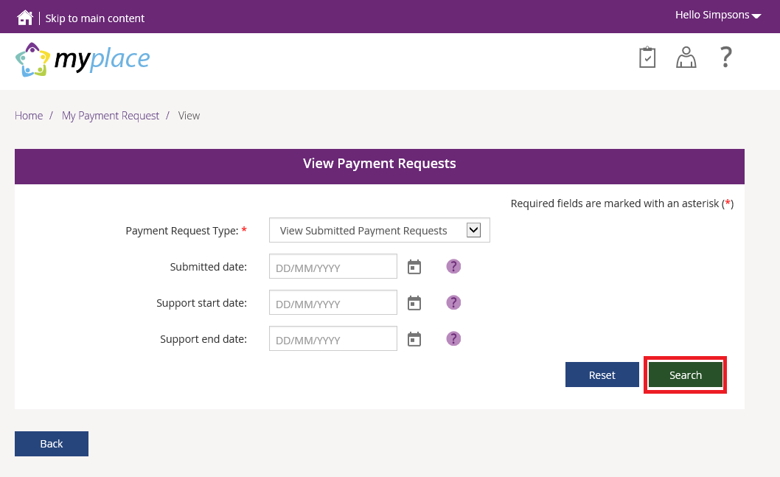

1. Click the **Search** button for a full list of all requests, or type in dates to view payments within a selected time period. A list of your payment requests display.

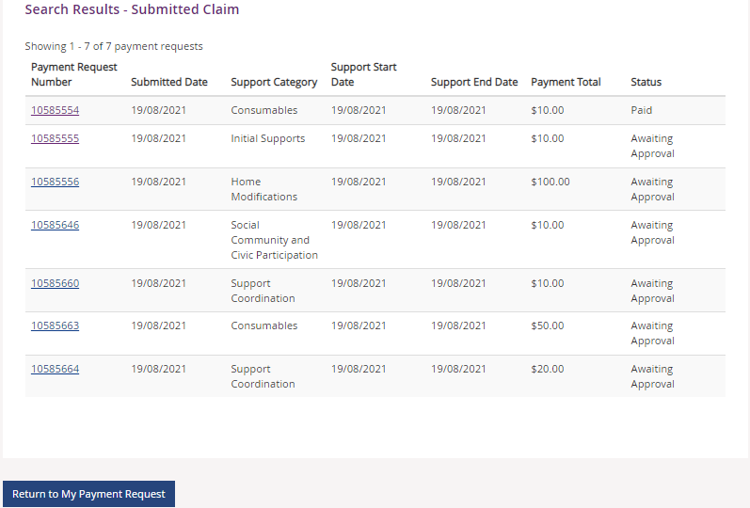

1. You can navigate through the payment request results by clicking the **First**, **Back**, **Next** and **Last** buttons.
2. Click on the **Payment Request Number** to view details about the payment request.

**Note:** You will see the payee’s ABN number (if applicable), when you or your representative have made a payment request using the my NDIS app or a NDIA staff member has made a claim on your behalf.

### Cancel Payment Requests

You can cancel payment requests you have submitted and payment requests that a nominee or child representative have submitted if they have the status of **Paid** and/or **Pending.**

**Note:**

* A Nominee or child representative can only cancel payment requests submitted by themselves.
* You will see the Payee’s ABN number (if applicable), when you or your representative have made a payment request using the my NDIS app or an NDIA staff member has made a claim on your behalf.

1. In **View Payment Requests**, click on the **Payment Request Number** link.

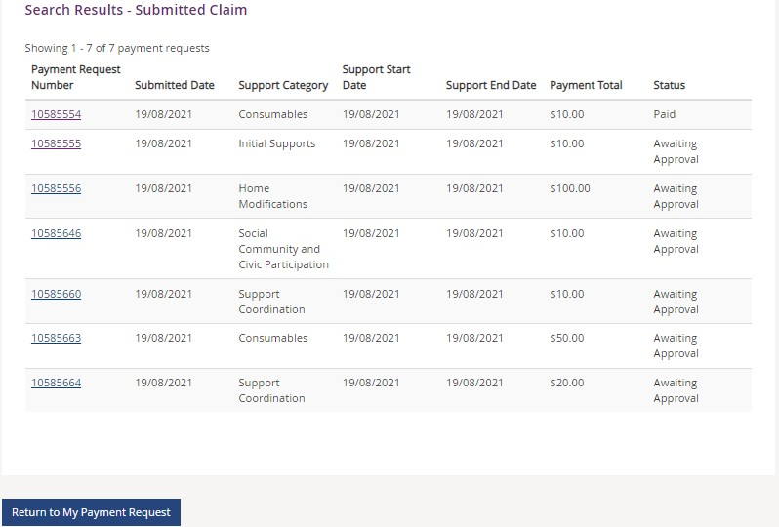

1. A summary of the payment request displays.

1. Click the **Cancel Payment** button on the bottom right-hand corner of the window.

Note: If the **Cancel Payment** button is not available, please contact NDIS.

1. Select the **Yes** button to cancel the payment request.

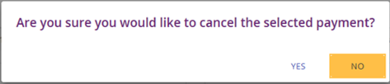

You are returned to the **View Payment Requests** page. A confirmation message will display, confirming the payment request has been cancelled successfully.



1. Select **Home** to return to the main homepage.

The Home tab highlighted which can be used to navigate back to the main home page. This tab sits next to the tabs My payment request and view.

## My Messages

This tile will only display if you have an active service booking with a registered provider. You can send instant messages to your providers.

1. Click on the **My Messages** tile on the home page.

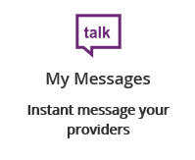

**2**. The **My Messages** page displays.

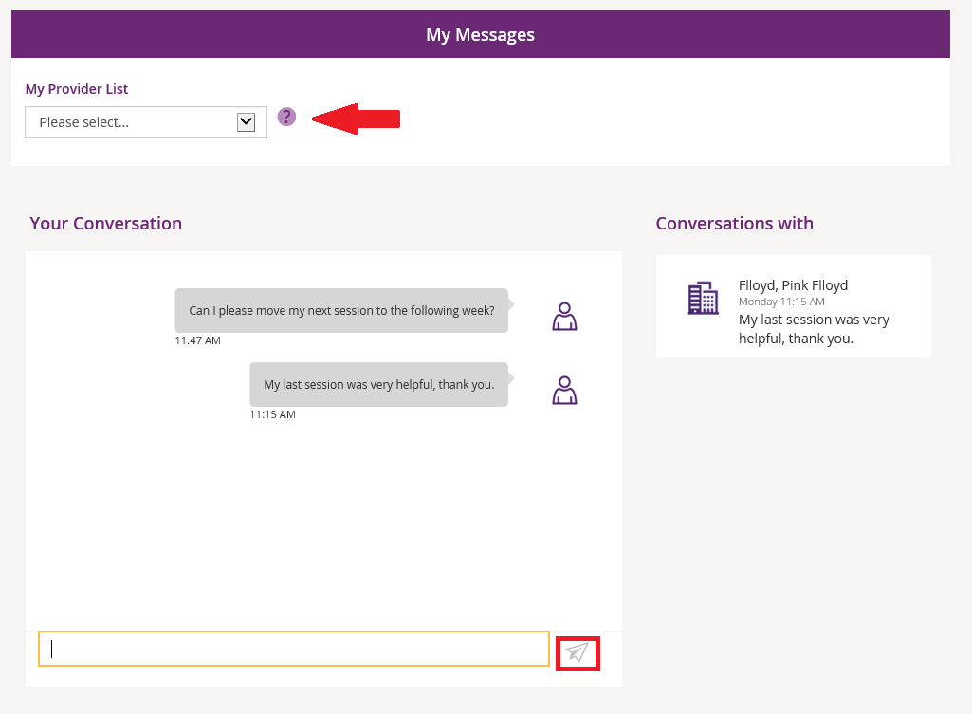

**3.** Select the chosen provider from the drop-down list under **My Provider List**.

**4.** Type your message in the yellow box and click the paper plane icon paper plane icon ) to send the

message.

**Note:** Conversations (messages) will appear under the **Conversations with** tab. You can continue a conversation by selecting the providers’ name.

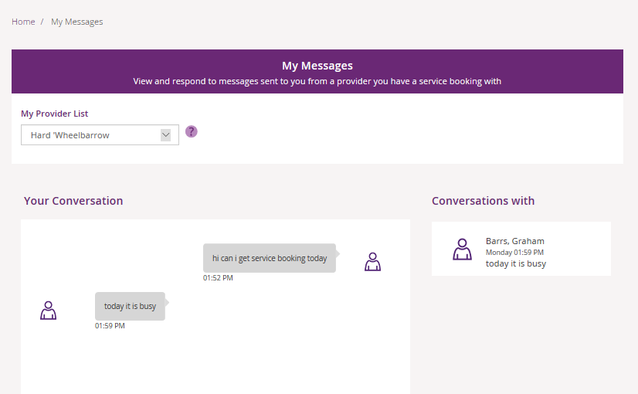

## Leaving Feedback

If you would like to provide feedback, a compliment, complaint or enquire about an internal review or external review, this section allows you to record your feedback and submit it to the agency.

From anywhere in the portal, click the **Feedback** link at the very bottom of the page.

My place home screen. Four tiles displayed My Payment Request tile, My Plan tile, My Contact Details tile, My Provider Finder tile, My Messages, Document Upload tile, MyGov Inbox tile and My Service Booking tile. At the bottom of the screen the word Feedback is highlighted. 


The **Feedback Form** opens.

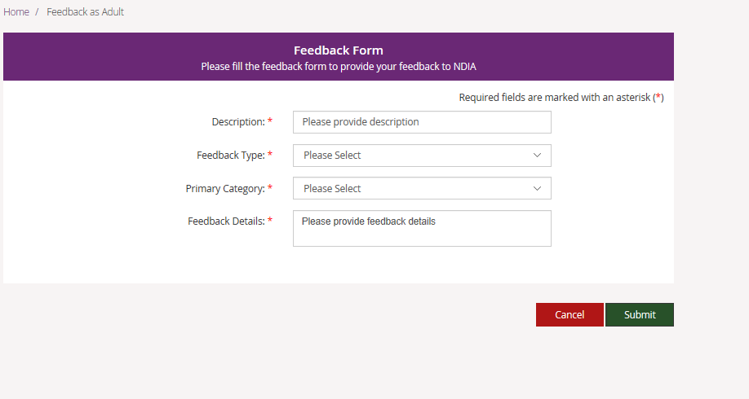

Enter a **Description** in the free text field and select a **Feedback Type** and **Primary Category** from the drop-down lists. In the **Feedback Details** field provide as much information as possible to assist the staff with your enquiry.

Select the **Submit** button in the lower right-hand corner of the screen.

A message with the reference feedback number will display.



## Logging out of myplace

Once you have completed all your tasks within the portal, log out by clicking on the down arrow next to your name at the top of the screen and select **Logout** from the drop-down menu.

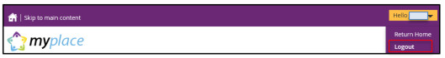

If you signed in via the NDIS website, you will be returned to the NDIS front page. If you signed in via the myGov website, you will be returned to your myGov homepage.