School leaver participant survey report
September 2022
Market Innovation & Employment Branch
ndis.gov.au

Contents
School leaver participant survey report 1
Contents 2
1. Executive summary 4
1.1 Vision 4
1.2 School leaver employment support 4
1.3 Participant survey 5
1.4 Key survey findings 5
2. Background 7
2.1 What is school leaver employment support? 7
2.2 Why are we reviewing school leaver employment supports? 7
2.3 Why the school leaver participant survey? 8
3. Survey findings 9
3.1 Participant demographics 9
3.1.1 Age and year left school 9
3.1.2 Respondents locations by State and Territory 10
3.1.3 Level of education completed 10
3.1.4 School settings during final year of school 11
3.1.5 Areas of functional impact of disability 11
3.1.6 Areas of functional impact by school type 12
3.2 Support implementation and fund utilisation 13
3.2.1 Support funding utilisation status 13
3.2.2 Reasons for participants not utilising the support 14
3.2.3 Most common means of selecting a provider 14
3.3 Provider performance 15
3.3.1 Support contribution to goal achievement 15
3.3.2 Support for work experience 16
3.3.3 Skills respondents learnt with the provider 17
3.3.4 Suggestions on how providers could have improved support 17
3.4 Participant outcomes 18
3.4.1 Outcomes measurement 18
3.4.2 Outcomes after finishing with the provider 18
3.4.3 Outcomes after finishing with the provider : open / supported & non-employment outcomes 19
3.4.4 Current employment status of school leavers : open / supported & non-employment outcomes 19
3.4.5 Correlation between providers understanding of support needs and employment outcomes 20
3.4.6 Correlation between frequency of progress and review and open employment out 20
4. Conclusion 21
4.1 Key findings 21
5. Appendix 22

Executive summary

Vision
In 2019 the NDIA released the NDIS Participant Employment Strategy (the Strategy), which sets out the vision, commitment, and plan for supporting participants to find and keep meaningful employment. The vision of the Strategy is that participants have the same opportunities to work as other Australians, and the confidence, support, and skills to take advantage of those opportunities. Our goal is to have 30% of working age participants in meaningful employment by 30 June 2023. As at December 2021, 22% of working age participants were in paid employment. One of the 6 key action items in the NDIS Participant Employment Strategy is to improve the path between education to work.

School leaver employment support
School leaver employment support is an early intervention support intended to smooth the transition from school to employment by building a young participants skills, confidence, and capacity for work. Through consultation with participants and the sector we know that while the rationale for funding school leaver employment supports is strong and stakeholders generally value the supports, several design problems have become evident:
    - Funding for school leaver employment supports implies a “program”
    - Providers’ income is largely unrelated to effort or outcomes
    - The performance of providers varies markedly
    - Participants lack information to guide decision-making in selecting the right provider
    - Support commences too late for some participants.
In research released by the Agency in September 2021 exploring the barriers and enablers to employment for participants of the scheme, some of the main barriers expressed by participants and their supporters were:
- A feeling that their disability and employment needs were not always well understood
- A lack of clarity around what employment funding and supports were available
- A lack of post-school training and education options appropriate for people with intellectual disability, autism spectrum disorder, and/or psychosocial disability and a lack of clarity about what NDIS supports and services are available to undertake further education
- A lack of self-confidence that they are employable people.

Participant survey
In November 2021, as part of a broader review of school leaver employment supports, the Market Innovation and Employment Branch invited 5,582 participants who had school leaver employment supports included in their plans in 2018 and/or 2019 to participate in a survey.
The aim of the survey was to understand the experience of participants who have received these supports and gain their perspectives on:
- the effectiveness of supports in assisting them to achieve their employment goals
- the outcomes they achieved
- improvements they believe could be made
- and for those who did not utilise their funding, the reasons why.
The following report walks through the survey results focussing on 4 key areas:
Participant demographics: Analysing who is utilising these supports, their ages, year left school, location by state and territory, level of education attained and school settings, and the areas of functioning impacted by disability.
Support Implementation and fund utilisation: Exploring who utilised the funding in their plan, where they did not the reasons why, and who is helping participants connect with providers.
Provider performance: Analysing whether supports have contributed to participants achieving their employment goals, the skills the participant learnt through the support, whether they were supported to engage in work experience and any recommendations for improvement the participants offered.
Participant outcomes: Analysing participant outcomes directly upon finishing with the provider and comparatively, the participant’s work status at the time the survey was completed (November 2021). It explores open, supported, and non-employment outcomes, and explores correlation in key features of the support with open employment outcomes.

Key survey findings
- Of 5,582 participants who had school leaver employment supports in their plan in 2018 and/or 2019, half (50.3%) did not utilise funding in the year provided. The survey was sent to the 5,582 participants; we received 651 responses.
- Respondents surveyed were typically aged 21, had left school in 2018, completed year 12, and attended a special unit within mainstream secondary school or special secondary school setting.
- The most common areas of functional impact for respondents across all school settings were learning, social interaction, and activities related to self-management.
- 74% of 651 respondents utilised their funding.
- Top reasons for participants not utilising the support: ‘nobody explained the purpose of funding; ‘other’ circumstances (the common themes in ‘other’ were, funding not suitable / participant not ready to utilise funding, COVID, funding not included in the plan at the right time, personal health) OR participant decided to do something else.
- The main supporters of participants to select an appropriate provider were parents and carers, schools, and providers themselves. 18% of participants reported they were assisted by a Support Coordinator and 15% reported they were assisted by their Local Area Coordinator (LAC).
- 44% of participants surveyed said that providers helped them to arrange work experience in an area of interest. 30% said they were supported to undertake courses to pursue employment goals. Of all participants who said they undertook work experience, 57% said that the provider supported them on the job during work experience, with 43% saying they required more support or were not supported at all.
- 46% of participants said that most or all supports helped them in achieving employment goals.

- Participants felt services could be improved by providers spending more time getting to know them (57%), arranging more work experience (52%), and offering more skill building opportunities (42%).
- The employment rate was measured on two dates. The first was the status directly after leaving the school leaver employment support provider. The second was the status at the time the survey was completed, which may have been up to 2 years post receipt of supports. 27% reported they achieved an employment outcome when first finishing with the provider (20% open and 7% supported). This increased to 40% at the time of the survey (33% open and 7% supported).
- 35% continued job seeking through a Disability Employment Service (DES), another provider, work experience or further education and training, while 38% continued looking for work unsupported or were not job ready.
- The variables associated with highest open employment outcome are regular progress review and providers’ very good understanding of participants’ support needs.

Background

What is school leaver employment support?
School leaver employment support is originally modelled on the NSW Transition to Work program, which aimed to circumvent the direct pathway to day programs or segregated employment options. NDIS school leaver employment supports commenced in Victoria, NSW, ACT and Tasmania in 2016 and expanded nationally in 2018.
School leaver employment support is an early intervention support intended to smooth the path from school to work by building a young participant’s skills, confidence and capacity for employment. Generally provided for a period of up to 2 years commencing in the final year of school, school leaver employment supports bridges a mainstream service gap by recognising many NDIS participants require significant early investment to gain the generic competencies needed to work.

Why are we reviewing school leaver employment supports?
The longitudinal study of employment support produced by the NDIA Office of the Scheme Actuary, has shown school leaver employment supports are delivering outcomes for participants.
Participants receiving school leaver employment supports show a larger improvement in achieving paid employment than a matched comparison group. At 2 years, 21% more of those receiving employment supports were in paid employment compared to 11% more in the comparison group, however there is still considerable room for improvement.
Through consultation with participants and the sector we have heard that:
    - Early intervention is important, supports for some participants should be available from the time a young person reaches working age. The current naming of supports creates confusion about when supports can be made available.
    - The current funding model does not promote an individualised approach to service provision. It does not properly reflect the effort required of providers nor promote faster progression for participants. The pricing model for these supports needs to enable provision of tailored supports based on individual needs and goals.
    - Greater clarity and assistance is needed for participants and families to navigate the complex disability employment system, including eligibility for supports and intersection of NDIS and mainstream employment supports.
    - More guidance and assistance is required for participants parents and carers to understand the expected outcomes of support, how to select suitable providers, and how to change providers if progress is insufficient.
    - Provider performance, quality, experience, skills, and knowledge varies greatly. More guidance is required to clearly define best practice milestones toward employment and expected outcomes of support. There is a greater need for provider accountability and regular progress review and reporting to participants, parents and carers.
    - Better equipped LACs and Planners will lead to more employment focussed conversations with participants, consistent decision making to include reasonable and necessary supports in plans and more support to connect participants with the right providers and services.
The review of school leaver employment supports aims to address these issues and to provide a comprehensive framework for these supports based on evidence based best practice.

Why the school leaver participant survey?
As part of the broader review of school leaver employment supports, in November 2021, the Agency sent the School Leaver Participant Survey to 5,582 participants who had school leaver employment supports funded in their plan in 2018 and/or 2019. We wanted to understand the experience of participants who have received these supports and gain their perspectives on:
- the effectiveness of supports in assisting them to achieve their employment goals
- the outcomes they achieved and
- improvements they believe could be made
- and for those who did not utilise their funding, the reasons why.

Survey findings
Of the 5,582 participants who received the School Leaver Employment Supports Participant Survey we received 651 responses. This section of the report provides an analysis of these responses.

Participant demographics

Age and year left school
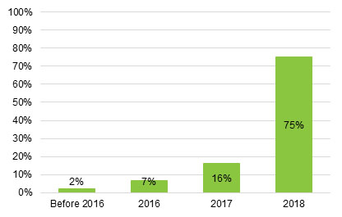
Number of respondents: 651
The majority of participants who responded to the survey (75%) left school in year 2018, with 16% reporting they left school in 2017, 7% in 2016 and 2% before 2016.
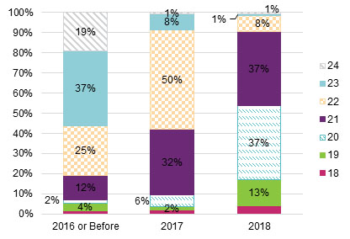
The majority of respondents left school in 2018 and were 17 or 18 years of age when they left school.

Respondents’ locations by State and Territory
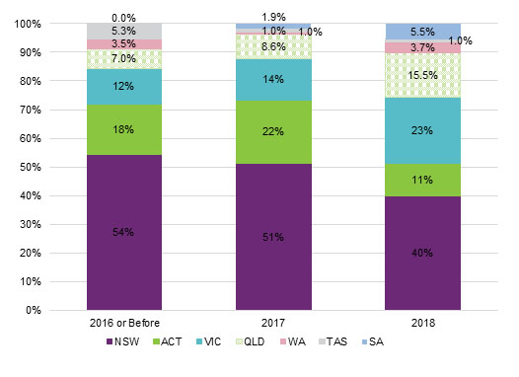
No. of respondents surveyed: 57 (2016 or before), 105 (2017), 489 (2018)

Level of education completed
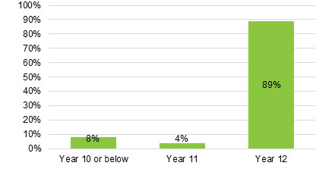
Around 89% of survey respondents left school after completing year 12.

School settings during final year of school
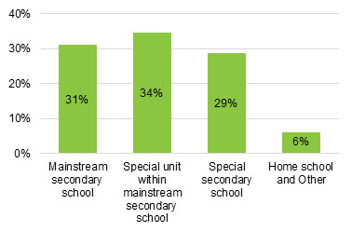
number of respondents on both charts: 651
63% of survey respondents attended a special unit within a mainstream secondary school or a special secondary school. 31% attended a mainstream secondary school and 6% attended home school and other school settings, including behavioural school and distance education.

Areas of functional impact of disability
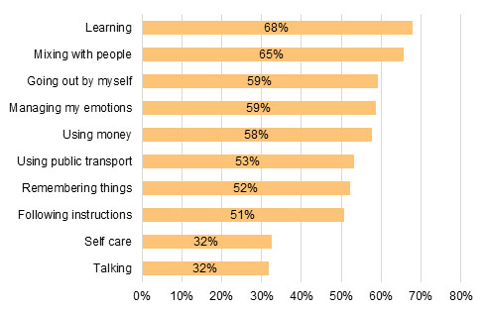
NOTE: See appendix 1 for full chart, number of respondents is 651. Multiple areas could be chosen for this question.
The top 5 areas of functional impact of disability reported by survey respondents are learning (68%), mixing with people (65%), going out by themselves (59%), managing emotions (59%), and using money (58%).

Areas of functional impact by school type
Areas of functional impact – special secondary school
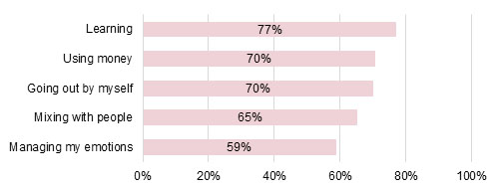
Number of respondents: 186
Areas of functional impact – special unit within mainstream secondary school
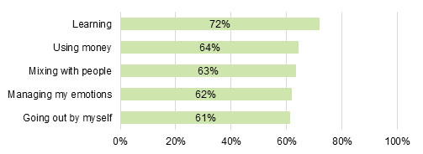
Number of respondents: 224
Learning, using money, going out independently, mixing with people and managing emotions are the top 5 areas of functional impact reported by survey respondents who attended special school settings (either special unit within a mainstream school or a special secondary school)
Areas of functional impact – mainstream secondary school
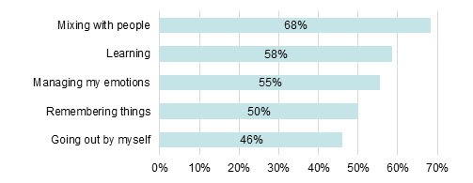

The main areas of functional impact reported by respondents who attended mainstream secondary school are similar to the areas of functional impact reported by respondents attending special secondary school and special unit within mainstream secondary school.
Areas of functional impact – home school and other school settings
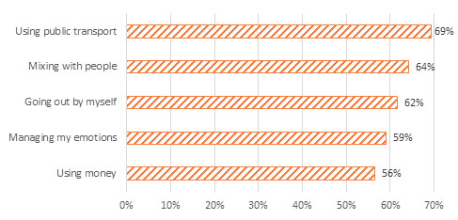
The areas of functional impact reported by those attending home school and other school settings (such as distance education, behavioural schools, special development schools) are slightly different, with using public transport and using money being two of the top 5 areas of functional impact.

Support implementation and fund utilisation

Support funding utilisation status
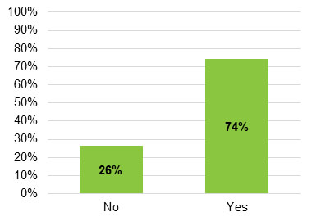
Number of respondents: 651
About 74% of the survey respondents used the support funds.

Reasons for participants not utilising the support
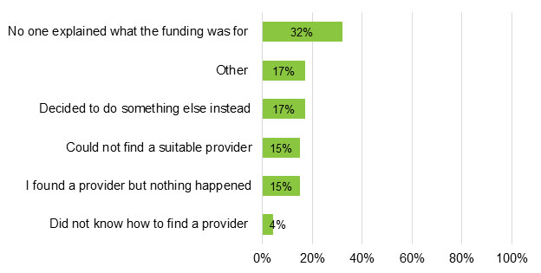
Number of respondents: 170
The top reasons for participants not utilising the support were ‘nobody explained the purpose of funding’ and ‘other’ circumstances (the common themes in ‘other’ were funding not suitable / participants are not ready, COVID, funding not included in the plan at the right time, personal health) OR the participant decided to do something else instead.

Most common means of selecting a provider
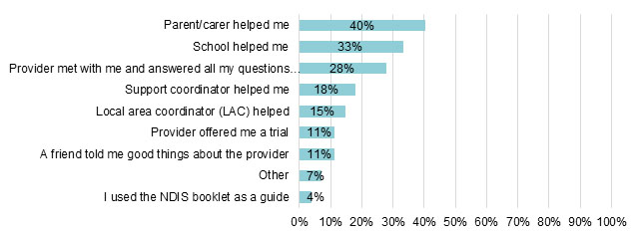
Number of respondents: 481
The top 3 most common means for participants to select a provider were: parent or carer, school, or assistance from a provider who met with the participant and answered their questions. 18% of respondents said their support coordinator assisted them and 15% said they were assisted by their LAC. Respondents were able to select multiple responses to this question.

Provider Performance

Support contribution to goal achievement
How well did your school leaver employment supports help you work towards your employment goals?
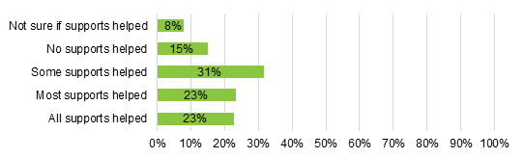
Number of respondents: 481
46% of survey respondents said that most / all supports helped them in achieving employment goals.

Did provider help you undertake courses to pursue employment goals?
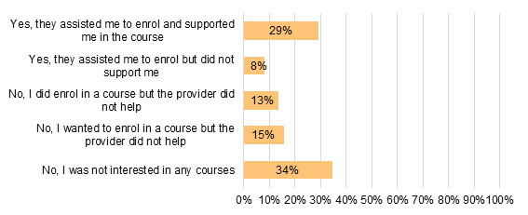
Number of respondents: 481
28% of survey respondents who used their supports said they were interested in enrolling in a course but did not receive support from their provider to enrol.
8% said their provider supported them to enrol in a course but did not support them further.
29% of survey respondents who used their supports said that the provider assisted them to enrol and supported them in the course.

Support for work experience
Did provider arrange work experience?
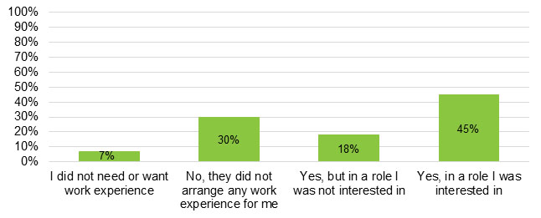
Number of respondents: 481
Of participants who used their supports, 61% said their provider arranged work experience. 44% said that the provider arranged work experience in a role they were interested in.

Did provider support you on the job during your work experience?
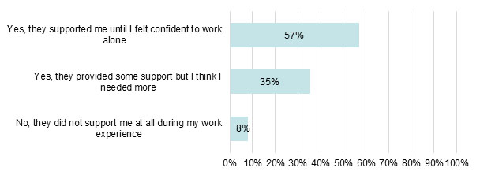
Number of respondents: 297
Out of all survey respondents who said they undertook work experience, 57% said that the provider supported them on the job during work experience. However, 43% said they required more support or were not supported at all.

Skills respondents learnt with the provider
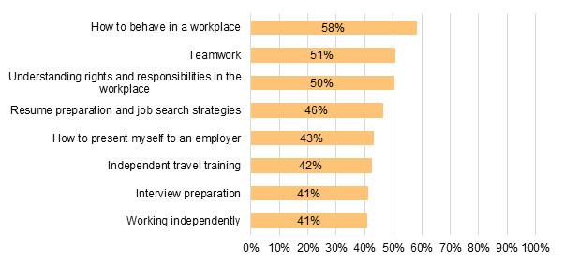
Note: See appendix 2 for full chart, number of respondents is 481
The top 5 skills respondents said they learnt with providers were how to behave in a workplace, teamwork, understanding rights and responsibilities in the workplace, resume preparation and job search strategies, and how to present myself to an employer.

Suggestions on how providers could have improved support
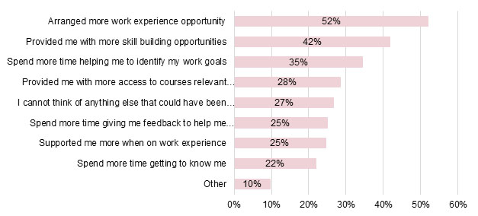
Number of respondents: 481
57% of survey respondents felt that their provider could have spent more time getting to know them and identifying their work goals, 52% felt that providers could have arranged more work experience, 42% believed they could have been afforded more skill building opportunities.

Participant Outcomes

Outcomes measurement
The following section of the survey analyses the outcomes from respondents who were previously receiving school leavers employment support and were not receiving the support at the time of the survey. As such, there are 275 respondents (out of 481 respondents who received the support) for this question.
Respondents were asked about the outcomes immediately after finishing with provider and their current employment status.
Employment Outcomes have been grouped into 3 categories:
- Open employment outcomes: paid employment in area of interest, paid employment not in area of interest, and starting own business.
- Supported employment outcome: started a job in Australian Disability Enterprise (ADE).
- Non-employment outcomes: did not find employment and had to look for work on my own, provider referred me to a Disability Employment Services (DES), did voluntary work to gain more work experience, did more study at TAFE/business college/similar, provider referred me to another service provider and other (e.g. not job ready).

Outcomes after finishing with the provider
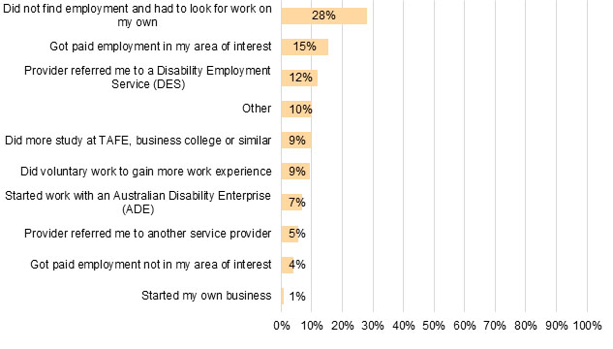
Number of respondents: 275
The top 4 outcomes after finishing with provider were: Did not find paid employment and had to look for work on their own, Got paid employment in their area of interest, Provider referred me to a DES, and ‘Other’ outcomes (the common theme in ‘Other’ was participant not ready for work).
20% of survey respondents achieved an open employment outcome on finishing with the provider, 15% of these in their area of interest. 7% achieved a supported employment outcome. The remaining 73% did not achieve an employment outcome.

Outcomes after finishing with the provider: open / supported & non-employment outcomes
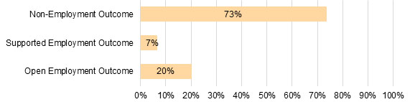
Less than 30% of respondents yielded an employment outcome immediately after completing the school leavers employment support.

Current employment status of school leavers: open / supported & non-employment outcomes
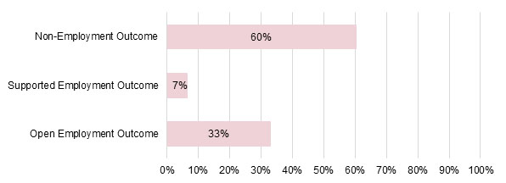
Number of respondents: 275
33% of participants surveyed reported an open employment outcome as their current employment status at the time of survey which is an increase of 13% from the outcome immediately post exit from the provider.

Correlation between providers understanding of support needs and employment outcomes

Number of respondents for this question: 29 (very bad), 37 (bad), 66 (neither good nor bad), 67 (good), and 76 (very good)
Survey respondents who reported their provider had a very good understanding of their support needs had the highest open employment outcomes (32.9%).

Correlation between frequency of progress and review and open employment outcomes
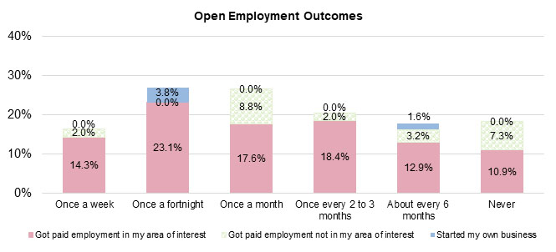
Number of respondents for this question: 49 (once a week), 26 (once a fortnight), 34 (once a month), 49 (once every 2 to 3 months), 62 (about every 6 months), and 55 (never).
Participants who had once a fortnight progress review had the highest proportion of open employment outcomes.

Conclusion

Key findings
- Respondents surveyed were typically aged 21, had left school in 2018, completed year 12, and attended a special unit within mainstream secondary school or special secondary school setting.
- The most common areas of functional impact for respondents across all school setting were learning, social interaction, and activities related to self-management.
- Main reason reported for not utilising support funding: ‘Nobody explained the purpose of support funding’.
- The main supporters of participants to select an appropriate provider were parents and carers, schools, and providers themselves. With 18% of participants reporting they were assisted by a Support Coordinator and 15% saying they were assisted by their LAC.
- 44% of participants surveyed said that providers helped them to arrange work experience in an area of interest, with less than 30% saying they were supported to undertake courses to pursue employment goals. Out of all participants who said they undertook work experience, 57% said that the provider supported them on the job during work experience. With 43% saying they required more support or were not supported at all.
- Participants felt services could be improved by providers spending more time getting to know them, arranging more work experience, and offering more skill building opportunities.
- 20% of respondents achieved an open employment outcome immediately after finishing the support. Nevertheless, the current employment status of 33% of the respondents at the time of survey was an open employment outcome.
- The variables associated with highest open employment outcome are regular progress review and providers’ very good understanding of participants’ support needs.

Appendix
Appendix 1: Areas of functional impact of disability
Appendix 2: Skills respondents learnt with provider

Appendix 3: Impact of skills on open employment outcomes

The following chart illustrates the correlation between skills learned from provider and open employment outcomes (paid employment in area of interest, paid employment not in area of interest, and starting own business) achieved by participants who have just completed the support.

