NDIS myplace provider portal
Step-by-step guide
Part 2. Maintaining your information

October 2023
Table of Contents
Changes from the last version 3
How to contact NDIS 4
Maintaining your information 5
Profile 6
About me 6
My organisation details 7
How Frequently Can NDIA Contact Me? 9
Organisational staff 11
Bank details 12
Link to my organisation 14

Changes from the last version
The following updates have been made to the last published version of the myplace provider portal step-by-step guide:

As of October 2023:

- Updated text and screenshots in Link to my Organisation chapter (pages 14 and 15)

How to contact NDIS

Contact the NDIS by
NDIS Webchat  You can live chat with us about:  - myplace provider portal  - Service bookings  - Payment requests  - Quotes  - Referrals  - Request for service  - Searching for a register provider | Phone  1800 800 110You can call us about:  - myplace provider portal  - Service bookings  - Payment requests  - Quotes  - Referrals  - Request for service  - Searching for a register provider  - Submitting a general enquiry, feedback, compliment or a complaint | provider portal  You can use the provider portal to:  - Submit a payment enquiry  - Submit a general enquiry, feedback, compliment or a complaint  - Search for a provider  - Upload documents
Email us  enquiries@ndis.gov.au  You can email us about:  - Submitting a general enquiry, feedback, compliment or a complaint  - Emailing a document, form report or letter | Contact and Feedback form  NDIS Online Form  You can use the Online form to:  - Submit a general enquiry, feedback, compliment or a complaint  - Request a call back | Mailing address  National Disability  Insurance Agency  GPO Box 700  Canberra ACT 2601  You can mail us:  - Compliment, complaint or provide feedback,  - Document, form, report or letter

Maintaining your information
These functions enable you to:

- View your Profile (your and your organisation’s contact information and roles within the provider portal).
- View your Registration details (the services you are approved to provide under the NDIS). To register and maintain your registration details and registration groups you will need to contact the NDIS Quality and Safeguards Commission.
- View your Outlets (the times and places from which you deliver services). To add or edit outlet information for outlet you will need to contact the NDIS Quality and Safeguards Commission.
- Manage the organisations which Link to my Organisation (the organisations you work for).
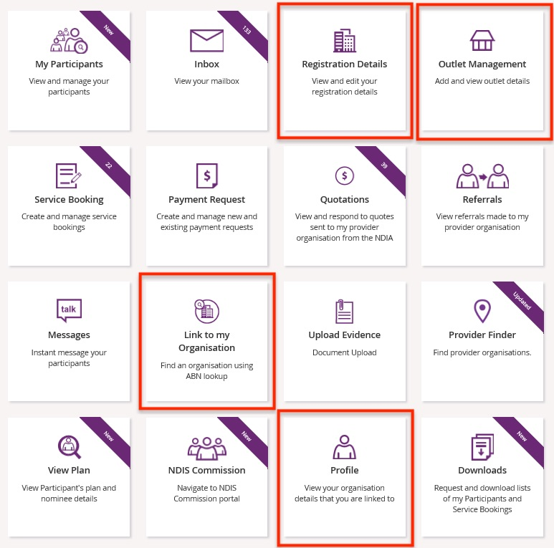

Profile
This allows you to view and update your personal details, and view (and update if you are the account manager for your organisation) the Provider Finder Display in your organisation details, organisation staff and bank details.

      - Select the Profile tile on the myplace home page, or the Person icon from other pages.
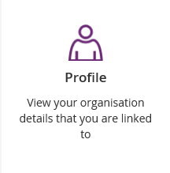
      - The Profile page displays. Use the Open and Close section buttons to see all the information.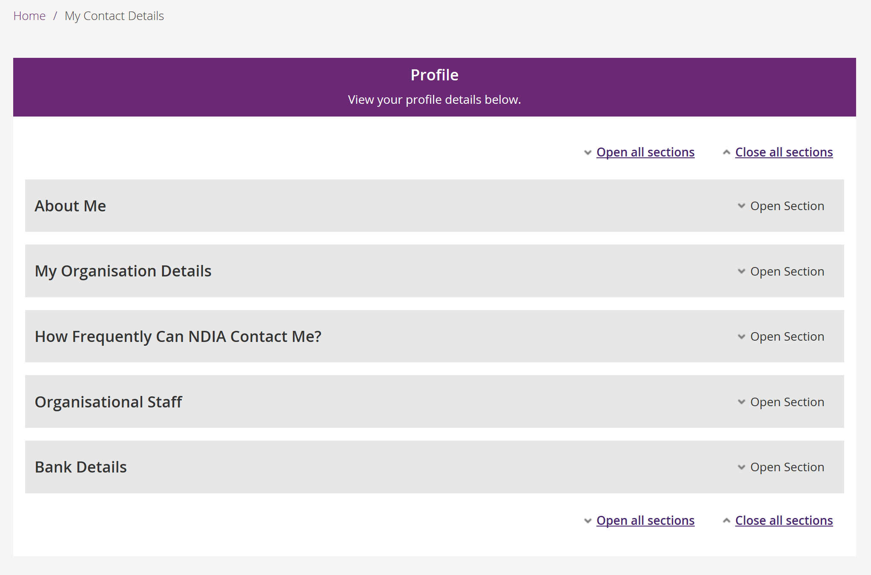

About me

- Select Edit in the About Me group to update your telephone numbers and email address.
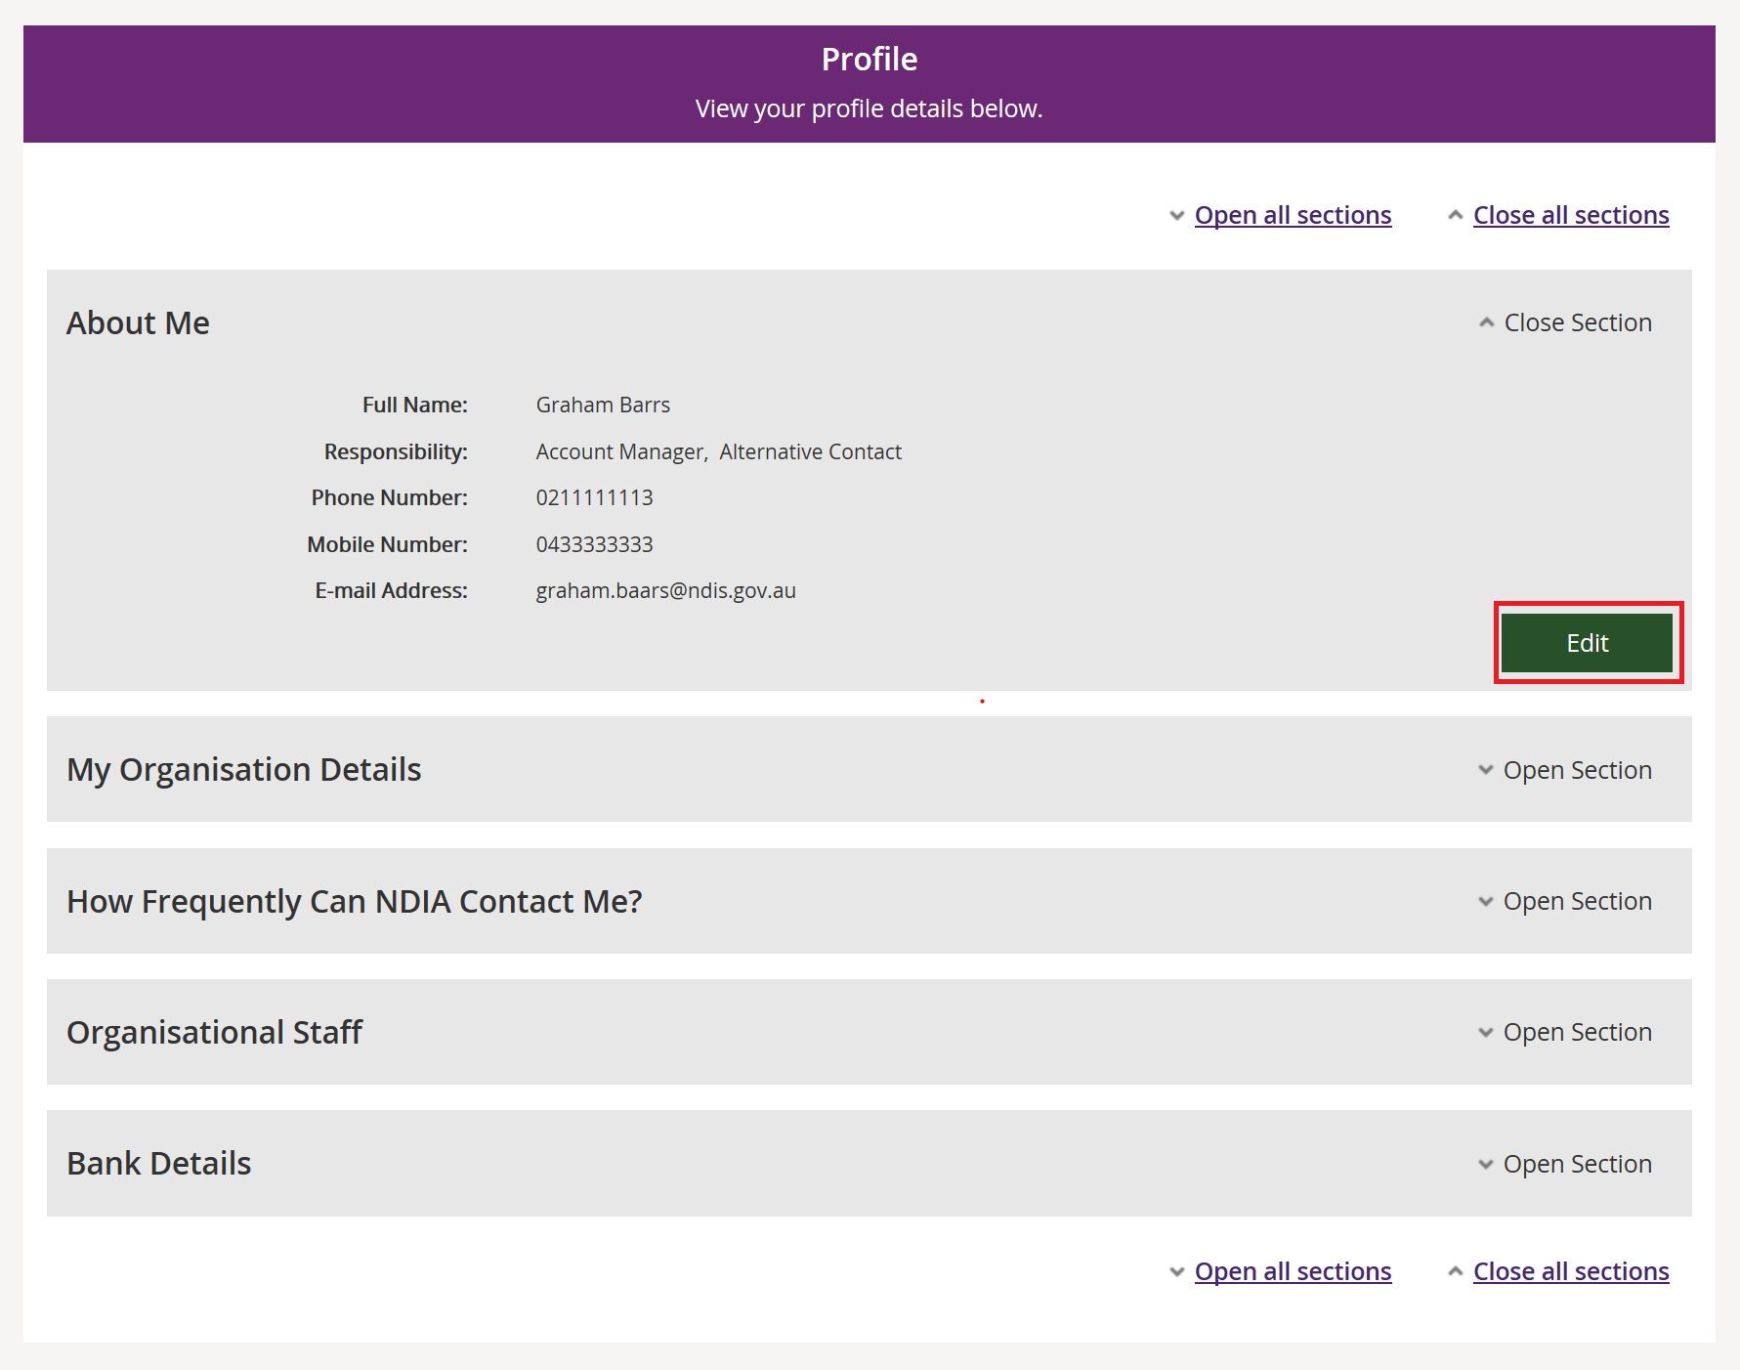
- Enter your changed details and select Update.
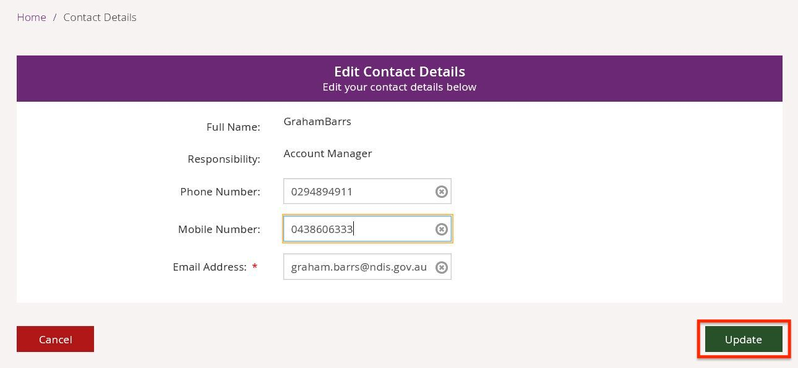
Note: If you do not wish to update your details, select cancel. You can only change phone numbers and the email address.

My organisation details
- View name and contact information for your organisation in the My Organisation Details section.
- Select Edit to update whether the provider should display in the Provider Finder, and if so whether the address should also be displayed.
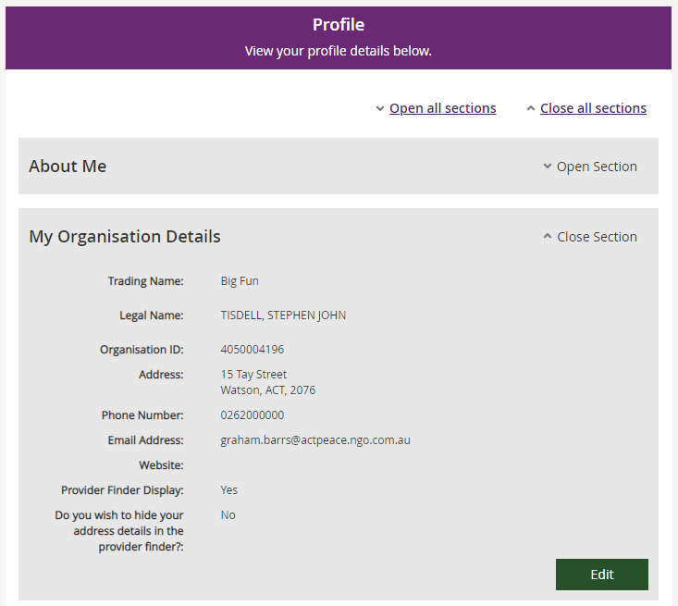
Note: The following steps are only available if you are the account manager for your organisation.
- Select ‘Yes’ if the provider should display in the Provider Finder, and if so whether the address should also be displayed. Then select Update.
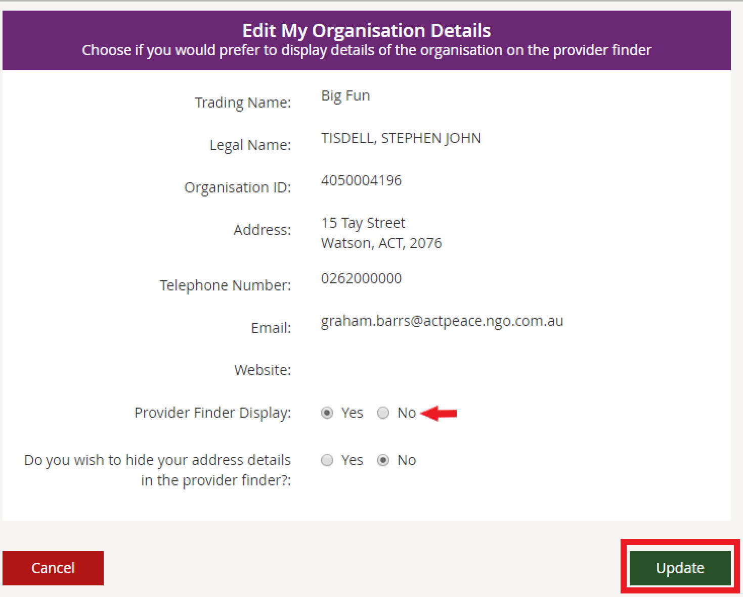
Note: To edit your organisation’s details including your email address, to make sure you receive important information, you will need to contact the NDIS Quality and Safeguards Commission.

How Frequently Can NDIA Contact Me?
Nominate how often your organisation wants to be notified about changes to service bookings and quotations, and new Requests for Service sent to your organization for review. For new Requests for Service you will be notified immediately. For service bookings and quotations you can choose to be notified:
- Immediately
- Daily
- Weekly
- Never

Note: You will only be notified about service bookings and quotations that your organisation needs to action.

- Select Open Section to view or edit your information.
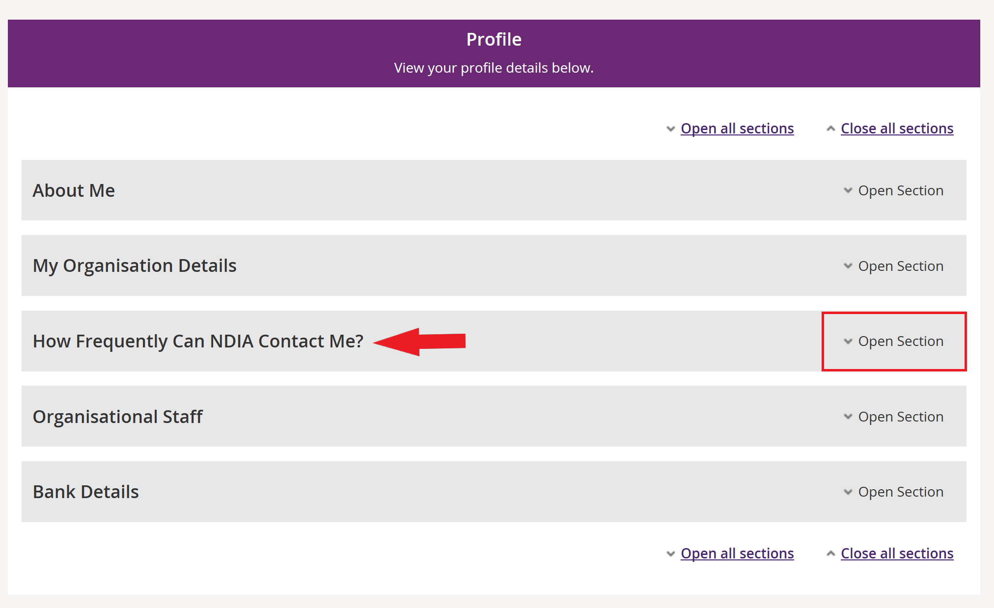
- Select Edit to update your preferred frequency.
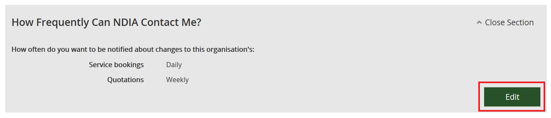
- Choose from the drop-down how often you wish to receive service bookings and quotations notifications and select Update:
- Immediately
- Daily
- Weekly
- Never
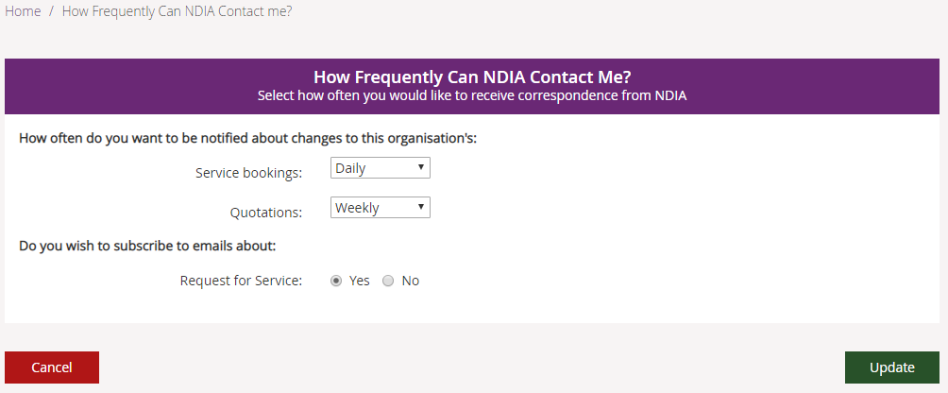
Note: If you choose daily or weekly, all changes for the previous day or week (Monday to Sunday) will be grouped together and sent in one message to your inbox.
- Choose from Yes and No to update your Request for Service email preferences.
- Select cancel if you wish to cancel the selection. A popup box will appear asking for confirmation to return to the Profile screen without updating any contact details.
- Select yes to return to the Profile screen; select No to return to the list of correspondence options and make a selection.
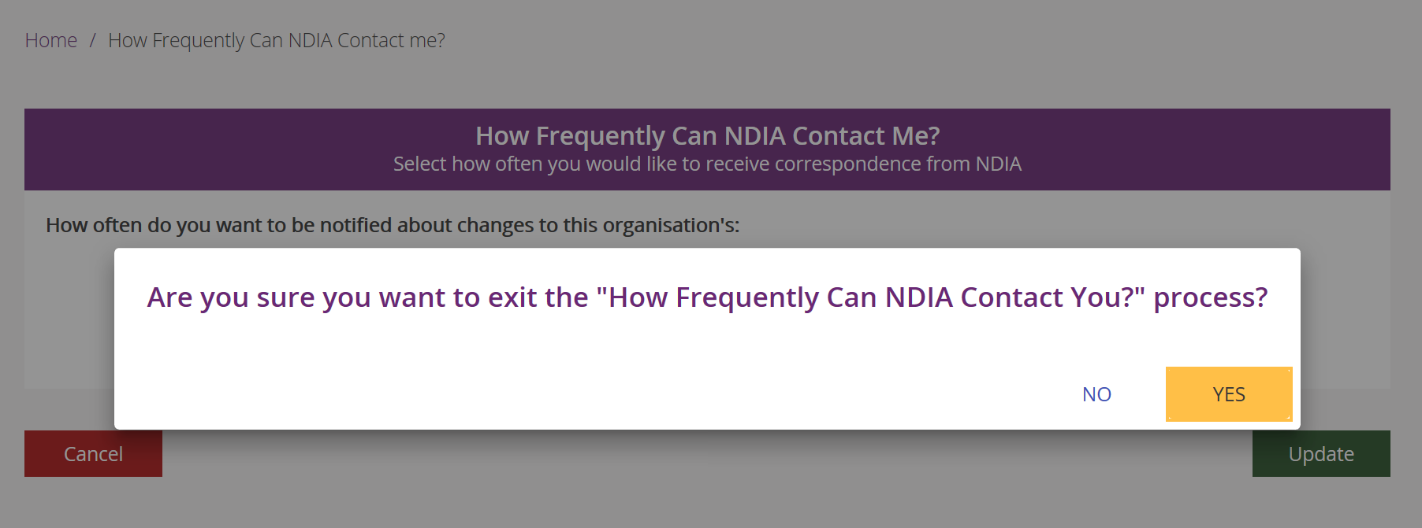

Organisational staff
Your role (also shown as Responsibility or Contact type depending on the screen) will be allocated to you by your organisation’s account manager.
If you are linked to multiple organisations, your role may vary between organisations.

Depending on your role, you can view your profile, edit your details, edit contacts and update bank account details. The roles available are:
Contact type / Responsibility role | Account manager | Primary contact | Alternative contact
Number allowed (per Organisation) | Multiple | One | Unlimited
Create Service bookings | Yes | Yes | Yes
Submit Payment requests | Yes | Yes | Yes
Cancel Paid and Pending Payment requests | Yes | Yes | No
Add/ Remove contacts | Yes | No | No
Update Bank account | Yes | No | No

If you have the account manager role, you can edit the staff roles for your organisation through the Organisational Staff section.

Important note: The first person who links to an organisation will be automatically assigned the roles primary contact and account manager. This applies when the registration is processed through the NDIS Quality and Safeguards Commission.

- Select End Role in the Action column to remove that access type from a contact.
- To add a new role to an existing contact, select Add Role.
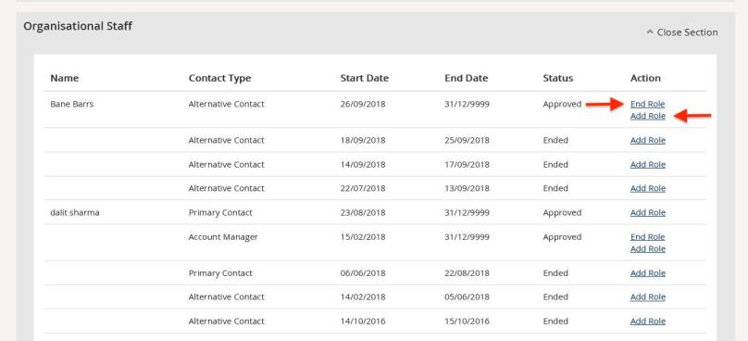
- Select the contact type from the Contact Type drop-down and select Update to save the record.
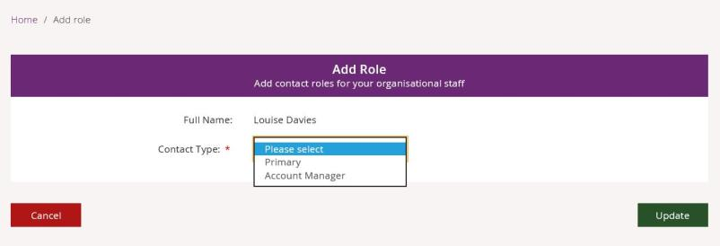
Tip: The Contact Type available to select will be limited to the roles the staff member does not hold.
Tip: An individual user cannot hold both primary contact and alternate contact roles at the same time.

Bank details
The NDIA will pay Payment Requests from your organisation to this account.

- To add bank account details, select Add Bank Detail from the Bank Details section.
Note: Only the account manager can add or edit bank accounts details.
Note: Bank details cannot be updated if there are payments approved but not yet paid. Changed bank details will take effect immediately.

- Complete the following fields:
- At Account Name, enter the bank account name.
- At BSB, enter the six-digit BSB number.
- At Account Number, enter the account number.
- Select Update.
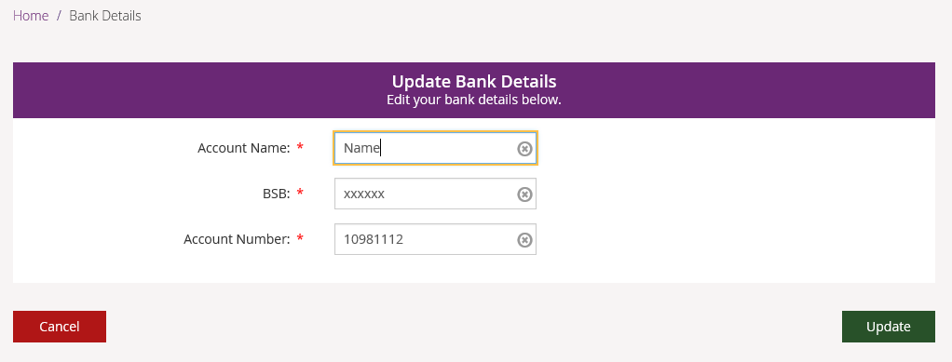

- Once you have saved your bank account details, use the Edit button if you need to change the account details.
Note: Whenever the bank account details are added or edited, the primary contact for your organisation will receive an SMS stating:
We have updated your bank account details as requested. Contact NDIA on 1800 800 110 if you need to.

Link to my organisation
This allows you to link your PRODA account to another provider. It works the same way as when you linked the current provider you are using in myplace.
- Select the Link to my Organisation tile on the myplace home page.
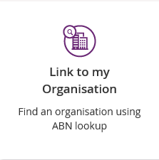

- Enter the ABN (11 digits, no spaces) or the Organisation Name of the provider to which you wish to link and select Search.
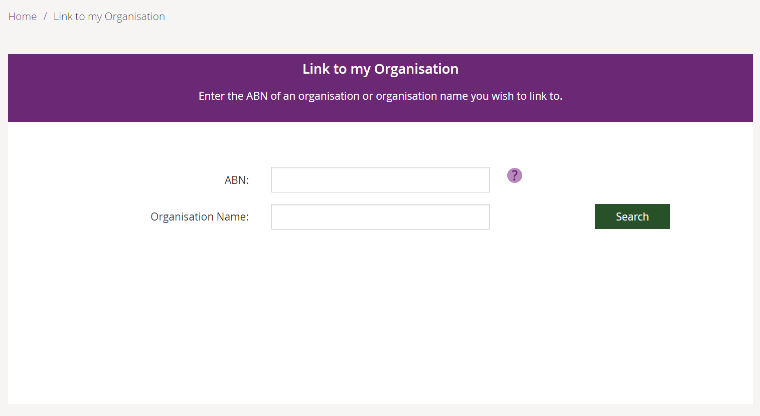

- Select the provider from the list and select next.
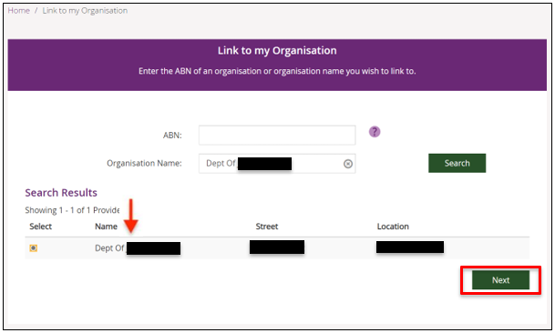

- A thank you message displays. Your request is sent through to the provider.
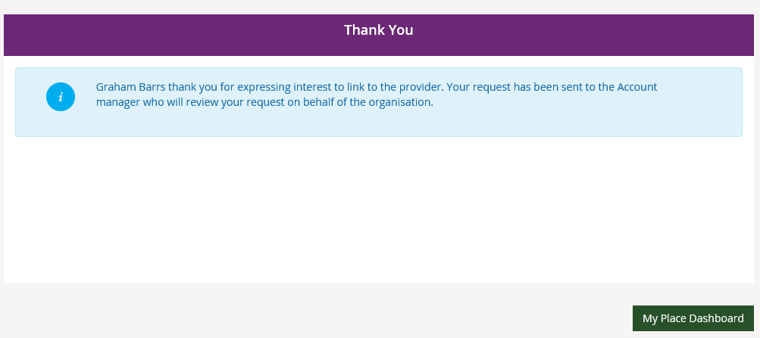
Important note: If you are linking to a provider that does not have a primary contact set up, a new screen will pop up that asks you to provide one.

