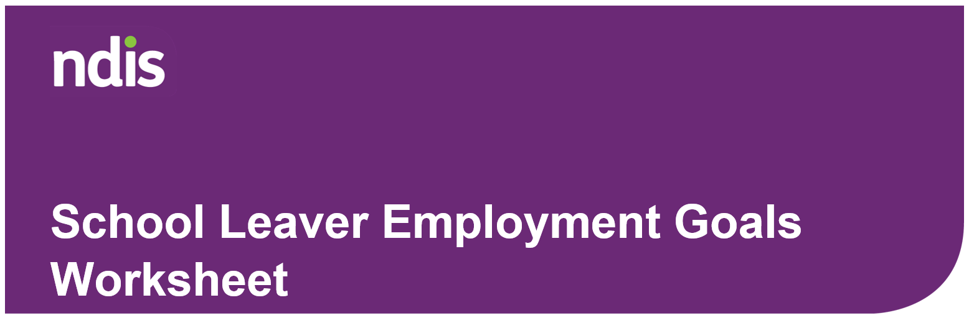
Congratulations on finishing school and turning 18! What a big milestone and exciting time.
As a school leaving age participant of the National Disability Insurance Scheme (NDIS), you can get extra support after leaving school to help you create and work towards achieving your employment goals.
This worksheet will help you think about what you want to do after school, including getting a job.

Some things to think about after leaving school
Take a moment to reflect on these questions:
- Do you want to get a job?
  - What sort of job?
- Do you need help to get a job?
  - What kind of help?
- Do you want to do further study?
  - Do you need help to do further study?
  - What type of help?
When you leave school, you have lots of choices. What you choose to do depends on your abilities, interests and your goals. The NDIS funds different types of support to help you achieve your goals.
We can support you by putting money in your plan to pay for the supports you need to enable you to study or to develop your work skills and get a job.
Another thing to think about is appointing an NDIS nominee.
- When you turn 18, the National Disability Insurance Agency (NDIA) considers you an adult and able to make decisions that affect your own life.
- If you want your parent/guardian or other support people to speak to the NDIA and help you with decisions about your NDIS plan, you need to appoint them as your NDIS plan nominee.

Setting goals
Fill in the worksheet on the next page. This will help your planner or local area coordinator (LAC) understand what you want to do and what support you might need. This helps make sure that you have the right funds in your plan to get the supports you need after leaving school.
Visit the Planning to achieve your goals page on the NDIS website to learn more about goals.
It is important that you bring this worksheet to your planning meeting.
Goals worksheet
- Do you have any work goals?
☐ Yes ☐ No
- Are you ready to start looking for work?
☐ Yes ☐ No

- What sort of work are you interested in?
Write answer here

- If you plan to study before working, what course or training would you like to do?
Write answer here

- Do you need help in finding out what your work goals are?
☐ Yes ☐ No

- Do you need help to build your skills, independence and confidence before looking for work?
☐ Yes ☐ No

- If you do not have any work goals right now, please tell us why.
Write answer here

Next steps
Once your plan is approved, it is important to talk to your employment provider/s about setting aside the right amount of money from your plan to help you achieve your goals. You will also need to complete a service agreement with them.
If you have any questions, talk to your LAC or planner or visit the Creating your plan page on the NDIS website.

