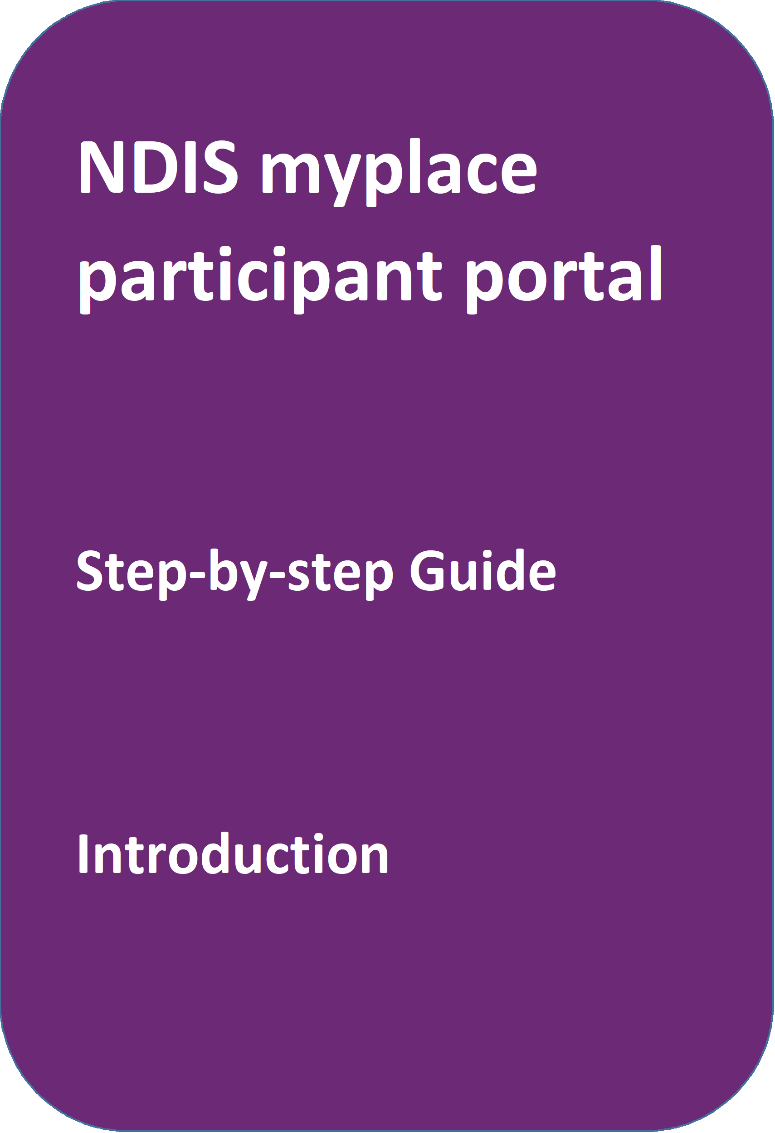
August 2023
portal
June 2020

Table of Contents
Table of Contents 2
Changes from the last version 3
Introduction 3
What can you do in myplace? 3
Internet Browser Requirements 3
Before you start 4
Your first login 4
Logging into the portal after linking with myGov 8
The portal via myGov website 8
The portal via NDIS website 9
myplace portal home page 10
Tiles 11
Need more help? 12
Logging out of myplace 12

Changes from the last version
The following updates have been made to the last published version of the myplace portal step-by-step guide:
- Inclusion of Terms and Conditions and Privacy Notice process (Page 7 to 8)

Introduction
The NDIS myplace portal is a protected and secure website that can only be accessed using myGov account login credentials.
The portal has been developed to allow you greater control over managing your own information, plan details and plan budget.
Note: the data used in the screenshots throughout this guide are have been created for instructional purposes and do not represent actual participants.

What can you do in myplace?
As a NDIS participant you can use the myplace portal to:
- View and update your contact details;
- View your NDIS Plan, including information about your funded supports;
- View and manage your current plan budget;
- Request payment for self-managed supports;
- Search and locate registered service providers;
- Create and manage service bookings with registered service providers;
- Manage your consent to share all or part of your plan with service providers;
- Upload documents; Print your plan;
- View the Planning Support Booklets; and
- MyGov Inbox

Internet Browser Requirements
The portal is accessed via the internet and has the following minimum browser requirements:
Internet Explorer 11
Microsoft Edge (Version 44)
Mozilla Firefox (Version 69)
Google Chrome (Version 77)
Safari 13 (Apple Only)

Before you start
To login to the portal, you will need a myGov account and a NDIS activation code.
You can request an activation code before you become a participant, or at any time, by contacting the NDIA on 1800 800 110.

Your activation code is temporary and will expire after 10 days. If you lose your code or it expires, you can contact the NDIA and request a new code.

Before logging in for the first time, you will need to link your myGov account to the National Disability Insurance Scheme. You will then be required to input your activation code; the activation code is only required the first time you login to the portal.

Note: Instructions for creating a myGov account can be found by typing the following address into your browser address bar: https://my.gov.au/mygov/content/html/help.html

Your first login
- Sign into myGov (my.gov.au) using your existing username and password.
- To link your myGov account to your NDIA record, click the View and link Services link at the bottom-right of the page.
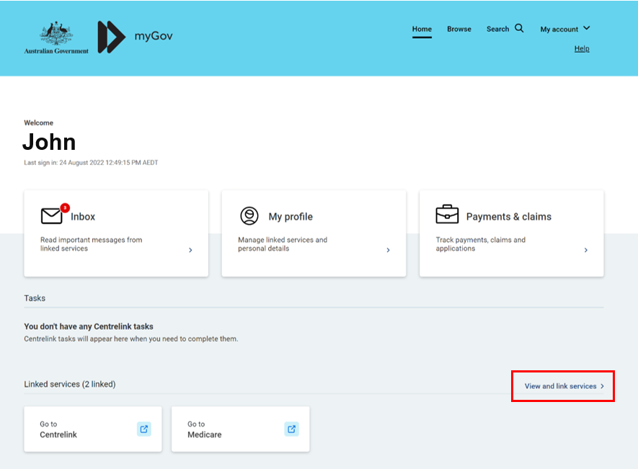
- Then choose National Disability Insurance Scheme from the Link a service list.
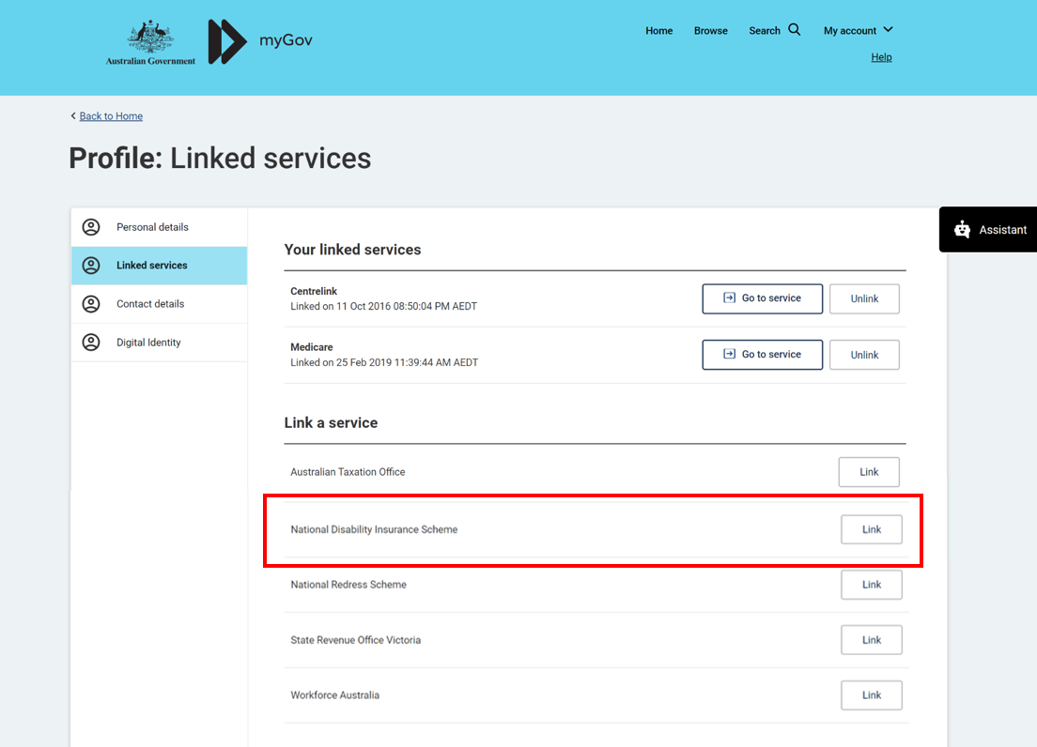
- Type in your NDIS Activation Code, your Last Name, and your Date of Birth, then click the Submit button at the bottom of the screen. You only need to put in the NDIS activation code the first time you access the portal. This screen will not display again.
Note: You can request an activation code by contacting NDIS on 1800 800 110 or here.
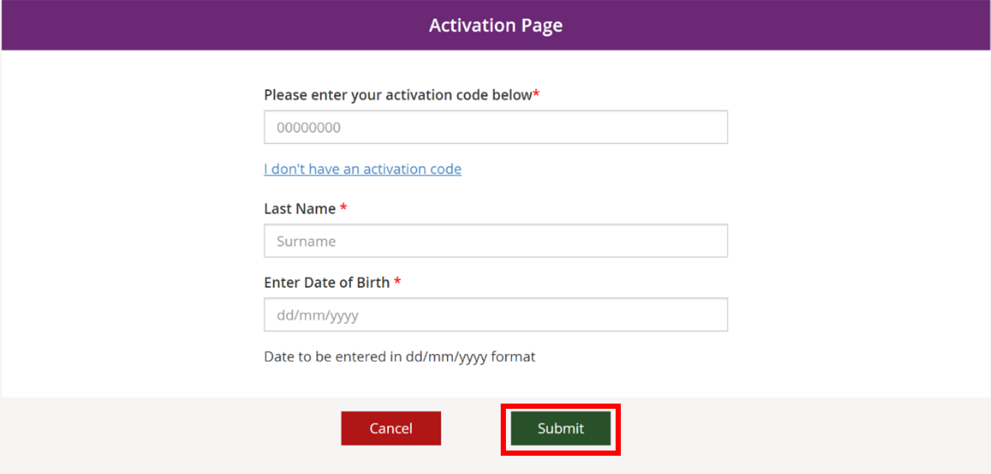

- The Terms and conditions will be displayed the first time you sign into the portal or when there have been updates that you need to be aware of. Move the scrollbar to read the Terms and conditions.

- Once you have read the Terms and conditions, select the checkbox located next to I have read and agree with the terms and conditions and press the I agree button to continue.
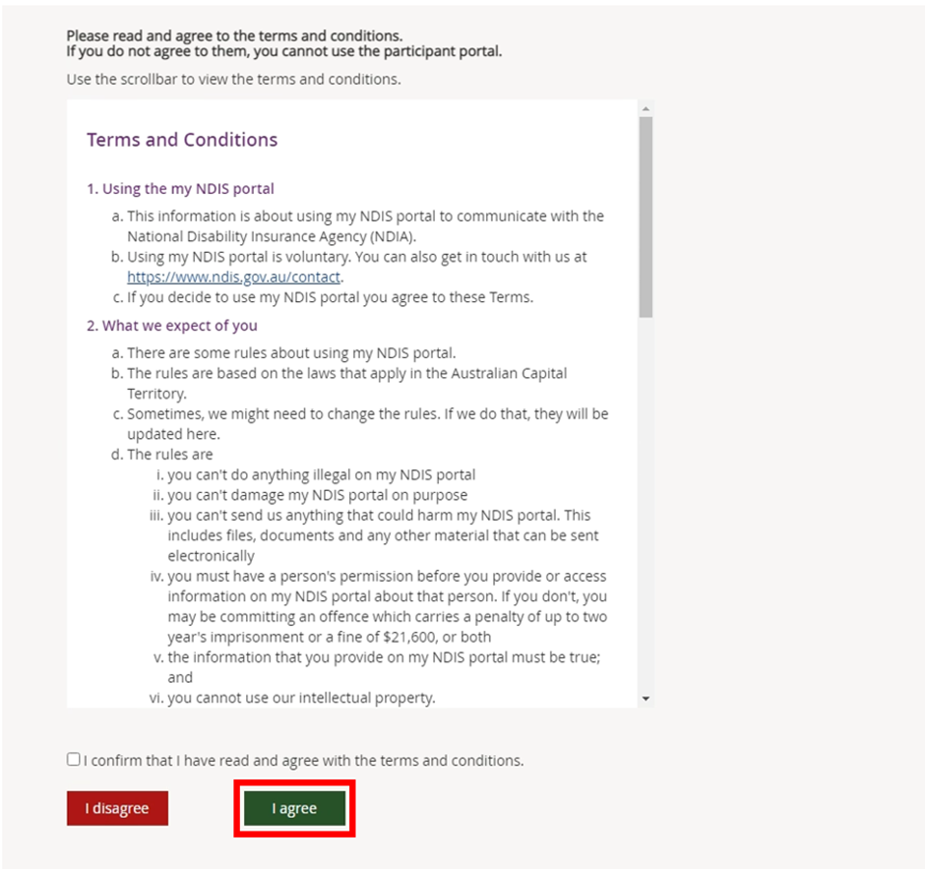
- The Privacy Notice will be displayed. Once you have read the Privacy Notice, select the checkbox located next to I have read and agree with the Privacy notice and press I agree button to continue.
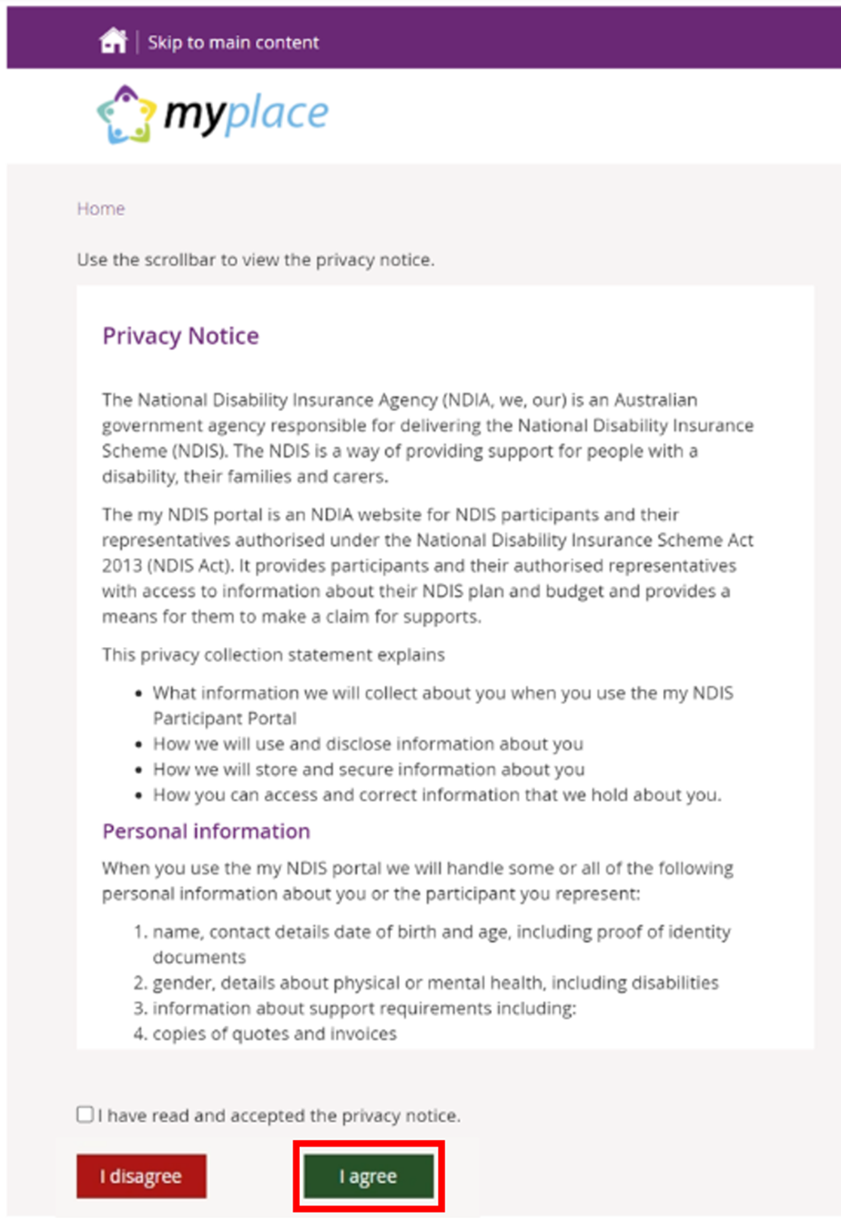

- The portal home page displays.

If you need any further support, you can contact the NDIS directly on 1800 800 110 or contact us here.

Logging into the portal after linking with myGov
Once you have linked your myGov account with your NDIS account, you can access myplace via the the myGov website (my.gov.au) or via NDIS website (ndis.gov.au).

The portal via myGov website
- Log into myGov (my.gov.au)
- Select NDIS under Your services.
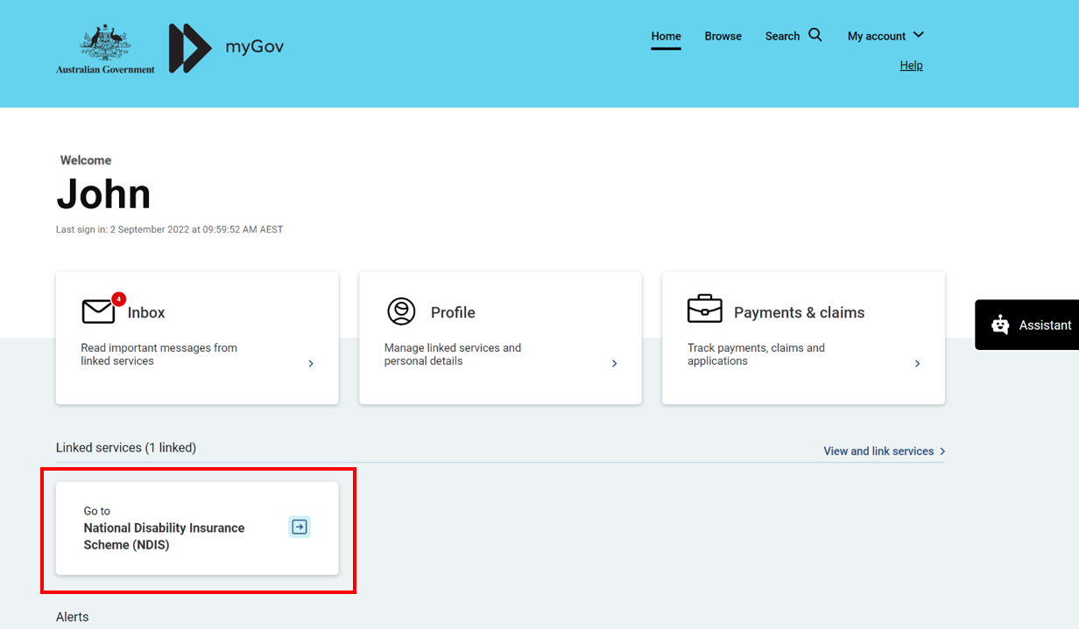
The portal home page displays
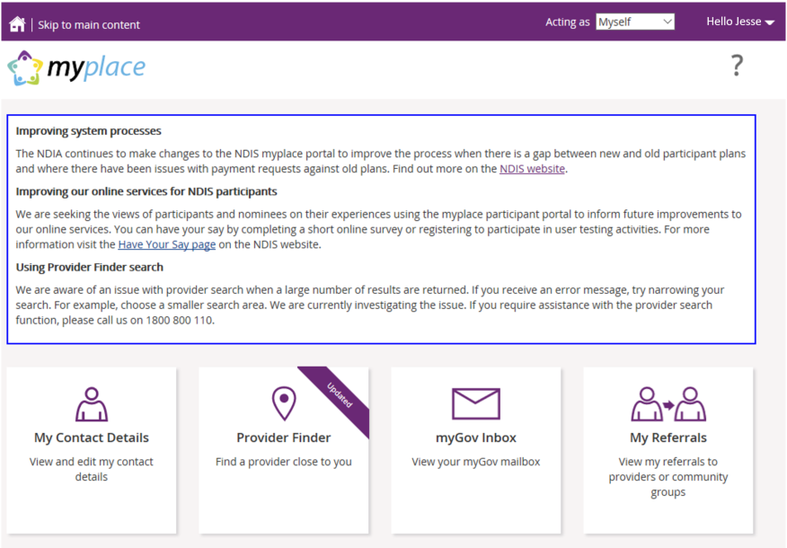

The portal via NDIS website
- Go to the NDIS website (www.ndis.gov.au).
- In the top right-hand corner click on the Portal sign in button and then select myplace participant portal from the drop-down menu.
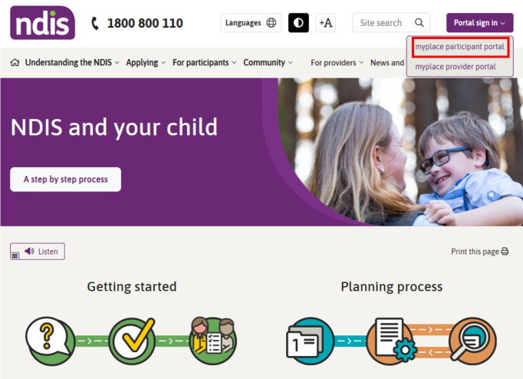
- Enter your myGov username (email or mobile number) and password, and then click the Sign in button.
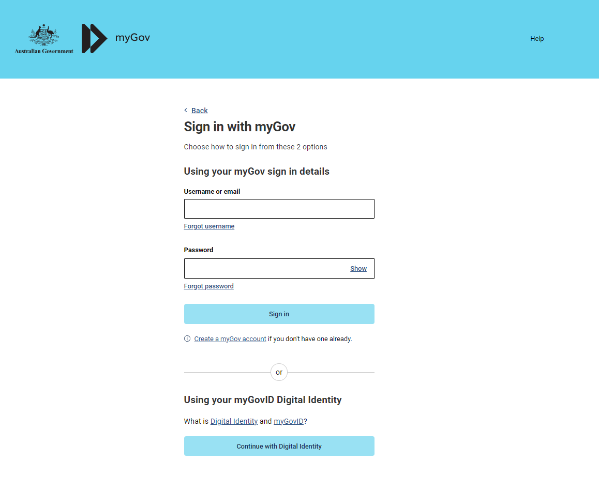
- Depending on your myGov preferences, you will need to answer secret questions, enter a unique security code or a myGov PIN. Once answered, click the Next button. The home page displays.

myplace portal home page
The homepage displays once you have signed in. The tiles you see are specific to the stage of the pathway (your NDIS journey) you have reached, or if you are signing in as a child representative or nominee. For example, the My Plan tile is only available once you have an approved NDIS plan.
- To return to the home page, click on the myplace icon or press the Home (house) icon.
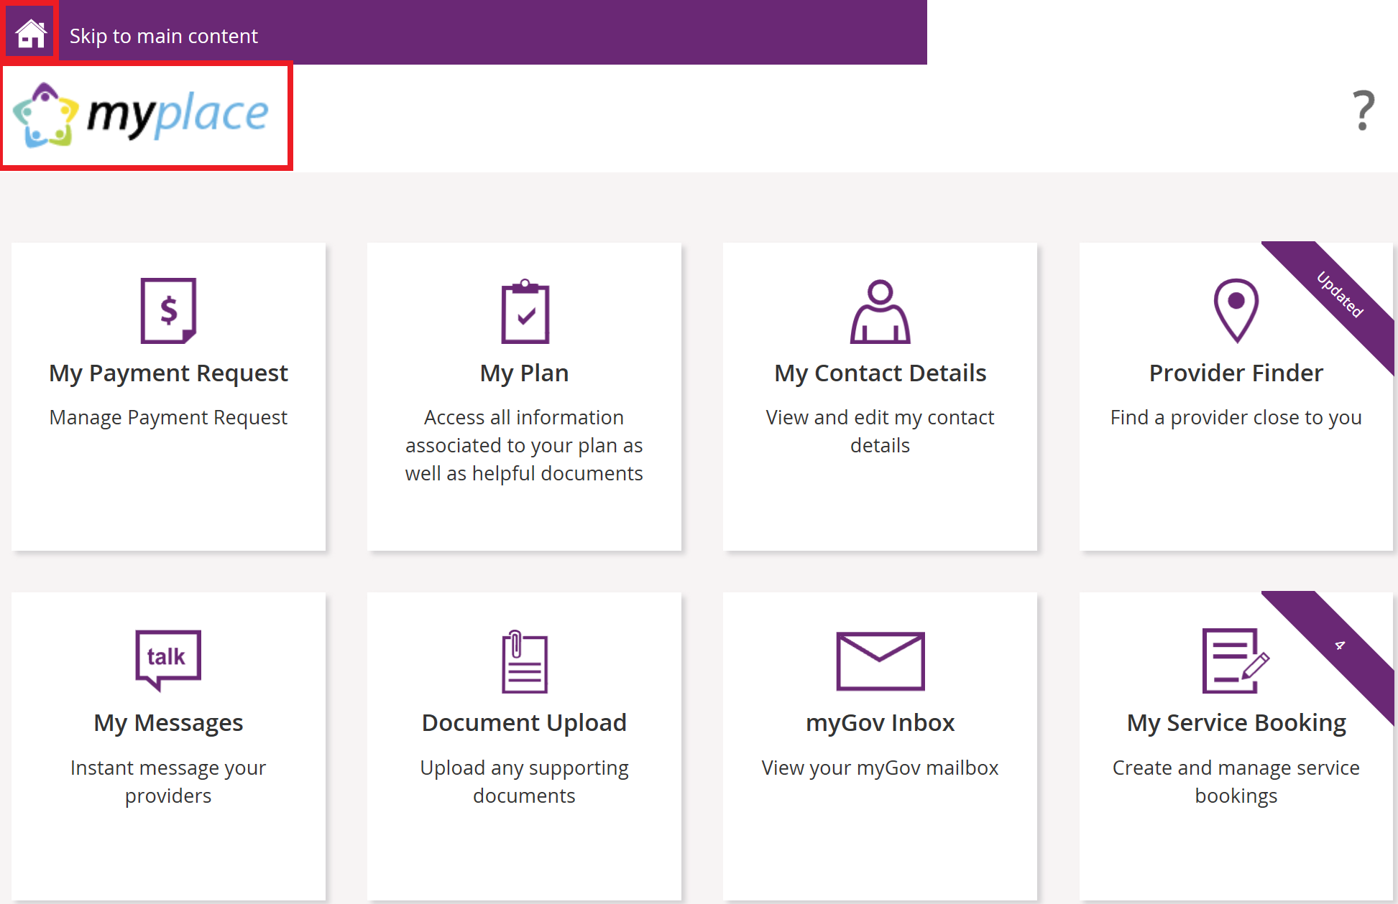

Tiles
The following table is a brief outline of what function each tile has within the portal.
.
Tile | Name | Function
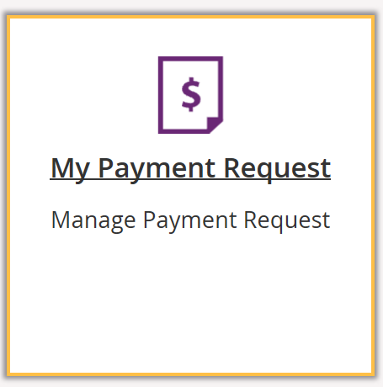 | My Payment Request | If you are self-managing all or part of your NDIS plan, this is where you can create, view and manage your payment requests (claims).
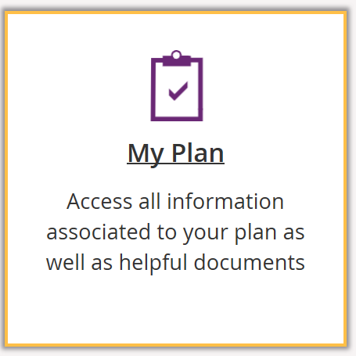 | My Plan | Once you have an approved NDIS plan, this is where you can view the details of your plan, including support budget, my referrals and my funding report.
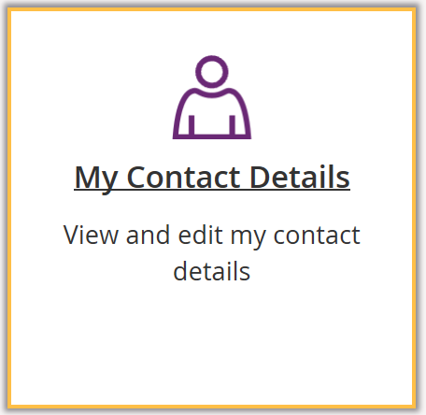 | My Contact Details | View and edit your personal details, contact details, address, How can I contact NDIA, bank account details and consent to share your plan with providers here.
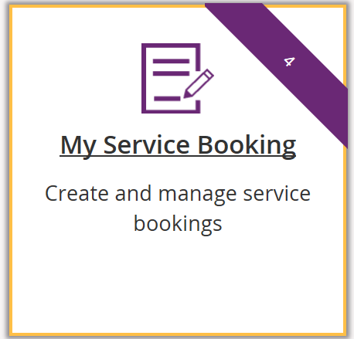 | My Service Bookings | Once you have an approved NDIS plan, this is where you can create, view and manage your Service Bookings with registered NDIS service providers (not applicable if you are self-managing).
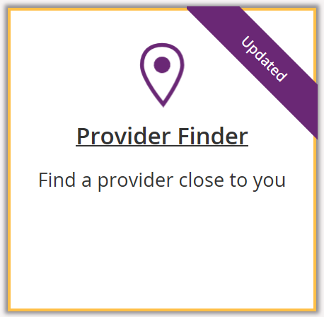 | Provider Finder | Use the Provider Finder to find a registered NDIS service provider near you. You will also be able to book in a service booking from this screen provided that the provider is taking referrals.
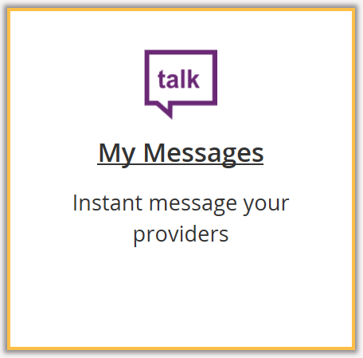 | My Messages | Instant messaging with your providers.  (Check with your provider to make sure this function is available for you).
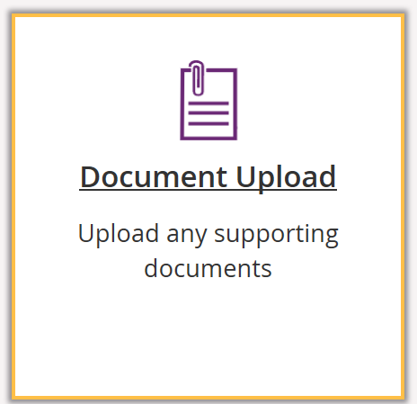 | My Document Upload | Upload documents to support claims or access documentation. Max files size is 25MB, required to have a Document name and description. Below upload document is all available documents previously uploaded.
 | myGov Inbox | View your myGov mailbox.
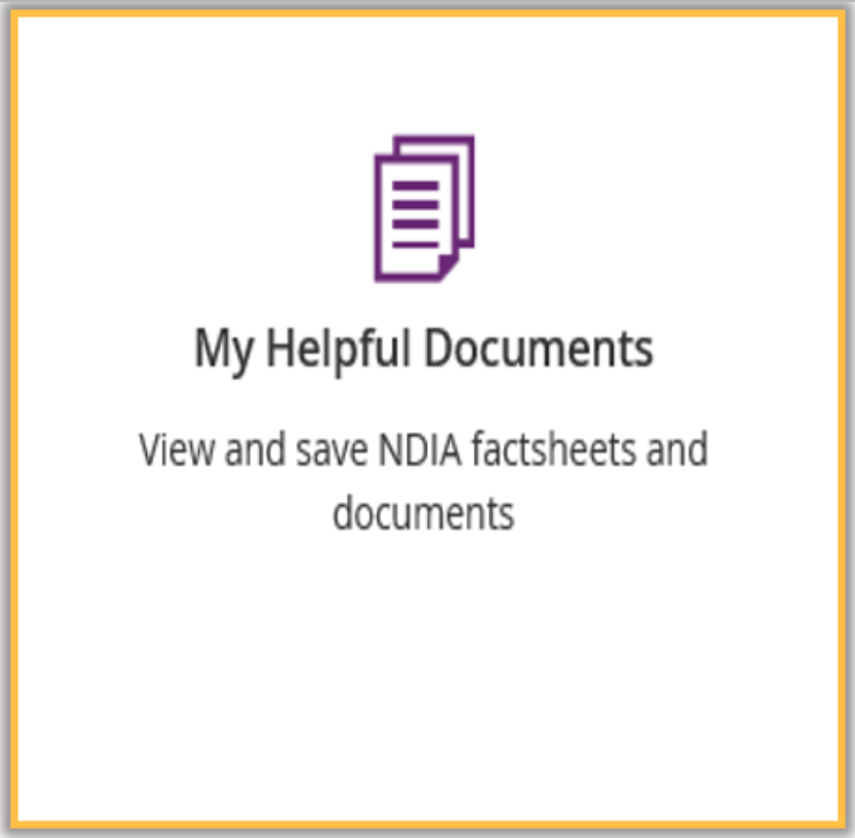 | My Helpful Documents | Use My Helpful Documents to access and view useful support booklets available on the NDIS website

Select a tile displayed on the home page to go that function. For example, selecting the My Payment Request title will navigate you to where you can add or view your payment requests.

Need more help?
In the lower left corner of the screen there is an option to contact the NDIA, click the Contact Us link for further information and detail on how to contact us. Please direct any queries to the NDIA on 1800 800 110 or visit your local NDIA office.

Logging out of myplace
You can log out by selecting the down arrow next to your name at the top of the screen and Select Logout.
This will return you to the NDIS website if you signed in from there or your myGov home page if you had signed in from there.

