NDIS myplace participant portal

Step-by-step guide

May 2024

Table of Contents

Changes from the last version 5
Introduction 5
What can you do in myplace? 5
Internet Browser Requirements 5
Before you start 6
Your first login 7
Logging into the portal after linking with myGov 11
The portal via myGov website 11
The portal via NDIS website 12
myplace portal home page 14
Tiles 15
Need more help? 16
Logging out of myplace 16
My Contact Details 17
About Me 18
How Can NDIA Contact Me? 18
How Can I Contact NDIA? 24
My Address Details 25
Share My Plan 27
My Bank Details 27
My Plan 29
View my plan 30
View my plan: section of the plan 32
My support budget 36
View my funding report 38
Funds breakdown 39
My Referrals 40
Provider Finder 41
Provider Search 41
Recent providers 45
Document upload 47
My helpful documents 49
myGov Inbox 50
My Service Booking 52
Service Bookings with different Funds Management 52
Add My Service Booking 53
View existing bookings 62
Edit a service booking 65
End service booking 68
My Payment Request 71
Add My Payment Request 72
View My Payment Requests 75
Cancel Payment Requests 77
My Messages 80
Leaving Feedback 82
Logging out of myplace 84

Changes from the last version
The following updates have been made to the last published version of the myplace portal step-by-step guide:
- General updates.

Introduction
In October 2023 the NDIA started using a new computer system. To help deliver this new computer system, we’ve built a new portal called the my NDIS participant portal.
The my NDIS participant portal is for participants whose plans are developed in our new computer system. For more information on the my NDIS participant portal, you can go to my NDIS participant portal and app | NDIS Improvements.
If you don’t have a plan in our new computer system yet, you should continue to use the NDIS myplace portal (portal) and this guide.
The NDIS myplace portal is a protected and secure website that can only be accessed using myGov account login details.
The portal allows you to manage your own information, plan details and plan budget.
Note: the information used in the screenshots throughout this guide is for instructional purposes and does not represent actual participants.

What can you do in myplace?
As a NDIS participant you can use the myplace participant portal to:
- View and update your contact details;
- View your NDIS plan, including information about your funded supports;
- View and manage your current plan budget;
- Request payment for self-managed supports;
- Search and locate registered service providers;
- Create and manage service bookings with registered service providers;
- Manage your consent to share all or part of your plan with service providers;
- Upload and view documents;
- Print your plan;
- View the Planning Support Booklets; and
- myGov inbox

Internet browser requirements
You can access the myplace portal via the internet and is supports latest stable browser version:

- Microsoft Edge (
- Mozilla Firefox
- Google Chrome
- Apple Safari

Before you start
To log into the myplace portal, you will need a myGov account and an NDIS activation code.
You can request an activation code when you become a participant or an authorized representative, by contacting the NDIS on 1800 800 110 (Monday – Friday, 8am – 8pm).
Your activation code is temporary and will expire after 10 days. If you lose your code or it expires, you can contact the NDIS and request a new code.
Before logging in for the first time, you will need to link your myGov account to the National Disability Insurance Scheme. You will then be required to input your activation code; the activation code is only required the first time you sign into the portal.
Note: Instructions for creating a myGov account can be found on the myGov website.

Your first login
- Sign into myGov (my.gov.au) using your existing username and password.
- To link your myGov account to the NDIS, click the View and link services link at the bottom-right of the page.
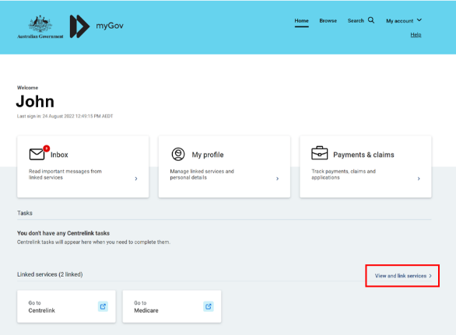
- Then choose National Disability Insurance Scheme from the Link a service list.
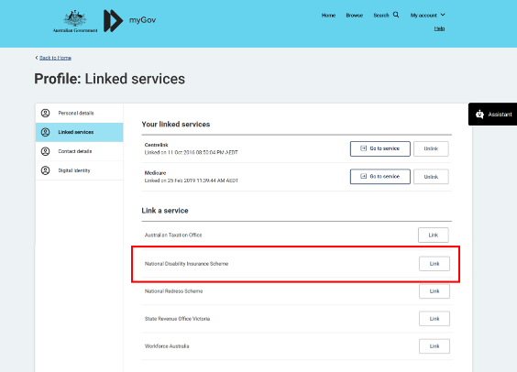
- Type in your NDIS Activation Code, your Last Name, and your Date of Birth, then click the Submit button at the bottom of the screen. You only need to put in the NDIS activation code the first time you access the portal. This screen will not display again.
Note: You can contact the NDIS on 1800 800 110 and request an activation code.
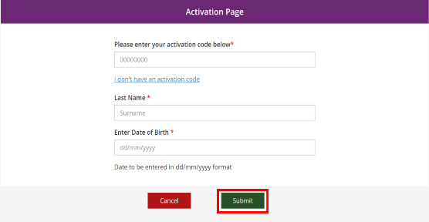
- The Terms and conditions will be displayed the first time you sign into the portal or when there have been updates that you need to be aware of. Move the scrollbar to read the Terms and conditions.
- Once you have read the Terms and conditions, select the checkbox next to I have read and agree with the terms and conditions and press the I agree button to continue.
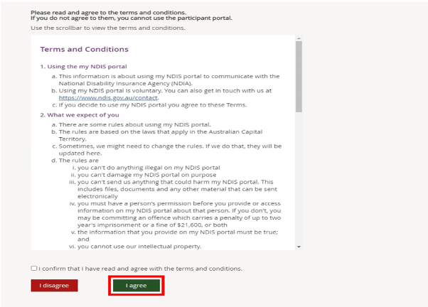

- The Privacy Notice will be displayed. Once you have read the Privacy Notice, select the checkbox next to I have read and agree with the Privacy notice and press I agree button to continue.
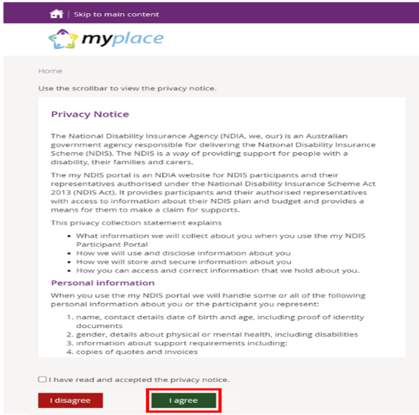
- The portal home page displays.
If you need any further support, you can phone the NDIS on 1800 800 110 or contact us.

Logging into the portal after linking with myGov
Once you have linked your myGov account to the NDIS, you can access the portal via the myGov website (my.gov.au) or via NDIS website (ndis.gov.au).

The portal via myGov website
- Log into myGov (my.gov.au)
- Select NDIS under Linked services.

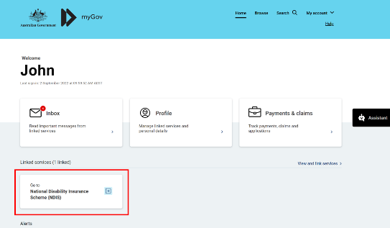
The portal home page displays.

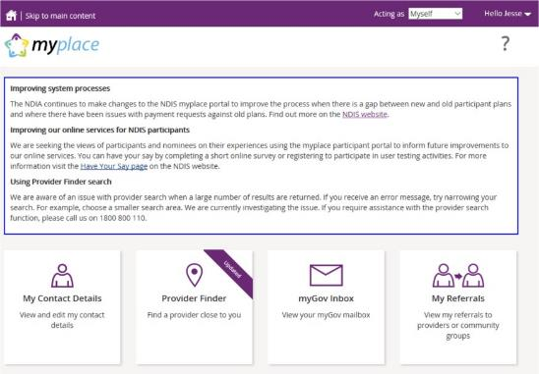

The portal via NDIS website
- Go to the NDIS website (www.ndis.gov.au).
- In the top right-hand corner click on the Portal sign in button and then select myplace participant portal from the drop-down menu.
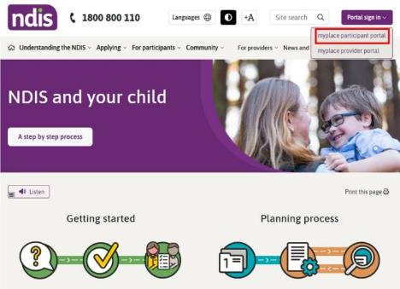
- Enter your myGov username (email or mobile number) and password, and then click the Sign in button.
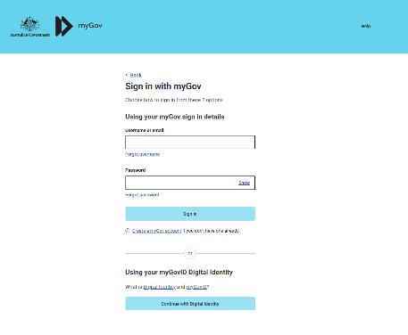
- Depending on your myGov preferences, you will need to answer secret questions, enter a unique security code or a myGov PIN. Once answered, click the Next button. The home page displays.

myplace portal home page
The homepage displays once you have signed in. The tiles you see are specific to the stage of the pathway (your NDIS journey) you have reached, or if you are signing in as a child representative or nominee. For example, the My Plan tile is only available once you have an approved NDIS plan.
If you have a new plan in the new computer system, you may see a banner that asks you sign into my NDIS portal.
- To return to the home page, click on the myplace icon or press the Home (house) icon.
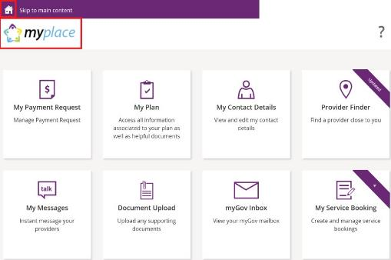

Tiles
The following table is a brief outline of what function each tile has within the portal.
Tile | Name | Function
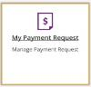 | My Payment Request | If you are self-managing all or part of your NDIS plan, this is where you can create, view and manage your payment requests (claims).
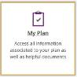 | My Plan | Once you have an approved NDIS plan, this is where you can view the details of your plan, including support budget, my referrals and my funding report.
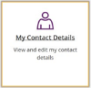 | My Contact Details | View and edit your personal details, contact details, address, How can I contact NDIA, bank account details and consent to share your plan with providers here.
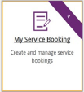 | My Service Bookings | Once you have an approved NDIS plan, this is where you can create, view and manage your Service Bookings with registered NDIS service providers (not applicable if you are self-managing).
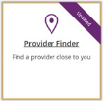 | Provider Finder | Use the Provider Finder to find a registered NDIS service provider near you. You will also be able to book in a service booking from this screen provided that the provider is taking referrals.
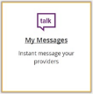 | My Messages | Instant messaging with your providers.  (Check with your provider to make sure this function is available for you).
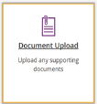 | Document Upload | Upload documents to support claims or access documentation. Max files size is 25MB, required to have a Document name and description. Below upload document is all available documents previously uploaded.
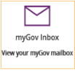 | MyGov Inbox | View your myGov mailbox.
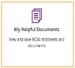 | My Helpful Documents | Use My Helpful Documents to access and view useful support booklets available on the NDIS website.
Select a tile displayed on the home page to go to that function. For example, selecting the My Payment Request tile will navigate you to where you can add or view your payment requests.

Need more help?
In the lower left corner of the screen there is an option to contact the NDIS, click the Contact Us link for further information and detail on how to contact us. Please direct any queries to the NDIS on 1800 800 110 or visit your local NDIA office.

Logging out of myplace
You can log out by selecting the down arrow next to your name at the top of the screen and select Logout.
This will return you to the NDIS website if you signed in from there or your myGov home page if you had signed in from there.

My Contact Details
My Contact Details is where you can manage your personal information. You can update your contact details, address and bank details.
This is also where you can choose to share (or not to share) details of your plan with registered service providers you have a service booking with.
- Select My Contact Details on the home page.
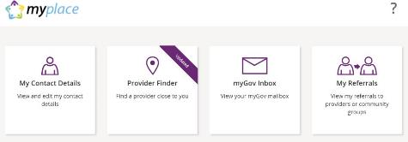
- The My Contact Details screen will display.
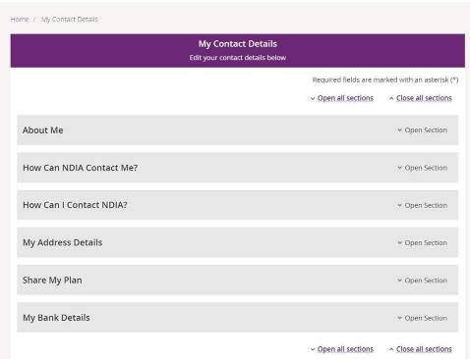

About Me
You can view your full name, preferred name, date of birth, NDIS number, gender, Indigenous origin and Australian South Sea Islander information (if applicable).
If any of these details are incorrect, please contact the NDIS on 1800 800 100 to have them updated.
- Click the Open Section link in the top right-hand corner to see the details.
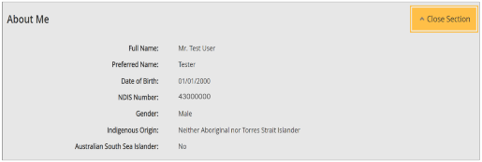

How Can NDIA Contact Me?
This section shows you your preferred method for notifications of service bookings, your preferred correspondence method (including different accessible formats) and your contact details.
- Click the Open Section link in the top right-hand corner to see the details.
- Select the Edit button in the bottom right hand corner.
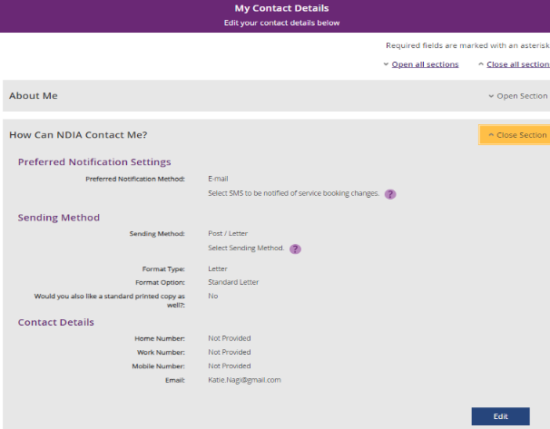
- Select a Preferred Notifications Method if you want to get notified when a provider has updated a service booking.
- To change the way you receive your letters, select an option from Sending Method drop down menu, then choose a Format Type and Format Option.
Note: If you would like a copy of your plan in a different format to your letters click the Add Method button and follow the instructions under Preferred Plan Format section.
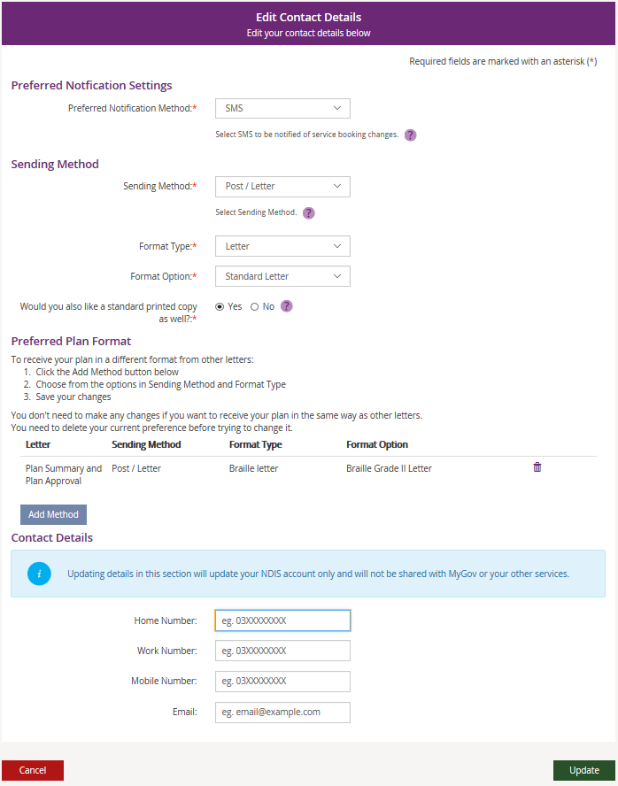
- You can update your phone numbers and email address in the Contact Details section. Click into the field (or select the delete cross icon) and type in your new details.
- Select Update.

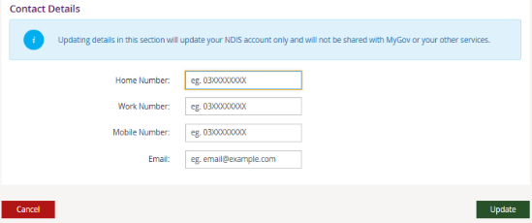
- This message will be displayed to confirm your contact details have been successfully requested: “We have your details and will update them in 2 business days. If you need help, please phone NDIS on 1800 800 100 or contact us.”
Note: This request may take up to 2 business days to complete. Once your contact details have been updated in the NDIS business system, you will be able to see the updated contact details in the myplace portal. If you need your details updated sooner, please phone the NDIS on 1800 800 110 or contact us.

Nominee/Child Representative process to update your own contact details
If you are a nominee or a child representative, you can update your own personal details in the ‘How Can NDIA Contact me?’ by selecting the Acting as Myself in the drop-down box in the top right-hand corner.
- Select the Edit button in the bottom right-hand corner.
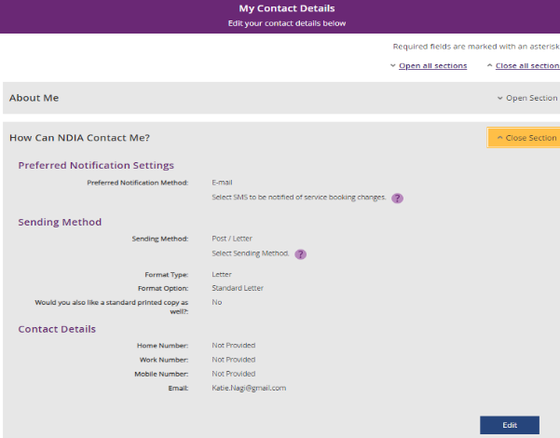
- The Edit contact details displays
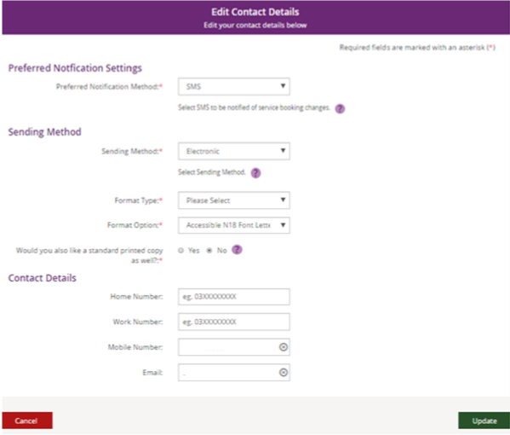

- You can update your phone numbers and email address in the Contact Details section. Click into the field (or select the delete cross icon) and type in your new details.
- This message will be displayed to confirm your contact details have been successfully requested: “We have your details and will update them in 2 business days. If you need help, please phone NDIS on 1800 800 100 or contact us.”
Note: This request may take up to 2 business days to complete. Once your contact details have been updated in the NDIS business system, you will be able to see the updated contact details in the myplace portal. If you need your details updated sooner, please phone the NDIS on 1800 800 110 or contact us.

How Can I Contact NDIA?
The How Can I Contact NDIA section provides the contact detail of your My NDIS Contact and our Contact Centre phone numbers.
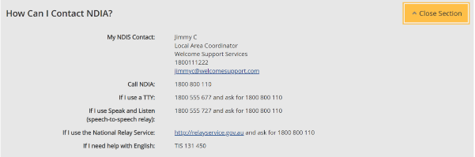

My Address Details
You can view your postal and home (standard address) addresses.
- Click the Edit (pencil) icon to update an address
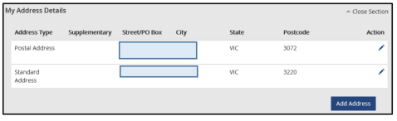
- Select the Add Address button to add a new address.
- Select the Address type and fill out the address fields. Enter the Start date and then select Update.
- This message will be displayed to confirm your contact details have been successfully requested: “We have your details and will update them in 2 business days. If you need help, please phone NDIS on 1800 800 100 or contact us”
Note: This request may take up to 2 business days to complete. Once your contact details have been updated in the NDIS business system, you will be able to see the updated contact details in the myplace portal. If you need your details updated sooner, please phone the NDIS on 1800 800 110 or contact us.

Nominee/Child Representative process to update your address
If you are a nominee or a child representative, you can update your personal details in the ‘My Contact Details’ by selecting the Acting as Myself in the drop-down box in the top right-hand corner.
- Click the Edit (pencil) icon to update an address
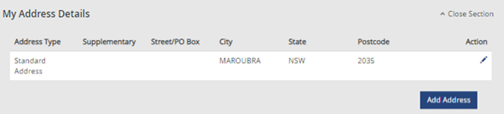

- The My Contact Details screen displays.
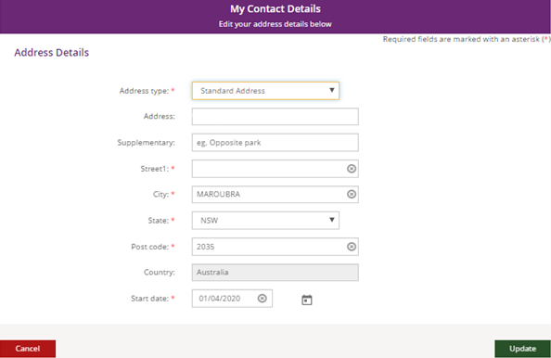
- Fill out the address fields. Enter the Start date and then select Update.
- This message will be displayed to confirm your contact details have been successfully requested: “We have your details and will update them in 2 business days. If you need help, please phone NDIS on 1800 800 100 or contact us.
Note: This request may take up to 2 business days to complete. Once your contact details have been updated in the NDIS business system, you will be able to see the updated contact details in the myplace portal. If you need your details updated sooner, please phone the NDIS on 1800 800 110 or contact us.

Share My Plan
The Share My Plan function enables you to share parts of your plan with any service providers you have an active service booking with. You can change a provider’s permission to view your plan at any time. It is your choice if you share your plan details with providers.
Note: If you have a new plan in the new NDIS business system, you are unable to change your share my plan details in the portal. Please phone the NDIS on 1800 800 110 or contact us.
- Tick the box next to the provider name/s to share your plan; or untick to not share.
- Provide a reason for the change in the Why are you updating or changing who can see the plan text box.
- Click the Submit button to finalise the changes.
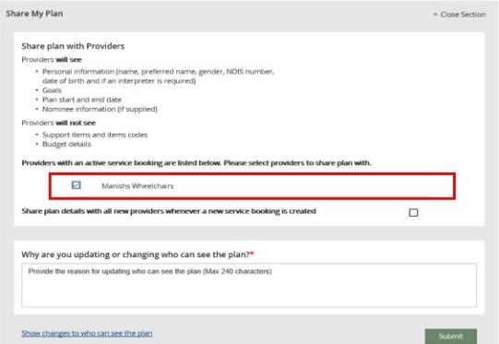
- Click the Close Section link in the top right-hand corner to close this section.

My Bank Details
The My Bank Details function enables you to view your bank details and add new account information. When you update your bank account details, the system will send you the following SMS:
“We have updated your bank account details as requested. If necessary, contact NDIS on 1800 800 110”.
- Click the Open Section link to view your bank details.
- Click the Add Bank Details button to add a new account.
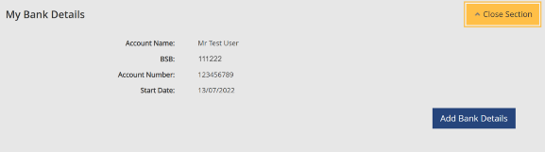
- Enter the new account details and then click the Update button to save.
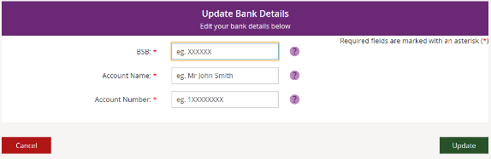
- Click the Close Section link in the top right-hand corner to close this section.
Note: If you are a plan nominee or child representative, contact the NDIS on 1800 800 110 to update the bank account details on your behalf.

My Plan
The My Plan tile displays once you have an approved NDIS plan. You can view your current and previous plans, your support budget and any referrals.
Note: If you have a new plan in our new computer system, you can only view your previous plan information in myplace portal. You need to sign in to the my NDIS portal to see your current plan information or your previous plan created in the NDIS business system.
- Select the My Plan tile on the homepage.
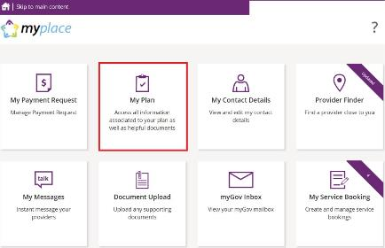
Once the My Plan tile opens, you will see the following tiles:
  - View My Plan
  - My Helpful Documents
  - My Support Budget
  - My Referrals
  - My Funding Report

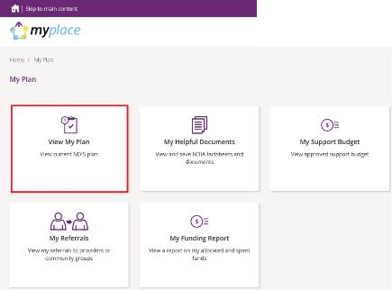

View my plan
All information about your plan is available in View My Plan. You can keep track of your plan review date, days remaining, My NDIS contact, goals, profile, funded supports information and access additional information in the Find out more section. You can also view previous plan information. This is a view only section of the portal.
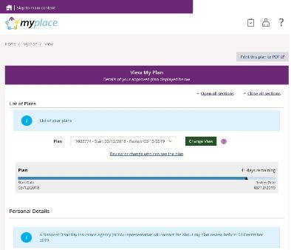
- Your current plan defaults. If you want to select a previous plan, use the Dropdown Arrow in the List of Plans section.
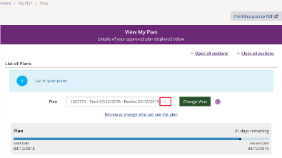
Note: To view a past plan, use the Change View button.
- Click the Open all Sections link to view all the information under each of the headings.
- To print a copy of your plan, click on the Print this plan to PDF button on the top right-hand corner of the screen.
Note: In some instances, you may not be able to preview or print a copy of the plan and you will see this message:
‘Plan document could not be retrieved. Please contact us to request a copy of this plan.’
If you see this message and you cannot view a copy of the plan, please contact the NDIS for help.

View my plan: section of the plan
The Personal Details section displays your NDIS Number, My NDIS Contact, the plan start and review due date and the length of the plan in months.
Contact the NDIS if you have any changes to your circumstances, which could change the supports you need to be included in your plan.
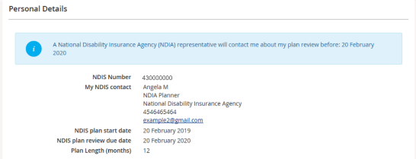
The Profile section outlines key information about you, such as your date of birth, current contact details, information about yourself (About me) and who supports you.
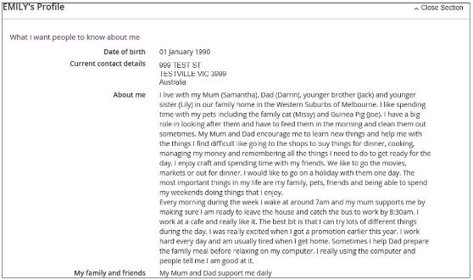
The Participant Goals outlines the goals you want to achieve and how you will achieve them and how you will be supported.
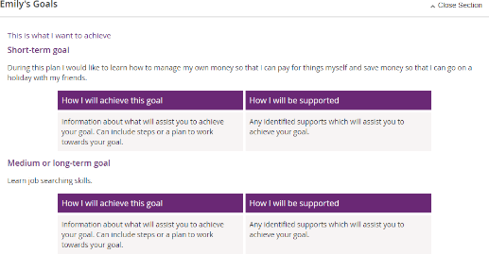
The Funded Supports section outlines the supports funded by the NDIS to help you achieve your goals. There is information on what the funding can be used for, how it is managed (e.g. self-managed) as well as how this funding amount is divided across the support categories (or budgets) in your plan.
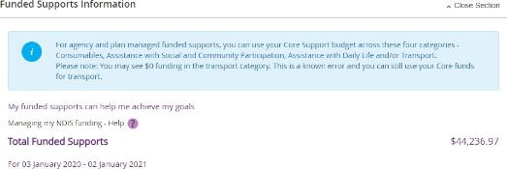
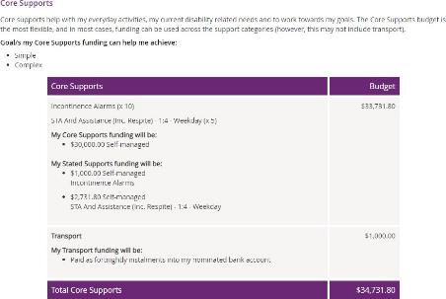

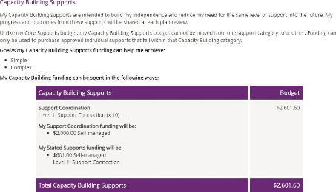
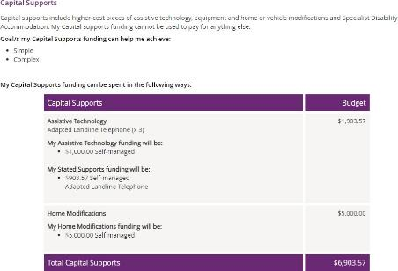
Note: Any items that require a quote will display as Quote required on your plan until a quote is approved by the NDIA. Once approved, the final quoted amount will display.
The Find out more section has information about who to contact if you need help with your plan, the Booklet 3 – Using your NDIS Plan and other ways to contact the NDIS.
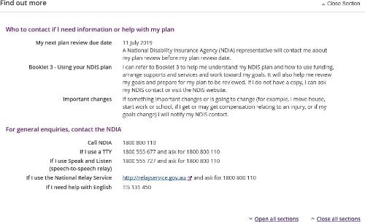
- Click the My Plan link at the top of the page to navigate back.

My support budget
My Support Budget is a summary of your current plan support budget. You can compare your approved funds, allocated, spent and remaining budget. The budget is also broken down by how the funding is managed (i.e. Agency, Plan or Self).
Note: Move your cursor over the question icons on the screen for further information about terms or features.
- Click on the My Support Budget tile on the My Plan page.
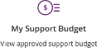
The My Support Budget screen displays.
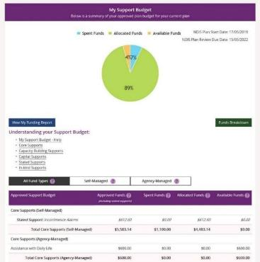
Your plan start and scheduled review dates are shown at the top of the screen. A pie chart displays in percentages your Spent Funds, Allocated Funds and Available Funds. Moving your mouse cursor over the pie chart shows the dollar values.
The Understanding your Support Budget section has links to information explaining:
  - My support budget –Help
  - Core supports
  - Capacity building supports
  - Capital supports
  - Stated supports
  - In-kind supports
- Scroll down the page to view the funds table. It shows Approved Funds, Spent Funds, Allocated Funds and Available Funds for each support type and support category.
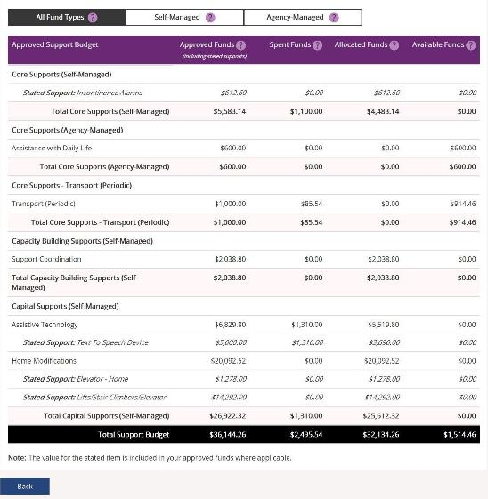
- You can view the budget by your funds management breakdown by selecting from the tabs available (for example, Self-Managed). The All Funds Type is the total values of the support budget.

View my funding report
The funding report provides a summary of allocated and spent funding in your plan organised by self-managed supports, agency managed supports and plan managed supports (if applicable). The funding report includes information on service booking dates and last payment request information.
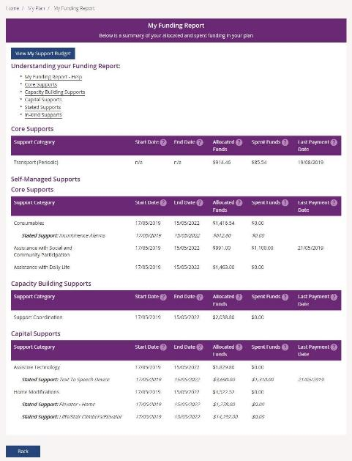
You can also access My Funding Report by selecting the My Funding Report from the My Plan home screen.
You can select the View My Support Budget button at the top of the screen to return to the My Support Budget screen or Back to return to the My Plan page.

Funds breakdown
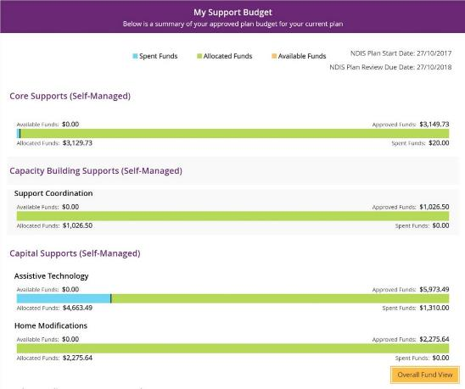
- Click the Funds Breakdown button to the right of the pie chart to view the funds information as a set of bar graphs.
The screen changes to display a detailed view of:
- What funds have been approved in your plan for each support category and support type
- What has been spent, what has been committed and what remains for each support type and support category
- Whether your support for each support category is agency managed, plan managed or self-managed.
Note: The figures shown do not include Payment Requests that have been submitted but not processed.

My Referrals
Your planner can add referrals to your plan, and these can be viewed through My Referrals.
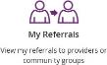
- Click the My Referrals tile on the My Plan page and your current referrals will display.
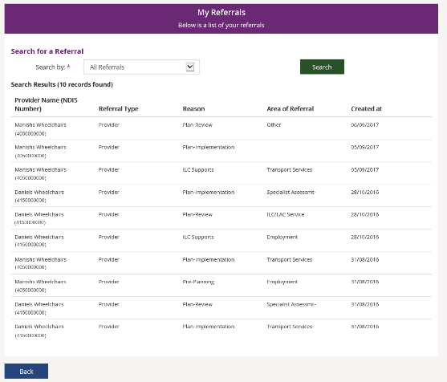
You can refine your list of referrals by using the search by field to select either registered providers or community groups.
- Select Back to return to the portal home page.

Provider Finder
The Provider Finder enables you to find and contact a registered provider. You can also view providers you have a service booking with. This section contains contact information of providers via the View Details link, and detailed directions via the Find Directions link.

Provider search
- Select Provider Finder tile on the homepage.
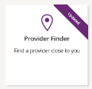
The Provider Finder page displays.
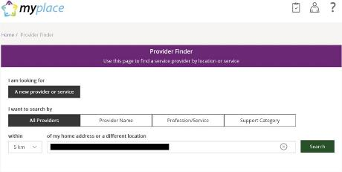
You have the option to search by:
  - All providers: All providers within the selected distance to your address will display.
  - Provider name: You can enter the name of the provider you are looking for.
  - Profession/service: You can choose the profession/service (for example, dietician) from a drop-down menu.
  - Support Category: You can choose the support category you are looking for from a drop-down menu.

The following steps is an example of searching by a profession/service.
- Select the Profession/Service tab.
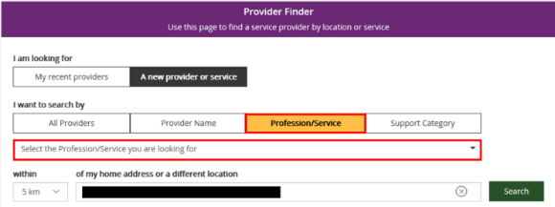
- Click the dropdown box and select a service.
- The search radius defaults to 5 kilometres from your home address. You can expand the search distance by clicking the within dropdown arrow.
- You can change the address that the search is on by clicking the delete icon in the ‘of my home address or a different location’ field and type in an address.
- Select Search. The search results display.
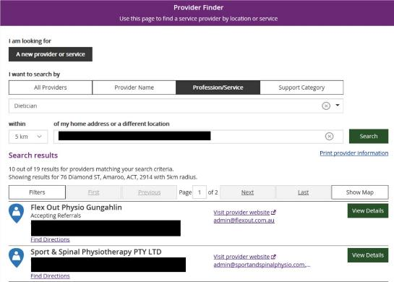

- To print your search results, select the Print provider Information link.
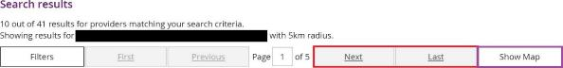
- If there is more than one page of results use the buttons of Next and Last to look at all the providers.
- To narrow down your search results, you can apply filters to your search by selecting the Filters button at the top of the window.
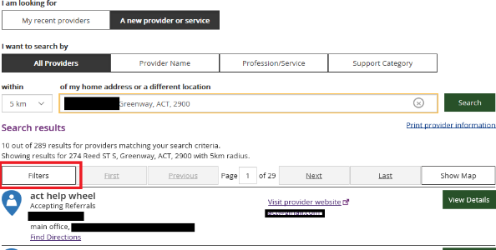
- The following filters can be applied to your search:
  - Accepting new referrals
  - Open extended hours on weekdays
  - Open on weekends
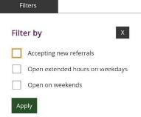

- To see more information on a specific provider, select the View Details button.
- The details of the provider will display with the following:
  - Organisational name: The provider business name.
  - Contact person: The name of the person you can speak within the organisation.
  - Contact details: Including contact phone numbers and email addresses.
  - Address: The street address of the provider.
  - Outlet status: This tells you if the provider is able to take referrals.
  - Services provided: A list of all services provided is listed here.
  - Operating hours: Details of the days and times the provider is open for business.
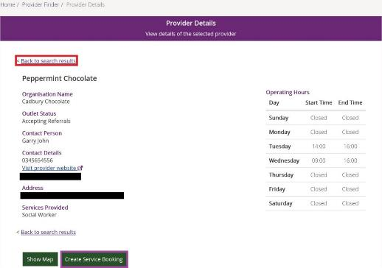
Note: If you would like to conduct another search, select Back to search results link at the top or bottom of the screen. This returns you to the Provider Finder screen, where you are able to complete another search.
- Select Show Map if you want to see the location of the provider.
- Once you have found the right provider, select Create Service Booking to make a booking with this provider. This button only displays if you have support funding that is Agency managed.

Recent providers
The My recent providers section only displays if you have had service bookings. It displays the providers of your last five service bookings.
- Select My recent providers. This lists the last five providers that you have had a service booking with.
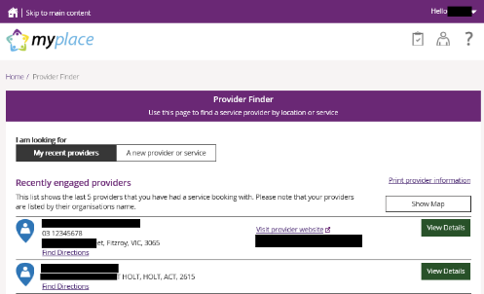
- To view the location of these providers, select the Show Map near the top right-hand corner of the window.
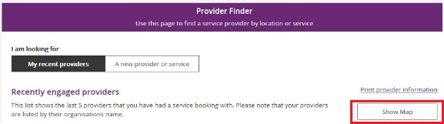
A map will populate on screen with markers identifying where the providers are located.
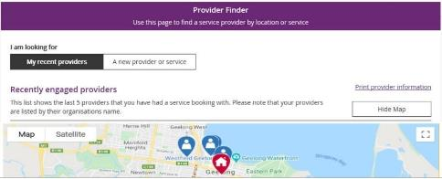
- Select Hide Map to return to the listing of providers.
- To view contact details and services provided by specific providers, click the View Details button to the right of the provider.

Document Upload
This screen is where you can send copies of documents to the NDIS.
Note: Once you have uploaded a document it cannot be deleted from the system.
- Click the Document Upload tile on the homepage.
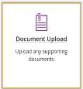
- The Document Upload page displays.
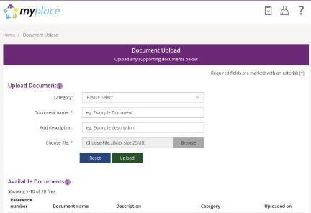

- In the Category field, select from the drop-down list.
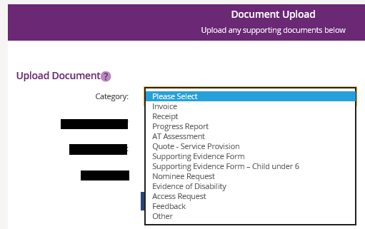
- In the Document name field, type the name of the document. Ensure the document name captures the main purpose of the document.
- In the Add description field, type a description of the file. Ensure the description is connected to the content within the document.
- Select Browse to find the file you want to upload from your computer.
Note: you can only upload a maximum file size of 25MB (Megabytes) per upload.
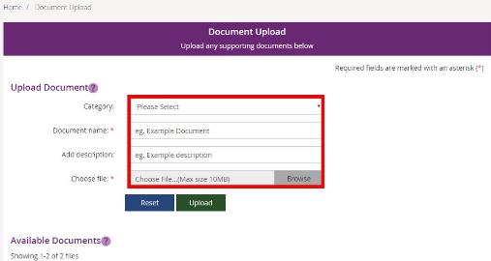
- Once you have selected the file, click the Upload button to send the document to the NDIS.
- Successfully uploaded documents are visible under the Available Documents section. The documents are displayed from the most recent date.
Note: If the matter relating to your document needs to be actioned urgently by an NDIS staff member or your local area coordinator (LAC), please contact the NDIS on 1800 800 110.
Note: If you have a new plan in the new computer system, you can use Document Upload to see the list of documents that have been uploaded in the past.

My helpful documents
This screen is where you can access helpful guides and resources.
- Select My Helpful Documents tile on your homepage.
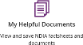
- Planning Support Booklets hyperlink will display.
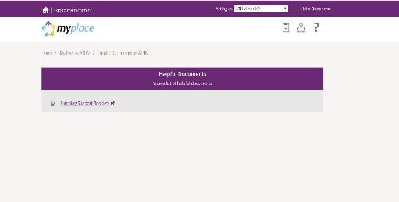
- Click on the Planning Support Booklets hyperlink.
- This will direct you to the ‘For participants’ page in the NDIS participant website.
- The ‘For participants’ page will display.
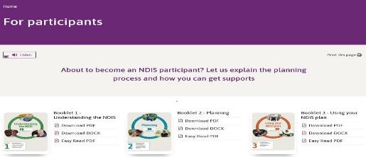
You will be able to select and view each booklet.

myGov Inbox
You can view all your myGov messages in the myGov Inbox. Note: This function is not available for participants with a plan in our new business system.
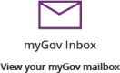
- Select the myGov Inbox tile on your homepage.
- Your myGov inbox displays all messages you have in your myGov account.
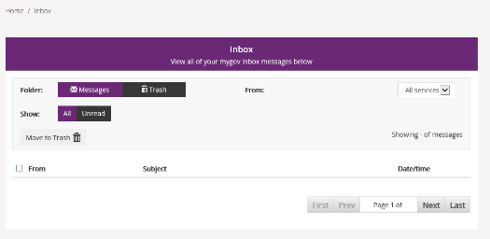
- Select the From dropdown to view specific messages.
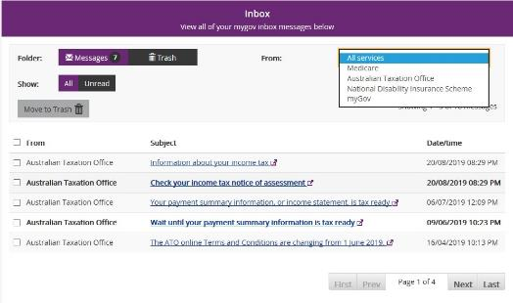
- Select Unread in the Show field to only display unread messages.
- To read a message, click on the message subject hyperlink. The message displays.
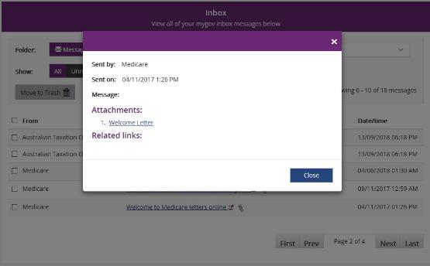
- Select Close to return to the Inbox screen.
- If you want to move a message to trash, click in the tick box next to the message and then select Move to Trash.
- Select Home to return to the myplace homepage.

My Service Booking
Service bookings are used to set aside funding for a NDIS registered provider for a support or service they will deliver. The provider can then claim payments against the service booking. A service booking will show the type of support to be provided, the length of time it is needed, and sets aside funding to pay for the support or service. Service bookings can be made by you, your nominee or an NDIS registered provider (with your consent). Self-managing supports do not have a service booking. If your plan is 100% self-managed, you do not need to go over this section.
Note: A service booking is different to a service agreement. A service agreement is an agreement between a participant and a provider. All participants should have service agreements with their providers, as the agreement sets out the expectations for the service to be delivered. Service agreements will not appear in the portal.

Service bookings with different funds management

If your NDIS funds are self-managed
You don’t use service bookings because you pay your providers directly.

If your NDIS funds are plan-managed
Your Plan Manager will make one service booking, which allows the Plan Manager to claim payment from the NDIS for all services and supports in your plan. In this case, both NDIS registered and unregistered providers can be included in the service booking.

If your NDIS funds are Agency-managed
You will need to give your NDIS registered service providers your NDIS number and the relevant support areas you have been funded for, so your provider/s can create the service booking on your behalf and receive payment.
- Select the My Service Booking tile from the home page.
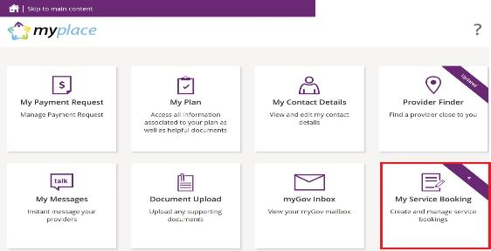
The Service Booking page displays. You have two tiles:
  - Add My Service Booking
  - View My Service Booking

Add My Service Booking
You only add service bookings for supports that are Agency-managed. Your provider may have already created a service booking on your behalf, so check with them first.
- Select the Add My Service Booking tile.
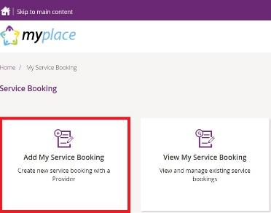
- Select the Find the Provider button to choose your provider.
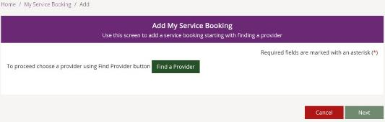
You are moved to the Provider Finder section of the portal.
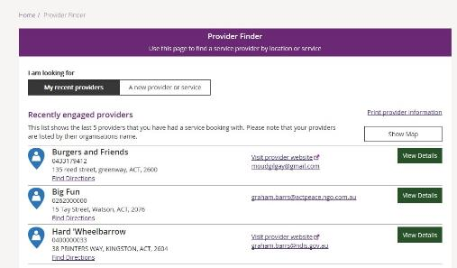

- Once you have found the provider, select View Details of the provider and then click the Create Service Booking button. If you need help, go to Part 4 – Provider Finder and documents guide.
You are returned to the Add My Service Booking section.
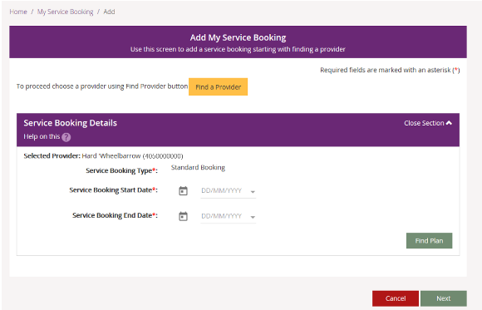

- Enter the Start Date and End Date of the service booking. Note: these dates must be within the start and end dates of the current plan.
- Select the Find Plan button.
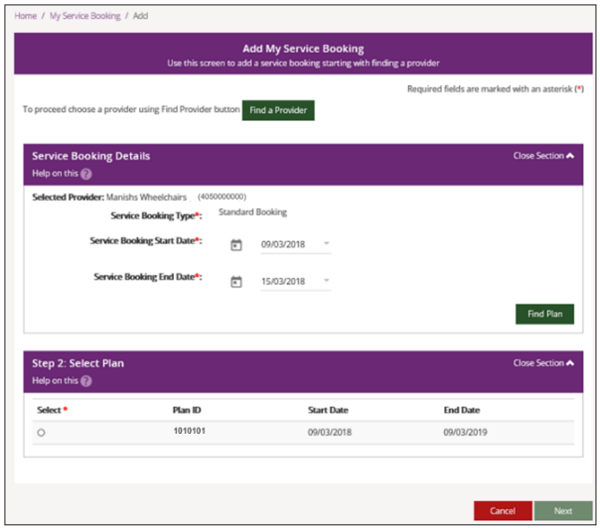

- Step 2: Select Plan displays. Select the radio button next to the plan.
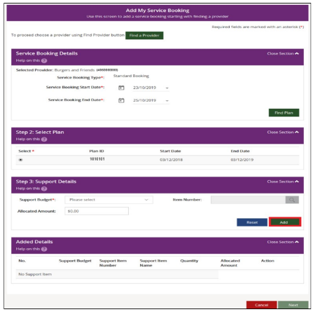Step 3: Support Details and Added Details display.
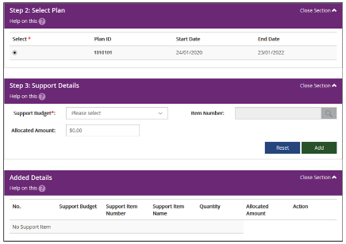

- The Support Budget displays the categories of funded supports in your NDIS Plan. Select the category from the drop-down list and enter the Allocated Amount. Once completed, click the Add button.
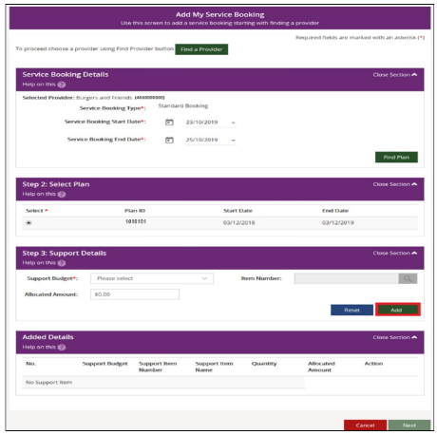

Generally, you are not required to select an Item Number (this is a specific item within the support category) unless discussed with your provider. If you do specify the item, the Allocated Amount is the agreed rate for that item. You will then enter the quantity of services needed.
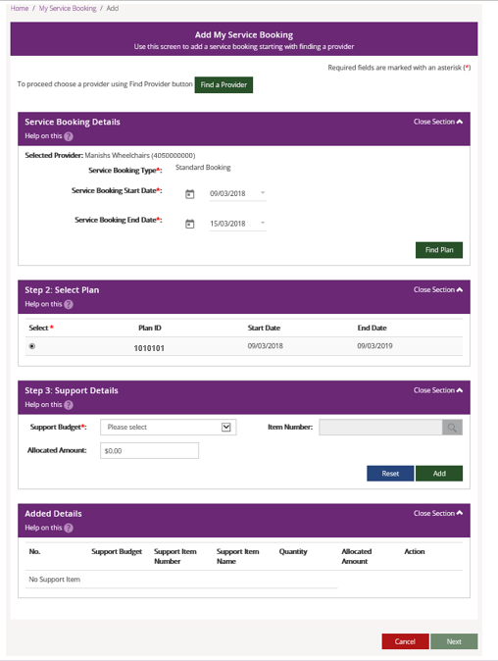
- To add more supports under the same provider, return to Step 7.
- If you need to make changes, click the Edit link to amend a support, or the Remove link to delete a support.
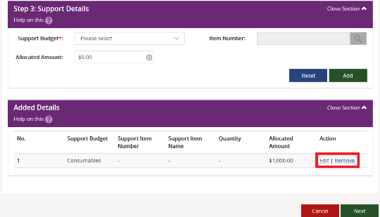
- Once all supports are added, click Next.
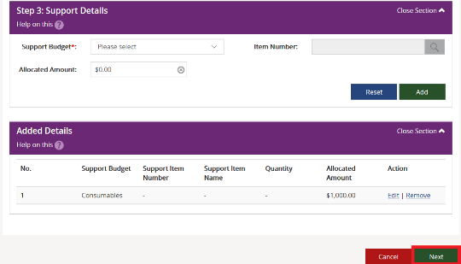

The Review screen displays.
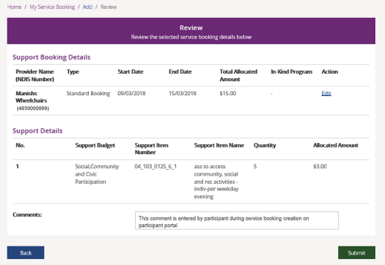
- Notes may be added in the comments section. The provider will see these comments.
- Select the Submit button to create the service booking A service booking confirmation message displays.
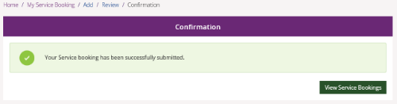
Select View Service Bookings to see the details of any of your service bookings.
Note: The status of the service booking you have created is Awaiting Provider Review. When the provider accepts the booking, the status will show as Active. If your provider rejects the booking, the service booking status will show as Rejected. The reason for rejection can be seen in the View Service Booking Details screen.

View existing bookings
- Select the View My Service Booking tile on the Service Booking page.
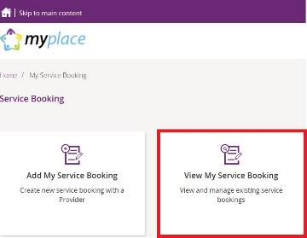
Your service bookings display.
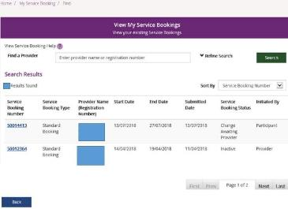

Refine search
- You can search by a provider or to expand the search criteria, click the Refine Search button.
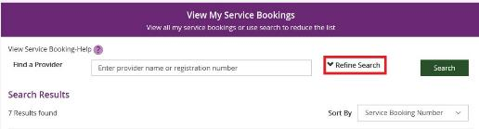
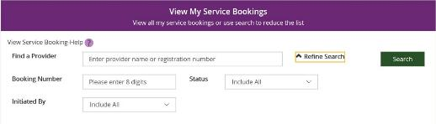
You can search by:
  - Booking Number – refers to the 8-digit service booking number.
  - Status – refers to the service booking status. For example: active/inactive, awaiting review, awaiting provider review, change awaiting provider, review change or rejected.
  - Initiated by – who initiated the booking. For example: all, participant, provider or staff.
- Once you have entered your search criteria, select Search.
- You can sort your search results by clicking the Sort By drop down field. The options are:
- Initiated by
- Service Booking Number
- Service Booking Start Date
- Service Booking End date
- Submitted Date
- Service Booking Status
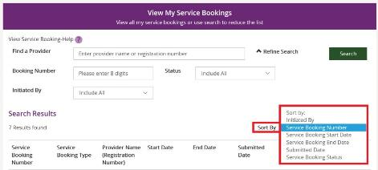
- To view details of a service booking, click on the Service Booking Number.
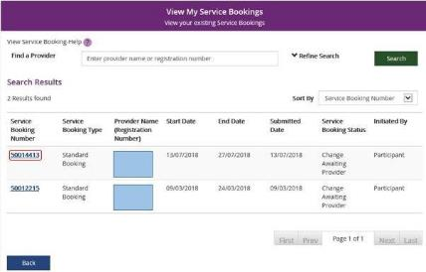
- If the status is ‘awaiting provider review’ you can delete the service booking by selecting Delete. Once a service booking has been accepted by the provider it cannot be deleted.
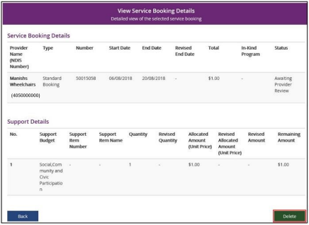

- Once you select Delete, the following warning message displays.
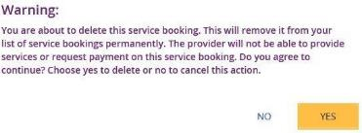
- If you select Yes, you will receive the following message confirming the service booking has been deleted.
You are returned to the View My Service Bookings page.

Edit a service booking
You can change or end a service booking (with the status Active) if it was created by yourself, your provider or by the NDIA.

Change the dollar values in a Service Booking
- Click the View My Service Bookings tile on the Service Bookings page.
- Click the Service Booking Number of the booking you wish to edit.
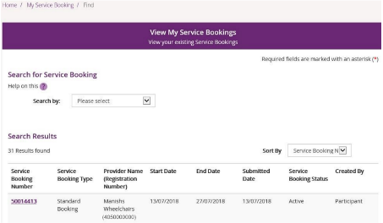
- Click the Request Update Allocation button in the bottom right-hand corner of the window.
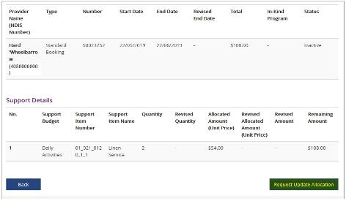
The Request Update Allocation page will display.
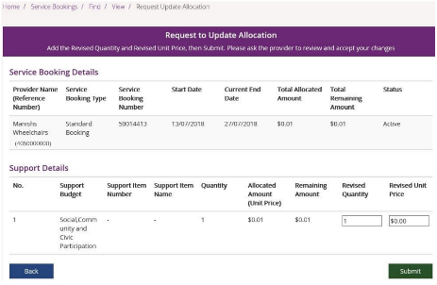
- Enter the Revised Quantity and Revised Unit Price and then select Submit.
A message displays at the top of the screen stating the details have been updated successfully.

- Click the Back button to return to the View My Service Bookings page.
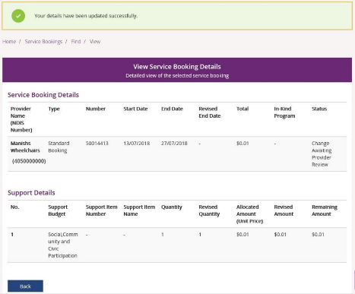
The status of the service booking will change to Change Awaiting Provider Review. This means the provider can accept or reject the changes you have made. If the provider accepts the changes, the status returns to Active.
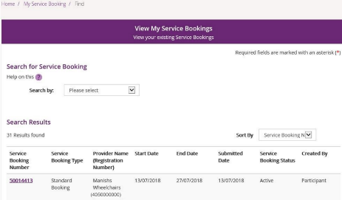
If your NDIS provider makes a change to your service booking, you will receive the following SMS notification:
“Your NDIS Provider has updated your service booking (number). Please review the change and discuss with your provider if necessary. Do not reply by SMS.”

End service booking
You can request to end a service booking with an active status that was created by the NDIA, your provider or yourself. The service booking will not be ended until your service provider accepts your request to end the service booking.
- Select View My Service Bookings and click the Service Booking Number of the booking you wish to end.
- Select Request End Date Change to end the service booking.
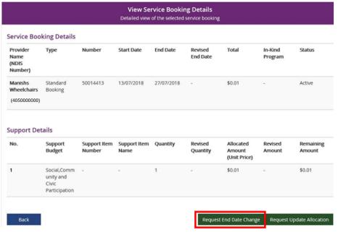

- Enter the Service Booking End Date and select a Reason for Change from the drop-down list.
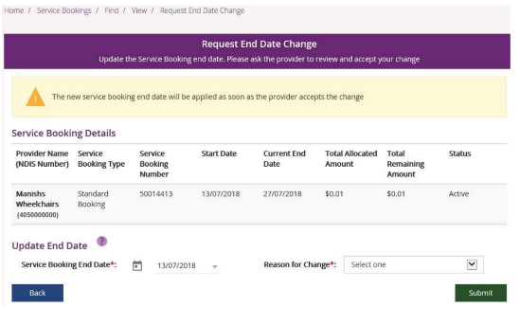
- Click the Submit button in the bottom right-hand corner of the window.
- An alert message displays confirming you want to continue. If you want to ending the service booking click Yes. If not, click No.
You will receive a message at the top of the screen confirming the details have now been successfully updated.

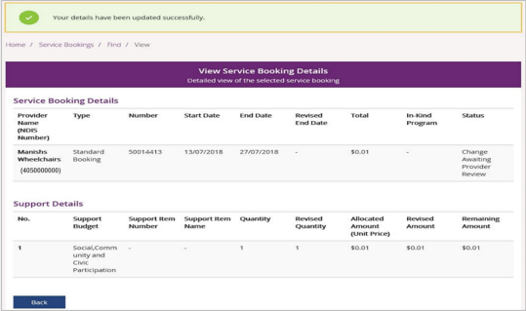
The status of the service booking will change to Change Awaiting Provider Review. This means the provider can accept or reject the changes you have made. When the service booking ends the status will show as Inactive. If the provider rejects your change for whatever reason, the status will show as Active and you will need to contact the provider.1

My Payment Request
Through My Payment Request you can create payment requests (only for self-managed participants) and view all past payment requests (including periodic transport).
Note:
- If you have a new plan in the new computer system, you must sign into the my NDIS portal to make a claim against your current plan.
- You will be able to see, filter and search for claims made against your previous plan in the myplace portal.
- You may be able to claim for services and supports up to 90 days after the old plan has expired in the myplace portal.
- Click My Payment Request on the homepage.
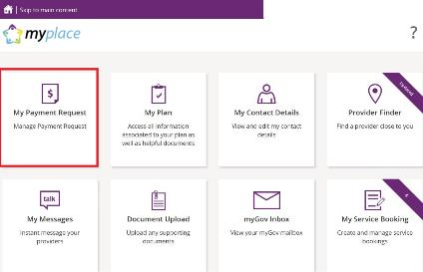
The My Payment Request screen displays.
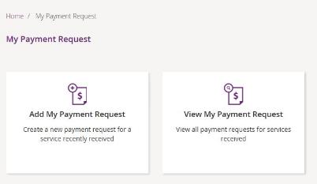
You have two tiles:
  - Add My Payment Request – to create new payment requests.
  - View My Payment Request – to see the details of all payment requests that have been submitted.

Add My Payment Request
This section is only for self-managed funded supports. Payment requests for funding that is Agency managed or Plan managed will be submitted by providers.
Ensure you have your bank account details recorded (in My Contact Details) before you submit your payment request.
- Click the Add My Payment Request tile on the My Payment Request screen.
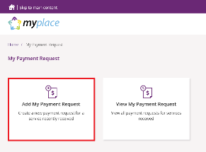
The Add Payment Request screen displays.
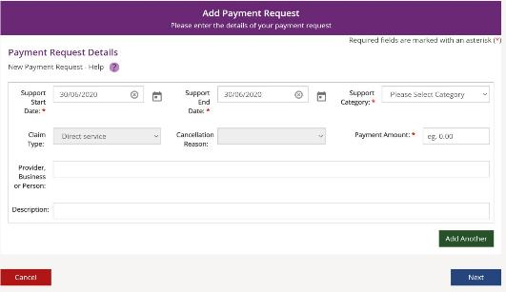
- Enter the details of your payment request. The Support Start Date field and Support End Date field will default to today’s date (change if required). Select the Support Category and Claim Type from the drop-down list and enter the Payment Amount.

- To help you track your payments, please enter the name of the payee in the Provider, Business or Person field and the Description of the payment. The provider, business or person name and description field are both optional fields.
Note: For more than one payment request, click the Add Another button in the lower right-hand corner of the window.
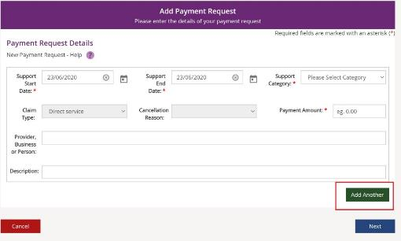
- Once all details have been entered, click the Next button on the lower right-hand side of window.
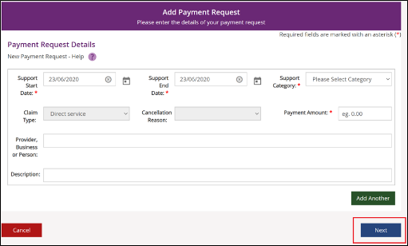

The Preview page displays.
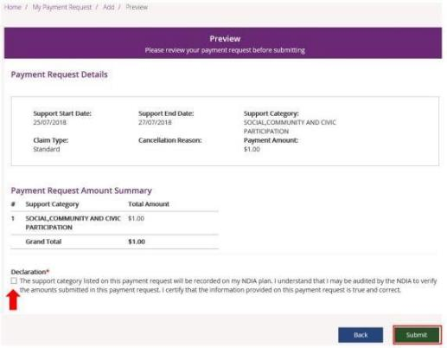
- Check the details are correct and then tick the Declaration box. Click the Submit button on the bottom right-hand side of screen.
- The Confirmation screen displays, stating that your payment request has been received.
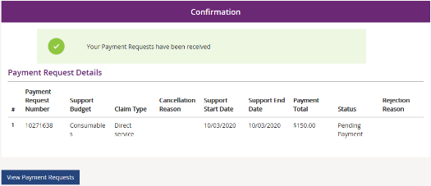
You can return to the home page or go to View Payment Requests.

View My Payment Requests
You can view the payment requests that were submitted by you, a provider or a NDIA staff member. Periodic transport payments can also be viewed in this screen.
- Click the My Payment Request tile on the home page.
- Select the View My Payment Request tile.
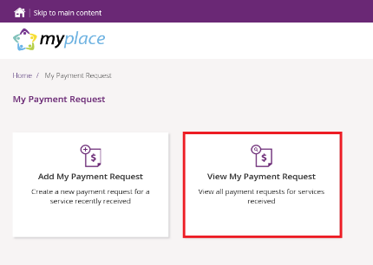
The View Payment Requests page displays.
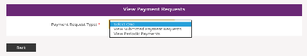
- Choose the Payment Request Type from the drop-down menu. The following steps are an example for submitted payment requests.

- For View Submitted Payment Requests, the following screen displays.
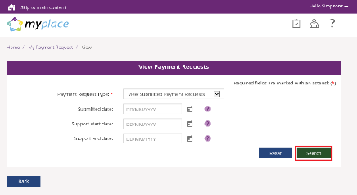
- Click the Search button for a full list of all requests, or type in dates to view payments within a selected time period. A list of your payment requests display.
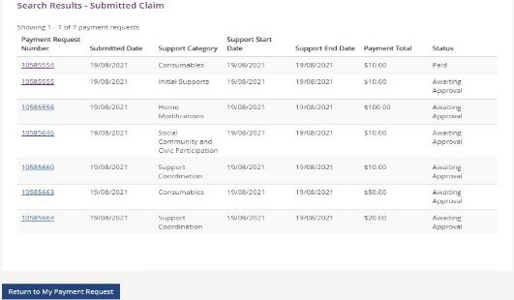
- You can navigate through the payment request results by clicking the First, Back, Next and Last buttons.
- Click on the Payment Request Number to view details about the payment request.
Note: You will see the payee’s ABN number (if applicable), when you or your representative have made a payment request using the my NDIS app or a NDIA staff member has made a claim on your behalf.
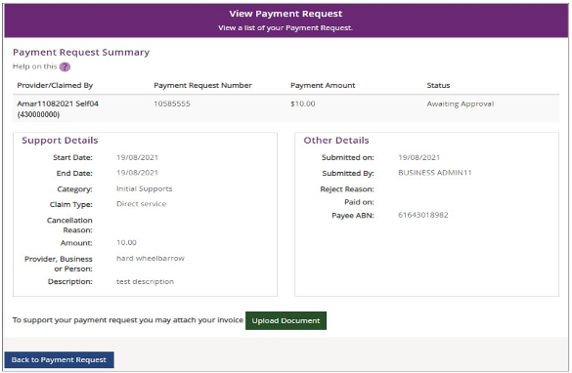

Cancel Payment Requests
You can cancel payment requests you have submitted and payment requests that a nominee or child representative have submitted if they have the status of Paid and/or Pending.
Note:
- A Nominee or child representative can only cancel payment requests submitted by themselves.
- You will see the Payee’s ABN number (if applicable), when you or your representative have made a payment request using the my NDIS app or a NDIA staff member has made a claim on your behalf.
- In View Payment Requests, click on the Payment Request Number link.
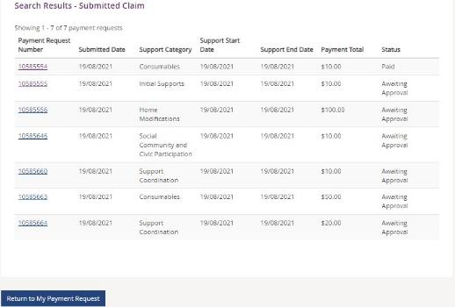

- A summary of the payment request displays.
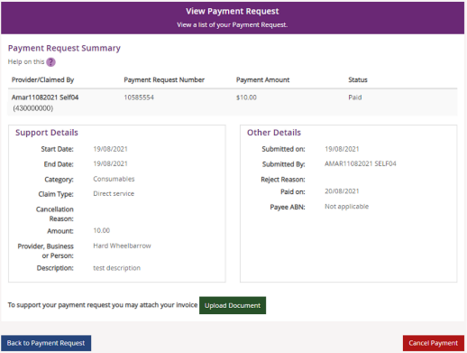

- Click the Cancel Payment button on the bottom right-hand corner of the window. Note: If the Cancel Payment button is not available, please contact NDIS.
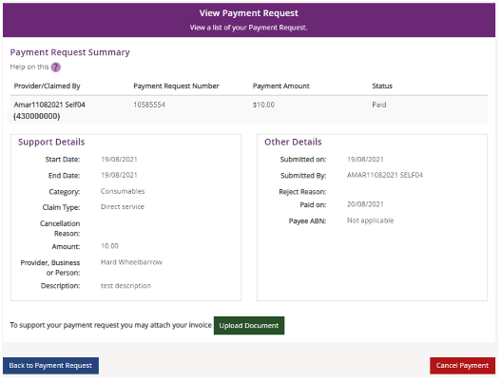
- Select the Yes button to cancel the payment request.
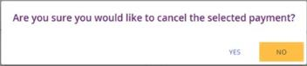
You are returned to the View Payment Requests page. A confirmation message will display, confirming the payment request has been cancelled successfully.
- Select Home to return to the main homepage.

My Messages
This tile will only display if you have an active service booking with a registered provider. You can send instant messages to your providers.
- Click on the My Messages tile on the home page.
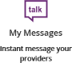
- The My Messages page displays.
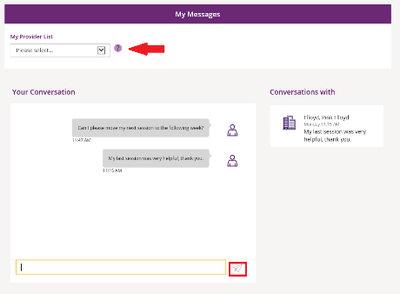
- Select the chosen provider from the drop-down list under My Provider List.
- Type your message in the yellow
- box and click the paper plane icon message.
) to send the

Note: Conversations (messages) will appear under the Conversations with tab. You can continue a conversation by selecting the providers’ name.
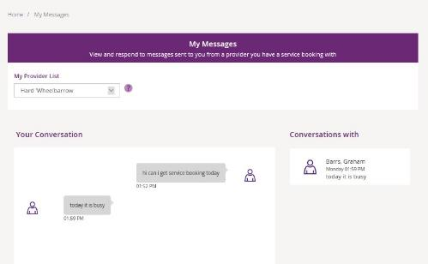

Leaving Feedback
If you would like to provide feedback, a compliment, complaint or enquire about an internal review or external review, this section allows you to record your feedback and submit it to the agency.
- From anywhere in the portal, click the Feedback link at the very bottom of the page.
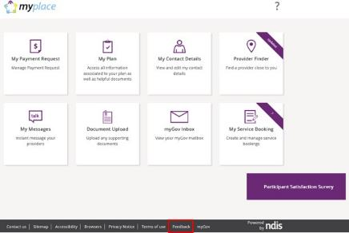
The Feedback Form opens.
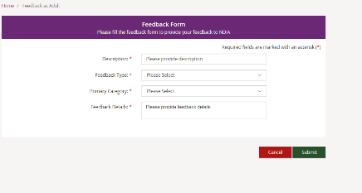
- Enter a Description in the free text field and select a Feedback Type and Primary Category from the drop-down lists. In the Feedback Details field provide as much information as possible to assist the staff with your enquiry.
- Select the Submit button in the lower right-hand corner of the screen.
- A message with the reference feedback number will display.

Logging out of myplace
Once you have completed all your tasks within the portal, log out by clicking on the down arrow next to your name at the top of the screen and select Logout from the drop-down menu.
If you signed in via the NDIS website, you will be returned to the NDIS front page. If you signed in via the myGov website, you will be returned to your myGov homepage.

