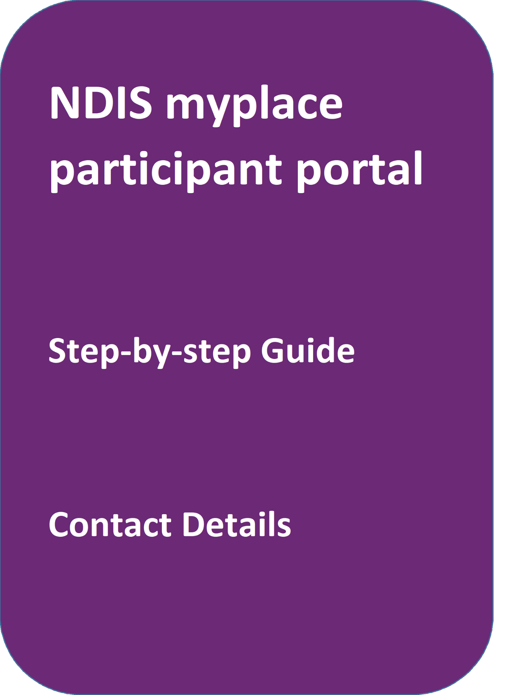
May 2024

Table of Contents
Table of Contents 2
Changes from the last version 3
My Contact Details 3
About Me 4
How Can NDIA Contact Me? 5
How Can I Contact NDIA? 10
My Address Details 11
Share My Plan 13
My Bank Details 14

Changes from the last version
The following updates have been made to the last published version of the myplace portal step-by-step guide:
- General updates

My Contact Details
My Contact Details is where you can manage your personal information. You can update contact details, address, and bank details.
This is also where you can choose to share (or not to share) details of your plan with registered service providers you have a service booking with.
1. Select My Contact Details on the homepage.

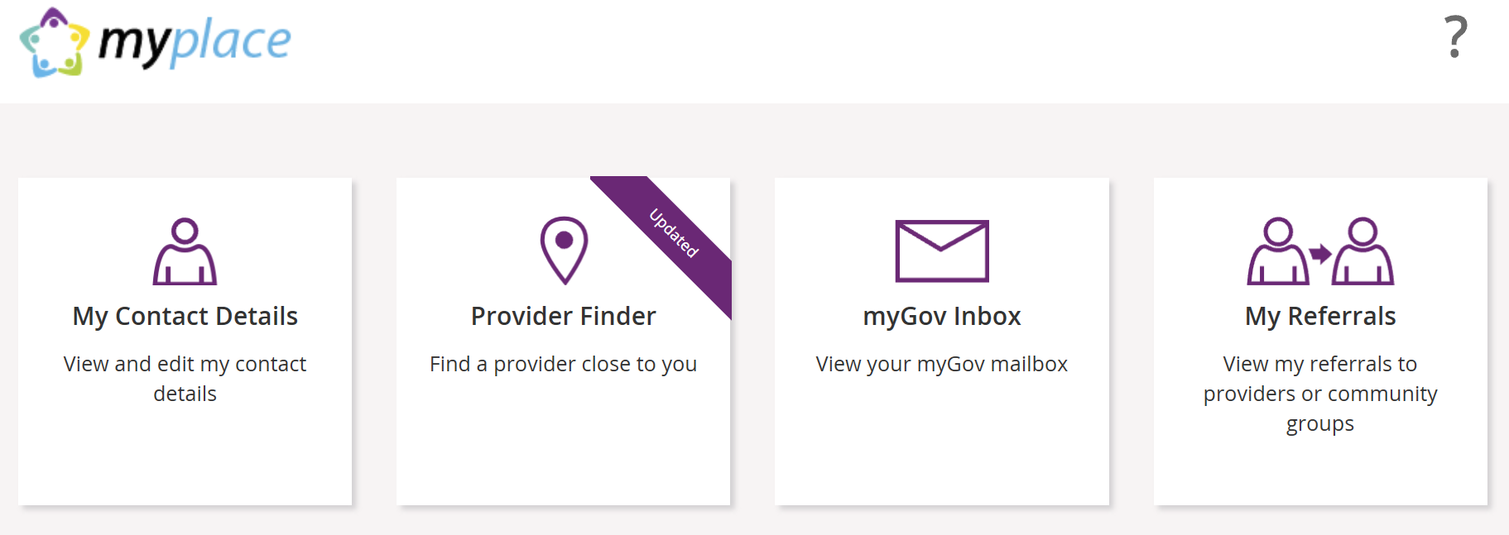

2. The My Contact Details screen will display. 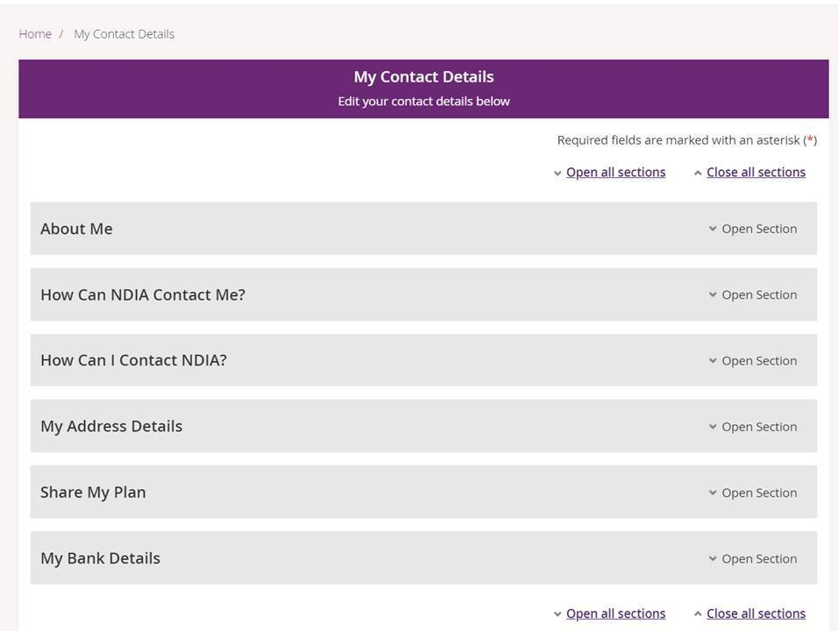

About Me
You can view your full name, preferred name, date of birth, NDIS number, gender, Indigenous origin, and Australian South Sea Islander information (if applicable).
If any of these details are incorrect, please contact the NDIS on 1800 800 110 to have them updated.
- Click the Open Section link in the top right-hand corner to see the details.
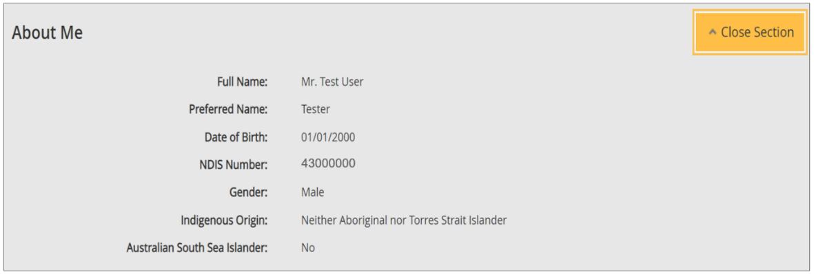

How Can NDIA Contact Me?
This section shows you your preferred method for notifications of service bookings, your preferred correspondence method (including different accessible formats) and your contact details.
1. Click the Open Section link in the top right-hand corner to see the details.

2. Select the Edit button in the bottom right-hand corner.

3. Select a Preferred Notifications Method if you want to get notified when a provider has updated a service booking.
4. To change the way you receive your letters, select an option from Sending Method drop down menu, then choose a Format Type and Format Option.
Note: If you would like a copy of your plan in a different format to your letters click the Add Method button and follow the instructions under Preferred Plan Format section.
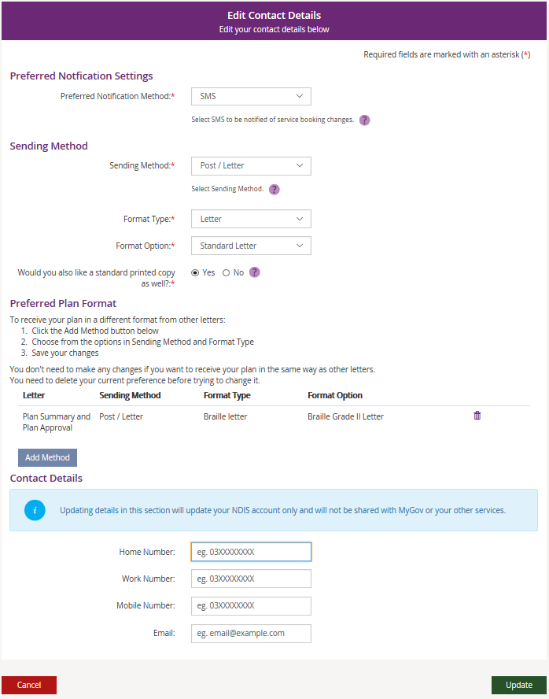
5. You can update your phone numbers and email address in the Contact Details section. Click into the field (or select the delete cross icon) and type in your new details.
- Select Update.

- This message will be displayed to confirm your contact details have been successfully requested: “We have your details and will update them in 2 business days. If you need help, please phone NDIS on 1800 800 100 or contact us.”

Note: This request may take up to 2 business days to complete. Once your contact details have been updated in the NDIS business system, you will be able to see the updated contact details in the myplace portal. If you need your details updated sooner, please phone the NDIS on 1800 800 110 or contact us.
Nominee/Child Representative process to update your own contact details
If you are a nominee or a child representative, you can update your own personal details in the ‘How Can NDIA Contact me?’ by selecting the Acting as Myself in the drop-down box in the top right-hand corner.

1. Select the Edit button in the bottom right-hand corner.

2. The Edit contact details displays
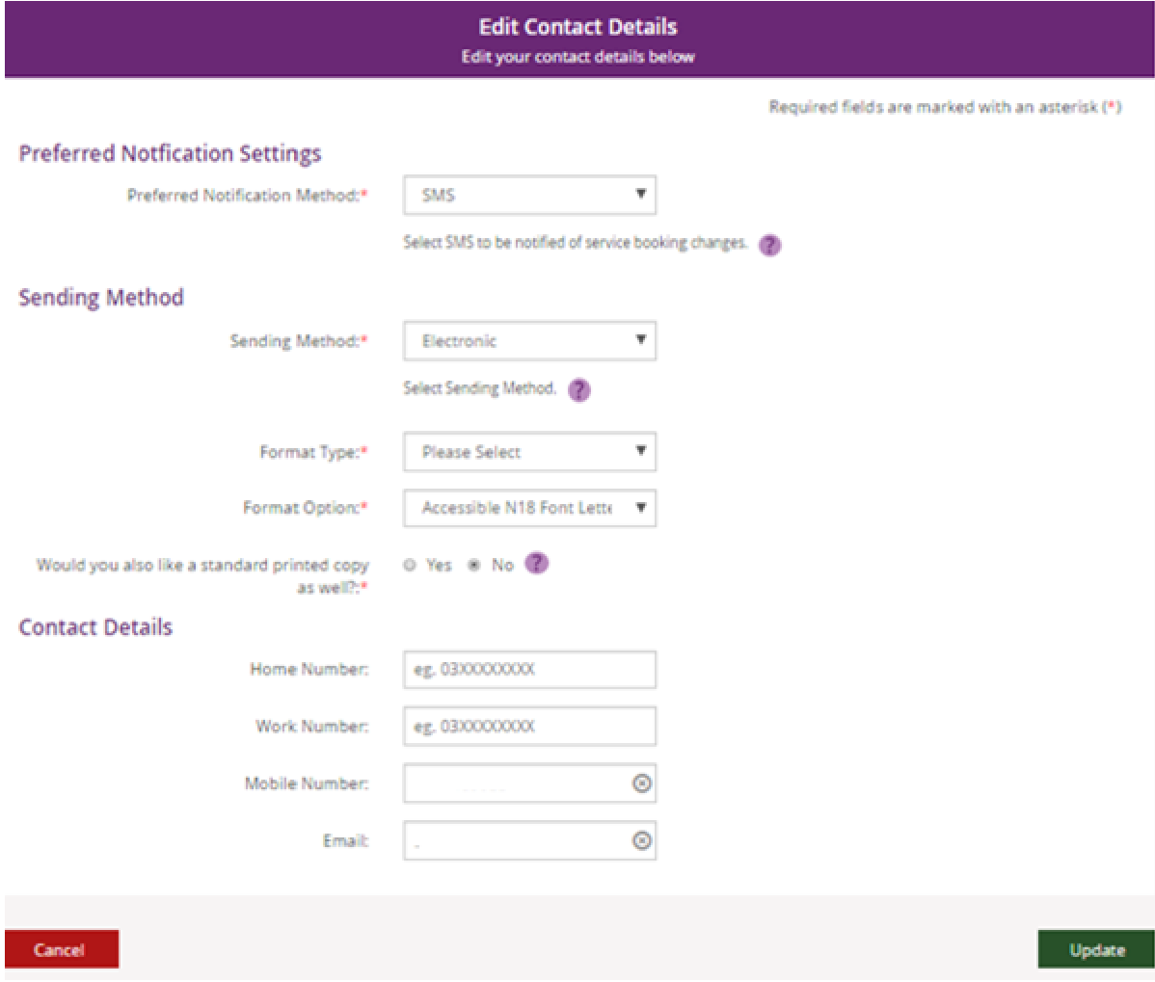

3. You can update your phone numbers and email address in the Contact Details
section. Click into the field (or select the delete cross icon) and type in your new
details.
4. This message will be displayed to confirm your contact details have been
successfully requested: “We have your details and will update them in 2
business days. If you need help, please phone NDIS on 1800 800 100 or
contact us.”

Note: This request may take up to 2 business days to complete. Once your contact details have been updated in the NDIS business system, you will be able to see the updated contact details in the myplace portal. If you need your details updated sooner, please phone the NDIS on 1800 800 110 or contact us.

How Can I Contact NDIA?
The How Can I Contact NDIA section provides the contact detail of your My NDIS Contact and our Contact Centre phone numbers.
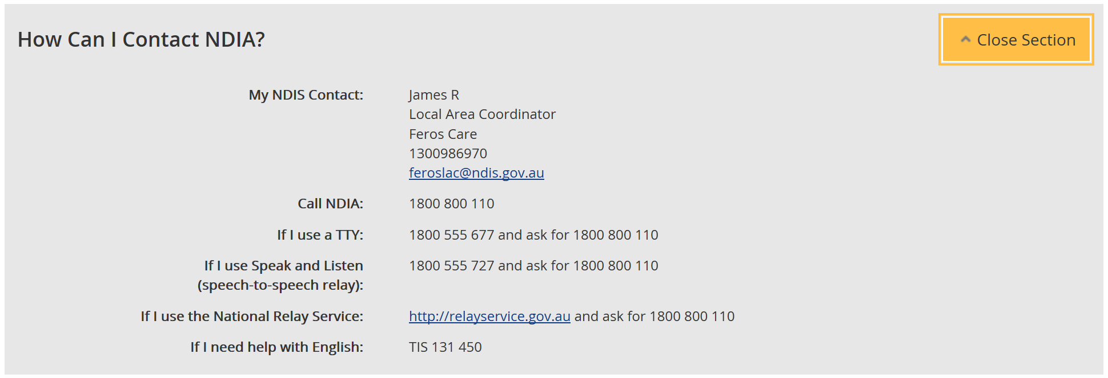

My Address Details

You can view your postal and home (standard address) addresses.

1. Click the Edit (pencil) icon to update an address

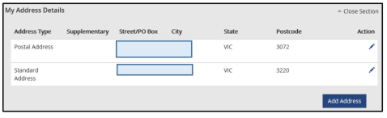

2. Select the Add Address button to add a new address.
3. Select the Address type and fill out the address fields. Enter the Start date and then
select Update.
4. This message will be displayed to confirm your contact details have been
successfully requested: “We have your details and will update them in 2 business
days. If you need help, please phone NDIS on 1800 800 100 or contact us”.

Note: This request may take up to 2 business days to complete. Once your contact details have been updated in the NDIS business system, you will be able to see the updated contact details in the myplace portal. If you need your details updated sooner, please phone the NDIS on 1800 800 110 or contact us.
Nominee/Child Representative process to update your address

If you are a nominee or a child representative, you can update your personal details in the ‘My Contact Details’ by selecting the Acting as Myself in the drop-down box in the top right-hand corner.
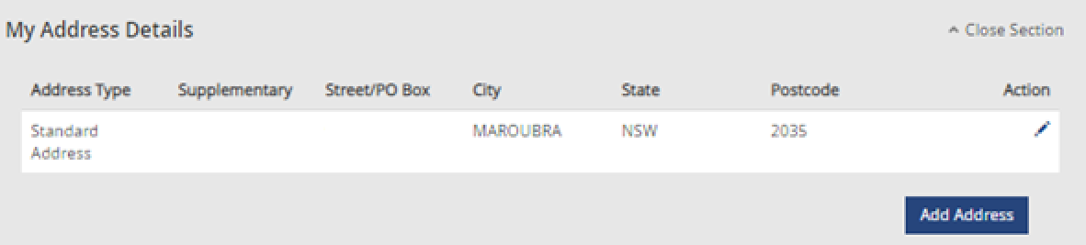
1. Click the Edit (pencil) icon to update an address

2. The My Contact Details screen displays.

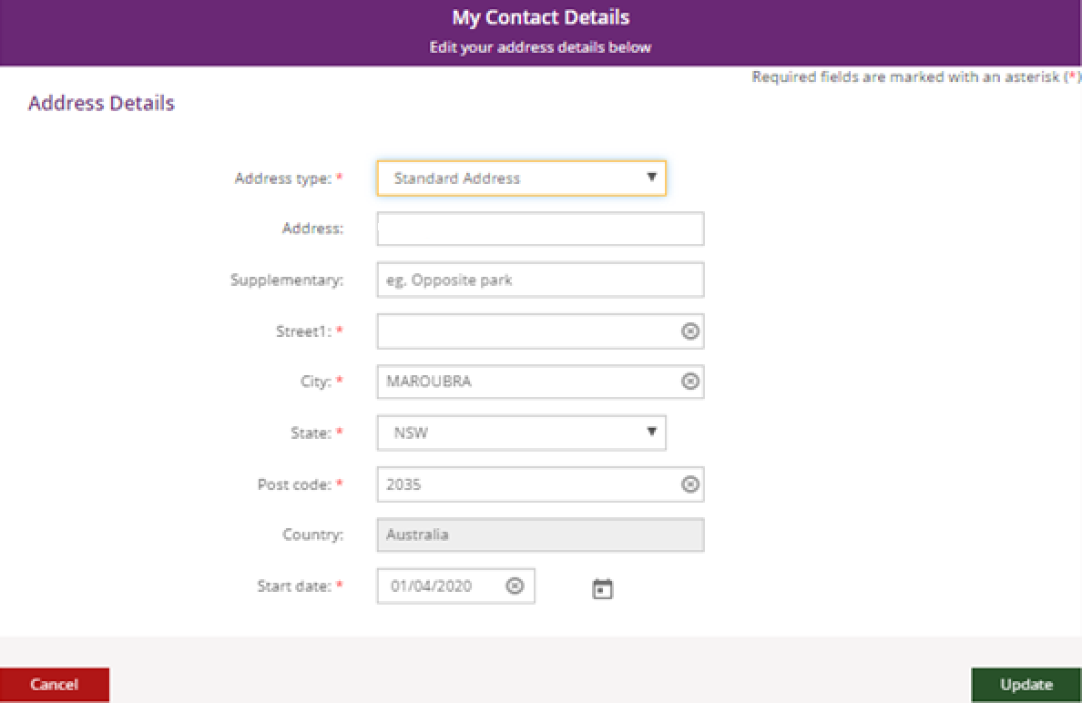

- Fill out the address fields. Enter the Start date and then select Update.
4. This message will be displayed to confirm your contact details have been successfully
requested: “We have your details and will update them in 2 business days. If you need
help, please phone NDIS on 1800 800 100 or contact us.
Note: This request may take up to 2 business days to complete. Once your contact details have been updated in the NDIS business system, you will be able to see the updated contact details in the myplace portal. If you need your details updated sooner, please phone the NDIS on 1800 800 110 or contact us.

Share My Plan
The Share My Plan function enables you to share parts of your plan with any service providers you have an active service booking with. You can change a provider’s permission to view your plan at any time. It is your choice if you share your plan details with providers.

Note: If you have a new plan in the new NDIS business system, you are unable to change your share my plan details in the portal. Please phone the NDIS on 1800 800 110 or contact us.

- Tick the box next to the provider name/s to share your plan; or untick to not share.

- Provide a reason for the change in the Why are you updating or changing who can see the plan text box.
- Click the Submit button to finalise the changes.
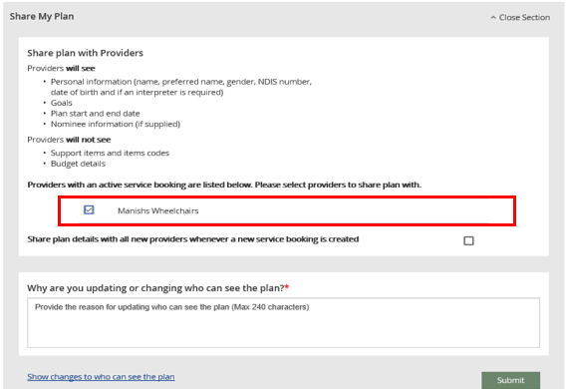
4. Click the Close Section link in the top right-hand corner to close this section.

My Bank Details
The My Bank Details function enables you to view your bank details and add new bank account information. When you update your bank account details, the system will send you the following SMS:
“We have updated your bank account details as requested. If necessary, contact NDIS on 1800 800 110”.

- Click the Open Section link to view your bank details.
- Click the Add Bank Details button to add a new account.
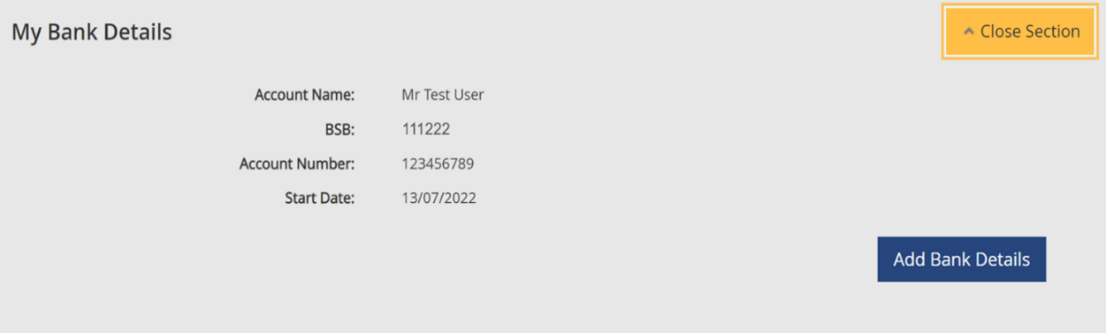

- Enter the new account details and then click the Update button to save.

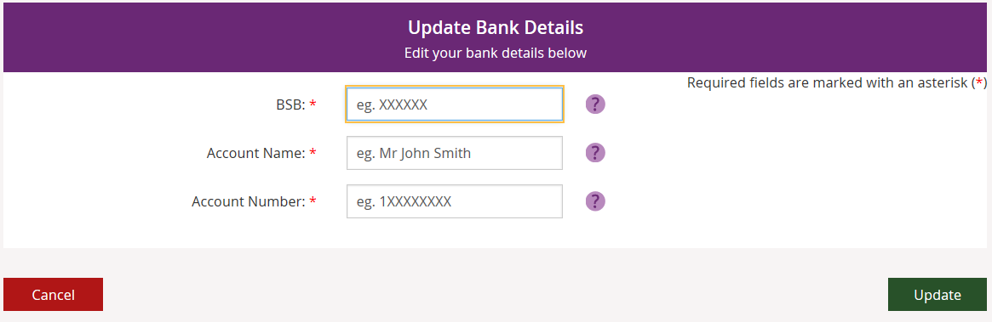

4. Click the Close Section link in the top right-hand corner to close this section.
Note: If you are a plan nominee or child representative, please contact the NDIS on 1800 800 110 to update the bank account details on your behalf.

