Budget calculator

This user guide explains how to use the Budget Calculator. It has screen shots so we have also created a version that is suitable for screen readers.

You can use this calculator to work out how much funding you have available for one support, or how many hours of one support you can get with your funding.

The examples in this user guide are made up.

Example 1: Sammy wants to know how much funding is available each week for their physiotherapy
- They have $50,000 in their plan for Capacity Building Supports for a year, which they can use flexibly. They decide they want to use half of it for physiotherapy - $25,000
- They have already spent $3,523 on first assessments and a couple of appointments
- Their plan started on 2 February 2022
- Their plan review date is 1 February 2023
Sammy puts these details into the budget calculator. The calculator tells them that they have $414.15 available per week for physiotherapy for the rest of their plan.
This is how Sammy used the budget calculator.

Question 1: Do you want an estimate of how much funding is available or how many hours of support are available?
More information: The calculator can estimate how much funding is left in your NDIS plan or how many hours of support you can buy
Answer:
The options are available as radio buttons.

Option 1: $ Amount – Sammy picks $ Amount
Option 2: Hours of support

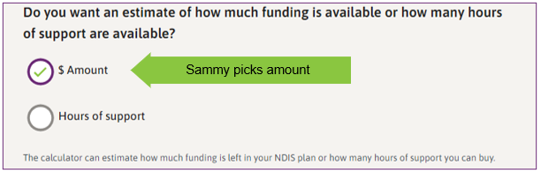

Question 2: How often will you use this support? (every month, fortnight, week, or day)
More information: The calculator can tell you the dollar amount or the number of hours of support available every month, fortnight, week, or day
Answer:
The options are available as radio buttons.

Option 1: Month – this is the choice that is initially ticked but it can be changed
Option 2: Fortnight
Option 3: Week – Sammy picks week
Option 4: Day
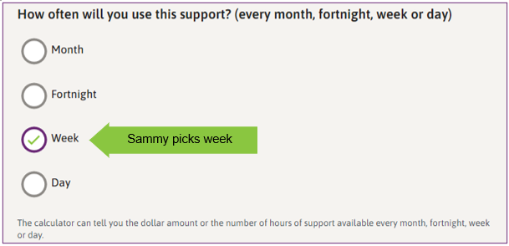

Question 3: How much funding is in your plan for the support you are estimating?
More information: You might not need the whole amount from your plan for a particular support. Your plan might have money for a few different supports. For example, you might have a total budget for Improved Daily Living which may include several different sorts of supports, such as occupational therapy, psychology, and some support worker help.
Answer: There is an input field with label ‘$’ to enter information. Sammy puts 25000 in this space.
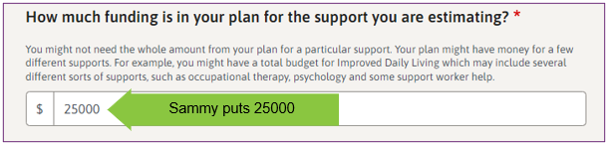

Question 4: How much funding has already been spent?
More information: If you have started using your plan, you might have already received some supports. The calculator needs to know how much has already been spent to work out what supports you can get in the future. You can get this number from the myplace participant portal or from your own records.
Answer: There is an input field with label ‘$’ to enter information. Enter amount or 0 if no funding has been spent. Sammy has already spent $3,523 on this support so puts 3523 in the box.
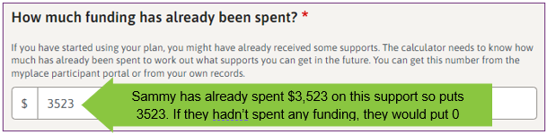

Question 5: When does your plan start?
More information: Leave empty to calculate your plan from today. In the example, Sammy is entering 2 February 2022 as the plan start date.
There are 2 options to put in the plan start date.
Option 1 – type in the numbers in the date input field in the format dd/mm/yyyy.
Sammy types 02 in the “dd” field for the day. The blue highlight then moves to the “mm” field.
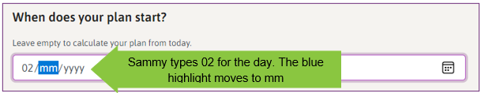

Sammy types 02 in the “mm” field for the month. The blue highlight then moves to the “yyyy” field.
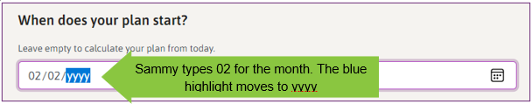
Sammy types 2022 in the “yyyy” field for the year.
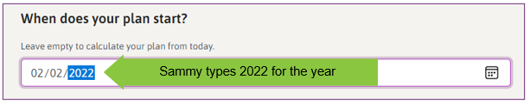
The date input field displays the date 02/02/2022 that Sammy typed in.
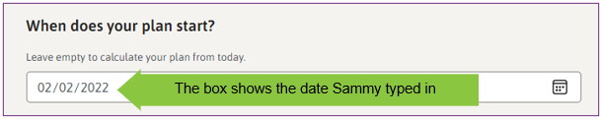
Option 2 – use the built-in calendar date picker.
The date can also be filled using the calendar date picker button found within date input field. The calendar date picker is found on the right-hand side of the date box. Sammy clicks on this to open the calendar date picker.
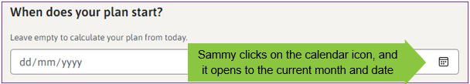
To change months, use the arrows in the top right corner on the calendar date picker. To clear or start over, select Clear button in the bottom left corner. To use today’s date, select the Today button in the bottom right corner. To choose the day, select that number.
Sammy uses the up arrow in the top right corner of the calendar date picker to go back to February.
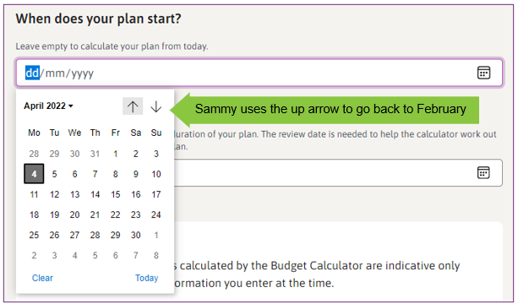

Sammy selects number 2 in the calendar date picker to choose 2 February 2022. 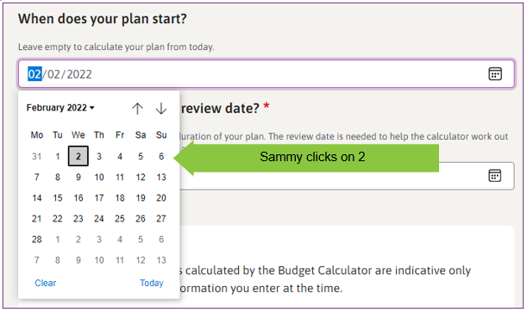
The image shows the date Sammy picked.
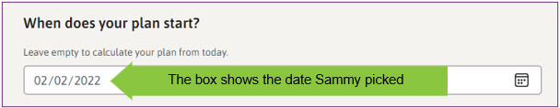

Question 6: What is your current plan review date?
More information: Your NDIS funding is available for the duration of your plan. The review date is needed to help the calculator work out how much time is left in your current plan. In the example, Sammy is entering 1 February 2023 as the current plan review date.
There are 2 options to put in the plan review date.
Option 1 – type in the numbers. Use the same method as for question 5.
Option 2 – use the built-in calendar date picker.
The calendar icon is found on the right-hand side of the date input box. Sammy clicks on the calendar date picker within the date field to open it.
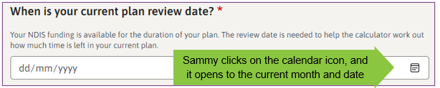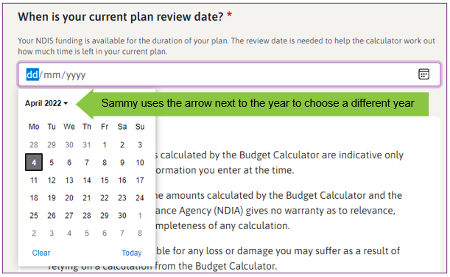
To change years, select the arrow next to the year in the top left corner. This opens to a list. The current year is expanded to show the months. The list also shows future years.

Sammy clicks on the arrow next to the year to choose a different year. Sammy selects 2023 in the calendar date picker.
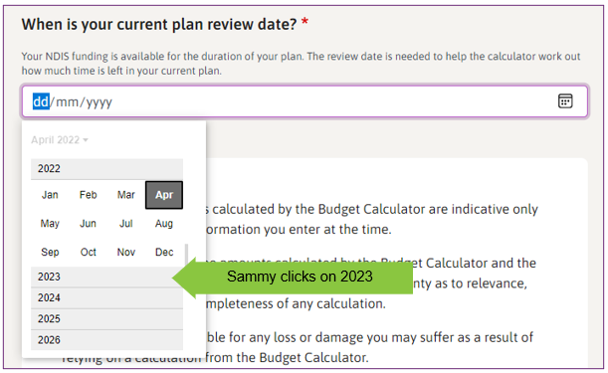
Once Sammy selects the 2023 tab the calendar date picker will expand to show the months.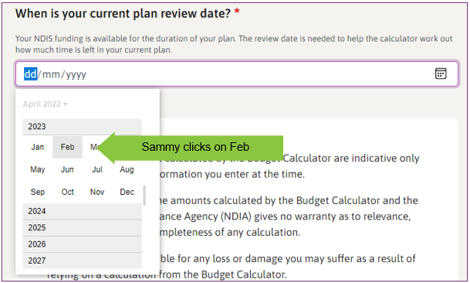
Sammy clicks on Feb tab and it expands to show the days. The top left corner will show February 2023. For 1 February, Sammy selects 1.
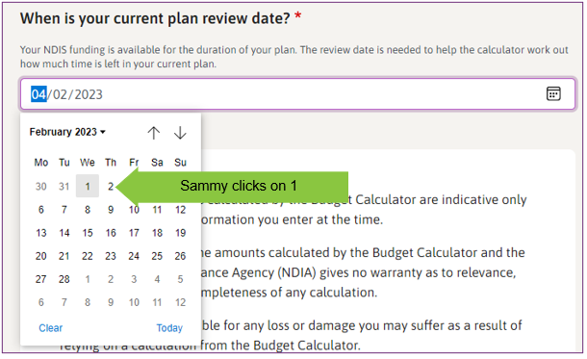
The date field displays the date Sammy picked (01/02/2023).
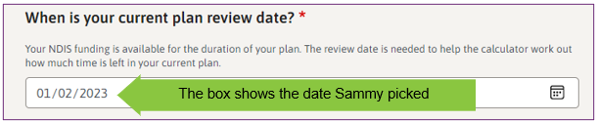

Disclaimer
Disclaimer: Any amounts calculated by the Budget Calculator are indicative only and are based on the information you enter at the time.
You should not rely on the amounts calculated by the Budget Calculator and the National Disability Insurance Agency (NDIA) gives no warranty as to relevance, accuracy, currency or completeness of any calculation.
The NDIA is not responsible for any loss or damage you may suffer as a result of relying on a calculation from the Budget Calculator.
The NDIA does not use the Budget Calculator for the calculations of reasonable and necessary supports.
If you have any questions about the Budget Calculator, please use the feedback form at the bottom of this page or through Contacts on ndis.gov.au or call the NDIA on 1800 800 110
Action: Check box – I have read and understood the above disclaimer. Sammy reads this disclaimer then clicks in the box to say they have read and understood it.
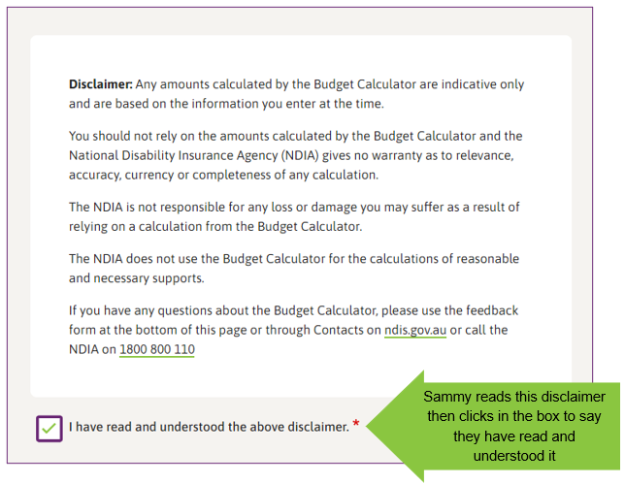

Calculate box
Sammy clicks on calculate button.
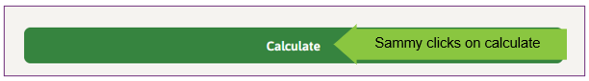

Answer box: Estimated available supports
More information: specific answer depends on user inputs above
Amount per week, and dollar amount.
The calculator gives Sammy their answer. In this example the answer is $414.15
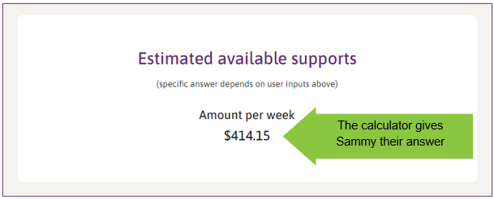
You can use the support organiser spreadsheet to help you keep track of all the supports in your plan.

Example 2a: Jedda wants to know how many hours of support she can get with her funding for psychology appointments.
- Jedda wants to see how many psychology appointments she can have each fortnight
- The psychologist charges $175 an hour
- Jedda has $50,000 in her plan for Capacity Building Supports for a year, which she can use flexibly. She wants to use $22,000 of it for psychology
- She hasn’t spent anything yet
- Her plan started on 2 February 2022
- Her plan review date is 1 February 2023
Based on the details she put into the calculator, Jedda can get 4.8 hours of support for a psychologist each fortnight for the rest of her plan.

Example 2b: Jedda decides she wants 5 hours of support.
- Jedda has some flexibility in her Capacity Building Supports budget
- She decides to use $22,600 for psychology
Based on the updated details she put into the calculator, Jedda can now get 5 hours of support for a psychologist each fortnight for the rest of her plan.

Example 2a: This is how Jedda used the budget calculator.

Question 1: Do you want an estimate of how much funding is available or how many hours of support are available?
More information: The calculator can estimate how much funding is left in your NDIS plan or how many hours of support you can buy.
Answer:
The options are available as radio buttons

Option 1: $ Amount – this is the choice that is initially ticked but it can be changed.
Option 2: Hours of support – Jedda picks hours of support.
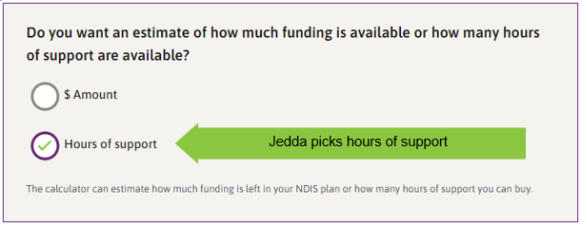

Question 2: How often will you use this support? (every month, fortnight, week, or day)
More information: The calculator can tell you the dollar amount or the number of hours of support available every month, fortnight, week, or day.
Answer
The options are available as radio buttons

Option 1: Month – this is the choice that is initially ticked but it can be changed.
Option 2: Fortnight – Jedda picks fortnight
Option 3: Week
Option 4: Day
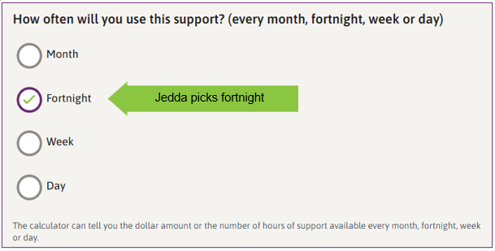

Question 3: What is the hourly rate of the support you want?
More information: Some types of support are charged on a per hour basis. Your provider should give you this information in your service agreement.
In this example, Jedda enters $175 per hour.
Answer: An input field labelled “$” to enter information.
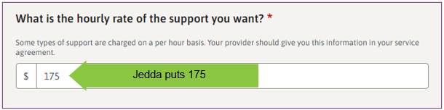

Question 4: How much funding is in your plan for the support you are estimating?
More information: You might not need the whole amount from your plan for a particular support. Your plan might have money for a few different supports. For example, you might have a total budget for Improved Daily Living which may include several different sorts of supports, such as occupational therapy, psychology, and some support worker help.
Answer: there is a box to enter amount for this support, Jedda puts 22000.
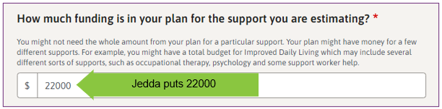

Question 5: How much funding has already been spent?
More information: If you have started using your plan, you might have already received some supports. The calculator needs to know how much has already been spent to work out what supports you can get in the future. You can get this number from the myplace participant portal or from your own records.
Answer: there is a box to enter amount or 0 if no funding has been spent. Jedda hasn’t used any funding on this support so puts 0.
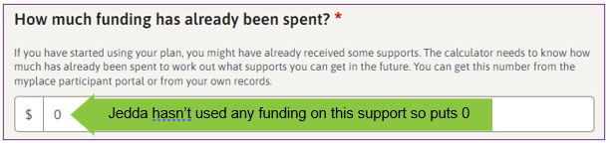

Question 6: When does your plan start?
More information: Leave empty to calculate your plan from today.
There are 2 options to put in the plan start date.
Option 1 – type in the numbers.
Jedda types 02 for the day. The blue highlight moves to mm.
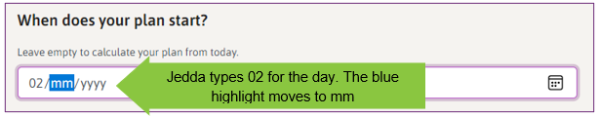
Jedda types 02 for the month. The blue highlight moves to yyyy.
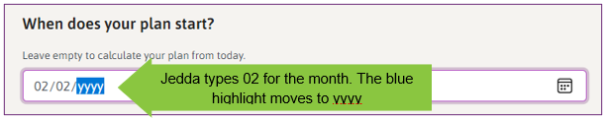
Jedda types 2022 for the year.
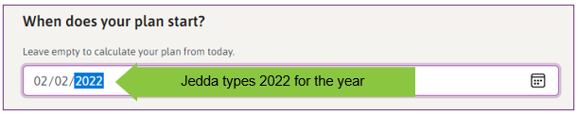
The box shows the date Jedda typed in.
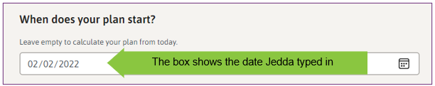
Option 2 – use the built-in calendar date picker.
The date can also be filled using the calendar date picker button found within date input field. The calendar date picker is found on the right-hand side of the date box. Jedda clicks on this to open the calendar date picker.
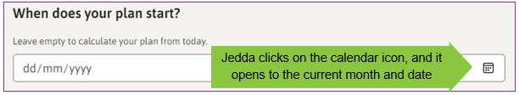
To change months, use the arrows in the top right corner on the calendar date picker. To clear or start over, select Clear button in the bottom left corner. To use today’s date, select the Today button in the bottom right corner. To choose the day, select that number.
Jedda uses the up arrow in the top right corner to go back to February.
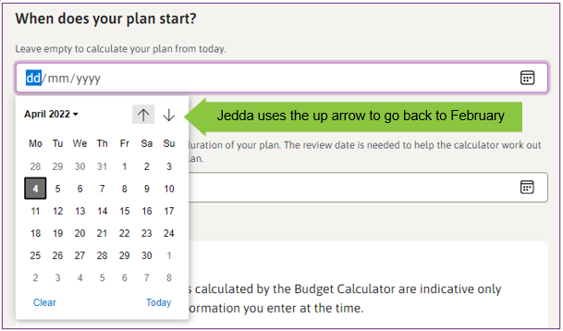
Jedda clicks on 2 to choose 2 February 2022.
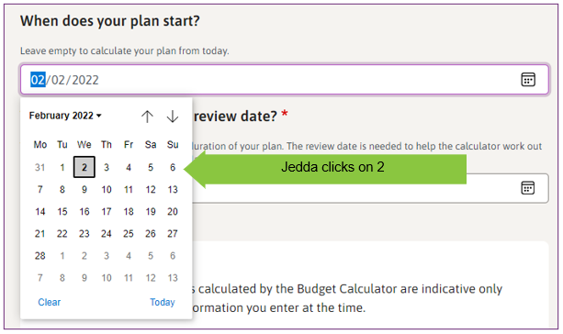
The box shows the date Jedda picked.
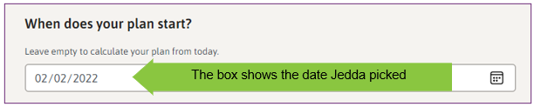

Question 7: What is your current plan review date?
More information: Your NDIS funding is available for the duration of your plan. The review date is needed to help the calculator work out how much time is left in your current plan.
There are 2 options to put in the plan review date.
Option 1 – type in the numbers. Use the same method as for question 6.
Option 2 – use the built-in calendar date picker.
The calendar icon is found on the right-hand side of the date input box. Jedda clicks on the calendar date picker within the date field to open it.
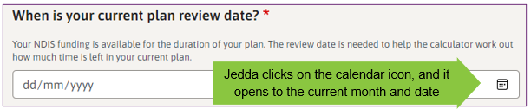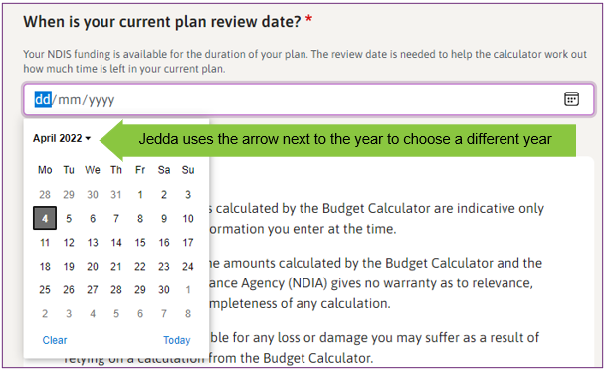
To change years, click on the arrow next to the year in the top left corner. This opens to a list. The current year is expanded to show the months. The list also shows future years.
Jedda clicks on the arrow next to the year to choose a different year. Jedda clicks on 2023 in the calendar date picker.
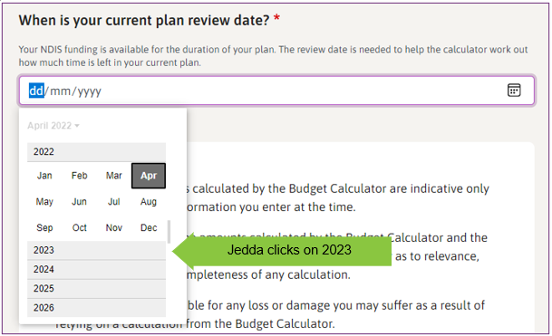
Jedda clicks on 2023 tab and the calendar date picker expands to show the months.
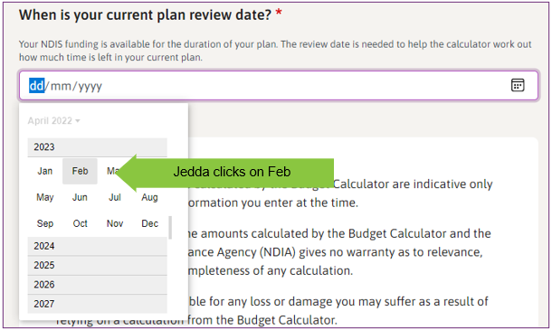
Jedda clicks on Feb tab and it expands to show the days. The top left corner will show February 2023. For 1 February, Jedda selects 1.
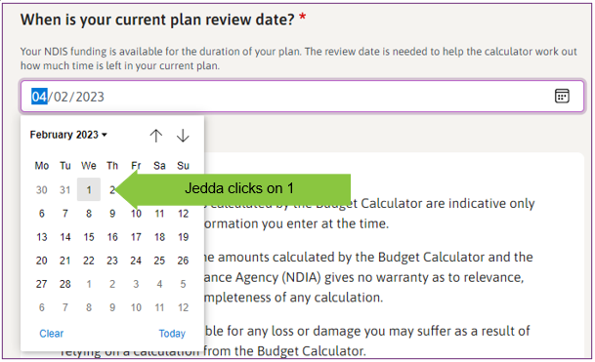
The date field displays the date Jedda picked (01/02/2023).
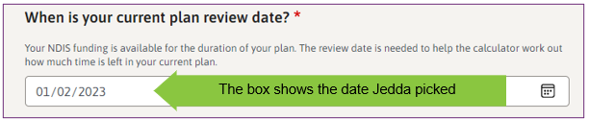

Disclaimer
Disclaimer: Any amounts calculated by the Budget Calculator are indicative only and are based on the information you enter at the time.
You should not rely on the amounts calculated by the Budget Calculator and the National Disability Insurance Agency (NDIA) gives no warranty as to relevance, accuracy, currency or completeness of any calculation.
The NDIA is not responsible for any loss or damage you may suffer as a result of relying on a calculation from the Budget Calculator.
The NDIA does not use the Budget Calculator for the calculations of reasonable and necessary supports.
If you have any questions about the Budget Calculator, please use the feedback form at the bottom of this page or through Contacts on ndis.gov.au or call the NDIA on 1800 800 110
Action: Check box – I have read and understood the above disclaimer. Jedda reads this disclaimer then clicks in the box to say they have read and understood it.
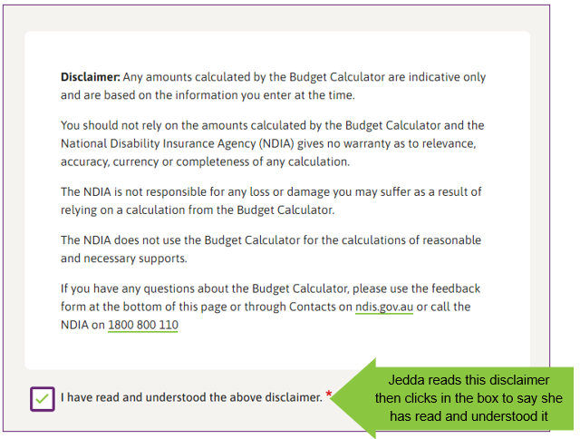

Calculate box
Jedda clicks on the calculate button
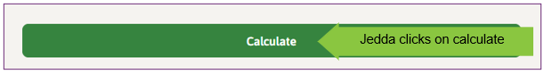

Answer box: Estimated available supports
More information: specific answer depends on user inputs above
Hours per fortnight.
The calculator gives Jedda her answer. In this example the answer is 4.8.
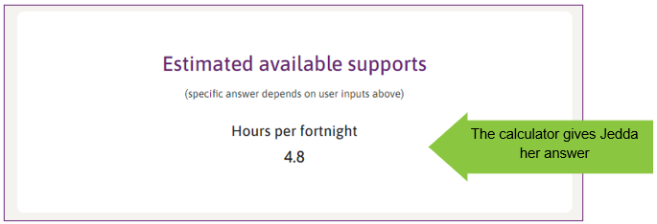

Example 2b: This is how Jedda changed the budget calculator
Jedda has $50,000 in her plan for Capacity Building Supports for a year and she decides to use $22,600 of it for psychology. She changes that number in Question 4 in the calculator.
This is how Jedda used the budget calculator for example 2b.

Question 4: How much funding is in your plan for the support you are estimating?
Jedda has changed the amount for the support by entering 22600 in the input field with the label ‘$’.
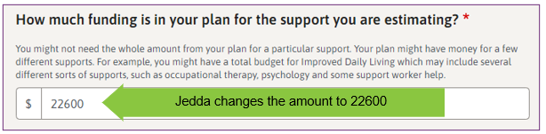

Calculate box
Jedda clicks on the calculate button.
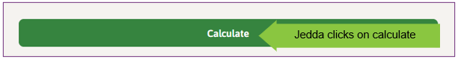

Answer box: Estimated available supports
The calculator gives Jedda her answer. In this example the answer is 5.
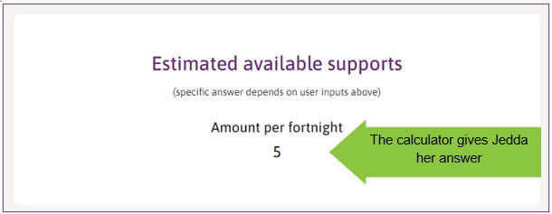
You can use the support organiser spreadsheet to help you keep track of all the supports in your plan.

